Name: Scott Thomas

Student number: 2015683

Project title: Design and implement a data capture system to improve efficiency of machinery and increase production levels

Aims & objectives
The main aim of my project
Design and implement a data capture system to log the reasons why production equipment is not running.
Objectives
- Increase Overall Equipment Effectiveness of production.

- Implement the data capture system on more than one machine

- Programme the data capture system to record the rate at which the machines are running to see how much product they are producing

- Introduce a real time screen in the managers or maintenance workshop to view the OEE figures and the production rates [1]

Background research
The primary piece of research for this project was to find out if the intended project was relevant and if so, what machine would be best suited to benefit from this system. I found that the bullion coining press was struggling to keep up with the demands of the customer and was not producing enough product during the working hours. The conclusion that I arrived at was that by highlighting the most frequently occurring faults, solutions for these faults can be found therefore reducing downtime and increasing production levels.
Before designing the system, I first had to find out what the most common faults and reasons for downtime and therefore lost production were. I found, by consulting the operators and engineering team that these were the most common reasons why the machine was not running:
Reasons for automatic stops on the press:
- No blank on table
- No blank in feed tube
- Die fault
- Feed bowl tripped
Reasons for manual stop on the press:
- Break time
- No blanks
- Tooling change
- Quality issues with blanks
- Lack of operator
- Electrical fault
- Mechanical fault
Research was carried out to determine the relevance of a data capture system in the industrial environment and if this type of system would improve the production rate of silver bullion the commemorative coin department.
Research shows that data is being used to achieve efficiency and productivity gains and uncover insight of what faults or issues that occur which effect production and quality. Using data capture systems, manufacturers can identify patterns that enable them to improve processes, increase supply chain efficiency and identify variabilities in the process that can affect production volume, production quality and can also identify consistency of production.[2] For example, in terms of consistency of production, with a data capture system it is possible to identify whether or not certain operators are not meeting the standards that are required of them. They could be having misfeed issues more than other operators and therefore could identify the need for retraining. Or maybe they are taking too long on their breaks. All issues that could affect production quantity and could lead to missing deadlines.
It is also possible for manufacturing companies, such as the Royal Mint’ to use data to manage the long-term operational health of the production equipment to reduce unscheduled down-time and prevent breakdowns for equipment. [3] This can be done by analysing the data that is collected. If production is being stopped for unplanned maintenance regularly then the maintenance schedule needs to be looked at. If the amount of unplanned maintenance is increasing, then it may be time for planned maintenance to take place. This will be done in the form of electrical planned maintenance and mechanical planned maintenance. The electrical planned maintenance will involve inspecting all sensors to see if they are becoming warn; checking cables, are they damaged? Are they becoming brittle?, checking motor brushes etc. All these issues could cause downtime in the future if they are left unchecked. The mechanical planned maintenance will involve stripping down all moving parts of the press, checking for wear and replacing worn parts. This will increase the efficiency of the press and again lead to less lost production time and increase the Overall Equipment Effectiveness.
The data capture system that I researched and found was the best fit for my application was ‘Gemba solutions’. They state that ‘Our services team actually spend a huge amount of time empowering organisations to turn their data into productivity gains for continuous improvement’. [4] This is the exact reasons why I felt that this is a worthwhile project and I believe that by recording the faults that occur and amount of downtime caused by these faults can have a massive impact on production levels. Finding the faults that decrease our OEE (Overall Equipment Effectiveness) means that we, in engineering, can find solutions for these faults and increase our OEE and therefore improve production levels. This is vital at the moment as the press’ are struggling to keep up with the demand for silver bullion in the current economic climate.

Specification
The system will comprise of a panel with a PLC mounted to it. On this panel will also be several connectors for the inputs and outputs of the PLC to connect to; an MCB to protect the PLC from overcurrent; fuses to protect the 24V components on the panel; and a relay which will be used to inhibit the press from running when a fault occurs. The only way for the press to run is when a button is pressed on the HMI to tell us what fault occurred, which will be the reason for the downtime, and then the relay will switch and the press will become uninhibited and therefore the press will be allowed to run. The other part of the system is the HMI screen which will be mounted to the pendant control panel for easy access for the operator/setter. The PLC and the HMI screen will be connected to the server via an IT switch and both will be connected via ethernet (cat 5 cable with RJ45 connectors)
The HMI screen will display the reasons for the press stoppages. The HMI screen will be fitted to the pendant control panel. These reasons for stoppages will be split into 7 buttons. The buttons will be labelled as follows:
- Misfeed (This will identify a misfeed of the blanks on the way to the dies. This could be for a variety of reasons such as the blank getting stuck in the tube or in the slide
- Setting (This button will be pressed if the setter needs to alter the setting of the press)
- Awaiting blanks
- Bad blank (this will highlight issues with the quality of blanks that we are receiving)
- Tool change (this button will be pressed when the tooling needs changing due to the quality of the struck coin deteriorating)
- Break time (This will highlight the amount of production lost due to break times)
- Unplanned maintenance (this will highlight the amount of downtime lost due to maintenance issues, both mechanical and electrical)
This set of buttons is the original design but overtime we will be able to further tailer the reasons for stoppages to get to the root cause of issues if the issues persist.
By logging the amount of downtime caused by each of the above issues, I hope to find the biggest reasons for downtime and correct these issues, either using technical solutions or managerial solutions.
An example of where a technical solution would be required is if the machine is stopping regularly for ‘no blank on table’ or ‘no blank in feed tube’ then we, in engineering, know that we need to work on the feed system in order to ensure that the blanks feed correctly.
An example of a managerial solution would be required is if the machine is down for ‘break time’ then it may be possible to stagger break times of operators so that the press can operate throughout the shift. Another managerial solution would be if the machine is suffering from downtime due to ‘no blanks’ then procurement must investigate why we haven’t got any blanks and investigate supply chain issues and possible planning issues.
I believe this project will be a success if:
- I manage to build the data capture panel and install it on the press inside the electrical cabinet
- Design a screen for the HMI using the ‘Factorytalk view machine edition’ and upload it to the HMI. I will then install the HMI to the pendent control panel
- Design a PLC program with help of the onsite programming engineer and upload the program to the data capture PLC
- Connect data capture PLC to the press PLC, picking up on the reasons for automatic stoppages
- Install an inhibit relay to the data capture system that works to inhibit the operation of the press so that it will not run until the reason for the stoppage is selected on the HMI screen. This will ensure that the operator/setter must enter the reason for the stoppage before restarting the press which will ensure we obtain the data needed to implement improvements to the machine
- Connect both the HMI and the data capture PLC to the IT network via ethernet cables connected to the IT switch located in the electrical substation

Project planning
Gantt Chart

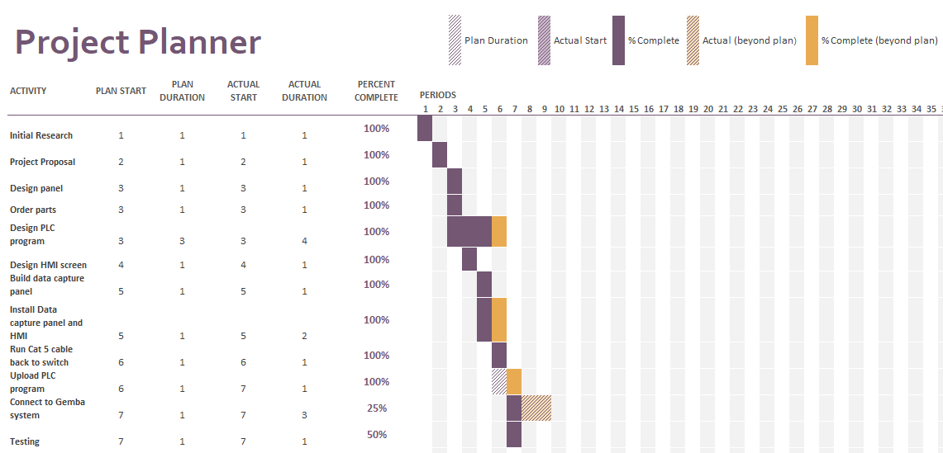
Shown above is the Gantt chart for my project. The first step of the project was to carry out some initial research to find a suitable project that will be good for my company. When I found a suitable project by researching the issues that the production team are facing I decided to develop a data capture system to reduce downtime and therefore increase production. I then submitted my project proposal for the project that I deemed the most suitable to carry out.
The next step was to design the panel by drawing out the circuit and identifying what outputs that I need to pick up off the press’ PLC. Now that the circuit has been designed, I could select what components and part I required before ordering them through our suppliers. As I was waiting on the parts to arrive, I started writing a PLC program for the data capture PLC with the help of the programming engineer. The program required was far larger than I expected, and I needed the programming engineer to complete the PLC programming side of things. I planned three weeks to complete the PLC program but as can be seem above it took a week longer. This was due to the complexity of the program and since the engineer also had other work on so he could not dedicate all his time to this project. He designed the PLC program in such a way that it could be used on a variety of different machines as the Royal Mint is looking to roll this type of system out across site.
While he was designing the PLC program I was free to design the HMI screen and build the data capture panel. I gave myself 2 weeks to complete the build of the data capture panel as I had to carry out the build while doing my maintenance job. These 2 milestones were completed on time.
The next milestone was to install the data capture panel and the HMI screen. This job took a week longer than I planned as the machine was not made available to me by production as they needed to complete work to meet an order deadline.
When I was waiting for the press to be released to me, I ran the two cat 5 cables (1 for the HMI and 1 for the data capture PLC) back to the substation. I connected the RJ45 connectors to the ends of the cables and then tested them to ensure they were wired correctly and there were no crossed connections. We then uploaded the program to the PLC using RSlinx.
The final part of the project was to connect to the Gemba server. Due to the time constraints this milestone has not been complete. I have had the approval to spend the money on the server but the server needed to be installed in IT. The issue was that IT haven’t got round to approving the addition of the Gemba system to the IT network.
Finally, we tested to ensure the data capture system was working. I have stated that this milestone was only 50% complete as we were not able to test whether it was connected to the Gemba server as it had not been installed at the time.
Risk Assessment

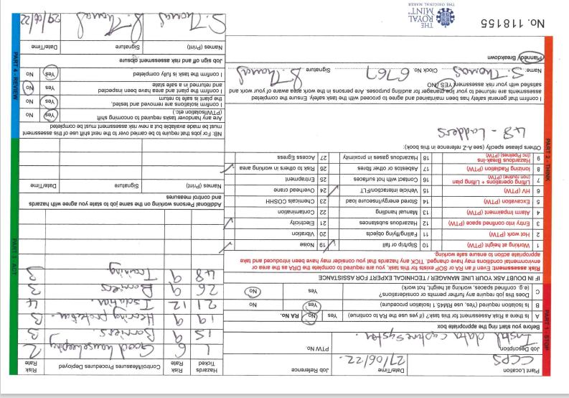
Part of the planning stage was to carry out a risk assessment. The risks identified and the control measures put in place are as follows:
- Slip/trip or fall – Follow good housekeeping procedures to ensure there are no trip hazards
- Vehicle interaction/FLT – Put barriers in place
- Noise – Wear hearing protection, i.e. ear plugs
- Electricity – Isolate the electricity following correct isolation procedures
- Risk to others in working area – Put barriers in place
- Use of ladders – Follow training and limit time up the ladder
Parts List
To reduce costs for this prototype project, mostly components that we had on site were used. This included the HMI (PanelView 600) The only parts required were:
- MicroLogix 1100 PLC - £930
- Gemba server - £3000 per press
Total cost of project = £3930
This total cost of the project does not take into account of the components that we had in storage on site or the cost of my labour as I am doing this project along side my normal job.

Design
Flow chart of the system:

PC

Above is a basic flowchart of the designed system. The first step is the Press PLC which feeds information about why the press has stopped to the data capture PLC. There is a two way arrow as the data capture PLC inhibits the press so that it will not start until the reason for stoppage is pressed on the HMI.
HMI
Press PLC
Data capture PLC
Network Switch
Server
The data capture PLC is then connected to the IT network by an ethernet cable via a network switch in the substation. The HMI is also connected to the network switch in the substation via ethernet cable. The Data capture PLC and HMI are given unique IP addresses so that the press PLC can read the information sent by the HMI which is the reason for the stoppage. The IP address for the data capture PLC is 192.168.5.100 and the IP address for the HMI is 192.168.101.
Unfortunately, due to time constraints in the IT department the Gemba server has not been installed and therefore this is as far as the flowchart goes for the time being.

PLC Circuit Diagram

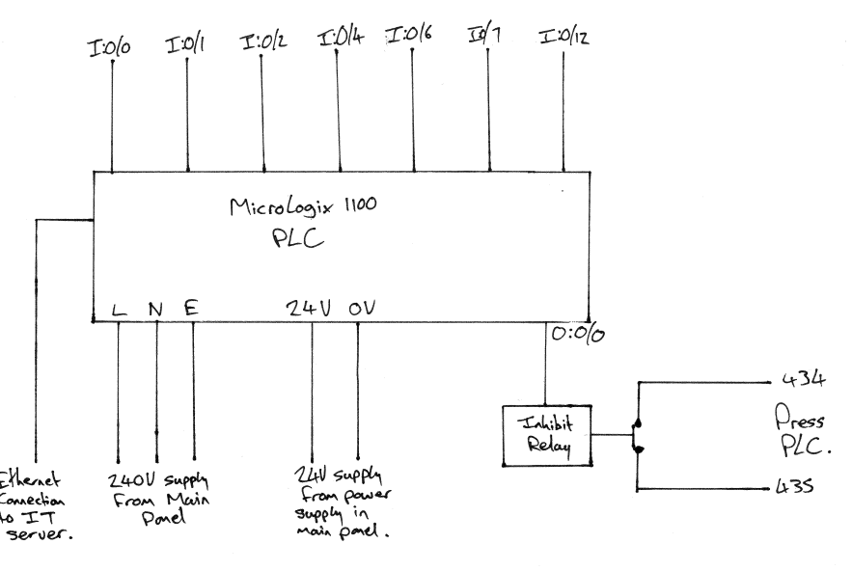

Shown above is the circuit diagram for the MicroLogix 1100 PLC. If the press stops running, then output 0/0 goes high and switches the inhibit relay. The inhibit relay then opens the normally closed contact and prevents the operator/setter from starting the press until they select a reason for why the press was stopped automatically. The reasons for non-auto stops are input by the HMI and input via the ethernet connection. The inputs are the reasons for the press stopping. The inputs are as follows:

- I:0/0 – Count
- I:0/1 – Feed tube empty
- I:0/2 – Feed overload
- I:0/4 – Die fault
- I:0/6 – Hopper call
- I:0/7 – Tote box full
- I:0/12 – Inhibit
Shown below is the connection to the clutch contact of the press. It can be seen in the PLC circuit diagram above that the inhibit relay normally closed contact is connected to pin 435 in the electrical cabinet. When this relay is powered, the contact opens and will not allow the clutch to be brought in until the reason for the stoppage is selected.

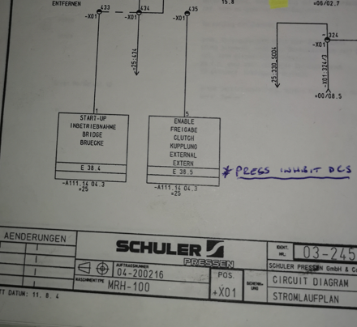

Data Capture Panel

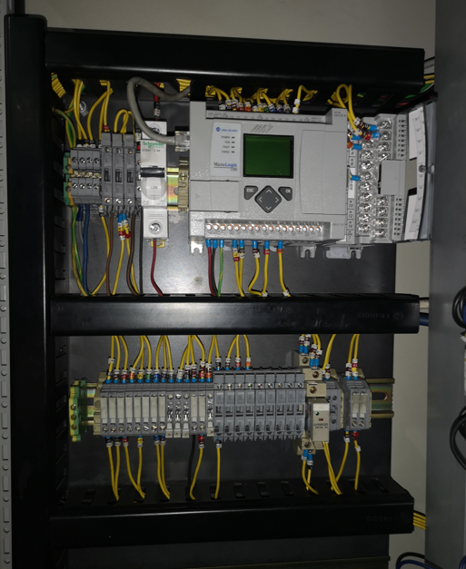

HMI
The PanelView 600 was programmed using the program ‘Factory talk view machine edition’
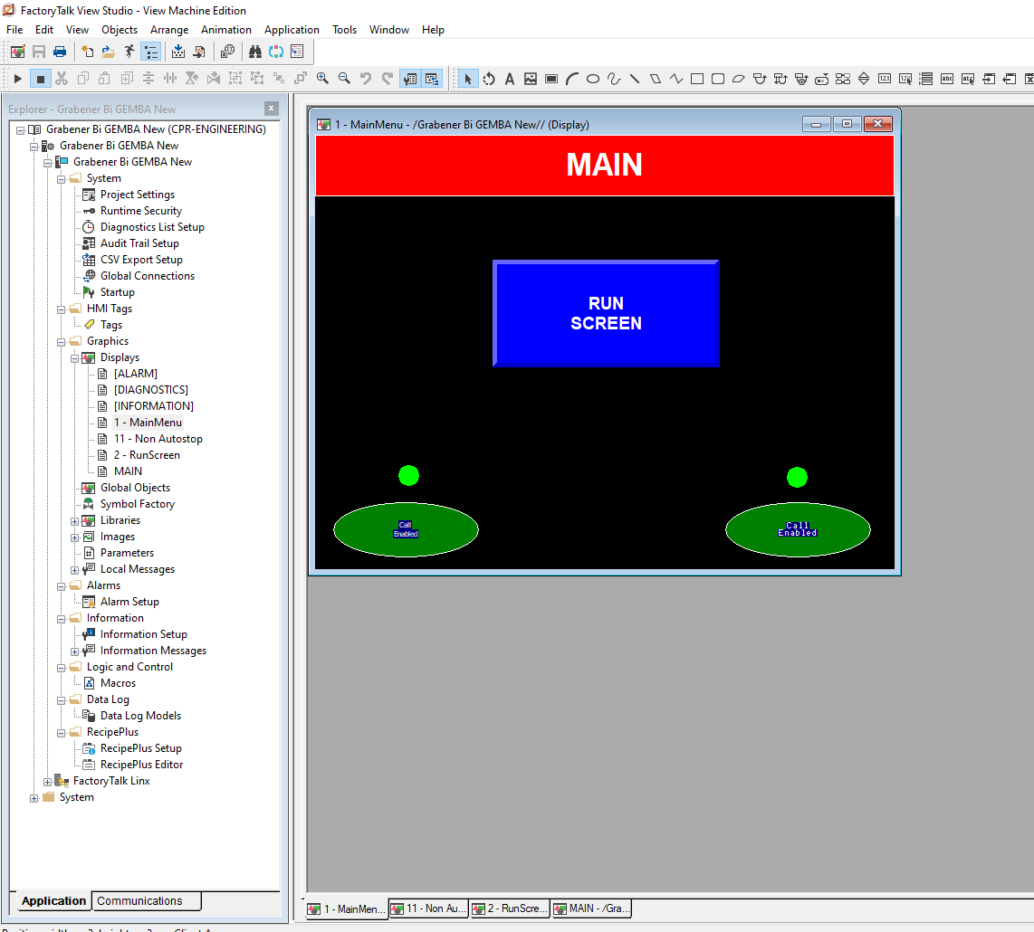

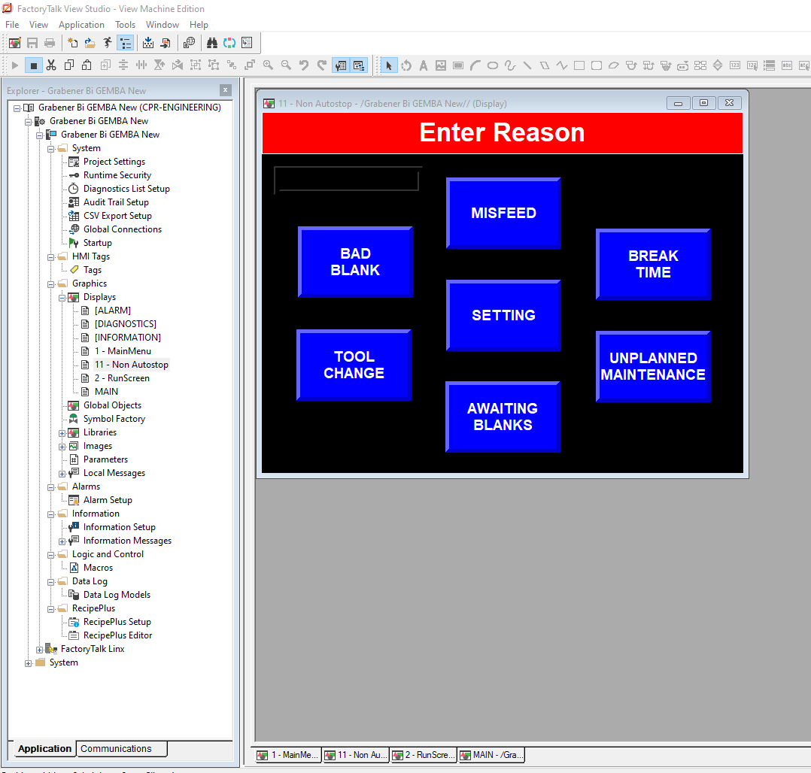
The PanelView installed on the press:

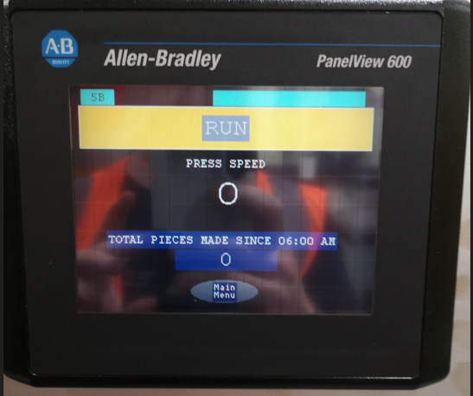

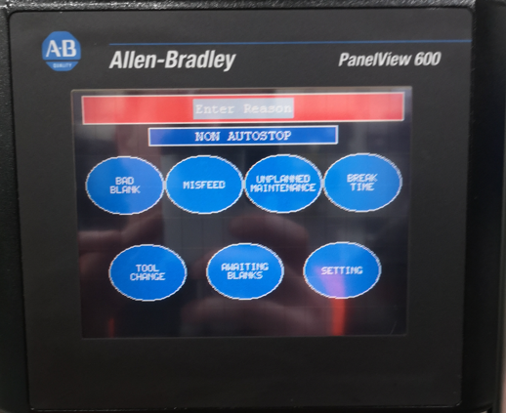
PLC Program
I have attached the PLC program separately via email. The onsite programming engineer helped greatly to complete this program as when I proposed this project, I underestimated the complexity of the PLC program that was required. The program used has been altered from an original program that was used for something else. The program could be simplified but a lot of the coding has been left in there in case there is use for it in the future.
Results
The result of this project is that the ground work has been put in to record all faults that occur with the press and when the Gemba server is installed we can start to analyse the causes of downtime and make our processes more efficient. The press still operates correctly with the data capture system installed and the press will not operate after a stoppage until the operator/setter inputs the reason for the stoppage. This will ensure that the reasons for stoppages will always be recorded and will help our production department become more ‘lean’. It also means that we in engineering can study the reasons for lost production and will be able to engineer solutions to ensure our presses are more efficient, more productive, and therefore will save costs.
Conclusion
The main aim of this project ‘design and implement a data capture system to log the reasons why production equipment is not running’ has been met. The data capture system with the HMI is capable of logging the reasons that the press stops automatically and also when it does not stop automatically. When the press does not stop automatically, the operator/setter must enter the reason for the stoppage. The inhibit relay means that the operator must input the reason for the stoppage, or the press will not start up. This means that the system is capable of logging a variety of data which can be analysed to improve production rates.
Objective 3 ‘Programme the data capture system to record the rate at which the machines are running to see how much product they are producing’ has been met. Input 1:0/0 is the count of the machine. This means that we can see how much product the press has produced.
Unfortunately, objectives 1,2 and 4 have not been met. Due to the time constraints, it has not been possible for IT to install the Gemba server and therefore we have not been able to analyse the data and ‘increase Overall Equipment Effectiveness of production’. This also links objective 4 ‘Introduce a real time screen in the managers or maintenance workshop to view the OEE figures and the production rates’ due to not being able to connect it to the server. I was also unable to complete objective 2 ‘implement the data capture system on more than one machine’ due to the time constraints and having to carry out my job at the same time as this project. Given the success of the data capture system that I have implemented, I believe that it will be worthwhile installing this system on multiple machines where production level is essential to the profitability of the business. I believe that given more time these objectives would have been met but the project will continue, and I believe that this system will greatly improve production rates.

Reflection
Through this project I have learned a great deal about the faults that occur on the presses in The Royal Mint and how a data capture system can improve Overall Equipment Effectiveness and drive The Royal Mint to become more ‘Lean’ and increase production rates.
I have learned a lot about PLC programming which is something I did not have a lot of experience with previously. Through the help of the on-site programming engineer I feel that I have developed my PLC programming knowledge and I look forward to doing more work in this field in the future.

References
[1] Scott Thomas – Project Proposal – Submitted to Turnitin 27/05/22 (Accessed 05/07/22)
[2] How Manufacturers Are Using Big Data Analytics to Improve Processes (sartorius.com) (Accessed 06/07/22)
[3] How Manufacturers Are Using Big Data Analytics to Improve Processes (sartorius.com) (Accessed 06/07/22)
[4] Empowering Workforce to Continuous Improvement | Gemba Solutions(Accessed 07/07/22)
[5] RS Components | Industrial, electronic products & solutions. (rs-online.com) (Accessed 07/07/22)

