Professional Career Development Reflection and Application

Component 1 (C1) –Reflective report

Nikola bajgerova
2232206
Professional Career Development
Submission Date 2 June 2023 At 3pm

Table of Contents
Introduction 3
Detailed understanding of each model 4
Johari Window 4
SWOT Analysis and conversion strategies 4
SMART goals 4
PDP and Learning Style Questionnaires 5
Application of Johari Window Model 5
Application of SWOT Analysis 6
Application of SMART goals model 8
Application of the PDP model 8
VARK learning style questionnaire 9
PDP includes 2 employability skills 9
Conclusion 10
Reference 11

Introduction
The focus of this assignment is on enhancing one's professional standing and prospects. Motivate kids to take stock of their own unique set of qualities, abilities, and interests to better serve them in school and life (Watkins, 2018). Then, they apply what they've learned to the process of deciding on a future profession. They have established a connection between their traits and interests, as well as their skills and talents, and probable future occupations. I discussed how to use career planning and career exploration to help kids choose and pursue fulfilling long-term careers, how to acquire the skills they'll need to be competitive in the modern job market, and how to find credible resources for learning about post-secondary education alternatives. Students will use their critical thinking abilities to determine where various occupations belong on a career spectrum. This section covers how and what I learned about the Johari Window model, SWOT strategy model, SMART goals model, Personal development plan, and Learning Style Questionnaires. Finally, how I could apply all these models to myself.

Detailed understanding of each model
I feel like I've gained a lot of knowledge about management that will help me advance in my profession thanks to this training. After doing the self-evaluation tests, I realized that I am an ISTJ, which, according to the Myers-Briggs personality typology, is characterized by a desire to be helpful and a desire to avoid causing others distress.

Johari Window
A person's ability to read other people is honed with the help of the Johari window model. The foundation of this approach rests on two tenets: first, that one may win the confidence of people by being transparent about one's characteristics, and second, by taking the advice of those others (Shumate, 2021). This model explains the process of providing and receiving criticism. A standard representation of a Johari is a four-paned window. Two of the windows show one's known self, while the other two show one's unknown self to others. Mutual trust is established by communication and the incorporation of group members' opinions into one's thinking, allowing for the free flow of information between the two windows.

SWOT Analysis and conversion strategies
Using a SWOT analysis, one may take stock of their advantages and disadvantages, as well as the chances and risks they confront. As a result, individuals are better equipped to capitalize on their talents, avoid their flaws, and use the chances at their disposal to their full potential (Bethencourt, 2021). For this reason, organizations have relied on it for decades as a go-to strategic planning tool that can help you see the big picture. However, SWOT analysis may be just as helpful on a personal level, in the context of career conversations and the identification of areas for improvement. Conversion techniques are effective because they increase revenue, delight customers, and encourage repeat business. Each objective is critical to the success of a conversion plan. Conversion rates are boosted through training and growth programs for staff, strict requirements for providing excellent customer service, and a variety of pricing models.

SMART goals
Meaningful, Accurate, Reliable, and Timely; the Specific, Measurable, Achievable, Relevant, and Time-Bound objectives are what we call "SMART goals." When individuals define these factors about their goals, it increases the likelihood that those goals will be accomplished in a reasonable amount of time. Establishing and maintaining objectives is essential in every organization or line of work because they create a feeling of purpose, drive, concentration, and priority (Travers, 2022). By establishing personal objectives, individuals give themselves something to work for.

PDP and Learning Style Questionnaires
The Performance Management System (PMS) includes the PDP, or Performance Improvement Plan (Performance Management System). Employee performance and the company's performance management system may both benefit from the PDP. It helps pinpoint problem areas, establishes directions for growth, establishes benchmarks for success, and molds action plans to achieve desired results (Travers, 2022). Quarterly meetings for performance development planning enable both workers and supervisors to assess and adapt strategies as required. PDP also helps both workers and management zero in on the most crucial individual and team objectives for moving the company forward. Taking an inventory of one's learning preferences might assist pinpoint one's preferred method of instruction. These registries are often administered in the form of a questionnaire designed to uncover respondents' strongest learning preferences. When filling out surveys, people often choose the options that most reflect their own opinions.

Application of Johari Window Model
I have already applied this model in my professional life. I am now employed by a certain group. In this setting, where my coworkers only knew a bit about me, the hidden and hidden will be greater than the open. Because the other people don't know much about me, our blind spot will be reduced, and our model will look like Figure 1. My coworkers and I had a hard time connecting since I was so reserved and mysterious at the workplace, where I spent much of my leisure time drawing. As a result of reading that assessment, I made an effort to engage in more conversation and team-building activities at work. As can be seen in Figure 2, this enabled me to expand my open area, reducing the size of the invisible and unknown regions. According to the comments made by my coworkers, I am capable of delivering excellent office performance, and my full potential may be uncovered via collaboration with my team. In this way, I can apply this model in my professional career.
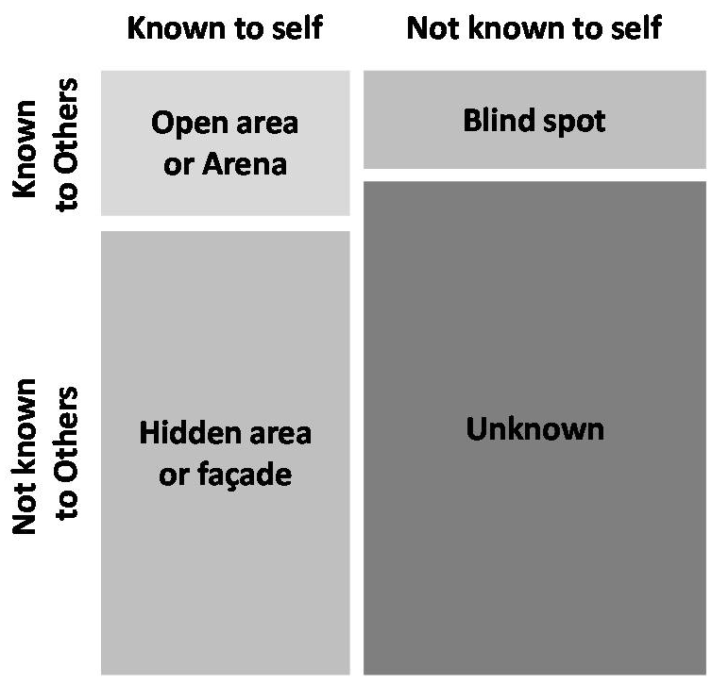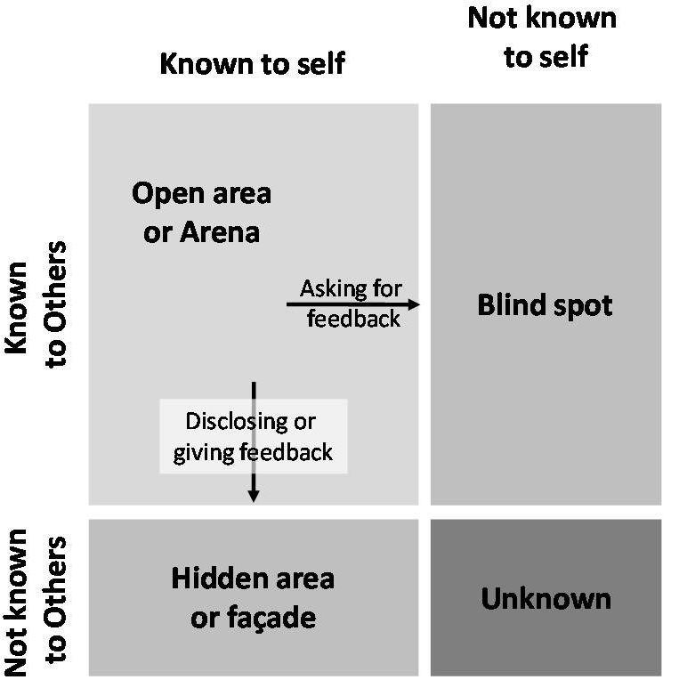
Figure 1 Figure 2
Source: Grit et al., 2019 Source: Grit et al., 2019

Application of SWOT Analysis
Strengths
Possessing strong ICT abilities is a valuable asset in the academic world. One of my many skills is being able to effectively use digital tools (Beausaert et al., 2021). In addition to doing my study on the items I use in the classroom I can also share that information with my students. I am proficient at making and using PowerPoint slides. I use email to get in touch with the pupils. One of my strengths is that I can assess the effectiveness of my teaching materials and tools since I have a deep understanding of my pupils. I never trust that I have utilized the most recent details without verifying them. To better serve my pupils, I routinely stay abreast of such developments and share them with them. I have mastered the art of time management. I have a strong reputation for being a reliable classroom timekeeper. I work hard to complete all of my coursework well before the due date.
Weakness
I've tried Excel, but I need to learn more. While I can create basic spreadsheets, I am not very proficient in the use of calculations, formulae, graphing, or data analytics. The referencing process might be difficult. When pulling information from many sources, citations are required. I've given credit to the original writers and noted where I found their work. My most recent jobs were in the hotel sector, namely at the front desk and in the back office. Silver service, plate service, buffet, and à la carte are just some of the dining options I've been asked to explain to students. The restaurant industry has changed much since I last worked there, so I feel the need to brush up on the latest trends.
Opportunity
Skill to develop | Action to be taken | What to gain | How to assess | Time
Excel | I can find a lot of amazing Excel lesson videos on YouTube. To better myself, I plan to watch those videos and make copious notes. | I hope to gain an understanding of how to put the results of the calculations and analyses to use (Phillips, 2021). | My growth can be evaluated by a more seasoned colleague. | 01 July to 30 July, once a week for 1 hour.
Reference | In particular, one of my coworkers excels at both subject references and in-text citations. A second explanation would be very appreciated. | To that end, I want to provide more instruction on proper referencing and in-text citation | My supervisor and advisor can evaluate me. | 07 July to 14 July for 50 minutes a day.

Threats
Possible obstacles on my path to a successful career include things like entrance exams and competition for interviews. If I am successful in confronting this aspect of the SWOT Analysis, it will ultimately strengthen me and propel me forward in my career. If you don't address your vulnerabilities, they will eventually turn into threats.

Application of SMART goals model
I've found that setting objectives is a great way to kick-start new routines, direct my attention, and keep the positive energy flowing in my life. Setting and achieving goals gives me a feeling of direction and empowerment. I can apply this model in my planning process where all the components of this model can be used.

Application of the PDP model
PDP Plan for 4 months
Duration | Tasks | Motives | Involved parties
23/02/2023 | Educate me about the rules that regulate the safekeeping and sharing of sensitive data. | Methodology for Instructing Analytical Thinking | - Teachers  - Headteacher  - Administrations
23/03/2023 | the power to keep the reader engaged and encourage thought. | Taking into account the significance of the three channels, | - Teachers  - Advertisements  - Administrations
23/04/2023 | Classroom use of gestures and emotions | Understanding the value of nonverbal cues such as tone, gesture, posture, position, and eye contact, and physical cues are stressed. | - Headteachers  - Classmates  - Teachers
23/05/2023 | Identifying and utilizing one's preferred method of learning | VARK is still useful in today's classrooms. | - Policymakers  - Teachers  - Headteachers

VARK learning style questionnaire
It is common for educators to use a variety of teaching methods, including those that emphasize visual, auditory, reading, and kinesthetic. Teachers need to understand their pupils and the unique ways they learn. Effective educator recognizes individual variations in their students and is willing to adapt their methods of instruction accordingly (Verklan, 2017). As I organize the materials, I want to utilize in my higher education courses, I must keep the VARK in mind. I plan on using PowerPoint presentations as a teaching aid. Because I want to include text, graphics, and videos in the slides, it will be useful for both visual and auditory learners. I can include a follow-up exercise to the PowerPoint presentations for kinesthetic learners who like to get their hands dirty. I may assign group projects to my students following a lesson on providing great service presented in PowerPoint format. Students will learn to work together to research a topic and then share what they've learned. When the students have finished working together, they will give presentations to the rest of the class. Those that learn best via doing received that chance in this exercise.

PDP includes 2 employability skills
Learners' capacity to recognize, explain, and provide proof of their learning and progress is facilitated by the close connection between PDP and employability skills. Data reveals that today's students need to do more than just learn the fundamentals to be successful in tomorrow's graduate employment. Early signs from a comprehensive literature study suggest that there is reason to hope that PDP is successful in bolstering student learning.
Working Well with Other People
Interpersonal competence refers to the ability to get along with others in a professional setting. My strong interpersonal skills enable me to work well with others in a variety of settings, including as a team member, in negotiations, in making choices and solving issues, and in satisfying the needs of customers and clients. A better and less stressful working environment may be achieved via the cultivation of strong interpersonal skills, which include the ability to sympathize with and create relationships with coworkers and customers (Charron, 2022). Interpersonal skills include several domains, such as Communication skills, Emotional intelligence, Negotiation, persuasion and influencing skills, Problem-solving, and decision-making. These skills won't always be necessary for every career. However, I am very certain that I will need them at some time in my career, and that I will require many of them daily.
A Willingness to Learn
Having a thirst for information means I am constantly on the lookout for methods to expand my horizons and sharpen my abilities. This is often called "personal development," but that phrase may also refer to a more structured process including deliberate goal-setting, focused effort, and critical evaluation of progress. No matter how I go about it, the contemporary world necessitates that I will always be improving and expanding my knowledge base and set of abilities. The most useful workers are the ones that are open to change and who see the benefits rather than the dangers that come with it. Another important aspect of self and empathy is the ability to be resilient, adaptive, and flexible.

Conclusion
Professional morale might well be strengthened through opportunities for professional growth. Increased assurance often results in greater job fulfillment, efficiency on the job, and enthusiasm among people. This discussion has helped me to get insightful criticism of my character and to assess the relative merits of my many positive and negative traits. My self-assurance has increased, and I've picked up some useful social and communication skills that have helped me in both my personal and professional endeavors. I gained insight into how to improve my self-awareness to build healthier connections with others throughout this session.

Reference
Watkins, H. (2018) “Professional convergence,” Librarian Career Development, 6(1). Available at: https://doi.org/10.1108/lcd.1998.10206aab.003.
Shumate, C. (2021) “Using the model for personal development,” Projection and Personality Development via the Eight-Function Model, pp. 163–250. Available at: https://doi.org/10.4324/9780429324130-9.
Bethencourt, P. (2021) “Your future: START WITH YOUR SWOT analysis,” Success in Six Cups of Coffee, pp. 129–154. Available at: https://doi.org/10.1057/9780230349407_6.
Travers, C.J. (2022) “Reflective goal setting and the transfer of learning,” Reflective Goal Setting, pp. 21–31. Available at: https://doi.org/10.1007/978-3-030-99228-6_2.
Verklan, M.T. (2017) “Johari window,” Journal of Perinatal & Neonatal Nursing, 21(2), pp. 173–174. Available at: https://doi.org/10.1097/01.jpn.0000270636.34982.c8.
Beausaert, S., Segers, M. and Gijselaers, W. (2021) “The Personal Development Plan Practice Questionnaire: The development and validation of an instrument to assess the employee's perception of Personal Development Plan Practice,” International Journal of Training and Development, 15(4), pp. 249–270. Available at: https://doi.org/10.1111/j.1468-2419.2011.00375.x.
Grit, R., Guit, R., and van der Sijde, N. (2019) “Managing your competencies.” Available at: https://doi.org/10.4324/9781003021858.
Phillips, A. (2021) “Your development plan,” Developing Assertiveness Skills for Health and Social Care Professionals, pp. 268–274. Available at: https://doi.org/10.4324/9781908911063-20.
Charron, R. (2022) “Plan for personal and Family Resilience,” Plan for a Turbulent Future: Your Roadmap to Personal Resilience for a Changing Climate, pp. 33–38. Available at: https://doi.org/10.1201/9781003349211-4.
Travers, C.J. (2022) “Reflective goal setting, goal setting theory, and the importance of writing about goals,” Reflective Goal Setting, pp. 33–46. Available at: https://doi.org/10.1007/978-3-030-99228-6_3.

