Luke MacDonald (2100654)

Multi-Storey Buildings Structural Systems

Table of Contents
Introduction 2
Structural Systems in Multi-Storey Buildings 2
Materials Used in Multi-Storey Construction 4
Loads and Design Considerations 4
Methods of Construction 5
Innovations in Multi-Storey Construction 5
Case Studies 6
Conclusion 7
References 8

Introduction
Structural engineering is the method concerned with the design, analysis, and construction of structures that safely resist applied loads while remaining economical and functional. As proven by Thomas (2025) who states that structural engineering is the analysis, design, construction, and maintenance of structures that are able to safely support and resist loads. Structural analysis is a fundamental part of this process, as it allows engineers to predict how structures behave under various loading conditions, including gravity loads, environmental forces, and dynamic effects.
Multi-storey buildings represent one of the most complex applications of structural engineering due to their height, slimness, and exposure to significant lateral forces such as wind. As buildings increase in height, vertical load resistance alone is no longer sufficient; lateral stability and serviceability become critical design challenges. Therefore, engineers must carefully choose appropriate structural systems, materials, and construction methods to ensure safety, efficiency, and performance.
This report investigates the key structural systems used in multi-storey buildings, the materials commonly used, the types of loads and design considerations involved, as well as modern construction methods and innovations. Relevant case studies are also included to demonstrate real-world applications of these principles.

Structural Systems in Multi-Storey Buildings
The selection of an appropriate structural system is one of the most important decisions in the design of a multi-storey building. Different systems are used depending on the height, function, and environmental conditions of the structure.
Load-bearing wall systems are one of the earliest structural forms, where walls carry vertical loads from floors and roofs. While this is simple and effective for low-rise projects, they become inefficient for taller buildings due to the increasing thickness required at lower levels, which reduces usable floor space and increases material usage.
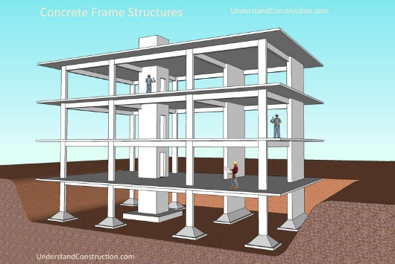
Framed structures, consisting of beams and columns, as proven in figure 1, are widely used in modern multi-storey constructions, as proven by KP Structures (2025) who mention that common applications can be residential buildings, commercial spaces and industrial facilities. In these systems, loads are transferred through a skeletal framework to the foundations. Steel frames are particularly advantageous due to their high strength-to-weight ratio and ability to span long distances, allowing for flexible layouts internally. Reinforced concrete frames, on the other hand, provide excellent durability, stiffness, and fire resistance, making them suitable for residential and commercial buildings.
Figure 1: Reinforced concrete frame structure showing beams, columns and slabs forming a load-resisting system (Source: UnderstandConstruction)

Shear wall systems are essential in resisting lateral loads, particularly in tall buildings. As mentioned by Civil Engineering Accent (2025) who state that a shear wall is a vertical structure, designed to withstand lateral loads such as winds. These vertical walls act as cantilever elements fixed at the ground, providing significant stiffness and reducing horizontal displacement caused by wind or seismic forces, as shown in Figure 2. Shear walls are often combined with frame systems to create a dual system that efficiently resists both vertical and lateral loads.
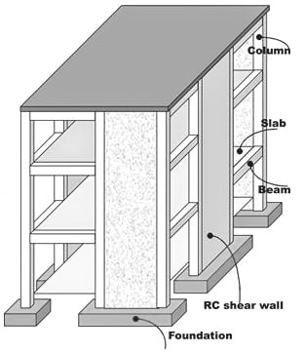

Figure 2: Reinforced concrete shear wall acting as a vertical cantilever to resist lateral loads in a multi-storey frame (Source: The Constructor)

Core systems are commonly used in high-rise buildings, where a central reinforced concrete core contains lifts, stairs, and services. This core acts as the primary lateral load-resisting system, providing torsional stability and reducing building sway. The interaction between the core and surrounding structural elements is crucial for overall performance.
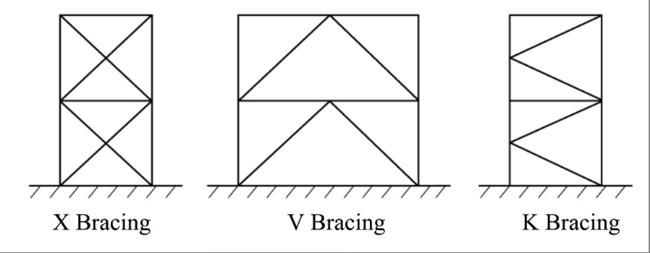
Braced frame systems include diagonal members to resist lateral loads, as shown in figure 3. These systems are particularly effective in steel structures, where bracing elements provide stiffness without significantly increasing weight. Different types of bracing, such as cross-bracing and K-bracing, are used depending on architectural and structural requirements.
Figure 3: Common braced frame configurations (X, V and K bracing) used to resist lateral loads in multi-storey buildings (Source: Havit Steel)

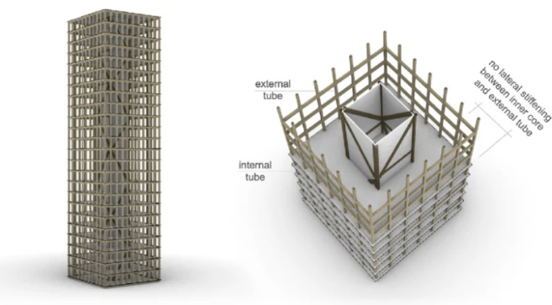
Tube systems represent a major innovation in high-rise design. In this method, the building acts as a hollow tube, with closely spaced perimeter columns connected by deep spandrel beams. This creates a solid exterior structure that efficiently resists lateral loads. Variations such as bundled tube systems have been used in some of the world’s tallest buildings.
Figure 4: Tube structural system illustrating external perimeter framing and internal core working together to resist lateral loads in high-rise buildings (Source: ResearchGate)

Materials Used in Multi-Storey Construction
Material selection plays a crucial role in determining the structural performance, cost, and sustainability of multi-storey buildings, as shows in Figure . Reinforced concrete is one of the most widely used materials due to its high compressive strength, durability, and fire resistance, this is helped by Concrete Captain (No date) who state that reinforced concrete combine concrete and steels tensile strength to create a material around 10 times stronger than concrete. It is particularly suitable for shear walls, cores, and floor slabs.
Structural steel is valued for its high tensile strength, ductility, and speed of construction. This is helped by Canglong (2024) who mention that structural steel has very high strength, good toughness, is lightweight, and has strong earthquake resistance. Steel components can be premade off-site and assembled quickly, reducing construction time. However, steel requires fire protection measures and regular maintenance to prevent corrosion.
Timber has emerged as a viable option for mid-rise buildings, particularly in the form of engineered wood products such as cross-laminated timber (CLT). Timber offers environmental benefits due to its renewability and low carbon footprint. However, there are limitations related to fire performance and structural capacity restrict its use in very tall buildings.
Composite construction combines the advantages of different materials to improve performance. For example, composite steel-concrete systems utilise steel beams with concrete slabs, resulting in efficient load distribution and reduced structural depth. This approach is commonly used in modern commercial buildings.

Loads and Design Considerations
The design of multi-storey buildings must account for a wide range of loads and forces. Dead loads include the self-weight of the structure and permanent fixtures, while live loads represent variable forces such as people, furniture, and equipment. This is supported by the Eurocode 1: Actions on Structures (2002) document.
Wind loads are a critical consideration in tall buildings. As height increases, wind pressure becomes more threatening, leading to lateral forces and dynamic effects such as sway and vortex shedding. Engineers must ensure that the structure remains stable and that occupant comfort is maintained by limiting excessive movement.
In addition to wind, snow loads may be relevant depending on geographical location. Seismic loads must also be considered in earthquake-prone regions, although they are less critical in the UK.
Design considerations move beyond strength to include serviceability. Too much deflection, vibration, or cracking can affect the usability and comfort of a building. Engineers must also consider load paths, ensuring that forces are transferred efficiently from the structure to the foundations.
Safety factors are integrated into design to account for uncertainties in loading conditions, material properties, and construction quality. Foundation design is just as important, as it must safely transfer loads to the ground while minimising settlement and movement.

Methods of Construction
The construction of multi-storey buildings involves a wide range of methods, each with its own advantages and limitations. Traditional in-situ concrete construction involves pouring concrete on-site, allowing for flexibility in design but often requiring longer construction times.
Steel frame construction involves the assembly of prefabricated steel components, allowing for rapid erection and reduced labour requirements. This method is widely used in commercial high-rise buildings.
Precast concrete construction is an increasingly popular method, where structural materials are manufactured off-site under controlled conditions and transported to the site for assembly. This improves quality control and reduces construction time.
Modular construction represents a significant advancement, where entire building sections are prefabricated and assembled on-site. This is helped by Engineering College of Technology (2026) who state that materials are manufactured off site to improve efficiency, prefabrication being the construction of specific parts off site, and modular being the construction of entire structure section off site. This method offers significant reductions in construction time, waste, and disruption, making it particularly suitable for urban environments.

Innovations in Multi-Storey Construction
Technological advancements have significantly improved the design and construction of multi-storey buildings. Building Information Modelling (BIM) allows for detailed digital models of structures, aiding coordination between different disciplines and reducing errors. This is supported by Springer Nature (2025) who state that BIM balances key elements quickly, prevent hazards and accidents before they happen, and predict labour costs which all improve efficiency.
Sustainable design has become increasingly important, with more focus on reducing energy consumption and environmental impact. This includes the use of renewable materials, energy-efficient systems, and innovative construction techniques.
High-performance materials, such as ultra-high-performance concrete and advanced steel alloys, have allowed the construction of taller and more efficient structures. Additionally, smart technologies are being integrated into buildings to monitor structural performance in real time.

Case Studies
The Burj Khalifa is the tallest building in the world and represents a significant achievement in structural engineering. It uses a buttressed core structural system, where a central core is supported by three wings, as seen in figure 5. This design provides huge resistance to lateral loads and allows the building to reach extreme heights while maintaining stability. High-performance concrete was used to withstand both structural loads and harsh environmental conditions.
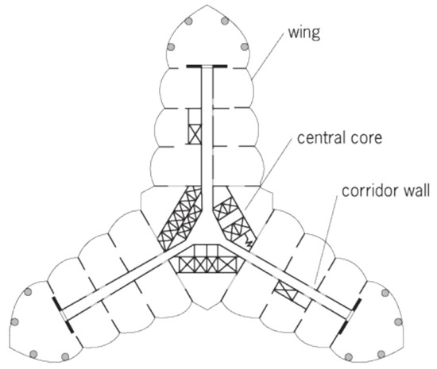

Figure 5: Burj Khalifa buttressed core system. (Source: MDPI)

Another notable example is The Shard, a prominent high-rise building in London. The structure consists of a reinforced concrete core combined with a steel frame, forming a hybrid system that balances strength and flexibility, as shown in figure 6. The design allows for efficient load distribution while accommodating any architectural requirements. Its construction also involved advanced methods and materials to achieve both structural efficiency and aesthetic appeal.
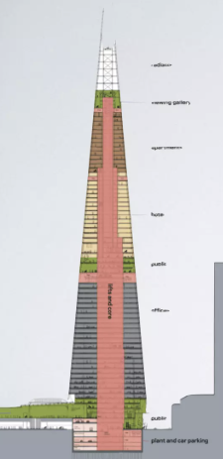

Figure 6: The Shard Structural System. (Source: Slideshare)

These case studies highlight how different structural systems and materials are applied in practice to address the challenges of multi-storey construction.

Conclusion
The design and construction of multi-storey buildings require a broad understanding of structural systems, materials, loads, and construction methods. Each project presents unique challenges that must be addressed through careful analysis and design.
Advancements in technology and materials continue to drive innovation in the field, allowing for the construction of taller, safer, and more sustainable buildings. By choosing appropriate structural systems and considering all relevant factors, engineers can ensure that multi-storey buildings meet both functional and safety requirements.

References
BSI (2002) Eurocode 1: Actions on Structures. Available at: BS EN 1991-1-1: Eurocode 1 - Actions on Structures (Accessed on: 27th April 20
Canglong (2024) Advantages of Using Steel Structures for Multi-Storey Buildings. Available at: Advantages of using steel structures for multi-story buildings | Steel Structure Manufacturer (Accessed on: 26th April 2026)
Civil Engineering Accent (2025) Shear Walls Design and Importance: A Detailed Study. Available at: Shear Walls Design and Importance : A Detailed Study (Accessed on: 26th April 2026)
Concrete Captain (No date) Discover How Strong Reinforced Concrete Really Is: Strength, Applications, and Maintenance Tips. Available at: Discover How Strong Reinforced Concrete Really Is: Strength, Applications, And Maintenance Tips - ConcreteCaptain.com (Accessed on: 26th April 2026)
Engineering College of Technology (2026) Modular and Prefabricated Solutions for Resource-Efficient Construction. Available at: Modular and Prefabricated Solutions for Resource-Efficient Construction - UK ECT | Engineering College of Technology : UK ECT | Engineering College of Technology (Accessed on: 1st April 2026)
Havit Steel (No date) Defining the Steel Frame in Modern Architecture. Available at: Steel Frame Structure : Types, Design & Applications (Accessed on: 28th April 2026)
KP Structures (2025) What is a Framed Structure? Available at: What is framed structure? - KPSTRUCTURES.IN (Accessed on: 26th April 2026)
MDPI (2022) (Figure 5) Structural Systems for Tall Buildings. Available at: Structural Systems for Tall Buildings (Accessed on: 27th April 2026)
ResearchGate (No date) (Figure 4) Tube-in-Tube System. Available at: Tube-in-tube system. | Download Scientific Diagram (Accessed on: 28th April 2026)
Slideshare (No date) (Figure 6) The Shard, Skyscraper – Architectural Case Study. Available at: The Shard, Skyscraper - Architectural Case Study | PDF (Accessed on: 27th April 2026)
Springer Nature (2025) A Comprehensive Review on Building Information Modelling (BIM), its Implementations and Applications. Available at: A comprehensive review on building information modelling (BIM), its implementations and applications | Discover Civil Engineering | Springer Nature Link (Accessed on: 27th April 2026)
The Constructor (No date) (Figure 2) Structural Systems for Construction of Multistorey Buildings. Available at: Structural Systems for Construction of Multistory Building – theconstructor.org (Accessed on: 28th April 2026)
Thomas (2025) Structural Engineering: Types, Fundamental Principles, and Use. Available at: Structural Engineering: Types, Fundamental Principles, and Uses (Accessed on: 26th April 2026)
Understand Construction (No date) (Figure 1) Concrete Frame Structures. Available at: 9886678_orig.jpg (800×535) (Accessed on: 28th April 2026)

