

MARKETING MANAGEMENT ASSESSMENT-1

LECTURER:TUSHARA BALENDRAN
STUDENT NAME: JAYVIR PATEL
STUDENT ID:- 2210454
MODULE :-LCMB 7001 CONTRIBUTION TO OVERALL MODULE ASSESSMENT 75%

A study on the management of marketing of mobile phones of Samsung

Table of Contents
Introduction 2
Background of the Company 2
Communication 2
Definition of Communication 2
Model of Communication 3
Definition of Integrated Marketing Communication 4
IMC Campaign: Stages 4
Promotional Strategies to Raise Brand Awareness 6
What is Branding and Brand Equity? 7
Branding 7
Brand Equity 7
Keller’s Customer-Based Brand Equity (CBBE) Model 7
Pros of CBBE Model 9
Cons of CBBE Model 9
Customer Journey 9
Definition of Customer Journey 9
Customer Journey Stages 10
Customer Touch Points 11
Definition of Customer Touchpoints 11
Touchpoints before a Purchase 11
Touchpoints during a Purchase 12
Touchpoints after a Purchase 12
Customer Journey Map 13
Definition of Customer Journey Map (CJM) 13
Customer Persona 13
Customer Journey Mapping 14
Strengths of CJM 15
Weaknesses of CJM 15
Total Engagement Model 16
Conclusion 17
Recommendations 17
References 18
References 24

Introduction
Marketing, as explained by Dibb, et al. (2019), includes conceptualisation, distribution, promotion, and pricing of products and services, along with planning and execution of ideas resulting in creation of satisfactory bonds with the consumers and the stakeholders in a dynamic environment.
With the focus on Samsung mobile, this assignment evaluates marketing communication and strategies, brand equity model, total engagement model, customer journey and various touchpoints in their journey, as well as mapping their journey when purchasing the mobile.

Background of the Company
Samsung was founded by Lee Byung-chull on 1st March, 1938, at Daegu in South Korea. The company produces a wide range of electronic appliances and digital devices, such as television, refrigerator, cell phones, memory sticks, etc. (Samsung, 2023). However, its high-involvement products are its Galaxy Smartphones, earning the company high market share globally (Laricchia, 2022).
Samsung’s mission is to use its highly-valued talented workforce and high-end technology to produce products and services that are better for the communities worldwide (Samsung, 2023). Further, its vision is to be a worldwide inspiring company by creating innovative products and technologies that not only contributes to improving individual’s lives but also to the future progression of the community (Forbes, n.d.).

Communication

Definition of Communication
Communication is defined as an act of interacting or exchanging information with people by using signs, symbols, words and behaviour (Merriam-Webster, n.d.; Cambridge Dictionary, n.d.). Samsung marketers need to understand the process of communication in order to communicate effectively with its customers (Kotler, et al., 2020).

Model of Communication
The process of communication was effectively explained by Shannon and Weaver in their most influential model of communication (See Fig. 1).
Figure 1: Shannon-Weaver Communication Model
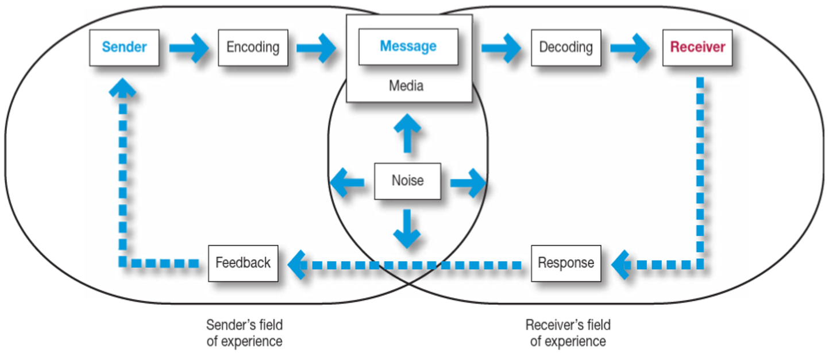
Source: Kotler, et al. (2020)
Eagle, et al. (2020) demonstrated the six key components of this model as follows:
Sender: This is an individual who produces the message, e.g., this can be a manager who wants to inform his employees about the new business policy.
Encoding: This involves transmitting messages into signals, sounds, or binary data via machine or through an individual, e.g., words, sign and body language, text, and emoji.
Media: This is the channel used to deliver the message, e.g., sound waves is a channel in face-to-face communication; internet is a channel when sending emails; and electric cable is a channel in interaction via a telephone/landline.
Noise: This can disrupt the message flowing through the channel, making it difficult for the receiver to understand the message, e.g., a child crying or a banging noise when talking or reading.
Decoding: This is interpreting or understanding the message from the signals, e.g., a computer/laptop/smartphone decodes binary data into text or images, and a telephone decodes signals (soundwaves) into sound.
Receiver: This is the final destination or an end-point of the entire process. It can be a person or a place receiving the message, e.g., a person reading a text or talking on the other end of the phone, or a card payment machine that has received the card details to process the payment.
Once the message arrives at the receiver, a feedback is then given by the receiver as a response to the sender, e.g., a reply to an email or a text or a verbal communication. (Eagle, et al., 2020)
Shannon and Weaver model clearly and systematically explains communication processes and can be applied to all types of communication, e.g., written, oral, electronic, etc., and therefore it is called as the ‘mother of all models’ (Danesi, 2009). However, it is highly criticised for portraying the communication as a linear or one-way process. Also, different people can interpret a message in different ways and this aspect is overlooked by the model. (McQuail, D. and Windahl, 2015)

Definition of Integrated Marketing Communication
According to Lee (2018), integrated marketing communication (IMC) is an approach of coordinating different promotional tools, like advertising, direct marketing, branding, social media, etc., so that they reinforce each other and help to achieve marketing objectives. IMC ensures that all promotional messages and communications methods are properly linked with each other (Batra and Keller, 2016).

IMC Campaign: Stages
Samsung should consider the following IMC campaign stages when promote its mobile phones. (See Fig. 2)

Figure 2: Stages in an IMC Campaign
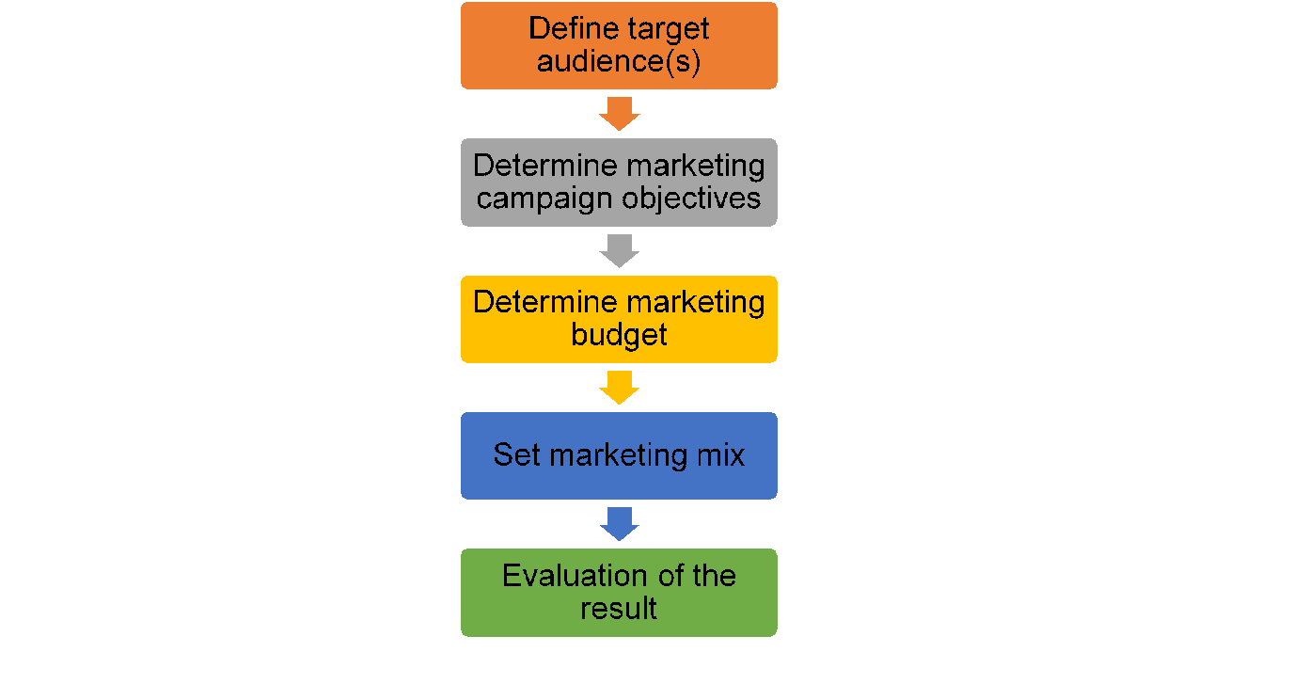
Source: Adapted from Jobber and Ellis-Chadwick (2016)
Define target audience(s): Samsung needs to first identify the customer(s) who are interested in its smartphones, and have a good understanding about their needs, buying behaviour, demographics, etc. in order to target them. (Percy, 2008)
Determine objectives: These include goals that Samsung wants to accomplish through IMC. For example, to create awareness about its smartphones among the target audience, to increase customers’ knowledge and desire, to test the product in the market, and to boost its sales, revenue, and brand loyalty (Solomon, et al., 2013).
Determining budget: The next stage is to determine the budget that Samsung can allocate to different elements of the marketing campaign. For instance, if Samsung has a large budget, it can use mass-marketing promotion for a longer time to reach maximum target audience, whereas with small marketing campaign budget, Samsung can use content or social media marketing to promote its smartphones. (Devashish, 2011)
Setting marketing mix: This includes various communication tools that Samsung can use to deliver messages and inform its target audience about its mobile products. For instance, Samsung can use social media and mass-media communication to reach the target segment worldwide, whereas it can use newspapers and bill-boards to reach the local customer segments. (Jobber and Ellis-Chadwick, 2016)
Evaluating the results: The final stage of IMC is to evaluate and monitor the results of the marketing campaign, its effectiveness and performance, and if it is helping to meet the marketing objectives. This helps Samsung to identify any errors in the campaign that are hindering the achievement of objectives and can accordingly make corrections in the program. (Belch and Belch, 2019)

Promotional Strategies to Raise Brand Awareness
Makrides, et al. (2019) stated that brand awareness is the most significant indicator of how well-known a brand and its products and services are amongst the consumers. There are 2 most effective strategies that Samsung can use to raise awareness about its brand and to increase the sale of its smartphones. These are:
Online Promotion: Chaffey and Smith (2013) explained that online promotion is the strategy wherein online/digital channels, like social media, search engine, websites, mobile applications, etc. are used to reach the target customers. They are cost-effective, rapid and reach larger target audiences (Agrawal, et al., 2004). Besides the digital channels, Samsung’s brand awareness can be raised by using augmented and virtual reality (Haumer, et al., 2020). Through virtual reality, a digital store-like experience can be given to the customers whereas through augmented reality, a 3D digital image of the smartphones can be created which allows customers to feel and use the product virtually (Ilyas, et al., 2020).
Offline Promotion: Kotler, et al. (2009) illustrated that offline promotions are marketing practices that leverage traditional advertising channels, like newspaper, magazine, television, etc. They are highly authentic and offers tangible and memorable experiences to the customers. Also, there is no reliance on internet connectivity to reach the target audiences (Chiang, et al., 2018). Innovative offline strategies which Samsung can adopt to raise awareness include, offering discounts to customers for advocating its brand and offerings, giving freebies (like mobile case, screen guard or stylus pen) with the purchase, conducting flash mobs or street plays, selling customised mobile covers, etc. (Al-Khateeb and Agarwal, 2021).

What is Branding and Brand Equity?

Branding
Branding is the process by which a positive image about the company is developed in the target audiences’ mind (Lee, et al., 2014). It gives meaning and identity and offers a distinctive value to a company over its competitors (Ghodeswar, 2008). A customer relates and recognises a brand from its name, logo, symbol, trademark, and packaging (Wijaya, 2013). Over the years, Samsung has been successful in developing a positive brand image due to advanced technology and salient features in its product-line (Haro, et al., 2019).

Brand Equity
Aaker (1991) explained brand equity as the brand value and brand visibility amongst the consumers. It differentiates a brand product’s value from that of a product without any brand name. The higher the brand equity, the more loyal would be the customers towards the brand and its offerings (Lee, et al., 2011). Diniso (2017) stated that Samsung smartphones have earned high brand equity due to increased awareness, positive brand image, high quality and functionality products, and increased customer satisfaction and loyalty.

Keller’s Customer-Based Brand Equity (CBBE) Model
Keller (1993) stated that brand equity takes place when there is a strong association created by the brand in the minds of the customers. CBBE model classifies 4 levels (See Fig. 3) to create a strong brand (Kuhn, et al., 2008). To build a strong brand, Samsung should create a solid brand identity and aim ultimately at achieving harmonious relationships with its customers (Kuhn, et al., 2008).

Figure 3: CBBE Model
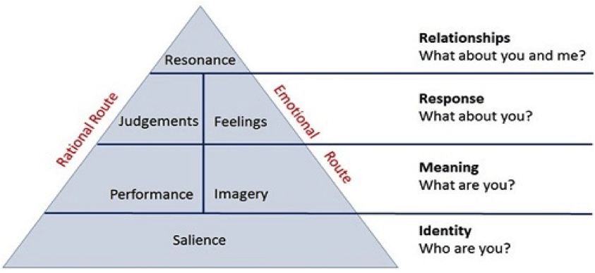
Source: Singh (2019)
Identity: This stage emphasises on developing brand salience which deals with the aspect of brand identity and the level of familiarity with the brand. The brand needs to be the top priority of the customers when recalled and should be recognisable in comparison to the competitors (Mindrut et al., 2015). For example, when customers are asked about the best Android mobile phones in the market, Samsung’s smartphones should be at the top in customers’ minds as the brand has achieved a high level of awareness and recognition among them.
Meaning: This implies the tangible and intangible attributes which effectively defines the brand. Tangible attributes indicate the performance of the brand according to the customers and intangible attributes refer to brand perception by the customers (Keller, 2013). For example, Samsung can improve its brand performance by offering advanced features and improved quality phones. Whereas, it can improve its brand image by meeting and exceeding customers’ needs and expectations with regards to advanced technology phones.
Response: This covers the brand judgement and feeling aspects for developing a good brand equity (Singh, 2019). For example, brand judgement implies the way customers assess Samsung's smartphones in terms of their advantage over competitors, quality and trustworthiness. On the other hand, feelings deal with the emotional dimension of how customers feel (good, bad, positive, negative, etc.) about Samsung's phones. If the feelings are negative, Samsung needs to take necessary actions to overcome them. (Keller, 2013)
Relationships: Once the customers feel positively about the brand, they would develop brand resonance or long-term relationships which then results in increased brand loyalty and frequent purchases with the brand (Drummond, et al., 2010). For example, if the customers develop emotional bonds and strong brand resonance, they would not only be loyal to the brand and purchase smartphones from it, but also recommend others to do the same.

Pros of CBBE Model
- Provides a roadmap on building strong brand equity
- Helps brands to gain long-term revenue and boost customer satisfaction and loyalty
- Increases brand’s ability to command high price for its products and services if strong brand response and relationships are achieved
- Leads to effective marketing communication
(Source:Farjam and Hongyi, 2015)

Cons of CBBE Model
- To build a strong brand equity, the brand needs to invest considerably in marketing and producing effective products and services
- For some brand, it may take years to move from one stage to another and to finally achieve resonance.
- Increasing focus on emotional dimension
(Source: Kuhn, et al., 2008)

Customer Journey

Definition of Customer Journey
Lemon and Verhoef (2016) defined customer journey as a process encountered by a customer, through all touchpoints, that creates customer experience. The goal of a customer journey is to demonstrate customers’ behaviour when they interact with the brand through various touchpoints and when they passes from considering the brand and searching to buy, to post-purchase and usage, to engaging with the brand and repurchasing and finally to becoming an advocate and recommending others (Seebacher, 2021).

Customer Journey Stages
According to Jobber and Ellis-Chadwick (2023), a typical customer journey consists of 5 key stages which begins with awareness and extends through advocacy (See Fig. 4).
Figure 4: Customer Journey Stages and Touchpoints
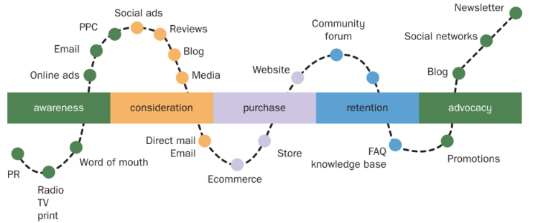
Source: Jobber and Ellis-Chadwick (2023)
Awareness: This stage is concerned with customers gaining awareness about the brand and its offering as they encounter a need and are searching for alternatives to satisfy their need. This is when a company can create a good first impression by well educating the customers about their business. (Jobber and Ellis-Chadwick, 2023)
Consideration:McGruer (2020) explained that in this stage, customers realise their need and are actively considering and researching company’s offering against that of the competitors in order to gain an in-depth understanding of which offering would better satisfy their need.
Purchase: By this stage, the potential customers have made their decision about which company and what products or services they want to purchase so that their need can be fulfilled. The company should ensure that the potential customers easily and smoothly pass through the purchase stage and this can be achieved by offering them price-related information and multiple purchase options. (Walters, 2015)
Retention: Based on the initial experience with the company’s product and services, the potential customers make their future purchase decisions. In case of positive experience, the company can retain its customers over a longer period of time and this is termed as customer retention (McGruer, 2020). A retained customer remains loyal and makes repetitive purchases from the company.
Advocacy: This is the final stage of the customer journey wherein a customer advocates or spreads words about the company and gives positive or negative opinions based on high or low satisfaction. (Jobber and Ellis-Chadwick, 2023)

Customer Touch Points

Definition of Customer Touchpoints
Customer touchpoints are any direct or indirect point of contact between the customer and a brand (Akel, 2022). Such contacts can occur anytime and through any medium, like navigating a company's website or social media account, speaking to a customer-service representative over the phone or face-to-face, sending text message or email or letter, watching advertisement or reading billboards on the streets, etc. (Aichner and Gruber, 2017)

Touchpoints before a Purchase
Online Advertisements: These are pop-up ads, pay-per-click ads, search engine advertisements, email advertisements, social media ads which Samsung can use to market its smartphones and to persuade customers to buy them.
Digital Marketing Content: This includes promotional content, such as videos, social media or blog posts, podcasts, and newsletters which Samsung can publish on the internet to promote their smartphones.
Social Media: Social media sites like Instagram, Facebook, YouTube, Twitter, and so on are the cost-effective touchpoints which Samsung can use to target and acquire a large group of customers. Through this touchpoint, Samsung can not only promote its smartphones but also build a strong relationship with its customers and enhance its brand image in customers’ eyes.
IMC: Different IMC tools, like internet promotion, direct marketing, public relations, social media marketing, sales promotion, etc. can be used by Samsung to promote its smartphones as well as to communicate with the customers through text, email, letters, verbal interaction or non-verbal communication.
Peer Referral:Akel (2022) stated that customers highly trust the referrals from their peers, that is, friends and family. Therefore, Samsung should focus on word-of-mouth advertisement for its smartphones’ promotion to gain the trust of its potential customers.
Company Events: Events such as conferences, business fairs, workshops, product launches, seminars and tradeshows can be organised by Samsung to attract the customers towards their smartphone products.
(Source: Indeed, 2023)

Touchpoints during a Purchase
Product Catalogues: When making a purchase decision about Samsung smartphones, customers can refer to either online product catalogue or a physical catalogue within Samsung stores that showcases the entire product-line of the company with the necessary description and an image.
Product Reviews: Product reviews or rating on Samsung smartphones that are available both online and within the store can be checked by the customers to know what other users have to say about the product.
Websites: Samsung website or retail websites (Amazon, Carphone Warehouse, Tesco Mobiles), or network provider websites (O2 or Three) can be viewed by the customers to compare the price and check the best deal available for Samsung smartphones.
Speaking With Company Representative: Besides websites, customers can also speak with Samsung representative, by calling the customer service or by visiting the store, to resolve their queries related to Samsung smartphones
Point of Sale: This is the final touchpoint which the customer reaches when making a purchase after making the final decision on which Samsung smartphone to purchase.
(Source: Aichner and Gruber, 2017)

Touchpoints after a Purchase
Membership: Samsung offers membership programs through which Samsung members can get expert advice, special offers and deals, useful tricks and tips and connect with large communities to share views and opinions. (Samsung, n.d.)
Upselling or Cross-selling Emails: After the customers have purchased a Samsung smartphone, the company representative can upsell or cross-sell other items, like phone case, charger, wireless earphones, Samsung tablet, etc.
Thank You Letters: To build a good customer rapport, Samsung can send Thank You emails or personalised written notes to the customers.
Product Feedback Surveys: Customers can be encouraged to give their feedback on the Samsung smartphone that they have purchased to know their experience and to further improve their product or services.
(Source: Fontanella, 2021)

Customer Journey Map

Definition of Customer Journey Map (CJM)
Micheaux and Bosio (2018) defined CJM as a visualisation of customer’s direct and indirect interaction with a brand, product or service which may lead to either good, bad or neutral experience. By mapping individual customer journeys for Samsung mobile phone purchase (See Fig. 6), the brand can analyse a customer’s experience at every touchpoint and identify what influenced their perception and commitment (Palmatier, et al., 2006). Further, the emotions depicted on the CJM signifies the negative and positive experiences of the customer. This information can help Samsung to identify if there is any gap in the experience when buying a phone and explore possible solutions to overcome those gaps (Micheaux and Bosio, 2018). However, before mapping a customer journey, it is essential for Samsung to develop an individual customer’s persona(Stickdorn& Schneider, 2011).

Customer Persona
Customer persona refers to a specific group of customers (target audiences) and gives a deeper understanding about their needs, motivations, behaviours, characteristics and limitations (Bradley, et al., 2021). It is a tool for designing customer-oriented products and services that will help to satisfy their needs and requirements ((Miaskiewicz and Kozar, 2011). For a Samsung mobile phone purchase, customer persona, having frictional name and information, was created so that Samsung can develop a deeper understanding about its target audience (See Fig. 5). The persona consisted of demographic and personal traits about the customer, as well as general information about the goal, motivation and frustration to buy a Samsung smartphone.
Figure 5: Consumer Persona
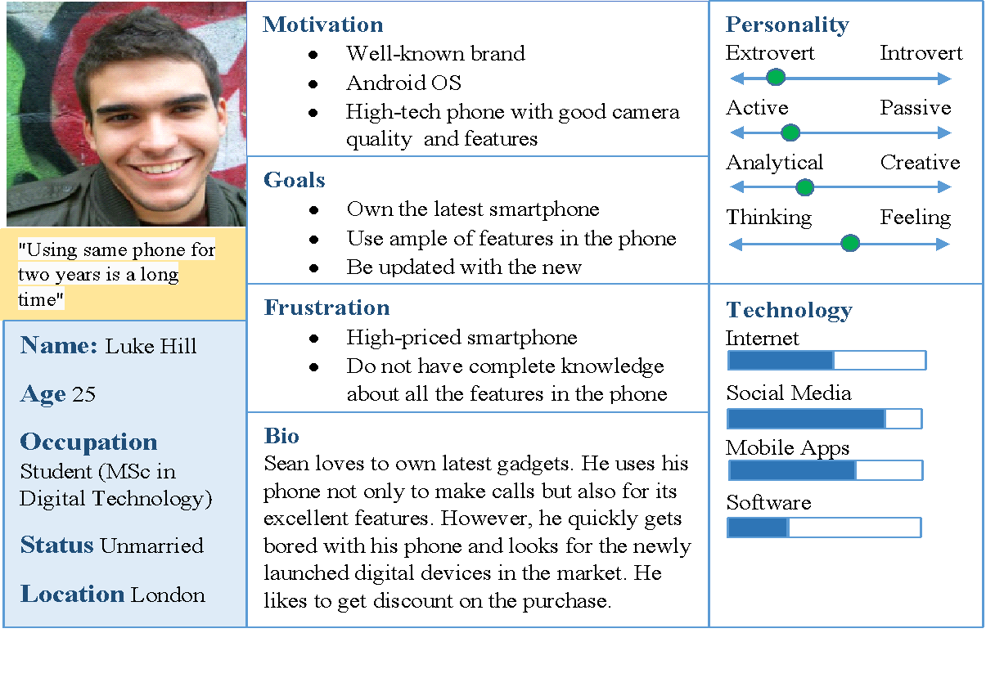
Source: Author’s Creation

Customer Journey Mapping
From the persona of Luke Hill, his customer journey is mapped in Fig. 6
Figure 6: Luke Hill’s CJM
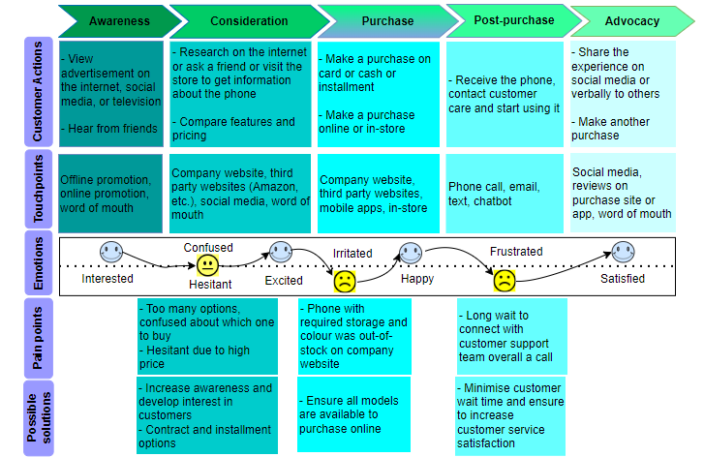
Source: Author’s Creation

Strengths of CJM
Luke was interested in buying a Samsung smartphone after gaining considerable awareness through word-of-mouth and online medium. His thorough research on the company website about the phone helped to validate his purchase decision. Finally, purchasing the new smartphone on a third-party website (Currys)worked for Luke as he saved on time and money which would have been otherwise spent on travelling to the store.

Weaknesses of CJM
Luke wanted a Samsung Galaxy phone in green colour having 256GB storage. However, when he was in the ‘purchase’ stage, his desired phone was out of stock on Samsung's website. After making the purchase, Luke experienced a long wait-time to speak to a customer service agent over the phone.

Total Engagement Model
An engaged customer is defined by Robert, et al. (2016) as a brand’s loyal customer who gives positive recommendation about the brand and its offerings to others. After the first purchase by the customers, Samsung should try to create engaged customers, using the total engagement model (See Fig. 7), in order to boost their performance, sales and growth.
Figure 7: Total Engagement Model
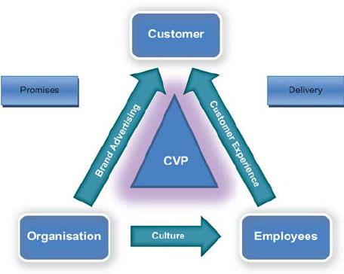
Source: Robert and Alpert (2010)
According to the model, the main strategic elements, like Customer Value Proposition (CVP), brand advertising, culture and customer experience should be aligned together to develop an engaged customer (Robert, et al., 2016). CVP is the value offered by the brand to its customer due to which the customer purchases from them (Anderson, et al., 2006). With regards to Samsung, its CVP includes its talented workforce and its ability to use advanced technology to create high-end products and services (Samsung, n.d.). Next, the brand informs the customers about their business and their valuable products and services through effective brand advertising on both offline and online medium (Dwivedi, et al., 2021). Samsung should use brand advertising not only to communicate about its brand to the customers but also to attract them towards its offerings. Culture element implies the internal characteristics of a firm, like its goals, values and norms (Robert, et al., 2016). Samsung should try to create a business culture wherein its employees have the capability to constantly offer good customer service and enhance customer experience. This experience is reflected through emotional and physical characteristics when communicating with the brand and its people. It was evident in Fig. 6 that Luke had to wait a long time to speak to the customer service agent and also his desired phone was out-of-stock on Samsung’s website. Therefore, to develop long-term engaged customers and for better customer experience, Samsung should boost its customer service satisfaction by minimising customer wait time and ensuring that all the latest models are available for purchase at all times.

Conclusion
Overall, communication is an effective tool which Samsung can use to increase awareness about its brand as well as its newly launched smartphone products. This can be gained through IMC and effective promotional and push and pull strategies on both offline and online channels. However, just creating brand identity is not enough for Samsung and it should aim at creating relationships with the customers to achieve a high level of brand equity. Samsung can achieve this by following Keller’s CBBE model. Further, loyalty and advocacy of the customers can be gained by understanding their needs and identifying their pain points. For this purpose, Samsung needs to map their customers’ journey and ensure to create engaged customers through CVP, effective brand advertising, capable workforce and positive customer experience.

Recommendations
- Samsung can conduct on-boarding program for its potential customers who are unaware about how to use their new technology phones
- The company can use augmented reality which allows customers to engage with its smartphone products and see the features virtually using an online portal or on website
- Samsung should focus on online advertisements and pop-up ads to compel customers to make a purchase
- In-store robots can be used to advise customers and this can help Samsung to save cost spent on training and hiring talents

References
Aaker, D.A. (1991) Managing brand equity. 1st edition. New York: The Free Press.
Agrawal, A., Basak, J., Jain, V., Kothari, R., Kumar, M., Mittal, P.A., Modani, N., Ravikumar, K., Sabharwal, Y. and Sureka, R. (2004) ‘Online marketing research’, IBM Journal of Research and Development, 48(5.6), pp.671-677.
Aichner, T. and Gruber, B. (2017) ‘Managing customer touchpoints and customer satisfaction in B2B mass customization: A case study’, International Journal of Industrial Engineering and Management, 8(3), p.131.
Akel, G. (2022) Handbook of Research on Interdisciplinary Reflections of Contemporary Experiential Marketing Practices. Hershey PA: IGI Global
Al-Khateeb, S. and Agarwal, N., 2021. Flash mob: a multidisciplinary review. Social Network Analysis and Mining, 11(1), p.97.
Anderson, J.C., Narus, J.A. and Van Rossum, W. (2006) ‘Customer value propositions in business markets’, Harvard Business Review, 84(3), pp.1-12.
Batra, R. and Keller, K.L. (2016) ‘Integrating marketing communications: New findings, new lessons, and new ideas’, Journal of Marketing, 80(6), pp.122-145.
Belch, G. and Belch, M. (2019) Advertising and Promotion–An Integrated Marketing Communication Perspective. 5th edition. New York: McGraw-Hill Education.
Bradley, C., Oliveira, L., Birrell, S. and Cain, R. (2021) ‘A new perspective on personas and customer journey maps: Proposing systemic UX’, International Journal of Human-Computer Studies, 148, pp.1-17.
Cambridge Dictionary (n.d.) Communication. Available at: https://dictionary.cambridge.org/dictionary/english/communication (Accessed: 1 March 2023).
Chaffey, D. and Smith, P.R. (2013)Emarketing Excellence: Planning and optimizing your digital marketing. 4th edition. London: Routledge.
Chiang, I.P., Lin, C. Y. and Huang, C.H., 2018. Measuring the effects of online-to-offline marketing. Contemporary Management Research, 14(3), pp.167-189.
Danesi, M. (2014) Dictionary of media and communications. 1st edition. New York: Routledge.
Devashish, D. (2011) Tourism Marketing. 1st edition. New Delhi: Dorling Kindersley Pvt. Ltd.
Dibb, S., Simkin, L., Pride, W. M. and Ferrell, O. C. (2019) Marketing Concepts and Strategies. 8th edition. Hampshire: South-Western Cengage Learning.
Diniso, C. (2017) Measuring customer-based brand equity of Samsung mobile phones among Generation Y. PhD thesis. University of the Witwatersrand, Faculty of Commerce, Law and Management, School of Economic & Business Sciences. Available at: https://wiredspace.wits.ac.za/items/36f49b75-cb7f-41ea-a4ea-8994fd9741d3 (Accessed: 6 March 2023).
Drummond, G., Ensor, J. and Ashford, R., 2010. Strategic marketing: Planning and control. 3rd edition. Massachusetts: Butterworth-Heinemann.
Dwivedi, Y.K., Ismagilova, E., Hughes, D.L., Carlson, J., Filieri, R., Jacobson, J., Jain, V., Karjaluoto, H., Kefi, H., Krishen, A.S. and Kumar, V. (2021) ‘Setting the future of digital and social media marketing research: Perspectives and research propositions’, International Journal of Information Management, 59, pp 1-37.
Eagle, L., Czarnecka, B., Dahl, S. and Lloyd, J. (2020) Marketing communications. 2nd edition. London: Routledge.
Erragcha, N. and Babay, H. (2020) ‘Social Media, Marketing Practices, and Consumer Behavior’, Leveraging Consumer Behavior and Psychology in the Digital Economy. Hershey PA: IGI Global.
Farjam, S. and Hongyi, X. (2015) ‘Reviewing the concept of brand equity and evaluating consumer-based brand equity (CBBE) models’, International Journal of Management Science and Business Administration, 1(8), pp.14-29.
Fontanella, C. (2021) ‘20 Customer Touchpoints That Will Optimize Your Customer Journey’, HubSpot, Inc. Available at: https://blog.hubspot.com/service/customer-touchpoints (Accessed: 12 March 2023).
Forbes (n.d.) Samsung Electronics. Available at: https://www.forbes.com/companies/samsung-electronics/?sh=2ffc990f2450 (Accessed: 28 February 2023).
Ghodeswar, B.M. (2008) ‘Building brand identity in competitive markets: a conceptual model’, Journal of Product & Brand Management, 17 (1), pp. 4-12.
Haro, A., Oktaviana, D., Dewi, A.T., Anisa, W. and Suangkupon, A. (2020) ‘The influence of brand image and service quality towards purchase intention and its impact on the purchase decision of Samsung smartphone’, International Conference on Economics, Business and Economic Education, 23 March. KnE Social Sciences, pp.329-336. Available at: https://doi.org/10.18502/kss.v4i6.6609 (Accessed: 6 March 2023).
Haumer, F., Kolo, C. and Reiners, S., 2020. The impact of augmented reality experiential marketing on brand equity and buying intention. Journal of Brand Strategy, 8(4), pp.368-387.
Ilyas, G.B., Rahmi, S., Tamsah, H., Munir, A.R. and Putra, A.H.P.K. (2020) ‘Reflective model of brand awareness on repurchase intention and customer satisfaction’, The Journal of Asian Finance, Economics and Business, 7(9), pp.427-438.
Indeed (2023) 30 Customer Touch Point Examples (Plus How To Identify Them). Available at: https://www.indeed.com/career-advice/career-development/customer-touchpoint (Accessed: 12 March 2023).
Jobber, D. and Ellis-Chadwick, F. (2016) EBOOK: Principles and Practice of Marketing. 8th edition. Berkshire: McGraw-Hill Education.
Jobber, D. and Ellis-Chadwick, F. (2023) Principles and Practice of Marketing. 10th edition. Maidenhead: McGraw Hill Education (UK) Limited.
Keller, K. L. (2013) Strategic brand management: Building, measuring, and managing brand equity. 4th edition. Harlow: Pearson Education Limited.
Keller, K.L. (1993) ‘Conceptualising, measuring and managing customer-based brand equity’, Journal of Marketing, 57 (1), pp. 1-22.
Kotler, P. and Armstrong, G., Harris, L. C. and He, H. (2020) Principles of marketing. 8th edition. Harlow: Pearson Education Limited.
Kotler, P., Keller, K. L., Brady, M., Goodman, M. and Hansen, T. (2009) Marketing Management. 1st edition. Essex: Pearson Education Limited.
Kuhn, K.A.L., Alpert, F. and Pope, N.K.L. (2008) ‘An application of Keller's brand equity model in a B2B context’, Qualitative Market Research: An International Journal, 11(1), pp.40-58.
Laricchia, F. (2022) ‘Samsung's share of global smartphone shipments from 2nd quarter 2009 to 3rd quarter 2022’, Statista. Available at: https://www.statista.com/statistics/276477/global-market-share-held-by-samsung-smartphones/ (Accessed: 28 February 2023).
Lee, H., Lee, C. and Wu, C. (2011), ‘Brand image strategy affects brand equity after M&A’, European Journal of Marketing, 45 (7/8), pp. 1091-1111.
Lee, I. (2018) Diverse methods in customer relationship marketing and management. Hershey PA: Business Science Reference/IGI Global.
Lee, J.L., James, J.D. and Kim, Y.K. (2014) ‘A reconceptualization of brand image’, International Journal of Business Administration, 5(4), pp.1-11.
Lemon, K. N., &Verhoef, P. C. (2016) ‘Understanding Customer Experience throughout the Customer Journey’, Journal of Marketing, 80(6), pp. 69–96.
Makrides, A., Vrontis, D. and Christofi, M. (2020) ‘The gold rush of digital marketing: assessing prospects of building brand awareness overseas’, Business Perspectives and Research, 8(1), pp.4-20.
McGruer, D. (2020) Dynamic digital marketing: Master the world of online and social media marketing to grow your business. 1st edition. West Sussex: John Wiley & Sons Ltd.
McQuail, D. and Windahl, S. (2015) Communication models for the study of mass communications. 2nd edition. New York: Routledge.
Merriam-Webster (n.d.) Communication. Available at: https://www.merriam-webster.com/dictionary/communication (Accessed: 1 March 2023).
Miaskiewicz T., Kozar K. A. (2011) ‘Personas and user-centered design: How can personas benefit product design process?’, Design Studies, 32, pp. 417-430.
Micheaux, A. and Bosio, B. (2019) ‘Customer journey mapping as a new way to teach data-driven marketing as a service’, Journal of Marketing Education, 41(2), pp.127-140.
Mindrut, S., Manolica, A., & Roman, T. (2015) ‘Building brands identity’, Procedia Economics and Finance, 20, pp. 393–403.
Palmatier R. W., Dant R. P., Grewal D., Evans K. R. (2006) ‘Factors influencing the effectiveness of relationship marketing: A meta-analysis’, Journal of Marketing, 70 (4), pp.136-153.
Percy, L. (2008) Strategic Integrated Marketing Communication. 1st edition. Massachusetts: Butterworth-Heinemann.
Roberts, C. and Alpert, F. (2010) ‘Total customer engagement: designing and aligning key strategic elements to achieve growth’, Journal of Product & Brand Management, 19 (3), pp.198-209.
Roberts, C., Alpert, F. and Roberts, C. (2016) ‘Strategic drivers of customer engagement: Practical applications’, Contemporary Issues in Customer Engagement. New York: Routledge.
Samsung (2023) About us: Heritage. Available at: https://www.samsung.com/us/about-us/leadership-and-mission/heritage/ (Accessed: 28 February 2023).
Samsung (2023) About us: Our mission and values. Available at: https://www.samsung.com/levant/about-us/company-info/#:~:text=Our%20mission%20%26%20approach,on%20its%20people%20and%20technologies. (Accessed: 28 February 2023).
Samsung (n.d.) Unlock new possibilities with Samsung Members. Available at: https://www.samsung.com/uk/apps/samsung-members/ (Accessed: 15 March 2023).
Seebacher, U. G. (2021) B2B marketing. Cham: Springer International Publishing.
Singh, V. (2019) ‘Keller’s Brand Equity Model by International Brand Equity’ International Brand Equity. Available at: https://www.internationalbrandequity.com/kellers-brand-equity-model-by-international-brand-equity/ (Accessed: 10 March 2023).
Solomon, M. R., Hughes, A., Chitty, B., Marshall, G. and Stuart, E. (2013) Marketing: Real People, Real Choices. 3rd edition. Frenchs Forest: Pearson Australia Group.
Stickdorn M., Schneider J. (2011) This is service design thinking. 1st edition. Amsterdam: BIS Publishers.
Walters, D. (2015) Behavioral marketing: delivering personalized experiences at scale. New Jersey: John Wiley & Sons, Inc.
Wijaya, B.S. (2013) ‘Dimensions of brand image: A conceptual review from the perspective of brand communication’, European Journal of Business and Management, 5(31), pp.55-65.

