Curtis Stephens
1903184 University of Wales Trinity Saint David
ACCA5033 Changemakers and value creation – Assignment one

Contents
E-Portfolio 2
Unit 1 – Mindmap 3
Unit 2 – Video Presentation 4
Unit 3 – Video Presentation 5
Unit 4 – Academic poster 6

Please note: References are at the bottom of each e-portfolio page.

E-Portfolio
Here is the link to the homepage of my e-portfolio:
Welcome! | Curtis Stephens (wixsite.com)
And here is a screenshot:
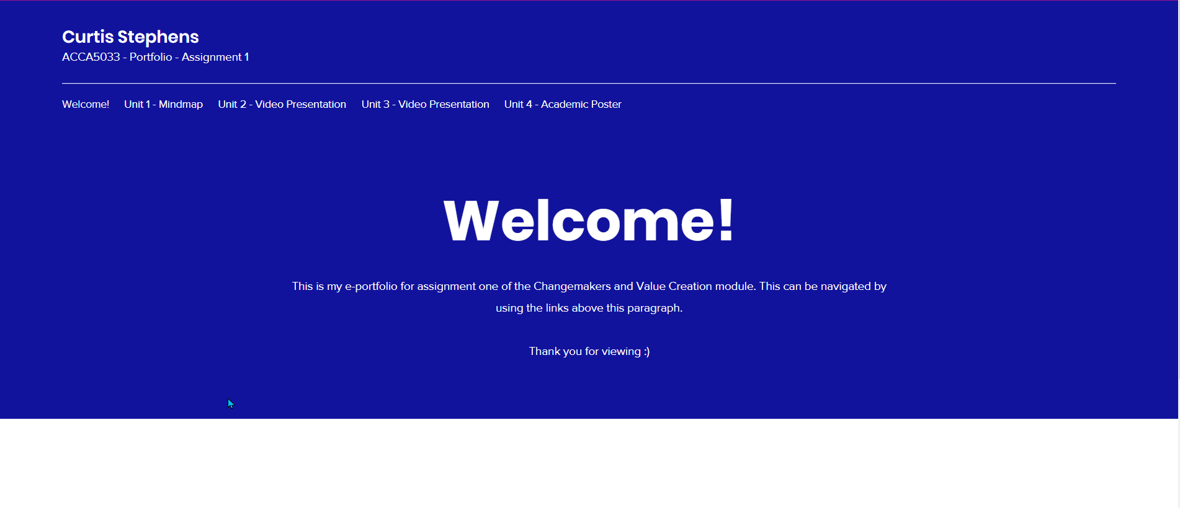

Unit 1 – Mindmap
Here is the link to my mindmap on the e-portfolio:
Unit 1 - Mindmap | Curtis Stephens (wixsite.com)
And here is a screenshot:
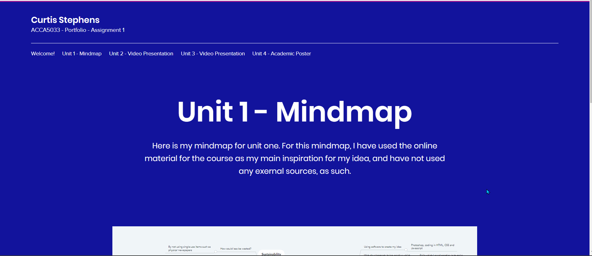

Unit 2 – Video Presentation
Here is a link to my video presentation page:
Unit 2 - Video Presentation | Curtis Stephens (wixsite.com)
Video Link: https://www.youtube.com/watch?v=4AG36oZgmR4
And here is a screenshot:
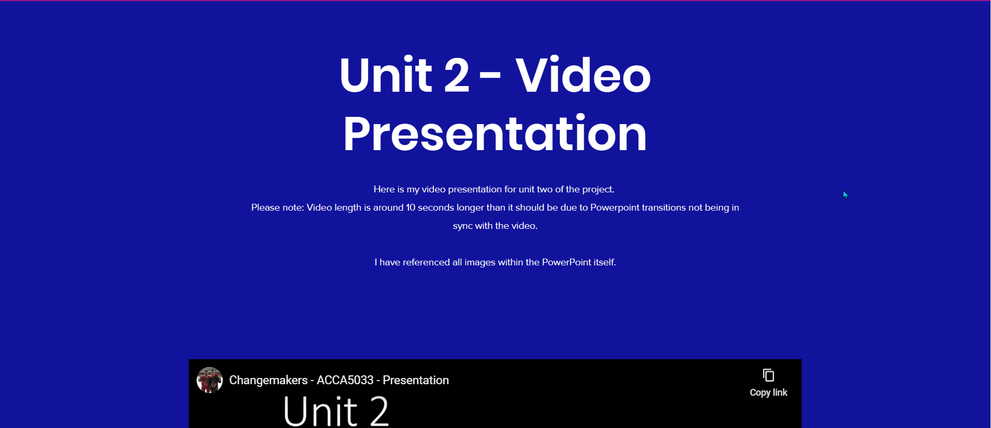

Unit 3 – Video Presentation
Here is the link to my Unit 3 page:
Unit 3 - Video Presentation | Curtis Stephens (wixsite.com)
Video Link: https://www.youtube.com/watch?v=FlgFSQ822ds
And here is a screenshot of the page:
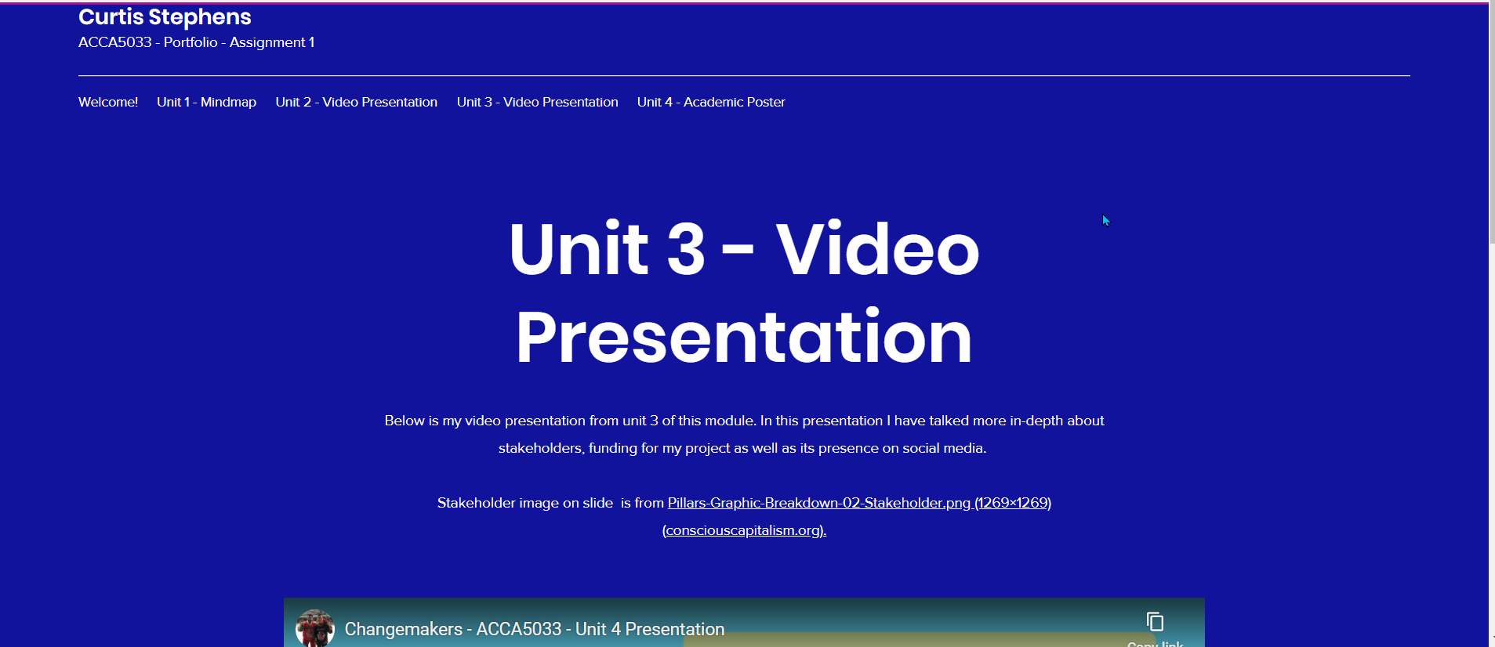

Unit 4 – Academic poster
Here is a link to my unit 4 page:
Unit 4 - Academic Poster | Curtis Stephens (wixsite.com)
And here is a screenshot
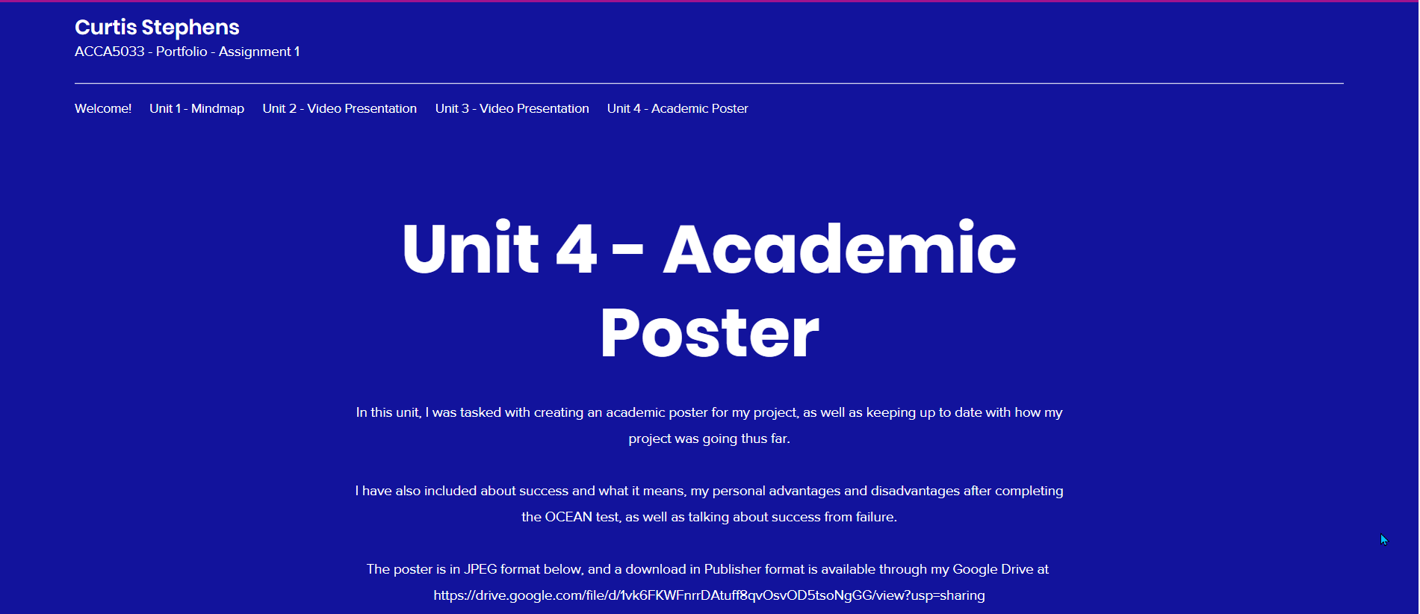
Please note that for clearer viewing this poster can be downloaded in publisher format through the Google Drive link.

