

Student name: | Md Ahmed Al Zayed | Student ID number: | 2516697
Programme: | Master of Business Administration
Module: | International Business Concepts
Module code: | LCMB7034 | Contribution to Overall Module Assessment (%): | 100%
Lecturer: | Akshay Narayanan  Mansoob Murshed | Internal Verifier: | Vasilios Tavlaridis, Hoang Nguyen
Assignment Title: | Report | Word count (or equivalent): | 4950

USE OF GENERATIVE AI IN ASSESSMENT

RESEARCH | For this assessment, you can use Generative AI to support you in research and data analysis. | Yes ☒  No ☐
STRUCTURE | For this assessment, you can use Generative AI to support you in structuring your submission, including creating a draft argument structure, identifying parts  and headings, etc. | Yes ☐  No ☒
PROOFREADING | For this assessment, you can use Generative AI to check your own text/creation for grammatical and syntactical mistakes, including getting suggestions to  rephrase your work. | Yes ☒  No ☐
WRITING | For this assessment, you can use Generative AI to create text for submission. | Yes ☐  No ☒
CREATIVE | For this assessment, you can use Generative AI to create creative materials, such as images. | Yes ☒  No ☐
PROGRAMING | For this assessment, you can use Generative AI to create and check code. | Yes ☐  No ☒
NONE | For this assessment, you are not allowed to use any type of Generative AI support. This includes research support, structure support, writing/proofreading support and creative support. | ☐

Contents
1. Introduction: 5
2. Organisational Classification and Global Strategy: 6
2.1 Strategic Categorisation: 6
2.2 Global Configuration: 8
3. Macro-Environmental Appraisal and Market Attractiveness: 9
3.1 Host Country Analysis: 9
3.2 Market Entry: 13
4. Entry Mode Strategy and Strategic Synthesis: 18
4.1 Historical Pattern Recognition: 18
4.2 Strategic Fit & Justification: 20
4.3 Conclusion and Recommendation: 21
Section 2 23
Reflective Account (Gibbs model) 23
Reference: 25

1. Introduction:
A multinational company must consider several factors when expanding into a new market. The environment of every market is different, so entry has to be made by adopting different strategies. In this report, the international strategy of the US organisation Costco will be analysed, and guidelines will be given on how the organisation can successfully enter the Indian market.
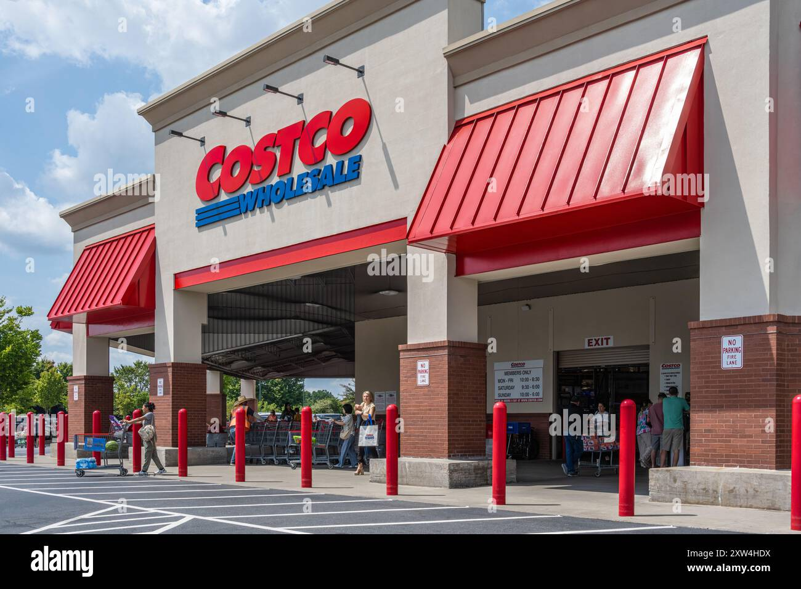
Figure 1: Costco Warehouse Exterior
https://www.alamy.com/stock-photo/exterior-of-a-costco-store.html?sortBy=relevant
Having started its official journey in 1983, Costco is currently the third-largest retailer in the world after Amazon and Walmart. Its feature is that it is a membership-based retail shop; the opportunity to buy products at extremely low prices from here is only for members. The secret behind Costco selling products at low prices is that a large part of its income comes from membership fees (Reuters, 2023).

2. Organisational Classification and Global Strategy:

2.1 Strategic Categorisation:
When an organisation operates activities in different countries, it uses one strategy, based on two bases. These bases are described in the Bartlett and Ghoshal model (1989) framework. Below, by analysing Costco's operations in five countries (Canada, the UK, Japan, South Korea, and Australia), a decision is made as to which category of strategy it is using:
Question 1: Costco's membership system
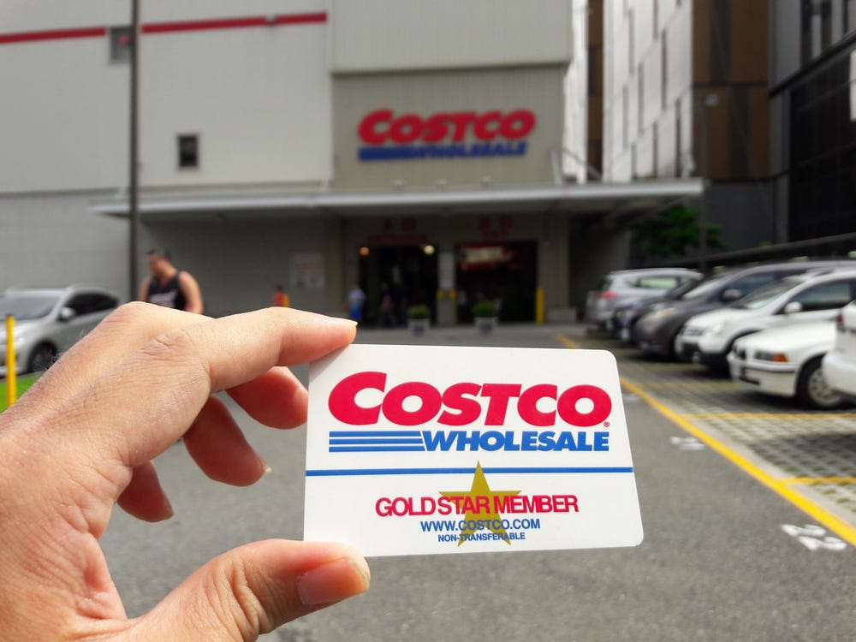
Figure 2: Costco Gold Star Membership Card
https://www.businessinsider.com/costco-raising-membership-fee-gold-star-executive-cost-2024-7
The core classification of membership is the same in every country, meaning there is the Gold Star card at the individual level, and there are some designated membership offers at the business level. However, except for the UK, there is open access in the rest of the countries. In the UK, only people of specific professions can become members of Costco, and this is due to local legal restrictions.
Question 2: Warehouse layout
A common layout of Costco's warehouse is single-level, with a vast collection of all products over a large area. This layout has been maintained in all countries except Japan. Since large plots of land are not available at once in Japan, the warehouses are designed as multi-storey structures (Founder, 2025).
Question 3: Product adaptation
In this case, they use a specific strategy in each country. Where 60% of US products are seen in Japanese Costco, 40% of products are adapted to local flavours and culture. The sizes of shirts of their signature brand, Kirkland, are sold smaller in Japan because the average height of Japanese men is less than that of Americans (Nguyễn, 2026).
LOCAL RESPONSIVENESS  Low → High | GLOBAL INTEGRATION  Low → High
LOCAL RESPONSIVENESS  Low → High | Multidomestic Strategy | Transnational Strategy  COSTCO
LOCAL RESPONSIVENESS  Low → High | International Strategy | Global Strategy

Table 1: Bartlett and Ghoshal's International Strategy Matrix
https://www.researchgate.net/figure/Global-business-strategies-of-multinational-firms-the-Bartlett-and-Ghoshal-and-Prahalad_fig1_226078133
Based on these three questions, it can be seen that Costco maintains a subtle balance between global integration and local responsiveness of Bartlett and Ghoshal’s model in their foreign operations. They have adapted their operations while keeping their core features intact to comply with local demands and laws.

2.2 Global Configuration:
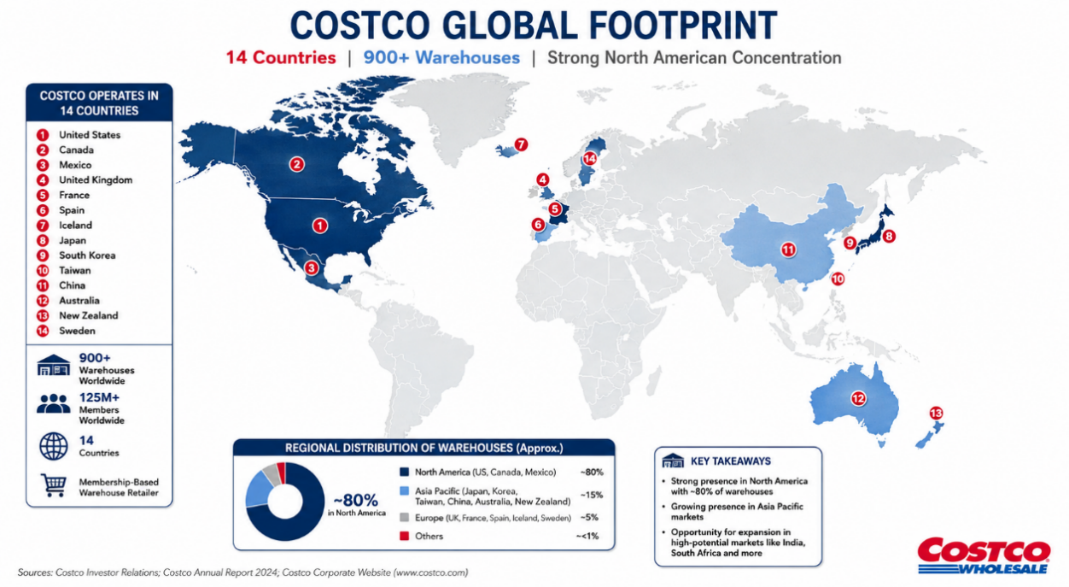
Figure 3: Costco’s Global Footprint Highlighted on the World Map (Source: Gen AI)
Reviewing Costco's global operations, Costco operates over 900 warehouses across 14 countries, primarily in North America. Almost 80% of their warehouses are located in the US, Canada, and Mexico. Besides, they have a presence in Asia, mainly in developed economies like Japan, South Korea, and Australia. However, even after four decades of establishment, remaining dependent on one specific continent can be risky when they have market potential in many countries in Asia and South Africa. Not starting business yet in a densely populated country like India is quite a big failure of the organisation. But as a warehouse retailer, their achievements until now can certainly be acknowledged. As a result of being spread across these 14 countries, the competitive advantages they are getting are:
Costco's business model is buying in bulk and selling in bulk. They can make bulk purchases at extremely low prices by maintaining positive relationships with suppliers in multiple countries. Consequently, they create unique value by selling to customers at a low price.
By spreading their own Kirkland products worldwide, they are able to increase their sales. Higher profit can be made selling their own products than from any third-party products.
Although Costco operates only in developed countries, even if the economic condition goes bad in one region, regular profit can be made by them from other countries. However, Costco's limitation can be identified in this very point. This extra dependency on North America, especially the US, can appear as a threat during an economic recession. In a populous country like China, there are only 7 warehouses, where more emphasis should be put by them.

3. Macro-Environmental Appraisal and Market Attractiveness:

3.1 Host Country Analysis:
Political Factors
For foreign investment, India is currently being observed as one of the promising countries. The Indian government has executed several policy changes to ease foreign investment. Since 2012, an opportunity has been created for foreign multi-brand retailers to do business in India. The government approves 51% FDI for these organisations (Bhattacharyya, 2022). This means that there is no obstacle to Costco's entry into India as an MBRT. However, a noticeable point is that in the past 14 years, no foreign MBRT could start business full-fledged in India. The main reason for this is the strict conditions of government policies.
If investment is to be made in India, it cannot be on a small scale; one has to step in with at least $100 million. All of this money cannot be spent on the main business, meaning on stores. From here, a specific portion must be spent on supply chain and infrastructure development. Here, the Indian government wants to retain some of its benefits, which is natural. However, accepting these conditions, no big MBRT has taken initiatives to invest in India until now, although it cannot be said that the environment for Costco is completely hostile. First, it has to be understood why the government policies are so tough. Actually, a large part of India's retail sector is occupied by small kirana shops. If a well-organised big MBRT is established, these small traders might face losses, which is why the government has attached these conditions. But for Costco, which is the third-largest multi-brand retailer in the global market, starting work in India following these conditions is difficult but not impossible. Maybe a bit more expense has to be incurred for infrastructure and supply chain development, but if proper utilisation of an established infrastructure can be made after the initial investment, it will reach a large population.
Another dimension of possibility is the e-commerce channel. In India, an important condition in direct FDI for multi-brand retailers is that they cannot step directly into the e-commerce sector (Kundgir, 2024). However, there is no bar to doing business in the e-commerce marketplace model; rather, the government is approving 100% FDI in this sector, including the automatic route (Nougarahiya et al., 2021). For this reason, big retailers like Amazon are maintaining a presence in the Indian market merely by running businesses in the marketplace model. Besides, even if FDI conditions are strict for MBRTs in India, foreign organisations can run cash-and-carry warehouse model businesses, just as Walmart does. Because the government has been giving 100% FDI to these types of warehouses since 1997 (Salgar, 2022). This is consistent with Costco's core business model, as they provide products in bulk to small businesses. Therefore, considering the political situation, multiple options are open for Costco's entry into India.
Economic Factors
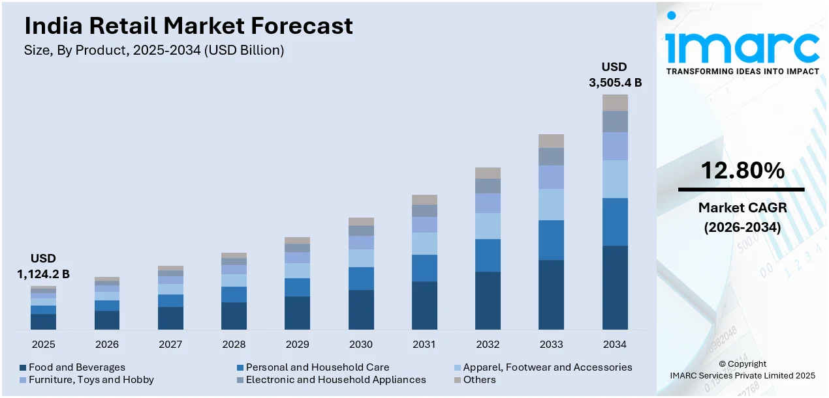
Figure 4: India Retail Market Size Forecast
https://www.globaldata.com/store/report/india-retail-market-analysis/
The recent growth of India's retail sector can appear as a ray of hope for foreign organisations. Researchers think that this market of 1.1 billion in 2025 will reach 3.5 billion by 2034 (Imarc Group, 2024). Behind this improvement of the market lies growth in the income of Indians. However, a significant portion of the entire retail market is occupied by unorganised shops, which are called 'kirana' shops in the Indian language. These kirana shops are big competitors to established retail stores in India. To buy something in small quantities, people go to the small kirana shop near their house. As much as the formal environment of a big retail store attracts Indians, many view kirana shops just like home (Chawla et al., 2019).
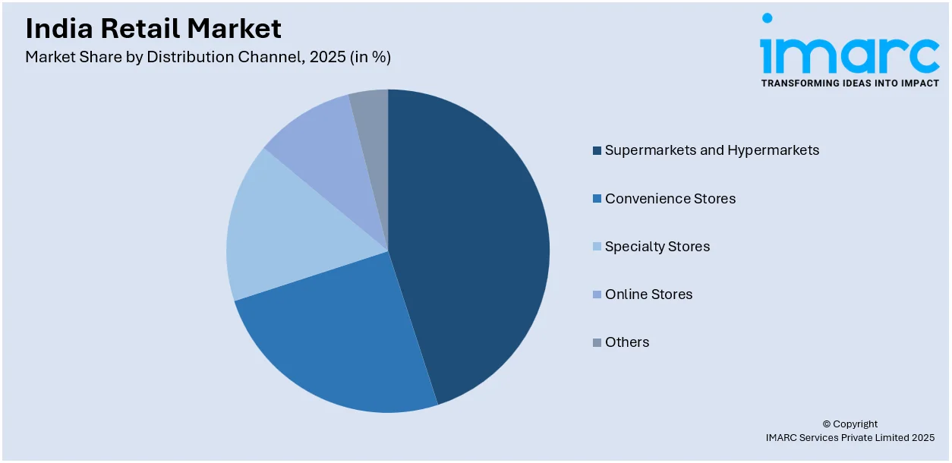
Figure 5: India Retail Market Size in 2025
https://www.globaldata.com/store/report/india-retail-market-analysis/
Therefore, even if the high economic numbers of the Indian retail market are attractive, Costco has to attract Indians while competing with kirana shops. Because an emotional relationship exists among Indians towards these things. The good news is that changes are being seen in people's expectations in big cities. As a result of digital access, people's interest in foreign brands is growing. Soaps, toothpaste, and beauty care products of many foreign brands are usually not available in small kirana shops. Modern-minded and young consumers, whose disposable income has increased significantly, go to big retail stores to buy these high-quality branded products. Many of those who want to buy authentic products go to organised retail stores instead of kirana shops. Because a bad reputation exists that local shops are full of fake products, they sell inferior fake stuff inside by copying packaging. Therefore, analysing the economic factors, it is seen that even if kirana shops create a big obstacle, Costco's customer base is actually different.
Legal Factors
To start business in India, approval of FDI of different percentages is given to any organisation according to sector. But guidelines on exactly how an organisation will be established here can be found in the Companies Act 2013 (Khuntia, 2014). Costco will be able to start business in the Indian market with a maximum of 51% ownership as an MBRT, so 49% of the investment must be taken from an Indian company or investor. The Companies Act 2013 gives Costco legal validity to open a subsidiary company in India, where they will be able to execute this investment.
Now, if Costco starts work in India, they must step in with a specific number of workers. Just like other countries, there are some laws to protect workers' interests in India as well. These laws were scattered earlier, but they were recently brought together and reformed. Following each law separately is quite a hassle. So this consolidated version has eased the complex processes for Costco. Within one law, guidelines are given regarding minimum wages of workers, social and occupational safety, and mutual relations (India.Gov.in, 2026). However, under this law, Costco will have to pay a specific amount as a minimum salary anyway, which can increase pressure on their operating costs in India.
Cultural Factors
When a multinational organisation like Costco enters a new country, they have to keep local cultural factors under consideration. There is variation in the culture of every country, which can be analysed using Hofstede's cultural dimensions (Minkov and Hofstede, 2021). The dimensions that are relevant for Costco to enter the Indian market are these; using those, the culture here is analysed below:
- Individualism vs. Collectivism: India is a country of collectivist culture. At present, although the number of nuclear families is increasing, they feel comfortable staying in a large community. There are still plenty of families where husband, wife, children, grandfather, and grandmother live together. For Costco's bulk selling, this is a big positive factor. A family will be able to spend almost their entire month's budget buying from Costco.
- Power Distance: This dimension is quite high in India. Where PDI is high, people of that society maintain a respectful attitude towards top individuals. If Costco sets up business in India, Indians will show trust, seeing their brand image and global recognition. Therefore, the organisation will not need to invest heavily in marketing. Furthermore, the respectful attitude of Indians towards big organisations will also benefit Costco in its supplier deals. Indian suppliers will not bargain too much as per their natural behaviour. However, at the managerial level, Costco will have to make slight changes. Because their core business structure is flat, where staff can state their opinions freely. But because of this mindset among Indians to refrain from giving opinions in front of the boss, Costco might have to add a hierarchy element, where the company will have to structure strategies in a new way.
- Uncertainty Avoidance: In this dimension, India's score is significantly lower than the global average. Indians accept uncertainty naturally. They can adapt to new situations rapidly. Because of this nature of theirs, Costco can gain acceptance among Indians within a few days. This membership-dependent shopping model can be said to be almost new in India. If Costco can position this new system properly among Indians, they will accept the membership model easily.

3.2 Market Entry:
John Dunning's eclectic paradigm is a framework that an organisation can use to make important decisions regarding international expansion. Decisions are taken considering three specific aspects of whether it is more reasonable to make FDI or enter the market through a different path (Dunning, 2015). Below is an analysis of how Costco can enter India through this framework:
- Quality control
- Brand protection
- Control over operations
- Protect membership modely
- Strong global brand
- Membership model
- Kirkland Signature
- Bulk purchasing capability
y
- aaay
- Large consumer market
- Growing organised retail
- Price-sensitive consumersy
Diagram 1: Costco’s OLI Analysis
https://genuineimpact.substack.com/p/costco-unchained
Ownership Advantage
This element shows how strong the organisation itself is. It is not that all established organisations that expand abroad will be successful. There is no guarantee that success in one country will work in another country too, especially if the local organisation abroad offers more value than them or is stronger; not much advantage can be gained going there. So right at the beginning, one has to see what qualities Costco itself has which Indian retailers do not have.
The primary strength is Costco's brand image. It has been running a business successfully for the last 40 years. So it will not enter India as a completely unfamiliar name. Although Reliance Retail's image in India is also robust, Costco's global recognition will keep it in a strong position. After that comes the membership-based model. Even if this is new for Indians, their habit of having a positive outlook towards uncertainty will not leave this new system completely neglected. Once someone takes a membership, they will not switch easily unless there is a major issue. Because when customers can buy everything necessary under one membership, there will be no need to change memberships repeatedly or go to another retailer. Costco stocks the products that have high demand among customers. Their SKUs are much lower than Walmart's, because rather than stocking up with diverse goods, they only bring in those types of products that customers want. So under one roof, customers will get everything.
Another matter is price sensitivity among Indians. Kirana shopkeepers have to go to the nearby 'mandi' to source their goods. If they obtain products at a relatively lower price from Costco, they will also be interested in taking its membership in the long run, since Costco's reputation itself is reducing per-unit costs through bulk selling.
However, just having an ownership advantage does not guarantee that an organisation will succeed abroad. At the start, everyone has to face trouble adapting to an unfamiliar environment. If they do not come after studying the Indian language and culture, Costco will have to take a hit right at the beginning. If this picture gets settled in the minds of Indians that Costco is a foreign company, meaning it creates an alienated picture for them, then Costco will have to face a big obstacle first.
Location Advantage
Having the organisation's own strength is not enough; one also has to see how advantageous the location of the country they are targeting is. Suppose an organisation has four options: China, Japan, India, and the UK. Why India will be chosen among these four is analysed with this element. Costco has already started operations in the remaining three countries, and India can be a potential location for them. The first reason for this choice is the 51% FDI given to foreign MBRTs by the Indian government. Although there are some restrictions in this case, considering other positive factors, Costco cannot discard India completely. Among these, the most significant advantage is the expectation of a better lifestyle among Indians. As a result of economic growth, people's hands are opening up for spending. Rather than the low-quality products of kirana shops, Indians are now more interested in buying authentic branded products from big retail stores. Especially in modern urban life, this trend is being seen more. The country is surrounded by the Arabian Sea, the Bay of Bengal, and the Indian Ocean, so bringing in and taking out goods via sea routes is effortless. So the trend is creating a geographical advantage for Costco. The e-commerce sector in India is now passing through a major crossroads. In the coming years, this market will become much larger. Although, as an MBRT, using e-commerce channels is prohibited under government FDI policies, Costco can still operate in a marketplace model like Amazon.
However, even if there is FDI approval, Costco will have to take government approval; there is no automatic route. Long paperwork is required for the approval process. Months or years might pass before getting approval. Besides, if local kirana store owners sit down in protest, the government might tighten policies even further under pressure. Until now, no big MBRT has entered India making FDI; kirana owners did not oppose it even though there was government approval. But if Costco starts doing business in India following the laws, and if this hurts the interests of kirana owners, they might start opposing. Besides, in India, e-commerce platforms like Amazon, Flipkart, etc. are already big names. If Costco wants to enter the e-commerce marketplace model, it will have to compete directly with these. And in the local organised retail market as well, there is immense competition. If Costco has to do business as an MBRT, it will have to fight with Indian companies like Reliance Retail and DMart.
Internalisation Advantage
An organisation has its own strengths, and the target country's situation is also properly favourable; even after that, a question remains: whether going there oneself is more profitable or licensing a local organisation is better. For Costco as well, there are two options here, and both have both profit and loss.
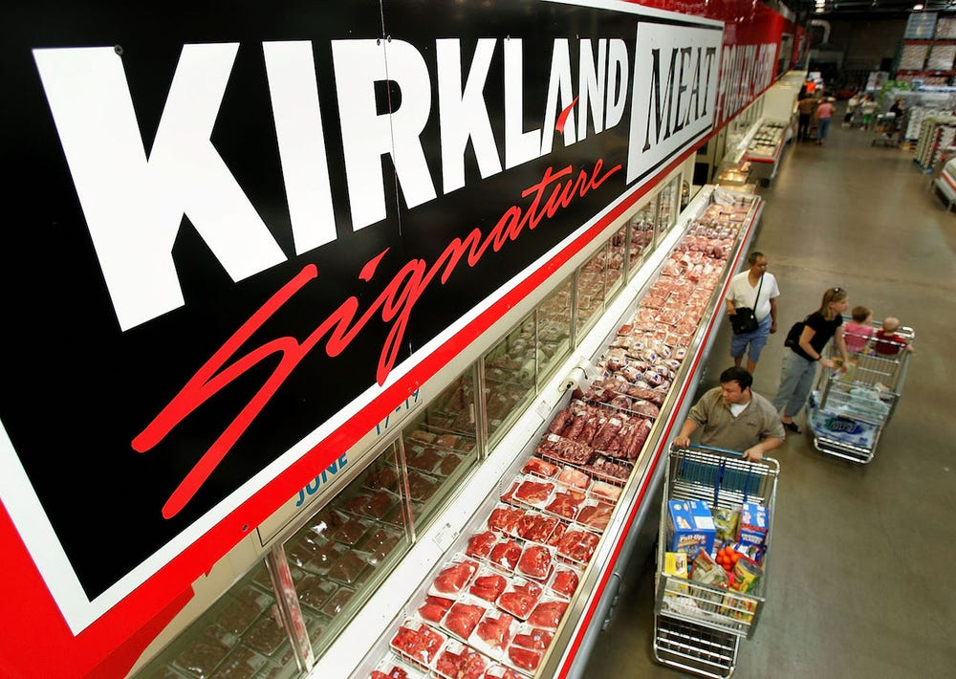
Figure 6: Costco Kirkland Signature Products
https://www.businessinsider.com/costco-kirkland-name-brand-products-compared-pop-secret-nature-valley-2019-9
Costco is a strong brand, and India's economic progress and people's growing better lifestyle; looking at these aspects, it is better if they choose FDI instead of licensing. To maintain the quality of their Kirkland Signature brand, one cannot rely on others. If another company uses Costco's name and sells bad products, a crack might appear in their global prestige.
Another thing is the membership model. In India, retail business in this model is not yet universally accepted. So if Costco steps into India, this will be their unique feature for Indians. But if Costco does not go itself and licenses a third party, the secret behind succeeding in this model will go into someone else's hands. And even if the situation is not that serious, since this is not an established business model in India yet, there is no guarantee whether licensed companies will be able to apply it properly or not. So considering these, Costco will want that control to remain in their own hands.
However, the opposite picture also has to be considered. Government restrictions on FDI in India are a significant hassle. Costco will not be able to use e-commerce channels there, which is a big medium nowadays. Costco's main target customer base is urban-centric, and in cities, customers contribute the most to the e-commerce sector. If Costco gives brand licensing to an independent Indian company instead of making FDI, they will be able to reach the huge customer base of e-commerce, although in this case Costco will not have direct control over the Indian company and they will only be able to claim licensing fees. Even if Costco compromises the e-commerce channel to understand the dynamics of the Indian market and, as per the 51% FDI policy in the MBRT sector, they must keep an Indian partner. In this case, Costco will be able to keep much control in their own hands, if not fully.

4. Entry Mode Strategy and Strategic Synthesis:

4.1 Historical Pattern Recognition:
Costco is currently operating in 14 countries altogether, including the US. It was founded in the US in 1983, after which, in 1985, it started foreign expansion for the first time through full ownership in Canada (Alamy Limited, 2026). In the table below, Costco's entry mode for each country is presented in brief:
Country | Entry Mode
Canada | Wholly-owned
Mexico | joint venture
UK | Wholly-owned subsidiary
South Korea | joint venture
Taiwan | joint venture
Japan | Wholly-owned
Australia | Wholly-owned
Spain | Wholly-owned subsidiary
Iceland | Wholly-owned subsidiary
France | Wholly-owned subsidiary
China | Wholly-owned
New Zealand | Wholly-owned
Sweden | Wholly-owned

Table 2: Historical Pattern of Costco’s Foreign Entry Modes (Berrill, 2025)

Figure 7: Costco's Historical Foreign Entry Modes (Berrill, 2025)
From every cell displayed in this table, it is clear that whenever Costco took initiatives for foreign expansion, its primary entry mode was direct investment with full ownership. In some countries, they established subsidiaries and made greenfield investments by directly constructing warehouses.
After entering Canada with full ownership, they entered Mexico by doing a joint venture with Controladora Comercial Mexicana. One of the main reasons for this was that they were still inexperienced in foreign expansion back then. Even though they successfully launched warehouses in Canada, Controladora was an established retail company in Mexico at that time. To understand the Mexican market, Costco did not go alone and held their hand. Later in 2012, when Costco became an established company in Mexico, they bought the remaining 50% stake from Controladora.
Costco's first footstep in the Asian market happened through South Korea and Taiwan. Since they were new in Asia and here as well, they entered with a joint venture. But later in both countries, they started operating with full ownership. Currently, where Costco has operations in 14 countries, nowhere do they have a local partner; they are running the whole thing themselves. However, one thing is noticeable: during the time of gathering initial experience, they did a joint venture in Mexico, and while gaining their first experience in Asia as well, they did a JV in South Korea and Taiwan. But even if these JVs were chosen as entry modes according to the situation, in the long term their goal was to achieve full ownership.

4.2 Strategic Fit & Justification:
Before entering the Indian market, Costco has to see what entry modes are realistic in front of them. When a business prepares to enter a specific market, multiple options lie before it. Choosing the suitable option from there can be critical.
Observing the historical pattern of Costco's entry mode, it is seen that even though they mainly emphasised subsidiaries with full ownership, in some cases, especially at the beginning to get familiar with the market, they took the path of JV. Considering the scenario of India, both these options can be chosen by them in different cases.
- Risk Factors: If Costco wants to enter as an MBRT, then the Indian government allows them 51% FDI. This arrangement means that the remaining 49% stake has to be shared by them with an Indian partner. So here there is no way without a joint venture. However, if they enter as a cash-and-carry wholesaler like Walmart, they will receive 100% FDI, including the automatic route. Here they will be able to enter with full ownership. But the problem is, they will not be able to sell to general customers. Goods can be supplied only to registered small traders and kirana shopkeepers. That is to say, Costco will not be able to reach the general Indian public then.
- Resource Commitment: In a JV, they will be able to keep 51% shares, but according to FDI conditions, they must invest a minimum of $100 million anyway. Costco must invest this amount; if it is more than this, there is no issue. But this entire investment cannot be poured into constructing warehouses. As per the conditions, some expenses must be made for supply chain and infrastructure development. For a big organisation like Costco, bringing in $100 million should not be very difficult, when even during the financial crisis they had bought the entire share of the South Korean partner. Even if they started with full ownership in the cash-and-carry option, they might struggle alone to adapt to a diverse cultural environment like India. If they can bear the financial risk of learning by testing, this route can work overall.
- Control vs Flexibility: If investment is made with full ownership, naturally all control will remain in their hands. They will be able to keep running operations in their own way following local laws. Any decision can be made quickly. Since discussion with a partner is not required, taking immediate steps will be easy. But in a JV, control has to be shared. Strict monitoring has to be done to maintain quality. Costco will be able to use its South Korean experience here. Here, right from the beginning, they held authority in operations and management. Meaning, even if ownership has to be shared with an Indian partner in a 51:49 ratio according to conditions, Costco can keep control of operations and management with itself in the agreement itself. In such a scenario, at least there will be no scope for quality questions.
- Long-Term Strategic Fit: Observing historical patterns, it is seen that Costco's long-term target was always towards full ownership. As a cash-and-carry wholesaler, they can hold this right from the beginning. However, as an MBRT, they must enter through a joint venture. In the three countries where they entered this way, at one point, seeing an opportunity, they gained full control. Since India's restrictions are relatively strict, it is not possible to achieve more than 51% ownership for at least the next few years. But if Costco can produce good results and positive traits are caught in the eyes of the government, these restrictions might ease somewhat in the national interest. They expanded in South Korea and Taiwan in the 90s, and to gain full ownership, they had to wait nearly two decades. Therefore, keeping long-term plans in mind, for now they can enter with a JV.

4.3 Conclusion and Recommendation:
In the last four decades, at various times, Costco has taken initiatives for expansion in 13 countries in total, and including the US, currently they have operations in 14 countries. Observing the operation of Costco in each country, it is seen that keeping their distinct characteristics intact, they responded according to regional demands. When constructing the first warehouse in Japan, 90% of their goods were Japanese. Thereafter, gradually, they increased the American touch there. In a multi-cultural country like India, this characteristic will be beneficial. However, the question is now about entry mode, since the Indian government has some restrictions; again, there are exemptions in some sectors as well. Since historically Costco has experience in joint ventures, now they can join hands with an Indian company with 51% ownership. In this, entering the market, they will be able to gain first-hand experience. Right now, going towards a cash-and-carry wholesaler will not be right because, in that case, they will be able to reach only small traders. No matter how many low-price bulk products a foreign company offers, traders do not change long-standing supply chains effortlessly. But attracting general customers is easier if proper campaigns can be run. When general customers lean towards Costco, interest in it will increase among small businesses as well. So for entering the Indian market, the best entry mode for Costco in the present situation is a joint venture.

Section 2

Reflective Account (Gibbs model)
Description: For writing this analytical report on Costco's foreign expansion, the start of my experience begins with reading the assignment brief. In the brief, I discovered two new frameworks that are not very familiar to me. Thereafter, I started separate research on the OLI and Bartlett-Ghoshal frameworks and tried to understand each of their components. Then, according to requirements, I kept looking for a company whose public information is available and has scope for expansion into potential countries. Thereafter, I found Costco and started research on it. I see that they have no operations in India, so I chose it as the target country.
Feelings: Since the OLI and Bartlett-Ghoshal frameworks were almost new to me, I was a bit uncertain about how complex it could be. Maybe I would not understand anything at all, or how I could even apply it? Apart from that, I fell into confusion regarding Costco's membership-based bulk-selling model because, to my knowledge, general people will not buy a product in such a quantity; traders might. Yet Costco presents itself as a multi-brand retailer. However, when I saw that Costco stocks more of those products, which are useful in people's daily lives in the long run, then I could catch the real formula. I know that price sensitivity exists among Indians, so thinking that this model of Costco could work here, I chose India. But seeing the legal complexities of India, I got a huge shock.
Evaluation: I did not start work right after reading the brief; rather, I tried to fix first where I found uncertainty initially. I did a separate study on the frameworks so that I could understand their purpose well. Later, while doing analysis, I faced some problems. But since I had concepts of the frameworks beforehand, my prior knowledge became very beneficial for me. However, when I started research on choosing India as the target country, I noticed that complexities exist in the policies. World-renowned retail companies like Amazon and Tesco have not started operations in India yet, only because of these complex rules and regulations. Now I was faced with a huge challenge regarding how I would fit Costco here.
Analysis: While creating this report, I understood that OLI and Bartlett-Ghoshal are not just theories; rather, they have logical, practical applications. Bartlett-Ghoshal's framework comes in handy to understand an organisation's foreign approach, and OLI is a necessary theory to analyse expansion suitability. For recommendations, I had to explain the historical context. However, it is not that what happened in the past has to happen in the present as well. I saw that in the past Costco gave more emphasis on full ownership, but depending on situations, they did joint ventures too. Now, if I had advised entry into India with full ownership, holding onto historical patterns, it would have been mismatched with reality. Actually, research does not mean just collecting information from one website or book or journal after another. The real purpose of research succeeds only when hypotheses are built, making comparisons and connections among each source of information, and after that a neutral decision can be reached.
Conclusion: The most significant lesson I had while writing this report is that a market being attractive does not mean that the path to enter it is smooth. The income of Indians has increased, the economy has been boosted, urbanisation is happening at a fast pace, and people are getting used to modern lifestyles; with just this much information, it can be said that the expansion of Costco, including other foreign multi-brand retailers, not happening in India in all these years is a surprising thing. But after that, going into deep analysis regarding laws and policies, it is seen that market entry is not easy at all. So even if a country has market potential, whether an expansion initiative can be taken depends on how straightforward entry is.
Action Plan: In the future, to do this kind of analysis, while choosing an organisation and target market, priority must be given more to reality than personal wishes and surprises. One has to see beforehand whether the legal restrictions of the target country are realistic for an organisation's expansion initiative. However, because of having a good study on the frameworks beforehand, many complex processes became easier. So in my next assignment, I will move forward like this.

Reference:
Alamy Limited (2026). Costco exterior hi-res stock photography and images - alamy. [online] Alamy. Available at: https://www.alamy.com/stock-photo/costco-exterior.html?sortBy=relevant [Accessed 10 Aug. 2026].
Berrill, A. (2025). Here’s exactly how many countries have Costco. [online] Yahoo Finance. Available at: https://finance.yahoo.com/news/heres-exactly-many-countries-costco-203000508.html?utm_source=perplexity&guccounter=1 [Accessed 10 Aug. 2026].
Bhattacharyya, R., 2022. The opportunities and challenges of FDI in retail in India. IOSR Journal of Humanities and Social Science, 5(5), pp.99-109.
Bitter, A. (2024). Costco just raised its membership fee for the first time in 7 years. [online] Business Insider. Available at: https://www.businessinsider.com/costco-raising-membership-fee-gold-star-executive-cost-2024-7 [Accessed 10 Aug. 2026].
Chawla, J., Sharma, B. and Agrawal, R. (2019). A Comparative Study of Organised and Unorganised Retailing in India. [online] Research Gate. Available at: https://www.researchgate.net/publication/335490242_A_Comparative_Study_of_Organized_and_Unorganized_Retailing_in_India [Accessed 10 Aug. 2026].
Curley, C. (2025). 9 Items you should always buy from Costco’s Kirkland Signature brand. [online] Business Insider. Available at: https://www.businessinsider.com/costco-kirkland-signature-products-worth-the-money-2018-6 [Accessed 10 Aug. 2026].
Dunning, J.H., 2015. The eclectic (OLI) paradigm of international production: past, present and future. International Journal of the Economics of Business, 8(2), pp.173-190.
Founder, J.W. (2025). Costco Japan vs America: What every shopper should know | Wakoku. [online] Wakoku. Available at: https://wakokujp.com/costco-japan-vs-america/ [Accessed 10 Aug. 2026].
Imarc Group (2024). India retail market size, share, growth and industry report. [online] Imarcgroup.com. Available at: https://www.imarcgroup.com/india-retail-market [Accessed 10 Aug. 2026].
India.Gov.in (2026). India.Gov.in | national portal India: Where government information converges. [online] India.gov.in. Available at: https://www.india.gov.in/spotlight/details/new-labour-code-for-new-india-biggest-labour-reforms-in-independent-india [Accessed 10 Aug. 2026].
Khuntia, R., 2014. Companies Act 2013- A new wave of effective regulation and corporate governance in India. International Journal of Advancement in Research & Technology, pp.148-158.
Kundgir, B.R. (2024). FDI in multi-brand retail in India: Myths and realities. ShodhKosh: Journal of Visual and Performing Arts, [online] 5(7SE), pp.273–275. doi:10.29121/shodhkosh.v5.i7SE.2024.6177.
Minkov, M. and Hofstede, G., 2021. The evolution of Hofstede's doctrine. Cross-cultural management: An international journal, 18(1), pp.10-20.
Nguyễn, V. (2026). SatPost by Trung Phan. [online] F-x Bike. Available at: https://fxbike.vn/trung-japan/ [Accessed 10 Aug. 2026].
Nougarahiya, S., Shetty, G. and Mandloi, D., 2021. A review of e–commerce in India: The past, present, and the future. Research Review International Journal of Multidisciplinary, 6(03), pp.12-22.
Reuter, D. (2023). How Costco became the king of bulk buying after starting out selling goods only to businesses out of an old aeroplane hangar. [online] Business Insider. Available at: https://www.businessinsider.com/founding-history-of-costco [Accessed 10 Aug. 2026].
Salgar, R.B., 2022. FDI in retail sector in India: A critical review. ZENITH International Journal of Business Economics & Management Research, 2(6), pp.143-152.

