

RESULT

School of Applied Computing ASSIGNMENT SPECIFICATION

Student name: | Mohammed Abdulla | Student P number: | P152058
Programme: | Computer network and cyber security
Lecturer: | Dr Tim Bashford | Internal Verifier:
Assignment Title:
Hand Out Date: | 14/02/2018 | Submission deadline: | 14/02/2018
Referencing: | In the main body of your submission you must give credit to authors on whose research your work is based. Append to your submission a reference list that indicates the books, articles, etc. that you have read or quoted in order to complete this assignment (e.g. for books: surname of author and initials, year of publication, title of book, edition, publisher: place of publication).
Disclosure: | I declare that this assignment is all my own work and that I have acknowledged all materials used from the published or unpublished works of other people. All references have been duly cited.
Student’s Signature: | Hardcopy assignments will not be accepted withomut a signature here | Date:
Late submission will result in a late penalty mark, as follows:
Up to one week late, maximum mark of 40% for first attempts. No late submission for resit work.
(Academic Quality Handbook 2016/17 7.5 (5))
Only the Extenuating Circumstances Committee may grant an extension.

Learning Outcomes tested
(from module syllabus)
Design and deploy critical network services and resources within optimised virtualisation based environments.

Demonstrate a systematic understanding of the concepts, principles and technologies within network service architectures.

Name: Mohammed AbdullaStudent number : P152058
L5 Computer Networks & Cybersecurity
Tutor: DR Tim Bashford
Mabdulla.152058@student.uwtsd.ac.uk
Facilitating a Virtualised Remote Network Infrastructure Utilising Type 1 Hypervisor software, and the RRAS (Routing and Remote Access Services).
Worksheet -1

Task 1:

Creating and setting up suitable environment before starting the tasks on this worksheet:
- Installation of virtual machines in a type 1 hypervisor environment.
- Creation of 2 Virtual servers, each with 3 network interfaces, a suitably renamed Backbone Connection and a LAN Switch connection.
- Creation of a Windows client with 3 network interfaces, a suitably renamed Backbone Connection and a LAN Switch connection.
- TCP/IP configuration for each of the 3 adapters in the two servers.

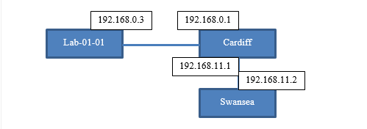
Topology for this worksheet

- We have configured the lab 01-01 network card TCP/IP with IP address 192.168.0.3 and a default gateway of the Cardiff server with IP address 192.168.0.1 of the 0 network
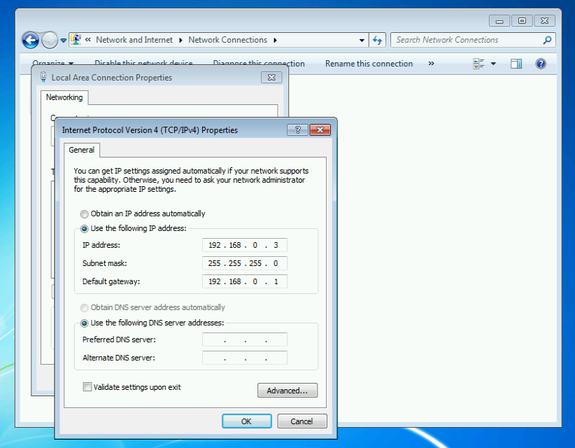

- Configuring Swansea server with IP address 192.168.11.2 and a default gateway of the Cardiff server is IP address 192.168.11.1 of the 11 networks.
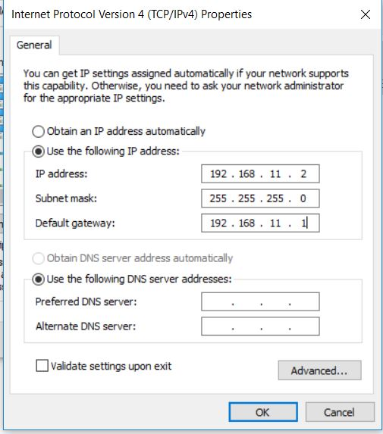

After the configuration we have tried to ping the LAB from Swansea, but no success simply because there is no mechanism to forward the ICMP packet

Ping fail from Swansea server to Lab 01-01
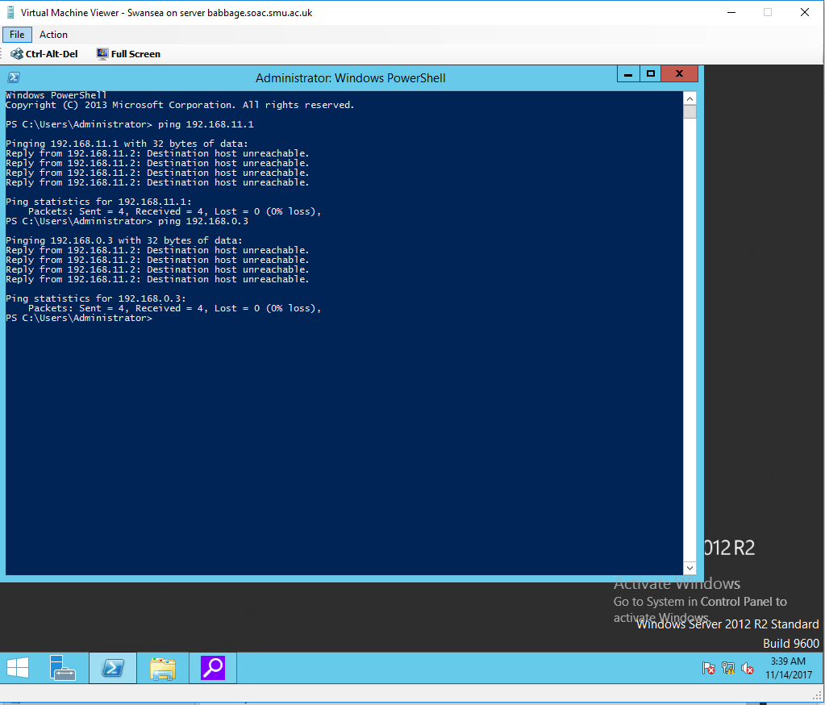

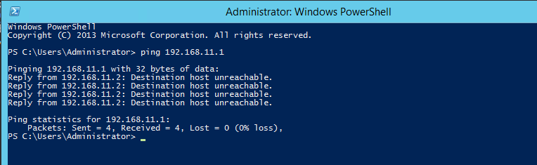
Ping fail from Swansea server to 11 network on Cardiff server

Task 2: Enabling the Routing and Remote Access Service on Cardiff Server:
RRAS(Routing and Remote Access Services) installed on Cardiff server , Cardiff server will act as a router.
Installation process
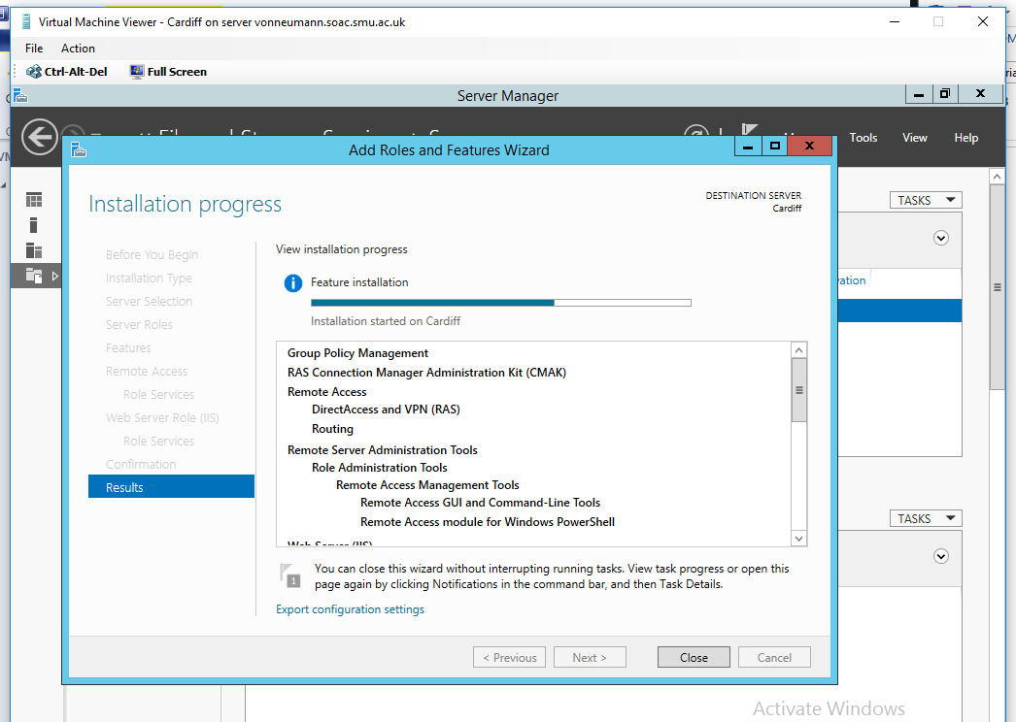

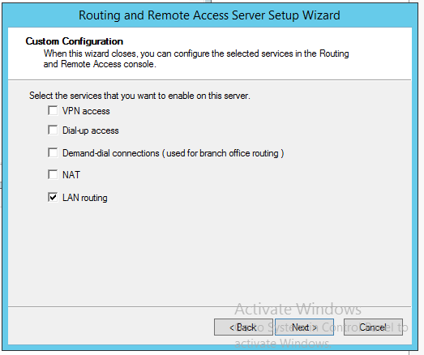
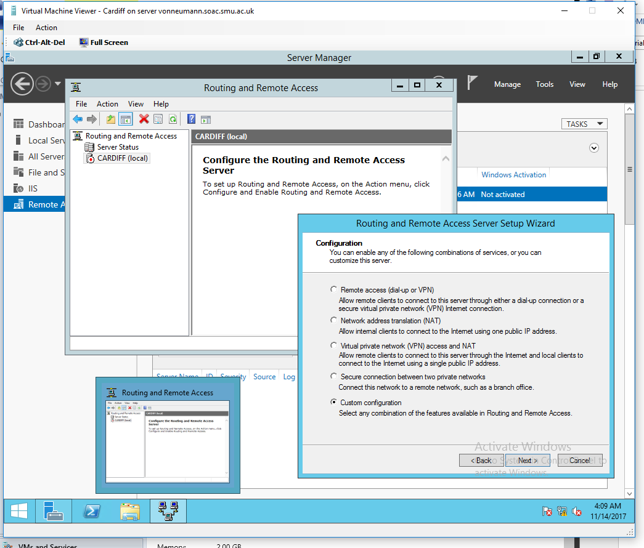
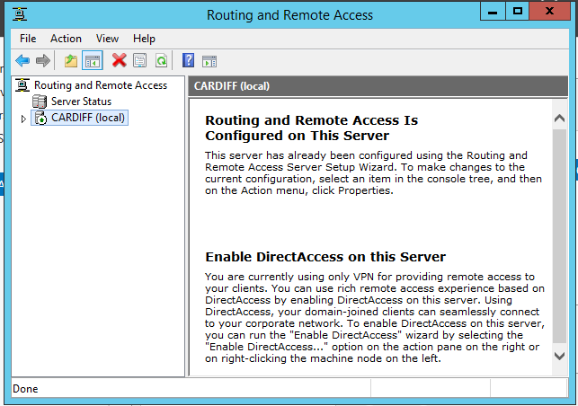

Even though after completing installing the feature of routing on Cardiff server, the ping still is unreachable from Swansea to the Lab again because this feature still need configuration so that Cardiff server will start to act like router.
Pings unreachable

Task 3: Add Routing Protocols on Cardiff Server and Add Two Routing Interfaces to the Routing Protocol on this server.
RIP v2 installed into both network cards on 0 network and 11 network, this will allow Cardiff server to act as router using the RIP routing Protocol.
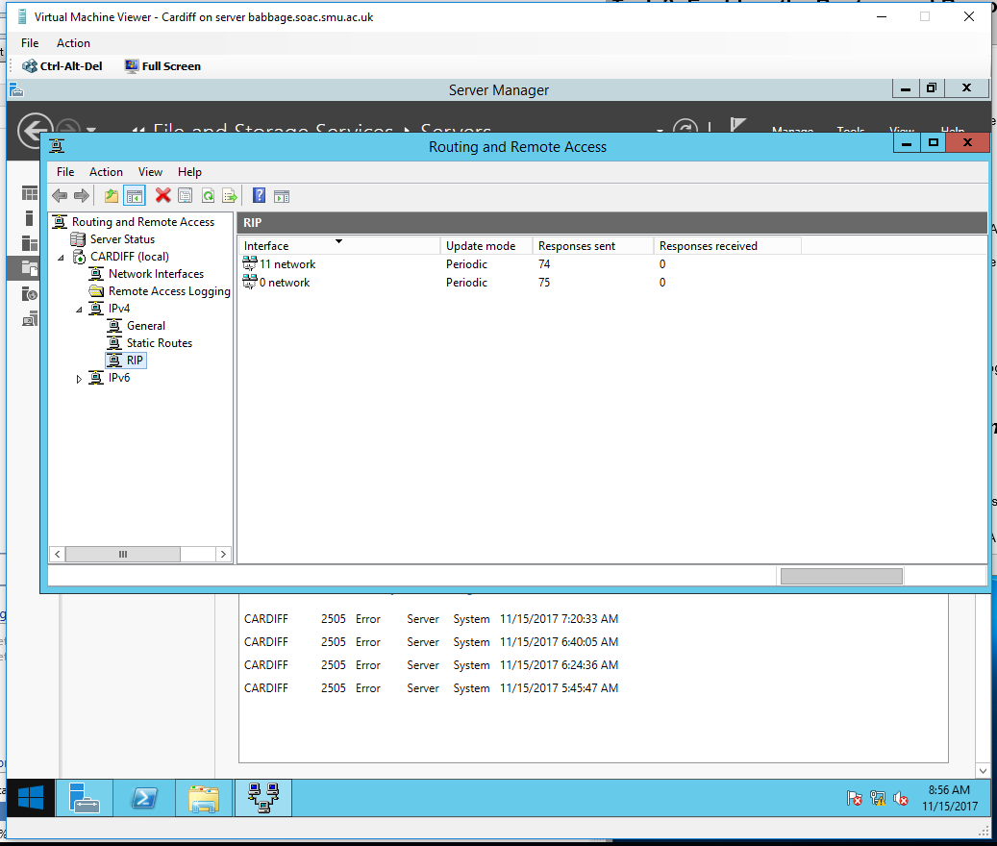

Now the ping is reachable between LAB1 and Swansea ,thanks to the RIP routing protocol
Ping was successful because ICMP packet now can be forward from one network to another thanks to the RIP routing protocol.
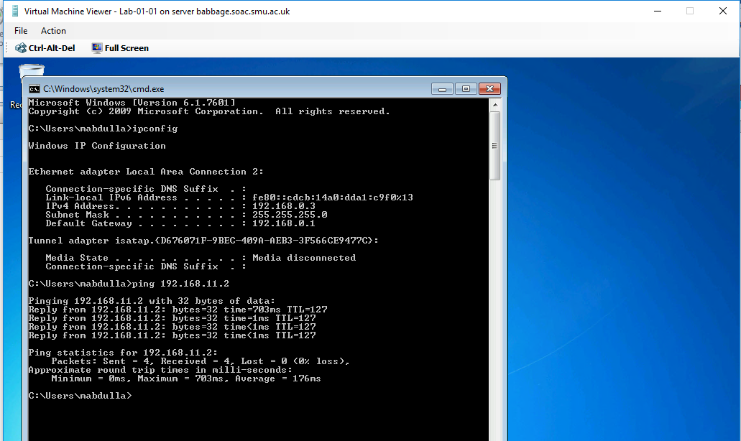
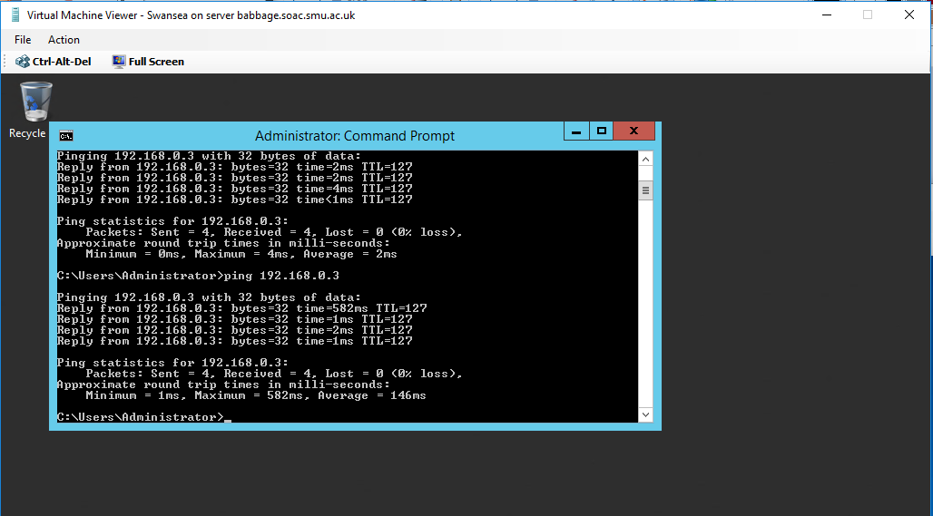

Task 4: Learning about Local Area Network Routing
Routing Table:

What can you determine from the resulting Routing Table?
From the resulting Table we can identify the following:
- Network IDs and subnet masks
- Gateway or forwarding address
- Ports number
- The Routing metric Value
- Directly connected network

Task 5: Additional Observation Tasks:

Questions
- Identify the benefits of Type 1 Hypervisor software services and briefly evaluate some suitable products.
- Define the role of Routers in the Network Architecture, what types can be used?
- Identify and discuss the usage of common Routing Protocols, what are the associated benefits of using Routing Protocols?
- Define the role of Routing Tables, what are they. Breakdown and analyze the information a Routing Table provides us with.
- What is the Subnet Mask, what is the significance of this in the Routing Table?

Q1.

The type 1 hypervisor allows better use of hardware in order to get more computing work done at the same instance.Furthermore,users normally benefit from the technology in sense that the technology supports execution of more than one operating system on top of any given single host computer (McNamara, 2014). With respect to product, one of the products is the hardware components whereby the technology plays a role in virtualizing the hardware elements of a computer.
Q2

In computer architecture, routers play a major role in the forwarding of data packets between different computer networks. Also, routers normal y perform the traffic directing roles on the Internet. Some of the most commonly used types are the wired routers, virtual routers as well as the wireless routers in the computer architecture (Varma, 2012).
Q3

One of the routing protocols is the RIP. Routing information protocol also known as RIP is a type of protocol responsible for distribution of routing information in a given autonomous system. With respect to the benefit of this protocol, this protocol normally prevents the routing loops (Hale, 2005).
Q4
Routing table is defined as a collection of rules that are usually shown in a table setup. The information is used to check whether information packets are travelling over the IP network protocol and their destination (Hale, 2005). Routing table is normally composed of the destination network feature as well as the net mask of the network. Finally, routing table shows the gateway of the network.
Q5
Subnet mask is a sequence that is used to identify the network address of any given IP address by operations of bitwise AND operations on the mask. In the routing table, network mask usually helps in allowing the exchange of packets between different networks (Hale, 2005).

Worksheet 2: Routing and Remote Access Services in Windows Server: ARP, Managing TCP/IP & ICMP Operations using Packet Filtering
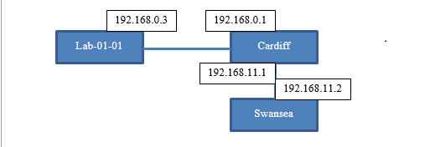

Task 1: Using the ARP Protocol to obtain Physical/Logical Network Node information
Computer building its ARP address table with physical and logical addresses
Example:
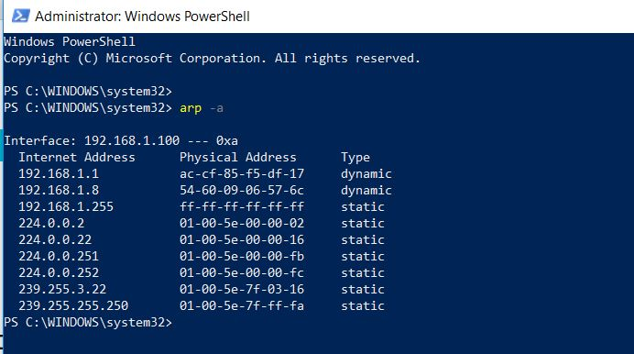

ICMP packets Exchange successfully between Cardiff and other servers and machines, the snapshot is for the arp after a ping is performed between the Lab and Swansea.

Task 2: Permitted TCP and ICMP Operations
Now Swansea server to act as an FTP server:
- Adding the Web Server (IIS) role with FTP service.
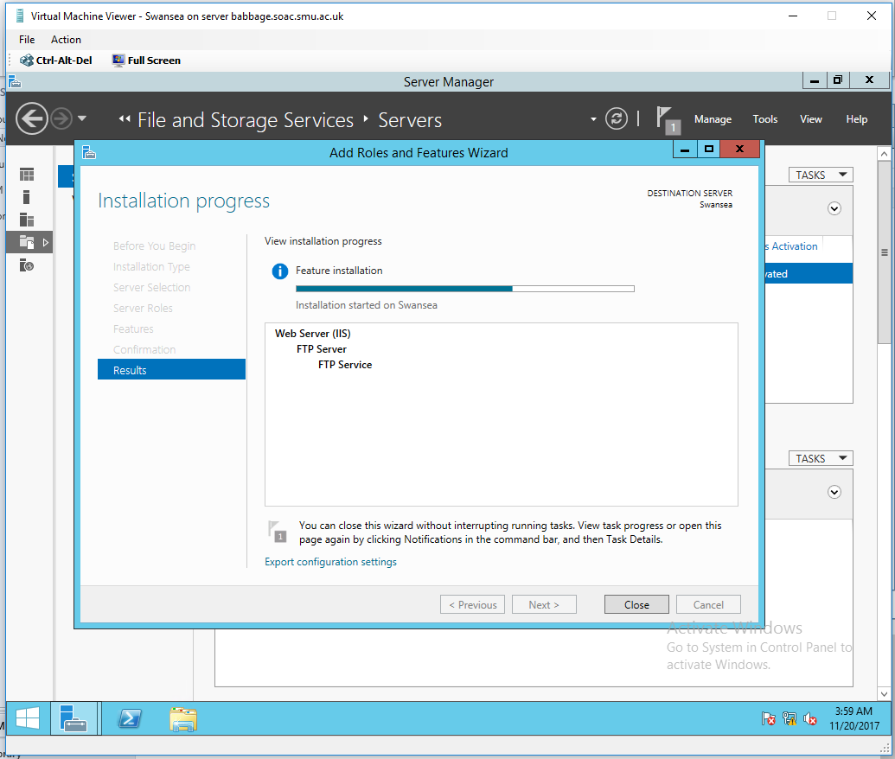

- We will add FTP user account credential to the computer management, to stop any unauthorised users.

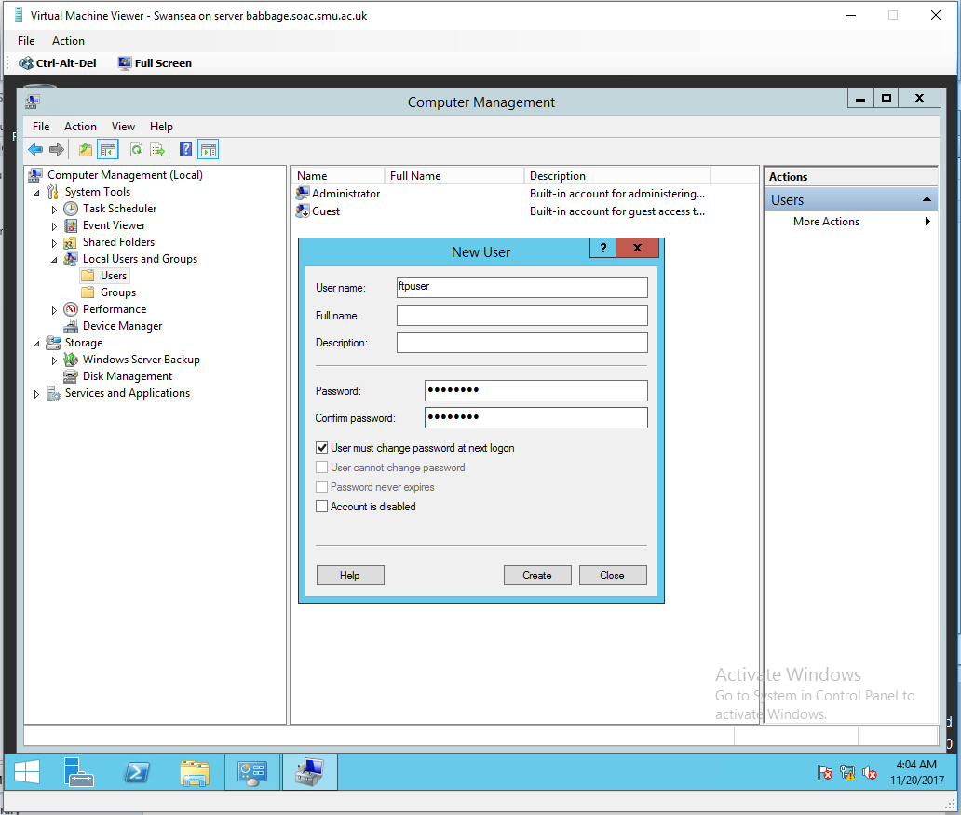

- Creating the FTP site and configuring message banner.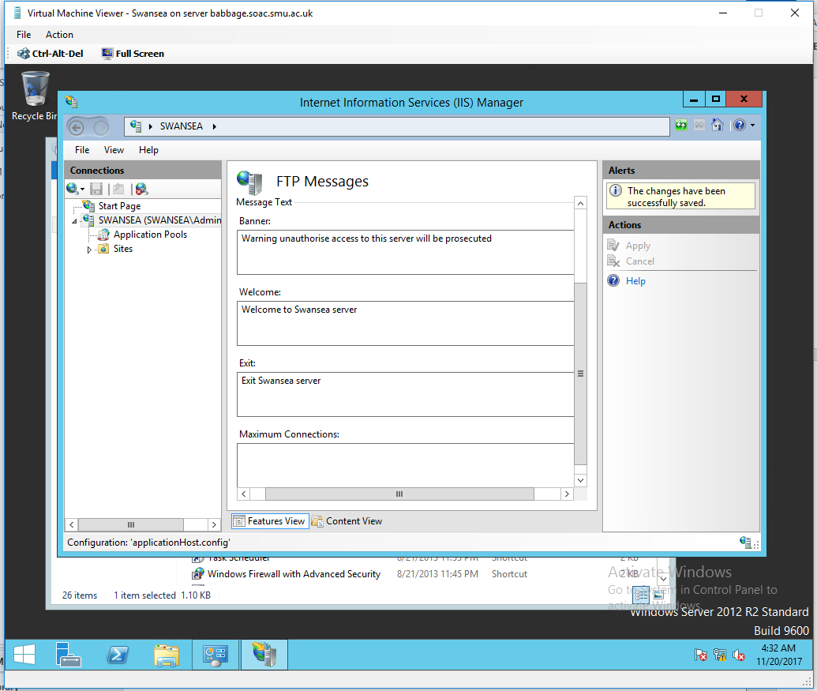

- Configuring the root drive for this FTP service to C:\Inetpub\ftproot

- Setting SSL for this service.
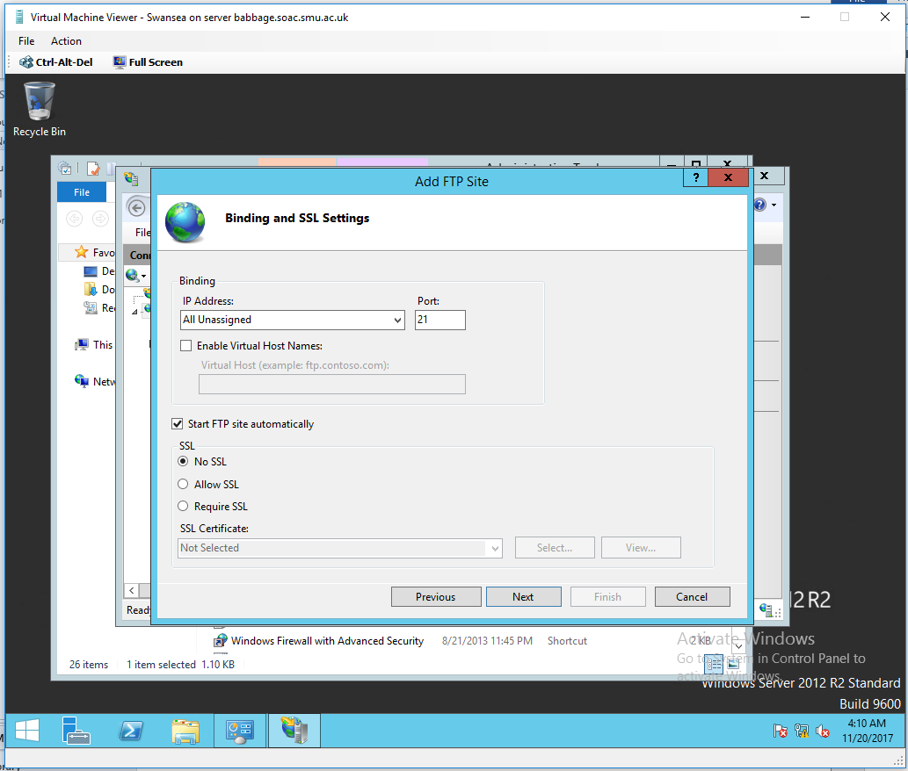

- Configuring the port numbers (20 & 21) to be used via the TCP protocol when using the FTP Service.

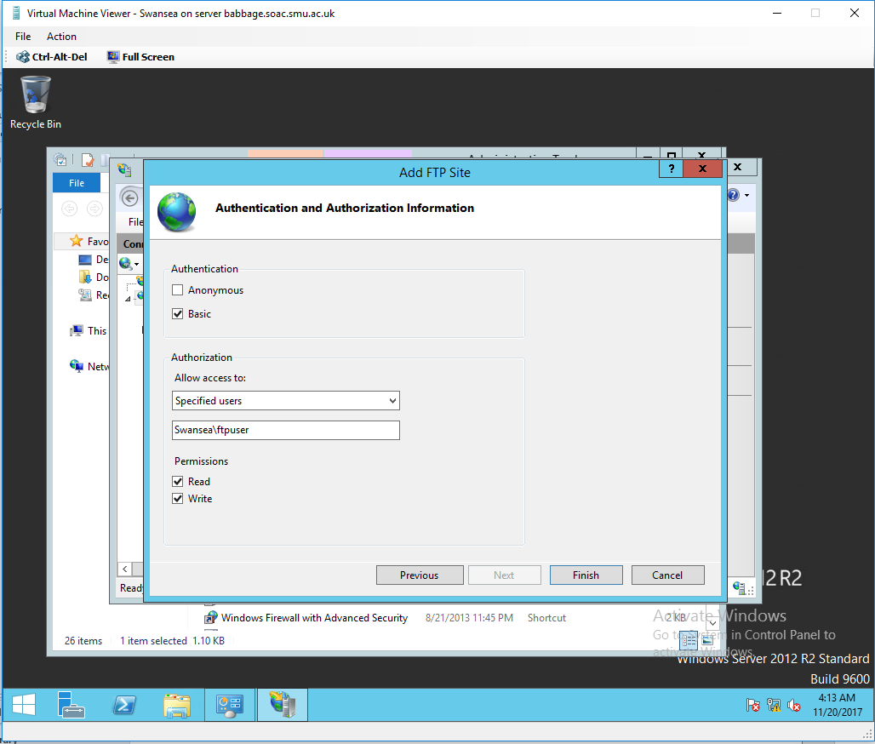
- Configuring the authentication and the access level for the user Swansea\ftpuser.

- Last step after finishing the setups of creating the FTP server, we create file named testftpdownload.txt on the C:\Inetpub\ftproot directory for testing purpose.

- We created a folder called ftpdownloads On Cardiff server we and we try to ftp Swansea server using command Prompt.

Unsuccessful FTP because the firewall still ON, the firewall will interfere with the process of filtering and blocking some packets.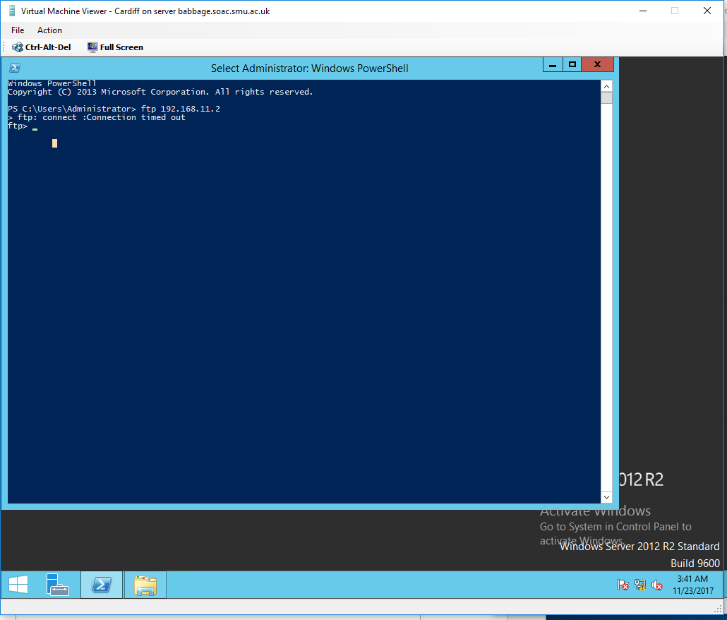

After Turing the firewall OFF we managed to ftp to Swansea server from Cardiff successfully.

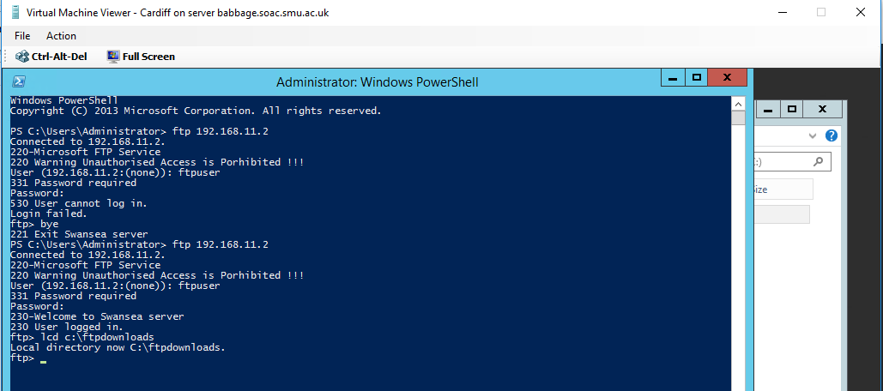
Changing directory command “lcd”

After logging in successfully to the server we performed two operations:

1st operation: downloading file called testftpdownload.txt from Swansea server into folder called ftpdownloads in Cardiff server (changing directory command “lcd” will help to control the destination or source of the ftp service).
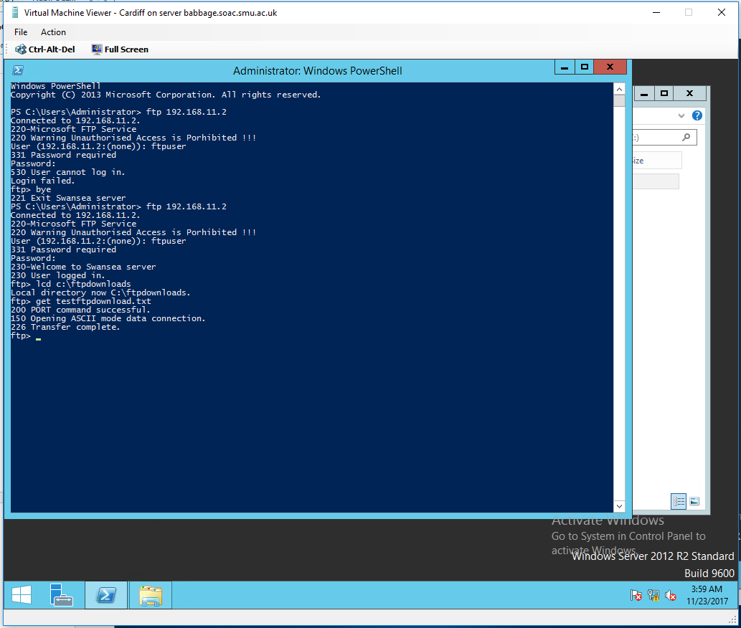

2nd operation: uploading file called testftpuploads.txt into Swansea server from source folder ftpfilesupload located in Cardiff server (also the “lcd” command help into chowing the ftp server where the file that need to be uploaded is located).

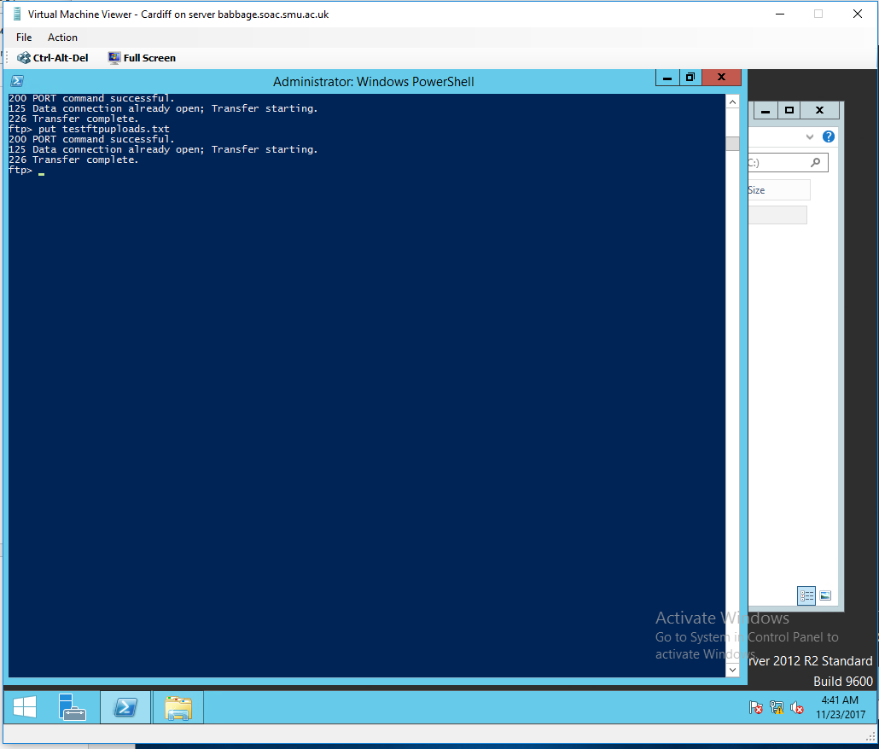

Checking that the file was uploaded successfully into Swansea server:
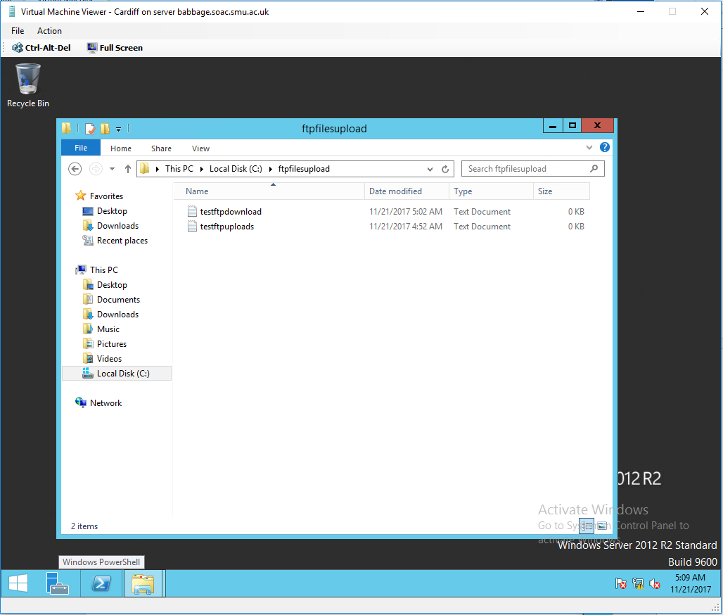

Task 3: Restricting ICMP Operations Using IP Packet Filtering with the Windows 2012 Server Routing and Remote Access Service
In this part we will configure Cardiff server to block ICMP packets from being routed from client Lab01-01 192.168.0.3 to reach destination Swansea server 192.168.11.2, this will block lab machine from pining Swansea FTP server (in this process selecting the correct protocol to block or allowed is a key also the port number for the specific traffic or just 255 if its for all types of traffic…
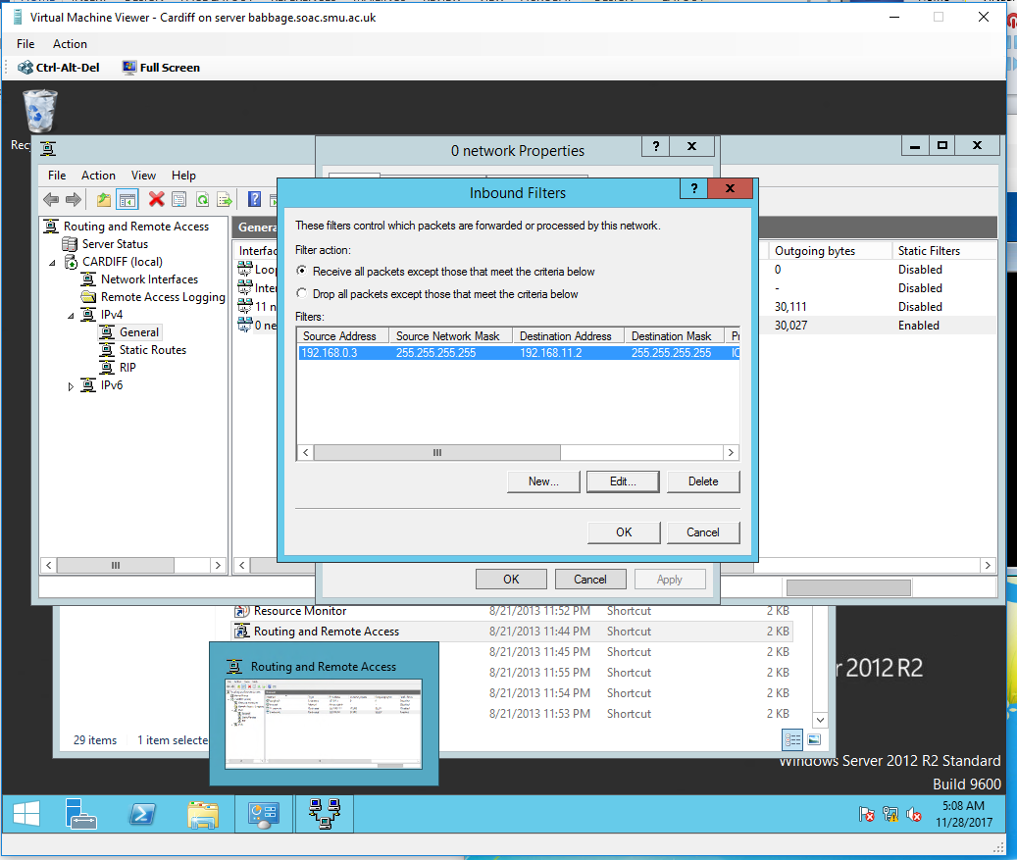

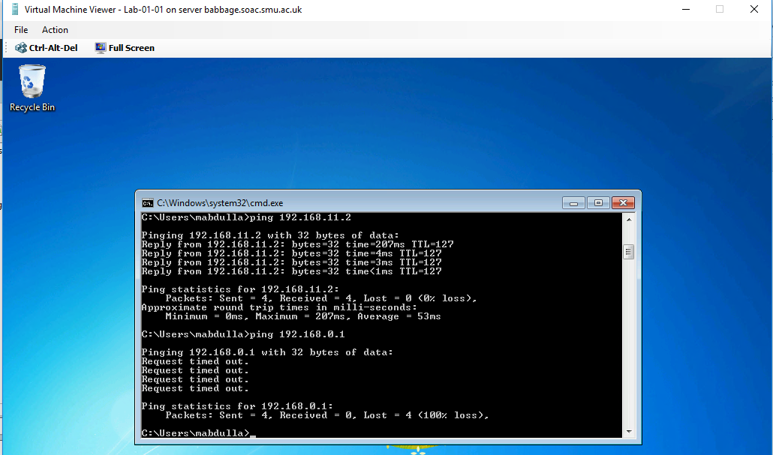
Ping test from lab machine to Swansea server before and after applying the ICMP filter
Task 4: Restricting TCP Operations Using IP Packet Filtering with the Windows 2003 Server Routing and Remote Access Service.
After removing the previous Inbound & Outbound Filters, this helps us avoid ‘Contradictory Filters’
We will block any TFTP attempt to Swansea by blocking all TCP traffics going through port 20 and 21 and coming from any network.
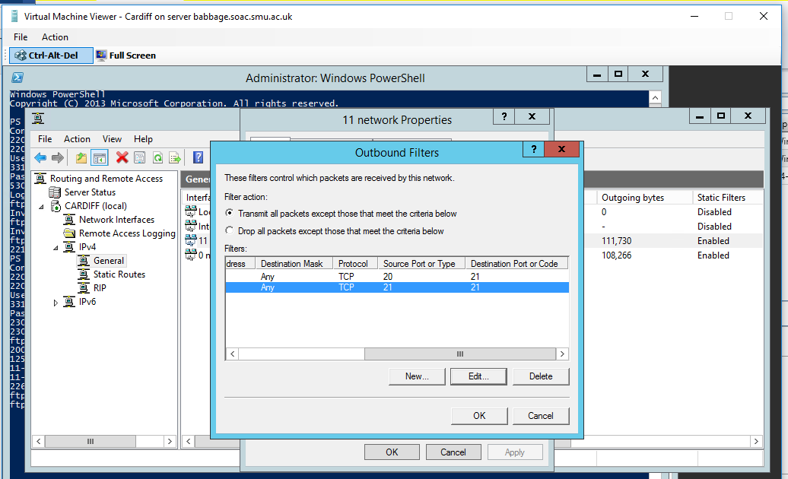
We could perform that by only blocking the traffic going to only Swansea by configuring the destination IP 192.168.11.2 or blocking in general all FTP traffic to come out of Cardiff outbound by giving any to destination mask.
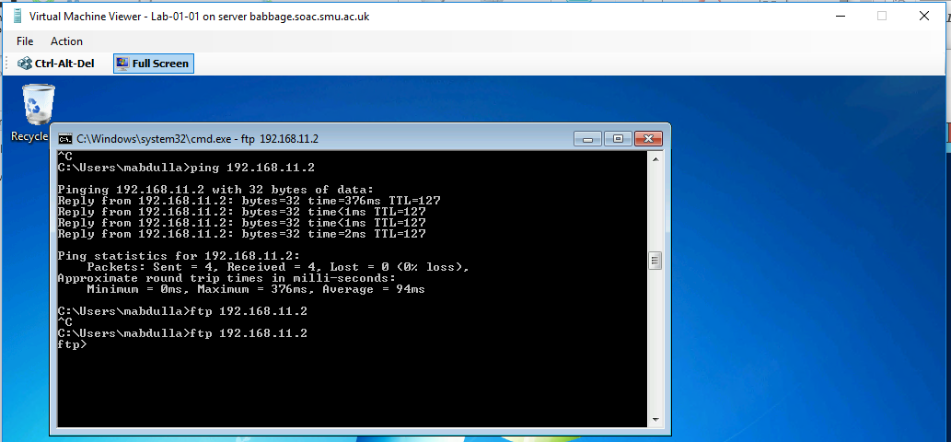
As result of this filter, Lab machine not anymore able to FTP Swansea server
Configuring an inbound filter to allow only Cardiff to FTP our sever
In this part we will be configuring an inbound traffic to block network traffic to FTP service except Cardiff router.
On the 0 network, we configure the inbound filter to allow all network traffic to go through except TCP traffic going through port 21/20 to stop FTP service to be allowed through.
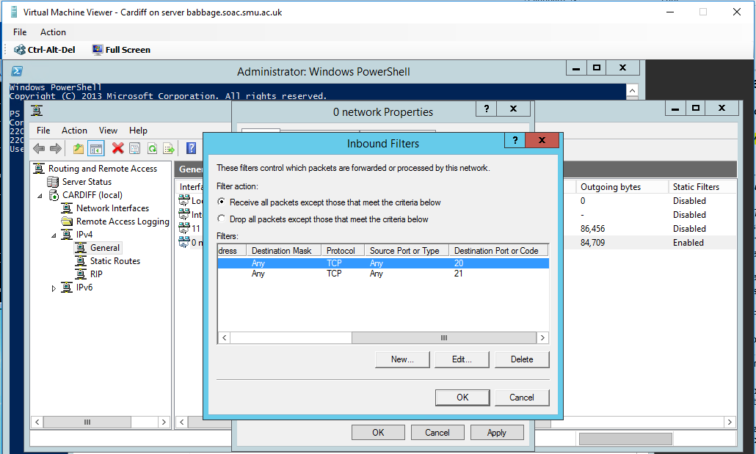

After applying this filter, the result was conclusive (lab blocked from FTP and Cardiff still FTP)

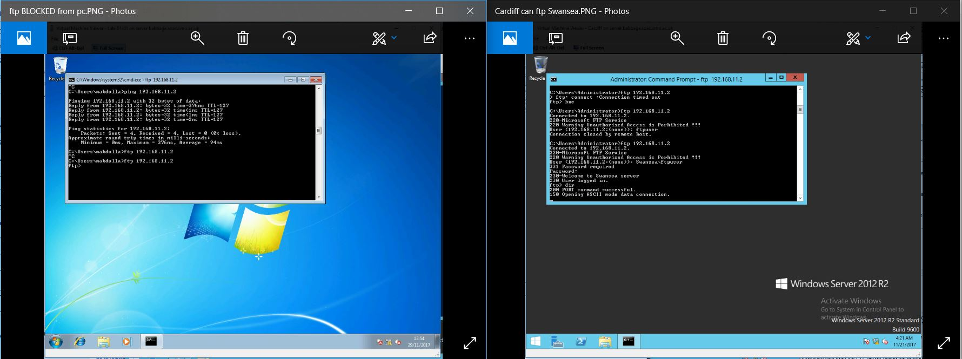

Configuring an outbound filter to allow all networks to FTP Swansea server and Block only Cardiff to FTP our server
In this part we will perform packet filtering by allowing all FTP network traffics (TCP on ports 21/20) going out from outbound interface except the traffic going out from the source IP address of Cardiff outbound to any destination address (255.255.255.255)
c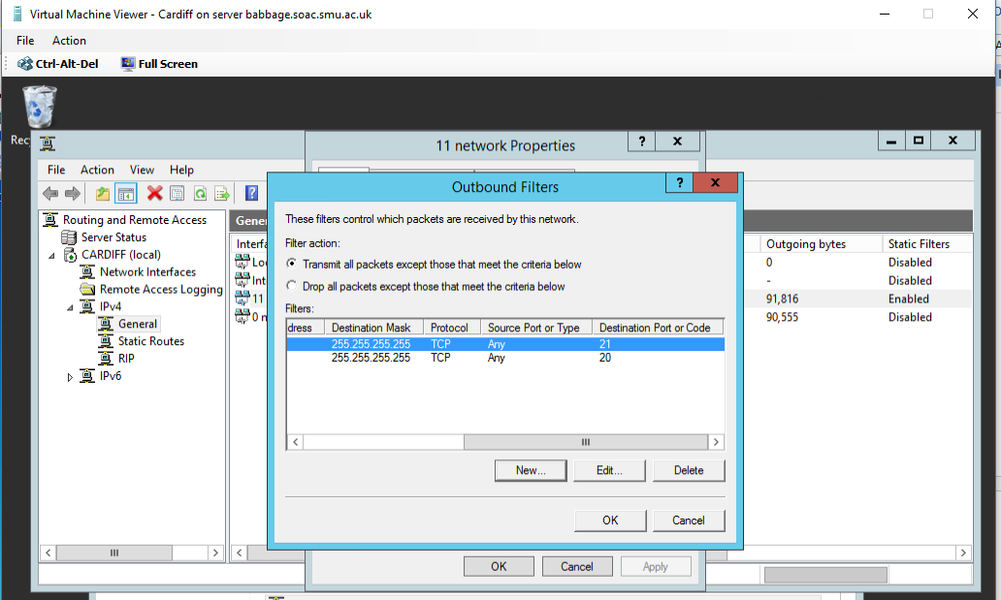
In this case the result also conclusive, Cardiff blocked and the rest still FTP to Swansea server.
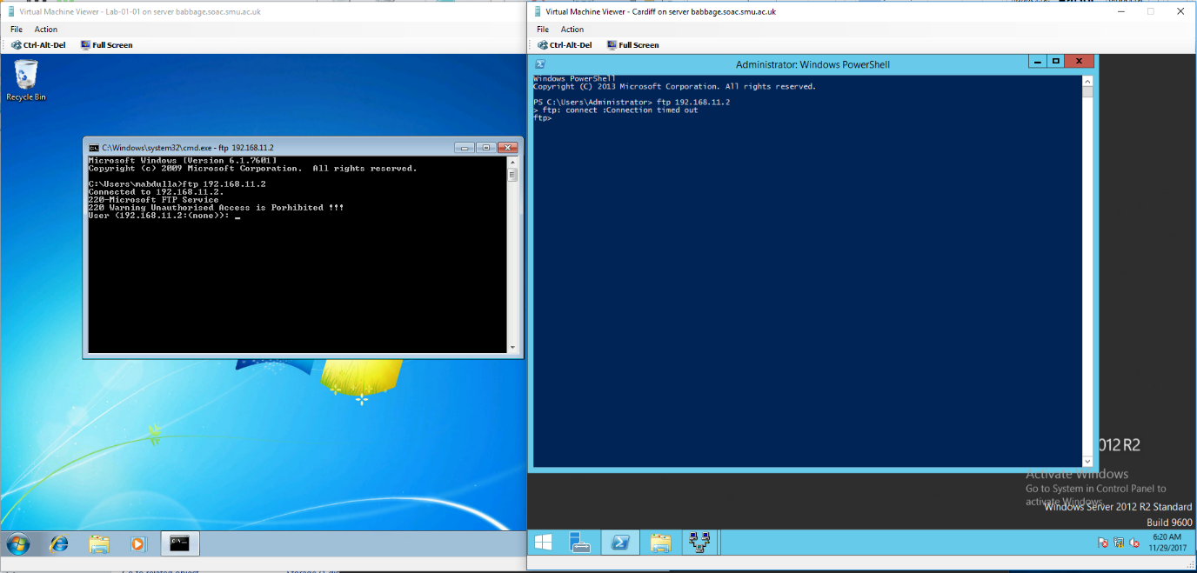

Task 5: Exercise
On this task would be blocking all the other traffics including FTP and pings to go through Cardiff router from all networks to reach Swansea with one exception allowing only Cardiff to FTP Swansea server.
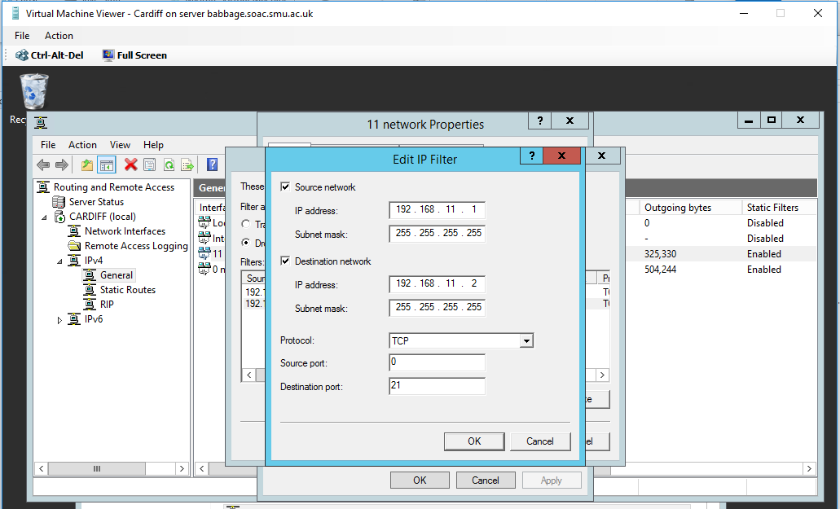
We will configure the outbound traffic on the outbound network card of Cardiff router to drop all traffic except the FTP traffic (TCP 21/20) going from source IP of Cardiff outbound to the IP of Swansea server via port 20/21.

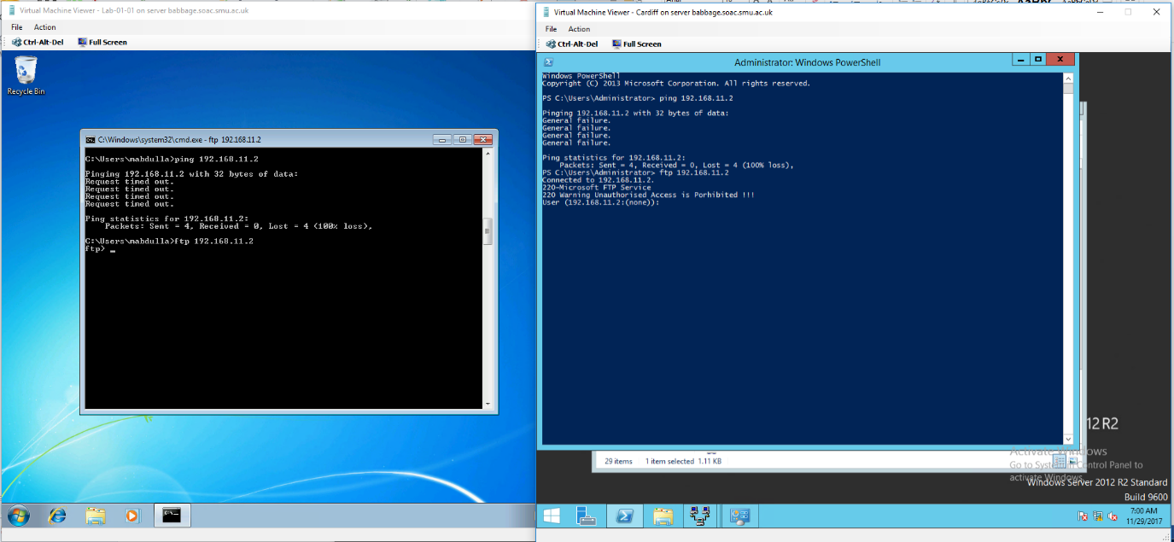
Result of the above filter, only traffic can go through the router is Cardiff FTP Swansea.

Task 6: Observational Tasks
Observational Tasks:

Q1). Describe (using appropriate illustrations) how the ARP process operates in Networking Contexts?

Q2). What is Packet Filtering? In our context, why is Packet Filtering termed ‘IP Packet’ Filtering? Why would you use Packet Filtering in your Network? What are the perceived benefits?

Q3). Why is it possible for contradictory filters to occur when you use packet filtering? Give an example of a Contradictory Filter:

Q4). FTP Server is just one Role/Service we can configure our Server to provide? What other roles can the Server provide that would benefit our Infrastructure in both a local and remote context?

Q1
ARP is a short form for routing resolution protocol, when one tries to pick an IP address on local network segment such as 192.168.1.1.the system has to convert the IP address 192.168.1.1 into a mac address, this is where the ARP is used to change the address.
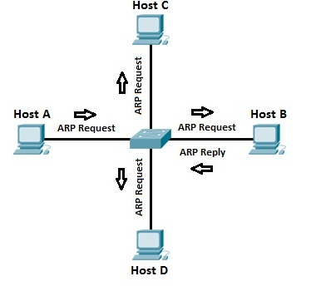
Teachrepuplic.com

Q2).
Packet filtering is termed as a type of firewall method that is used to regulate the network admission by monitoring the moving and inward packets and authorizing them to pass or decompose based on their source and respective endpoint. It is called the IP packet fltering,since the method uses IP addresses to determine the source of various packets. I would use packet filtering since it ensures all contents of any given network are secure. One benefit of this method is that it allows in securing the network by ensuring all packets that enter the network are not harmful.

Q3).
It is likely for contradictory filters to take place when packet filtering is existing due to the fact that it is possible to configure both the input and the output filters interface. A good example is when the input filter in one interface permits the incoming traffic and the interface filter of another interface ending up not permitting the similar traffic to be sent (Wolfe, 2015).

Worksheet 3: TCP/IP Configuration using DHCP (Dynamic Host Control Protocol).
Worksheet -3
Setup of the topology
After configuring the network so that each virtual machine is connected to each virtual network. I.E. Cardiff, Swansea and Lab-01-01 should each have 3 interfaces, with one interface on Network 1, one interface on Network 2 and the third interface on Network 3.

Task 1: Understanding Different TCP/IP Configurations
By using APIPA (Automatic Private IP Addresses) all machine within the network will be able to obtain IP address to be able to communicate with other devices inside the network when there is no DHCP server.
We will use ipconfig/release and ipconfig/renew we will we will auto configure an IP from range 169.254.0.1 to 169.254.255.255 with subnet mask 255.255.0.0
Cardiff APIPA address
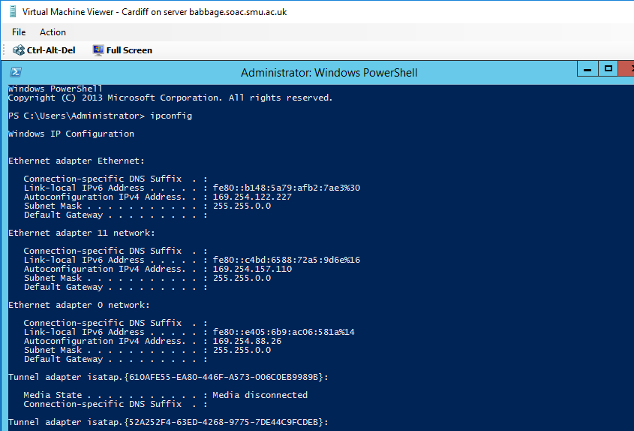
Swansea APIPA address
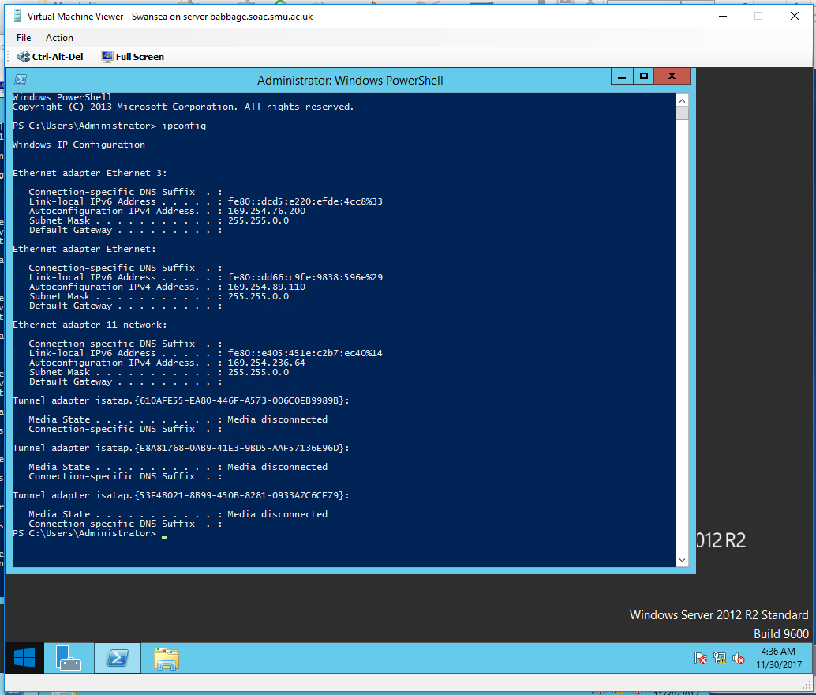

Lab 01-01 APIPA Address
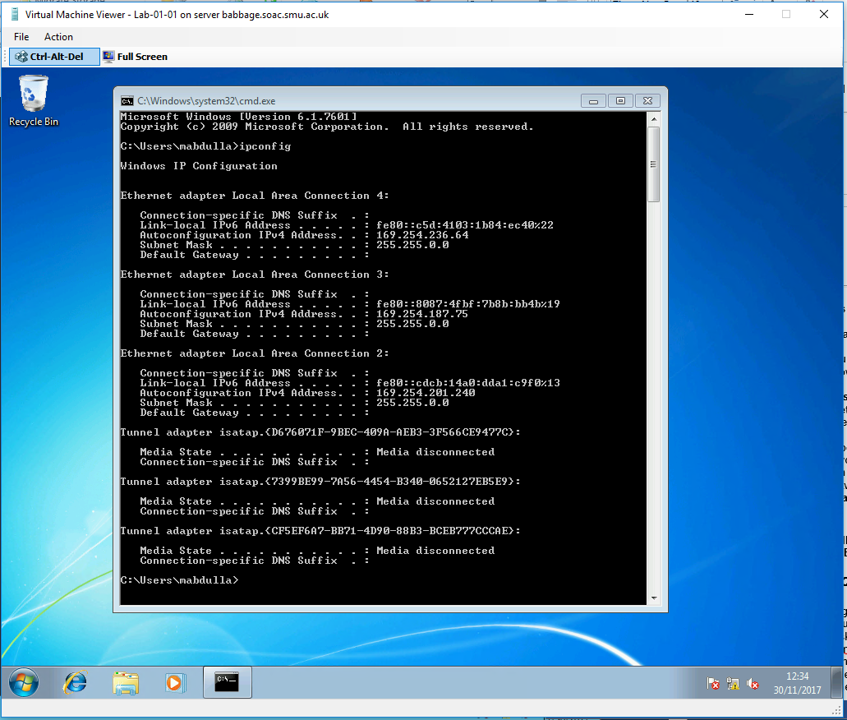
After finishing the auto-configuration of the APIPA address, not all pings are successful some are some not.
Results of PING between Lab 01-01 and Swansea server.
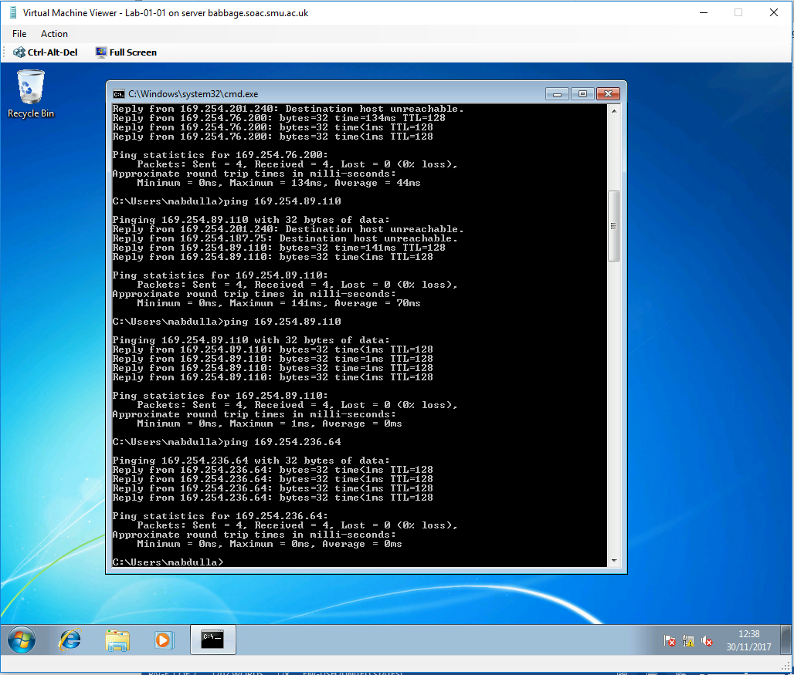
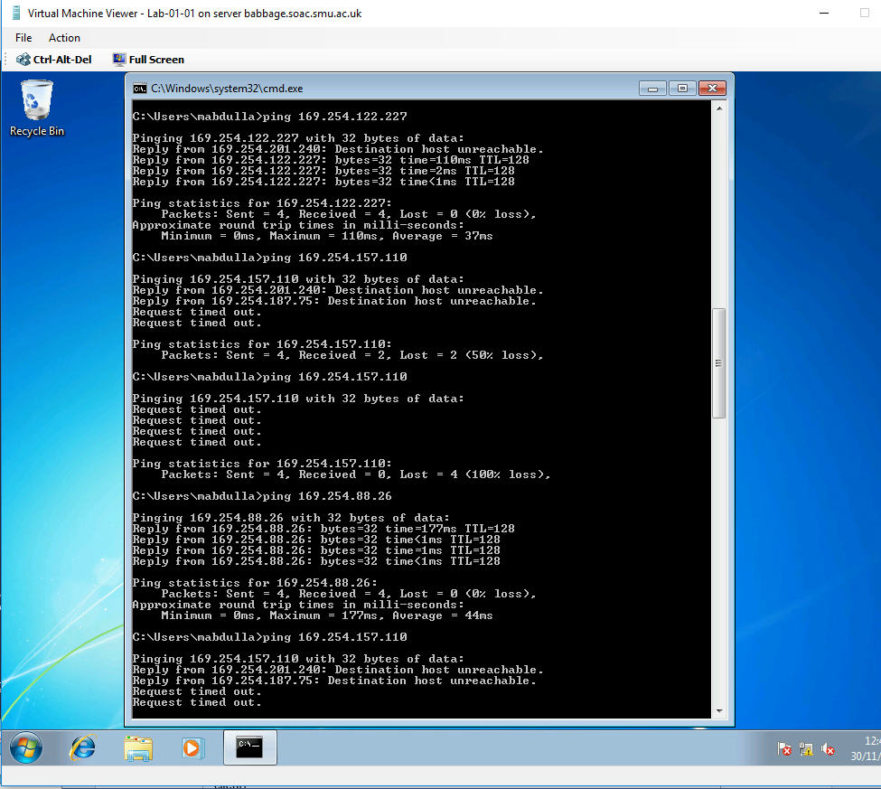
Results of PING between Swansea server and Cardiff server.

Task 2: Installing the DHCP Server on Cardiff
Before starting installing the DHCP server role to Cardiff server we need to reconfigure the IP address to static IP with default gateway, this server will be on charge of assigning the TCP/IP setting and total control over IP addressing inside the LAN.
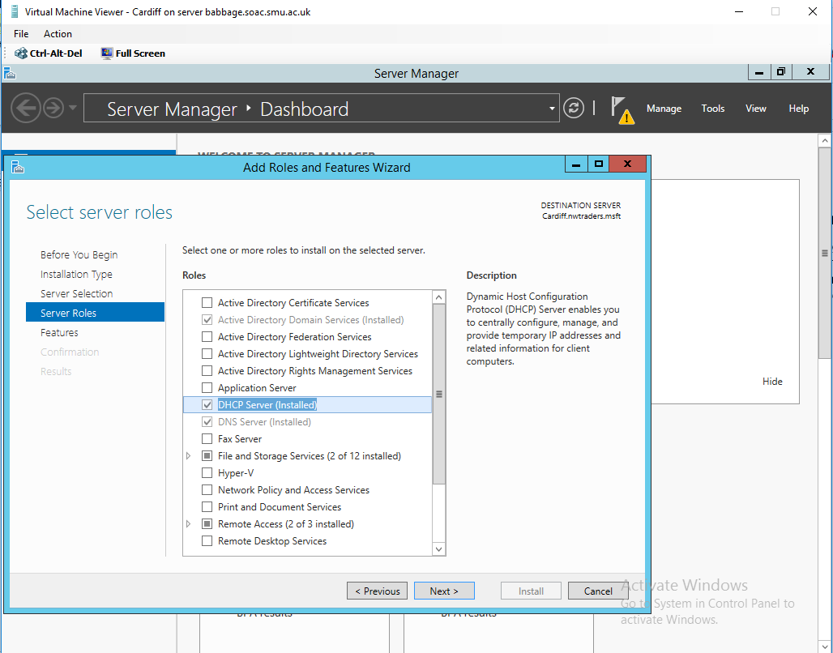

Task 3: Authorising the DHCP Server
For the domain client to receive valid IP address from DHCP server, the server must be authorized in active directory in order to be authorized the DHCP server must be running DHCP console and member server or domain controller in Active Directory domain.

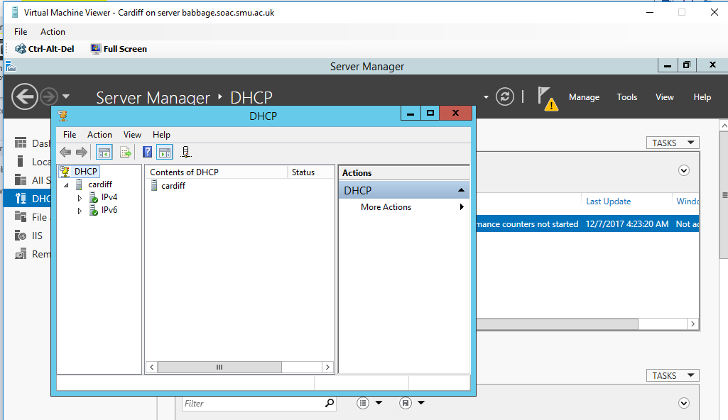

Task 4: DHCP Scopes
Creating a DHCP scope for initialization of ‘Leasing’ IP addresses to DHCP clients on the 0 network
0 Network DHCP Scope (from 192.168.0.2 to 192.168.0.254)
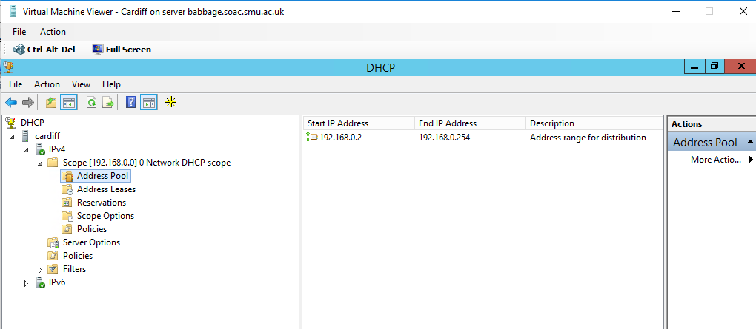

Q . Why is important to use reservation when usin DHCP

Some IPs need to be reserved for test purposes or for example gateway and other services e.g. email and other machine that need to be configured statically

DHCP Client “Swansea Server” obtains a leased IP address from Cardiff DHCP server
On Swansea network connection we set the Internet Protocol (TCP/IP) properties to Obtain IP address automatically and DNS Server address automatically (for future use).
We used the bellow commands to delete the old APIPA address and request new IP address from Cardiff DHCP server.
- Type: ipconfig /release
- Type: ipconfig /renew (to obtain an IP address from DHCP Server)
- Type: ipconfig /all

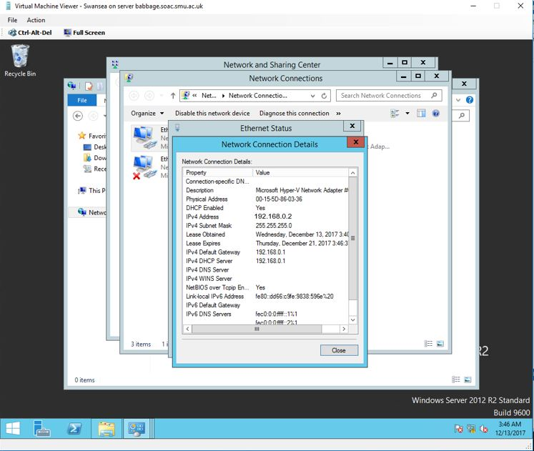
Successfully we obtained new IP address 192.168.0.2 from the scope created (192.168.0.2 -192.168.0.254).

IP address leases on Cardiff DHCP console.
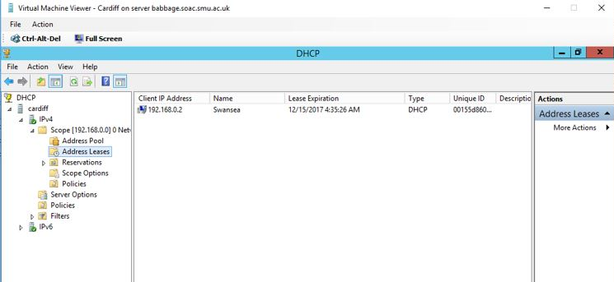

Task 5: Configuring DHCP reservations
IP reservation features is very important , DHCP will reserve some IP addresses so they will never be automatically assigned to any device.
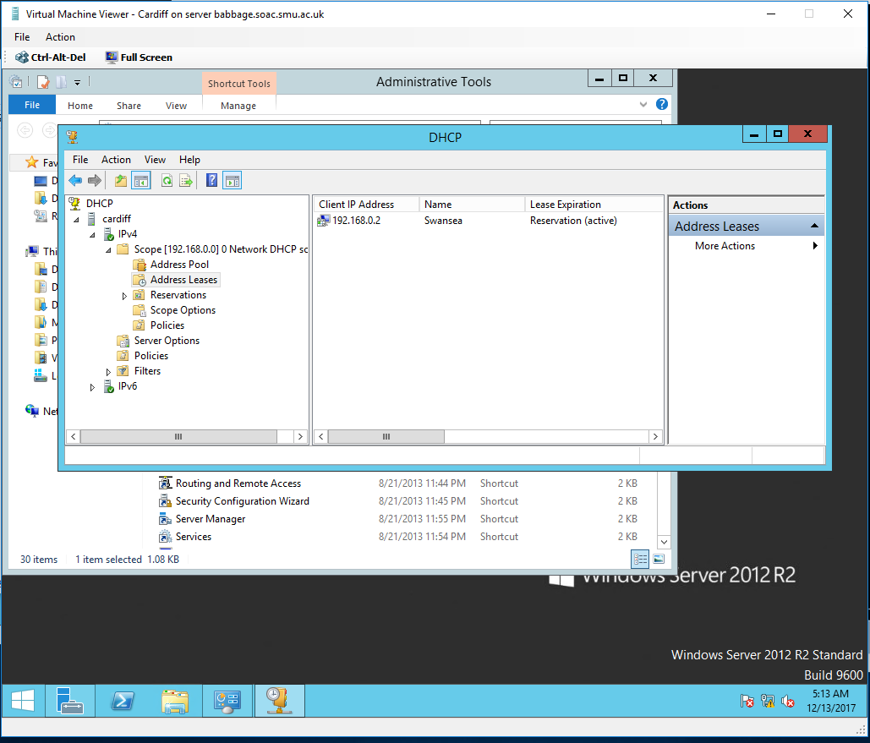
We will convert the single lease 192.168.0.2 – Swansea to reservation by simply sing the right click and add reservation.
After creating a lease for a computer for which we do not have a lease, using the MAC address this time for our Lab 01-01 windows 7 client.We will do associate MAC address 00-15-5D-86-03-3A with IP address 192.168.0.5 association..
Lab01-01 MAC address
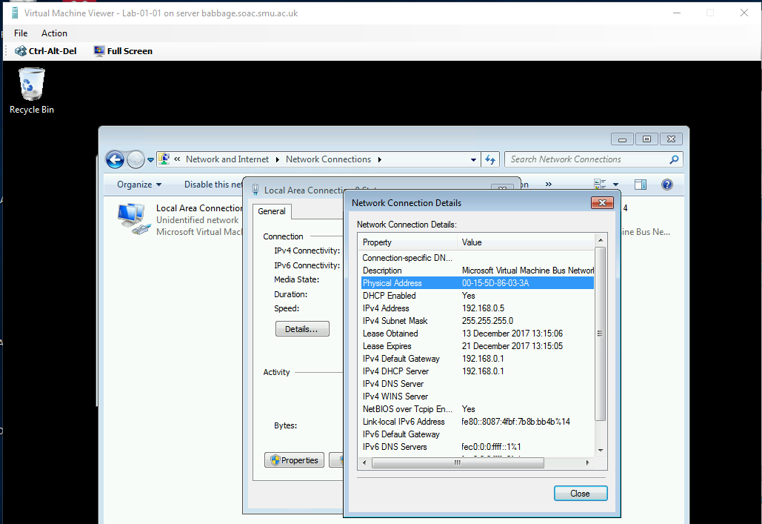

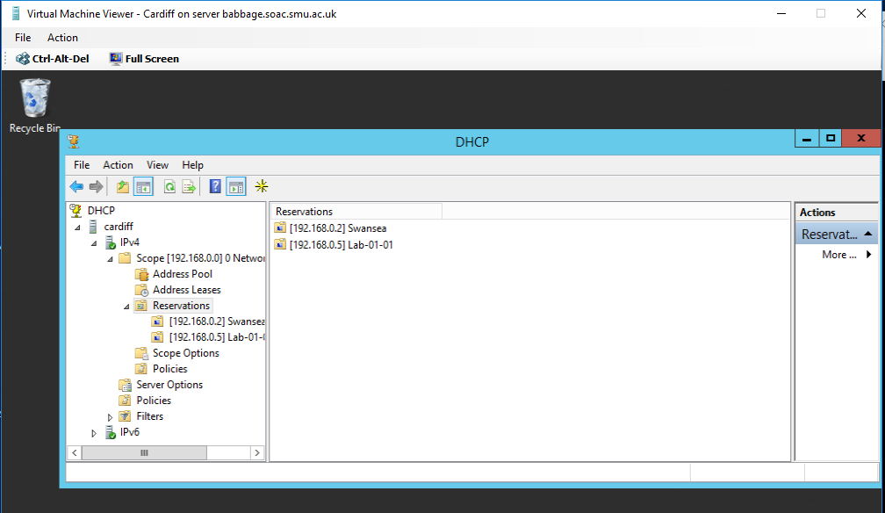
LAB 01-01 IP reservation created using the MAC address
We will test the IP reservation on Lab 1 machine , we will try to delete the existing IP address and will use the renew feature to see if the IP address will change
- “ipconfig /release”
- “ipconfig /renew”
- “ipconfig”

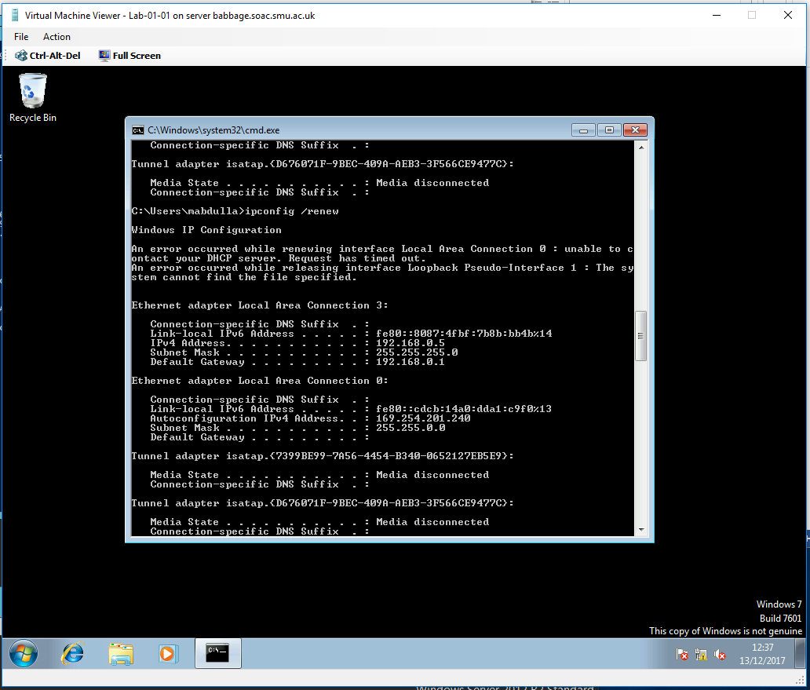
Test result shows that the IP address stay the same when used the renew features renewed, because the DHCP server still have the MAC address of the Lab machine associated with one IP address 192.168.0.5 on his Static Mapping table.

In this part we will be testing if our client Lab01-01 if it will take another IP address from DHCP server after changing its reservation to 192.168.0.3.
IP address doesn’t change.
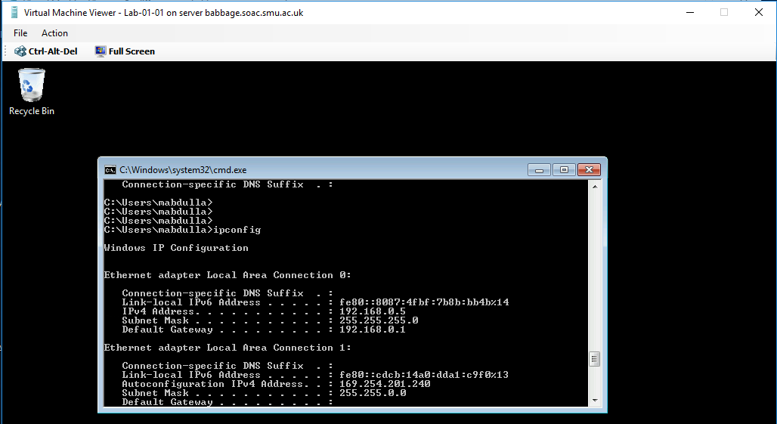
The result shows that the IP address shows that The client keeps getting the same first IP address (192.168.0.5) when the reservation was created using the MAC address, even when we repeat the process of renewing its IP address ( “ipconfig /release” “ipconfig /renew”) we keep getting the same IP address.
The only way to change it would be deleting it from the reservation tab and adding new one.
IP address stay the same 192.16

Questions
Q). Define the role of the DHCP Server in your Network?
Q). What happens when we have dynamically configured TCP/IP for our NIC, but then consequently cannot contact a DHCP server?
A.
Q). Illustrate (with illustrations!!) the 4 stage process involved when DHCP clients look to obtain an IP address via DHCP?

Q). Describe the advantages of using a relay agent. Explain (with descriptions and illustrations) how and why we would setup the Relay Agent on our Router?

Answers:
Q1.

The role of DHCP servers in the network is to repeatedly assign new IP addresses to existing and new hosts that are in a given network (Wolfe, 2015).
Q2.

In such a scenario whereby any given dynamically configured TCP/IP for NIC cannot contact the DHCP server,the system goes ahead and assign itself a private IP address (Wolfe, 2015).
Q3
The process initiates by discover offer request act first where the client sends the DHCPDISCOVER broadcast IP message i.e. 255.255.255.255 .If there are more than one servers on the network, then the port 67 is used to hear the request. The existing DHCP server on the network normally reply using IP lease DHCPOFFER the reply further uses the address 255.255.255.255 but the frame usually is composed of MAC address of the sending client.Hence,only the requesting device is able to receive the offer (Wolfe, 2015). There is normally more than one DHCP server, as a result, the requesting client might end up taking more than one DHCPOFFER and this will led to the sending of DHCPREQUEST to the DHCP server that ends up sending the offer. At the final stage, the DHCP server sends back a DHCPACK to inform the client of the offered information.
Q4.
There are various benefits of using the relay agents. One of them is that it leads to the saving of bandwidth in the local distributed networks.Also,it ensures the load is removed from the GFI Languard server component and distributed amongst the relay agents. The set up on router is normally done by initializing the fa/0 interface, whereby the default gateway is configured and the respective router interface (Wolfe, 2015). The reasons for implementing such technology is because it ensures the routers are able to forward DHCP messages to the DHCP servers and there is response from DHCP servers where the router is able to forward such replies to the client.

Name Resolution using the Domain Name Service (DNS) Worksheet - 4

Task 1: Understanding DNS operation; Planning and deploying DNS

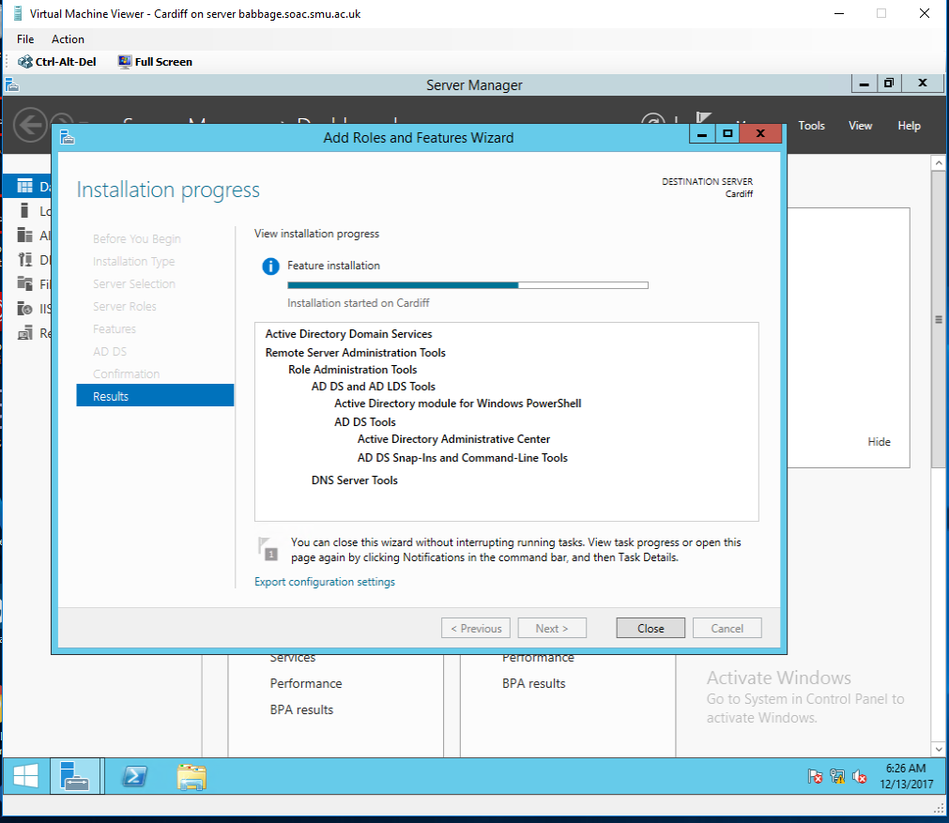
1-1 At this stage we will Installing Active Directory Domain Services on Cardiff server.

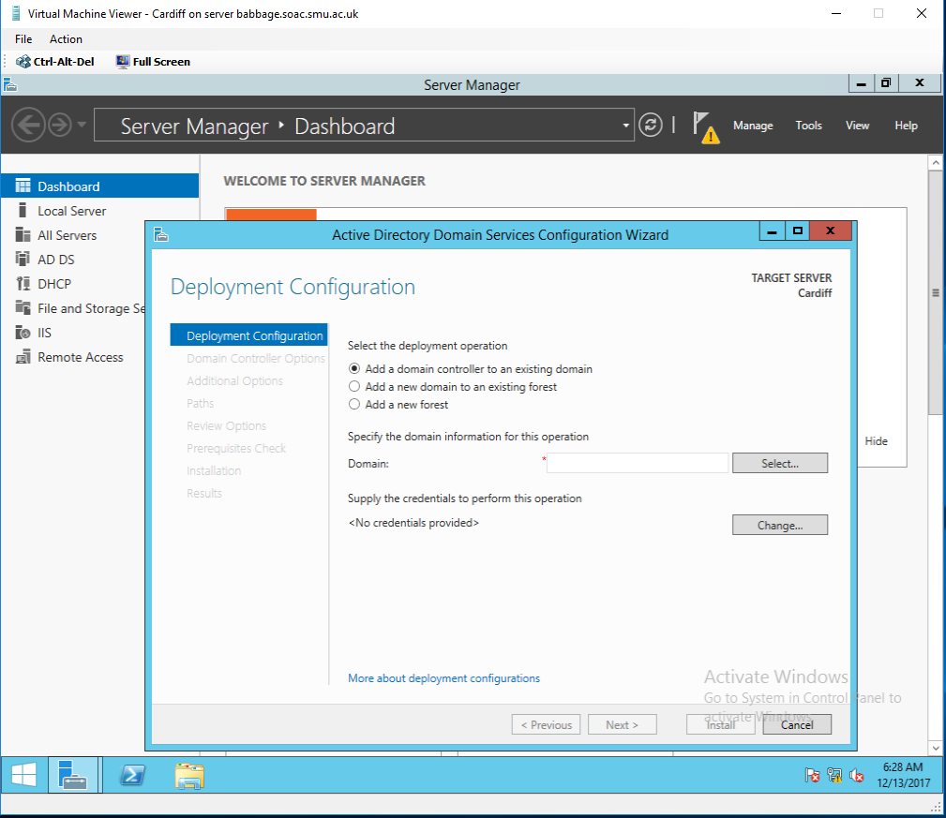
1-2 We will create a new forest using the fully Qualified Domain Name (FQDN) nwtraders.msft.
  - We will give an appropriate Password for the Domain.
Admin password is set to Mohammed77 for this domain.
  - Authorising the DHCP server so it can work on the nwtraders.msft domain.
This was done by simply using right click and authorise as per worksheet 3.
  - Adding Swansea server to the nwtraders.msft domain.
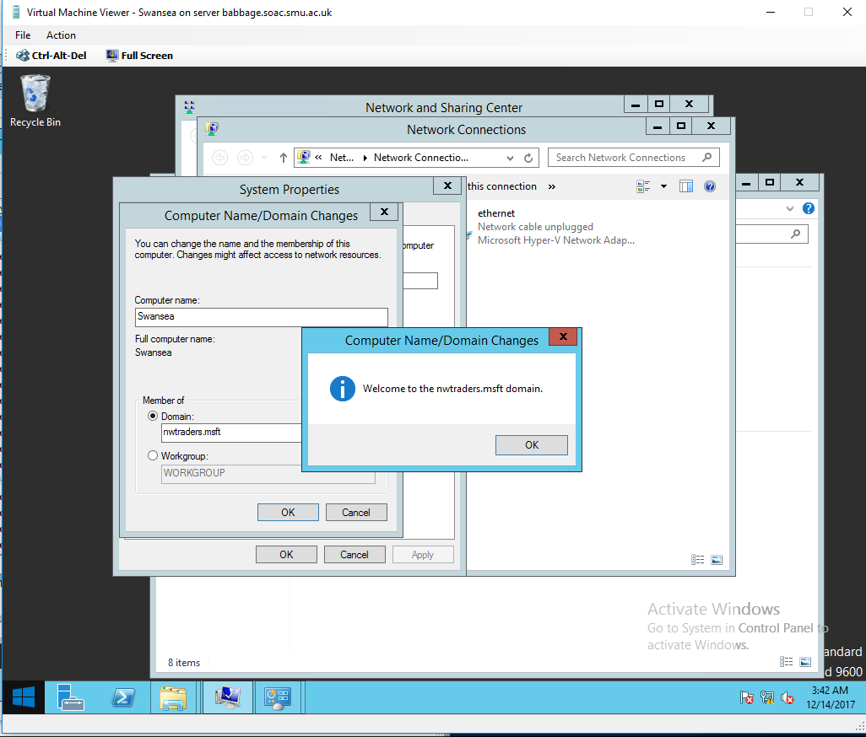

  - We will be adding Lab01-01 Windows 7 client to the nwtraders.msft domain.
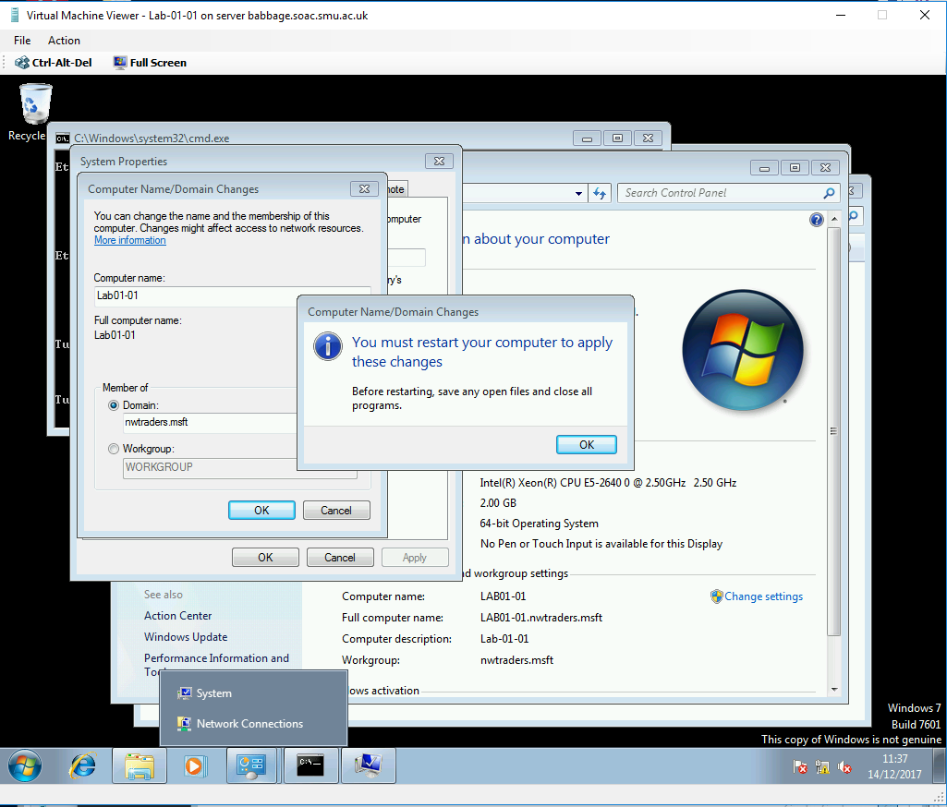

On Cardiff Active Directory Users and Computers console, the 3 servers now exist on this domain nwtraders.msft
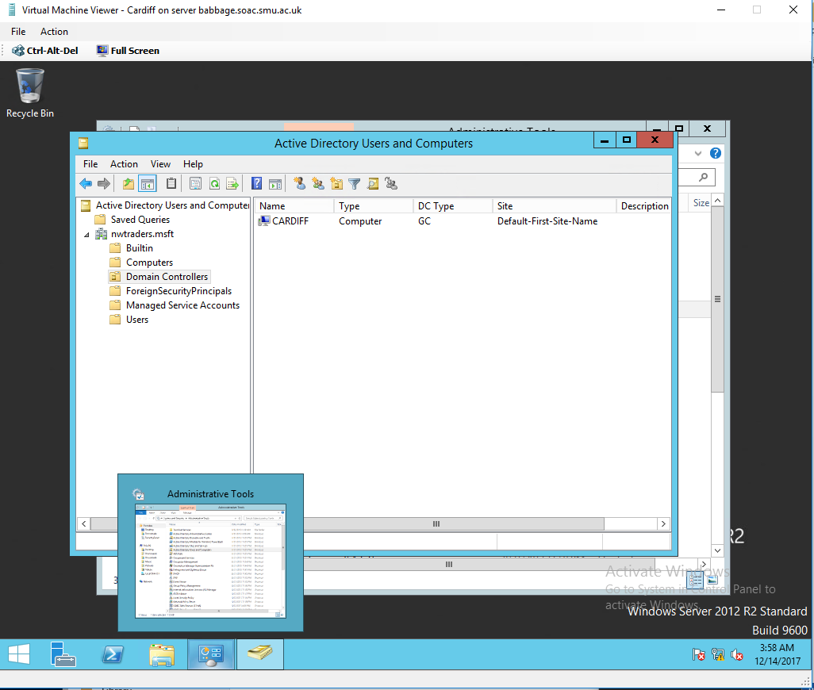
Cardiff Domain Controller

Swansea and Lab01-01 on domain nwtraders.msft
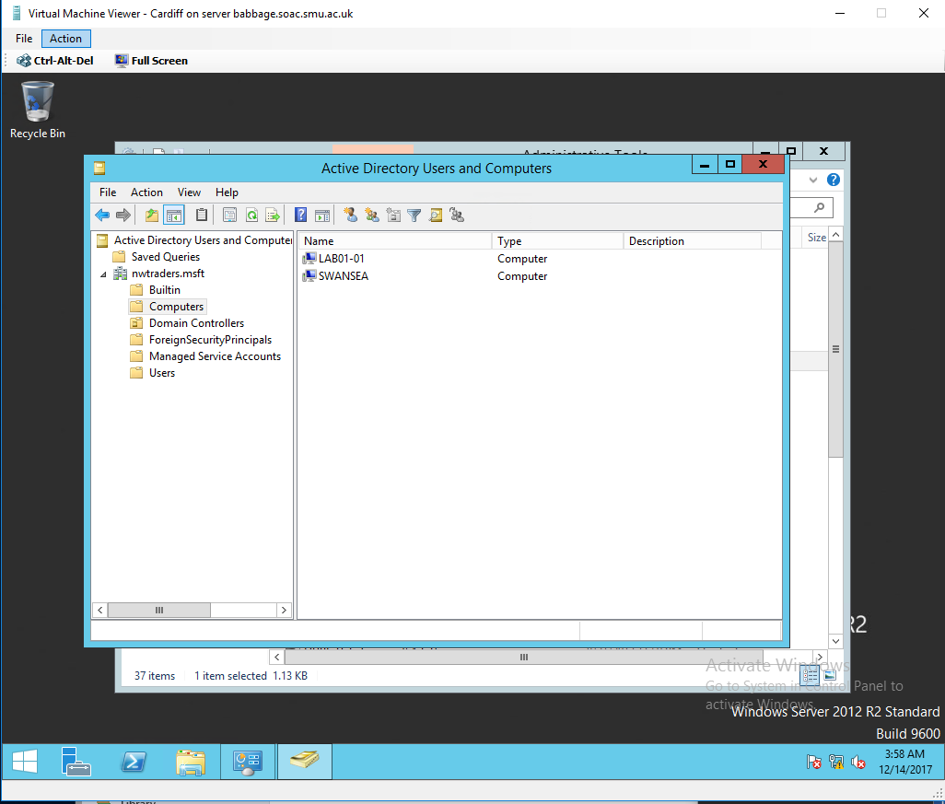

DNS Server Service
Before installing the DNS services on Swansea server we will be first recording the Host Name and Fully Qualified Domain Name of our servers, because this is very important information when trying to map Computer name to logical IP address using DNS namespace service.
Using cmd commands
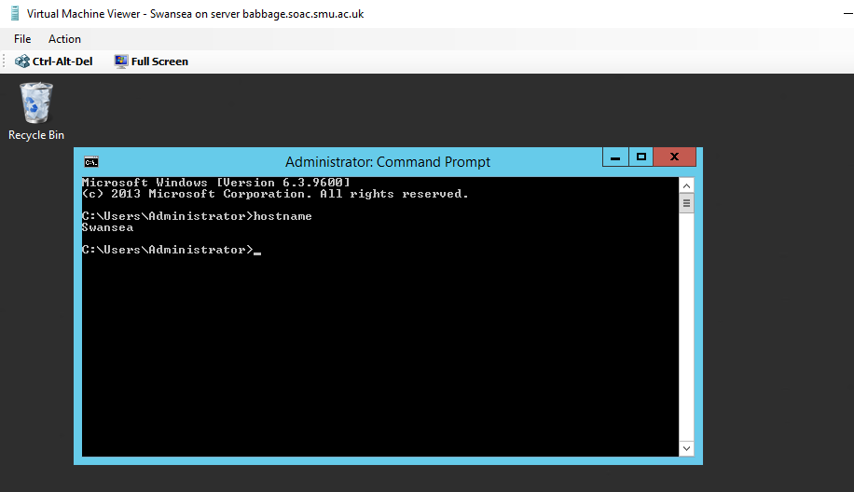
Using Computer properties
Cardiff.nwtraders.msft & Swansea.nwtraders.msft
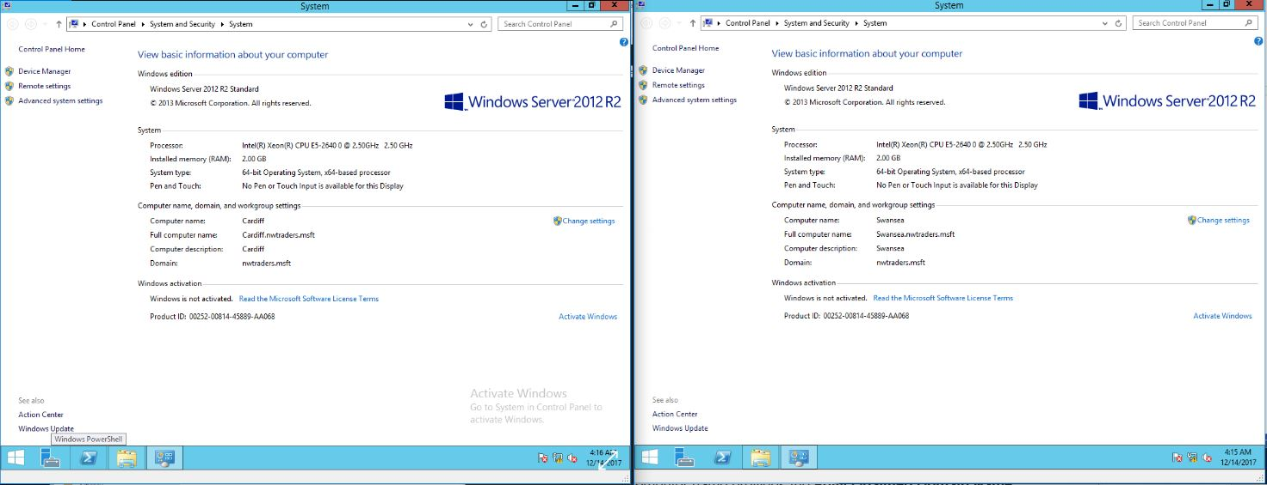
Installing DNS server services on Swansea Server
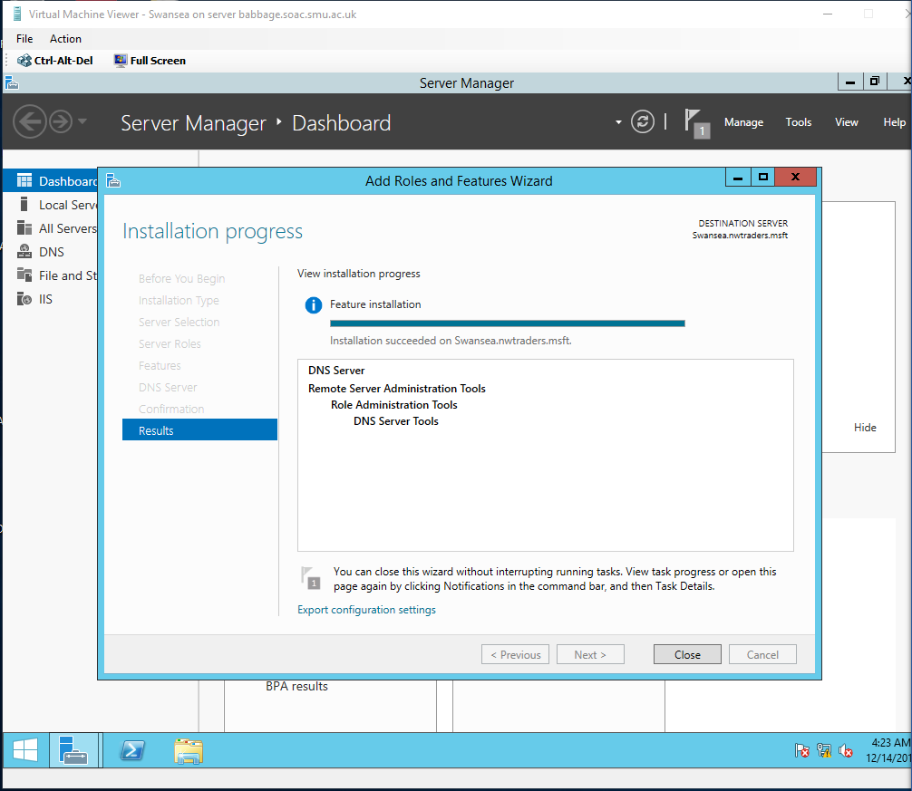

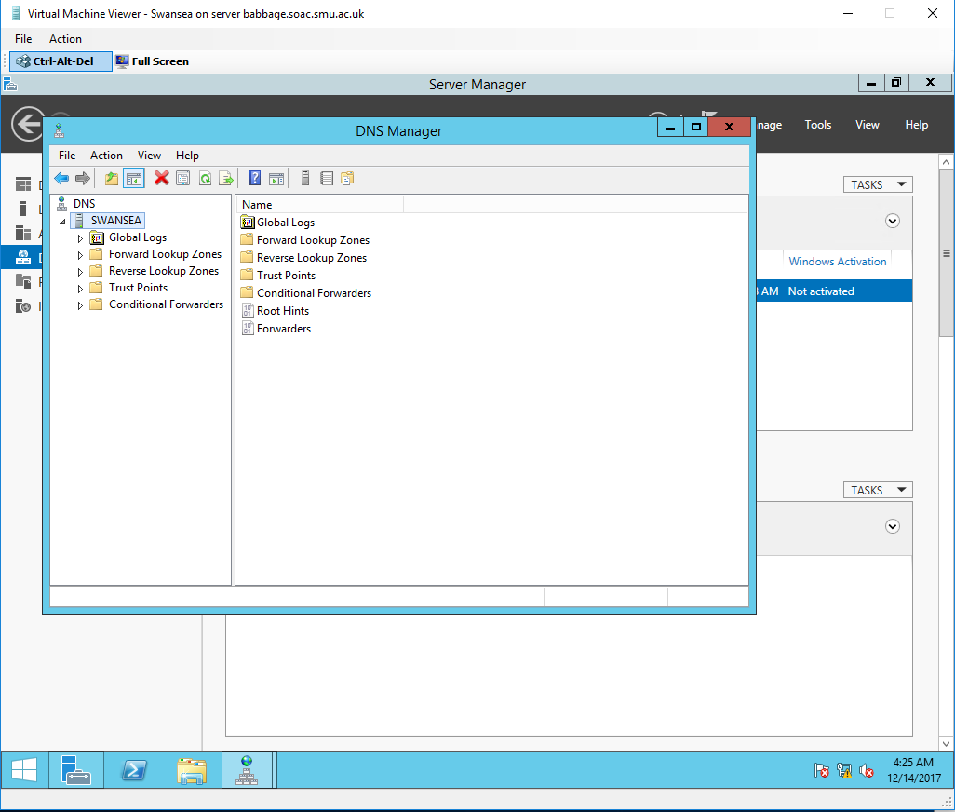

Configuring the Properties of the DNS Server Service.
Q). We will not configure the DNS server at this time, although it is generally a good procedure to make the DNS Server, a Client of itself. In other words make our computer a DNS client, then this client will be a client of the DNS Server we are installing, why is it important do this?

- Demonstrate how you would make this server a client of itself

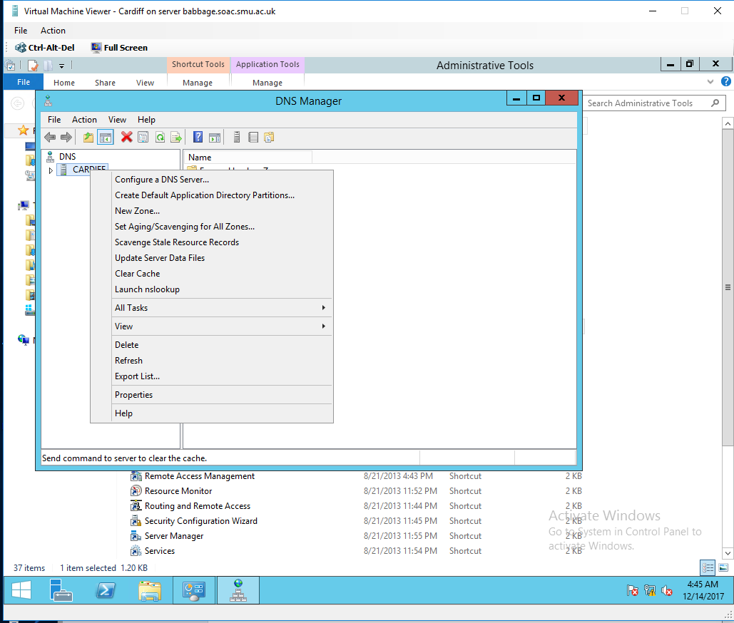
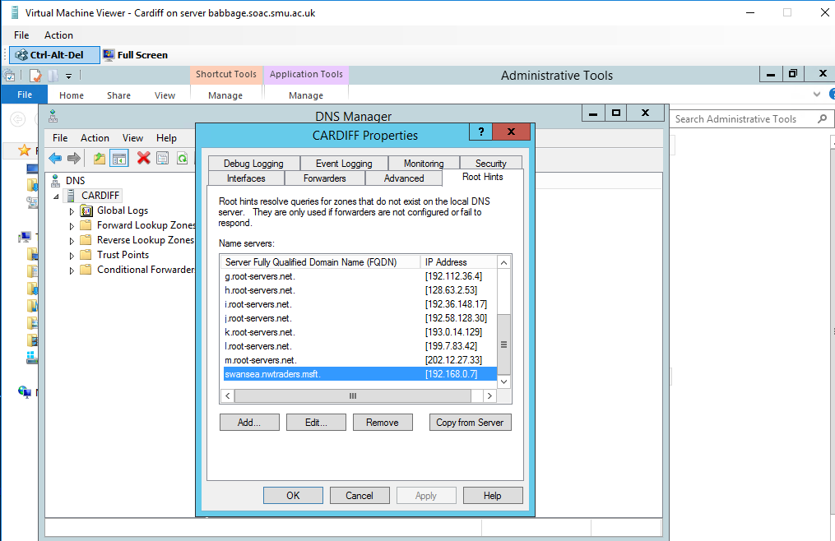
Updating Root Hints on Cardiff server and clearing DNS cache entries.

Root Hints: These are resource records stored on a DNS Server that list IP addresses of DNS root Servers.
Configuring a DNS Server to use a DNS Forwarder
On Swansea server we set Cardiff as Domain to forward into and setting the time out for the forward queries to 10 second.
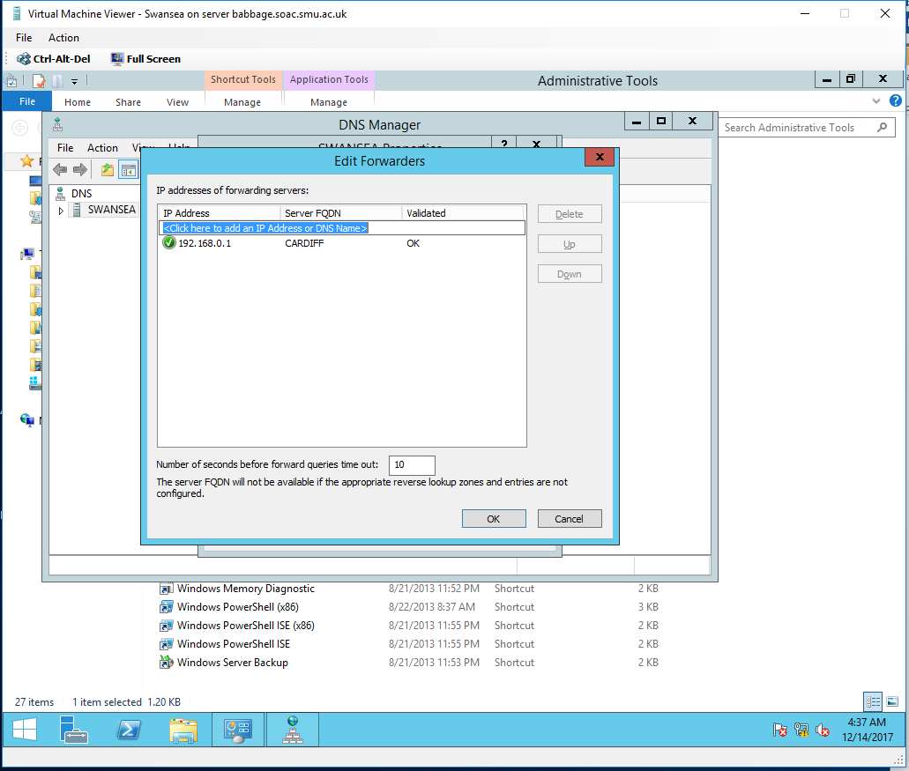
Q). Why is it important to be able to control the DNS cache and in some cases clear the DNS cache entries?

Task 2: Storing and Maintaining DNS Data.
Configuring DNS Zones
In this part we will be configuring Swansea server secondary forward Lookup Zone to the domain name nwtraders.msft and to add Cardiff IP address to the Master DNS servers. Also allowing “dynamic updates to non secure and secure” to ensure that zone transfers are allowed.
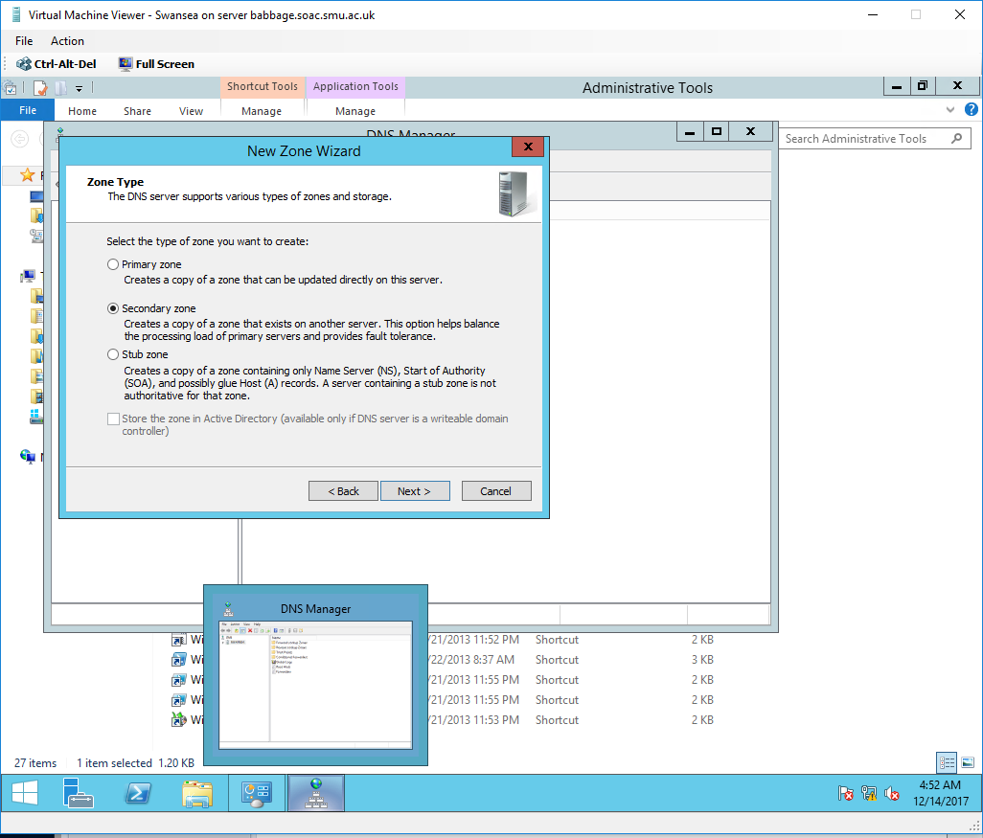

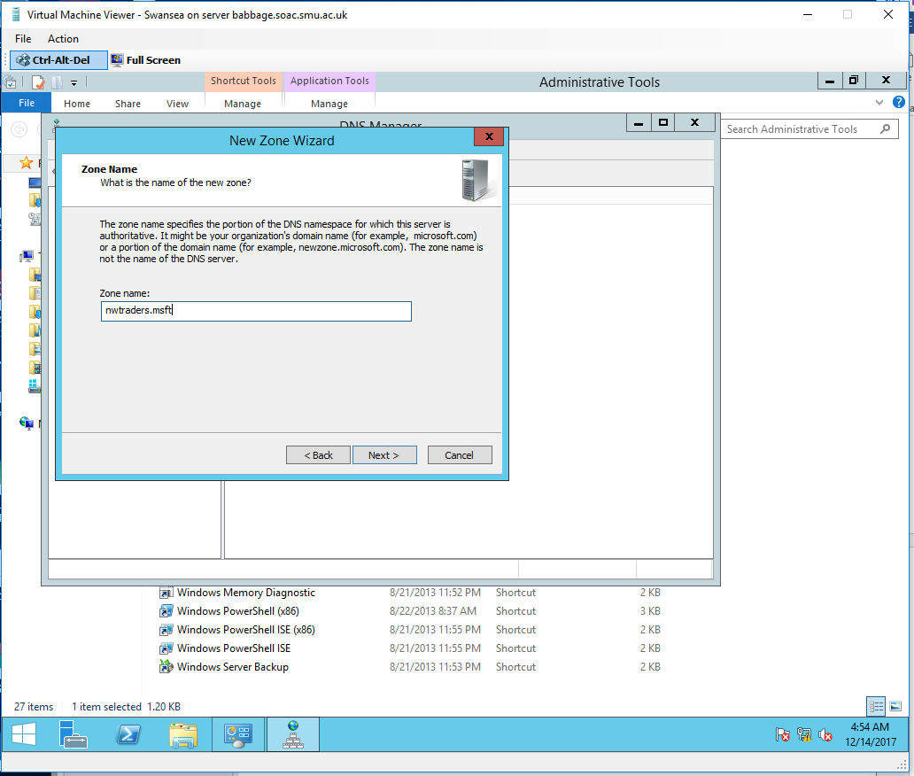
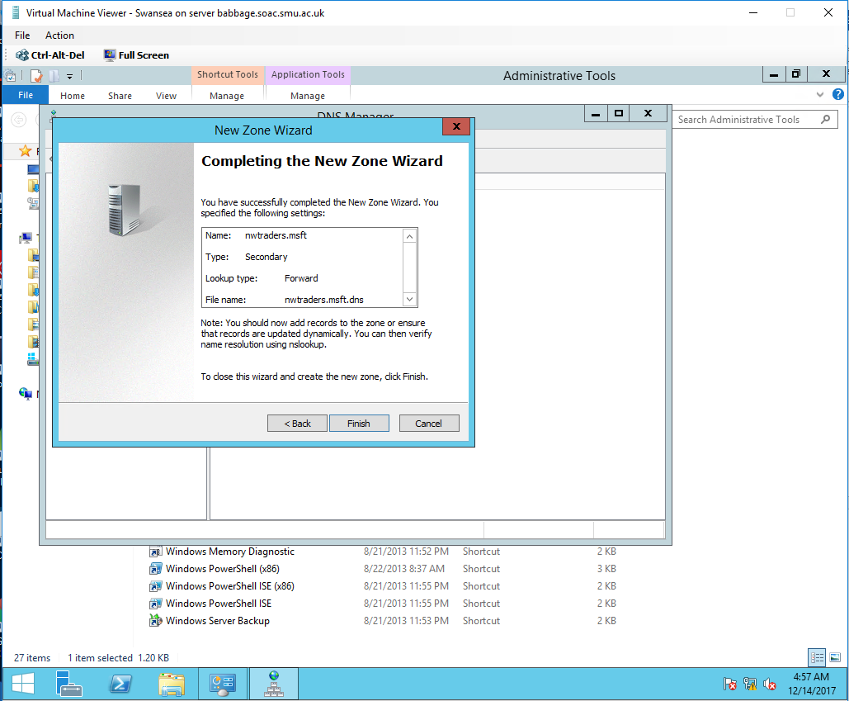
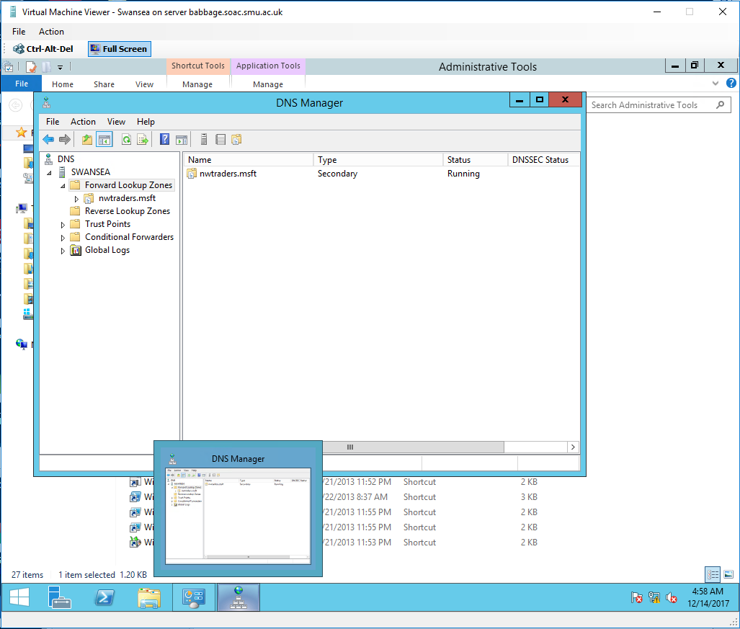

Adding Cardiff IP address to the Master DNS servers.
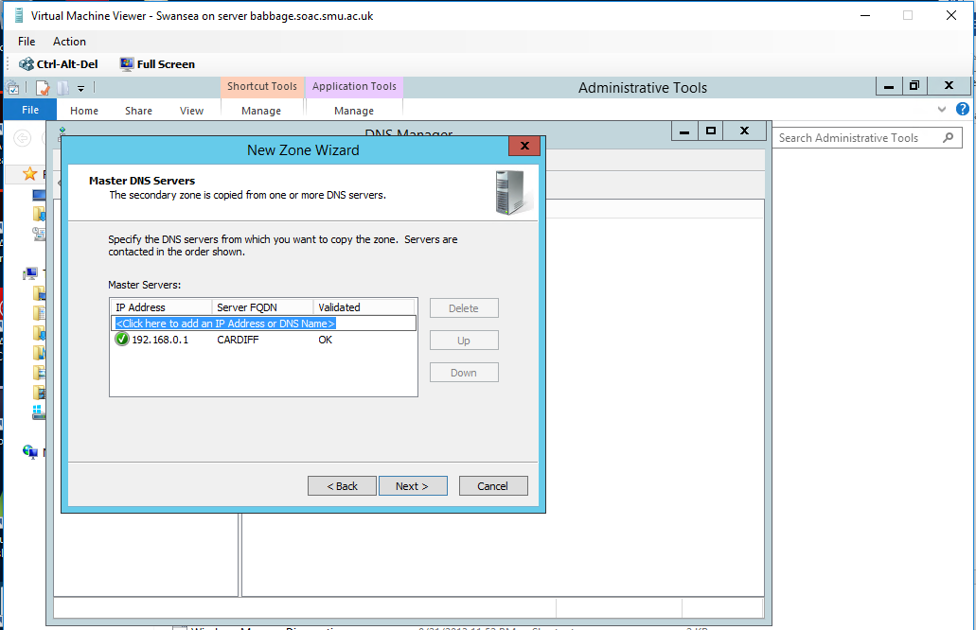

Configuring the Reverse Lookup Zone for Swansea
In this part we will be configuring Swansea DNS server secondary Reverse Lookup Zone to the domain name 192.168.0 network ID of the 0 network and to add Cardiff IP address to the Master DNS servers.
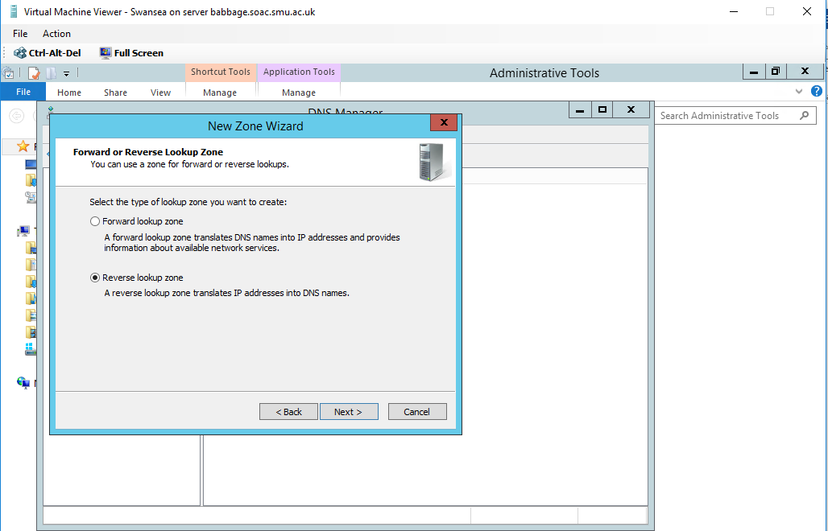

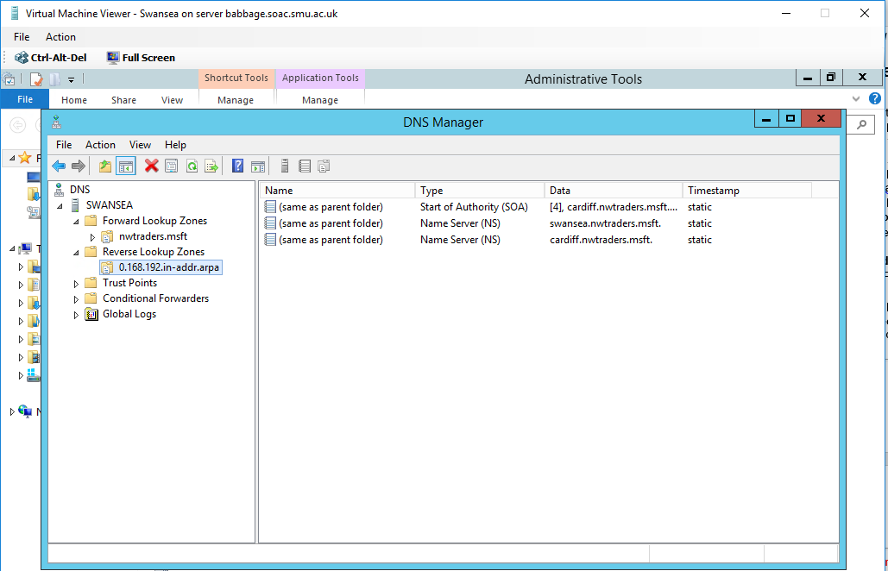

Configuring the Forward Lookup Zone for Cardiff
In this part we will be configuring Cardiff server Primary Forward Lookup Zone to the domain name of the server swanseaserver.nwtraders.msft and we will configure Dynamic update between zones for both non-secure and secure dynamic updates.
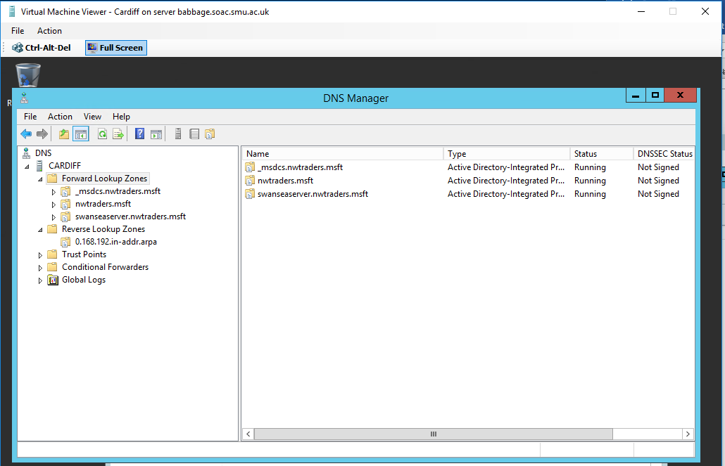
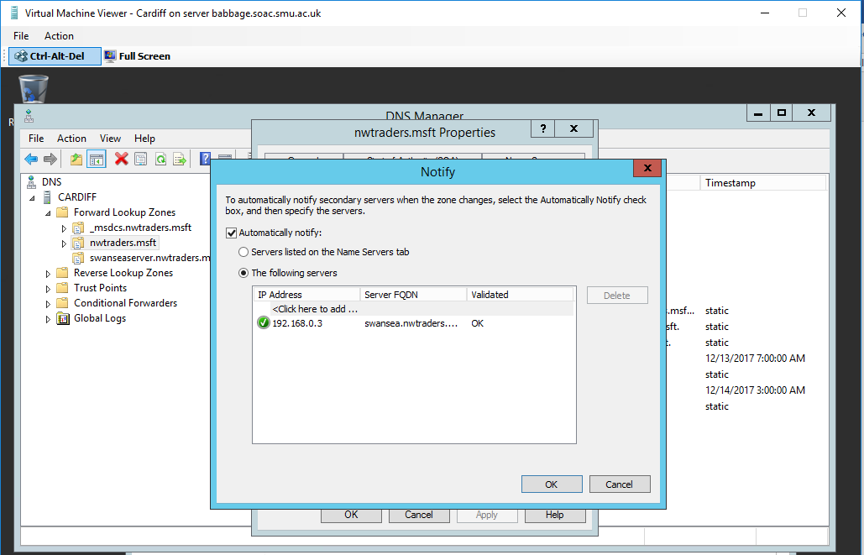
To complete configuring the forward Lookup Zone on Cardiff server, we will add fully qualified domain name (FQDN) of swansea.nwtraders.msft to the Allow Zone Transfers

Task 3: DNS Application
In this part we will Create virtual directory in Swansea server and giving it the alias name test1 using Internet Information Services (IIS), we stored the web content on the local directory Inetpub/www within the local disk and we configured the Internet Guest Account user to have at least modify permissions.
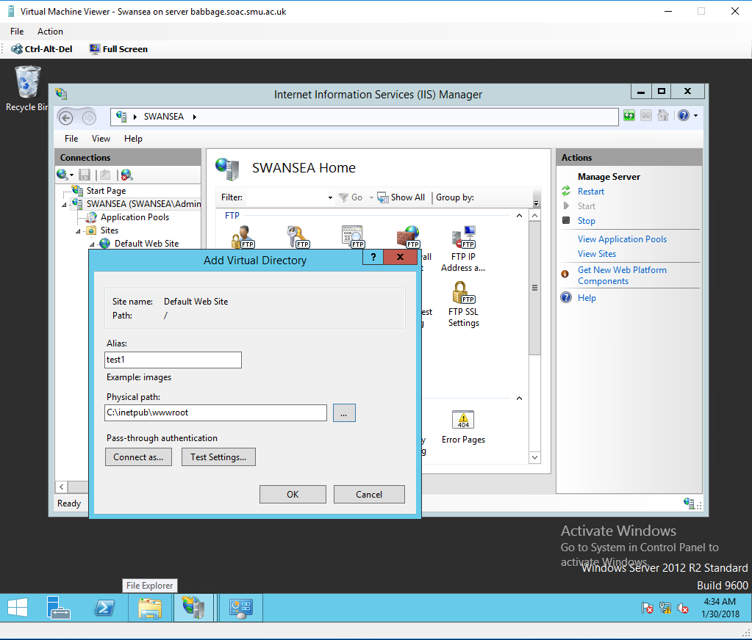

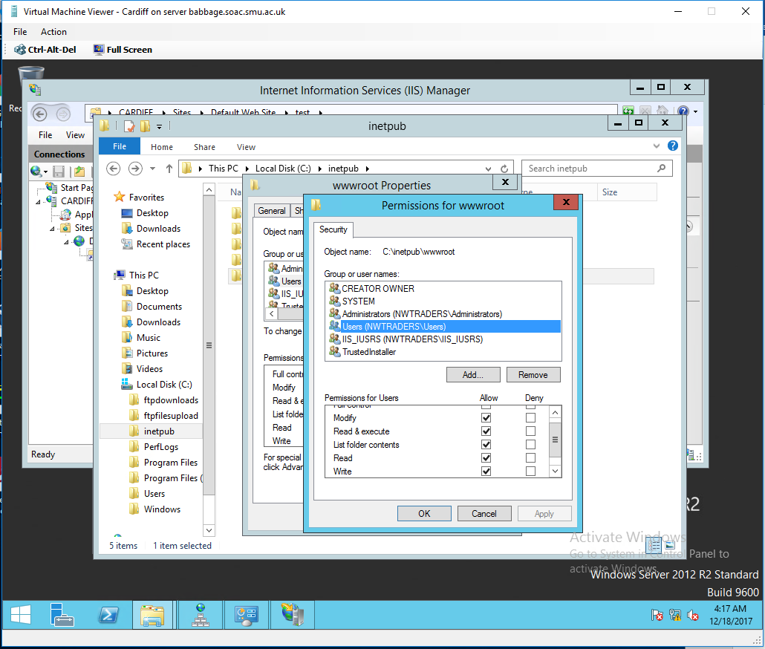

Testing Locally from Swansea server simple web content with hello world html page.
Creating the “Hello World” html page.
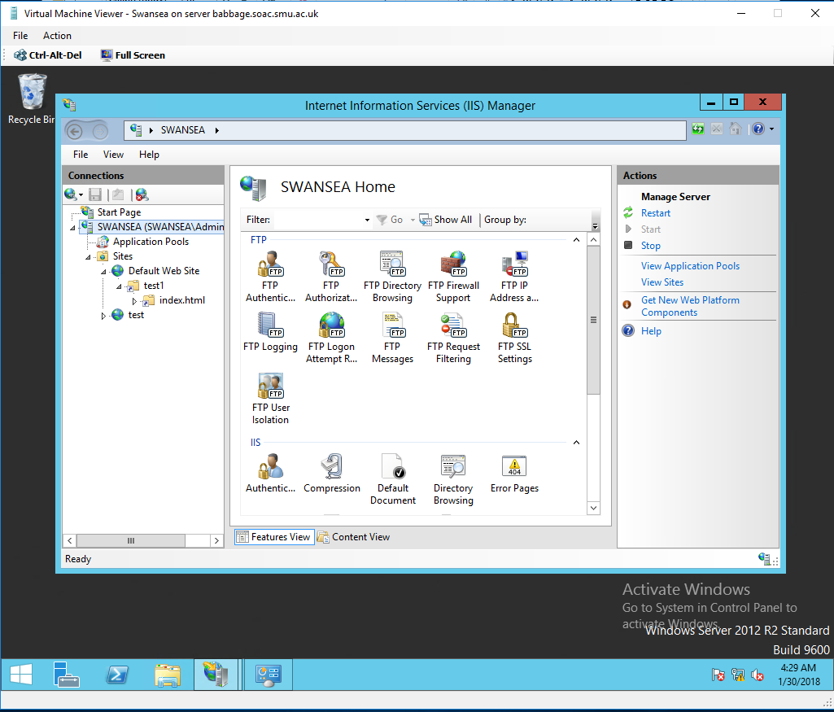
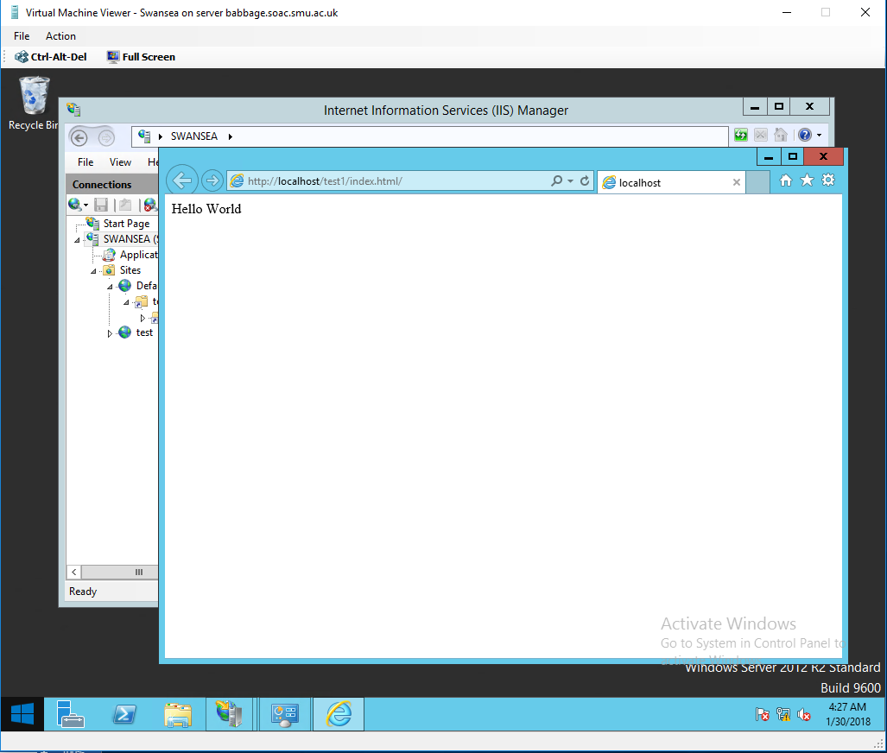
Testing the web page locally

Testing the web page from the lab machine
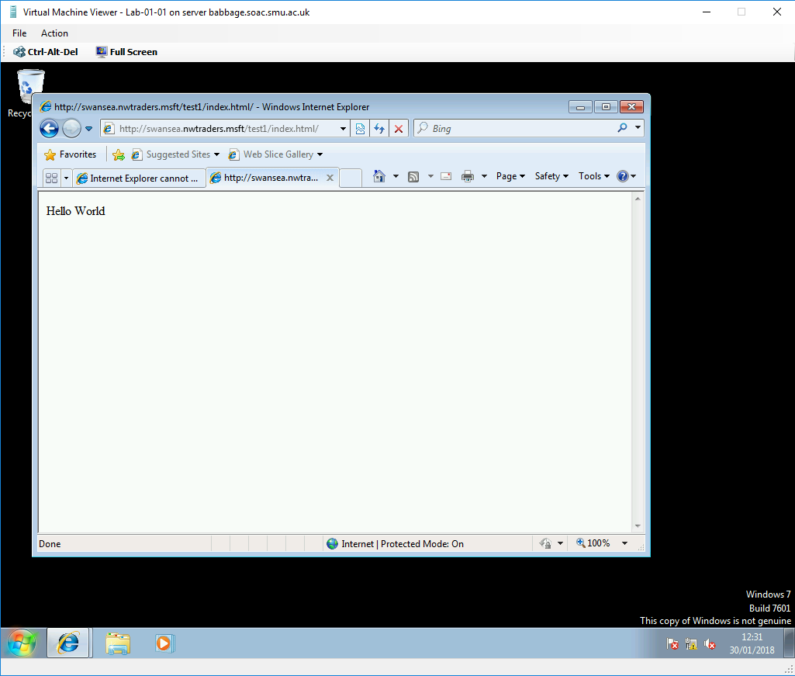

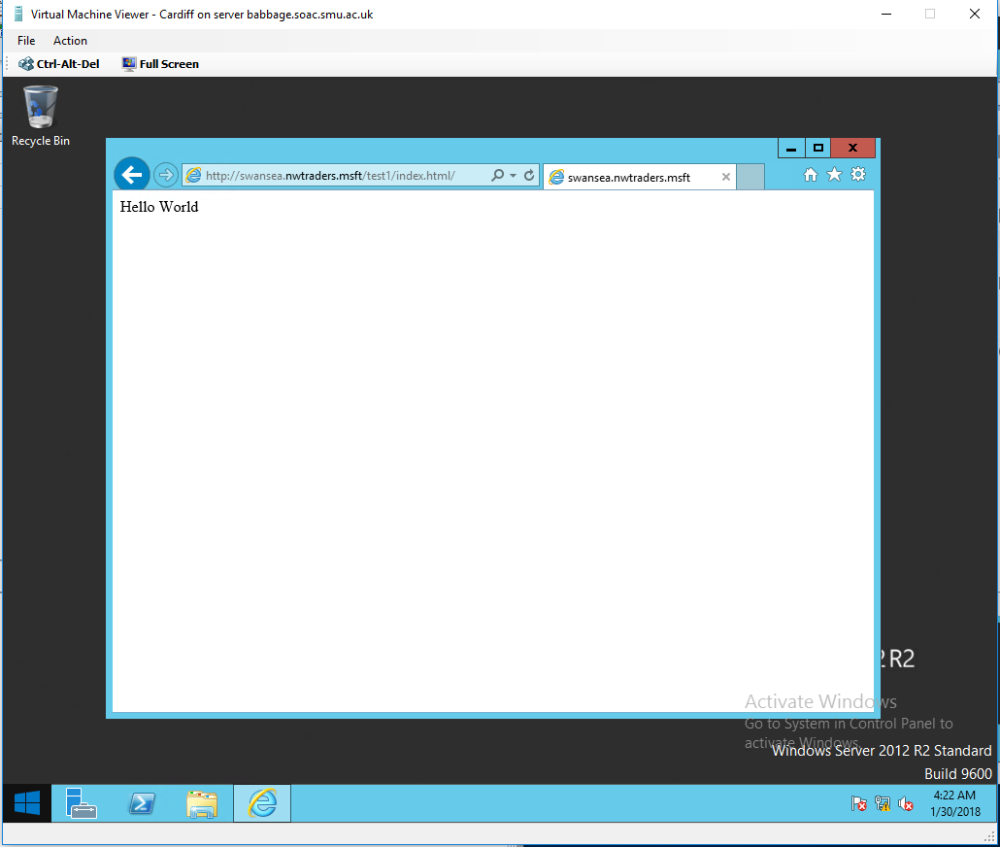
Testing the web page from Cardiff Server

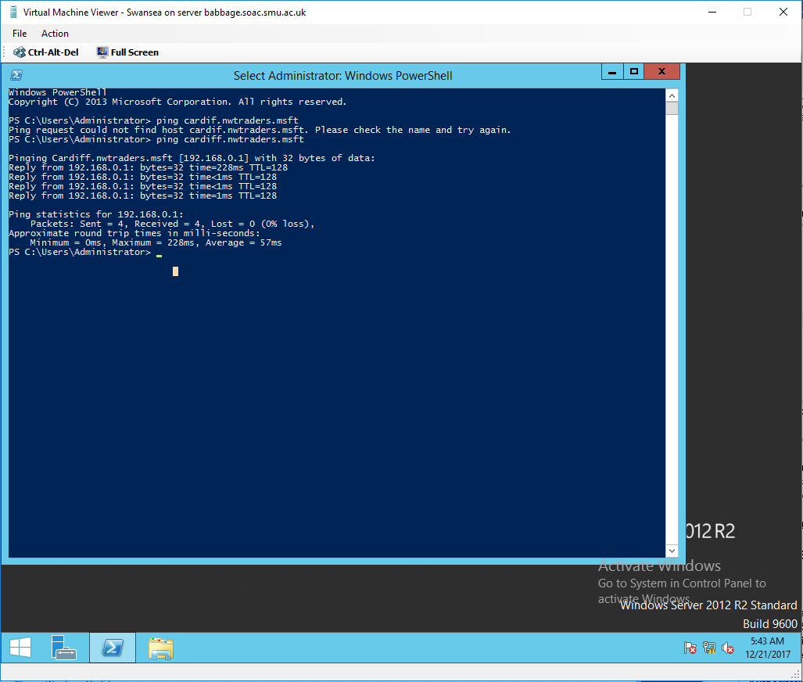
Small demonstration from Swansea server using PING command to show that DNS server is able to translate the FQDN of Cardiff server into IP address (Ping Cardiff.nwtraders.msft)

Task 4: Observational Tasks
Q1). What steps does a client take (what is the process involved) when trying to resolve a Name to an IP address?

A. A query in question seeks to match the domain with the corresponding IP address. The first server usually interacts with recursive resolve that can be operated by the ISP.The recursive resolve knows with other DNS servers need to ask the original query. The client usually initiates the recursive resolve to ensure necessarily matching is done (Wolfe, 2015).

Q2). Describe how the Recursive Query and Iterative Query Processes resolve DNS Client Requests?
A. In recursive query, the DNS client needs the DNS server to reply to the client with either the source that is requested or the error message that informs the domain name or record the existence of such (Wolfe, 2015). On the other hand, the interative name query,DNS client permits the DNS server to return the best response it can give that is normally based on its zone data or cache.

Q3). Explain the significance of root hints and how this process enables us to resolve names that are not managed (or kept in an authoritative DNS server in our network)?

A. Roots hints are of importance with respect to they enable the resolving names that are not managed. This is facilitated by the fact that root hints are able to offer a list of preliminary resource records that can be used by DNS service to locate other DNS servers that are authoritative for the root domain of the DNS domain service tree (Wolfe, 2015).

Q4). We have a Server called Server1, this server will be hosted in a subdomain called ‘subcontA’ with a root domain called nwtraders.msft, answer the following questions:

(1). What is the exact FQDN for this host.
(2). Illustrate how the Domain Name System breaks up this FQDN into Host and
Domain Namespace.
A. When doing so,the Host is usually based on the name of the network which is nwtraders and the domain name space which is the .msft.This makes it is usually facililated by administrative authorities to achieve such breakdown.

Q5). Explain how DNS Zones are used in DNS, give examples to illustrate the use of multiple
zones and how these can be used to manage resource records of domains. What
important factors/characteristics do we need to be aware of?

A.
With respect to how the DNS zone is applied, in first instance, DNS zone involves the use of administrative portion of the global DNS namespace.Factors such as name of the zone, Same zones and multiple zones played a role in creation of DNS (Wolfe, 2015).

Worksheet 5
Evaluating Clustering Strategy

Introduction
Web hosting is universal characterised by a general pattern that is applicable in most situations in the computing sector. The highest level in web hosting supports the server applications that generate web pages, which have dynamic and static content over HTTPS or HTTP. The main component in web hosting is the application server; however, to have a reliable, secure, high performing architecture there are various other components that are required like firewalls, load balancers, file repositories, transformation and connectivity functions, robust security, enterprise data and content delivery networks (Cloud Standards Customer Council, 2016). The 3-tier clustering web hosting strategy evaluated in this paper establishes the core tools, technologies and components that are required in a web hosting solution.
The 3-Tier Web hosting Architecture is a unique strategy for developing a database-based web application that works around the client/server model made up of database tier at the bottom, the middle application tier and at the top, the client tier. This inclusive web clustering architecture is the most used to host applications over the Internet. The clustering strategy is grouped into 3 main parts, with each distributed across a network (Kreger, Pleasant, Lonesome, Schalk, Sivakumar & Iyer, 2016). The figure shown below displays the 3-tier clustering architecture of a web hosting solution.
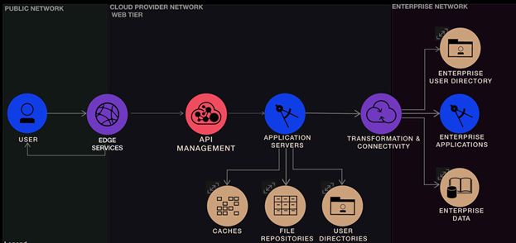
Figure 1: 3-tier clustering strategy (Source – Cloud Standards Customer Council)
This clustering strategy has 3 tiers that contain components corresponding to each tier. All layers in this 3-tier strategy have security applied to them.
- The public network or client tier consists of the user interface or web browser as well as edge services which connect external devices to the internet services.
- The Web tier consists of the data, application, user services, as well as connectivity and transformations functions that connect the record system to the application.
- Enterprise network or database tier consists of enterprise data and its associated applications (Kreger, Pleasant, Lonesome, Schalk, Sivakumar & Iyer, 2016).
First Tier: Client tier – tools and technologies
In a normal 3-tier clustering strategy, the user's workstation consists of a programmed graphical user interface and interactive windows or suitable entry forms for an application. In this tier, the output/results of the web service is organised into a form that is readable and useful to the client. The client connects to the internet from various systems and devices. In this tier, edge services consist of network service capabilities necessary in the delivery of content to the web applications as well as its clients via the Internet (Kreger, Pleasant, Lonesome, Schalk, Sivakumar & Iyer, 2016). The tools and technologies consists of:
- The Domain Name System server that maps the URL for a certain internet resource to a system’s TCP-IP address capable of delivering the web resource to the user.
- Content Delivery Networks (CDN) these are geographically distributed server systems deployed to decrease response time when serving web resources to users who are geographically distributed.
- A Firewall designed to manage communication with a system, with the aim of permitting only traffic that meets a set rules or policies to proceed while blocking any other traffic.
- Load Balancers that have the role of distributing network traffic across various resources (like computers, or network links) in order to decrease response time, maximize throughput, develop capacity, and foster applications’ reliability (Kreger, Pleasant, Lonesome, Schalk, Sivakumar & Iyer, 2016).
Second Tier: Web Service Tier – tools and technologies
The web services tier consists of the logic that is used in generating dynamic online content. This involves retrieving data from databases, files, HTTP-services and sensors among other data sources (Leite, Kusic, Mossé & Bertini, 2010). Also, this tier engages in programmatic production of fresh information or data. In addition, both application and web servers can be instantiated with separate application and web servers. Application servers are used to access databases or various other systems. The components in this tier include:
- Application Servers that provide web server functions as well as an incorporated application server function when needed. The web servers return resources (like web content) following a HTTP request. Application servers support clustering among other scaling configurations such as auto scaling depending on the application server demands (Sterrett, Sun & Tahir, n.d).
- Caches that store temporally information required to meet the application server request (Adenubi, Lewis & Abimbola, 2014).
- The file repositories, which are applications or devices that store data, information, etc. in files.
- The User Directory that retains user credentials and IDs necessary for validating user access to applications or information in both application and web servers (Kreger, Pleasant, Lonesome, Schalk, Sivakumar & Iyer, 2016).
Another component is API management capabilities that publicise to the application the accessible services endpoints. They are the foundations for transformation and most of the connectivity functions. API management include the following capabilities:
- API Discovery/Documentation that allows mobile developers to locate and utilise APIs in a secure way.
- Management that allows management view of API utilisation by online applications as well as mobile apps through information gathered from mobile backend, gateway, etc.
Another component is the transformation and connectivity function that allow secure connection to the enterprise systems as well as the capacity to aggregate, filter, or adjust data or modify data format while moving between online components and enterprise systems (usually, record systems). This component consists of the capabilities outlined below:
- Enterprise secure connectivity that leverages security services in order to validate and allow access to the enterprise systems.
- Transformation capability that modifies data across enterprise systems.
- The Enterprise Data Connectivity that allows secure connection of mobile components to the enterprise data. Some examples of such tools include gateway and VPN tunnels (Kreger, Pleasant, Lonesome, Schalk, Sivakumar & Iyer, 2016).
Third Tier: Database tier – tools and technologies
This third tier consists of database and the software used to manage the write and read access to the database. Enterprises use enterprise networks that usually host various applications that provide critical solutions for businesses together with their supporting infrastructure such as data storage. Components in this tier include:
- The Enterprise User Directory that offer access to and storage for user information in order to support verification, profile or authorization data.
- The Enterprise Data that consists of metadata on the data and record systems for enterprise applications. Most enterprise data is essential for the development of web hosting design.
- The Enterprise Applications that utilise data in generating results that meet the business objectives and goals. Updates for enterprise applications come from the enterprise data or internet applications, or the applications themselves may offer content and input for the enterprise data or internet applications (Kreger, Pleasant, Lonesome, Schalk, Sivakumar & Iyer, 2016).
Conclusion
Even though the design of a web application is complicated, the three-tier view provides a useful way of thinking about the various parts of a clustering strategy used in web hosting. The three-tier clustering strategy makes use of the client-server model. The distributed deployment ensures that the various tiers reside in different physical tiers. This tiered distribution classifies the web hosting infrastructure into physical tiers that offer unique environments that are optimised for certain operational needs as well as the usage of system resources. The distributed approach enables configuration of application servers which host the different layers to meet the needs of every layer appropriately. The distributed deployment enables application of stringent security on the servers like incorporating a firewall in between the application and web servers and making use of various verification options.

References
Adenubi, A., Lewis, O., & Abimbola, B. (2014). Techniques for Scaling Components of Web Application. In Proceedings of the International MultiConference of Engineers and Computer Scientists (Vol. 1).
Cloud Standards Customer Council. (2016). Cloud Customer Architecture for Web Application Hosting, Version 2.0. Retrieved December 22, 2017, from http://www.cloud-council.org/deliverables/CSCC-Cloud-Customer-Architecture-for-Web-Application-Hosting.pdf
Kreger, H., Pleasant, M., Lonesome, B., Schalk, K., Sivakumar, K., & Iyer, S. (2016, February 19). How IBM leads in building web application hosting cloud solutions. Retrieved December 22, 2017, from https://www.ibm.com/developerworks/cloud/library/cl-ibm-leads-building-web-app-hosting-cloud-solutions-trs/index.html
Leite, J. C., Kusic, D. M., Mossé, D., & Bertini, L. (2010, June). Stochastic approximation control of power and tardiness in a three-tier web-hosting cluster. In Proceedings of the 7th international conference on Autonomic computing (pp. 41-50). ACM.
Sterrett, C., Sun, Y., L., & Tahir, S. (n.d.). OpenStack Workload Reference Architecture: Web Applications. Retrieved December 22, 2017, from https://www.openstack.org/assets/software/mitaka/OpenStack-Wor Hale, J. (2005). Crisis Response Communication Challenges: Building Theory From Qualitative Data. Journal of Business Communication, 42(2), pp.112-134.
McNamara, J. (2014). Technical Aspects of Data Communication. Elsevier Science.
Varma, A. (2012). Data Link Control in Data Communication. IOSR Journal of Electronics and Communication Engineering, 4(1), pp.39-47.
Wolfe, J. (2015). Teaching Students to Focus on the Data in Data Visualization. Journal of Business and Technical Communication, 29(3), pp.344-359.
kloadRefArchWebApps-v7.pdf

