Samanta Glowacka - 2534691
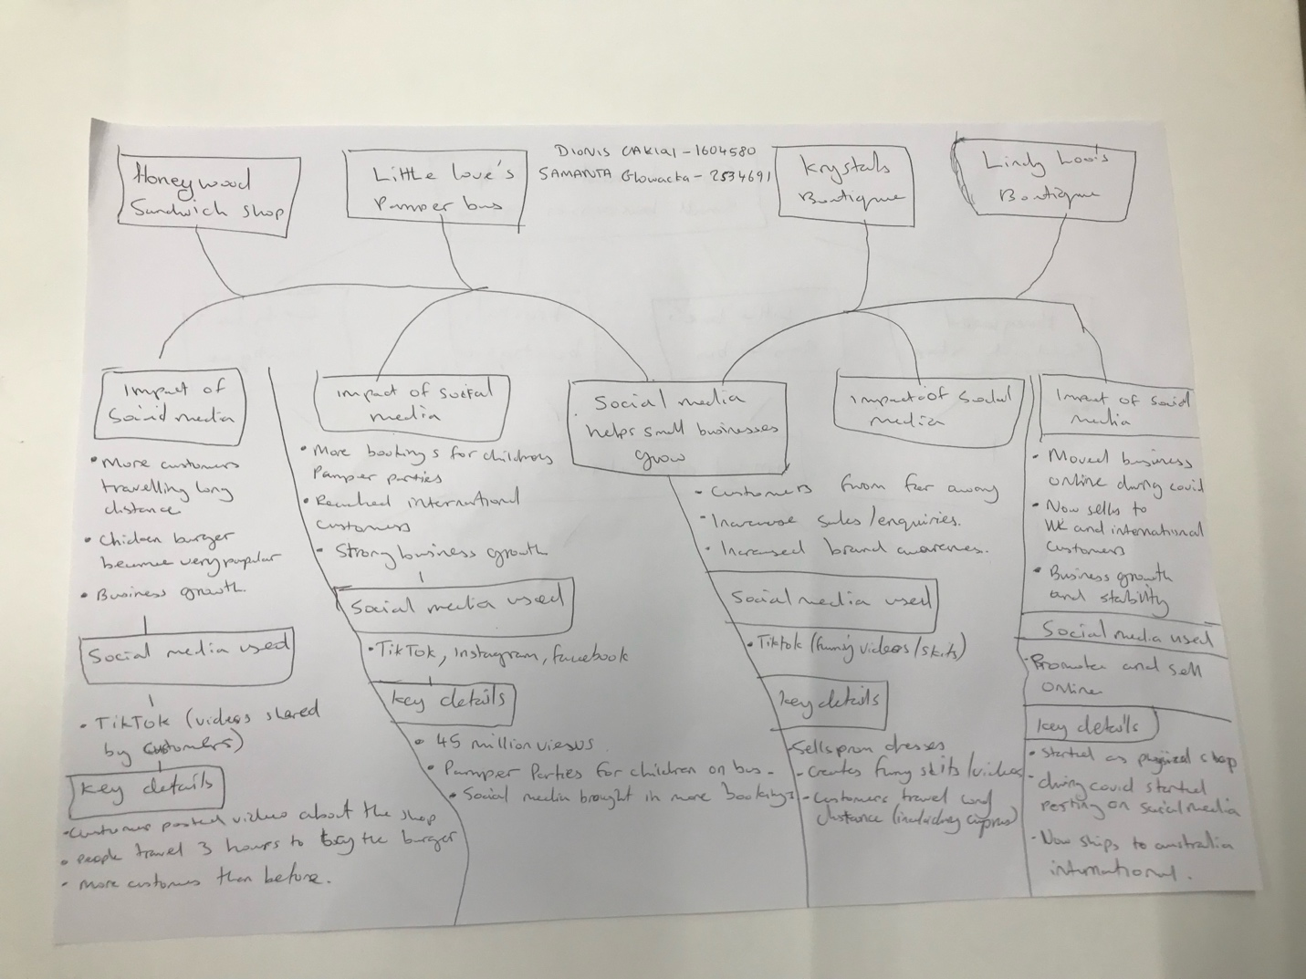

AS Task 1 – Reading Task

a. What is the main idea of the text?
The main idea is that social media helps small businesses grow by attracting more customers and increasing sales. The article shows that businesses can become more successful when more people discover them through social media.
b. What are two key points?
One key point is that businesses can become well known when customers share videos about them on social media. For example, Honywood Sandwich Shop became popular after customers posted videos of its food online.
Another key point is that social media can help businesses reach customers in other countries. For example, Lindy Loo's Boutique now sends clothing to Australia after becoming popular on social media.
c. What part of the text did you find most important? Why?
The most important part is the story about Krystals Boutique because it showed that a small local business could attract customers from different countries. It made me realise how social media can help even small businesses reach a much wider audience.
d. Was anything unclear or difficult to understand?
I was not sure about whether every small business could become successful through social media or if it only works for certain businesses. The article gave successful examples, but I wondered if the same results would happen for every business.
e. How did your group help you understand the text better?
My group helped me by talking about the different businesses in the article and comparing our ideas. This helped me understand the article better and identify the most important points.
Reflection
The hardest part was identifying the key points from the article because there was a lot of information to read through.

