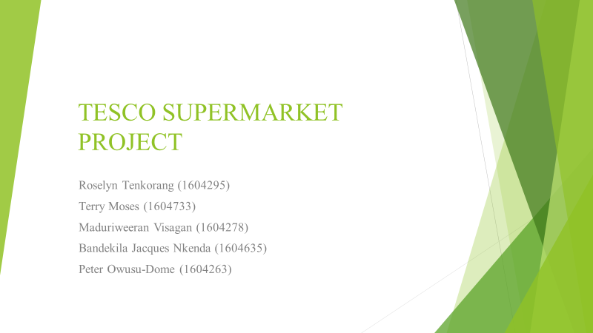
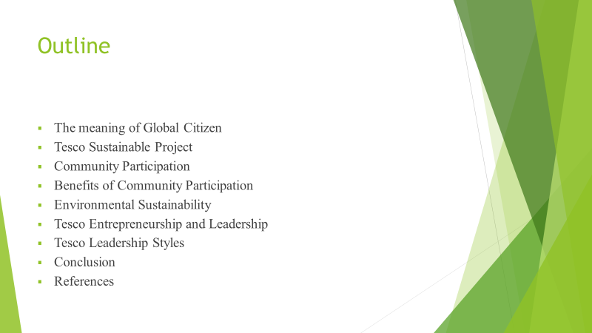

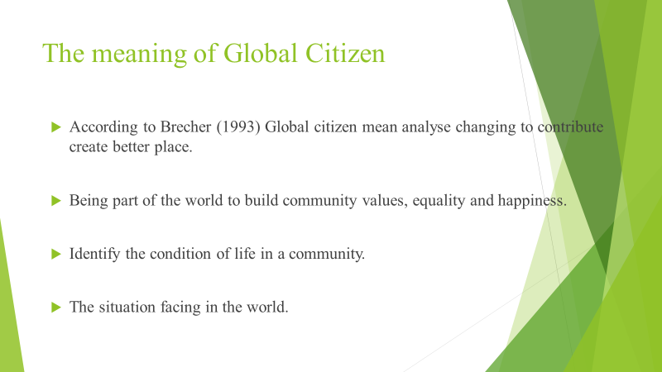

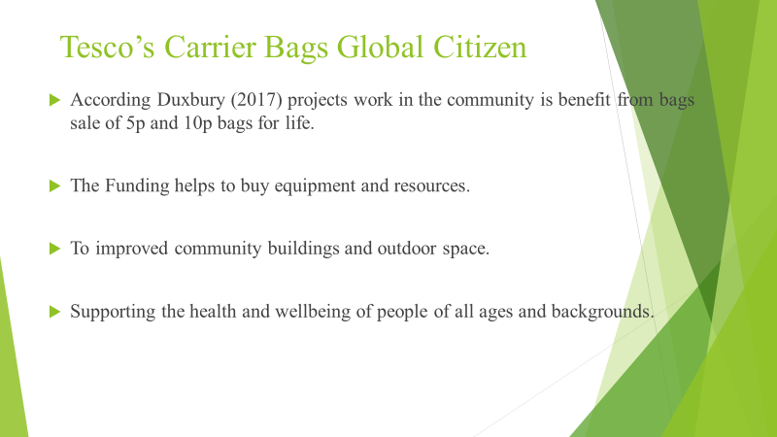

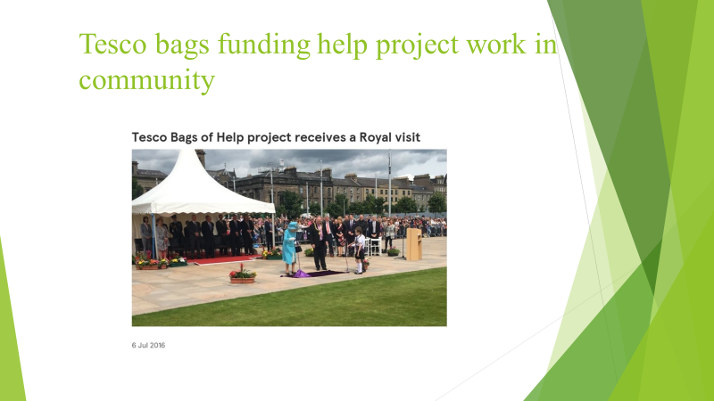
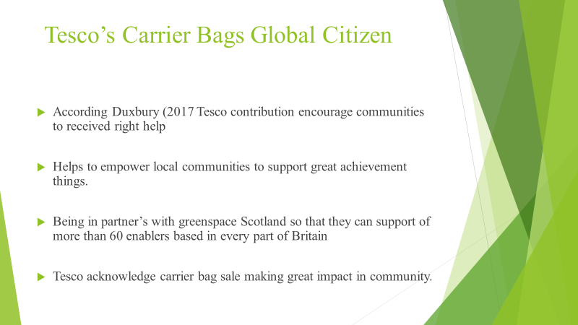

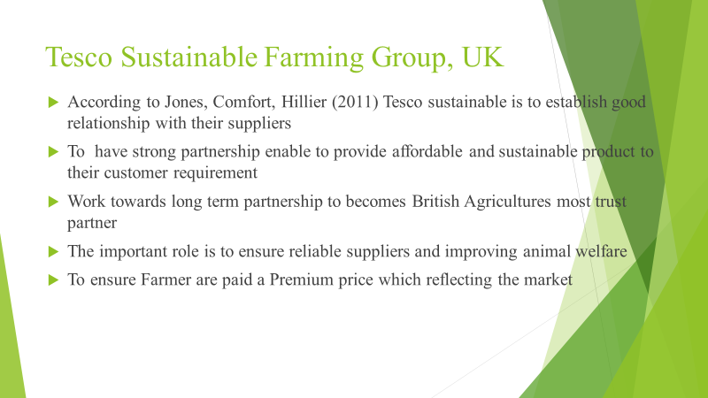
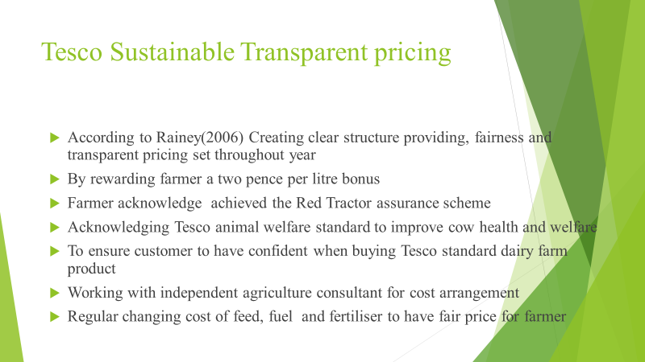



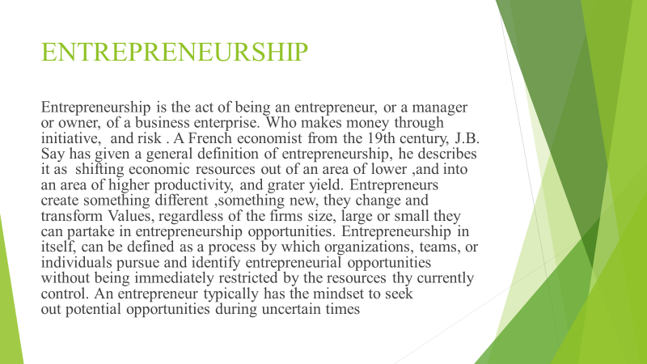

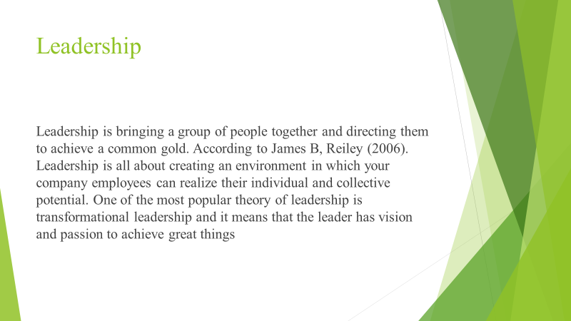
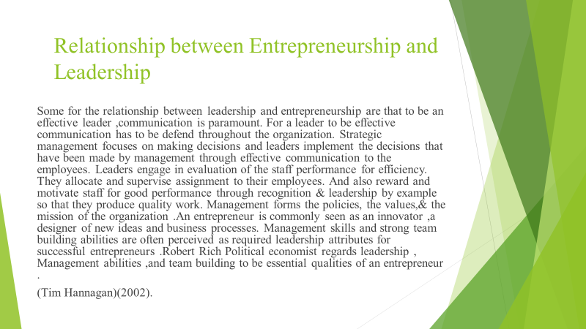

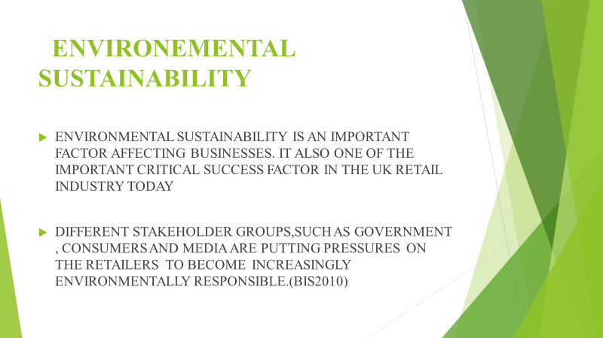

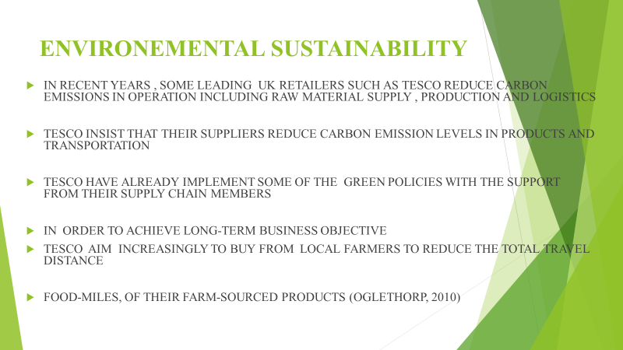

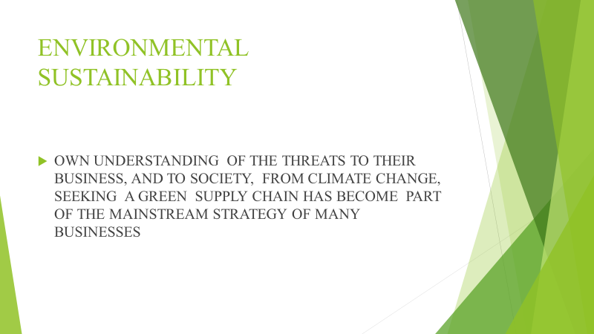
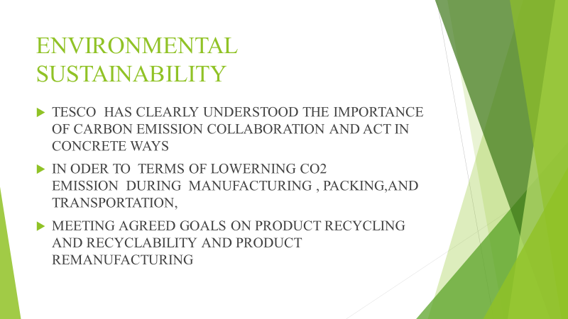

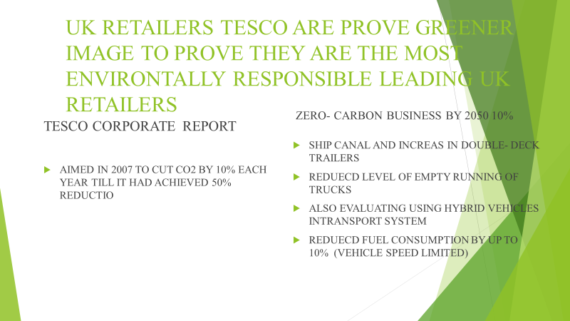

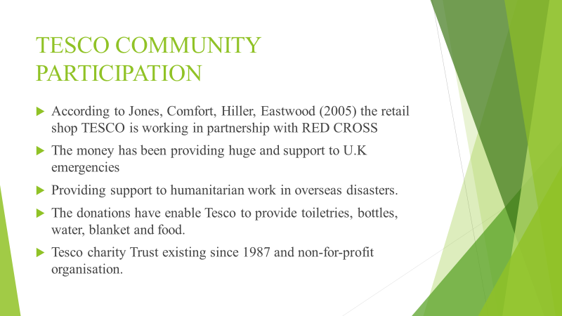

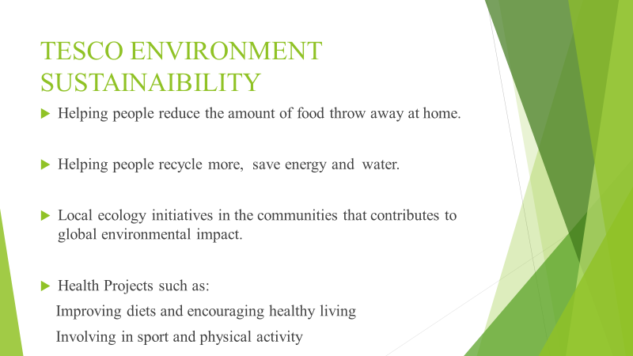

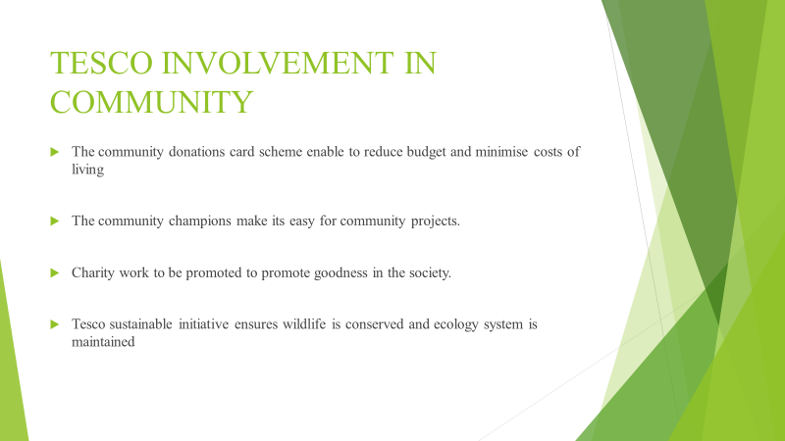

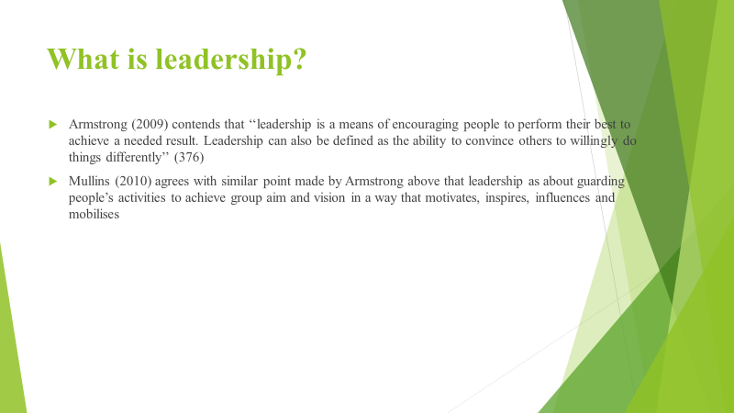

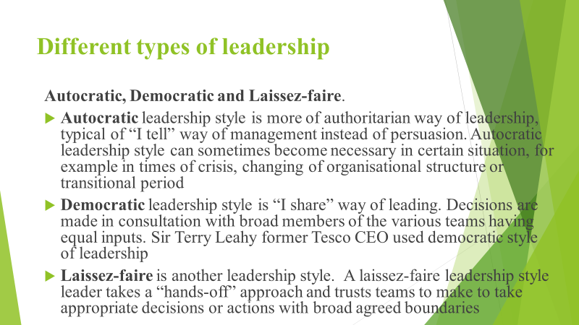

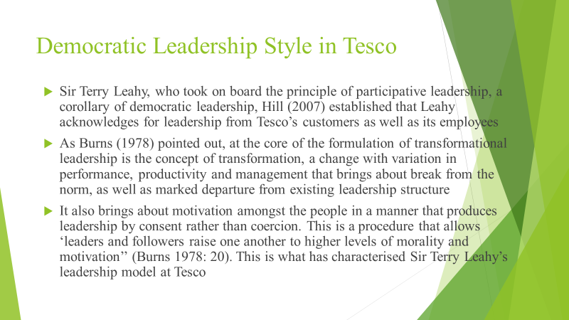

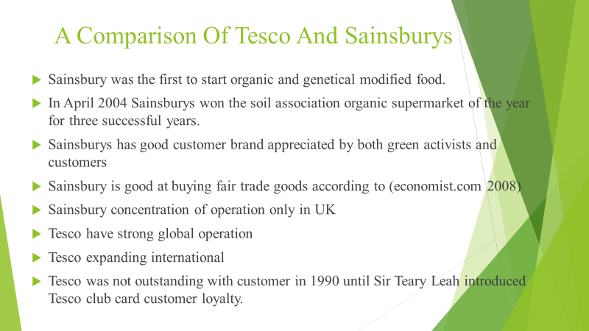

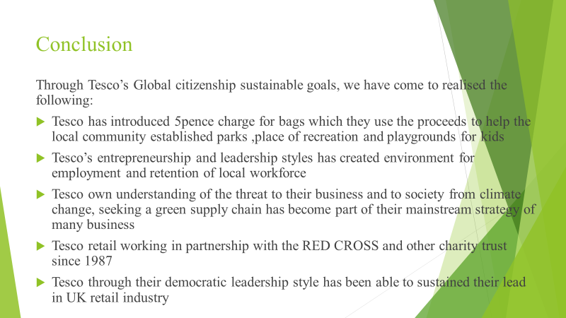

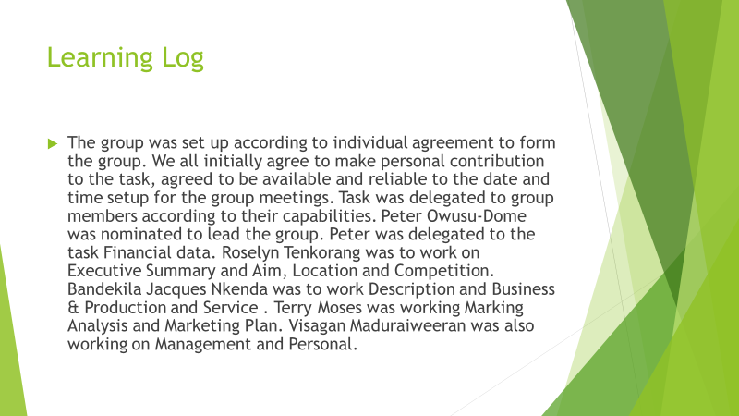

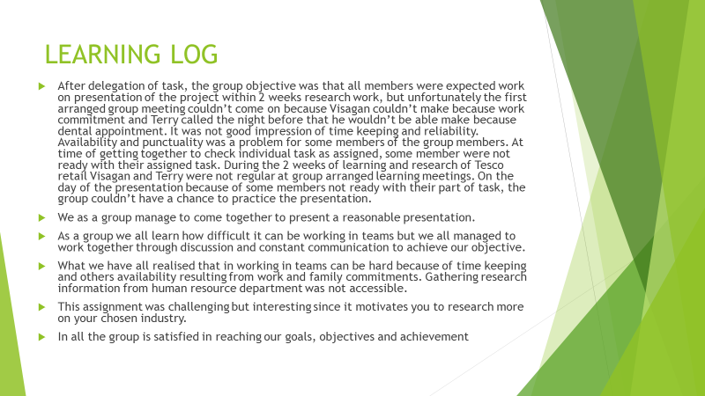

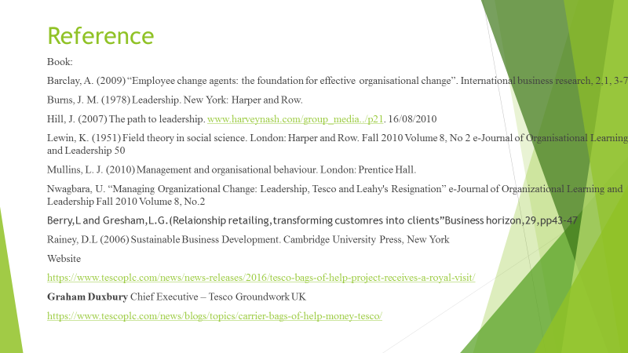

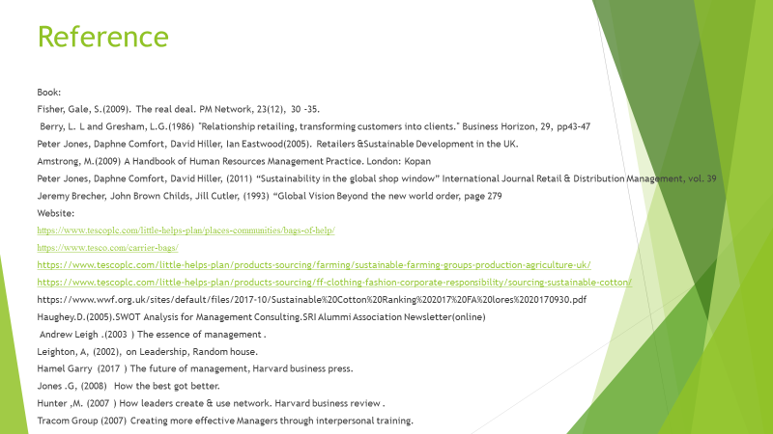

Learning log
The group was set up according to individual agreement to form the group. We all initially agree to make personal contribution to the task, agreed to be available and reliable to the date and time setup for the group meetings. Task was delegated to group members according to their capabilities. Peter Owusu-Dome was nominated to lead the group. Peter was delegated to the task Financial data. Roselyn Tenkorang was to work on Executive Summary and Aim, Location and Competition. Bandekila Jacques Nkenda was to work Description and Business & Production and Service . Terry Moses was working Marking Analysis and Marketing Plan. Visagan Maduraiweeran was also working on Management and Personal.
After delegation of task, the group objective was that all members were expected work on presentation of the project within 2 weeks research work, but unfortunately the first arranged group meeting couldn’t come on because Visagan couldn’t make because work commitment and Terry called the night before that he wouldn’t be able make because dental appointment. It was not good impression of time keeping and reliability. Availability and punctuality was a problem for some members of the group members. At time of getting together to check individual task as assigned, some member were not ready with their assigned task. During the 2 weeks of learning and research of Tesco retail Visagan and Terry were not regular at group arranged learning meetings. On the day of the presentation because of some members not ready with their part of task, the group couldn’t have a chance to practice the presentation.
We as a group manage to come together to present a reasonable presentation.
As a group we all learn how difficult it can be working in teams but we all managed to work together through discussion and constant communication to achieve our objective.
What we have all realised that in working in teams can be hard because of time keeping and others availability resulting from work and family commitments. Gathering research information from human resource department was not accessible.
This assignment was challenging but interesting since it motivates you to research more on your chosen industry.
In all the group is satisfied in reaching our goals, objectives and achievement

