Melanie Nelson
1604696
Pathway project 1-EMPL4013
Assignment 2
Lecture- Mr Ze Zook

Reflective Review

For my pathway project 1 assignment I was asked to work in a group of four people to create a 10 minute PowerPoint presentation which had to be delivered to the class, I had done a group presentation once before which I felt didn’t go very well, I was very nervous when delivering the presentation and got confused on what I was talking about, I believe this happened due to lack of experience and confidence and also inefficient production from the team, there was not much background information on our topic, therefore answering questions proved very difficult, which made me feel rather incompetent, according to Tuckman’s theory there are four phases in team building which are as follows:

- Forming – team is assembled, and tasks allocated
- Storming – the team the team starts to address tasks, suggestions and ideas
- Norming- accepting vital contribution of each team member
- Performing – there is a high level of respect for and trust as they all work well together ( (Anon., n.d.))

Once the group was formed, a group leader had to be allocated, after much deliberation it was decided that it would be me. A successful leader is a person who posses the skill to motivate a group or team of individuals to work towards achieving a common goal, good leadership is having great ideas (whether your own or borrowed) that will inspire others, this cannot happen unless these ideas are communicated so that people are engaged enough to act as a leader would like them to act. A leader will inspire and direct others using a combination of personality and leadership skills that makes others want to follow, possessing these skills in employment are essential in any business ( (Anon., n.d.))

I had never been a team leader before, i felt a little nervous and dubious about taking on the responsibility. We discussed the assignment and I suggested that our topic would be on community participation, sustainability and globalisation within the tourism sector, we chose the premier inn hotel chain for our presentation.
I had worked with some of the members of this group before, which made me feel a bit more comfortable and confident as we already had a good connection and new each other’s weaknesses and strengths, we discussed the assignment as a group, I then delegated different tasks for each member to research and work on, everybody understood and was happy with what they had to work on. Delegation is the way of assigning the responsibility of a specific task or activity to another person or persons, (delegation Wikipedia)

My pathway project one class would take place on a Monday, I would always take notes of what was said and done during the lesson, this really helped me as I could always look back on my notes to help with my assignment, after class our group would meet to work on the presentation. I felt our team worked very well together and respected each other’s views and opinions. Although I was allocated team leader each member gave just as much input as the other,

Meetings were very important for the team, I proposed we make date and times for group meetings, were we would collectively come together to discuss and share information that we had researched. we always tried our best to attend meetings but at times it was difficult due to other responsibilities and commitments, we used Skype which is a telecommunication app that allows video chat and voice calls between computers tablets or mobile phones, this allowed us to have meetings when it wasn’t possible for us all to meet on campus. Effective meetings are not only essential to achieve team goals and successful completion of tasks they are also important overall for functioning of the team whether they are conducted in real time, in person or by remote conference, team meetings are important tools for managing team tasks and productivity, (Anon., n.d.)

Time management was a vital part of our group product, we had to make time to get together to work in our assignment, although we all had children and other responsibilities and commitments, I was very impressed of how all group members made an effort to make time for meetings be it on campus or via skype, I myself lead a very busy lifestyle I have two sons, one who has disabilities and learning difficulties to who I support and care for, I also work part time and have other commitments and deadlines to keep, I put a time chart in place which helped my organise and prioritise time to carry out different task.
Time management refers to the way that organise and plan how much time you spend on a specific activity or task, good time management creates greater productivity, efficiency and a better professional reputation, poor time management creates missed deadlines, inefficient work flow and poor quality of work. (Anon., n.d.)

A big part of this assignment involved research on sustainability, global citizenship and community participation:

Sustainability
Sustainability is the ability to maintain something at a certain rate or level causing little or no damage to the environment and consequently able to continue over a long period of time avoiding consumption of natural resources. (Anon., n.d.)

Community participation
Community participation is being involved in a community or community project, some businesses may hold charity fundraisers to support hospitals, schools or other small businesses

Global citizen
A global citizen is a person or people that understand the world and their place in it, they take an effective role in their community and work with others to make our planet more equal, fair and sustainable. (hpps://www.oxfam.org)

We also made a plan to visit the premier in hotel in Brixton where we could get first-hand information on their practices and procedures, on our arrival at the hotel we were met by a member of staff who showed us around, and was happy to answer any questions asked.

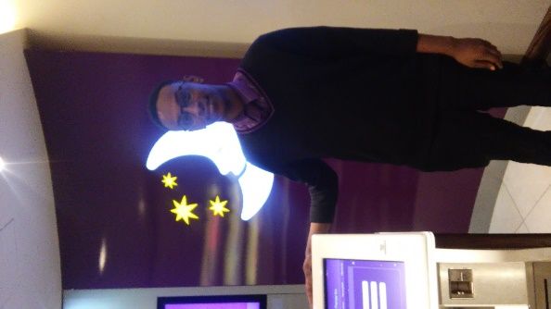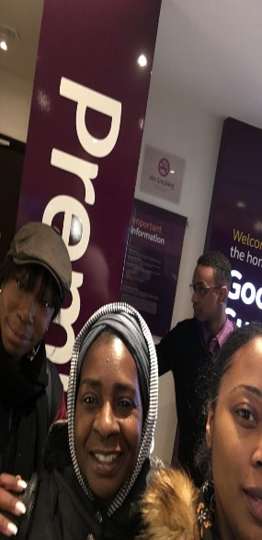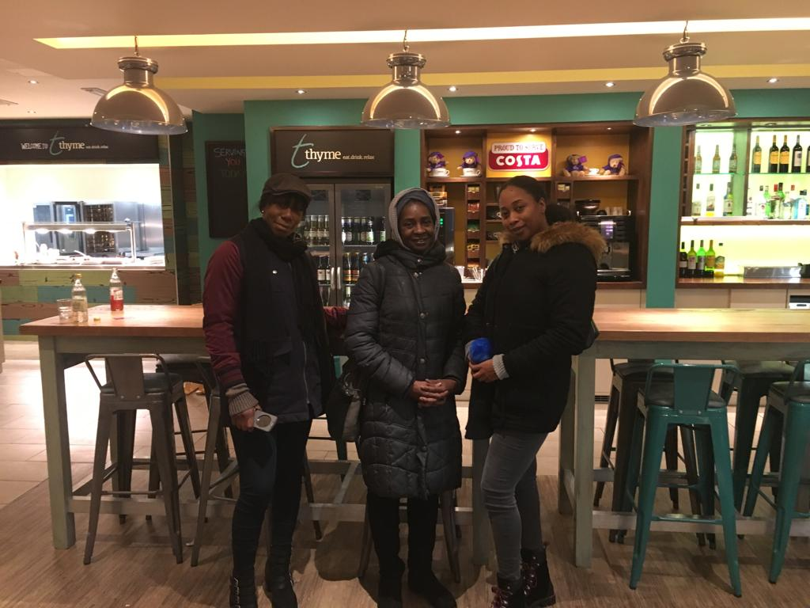

Once our group had researched all the information needed, we arranged to get together to set up our PowerPoint presentation slides, I chose a design that everyone was happy with and emailed the slides on outlook where each individuals could add their information on to the slides. After completing the presentation slides we then set to work on practicing our presentation skills, I could feel I was getting a little nervous at first but after a few more practices I felt more confident, it helped that I had done my background research, so I knew and understood what I was talking about, and as did the rest of the team.

In the week that our presentation was due the a member of our group had a bereavement in their family, I also lost my uncle in that same week, although it was a difficult time for us we still worked and supported each other as a team.

Teamwork is the process of working collaboratively with a group of people to achieve a goal, it is often a crucial part of business, as it’s important that people work well together, supporting each other and trying their best in any circumstances. (Anon., n.d.)

On the day of our presentation we got together before class started to insure everyone was feeling good and positive about what they had to do,
I was still feeling a little nervous but didn’t let it show. We went into the class and sat in our seats, there was two groups that did their presentation first and it was then our turn, one of our team members set up the PowerPoint slides, being the leader, I had to do the introduction, strangely enough I didn’t feel as nervous as I thought I would. We all had three to four slides each which we had to present, I felt a lot more confident during this presentation, due to the fact we had done all the necessary research and the and our group worked very well together, at the end if our presentation the there was questions from the class and tutors which were happy to answer as we had relevant back ground information.

During this assignment I learned a lot about collaboratively working in a team and team dynamics, I also gained more confidence in asserting my views and opinions, having the opportunity to lead a group gave me a good insight to leadership, which will be valuable to me in my working career, learning about what it is to be a global citizen made me look at myself as a global citizen and make improvements where necessary. I also gained new and different researching skills which will help me in the future.

References
Anon., n.d. https://www.aamc.org/members/gfa/faculty_vitae/148582/team_meetings.html. [Online].
Anon., n.d. https://www.oxfam.org.uk/education/who-we-are/what-is-global-citizenship?pscid=ps_ggl_gr_DSA+-+Whole+Site&gclid=EAIaIQobChMI6uSslqTJ2AIVE-EbCh0TvAhhEAAYASAAEgI8MfD_BwE&gclsrc=aw.ds&dclid=COaWh5-kydgCFRcy0wodIXEAoQ. [Online].
Anon., n.d. www.mindtools.com. [Online].
Anon., n.d. www.teambuilding.co.uk. [Online].
Anon., n.d. www.thebalance.com. [Online].
Anon., n.d. www.thwink.org. [Online].

Appendix

Learning log

Questions | Answers | Questions | Answers | Questions | answers
Did the group work well together? | We worked well together as a group,  I knew the group members, we had a good relationship | Did you use Skype for any meetings | We set up, skype meetings when we could’ve all meet on campus | How did you divide the work between you? | Each member was allocated a task which they research
Who worked on what | I allocated different task to each individual, we shared and worked together on our findings. | Did skype work well? | It was a bit tricky at first but once up and running worked well | Was the work evenly distributed | The work was fairly shared out and everyone was happy with what they had
What went well in your group | Dynamic of the  Group worked  Well,communication  Was good |  |  | Did you enjoy working on this assignment | I enjoyed working on this assignment with my team
Did you get together often enough | We arrange to meet on campus where we will share our work and discuss the assignment | What do you think you could have done better | I feel I could have improved on my leader ship skills, be more assertive and stronger in my role

