Definition Of An Entrepreneur
15th of January 2019
Lucy Crocker
1701540
Entrepreneurship Assignment 2
M5X00846
Table of Contents
Executive Summary: 2
Report Remit: 4
Introducing The Honest Company: 4
Definition Of An Entrepreneur: 5
What Is An Entrepreneur? 5
Jessica Alba – An Entrepreneur? 6
The Approach to Entrepreneurship 7
Motivational Framework: 8
Economic Theory: 9
Psychological Theory: 9
Sociological Theory: 11
Conclusion: 11
Bibliography 13

Figure 1: The Honest Company Logo (The Honest Company , 2018) 2
Figure 2: (Toppin, 2015) 3

Executive Summary

This report aims to explain why a corporation and their founder can be labelled as an entrepreneur. The author examines Jessica Alba and The Honest Company, and why she can be labelled an entrepreneur. Honest develop infant and cleaning products that are made with natural and organic materials and ensure that no harsh chemicals come into contact within the products. The Honest Company’s desire is to provide safe and effective products and provide information for the products to families.To become successful an entrepreneur would have to follow various strategies, for example, an entrepreneur would need to be willing to develop new skills and adapt their behaviour due to changing demands. There are various advantages for an entrepreneur, such as, having control and a flexible schedule. There are also disadvantages to becoming an entrepreneur, for example, self-reliance and isolation.
Alba is known through the acting industry but also the business industry as the founder of The Honest Company. Alba has won and been nominated for various entrepreneurship and general business awards ,and has also appeared on a variety of lists by Forbes. Ms Alba became motivated to develop an organisation after having a reaction to laundry detergent, and from her reaction Alba had researched the chemicals within the product, and found insufficient information. There are three approaches to entrepreneurship, known as ,economic, psychological and social behaviours. The motivational theory that represents Jessica Alba’s style is Peter Druckers theory as Ms Alba was researching the ingredients in the washing products, and was looking to develop an alternative that would be friendlier on skin. The economic theory that represents Jessica Alba’s stye is Shackles Theory, as Alba is known to have an acting career and later developed an interest in business, which is a drastic environmental change, especially when an individual is moved from an acting environment into a more controlled environment . The psychological theory that represents Alba’s style is McClellands’s theory. Alba wasn’t influenced by anyone to develop an organisation, but by her own personal experience which had motivated her to make a change. The author believes that there isn’t a sociological theory that can relate to Jessica Alba’s style. To conclude, Alba can be labelled as an entrepreneur as in accordance to Drucker’s theory, where Alba based her entrepreneurial idea off of her own experiences and then researched how to adapt the ingredients and introduce natural and organic alternatives into household products.

Report Remit:
The aim of this report is to research a corporation and its founder and explain how they are labelled as an entrepreneur. The author has chosen to research The Honest Company and its founder Jessica Alba for this report. This report contains an insight into the entrepreneurial style of Jessica Alba and what motivated her to establish her own corporation through the use of Peter Drucker’s motivational theory, Shackle’s Economic theory and David McClelland’s theory of needs.

Introducing The Honest Company:
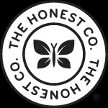
The author has decided to research Jessica Alba, the founder of The Honest Company, which is an organisation that specialises in organically manufactured products.
Figure 1: The Honest Company Logo (The Honest Company , 2018)

The company was founded from the desire to provide a platform for trusted products to enable parents to make the right choices for families and to provide information for parents unsure who or where to turn to when purchasing items for their families, but importantly, also a place where trusted products and information can be found. The Honest Company began as a “e-commerce subscription service” for infant products such as baby wipes, but later expanded its range to over 100 products (Forbes, 2016 A) , such as the Honest Essentials Bundle which is a botanical body care and home cleaning essentials. The wide variety of products sold by Honest have won numerous industry awards and certifications, such as, being Certified Cruelty Free for body washes, their shampoo range has been awarded a 2018 Cribsie Award, their calcium and vitamin D supplements for children have also been certified with a QAI Organic Certification, amongst a variety of other awards and certifications (The Honest Company , 2018). The Company’s mission statement is to produce “safe effective products that perform” and to make the right choices for families and a vision to empower its customers to live healthy and happy lives, and that what people put in, around and on their body matters (The Honest Company , 2018).

Definition Of An Entrepreneur:
An entrepreneur has been defined by the Global Entrepreneurship Monitor as “ any attempt at new business or new venture creation, such as self-employment, a new business organization, or the expansion of an existing business, by an individual or a team of individuals” (GEM, 2018). An entrepreneur has also been defined as “someone who starts their own business, especially when this involves seeing a new opportunity,” by (Cambridge Dictionary, 2019). The author believes that the definition provided by GEM, (2018) is the most appropriate definition as it acknowledges that entrepreneurs are not only those who founded the business.

What Is An Entrepreneur?
According to (Forbes, 2015) entrepreneurs are “integral to the success of the US economy” and over 50% of America’s working population are entrepreneurs of small businesses which would equate to over 120 million competitors. This is compared to the UK economy where the amount of start- up corporations had increased to 660,000 in 2017, compared to 608,000 in 2015 (The Financial Times , 2017).
There are various strategies for an entrepreneur to adopt in order to become successful, an example of this is, the context and circumstances surrounding the organisation and the willingness of the entrepreneur to develope new skills and to adapt to changing demands (Picken, 2017, p. 10), it is also important for entrepreneurs to be confident communicators especially when presenting their ideas to investors when promoting the organisation(Forbes, 2012). There are numerous advantages to becoming an entrepreneur, for example, a flexible schedule, constantly developing new skill sets and controling the development of the organisation (Forbes , 2016). But there are also many disadvantages to becoming an entrepreneur, such as, lack of support, self-reliance and isolation (Thomas, 2018).
There are various impacts that an entrepreneur’s activities can have on the economy it is based within, for example, job creation. The GEM, who provide data on entrepreneurship to organisations such as The United Nations, in their Global Report for 2017/2018 revealed that across the 50 economies that participated, the majority of entrepreneurs are expecting to create no jobs within the next five years, while the minority expect to create six jobs or more within the period of the next five years (GEM, 2018, p. 39).

Jessica Alba – An Entrepreneur?

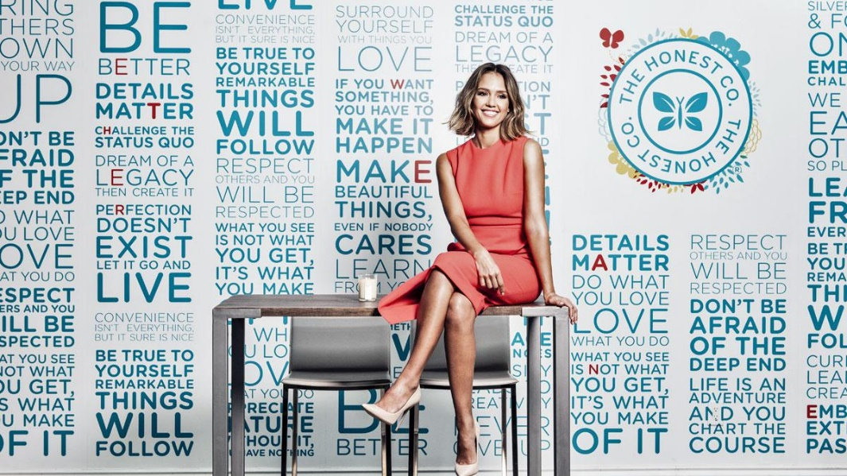
Figure 2: (Toppin, 2015)
Jessica Alba is known for her success in acting but also as the founder of The Honest Company, she has proven to have been extremely successful and has been nominated for and won various entrepreneurship and business awards , for example, the Glamour Award for Entrepreneur in 2012. She has also appeared on various lists by Forbes, for example, she was number 34 on Forbes ,(2016A) America's Richest Entrepreneurs Under 40 for 2016 and number 42 of America’s Richest Self-Made Women in 2016 (Forbes, 2016 B). Jessica became motivated after she had a reaction to the chemicals in laundry detergent, and upon researching the ingredients within the product she discovered that some of the toxins labelled on the packaging were labelled as the fragrance. After the experience Ms Alba became motivated to develop products that were toxin free “safe and effective” but also “beautifully designed, easy to get and accessibly priced” (Vanity Fair, 2015).
Alba developed products using natural materials that are safe for families, this then developed into a new business venture which would become The Honest Company. The organisation began due to Alba’s personal experience, which later evolved into a group of like minded individuals who had a similar experience and who then realised that there was a gap in the market for this business idea. Alba was determined to develop her company even after numerous rejections from many investors, as she reasoned “Actresses are used to rejection,” (Vanity Fair, 2015). Due to the business idea getting rejected, Alba adapted her entrepreneurial behaviour in order to get the recognition Honest needed to succeed .

The Approach to Entrepreneurship
There are various strategies and theories used to approach entrepreneurship and these can be broadly separated into three different approaches, the economic approach, the psychological trait approach and the social behaviours approach. The first of the strategies used to examine entrepreneurship is the economic approach, which examines the role of the entrepreneur within the economy. In addition, there is the psychological trait approach, which consists of analysing the personality characteristics of the entrepreneur. The final strategy to approach the study of entrepreneurship is the social behaviour approach which examines the influence of the social environment within the organisation (Thomas, 2018).

Motivational Framework:
The theory framework that the author believes to reflect Jessica Alba’s entrepreneurial style is that of Peter Drucker’s motivational theory. Drucker, often called the “father of modern management” has been described as one of the “most widely known and influential thinkers of management” (British Library, N.D). Drucker has explained that he believes that an entrepreneur is an individual who “always looks for change, responds to it and exploits it as an opportunity” (ANON, n.d.).
The author agrees that Ms Alba’s approach to founding The Honest Company was through this motivational theory, as she was constantly researching the ingredients that were used within the washing products she had a reaction to, and was looking to change the types of ingredients within the product, in order for them to be friendlier on skin. Ms Alba responded to her research by comitting to develop products that would be organic and natural, but to also provide information on the products they would sell and what is included within them, as due to her own personal experience there was a lack of information for the chemicals researched. This enabled the consumer to make an informed choice as to the suitability of the product for them. Jessica Alba’s experience with other products and the lack of information about them had motivated her to develop products that would be safe and effective for families and to provide a service where the information can be accessed easily. Jessica had exploited the difficulty finding information and her reaction to clothing detergent chemicals as an opportunity and has built the Honest Company based on this.

Economic Theory:
An example of an economic theory the author believes Jessica Alba can relate to is Shackle’s Economic theory. Shackle believes that an entrepreneur is creative and imaginative, they operate in an uncertain environment with imperfect knowledge, where they can develop opportunities (Thomas, 2018). This theory is suitable for Jessica Alba as she is known to have an acting career and later developed an interest in becoming an entrepreneur, which is a drastic change in environment, especially when one has moved from an active acting environment into a more focused working environment. The Honest Company itself follows this theory as it is creative and imaginative within the designs of their products, for example, the design on the household cleaner bottles and packaging designs.

Psychological Theory:
The psychological theory the author believes Jessica Alba can relate to is McClelland’s theory of needs. David McClelland’s theory is based upon three important factors, known as, achievement, power and affiliation. This theory states that the need for power, affiliation and achievement will influence the behaviour of an individual (Management Study HQ, 2019). This theory is suited for Jessica Alba, as an entrepreneur within this category has a commitment to others and the ability to act on opportunities , which in this case, Ms Alba has achieved due to acting upon opportunities based on personal experience (Thomas, 2018). The Honest Company represents this theory as the organisation has a commitment to its customers by delivering chemical free products and information surrounding them . In relation to David McClelland’s theory of needs, the author believes only the achievement and power element are the two factors that influence Ms Alba’s behaviour within the Honest Company, whilst the affiliation element has no influence on her behaviour.
The first element of this theory is achievement. This element suggests that it is the need to achieve something that an individual has set for themselves, for example, an entrepreneur it is to develop and run a successful organisation and to be known for this success. The individuals that are motivated by the needs for achievement have a strong desire of creating and accomplishing a difficult objective, in relation to The Honest Company, they desire to create and develop cleaning and health products that are organic and natural that are safe and effective for families. The Honest Company have accomplished this goal by creating a No List, which consists of over 3000 chemicals and materials that Honest will not use within their production line, 1300 of chemicals on this list have been banned in personal care products by the European Union (The Honest Company , 2018), and this list shows that Honest have completed their goal of ensuring that all their products are made with natural and organic materials, which was the main objective for this organisation. A future target for The Honest Company would be to launch their new cosmetics line into various Douglas Stores in Western Europe (Blakely, 2018).
The final element of this theory is the need for power, where an individual can hold authority and control over others and can influence and change any decision that is made in accordance to their own needs and desires (Management Study HQ, 2019). Jessica Alba has a high level of power within The Honest Company as Ms Alba takes authority over final decisions made for the products, for example, with their “The Paris Collection” the design included the French Flag, The Eiffel Tower and a French Bulldog, Ms Alba had flagged the tower’s salmon coloured packaging as she believed it may seem too feminine for parents of boys (Vanity Fair, 2015), this example shows the level of authority Jessica Alba has within The Honest Company.

Sociological Theory:
The sociological theory suggests that a good amount of entrepreneurs have experience within the entrepreneurial sector as they emerge out of a family with an entrepreneurial background. In these households, parents will tend to train the children towards independence which will inspire and motivate that individual to become an entrepreneur (Thomas, 2018). This theory isn’t suited for Jessica Alba’s entrepreneurial style, as she wasn’t trained by her family to becoming an entrepreneur. Ms Alba was educated in California with the desire to become an actress where she attended various acting schools and was cast in various filming productions, before developing The Honest Company. The Honest Company was founded by Jessica Alba herself, with no entrepreneurial experience nor entrepreneurial education from relatives or peers.

Conclusion:
To conclude, Jessica Alba can be labelled as an entrepreneur as in accordance with Drucker’s motivational theory, where Alba had based her business idea off of her own experiences and had then researched how to adapt the ingredients in the products, and had finally exploited the publics desire for products free from harsh chemicals and minerals , in order to produce safe and effective household products. Alba can relate to McClelland’s psychological theory as she shows attributes of power and achievement through the high level of power during the decision making process for the designs of the products, but also the company itself is a major achievement for Alba. The future goal for Jessica Alba is to introduce her cosmetics line into the European market and to include this range within a variety of Douglas stores within Western Europe.

Bibliography
ANON, n.d. Theoretical Framework And Analysis. [Online]
Available at: https://moodle.uwtsd.ac.uk/pluginfile.php/79249/mod_resource/content/1/Entrepreneruship%20Theorey.pdf
[Accessed 07 01 2019].
Blakely, L., 2018. Jessica Alba's Honest Company Bets Big on Makeup. [Online]
Available at: https://www.inc.com/lindsay-blakely/jessica-albas-honest-company-bets-big-on-makeup.html
[Accessed 12 01 2019].
British Library, N.D. Peter Drucker. [Online]
Available at: https://www.bl.uk/people/peter-drucker
[Accessed 10 01 2019].
Cambridge Dictionary, 2019. Entrepreneur. [Online]
Available at: https://dictionary.cambridge.org/dictionary/english/entrepreneur
[Accessed 15 01 2019].
Forbes , 2016. 4 Benefits Of Being An Entrepreneur Beyond Being Rich. [Online]
Available at: https://www.forbes.com/sites/neilpatel/2016/04/18/4-huge-life-benefits-of-being-an-entrepreneur-being-rich-isnt-one-of-them/#78702c7e7fde
[Accessed 10 01 2019].
Forbes, 2012. What makes entrepreneurs successful?. [Online]
Available at: https://www.forbes.com/sites/scottshane/2012/05/24/what-makes-entrepreneurs-successful/#95f7e2a94e26
[Accessed 06 01 2019].
Forbes, 2015. Rethinking The Definition Of 'Entrepreneur'. [Online]
Available at: https://www.forbes.com/sites/theyec/2015/02/23/rethinking-the-definition-of-entrepreneur/#67bd81326bb9
[Accessed 31 12 2018].
Forbes, 2016 A. #34 Jessica Alba Forbes Profile. [Online]
Available at: https://www.forbes.com/profile/jessica-alba/#3088c20e159e
[Accessed 31 12 2018].
Forbes, 2016 B. Forbes' 2016 List Of America's Richest Self-Made Women. [Online]
Available at: https://www.forbes.com/sites/forbespr/2016/06/01/forbes-2016-list-of-americas-richest-self-made-women/#7acf5aad1747
[Accessed 04 01 2019].
Forbes, 2018. The 8 P's Of Entrepreneurship. [Online]
Available at: https://www.forbes.com/sites/ninaangelovska/2018/10/10/the-8-ps-of-entrepreneurship/#6118491614f5
[Accessed 12 01 2019].
GEM, 2018. Global Report 2017/2018, s.l.: Global Entrepreneurship Monitor.
GEM, 2018. How GEM Defines Entrepreneurship. [Online]
Available at: https://www.gemconsortium.org/wiki/1149
[Accessed 11 01 2019].
Management Study HQ, 2019. McClelland’s Theory of Needs (Power, Achievement and Affiliation). [Online]
Available at: https://www.managementstudyhq.com/mcclellands-theory-of-needs-power-achievement-and-affiliation.html
[Accessed 12 01 2019].
Picken, J. C., 2017. From founder to CEO: An entrepreneur's roadmap. Business Horizons , 60(1), pp. 7-14.
The Financial Times , 2017. Number of UK start-ups rises to new record. [Online]
Available at: https://www.ft.com/content/cb56d86c-88d6-11e7-afd2-74b8ecd34d3b
[Accessed 31 12 2018].
The Honest Company , 2018. Who we are. [Online]
Available at: https://www.honest.com/about-us/who-we-are
[Accessed 31 12 2018].
Thomas, C., 2018. Key Theories Presentation, Swansea: UWTSD.
Toppin, J., 2015. How Jessica Alba Built A $1 Billion Company, And $200 Million Fortune, Selling Parents Peace Of Mind. [Online]
Available at: https://www.forbes.com/sites/clareoconnor/2015/05/27/how-jessica-alba-built-a-1-billion-company-and-200-million-fortune-selling-parents-peace-of-mind/#59bc856642b4
[Accessed 07 01 2019].
Vanity Fair, 2015. How Jessica Alba Built a Billion-Dollar Business Empire. [Online]
Available at: https://www.vanityfair.com/style/2015/11/jessica-alba-honest-company-business-empire
[Accessed 04 01 2019].

