Introduction to Physiology
Student Name-Ruhela Begum
Student ID-1714385
BMHP5003/BIRM
Assignment 1- Giridhar Katti

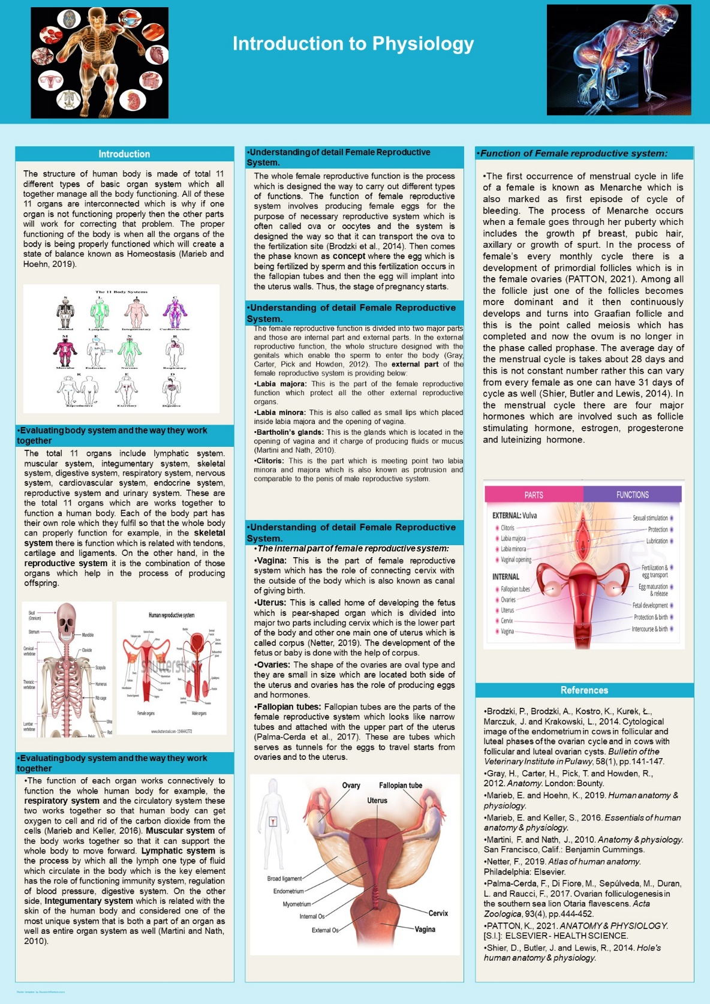
Evaluating body system and the way they work together
The structure of human body is made of total 11 different types of basic organ system which all together manage all the body functioning. All of these 11 organs are interconnected which is why if one organ is not functioning properly then the other parts will work for correcting that problem. The proper functioning of the body is when all the organs of the body is being properly functioned which will create a state of balance known as Homeostasis(Marieb and Hoehn, 2019). The total 11 organsinclude lymphatic system. muscular system, integumentary system, skeletal system, digestive system, respiratory system, nervous system, cardiovascular system, endocrine system, reproductive system and urinary system. These are the total 11 organs which are works together to function a human body. Each of the body part has their own role which they fulfil so that the whole body can properly function for example, in the skeletal system there is function which is related with tendons, cartilage and ligaments. On the other hand, in the reproductive system it is the combination of those organs which help in the process of producing offspring. The function of each organ works connectively to function the whole human body for example, the respiratory system and the circulatory system these two works together so that human body can get oxygen to cell and rid of the carbon dioxide from the cells(Marieb and Keller, 2016). Muscular system of the body works together so that it can support the whole body to move forward. Lymphatic system is the process by which all the lymph one type of fluid which circulate in the body which is the key element has the role of functioning immunity system, regulation of blood pressure, digestive system. On the other side, Integumentary system which is related with the skin of the human body and considered one of the most unique system that is both a part of an organ as well as entire organ system as well(Martini and Nath, 2010).
Understanding of detail Female Reproductive System.
The whole female reproductive function is the process which is designed the way to carry out different types of functions. The function of female reproductive system involves producing female eggs for the purpose of necessary reproductive system which is often called ova or oocytes and the system is designed the way so that it can transport the ova to the fertilization site(Brodzki et al., 2014). Then comes the phase known as concept where the egg which is being fertilized by sperm and this fertilization occurs in the fallopian tubes and then the egg will implant into the uterus walls. Thus, the stage of pregnancy starts.
The female reproductive function is divided into two major parts and those are internal part and external parts. In the external reproductive function, the whole structure designed with the genitals which enable the sperm to enter the body(Gray, Carter, Pick and Howden, 2012). The external part of the female reproductive system is providing below:
Labia majora: This is the part of the female reproductive function which protect all the other external reproductive organs.
Labia minora: This is also called as small lips which placed inside labia majora and the opening of vagina.
Bartholin’s glands: This is the glands which is located in the opening of vagina and it charge of producing fluids or mucus(Martini and Nath, 2010).
Clitoris: This is the part which is meeting point two labia minora and majora which is also known as protrusion and comparable to the penis of male reproductive system.
The internal part of female reproductive system:
Vagina: This is the part of female reproductive system which has the role of connecting cervix with the outside of the body which is also known as canal of giving birth.
Uterus: This is called home of developing the fetus which is pear-shaped organ which is divided into major two parts including cervix which is the lower part of the body and other one main one of uterus which is called corpus(Netter, 2019). The development of the fetus or baby is done with the help of corpus.
Ovaries: The shape of the ovaries are oval type and they are small in size which are located both side of the uterus and ovaries has the role of producing eggs and hormones.
Fallopian tubes: Fallopian tubes are the parts of the female reproductive system which looks like narrow tubes and attached with the upper part of the uterus(Palma-Cerda et al., 2017). These are tubes which serves as tunnels for the eggs to travel starts from ovaries and to the uterus.

Function of Female reproductive system:
The first occurrence of menstrual cycle in life of a female is known as Menarche which is also marked as first episode of cycle of bleeding. The process of Menarche occurs when a female goes through her puberty which includes the growth pf breast, pubic hair, axillary or growth of spurt. In the process of female’s every monthly cycle there is a development of primordial follicles which is in the female ovaries(PATTON, 2021). Among all the follicle just one of the follicles becomes more dominant and it then continuously develops and turns into Graafian follicle and this is the point called meiosis which has completed and now the ovum is no longer in the phase called prophase. The average day of the menstrual cycle is takes about 28 days and this is not constant number rather this can vary from every female as one can have 31 days of cycle as well(Shier, Butler and Lewis, 2014). In the menstrual cycle there are four major hormones which are involved such as follicle stimulating hormone, estrogen, progesterone and luteinizing hormone.

References
Brodzki, P., Brodzki, A., Kostro, K., Kurek, Ł., Marczuk, J. and Krakowski, L., 2014. Cytological image of the endometrium in cows in follicular and luteal phases of the ovarian cycle and in cows with follicular and luteal ovarian cysts. Bulletin of the Veterinary Institute in Pulawy, 58(1), pp.141-147.
Gray, H., Carter, H., Pick, T. and Howden, R., 2012. Anatomy. London: Bounty.
Marieb, E. and Hoehn, K., 2019. Human anatomy & physiology.
Marieb, E. and Keller, S., 2016. Essentials of human anatomy & physiology.
Martini, F. and Nath, J., 2010. Anatomy & physiology. San Francisco, Calif.: Benjamin Cummings.
Netter, F., 2019. Atlas of human anatomy. Philadelphia: Elsevier.
Palma-Cerda, F., Di Fiore, M., Sepúlveda, M., Duran, L. and Raucci, F., 2017. Ovarian folliculogenesis in the southern sea lion Otariaflavescens. Acta Zoologica, 93(4), pp.444-452.
PATTON, K., 2021. ANATOMY & PHYSIOLOGY. [S.l.]: ELSEVIER - HEALTH SCIENCE.
Shier, D., Butler, J. and Lewis, R., 2014. Hole's human anatomy & physiology.

