
Module Name: Professional Career Development

Module Code: BMBS4005

Student Name: Kathryn Parker

Student Number: 2025377811

Lecturer: Scott James

Deadline: Monday 26th October 2026 23.59PM

AI Acknowledgement
I acknowledge the use of:
Google AI (www.google.com) on 28/09/26 to support research.
Chat GPT (www.chatgpt.com) on 08/10/26 to support fine tuning of my CV.

Prompt(s) used (if applicable):
- Current trends affecting the Customer Service sector.
- What skills are important within the customer service sector
- Please fine tune my CV and check spelling and grammar

I confirm that I have not presented any AI-generated text as my own work. I confirm that I have retained copies of drafts, notes, and resources used before and after the use of AI tools.

Contents
Element 1: Career Sector Investigation 3
1.1 My Chosen Sector or Business Area 3
1.2 Sector / Business Area Research 3
1.3 Skills, Qualities and Attributes Valued by Employers 3
1.4 Current Trends Affecting the Sector 4
1.5 Personal Career Fit 4
Element 2: Skills Audit and Professional Development Plan 5
2.1 Personal SWOT Analysis 5
2.2 Emotional Intelligence and Professional Behaviour 5
2.3 Applying Theories or Models 6
2.4 SMART Development Goal 7
Element 3: Recruitment Application Pack 7
3.1 Selected Job Role 7
3.2 Tailored Curriculum Vitae (CV) 7
3.3 Cover Letter 10
3.4 LinkedIn Profile 12
3.5 Application Rationale 12
References 13

Element 1: Career Sector Investigation

1.1 My Chosen Sector or Business Area
The career sector I’ve chosen is customer service, specifically working as a senior customer service agent in a call centre environment. I selected this sector because I am interested in a career where I can communicate with people, help them solve problems and provide a positive customer experience. I also believe it would help me develop further in useful communication, IT and problem-solving skills.

1.2 Sector / Business Area Research
Customer service involves helping customers with questions, problems, complaints, orders and information about products or services. Call centre agents mainly communicate with customers by phone, although modern customer service can also involve email, webchat and social media. Responsibilities usually include answering enquiries, resolving problems, processing orders and updating customer records.

Call centre agents can work for banks, insurance companies, retailers, telecommunications companies, government organisations and utility providers.

1.3 Skills, Qualities and Attributes Valued by Employers
Communication skills are essential because agents need to explain information clearly and understand customer’s needs. Active listening is also important so that agents can identify the problem before providing a suitable solution.

Employers also value patience, empathy and a positive attitude, particularly when dealing with unhappy or frustrated customers. Agents need to remain calm and professional when handling complaints. Problem solving skills are important because customers may have issues that require investigation and a suitable solution.

Other valuable attributes include teamwork, time management, organisation, attention to detail and IT skills. Careers Wales identifies communication, customer service, teamwork, self-motivation and time management as skills employers want (Careers Wales, 2026)

1.4 Current Trends Affecting the Sector
One major trend affecting customer service is the increasing use of artificial intelligence (AI). Businesses can use AI chatbots and automated systems to answer straightforward questions, helping to reduce the workload of customer service employees. The UK Government's AI Skills for Life and Work: Stakeholder Engagement Report (2026) identifies that chatbots can handle simple or frequently asked customer queries, allowing employees to focus on more complex enquiries. However, employees still need good digital skills, critical thinking and adaptability to work effectively alongside AI technology (Department for Science, Innovation and Technology, 2026). This suggests that human employees will continue to play an important role in resolving complicated customer problems and providing personal support.

Remote and hybrid working is another trend. Some call centre agents can work from home using digital communication and customer management systems. This requires employees to be organised, self-motivated and confident using technology.

Skills shortages are also relevant. The Welsh Employer Skills Survey 2024 found that 40% of skill shortage vacancies were associated with sales and customer service skills, showing the importance of these skills to Welsh employers (Welsh Government, 2024)

1.5 Personal Career Fit
I believe customer service would suit my interests because it helps build on my current skills and experiences and I enjoy communicating with people and helping them solve problems. I would like to develop my confidence when speaking to different customers and improve my ability to handle challenging situations professionally.

I would need to continue developing my IT, communication and problem-solving skills, as well as my ability to remain calm under pressure. Experience as a senior customer service agent will also provide opportunities to progress into higher roles such as team leader, supervisor or customer service manager.

Element 2: Skills Audit and Professional Development Plan

2.1 Personal SWOT Analysis
STRENGTHS  • Complaints resolution  • Technical support  • Stakeholder management | WEAKNESSES / AREAS FOR DEVELOPMENT  • Lack confidence  • Strategic thinking  • Formal management experience
OPPORTUNITIES  • CertHE in Business Skills  • LinkedIn Learning  • Progressing into Leadership | THREATS / CHALLENGES  • Taking on too much  • Prioritisation skills  • Strategic planning skills

My experience demonstrates several key strengths that are important to my future development. I have over a decade of experience in customer service, complaints resolution and technical support, alongside strong communication, problem solving and stakeholder management skills. I have achieved 11 consecutive annual awards for customer service and project contributions, demonstrating consistency, resilience and commitment. I have also contributed to process improvements, including creating a staff support hub that became part of core operations and auditing over 1,000 selfcare articles.

My main development needs are building greater confidence in leadership, strategic thinking and formal management. Although I have coached colleagues, supported projects and contributed to employee engagement, I have limited formal management experience. My current CertHE Business Skills studies provide an opportunity to develop my academic and business knowledge alongside my practical experience.

My opportunities include progressing into leadership, where I can use my existing experience. However, I need to manage the threat of taking on too many responsibilities. Developing delegation, prioritisation and strategic planning skills will help me progress while maintaining a healthy and sustainable approach to work.

2.2 Emotional Intelligence and Professional Behaviour
Emotional intelligence is a significant strength within my professional behaviour. My experience managing complex and CEO level complaints requires me to remain calm, empathetic and professional when dealing with challenging situations. I must understand customer’s concerns while also working within GDPR, Ombudsman and OFCOM requirements. This demonstrates emotional control, empathy and an ability to balance individual needs with organisational responsibilities.

I’ve also demonstrated relationship management skills through my role as a Local VOICE Representative and Reward & Recognition Champion. Supporting conflict resolution and employee wellbeing required me to listen to different perspectives and communicate appropriately.

As a remote worker, effective communication and collaboration are particularly important. I work virtually with managers, colleagues and wider stakeholders, which has strengthened my ability to communicate clearly and maintain professional relationships without relying on face to face interaction.

2.3 Applying Theories or Models
Gibbs’ Reflective Cycle provides a great framework for reviewing my experiences through description, feelings, evaluation, analysis, conclusion and an action plan (Gibbs, 1988). Reflecting on my creation of a staff support hub, I can see that identifying a problem and developing a solution demonstrated initiative and problem solving. The positive outcome, with the hub becoming part of core operations, shows that my actions created lasting value. However, Gibbs’ model also encourages me to consider how I manage competing responsibilities. In future, I should use prioritisation and delegation to ensure that taking initiative does not lead to excessive workload.

The Johari Window can also support my development by considering what I know about myself and what others know about me (Luft and Ingham, 1955). My achievements and awards demonstrate an established open area of strengths. However, there may be a blind area around my leadership potential. Coaching colleagues, supporting projects and improving employee engagement suggest that I already demonstrate leadership behaviours, even without holding a formal management position. Seeking regular feedback from managers and colleagues could help identify strengths and development needs that I may not recognise myself. This will support my progression towards future leadership and business focused roles.

2.4 SMART Development Goal
Specific | My goal is to secure a management position within the next 18 months by developing my leadership, strategic thinking, delegation and people management skills.
Measurable | I’ll seek opportunities to take responsibility for at least two leadership or project activities within my current organisation. I’ll also request quarterly feedback from my manager and colleagues to identify areas for improvement and demonstrate my progress.
Achievable | This goal is realistic because I already have significant professional experience and demonstrated leadership behaviors. My experiences provide a strong foundation for progressing into formal management.
Relevant | Achieving a management position is relevant to my career development because it will allow me to use my existing strengths while developing new skills.
Time-bound | I aim to reach a management position within 18 months. During this period, I will review my progress every three months, seek constructive feedback, identify opportunities to demonstrate leadership and update my development plan where necessary.

Element 3: Recruitment Application Pack

3.1 Selected Job Role
Job Title | Senior Customer Support Specialist
Organisation | Olo
Location | Remote, United Kingdom
Where the vacancy was found | Linked In
Job Role URL | https://www.linkedin.com/jobs/view/4474597480/

3.2 Tailored Curriculum Vitae (CV)

KATHRYN PARKER
5 Tan-Y-Lon, Clydach, Swansea, SA6 5JE
07455960285 |Kathparker88@hotmail.com
https://www.linkedin.com/in/kathryn-parker3105

PROFESSIONAL SUMMARY
An award-winning customer service and complaints specialist with over a decade of experience in remote communication, technical support, and high-level escalations. Recognised for delivering exceptional customer care, resolving complex issues, and driving employee engagement and department wide improvements. Consistently praised for achieving top performance results, professionalism, empathy, and maintaining confidentiality when handling sensitive cases. With 11 consecutive years of performance awards, I bring dedication, resilience and a proven ability to enhance customer and employee experiences.

KEY SKILLS
Customer Service Excellence | CEO & High-Level Complaints Resolution | Technical and Fault Support | Performance & Target Delivery | Remote Working & Virtual Collaboration | Stakeholder Engagement & Relationship Building | Root Cause Analysis | Safeguarding Awareness | Multi Channel Support (Social Media, Live Chat, Community Forums) | Conflict Resolution | Process Improvement & Knowledge Auditing | CRM & Multi System Navigation | Written and Verbal Communication

PROFESSIONAL EXPERIENCE
Senior Customer Contact Advisor
Remote worker
Virgin Media O2, Concord Business Park, Threapwood Road, Wythenshawe, Manchester, M22 0EY
25 January 2021 – Present

- Supported customers across social media platforms including Facebook, Instagram, X, Trustpilot, Community Forums, and Live Chat.
- Resolved a wide range of technical faults and account queries using the company’s multiple IT systems with a focus on accuracy and efficiency.
- Managed CEO level complaints, delivering resolutions aligned with GDPR, Ombudsman and OFCOM guidelines.
- Upsold products and add-ons using a tailored and customer centric approach.
- Maintained a consistently high performance against monthly company and personal targets.
- Prioritised and structured workload to meet deadlines and performance targets.
- Collaborated virtually with managers, teams, and wider stakeholders to ensure a consistent customer first approach.
- Achieved 11 consecutive Annual Awards for outstanding customer service and project contributions.
- Provided project support including root cause analysis and improvements to knowledge resources to increase first contact resolution.
- Created a support hub for staff to streamline access to guidance and tools. This is now part of core operations.
- Audited over 1,000 self-care articles ahead of schedule and to high accuracy.
- Served as Reward & Recognition Champion, increasing engagement scores by over 40% in the first year.
- Acted as a Local VOICE Representative, supporting conflict resolution, promoting transparency, and improving employee wellbeing.
- Served as an Awards Panellist for 5 years, promoting engagement and coaching teams on impactful nominations.

Administrative Officer
DVLA, Sandringham Park , Swansea Vale, Llansamlet, Swansea, SA6 8AJ
25 March 2019 – 22 January 2021

- Assisted customers with vehicle related queries via inbound calls.
- Promoted digital self-service tools and supported customers in completing tasks confidently.
- Worked across multiple systems to provide accurate and timely support.
- Shared best practice with colleagues to drive teamwide improvement.
- Maintained strong performance against challenging time sensitive targets.

Technical Support Agent, Next Generation Team Manager
Virgin Media, Matrix Court, Llansamlet, Swansea, SA7 9BB
13 February 2012 – 22 March 2019

- Delivered technical support to customers requiring troubleshooting and issue resolution via inbound calls.
- Managed team performance and supported new advisors through coaching and best practice sharing.
- Maintained consistent high service levels in a fast-paced environment.

EDUCATION
- September 1999 – July 2004, St Joseph’s Comprehensive School and 6th Form Centre.
Qualifications gained: 10 GCSEs at grades A – C
- September 2015 – July 2016, Ystrad Mynach College.
Qualification gained: Level 1 Certificate in British Sign Language
- October 2016 – First Aid Trained
Qualification gained: Pass

- April 2025 – Current, University of Wales Trinty St David’s.
Studying CertHE Business Skills

References can be provided on request.

3.3 Cover Letter
Dear Olo Hiring Team,

I am writing to apply for the Senior Customer Support Specialist position at Olo. With over a decade of experience across customer service, technical support, complex complaints resolution and stakeholder engagement, I am excited by the opportunity to bring my experience to a technology focused organisation that is helping restaurants deliver better and more personalised customer experiences.

In my current role as a Senior Customer Contact Advisor with Virgin Media O2, I manage a wide range of technical faults, account queries and high level escalations across multiple IT systems. I regularly handle CEO level complaints, ensuring that complex issues are resolved accurately and efficiently while working within GDPR, Ombudsman and OFCOM requirements. This experience has developed my ability to take ownership of challenging customer problems, investigate issues methodically, communicate clearly and remain customer focused throughout the resolution process.

I believe my technical support background aligns particularly well with Olo's requirement for someone who can independently diagnose increasingly complex issues and work towards effective resolution. Earlier in my career, I worked as a Technical Support Agent and Next Generation Team Manager, providing technical troubleshooting and coaching new advisors. Across my roles, I have consistently worked in fast paced environments, maintained high performance against demanding targets and developed the ability to learn and navigate multiple systems effectively.

A key strength I would bring to Olo is my commitment to continuous improvement. In my current position, I have contributed to root cause analysis and improvements to knowledge resources, audited more than 1,000 self-care articles, and created a staff support hub to streamline access to guidance and tools. The support hub subsequently became part of core operations. These experiences closely align with Olo's focus on identifying recurring issues, improving support operations and sharing knowledge across the team.

I would also bring strong communication and collaboration skills. I have supported colleagues through coaching and best practice sharing, worked virtually with managers and wider stakeholders, and served as both a Reward & Recognition Champion and Local VOICE Representative. In the latter roles, I supported conflict resolution, promoted transparency and contributed to employee wellbeing. As someone who has worked successfully in a fully remote environment, I understand the importance of clear written and verbal communication, accountability and collaboration when working across teams.

Customer outcomes are central to my approach. I have achieved 11 consecutive annual awards for outstanding customer service and project contributions, demonstrating my consistency, resilience and commitment to delivering high quality experiences. I am particularly attracted to Olo because the role combines customer advocacy with technical problem solving, knowledge sharing and continuous improvement. Areas where I have demonstrated strengths throughout my career.

I am also currently studying for a CertHE in Business Skills, reflecting my commitment to continued professional development and my ambition to broaden my skills beyond day to day operational support. I would welcome the opportunity to apply my existing experience while developing further within Olo's Customer Support team.

Thank you for considering my application. I would be delighted to discuss how my technical support experience, customer first approach, problem solving skills and commitment to continuous improvement could contribute to Olo's customers and wider Support organisation.

Kind regards,
Kathryn Parker

3.4 LinkedIn Profile
LinkedIn Profile URL | https://www.linkedin.com/in/kathryn-parker3105
Professional Headline | Senior Customer Contact Advisor at Virgin Media O2
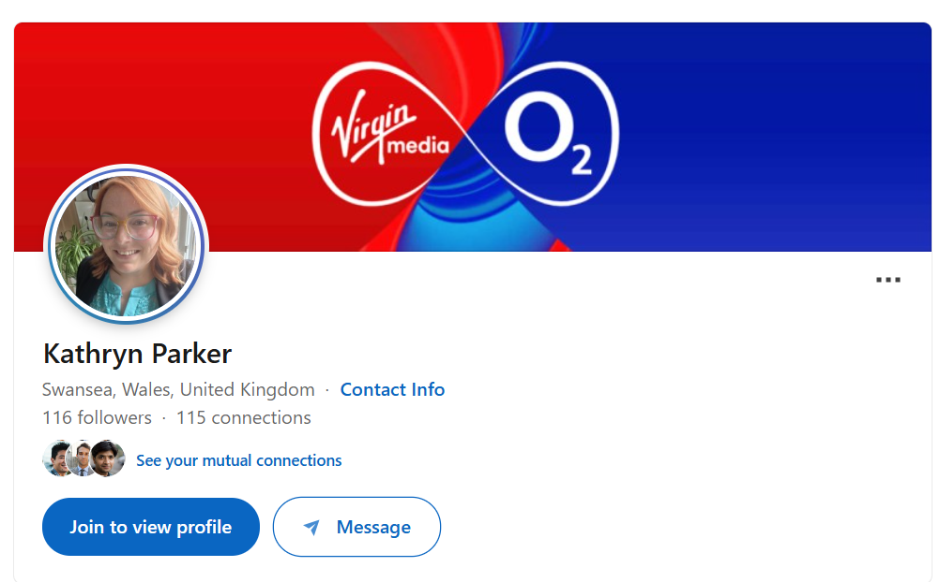

3.5 Application Rationale
I tailored my application specifically to Olo’s Senior Customer Support Specialist role by identifying the key requirements within the job description and matching these against my existing skills and experience. I prioritised the requirements relating to complex customer problem solving, technical troubleshooting, KPI performance, written and verbal communication, root cause analysis, knowledge sharing and working independently within a remote environment.

My CV was adapted to highlight my most relevant experience rather than focusing solely on general customer service. I emphasised my current role as a Senior Customer Contact Advisor, including resolving technical faults and account queries across multiple IT systems, managing CEO level complaints and consistently achieving performance targets. I also highlighted my previous technical support experience, coaching of colleagues and ability to work effectively in fast paced environments.

The application also prioritised Olo’s requirement for employees to identify recurring problems and contribute to improvements. Therefore, I included examples of root cause analysis, auditing more than 1,000 self care articles and creating a staff support hub that became part of core operations. These examples demonstrate my ability to identify opportunities for improvement, share knowledge and contribute beyond individual customer interactions.

My cover letter was tailored to demonstrate how my experience could transfer into Olo’s SaaS environment while avoiding claims about specific systems or tools that are not evidenced in my CV. I also highlighted my 11 consecutive annual awards to demonstrate consistent customer focused performance.

Finally, my LinkedIn profile was considered an opportunity to reinforce the same professional brand, focusing on customer service, technical support, problem solving, communication and continuous improvement. Maintaining consistency across my CV, cover letter and LinkedIn profile ensures that the application presents a clear and credible picture of my suitability for Olo’s Senior Customer Support Specialist position.

References
Careers Wales, 2026. Skills and strengths employers want. [Online]
Available at: https://careerswales.gov.wales/plan-your-career/skills-and-strengths/skills-and-strengths-employers-want
[Accessed 28 09 2026].
Department for Science, Innovation and Technology, 2026. AI Skills for Life and Work: Stakeholder Engagement Report. [Online]
Available at: https://www.gov.uk/government/publications/ai-skills-for-life-and-work-stakeholder-engagement/ai-skills-for-life-and-work-stakeholder-engagement-report
[Accessed 10 10 2026].
Gibbs, G., 1988. Learning by Doing: A Guide to Teaching and Learning Methods. Oxford Polytechnic.
Luft, J. and Ingham, H., 1955. The Johari window, a graphic model of interpersonal awareness. Proceedings of the western training laboratory in group development. University of California.
Welsh Government, 2024. Employer Skills Survey: 2024 (Wales regional reports). [Online]
Available at: https://www.gov.wales/employer-skills-survey-2024-wales-regional-reports
[Accessed 28 09 2026].

