

Module: Learning in the Digital Era
Student Name: Kiran Ali
Student ID: 2522876
Module Code: ACCA4025
Lecturer: Masud Siddiqui
Assignment title: Professional Development Plan (PDP)

Table of Contents
Task 1 – Self-evaluation. 3
Task 2 – PDP. 4
Presentation link: 4
Screenshots of PDP 4
Task 3 – Unit 4 topic summary. 6
Task 4 – Video presentation. 7
YouTube link 7
Google Drive link of presentation: 7

Task 1 – Self-evaluation.
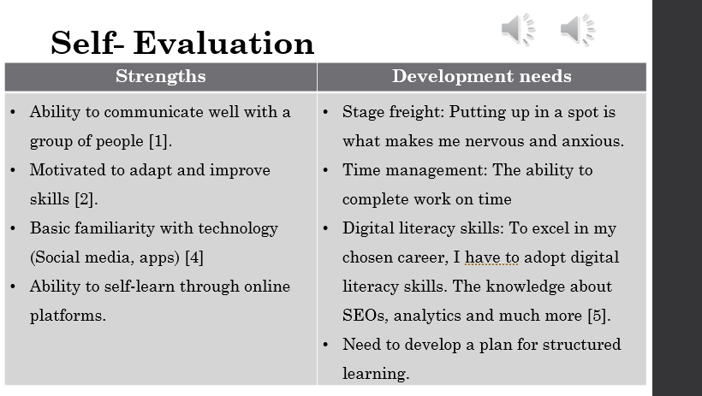

Task 2 – PDP.
Presentation link:
https://docs.google.com/presentation/d/1Km-pxAIwWmzf16Y8UNGeZatNweY5FTpd/edit?usp=sharing&ouid=109988500000511658466&rtpof=true&sd=true

Screenshots of PDP
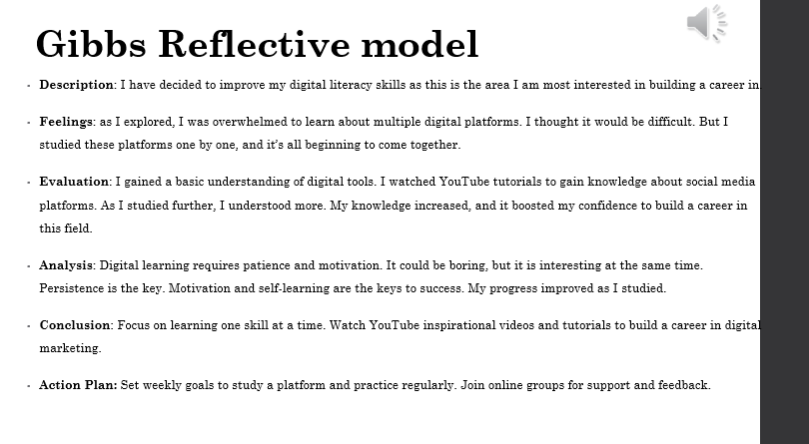
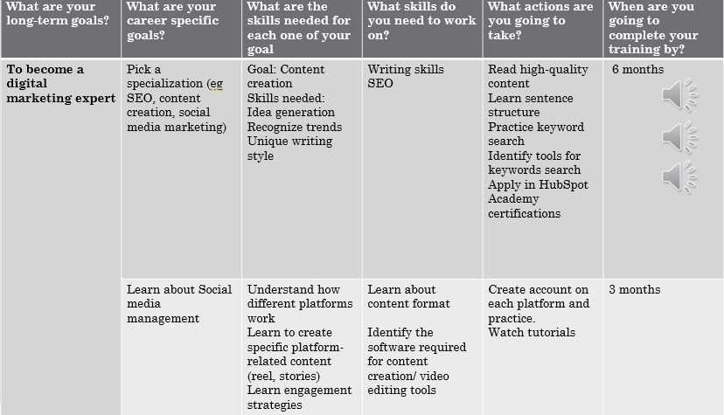

Task 3 – Unit 4 topic summary.
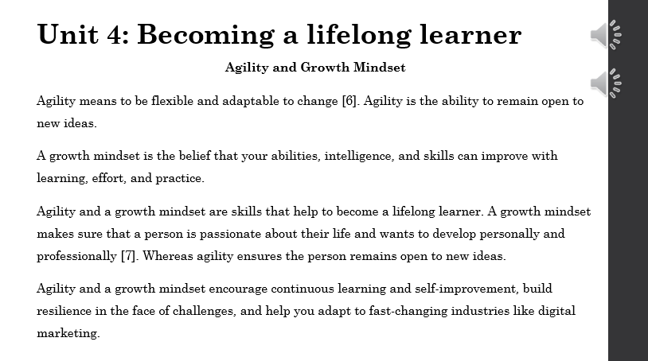

Task 4 – Video presentation.

YouTube link
https://www.youtube.com/watch?v=5Q0rWOK-8zY
Screenshot of the Video in its cloud platform (e.g., YouTube).
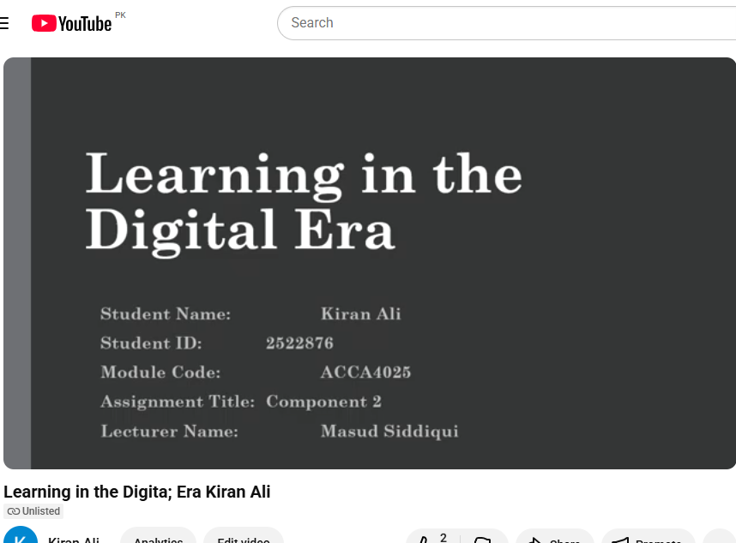

Google Drive link of presentation: https://docs.google.com/presentation/d/1Km-pxAIwWmzf16Y8UNGeZatNweY5FTpd/edit?usp=sharing&ouid=109988500000511658466&rtpof=true&sd=true

