Imagination: the power to transform the ordinary into the extraordinary

Aled Francis Williams

“Submitted in partial fulfilment of the requirements for the degree of Photojournalism and Documentary Photography BA(Hons), University of Wales Trinity Saint David, Swansea”

10th December 2018

Word Count of Main Body
: 5130

TABLE OF CONTENTS

Page 3 | List of Illustrations
Page 5 | Summary of Topic
Page 6 | Chapter 1 – Introduction
Page 8 | Chapter 2 - Observation
Page 11 | Chapter 3 – Perception
Page 15 | Chapter 4 – Simplicity
Page 20 | Chapter 5 – The Decisive Moment
Page 23 | Chapter 6 - Imagination
Page 26 | Chapter 7 - Conclusion
Page 28 | Bibliography

List of Illustrations

Figure 1: Lange, D. (1936) Migrant Mother (Black and white photograph) Available at: https://en.wikipedia.org/wiki/Florence_Owens_Thompson#/media/File:Lange-MigrantMother02.jpg (Accessed: 8 November 2018)

Figure 2: Turner, JMW. (1834) The Burning of The Houses of Lords and Commons (Oil on canvas) Available at: https://en.wikipedia.org/wiki/The_Burning_of_the_Houses_of_Lords_and_Commons#/media/File:Joseph_Mallord_William_Turner,_English_-_The_Burning_of_the_Houses_of_Lords_and_Commons,_October_16,_1834_-_Google_Art_Project.jpg (Accessed: 9 November 2018)

Figure 3: Monet, C. (1908) Sunset in Venice (Oil on canvas) Available at: https://en.wikipedia.org/wiki/San_Giorgio_Maggiore_at_Dusk#/media/File:Claude_Monet,_Saint-Georges_majeur_au_crépuscule.jpg (Accessed: 10 November 2018)

Figure 4: Raphael. (c.1519-20) The Heads and Hands of Two Apostles (Black chalk touched with white on greyish paper) Available at: https://theartstack.com/artist/raphael-sanzio-1483-1520-1/heads-and-hands-two-apo (Accessed: 11 November 2018)

Figure 5: Rothko, M. (1945) Archaic Idol (Oil on canvas) Available at: http://www.markrothko.org/paintings/ (Accessed: 12 November 2018)
Figure 6: Rothko, M. (1958) Four Darks in Red (Oil on canvas) Available at: http://www.markrothko.org/paintings/ (Accessed: 13 November 2018)

Figure 7: Vermeer, J. (1665) Girl with a Pearl Earring (Oil on canvas) Available at: https://en.wikipedia.org/wiki/Girl_with_a_Pearl_Earring#/media/File:Meisje_met_de_parel.jpg (Accessed: 15 November 2018)

Figure 8: Constable, J. (1821) The Hay Wain (Oil on canvas) Available at: https://en.wikipedia.org/wiki/The_Hay_Wain#/media/File:John_Constable_The_Hay_Wain.jpg (Accessed: 16 November 2018)

Figure 9: Bresson, HC. (1932) Derriere la Gare Saint-Lazare (Black and white photograph) Available at: https://iconicphotos.wordpress.com/2009/07/26/derriere-la-gare-saint-lazare/ (Accessed: 17 November 2018)

Summary of Topic

As an aspiring photojournalist and filmmaker, I have come to regard ‘observation’ and ‘perception’ as fundamental processes within my own work. I have had the opportunity of seeing the work of creative geniuses first-hand, in film (Kubrick), art (Raphael, Rothko and Turner), photography (Man Ray, Cartier-Bresson and Franklin) and literature (Steinbeck and Tolkien). I felt compelled to search for a deeper understanding of how these two processes, along with ‘simplicity’ and ‘imagination’’, when in the hands of a creative genius, can create timeless extraordinary masterpieces.

Chapter 1: Introduction
“The meaning of life is to find your gift. The purpose of life is to give it away.” The origin of this remark is unknown, but its truth is surely too contestable. Throughout human life, running as a continuous thread, the human mind has sought out these features which demand attention and will exercise the gifts which every human being possesses. Be it the written word, the marks on a canvas, the sound of an instrument or the most abstract nature of scientific discovery, all are subject to the brain’s powers of observation, perception, analysis and deduction. Imagination does not stand out from this process, it springs from the very roots of human thought and possesses enormous power, so much power that often it has to undergo a simplification process to make it fit into common human interaction and understanding, especially in the world of science and technology.

These are the ‘building blocks’ of human endeavour – to first find, then practice, the gift of creativity. Building on the discussion of major human achievements in the proposal, we now move to a clear examination of these processes and cast our net somewhat wider. We shall also try to find common themes within these endeavours, those mental features which serve the physical brain ‘the master tool’ of consciousness, creativity and the foundation of that which unites all mankind.
The core feature of this journey towards imagination lies in the distinction of the psychology, of the mind and the philosophy of life, the bridge of understanding which unites the engine house of the brain to the realities of life. This bridge forms the core power of creativity in all its manifestations; without it there can be no ‘Life’ as we know it – be it Locke’s ‘Tabula Rasa’, Kant’s creative affirmation of the power of the mind to create patterns of existence – to create an existentialist world. Thus, the ebb and flow of creativity, be it literature, music, art or the physical reproductions of the world of photography, all are part of the ebb and flow of that which is created, thus becoming the bridge of understanding, the gift which is given by one to another. This gift has many shapes, skills and forms. I will also look at photography and film, skills which are as creative as any which have been followed throughout the ages, and one could make the case that their impact has been as considerable as any other form of communication.
In my first two chapters I have defined the powers of ‘observation’ and ‘perception’ as being the keys to unlocking our imaginations and have given examples of how these appear across the creative arts. Next, I have studied and defined simplicity as the gateway to bridging the gap of understanding and provided instances that demonstrate this in practise. In Chapter 5, I have synthesised the three key concepts by discussing the street photographer, Cartier-Bresson and his ‘decisive moment’. Finally, I have talked about how imagination lies at the very heart of the process of turning the ordinary into the extraordinary.

Chapter 2: Observation
‘The action or process of closely observing or monitoring something or someone.’
All artists are observers of one kind of another, be it songwriters, filmmakers, poets, photographers or painters. Lyrics and observation. Brushstrokes and observation. Thoughts and observation. Words and observation. Photographs and observation.
Writers’ words are based on what they see and what they hear. Oscar Wilde was a true observer of the world around him as he melded human action, thought and words into laughter, unlike any other writer. His sensational wit created a sense of amazement in the listener, as he was able to create humour and fun out of mundane, everyday occurrences. ‘The Importance of Being Earnest’ provided an insightful account of how the absurdities of life can be regarded as funny. His ability to observe all that went on around him in every strata of society meant that his works could be universally understood. His ‘Ballad of Reading Gaol’ demonstrates he could read minds and empathise with the sufferings of those not in his society. Thrown into a cauldron of unhappiness and misery, his brilliant observational mind could turn such despair into a work of art. He saw, he knew, he felt, he suffered and through all those observances he triumphed. He turned the ordinary into the extraordinary.
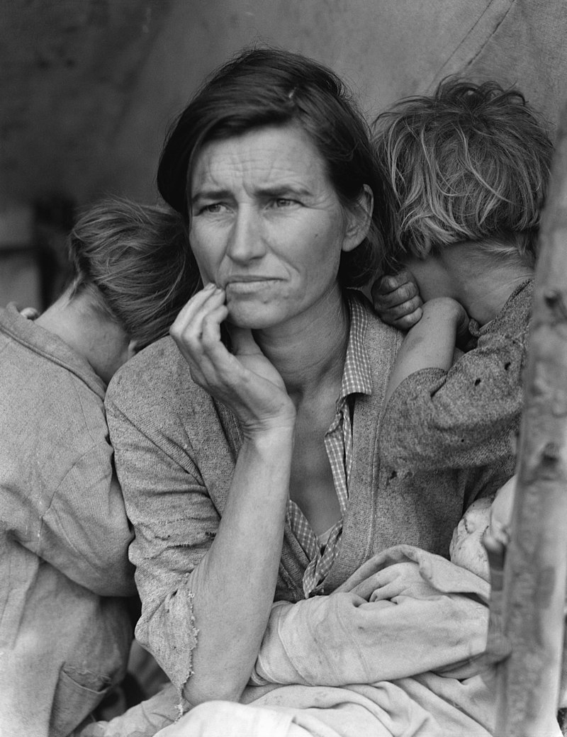
Similarly, in photography we can find obvious examples of creative minds who can use their innate powers of observation to capture the world around them. One such mind is that of Dorothea Lange. There is no better example than Dorothea Lange’s 1936 photograph the ‘Migrant Mother’ which captures the American Great Depression like no other. The dignity of a suffering mother, the despair of her children still has the power to move us to pity more than any other photograph of that dreadful era. The simplicity of mother and children becomes a cry for justice, fair play and human love and compassion.

Figure 1: Migrant Mother

As Bethan Morgan (2016) states in her commentary of Lange’s work, “Her documentary technique is both neutral and detached. By remaining creatively impartial, Lange documented the scene with honesty, conveying a powerful image of strength through suffering”
This photograph shows her at her most discerning, at her most insightful and at her most touching. She knows these people, she feels for them: she had seen great wealth in her early portraits of San Francisco society, now she sees the other side of life and how awful it can be. She poured her emotions into her art, but above all – as evidenced in her later photographs – she was witness to the degradation of poverty, in ordinary language she has a keen ‘observer’ of what lay on the other side of the American Dream.
Again, as Morgan (2016) states,
Dorothea Lange not only epitomises an entire era of American history, but a photographic discourse. She was a cultural commentator who used the camera to accurately record – but never interfere with – the political happenings of the time. Lange’s photographs remain iconic.
We enter the world of ‘observation’ through a perceptive photograph of poverty and a commitment to truth. The photograph is as much a moral statement as Carol Reed’s ‘The Third Man’; Kant in his ‘Critique of Judgement’ continues his fundamental distinction between sensory and reflective judgement. When these ideas are applied to Lange’s photographs, the perceptive element comes to the fore and we are presented with a work which combines all three of our key analytical elements. This one photograph blends simplicity, observation and perception into a striking unity which underlines the basic truth that these three human senses, whilst they can be used separately, when combined can produce a powerful and memorable effect. Lange’s forces of observation, still at a ‘simple’ subject of three human beings and the perceptive mind guided by kindness and empathy has given us one the most powerful peacetime images of the fourth decade of the twentieth century.
We may sometimes struggle to link imagination with observation but, they are without doubt intertwined; that which is observed is not imagined, that which is imagined cannot be observed – except, and most importantly within the mind of the person who is using his or her imagination. The role of the ‘creator’ – painter, writer, photographer, filmmaker is to fuse both these processes in order to deliver a product that has been driven by imagination and detailed by observation. The end result does not mirror reality as we commonly know it; it is a product of the reality that has been infused with enough imagination to make the viewer stand back in awe. Many of our creative minds have the innate ability to merge the processes of observation and imagination together.
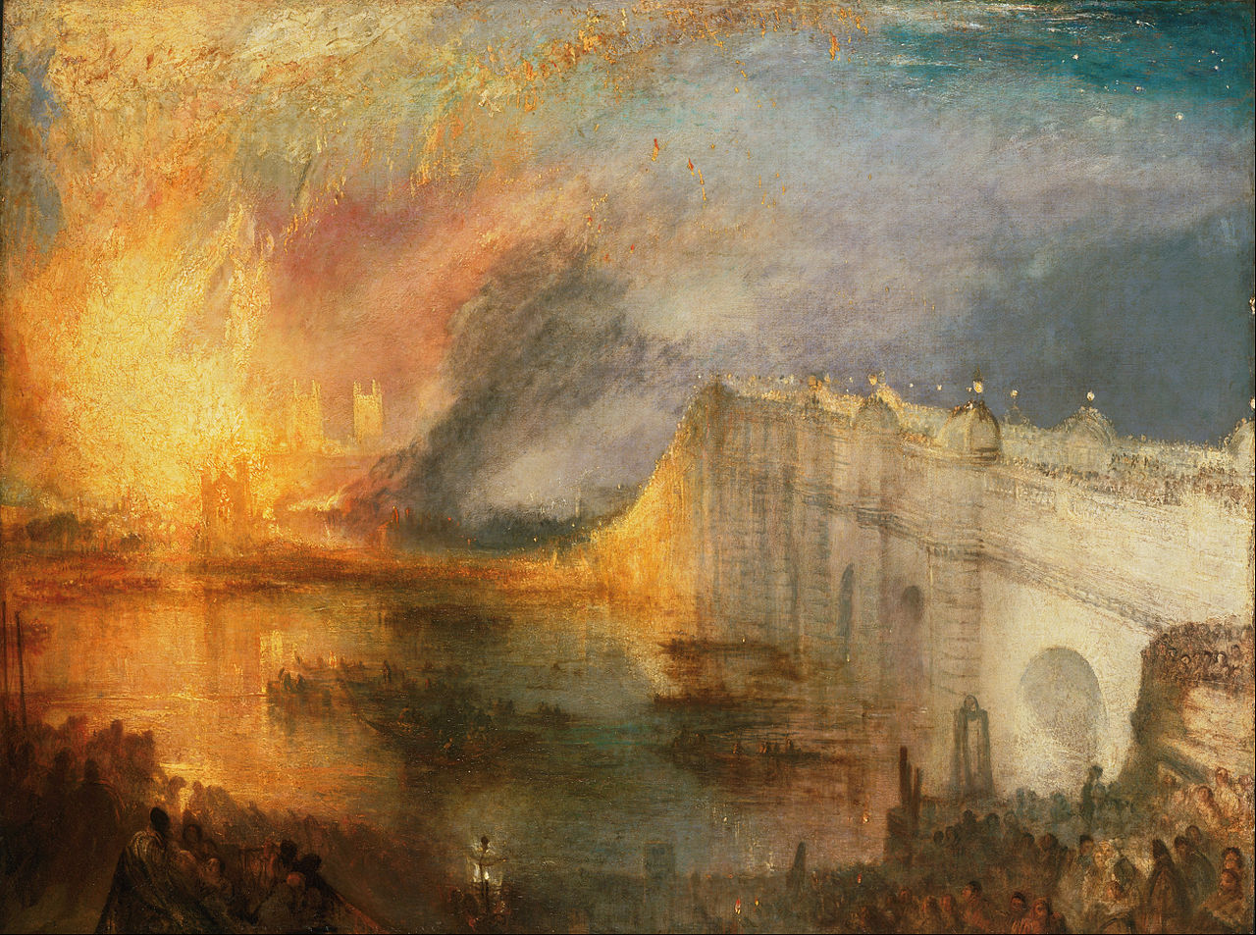
The English artist JMW Turner displays this power in its most dramatic form. Living at a time of great change in Britain, the vibrancy and dynamism of his later oil paintings heralded a new era in art. His keenness to create from his own eye witness observations is clearly demonstrated in his painting ‘The Burning of the Houses of Lords and Commons’. He is recorded to have rushed to join the throng and watch the event unfold before his very eyes. Using both pencil and watercolour, Turner quickly sketched what he saw, capturing the scene from different vantage points on the Thames River. These observations allowed him to create a captivating visual record of the event from his studio. Someone once said that Turner’s late oil paintings show maximum effect with minimum effort. There is more than a grain of truth in this remark, those few brush strokes, that observant and imaginative mind gave us some of the most iconic of British paintings. Without doubt he created the extraordinary out of the ordinary.
Figure 2: The Burning of the Houses of Lords and Commons

Chapter 3: Perception
‘The ability to see, hear, or become aware of something through the senses.’
To see, to hear, to touch, to taste are the senses that enable humans to build a perception of the world around them. Without thought and interpretation, however, our perception is limited; with thought and imagination the extraordinary can be transformed out of the ordinary.
The Impressionists were a group of artists in France who changed the very face of painting by choosing to paint “on the spot” or, ’en plein air’ and not in their studios from previously made sketches. Their aim was to convey an impression of what they saw for the viewer. The influence of Turner is unambiguous, but in intellectual terms Impressionism is far removed from Turner. Impressionism by its’ very nature travels much deeper into the mind of the artist. Where Turner’s undoubted brilliance lay in his mastery of the art of painting, his dynamic use of colour to give movement to objects, the Prince of Impressionism, Claude Monet, was distinctly different. Perception was the bedrock of Impressionism. This movement heralded the first insight into the creative minds of artists. Monet’s paintings merely reflected the feelings that arose in his mind and the perceptions that he held. Is perception feeling? To a great extent it is, there is no better way to express a feeling based on an immediacy of thought or a first sight than to portray it through paint on canvas. Through his paintings, Monet delivers an impression of what he sees, an insight into his mind and how this affects his immediate appreciation.
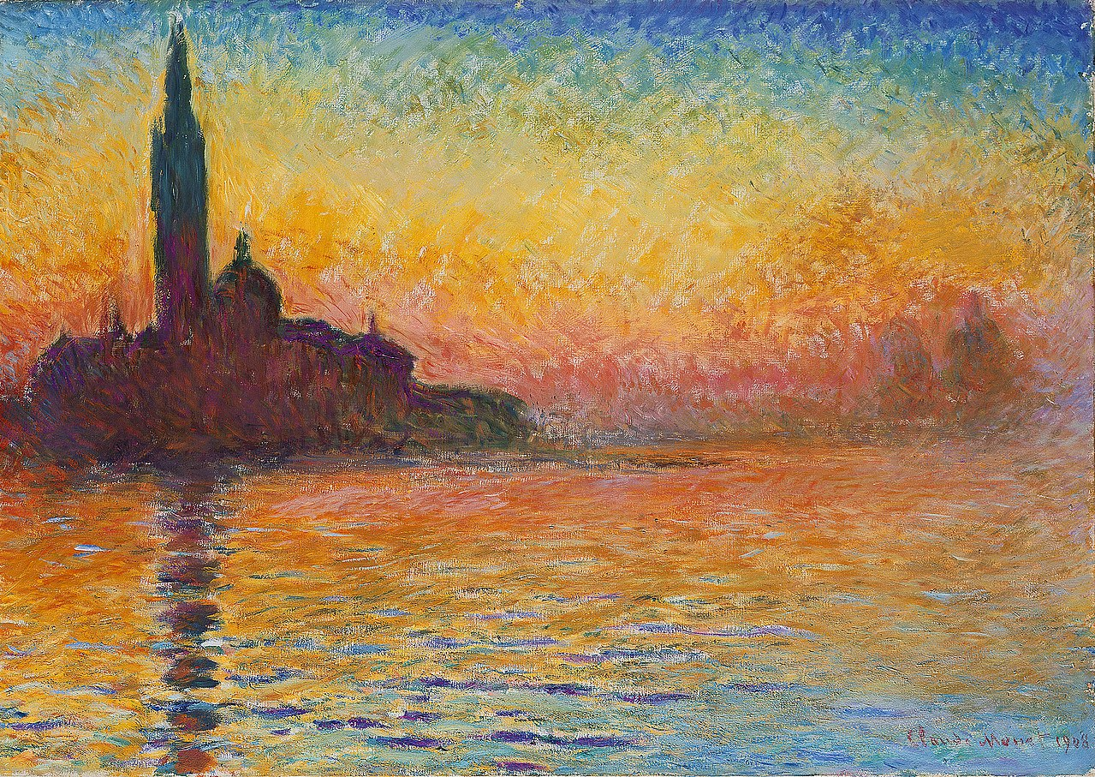
For me, one of his lesser known paintings ‘Sunset in Venice’ encapsulates this ability to translate what he sees onto canvas. Although this painting is ostensibly of the island of San Giorgio Maggiore, it is the beauty of the light at sunset that truly captures Monet’s eye. In true Impressionist form, he manages to convey the changing qualities of light and to use the typical brushstrokes to evoke a sense of movement on the water. One cannot look at this painting without securing an insight into the mind of Claude Monet.
Figure 3: Sunset in Venice
In his own words he said,
When you go out to paint, try to forget what objects you have before you - a tree, house, a field.... Merely think, here is a little square of blue, here an oblong of pink, here a streak of yellow, and paint it just as it looks to you, the exact colour and shape, until it gives your own naive impression of the scene before you.
John Berger in his ‘Ways of Seeing’ attempts to explain for the lay person the importance of our own perception. He insists that what we see in an image is purely unique to ourselves as individuals. He says, “The way we see things is affected by what we know or what we believe.” (Berger,1972, p.8). He uses the example of people living in the Medieval times and their belief in the ‘physical existence of hell’. This belief would have engendered in them a sense of absolute fear at the sight of fire. Whereas in today’s world this image of fire no longer has the power to create such fear. Therefore, it is clear that our firmly held beliefs inform our unique perception on what we see.
“Seeing comes before words. The child looks and recognizes before it can speak.” (Berger, 1972 p.7) He is explaining that when we see the world we place ourselves in it entirely, however, it is words that are used to make sense of the world. Magritte, the surrealist painter highlighted this in his belief that there was an ever present space between sight and words. Berger uses his painting The Key of Dreams in his book to emphasise the disconnect between the object and the written word.
In his article ‘On Ambiguity’, Stuart Franklin cites many photographers who wish their work to remain uncaptioned to allow the viewer to reach their own conclusions based on their own unique perception. Berger, himself, says “All photographs are ambiguous.” It is unlikely that the viewer always knows the history behind an image and therefore is forced to interpret it in their own way. Henri Cartier-Bresson, for example, was determined to withhold explanations and deliberately did not provide a commentary on his images.
The ability to use our own perception when looking at an image – a painting or a photograph enables us to translate the ordinary into the extraordinary.

Chapter 4: Simplicity
‘The quality or condition of being plain or uncomplicated in form or design.’
At it’s deepest foundations, everything in life is simple. Imagination takes hold of simplicity and by building upon it layer by layer it drives diversity into a new unity. All and everything can be broken down so easily but it takes a genius to add imagination and it takes imagination to master the transference of thought to word, perception to brush and eye to film. Kant and Raphael were such masters. “The Third Man” is a relatively simple story of criminal anti-social activity in post war Vienna. In fact, the film was conceived by a sole sentence scribbled down by screenwriter Graham Green. This story was a simple portrayal of good versus evil and demonstrated the simple and idealistic faith that human beings place in institutions, family, friends and morals. In the end, the main characters simply have each other. Carol Reed adds a mixture of mystery, friendship and human endearment to an activity which poses a fundamental moral problem. Similarly, Immanuel Kant wrestled with these problems and presented us with his Categorical Imperative; that our moral actions should have the power to become laws of human behaviour. Kant and Reed are dealing with the same problem but in vastly different formats, yet the outcome is the same. Reed’s film and Kant’s Categorical Imperative gave us the same message, namely that evil should not be accepted by society. ‘The Third Man’ is as much a moral take as ‘The Fundamental Principles of The Metaphysics of Ethics’. Whether man and ‘the world’ has ever lived up to this ideal is, of course, a massive question mark; the best we can say is that it is ‘work in progress’ and that ‘The Third Man’ is, on the whole, rather more enjoyable than Kant’s ‘Fundamental Ethics.’
Imagination is again beginning to creep into our thoughts. This is not the Imagination of Simplicity – it is the imagination of humanity grappling with amoral forces. Yet very serious art can be “Simple” in all forms of creativity – Raphael, Vermeer, Constable and Rothko are, for me, excellent examples of this through time.
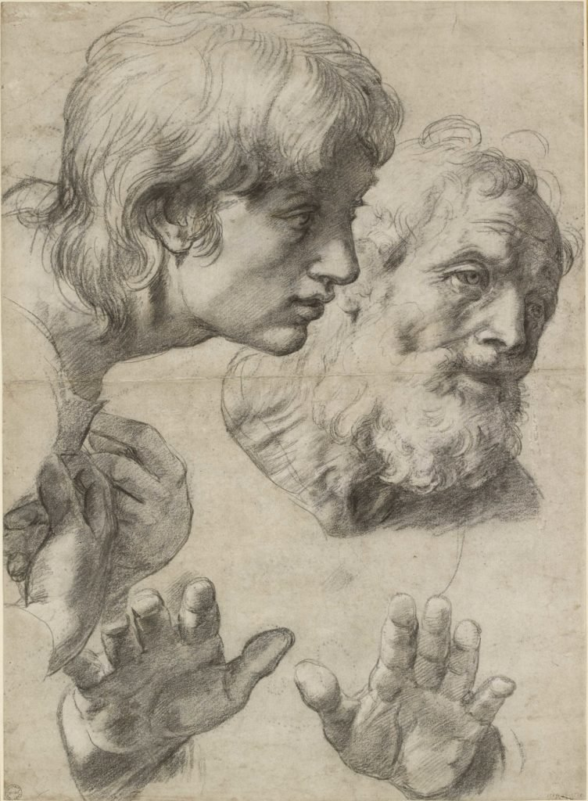
The simplicity that Raphael brings in his drawings is the determination, the knowledge of and the mastery of the human form in all its twists and turns. Nothing demonstrates his supreme mastery of technique more than his drawing ‘The Heads and Hands of Two Apostles’. Here we simply see two heads and four hands. The angst of age and the slight bewilderment of youth have never been more accurately or more movingly displayed. On seeing this first hand in the Ashmolean exhibition of Raphael’s drawings I saw a sudden simplistic view of the world in front of me. When I glimpsed at this drawing I saw humanity and all its complexities reduced to its simplest forms.
We can learn so much more of simplicity in art, from the early Italian masters through Vermeer to Constable much of French impressionism and up to our day where Rothko’s extensive simplicity has the power to fill us with wonder.
Figure 4: The Heads and Hands of the Two Apostles
As Rothko’s art progressed his work appeared to become more and more simplistic, showing a reverse evolution and a reduction to almost nothingness. His later work, from 1947 – 1969 clearly demonstrated this move to simplicity and an elimination of clutter. The following two paintings illustrate this transformation to simplicity.

As Mark Rothko stated,
The progression of a painter’s work …. will be toward clarity; toward the elimination of all obstacles between the painter and the idea and between the idea and the observer……. to achieve this clarity is inevitably, to be understood.
Figure 5: Archaic Idol
Figure 6: Four Darks in Red
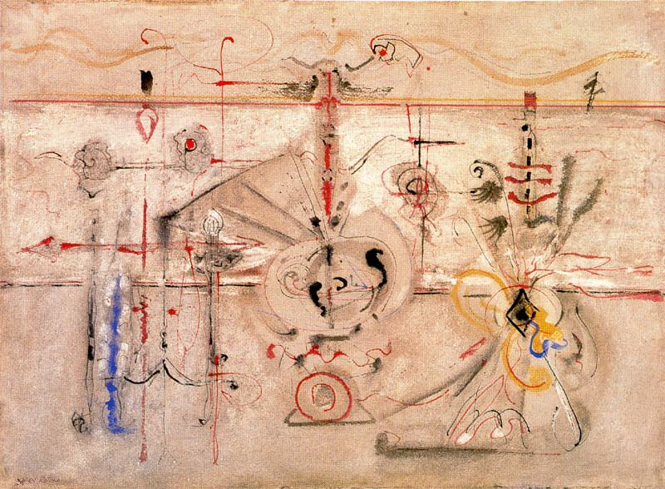
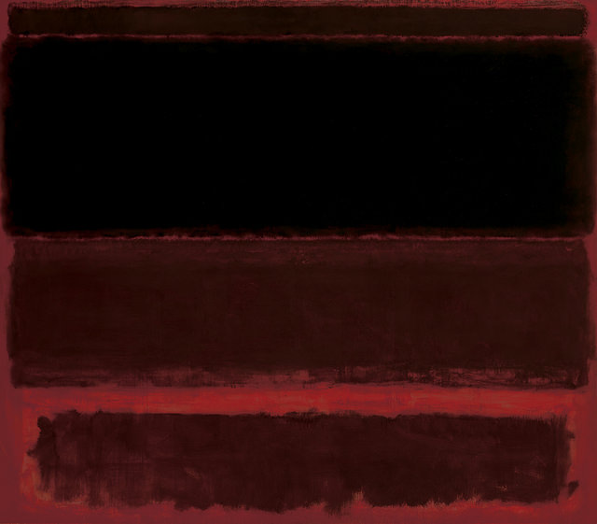
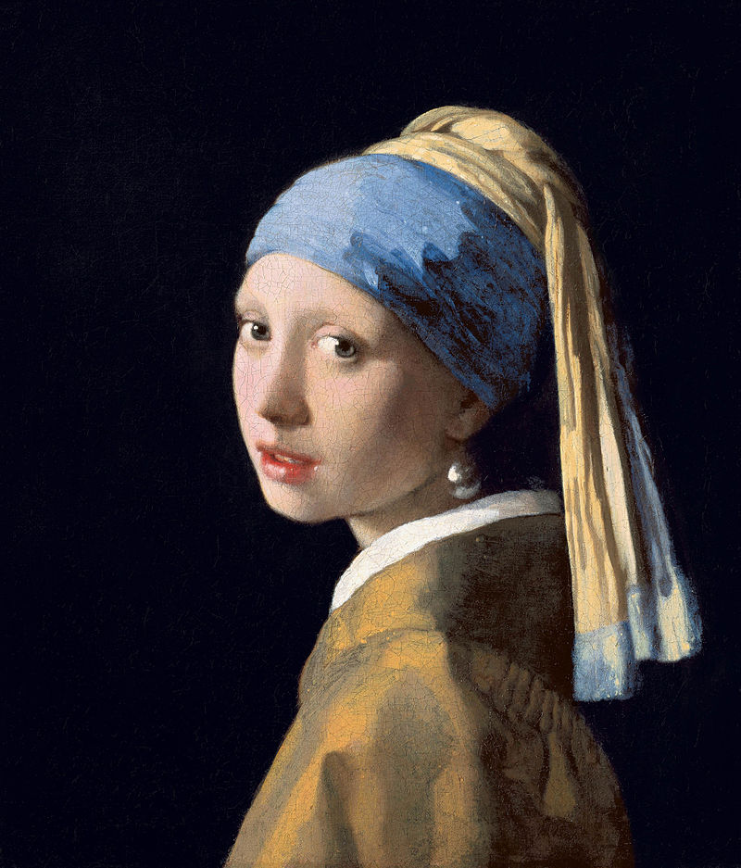
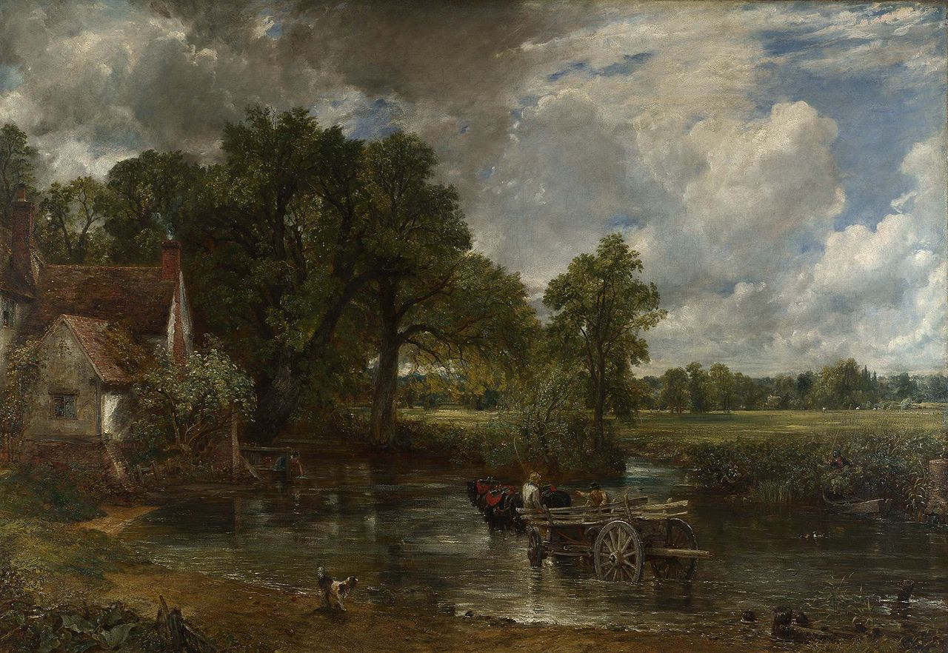
Figure 8: The Hay Wain
Figure 7: Girl with a Pearl Earring

In Vermeer’s ‘The Girl with A Pearl Earring’ the artist wanted to capture a simple moment in time to enable onlookers to create their own ideas about the subject. We have become transfixed upon her facial expression and transported to a world of realism and simplistic ideas. In Constable’s ‘Hay Wain’ the subject is portrayed in a very realistic way as this is what Constable saw from a very young age. He painted nature as he saw it in its most simple form. His familiarity enhanced his vision and understanding of this everyday environment.
All of these works – portraits, landscapes, ‘Rothkonian’ lines have the power to let our imaginations loose, to let us add to what we see in front of us. Through the Italian Renaissance, Holland’s quiet supremacy, England’s soothing countryside or Rothko’s urgent appeal to our intellectual curiosity these, and much more, test our perception of what the nature, and the effect of, great art is.
What of film and photography?
We move from Raphael and Kant to Laurel and Hardy. Is this relevant? Yes, it is because it is about creativity. The arch exponents of zany comedy hold an important and treasured place in our hearts and minds because they gave us, through the format of moving film, a glimpse into a world of humour, laughter and hours of freedom from the cares of the world. This is what creative humour is. We do not usually find it in art; we can find it in literature (Shakespeare’s comedies and so much more), music (Rossini) Variety (Morecambe and Wise) and we can find it in our everyday lives: humour in film is something special. Add Effects to Special and this reinforces our enjoyment of an art form which has become a main creative force over the past one hundred years. Storytelling itself is the most basic form of human communication which can be passed on from one generation to an another, as George Lucas said - “A special effect without a story is a pretty boring thing.” Star Wars is filled with special effects, yet at heart it is a tale of adventure, of humanity in a distant age fulfilling the aspirations and dreams that, in their mental context, have been in the mind of man for centuries. Star Wars’ ultimate appeal lies in the simple message of good overcoming evil in an intergalactic setting. David Lean’s ‘Lawrence of Arabia’ is a mixed tale of adventure, war, brotherhood and political betrayal. Yet its gives us a glimpse into the Arabian world of the early twentieth century and we see images of a society, traditions and a world so different to that of the late twentieth century. Yet underlying ‘Star Wars’ and ‘Lawrence of Arabia’ are the same technique and method which underline all film production. Whether one is a master of film, whether one is Reed, Lean or Lucas the same principles apply, and one of the main features is simplicity. These filmmakers are masters of the ordinary or the simple becoming the extraordinary.

Chapter 5: “Decisive Moment”

Simplicity, observation and perception seem now to be melding together to form a bedrock model not too distant form Henri Cartier-Bresson ‘Decisive moment’, a concept which has aroused much comment, applause and criticism, since he introduced it in 1952. Any decisive moment must contain strong elements of all three; the context of any imaginative endeavour is vitally transformed when these three elements are interwoven into a recognised pattern. John Steinbeck’s ‘The Grapes of Wrath’ is a prime example of a work where all three are moulded together to form as vivid a portrait of destitution hope and forbearance as Lange’s ‘Migrant Mother’. Any work of art, be it a novel, a photograph, film, music or a portrait needs these three mental processes to gain our attention and to hold it in our memories and our minds eye.
Where does imagination fit into this pattern? Einstein said that “imagination is more important than knowledge.” For knowledge is limited, whereas imagination embraces the entire world, stimulating progress, giving birth to evolution “Embraces the entire world” is the important element. Imagination is not beyond the world of the senses; it feeds on the senses and creates new patterns and it becomes the foundation of originality. This applies to all human endeavour; progress as such is based on pushing and pulling the senses into new territories which had never entered one’s mind before. We cross the bridge of understanding, from the unknowable to the knowable and we enter the common world.

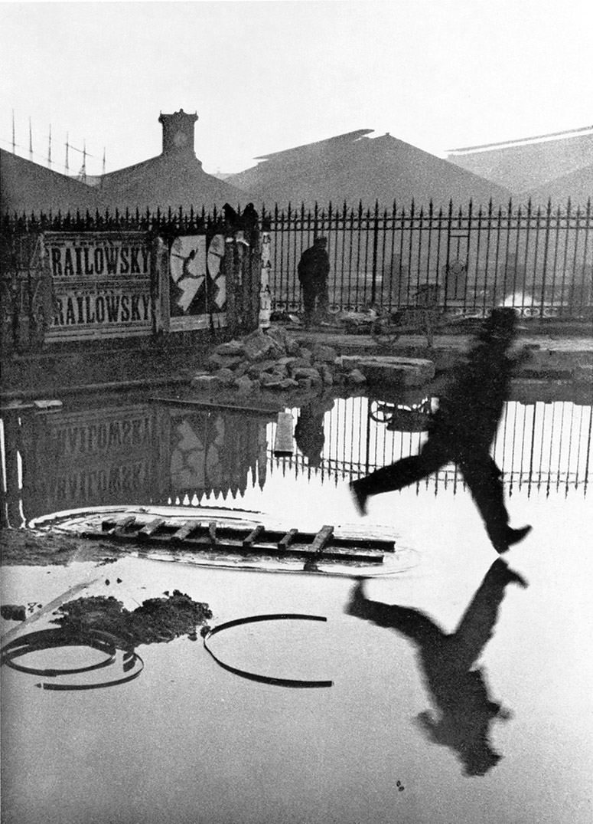
How can this apply to a photograph? Surely this is the one art form where the knowable is all that is needed: we leave it to others to make what they will of the image that we present them. Cartier-Bresson’s photograph, commonly called ‘The Puddle’ stands out as a stunning example of the ‘Decisive Moment’ in photography. It is a comparatively simple photograph of a gentlemen possibly about to jump over a puddle using a ladder as a “spring board.” This is what we observe. What is perceived in this ordinary street photograph is up to the viewer. Who is the gentlemen? Will he make it over the puddle? Do we care if he does or does not? We begin now to wonder, and imagination begins to enter the equation. This is not gravity or general relativity, it is not a Shakespearean sonnet or a Beethoven symphony; it is not the ‘Last Supper’ or the ‘Mona Lisa’. But perhaps for just that one moment, that decisive moment, our minds are fixed on this image: the depth of feeling will not be great, but it is an image we know we shall return to because it has the power to demand our attention. A simple photograph of a man and a puddle: photographs of tragedy or beauty hold our attention and test our emotions for much longer. Yet this is Cartier-Bresson’s genius; the ordinary becomes the extraordinary, following on from the genius of Dorothea Lange. It takes imagination to make the ordinary become the extraordinary, that split second becomes the hallmark of the truly skilled. It is not given to all, and it is this fact that makes us cherish originality all the more.
Figure 9: Derriere la Gare Saint-Lazare

“The meaning of life is to find your gift. The purpose of life is to give it away” We started with this motto and have commented on some who found their gift, person to person, across a bridge of understanding. The act of perception, the process of observation and the efforts of simplification, intrinsic functions of the physical brain.

Chapter 6: Imagination

Where does imagination stand in the process. It stands at the very heart. It may sound too great a judgement to award, but without imagination all our creative abilities would die at birth. It is the engine house of creativity and within itself can form original visual and mental images which transcends the generality of creative endeavour. J.R.R Tolkien’s ‘The Lord of The Rings’ is one of the prime examples of that first step across the bridge of understanding, that link between the known and the unknown. Here is a world of the imagination that has enthralled readers of all ages since its first appearance. It is a work which profoundly joins up imagination and originality to create a “make believe” world that to so many has become believable. Peter Jackson’s film adds to its originality; it gives form to our imagination and adds to the sense of reality. Again L. Frank Baum’s The Wonderful Wizard of Oz mixes originality with imagination and produces a classic book which translates into one of the cinema’s greatest films, Victor Fleming’s ‘The Wizard of Oz’. The marriage of imagination in literature to the world of film leads us to another genre so closely tied to originality and imagination, namely fantasy and its twin sibling animation. We are now stretching our thoughts through much of the film world of the twentieth century and to one of its greatest names – Walt Disney ‘Disneyland’ has become a byword for originality, imagination, fantasy and pleasure. Yet most of this is anchored in ‘The Tales of Yore’, the tales and myths of Ancient Greece, Rome, the middle ages and on the modern world where myth has so often become the reality of hatred, abuse and death. Originality and imagination are powerful features of the human mind but for all the vast creative effort there is a darker side. Nowhere has this been more clearly exhibited than in the Germany of the 1930s where genuine creativity was expunged to allow the growth of hatred using film, literature and photography as propaganda weapons for the master race. In no way is it ironic that Joseph Goebbels became ‘Patron of The German Film’.
Thus, ebb and flow of simplicity, observation and perception weaves its way through creative endeavour. We have noted that imagination and originality play a large part in the mental make-up of such exercises, and it is difficult to mark the boundaries of the mental powers. Are there boundaries? There are boundaries of form – a philosopher is not a painter, a painter is not a poet, a photographer is not a musician. But the common theme, regardless of form, is skill, dedication and the ability to extract meaning from various forms of creativity. ‘Meaning’ itself takes many forms – from visual beauty, intellectual stimulation to a higher appreciation of the intrinsic qualities of that which one is involved with. Kant’s philosophy is difficult, much so if compared to looking at a Monet painting. The skill of Oscar Wilde is as a wordsmith and acute observer of the absurdities of the society within which he moved; but just as keen as observers of their societies were Dorothea Lange, Henri Cartier-Bresson and Robert Frank. Nietzsche is not a great system builder, but like Turner with paint, he made dramatic arrow – like thoughts stand out and hold his reader’s attention – revelatory passages that have the power of the opening bars of Beethoven’s fifth symphony which startled the first audience and continues to enthral the modern listener. Can Raphael’s supreme drawings be compared to Jackson Pollock’s ‘splashes’ or Joseph Beuys’ brilliant early drawings? Yes they can, because they aim at purpose and meaning and they achieve purpose and meaning. How all these endeavours are perceived is another matter. The architect of creativity should not be seen as judge and jury; he or she will see, read, look or listen and will make an evaluation based on the very principles which moved the creator. Any contradictory elements will be viewed as openings to perhaps a deeper understanding of the creator’s message. Wide acclaim will mark a work to be valued as a treasure. In the world of film, John Grierson ‘Night Mail’ is rightly considered a classic which stands the test of time, to be admired as one of the great documentary films of the twentieth century. Sorting mail on an overnight train from London to Glasgow would not, on the face of it, arouse great expectations but in the hands of a master like Grierson and his outstanding team at the GPO Film Unit it takes on life of its own. Wonderful photography, fine words (Auden) and music (Britten) combine to hold the attention of even the most cynical ‘treasure resistant individual’. Once again, the ordinary has become the extraordinary.

Chapter 7: Conclusion

“The meaning of life is to find your gift. The purpose of life is to give it away.” We have commented upon a number of creators who have shared their gifts with us, the fruits of their imagination, their observations, their perceptions and their ability to cross the Bridge of Understanding and to make it appear so simple. Simple it is not, but their marvellous skills make it appear so. Have we found the answer to imagination? Not yet. The closest we can come is to add their skills together, and then ponder the mystery from whence such power arises. One possible answer is to divide imagination into Primary and Secondary powers of the brain. Primary is the innate ability to concentrate the mind on the totality of the senses, secondary is to infuse that with the most abstract thoughts that push even the boundaries of sanity and then to execute that image with the innate and learned skills achieved through hard work, patience and a belief in the meaning and purpose of what one is attempting to achieve. Perhaps imagination will forever be a closed box, never to be understood yet generously given and gratefully received. Cartier-Bresson’s Decisive Moment comes to mind; the immediate sequence of that which was, that which is and that which may come ‘A photograph is worth more than a thousand words’ this may or may not be true but what it does contain is the belief that a photograph by its very nature can hold the viewer in a moment of time as no other form can. We can be immeasurably moved by a Beethoven quartet, a stunning Picasso, a supreme Raphael or the profound words of Dylan and Lennon. Yet for that decisive moment, for that one to one contact, it is the photograph that combines all the elements of appreciation. Words to sum up this subjective view? Atmosphere; the sense of reality; the feeling of ‘Being There’; stillness; record; performance; Imagination – a box, a shutter, a sense of purpose and the creation of the extraordinary out of the ordinary.

Bibliography
Berger, J (1972) Ways of Seeing. Penguin Books
Berger, J (1980) About Looking. 2nd Ed. Bloomsbury Press
Cheroux, C (2008) Henri Cartier-Bresson Thames and Hudson Ltd
Collins English Dictionary (2015)
Cumming, L (2012) Turner Inspired: In the Light of Claude – review [Online] Available at: https://www.theguardian.com/artanddesign/2012/mar/18/turner-inspired-claude-national-review (Accessed: 21st April 2018)
Ellmann, R (1988) Oscar Wilde. Penguin
Evans, M (2014) John Constable: The Making of a Master V&A Publishing
Franklin,S (2016) The Documentary Impulse Phaidon Press
Franklin, S On Ambiguity Stuart Franklin meditates on the role of caption and context in our reading of photographs [Online]
Available at: https://www.magnumphotos.com/theory-and-practice/stuart-franklin-ambiguity/ (Accessed: 25th October 2018)
Magee, B (1987) The Great Philosophers. BBC books
Morgan, B (2016) Dorothea Lange: A Powerful Photographic Portrayal Of Strength Through Suffering [Online]
Available at: https://theculturetrip.com/north-america/usa/california/articles/dorothea-lange-a-powerful-photographic-portrayal-of-strength-through-suffering/ (Accessed: 8th November 2018)
Neuendorf,H. (2017) Forget His Paintings, Raphael’s Drawings Reveal His True Genius [Online]. Available at:
https://news.artnet.com/art-world/raphael-drawings-ashmolean-991430 (Accessed on April 23rd 2018)

Pardo, A (2018) Dorothea Lange: Politics of Seeing Prestel
Raphael. (circa 1517) Studies of the Heads of two Apostles and their Hands [Online]. Available at:
http://www.ashmoleanprints.com/image/383234/raphael-1483-1520-studies-of-the-heads-of-two-apostles-and-their-hands (Accessed: 26 April 2018)
Schutz,K (2017) Vermeer: The Complete Works Taschen
Scruton, R (2001) Kant: A Very Short Introduction. OUP Oxford
Tanner, M (2000) Nietzsche: A Very Short Introduction. OUP Oxford
Teshuva, J B (2015) Rothko Taschen
Whistler, C (2017) Raphael: The Drawings. Ashmolean Museum
Wildenstein, D (2013) Monet Or the Triumph of Impressionism. Taschen
Wilton, A. (2006) Turner in His Time. Thames & Hudson Ltd

