Assignment – Design and Construction.
Name: Greg Thompson
Student Number: 1705753

The building has a 30-metre-side footprint and it is placed in the centre of the plot. According to these indications and the soil cross section attached in the next page, you have to design the following:

Into

Within the Paxton Street car park the construction of a 20-storey building with 3 car park underground floors will be taking place. Image 1.0 is the boundaries of the building and where the intended excavation will happen. This is the ideal location for the building as there is more than 18m from each boundary to the site compound boundary. This enables large machinery and plant to be able to move more freely. It also enables opportunity for storage and welfare units to be stored on site which is a huge bonus and a real time saver to the construction process.
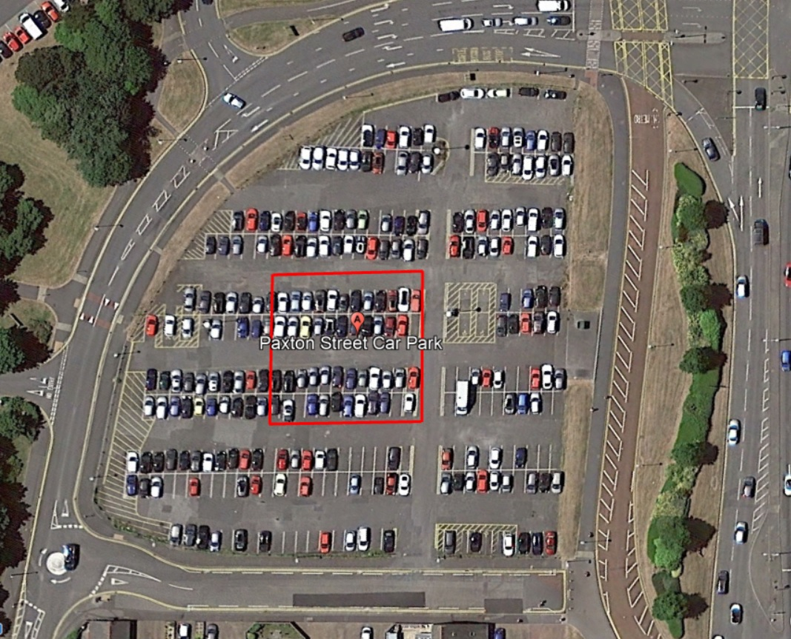

(image 1.0) – google image
secant piling – explain / anchors
Due to this building having a 3-storey underground car park the options for its foundations were limited. The other factor is that it is a 20-storey building above ground level, only a deep foundation would be suitable. After much research the following options for the foundations were possible, secant piling and diaphragm walls. Even though diaphragm walls maybe a cheaper alternative for the complexity of this building secant piling would have the greatest effect for many reasons.

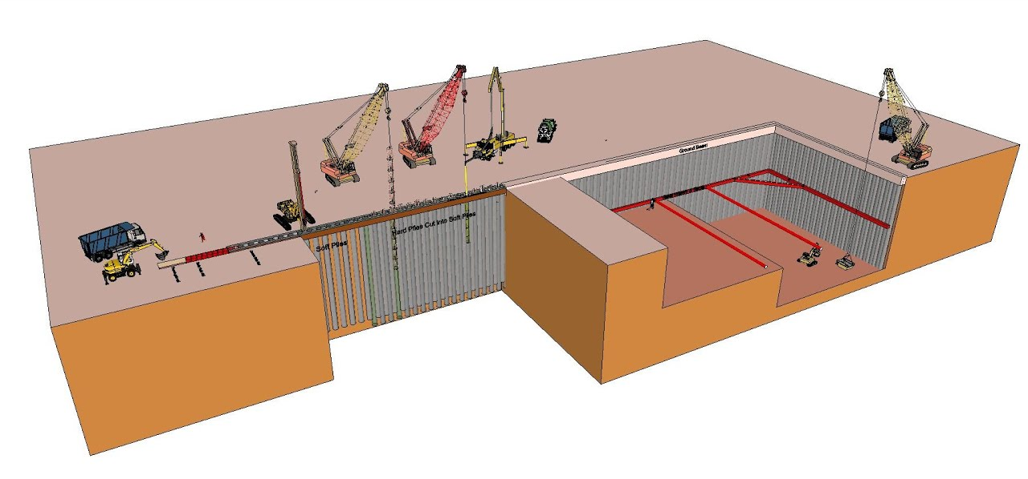
(image 2.0) https://www.youtube.com/watch?v=N_o8Njzo8dc – screenshot

secant piling is commonly used for basement construction and especially when building underground car parks. How does it work? First a guide wall is installed, this is usually made from polystyrene to give the inner wall it’s shape. The cases for the primary Piles will then be installed. All the soil will be removed using an Augar. Once all the soil is removed the case will be filled with concrete. This concrete would be designed specifically for the construction, this is because it needs to be slightly softer than usual to allow the secondary pile to overlap and eat into it as shown in image 3.0. The casing for these piles will then be removed leaving just concrete piles. A metal reinforcement cage will then be lifted and drilled down in-between the primary piles to create the casing for the secondary pile. This will then be filled with concrete. This will then be repeated along the perimeter of the foundation. This will then be a retaining wall for the structure. The secant piles will be driven in lower than the lowest level of the underground car park. The lowest car park floor will be as deep as 12.20m below ground level; therefore, the secant piles will be bored down to approx. 17.20m as it needs at least 5 extra meters below the lowest point to offer stability to the structure.

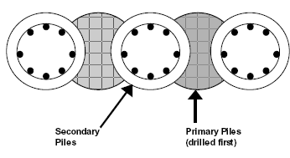

http://www.railsystem.net/secant-pile-walls/ - image of the secant piles (image 3.0)

Advantages and disadvantages of secant piling

Secant piles can be very effective deep foundation, this is due to several reasons; it increases wall stiffness as the piles are interlocked with each other, ease of construction and being able to install on difficult ground. However, this does come at a greater cost than other foundation options. The other issue with secant piling is that it is very difficult to waterproof the joints between the primary and secondary piles. You can use other methods as retaining walls such as timber and steel, although steel sheet piling is often used for basement retaining walls it is not as reliable as concrete due to the strength of the interlocking piles. This is crucial for a building of this size.

https://www.deepexcavation.com/en/secant-pile-walls

Anchors for the secant pile walls

Ground anchors will be necessary on this building due to the size of it and the depth of the 3-storey underground car park. The secant piles will need 3 anchors in them to support the structure. These will be located at every soil change within the soil build up. These will be at 4.95m deep in to the made soil, 7.95m brown sand and 10m in the boulder clay. These will be drilled on a 45-degree angle and the length will be calculated by a structural engineer to ensure they can take the correct loadings.

Load bearing piles
The load bearing piles will be installed once the secant piles are all in place. The layout of the piles will be crucial for top down construction. Ref Foundation design & construction 6th edition, M J Tomlinson, 1995. Load bearing piles are often used in heavy load basement structures, the soil directly below the underground car park is boulder clay this is not suitable to take the loadings of the structure. Therefore, the load bearing piles would have to be bored and concreted to the mudstone which is at 18.60m below ground level according to the borehole sample. The whole in which the pile will be created in will be bored first, then the reinforcement cage will be installed. The cage should be fully inspected before placed in the whole as it is impossible to remove the cage once the concrete has set around it. Once the cage is in place concrete should be pumped in using a tremie pipe. When using the tremie pipe it is crucial to ensure that the bottom of the pipe is always submerged in the already poured concrete. This will reduce and air bubbles and water ingress. Another option is to drive the pile in. this method would not be suited for this project due to the length of the piles, there would be a great chance that they would snap in the ground. Pile caps are an extremely important for a deep foundation as it ties all the bored piles together creating a stable base for the superstructure to be built off. It also spreads the load over the piles so there is no direct pressure onto the piles. The pile caps will be fully reinforced to ensure there is no concrete break down over time.

Top down construction
Top down construction is when the foundations and the ground floor level is installed. This then allows the construction of the substructure and superstructure to take place at the same time. This is extremely cost and time effective way of constructing a building with a basement. This is often used within cities as room is limited so they maximise space by incorporating the car park underground.

Once the retaining walls, piles and their caps are all in place the ground floor concrete slab is installed. Concrete is poured into the reinforcement cage surrounding the pile caps to create one concrete level. Once this is cast there will be an opening in the floor level for machinery and workers to be able to work below the floor level and continue to excavate. This is dangerous as if there is a collapse it can injure and trap people. To prevent this, struts are required to keep the retaining walls from caving in. due to the area being 30m x 30m there will have to be a number of struts in each corner, this will maintain the structures stability whilst under construction. This process of excavating under the concrete foundation will be repeated 3 times to create the underground car park. Once this is completed the access areas will be infilled with reinforced concrete and therefore is ready for waterproofing.

Excavation - construction
The excavation will go as deep as 12.20m this allows for the ground beam and the 3-storey car park. Each stratum classification has an individual bulk factor. A bulk factor is the ratio of area when in the ground compared to when removed and lose.

Classification | Depth | Area m2 | Total Area m3 | Bulking factor | Total m3 incl BF
Made Ground | 4.95m | 900 m2 | 4,455m3 | 1.25 | 5,568.75
Very dense brown sand | 3.00m | 900m2 | 2,700m3 | 1.19 | 3,213
Boulder clay | 4.25m | 900m2 | 3,825m3 | 1.07 | 4,092.75
 |  | Total: | 10,980m3 | Total: | 12,874.50

To find out the cubic meters of strata build up that needs to be removed the following equation is carried out.

Depth of stratum x area = m3 total

M3 total x bulking factor = m3 of lose ground

This equation is carried out for each classification and then added together. The overall ground that will need to be excavated and taken from site is 12,874.5m3.

The strata will be removed by an excavator and the loaded into a dumper to be taken to a landfill site.
- The dumper can hold approx. 25m3 of loose strata.
- The excavator can hold 3m3 per lift and can do one lift every 5 minutes.

Based on those calculations the excavator would need to lift 8 times to fill the dumper. With the full amount of strata being 12,874m3, it would take 514 trips by one dumper to remove all strata from the site.

The landfill site is 5 miles away, taking the dumper 20 minutes to drive there and 20 minutes back. It also takes the dumper 8 minutes to dump all strata in the land fill site.

If both dumpers start on site at the start of the day it would be possible to run both dumpers and have an approx. 8-minute gap between loadings. This would obviously be down to traffic and other unforeseen issues. It would take 52 days to remove the full load with 2 dumpers working continuously for 8 hours of the day. How did I get to that?

To fill a dumper it would take 40 minutes (8 lifts @ 5 minute per lift = 40 minutes)
To drive to the landfill site it would take 20 minutes
To dump the strata 8 minutes
To drive back to the construction site 20 minutes.
Total = 1 hr 28 minutes or 88minutes

8 hours per day = 480 minutes
480 / 88 = 5.45 trips per day
5 trips x 2 dumpers = 10 trips per day
514 trips / 10 = 51.4 days = 52 days.

However, it may be possible to run 4 dumpers and 2 excavators if the budget of the project has allowed for it. This would obviously half the time needed to remove the strata. on this project this would be possible due to the large surrounding area around the perimeter of the building. As show in image 4.0.
Site Map of Paxton car park for the construction. Image 4.0

3.Depth of water level below the ground surface
The water table level on this project is at 5.7m deep. The water will need to be removed before excavation can take place due to the sheer amount of it.
https://www.thebalancesmb.com/what-is-dewatering-844520
There are several options that can be used to remove the water from an open excavation. Due to the water table being quite shallow in relation to our full construction depth, the best solution would be to use a sump pump. A collector drain would be dug in the centre of the excavation and will be dug on a slight gradient towards the slump pump. The slump pump would be dug down in its own little well. Once water starts collecting there will be a fully designed system by engineers which will then direct the water away from the excavation area and discharge to where agreed.
https://www.groundwatereng.com/dewatering-techniques/sump-pumping
once the water for the excavation has been removed then the secant piles that will act as a cut-off wall. This will reduce the water ingress for the remainder of the construction process. The secant piles will need to be waterproofed to ensure no water ingress for the building lifetime.

- Drainage systems used during all the construction process, as well as permanent solutions to implement considering the proximity to the sea and the high level of the water table.
Basement waterproofing
There are various ways that a basement can be constructed. There can be a waterproofing membrane installed to the exterior of the concrete frame. The reinforced concrete can be waterproof so in some cases a protection layer is not necessary. Thirdly, a cavity drainage gap in the concrete wall. However, in this case the most obvious solution would be to waterproof the outside of the envelope and have a cavity wall installed. This is due to the amount of water that could possibly surround the building with such a high-water table and the sea being less than 1k away. This falls in line with regulation BS8102. Regulation BS8102 highlights all basements should be able to withstand a flash flood and a burst in the water mains. https://www.firstinarchitecture.co.uk/basement-construction-details/
https://www.basementwaterproofingassociation.org/what-is-bs-8102-and-how-does-it-affect-basement-waterproofing/
Appendix 5.0

curtain wall
For the vertical envelope of this building a curtain wall will be best suited. There will be an aluminium frame with a glass panels attached to it. The aluminium frame will then be fixed to the frame of the building. The glass panels are extremely light weight allowing them to be fitted quickly and they do not have a great effect on the buildings structure, it does however have to withstand the pressures from wind loads.
Glass curtain walling is extremely common in high rise office blocks and hotels as large windows attracts the public as they offer the best views. This is crucial when the building is so close to the sea and has such picturesque views. Another benefit is that it allows natural light into the building which will reduce the need for any artificial light.
A stick system would be used for this building as the glass would be installed one panel at a time into the aluminium frame. The glass would be double glazed to maintain the U-Value needed for the building. There would also be a ventilation system within the aluminium frame. this is crucial when installing a glass curtain wall as the building can heat up very quickly; especially in the summer months.

- curtain wall – pick one from slide show and draw.
- cold bridges!

