DATABASE DESIGN & IMPLEMENTATION
MedAssist Clinic Database System
Student name | Reyhaneh Mehrabi
Student ID | [ENTER YOUR STUDENT ID]
Programme | BSc/HND Computing Portfolio
Module | Databases and Application Development
Module code | ACCA5026
Lecturer | Suresh Shanmugasundaram
Submission deadline | 14 August 2026

Editable evidence-based report template

Table of Contents
1. Introduction 3
2. Database Design 4
3. Implementation Documentation 8
4. Stored Procedures and Transactional Scenario 13
5. Trigger and Function 18
6. Performance Tuning Enhancement 20
7. Security and Multi-user Considerations 21
8. Conclusion and Reflection 21
9. References 22

1. Introduction
MedAssist Clinic needs a modern and organised way to store patient information, doctor details, appointments, treatments and feedback. Paper-based records can be lost, duplicated or become difficult to search. A relational database provides a more consistent method of storing connected information and supports accurate retrieval by authorised clinic staff [1].
The prototype contains separate tables for departments, doctors, patients, appointments, treatments and feedback. Each table uses a primary key to identify records, while foreign keys connect related records. This structure supports referential integrity and reduces the risk of duplicated or disconnected data [2].
MySQL and phpMyAdmin were used to create and test the prototype. Stored procedures support patient operations, a trigger validates feedback ratings, and a function counts patient appointments. COMMIT and ROLLBACK tests demonstrate transaction control, while secondary indexes were created for columns expected to be searched frequently. The prototype is a foundation for a clinical database, although additional security, auditing and scheduling features would be required for production use.

1.1 Project Objectives
- Manage patients, doctors and departments in a structured relational database.
- Record appointments, diagnoses, prescriptions, treatment notes and patient feedback.
- Protect data integrity through primary keys, foreign keys and validation logic.
- Demonstrate stored procedures, transactions, COMMIT, ROLLBACK, triggers, functions and secondary indexes.

2. Database Design

2.1 Entities and Attributes
Entity | Primary key | Important attributes | Foreign key(s)
Department | DepartmentID | DepartmentName, Location, Phone | None
Doctor | DoctorID | FirstName, LastName, Speciality, Phone, Email | DepartmentID
Patient | PatientID | FirstName, LastName, DateOfBirth, Gender, Phone, Email, Address, MedicalHistory | None
Appointment | AppointmentID | AppointmentDate, AppointmentTime, ReasonForVisit, Status | PatientID, DoctorID
Treatment | TreatmentID | Diagnosis, Prescription, TreatmentNotes, TreatmentDate | AppointmentID
Feedback | FeedbackID | Rating, Comments, FeedbackDate | AppointmentID

Each entity represents a separate part of the clinic's work. Department stores service areas, Doctor stores staff details, Patient stores personal and medical information, Appointment records consultations, Treatment records clinical outcomes, and Feedback stores ratings and comments. Separating these subjects reduces duplication and makes each table easier to maintain [1], [2].
Primary keys uniquely identify records and foreign keys connect related tables. VARCHAR is used for variable-length values such as names and contact details, DATE and TIME are used for temporal values, and TEXT is used for longer medical notes.

2.2 Relationships and Cardinalities
- One Department can contain many Doctors; each Doctor belongs to one Department.
- One Patient can have many Appointments; each Appointment belongs to one Patient.
- One Doctor can attend many Appointments; each Appointment is assigned to one Doctor.
- One Appointment can be associated with Treatment and Feedback records.
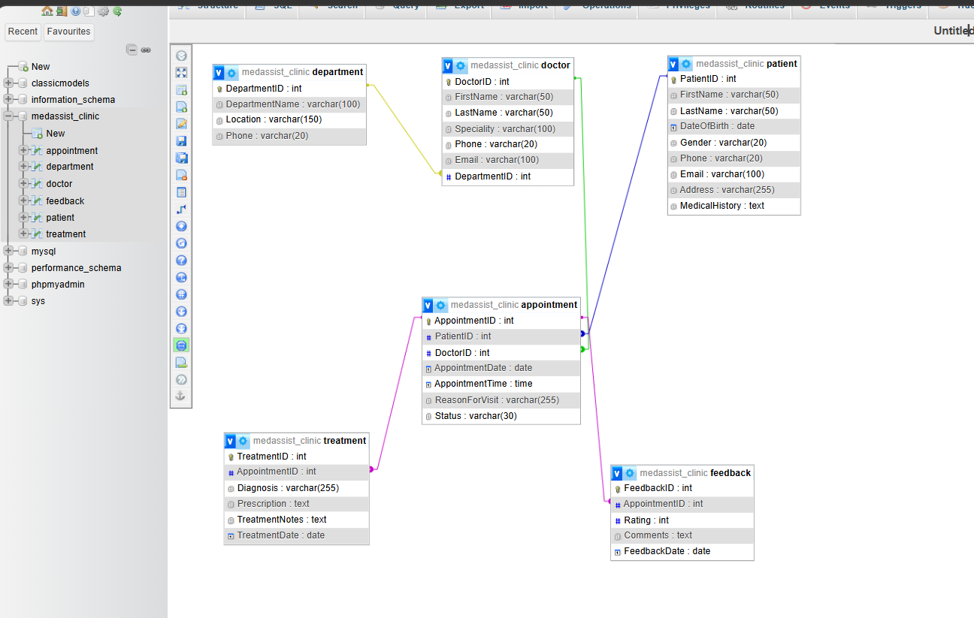
Figure 1. Final ERD showing the six entities and their foreign-key relationships.
Figure 1 shows the six entities and the links between them. One department can contain many doctors, while each doctor references one department. A patient and a doctor can each participate in many appointments. Treatment and feedback records reference an appointment, allowing the clinic to follow a consultation from booking to outcome and review. The current schema permits more than one Treatment or Feedback row per appointment because AppointmentID is indexed but is not defined as UNIQUE.

2.3 Normalisation to Third Normal Form
Stage | How it is addressed in this design
First Normal Form (1NF) | Each table contains atomic values and each record is uniquely identified.
Second Normal Form (2NF) | Non-key attributes depend on the whole primary key; the design uses single-column primary keys.
Third Normal Form (3NF) | Department, doctor, appointment, treatment and feedback details are separated so non-key attributes do not depend on other non-key attributes.

One avoided redundancy was storing DepartmentName in every Doctor record. If a department name changed, multiple doctor rows would require updates and inconsistent values could remain. Keeping department data in a separate table means the name is updated once. This removes a transitive dependency and supports Third Normal Form (3NF) [2].

2.4 Integrity Constraints
NOT NULL requires important values to be supplied. AUTO_INCREMENT generates a new numeric identifier, while PRIMARY KEY guarantees a unique row identity. FOREIGN KEY constraints ensure that dependent rows reference valid parent records and help prevent orphan data. Secondary indexes support lookup operations but do not replace integrity constraints.
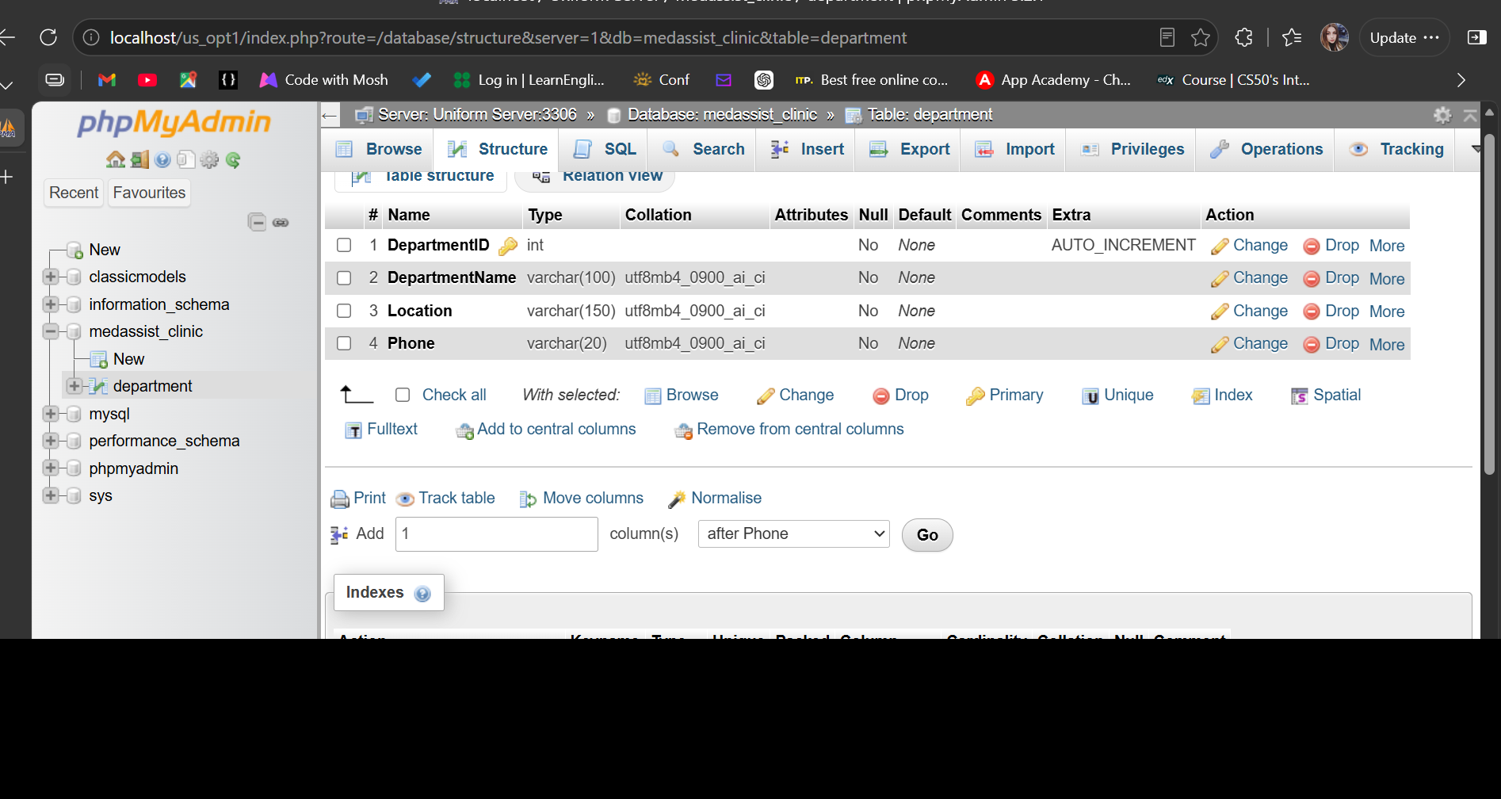
Figure 2. Department table structure with primary key and AUTO_INCREMENT.
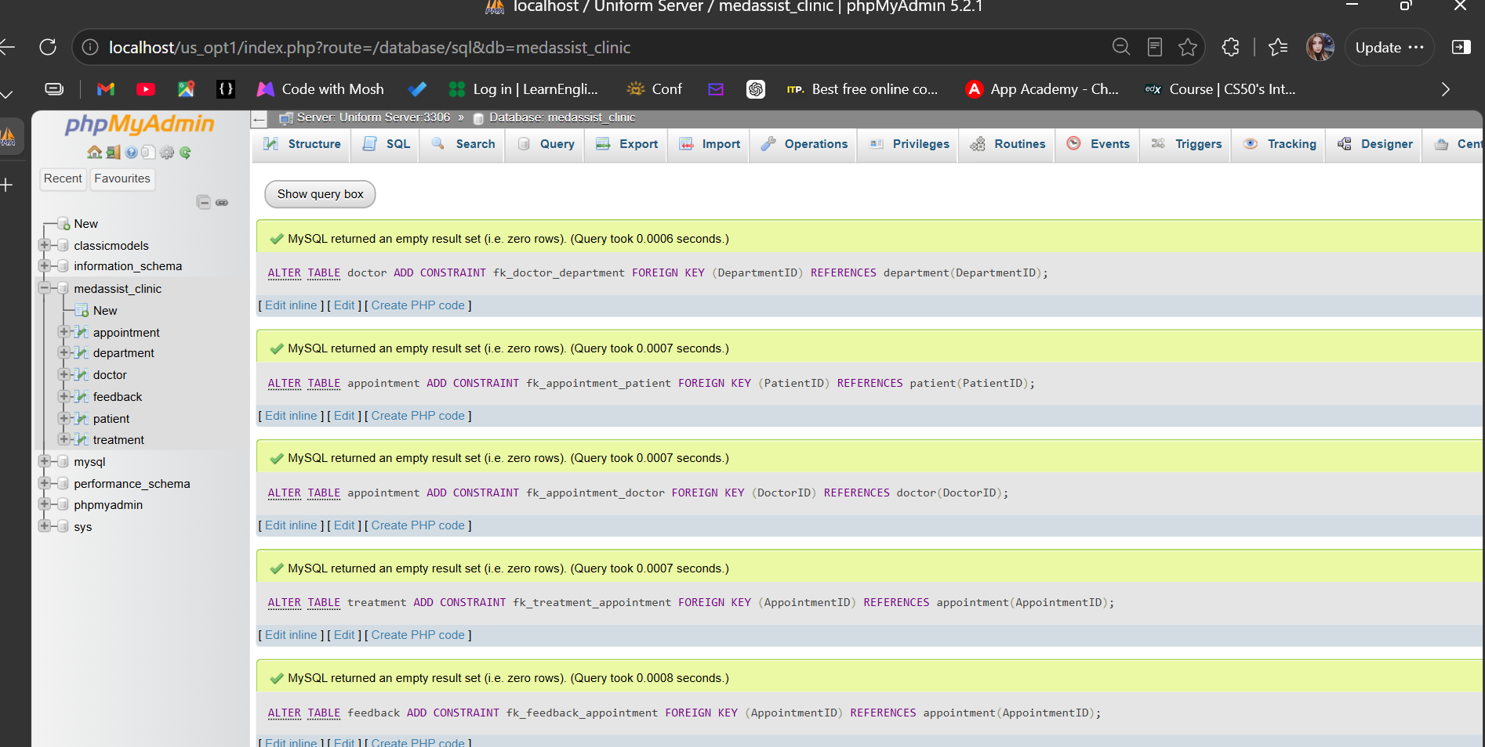
Figure 3. Successful creation of five foreign-key constraints.

3. Implementation Documentation

3.1 Database and Table Creation
The prototype was implemented with MySQL through phpMyAdmin. Parent tables such as Department and Patient were created before tables that depend on them. Appointment was then linked to Patient and Doctor, followed by Treatment and Feedback. This order made it possible to add foreign-key constraints without referencing tables that did not yet exist.
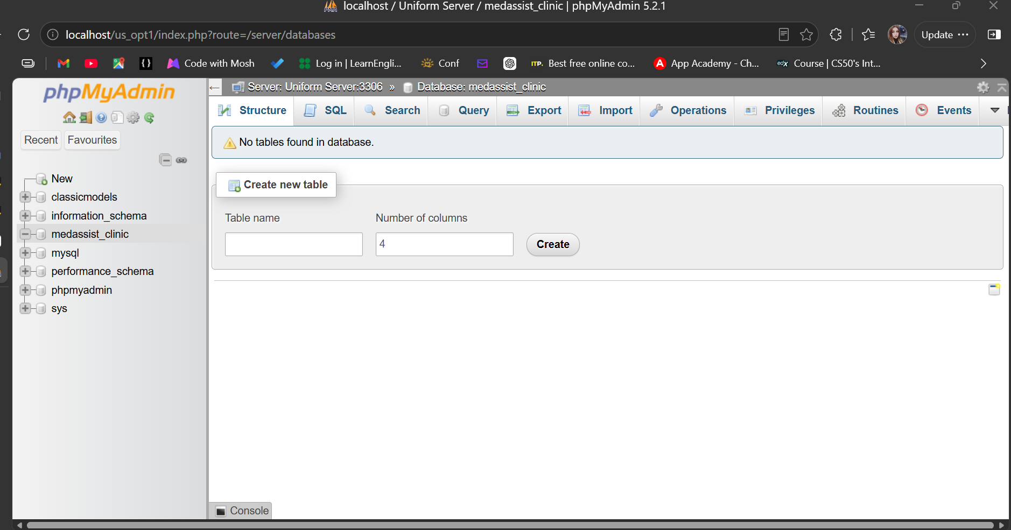
Figure 4. Creation of the medassist_clinic database in phpMyAdmin.
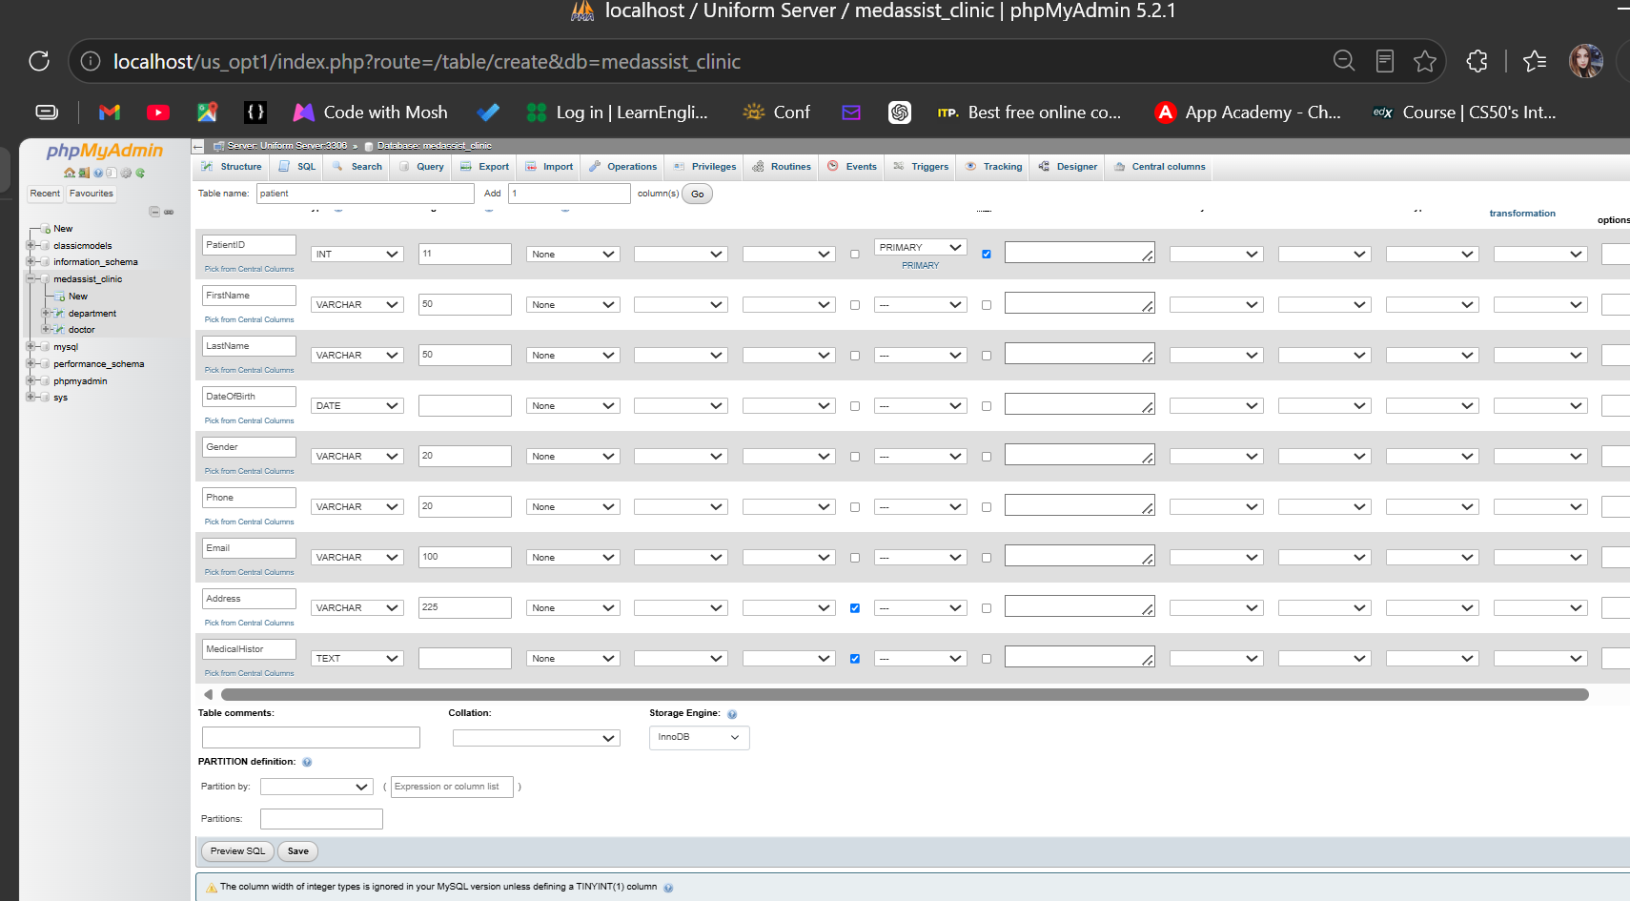
Figure 5. Patient table definition with data types, key and nullable fields.
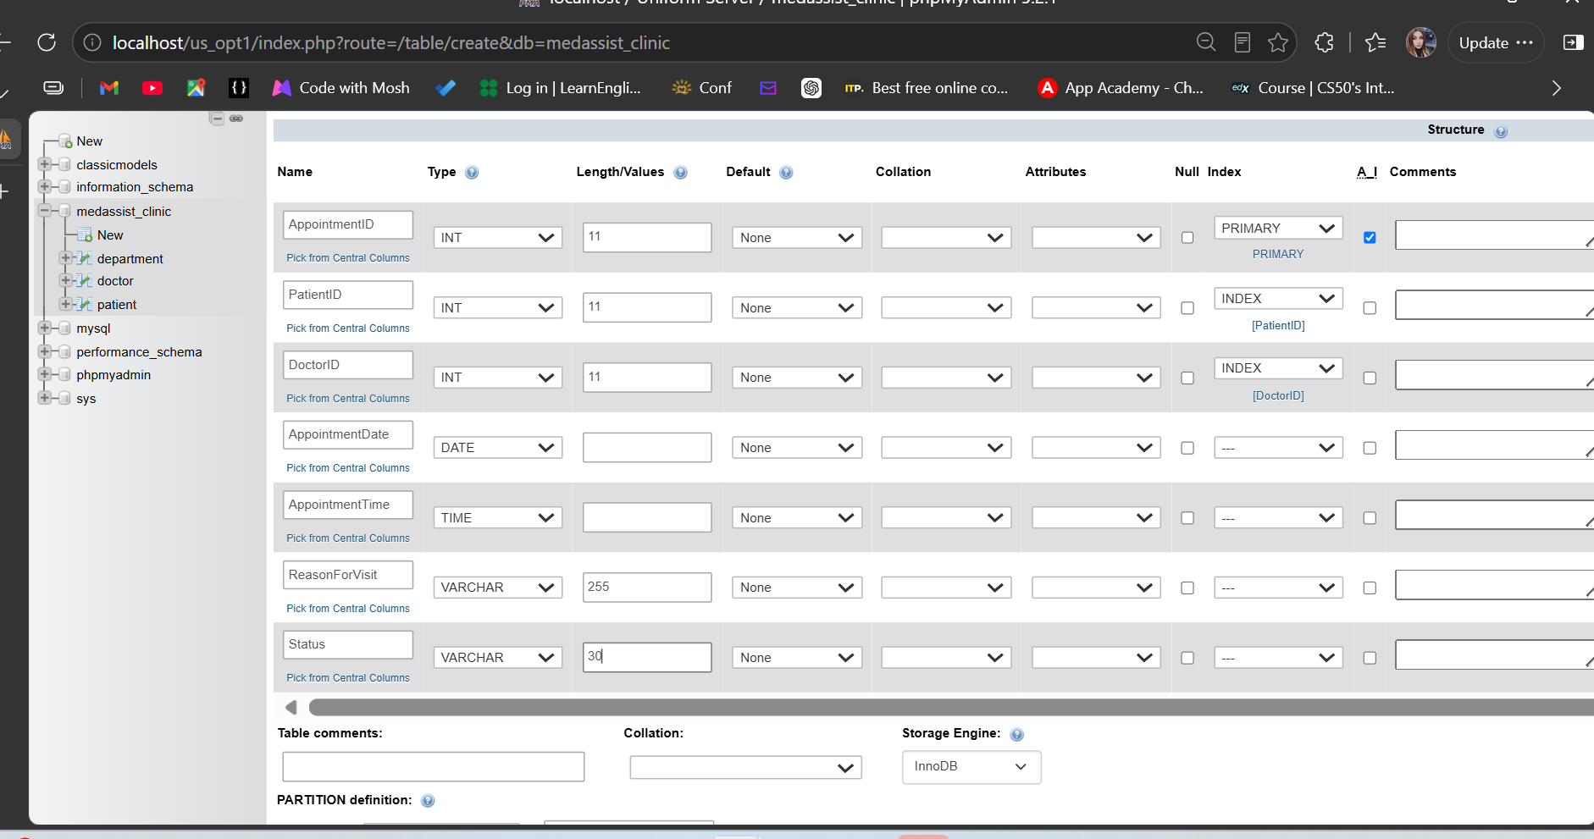
Figure 6. Appointment table definition, including indexed PatientID and DoctorID.
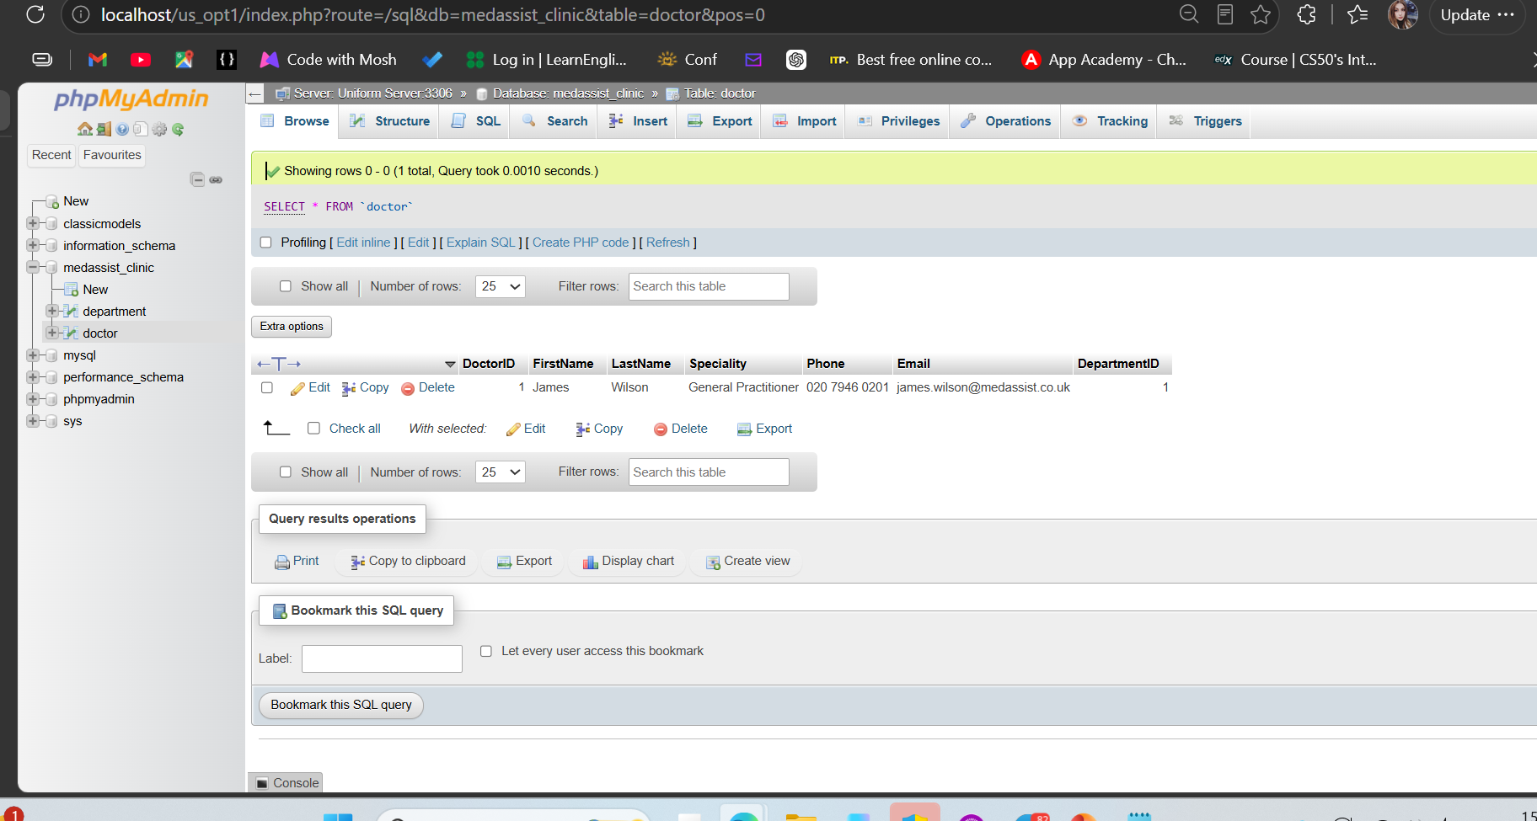
Figure 7. Doctor sample record linked to DepartmentID 1.

3.2 Sample Data Insertion and Validation
Realistic sample records were inserted to test the design. Browse and SELECT results confirmed that patients and doctors were linked to appointments and that treatments and feedback referenced valid appointments. The sample data also provided records for testing the procedures, function and transaction scenarios.
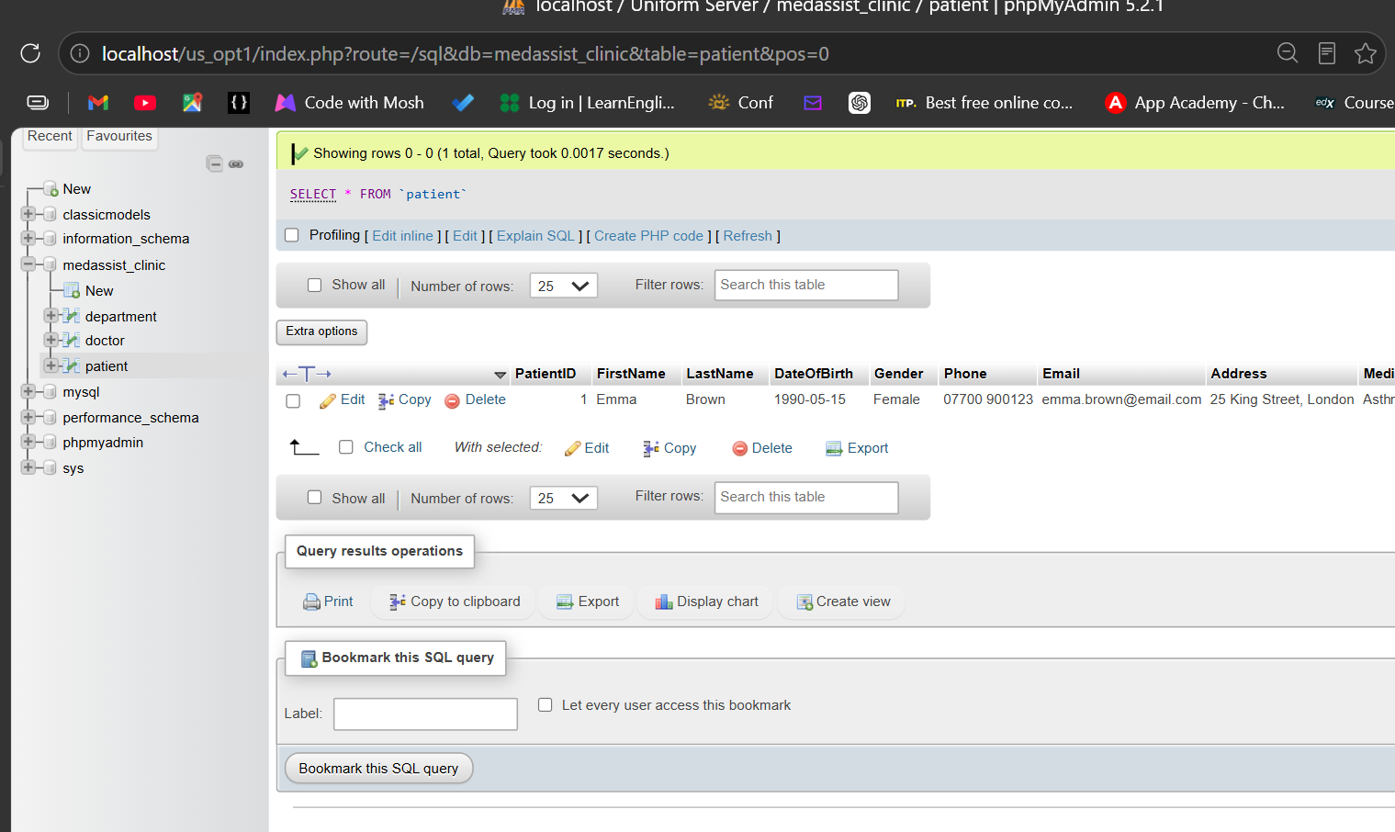
Figure 8. Patient sample data for Emma Brown.
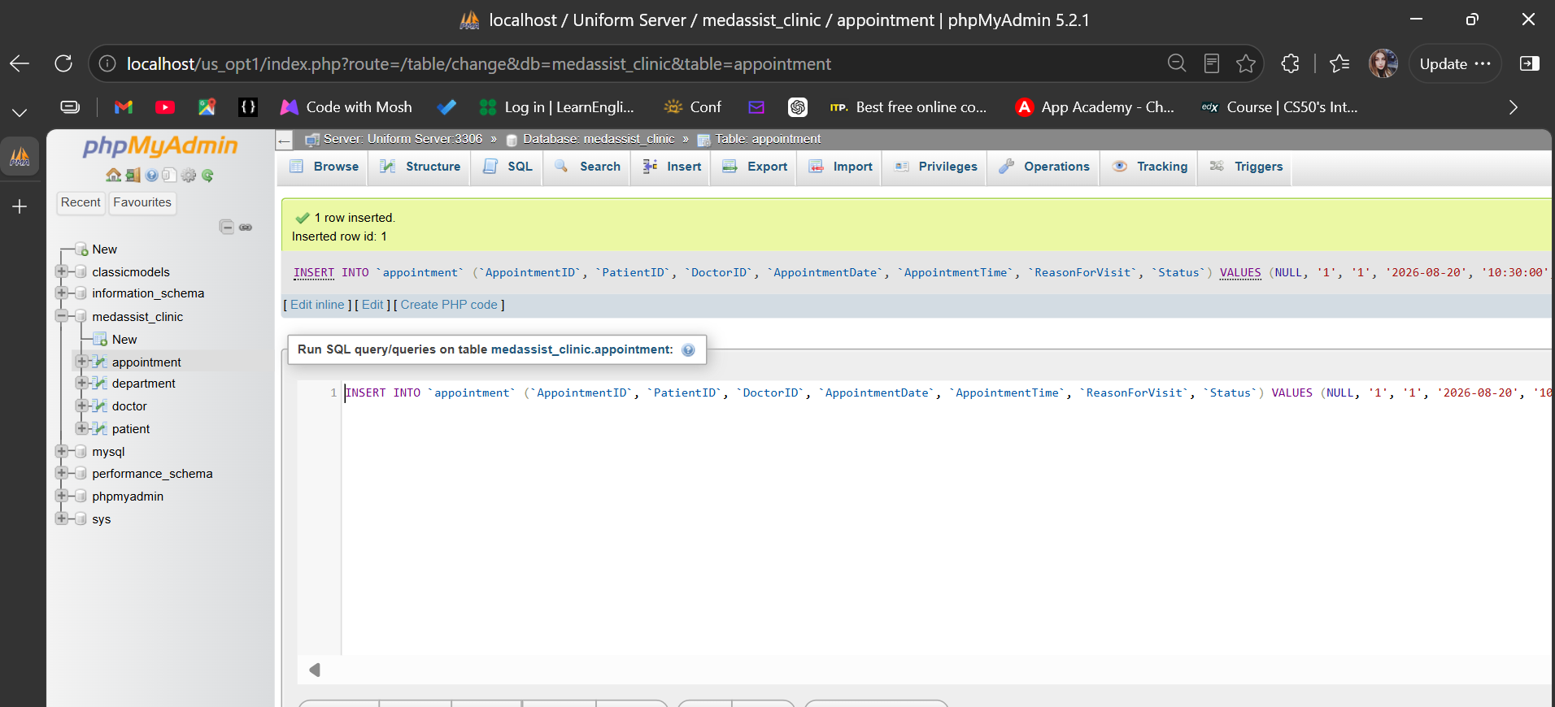
Figure 9. Successful insertion of an appointment linking PatientID 1 and DoctorID 1.
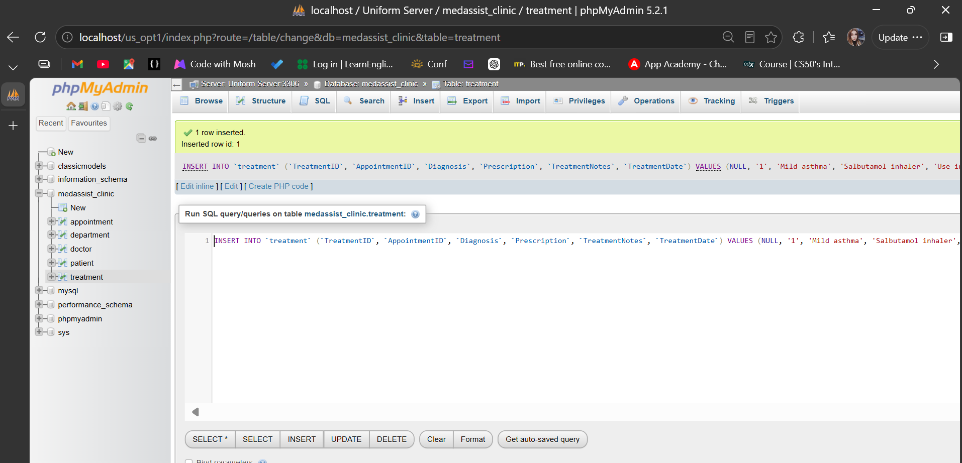
Figure 10. Successful insertion of a treatment linked to AppointmentID 1.
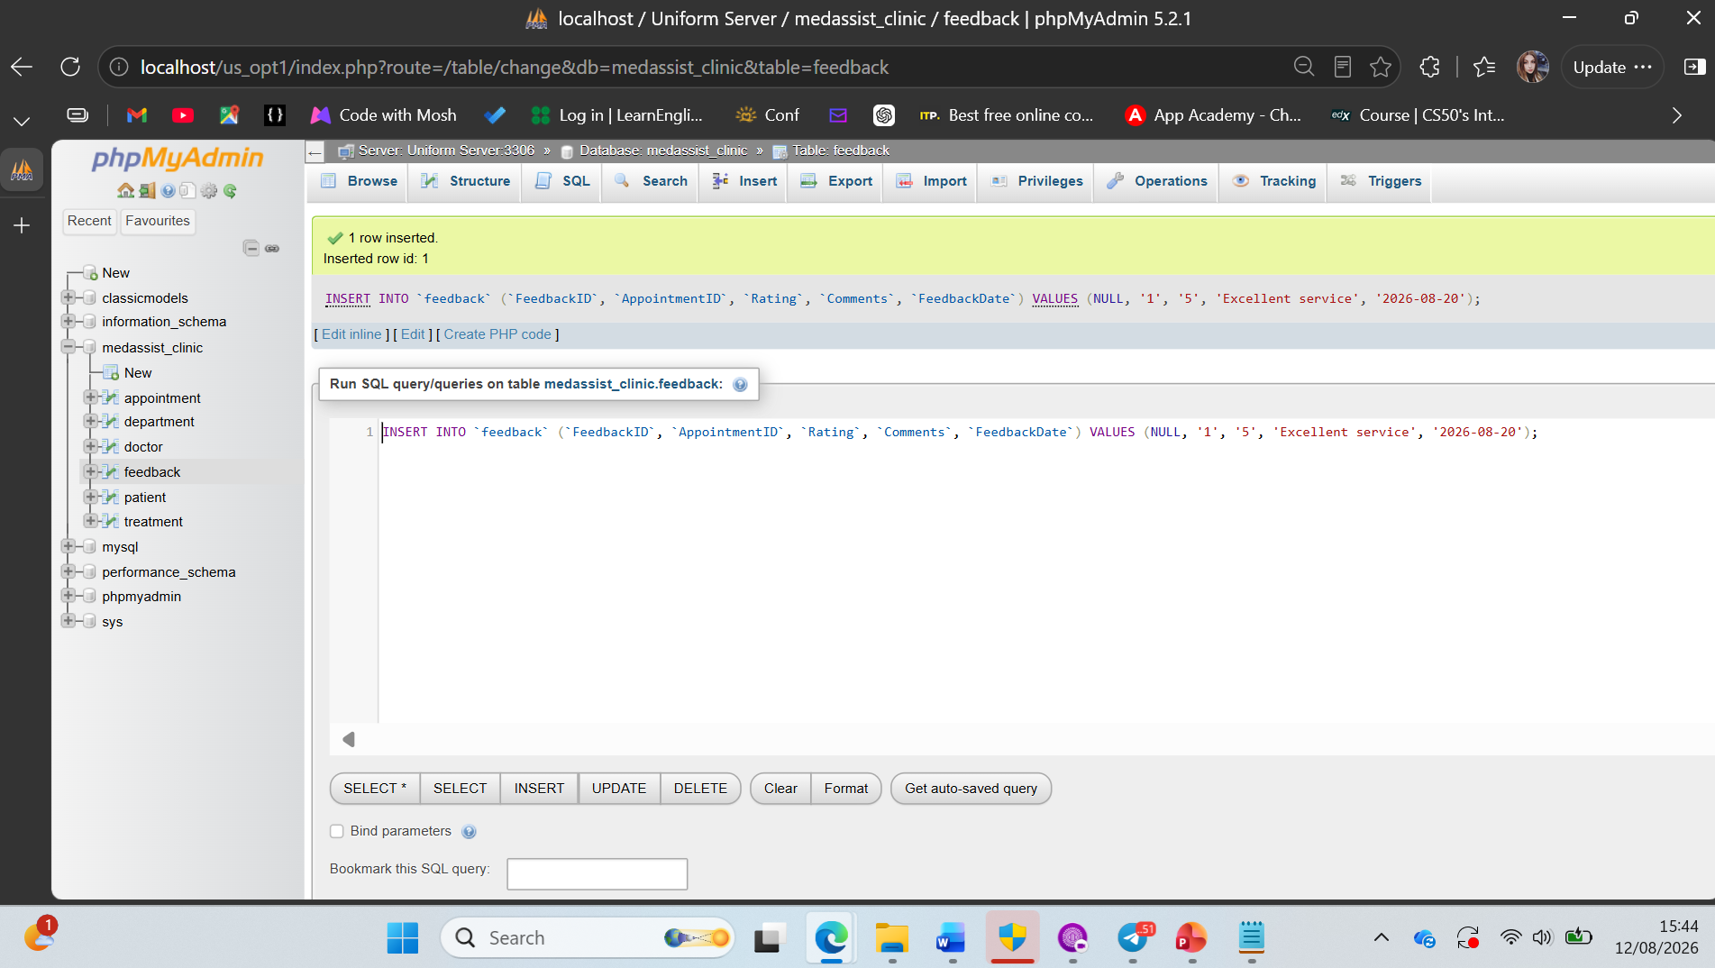
Figure 11. Successful insertion of feedback with a valid rating of 5.
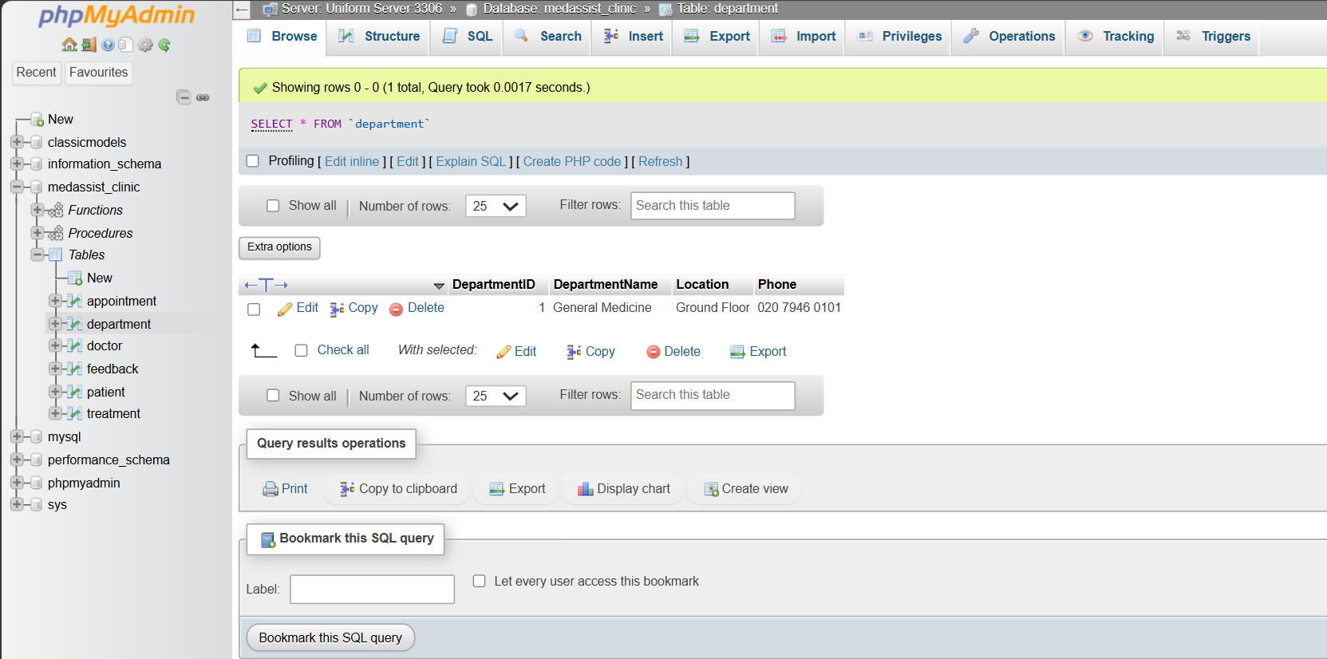
Figure 12. Department table populated with the General Medicine record.
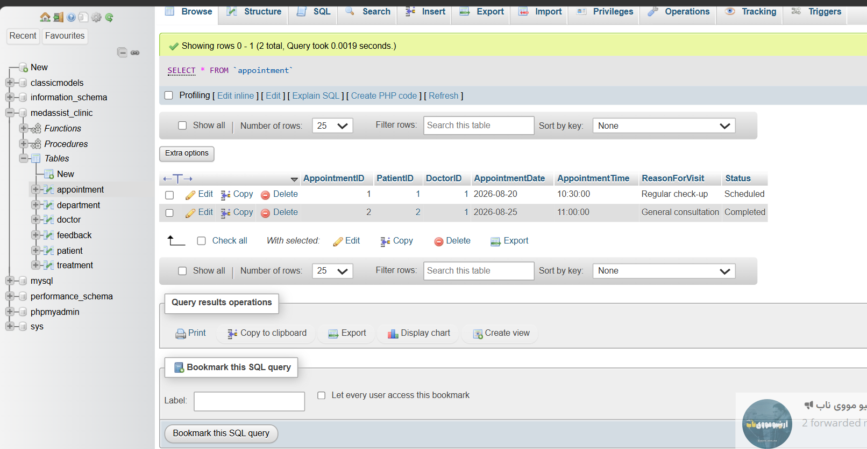
Figure 13. Appointment table showing two linked appointment records.
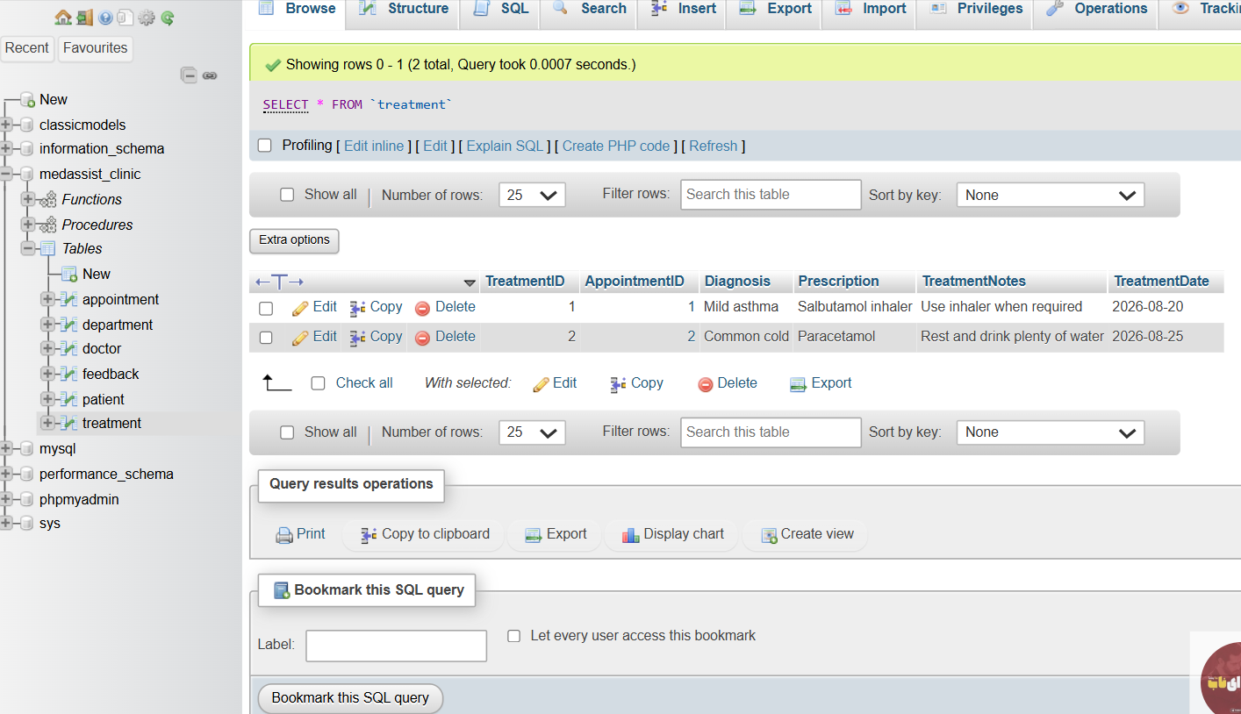
Figure 14. Treatment table showing the two linked clinical outcomes.

4. Stored Procedures and Transactional Scenario

4.1 CRUD Stored Procedures
Procedure | Operation | Purpose
AddPatient | INSERT | Adds a patient using input parameters.
UpdatePatientContact | UPDATE | Changes phone, email and address for a selected PatientID.
DeletePatient | DELETE | Removes the selected patient when referential constraints allow it.

Stored procedures place commonly used SQL operations behind named database routines. They can improve reuse and consistency and may support controlled permissions when access is granted to a routine rather than directly to a table [4]. AddPatient inserts a patient using parameters, UpdatePatientContact changes contact details for a selected PatientID, and DeletePatient removes a selected patient when referential constraints allow it. The procedures were tested individually. A limitation is that transaction handling was demonstrated separately rather than embedded inside these three CRUD procedures.
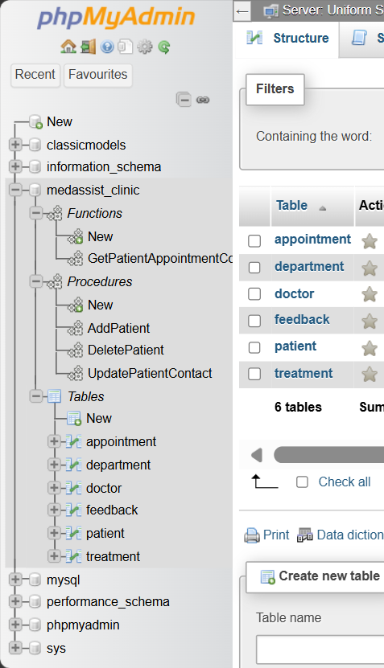
Figure 15. Database navigation tree showing the three procedures and one function.
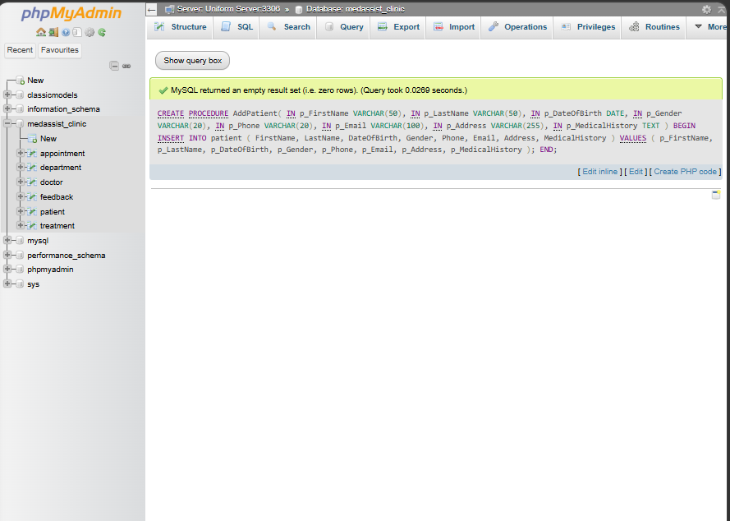
Figure 16. Successful creation of the AddPatient stored procedure.
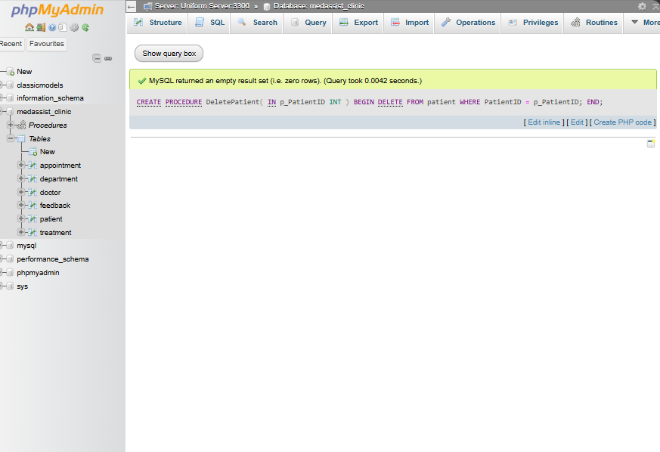
Figure 17. Successful creation of the DeletePatient stored procedure.
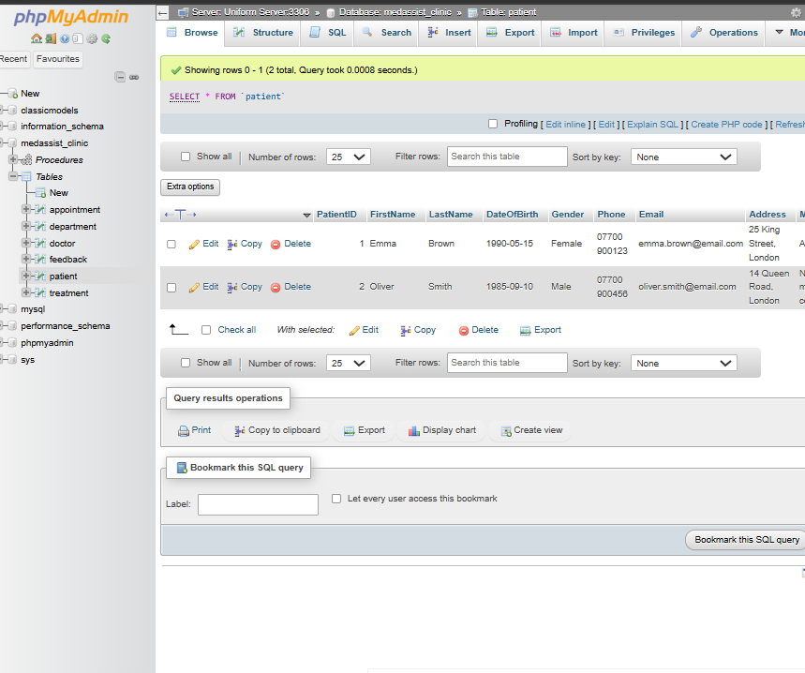
Figure 18. Oliver Smith added through the AddPatient procedure.
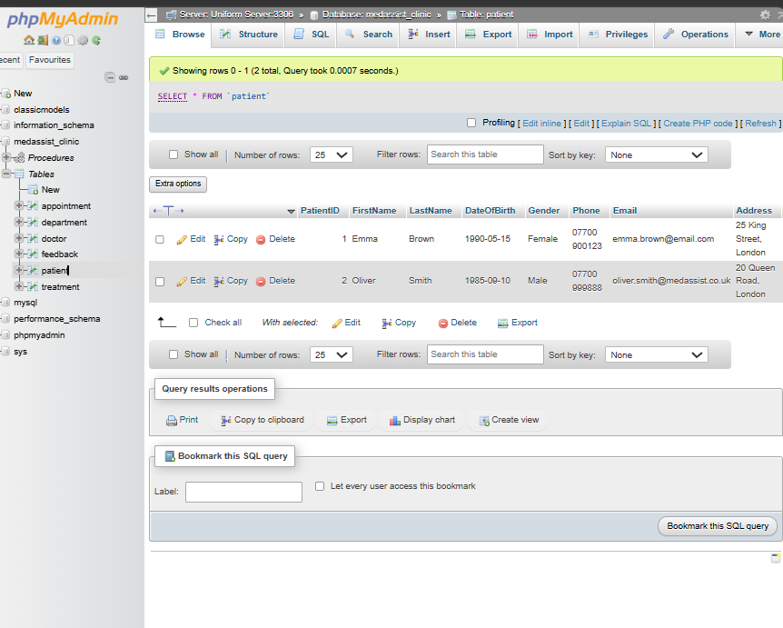
Figure 19. Oliver Smith's contact details updated through the update procedure.

4.2 ROLLBACK Test
A test transaction temporarily changed Oliver Smith's phone number. ROLLBACK was then executed, and the final SELECT result showed the original number. This demonstrates that uncommitted changes can be undone when an error or cancellation occurs, protecting the database from unwanted partial updates [3].
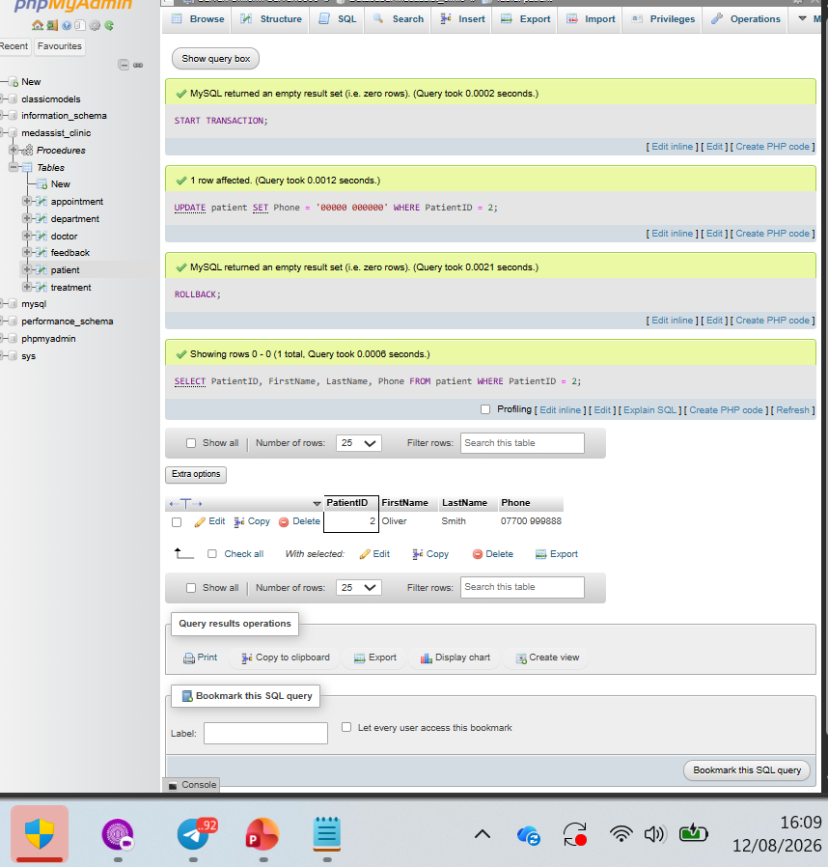
Figure 20. ROLLBACK restores Oliver Smith's original phone number.

4.3 Multi-operation COMMIT Scenario
The second scenario inserted an appointment and its related treatment as one logical unit. LAST_INSERT_ID() captured the new AppointmentID so the treatment referenced the correct appointment. COMMIT permanently saved both rows after the operations succeeded. In a production routine, an error handler should issue ROLLBACK if either step fails so an incomplete clinical record is not retained [3].
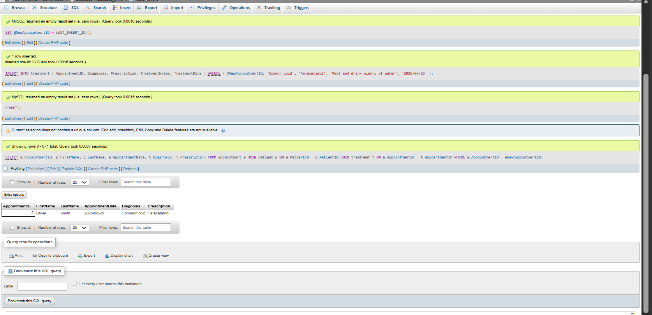
Figure 21. COMMIT scenario showing the linked appointment and treatment for Oliver Smith.

5. Trigger and Function

5.1 Feedback Rating Trigger
ValidateFeedbackRating runs BEFORE INSERT on the Feedback table. It uses SIGNAL to reject ratings below 1 or above 5. The test with a rating of 8 produced the expected error. Database-level validation is useful because it protects the rule even when data is inserted outside an application interface. However, this is a validation trigger rather than an auditing trigger. A future version should add an audit table and INSERT, UPDATE and DELETE audit triggers to record the user, action and timestamp.
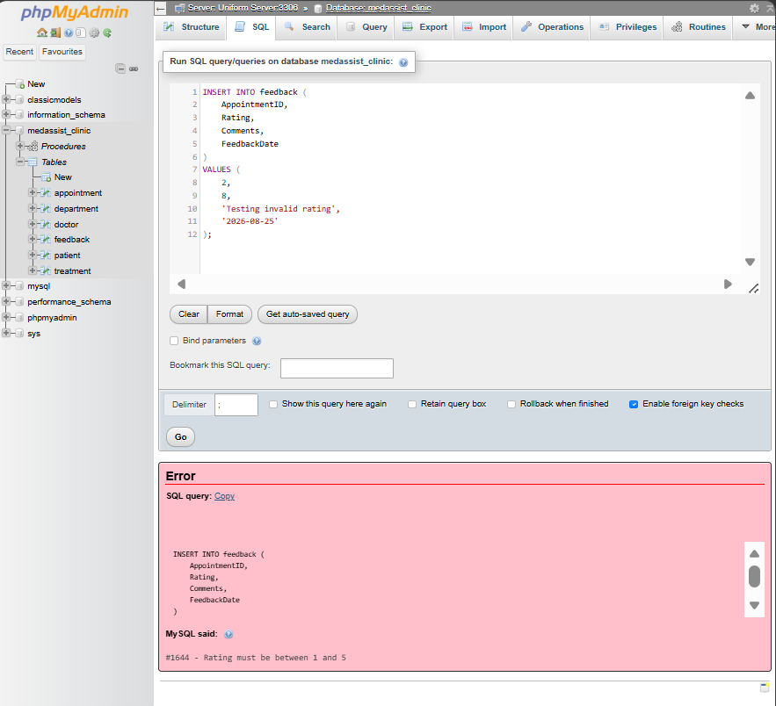
Figure 22. Trigger test rejects invalid rating 8 with the expected error message.

5.2 Appointment Count Function
GetPatientAppointmentCount accepts a PatientID, counts matching Appointment rows and returns an integer. The test returned one appointment for PatientID 2. This function could support patient-history summaries or administrative dashboards.
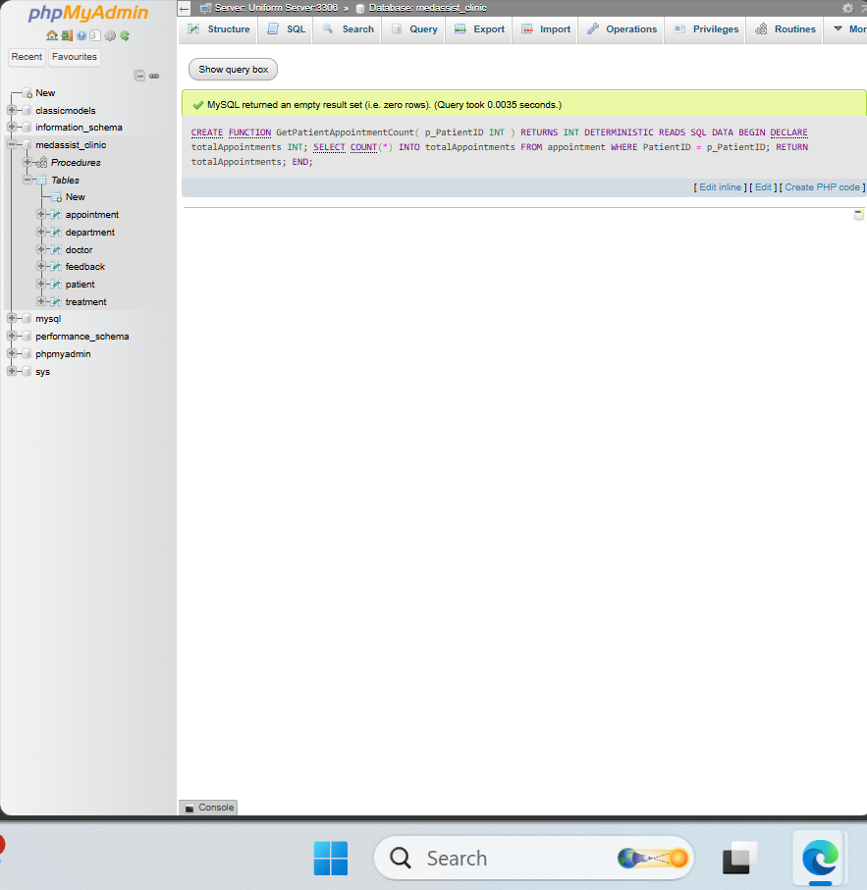
Figure 23. Successful creation of GetPatientAppointmentCount.
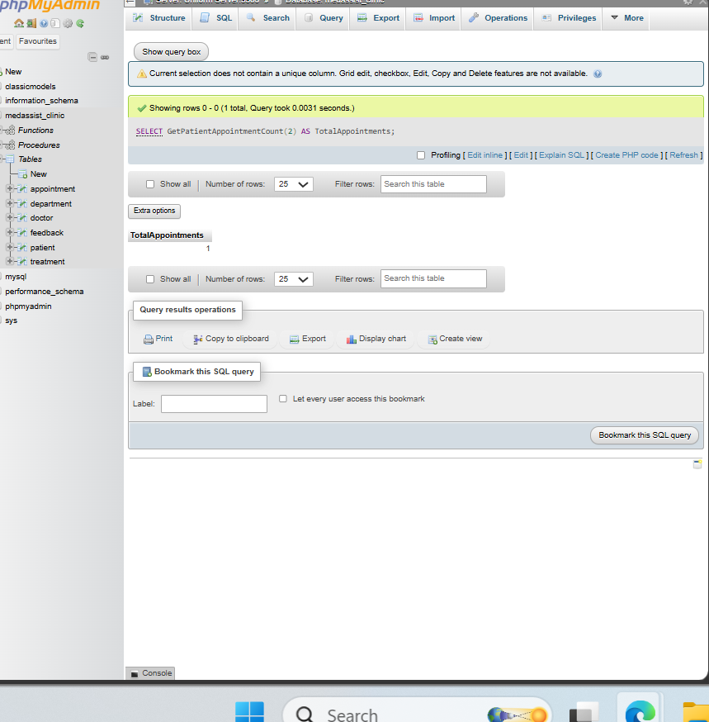
Figure 24. Function test returns one appointment for PatientID 2.

6. Performance Tuning Enhancement
Index | Column | Expected query pattern
idx_patient_lastname | patient.LastName | Searching and sorting patients by surname.
idx_appointment_date | appointment.AppointmentDate | Finding appointments for a selected date or date range.
idx_doctor_speciality | doctor.Speciality | Locating doctors by clinical speciality.

Secondary indexes were created on Patient.LastName, Appointment.AppointmentDate and Doctor.Speciality. These columns are likely to be used when searching for patients, finding appointments by date and locating doctors by speciality. MySQL can use an appropriate index to reduce the number of rows examined for selective queries [5]. Indexes also use storage and add maintenance work to INSERT and UPDATE operations, so they should be created for useful query patterns rather than every column.
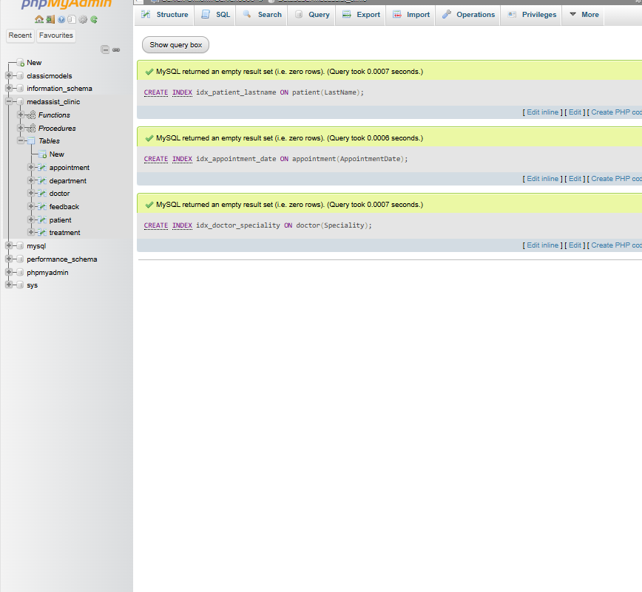
Figure 25. Successful creation of three secondary indexes.

6.1 Suggested Performance Test
The indexes were created successfully, but this prototype did not record execution-time measurements or an EXPLAIN comparison before and after indexing. Therefore, the report describes the expected performance benefit rather than claiming a measured speed improvement. A larger test dataset and EXPLAIN output would provide stronger evidence in future work.

7. Security and Multi-user Considerations
A production clinical system should use role-based access and the principle of least privilege. Administrative staff, doctors and database administrators should receive only the permissions needed for their work. Strong authentication, encrypted connections, secure backups and recovery testing are also important. Because medical and personal information is sensitive, its collection, access, retention and deletion must follow the UK GDPR data-protection principles [6]. This prototype demonstrates database structure and is not a production-ready medical system.

8. Conclusion and Reflection
The project created a working relational database prototype for MedAssist Clinic. The six main tables store departments, doctors, patients, appointments, treatments and feedback. Primary and foreign keys maintain relationships, while the normalised structure reduces repeated information. Sample records and Browse results confirmed that the main links worked correctly.
Stored procedures were created for adding a patient, updating contact details and deleting a patient. A ROLLBACK test restored an original phone number, and a COMMIT scenario saved a related appointment and treatment. The feedback trigger rejected a rating outside the permitted range, and the appointment-count function returned the expected result. Three secondary indexes were also created for common search columns. These indexes are expected to support efficient lookup, although performance was not measured on a large dataset.
The main challenges were creating tables in the correct order, defining foreign keys, using delimiters for routines and testing transactions without damaging connected records. These problems were addressed by creating parent tables first, checking IDs before inserts, and confirming results with SELECT and Browse views. The work improved my understanding of relational design, referential integrity and transaction control.
There are still limitations. The validation trigger does not create an audit history, and transaction handling was demonstrated separately instead of being embedded in the CRUD procedures. Future development should add an audit table and audit triggers, transactional procedures with exception handlers, doctor availability schedules, role-based user accounts, stronger validation, backup procedures and performance testing with EXPLAIN.

9. References
Academic and technical sources are listed in IEEE style.
[1] A. Silberschatz, H. F. Korth and S. Sudarshan, Database System Concepts, 7th ed. New York, NY, USA: McGraw-Hill, 2019.
[2] R. Elmasri and S. B. Navathe, Fundamentals of Database Systems, 7th ed. Harlow, UK: Pearson, 2016.
[3] Oracle, 'MySQL 8.0 Reference Manual: InnoDB Transaction Model,' MySQL Documentation. [Online]. Available: https://dev.mysql.com/doc/refman/8.0/en/innodb-transaction-model.html. [Accessed: 12-Aug-2026].
[4] Oracle, 'MySQL 8.0 Reference Manual: CREATE PROCEDURE and CREATE FUNCTION Statements,' MySQL Documentation. [Online]. Available: https://dev.mysql.com/doc/refman/8.0/en/create-procedure.html. [Accessed: 12-Aug-2026].
[5] Oracle, 'MySQL 8.0 Reference Manual: How MySQL Uses Indexes,' MySQL Documentation. [Online]. Available: https://dev.mysql.com/doc/refman/8.0/en/mysql-indexes.html. [Accessed: 12-Aug-2026].
[6] Information Commissioner's Office, 'A guide to the data protection principles,' ICO. [Online]. Available: https://ico.org.uk/for-organisations/uk-gdpr-guidance-and-resources/data-protection-principles/. [Accessed: 12-Aug-2026].

ACCA5026 · PART B
MedAssist Clinic Website
PHP/MySQL implementation and SQL injection security report
Student | Reyhaneh Mehrabi
Student ID | ________________________
System | MedAssist Clinic database website
Date | 14 August 2026

Project summary. This report documents a dynamic PHP and MySQL website developed for MedAssist Clinic. The system provides secure administrator access, patient CRUD operations, patient search, and database views for doctors and appointments. The final database contains 19 operational sample records across the three main website views.

1. System Overview
The website was built locally using PHP, MySQL, phpMyAdmin and Uniform Server. A shared db.php file creates the database connection, while auth.php checks the administrator session before protected pages are displayed. The final interface uses one CSS file so that all pages have a consistent colour scheme and layout.
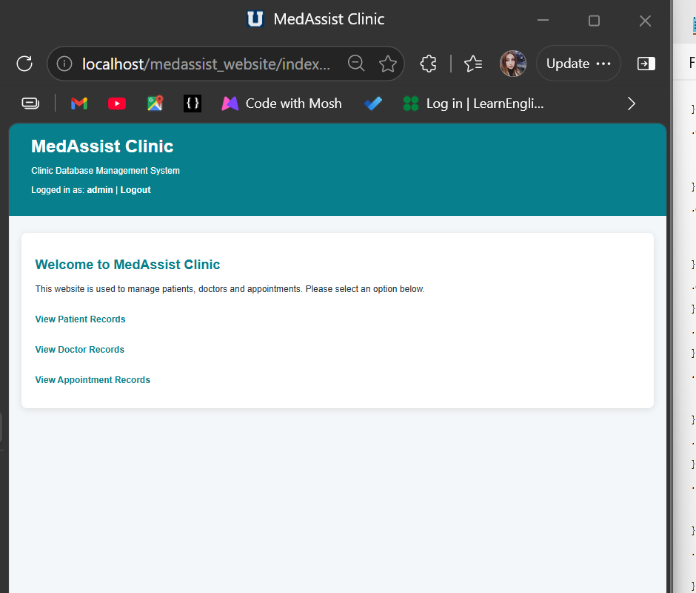
Figure 1. Final authenticated home page with navigation and Logout.

2. Database Views and Sample Data
The website reads live information from the MedAssist database. The final dataset contains eight patients, four doctors and seven appointments, which gives 19 records in total. The IDs are not consecutive because a temporary CRUD test patient was deleted; this is expected behaviour with AUTO_INCREMENT.
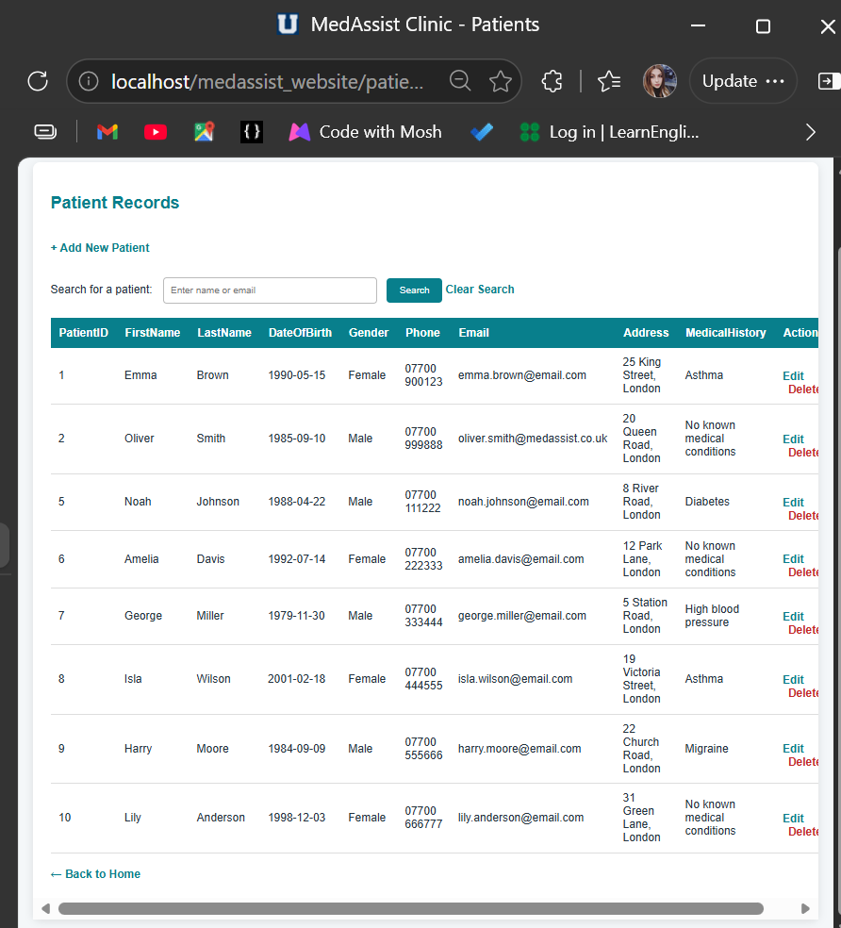
Figure 2. Final patient records with Search, Add, Edit and Delete controls.
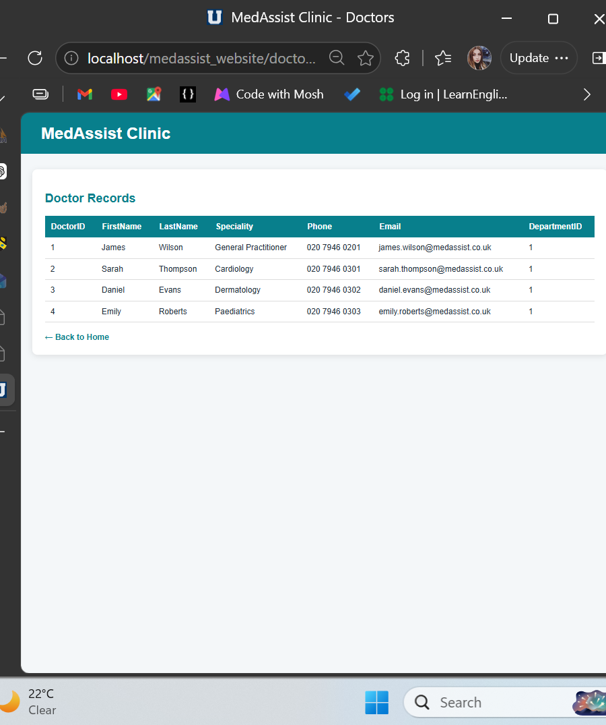
Figure 3. Final doctor records retrieved from MySQL.
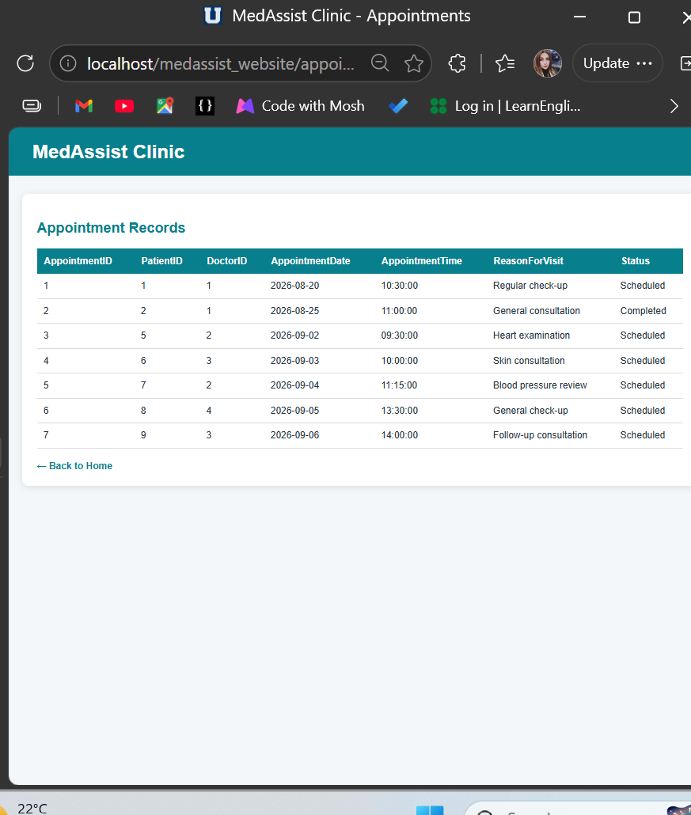
Figure 4. Final appointment records retrieved from MySQL.
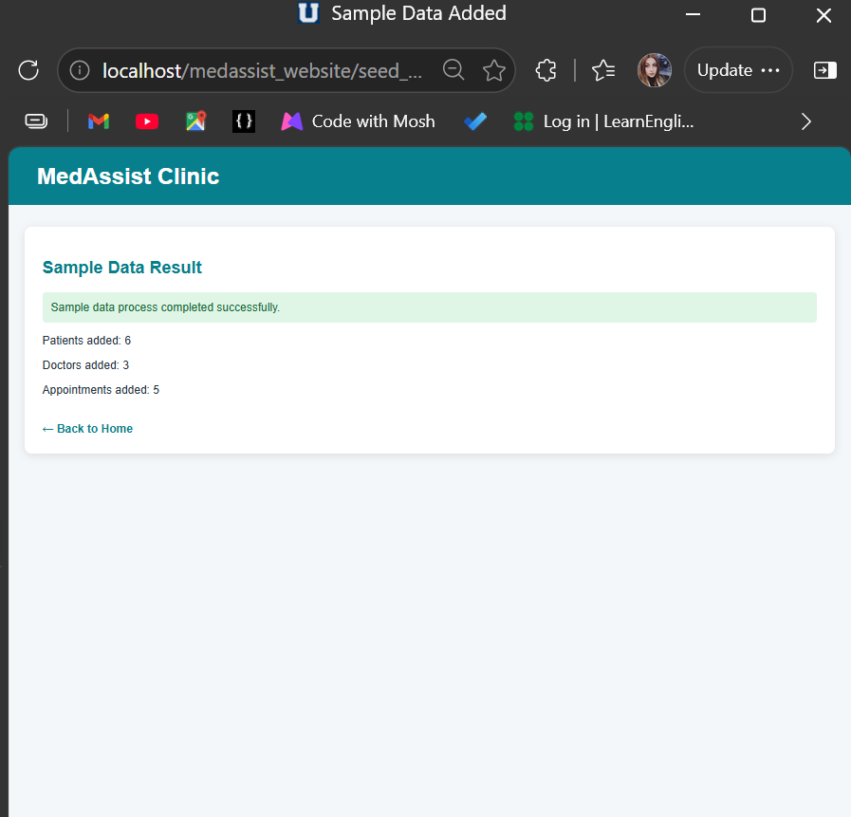
Figure 5. Successful addition of six patients, three doctors and five appointments.

3. Functional Requirements

3.1 Search
The patient page supports searches by first name, last name or email address. A search for Emma returned only the matching patient, confirming that the filtering function works as intended.
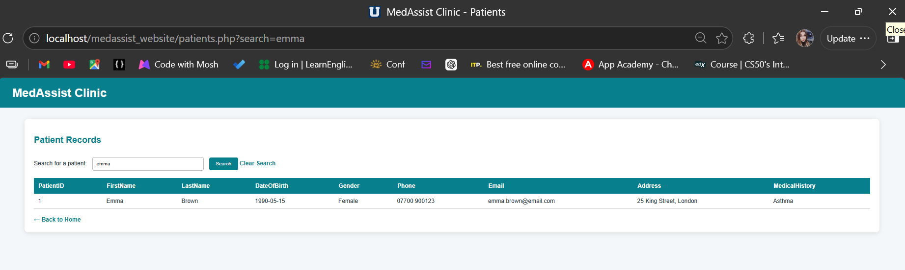
Figure 6. Successful patient search for Emma.

3.2 Create, Update and Delete
CRUD was tested with a temporary patient called Sophia Taylor. The record was inserted, updated and then removed through a confirmation page. Required fields and email validation were applied before changes were sent to MySQL.
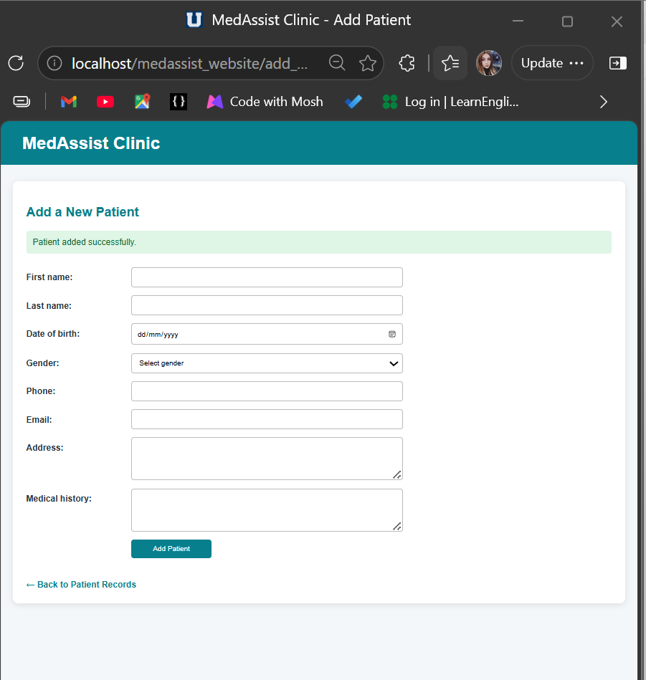
Figure 7. Create operation completed successfully.
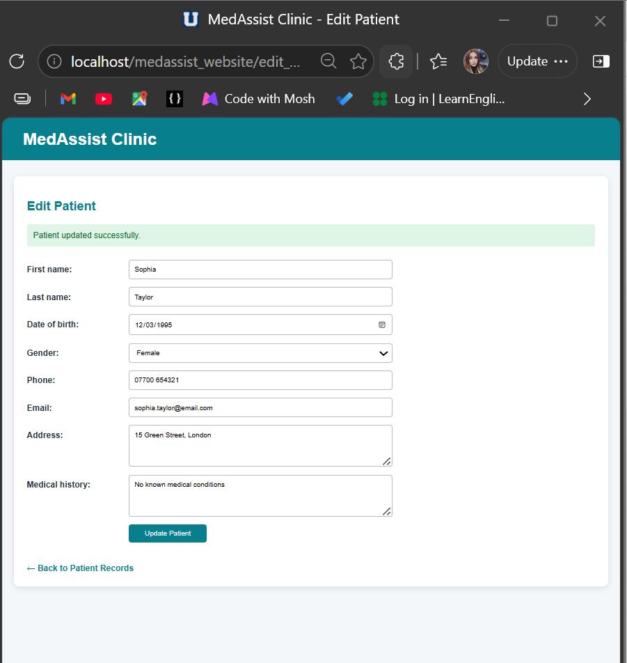
Figure 8. Update operation completed successfully.
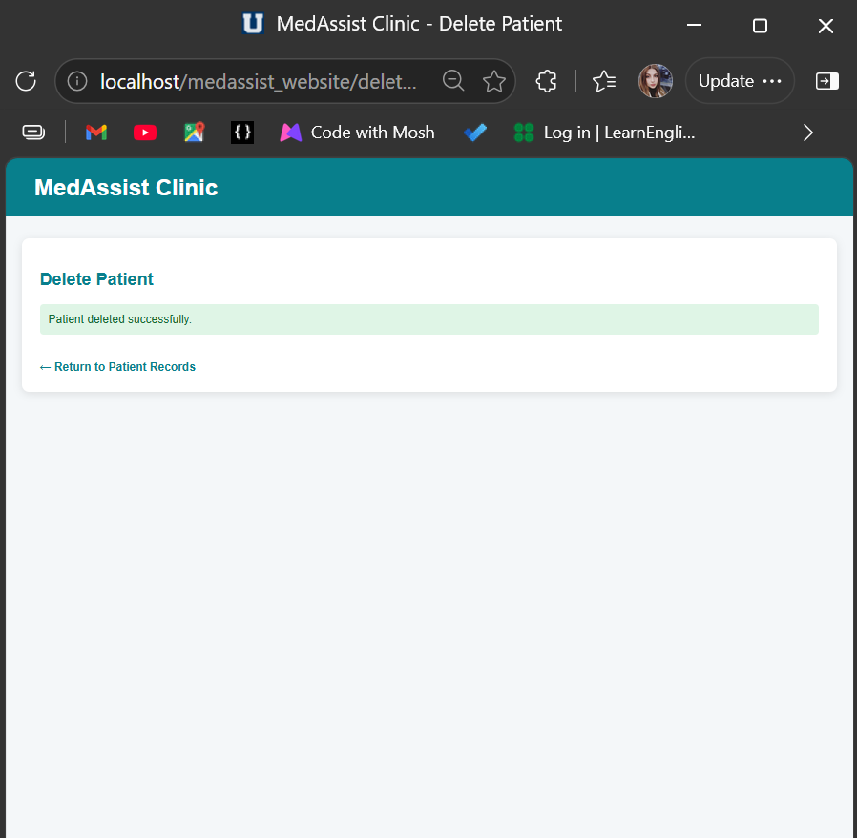
Figure 9. Delete operation completed successfully.

3.3 Authentication and Session Control
The AdminUser table stores the password as a hash rather than plain text. The login process uses password_verify(), creates a PHP session after successful authentication and regenerates the session ID. Protected pages include auth.php and redirect an unauthenticated visitor to login.php. Logout clears and destroys the session.
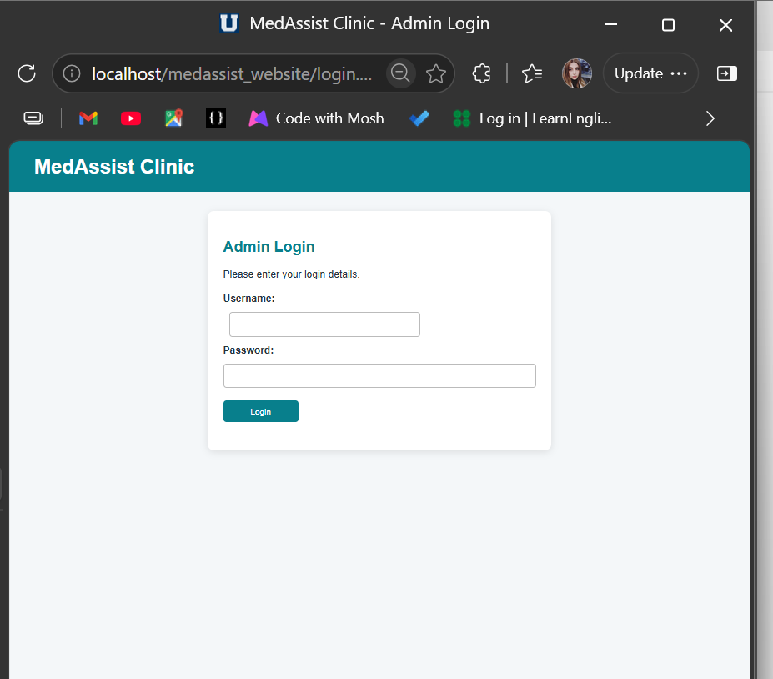
Figure 10. Final administrator login page.
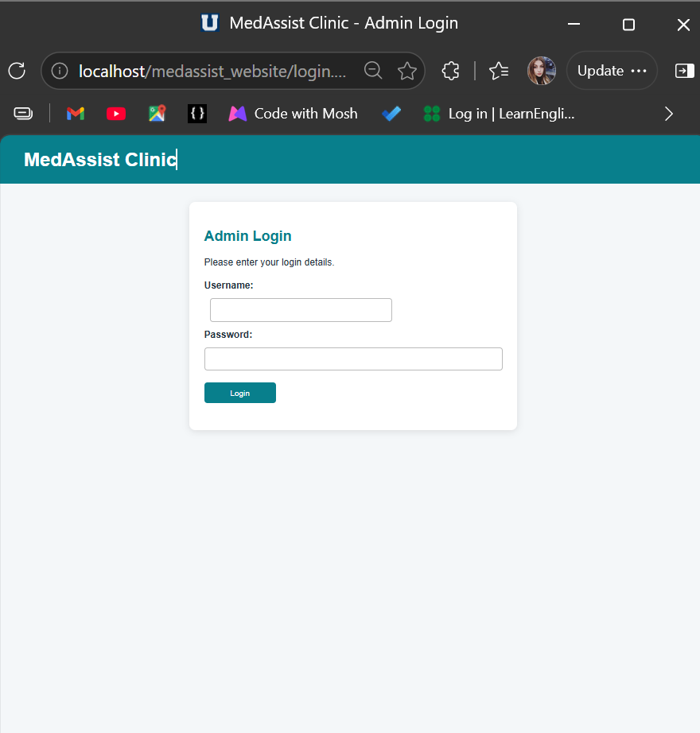
Figure 11. Protected page redirected to Login after Logout.

4. SQL Injection Security Report
SQL injection is a web security problem that happens when untrusted input is joined directly to a database query. An attacker can enter SQL syntax into a form field so that the database treats the input as part of the command instead of normal data. For example, a vulnerable login query may place a username directly inside a WHERE clause. A value such as admin' OR '1'='1 could change the condition and possibly allow access without a valid password. Similar attacks can expose patient information, modify records or delete data. This risk is serious for a clinic because the database contains personal and medical information.
The main defence used in this project is prepared statements with parameterised queries. The SQL command is prepared first and question-mark placeholders are used where user values are required. The values are then attached separately with bind_param() before execute() runs the query. OWASP explains that this separation allows the database to distinguish SQL code from data, even when a user enters SQL characters [1]. The PHP manual also documents placeholders and binding variables before execution [2].
Prepared statements were applied to the Admin Login and Patient Search. In login.php, the query selects an AdminUser only where Username equals a placeholder. The submitted username is bound as a string. The password is never included in the SQL query; after the user record is returned, password_verify() compares the submitted password with the stored hash. This avoids storing the real password and prevents a username field from changing the purpose of the query. The application also returns one general error message for an incorrect username or password, so it does not reveal which value was wrong.
In patients.php, the search value is used with three LIKE placeholders for FirstName, LastName and Email. The percent signs needed for partial matching are added to the PHP value before it is bound. They are not used to construct new SQL syntax. Therefore, a malicious search is treated as a literal text value. The same prepared-statement approach is used for Create, Update and Delete operations. Integer IDs are validated and cast before use, required fields are checked, email addresses are validated, and output is displayed with htmlspecialchars() to reduce the risk of injected HTML being interpreted by the browser.
Two practical tests were completed. First, the patient search received the payload ’ OR 1=1 --. A vulnerable query could interpret this as an always-true condition and display every record. The secure page displayed “No matching patient records were found”, proving that the payload remained data. Second, the login username received admin' OR '1'='1 with an invalid password. The application displayed “Incorrect username or password” and did not create a session. These results demonstrate that parameterisation protected both entry points.
Prepared statements are an essential control but they should be combined with other security measures. This prototype uses server-side validation, password hashing, session checks and restricted access to management pages. In a production clinic system, further controls should include HTTPS, strong unique passwords, role-based permissions, secure storage of database credentials, session time-outs, audit logging, backups, software updates and least-privilege database accounts. Error details should be logged securely rather than shown to users. Regular security testing would also be necessary because a system can have other vulnerabilities even when SQL injection is controlled.
Overall, the tests show that the final MedAssist website does not join the tested user inputs directly into SQL commands. The database receives a prepared command and separate parameter values. This design keeps the intended query structure unchanged, which is the central reason that both SQL injection attempts failed.

4.1 Evidence: Patient Search Attack
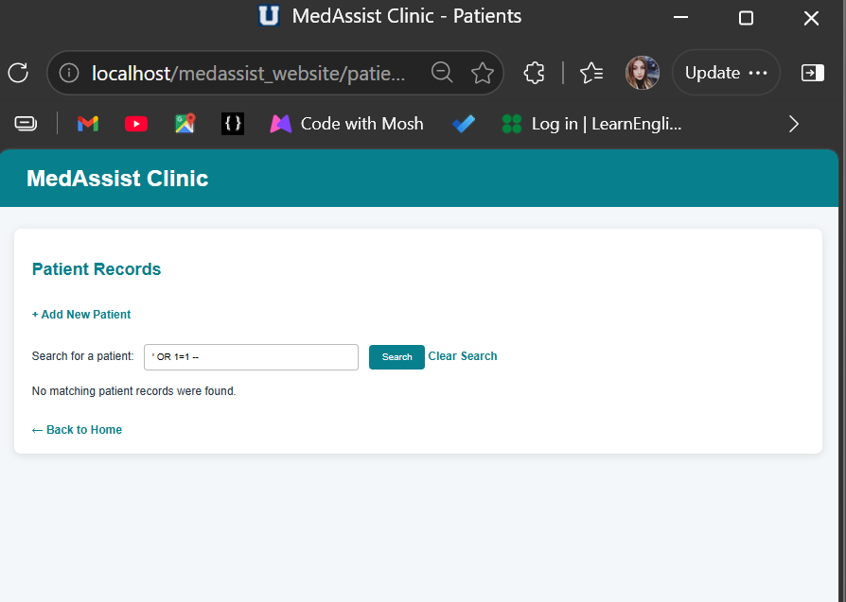
Figure 12. SQL injection payload returned no patient records.

4.2 Evidence: Admin Login Attack
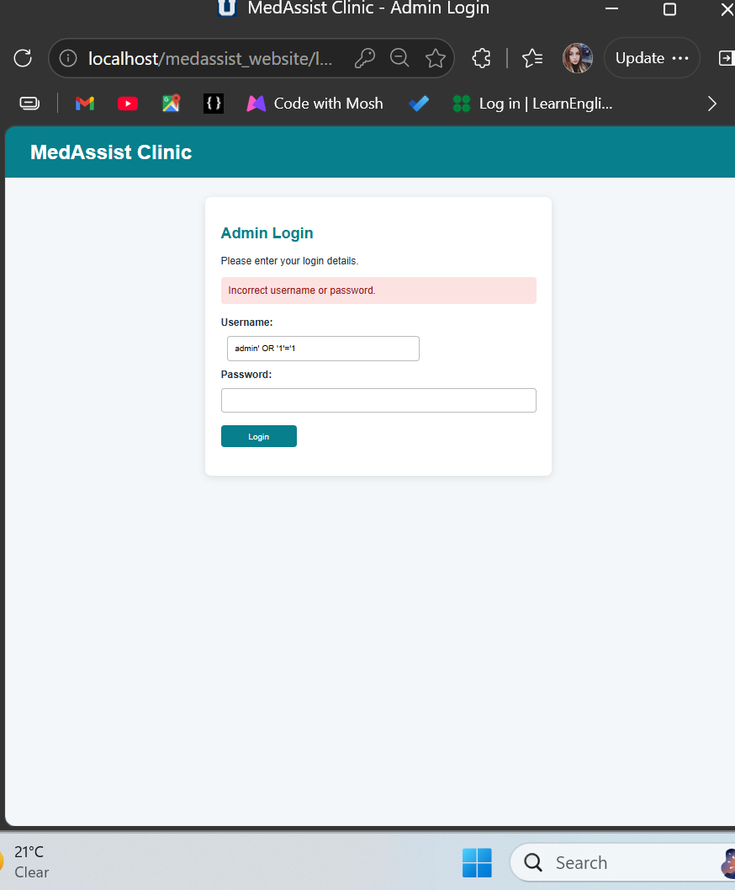
Figure 13. SQL injection payload rejected by Admin Login.

4.3 Defensive Code
The following screenshots show the final prepared statements used by the two tested entry points.
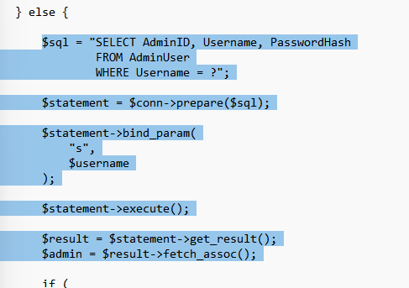
Figure 14. Login prepared statement, parameter binding and execution.
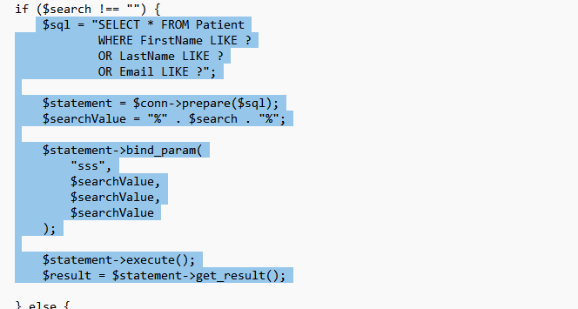
Figure 15. Patient Search prepared statement with three bound values.

5. Final Project Files
Only the final website files were retained. Temporary setup, password-reset and sample-data scripts were removed after use. A fresh SQL export was created after adding the AdminUser table and final sample records, and it was included with the PHP project before the ZIP file was created.
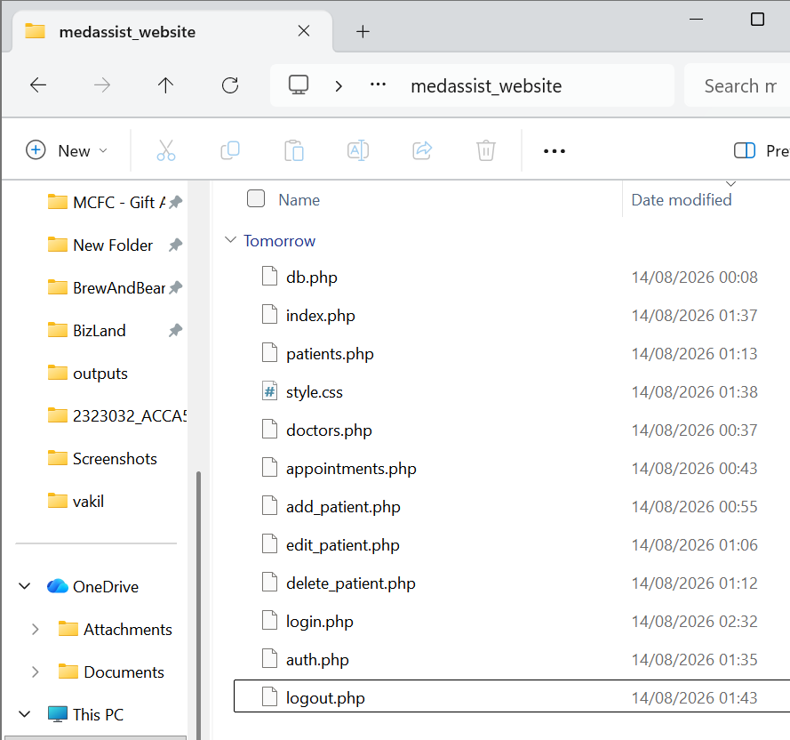
Figure 16. Clean final PHP/CSS project folder before adding the SQL export.
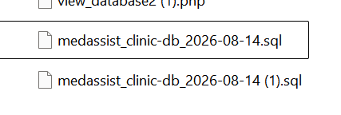
Figure 17. Final medassist_clinic SQL export downloaded successfully.

6. Conclusion
The MedAssist Clinic prototype meets the main Part B requirements. It connects PHP to MySQL, displays live database records, supports patient search and CRUD, validates input, provides administrator authentication and session-based access control, and contains 19 sample records. Prepared statements protected the tested Search and Login entry points from SQL injection. The website, database export and evidence screenshots are ready for submission.

References
[1] OWASP Foundation, “SQL Injection Prevention Cheat Sheet,” OWASP Cheat Sheet Series. Available: https://cheatsheetseries.owasp.org/cheatsheets/SQL_Injection_Prevention_Cheat_Sheet.html (accessed 14 August 2026).
[2] PHP Documentation Group, “mysqli::prepare,” PHP Manual. Available: https://www.php.net/manual/en/mysqli.prepare.php (accessed 14 August 2026).
[3] PHP Documentation Group, “password_hash,” PHP Manual. Available: https://www.php.net/manual/en/function.password-hash.php (accessed 14 August 2026).
[4] PHP Documentation Group, “password_verify,” PHP Manual. Available: https://www.php.net/manual/en/function.password-verify.php (accessed 14 August 2026).

