LCMB7011 MANAGING PEOPLE

Assignment 1 – Individual assignment
Student Name: Patel Uttam Bhai Kanu Bhai
Student Id: 2237232
Subject: Managing People
University Name: University of Wales Trinity Saint David

Executive summary
The entry of the University of Wales Trinity into India highpoints the critical function that human resource management plays in global and competitive environments. Among global concerns, HRM is vital for efficiently hiring, training, and involving staff members. It needs an in-depth sympathetic of cultural dynamics and global labor markets to guarantee the institution's long-term viability and lowness. HRM serves as the cornerstone, promoting incentive and cross-cultural capability while cultivating a welcoming and comprehensive work environment. HRM is essential to the university's growth internationally and the well-being of its staff. In the milieu of the University of Wales Trinity's new locations in India and the recruitment of UK staff, some critical factors must be addressed for the effective incorporation and well-being of expatriate staff. The staffing procedure should take into account the arrangement of skills, cultural fit, and language aptitude. A critical evaluation of emigrant success and well-being matters should be an ongoing process, ensuring that the transition to India is even and creative for the recruited employees.
Table of Contents
1. Introduction 4
2. Discussion and analysis 4
2.1 Ethnocentric, egocentric, and polycentric strategies in a new campus in India 4
2.1.1 Ethnocentric strategies in managing the new campus in India 4
2.1.2 Egocentric strategies in managing the new campus in India 6
2.1.3 Polycentric Strategies 8
2.2 Factors in the recruitment, training, and settlement of expatriate staff in India 9
2.2.1 Factors to consider in recruitment 9
2.2.2 Factors to consider in training 12
2.2.3 Factors to consider in settlement 14
2.2.4 Critical evaluation of expatriate success and well-being issues 16
3. Recommendations 18
3.1 Local Workforce Empowerment and Autonomy 18
3.2 Integration and Training Across Cultures 19
3.3 Talent Development and Local Recruiting 19
3.4 Involvement of Local Stakeholders 19
4. Conclusion 20
References 21
Appendix 24

1. Introduction
The University of Wales Trinity's wants to open a new campus in India offers an intriguing framework for study the complex function of human resource supervision in a global level, competitive environment. HRM is essential to this project because it helps with hiring, training, and retaining employees. The recruitment process becomes increasingly complex when an organisation grows internationally, requiring a keen awareness of cultural dynamics and foreign labour markets (Renzulli and Reis, 2021). The success of the organisation and the welfare of its employees depend on developing talent and encouraging employee engagement in a setting that is becoming more and more competitive. This study emphasises the crucial role HRM plays in guaranteeing the success of the institution and the general well-being of its employees, setting the tone for a critical analysis of the complexities and challenges involved in managing a diverse and complex workforce (Tervooren, Schmidt-Hertha and Schmidt, 2023).

2. Discussion and analysis

2.1 Ethnocentric, egocentric, and polycentric strategies in managing the new campus in India
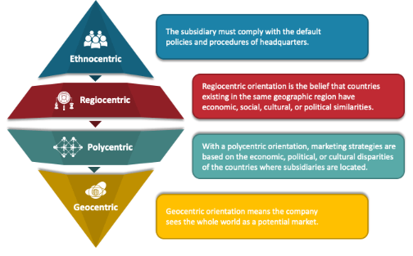
Figure 1: Ethnocentric, egocentric, and polycentric strategies
Source: (sketchbubble, 2023)

2.1.1 Ethnocentric strategies in managing the new campus in India
Cultural Sensitivity and Adaptation
Cultural sensitivity and adaptation are the primary deciding factors when selecting ethnocentric staff management practices for the new campus in India. The University of Wales Trinity must acknowledge and recognise the subtle cultural differences of India. India is a multilingual, multireligious, multi-traditional, and multi-custom nation (Bizumic, Monaghan and Priest, 2020). The institution should provide cultural sensitivity training for its foreign employees and cultivate an organisational culture that honours and respects regional traditions in order to guarantee a peaceful work environment. The success of the campus as a whole may suffer from miscommunication, employee resistance, and other consequences of a failure to adjust to the local culture (Tripathy, 2019).
Talent Management and Local Workforce Integration
The integration of local labour and talent management constitutes the second critical factor. While the university's headquarters may send staff members abroad as part of ethnocentric policies, it is crucial to balance this with the availability of local talent. Employers in the area should be given priority when it comes to hiring, developing, and training new staff members to fostering diversity and tolerance, this makes use of priceless local knowledge and experience. The university can gain from the perspectives and connections of the local talent by hiring them. If this isn't done, the local labour can feel alienated and long-term viability may be hampered (Baber et al., 2022).
Regulatory and Legal Compliance
Respect for regional rules and ordinances is a crucial consideration while creating ethnocentric initiatives in India. Specific labour rules and regulations, such as those pertaining to discrimination, worker safety, and wage and hour, govern employment in India. Wales Trinity University must make sure that all of its policies and procedures comply with Indian labour laws (Tripathy, 2019). There may be fines, legal ramifications, and reputational harm to the university if these regulations are broken. Engaging with legal experts and consultants who possess a thorough understanding of Indian labour regulations is imperative in order to steer clear of potential hazards that may arise from non-compliance (Tervooren, Schmidt-Hertha and Schmidt, 2023).
Communication and Engagement of Employees
Successful staff involvement and communication are essential to the new campus's success in India. There shouldn't be a communication breakdown between local and foreign employees as a result of the ethnocentric approach. It is imperative that the University of Wales Trinity create unambiguous routes for interaction and communication (Baber et al., 2022). To guarantee that staff members feel heard and appreciated, open-door policies, feedback channels, and town hall meetings ought to be held on a regular basis. Addressing language barriers is another important way to improve cross-cultural communication. Ineffective engagement and communication can cause misalignment, low morale, and eventually reduce productivity (Baber et al., 2022).
The choice of the University of Wales Trinity to open a new campus in India requires careful thought to ethnocentric staff management techniques. It takes cultural sensitivity and adaptation to guarantee a peaceful workplace. To fully utilise local expertise, talent management and local workforce integration must be balanced (Baber et al., 2022). To prevent legal issues, conformity with laws and regulations is crucial. A motivated and effective team depends on effective employee engagement and communication. Through a thorough analysis and resolution of these variables, the university can enhance the probability of a prosperous endeavour in India while cultivating a mutually advantageous association with its staff (Bizumic, Monaghan and Priest, 2020).

2.1.2 Egocentric strategies in managing the new campus in India
Regional Talent Mobility
Regional talent mobility is a crucial element that influences the selection of regiocentric techniques for personnel management in the new campus located in India. Regiocentric approaches emphasise the value of the particular region in the case of India as well as the possibility of talent movement within the region. The University of Wales Trinity has to think about putting in place talent development initiatives that permit staff members to relocate throughout India (Sreeja and Kovoor, 2021). This strategy can improve employees' professional development chances and result in the effective use of talents and expertise across several locations. But it's crucial to assess critically if India's talent pool and particularly the one in the area of the new campusis big enough to meet the demands of the university. If there is insufficient diversity or qualification in the local talent pool, then relying too much on regional talent mobility may prove to be problematic (Tervooren, Schmidt-Hertha and Schmidt, 2023).
Local Market Knowledge and Adaptation
The breadth of one's understanding of the local market and one's capacity for contextual adaptation in India are other critical factors. Regiocentric approaches recognise the importance of regional diversity and variances. The University of Wales Trinity ought to make an investment to fully comprehend student preferences, local competitiveness, and the Indian education industry (Asbari, Hidayat and Purwanto, 2021). The university will be able to customise its services and academic offerings to meet the unique requirements of Indian students. Lower enrolment and a smaller market share may arise from a failure to adjust to the local market and create a rift with the intended audience. The university needs to evaluate critically how well it can collect and apply this local market knowledge (Komlik, 2021).
Regional Regulatory Compliance
When putting regiocentric tactics into practice in India, adherence to local laws and regulations is crucial. Rules and laws pertaining to employment, postsecondary education, and other aspects of campus administration may differ between Indian states. The legal and regulatory frameworks that are applicable to the new campus in the region should be thoroughly examined and comprehended by the University of Wales Trinity (Komlik, 2021). Breaking these rules can result in financial penalties, legal issues, and reputational harm to the university. The university may need to build trusting connections with local legal professionals and consultants who understand the specific legal peculiarities of the area in order to assure compliance (Sreeja and Kovoor, 2021).
Regional Stakeholder Engagement
A crucial element of a regiocentric strategy is effective involvement with regional stakeholders. Long-term success in India requires establishing connections with the community, government agencies, business partners, and educational institutions in the area. It is imperative that the University of Wales Trinity conduct a rigorous evaluation of its capacity to interact with these stakeholders, comprehend their demands, and synchronise campus operations with regional goals (Asbari, Hidayat and Purwanto, 2021). Ignoring the involvement of regional stakeholders might lead to lost chances for funding, research, and collaboration. And it may result in negative opinions in the neighbourhood, which would impede the university's expansion and acceptability there (Asbari, Hidayat and Purwanto, 2021).
Careful examination of a number of crucial criteria is necessary before implementing egocentric strategies for managing staff at the new campus in India. Career development can be further enhanced by regional talent mobility, but it must be evaluated in light of the credentials and availability of the local talent pool. To effectively recruit and retain students, it is imperative to comprehend and adjust to the local market. It is essential to abide by local laws in order to prevent legal issues (Sreeja and Kovoor, 2021).

2.1.3 Polycentric strategies
Local Workforce Empowerment and Autonomy
The degree of local workforce autonomy and empowerment is an important consideration when choosing polycentric solutions for managing personnel in the new campus in India. Giving local management and staff a significant degree of independence is emphasised in a polycentric strategy. It is imperative that the University of Wales Trinity conduct a thorough evaluation of its readiness and capacity to assign decision-making powers to local employees, enabling them to modify policies and procedures to suit the Indian environment (Neri and Wilkins, 2018). Increased job satisfaction, motivation, and productivity within the local workforce can result from this empowerment. To guarantee consistency with the university's overarching objectives and core values, it also necessitates a strong faith in the local team's talents as well as the creation of efficient channels for coordination and communication between the local and central administration (Lubell and Morrison, 2021).
Integration and Training Across Cultures
A polycentric plan must take into account the importance of cross-cultural integration and effective training. The University of Wales Trinity needs to critically assess its ability to offer comprehensive cross-cultural training to both local and expatriate personnel in light of India's numerous cultural, linguistic, and regional variances (Salas‐Vallina, Alegre and López‐Cabrales, 2020). Through this training, staff members should be better able to recognise and value the subtle cultural differences, communication preferences, and work ethics of their coworkers. Efficient cross-cultural adjustment can result in a more peaceful workplace, more teamwork, and more innovation. Inadequate or incompetent cross-cultural training could lead to miscommunications, disputes, and ineffective teamwork (Salas‐Vallina, Alegre and López‐Cabrales, 2020).
Talent Development and Local Recruiting
Another important aspect of a polycentric strategy is the recruitment and talent development process. Employing local people to perform important roles and making development investments in them are components of the polycentric strategy. It is imperative that the University of Wales Trinity conduct a rigorous evaluation of its capacity to locate, draw in, and hold onto qualified candidates from the local labour market (Salas‐Vallina, Alegre and López‐Cabrales, 2020). This entails assessing how competitive its benefits and pay plans are, as well as how well-known its employer brand is in India. To make sure that local employees have the opportunity to advance into leadership positions on campus, the efficacy of local talent development initiatives must also be closely examined. Inadequate recruitment and development of local talent may result in a detachment between the central and local teams and make it difficult to fill critical roles (Lubell and Morrison, 2021).
Involvement of Local Stakeholders
The University of Wales Trinity needs to assess seriously how well it can negotiate the Indian education system and forge reliable alliances. Interacting with regional partners might yield beneficial assistance, materials, and joint venture prospects. A poor strategy for engaging stakeholders can result in missed opportunities, bureaucratic roadblocks, and a lack of community support, all of which can harm the campus's success as a whole (Aburumman et al., 2020).

2.2 Factors in the recruitment, training, and settlement of expatriate staff in India

2.2.1 Factors to consider in recruitment
International Expertise
The arrival of UK personnel at the Indian school is a powerful inducement to enhance the scholarly environment. Their presence facilitates a lively exchange of ideas by bringing a plethora of scholarly knowledge and perspectives from around the world. By introducing students to a variety of learning styles and international best practices, this knowledge infusion improves the standard of education (Kroumova and Mittal, 2023). Students gain a wider perspective and the knowledge and understanding necessary to succeed in a world that is more interconnected when they study in an academic setting that transforms into a melting pot of ideas and cultures (Whately, 2021).
Cross-Cultural Exchange
Not only does the hiring of UK personnel contribute academic competence to the Indian campus, but it also actively promotes cross-cultural interactions between the two academic communities. Due to the exposure of both parties to a variety of viewpoints and behaviors, this interchange is a potent catalyst for tolerance and understanding between people (Chwialkowska, 2020). Also, it establishes a strong framework for cross-border cooperation in research and teaching. Because it becomes a centre for the peaceful fusion of information and cultures, the university's prestige is greatly enhanced on a global basis, benefiting all parties participating in the academic process (Kroumova and Mittal, 2023).
Cultural and Language Differences
One major obstacle to hiring UK personnel for the Indian campus is the substantial cultural and linguistic differences between the UK and India. These variations may provide an ideal environment for problems with integration and communication. Employees from the UK could have trouble adjusting to the Indian environment, that could lead to miscommunications and misunderstandings (Kroumova and Mittal, 2023). Conflicts across cultures can also arise from disparate customs, beliefs, and methods of instruction and management. It is imperative to put in place efficient cross-cultural training programmes that educate UK employees about Indian norms and practices in order to overcome these issues. Strong communication techniques should also be implemented in order to promote amicable and effective work environments by easing staff interactions, understanding, and cooperation (Whately, 2021).
Cost Considerations
Significant financial resources are required for the recruitment and relocation of UK employees to India for the university's new campus. In addition to paying salaries, the organization has other costs to pay, such as housing, healthcare, and other moving-related fees, and visa sponsorship (Chwialkowska, 2020). This financial commitment may put a strain on the university's overall finances by taking funds away from other urgent requirements, such as student scholarships or infrastructure development. To make sure that the hiring process is sustainable and consistent with the long-term financial health of the university, rigorous resource allocation, cost-effective strategy exploration, and external funding alternatives are required (Kroumova and Mittal, 2023).
Local Talent Development

Figure 2: Talent management framework
Source: (Rencai, 2023)
Although hiring people from the UK offers advantages, local talent should not be impeded by this. A cycle of dependency could be established by an over-reliance on foreign employees, making it difficult for the Indian campus to develop its own administrative and scholarly capacities (Renzulli and Reis, 2021). Faculty and workers in the area who feel marginalized by this scenario may become resentful. In order to solve this, the university ought to provide local talent's professional development and mentoring top priority, making sure they have chances for improvement (Chwialkowska, 2020).
Administrative Hurdles
Navigating intricate administrative rules, regulations, and processes is necessary when hiring UK employees for an Indian school. Hiring staff for the campus may be delayed if the required work permits are not obtained in a timely manner. Navigating bureaucratic red tape and administrative procedures can be taxing for the university as well as the hired staff, that may have an impact on productivity and morale (Renzulli and Reis, 2021). To minimize the impact of these obstacles on the hiring process, the university should devise a streamlined and effective procedure for offering complete assistance to employees in managing administrative responsibilities (Whately, 2021).

2.2.2 Factors to consider in training
Cultural Exchange and Diverse Perspectives
A unique chance for a deep cultural interchange and the introduction of several viewpoints is presented by the integration of UK employees into an Indian university. The opportunity for students and employees to broaden their perspectives, confront preconceptions, and gain a more thorough grasp of global concerns makes this multicultural atmosphere a tremendous asset (Morin and Talbot, 2021). The blending of Indian and British viewpoints enhances scholarly conversation and promotes a more intelligent, all-encompassing method of teaching and learning. A truly inclusive and globally-aware learning environment is created by this harmonious blending of worldviews, that fosters tolerance, respect for one another, and a global perspective within the campus community (Guo, Rammal and Pereira, 2021).
Quality of Education
Unquestionably, UK universities have gained recognition throughout the world for their excellent teaching and significant research achievements. The new campus in India will benefit from the invaluable skills, teaching methods, and vast research experiences of the UK professionals that they bring with them. Their presence acts as a catalyst for transformation, raising the bar for academic standards at the institution (Wang et al., 2019). It guarantees that students are exposed to top-notch instruction and innovative research, setting them up for success in their academic endeavours and future employment. The institution is better equipped to uphold its excellent reputation and fulfil its commitment to academic excellence due to this influx of knowledge and practices (Morin and Talbot, 2021).
Cultural Understanding and Adaptation
There is also little doubt that cultural interchange enriches the University of Wales Trinity's Indian campus in many ways. It does come with the important disclaimer of cultural sensitivity and adaptability. Potential difficulties could arise from UK staff members' unfamiliarity with the complexities of Indian academic systems and culture (Bashir et al., 2021). The institution ought to provide cultural sensitivity training top priority to promote harmony in the workplace. Understanding regional traditions, communication etiquette, and the Indian academic environment should all be included in this course. Giving UK employees this information will help them interact with students, coworkers, and the larger Indian community in a successful manner while also averting misunderstandings and disputes (Guo, Rammal and Pereira, 2021).
Cost and Resource Implications
It is true that hiring employees from the UK might be an expensive affair. Because of their depth of knowledge and experience, these people frequently have greater compensation expectations. The budget may also be further strained by other incentives like housing, healthcare, and relocation reimbursements. The university must set aside funds for thorough training and support programs, that are essential for acclimating these foreigners to the Indian campus atmosphere, in order to guarantee a smooth transition and integration (Bashir et al., 2021). Thorough financial analysis is necessary to match this project's expenses to the organization's larger aims and objectives. To ensure that the investment in UK workers results in improved academic quality and a good international reputation, that justifies the expenses paid, prudent planning is essential (Morin and Talbot, 2021).
Visa and Legal Challenges
Hiring international employees in India can present complicated and time-consuming bureaucratic and legal difficulties. Handling the complexities of Indian work permit and visa laws requires a lot of administrative work (Wang et al., 2019). To ensure compliance with Indian labour laws and negotiate these rules, the institution needs to be ready to commit time and resources in this regard. In order to properly navigate this potentially difficult process, diligence and experience are needed (Guo, Rammal and Pereira, 2021).
Diversity and Inclusion Initiatives
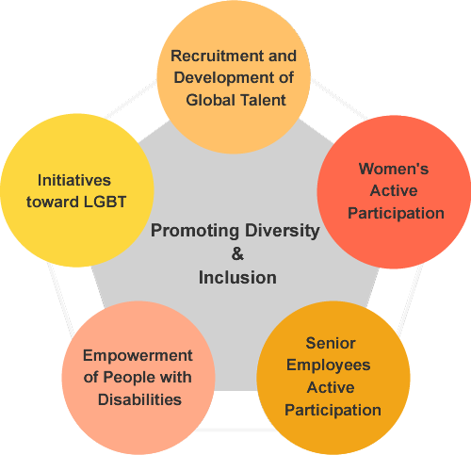
Figure 3: Diversity and inclusion
Source: (Rohm, 2023)
While hiring UK workers in India can increase diversity, it's important to strike a balance with regional inclusion programs. The talent and potential of indigenous instructors may unintentionally be overshadowed by the flood of foreign personnel (Bashir et al., 2021). Actively involving and assisting local academics and staff is essential, as is offering them chances for professional development. Local talent may feel ignored or ostracized if these activities are neglected. Consequently, in order to ensure that all educators, regardless of where they are from, may contribute to and benefit from the growth and success of the institution, universities should put in place policies and programs that support both diversity and inclusion (Morin and Talbot, 2021).

2.2.3 Factors to consider in settlement
International Collaboration
Hiring employees from the UK for the campus in India might promote vital international cooperation in research and teaching methods. Academics from Britain and India can gain a great deal from exchanging ideas and sharing expertise. Interdisciplinary efforts, collaborative research projects, and co-authored articles can all succeed (Chinyamurindi, 2019). This not only helps the university's image around the world but also advances a number of other fields. International partnership drives academic success and creativity by fostering an environment where varied viewpoints come together (Almansour, Gobbi and Prichard, 2021).
Global Perspective
The presence of UK employees on the campus in India gives the learning environment a more global viewpoint. This is extremely valuable in a globalized environment. These faculty members can aid students in expanding their worldviews because of their varied experiences and areas of expertise (Faeth and Kittler, 2020). Students are better equipped to succeed in an increasingly competitive and international labour market when they are exposed to a variety of instructional approaches, cultural contexts, and global challenges. The University of Wales Trinity's distinctive selling proposition is its worldwide viewpoint, that draws in students looking for a well-rounded education that transcends national borders (Chinyamurindi, 2019).
Recruitment Challenges
Finding people who are prepared to migrate is a significant recruiting obstacle for the UK campus in India. Many academics may be reluctant to take on an overseas assignment due to the UK's attractiveness of a familiar setting, close proximity to family, and cultural comfort (Handique, 2021). The pool of potential candidates may be reduced by this reluctance in addition to the particular training and experience needed. Comprehensive recruitment techniques, like providing appealing relocation packages and outlining the special benefits of this opportunity, are imperative for the university to implement (Almansour, Gobbi and Prichard, 2021).
Potential for Misalignment
International collaboration is great, but it's important to be aware that there may be a mismatch between UK staff expectations and the actual realities of the Indian school. The foreign employees may become frustrated and dissatisfied as a result of this imbalance. For example, cultural clashes can arise due to disparities in administrative procedures, educational techniques, or work pace (Faeth and Kittler, 2020). The institution should create open lines of communication, offer cultural sensitivity training, and encourage staff members from the UK and India to speak candidly in order to close any knowledge gaps in order to reduce this danger (Chinyamurindi, 2019).
Cultural Sensitivity
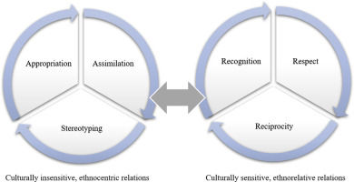
Figure 4: Cultural sensitivity framework
Source: (Viken, 2021)
In order to successfully integrate UK workers into the Indian campus, cultural sensitivity is essential. It is imperative that they modify their pedagogy and methods of operation to suit the regional milieu. Failing to do so may cause a rift between coworkers and students. Cultural sensitivity includes appreciating the diversity of Indian culture and being aware of regional customs and communication standards (Handique, 2021). Establishing a robust training program that addresses cultural sensitivity can play a pivotal role in guaranteeing a peaceful workplace and productive cooperation between employees from the UK and India (Almansour, Gobbi and Prichard, 2021).

2.2.4 Critical evaluation of expatriate success and well-being issues
Cultural Adaptation
A vital component of expatriate success and well-being is cultural adaptation. The social customs, business etiquette, and cultural standards differ dramatically when one relocates from the UK to India. Employees who work abroad may suffer from culture shock, that can impair their effectiveness at work and cause stress and feelings of loneliness (María Bastida Domínguez et al., 2023). UWTSD should make investments in cultural sensitivity training initiatives to solve this problem. An extensive grasp of Indian culture, including social mores, communication etiquette, and business procedures, ought to be imparted through these classes. Such training can reduce culture shock and promote wellbeing by assisting UK employees in adjusting to the local way of life more successfully (Liem et al., 2021).
Legal and Administrative Barriers
Legal and administrative procedures in India can be difficult and time-consuming, particularly for visitors. For foreign employees, navigating work permits, visas, and local labour rules can be a difficult undertaking. UWTSD must offer thorough assistance in this field (Fabio, 2021). This could involve partnering with law firms that have experience with expatriate matters or offering legal support. To avoid legal problems that could have a detrimental effect on expatriate success, it is imperative to make sure that the required paperwork and documentation are in order (Biswas, Mäkelä and Andresen, 2021).
Health and Well-being
Having access to high-quality healthcare is crucial for foreign employees' well-being. The healthcare system in India is diverse, and there are wide variations in the standard of care. Comprehensive health insurance that includes emergency care, regular checkups, and mental health treatments should be provided by UWTSD (Fabio, 2021). Since moving to a new culture and work environment can be emotionally taxing, adequate mental health care is crucial. Giving foreigners access to support groups or counseling services can aid in managing stress and mental health issues, hence improving their general well-being (Liem et al., 2021).
Work-Life Balance
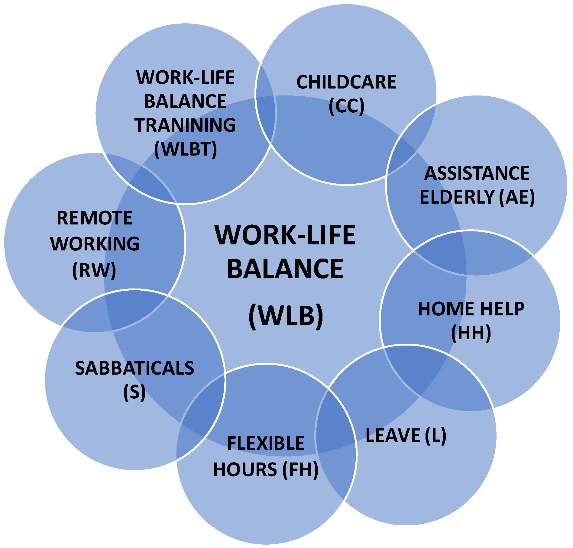
Figure 5: Work-Life Balance
Source: (Hernandez, 2019)
Ensuring that foreign employees in India have a positive work-life balance is critical to their performance and welfare. Compared to what expats are used to in the UK, the work culture in India may sometimes involve longer working hours and a higher expectation of dedication to the profession. Ignoring this disparity can result in burnout, that affects people's quality of life generally as well as their performance at work (María Bastida Domínguez et al., 2023). UWTSD should aggressively encourage a work environment that appreciates and prioritizes work-life balance in order to reduce this risk. This entails creating an atmosphere where workers feel empowered to create a good work-life balance, giving flexible work schedules when practical, and establishing explicit policies that forbid working long hours (Biswas, Mäkelä and Andresen, 2021).
Housing and Living Conditions
For foreign employees, finding acceptable accommodation in India and adjusting to the local way of life can be difficult tasks. The quality of life and housing alternatives available to expatriates in India might differ greatly, that may have an impact on their well-being (Fabio, 2021). UWTSD should help its employees locate lodging that satisfies their needs and is both secure and comfortable. Giving advice on daily life, transportation, and local facilities can greatly lower stress and improve the well-being of the expatriates (Liem et al., 2021).
Language and Communication
For foreign employees, language limitations can be a major problem, especially in a multilingual nation like India. Good communication is essential for both personal and professional success. Offering language training courses would help UWTSD provide its employees with the language proficiency they need (María Bastida Domínguez et al., 2023). The emphasis of these courses needs to be on effective communication in everyday and professional settings. This language training investment improves the efficacy and efficiency of the work performed by foreign employees while also promoting well-being (Biswas, Mäkelä and Andresen, 2021).

3. Recommendations

3.1 Local Workforce Empowerment and Autonomy
The degree of local workforce autonomy and empowerment is an important consideration when choosing polycentric solutions for managing personnel in the new campus in India. Giving local management and staff a significant degree of independence is emphasised in a polycentric strategy. It is imperative that the University of Wales Trinity conduct a thorough evaluation of its readiness and capacity to assign decision-making powers to local employees, enabling them to modify policies and procedures to suit the Indian environment (Saks, 2021). Increased job satisfaction, motivation, and productivity within the local workforce can result from this empowerment. To guarantee consistency with the university's overarching objectives and core values, it also necessitates a strong faith in the local team's talents as well as the creation of efficient channels for coordination and communication between the local and central administration (Aburumman et al., 2020).

3.2 Integration and Training Across Cultures
A polycentric plan must be considered the importance of cross-cultural integration and effective training. The University of Wales Trinity needs to critically assess its ability to offer comprehensive cross-cultural training to both local and expatriate personnel in light of India's numerous cultural, linguistic, and regional variances (Sabuhari et al., 2020). Through this training, staff members should be better able to recognise and value the subtle cultural differences, communication preferences, and work ethics of their coworkers. Efficient cross-cultural adjustment can result in a more peaceful workplace, more teamwork, and more innovation. Inadequate or incompetent cross-cultural training could lead to miscommunications, disputes, and ineffective teamwork (Saks, 2021).

3.3 Talent Development and Local Recruiting
Another important aspect of a polycentric strategy is the recruitment and talent development process. Employing local people to perform important roles and making development investments in them are components of the polycentric strategy. It is imperative that the University of Wales Trinity conduct a rigorous evaluation of its capacity to locate, draw in, and hold onto qualified candidates from the local labour market (Nguyen, Yandi and Mahaputra, 2020). This entails assessing how competitive its benefits and pay plans are, as well as how well-known its employer brand is in India. To make sure that local employees have the opportunity to advance into leadership positions on campus, the efficacy of local talent development initiatives must also be closely examined. Inadequate recruitment and development of local talent may result in a detachment between the central and local teams and make it difficult to fill critical roles (Nguyen, Yandi and Mahaputra, 2020).

3.4 Involvement of Local Stakeholders
Using local stakeholders in dialogue is essential to a polycentric approach. In the context of Indian higher education, this means establishing connections with local companies, governmental organisations, accreditation organisations, and the community. The University of Wales Trinity needs to assess seriously how well it can negotiate the Indian education system and forge reliable alliances. Interacting with regional partners might yield beneficial assistance, materials, and joint venture prospects (Nguyen, Yandi and Mahaputra, 2020). A poor strategy for engaging stakeholders can result in missed opportunities, bureaucratic roadblocks, and a lack of community support, all of which can harm the campus's success as a whole (Sabuhari et al., 2020).

4. Conclusion
Human resource management is crucial for hiring, developing, and engaging staff in a global and competitive environment, as demonstrated by the opening of the University of Wales Trinity's new campus in India. Good HRM procedures are necessary to drive employee motivation in the face of growing competition, foster cross-cultural competency, and negotiate the complexities of international labor markets. The well-being of employees and the performance of the organization both depend heavily on managing a diverse and complex workforce. The key component of this process is HRM, which makes sure the organization prospers internationally and provides a welcoming and inclusive work environment for its employees.

References
Aburumman, O., Salleh, A., Omar, K. and Abadi, M. (2020). The impact of human resource management practices and career satisfaction on employee’s turnover intention. Management Science Letters, 10(3), pp.641–652.
Almansour, H., Gobbi, M. and Prichard, J. (2021). Home and expatriate perceptions of job satisfaction: Qualitative findings. International Nursing Review, 47(8). doi:https://doi.org/10.1111/inr.12699.
Asbari, M., Hidayat, D.D. and Purwanto, A. (2021). Managing Employee Performance: From Leadership to Readiness for Change. International Journal of Social and Management Studies, [online] 2(1), pp.74–85. doi:https://doi.org/10.5555/ijosmas.v2i1.12.
Baber, R., Upadhyay, Y., Baber, P. and Kaurav, R.P.S. (2022). Three Decades of Consumer Ethnocentrism Research: A Bibliometric Analysis. Business Perspectives and Research, p.227853372210984. doi:https://doi.org/10.1177/22785337221098472.
Bashir, H., Ahmad, B., Bari, M.W. and Khan, Q.U.A. (2021). The impact of organizational practices on formation and development of psychological contract: expatriates’ perception-based view. International Journal of Emerging Markets, 68(9). doi:https://doi.org/10.1108/ijoem-10-2020-1187.
Biswas, T., Mäkelä, L. and Andresen, M. (2021). Work and non-work-related antecedents of expatriates’ well-being: A meta-analysis. Human Resource Management Review, 32(3), p.100889. doi:https://doi.org/10.1016/j.hrmr.2021.100889.
Bizumic, B., Monaghan, C. and Priest, D. (2020). The Return of Ethnocentrism. Political Psychology, 42(S1). doi:https://doi.org/10.1111/pops.12710.
Chinyamurindi, W.T. (2019). Framing Career Wellbeing Amongst Expatriate Workers: A Narrative Analysis. Theory, Research and Dynamics of Career Wellbeing, [online] 89(3), pp.283–307. doi:https://doi.org/10.1007/978-3-030-28180-9_14.
Chwialkowska, A. (2020). Maximizing Cross-Cultural Learning From Exchange Study Abroad Programs: Transformative Learning Theory. Journal of Studies in International Education, 24(5), pp.535–554. doi:https://doi.org/10.1177/1028315320906163.
Fabio, A.D. (2021). Cross-cultural Perspectives on Well-Being and Sustainability in Organizations. Springer eBooks. Springer Nature. doi:https://doi.org/10.1007/978-3-030-86709-6.
Faeth, P.C. and Kittler, M.G. (2020). Expatriate management in hostile environments from a multi-stakeholder perspective – a systematic review. Journal of Global Mobility: The Home of Expatriate Management Research, 8(1), pp.1–24. doi:https://doi.org/10.1108/jgm-07-2019-0035.
Gatto, A. (2022). Polycentric and resilient perspectives for governing the commons: Strategic and law and economics insights for sustainable development. Ambio, 51(9), pp.1921–1932. doi:https://doi.org/10.1007/s13280-022-01719-x.
Guo, Y., Rammal, H.G. and Pereira, V. (2021). Am I ‘In or Out’? A social identity approach to studying expatriates’ social networks and adjustment in a host country context. Journal of Business Research, 136(3), pp.558–566. doi:https://doi.org/10.1016/j.jbusres.2021.07.059.
Handique, I. (2021). India-Ethiopia in the Educational Sector: It’s Cooperation in the Past and the Present. Addaiyan Journal of Arts, Humanities and Social Sciences, 15(3), pp.64–67. doi:https://doi.org/10.36099/ajahss.3.7.5.
Karoui, S. and Khemakhem, R. (2019). Consumer ethnocentrism in developing countries. European Research on Management and Business Economics, 25(2), pp.63–71. doi:https://doi.org/10.1016/j.iedeen.2019.04.002.
Komlik, O. (2021). Egocentric Perceptions and Self-Serving Bias in Negotiations: Fairness, Dynamics, and Ethics. Journal of Intercultural Management and Ethics, [online] 4(3), pp.61–70. Available at: https://www.ceeol.com/search/article-detail?id=989869.
Kroumova, M. and Mittal, R. (2023). Cross‐cultural experiences and self‐protective leadership: A multi‐country comparison of managerial perception. Global Business and Organizational Excellence, 35(7). doi:https://doi.org/10.1002/joe.22211.
Liem, A., Renzaho, A.M.N., Hannam, K., Lam, A.I.F. and Hall, B.J. (2021). Acculturative stress and coping among migrant workers: A global mixed‐methods systematic review. Applied Psychology: Health and Well-Being, 13(3). doi:https://doi.org/10.1111/aphw.12271.
Lubell, M. and Morrison, T.H. (2021). Institutional navigation for polycentric sustainability governance. Nature Sustainability. doi:https://doi.org/10.1038/s41893-021-00707-5.
María Bastida Domínguez, Belén Bande, Luísa Helena Pinto and Castro‐González, S. (2023). ‘Be Happy’ While You Can: How Expatriates’ Accomplishments Affect Their Subjective Well-Being and Job Satisfaction. SAGE Open, 13(3). doi:https://doi.org/10.1177/21582440231184872.
Morin, G. and Talbot, D. (2021). Cultural intelligence of expatriate workers: a systematic review. Management Review Quarterly, 47(7). doi:https://doi.org/10.1007/s11301-021-00245-6.
Neri, S. and Wilkins, S. (2018). Talent management in transnational higher education: strategies for managing academic staff at international branch campuses. Journal of Higher Education Policy and Management, 41(1), pp.52–69. doi:https://doi.org/10.1080/1360080x.2018.1522713.
Nguyen, P.T., Yandi, A. and Mahaputra, M.R. (2020). FACTORS THAT INFLUENCE EMPLOYEE PERFORMANCE: MOTIVATION, LEADERSHIP, ENVIRONMENT, CULTURE ORGANIZATION, WORK ACHIEVEMENT, COMPETENCE AND COMPENSATION (A STUDY OF HUMAN RESOURCE MANAGEMENT LITERATURE STUDIES). Dinasti International Journal of Digital Business Management, [online] 1(4), pp.645–662. doi:https://doi.org/10.31933/dijdbm.v1i4.389.
Renzulli, J.S. and Reis, S.M. (2021). The Schoolwide Enrichment Model: A How-To Guide for Talent Development. [online] Google Books. Routledge. doi: https://books.google.com/books?hl=en&lr=&id=g4FGEAAAQBAJ&oi=fnd&pg=PT6&dq=Local+Talent+Development&ots=5bh6xUPCe9&sig=yv2PMpvwG9OUFdTeWPjuZ0xjoz0.
Sabuhari, R., Sudiro, A., Irawanto, D. and Rahayu, M. (2020). The effects of human resource flexibility, employee competency, organizational culture adaptation and job satisfaction on employee performance. Management Science Letters, 10(8), pp.1775–1786.
Saks, A.M. (2021). Caring human resources management and employee engagement. Human Resource Management Review, 32(3), p.100835. doi:https://doi.org/10.1016/j.hrmr.2021.100835.
Salas‐Vallina, A., Alegre, J. and López‐Cabrales, Á. (2020). The challenge of increasing employees’ well‐being and performance: How human resource management practices and engaging leadership work together toward reaching this goal. Human Resource Management, [online] 60(3). doi:https://doi.org/10.1002/hrm.22021.
Saputra, F. and Mahaputra, M.R. (2022). EFFECT OF JOB SATISFACTION, EMPLOYEE LOYALTY AND EMPLOYEE COMMITMENT ON LEADERSHIP STYLE (HUMAN RESOURCE LITERATURE STUDY). Dinasti International Journal of Management Science, [online] 3(4), pp.762–772. doi:https://doi.org/10.31933/dijms.v3i4.1324.
Shiksha (2023). [online] Shiksha.com. Available at: https://images.shiksha.com/mediadata/images/1541152532phpaMbjD5.jpeg [Accessed 17 Oct. 2023].
sketchbubble (2023). [online] Sketchbubble.com. Available at: https://cdn.sketchbubble.com/pub/media/catalog/product/optimized1/1/4/146381cd31144ce1c789d82925fdb86b6e4d51c1e3e72a9bba1989b0ae040d63/eprg-framework-mc-slide1.png [Accessed 17 Oct. 2023].
Sreeja, M.U. and Kovoor, B.C. (2021). A unified model for egocentric video summarization: an instance-based approach. Computers & Electrical Engineering, [online] 92, p.107161. doi:https://doi.org/10.1016/j.compeleceng.2021.107161.
Sun, L. and Bunchapattanasakda, C. (2019). Employee Engagement: A Literature Review. International Journal of Human Resource Studies, [online] 9(1), pp.63–80. Available at: https://ideas.repec.org/a/mth/ijhr88/v9y2019i1p63-80.html.
Tervooren, A., Schmidt-Hertha, B. and Schmidt, K. (2023). University of wales trinity . Erziehungswissenschaft, [online] 34(1), pp.3–6. doi:https://doi.org/10.3224/ezw.v34i1.01.
Tripathy, M. (2019). Subduing Cultural Stereotype & Ethnocentrism In Business Organizations: A Soft Skills Stance. Jurnal Sosial Humaniora, 12(1), p.28. doi:https://doi.org/10.12962/j24433527.v12i1.4897.
Wang, C.Y.-P., Lien, M.-C., Jaw, B.-S., Wang, C.-Y., Yeh, Y.-S. and Kung, S.-H. (2019). Interrelationship of expatriate employees’ personality, cultural intelligence, cross-cultural adjustment, and entrepreneurship. Social Behavior and Personality: an international journal, 47(12), pp.1–16. doi:https://doi.org/10.2224/sbp.8341.
Whately, C. (2021). Recruitment. [online] brill.com. doi: https://brill.com/display/book/9789004461611/BP000015.xml.

Appendix

