TASK 2 - Illustrated Book Project Proposal Task
500 words, due 5pm Feb 12th, submitted via moodle.
Formatting: please use the headings below making use of the advice and resources provided. References should be made using the Harvard format.

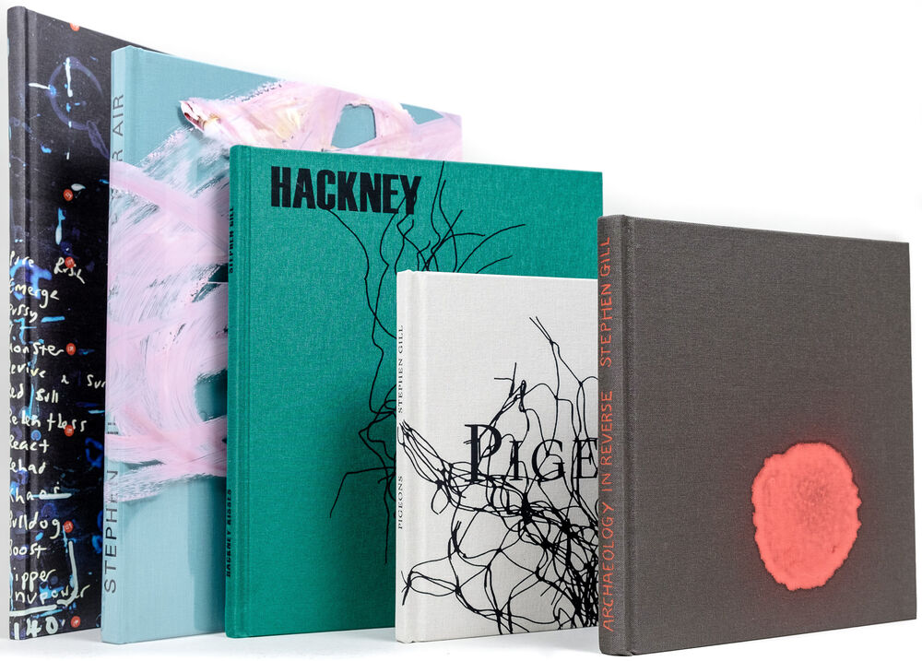
Name: Abbie Ashman

Theme/Context
Provide a brief summary of the theme or subject you want your work to focus on. You might include details about the impact you hope to achieve, how the book format will help you connect with your audience, and what will make your work stand out. (300 – 500 words)
Throughout this book project I would like to focus on eyes, exploring how they differ from person to person and the possibility that they hint towards a persons experiences and life stories. I would also like to consider the idea that the “eyes are a window to the soul”, and what this means along with how this idea presents itself practically. Do they truly reflect emotions, memories, or deeper truths about person or is this just a poetic concept? Another possible avenue to pursue is experiments in post production, such as layering images both digitally and in the dark room, in the past I have experimented with layering light painting with images of eyes which creates an interesting effect that I would like to explore further.

The impact I hope to achieve is to encourage people to look beyond the surface, to think deeper into the intricate details of eyes and what information they may hold about a person. A book format would be an interesting way to present this, allowing readers to turn through pages filled with eyes – each unique in the way it looks and the secrets it holds. By seeing the differences in each persons eyes up close, the viewer may begin to question why each persons eyes are so unique and whether they can in fact hint towards a persons experiences and feelings.
My ultimate goal is to create a body of work that invites curiosity, further examination of feeling and a deeper appreciation of the impact of the human gaze and how eyes function as a symbol of human emotion and experience.

Influence
Highlight the work of a photographer who currently inspires your work. Analyse an image of theirs and explain your interest in their work. Consider style, theme, context, practical technique. (300 – 500 words)

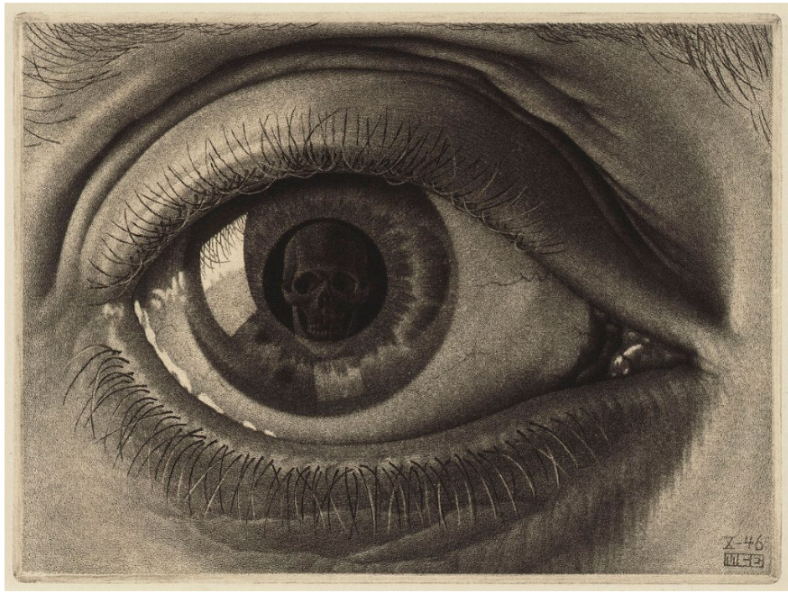An artist that has inspired this idea is M.C. Escher, in his work there seems to be hidden meanings that take closer inspection and research to understand further. I love his use of eyes and other spherical objects to encapsulate detail and hidden meanings. Although this work is not photographic, I am inspired by the use of reflections and hope to learn to incorporate this into my practice.

Book Form
Referencing the session PowerPoint on Moodle (or another relevant source), discuss at least one book that has influenced you. Explore its visual and aesthetic qualities, social or historical context, impact, or practical methods relevant to your theme. You may also evaluate its overall effectiveness. (300 – 500 words)

Christian Boltanski’s photobook ‘Kaddish’ has a very interesting way of presenting photos, I like the way that each page has a full bleed image of face, each as unique as the next. The monotony of each page containing such similar imagery allows the reader to hone in on the uniqueness of each face. This is something that I hope to recreate in my own photobook.

