Academic and Employability
Skills
BMSW4001
Task 2

Module Leader: Lizeta Demetriou
Bianca Agapina Sztan
Student ID: 2115858

Table of Contents

1.0 Introduction page 03
2.0 Reflective writing page 04
3.0 Academic writing page 05
4.0 Paraphrasing page 06
5.0 CV Writing page 07
6.0 Presentation and Public Speaking Page 08
7.0 Time Management Page 09
8.0 Conclusion Page 12
9.0 References Page 13
10. Appendix Page 14

1.0 Introduction
This report is a reflection on myself. According to the module instruction, I will be choosing 3 of the topics taught in the classroom and the 4th topic is public speaking and presentation. On these topics, I need to provide an in-depth reflection about how I understood the concept of these topics. For the reflective analysis, my chosen topics for this report are Time Management, Academic Writing, Paraphrasing, and CV Writing. For the reflective analysis, I will use Gibbs’ reflective cycle.

2.0 Reflective Analysis Using Gibbs’ Reflective Cycle

Gibbs’ reflective cycle is a reflective model that assesses and evaluate a situation in 6 different steps to explore the experience and to learn from that (Bassot, 2016).

Figure 1 Gibbs’ Reflective Cycle
Source: (Bassot, 2016)
This is the first step where the description of the experience is shared. The main question asked in this step is about what happened in the experience (Cash, 2018). Following is the description of the 4 selected topics. Feeling is the second step where the feeling regarding the experience is shared. The main question for this step is how I felt when the experience happened and what I think about the experience (David, 2017). In the evaluation step, the experience is evaluated. How the experience affected the practitioner is the main focus of this stage (Hayes et al., 2017). The question that is asked in this step is what was good and what was bad about the experience. In this stage, the main agenda is to focus on the sense of the situation. What sense can be made out of the situation is the main agenda for this point (Helyer, Wall, Minton and Lund, 2019). How the experiences can impact me and how it drives me to improve is the analysis for this point of the model. Conclusion is the step of alternative possibilities. In this step, how the situation or the experience could have been improved will be discussed (Jones, 2014). The reason is that depending on the situational analysis, a more refined action plan can be developed. The main question in this step is what else could have been done differently? Action plan is the last step of the model. In this step, the action plan is developed. Based on the previous analysis and evaluation, how to improve my experience is the main focus of this stage of the model (Manktelow and Birkinshaw, 2016). The main question for this step is if the situation arose again, what would I do differently?

3.0 Academic Writing

At the first time when I started the module, I did not understand the importance of academic writing. However, when I first participated in a writing competition, I fell short due to my lack of competencies in academic writing. I felt very disappointed in myself for not knowing the academic writing format. I put a lot of work into that essay from the beginning and I had high hopes that it would be selected.
But when I came to know my writing format was not up to the academic standard, I was very disappointed in myself.

The good thing about the experience of academic failure was that I learnt about the concept of academic writing, and I was motivated to improve my academic writing skill. Since I put a lot of work into that essay and it got rejected, I could not put another effort of me to waste. But a bad thing about the experience was that I also felt devastating since my effort was wasted due to a single aspect.

Academic writing is the foundation of both academic and employability skills. One of the major portions of the job is to prepare notes and reports. So, academic writing in both job and the university is much more important than any other concept.

For the academic writing failure, the alternative action could have been simple research on essay writing. If I searched on google for a format of essay writing at the competition level, I could have gotten a lot of formats and templates available for free. From there, I could have chosen and understood how to write an essay in an academic format.

If I were to participate in an essay writing competition again, the thing that I would do differently is I would select a format that is accepted globally if the competition does not state the format that the essay must be written. And I would then research the format and how to write following the format before starting writing.

4.0 Paraphrasing

In the same writing competition, I was tasked with writing an essay on the topic of ‘Shared Economy’. However, I did not know how to paraphrase or more importantly, I did not know that paraphrasing is a thing. So, the second ground that my writing got rejected was that in my essay, there was a 56% similarity with other sources.

In a sense, I felt enlightened about the paraphrasing failure of my essay. At first, it was a shock to me. But when I thought about that, it all made sense. I cannot use an article or information from a source directly. That is a violation of copyright. I learnt a good lesson about how to use an article in a writing. So, I felt enlightened.

There wasn’t any bad side to the experience of paraphrasing failure. Since I was convinced that it is a good thing that I learnt about paraphrasing and understood how this works, it was a good experience for me.

With par academic writing, paraphrasing is also a very important concept. Not only in the academic sense, in employability skills, but this is also a very important concept. Just think of stealing a joke from your friend and see how mentally frustrated they get when you do this. It is a perfect example of how human nature is driven and to develop myself as a good manager and a good student, paraphrasing skill is very important.

The alternative course of action would have been checking the plagiarism of the submitted content. If I would check the plagiarism of the essay that I submitted, it would be pretty evident that there is a grave mistake with the essay, and I need to paraphrase the contents that I have submitted. Thus, the situation could have been improved.

I would use digital tools to check whether there is any similarity in my essay with external sources. If the similarity exceeds the tolerable limit, I would actively paraphrase the sentences and if needed, I would take the help of various online tools for the paraphrasing so that I do not have any similarities and plagiarism.

5.0 CV Writing

Sometimes ago, I approached one of my acquaintances about a job since I needed a job. So, he told me to send a CV in his e-mail and he would look at what he can do. But I did not know how to write a CV. So, that was a failed attempt of getting a job.

It was an embarrassing moment for both me and my acquaintance. As a student at this level, CV writing is considered to be a basic skill. Since at this growing market everyone is acknowledging the importance of experience, CV writing should be a basic skill since it is the very first step to get a job and gain experience. But not being able to write a CV was embarrassing for me and not getting the most basic skill expected from me was also embarrassing for my acquaintance.

The good thing that happened from that experience is that I learnt the concept of assessment. I started developing my CV writing skill and this helped me understand how I can assess myself. Because, while writing a CV, a person needs to define themselves and assess their skills and represent themselves. So, it was a good experience that I learnt the self-assessment technique.

CV writing is considered to be a skill and to develop a proper skill of CV writing, helps me personise myself in front of employers. To get a job, a CV is the first glimpse of myself that the employers of mine get for the first time. So, CV is one of the ways of first impression. Thus, a person needs to be able to write a CV correctly.

The same goes for CV writing as well. A bit of research would have been the best option for me. There are a lot of online free websites that do CV writing for free. Just inserting the information would have been enough. I could even use one of those tools to create my CV before submitting it to a potential employer.

In terms of CV writing, the main thing that I would do differently is the audience analysis. A lot of people prefer short CVs like a 1-page CV to go through the description as quickly as gets. And some people prefer a more detailed description of skillset analysis. So, according to the audience, I would prepare the CV differently.

6.0 Presentation and Public Speaking

I am terrified of public speaking. However, in week 9, I had to give a presentation which is a form of public speaking. I was terrified at first and I also fumbled quite a bit when speaking. In my head and before the presentation, I was fine, and I faced no problem when practising either. But at the stage, I froze.

I felt confused. I did not deliver a lot of public speed in my life. So, every time I get on a stage, it is a completely new feeling for me. The confusion for me was how did I freeze and why did I freeze or fumbled or felt afraid of speaking. I was practising the same speech I delivered on the stage, but I didn’t face any problem in my practice. So, why did I fumble and felt anxious on the stage? This was a confusing feeling.

I came to know about stage fright. How people are more afraid of stage fright than dying. The presentation also helped me develop some ideas about how to overcome the fright.

Public speaking is arguably the most important skill in employability skill. Also, presentation skills do not confine to the idea of a class presentation. In a job, a live presentation is the main way to attract the audience and provide an overview of an idea. So, public speaking and presentation skill is very important.

In a general analysis, there wasn’t anything particular to do with presentation skill and public speaking. These skills improve over time and with practice. However, I think there was a lack of practice before going on stage. If I were to practice even more than I did, I may have been able to avoid the fumbling and stage fright.

The only thing that I would do differently is that I would practice a lot. As a general rule of thumb, I will practice twice as much if I fail any public speaking and presentation. I think public speaking and presentation skill is improved with practice. So, I would increase the amount of practice.

7.0 Time Management
Before starting the module, I wasn’t aware of managing time. Thus, prioritizing tasks and allocating sufficient time for each task were a pipe dream for me. Hence, it ceased me to lay much stress upon me.
Daily Schedule

Activity | Time | Priority
Academic Study | 7 am | High
Lunch | 1 pm | Last minute task
Work | 2 pm | Trivial
Family/ Friends | 5 pm | High
Playing Games | 6 pm | Trivial
Academic Study | 7pm – 9 pm | High
Using social media | 10 pm | Trivial
Dinner | 11pm | High
Sleep | 12 am – 6 am | High

Since I didn’t occupy any control over my time, I always missed the deadline. This procrastination made me feel guilty. Therefore, I started working upon my limitations by following some crucial recommendations on time management, including daily schedule, Pareto 80/20 rule, Pomodoro technique, etc. Among them, Pareto 80/20 worked on me effectively. This principle suggests that 80% of the output or results will come from 20% of the input or action (Dunford et al., 2014). This rule can be applied in any situation if we want. The way I apply this principle in my life can be described in this manner. For instance, when I can ascertain that 20% of my tasks allow 80% of my tasks’ outputs, I start making those tasks my priority. In the following, I’ve attached my daily routine.

By maintaining a routine for my daily tasks for five consecutive weeks, I have become more confident about catching up with my work deadlines.

Effective time management has provided me with innumerable benefits, including prioritising my work, enhancing my productivity, and boosting my confidence as well. Now I am pretty confident that my time management skills will provide me with an edge in my both academic and professional career.

It was pretty cumbersome for me to manage my time efficiently at the initial stage. However, following some tips discussed in the earlier section have enabled me to focus

Even though I am using some tips described previously, my performance in managing time still isn’t satisfactory. From now on, I should work more on improving my time management skills to generate higher levels of productivity.

8.0 Conclusion
This report was about self-reflection. I selected three of the classroom subjects, and the fourth topic was public speaking and presenting. I then conducted an in-depth comment on how I grasped the concepts. My chosen themes for the reflective analysis in this report were Time Management, Academic Writing, Paraphrasing, and CV Writing. I have utilized Gibbs' reflective cycle for the reflective analysis.

9.0 References
Bassot, B., 2016. The reflective journal. London: Palgrave.
Cash, R., 2018. Self-regulation in the classroom.
David, B., 2017. The reflective practice guide.
Dunford, R., Su, Q. and Tamang, E., 2014. The pareto principle.
Hayes, C., Daly, J., Duncan, M., Gill, R. and Whitehouse, A., 2017. Developing as a reflective early years professional.
Helyer, R., Wall, T., Minton, A. and Lund, A., 2019. The work-based learning student handbook.
Jones, K., 2014. Surviving your Social Work Placement. Palgrave Macmillan.
Manktelow, J. and Birkinshaw, J., 2016. Mind Tools for Managers.
Williams, K., 2018. Reflective Writing. Palgrave Macmillan.

10.0 Appendix
Slide 1

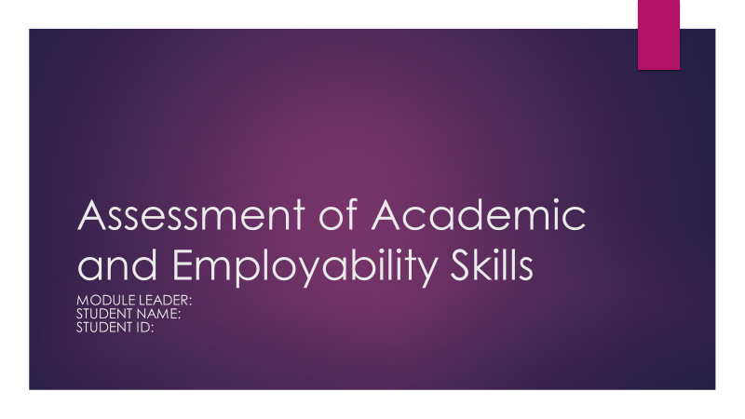

Slide 2

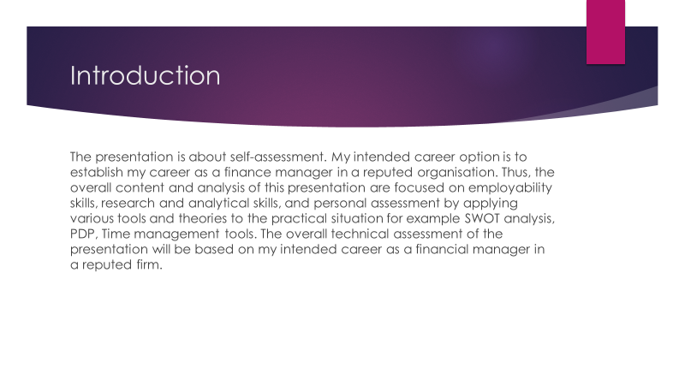

Introduction
The presentation is about self-assessment. My intended career option is to establish my career as a finance manager in a reputed organisation. Thus, the overall content and analysis of this presentation are focused on employability skills, research and analytical skills, and personal assessment by applying various tools and theories to the practical situation for example SWOT analysis, PDP, Time management tools. The overall technical assessment of the presentation will be based on my intended career as a financial manager in a reputed firm.

Slide 3

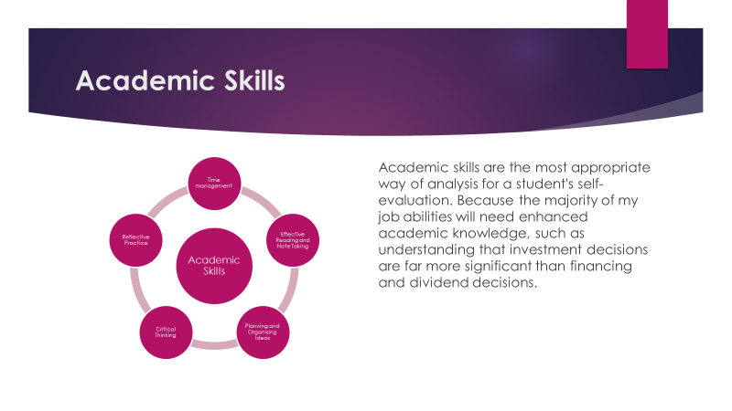

Academic Skills
For self-evaluation, academic skills are the most suitable mode of analysis for a student. Since most of my career skills will demand refined academic knowledge, for example knowing that investment decision is much more important than the financing and dividend decision. Thus developing academic skills is very important for my intended career option. Some specific academic skills are useful in terms of pursuing a career. For example,
Time Management. To be punctual is always a good thing and for academic skills, time management is a very important skill to learn. Time management can be handy in various academic situations. Such as, for this presentation, I had to make sure no other work or task is colliding with the schedule with the presentation and I can make it on time. So, I needed to be ready for this presentation for a certain period prior. These are all examples of how time management is linked with academic skills.
Effective Reading and Note Taking. The second academic skill that is important is effective reading and note-taking. As a student, reading has no alternative. To understand a concept, I have to read and try to understand the concept. Also, for understanding a topic or a concept, note-taking is important. Apart from the class note, taking notes of important parts of a concept is another important academic skill that is much needed.
Planning and Organising Ideas. From my experience, I can say that from time to time, I had many ideas. Some of them were about business, some of them were about just arranging a tour. However, most of the ideas were dropped. The reason was I did not have any defined plan to implement the ideas and definitively organise those tangibly. Thus, planning and organising ideas is another academic skill that helps in the long run.
Critical Thinking. In academic life, critical thinking is an aspect that is one of the most important. In various situations, we tend to ignore either the negative or the positive impact of a particular concept. Most of us believe in a spectrum of good or bad, the grey area is never acknowledged. Critical thinking teaches us to focus on the grey area where both the negative and the positive aspect has an impact which is a very important academic skill.
Reflective Practice. Arguably the most important academic skill is reflective practice. The reason for this is because we tend to do a lot of mistakes in our academic life, it is better to learn from our own mistakes. That way, we can ensure the continuous improvement of ourselves. Reflective practice gives us that scope of learning from our own mistakes. For this reason, reflective practice is another most important academic skill.
This slide summarises the academic skills that we need in our life. However, the self-assessment of these skills is presented in the later slides (Philpot et al., 2018).

Slide 4

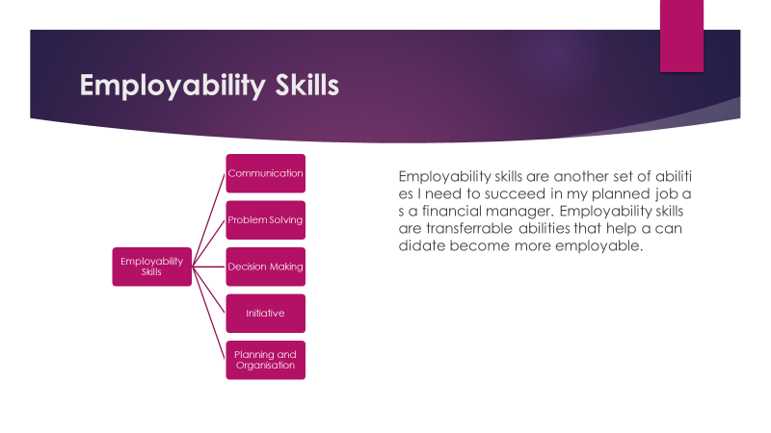

Employability Skills
Another set of skills I need to achieve success in my intended career as a finance manager is employability skills. Employability skills are transferable skills to develop a candidate as an employable person. There are various employability skills. However, for the post of a finance manager, the following employability skills are important:
Communication: As a finance manager, I need to be able to communicate with my teammates, the board, and the investors about the decisions I took. Also, to take decisions in the organisation, I need to communicate with other departments to take an informed decision.
Problem Solving: As a finance manager, the most important part of my job would be solving financial problems and making various financial decisions regarding the stock price, the budget, etc. So, I need to have a problem-solving ability.
Decision Making: Every manager needs to have a decision making skill since most of the job of a manager is to take decisions in their whole life.
Initiative: Finance managers need to take a lot of initiatives. For example, changing the retention rate in the company for reinvesting in the organisation is a huge initiative from the investors. So, I need to be initiative.
Planning and Organising: A finance manager needs to be able to plan ahead of time for proper decisions. For this reason, a finance manager needs to be organised. Thus, planning and organising is also transferable skill (Hind & Moss, 2019).
Slide 5

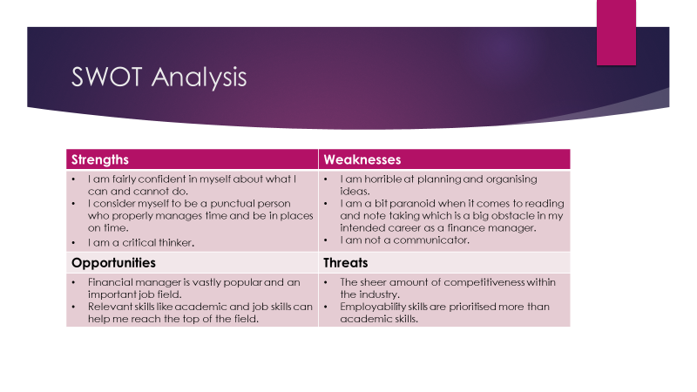

SWOT Analysis
In the previous slide, academic skills were discussed. What skills do we need and what skills helps us the most in our academic journey. This slide will be the first step of the self-assessment. With the help of SWOT analysis, I will be able to identify my strengths, weaknesses, opportunities, and threats.
Starting with the strengths, my most prominent strength is that I am fairly confident in myself about what I can and cannot do. If the goal is achievable, I can easily achieve the goal with a bit of motivation. In terms of time management, I consider myself to be a punctual person who properly manages time and be in places on time. And, I am a critical thinker. I consider myself to be a person who likes to think including the positives and negatives of a perspective so that I can take an informed decision.

However, there are some weaknesses of mine. Starting with the weaknesses, I am horrible at planning and organising ideas. As mentioned earlier, the concept of organising thinking is my biggest weakness of mine. In a lot of cases, I cannot even think straight which brings to my second weakness which is effective reading and note-taking. I am a bit paranoid when it comes to reading and note taking which is a big obstacle in my intended career as a finance manager. Effective reading is that kind of reading which focuses on the important topics and takes notes which summarises the entire concept that is described. But I become paranoid and feel that every line of the book is equally important which makes me a terrible note-taker. My third weakness is that I am not a communicator. In-person person conversation, I cannot keep the conversation alive and fail to communicate with the person properly.

For the opportunities, there is various scope that I can capitalise as the opportunities. Firstly, Financial manager is vastly popular and an important job field. There is no alternative to a finance manager. Also, relevant skills like academic and job skills can help me reach the top of the field. And lastly, various job opportunities can be availed online and various part-time jobs also provide a significant experience for beginners.

Lastly, multiple threats can be proven to be obstacles in my career. The sheer amount of competitiveness within the industry is the first and foremost of all threats. Also, in recent times, employability skills are prioritised more than academic skills which can also be proven to be a threat for freshers (Cohen et al., 2018).

Slide 6

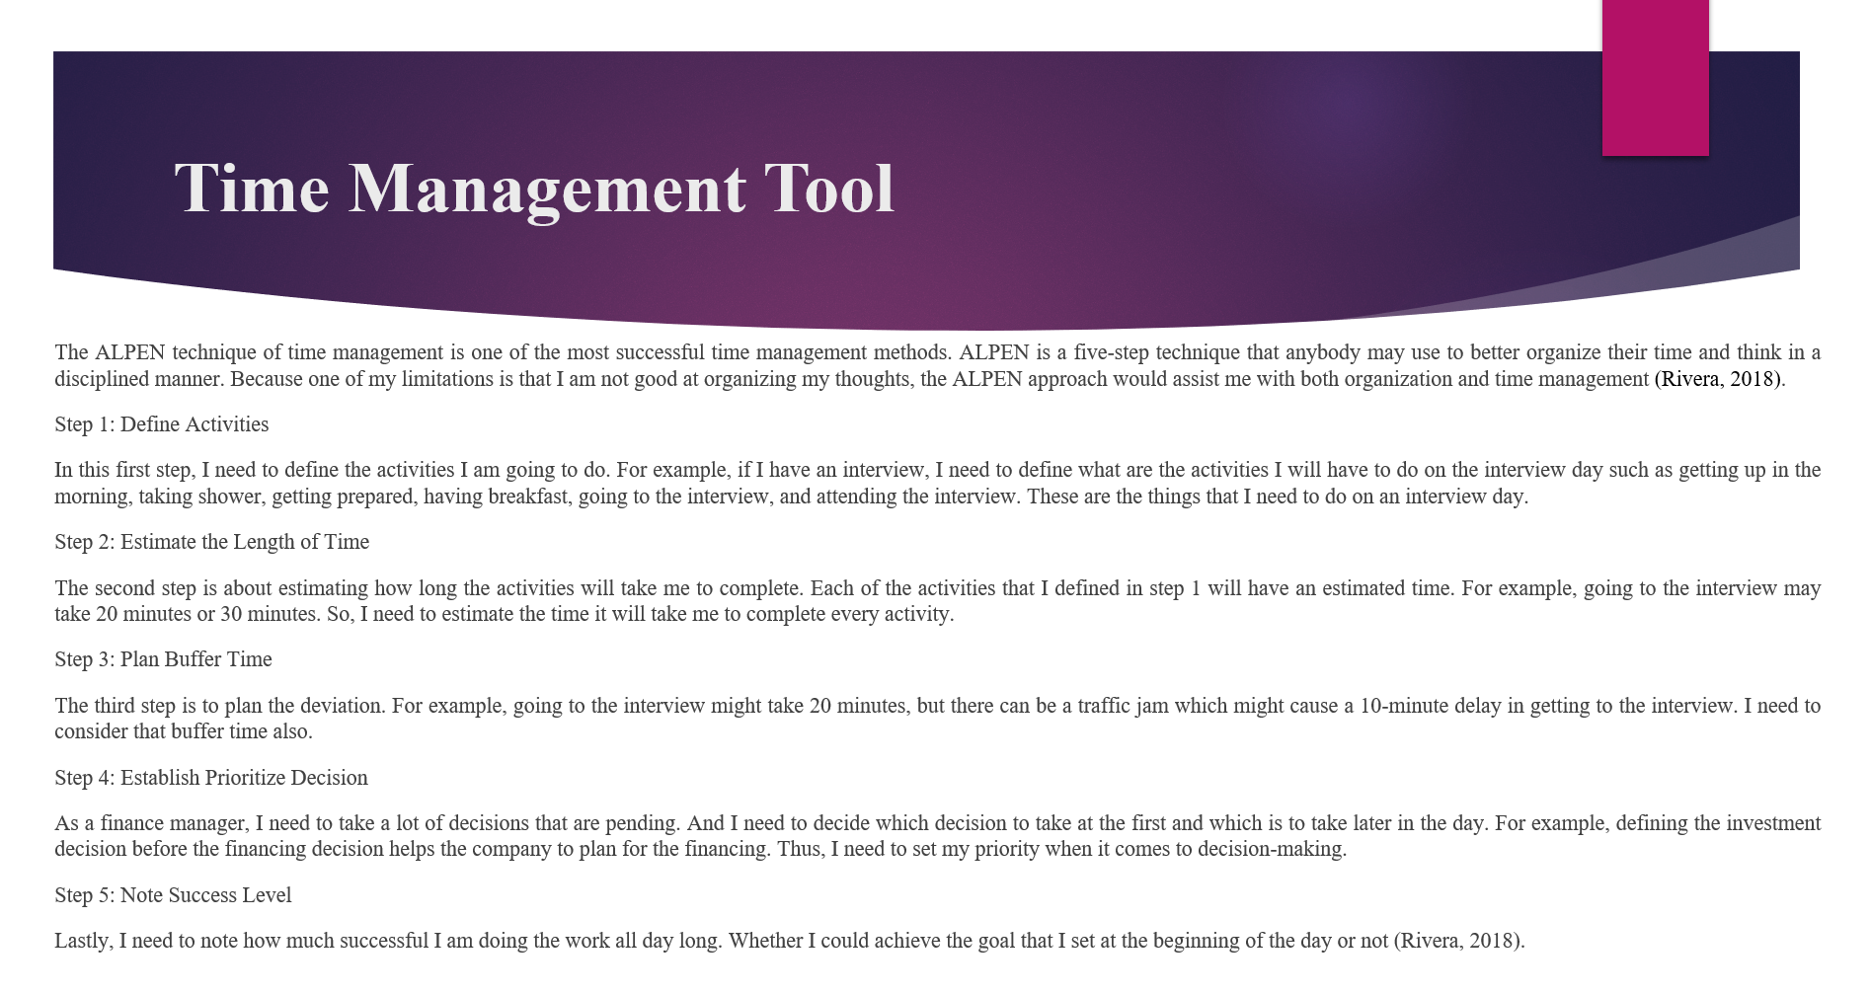

Time Management Tool
Another way to achieve both academic and employability skills is to ensure that I manage my time accordingly to the need of my job and academic studies. For proper time management, there are various ways to do so. There are several time managements tools in practice. One of the most effective tools for time management is the ALPEN method of time management. ALPEN is a 5 step process by which anyone can better organize the time and think in a structured way. Since one of my weaknesses was that I am not good at organised thinking, the ALPEN method would help me both in organised thinking and time management. There are 5 steps in the ALPEN method.
Step 1: Define Activities
In this first step, I need to define the activities I am going to do. For example, if I have an interview, I need to define what are the activities I will have to do on the interview day such as getting up in the morning, taking shower, getting prepared, having breakfast, going to the interview, and attending the interview. These are the things that I need to do on an interview day.
Step 2: Estimate the Length of Time
The second step is about estimating how long the activities will take me to complete. Each of the activities that I defined in step 1 will have an estimated time. For example, going to the interview may take 20 minutes or 30 minutes. So, I need to estimate the time it will take me to complete every activity.
Step 3: Plan Buffer Time
The third step is to plan the deviation. For example, going to the interview might take 20 minutes, but there can be a traffic jam which might cause a 10-minute delay in getting to the interview. I need to consider that buffer time also.
Step 4: Establish Prioritize Decision
As a finance manager, I need to take a lot of decisions that are pending. And, I need to decide which decision to take at the first and which is to take later in the day. For example, defining the investment decision before the financing decision helps the company to plan for the financing. Thus, I need to set my priority when it comes to decision-making.
Step 5: Note Success Level
Lastly, I need to note how much successful I am doing the work all day long. Whether I could achieve the goal that I set at the beginning of the day or not (Rivera, 2018).

Slide 7

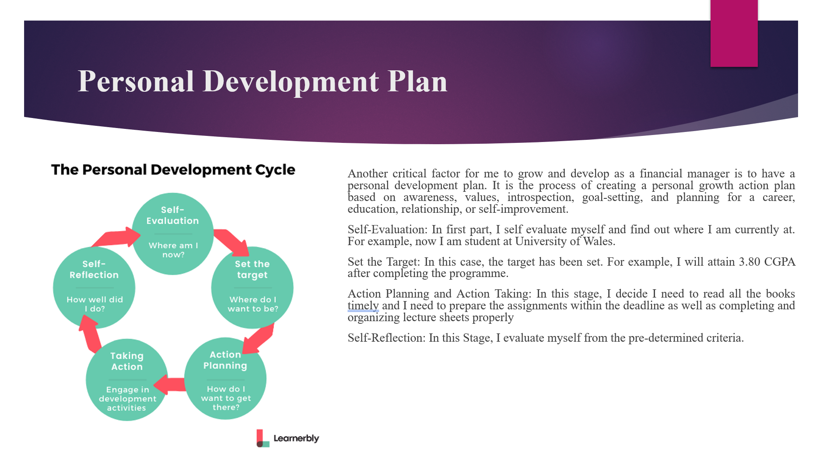

Personal Development Plan
Another important aspect for me to grow and develop myself as a finance manager is to ensure the personal development plan. It is the process of developing an action plan for personal growth based on awareness, values, introspection, goal-setting, and planning for a profession, education, relationship, or self-improvement. The following steps are important in the PDP.
Identify Objectives: First, for personal development, I need to identify what I am trying to achieve. For example, I am trying to be a successful finance manager. Thus, my objective is to learn and apply theoretical and practical knowledge regarding finance in real-world situations.
Planning, Preparation, Participation: The second step is to plan and prepare for the objective. For example, I need to prioritise my decisions and source available resources on being a finance manager, making decisions, and participating in engaging activities associated with management finance.
Monitoring, Assessment, Achieving: In this step, I need to monitor my progress. For example, as a finance manager, I need to monitor my decisions and assess my achievement within an organisation. Such as, I need to monitor my achievement of preparing a budget in an organisation and monitor for any control action.
Record, Review, Reflection: I need to reflect on my recorded activities. For example, after preparing a static budget, I need to prepare a flexible budget based on the actual result and find out where I was wrong and I need to fix my actions to be a better finance manager. And this cycle continues (Rouse, 2017).

Slide 8

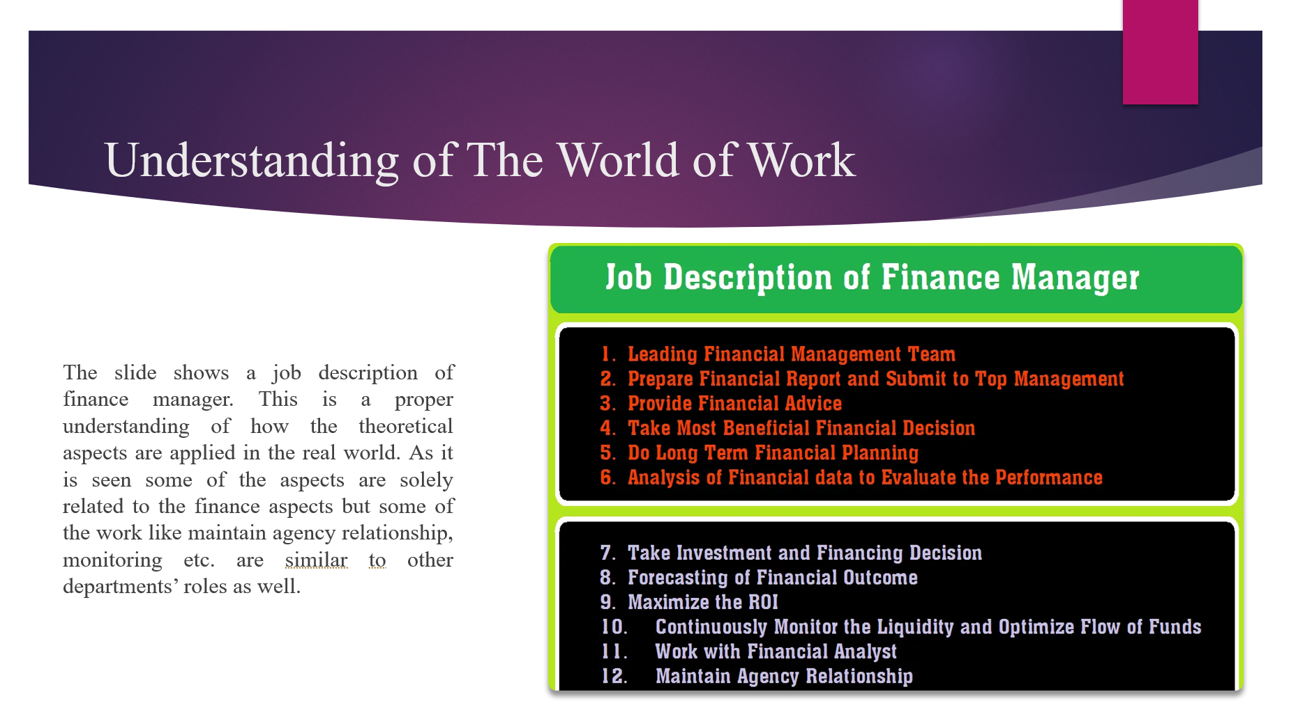

The slide shows a job description of finance manager. This is a proper understanding of how the theoretical aspects are applied in the real world.

Slide 9

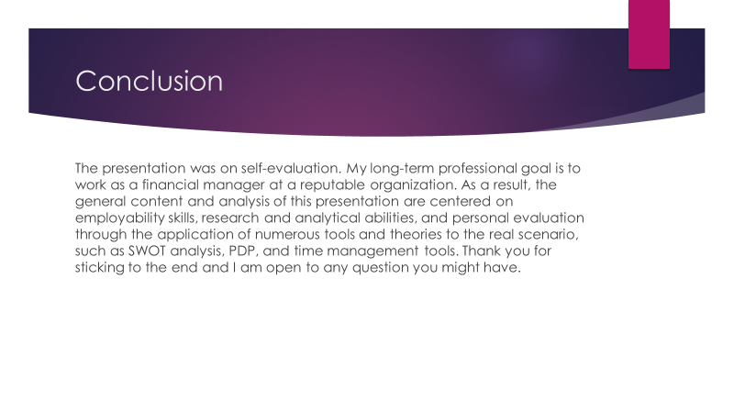

The presentation was on self-evaluation. My long-term professional goal is to work as a financial manager at a reputable organization. As a result, the general content and analysis of this presentation are centered on employability skills, research and analytical abilities, and personal evaluation through the application of numerous tools and theories to the real scenario, such as SWOT analysis, PDP, and time management tools. Thank you for sticking to the end and I am open to any question you might have.

Slide 10

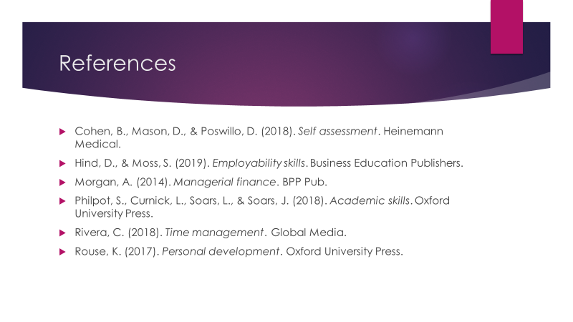

Cohen, B., Mason, D., & Poswillo, D. (2018). Self assessment. Heinemann Medical.
Hind, D., & Moss, S. (2019). Employability skills. Business Education Publishers.
Morgan, A. (2014). Managerial finance. BPP Pub.
Philpot, S., Curnick, L., Soars, L., & Soars, J. (2018). Academic skills. Oxford University Press.
Rivera, C. (2018). Time management. Global Media.
Rouse, K. (2017). Personal development. Oxford University Press.

