Application Development – ACCA5012
Kemi Ademoye
Richard Davies 1701574 – Software Engineering

0 - Contents
1 – Introduction 2
2 – Application Development Concepts 3
2.1 – Introduction 3
2.2– Application Security Vulnerabilities 3
2.2.1 – Input Validation 3
2.2.2 – Logging Mechanism 3
2.2.3 – Fail-open Error Handling 3
2.2 – Software Design Patterns 4
2.2.1 – Singleton 4
2.2.2 – Factory Method 4
2.2.3 – Strategy 5
2.2.4 – Observer 5
3 – Requirements 6
4 – Design Principles 7
5 – Implementation 7
5.1 – View 7
5.2 – Controllers 7
5.3 – Screenshots 8
6 – Evaluation 13
7 - References 14

1 – Introduction

The purpose of this report is to show a researched discussion around security vulnerabilities and software design patterns. The design patterns investigated during the research will be used to design and build a suitable website. The report will then show the website implementation using screenshots.
An evaluation of the application will appear at the end and will discuss various ways about improving various aspects of the application for the future.
The brief was split into three separate tasks, but will all be presented in a single report format.

2 – Application Development Concepts

2.1 – Introduction
The first section of this report will be a discussion about application security vulnerabilities and the benefits and drawbacks of software design patterns.

2.2– Application Security Vulnerabilities

A vulnerability can be defined as
‘…a hole or a weakness in the application, which can be a design flaw or an implementation bug, that allows an attacker to cause harm’ [1]
The following are examples of vulnerabilities [1] –
- Lack of input validation.
- Lack of sufficient logging mechanism.
- Fail-open error handling.

2.2.1 – Input Validation
This type of vulnerability could allow unauthorised access to the site, which in turn has the potential risk to have all the data I the databases being stolen and even deleted.
Example include –
- Cross-site scripting
- Buffer overflow
- SQL injection

This type of vulnerability is pertinent to the web application made for this assignment and could potentially delete all the tables in the database.

2.2.2 – Logging Mechanism
The log is basically a written list of what has happened on the application and without adequate management of these logs it would be impossible to know how the application is running or what users are doing.
This is a vulnerability because without knowing where and attack came from or what it did it would be almost impossible to either repair the damage or stop the attack from happening in the future.

2.2.3 – Fail-open Error Handling
This is simply the term given to how an authorization system works. It should be closed to everyone, open with access and not open to everyone, closed without access.
These differ by having the default access to granted which can allow attackers to access the application with authorisation and could have potentially the same implications as lack of input validation

2.2 – Software Design Patterns
Software design patterns are used to show the best practices of experienced software developers and describes the problem, solution and consequences [2]. According to educative the 4 top design patterns are [3] –
- Singleton
- Factory Method
- Strategy
- Observer

2.2.1 – Singleton
This pattern limits creation of a class to only a single object, hence its name, and each instance of an object is shared between each user [3] [4].
The advantages are –
- Flexibility regarding the object instances
- Easy to implement regarding application creation

The disadvantages are –
- Overuse can lead to hard to maintain code that doesn’t have clear object separation
- The state of the object is shared across the whole application and any change in that state can cause bugs

2.2.2 – Factory Method
This pattern still uses objects but upon creation instead of using a constructor it uses a factory method which allows the object to not be tied to the standard class creation [3].
Some advantages are –
- It allows for testing an application without the full implementation of a class [5]
- The design of the application can be easily modified [5]

A disadvantage is –
- The code can be more difficult to read as each instance of an object may use different parts of a class [5]

2.2.3 – Strategy
This pattern groups similar algorithms under a single abstraction so instead of running a single algorithm, the code will receive an instruction which specify which algorithm group to use. [3]
Some advantages are –
- Vary simple to extend the application [6]
- Conditional statements are prevented [6]

A disadvantage would be –
- The number of objects in the application Is increased which can have a detrimental effect on the performance [6]

2.2.4 – Observer
This is simply a one-to-many pattern in terms of objects, when an object(subject) changes state it changes in each one of its dependents (observer) [3]
An advantage of this is –
- Data can be sent to other objects without changes in either the subject or observer [7]

But a disadvantage is –
- The observer must be in its own class which if not implemented correctly can lead to performance issues [7]

3 – Requirements

This site will show the model trains available for purchase on the Hornby website [8] which are -
- The Highland Rambler Train Set
- Mallard Pullman Train Set
- Hornby West Coast Highlander Train Set
- The Coca-Cola Christmas Train Set
- Hogwarts Express Train Set
- East Coast Express Train Set
- The Flying Scotsman Train Set
- Eurostar Train Set
- Industrial Freight Train Set
- Santa’s Express Train Set
- GWR High Speed Train Set

Clicking on the models will show some information about each model. The target for this site is anyone who collects Hornby model trains in OO (1-76 inch) scale.

The software that was used for the development of the site are –
- Microsoft Visual Studio 2017
- Top three browsers [9].
  - Google Chrome
  - Mozilla Firefox
  - Microsoft Edge
  - Mozilla Firefox Developer Edition

While it would be more effective to test the site on various browsers and differing screen sizes, time limitations meant that this was difficult to accomplish.

4 – Design Principles
Some of the main design principles that were followed while designing and building the site are [10] -
- Use White Space
- Use images (wisely)
- Keep pages consistent
The design principles were discussed in assignment 1 so this is only a brief list and not an explanation.

5 – Implementation
For this section the implemented views and controllers will be listed along with annotated screenshots of the application

5.1 – View
The following Is a list of the views that were implemented by the author –
- ModelStocks
- ModelTrains
- ShoppingBasket

There area also the Home and Shared views but they were generated and not implemented

5.2 – Controllers
The following is a list of controllers that the author implemented –
- ModelStocksController
- ModelTrainsController
- ShoppingBasketController

The other controller is the HomeController, but it was auto generated and not implemented

5.3 – Screenshots
this section holds annotated screenshots of the main pages of the application. It will only show the pages created by the author and not the auto generated pages. The main index will not be shown because it was not created by the author.
Model Trains Page
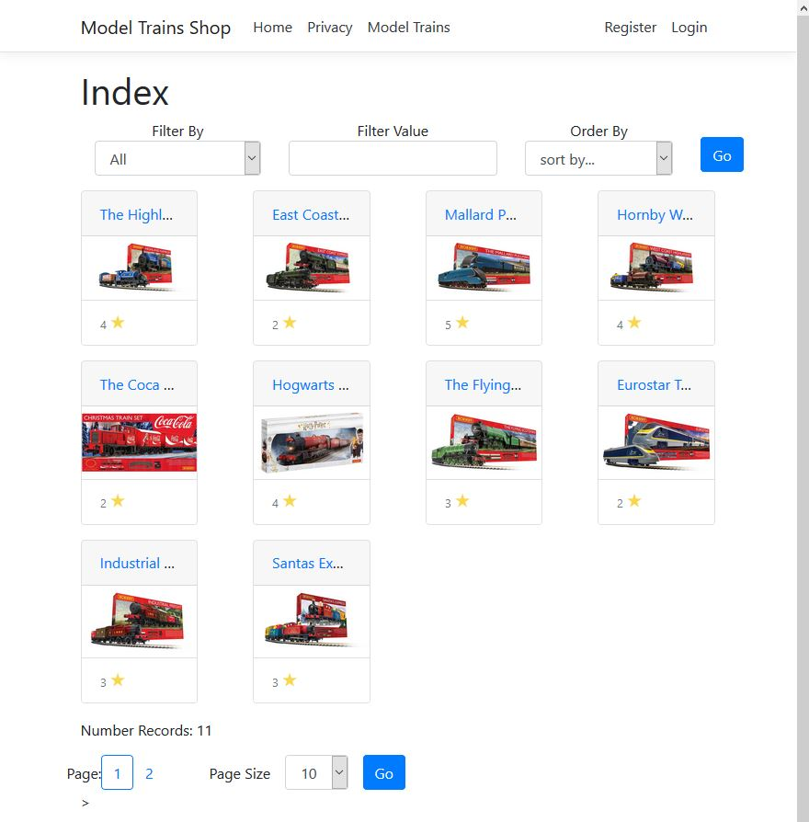
This page shows the model train models available, due to the number of models it is over two pages as shown at the bottom.

Model details page
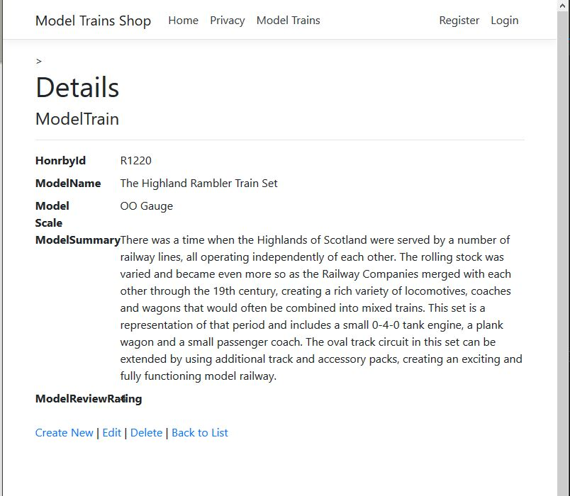
Each model has its own details page that shows when the user clicks on the model they would like to know about.

User log in screen.
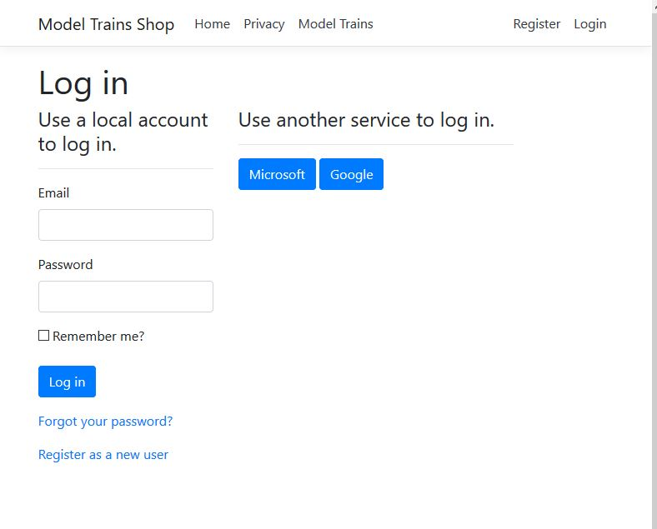
Clicking on any of the options at the bottom (Create, Edit and Delete) will ask the user to log in if not already logged in. the application supports both Microsoft and Google authentication.

Edit details page.
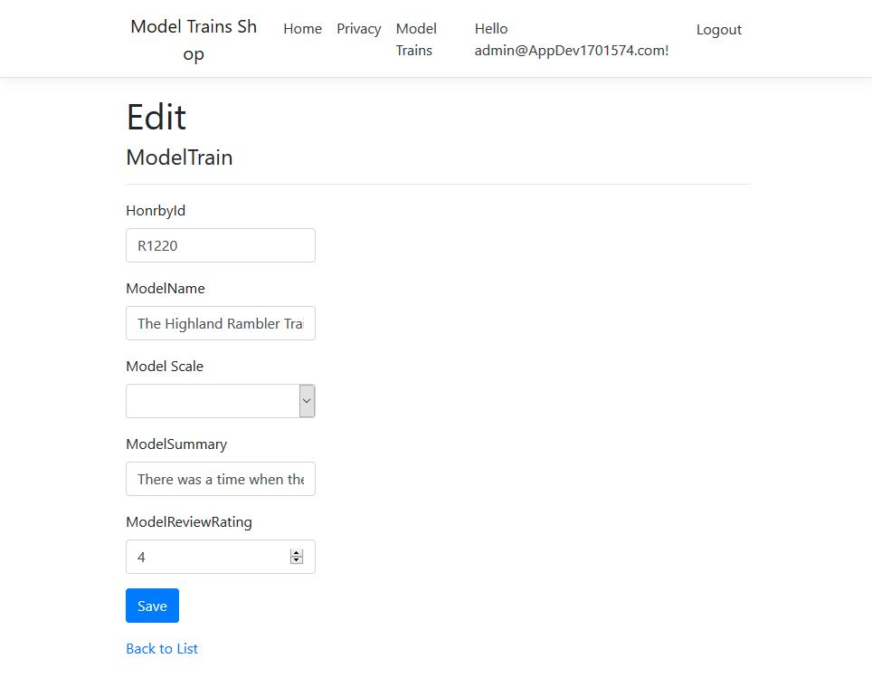
When logged in as admin you will be allowed to edit, create and delete the models. Only registered admins can do this.

The model page – filtered
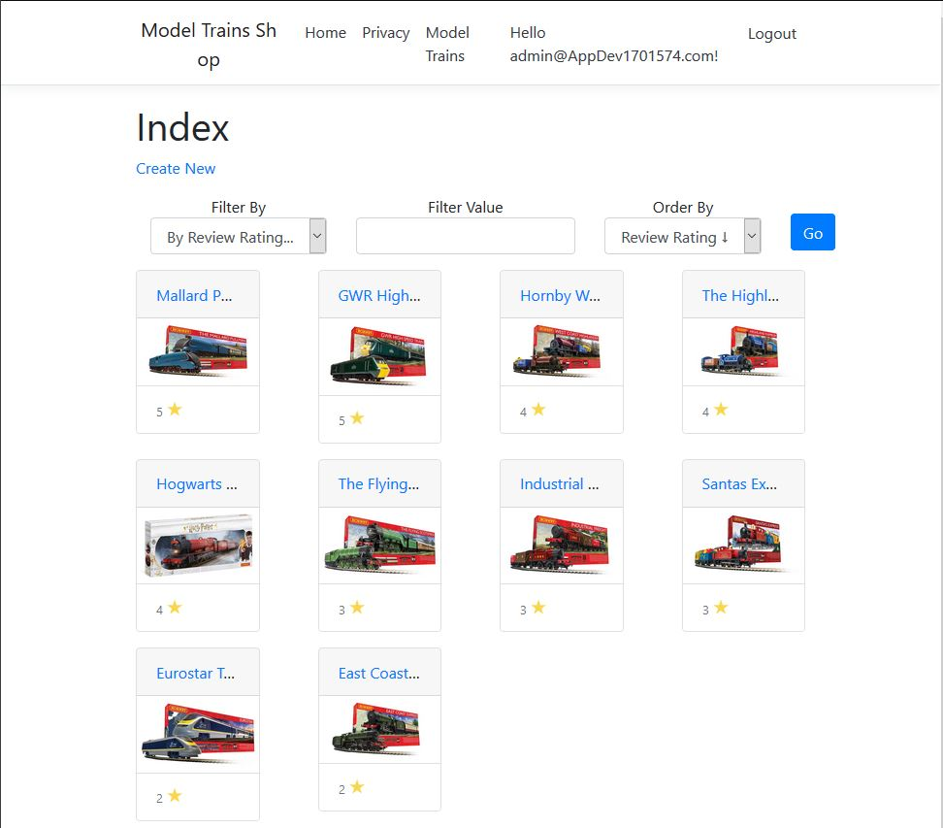
On this model trains page, the view has been filtered to show the highest reviews first and the lowest at the bottom.

6 – Evaluation
Design principles were mentioned in section 4 after being discussed in the first assignment it is believed that the following principles were followed –
- Sensible use of white space – this pushes the user to the specific areas of the site that require user input or interaction
- Sensible use of images – the only images used are that of the actual models used which is like the actual Hornby site [8]
- Page consistency – all the pages follow the sane pattern and look similar with the menu at the top and the information in the centre.

The usability of the site is also consistent and follows the information gathered in the first assignment which include –
- Menu consistently at the top
- Scroll bar stays on the right of the window

Once again, the user experience is affected by not everyone collects model trains in the OO scale.
A very simple way to improve this site for the future would be to add more models to view and buy but all models where taken from the Hornby site and the authors application shows the same number of models available, it would be an improvement to add different scales of models which would add to the overall number of models available. The functionality of the site is mostly generated and would be difficult to change to modify any of the main functionality.
Overall, it proved challenging to implement the application in the required language and having now completed the application and the assignment the author feels that if they were to make this application again that it would be simpler to do thanks to the knowledge gained while implementing the application.

7 - References

[1] | “Category:Vulnerability,” OWASP, 6 June 2016. [Online]. Available: https://www.owasp.org/index.php/Category:Vulnerability. [Accessed 5 May 2019].
[2] | “Software Design Patterns,” GeeksforGeeks, [Online]. Available: https://www.geeksforgeeks.org/software-design-patterns/. [Accessed 06 May 2019].
[3] | “Educative - The 7 Most Important Software Design Patterns,” Medium, 8 November 2018. [Online]. Available: https://medium.com/educative/the-7-most-important-software-design-patterns-d60e546afb0e. [Accessed 06 May 2019].
[4] | K. Chanproseth, “Pros and Cons of Singleton.,” Mad Insights, [Online]. Available: https://why.workwithmad.com/pros-and-cons-of-singleton/. [Accessed 06 May 2019].
[5] | P. Smith-Kline, “What are the pros and cons of the factory design pattern?,” Quora, 6 October 2013. [Online]. Available: https://www.quora.com/What-are-the-pros-and-cons-of-the-factory-design-pattern. [Accessed 6 May 2019].
[6] | miafish, “Strategy pattern pros and cons,” miafish , 16 Janurary 2015. [Online]. Available: https://miafish.wordpress.com/2015/01/16/strategy-pattern-pros-and-cons/. [Accessed 05 May 2019].
[7] | “The Observer pattern – advantages and disadvantages,” Packt, [Online]. Available: https://subscription.packtpub.com/book/application_development/9781785888038/6/ch06lvl1sec50/the-observer-pattern-advantages-and-disadvantages. [Accessed 7 May 2019].
[8] | “Train Sets,” Hornby, 2019. [Online]. Available: https://www.hornby.com/uk-en/shop/all-sets.html. [Accessed 05 May 2019].
[9] | J. Martin, “The best web browsers for 2018,” Tech Advisor, 04 December 2018. [Online]. Available: https://www.techadvisor.co.uk/test-centre/software/best-web-browsers-3635255/. [Accessed 07 December 2018].
[10] | D. Jiminez, “10 Tips That Can Drastically Improve Your Website's User Experience,” HubSpot, [Online]. Available: https://blog.hubspot.com/marketing/improve-your-websites-user-experience. [Accessed 08 December 2018].

