

Digital Forensics Analysis

Programme Name: MSc Cybersecurity & Digital Forensics
Module Name : Digital Forensics Analysis
Module code: ACCA7031
Lecturer: Dr. Mohamed Ghanem
Student Name: Ishika Pravinbhai Shiyani
Student ID: 2434330

TASK-1 Table of Contents
1. Current State of the Field 3
2. Digital Forensics and Cybersecurity Intersection 3
3. New Digital Forensic Trends 4
3.1 Artificial Intelligence and Machine Learning 4
3.2 Cloud Forensics 4
3.3 Deepfake Detection 5
3.4 IoT and Mobile Forensic 5
3.5 Quantum Computing 5
4. Key Challenges 5
5. Job Market National and International 6
5.1 UK Market 6
5.2 International Market 6
References 7

TASK -2 Table of Contents
1. Case Background 4
1.1 Incident Overview 4
1.2 Scope & Objectives 4
1.3 Legal and Ethical Framework 4
2. Chain of Custody and Evidence Inventory 4
2.1 Device Inventory 4
2.2 Chain of Custody 5
2.3 Hash Verification Log 5
3. Methodology 6
3.1 Forensic Acquisition Process 6
3.2 Tools and Software Used 6
3.3 Analysis Workflow 7
3.4 Ethical Concerns and Limitations 7
4. Findings 8
4.1 Device 1: Huawei POT-LX1 P Smart 8
4.1.1 User Identification 8
4.1.2 Communication Analysis 8
4.1.3 Suspicious Activity and Behavioural Indicators 8
4.2 Device 2: Samsung GSM SM-A137F Galaxy A13 9
4.2.1 User Identification 9
4.2.2 Travel Logs and Geographic Footage. 9
4.2.3 Financial Evidence and Anonymous Payment Methods 10
4.3 Device 3: Ulefone Note 14 10
4.3.1 User Identification 10
4.3.2 Analysis of Payment Instruments 10
4.4 Device 4: Nokia C2 2nd Edition 11
4.4.1 Encrypted File Analysis 11
4.4.2 Unidentified Male Photograph 11
4.5 Cross-Device Timeline Reconstruction 12
4.6 Suspect Profiling Summary 13
5. Forensic Collection Information 15
6. Conclusion 18
6.1 Summary of Evidence 18
6.2 Supporting Evidence of Legal Action 18
7. Recommendations 19
7.1 Immediate Forensic Actions 19
7.2 Legal and Law Enforcement Action 19
7.3 Organisational Remediation at Quantum Tech. 20
References 21

1. Current State of the Field
Digital forensics has become an increasingly multi-disciplinary, technically intensive career in the center of contemporary criminal justice and corporate security. This maturity is evidenced by the global market, which is estimated to be USD 13.46 billion in 2025 with an estimated total of USD 53.65 billion in 2035, with a CAGR of 14.83% due to the increasing cybercrime, data privacy regulation, and digital transformation in the respective sectors [1].
Table 1: Core Tools in Active Use (2025–2026)
Tool | Type | Key Features
Autopsy | Open-source | File carving, keyword search, timeline analysis, hash verification
FTK (Forensic Toolkit) | Commercial | Rapid data processing, multi-format support, collaborative functionality
Cellebrite UFED | Commercial | Mobile extraction, cloud data, deleted data recovery
EnCase | Commercial | Disk imaging, email analysis, legal reporting
Wireshark | Open-source | Live network packet capture and protocol analysis
Belkasoft X | Commercial | AI-based media detection, YARA/Sigma rule searching, automated evidence processing

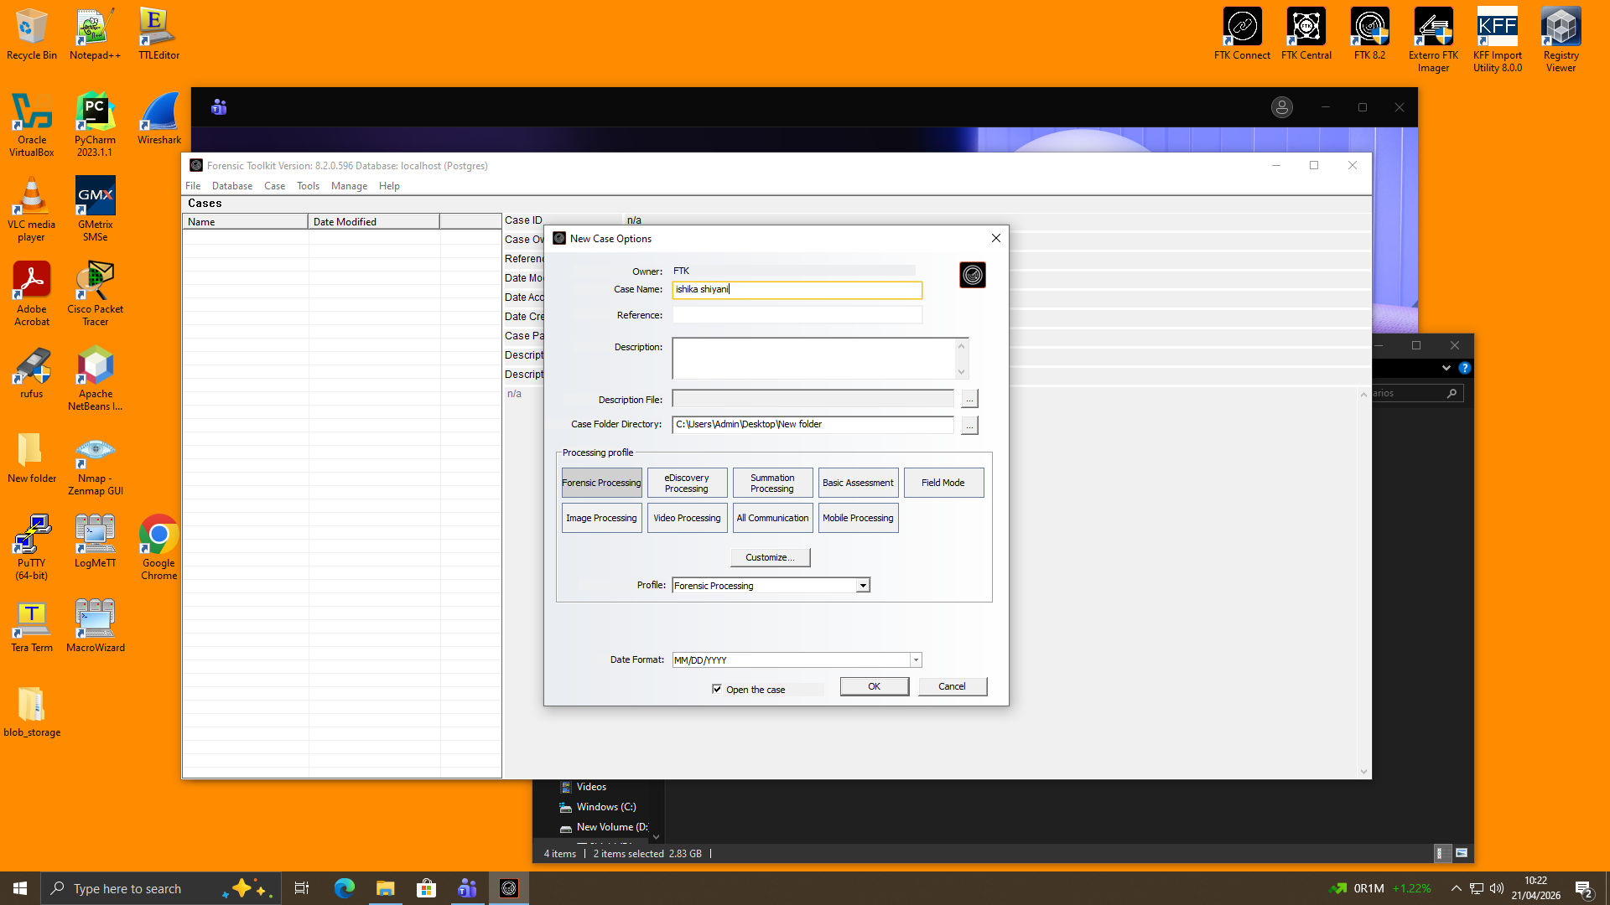
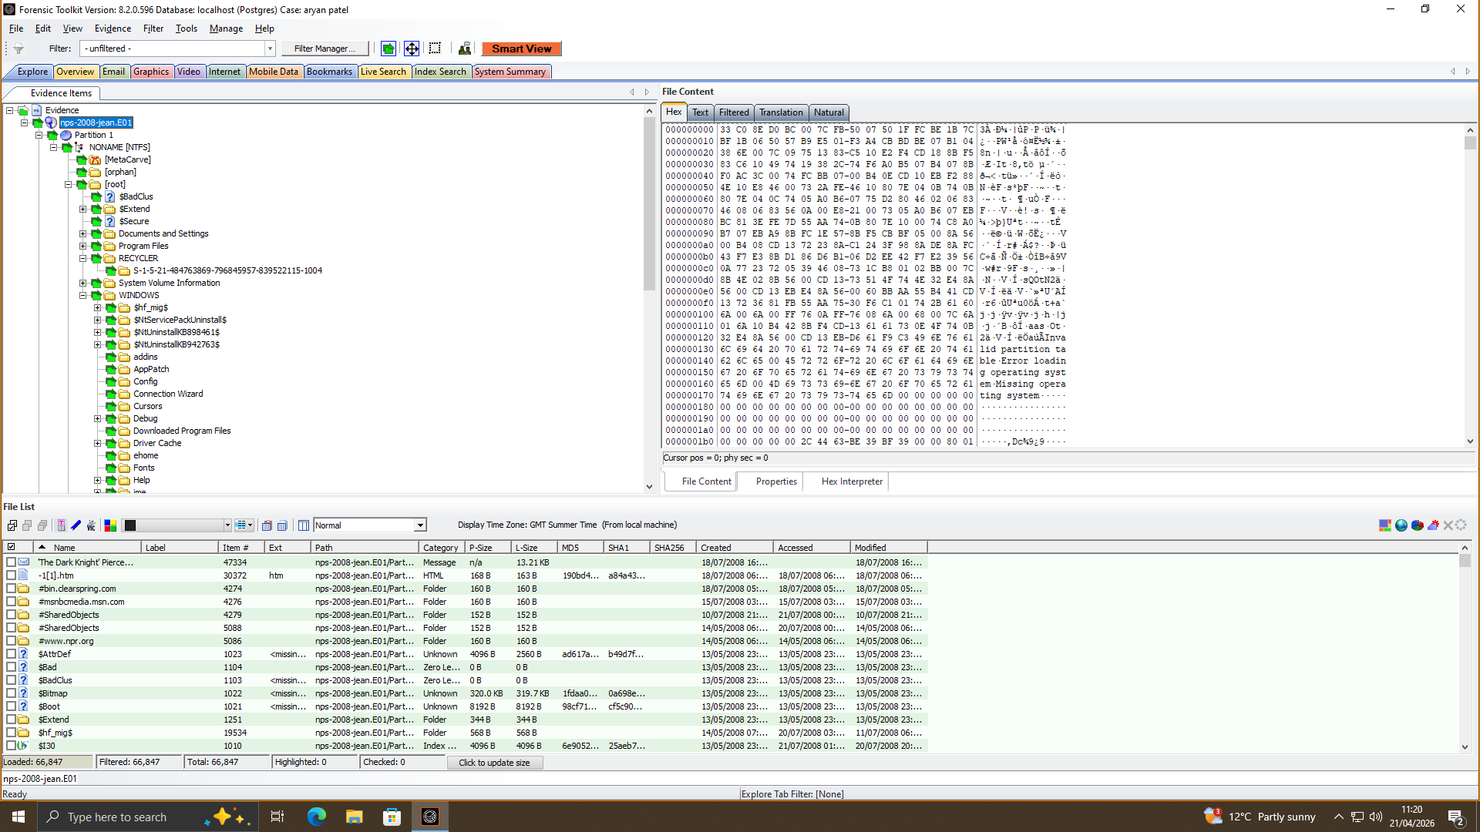
AI categorisation, automated evidence handling and hash verification are used by modern tools to minimize manual labour and provide court-admissible integrity [2].

2. Digital Forensics and Cybersecurity Intersection
The convergence of digital forensics and cybersecurity as distinct fields of practice has become an integrated practice under the name DFIR (Digital Forensics and Incident Response). Since cyber threats become more advanced, ransomware, insiders, data breach, this all means that organisations are integrating forensic teams into incident response units to trace breaches in real time [3], [4].
Significant Areas of Intersection:
- SIEM Integration: Forensic specialists now have the ability to integrate with Security Information and Event Management (SIEM) tools which allow them to analyse real-time network traffic to determine any malicious activity before complete compromise has taken place [4].
- Threat Intelligence Feedback Loop: Feedback between future cybersecurity defences is direct as the result of investigative post-incident analysis into what occurred before, and therefore constitutes a closed-loop security model [5].
- Hybrid Roles: Professionals specializing in forensic investigation and proactive cyber defence (i.e. evidence acquisition and vulnerability analysis) are being manufactured in the field [4].
- Forensic Readiness: Organisations are now establishing forensic procedures prior to the event or incident, eliminating loss of evidence and time of investigation.
This convergence in the labour market is confirmed by the UK government and the DSIT Cyber Security Skills Report 2025, which indicates that thirty percent of businesses identified specific skills shortages in forensic analysis, penetration testing and decoding malicious code the skills that were at the intersection of the two.

3. New Digital Forensic Trends
A number of disruptive trends will transform the way investigations are carried out in the year 2025 and beyond [6]:

3.1 Artificial Intelligence and Machine Learning
Forensic analysis has become dominated by AI. Anomalies are now computerized to be flagged, legal pictures can be detected, hidden patterns in large data sets can be identified as well as predictive threat estimations- all previously took weeks to be manually reviewed. Indicatively, Belkasoft X applies AI in face detection, explicit content identification, and scale-agnostic YARA-rule matching.

3.2 Cloud Forensics
According to ICD, more than 60% of data created will be in the cloud by 2025. Forensic instruments now have to recover evidence in multi-cloud settings, which entails cross-jurisdictional legal frameworks and cross-cloud methods of procurement. Both standardisation of cloud forensic tools and international legal cooperation frameworks are hastening along.

3.3 Deepfake Detection
The AI-generated media has become a real threat in terms of evidence. To prove authenticity of video and audio evidence, investigators now have to check through the multi-layer manipulation methods of verification that are rapidly becoming a common feature in the forensic tool kit.

3.4 IoT and Mobile Forensic
The primary sources of evidence in the contemporary investigation are smartphones and IoT devices (wearables, smart home systems, industrial sensors). Their operating systems are however different, with limited local storage, and high data decay, which require quicker, gadget-specific purchase processes [7].

3.5 Quantum Computing
Quantum computing is already starting to find its way into evidence recovery (complex encryption breakage), and evidence protection (quantum-resistant cryptography) - two opposite sides, which the forensic professionals will now need to be aware of [6].

4. Key Challenges
There are several challenging and growing threats to digital forensics in 2025:
- Encryption & Anti-Forensics: End-to-end apps (e.g., WhatsApp, Signal), full-disk encryption would ensure almost that their evidence cannot be gathered without keys. The compromise between the privacy and the legitimate access has not been reached.
- Volume Data & Variety: Data has evidence in the smartphone, cloud, social media, blockchain, and IoT. Such a variety of data cannot be processed fast enough.
- Cross-Border Jurisdiction: Data may be stored overseas, and slow procedures such as MLATs can result in evidence loss.
- Deepfakes & Authenticity: Artificial intelligence finds its way in the court, and the authenticity of digital evidence becomes questionable with each new information generated by AI.
- Governance & Accreditation: Standards (e.g., ISO/IEC 27037) and chain of custody problems introduce differences across laboratories and jurisdictions.
- AI Skills Shortage: Demand of AI skills is increasing in contrast with large workforce gaps in existence.

5. Job Market National and International

5.1 UK Market
The UK government estimates the cyber security skills workforce within the UK to be around 143,000 (an increase of 5% each year) as highlighted in its UK government report on DSIT Cyber Security Skills Report 2025. The labour market has also achieved equilibrium with the workforce standing at 3,800 professionals, but the entry-level positions were affected, with 63 percent of the job advertisements demanding 2-6 years of mid-level experience.
In the case of digital forensics particularly [8]:
- Average UK wage: £60,000 (6 months to March 2026)
- Median salary in London: £67,500.
- UK outside London: £50,000.
- The supply of specialists in digital forensics (the lowest of all 15 Cyber Career Framework specialisms) is currently only 8% of UK cyber businesses, which suggests a supply gap.

Although the cyber job postings slowed down in a more general market (down 33% in 2023), the DSIT report reported that the digital forensics and cryptography were under the most frequently mentioned gaps of advanced skills.

5.2 International Market
The market in digital forensics will increase to USD 53.65B (2035) by increasing USD 13.46B (2025), and is in demand in controlled industries. Some of the major ones are DFIR analysts and forensic experts particularly within the US, the UK, the EU, and in Australia and the Gulf regions [9].

References
[1] Precedence Research, “Digital Forensics Market Size to Hit USD 47.9 Billion by 2034,” Precedenceresearch.com. [Online]. Available: https://www.precedenceresearch.com/digital-forensics-market
[2] Pritesh K, “Top 10 Digital Forensics Tools in 2025: Features, Pros, Cons & Comparison - Cotocus Blog,” Cotocus Blog. [Online]. Available: https://www.cotocus.com/blog/top-10-digital-forensics-tools-in-2025-features-pros-cons-comparison/
[3] Belkasoft, “Top 6 Trends in Digital Forensics and Incident Response for 2025,” Belkasoft.com. [Online]. Available: https://belkasoft.com/dfir-trends-2025
[4] Oxygen Forensics, “CEO Lee Reiber: The Digital Forensics Landscape in 2025 - What Lies Ahead?,” Oxygen Forensics. [Online]. Available: https://www.oxygenforensics.com/news/digital-forensics-trends-2025/
[5] ArcPoint Forensics, “Key Trends in Digital Forensics for 2025,” ArcPoint Forensics. [Online]. Available: https://www.arcpointforensics.com/news-1/2025-digital-forensic-trends
[6] Computerforensicslab, “Digital Forensic Trends 2025: AI, Cloud, and Risk,” Computer Forensics Lab | Digital Forensics Services. [Online]. Available: https://computerforensicslab.co.uk/digital-forensic-trends-2025/
[7] AGT Marketing, “7 Challenges Facing Digital Forensics Teams in 2025,” AGT - Advanced German Technology. [Online]. Available: https://agt-technology.com/7-challenges-facing-digital-forensics-teams-in-2025/
[8] It Jobs Watch, “Digital Forensics Job Trends, Salaries & Related Skills,” IT Jobs Watch. [Online]. Available: https://www.itjobswatch.co.uk/jobs/uk/digital%20forensics.do
[9] Grand View Research, “Digital Forensics Market Size & Outlook, 2030,” Grandviewresearch.com. [Online]. Available: https://www.grandviewresearch.com/horizon/outlook/digital-forensics-market-size/global

Task 2: Digital Forensics Report

1. Case Background

1.1 Incident Overview
The IT security division of Quantum Tech identified an intrusion into the proprietary AI chip design patent (ID: QT-AI-2025) of the company. Emma, a new senior engineer who is claimed to have stolen the patent and sold it to one of their rivals NexGen Circuits, is the main suspect. Joe was the operation intermediary with Norman being the potential buyer. Quantum Tech has officially filed a case about the incident with the police; the results of the investigation are expected to aid the court in their legal case [1].

1.2 Scope & Objectives
The purpose of this investigation will be to:
- Trace the owners of the four mobile devices that were captured.
- Determine the relationships and roles between Emma, Joe, and Norman.
- Rebuild chronological list of communications and activities.
- Identify and verify files about patents in every device.
- Deliver legally admissible results of corporate espionage and IP theft charges.

1.3 Legal and Ethical Framework
All the devices have been taken under the correct continuity-of-evidence procedures, according to the UK Computer Misuse Act 1990, PACE Act 1984, and ISO/IEC 27037 (digital evidence handling). Each and every forensic process is followed in accordance with industry best practices in order to guarantee full admissibility of the evidence. Sensitive or encrypted information was recorded and its identity was marked without redundant accessibility or sharing.

2. Chain of Custody and Evidence Inventory

2.1 Device Inventory
Quantum Tech was the provider of access credentials to all devices received unlocked. All the devices were marked, packaged, and identified with a specific piece of evidence reference number at the seizure point, but were then transferred to the forensic lab [2].
Ref | Device | Attributed Suspect | Extraction Type | Acquisition Tool
EV-001a | Huawei POT-LX1 P Smart | Emma (Perpetrator) | Android Backup (APK Downgrade) | Cellebrite UFED
EV-001b | Huawei POT-LX1 P Smart | Emma (Perpetrator) | Kirin Live | Cellebrite UFED
EV-002 | Ulefone Note 14 | Norman (Buyer) | Android Backup | Cellebrite UFED
EV-003 | Nokia C2 2nd Edition | Unknown Co-conspirator | Android Backup | Cellebrite UFED
EV-004 | Samsung GSM SM-A137F Galaxy A13 | Joe (Intermediary) | Android Backup | Cellebrite UFED

2.2 Chain of Custody
Chain of custody is the written and uninterrupted history of possession of evidence since it was seized until it was brought before the court - its integrity is what makes it admissible in court. All five extractions were obtained on 28 October 2025, and each transfer (seizure - secure storage - forensic workstation) was signed, timestamped, and recorded by the investigator responsible. Prior to connecting any device to forensic hardware, hardware write-blockers were used to block any data change.

2.3 Hash Verification Log
The values of the hash that were created on the moment of the acquisition in both MD5 and SHA-256 algorithms were determined and re-verified before the analysis. Comparing the values before and after the transfer of the data is done to ensure that there was no corruption and tampering.
Ref | MD5 Hash | SHA-256 Hash | Status
EV-001a | 4dbb160d46321c4bdf3b0725a889e39a | d2a9a46fc50ec06c51aabdb1448e5de65e9394729a34fbf0aa8261a5771413de | Verified
EV-001b | eb2b1b83250a9fffd6bbf5a967545f37 | d5193dbf8246c09fdde73be8558343985ab24a2e1c142e4d64e16e2b6507e31f | Verified
EV-002 | 342a0c050d8fdbe53e62aea58f3aadde | 630724e2f8863adb9c4f7df1ab645e56c19a832d546fe7ab55b0cebf8ea7befd | Verified
EV-003 | da4b0f0573050b22c111f763242c5ac8 | a693656c260e339069756be8005346e97033d0ccf2f79add56cd69c9eade13ab | Verified
EV-004 | e5998654f5ed1fce51b99472b028a04c | 0e585c4fe8160254253be515a16ff94b7fdf88b248b67d45cfdef8753a9a3195 | Verified

3. Methodology

3.1 Forensic Acquisition Process
On 28 October 2025, all four devices were forensically acquired with Cellebrite UFED, yielding logical file system extractions. The Huawei POT-LX1 P Smart produced two distinct extractions: an Android Backup (APK Downgrade), and a Kirin Live extraction, which would enable it to extract a more in-depth and complete dataset, unlike what a single extraction would have allowed.
Hardware write-blockers were used before any device was connected to the forensic workstation and as such, it prevented any inadvertent alteration of original data [3]. All the obtained images were saved on encrypted storage media in forensic grade, and acquisition timestamps and file manifests were recorded on each device.
Acquisition physically was impossible on every device by limitations of hardware chipsets, and operating system-level constraints. This is also recorded as one of the investigative limitations as corporeal recoveries would have retrieved some extra deleted artefacts unreachable using logic.

3.2 Tools and Software Used
Tool | Purpose
Cellebrite UFED | Mobile device forensic acquisition
Autopsy (v4.x) | Primary analysis platform: file carving, keyword search, timeline analysis
aLEAPP (Android module) | Android artefact parsing within Autopsy
wa-crypt-tools | WhatsApp database decryption using extracted key file
PhotoRec Carver | Deleted file recovery and data carving
ExifTool | Image metadata and GPS coordinate extraction
Autopsy Geolocation Module | Mapping GPS coordinates from EXIF data
Hashdeep / MD5sum | Hash generation and verification of forensic images
All of the tools are also industry standard, forensically tested, and accepted in UK legal proceedings.

3.3 Analysis Workflow
It was analyzed in a well-organized five-phase procedure:
- Phase 1, Ingestion: Each of the forensic images was added to Autopsy with ingest modules turned on, such as aLEAPP, Email Parser, Keyword Search, and PhotoRec Carver.
- Phase 2, Artefact Extraction: Each device had communication logs (WhatsApp, Instagram DMs, Gmail), call records and data on installed applications extracted.
- Phase 3, Decryption Attempts: The WhatsApp decryption process on the Huawei device, based on the recovered key file, was technically successful and was none the worse, with no recorded substantive conversations showing, suggesting it had been deleted previously [4]a. The Open.Docx on the Nokia was not decrypted in brute-force, which implies that it has a strong non-dictionary password.
- Phase 4, Geolocation and Multimedia Analysis: EXIF metadata was analyzed on all image files, audio and video files were inspected with regard to the relevance to the case.
- Phase 5, Cross-Device Correlation: Timeline tool and Keyword search were then utilized to match up the evidence on all four devices in a single investigative profile.

3.4 Ethical Concerns and Limitations
The analysis was done with a strict focus within the boundaries of the investigation. Personal information that was irrelevant to the case was indicated but was not explored. Encrypted texts were recorded and sent to a specialist cryptanalysis instead of being ignored without the necessary permission.
There are two important limitations that are mentioned. To start with, logical-only extractions might have forgotten about data that was deleted and the physical acquisition might have salvaged it, resulting in some gaps in evidence. Second, the WhatsApp key file was not extracted to the Nokia C2 device and as such, no communication analysis could be done on the same device. Both constraints are recognised as shortcomings of completeness of findings.

4. Findings

4.1 Device 1: Huawei POT-LX1 P Smart

4.1.1 User Identification
The RpcCache.csv file and the Web Accounts artefacts, decoded using the aLEAPP module within the Autopsy tool, led to the identification of the primary account that was related to this device as dovp59@gmail.com, belonging to Emma. It was configured on 17 August 2024 and both WhatsApp and Google accounts were switched on that day. The instant connection of several communication systems to a newly-provisioned device just before the suspect starts moving would suggest intentional preparation of operations and not the usual use of personal equipment [5]. Current applications that have been installed and verified on the phone are WhatsApp, Instagram and Gmail and this is in line with the exact communication channels mentioned in the case brief.

4.1.2 Communication Analysis
A record of josephrehan464 at gmail.com with a timestamp of 19 August 2024 (Unix: 1724067883916) was found in Gmail cache file (RpcCache.csv) which belonged to Joe. This makes Emma in close proximity with the middleman within the 48 hours of device activation, not an incidental encounter but a planned and intended correlation.
The decryption of WhatsApp database was done with the help of the key file that had been retrieved through wa-crypt-tools on the device. Although the process of decryption was successful in a technical way, no substantive conversations were found. It is in line with intentional deletion of the history of messages or utilization of the device as a secondary medium. Instagram and Gmail communication were scraped but produced no recoverable direct messages or emails of evidentiary value, which is also indicative of organized data hygiene. However, Emma cannot be excused by the lack of messages. The confirmed connection of contact with identity and account history show a definite forensically validated chain of association with the intermediary.

4.1.3 Suspicious Activity and Behavioural Indicators
History of web browsing retrieved on 21 August 2024 showed a search query: how to unblock a contact in WhatsApp huawei. This is behaviourally important. It shows a conscious effort to re-connect with a blocked person, a trend that fits in-managed covert communications in which contact is activated and reduced to conceal the communication. This is circumstantial but significant evidence of operational security consciousness. Combined, the conscious arrangement of devices, the direct communication with the mediator, and active control of communication channels create a strong picture of the thought-out involvement [6]. None of the files pertaining to patents was found on this device itself, and it makes sense as Emma is the insider who allowed gaining access to the IP and should not have stored it in her hands.

4.2 Device 2: Samsung GSM SM-A137F Galaxy A13

4.2.1 User Identification
This device did not identify any formal name or registered account. A profile image of the letter J was found on device media, however, which gave a circumstantial yet consistent association with Joe. This can be substantially reinforced by cross-device correlation: the email josephrehan464 at gmail was restored in the cache data of Emma of Huawei and supports the identity of the user of this device as that of the same person. The totality of travel history, financial devices and communication history on this device characterises a person who travels very frequently and has a logistical and coordination role, which is in line with the intermediary role.

4.2.2 Travel Logs and Geographic Footage.
A sequence of photo spreads found on the gadget traces the movements of Joe both in the UK and abroad and creates a clear geographical and chronological footprint:
Date | Location | Evidence
31 Aug 2024 | Glasgow, Scotland | Train ticket photograph
4 Sep 2024 | Swansea to Luton Airport, UK | Train ticket and Ibis hotel key card
15 Oct 2024 | Paris, France | Ibis hotel receipt, Debit Mastercard ****3758
16 Dec 2024 | Wembley, London | Parking receipt, Debit Mastercard ****3758

The trip to Paris is especially important since it proved the international organization of the conspiracy that increased the possible level of charges to transnational corporate espionage [7]. The fact that an individual has used the same Debit Mastercard (****3758) in all the transactions both domestic and overseas connects all the movements to a single person. The presence of hotel key cards and travel documents also help as far as these were business meetings and not personal traveling.

4.2.3 Financial Evidence and Anonymous Payment Methods
The device had retrieved a photograph of a One4all gift cards with the card number and CVV in plain view. One4all gift cards are non-traceable, and do not bear any personal identifiers, pre-paid instruments that are popular in the financial crime investigations as a way of making anonymous payment. Their location on the hard disk of the intermediary carries a strong implication of payments being ready to make or transfer which are untraceable and this is in line with commission or down-payment on brokering the sale of the patents. The working presentation of this evidence coupled with the travel record supports the role of Joe as an operator: working to coordinate the physical activities between Emma and Norman with the anonymous financial transactions.

4.3 Device 3: Ulefone Note 14

4.3.1 User Identification
No artefact of evidentiary relevance of an official name, email account, or direct communication was obtained out of this machine. The attribution based on Norman is made by checking the case brief which references to Android smartphone as one of the items seized belonging to Norman, and the character of the information in it [8]. It was designed to have a forensic profile that only concentrates on financial instruments, but not on active communications, and this complies with the kind of role of a financier or buyer but not an operational communicator. None of the WhatsApp, Instagram, or Gmail artefacts of the investigative value were found.

4.3.2 Analysis of Payment Instruments
One of the most crucial discoveries on this phone was two photos of an SBI debit card. The card does not contain the name of a particular cardholder but instead contains the name of a State Bank customer. It is a generic card, which was purposely acquired to deanonymise the identity of the owner. Another method recorded in financial crime is the use of non-personalised debit cards, which allow transfers of cash which cannot be identified with any named bank account holder using normal banking records.
The photos present in this cell phone device suggest two possible reasons: someone had been transferring the card information to another party most probably Joe to give them the payment information or the user himself was maintaining a personal history of the payment tool. In either construal either interpretation puts the user of this device into the financial structure of the conspiracy as the one that makes the money to purchase the stolen patent.

4.4 Device 4: Nokia C2 2nd Edition

4.4.1 Encrypted File Analysis
The device only held a single file of particularly interesting investigative value: "Open.docx," which was a password-protected file in the Microsoft Word format. Forensic works on gaining access to the file consisted of a brute force attack with the help of a standard wordlist. This method failed to work and it was found that the password must have been very strong and cannot be founded on common and guessable words [9]. Any of this resistance to simple cracking methods may indicate that a non-dictionary password is deliberately used as a method of providing a security mechanism to avoid unauthorized access.
Additional points indicate that the naming scheme of the file is strangely general and has no descriptive merit. In normal business or professional practice, items are given specific and useful titles to help them to get organized and be found. The pseudo name combined with the use of strong encryption looks suspicious and strange. It is thus logical to conclude that the file name could have been carefully selected to confuse or hide the real contents of the file.
The investigation was also limited in the analysis of WhatsApp data on the device. The extraction lacked the necessary encryption key file that is needed to decrypt any communications that are stored. It is one of the identified limitations of logical acquisition procedures. Even though the document contents are not visible, its properties highly indicate that it might hold information of sensitive value or high value (intellectual property, financial transactions, or sensitive contact details).

4.4.2 Unidentified Male Photograph
An image of an unknown male was picked up on the media in the device. Analysis of EXIF metadata did not provide any GPS positions or information about the identification device. This photo could be of the device owner or a picture posted by some other conspirator and used to identify the individual [10]. The analysis of facial recognition when comparing it with suspects known images can be offered as one of the priority investigative steps.

4.5 Cross-Device Timeline Reconstruction
Date | Event | Device | Evidence Source
17 Aug 2024 | Emma activates Huawei device; sets up WhatsApp and Gmail on the same day | Huawei (Emma) | Web Accounts artefact, aLEAPP
19 Aug 2024 | Emma contacts Joe (josephrehan464@gmail.com) within 48 hours of device activation | Huawei (Emma) | RpcCache.csv
21 Aug 2024 | Emma searches how to unblock a WhatsApp contact | Huawei (Emma) | Browser history
31 Aug 2024 | Joe travels to Glasgow, Scotland | Samsung (Joe) | Train ticket image
4 Sep 2024 | Joe travels from Swansea to Luton Airport; stays at Ibis hotel | Samsung (Joe) | Train ticket, hotel key card
15 Oct 2024 | Joe travels to Paris, France; stays at Ibis hotel | Samsung (Joe) | Hotel receipt, Mastercard ****3758
16 Dec 2024 | Joe present at Wembley, London | Samsung (Joe) | Parking receipt, Mastercard ****3758
Undated | Norman photographs non-personalised SBI debit card | Ulefone (Norman) | Device media storage
Undated | Nokia user stores encrypted Open.docx and unidentified male photograph | Nokia (Unknown) | File system artefacts

Narrative Analysis
The multiphase conspiratorial testimony has been corroborated by the cross-device evidence:

Phase 1, Preparation (August 2024): Emma acquires a special machine and updates all the main communication platforms on 17 August 2024. She actually makes contact with Joe within 48 hours and this shows that the relationship is pre-determined and not natural. This operation was commissioned as a result of the purchase of the device.
Phase 2, Coordination (August to December 2024): Joe takes a challenging schedule of arranged domestic and international tours in Glasgow, Swansea, Paris and London. The most important will be the visit in Paris in October 2024 which will be the most probable high level meeting with the buyer or his representative to seal the terms of the patent trade.
Phase 3, Financial Arrangement: Norman makes a non-personalised payment of SBI in debit card form (anonymous payment instrument). The card that was photographed and sent to his device proves that it was actually staged and that it was something that could be used pointing to the fact that this is how the financial aspect of the operation was being coordinated at the same time as the operation itself.
Phase 4, Operational Security: All the three suspects identified show active-counter forensics awareness. The fact that the messages have been deleted, the document is encrypted, the instruments are anonymous and pre-paid, and special devices also show that the conspiracy was planned to leave the least trace in digital evidence.

4.6 Suspect Profiling Summary
The summary of suspect profiling can be explained in the following manner.
Emma: The Perpetrator
- Role: Insider threat. Used her role as a senior engineer with Quantum Tech to obtain and transfer the QT-AI-2025 patent.
- Motive: Economic interest. Interaction with the intermediary within 48 hours after the installation of the device, coupled with the installation of all the major communication platforms, discover her as a person who instigates the conspiracy.
- Strength of Evidence: Medium-high. The forensic verification is done of device account linkage and communication timestamps. The deletion of the messages that are not recovered is because they were deleted intentionally and not used [11].
- Recommended Charges: Corporate espionage, theft of intellectual property, breach of employment contract, breach of data protection obligations under UK GDPR.
Joe: The Intermediary
- Role: Deal broker and logistics coordinator position. The transaction occurred between parties across the UK and internationally through physical means that were used to transport between the parties.
- Motive: Financially associated. The One4all gift cards and the fact that a particular mastercard has been used in several trips suggest a well organized payment arrangement.
- Strength of the Evidence: High. Travel records are photo-graphic and time stamped. The correlation of cards between domestic and international transactions is a forensically sound correlation and also supported independently [12].
- Recommended Charges: Conspiracy to commit corporate espionage, stealing data, laundering of money by using anonymous payment instruments.
Norman: The Buyer/Financier
- Role: End buyer. Attorney that financed the purchase of the patent through an anonymised banking instrument on behalf of NexGen Circuits.
- Motive: Competitive gain in the form of illegal procurement of the proprietary AI chip design of Quantum Tech.
- Strength of the Evidence: Medium. The standard image of a SBI card is a strong signifier that needs to be confirmed by a formal banking statement and requests of subscriber information.
- Recommended Charges: Misappropriation of intellectual property by theft, conspiracy to engage in corporate espionage.

5. Forensic Collection Information

Device 1: Huawei POT-LX1 P Smart
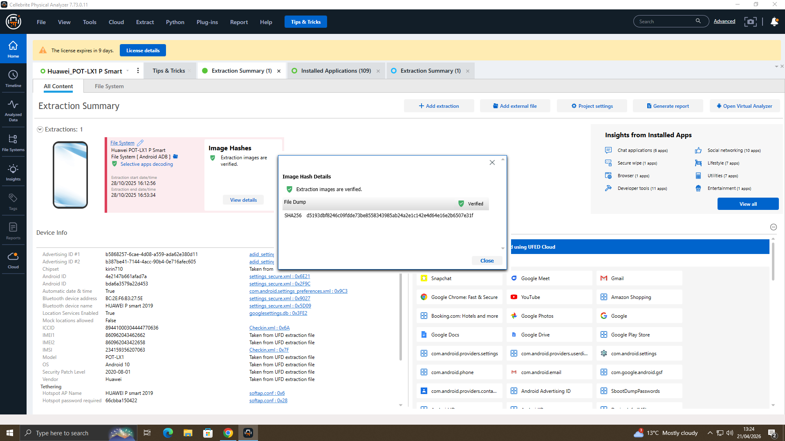
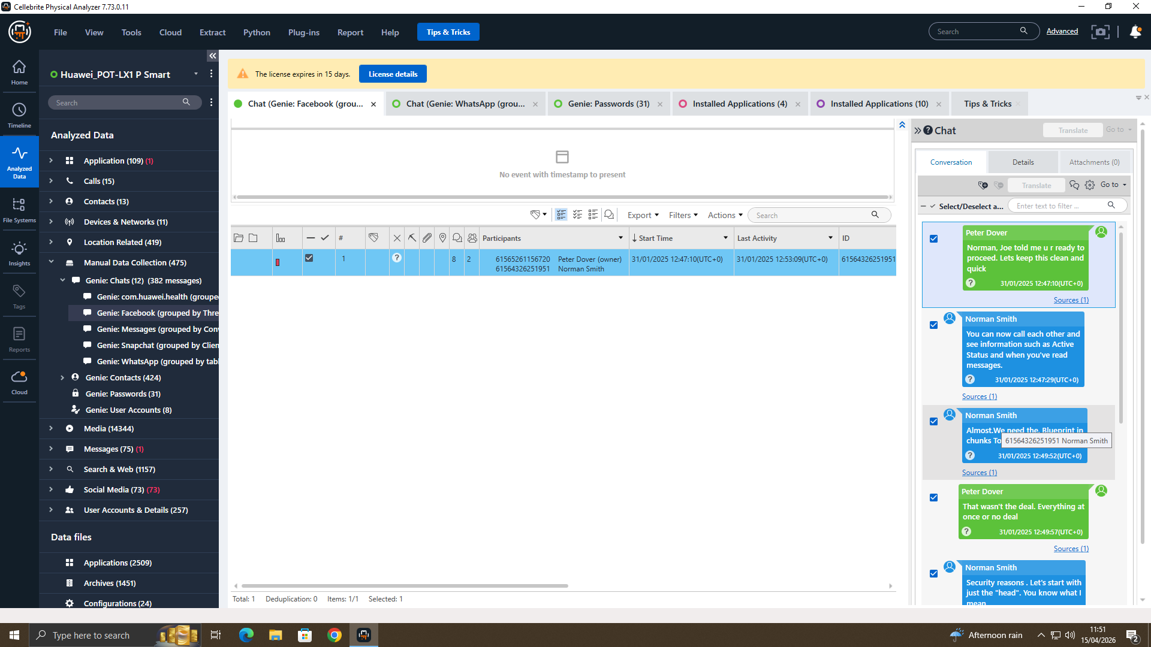

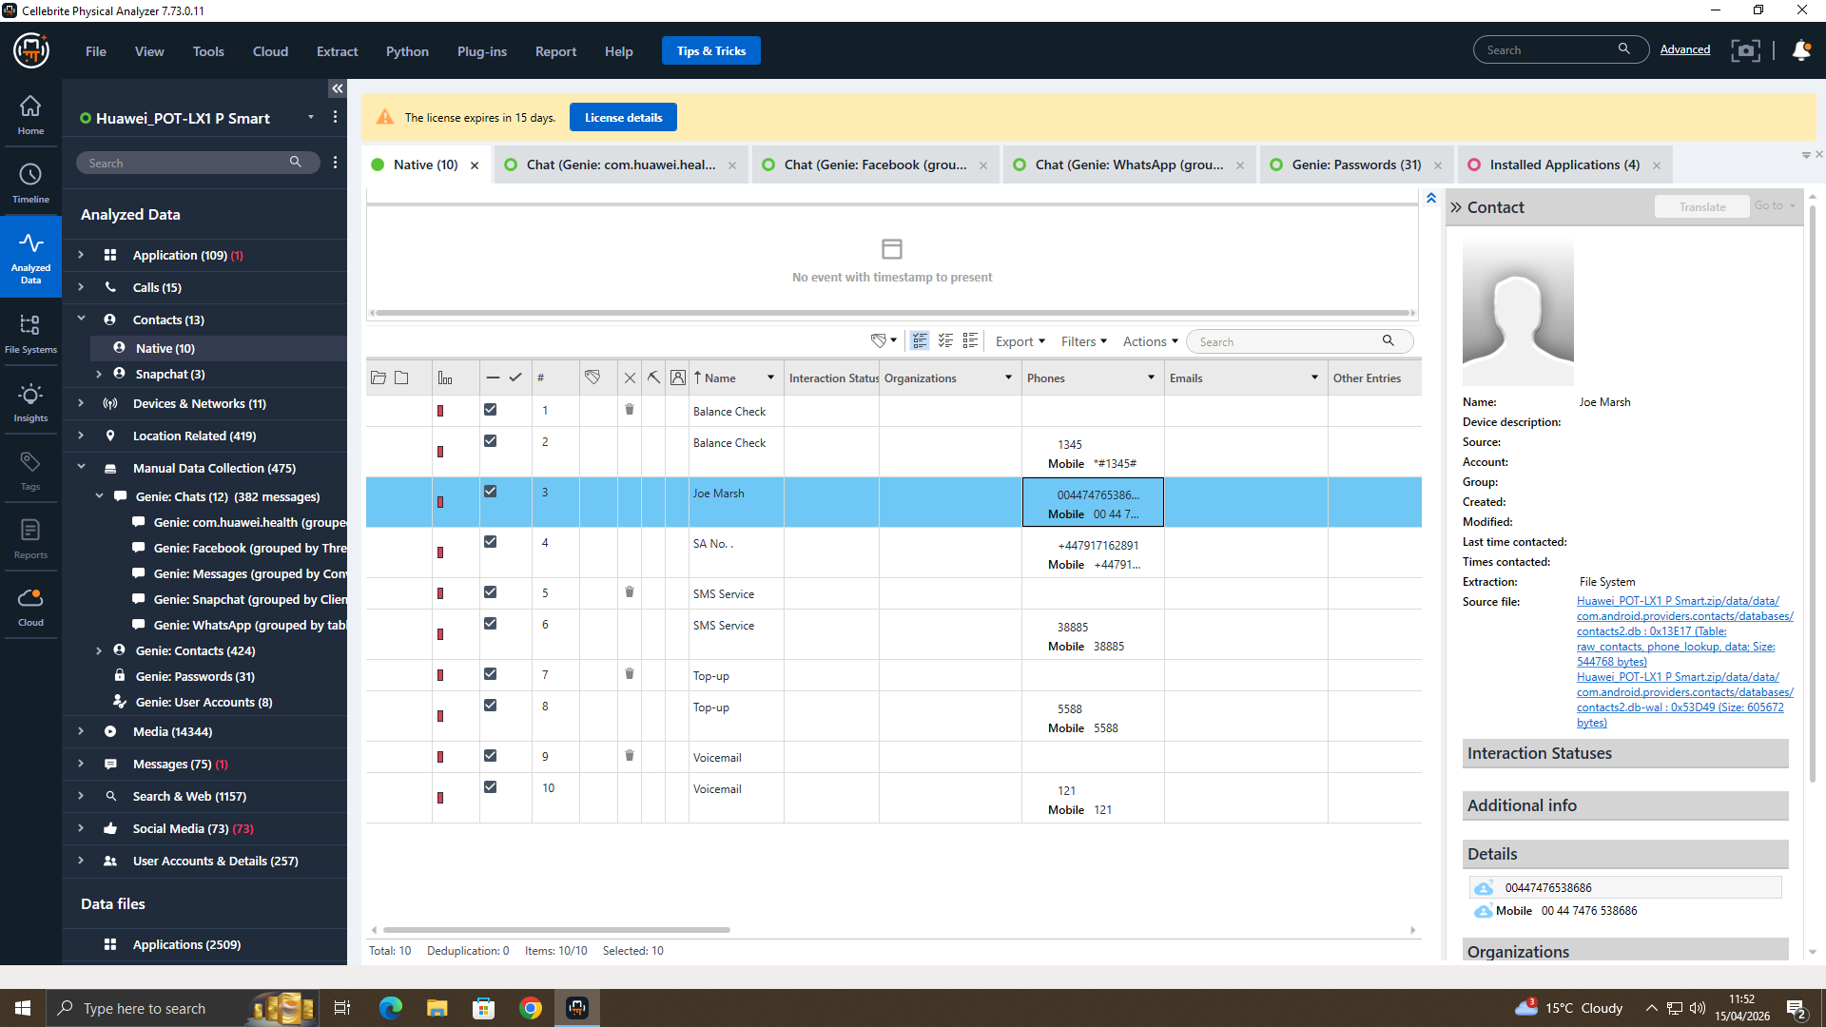

Device 2: Samsung GSM SM-A137F Galaxy A13

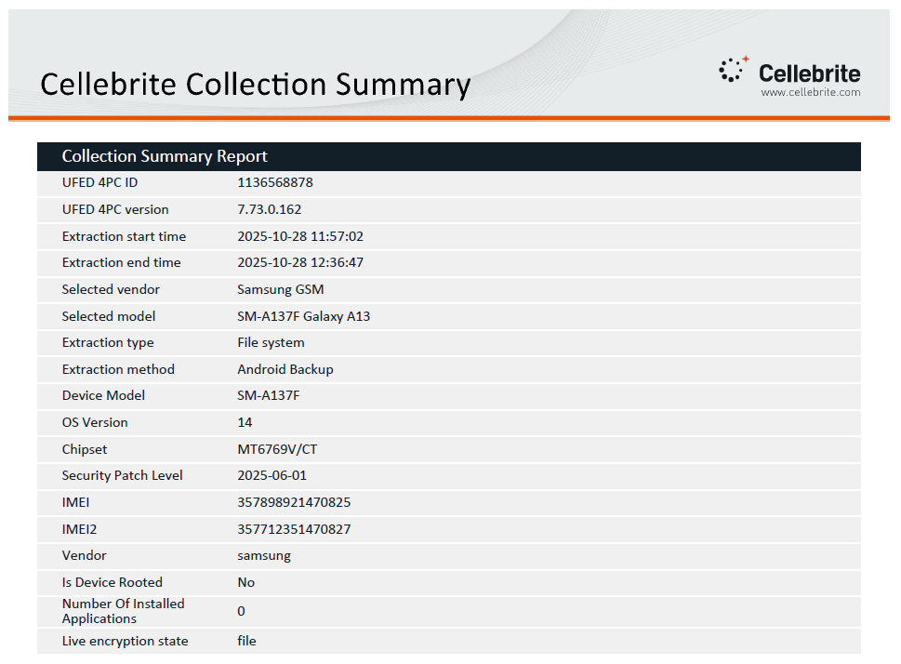

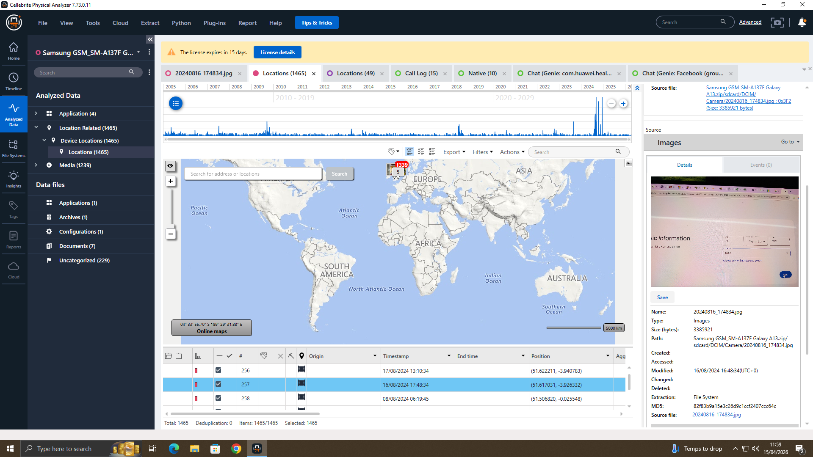
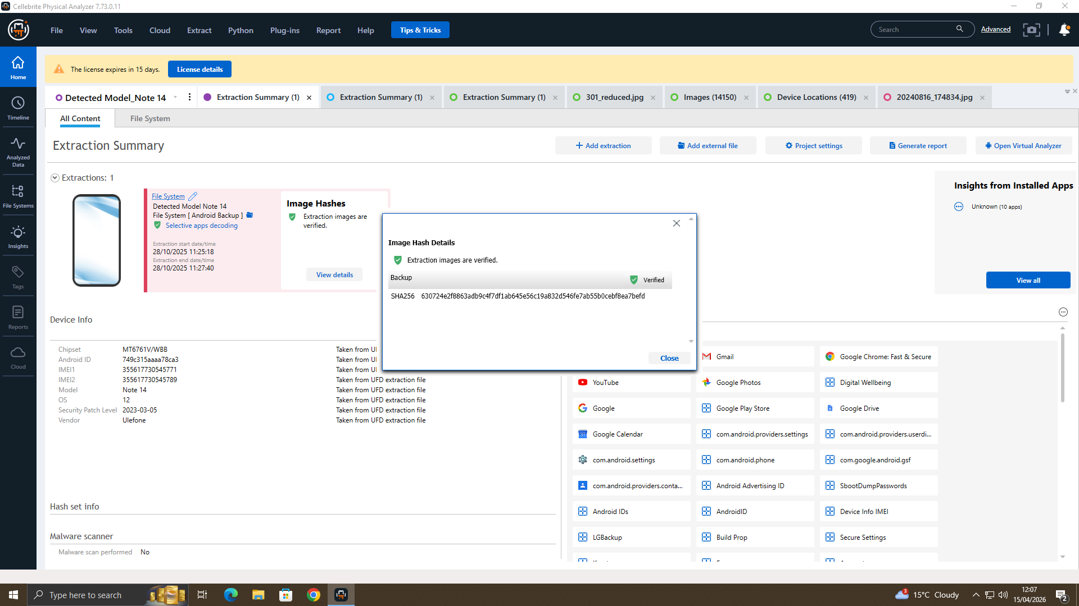

Device 3: Ulefone Note 14
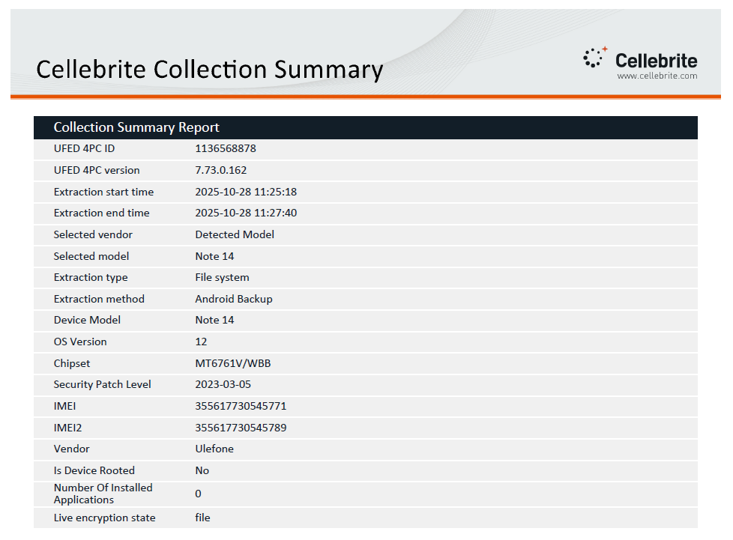

Device 4: Nokia C2 2nd Edition
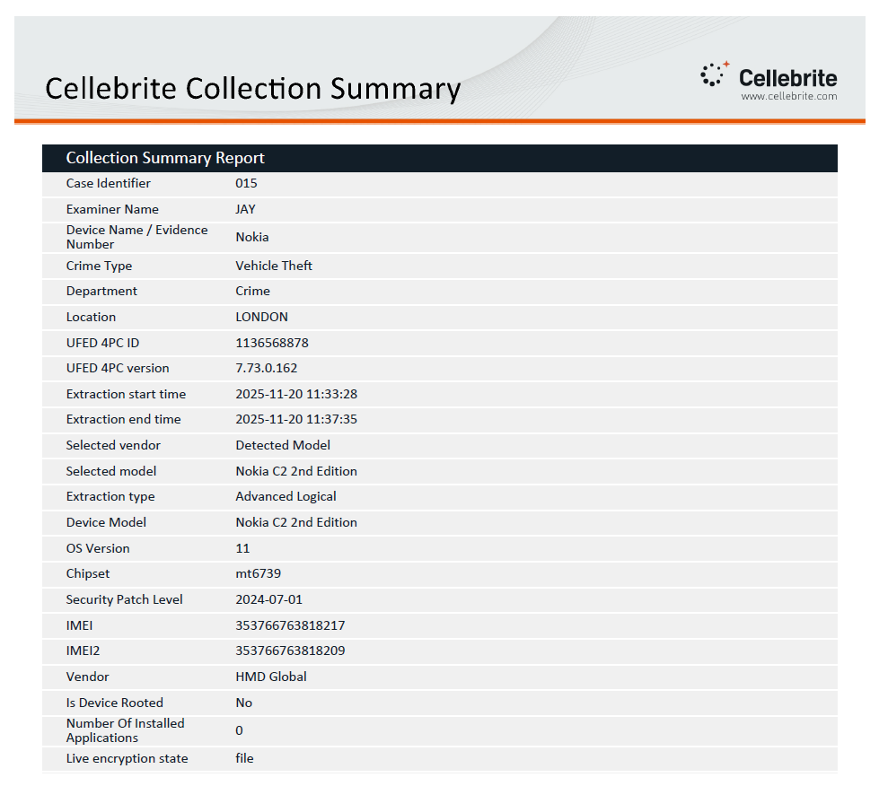

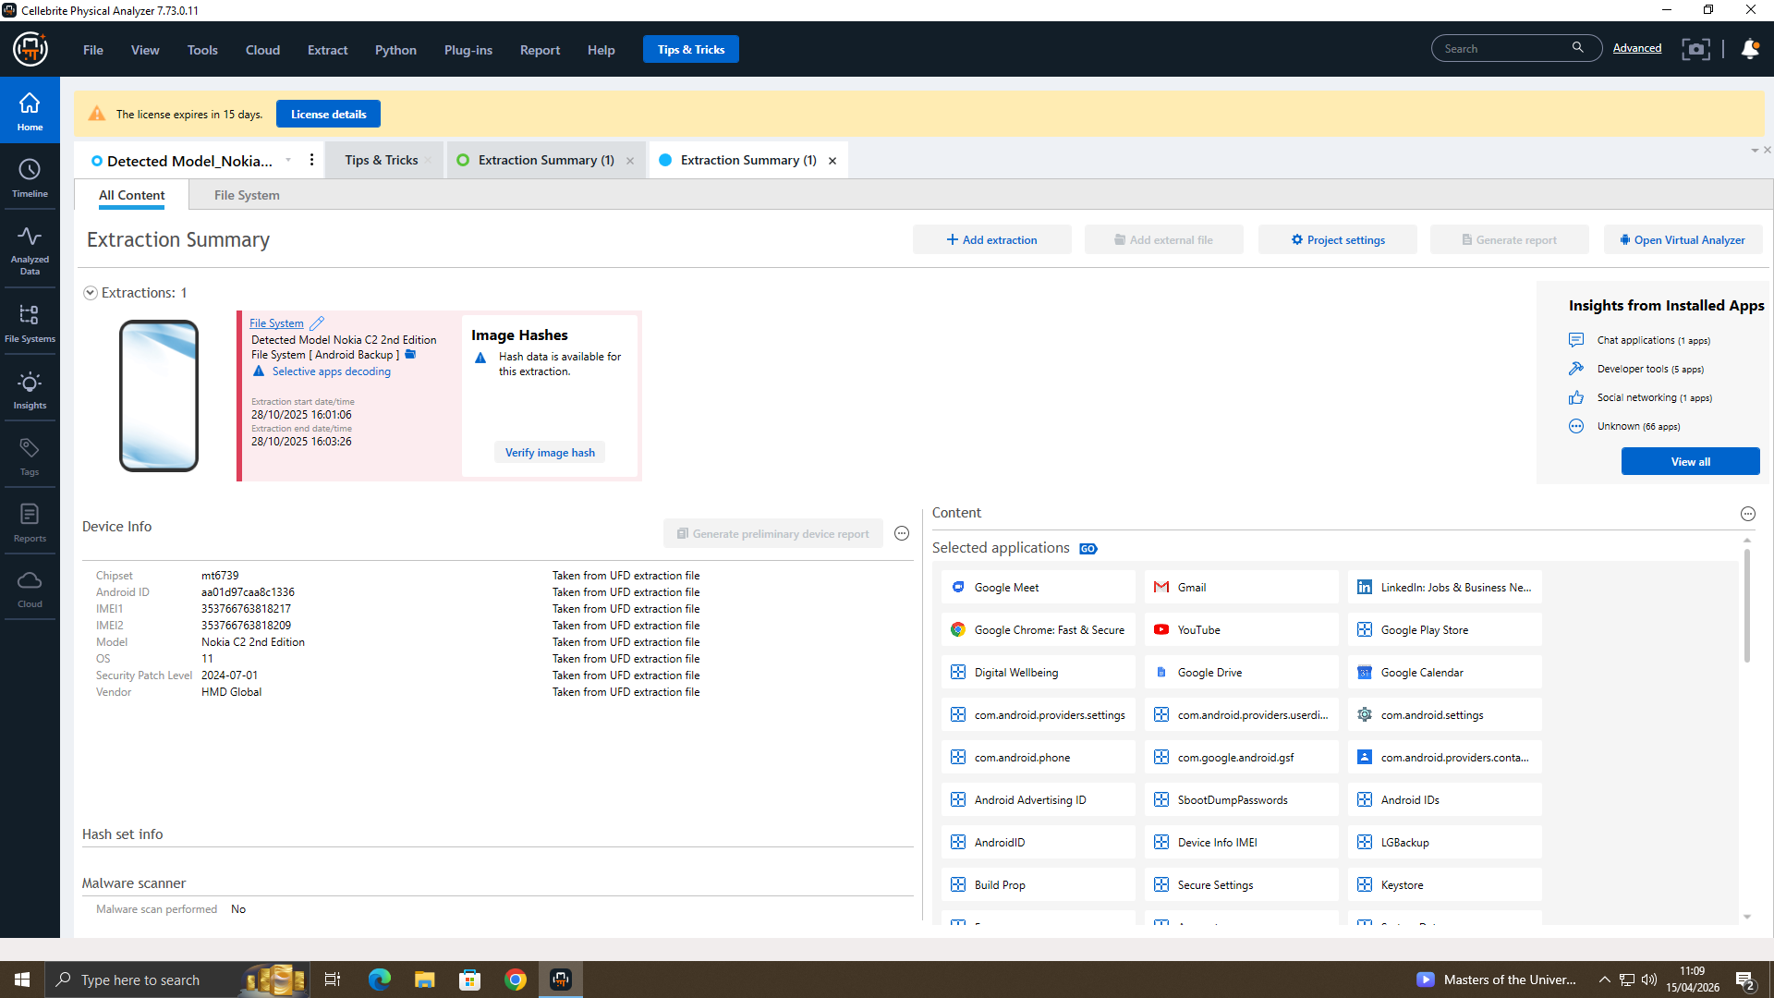

Device 5: MY PHONE (IPHONE 11)

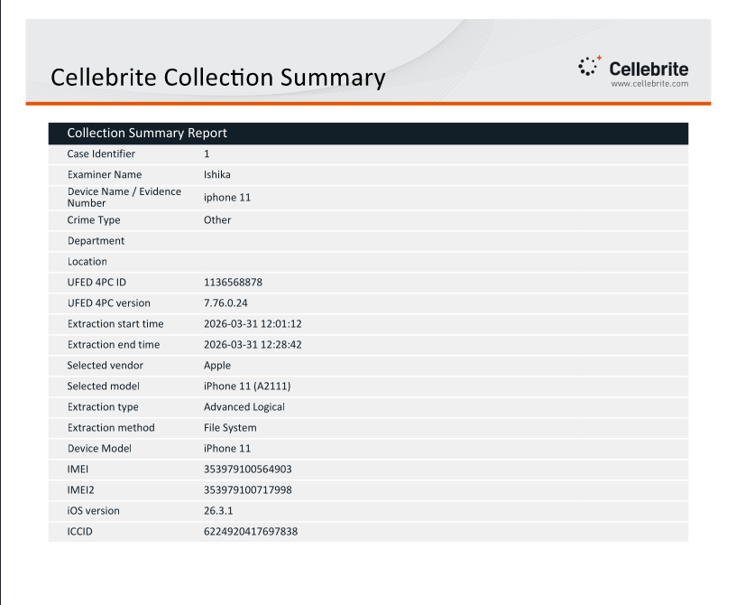
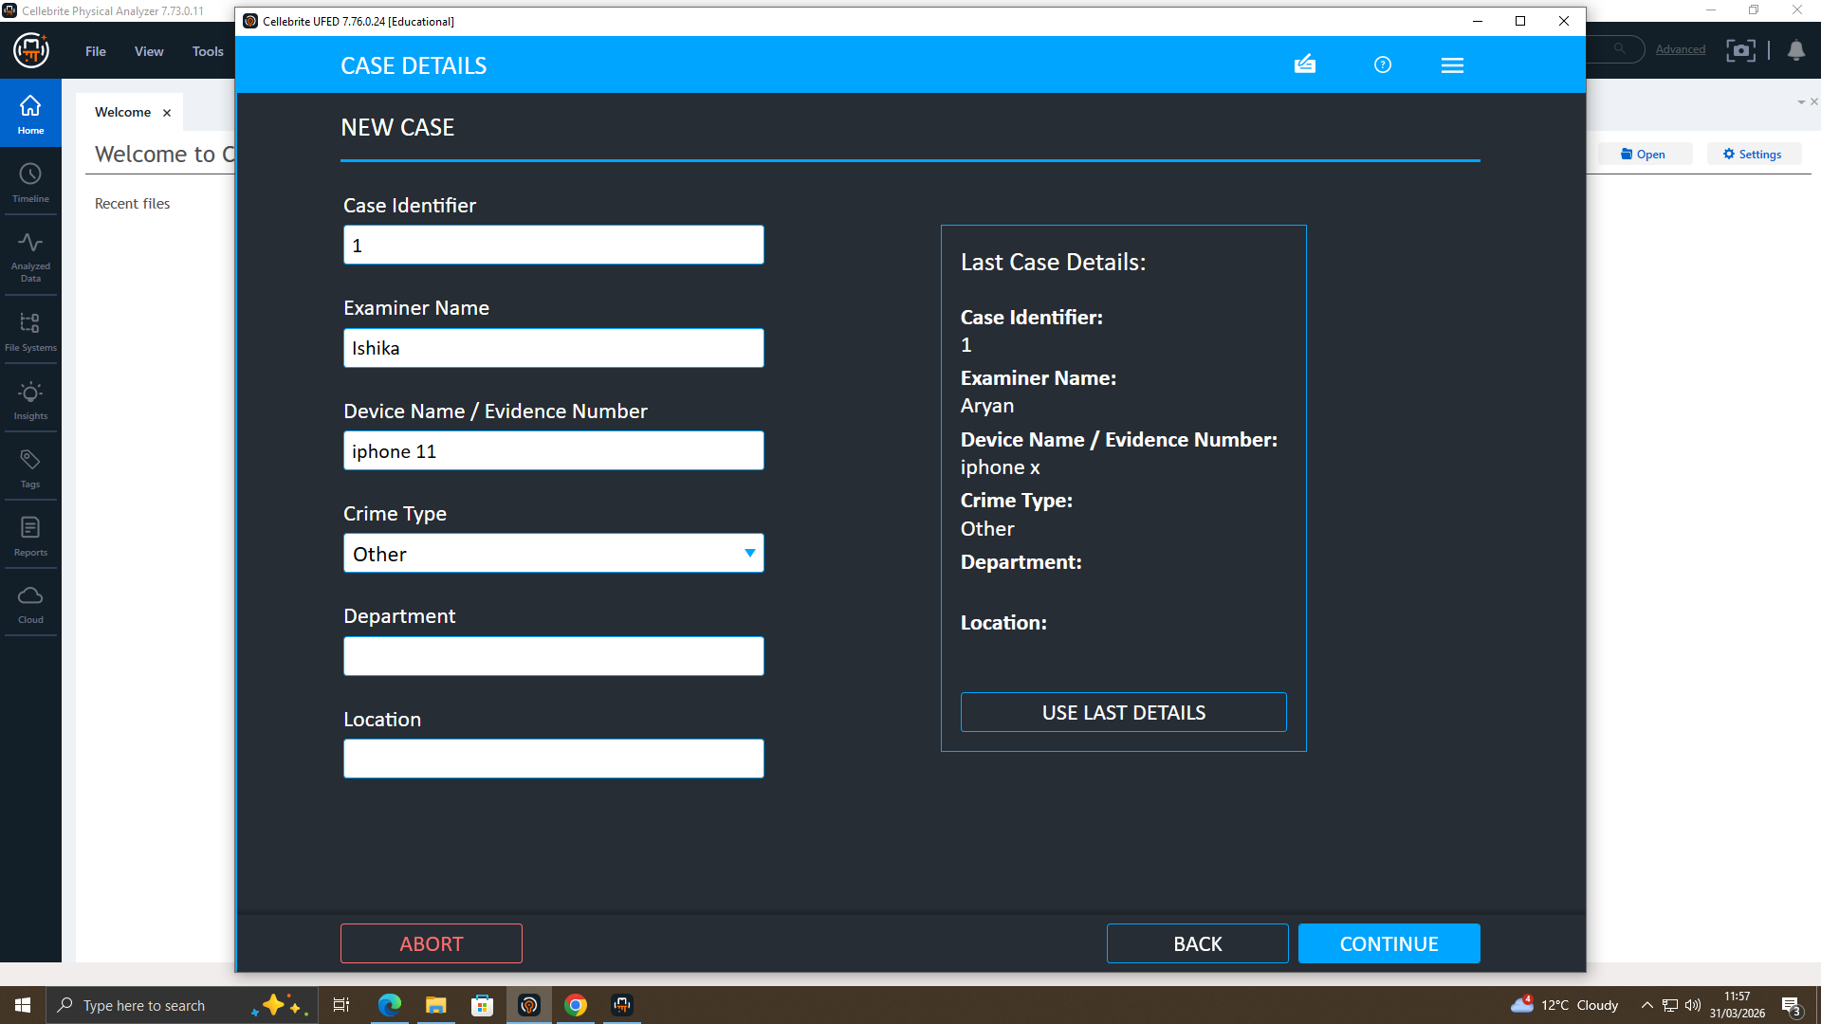
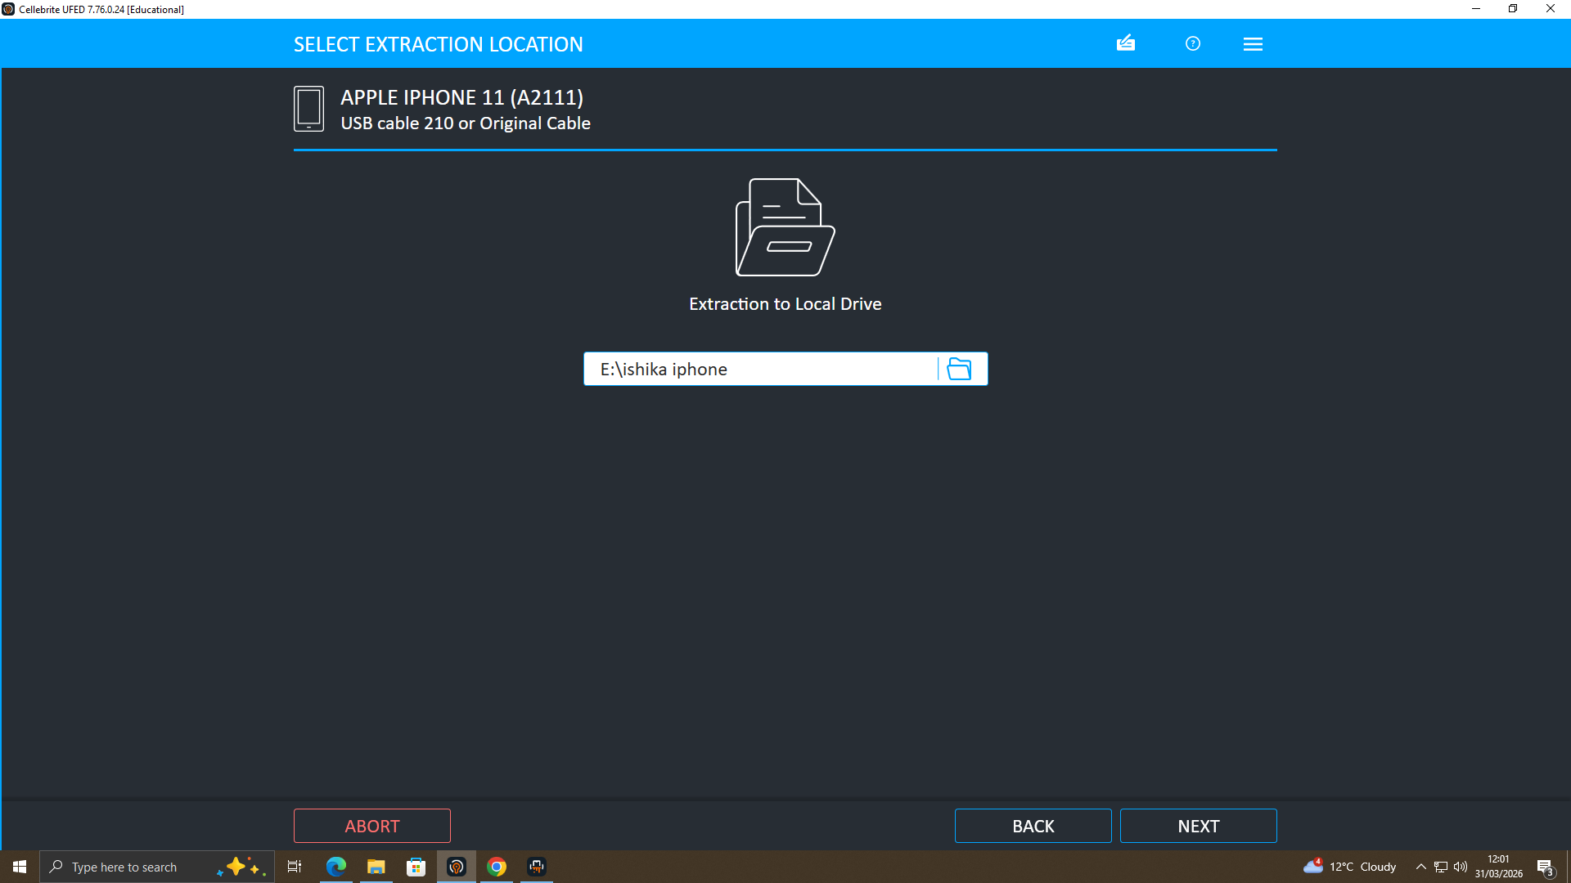
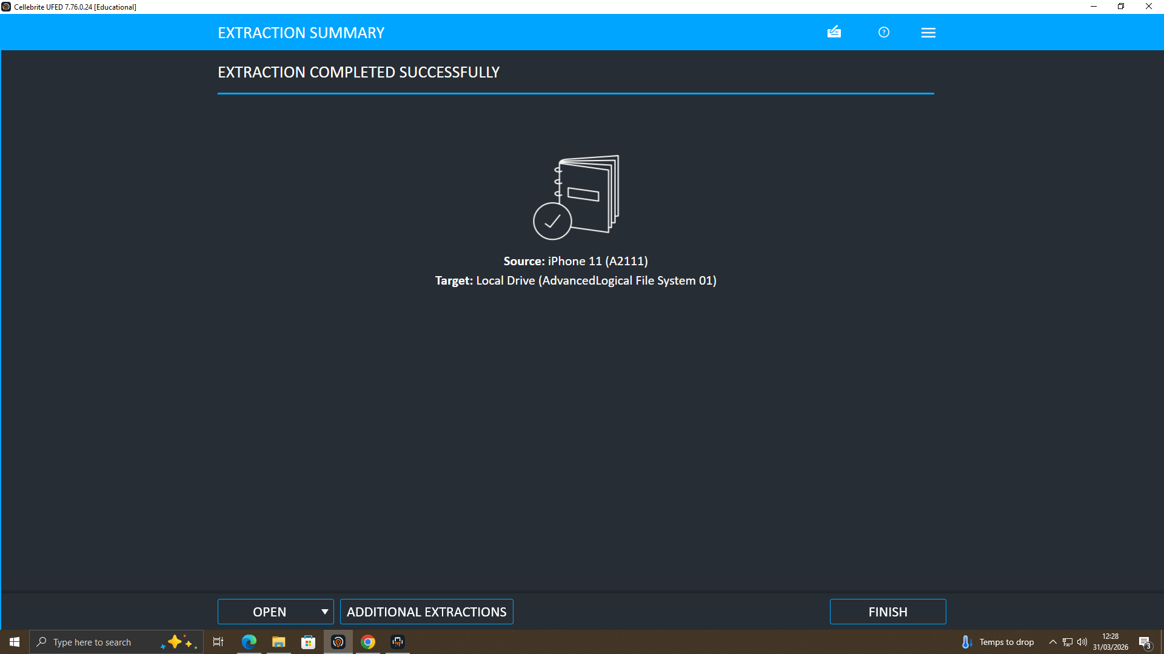
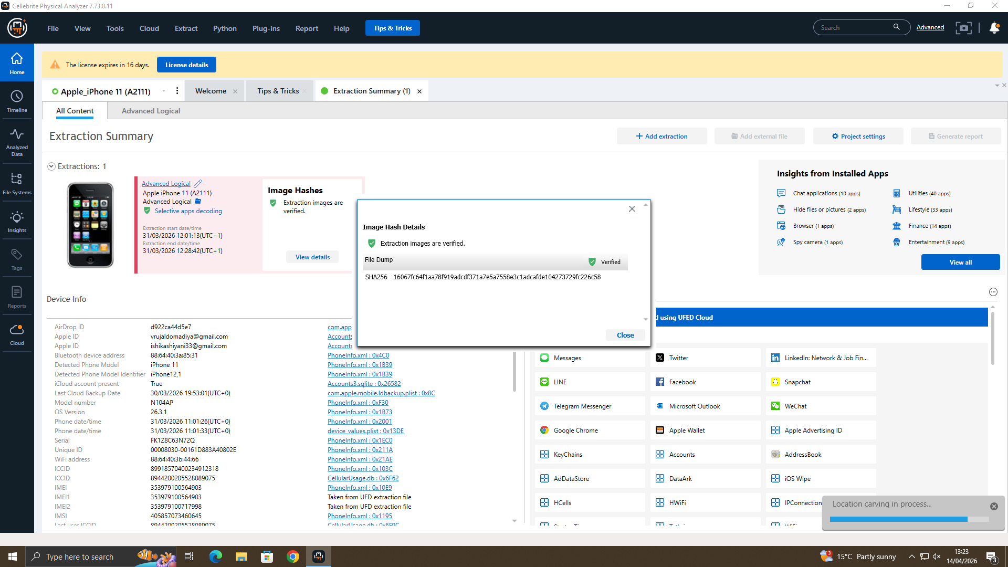
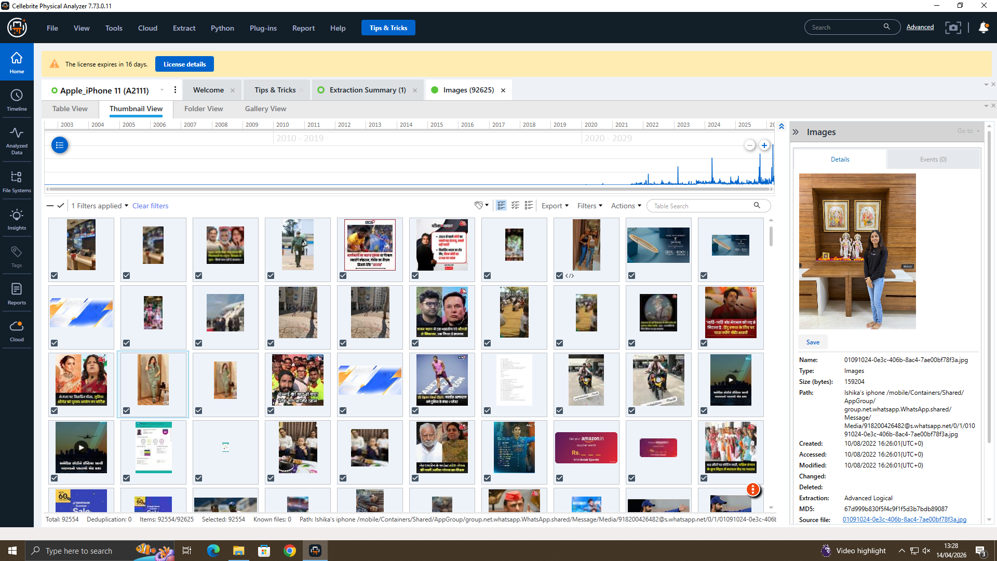
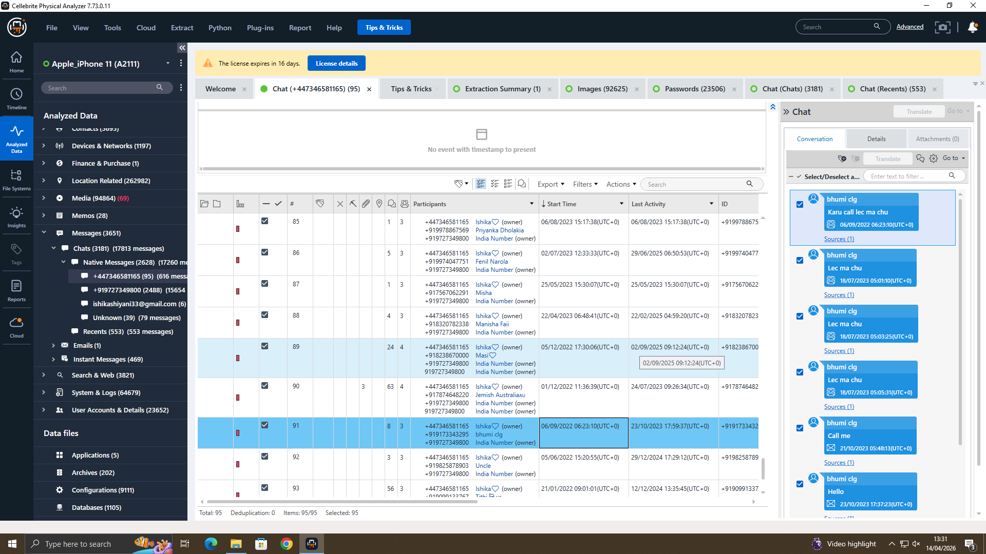
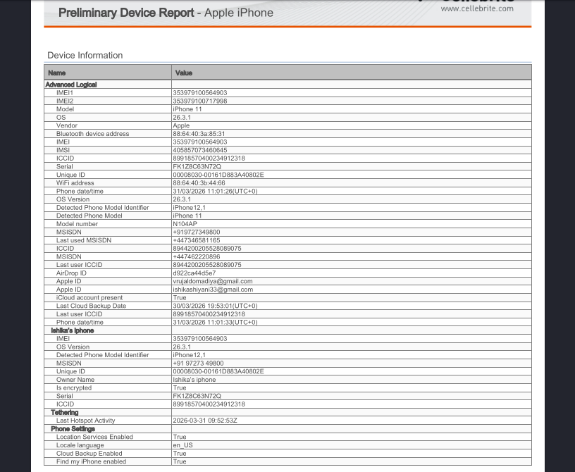

6. Conclusion

6.1 Summary of Evidence
The four mobile devices examined in the course of the forensic examination have yielded corroborated evidence across several communication platforms, geographic documentations, and financial tools, all collectively corroborating that a structured, multi-party conspiracy existed to steal and subsequently sell the proprietary AI chip design patent of Quantum Tech (QT-AI-2025).
Emma is classified as the insider perpetrator because she took advantage of her advantaged position to launch the operation. Joe is recognized as the working middle man, who is in charge of the logistics and payments within the UK and overseas. The buyer/financier is named as Norman, and there is forensic support indicating that Norman is implicated in a purposefully anonymised payment instrument.
Fourth and unnamed person is the owner of the Nokia C2 phone who carries a document of very high encrypted data that might be the most important untested evidence in this case. It has unknown contents and ought to be a priority target of sophisticated cryptanalysis.
In spite of overt and concerted counter-forensic actions on the part of all suspects, deleted messages, encrypted files, anonymous payment tools, and specially-purpose devices, data correlation across devices has provided a detailed, time-stamped and credible legal description of the conspiracy.

6.2 Supporting Evidence of Legal Action
The evidence presented altogether can be prosecuted against via the following UK laws:
- Computer Misuse Act 1990: Hacking on proprietary patent database of Quantum Tech.
- Fraud Act 2006: Motive to make financial advantage through fraudulent and illegal means.
- Trade Secrets (Enforcement, etc.) Regulations 2018: Prohibition on unlawful acquisition and attempted sale of safeguarded trade secrets.
- Proceeds of Crime Act 2002: Anonymous financial instruments or use of non personalised debit cards or prepaid gift cards; these are the forms of money laundering that may occur.
Any evidence that has been received, processed, and maintained in full adherence to the requirements of ISO/IEC 27037 has maintained its integrity and admissibility in court.

7. Recommendations

7.1 Immediate Forensic Actions
There are three forensic actions that should be prioritised immediately:
- Facial Recognition Analysis: The unknown male photograph found on the Nokia C2 cell phone must be inputted in the facial recognition scan and compared with known suspect images in order to confirm the identity of the fourth perpetrator.
- Specialists Cryptanalysis: Specialist cryptanalysis services, be it a commercial password recovery company or a law enforcement cryptanalysis unit, should be contracted to make attempts to decrypt Open.docx. It is most likely to have high-value evidence in its contents which may be used to materially add strength to the case.
- Physical Device Acquisition: Physical forensic acquisition needs to be attempted on all the four devices. Logical extractions, in their turn, are not able to obtain all the deleted data. Application data and other artefacts, including deleted WhatsApp messages, may be recovered through physical acquisition and can now be used to fill major evidential gaps.

7.2 Legal and Law Enforcement Action
The following should be contacted at once by submitting formal legal requests:
- Google: subscriber identity and complete email history of doxp59@gmail.com and josephrehan464@gmail.com.
- State Bank of India: Identity of the account holder and entire transaction history of non-personalised debit card retrieved via the Ulefone device.
- Mastercard: Detailed records about cardholder information and transactions of card ****3758, which was used in Paris and London.
- Meta/WhatsApp: The History of registering an account and sending and receiving messages of all four known devices.
The law enforcer must then move forward to a point of formally accusing Emma, Joe, and Norman based on the existing evidence whilst the investigative activities given above carry on concurrently.

7.3 Organisational Remediation at Quantum Tech.
To ensure that it does not repeat and to make its security posture stronger, Quantum Tech should do the following:
- Carry out a complete internal audit of the access logs of QT-AI-2025 and understand all the persons who accessed the patent, the period that they accessed the patent and whether they had any data exported or copied.
- Adopt Role-Based Access Controls (RBAC) that can limit access of sensitive intellectual property to only verified personnel who absolutely need it.
- Implement Data Loss Prevention (DLP) software that can identify and prevent unauthorised exit through USB devices, email attachments and uploads to the cloud.
- Formalize a Forensic Readiness Policy that integrates standard evidence seizure procedures and provides HR and IT staff with initial incident response protocols to limit the destruction of evidence during any subsequent security breach.

References
[1] C. J. Hoofnagle and S. L. Garfinkel, Law and Policy for the Quantum Age. Cambridge University Press, 2022.
[2] A. Kaur, F. Jamal, Shikha, A. Ramesh, A. Sojan, and D. Dileep, “Collection, Preservation, and Packaging: Forensic Evidence Management,” Crime Scene Management within Forensic science, pp. 51–105, 2021, doi: https://doi.org/10.1007/978-981-16-4091-9_4. Available: https://link.springer.com/chapter/10.1007/978-981-16-4091-9_4
[3] S. S. Iyengar, S. Nabavirazavi, Y. Hariprasad, P. HB, and C. K. Mohan, “Digital Forensics: Tools, Techniques, and Methodologies,” Signals and Communication Technology, pp. 89–137, 2025, doi: https://doi.org/10.1007/978-3-031-89327-8_3
[4] G. T. Davies et al., “Security Analysis of the WhatsApp End-to-End Encrypted Backup Protocol,” Lecture Notes in Computer Science, pp. 330–361, Jan. 2023, doi: https://doi.org/10.1007/978-3-031-38551-3_11
[5] P. Madduri, The Future: Self-Architecting Systems: The Journey from Automation to Autonomous Cloud. Geh press, 2026.
[6] N. Nazarov, “The impact of digital sensory marketing on consumer purchase intentions,” Epublications.vu.lt, 2026. Available: https://epublications.vu.lt/object/elaba:277677070/
[7] A. Beunder and E. L. Briant, “Understanding Conspiracy Theories as a Business,” Routledge Handbook of the Influence Industry, pp. 200–221, Aug. 2024, doi: https://doi.org/10.4324/9781003256878-15
[8] Y. Yang, M. Elsabagh, C. Zuo, R. Johnson, A. Stavrou, and Z. Lin, “Detecting and Measuring Misconfigured Manifests in Android Apps,” Proceedings of the 2022 ACM SIGSAC Conference on Computer and Communications Security, pp. 3063–3077, Nov. 2022, doi: https://doi.org/10.1145/3548606.3560607
[9] N. Chakraborty et al., “Honeyword-based Authentication Techniques for Protecting Passwords: A Survey,” ACM Computing Surveys, vol. 55, no. 8, pp. 1–37, Dec. 2022, doi: https://doi.org/10.1145/3552431
[10] R. L. Leon, “Fontcuberta and Post-Photography,” Connecting Visual Literacy to Theory, pp. 57–73, May 2024, doi: https://doi.org/10.4324/9781032651781-5
[11] A. R. Onik, J. Brown, C. Walker, and I. Baggili, “A Systematic Literature Review of Secure Instant Messaging Applications from a Digital Forensics Perspective,” ACM Computing Surveys, Mar. 2025, doi: https://doi.org/10.1145/3727641
[12] P. Morrow and P. Morrow, Seeing Atrocities. Oxford University Press, 2025.

