

Implementing a Training and Communication Application for System Integration Testers in DHCW
by
Sharla Passariello

Supervisor: Gareth Jones
Second Marker: Gaynor Thomas

Project submitted as part of the requirements for the award of
BSc (Hons) Computing (Software Engineering)

July 2023
DECLARATION

I, Sharla Passariello declare that I am the sole author of this Project; that all references cited have been consulted; that I have conducted all work of which this is a record, and that the finished work lies within the prescribed word limits.

This work has not previously been accepted as part of any other degree submission.

Date : 21/07/2023

FORM OF CONSENT

I, Sharla Passariello hereby consent that my Project, submitted in candidature for the B.Sc.(Hons) Computing (Software Engineering) degree, if successful, may be made available for inter-library loan or photocopying (subject to the law of copyright), and that the title and abstract may be made available to outside organisations.

Date : 21/07/2023

ABSTRACT
In March 2020, NHS Wales Informatics Service (NWIS) migrated from office-based working to remote working due to the COVID-19 pandemic. In April 2021, NWIS became its own special health authority and rebranded to Digital Health and Care Wales (DHCW). During this transition, the DHCW Test Team were disbanded from being an independent team and software testers moved to funded positions in Application Teams. DHCW software testers continue to operate within the same System Integrated Test (SIT) environment. Thus, any changes to a system potentially impacts other systems being assured by other DHCW software testers. Since the transition to remote working and restructuring of the Test Team, communication issues have occurred causing challenges when assuring systems. The aim of this project was to analyse and overcome the communication challenges within DHCW SIT to prevent delays to deployments, reduce the risk of impact to patient care, as well as avoid financial and reputational harm. The solution involved developing a SIT Training and Communication web application that would help foster communication and collaboration between DHCW software testers.
The author conducted a literature review to gain knowledge on established research, and then conducted a survey with DHCW software testers to establish their current obstacles. An agile methodology was used to develop a most viable product (MVP) deliverable. A client-side only prototype was developed due to DHCW server capacity issues and the prototype was demonstrated and reviewed by DHCW software testers. The feedback received for the SIT Training and Communication Application was positive and reflected a desire for this to be deployed for use. For deployment, future tasks involve the need to update the code, integrate backend functionality, take necessary security measures, and conduct research on server storage requirements for deployment. The implementation of these enhancements will significantly enhance the readiness and efficacy of the application, ultimately enhancing communication, collaboration, and efficiency among DHCW software testers.

CONTENTS PAGE
Table of Contents
ABSTRACT 3
CONTENTS PAGE 4
TABLE OF FIGURES 6
TABLE OF TABLES 6
ACKKNOWLEDGMENTS 7
CHAPTER 1 - INTRODUCTION 8
1.1 Aims 9
1.2 Objectives 9
CHAPTER 2 - RESEARCH & REVIEW OF LITERATURE 10
2.1 Introduction 10
2.2 What is Software Testing? 10
2.3 The Importance of Communication Within Software Development 11
2.4 The Impact of Remote Working on Software Development 13
2.4.1 Poor communication 14
2.4.2 Unstable environment 14
2.4.3 Delay in project delivery 15
2.4.4 Incomplete testing 15
2.5 Development Methodologies – Agile vs Waterfall 16
2.6 DHCW Software Development Framework 20
2.6.1 Preferred Software Tools 20
2.6.2 Application Lifecycle Management 21
2.6.2 SCRUM 21
2.6.4 Planning Work 21
2.6.5 Coding Standards 21
2.7 Information Governance within NHS Wales Systems and Services 22
2.8 Conclusion 23
CHAPTER 3 - RESEARCH AND DEVELOPMENT METHODOLOGY 25
3.1 Research Survey 25
3.2 Survey Results 25
3.3 Software Development Methodology 29
3.3.1 Agile Methodology 29
3.3.2 Advantage of using Agile 30
3.3.3 Disadvantage of using Agile 30
3.3.4 How Agile Will Be Implemented for the SIT Training and Communication Application 30
3.3.5 Software and Hardware Requirements 32
CHAPTER 4 - DESIGN AND IMPLEMENTATION 33
4.1 Design 33
4.1.1 Gathering Requirements 33
4.1.2 Refinement of Requirements 34
4.2 Sprint Planning 34
4.2.1 Scrum Poker 34
4.2.2 Selected MVP User Stories 36
4.3 Implementation 37
4.3.1 Project Requirements/System Models 37
4.3.1 Project Hurdles 37
4.3.2 Tools and Techniques Used 37
4.3.3 User Interface 40
4.3.4 Code Success and Failures 41
4.3.5 Testing of the SIT Training and Communication Application 47
4.3.6 User Feedback 51
4.3.7 Future Implementation 51
CHAPTER 5 – EVALUATION 53
CHAPTER 6 - CONCLUSIONS AND RECOMMENDATIONS 55
6.1 Suggestions for further work 56
CHAPTER 7 – REFLECTION 57
CHAPTER 8 – REFERENCES 58
CHAPTER 9 – FURTHER READING 63
APPENDICES 64
Appendix One 64
Appendix Two 72
Appendix Three 76
Appendix Four 79
Appendix Five 87

TABLE OF FIGURES
Figure 1 Waterfall Development Methodology [35] 17
Figure 2 The Scrum methodology [36] 18
Figure 3 Agile Methodology for the SIT Training and Communication Application 31
Figure 4 Requested Functionality for the SIT Training and Communication Application 33
Figure 5 File layout for SIT Training and Communication Application Code 39
Figure 6 Welsh Clinical Portal User Interface 40
Figure 7 SIT Training and Communication Application User Interface 40
Figure 8 jQuery for AJAX Call for SIT Environment Updates Page 44
Figure 9 HTML for Document Upload Functionality on System/Service Pages 47
Figure 10 jQuery for Document Upload Functionality on System/Service Pages 47

TABLE OF TABLES
Table 1 Participant Functionality Proposals 27
Table 2 Desired Functionality Vote Count 28
Table 3 MVP Sprint User Stories 35
Table 4 DHCW Defect Severity Definitions 48
Table 5 DHCW Defect Priority Definitions 49
Table 6 SIT Training and Communication Application Open Defects 50

ACKKNOWLEDGMENTS
I would first like to thank my supervisor, Gareth Jones, for providing support and feedback throughout this project. I am thankful to Emily Stockdale, Brandon Gorman, Bryoni Keighley, and Katie Rees for the endless support and guidance you have provided during my time at University of Wales Trinity St David’s; I am so grateful for the endless laughs, especially at times when it felt like the weight of the world was on my shoulders. I would like to thank all the staff at Starbucks Coryton, who put up with us coming in every day for a month and helped carry us over the finish line. Finally, I would like to thank my family for their love and support that never waivers; I am forever grateful for you.

CHAPTER 1 - INTRODUCTION
For many years, the NHS Wales Informatics (NWIS) Test Team were an independent, centralised team. NWIS Application Teams were required to contact the Test Manager and request testing resource for any new developments in need of quality assurance. The NWIS Test Team sat together in an open-plan office and all relevant updates were mostly communicated verbally amongst the software testers. On March 16th, 2020, the UK government announced that all members of the public should work from home where possible in order to contain the spread of the COVID-19 epidemic [33]. NWIS adhered to government guidance and all employees of the organisation, aside from a small minority of those whose job roles required them to be on site, shifted to remote working indefinitely.

As of April 2021, NWIS ceased from being part of the Velindre University NHS Trust [34] and became their own special health authority, rebranding NWIS to Digital Health and Care Wales (DHCW). Upon becoming a special health authority, DHCW restructured teams within the organisation. Part of this restructure included disbanding the independent Test Team and requiring Application Teams to fund their own software tester positions.

Despite the transition of the software testers from an independent team into their roles within Application Teams, it is important to note that DHCW software testers continue to operate within the same System Integrated Test (SIT) environment. Thus, any changes made to a system potentially impacts other systems being assured by the other software testers due to the integration. The restructuring of software testers and the shift to remote working introduced communication challenges between the DHCW software testers. Communication obstacles amongst the DHCW software testers within the SIT phase can result in delays to the deployment of deliverables. Late discovery of information within the test window can render test scripts invalid, necessitating amendments and affecting project timelines. Inadequate communication can also contribute to undiscovered defects, which may subsequently manifest in the live environment. These challenges can adversely affect patient care, with the potential of causing fatal incidents, as well as resulting in reputational and financial harm for the organisation.

1.1 Aims
The aim of this project is to identify the communication obstacles and deliver a SIT Training and Communication Web application, or at least prototype, which will allow DHCW software testers to have all the relevant information they need in one area. The solution should encourage communication and collaboration between DHCW software testers to help resolve the current challenges and enhance the current testing process.

1.2 Objectives
The following objectives will be required to deliver a successful SIT Training and Communication Application:

- Conduct an analysis of the current communication issues within DHCW System Integrated Testing
- Gather and refine requirements to determine the key information and features needed for an application solution
- Review the appropriate software and hardware needed for the application to be built
- Develop and test the application solution
- Gather user feedback to ensure DHCW software testers are satisfied with the solution

This report will conduct a thorough examination of peer-reviewed literature relevant to the impacts of remote working and communication on software development. In addition, this report will showcase the research conducted by the author with the DHCW software testers for the purpose of establishing and refining requirements for a solution. The development methodology used in creating the solution will be discussed, along with the design and implementation steps taken, and the reasons behind those actions. User feedback will be presented, and the author will assess the solution, reflecting on both successes and areas for improvement for ongoing application enhancement.

CHAPTER 2 - RESEARCH & REVIEW OF LITERATURE

2.1 Introduction
DHCW has witnessed a significant transformation in recent years to the ways of working due to the restructure of the organisation into a special health authority, and the unprecedented impact of the Covid-19 pandemic. Due to these events, there have been added challenges for delivering software to digitally aid in improving healthcare across Wales.

This literature review aims to look at these challenges on a broader scale by analysing previous studies and comparing the results to conclude what the best approaches will be for a solution. A review of best practices within DHCW and NHS Wales will also be undertaken.

Specifically, the review will focus on understanding what software testing is and how it fits into the software development lifecycle, the importance of communication within the software development lifecycle, the impact of remote working on software development, a comparison of development methodologies, the DHCW software development framework, and information governance within NHS Wales.

2.2 What is Software Testing?
Software testing is a phase in software development that is defined by the International Software Testing Qualification Board (ISTQB) as “an activity used to reduce risk and improve quality by finding defects” in software [1]. The role of a software tester is to methodically explore a system or component of software with the objective of finding and reporting defects, to ensure the software satisfies the given specifications.

As of the initial design phase, software development is susceptible to the risk of human fallibility. Deadline pressures, complex systems, and evolving technology all increase the risk of errors in design specifications and the development of code [1]. Errors in design specifications will inevitably result in code being developed that produces undesirable behaviour in the software.

Software that behaves incorrectly can cause financial and reputational harm to businesses, poor patient care if healthcare systems malfunction which could lead to serious harm or a fatality, and damage to the environment if chemicals or radiation are released as a result. Thus, to avoid failures such as these, errors in the design specification and development stages must be avoided. Software testing provides a safety barrier for finding failures before the software is delivered into a production environment where it can result in such harm [1].

Software testers are involved from the design phase, where the requirements and specifications are established [2]. Software testers will also work alongside developers during the development phase. Software testers will then methodically put together test scripts to cover testing for as much functionality as possible in the given timeframe, prioritising tests to be executed based on the risk of failures within the given area of the software.

2.3 The Importance of Communication Within Software Development
Software development comprises of multiple team roles and stages to proceed from being an initial idea into a working product, regardless of which development methodology is used. The more complex a system is, the more complex the coordination between those involved and the various phases of the development becomes.
A study was conducted by Herb Krasner, Bill Curtis, and Neil Iscoe on the software design process for large systems. The study interviewed personnel from 17 large projects to gain insight into the design activities from the viewpoints of the individuals whose actions made up the process. This was to establish by what means design decisions were created, communicated, and modified and how these impacted software productivity and quality [3]. The interviews were structured to be approximately one hour long, and interviewed those in the roles of software engineers, software testers, senior software designers, the project manager, and customer representatives. The questions were structured to focus on requirement analysis, project communications, design meetings, and customer interactions. Summaries were then created of the process-related issues revealed by the individual’s answers and clustered into areas that were repeated across the different projects. There were three prominent problems that were identified amongst all 17 large projects: Communication and coordination breakdowns, thin spread of application domain knowledge, and fluctuating and conflicting requirements [3]. Communication within a project was divided into separate levels, with software testing implemented at the company level. Within the company level, companies would typically establish a formal process for decision making and design reviews for the system. However, it was found that these structures were ineffective for communication. Informal, casual human interaction proved to be the most efficient way to communicate across the organisation [3].

A survey was conducted by Robert E. Kraut and Lynn A. Streeter on coordination in software development, with coordination defined as the direction of each team members efforts to achieve the group’s recognised common goal. The study examined the role of formal and informal communication mechanisms whilst coordinating work on a software project. The survey was held across 65 projects within one software company that focused on features of the projects and the practices that influenced the sharing of information and goals [4]. Software engineers, software testers, analysts, managers, and documentation specialists made up those surveyed. The survey measured project size, project age, and project stage whilst requiring additional explanations around interpersonal networks and outcome measures. Interpersonal networks were assessed on respondents being provided a list of 100 randomly selected first-level supervisors from the software development units and being asked to identify from the list those in which that had talked to in the previous two years. Outcome measures were assessed on an informed scale, where respondents were to assess how informed they were, and coordination success scale where respondents were to reflect on how coordinated they believed their projects to be [4]. To validate the responses, senior management were to assess the quality of the software product and process. This was also compared to client ratings on the quality of the developed software, with both assessments being aligned with metric data on productivity and quality throughout the process.
According to the survey results, formal communication exchange for larger projects, such as requirement and status reviews, were most frequently used and appreciated during the design and planning phases. Nevertheless, regardless of the size, ages, or stage of the project, informal interpersonal communication such as impromptu meetings were regularly used, and the informal interactions were highly valued during the design and planning stages. When projects relied substantially on input from other groups within the organisation, electronic communications were employed more frequently. Upon path analysis, the survey found that maintenance of an extensive interpersonal network correlated with better project outcomes, with greater awareness aiding intergroup coordination [4].

Communication contributes to minimising errors, increasing shared knowledge for improving team coordination, and preventing timescale delays. Effective communication throughout the testing phase of software development results in more efficient testing, thus producing a better-quality product. The earlier information is known to software testers, the quicker testing can start, and defects identified and reported. Inefficient communication can result in misinformation, presenting the risk of invalid tests being executed and schedule delays. Each of which negatively impacts the quality of the final product and timescales in which the product is to be deployed. Software testers communicate with various stakeholders within an organisation to ensure the tests meet the designed specifications, and to ensure open defects are known to all stakeholders of the project. For example, software testers communicate with developers, project managers, business analysts, and other software testers during the coordination of a project. Thus, it is imperative that communication be efficient and of good quality to achieve the best outcome possible.

2.4 The Impact of Remote Working on Software Development
Although remote working has been an option for some organisations for many years, the Covid-19 pandemic in 2019 exacerbated the move to remote working. The Wales Institute of Social and Economic Research and Data reported that 5.7% of workers worked remotely in January 2020 prior to the pandemic laws being announced for people to work from home where possible, to 36.5% of workers in June 2020 [7]. When Covid-19 restrictions were dropped, many returned to working in the office, however many organisations established remote working, or hybrid working as their new normal. Data analysis from the 2021 census found that 22% of workers now work remotely as of May 2022, in comparison to the 5.7% that did prior to the Covid-19 pandemic [8].

The data analysis from the census details that 78% of those who worked remotely in some capacity reported having an improved work life balance. 52% reported that they were quicker to complete work, 53% stating they had fewer distractions, and 47% of those working remotely reported an improved wellbeing due to the transition [8].

In ‘An Empirical Investigation to Understand the Issues of Distributed Software Testing amid COVID-19 Pandemic’, Abdullah et al [9] discuss the distributed software development model, in which software development is created in a variety of places remotely. Abdullah et al state that numerous obstacles contribute to reducing team efficiency, decreasing the quality of the software, and increasing production cost when working in a distributed software development model. These obstacles included:

2.4.1 Poor communication
It was found that the biggest obstacle to working remotely is the lack of interaction. Working remotely presents additional disruptions that can lead to misinterpretations of specifications and failures in communication. If software testers are working off technical specifications that have been incorrectly established or if there is information that has not been communicated or documented for the testers, this runs the risk of test results not accurately reflecting the desired software behaviour. Additionally, over-communicating can be interpreted as a lack of confidence and mistrust, thus deteriorating team morale.

2.4.2 Unstable environment
During the process of software development, modifications are made in response to fixtures of defects or initial requirements, thus the test environment is modified often. If software testers are not aware of changes being deployed to the test environment, this can disrupt the software lifecycle as testing may be delayed or tests previously ran may no longer be valid due to a changed, and possibly unstable environment.

2.4.3 Delay in project delivery
A relaxed home environment and lack of motivation may invite more distractions, making it hard to focus and complete tasks on schedule.

2.4.4 Incomplete testing
Where verbal communication is favoured such as on conference calls, documents may not be produced for functional and non-functional specifications, making testing inherently difficult to complete as an absence of documented requirements will result in testing not assuring that the software satisfies the desired specifications.

Additional impacts of remote working included lack of resources, lack of control, data insecurity, and an inadequate schedule [9]. Abdullah et al propose a Technique for Order Preference by Similarity to Ideal Solution (TOPSIS) approach to help limit the difficulties faced with remote working in software development. The TOPSIS approach principle is a decision-making process that selects the closest ideal solution while being the furthest away from the negative perfect solution [9]. In this approach, it is necessary to identify and group the problematic behaviour and desired behaviour to achieve this goal.

An area of the Abdullah et al research that is questionable is where lack of motivation and a relaxed home environment makes it hard for software development to be completed in the scheduled time. Ford et al [10] conducted a survey with 3646 Microsoft employees [11] looking into the consequences of remote working on productivity and employee well-being. Ford et al concluded that although experiences differed between employees in what they considered an advantage or disadvantage, there was no significant evidence that productivity has been substantially affected by the transition to remote working due to the pandemic [11]. Studies such as Ralph et al [12] that argued productivity was affected negatively considers that there may be disproportionate effects of transitioning to remote working during the Covid-19 pandemic to women, people with disabilities, and parents. Whereas Abdullah et al did not account for factors as such in their research.
Pernilla et al [11] discuss many aspects of remote working in agile software development. Conducting data from a questionnaire shared with 96 respondents and interviewing seven practitioners from seven companies, Pernilla et al analysed data through Bayesian analysis and thematic analysis that concluded that technical work aspects had not changed substantially, yet the most substantial area of change in agile software development due to remote working was communication and social interactions.

It can be established that the shift to remote working has affected employees in software development in different ways, both positively and negatively which seems dependant on personal preference. However, a recurring theme established is that communication within software development has become a more difficult concept to manage with the introduction of remote working, and one that requires a tailored solution to be drafted.

2.5 Development Methodologies – Agile vs Waterfall
In preparation to building a software solution, a development methodology must be determined to establish the process in which the software will be designed and developed. There are a variety of methodologies that can be utilised when developing software with examples such as the traditional waterfall methodology, V-model, agile (Extreme Programming), agile (SCRUM), Kanban, Rapid Application Development (RAD), Rational Unified Process (RUP), and spiral [13][14]. To narrow the choices to be used and for the purpose of consistency, we will consider the research around the two methodologies most used within Digital Health and Care Wales – agile (SCRUM) and waterfall.

Conventionally, the waterfall methodology has been considered one of the most popular methodologies over the years. The waterfall methodology is a sequential model that requires one stage of the process to be completed before moving onto the next stage. Design requirements must be defined before moving into the development stage, all code development of the requirements must be complete before moving into the testing stage, and testing must be completed and assured before any product version can be deployed into the live environment.

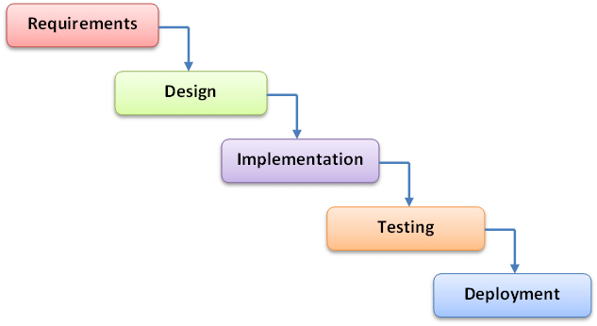Figure 1 Waterfall Development Methodology [35]

Khoza and Marnewick argue through their research that waterfall relies greatly on the requirements being well-defined for the overall project to be successful [15]. Comparatively, Kaushal and Manish [16] studied the impact of incorrect and new requirements on a waterfall software development project to find that “relatively few requirement changes resulted in errors” and changes made due to incorrect requirements reduced defects. Additionally, incomplete requirements showed no significant impact on defects [16]. Due to its sequential nature, communication between team members such as software developers and software testers are typically delayed until stage progression in the product, as progress meetings are not well established between roles within the waterfall methodology. As such, team members may only find they are able to contribute ideas and questions at late stages due to segregated involvement in the product’s lifecycle.

Comparatively, an agile SCRUM methodology takes an iterative approach to software development to develop rapidly within short periods. Where a waterfall methodology produces a release in a sequential model, an agile methodology such as SCRUM splits the product into smaller chunks, deploying deliverables in iterations known as sprints, so that adapting requirements and complex modifications can be managed until a final product is completed [18]. The SCRUM process entails pre-defined roles such as a SCRUM Master, Product Owner, and SCRUM Team. The SCRUM Team is typically made up of software developers, software testers and on occasion business analysts. All pre-defined roles of SCRUM attend and contribute to SCRUM events. A sprint is an established timeframe and for how long a development iteration of a version will last. Sprint planning meetings are held prior to a sprint beginning to discuss what deliverable items will be developed within the sprint, ready for deployment at the end of the sprint. Daily SCRUM meetings are held with all SCRUM roles in attendance during the sprint timeframe to discuss the progress and any blockers that are preventing work being carried out. At the end of the sprint, sprint review and sprint retrospective meetings take place to provide overview on what was achieved in the sprint with the outcome of deliverables, and to provide a feedback cycle on how the sprint went for improvements to be made in the next iteration [18].

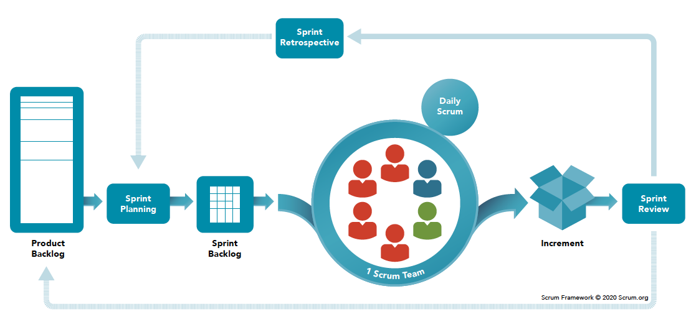
Figure 2 The Scrum methodology [36]
A case study by Thummadi and Lyytinen [17] aimed to discover how much a methodology truly mattered within software development through the comparison of waterfall and agile methodologies. Thummadi and Lyytinen formulated a design routine analysis and combined qualitative content analysis with computational techniques in six software projects over the course of four years. This established the extent at which methods affect design routine variation and if such variations differ across waterfall and agile methodologies [17]. Thummadi and Lyytinen found that “waterfall projects were more stable because they involved extensive quality and inspection tests that increased the stability of designs as well as the level of formality of the project activities” [17] however agile and waterfall methodologies mimic each other in many ways such as ultimately involving iterations at varying frequencies, and the way in which troublesome requirements are resolved. Thummadi and Lyytinen deemed there to be effective differences between both methodologies but the differences to be “less pronounced than often assumed in the literature” [17].

A further study of comparison between agile and waterfall methodologies by Mokhtar and Khayyat [19], based on a Saudi Arabia insurance company comprising of 300 employees, established that of 82 respondents that participated in the study, 44% of participants used both agile and waterfall methodologies. Of these, 26% stated that waterfall methodology projects did not meet completion deadlines, with 34% not being sure and 40% stating waterfall methodology did meet completion deadlines. In comparison, only 13% of participants stated agile methodology did not meet completion deadlines with 30% not being sure, and 57% suggesting agile methodology met completion deadlines [19]. These statistics align with Hema et al’s [18] study in which they state 54% of agile projects achieve success in comparison to waterfall’s 35% success rate.

Mokhtar and Khayyat’s survey [19] gathered further insight into the advantages and disadvantages of the waterfall methodology. The stated advantages of the waterfall methodology included that it requires minimal resources due to its sequential method, and each stage is completed with minimal issues usually on time. The disadvantages stated that the waterfall methodology was inflexible for dynamic user requirements and difficult to fix errors after a project phase is completed, as well as project documentation including development and testing being extensive.

Mokhtar and Khayyat [19] and Hema et al’s [18] statistics suggest agile methodology generally produces a better project success rate, but that is not to testify that the agile methodology is the perfect fit for all software development projects. Thummadi and Lyytinen [17] provide evidence that there is not as big of an impact on project success rate that other literatures of study imply. Therefore, a conclusion can be made that each software development project is better suited to require project team members to evaluate the complexities that might occur in a project and select the development methodology based on a project-by-project factor, as opposed to setting an organisation methodology standard.

2.6 DHCW Software Development Framework
It is important to understand the regulations and frameworks that are to be adhered to within DHCW when developing software for the organisation. The DHCW Software Development Handbook [20] is a framework that acts as guidance for managing the software development lifecycle and building software.
The framework contains important guidance to be considered for developing a SIT Training and Communication Application.

2.6.1 Preferred Software Tools
The following tools are to be used in accordance with the framework:
- Team Foundation Server or Azure DevOps Services for Application Lifecycle Management
- Visual Studio Visual Studio Code, Git, SQL Server Management Studio and SQL Toolbelt Essentials, dotUltimate, and HL7 edit for Developer environments
- ASP.NET MVC with C# and Microsoft SQL Server with T-SQL for back-end development
- ASP.NET MVC with C#, Xamarin with C#, and client-side JavaScript for front-end development

It is significant to note that the framework also states: “You will also need to make your own technology choices. Consider the wider context when doing so. For example, if you’re adopting a JavaScript framework, find out what’s already in use. Avoid introducing something different” [20]. This allows for a further scope of tools to be used for development on consideration of additional tools currently being used with DHCW, with the reference to preferred software tools acting more as a guideline than a strict set of rules.

2.6.2 Application Lifecycle Management
As stated in the Preferred Software Tools section of the framework, Team Foundation Server or Azure DevOps Services should be used for managing the application lifecycle. DHCW are currently in the process of migrating from Team Foundation Server to Azure DevOps Services on a project-by-project basis, so it is more likely that Azure DevOps would be the tool used for managing the application lifecycle. However, if Azure DevOps or Team Foundation Server is not available, Microsoft Excel will be the tool of choice for traceability purposes.

2.6.2 SCRUM
The framework dictates that DHCW has adopted SCRUM, an agile methodology in which pre-defined roles of Product Owner, Scrum Master and a SCRUM Team are involved. SCRUM events such as Sprint Panning, Daily SCRUMS, Sprint Reviews and Sprint Retrospectives should also take place [20].

2.6.4 Planning Work
The framework dictates that requirements should be captured in the form of User Stories and progress should be tracked throughout development through the Daily SCRUMS and a dashboard of the Application Lifecycle Management Tool [20].

2.6.5 Coding Standards
The framework directs readers to the DHCW Coding Standards that must be adhered to so that solutions are clear and explicit, understandable by developers of all abilities, and safely extensible and well documented [21]. As per the DHCW General Coding Standard [22]:
- Code should be clean
- Code should use SOLID principles
- Code should follow Microsoft’s C# coding conventions where the convention is appropriate
- Code should follow Microsoft’s naming and layout conventions
- Code should follow Microsoft’s comment conventions
- Variables should be declared as close to as possible where they are used and at the top of their scope
- Parameters should be ordered consistently and named where possible to improve the readability of code
- Conditionals should be defined in the positive
- Statements should be ordered in a logical fashion
- Code should handle exceptions and use defensive coding techniques [22]

All aspects of the Software Development Handbook and Coding Standards should be kept in consideration throughout the creation of the SIT Training and Communication Application.

2.7 Information Governance within NHS Wales Systems and Services
As well as the software development frameworks, DHCW and NHS Wales as whole follow legislation and regulations for managing the way in which information is handled, known as information governance. Due to the nature of the organisation, sensitive and personal information makes up most data handled within DHCW such as patient demographics and patient medical records. Therefore, it is important when developing any software in DHCW to ensure that information governance is being managed throughout all stages of the software development lifecycle.
DHCW is subject to an All-Wales Information Governance Policy developed by the Information Governance Management Advisory Group (IGMAG) [23]. The All-Wales Information Governance Policy sets the statutory, regulatory, and professional requirements to provide staff with direction on their roles and responsibilities in protecting the security and confidentiality of personal data [24].
To guarantee the protection of personal data, information governance practices must be accounted for in advance for all new projects or information flows. This provides assurance that NHS Wales organisations are operating in accordance with the relevant standards and data protection laws [24]. Staff are not permitted to access data for any individual to whom they are not providing treatment, care, or administration services to within a professional capacity, for strictly work-related activities [24]. Per the All-Wales Information Governance Policy, DHCW follows the WASPI Framework [25] for providing good practice when sharing personal data to ensure data is shared effectively and lawfully.
Per the DHCW Test Framework [2], the patient data used within development and test environments should be reflective of real-world scenarios. It is recommended that projects arrange for “utilisation, and subsequent anonymisation, or live NHS patient data to better mimic the complicated scenarios that occur in the live environment” [2]. This allows for data within development and test environments to be reflective of the live environment, whilst minimising risk of improper care of personal data, ensuring data protection regulations can be easily followed in an area where data is used and manipulated frequently. As the SIT Training and Communication Application would integrate with information within testing environments, the data protection risks are low, as the majority of test patient data is created by the testers yet should still be consistently monitored throughout use as per the All-Wales Information Governance Policy [24].

2.8 Conclusion
It can be concluded from the research that software testing is a crucial part of the software development lifecycle as it ensures the quality of the software meets the specified requirements, whilst reducing the risk of releasing a defective product to users. Thus, preventing harm being caused in a financial, reputational, and physical nature.
Communication was found to be a key factor in minimising errors and delays, improving project coordination, and ensuring the software development lifecycle is executed efficiently and effectively. Although formal communication is used often throughout an organisation’s software development lifecycle, it was found that informal communication was deemed the most effective by those who partook in the studies. The Covid-19 pandemic produced a shift to the permanence of remote and hybrid working for many organisations, further enhancing the challenges of producing effective communication within a software development lifecycle.
To develop a solution that will counteract the challenges of communication software development lifecycles, specifically software testing faces, a development methodology should be chosen that aligns with DHCW best practices. The waterfall methodology provides a clear end goal using a sequential model, which allows for clear task direction to those involved. However, this model does not allow for flexibility of requirements and only allows for communication to occur between stakeholders late in each sequential phase. The agile methodology takes an iterative approach which allows for better, more consistent communication throughout the development and allows for incorporating requirement changes. A development methodology should be selected based upon project requirements and what will work best for that specific project, however DHCW recommends using agile (SCRUM) where possible.
Additionally, developing a solution to combat communication issues within software testing should follow the guidelines set out in the DHCW Software Development Framework to ensure best practice is used and code is maintainable. Information Governance protocols should be adhered to for ensuring patient confidentiality throughout the development lifecycle.

CHAPTER 3 – RESEARCH AND DEVELOPMENT METHODOLOGY
A few months subsequent to the restructure of DHCW in 2021, several DHCW software testers informally raised concerns of communication challenges surrounding system integration testing. To generate a solution plan, further research was needed to formally identify if the issue were impacting all software testers and what they, as users of the solution, would require for resolving the issues raised. This utilised an action-based research method [28].

3.1 Research Survey
A survey was distributed to all DHCW software testers. The survey aimed to get participants to quantify their levels of communication and knowledge prior to the restructure whilst they were working in the office and compare these levels to after the restructuring and shift to remote working. It also aimed to establish what functionalities the participants would require for a solution. A SIT Training and Communication Application was proposed as a solution as it allows for informal communication to be maintained as recommended from the literature review.

3.2 Survey Results
The survey was distributed to a total of 22 software testers, with 19 of those participating. Please refer to Appendix One for the detailed results.

Participants were asked to state how aware they felt of project updates to systems and services that they were not personally testing, prior to the restructuring of the Test Team and shift to working remotely. 63% of participants reported feeling very aware or somewhat aware of these updates during this time period. Since the move to remote working and decentralisation of the Test Team, 68% of participants now feel unaware of project updates since the changes were incorporated.

A comparison was then made regarding changes to the SIT environment that testers felt could impact their testing. Prior to remote working and the decentralisation of the Test Team, approximately 63% of participants reported feeling very aware or somewhat aware of changes being made within the SIT Environment that could impact their testing. Subsequent to the decentralisation of the Test Team and the shift to remote working, only 37% of participants now feel positively aware of any changes being implemented to the SIT environment.

The study found that 79% of participants would upload test documentation or knowledge sharing documents to an area that was accessible by all DHCW software testers. The remaining 21% stated this question was not applicable due to not being employed in the organisation during this period. Since the shift to remote working and decentralisation of the Test Team, 74% of testers will upload test documentation and knowledge sharing documents, albeit less frequently, to an area accessible to all DHCW software testers. The remaining 26% declared that they do not ever upload test documentation or knowledge sharing documentation to a shared, accessible area.

Another consequence that DHCW software testers inhibited from the changes was an increasing knowledge gap in which testers were the point of contact for other systems or services. Prior to the changes, 74% of participants were very aware or somewhat aware of which staff member was assigned to testing each system or service. This dropped to 47% as a result of the changes implemented within DHCW and shift to remote working.

All 19 participants agreed that a web application for system integrated testing to provide project communications, environment communications, and training would be beneficial.
The participants were then presented with eight functionality options in which they could select those they would like to see in the solution. The following table shows the participant votes for each functionality:

Proposed Functionality | Vote Count | Vote Count as Percentage (Approximate)
Training/Knowledge Sharing Documents | 19 | 100%
Test Environment Links | 18 | 95%
SIT Environment Changes Updates | 17 | 89%
Project Release Updates | 17 | 89%
Testing Resource Assigned to each System/Service | 15 | 79%
Link to Test Patient Generator | 14 | 74%
TFS/ADO Links | 12 | 63%
Chat Functionality | 6 | 32%
Table 1 Participant Functionality Proposals

Participants were then asked to provide additional functionality they would like to see in the solution. 10 of the 19 participants provided additional desirable functionalities. The desired functionalities included:
- An area for uploading demonstration videos of systems/services
- An overview of each application
- Chat functionality in the form of a message board
- An interactive timeline feature that displays sprint and release dates, with the ability to link the appropriate user stories and test suites to the sprints
- API Training
- Test related tools
- A SIT BETA testing area where those outside of dedicated testing resource can report unexpected behaviours
- Test Environment diagram
- User guides for each application

To understand what requirements should be prioritised for the minimum viable product (MVP), participants were asked to establish the functionalities they would most like to see. Participants were not constrained to only one option and could declare as many desirable functionalities as they desired. A vote was counted against each mentioned functionality, this would then be used for design of the system further into the development process. The results were as follows:

Desired Functionality Description | Vote Count
SIT environment updates | 7
Project updates | 6
Assigned testing resource to system/services | 6
Training/Knowledge sharing document page | 5
Test Environment URL’s | 3
End-to-End flow diagram of systems | 1
Chat functionality | 1
TFS/ADO project URL’s | 1
Active Directory accounts needed for new starters to access the test environments | 1
Table 2 Desired Functionality Vote Count

It can be concluded from the survey results that the restructuring of DHCW’s Test Team and the shift to remote working has had a negative impact on communication across system integrated testing in DHCW. During the assurance quality process, it is imperative that environment change control is strict and communicated to those it may impact. Poor communication during the SIT phase enhances the potential of software defects going undetected and being progressed into the live environment, which in a healthcare setting such as DHCW, could result in consequences that range from minor inconveniences in the patient care process, to contributing to a fatality. The survey also provided an insight into the functionalities that could help provide a solution to the communication issues being faced.

3.3 Software Development Methodology
As per the Digital Health and Care Wales Software Development Handbook [20], software development within DHCW should employ the agile methodology when delivering a project, specifically the SCRUM approach. Thus, to align with DHCW development processes, agile was selected as the development methodology to be used for the SIT Training and Communication Application solution.

3.3.1 Agile Methodology
The agile methodology promotes the delivery and deployment of software in increments known as sprints, as opposed to the traditional waterfall approach [29]. agile encompasses four core values: individuals and interactions over process and tools, working software over comprehensive documentation, customer collaboration over contract negotiation, and responding to change over following a plan.
Typically, during the SCRUM process of an agile methodology, requirements are converted into the form of user stories and put into a sprint backlog. A sprint planning session is then held prior to a sprint beginning, and user stories are selected from the backlog for development within the sprint. The selection of user stories is based off of functionality priority and a scoring system of development efforts, known as scrum poker. When the sprint starts, the user stories are developed and a daily scrum meeting is held where all scrum members discuss what they worked on the day prior, what they are working on in the current day, and if they have any blockers are preventing work being executed. Once the sprint ends, a sprint review meeting is held to showcase what has been developed. A sprint retrospective meeting is also held to discuss what went well during the sprint and what can be improved. The changes for improvement should then be incorporated during the next sprint. These iterations continue until the product is fully completed [20][29].
For the SIT Training and Communication Application solution, the author will be inhibiting all of these roles due to the nature of the project. This removes the need for a daily scrum meeting as the author is taking full responsibility of all work and will be fully aware of the ongoing development and blockers. It is still important that a sprint planning, sprint review, and sprint retrospective session is adhered to even if done as an individual evaluation, as these influence the quality of the sprint deliverables as well as any subsequent sprint deliverables.

3.3.2 Advantage of using Agile
Because the agile methodology break downs the development of the final product into smaller pieces, this allows flexibility if requirements change, whilst providing continuous feedback throughout development of the product. Defects are also more likely to be detected early as functionality will be assured earlier, as opposed to the sequential development process of the waterfall methodology. These advantages should be apparent during the development of the SIT Training and Communication Application, even with the limited resource of persons involved.

3.3.3 Disadvantage of using Agile
Because agile values working software over comprehensive documentation, a disadvantage that may be apparent during the development of the SIT Training and Communication Application is that knowledge may not be maintained due to the overhead as only a single resource is designing and developing the product.

3.3.4 How Agile Will Be Implemented for the SIT Training and Communication Application
The approach for implementing an agile methodology for the SIT Training and Communication Application will differ slightly from the typical agile approach as daily SCRUM meetings will not be held throughout the sprint. This is due to the author being the only resource on the project. The methodology will be implemented in the following way:
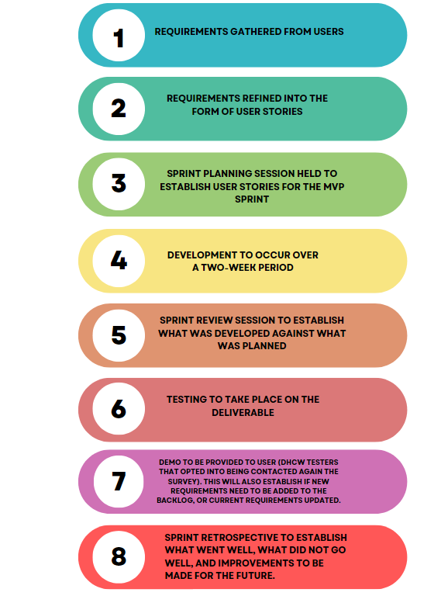

Figure 3 Agile Methodology for the SIT Training and Communication Application

3.3.5 Software and Hardware Requirements
To adhere to the Digital Health and Care Wales Software Development Handbook [20], the author was originally going to develop the SIT Training and Communication Application using the tools advised by DHCW’s Software Developer Manager.
The advised tools included Visual Studio, Microsoft SQL Server Management Studio, and Azure DevOps. The advised languages included ASP.NET MVC with C# and JavaScript for front-end development, and ASP.NET with C# and Microsoft SQL Server with T-SQL for back-end development. It is important to note that the handbook also states “Make sensible choices. You will need to make your own technology choices. Consider the wider context when doing so” [20].

Upon researching appropriate hardware resources, the author discovered that DHCW had recently fallen under server capacity issues. The author discussed the SIT Training and Communication Application project with the Application Manager of the Integration and Reference Application Team, and it was deemed inappropriate to deploy a project of this nature onto DHCW servers at this time. This was not only due to capacity issues, but also due to the security processes and risks it would entail for DHCW. As this was not to proceed further on DHCW infrastructure, further research into required server capacity ceased.

The author reconsidered the wider context and established that a client-side prototype would suffice for the project. This prototype could be developed and demonstrated to the potential users and would allow the code to be updated and implemented in the future if hosting resource were to become available. It was decided by the author to develop the prototype using html, CSS, and jQuery. AJAX calls to pseudo data would be included within the jQuery to further demonstrate the functionality of the MVP to stakeholders. Furthermore, if the project were to be implemented onto DHCW infrastructure and additional functionality added, the author would look at incorporating ASP.NET with C# as well as Microsoft SQL Server into the development. However, for the MVP the functionality being demonstrated would suffice using html, CSS, and jQuery, as this could all be developed on a local machine and distributed with ease for demonstration purposes.

CHAPTER 4 - DESIGN AND IMPLEMENTATION

4.1 Design

4.1.1 Gathering Requirements
As outlined previously in the agile methodology process for the SIT Training and Communication Application, the first step of the design phase entailed gathering requirements from the users. Desired functionalities had been queried throughout the survey during the research phase. The functionalities that were most desired collectively by the user group would be prioritised as requirements for the development of the MVP. Items that were not as desirable collectively would still be considered for the MVP, however their inclusion would be dependent on the outcome of sprint planning and if the added workload would be achievable in the given sprint period.

The author collected the data from the survey results and organised the required functionalities that should be prioritised for the MVP. The order of most requested functionality to least requested which dictated the priority were as follows:

Most Requested Functionality | SIT environment updates
Least Requested Functionality | Project updates
Least Requested Functionality | Assigned testing resource to system/services
Least Requested Functionality | Training/Knowledge sharing document page
Least Requested Functionality | Test Environment URL’s
Least Requested Functionality | End-to-End flow diagram of systems
Least Requested Functionality | Chat functionality
Least Requested Functionality | TFS/ADO project URL’s
Least Requested Functionality | Active Directory accounts needed for new starters to access the test environments
Figure 4 Requested Functionality for the SIT Training and Communication Application

4.1.2 Refinement of Requirements
Although the requested functionalities provided a blueprint, the requirements needed further refinement to ensure user expectations could be met. This also aligned with the next step of the agile methodology, in which requirements were refined into user stories. The defined user stories are shown in Appendix Two.

To ensure the core values of agile were being adhered to, such as customer collaboration, the DHCW software testers who agreed to be contacted again in the survey were called via Microsoft Teams and shown the defined user stories. This was to confirm user satisfaction in what was being developed and ensure the requirements aligned with expected behaviour. The user group were happy with the user stories and no additional comments were received. It is imperative to any software development project to ensure requirements are defined clearly from as early as possible to provide a solid foundation for the project and allow for early identification of defects. Clear requirements facilitate planning of resource and provide guidance for predicting milestones for the overall project plan.

4.2 Sprint Planning
A sprint planning session was held to assess the user stories defined in Appendix Two and determine which items would be developed for the MVP sprint. User stories not selected for the MVP sprint will then return to the backlog to be developed in future sprints.

4.2.1 Scrum Poker
In order to establish the MVP user stories for development, a scrum poker session was held. The scrum poker session entails scoring each user story with the estimated development effort required, using the Fibonacci sequence. Benefits of scrum poker include more accurate time estimations of the work in comparison to individual estimations and early identification of gaps in requirements [31].

As displayed in Appendix Two, the user stories were given a reference ID. The table below displays the assigned scrum poker scores against the relevant reference ID.

User Story ID | Scrum Poker Score | Reason for Score
US1 | N/A | US encompasses overall product goal. Score not applicable
US2 | 1 | Cosmetic implementation
US3 | 3 | Ajax calls will require effort
US4 | 3 | Ajax calls will require effort
US5 | 2 | Some effort required in gathering the data needed for the list
US5.1 | 2 | Some effort required in gathering the data needed for contact emails
US6 | 1 | Should be simple to implement this page
US6.1 | 3 | Effort required in implementing due to the quantity of systems/services to be displayed
US6.2 | 5 | Challenge in functionality for client-side prototype only
US7 | 1 | Data required is already obtained
US7.1 | 1 | Data required is already obtained
US8 | 1 | Already obtained diagram, simple to display in required location
US9 | 21 | Unable to produce real-time chat functionality on only client-side prototype. Would require service integration to store previous chat history
US10 | 2 | Data would need to be obtained but simple to implement into the prototype
US11 | 2 | Data would need to be obtained but simple to implement into the prototype
US12 | 13 | Would require technical effort as well as the quantity of pages it would need to be implemented into
Table 3 MVP Sprint User Stories

4.2.2 Selected MVP User Stories
The author determined that the effort score that can be produced for a two-week sprint
is 21 points as this aligns with the designated score applied across DHCW per developer for a sprint of this duration. However, if there is time left over in the sprint, additional items may be included.

The table below establishes the user story items to be developed in the MVP. These have been based on the scrum poker scores with consideration of the priority of functionality requested from DHCW software testers in the survey.

User Story ID | Scrum Poker Score | Priority | Chosen for MVP Sprint?
US1 | N/A | High | Yes
US2 | 1 | Medium | Yes
US3 | 3 | High | Yes
US4 | 3 | High | Yes
US5 | 2 | High | Yes
US5.1 | 2 | Medium | Time Dependant
US6 | 1 | High | Yes
US6.1 | 3 | High | Yes
US6.2 | 5 | High | Yes
US7 | 1 | High | Yes
US7.1 | 1 | Medium | Yes
US8 | 1 | High | Yes
US9 | 21 | Low | No
US10 | 2 | Medium | Time Dependant
US11 | 2 | Low | No
US12 | 13 | Low | No

All high priority items were included in the MVP. Two of four medium priority items were selected for the MVP sprint as they fit into the assigned point allowance. The remaining two medium priority items were not initially chosen for the MVP sprint, however if there is time remaining in the sprint, these would be the next priority items to be included.

4.3 Implementation

4.3.1 Project Requirements/System Models
As stated previously, project requirements were formed through gathering desired functionality from DHCW software testers via a survey and creating user stories as shown in Appendix Two. The user stories were vetted and approved by the software testers via Microsoft Teams calls.

4.3.1 Project Hurdles
The primary obstacle encountered during the project was the unavailability of a DHCW server, primarily due to capacity and security constraints. Had a server been accessible, the author would have adhered closer to the guidelines of the DHCW Software Development Handbook and utilized ASP.Net for development, alongside SQL Server for database management. Due to this challenge, the author made necessary adjustments to the project in order to showcase a prototype. While the majority of the product's functionalities are fully functional, there are components that cannot operate at full capacity due to the absence of a server. Furthermore, certain demonstrated features can be improved if a client-server relationship is established in the future.

4.3.2 Tools and Techniques Used
Due to the limitations of not having a server integrated for the project, the author made the decision to present a client-side prototype. The prototype was created using Visual Studio Code and comprised of multiple html, CSS, and JavaScript files. Each of the main navigation pages in the application were assigned their own set of html, CSS, and, when applicable, JavaScript files. Additionally, a dedicated folder was established to accommodate additional html, CSS, and JavaScript files for the system pages located in the Training and Knowledge Sharing area of the application. It is worth noting that while there is consistency in the CSS throughout the application, separate CSS files were created so that any cosmetic defects that were present would be contained to one area of the application, as opposed to having defects further spread across all pages of the web application due to a shared CSS file. The same concept was applied to the JavaScript files.

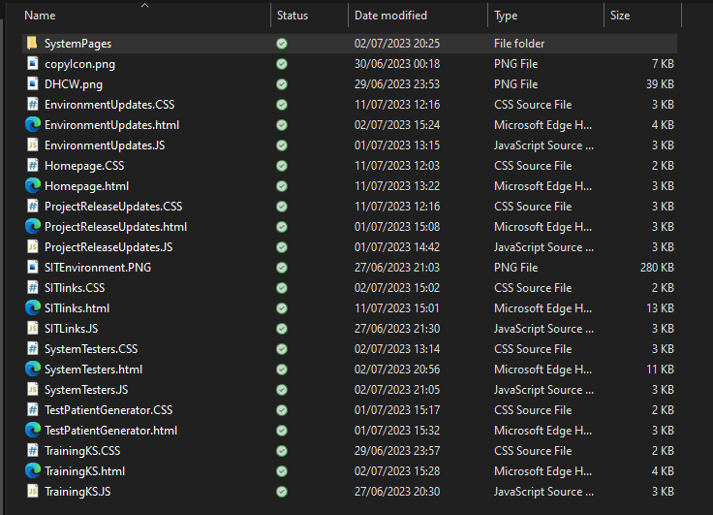

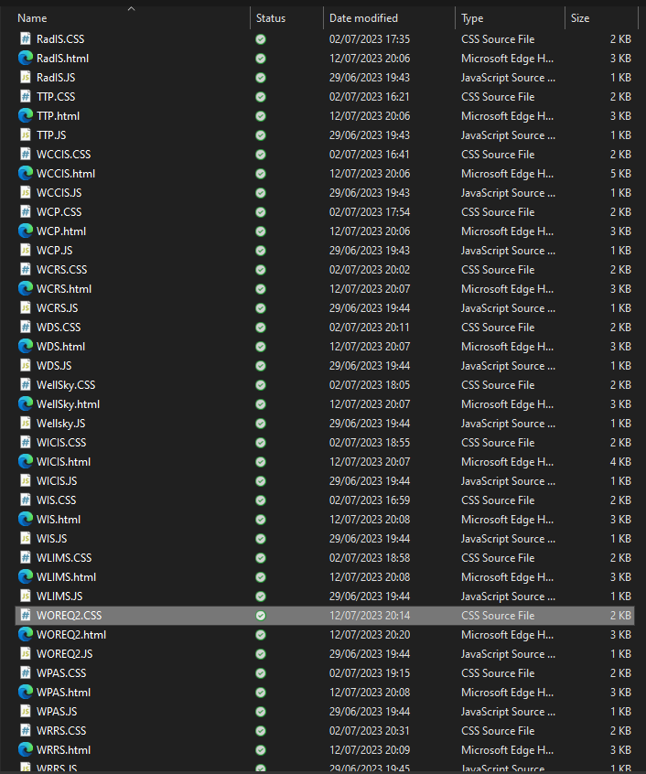
Figure 5 File layout for SIT Training and Communication Application Code

4.3.3 User Interface
In accordance with user story US2, the design of the user interface was intended to resemble that of a DHCW product. The Welsh Clinical Portal served as the primary reference for this design.

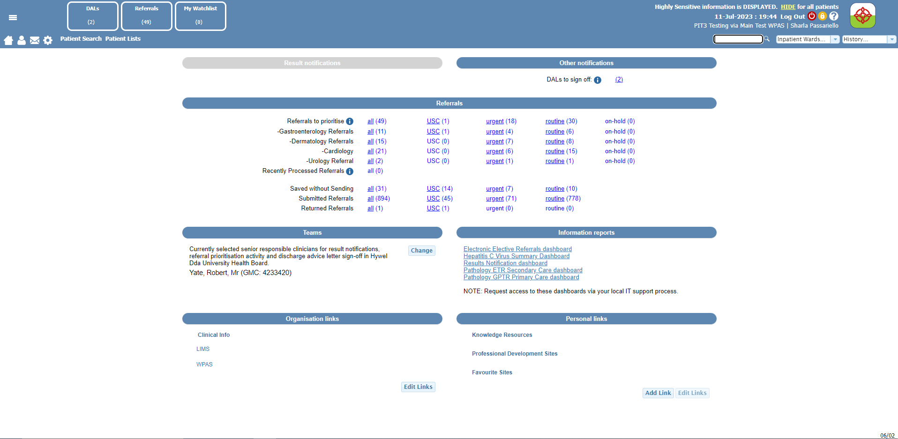
Figure 6 Welsh Clinical Portal User Interface

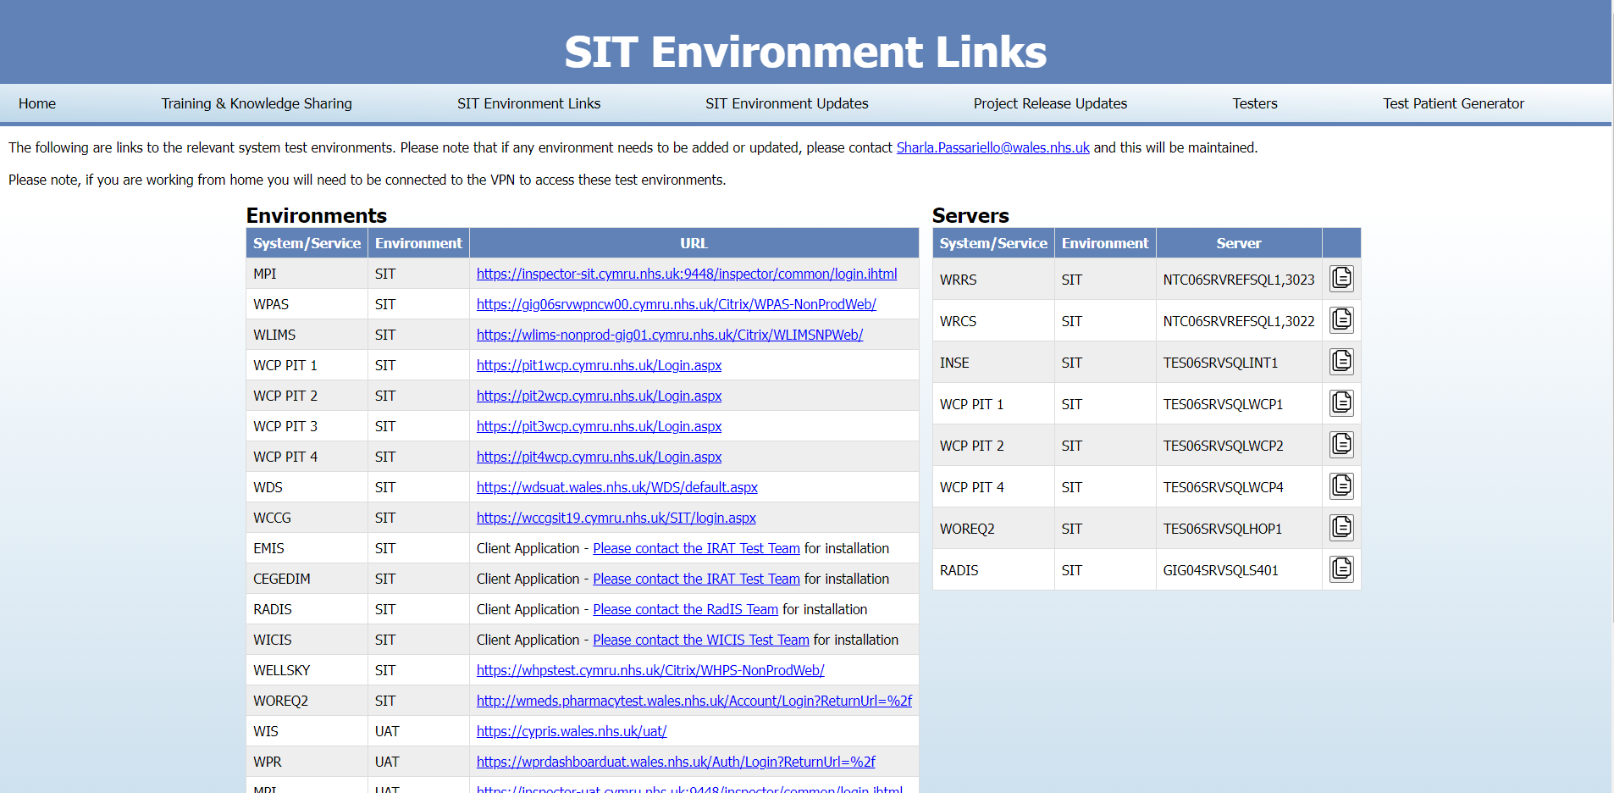
Figure 7 SIT Training and Communication Application User Interface

4.3.4 Code Success and Failures
Due to the client-side only limitations, the html, jQuery, and CSS used throughout building the application was relatively simple. However, one of the notable successes within the application were the AJAX calls implemented within the SIT Environment Updates area and the Project Release Updates area. To illustrate the process of retrieving and posting data from/to a database using a REST API , the author used an online fake REST API known as JSONPlaceholder [32]. This approach enables the application to utilise mock data, effectively demonstrating how real-world implementation and features would display within the SIT Training and Communication Application.

The SIT Environment Updates area and the Project Release Updates area consisted of two types of AJAX calls. The first type involved using the POST method to send data to the mock server. This is ideal for scenarios where a user intends to add an environment or project update. The second type employed the GET method to retrieve data from the mock server. This allows users to conveniently view the environment and project updates. A code snippet has been provided below showing the incorporation of AJAX calls in the SIT Environment Updates page. A similar AJAX call for the Project Updates page can be found in Appendix Three.

//SIT Environment Updates Page
function addEnvironmentUpdate() { // Function to add an Environment Update using POST method

let data = {
title: $("#userID").val(),
body: $("#addEnvironment-Update").val()
};

let $addEnvironmentUpdate = $("#environmentUpdates tbody");
let $method = "POST";

$.ajax({
cache: false,
method: $method,
url: "https://jsonplaceholder.typicode.com/posts",
data: JSON.stringify(data),
contentType: "application/json; charset=utf-8",
dataType: "json",

success: function (data) {

$addEnvironmentUpdate.append(`<tr><td>${data.title}</td><td>${data.body}</td></tr>`);
$('#addEnvironmentUpdate input[type="text"]').val(''); //clear text input fields
$('#addEnvironment-Update').val('');
},
error: (req, status, error) => window.alert("AJAX error")
});
};

function returnEnvironmentUpdates(eventData, handler) {//Returns Environment Updates Posts

let $myEnvironmentUpdates = "https://jsonplaceholder.typicode.com/posts";
let $method = "GET";

$("#environmentUpdates tbody").children().remove(); //Clear data currently populated in html table

$.ajax({

url: $myEnvironmentUpdates,
cache: false,
contentType: "application/json; charset=utf-8",
dataType: "json",
type: $method,
error: function (jgXHR, textStatus, errorThrown) {

},
success: function (data, textStatus, jqXHR) {
let $myEnvironmentUpdates = $("#environmentUpdates tbody");
$.each(data, function (index, value) {
$myEnvironmentUpdates.append(`<tr id=${value.id}><td>${value.title}</td><td>${value.body}</td></tr>`);
});
}
});
}

$(function () {

$("#searchEnvironmentUpdates").on("keyup", function () { //Search Bar functionality on Environment Updates
let value = $(this).val().toLowerCase();

$("#environmentUpdates tr").filter(function () {
$(this).toggle($(this).text().toLowerCase().indexOf(value) > -1) //Toggle method to hide rows that don't match search, toLowerCase method converts text to lower case so not case sensitive
});
});

returnEnvironmentUpdates();//GET all environment updates

addEnvironmentUpdate(); //POST new environment update
$.ajaxSetup({ cache: false });
$("#submitEnvironmentUpdateButton").click(function (e) {
addEnvironmentUpdate();
e.preventDefault();
return false;
});

});
Figure 8 jQuery for AJAX Call for SIT Environment Updates Page

As previously stated, certain functionalities could not be implemented due to the absence of a client-server relationship. Notably, the prototype was unsuccessful in incorporating features such as the ability to add, store, and view documents within the Training and Knowledge Sharing area's system and service pages. Additionally, the edit button in the System Testers section for updating information on DHCW software testers is currently non-functional. However, these areas have been programmed to display a pop-up alert notifying the user that the intended action would have been executed. The following code was implemented for uploading documents to each of the system/service pages:

<!DOCTYPE html>
<html>

<head>
<title>MPI</title>
<link rel="stylesheet" href="MPI.CSS">
</head>

<body>
<div class="navigationBar">
<h1>MPI</h1>

<!--Navigation Buttons-->
<ul>
<li><button class="button" type=button onclick="document.location = '../Homepage.html'">Home</button></li>
<li><button class="button" type=button onclick="document.location = '../TrainingKS.html'">Training & Knowledge Sharing</button></li>
<li><button class="button" type=button onclick="document.location = '../SITlinks.html'">SIT Environment Links</button></li>
<li><button class="button" type=button onclick="document.location = '../EnvironmentUpdates.html'">SIT Environment Updates</button></li>
<li><button class="button" type=button onclick="document.location = '../ProjectReleaseUpdates.html'">Project Release Updates</button></li>
<li><button class="button" type=button onclick="document.location = '../SystemTesters.html'">Systems and Testers</button></li>
<li><button class="button" type=button onclick="document.location = '../TestPatientGenerator.html'">Test Patient Generator</button></li><br>
</ul>
</div>

<main>
<section>
<br><p>Patients in Wales are often registered on multiple clinical systems depending on how and where they receive care.
It is very difficult to link the data from the various systems together and hence to collate the clinical
information together to present to care providers. To overcome these issues, NHS Wales has an Electronic MPI
(Master Patient Index) which helps maintain and link
identities of patients across various clinical systems within Wales. The MPI system was originally procured from
Initiate Systems (now taken over by IBM) several years back. The system is linked up to a large number of
systems like PASs (Patient Administration Systems), Welsh Demographic Service (WDS), Radiology systems, LIMS
(Laboratory Information Management Systems), WCP (Welsh Clinical Portal) amongst others.<br><br>

These systems use the MPI for providing and receiving latest patient demographics data and for querying the MPI
for patient demographics as required but all systems do not use all the services provided by the MPI. The MPI is
an intelligent system, which uses algorithms to match patient records based on configured criteria.<br><br>

All interactions with the MPI system use the HL72.5 messaging standard and are either TCP pipe and hat based or
web services based depending on the type of interaction. All notification messages are channelled routed using
the Integration service in DHCW.</p><br>

<div class="docUploadTitle">
<h1>Training and Knowledge Sharing Documents</h1><br>
</div>

<br><form method="post" action="" enctype="multipart/form-data" id="mpiDocumentUpload">
<div>
<input class="selectUpload" type="file" id="file" name="file" />
<input class="uploadButton" type="button" class="button" value="Upload Document" id="uploadButton">
</div>
</form>

</section>
</main>

<script src="https://code.jquery.com/jquery-3.6.1.js"
integrity="sha256-3zlB5s2uwoUzrXK3BT7AX3FyvojsraNFxCc2vC/7pNI=" crossorigin="anonymous"></script>
<script src="https://cdn.datatables.net/1.12.1/js/jquery.dataTables.min.js"></script>
<script src="MPI.JS"></script>
</body>

</html>
Figure 9 HTML for Document Upload Functionality on System/Service Pages

function uploadSuccess (){

$('#uploadButton').click(function() {

setTimeout(function() {
alert('Document uploaded successfully');
}, 2000); // 2000 milliseconds (2 seconds) delay for demonstration purposes
})

}

$(function () {
uploadSuccess();
});
Figure 10 jQuery for Document Upload Functionality on System/Service Pages

4.3.5 Testing of the SIT Training and Communication Application
The author conducted high-level system testing on the SIT Training and Communication Application once development for the MVP sprint was completed. This was to confirm that even with the known functionality issues resulting from a client-side only prototype, that no unexpected defects were present.

High-level test cases were logged to cover user story functionality. These test cases can be located in Appendix Four. Any defects found during the testing of the MVP were then logged. As per the DHCW Test Framework [2], defects were assigned a severity and priority rating. DHCW categorises the severity and priority of defects per the following descriptions [2]:

Severity:
Severity | Severity Definition
1 - Critical | The issue relates to a crucial part of the system. Clinical users would be critically impacted if the defect were released into production. No workaround exists.
2 - High | The issue relates to a crucial part of the system. Clinical users would be highly impacted if the defect were released into production. A workaround does exist.
3 - Medium | The issue relates to an essential part of the system. However, clinical users would not be severely impacted if the defect were released into production as there is a workaround.
4 - Low | The issue relates to a non-essential function, or a function is working in a restricted manner, or there is a minor problem with the application. Effect on the end user would be minimal.
Table 4 DHCW Defect Severity Definitions

Priority:
Priority | Priority Definition
1 | The system cannot be tested until this issue is resolved
2 | The defect has a considerable impact on the progress of testing overall
3 | The defect has an impact on the progress of testing a particular component
4 | No impact to the progress of testing
Table 5 DHCW Defect Priority Definitions

Defect ID | Defect Description | Area Located | Severity | Priority
1 | When small text entry has been added to SIT Environment Updates area, if the entry is then searched, the Add Update box and results table shrinks | SIT Environment Updates | 4 | 4
2 | When data is searched in the SIT Environment Updates area, and then an entry is added while the search is still being executed, the new entry is showing as a search result even if not an accurate result of what is being searched | SIT Environment Updates | 4 | 4
3 | When small text entry has been added to Project Release Updates area, if the entry is searched, the Add Update box and results table shrinks | Project Release Updates | 4 | 4
4 | When data is searched in the Project Release Updates area, and then an entry is added while the search is still being executed, the new entry is showing as a search result even if not accurate result of what is being searched | Project Release Updates | 4 | 4
5 | When new software tester added to the Testers list, the delete functionality does not work on the new tester | Testers | 3 | 4
6 | When new software tester added to the Testers list, the edit button alert functionality does not work on the new tester | Testers | 3 | 4
The defects discovered from the MVP sprint testing were as follows:

Table 6 SIT Training and Communication Application Open Defects
The issues identified during the MVP sprint will be included in the backlog, along with the user stories that were not included in the sprint. These will be addressed and resolved in subsequent sprints.

4.3.6 User Feedback
To ensure the requirements were satisfied in the development and user expectations were met, a demonstration of the prototype was provided to DHCW software testers who participated the initial survey for requirement gathering. Of the 16 software testers that responded in the initial survey that they were happy to be contacted again, 14 were available for contact. Prior to the demonstration, participants were provided a link to a feedback form via Microsoft Forms and were asked to complete the form after the demonstration. Out of the 14 whom participated in the demonstration, 12 completed the feedback form. The full details of the feedback can be found in Appendix Five.

The outcome of the user feedback was overall very positive. The consensus of the feedback emphasized that the application was very user friendly and provided a lot of beneficial information in a clear, and easy to navigate format.

Participants were asked if they disliked any aspects of the SIT Training and Communication Application. The majority of participants expressed contentment and mentioned no grievances regarding the application. One participant mentioned that they did not like that users had the ability to delete software testers from the Testers list, another mentioned that they thought the SIT Environment Updates table should be displayed in a message board format so that items do not display in a large list, and another user mentioned they would like to see a ‘Message of the Day’ functionality that displays the latest SIT Environment Updates entry.

Participants ranked themselves very likely to use the application were it to go live and rated the MVP deliverable very highly. Thus, the author feels like the delivered product was successful in achieving the desired user satisfaction and will benefit the DHCW software testers if implemented in the future.

4.3.7 Future Implementation
During the demonstration, a Lead Test Analyst expressed their admiration for the prototype. The software tester mentioned their intention to acquire a hosting server in order to continue developing the in-house test patient generator that they themselves built, as it will soon be removed from its current hosting on the WCP developer's server due to capacity challenges. The tester expressed enthusiasm at the possibility of having the prototype hosted on the server, enabling the SIT Training and Communication Application to go live in the future.

With the potential of resourcing a hosting server, the SIT Training and Communication Application will require changes to convert the current format of code into ASP.Net with C# for the frontend development, as well as SQL Server for the backend development. This will allow the application to align with the DHCW Software Development Handbook [20] standards as well as allow for resolution of current functionality issues where a client-server relationship is not available. It is probable that at least two additional sprints will be needed for the SIT Training and Communication Application to be in a state where it is ready to be used in a live environment. However, this milestone will need more sprint planning to accurately establish how long development would take to reach that status.

CHAPTER 5 – EVALUATION
Upon evaluating the data collected around the communication challenges within DHCW, it was evident that these issues aligned with the research results from the literature review. Curtis, Krasner, and Iscoe [3] reported that communication and coordination breakdowns, as well as thin spread of application domain knowledge were identified as key problems in software development, which was reflected as an issue in the DHCW survey. Just as DHCW software testers conveyed, Alharbi et al [9] found that remote working also contributed to reducing team efficiency and decreasing quality of software due to poor communication. It was evident that information was not available in one place for DHCW software testers and was making their roles more difficult, and in some cases, the software testers were not at all aware of information that was impacting them. The literature review showed that problems DHCW software testers faced were not internal challenges as such, but a challenge that is broadly encountered in software testing as a whole.

The feedback received from the software testers on the SIT Training and Communication Application prototype was a positive indication that this is a viable solution to the obstacles being faced. The author is satisfied that the aim of the project has been met and all objectives that were required to meet the aim were achieved, providing a foundation for a solution. The project followed DHCW Software Development standards where possible, and the author used the agile methodology as best as possible with a singular resource. It should be noted that one of the challenges faced throughout this project was that the author took on the role of three DHCW roles: business analyst, software developer, and software tester. Within a project these roles would also demand more than one person per role. Therefore, certain tasks such as unit testing were not executed due to time management, or other tasks were not produced in the amount of detail that the role would normally entail, such as writing out detailed test scripts for the test cases.

If the author were to undertake this project again, the author would allocate more time for the development phase. This would enable the author to incorporate more sprints into the development so that the author could develop the frontend functionality in ASP.Net with C# and implement backend functionality ready to be connected to SQL Server. This approach would bring the prototype closer to being ready for deployment, eliminating the need for recoding the application if a hosting server is resourced in the near future. Additionally, the author would look to condense the CSS files where possible to allow for limiting the number of changes to be made in future if cosmetic changes were needed. However, the author would look to do this in a way that limits the complexity of a change impacting a wide range of areas within the application.

CHAPTER 6 - CONCLUSIONS AND RECOMMENDATIONS
Throughout the course of this project, the author explored communication challenges faced by DHCW software testers since transitioning to remote working and the movement of testers to Application Teams. To gain further understanding, the author explored relevant research literature, examining current findings on software testing, the significance of communication in software development, the impact of remote working on software development, a comparative analysis of agile and waterfall methodologies, the DHCW Software Development Framework, and NHS Information Governance.
To validate the observed communication challenges, the author designed and administered a survey to DHCW software testers. The survey aimed to identify the specific hurdles they encountered as well as determine the essential functionalities required for a web application that could serve as a potential solution to the communication obstacles.
Furthermore, the author explored the agile methodology, examining its advantages and disadvantages, as well as exploring how it could be implemented for the development of the SIT Training and Communication Application. Software and hardware requirements were also analysed. Additionally, the author gathered and refined requirements based on the survey results, converting them into user stories to articulate how the features will be beneficial to the users and act as a blueprint to develop from.
To align with utilising the agile methodology and ensure efficient project management, the author conducted a sprint planning session, using scrum poker to determine the user stories to be developed for the sprint and determine the MVP deliverable, ensuring that the highest priority features were developed within the designated sprint timeframe.
The author implemented the development and discussed the numerous challenges and successes, as well as user feedback from DHCW software testers. The feedback received will guide future improvements and enhancements to the SIT Training and Communication Application. Furthermore, the author evaluated the overall success of the project, encompassing its usability and the extent to which it addressed the initial communication challenges faced by the DHCW software testers. By analysing these aspects, the author was able to determine the projects efficacy and the potential impact the application solution will have on the software testers productivity and efficiency.
In conclusion, implementing a SIT Training and Communication Application has encompassed a range of tasks including extensive research, survey implementation, thorough analysis of requirements, agile development, and comprehensive evaluation. By addressing the communication challenges faced by the DHCW software testers through the creation of the SIT Training and Communication Application, the author has strived to improve collaboration, streamline the process of finding relevant information, and enhance productivity across all DHCW software testers. These met the initial objectives which in turn allowed the author to achieve the aim of the project. Although the author deems the project as successful, there is still room for improvements that should be considered in future.

6.1 Suggestions for further work
Further work is needed for the SIT Training and Communication Application to be in a ready state for deployment. As previously mentioned, the code will need to be updated to ASP.Net with C# and have backend functionality implemented to connect to SQL Server. Further research will be needed into what security processes need to be taken, as well as server storage requirements for implementing the solution to a DHCW server. This research ceased at the beginning of the project when it was known to the author that a server would not be available for the foreseeable future.

CHAPTER 7 – REFLECTION
Upon reflection, it became apparent to the author that the literature review adequately supported the challenges faced within DHCW. However, the author underestimated the difficulty of independently completing the entire project. As previously mentioned, a project of this nature in DHCW involves a minimum of three teams comprised of multiple individuals. The author found it challenging and time-consuming to maintain the quality that each task required as a singular person, leading to a perceived decrease in the quality of certain tasks. In the event of redoing the project, the author would allocate more time to ensure better task quality. Additionally, they would schedule more development sprints to bring the application closer to a deployable state that aligns with the DHCW Software Development framework [20].
Despite facing challenges, the author was happy that they were able to identify a problem and build a prototype that received such positive feedback from the DHCW software testers, despite its existing flaws.

Throughout the project the author was able to experience working in roles that differ from their typical software tester role. This allowed to author to consider if they would be interested in switching their careers to any of those experienced throughout this project. The author found the development task really enjoyable at times but also frustrating at others and had considered if they would like to move into a development role. The author is still considering this and thinks it would be worth developing their own projects during their personal time to see if they continue to enjoy it. The author discovered they would not like to go into the role of a business analyst where gathering and refining requirements would mostly be done.

Completing this project also revealed to the author that they needed to establish a more effective way of balancing extensive workloads. The author grappled with a poor work-life balance and consequently suffered with insomnia and lack of appetite throughout the project. This exacerbated a decline in their mental and physical health. It was a valuable lesson that the author needs to allocate time for self-care and personal well-being when knowingly taking on extensive workloads.

CHAPTER 8 – REFERENCES
[1] B. Hambling and P. Morgan, Software testing: an ISTQB-ISEB foundation guide. Swindon: Bcs, 2010.
‌
[2] R. Murray, G. Norton, R. Wettach, and P. Samuel, “Test Framework,” Digital Health and Care Wales, Cardiff, Jul. 2021.
‌[3] B. Curtis, H. Krasner, and N. Iscoe, “A field study of the software design process for large systems,” Communications of the ACM, vol. 31, no. 11, pp. 1268–1287, Nov. 1988, doi: https://doi.org/10.1145/50087.50089.
[4] R. E. Kraut and L. A. Streeter, “Coordination in Software Development,” Communications of the ACM, vol. 38, no. 3, pp. 69–81, Mar. 1995, Accessed: Apr. 01, 2023. [Online]. Available: https://dl.acm.org/doi/pdf/10.1145/203330.203345
‌
[5] A. Gopal, T. Mukhopadhyay, and M. S. Krishnan, “The role of software processes and communication in offshore software development,” Communications of the ACM, vol. 45, no. 4ve, Apr. 2002, doi: https://doi.org/10.1145/505999.506008.
‌[6] S. Goericke, Y. Jiang, M. Gao, C. Hou, and K. Van Dam, “The Future of Testing,” in The future of Software Quality Assurance, Germany: Springer Open, 2019.
[7] A. Felstead and D. Reuschke, “HOMEWORKING IN THE UK: BEFORE AND DURING THE 2020 LOCKDOWN,” Wiserd, Cardiff, Southampton , Aug. 2020. Accessed: Apr. 03, 2023. [Online]. Available: https://wiserd.ac.uk/wp-content/uploads/Felstead_Reuschke_2020_Homeworking-in-the-UK_Report_Final.pdf

[8] “Is hybrid working here to stay?,” Census 2021, Office for National Statistics – Business Insights and Conditions, May 2022. Accessed: Apr. 03, 2023. [Online]. Available: https://www.ons.gov.uk/employmentandlabourmarket/peopleinwork/employmentandemployeetypes/articles/ishybridworkingheretostay/2022-05-23
‌[9] A. Alharbi et al., “An Empirical Investigation to Understand the Issues of Distributed Software Testing amid COVID-19 Pandemic,” Processes, vol. 10, no. 5, p. 838, Apr. 2022, doi: https://doi.org/10.3390/pr10050838.
‌[10] D. Ford et al., “A Tale of Two Cities: Software Developers Working from Home During the COVID-19 Pandemic,” Cornell University, Sep. 2021. Accessed: Apr. 16AD. [Online]. Available: https://arxiv.org/pdf/2008.11147.pdf
[11] P. Ågren, E. Knoph, and R. Berntsson Svensson, “Agile software development one year into the COVID-19 pandemic,” Empirical Software Engineering, vol. 27, no. 6, Jun. 2022, doi: https://doi.org/10.1007/s10664-022-10176-9.
‌
[12] Dr. M. F. Flores, “Understanding The Challenges Of Remote Working And It’s Impact To Workers,” International Journal of Business Marketing and Management (IJBMM), vol. 4, no. 11, pp. 40–44, Accessed: Apr. 04, 2023. [Online]. Available: http://ijbmm.com/paper/Nov2019/824043604.pdf
‌
[13] M. Khosrow-Pour, Systems and software development, modeling, and analysis : new perspectives and methodologies. Hershey, Pennsylvania (701 E. Chocolate Avenue, Hershey, Pa., 17033, USA): IGI Global, 2014.

[14] International Software Testing Qualifications Board, ISTQB ATM Student Book, 3rd ed. International Software Testing Qualifications Board, 2019, pp. 46–50.
‌[15] L. Khoza and C. Marnewick, “Waterfall and Agile information system project success rates – A South African perspective,” South African Computer Journal, vol. 32, no. 1, Jul. 2020, doi: https://doi.org/10.18489/sacj.v32i1.683.
[16] K. Chari and M. Agrawal, “Impact of incorrect and new requirements on waterfall software project outcomes,” Empirical Software Engineering, vol. 23, no. 1, pp. 165–185, Apr. 2017, doi: https://doi.org/10.1007/s10664-017-9506-4.
‌[17] B. V. Thummadi and K. Lyytinen, “How Much Method-in-Use Matters? A Case Study of Agile and Waterfall Software Projects,” Journal of the Association for Information Systems, vol. 21, no. 4, pp. 864–900, Jul. 2020, doi: https://doi.org/10.17705/1jais.00623.
‌[18] V. Hema, S. Thota, S. Naresh Kumar, C. Padmaja, C. B. Rama Krishna, and K. Mahender, “Scrum: An Effective Software Development Agile Tool,” IOP Conference Series: Materials Science and Engineering, vol. 981, p. 022060, Dec. 2020, doi: https://doi.org/10.1088/1757-899x/981/2/022060.
‌[19] R. Mokhtar and M. Khayyat, “A Comparative Case Study of Waterfall and Agile Management,” SAR Journal - Science and Research, vol. 5, no. 1, pp. 52–62, Mar. 2022, doi: https://doi.org/10.18421/sar51-07.

[20] G. Norton, “Digital Health and Care Wales Software Development Handbook,” Digital Health and Care Wales, Cardiff, Wales, Dec. 2022.

‌[21] G. Norton, “How To Organise Your Software Solution” Digital Health and Care Wales, Cardiff, Dec. 2022. Accessed: Apr. 05, 2023. [Online]. Available: https://nhswales365.sharepoint.com/sites/DHC_Quality/IMS/Forms/AllItems.aspx?id=%2Fsites%2FDHC%5FQuality%2FIMS%2FHow%20to%20Organise%20your%20Software%20Solution%2Epdf&parent=%2Fsites%2FDHC%5FQuality%2FIMS

‌[22] G. Norton, “General Coding Standard,” Digital Health and Care Wales, Cardiff, Dec. 2022. Accessed: Apr. 05, 2023. [Online]. Available: https://nhswales365.sharepoint.com/sites/DHC_Quality/IMS/Forms/AllItems.aspx?id=%2Fsites%2FDHC%5FQuality%2FIMS%2FGeneral%20Coding%20Standard%2Epdf&parent=%2Fsites%2FDHC%5FQuality%2FIMS
‌
[23] “Information Governance Fundamentals,” Digital Health and Care Wales, Oct. 12, 2020. https://dhcw.nhs.wales/ig/information-governance/information-governance-fundamentals/ (accessed Jul. 16, 2023).
‌[24] Information Governance Management Advisory Group Policy Sub Group, “NHS Wales Information Governance Policy,” NHS WALES, Wales, Jan. 2021.
‌[25] “Data Disclosure Agreement,” Welsh Accord on Sharing Personal Information, Wales. Accessed: Apr. 05, 2023. [Online]. Available: https://view.officeapps.live.com/op/view.aspx?src=https%3A%2F%2Fwww.waspi.gov.wales%2Ffiles%2Fwaspi-framework-documentation%2Fdda-template%2F&wdOrigin=BROWSELINK
‌
[26] N. Faci, V. Burégio, E. Ugljanin, and Z. Maamar, “Web 2.0 applications in the workplace: How to ensure their proper use?,” Computers in Industry, vol. 88, pp. 1–11, Mar. 2017, Accessed: Apr. 04, 2023. [Online]. Available: https://www.researchgate.net/publication/315767586_Web_20_applications_in_the_workplace_How_to_ensure_their_proper_use
‌
[27] Mugilan T. S. Ragupathi, Learning ASP.NET Core MVC Programming. Packt Publishing Ltd, 2016.
‌
[28] J. Dudovskiy, “Action Research - Research-Methodology,” Research-Methodology, 2011. https://research-methodology.net/research-methods/action-research/
‌[29] Stamelos, Ioannis G and P. Sfetsos, Agile Software Development Quality Assurance. IGI Global, 2007.
‌[30] J. Duvall, “Scrumfall: When Agile becomes Waterfall by another name,” Business And Economics--Computer Applications, Apr. 2022, Accessed: Apr. 10, 2023. [Online]. Available: https://www.proquest.com/docview/2678813537?accountid=130472&parentSessionId=tEfseplaFaO7Cau3GiHttpw2p9FQMEUjsN70jUoMphs%3D&pq-origsite=primo
‌[31] K. Moløkken-Østvold, N. C. Haugen, and H. C. Benestad, “Using planning poker for combining expert estimates in software projects,” Journal of Systems and Software, vol. 81, no. 12, pp. 2106–2117, Dec. 2008, doi: https://doi.org/10.1016/j.jss.2008.03.058.
‌[32] “JSONPlaceholder - Fake online REST API for testing and prototyping,” jsonplaceholder.typicode.com. https://jsonplaceholder.typicode.com/
‌[33] GOV.UK, “Prime Minister’s statement on coronavirus (COVID-19): 16 March 2020,” GOV.UK, Mar. 16, 2020. https://www.gov.uk/government/speeches/pm-statement-on-coronavirus-16-march-2020
‌
[34] “The Digital Health and Care Wales (Establishment and Membership) Order 2020,” Legislation.gov.uk, 2020. https://www.legislation.gov.uk/wsi/2020/1451/made (accessed Jul. 16, 2023).

[35] Y. Y. A. Talib, MASMe: Developing Mobile Accounting Software for Micro Entrepreneurs. 2018. Accessed: Jul. 17, 2023. [Online]. Available: https://www.researchgate.net/figure/Waterfall-Methodology_fig1_326412659

[36] Scrum.org, What is Scrum? Accessed: Jul. 17, 2023. [Online]. Available: https://www.scrum.org/resources/what-scrum-module
‌

‌

‌

CHAPTER 9 – FURTHER READING
[1] Storr, Will (2020), The Science of Storytelling, William Collins
[2] Brinkmann, S. and Kvale, S. (2018) Doing Interviews (Qualitative Research Kit). Sage
[3] Gottschall, Jonathan (2013), The Storytelling Animal: How Stories Make Us Human, Houghton Mifflin
[4] Aubrey, K. & Riley, A. (2017) Understanding and Using Challenging Education Theories, London: SAGE.

APPENDICES

Appendix One

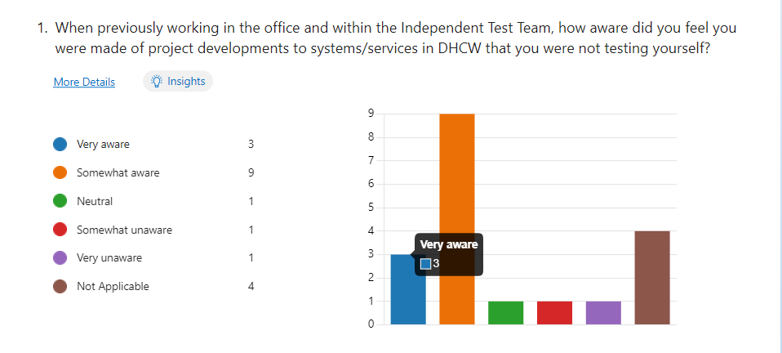

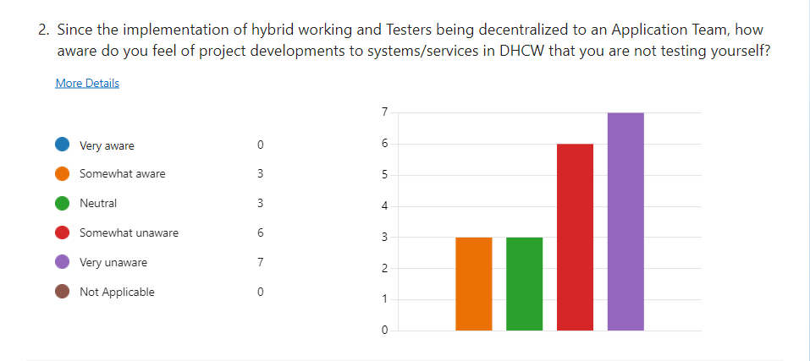

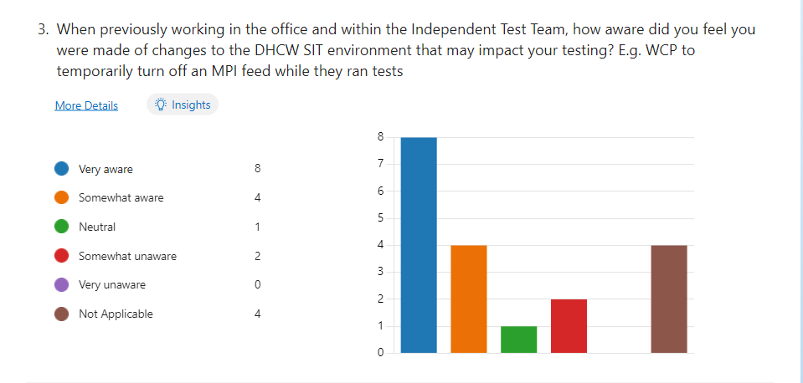

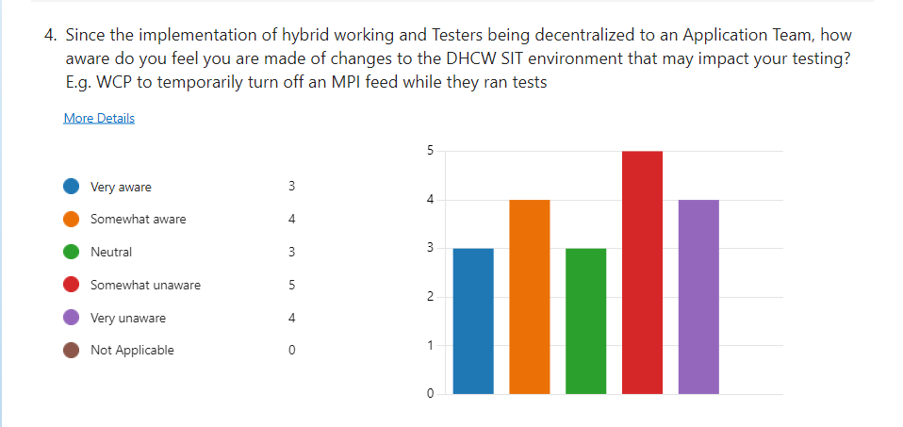

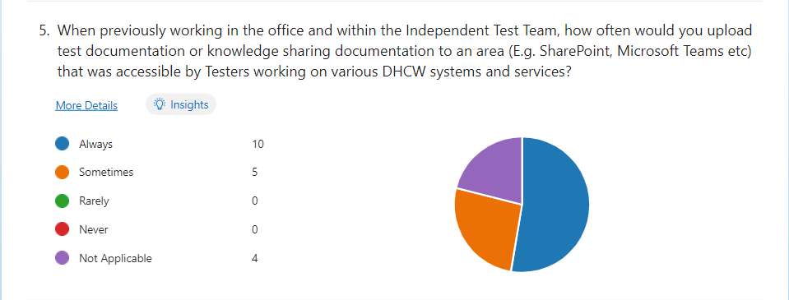
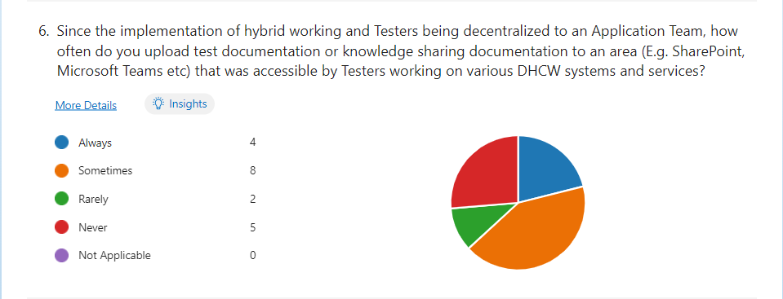
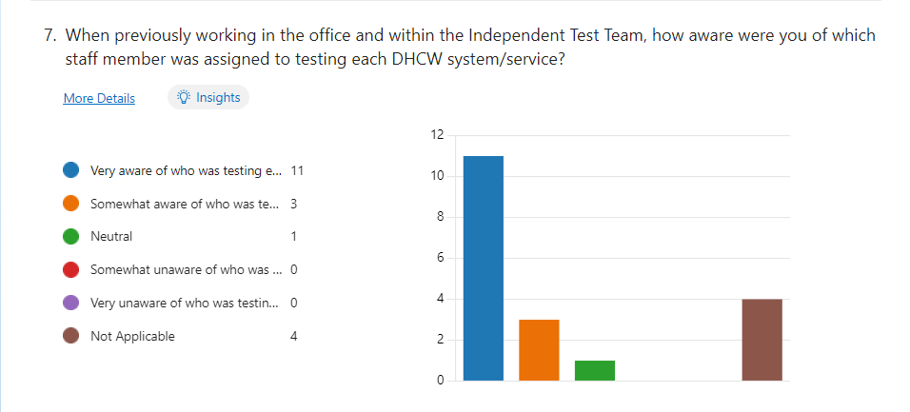
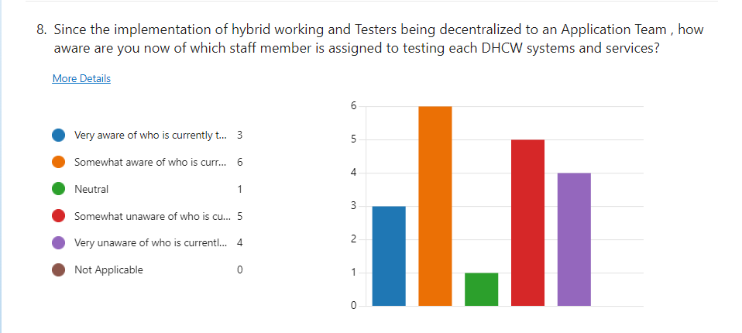
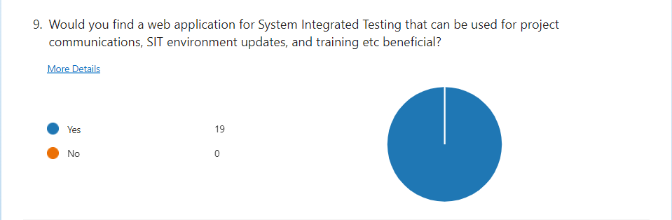
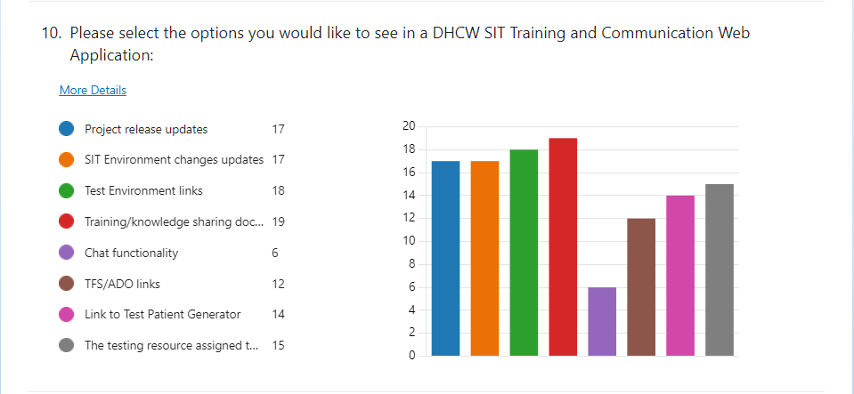
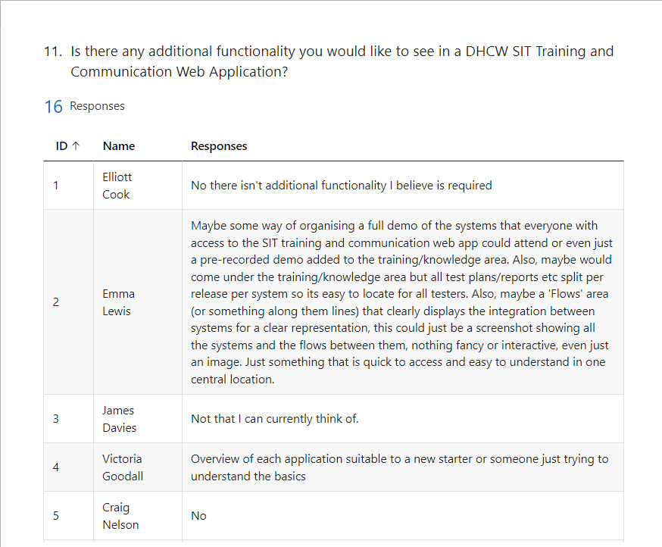
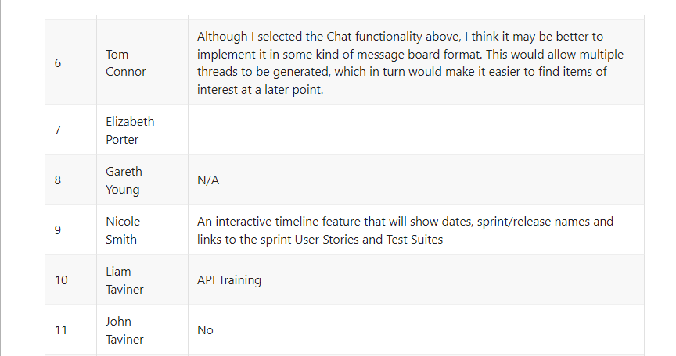
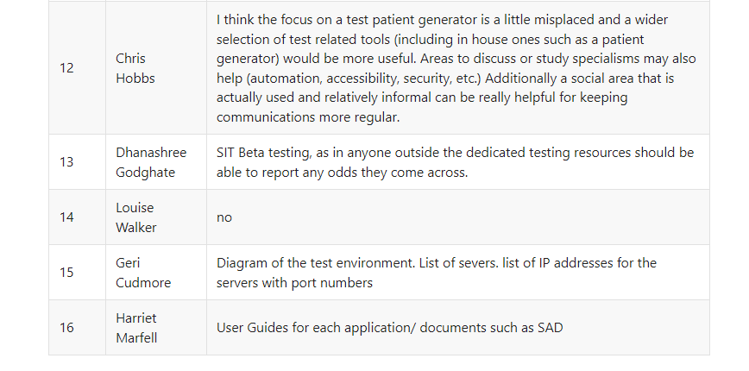
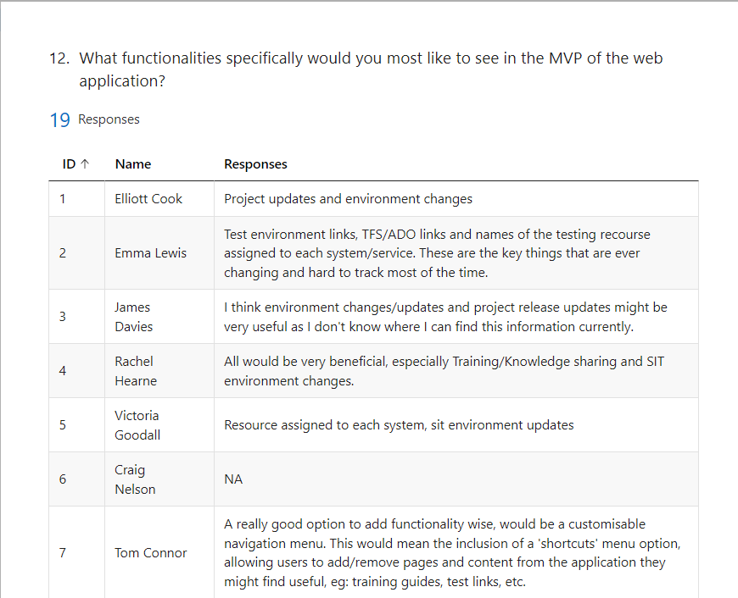
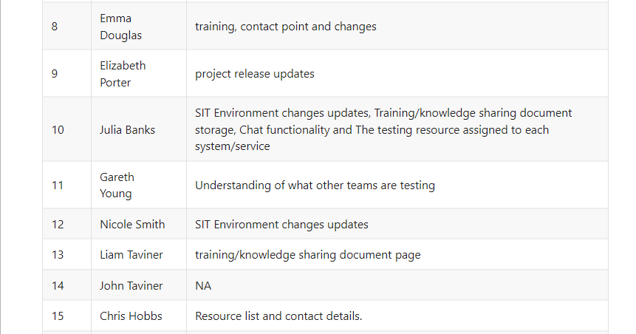
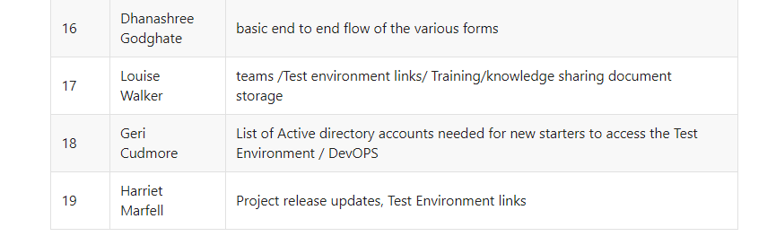

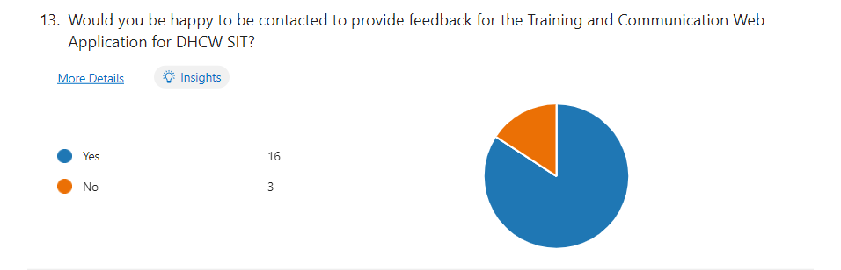

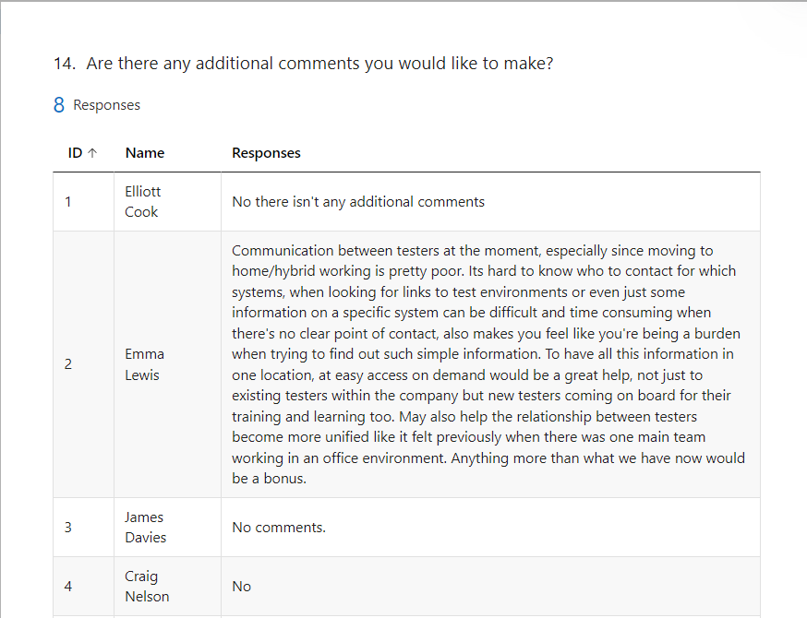
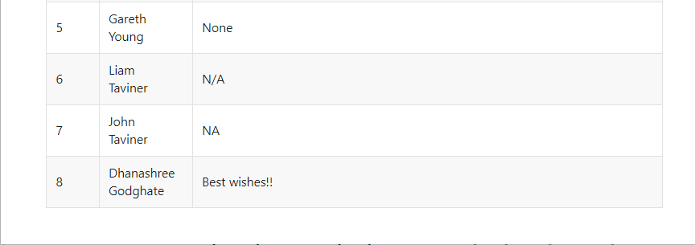

Appendix Two

US1
As a DHCW software tester…
I want… a SIT Training and Communication Web Application
So that… I can enhance communication and knowledge gaps with other DHCW Testers

US2
As a DHCW software tester…
I want… the SIT Training and Communication Application to have the same look and feel as other inhouse DHCW products, such as the colour of the application being blue and the font being Tahoma
So that… the application aligns cosmetically with other NHS applications

US3
As a DHCW software tester…
I want… the SIT Training and Communication Application to have an area to post and view SIT Environment Updates
So that… I can view and share information that impacts the testing of my system/service and other systems or services

US4
As a DHCW software tester…
I want… the SIT Training and Communication Application to have an area to post and view Project Updates
So that… I can view and share information about ongoing projects that could impact the testing of my system/service or other systems or services

US5
As a DHCW software tester…
I want…the SIT Training and Communication Application to provide a list that shows who tests on what systems and services
So that…I am able to know who to contact if I need further information on a system or service

US5.1
As a DHCW software tester…
I want… the list that shows the testers that are assigned to each system or service to provide a contact email address
So that… I can easily contact the software tester if I need further information on their system or service

US6
As a DHCW software tester…
I want… the SIT Training and Communication Application to have a knowledge and training area
So that… I can see information about other systems and services

US6.1
As a DHCW software tester…
I want… the knowledge and training area in the SIT Training and Communication Application to show the different systems and services
And… when I click on a system or service it shows me an overview of the selected system/service
So that… I can understand what that system/service does

US6.2
As a DHCW software tester…
I want… to be able to upload and view documentation to the system or service I select in the knowledge and training area in the SIT Training and Communication Application
So that… I can view and share relevant documentation on that system/service that allows me to gain more knowledge and understanding

US7
As a DHCW software tester…
I want…the SIT Training and Communication Application to provide a list of test environments for each system or service
So that… I can access all test environments easily from one place

US7.1
As a DHCW software tester…
I want… the SIT Training and Communication Application to provide a list of the relevant SQL servers for the test environment with the ability to copy them from a click of a button
So that… I can access the relevant SQL servers for testing and copy the server’s name with ease

US8
As a DHCW software tester…
I want… to be able to view the SIT environment end-to-end diagram in the homepage of the SIT Training and Communication Application
So that… I can see what systems and services are connected in the DHCW SIT environment

US9
As a DHCW software tester…
I want… the SIT Training and Communication Application to have a chat functionality
So that… software testers can communicate with each other for any topics not currently accessible in the SIT Training and Communication Application

US10
As a DHCW software tester…
I want… the SIT Training and Communication Application to provide a list of URL’s to different Azure DevOps projects
So that… I can view ongoing sprint work for projects that I have access to in Azure DevOps

US11
As a DHCW software tester…
I want… the SIT Training and Communication Application to provide a list of active directory accounts needed when a new starter joins the organisation
So that… I can ensure new starters are given the required access

US12
As a DHCW software tester…
I want… the SIT Training and Communication Application to have a customisable navigation bar
So that… I can hide functionalities in the application that I will not use and view specific functionalities that I would like to see

Appendix Three
Code Incorporating AJAX Calls in the Project Release Updates Page:
//Project Release Updates
function addProjectUpdate() { // Function to add an Environment Update using POST method

let data = {
title: $("#projectUserID").val(),
body: $("#addProject-Update").val()
};

let $addProjectUpdate = $("#projectUpdates tbody");
let $method = "POST";

$.ajax({
cache: false,
method: $method,
url: "https://jsonplaceholder.typicode.com/posts",
data: JSON.stringify(data),
contentType: "application/json; charset=utf-8",
dataType: "json",

success: function (data) {

$addProjectUpdate.append(`<tr><td>${data.title}</td><td>${data.body}</td></tr>`);
$('#addProjectUpdate input[type="text"]').val(''); //clear text input fields
$('#addProject-Update').val('');
},
error: (req, status, error) => window.alert("AJAX error")
});
};

function returnProjectUpdates(eventData,handler) {//Returns Environment Updates Posts

let $myProjectUpdates = "https://jsonplaceholder.typicode.com/posts";
let $method = "GET";

$("#projecttUpdates tbody").children().remove(); //Clear data currently populated in html table

$.ajax({

url: $myProjectUpdates,
cache: false,
contentType: "application/json; charset=utf-8",
dataType: "json",
type: $method,
error: function (jgXHR, textStatus, errorThrown) {

},
success: function (data, textStatus, jqXHR) {
let $myProjectUpdates = $("#projectUpdates tbody");
$.each(data, function (index, value) {
$myProjectUpdates.append(`<tr id=${value.id}><td>${value.title}</td><td>${value.body}</td></tr>`);
});
}
});
}

//Document Ready
$(function () {

//Project Release Updates Page
$("#searchProjectUpdates").on("keyup", function () { //Search Bar functionality on Project Updates
let value = $(this).val().toLowerCase();

$("#projectUpdates tr").filter(function () {
$(this).toggle($(this).text().toLowerCase().indexOf(value) > -1) //Toggle method to hide rows that don't match search, toLowerCase method converts text to lower case so not case sensitive
});
});

returnProjectUpdates();//GET all project updates

addProjectUpdate(); //POST new project update
$.ajaxSetup({ cache: false });
$("#submitProjectUpdateButton").click(function (e) {
addProjectUpdate();
e.preventDefault();
return false;
});

});

Appendix Four

Test Script ID | Related User Story ID | Script Title | Steps | Pass/Fail | Additional Comments
1 | US2 | Confirm Application has same look and feel as other DHCW Products | Select each page and confirm the following:  - Colour theme throughout is blue headers, white/blue background, white/grey tables with blue headers.  - All text throughout app is Tahoma font | Pass
2 | US3 | Confirm SIT Environment Updates Area | Confirm option on navigation bar for SIT Environment Updates area  Confirm when selecting option that the SIT Environment Updates area opens | Pass
3 | US3 | Add SIT Environment Update | In SIT Environment Updates area confirm you can add text into updates box including alphabetical, numerical, and special characters  Confirm when you select Submit the text boxes clear  Confirm when you select Submit the update is added to the updates table | Pass | Adding small amount of text causes CSS Issue - Bug to be raised for this
4 | US3 | Search SIT Environment Updates | Confirm Search Bar brings back appropriate results in SIT Environment Updates table | Pass | When data is searched and then an entry is added while the search is still being executed, the new entry is showing as a search result even if not accurate - Bug raised
5 | US4 | Confirm Project Release Updates Area | Confirm option on navigation bar for Project Release Updates area  Confirm when selecting option that the Project Release Updates area opens | Pass
6 | US4 | Add Project Release Update | In Project Release Updates area confirm you can add text into updates box including alphabetical, numerical, and special characters  Confirm when you select Submit the text boxes clear  Confirm when you select Submit the update is added to the updates table | Pass | Adding small amount of text causes CSS Issue - Bug to be raised for this
7 | US4 | Search Project Release Updates | Confirm Search Bar brings back appropriate results in Project Release Updates table | Pass | When data is searched and then an entry is added while the search is still being executed, the new entry is showing as a search result even if not accurate - Bug Raised
8 | US5 | Confirm Testers Area | Confirm option on navigation bar for Testers area  Confirm when selecting option the Testers area opens | Pass
9 | US5 | Confirm Tester information is displayed | Open Testers area and confirm a list is displayed that shows each tester, what system they test, what their job role is, and what their contact email is | Pass
10 | US5 | Confirm Edit and Delete buttons work in Testers area | Select Edit button on a Tester listed and confirm a pop up appears stating edit has occurred  Select Delete button on a Tester listed and confirm Tester is removed from the list | Pass
11 | US5 | Confirm Tester can be added | Open Testers area and enter text into all "Add Tester" fields including alphabetical, numerical, and special characters  Click Add and confirm tester info added to the table  Select Edit button on newly added Tester and confirm pop up alert appears  Select Delete button on newly added Tester and confirm Tester is removed from list | Fail | Edit an Delete button functionality does not work after Tester has been added
12 | US5.1 | Confirm contact email in Testers area | Open Testers area and confirm a list is displayed that shows each tester, what system they test, what their job role is, and what their contact email is  Confirm when you click on the email address that a draft email opens addressed to the contact you clicked on | Pass
13 | US6 | Confirm Knowledge and Training Area | Confirm option on navigation bar for Knowledge and Training area  Confirm when selecting option that the Knowledge and Training area opens | Pass
14 | U6.1 | Confirm Systems/Services Displayed in Knowledge and Training Area | Confirm Systems/Services are displayed in the Knowledge and Training area  When System or Service is selected it opens up that System/Service Page. An overview of that system/service is displayed. | Pass
15 | U6.2 | Adding/Viewing Training Documentation | Open a system/service page from the Knowledge and Training area and confirm under the overview a section of the system/service there is a section for Training Documentation with a Choose File and Upload button  Select Choose file and select a file  Click Upload and confirm pop up alert states upload successful | Pass
16 | US7 | Confirm SIT Environment Links Area | Confirm option on navigation bar for SIT Environment Links area  Confirm when selecting option that the SIT Environment Links area opens | Pass
17 | US7 | Environment Links List displays and provides environments | Open SIT Environment Links page  Confirm list of environments is displayed on the left hand side of the page. The table states if they are in the SIT/UAT environment, displays the system name, and provides a URL link  Confirm when link it clicked, environment opens on a new tab | Pass
18 | US7.1 | Confirm Server list for SIT Environments | Open SIT Environment Links page  Confirm list of servers if displayed on the right had side with the relevant system/service name, if it is in SIT or UAT environment, the server name, and a copy button  Confirm when you select the copy button on a server it is copied to the clipboard | Pass
19 | US8 | Confirm End to End Diagram is displayed on Homepage | Confirm option on navigation bar for Homepage area  Confirm when selecting option that the Homepage area opens  Confirm the End to End DHCW SIT Environment diagram is displayed | Pass

Appendix Five



