Module: Project Management
Module Code: LCLM5003
Student Name: Nadia Qamar
Student ID: 2312083
Assignment Title: A Project Portfolio.

SUSTAINABLE REDESIGN OF MANCHESTER CENTRAL TRANSPORT HUB FOR NET-ZERO URBAN MOBILITY AND ECONOMIC RECOVERY

Part A (Poster)
Part B (Reflection on Feedback)
Part C (Project Management Plan)

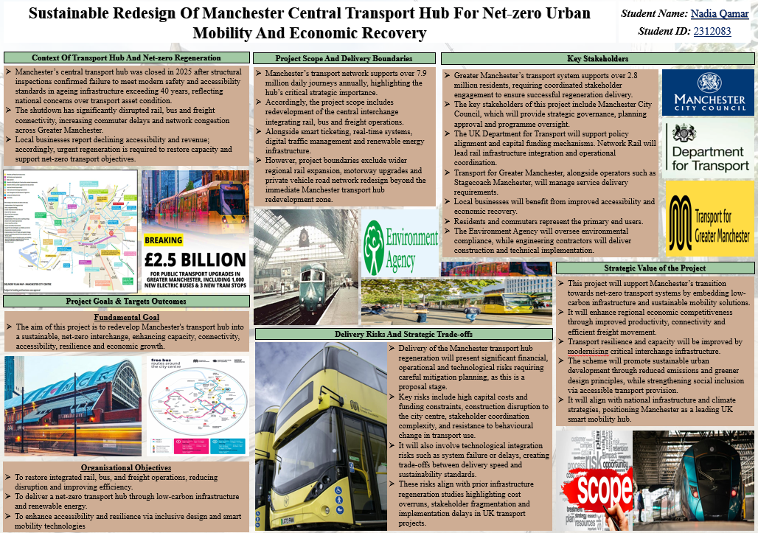
PART (A) – PROJECT PROPOSAL ACADEMIC POSTER

Table of Contents
Part B – Reflection on Feedback 4
➢ Identification of Key Strengths 4
➢ Areas for Improvements 4
➢ Feedback Informed Changes to Final Project Management Plan 5
References 17

Part B – Reflection on Feedback
My tutor and peers have given me some valuable feedback on the strengths of my project proposals and on what I need to do to improve my project management plan. This feedback has helped me to reflect on and assess the quality of my initial work and the structured approach to project management that I would need to adopt to improve the final submission.

Identification of Key Strengths
A key strength identified within the feedback was the clear justification of the sustainable redesign of Manchester Central Transport Hub. I successfully highlighted the interconnectedity of issues of ageing infrastructure, accessibility, congestion, freight efficiency, and regional economic recovery that the proposed redevelopment tackled rather than stopping at the construction itself. This integrated approach was the result of the vision of infrastructure planning in the era, which aimed to achieve multiple goals, including environmental, social, and economic purposes, through a single investment (Hadjidemetriou et al., 2022). A further recognised strength was my focus on digital transformation in the field of passenger management, integrated ticketing, and real-time information systems with AI. In my personal experience, I have seen how real-time updates of the services provided, especially during disruptive events, have helped to mitigate uncertainty and enhance people's trust in the transportation services. This led me to understand the value of smart mobility technologies to operational efficiency and user satisfaction.

Areas for Improvements
The strengths were acknowledged in the feedback, but there are some areas which also need further development. I had suitable goals, but they were not quantifiable and had no quantified time scales. Project management literature consistently states that SMART goals facilitate project monitoring, accountability and project performance measurement since measurable outcomes allow project managers to make objective assessments of project progress (Amin et al., 2023). I also realised that my stakeholder discussion was more about identifying who the key organisations are, rather than assessing their influence, interests, or communication needs. Likewise, my treatment of project risks was descriptive, where mitigation measures, contingency plans and ownership responsibilities were not fully developed. This feedback got me to think about effective project management and realise that it is not just about clever ideas; it is about planning systems! Even well-designed infrastructure proposals can have implementation challenges without measurable goals, structured governance, and initiative-taking risk management.

Feedback Informed Changes to Final Project Management Plan
The feedback was directly used to make several improvements in my final project plan for project management. First, the objectives will be SMART, with the addition of quantifiable carbon-reduction targets, accessibility indicators, operational reliability measures, and completion deadlines. Secondly, a detailed stakeholder power and interest matrix and communication plan will establish the engagement approaches for Manchester City Council, Network Rail, Transport for Greater Manchester, contractors, businesses, and local communities. Third, governance will be improved with a detailed work breakdown structure, Gantt chart, responsibility matrix, and stage gate reviews. The risk will then be controlled by a probability-impact matrix with named owners, risk mitigation and contingency actions and monitoring mechanisms. Systematic governance and risk management enhance the performance of delivering infrastructure projects, while enhancing academic rigour and implementation.
Additionally, this feedback has had a major impact on my personal learning and future attitude toward project management. I have identified to being innovative in my solutions, that I need to be capable of applying structured governance and evidence-based decision-making and measurable planning across the project life cycle to ensure that projects are delivered successfully. For future projects I will regularly be creating SMART objectives, stakeholder engagement plans, detailed risk registers, and governance framework from the beginning. This is a reflective experience that has further reinforced my confidence with using the tool of professional Project Management in complex infrastructure and sustainability projects.

Table of Contents
Part C – Project Management Plan 7
➢ Introduction 7
➢ Project Description 7
➢ Scope 8
➢ Work Breakdown Structure (WBS) 9
➢ The Quad Chart 11
➢ Gantt Chart 12
➢ Stakeholders’ Involvement 13
➢ Allocation of Resources 14
➢ Risk Analysis 15
➢ Conclusion 16
References 17

Part C – Project Management Plan

Introduction
Proposed as an intervention vital to the regeneration of Manchester Central Transport Hub, the ageing interchange is no longer meeting today's expectations for safety and accessibility standards and will be closed in the hypothetical 2025. This need for renewal is emphasised by Manchester Piccadilly station, the second busiest station in Britain outside London, with 25.8 million passenger arrivals and departures in 2023/24 (Britton, 2024). Significant pressure on accessibility is seen in the 47,202 PAS that were recorded at Piccadilly over the same period (Network Rail, 2019), demonstrating the importance of inclusive interchange design. Greater Manchester's carbon footprint is 39% attributed to transport, 3.9 MtCO₂, requiring strategic integration and low-carbon operations. (Anciaes and Jones, 2023) The project rationale will, therefore, integrate the developments of the assets with the welfare of renewable energy, smart ticketing, real-time management and coordinated rail, bus, and freight. This management plan will outline the scope, work packages, schedule, resources required, stakeholder engagement and risk controls for this project. It will serve as an easily translatable blueprint to ease the delivery of a resilient, accessible, and economically productive interchange to relevant stakeholders. The plan will be finalised with a review of the readiness of delivery and expected strategic value.

Project Description
To redevelop Manchester Central Transport Hub into a resilient, Multi-Modal, Rail-Bus-Active Travel-Urban-Freight interchange destined to become a net-zero facility. The proposal addresses the anticipated closure of redundant hub infrastructure, and Manchester Piccadilly is selected as the operational target, as it was the second busiest station outside of London with 25.8 million passenger entries and exits from the station in 2023/24 according to Britton (2024). The facility will be re-designed to include barrier-free routes, lifts, tactile wayfinding, sheltered interchange space as well as digitally accessible passenger information. The intervention is supported by 47,202 instances of passenger assistance requests (PARs) made at Piccadilly in 2023/24, which represents the material demand for inclusive station operation (Network Rail, 2019). The project will be managed following the guidelines of SMART as the objectives are specific, measurable, achievable, relevant and time bound.
- Objective 1: At project completion in 2030, restore integrated rail, bus & freight operations and have 95% scheduled-service reliability.
- Objective 2: Implementation of PV Renewables and energy-efficient systems, as well as electric-bus charging, will help to reduce operational carbon emissions by 40% by 2030 compared to 2025.
- Objective 3: Prior to 2030, implement 100 % Step Free passenger routes and make all interchange information available in real-time and accessible via all modes.
By 2038, Greater Manchester will be aiming to reach carbon-neutral status and to successfully make infrastructure choices that will lead to modal shift and transport emissions reductions (Crowther et al., 2023). The assessment of success will be through reaching the criteria of operational readiness, carbon monitoring, reliable passenger flow, construction safety, and acceptance of stakeholders. The Bee Network aims to be an integrated bus, tram, cycle, walk, and rail by 2025 (Manchester), 2030 (London). As such, measurable environmental, social, and economic benefits will be created for residents, visitors, employers, and coordination operators as part of this project.

Scope
The project will include the full redevelopment of the defined Manchester Central Transport Hub site from 2026 to 2030. In scope works include safely removing old, unsafe buildings, building integrated interchange and rail, bus, and freight facilities, installing step-free access, introducing lifts, tactile paving, creating sheltered waiting areas, providing secure cycle storage and public realm improvements. Digital deliverables include account-based ticketing, real-time passenger-information displays, AI-supported crowd management, integrated control-room systems, and cybersecurity controls. Environmental works will involve fitting rooftop photovoltaic panels, energy-efficient lighting, ventilation, and heating, charging electric buses, providing sustainable drainage and low-emission space for the consolidation of vehicle freight.
By 2030, the project will be commissioned, and at that time, the environmental outcomes will include Operational carbon emission reduction of 40% when compared to the 2025 baseline and 95% scheduled-service reliability, with 100% step-free interchange routes. The scope exclusions include regional rail-route expansion, motorway improvements, redesign of private roads outside the hub area and acquisitions of rolling stock and citywide bus-network reform. Some factors that hinder key constraints are essential services, statutory planning approval, rail possessions, funding, and construction site safety. The formal approval of any impact on cost, schedule, carbon target, or operational capacity applies to any change that has an impact.

Work Breakdown Structure (WBS)
The Work Breakdown Structure breaks down the Manchester Central Transport Hub programme into nine controlled deliverable streams that allow for accountable planning, cost estimation and integration of schedules. It starts with governance and the formation of the project board, business case, funding approvals, reporting process and change control authority. This is particularly crucial as the Infrastructure and Projects Authority (IPDA) mandates that large-scale projects have clear accountability, a reassuring guarantee and significant decision-making documented to flow fluently through delivery (Moshood et al., 2025). Preparing for and gaining approval of structural, environmental, utilities, accessibility and passenger-flow surveys before detailed design, environmental assessment and statutory consents. The package of work will include civil engineering, rail systems, digital technology and renewable energy innovations, which will be supplied by selecting the highest-quality, lowest-cost, least-carbon and most-social-value bids. Public procurement policies ensure that contracting authorities are treating suppliers equally, transparently and proportionately (Hamilton, 2022).
Temporary diversions, isolation of utilities, removal of unsafe assets and remediation of contaminated land will all be done during enable works prior to construction. Core infrastructure is being built to provide rail interfaces, bus bays, freight area, lifts and ramps, tactile surfaces, cycle storage, drainage and public realm. The accessibility package will be checked against the Equality Act 2010 duty to make reasonable adjustments for disabled persons (GOV.UK, 2010). Net zero systems have photovoltaics, efficient building services, electric bus charging and Sustainable drainage. Digital mobility integration will use account-based ticketing, live information, analytics for managing crowds, control-room interfaces and cybersecurity protection. Testing, commissioning and handover will ensure that safety, accessibility, interoperability and operational readiness are confirmed. Finally, benefits realisation will be tracking the 40% operational-carbon reduction, 95% reliability target and gauge stakeholder satisfaction, and lessons learned will be closing contracts and enhancing future urban infrastructure delivery.
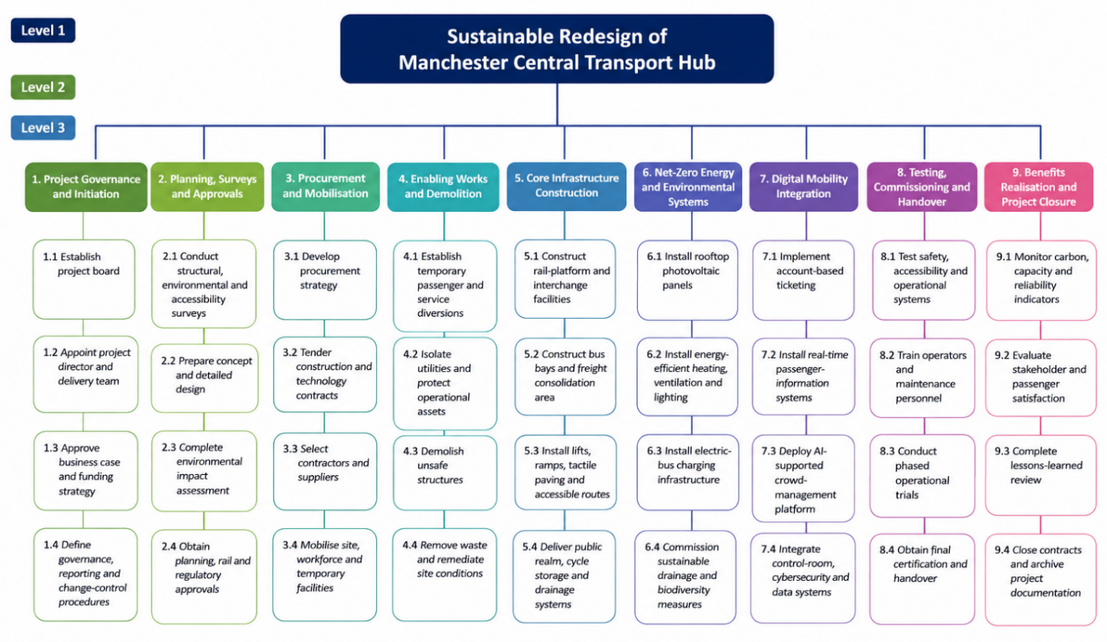
Figure 1: Work Breakdown Structure Decomposes the Manchester Central Transport Hub Programme
The Work Breakdown Structure has a hierarchical numbering system starting from 1.0 through 9.0 for the major work packages and 1.1 through 1.4 and 2.1 through 2.4 for the subordinate activities. Ownership is assigned for each major deliverable for greater accountability and performance monitoring. Governance is led by Manchester City Council (1.0), planning and approvals are managed by procurement specialists (3.0), principal contractors (4.0–6.0) deliver construction work and net-zero infrastructure, and digital system providers (7.0) implement smart technologies, and Transport for Greater Manchester (8.0–9.0) oversees commissioning, benefits realisation and project closure.

The Quad Chart
One visual management instrument for decision-making is a quad chart, which succinctly presents the objectives, time, resources, and risks (Murphet, 2022).
Objectives and Benefits: The scheme will re-open with 100% step-free interchange routes, 95% scheduled-service reliability and a 40% operational-carbon reduction compared to the 2025 baseline in 2030. By 2038, Greater Manchester has a statutory target to become carbon neutral by 2038 (Manchester, 2025), and these outcomes play a key role in meeting that target.
Schedule and Milestones: The design and approval process will take place from January 2026 until December 2026, procurement and enabling works from January 2027 until June 2028, construction from July 2028 until December 2029 and testing, commissioning, and handover from January to June 2030. Rail possessions will be planned in a sequence during less busy periods to ensure continuity of service.
Resources and Governance: Manchester City Council will be the project board chairman; Transport for Greater Manchester will provide leadership for service integration; Network Rail will sign off on rail interface approvals, whilst a main contractor will be responsible for site delivery. Financial resources will comprise public funds, financing from operators and green financing tools.
Principal Risks: Cost escalation, slow approvals, disruption, supply chain shortages, and failure caused by a cyber system will be mitigated by contingencies, stage gate, differences, framework procurement, penetration testing, and manual fallback procedures. As such, the quad chart will allow for quick governance-level review and coordination of delivery decisions.

Gantt Chart
Table 1: Gantt Chart
Work package | Month - 01 | Month - 02 | Month - 03 | Month - 04 | Month - 05 | Month - 06 | Month - 07 | Month - 08 | Month - 09 | Month - 10 | Month - 11 | Month - 12
Governance, surveys and approvals
Detailed design and procurement
Enabling works and diversions
Demolition and core construction
Net-zero and digital installation
Testing, commissioning and handover
The 12-month programme starts with governance, baseline surveys, and statutory approvals in Months 01-04, before progressing through a sequence of activities, durations, and dependencies to monitor conclusion in Months 11-12. The detailed design and procurement processes occur side-by-side within Months 03 – 06, which reduces the programme duration without eliminating any approval gateways. Work is done to enable, and passenger diversions from the line and site are conducted in Months 05 - 07 prior to the start of demolition. During Months 07–10, referencing the critical path, the Core construction is built, with the end date of the critical path depending on the completion of the Core construction. Installing PV, electric-bus charging, ticketing, and real-time systems are done during Months 09–11. Evaluate, Accessibility Assurance, Operational Trials and Handover take place from Months 11-12. Progress reviews will be conducted monthly to determine progress and compare to milestones and recover the delays; the latter will be escalated if not recovered.

Stakeholders’ Involvement
Stakeholder engagement will be managed through a power-interest matrix, which will differentiate between parties who make decisions, who deliver on the agreements, regulators, and affected users. The programme will be funded by Manchester City Council, operate under a monthly Project Board with Manchester City Council as the chair, and will decide on planning, land-use, and regeneration. Manchester, 2025, recognises Piccadilly as a strategic gateway that needs to be developed through integrated transport-led development (UITD). Temporary service planning and passenger communication are clearly allocated responsibilities for local transport services within the Greater Manchester Combined Authority framework (Carter et al., 2024) and will be led by Transport for Greater Manchester. The role of Network Rail will be to approve the design for the rail interface, possessions, and operational safety arrangements, with a focus on funding assurance and policy development given to the Department for Transport.
The principal contractor, specialist designers and digital suppliers will report cost, quality, safety, carbon performance, and attend, maintain and participate in weekly delivery meetings. The Environment Agency will be looking at flood-risk, drainage, and pollution-control measures as part of the requirement for regulating environmental protection (Woods, 2024). Quarterly workshops, easy access surveys, and briefings on construction impacts will involve residents, commuters, disability organisations, businesses, and freight operators. This is key as public authorities are accountable to meet the needs of disabled users when providing services (Balaji 2025). A stakeholder register will contain interests, influence, frequency of communication, concerns, actions, and owners accountable. Programme continuity and public legitimacy will be maintained through the Project Board to settle escalated disputes within ten working days.

Allocation of Resources
Financial, human, physical, technological, and environmental inputs will be combined for resource allocation, using a 12-month baseline schedule. Manchester City Council and the Department for Transport will fund the infrastructure, and spending will not be considered until the Project Board has received stage-gate assurance. Public investment decisions – require the public Treasury Green Book to show strategic, economic, commercial, financial and management cases (HM Treasury, 2026). A cost manager will keep a cost-loaded schedule, forecast cash flow monthly and manage approved change requests for contingency spending. The principal contractor will be responsible for a usability specialist, rail-interface, civil engineer, architect, quantity surveyor, accessibility adviser, environmental manager, electrician, health-and-safety experts, as well as digital-system engineers.
Labour needs will be compared to construction productivity, possession windows, and critical-path activities weekly. Isla will leverage temporary bus capability, lifting equipment, low-emission plant, construction materials, PV panels, charge units, lifts and ticketing hardware and control room servers. Whole-life value, carbon performance, and supply-chain resilience will be key issues in the procurement process, in line with public procurement policy objectives (Lesniewska, 2026). Digital resource will comprise secured cloud storage, interoperable data platforms, cybersecurity testing, and operational dashboards. There will be Sustainable Drainage features, Biodiversity Planting, and Waste-Segregation facilities as environmental resources. Reporting resource utilisation will alert to shortages early, allowing resequencing, supplier escalation, or budgeted reallocation as resource requirements.

Risk Analysis
Risk analysis is a process of systematically identifying and analysing uncertainties and assigning appropriate responses to risks safeguarding project goals, while also assessing the probability and impacts of risks (Zhang et al., 2024). Threats will be assigned a score in the risk register using a probability x impact matrix of 5 x 5; this will range from 1 to 25. Risks with a score of ≥ 15 are reported monthly to the Project Board, have named owners, and have funded contingency actions applied. Cost escalation is important as UK public works programmes have been impacted by affordability and delays in completion rates, as per the study (Onalaja, 2023). Early market input, suitable ‘best value' type fixed-price packages, value engineering reviews and a controlled contingency reserve will be deployed by the commercial manager. Operations and reputation risk from construction disruption exists due to the need to maintain operations of the rail, bus, freight, and pedestrian systems during redevelopment.
In terms of work distribution, the operations manager will allocate possessions between times of lower demand, issue signed temporary routes, post notices and keep track of passenger-flow data every day. Appropriate method statements, competence checks, segregation of work areas and independent audits are required for health and safety risk activities such as lifting, live rail interface, and confined areas. To build, occupational hazards must be systematically managed (Cook et al., 2022). Digital integration failure is high because ticketing systems and passenger information, and the control room, for it, also need to be able to exchange data effectively. Interoperability, staged testing, penetration testing, supplier agreements, and manual fallback procedures will be a digital lead necessity. Supplier, access-control, and incident-response risks will be covered by cybersecurity controls (Green, 2023).
In addition, the environmental risks are contaminated land, flooding, noise, dust, and delayed consent. These conservational hazards are a subset of planning risks. The environmental manager will conduct surveys, undertake sustainable drainage, and secure ongoing regulator engagement. Consultation will be made easily available, schedules will be published, and complaints will be settled in a timely manner to minimise stakeholder resistance. RoA Ratings, Triggers, Mitigations and Residual exposures will be updated weekly. Escalation and recovery planning/final change-control decisions will result from risks that go beyond tolerance.

Conclusion
This project management plan sets out a managed delivery route to make Manchester Central Transport Hub a controlled delivery to deliver an integrated, accessible and net-zero transport hub. Clear scope boundaries, SMART objectives, work packages, schedule control, stakeholder governance, resource allocation, and risk mitigation ensure full accountability during implementation. Emphasis is placed on safe operations with continuity on rail, bus, freight, and pedestrian transport, in addition to the provision of renewable energy, electric charging, digital mobility and inclusive access systems in a 12-month programme. Success will be achieved via 100% step free, 95% scheduled-service reliability, and a 40% reduction against the baseline from an operational-carbon view. This will therefore establish Greater Manchester as a resilient, economically robust, and passenger-friendly region with sustainable urban transport.

References
Amin, H., Scheepers, H. and Malik, M., (2023). Project monitoring and evaluation to engage stakeholders of international development projects for community impact. International Journal of Managing Projects in Business, 16(2), pp.405-427.
Anciaes, P. and Jones, P., (2023). Developing low-carbon freight microhubs in London-Principles, benefits, and locational analysis.
Balaji, K., (2025). E-Government and E-Governance: Driving digital transformation in public administration. Public governance practices in the age of AI, pp.23-44.
Britton, P. (2024). Manchester Piccadilly named second busiest railway station outside London. [online] Manchester Evening News. Available at: https://www.manchestereveningnews.co.uk/news/greater-manchester-news/manchester-piccadilly-named-second-busiest-30418978 [Accessed 24 Jun. 2026].
Carter, J., Labib, S.M. and Mell, I., (2024). Understanding and assessing climate change risk to green infrastructure: Experiences from greater manchester (UK). Land, 13(5), p.697.
Cook, E., Velis, C.A. and Black, L., (2022). Construction and demolition waste management: a systematic scoping review of risks to occupational and public health. Frontiers in Sustainability, 3, p.924926.
Crowther, A., Petrova, S., Evans, J. and Scott, K., (2023). Making and mobilising place: The governance of Greater Manchester’s decarbonisation ambitions. Norsk Geografisk Tidsskrift-Norwegian Journal of Geography, 77(3), pp.157-170.
GOV.UK (2010). Equality Act 2010. [online] Legislation.gov.uk. Available at: https://www.legislation.gov.uk/ukpga/2010/15/contents [Accessed 24 Jun. 2026].
Green, C., (2023). Best practices in supplier relationship management and response when supply is disrupted by cyber-attack: An incident response framework. Journal of business continuity & emergency planning, 17(1), pp.6-15.
Hadjidemetriou, G. M., Teal, J., Kapetas, L., and Parlikad, A. K. (2022). Flexible planning for intercity multimodal transport infrastructure. Journal of Infrastructure Systems, 28(1), 05021010.
Hamilton, S.G., (2022). Public procurement–price-taker or market-shaper? Critical perspectives on international business, 18(4), pp.574-615.
HM Treasury (2026). THE GREEN BOOK UK GOVERNMENT GUIDANCE ON APPRAISAL. [online] Available at: https://assets.publishing.service.gov.uk/media/698dbcd17da91680ad7f4308/The_Green_Book_2026.pdf [Accessed 24 Jun. 2026].
Lesniewska, F., (2026). Tapping into public procurement. A Research Agenda for Law, Finance and the Environment, p.251.
Manchester, G. (2025). The Bee Network. [online] Greater Manchester Combined Authority. Available at: https://www.greatermanchester-ca.gov.uk/what-we-do/transport/the-bee-network/ [Accessed 24 Jun. 2026].
Moshood, T.D., Rotimi, J.O. and Wajiha, S., (2025). Sustainability principles in infrastructure project delivery: establishing the broader implementation strategies for decision-making. Construction Innovation, 25(5), pp.1370-1411.
Murphet, J., (2022). Understanding Quad. Beckett and media, pp.155-76.
Network Rail (2019). Manchester Piccadilly’s Assisted Travel Lounge fully opens to passengers. [online] Network Rail Media Centre. Available at: https://www.networkrailmediacentre.co.uk/news/manchester-piccadillys-assisted-travel-lounge-fully-opens-to-passengers [Accessed 24 Jun. 2026].
Onalaja, A.A., (2023). Improving costing in infrastructure projects to accommodate uncertainties. University of Northumbria at Newcastle (United Kingdom).
Wadhwa, K., (2024). The Role of Gantt Chart in the Project Management.
Woods, N.D., (2024). Structuring Bureaucratic Performance? Assessing the Policy Impact of Environmental Agency Design. Sustainability, 16(17), p.7505.
Zhang, X., Goh, M., Bai, S. and Wang, Z., (2024). Risk response decisions for projects in project portfolios considering objective adjustments and project interdependencies. Kybernetes, 53(7), pp.2217-2246.

