Jaroslav Demeter (2240603)

Effective teamworking and communication skills
(BMSW4009_CARD)

Contents
Terms of Reference. 1
Procedure. 1
Introduction. 1
Main Findings. 2
What makes Effective Team Communication. 2
Belbin’s Theory. 3
Practical Example. 5
Conclusion. 6
Reference List. 7
Apendices. 8

Terms of Reference.

This report has been requested by Melanie Squire as part of the Effective Teamworking and Communication Module, for the Employability Skills Business Course of the UWTSD. This report has been done by Jaroslav Demeter and will be submitted by the 17th of November.

Procedure.

Using Websites, Online Blogs and Lectures Content.

Introduction.

This report will expand on the concept of Effective Teamwork Communication, the importance of it in the workplace and the structure of Good Teamwork Communication. Will offer an overview of Belbin’s Theory and an example of a Practical Communication Issue in the Workplace.

Main Findings.

What makes Effective Team Communication.
Effective communication in the workplace is an essential element in promoting employee morale, engagement, productivity, and satisfaction. It fosters better collaboration and cooperation among team members, resulting in improved outcomes for individuals, teams, and organizations. Employing effective communication strategies in the workplace is therefore pivotal in achieving successful business results. (Better Up, 2022)
It is essential to provide employees with the information they need to excel, enabling them to perform their tasks more efficiently and achieve their goals. Good communication is important not only for creating a positive work environment and promoting teamwork but also for eliminating misunderstandings and inefficiencies. Achieving this requires clear and assertive communication, striking a balance between accuracy and human relationships. By prioritizing effective communication, organizations can significantly improve their productivity, employee satisfaction, and overall success. (Coursera, 2023)
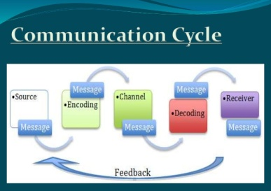

Belbin’s Theory.
Dr. Meredith Belbin, an international management consultant, developed Belbin’s Team Role Theory to identify certain roles that people tend to prefer in a team environment and how it affects group productivity. There are nine team roles identified by Belbin that include shaper, brainstormer, coordinator or chairperson, implementer, specialist or expert, completer/finisher, monitor-evaluator, plant or ideas generator, and resource investigator.
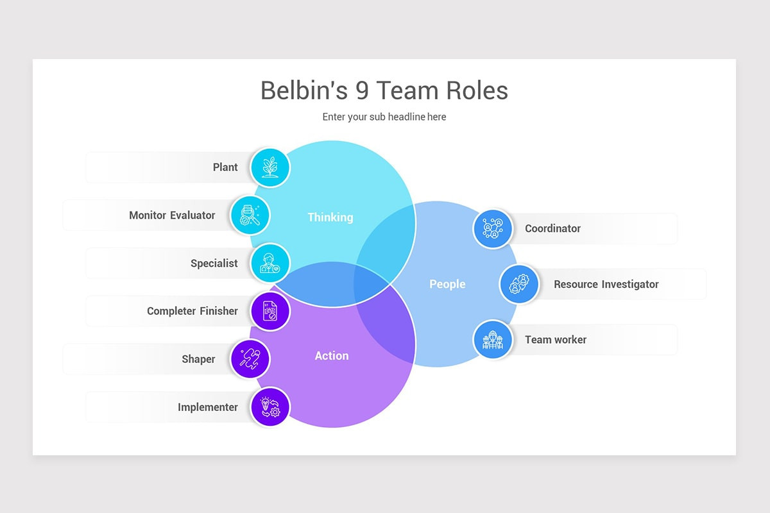
(Nulivo.com)
In accordance with Belbin's theory, it is important for every team member to assume separate roles depending on their distinct characteristics and skills to ensure the success of the group (Couch Foundation, 2023).
A good manager might choose to give an introverted plant space to shape her ideas away from the group, rather than subjecting her to critical thinkers like shaper and monitor-evaluator before her creative concepts are fully realised. A resource investigator and implementer might require a flexible schedule, giving him time in and out of the office to balance external connections with project work. Meanwhile, the coordinator and team worker will need regular contact with all her colleagues to oversee the project and ensure that everyone is working towards the same goal. (TSW, 2022)
This approach enables an individual or team to benefit from self-knowledge and adjust behaviour according to the demands being made by the external situation. (University of Cambridge, 2016)
Monitor Evaluators, from Belbin's team roles model, value rational, strategic thinking, and planning. They analyse situations and make objective conclusions, making sound decisions thanks to their analytical skills. (Firmbee, 2023)
Specialists prioritize acquiring technical skills and specialized knowledge to maintain professional standards and defend their field Able to provide logical and technical solutions with scientific training. (Peter Mackechnie, .)
Misunderstandings lead to conflicts. Plants focus on the bigger picture but may overlook details, which can be a strength or a weakness. (Team Challenge Company, 2017)
Shapers are initiative-taking individuals with a forceful, directive managerial style. They are competitive, daring, and assertive leaders who achieve results quickly, advancing their careers faster than others. (One Education, 2023)
In a team, the Implementer plays a crucial role in ensuring that things get done. They organized tasks and the practical aspects of a project to create a clear plan of action that the rest of the team could follow. The implementer is known for their exceptional organizational and practical skills. (Virtual College, 2022)
A coordinator is a vital part of any team. They manage procedures, set agendas for meetings, facilitate discussions, and delegate tasks effectively. They also have a talent for recognizing and utilizing the strengths of team members. (John Dabell, 2019)
Team Workers are individuals who play a vital role in ensuring that members of a team work together efficiently and effectively. They function as negotiators within the team and possess qualities such as flexibility, diplomacy, and perceptiveness.

The Completer Finisher is a person who is highly focused on achieving perfection and will always go the extra mile to ensure that everything is precisely the way it should be. (Hopman,.)
In every team, there is usually someone who is an inventive mind and produces new and innovative ideas. This person is known as the Resource Investigator. They are ideal for brainstorming sessions and setting the tone for new projects. However, their weakness lies in following through and executing their ideas. (Harappa, 2022)
Even though this Theory has many benefits, we cannot forget that Belbin’s team roles theory is predicated on an individual's self-assessment of their inherent strengths and weaknesses, which subsequently informs their ideal role within a team. However, this approach can be subject to bias, as individuals may overestimate their strengths or undervalue their weaknesses. This can have a detrimental impact on the accuracy of the assessment, leading to suboptimal team performance (Rosseland, 2023).

Practical Example.

My example was that I noticed that my employee wasn’t following cleaning protocols properly, leading to misunderstandings. To address this, I initiated a one-on-one meeting, clearly communicated expectations, and provided hands-on training to ensure they understood the correct procedures. Regular check-ins were established to maintain open communication, fostering a better understanding between me and my employees.
In order to prevent a recurrence of this situation, it is advisable to establish a clear protocol for all employees to adhere to. It is important that all personnel understand the significance of following company policies and procedures at all times. Furthermore, it is important to emphasize that you are always available to assist in the clarification of any work-related issues and are willing to provide support and additional training to ensure that everyone is equipped to perform their job duties effectively.

Conclusion.

In conclusion, Good Teamwork Communication is essential in the workplace. From promoting good relations between employees to ensuring productivity and effectiveness by avoiding mistakes. Belbin’s Theory has been an incredibly valuable discovery for me, as it has also been Tuckman’s theory and the Team Developing Phases. I’ll make sure to make good use of both as I have already done with Kolb’s Theory from the moment I learnt about it.

Reference List.

Better Up. (2022). Communication is key in the workplace. Here is how to improve. [Online]. betterup.com. Last Updated: 14 July 2022. Available at: https://www.betterup.com/blog/why-communication-is-key-to-workplace-and-how-to-improve-skills [Accessed 14 November 2023].

Couch foundation. (2023). The Belbin Team Role Model. [Online]. couchfoundation.com. Last Updated: 25 Jun 2023. Available at: https://coachfoundation.com/blog/belbin-team-role-model/?wickedsource=google&wickedid=Cj0KCQiAo7KqBh [Accessed 9 November 2023].

coursera. (2023). Why Is Workplace Communication Important? And How to Improve It. [Online]. coursera.org. Last Updated: 9 November 2023. Available at: https://www.coursera.org/articles/workplace-communication [Accessed 14 November 2023].

Firmbee. (2023). The 9 Belbin team roles – a great tool for managers. [Online]. firmbee.com. Last Updated: 6 September 2023. Available at: https://firmbee.com/the-9-belbin-team-roles [Accessed 9 November 2023].

Harappa. (2022). Belbin’s Team Role Theory. [Online]. Harappa. Education. Last Updated: 13 August 2021. Available at: https://harappa.education/harappa-diaries/belbins-team-roles-theory/ [Accessed 9 November 2023].

Hotpmo. (.). Dr. Meredith Belbin. [Online]. hotpmo.com. Last Updated: .. Available at: https://www.hotpmo.com/management-models/belbin-team-roles/ [Accessed 9 November 2023].

John Dabell. (.). Belbin’s Team Roles. [Online]. johndabell.com. Last Updated: 2 January 2019. Available at: https://johndabell.com/2019/01/02/belbins-team-roles/ [Accessed 9 November 2023].

Peter Mackechnie. (.). Belbin Team Role Theories. [Online]. business coaching. Last Updated: .. Available at: https://www.businesscoaching.co.uk/files/belbin_team_role_theories.pdf [Accessed 9 November 2023].

One Education. (2023). Belbin Team Roles. [Online]. oneeducation.org.uk. Last Updated: 16 January 2023. Available at: https://www.oneeducation.org.uk/belbin-team-roles/ [Accessed 9 November 2023].

Rosseland,T.D. (2023). Exploring the Benefits and Limitations of Belbin's Team Roles in Project Management. [Online]. DTU. Last Updated: 28 April 2023. Available at: http://wiki.doing-projects.org/index.php/Exploring_the_Benefits_and_Limitations_of_Belbin%27s_Team_R [Accessed 14 November 2023].

Team Challenge Company. (2017). Belbin's Roles: The Plant. [Online]. teamchallenge-company.co.uk. Last Updated: 17 January 2017. Available at: https://www.teamchallenge-company.co.uk/industry-insights/belbins-roles-the-plant/ [Accessed 9 November 2023].

TSW training. (2022). Belbin’s Team Roles: How Can Team Roles Improve Performance In The Workplace? [Online]. tsw.co.uk. Last Updated: .. Available at: https://www.tsw.co.uk/blog/leadership-and-management/belbins-team-roles/ [Accessed 14 November 2023].

Virtual College. (2022). What are the 9 Belbin Team Roles?. [Online]. virtual-college.co.uk. Last Updated: 4 January 2022. Available at: https://www.virtual-college.co.uk/resources/what-are-the-nine-belbin-team-roles [Accessed 9 November 2023].

University of Cambridge. (2016). Belbin's team roles. [Online]. ifm.eng.cam.ac.uk. Last Updated: 2016. Available at: https://www.ifm.eng.cam.ac.uk/research/dmg/tools-and-techniques/belbins-team-roles/ [Accessed 9 November 2023].

Apendices.

