Health & Safety Legislation

Prepared for:
Rhodri Thomas

Created by:
Lloyd wilson
2211509

Date completed:
May 2023



Word count: 1911

Table of Contents
2. Introduction 2
3. Glossary of terms 2
4. Findings 3
4.1 Crown Palace 3
4.2 Risk 4
4.3 Training and monitoring H&S 7
4.4 CDM 9
5. Conclusion 10
6. References 11
7. Risk assessment 12

Introduction

This report will show the relevant Health and safety management on the construction of “Crown Place” which is a new student accommodation in Swansea. The development is 8 storeys high complex adjacent to the waterfront, inside it will have 645 student bed spaces and other facilities such as gym, cinema etc… The contract value is 4.1 million with the main contractor being Midas and the client being Crown Student Living. The director has asked for details on health and safety on this project, which will have a few risks due to its location and build type that will be identified in this report.

Glossary of terms

CDM | The Construction, Design and Management regulations 2015
Client | Organisation or individual funding the project/owner
COSHH | Control of Substances Hazardous to Health Regulations 2002
HAVS | Hand arm vibration syndrome
Health Surveillance | Monitoring health of work activities on employees
HSW | Health and Safety at Work Act 1974
LOLER | Lifting Operations and Lifting Equipment Regulations 1998
PPE | Personal Protection Equipment
Principle Contractor | Organisation or individual controls the construction phase of any project with more than one contractor
Principle Designer | Organisation or individual with technical knowledge who implements design decision preconstruction phase
PTW | Permit to work
PUWER | Provision of Use of Work Equipment Regulation 1998
RAMS | Risk and method statements
RIDDOR | Reporting of injuries, diseases dangerous occurrences Regulation 2013
VWF | Vibration white finger
Working at height | Working at height regulations 2005

Findings

Crown Palace

Health and Safety legislation on a project like the Crown place governs how the building is constructed in a safely manner that reduces risk of harm to workers and the general public. The site is particular tricky as it’s in a busy area of Swansea city that has a lot of footfall and road traffic adjacent to the build, additionally, it’s a high raise building next to the river Tawe. All these factors contribute to the difficulty of the project. It’s the duty of the Principal Contractor to reduce harm to all that would be affected by the construction phase of the build under (The Construction, Design and Management regulations, 2015). Furthermore, safe access and egress to the building is essential and must be in force during the build as this is legislative under CDM and it’s the responsibility of the client that this is enforced. Before the build started a planning application would have been submitted for approval to the local council, this would outline the desired project and would have needed plans of the build outlining the building type and use. This work would need to be notifiable as under (The Construction, Design and Management regulations, 2015) as any work that is more than 30 working days or 500 person hours it must be notified through a F10 form submitted by the client. The start of the construction stage seen a large excavation below ground level as seen below with barriers and signage.

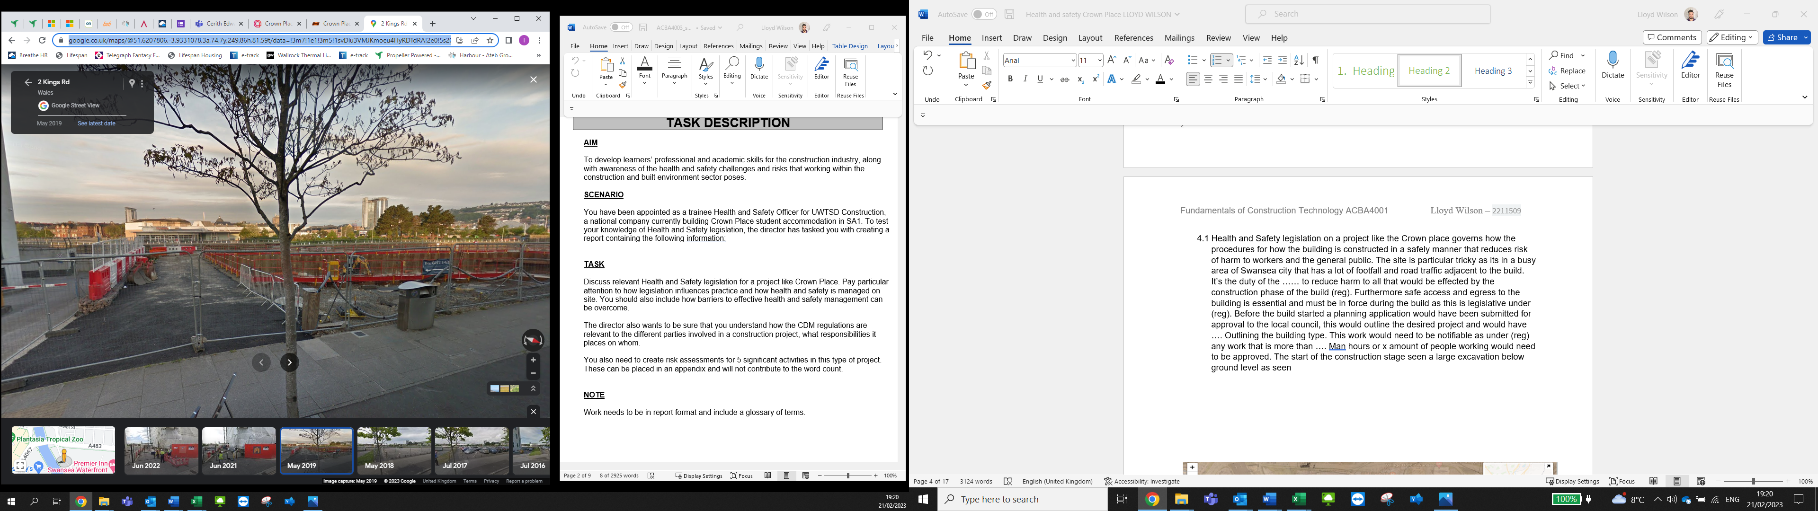
illustration: Google maps, May 2019
https://www.google.co.uk/maps/@51.6207806,-3.9331078,3a,74.7y,249.86h,81.59t/data=!3m7!1e1!3m5!1svDlu3VMJKmoeu4HyRDTdRA!2e0!5s20190501T000000!7i13312!8i6656
5/3/2023

Risk

The risk and likelihood of harm is reduced by having the site barriered off with signage to stop/warn persons of the potential of falling so the (The working at height Regulations , 2005) must be enforced across the site during the construction. The risk is not only harmful to health but can become devastating for the progress of the project, an health and safety inspector can also visit a site with or without notice and can put a enforcement notice on the site is breaches of the law are made (HSE, 2017). Visits and/or workplace injuries can cause delays in the work program with financial penalties could also occur, this is why site management is vital in running the day-to-day duties of the build. Site layout, schedule of works and regular toolbox talks are power mount in prevention of any breaches in health and safety on site. The issue occurs when time/deadlines must be met and sometimes shortcuts are made by operatives that lead to harm or damage. These must be weighed up before tasks are started, they can be measured up in the form of a method statement/risk assessment as shown in the illustration below from the HSE.
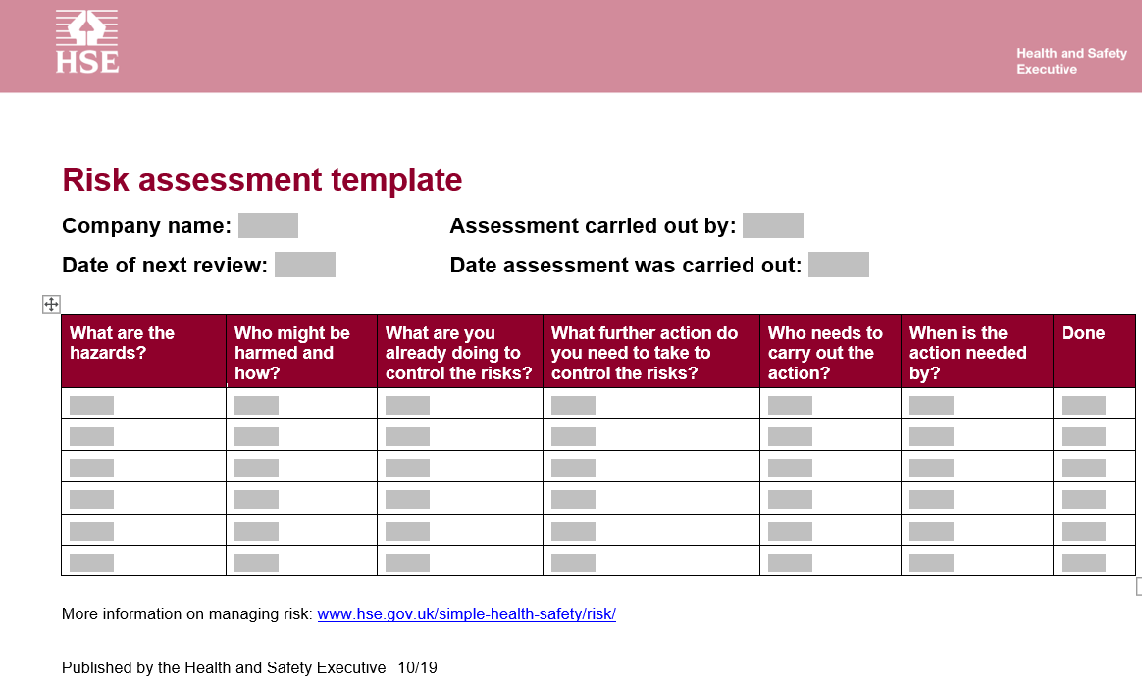
Illustration: Risk assessment template from the HSE website 5/3/2023
https://www.hse.gov.uk/simple-health-safety/risk/risk-assessment-template-and-examples.htm

These can then be the catalyst for training required for staff to carry out work safely on this project. One of the main risks working on a high raise building of this nature is safe evacuation, having an evacuation plan with emergency planning in place is crucial, training and site inductions for these risks such as fire, explosions, flooding, or structural collapse. These escape routes should be checked daily and on inside work area checks on emergency lighting must be also monitored. Everyone who enters the site should be inducted with areas of importance identified such as:
- Fire escapes/exits.
- Muster point
- Smoking area
- Toilets/Welfare area
- First aid points
- Site office
- Fire extinguishers
- Notice board.
The Crown Palace scaffolding has a temporary external emergency stairwell as well as the use of permanent stair wells inside the building.

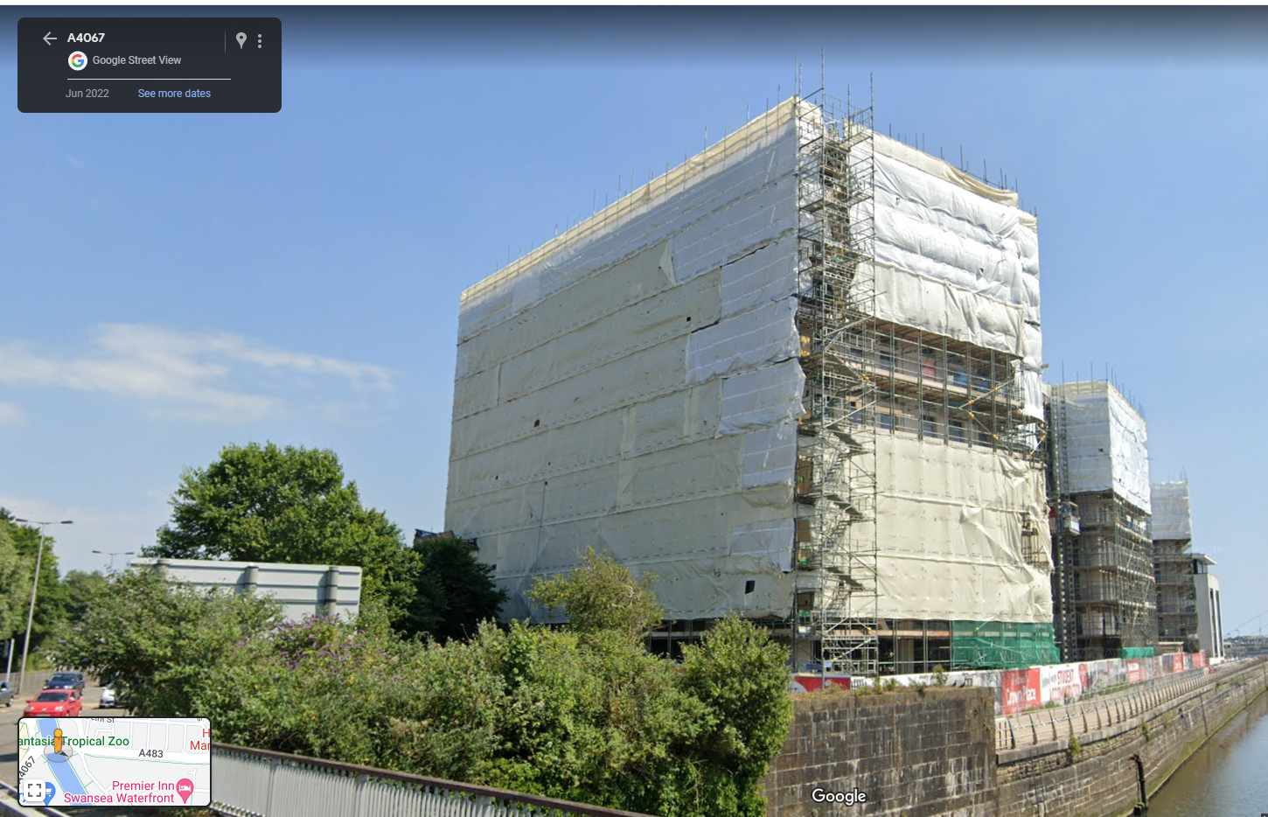
Illustration: google maps, January 2022. Rear of the Crown Palace development, with external stair well 5/3/2023
https://www.google.co.uk/maps/@51.6217331,-3.934876,3a,42.3y,125.41h,102.1t/data=!3m7!1e1!3m5!1s0sNcP0lKVOxaSuOw57uq7Q!2e0!6shttps:%2F%2Fstreetviewpixels-pa.googleapis.com%2Fv1%2Fthumbnail%3Fpanoid%3D0sNcP0lKVOxaSuOw57uq7Q%26cb_client%3Dmaps_sv.tactile.gps%26w%3D203%26h%3D100%26yaw%3D116.90409%26pitch%3D0%26thumbfov%3D100!7i16384!8i8192
Transporting the materials up to the higher levels is a dangerous task and can be achieved in different ways, the site has lifts that can be used or materials can be hosted up by other mechanical aids such as telehandlers or cranes. These again must be used to reduce harm to operatives but strict method statements must be in place and followed so the procedures are as safe as possible. The illustration above shows the external lifts that give ease of access to workers they should be inspected in line with LOLER (HSE , 2023) as it is the lifting operations and equipment regulation that governs the provision of use of such tasks/equipment. It also covers the cranes and telehandlers as stated above, it’s imperative that these aids are maintained on a annual basis but also inspected before each use. A checklist form is commonly used for pre user checks and a logbook for the usage with a proposed date for annual maintenance. Not doing these checks would enhance the likelihood of failure and also breech the method statements of the site rules, this can result in an instant dismissal or suspension to the operative.

Training and monitoring H&S

Training any workforce is key to keep proper standards of health and safety on sites, the crown place is no exception to the rule. Site inductions are one of the first steps to allowing persons on the site to work or visit. Another basic requirement of works to have is a CSCS card with is a course that needs to be completed by employees that demonstrates individuals have a basic understanding of workplace hazards. Adding to that extra training might be needed to overcome task specific activities on the construction project to improve knowledge and understanding of (Health and Safety at Work etc. Act (1974), n.d.). Basic manual handling training can dramatically reduce workplace injuries which results in employee’s ability to work, back related injuries are highly common injury (HSE, 2022) so using safe working practises reduces the injury rate. They can have lifelong effects so must be reduced by introducing mechanical aid as much as possible and or proper lifting techniques used when manual handling is required.
It’s imperative to have a healthy workforce as its great for production which helps maintain meeting targets as finical implications of not reaching them can financially cripple contractors and the whole project. Health surveillance is used on operatives in the workforce these can be annual health checks, which entails a series of health checks. Hearing tests are required to monitor hearing loss if workers are generally use loud tools. Even though they use P.P.E. to prevent long term effects, misuse of tools and P.P.E. can dramatically affect the user or other persons in the area. Its best practice on sites with heavy duty power tools that cause a lot of vibration must be checked out from the stores and use of the tools are monitored by recorded usage. Some tools have a daily limit and others even minutes as pre the manufacturer instructions, this is due to illnesses such as HAVS and VWF causing life changing effects on the users. PUWER governs the use of these such tools which the contractors must follow and enforced by the site managers, they will check the logs of use of tools to see if the right usage is followed (Provision and Use of Work Equipment Regulations, 1998). Power tools must be used by a competent person who has experience or has received the relevant training to use the Equipment.
Its not just the physical and visual objects that can cause harm to a workforce, mental health is being taken seriously in recent years but needs to be considered on every worksite. It can cause big delays in production as it can cause work absences and disrupt productivity as the work culture needs to be balanced. Guidance from (HSE, 2023) helps spot signs of stress and mental health in the workplace, there should be support giving to staff to help prevent this from happening as wellbeing of staff is crucial. Toolbox talks and team building days are great ways to improve the cohesion of a workforce.
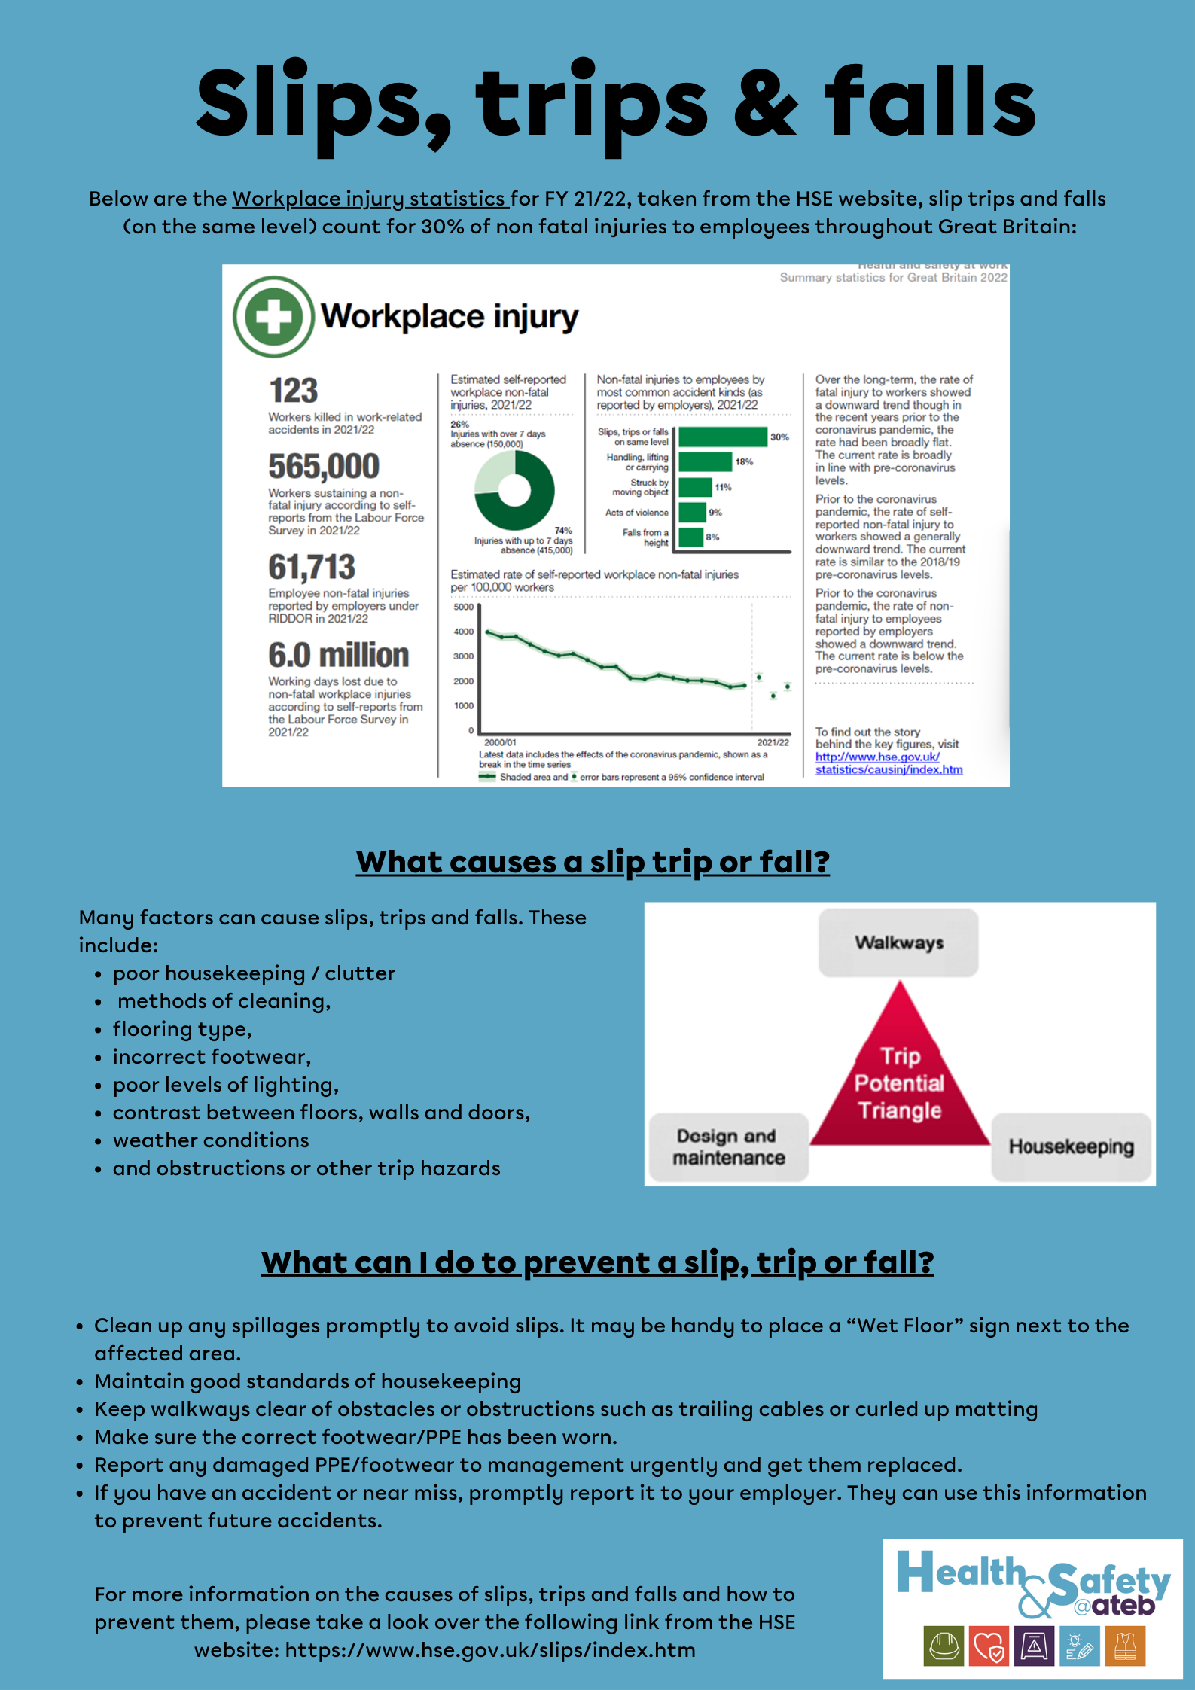
Illustration: Ateb company newsletter 1/5/2023

4.4 CDM

As noted above CDM stands for The Construction, Design and Management regulations 2015, it’s the main set of rules/regulations to follow on construction projects. It covers all building construction work that includes maintenance, repair, extensions, demolition, new builds, conversions, and refurbishment. It can be broken down into three main roles Client, Principal designer, and Principal contractor all of which have different duties with different responsibilities. Client can be broken down into two sub sections commercial and domestic, duties do vary but in this case Crown palace are the commercial type. CITB have informative YouTube video on CDM regulations (YouTube , 2016) it outlines the basics components that make up the CDM.

Client: Is the person or business who the project is for, in this case its Crown Student living. They will be responsible for the appointment of the designer and contractor, also providing the adequate resources, time frame and provide the relevant information to the other duty holders. They must also ensure welfare facilities will be on the project with HSW enforced, followed, and monitored. They are responsible for the maintenance of the building after the construction has finished.

Principle designer: Have an important role under CDM, they must plan. Monitor, coordinate and manage the health and safety at the pre-construction phase. They look at the construction design information that may affect work carried out pre and post the construction phase. They work with the designers to eliminate and/or reduce the potential risks at could occur at the build phase, to ensure safe building process is mapped out. They must share information with the other duty holders to help prepare for the construction phase.

Principle contractor: Is also appointed by the client, they are the main link between the contractors to which they organise the operation of the build by co coordinating work streams amongst the sub-contractors or sub departments. Other duties include plan, monitor, and manage H&S at the construction phase of the development. They will liaise with the Client and principal designer throughout the project which is vital to have good communication links throughout. They ensure that site inductions are provided, workers are consulted via toolbox talks and or message boards/emails all promoting H&S matters relative to the project. They manage the welfare facilities for all site operatives and visitors. Proper removal and storage of waste is also their responsibility under (Control of Pollution Act (1974), n.d.) So proper procedures must be in place with recorded documents stored in the site office.

Conclusion

The report indicates the responsibilities of the persons under CDM, these duties must be upheld as they defer to who’s accountable for each responsibility. I’ve indicated Cleaning after work duties in the risk assessment, this breaks down different activities for different work persons for different types of work areas and different considerations within the workplace. The glossary of terms explains a variety of abbreviations that are commonly used in the work place that is used as a guide to highlight their meaning for deeper understanding. I’ve highlighted the importance of preventing hazards also how to manage these with training and prevented methods or procedures. The importance of training to all staff to specific tasks must be done and if any operative is unsure of how to do a task or feels unsafe should report to their supervisor asap for guidance. If workers feel that they see anything that is unsafe, they should barrier off the area and report to the supervisor and H&S site officer, by doing this the site should be a safer place to work in.

References

Control of Pollution Act (1974), n.d. [Online]
Available at: https://www.legislation.gov.uk/ukpga/1974/40/contents
[Accessed 12 12 2022].
Health and Safety at Work etc. Act (1974), n.d. [Online]
Available at: https://www.legislation.gov.uk/ukpga/1974/37/contents
[Accessed 14 12 2022].
HSE , 2023. Lifting Operations and Lifting Equipment Regulations 1998 (LOLER). [Online]
Available at: https://www.hse.gov.uk/work-equipment-machinery/loler.htm
[Accessed 4 5 2023].
HSE, 2017. When a health and safety inspector calls. [Online]
Available at: https://www.hse.gov.uk/pubns/hsc14.htm
[Accessed 12 03 2023].
HSE, 2022. Back Pain. [Online]
Available at: https://www.hse.gov.uk/msd/backpain/index.htm
[Accessed 27 4 2023].
HSE, 2023. Stress and mental health at work. [Online]
Available at: https://www.hse.gov.uk/stress/?utm_source=govdelivery&utm_medium=email&utm_campaign=working-minds&utm_term=stress-awareness-3&utm_content=digest-18-apr-23
[Accessed 1 5 2023].
Provision and Use of Work Equipment Regulations, 1998. Provision and Use of Work Equipment Regulations 1998 (PUWER) HSE. [Online]
Available at: https://www.hse.gov.uk/work-equipment-machinery/puwer.htm
[Accessed 27 4 2023].
The Construction, Design and Management regulations, 2015. [Online]
Available at: https://www.legislation.gov.uk/uksi/2015/51/contents/made
[Accessed 05 03 2023].
The working at height Regulations , 2005. [Online]
Available at: https://www.legislation.gov.uk/uksi/2005/735/contents/made
[Accessed 12 03 2023].
YouTube , 2016. The basics of Construction (Design and Management) Regulations 2015. [Online]
Available at: https://www.youtube.com/watch?v=V1jLyWTscjs&t=1s
[Accessed 14 3 2023].

Risk assessment

Score Matrix for risk assesment
Risk rating (R) = Impact (I) x Probability (P)
 |  | P | P | P | P | P
 |  | 5 | 4 | 3 | 2 | 1
I | 5 | 25 | 20 | 15 | 10 | 5
I | 4 | 20 | 16 | 12 | 8 | 4
I | 3 | 15 | 12 | 9 | 6 | 3
I | 2 | 10 | 8 | 6 | 4 | 2
I | 1 | 5 | 4 | 3 | 2 | 1

Risk Matrix | Severe | 20 - 25
Risk Matrix | High | 15 - 16
Risk Matrix | Moderate | 9 - 12
Risk Matrix | Low | 5 - 6
Risk Matrix | Minimal | 1 - 4

Name of person completing the risk assessment: | Lloyd Wilson | Date and time completed: | 26/04/2022
Description of work area being assessed: | Cleaning work site after different tasks for different persons
Description of task being assessed: | Cleaning of general areas for different tasks
What is the hazard? | Who might be harmed? | How might they be harmed? | Existing Risk Control measures | Risk rating |  |  | Additional Controls | Residual Risk Rating |  |  | Action / Monitored by Whom | Action / Monitored by When?
 |  |  |  | L | C | R |  | L | C | R
Hazardous substances | Staff and trainees | Skin irritation and disease as a result of contact and poor work practice with silicone, lead, pastes, paints, cleaning sprays, releasing agents, etc. | - COSHH procedure, assessment inventory, assessments, and product label instructions – available via site office  - Staff will inform supervisors when new products are required or replaced by suppliers before using.  - Site have a 3-step dry handwash systems in the toilets.  - Method statement and Point of Work Risk Assessment (POWRA) followed and understood. | 2 | 3 | 6 | - Products only to be used if COSHH assessment complete and staff advised of precautions  - Recommended PPE to be available and used  - Ensure adequate ventilation | 1 | 3 | 3 | Staff  Staff / Line Managers  Staff | Ongoing  As required  When substances are in use
Dust | Staff, trainees, customers, members of the public. | Damage and disease of lungs, nose, mouth and throat as a result of breathing in dust and cleaning sprays/agents. | - Site approved equipment list in place.  - Site Occupational Health Surveillance procedure in place.  - FFP3 dust masks used for building fabric dust clean up tasks.  - PPE/RPE is the last line of defence and only used in conjunction with other listed controls, and replenished at Site office, materials suppliers by staff as required.  - Site Personal Protective Equipment Procedure  - Monthly RPE checks carried out on mobile working devices.  - Method Statement and POWRA. | 2 | 3 | 6 | - Only tools and equipment listed on the Site Approved Power Tool List to be used by staff and purchased by line managers (new equipment requests require assessment and approval before purchase/use).  - Staff to ventilate property/work areas and advise customers when dust may be created so they can relocate within the building. | 1 | 3 | 3 | Staff / Line Managers | On-going / as required
Noise | Staff and trainees | Temporary or permanent loss of hearing, and/or accidents caused by noise interfering with communication, through the prolonged use of power tools and equipment. | - Vacuum cleaners used generally low noise at with a low exposure limit whilst tools such as drills, circular saws output higher noise so exposure must be limited.  - Noise monitoring programme completed with external provider and data used for OHS assessment and review.  - Hearing protection in accordance with tool requirements  - PUWER Procedure in place.  - Site approved equipment list in place.  - Hearing protection PPE is the last line of defence and only used in conjunction with other listed controls, and replenished at the Site office, materials suppliers by staff as required.  - Personal Protective Equipment Procedure.  - Occupational Health Surveillance procedure in place.  - Site approved tool list in place. | 2 | 3 | 6 | - Staff are instructed to spread the use of power tools and equipment out over each day and not to exceed the exposure duration times, for each tool and report any noise issues or concerns  - Inspecting equipment prior to use to ensure there is no damage. | 1 | 3 | 3 | Staff and Trainees | On-going
Electricity | Staff, trainees, customers, members of the public. | Fatalities or injury from electrical shock due to non-compliant electrical work, work practices or faulty/poorly maintained electrical equipment. | - Site Electrical Safety Management Policy and supporting Process Maps.  - Site Group PUWER Procedure in place.  - Safe Electrical Isolation and practice RAMS (staff must ensure correct isolation of electrics before work commences).  - Electrical Safety Awareness e-learning.  - Only tools and equipment listed on the Site Approved Power Tool List to be used (new equipment requests require assessment and approval before purchase/use).  - Staff will visually inspect all plant, tools and equipment before use and stop work/report any faulty equipment to line managers for repair/replacement.  - Electrical equipment PAT tested annually, or other specific intervals, and recorded in database. Replaced, as necessary.  - RCD plugs or adapters to be used for 240v equipment (e.g. battery chargers, transformers) and fitted/issued during PAT testing or when new equipment issued.  - Staff to test RCDs before use.  - Method Statement and POWRA. | 2 | 4 | 8 | - Electrical topic via toolbox talks.  - PAT testing of equipment  - Non-electrically qualified staff and staff not trained in safe electrical isolation are not permitted carry out safe isolation procedures unless trained on appropriate equipment. | 1 | 4 | 4 | Line managers / Team leaders  Staff and trainees | On-going, as released.  21/22  On-going
Manual Handling | Staff and trainees | Musculoskeletal injuries due to incorrect lifting and moving techniques when carrying out tasks. | - Staff have received Manual Handling Awareness e-learning and/or Toolbox Talk on induction.  - Manual Handling procedure in place.  - Materials generally delivered to site and heavy / large materials ‘tail-lifted’ to ground level or scaffold lifts.  - Method Statement and POWRA. | 2 | 4 | 8 | - On-going H&S Improvement plan monitored by Safety Team. | 1 | 4 | 4 | Safety Team / SMT | On-going
Slips, trips and falls | Staff, trainees, customers, members of the public. | Serious injury from slips, trips and falls due to poor workplace management and practices. | - Protective footwear provided.  - Lighting provided to reduce the risk of accidents within poorly lit areas (see poor lighting measures below).  - IOSH Working Safely training provided.  - Adhesive floor coverings supplied and preferred to cloth dust sheets on carpets and stairs.  - Method statement and POWRA.  - Electrical leads and cables to be kept out of walkways and secured. | 2 | 4 | 8 | - Staff and trainees must plan access and egress routes and practice good housekeeping on-site; keeping work areas dry, clean, tidy and free from unnecessary waste materials, tools, equipment and other trip hazards.  - Staff will ‘barrier off’ and / or use ‘pop-up’ warning signage where work areas may present a slip, trip or fall hazard to customers and the public.  - Staff to avoid carrying loads over uneven grounds and use mechanicals aids as much as possible | 1 | 4 | 4 | Staff and trainees | On-going
Working at height | Staff, trainees, customers, members of the public. | Fatality or serious injury as a result of falling from height or by items falling from height. | - Work at height procedure accessible via the site office and followed e.g., use of scaffolding.  - HSE guidance read and understood on safe use of ladders & step ladders.  - 3 points of contact when ascending / descending a ladder.  - Ladder to be tied off or footed before use.  - Do not climb on the top three rungs of a ladder.  - WAH activities to be planned in advance and line managers to assist/lead where site specific WAH risk assessments are required.  - Ladders and access equipment (scaffolding) periodically checked by line managers, date tagged and replaced if damaged.  - Scaffold adaption work only issued to qualified staff/contractor.  - On-going staff training programme for Working at height awareness training.  - duration ladder/harness work courses.  - Staff to apply good workplace housekeeping practices.  - Method Statement and POWRA. | 2 | 4 | 8 | - Ladder/Scaffolding inspections to be carried out daily/weekly.  - On-going H&S Improvement plan monitored by Safety Team. | 1 | 4 | 4 | Line Managers | On-going

Review date: | 26/04/2024 | Signature of person completing the risk assessment / method statement: | L. Wilson

