UNIVERSITY OF WALES
TRINITY SAINT DAVID

STUDENT: MARIN HANU
STUDENT NUMBER: 1915952
MODULE: MANAGING PEOPLE
ASSIGNMENT: ASSIGNMENT 2
LCBB5004
PROGRAMME: BA BUSINESS MANAGEMENT
LEVEL 5/TERM 2/GROUP 2
LECTURER: CHARLES OHAM

Table of Contents
Introduction 2
Concept of Employee Engagement 3
Drivers of employee engagement 3
Diagnostic tools to measure employee engagement 5
Employee Value Proposition 7
Conclusion 9
References 10

Introduction
Employee engagement is essential in an organisation for the success of the business. Maximum employee engagement helps in accomplishing the goals and objectives of an organisation. Therefore, this report will determine a brief concept on the employee engagement process. Further, the report would contain diagnostic tools to measure the engagement of employees and has constructed an employee value proposition from the above analysis. It also includes the strategies for increasing the level of employee engagement.

Concept of Employee Engagement
The term of employee engagement it is viewed as strong emotional and menta attitude between people and their work and the organisation they are employed to. There are several ways and activities that the HR department performs for increasing the engagement of employees by marinating healthy commination, relationship and positive workplace culture. Therefore, such activities and programs help in inspiring the employees towards their work and also maximize the retention of employees. Thus, organisation’s HR department must highly invest in the programs and activities which drive employee engagement. These programs promote the satisfaction of employees and reduce employee turnover which results in high profits for the company. Employees feel satisfaction towards their work and the organisation which also improves the effectiveness of their work and eliminates errors. Thus, employees trust and loyalty towards the organisation they work increases. The highly engaged employees hold very favourable opinions of their workplace. They encourage others in performing their best and make extra efforts for the achievement of organisational goals and objectives. In addition to this, other benefits that employee engagement provides involves better employees health, reduced workplace injuries, lower absenteeism and maximized customer satisfaction. These benefits could be gained when managed employee engagement effectively (Burnett and Lisk, 2019).

Drivers of employee engagement
Relationship amongst employees
One of the primary ways to maximize employee engagement is through establishing healthy and strong relationships amongst employees and the management of the company. Positive relationships build a healthy working environment that motivates the employees in working effectively. Employees feel inspired towards their work and make extra efforts for the achievement of organisational goals and objectives. Therefore, relationships with employees and management must be strong maintaining cordial and healthy relationships with the employees by effective communication and fulfilment of the needs and requirements of the employees (Shaik and Makhecha, 2019).

Autonomy
Autonomy refers to the authority given to the employees for making their own decisions in the workplace. In this way, the employees find their way of performing for the achievement of organisational goals and objectives. Employees feel more independent through autonomy. Therefore, Uber management may indulge in Autonomy practices where they should allow the employees to make their own decision as it will drive more efficiency in the work and supports in the achievement of organisational goals and objectives.
Professional development
Professional development of employees is one of the sources to promote retention and high engagement of employees. The opportunities provided by an organisation for the development and growth of employees builds a strong reputation and trust amongst the employees. They feel like a part of the organisation and improve their performance efficiency. Therefore, by establishing professional development programs, high employee engagement would be promoted by the company. This would not only increase engagement but also promotes the growth of organisational goals and objectives (Antony, 2018).
Feedbacks and suggestions
For employee engagement, feedbacks and suggestions plays a significant role. They are the crucial driver of engagement as both the positive or negative feedbacks provide an opportunity for the betterment of work. It helps in increasing the effectiveness of work through working on the improvement areas and by creativity through positive suggestions. Thus, employees in Uber would feel respected and honoured by taking their suggestions and the feedbacks provided they would also help in improving their performance.
Motivation
There are many challenges faced by the employees in day-to-day work. Thus, employees need motivation from their managers and leaders to perform their tasks effectively. It helps the employees in providing them guidance and direction towards the goals and objectives of the organisation (Motyka, 2018).
Purpose
A business drives with purpose as it plays an important part in the growth and success of the company. Therefore, by determining the purpose of the organisation to the employees, they feel connected and a part of the process which enables them to perform effectively with a mission to accomplish the goals and objectives. The purpose, clarity and aims of the organisation must be well communicated for driving employee engagement in the company (Young et al., 2018).
Role clarity
The roles and responsibilities of the employees must be communicated for smooth business operations as it makes them able to connect easily with their daily tasks. The clarity of duties enables the focus towards the work by employees. Thus, the HR manager must clearly define the tasks and duties of employees for the efficiency of work and the proper delegation of authority and responsibilities.
Teamwork and shared values
Shared values and teamwork refer to the common work attitude and participles amongst the colleagues of an organisation. The mutual interest of a company would be promoted by efficient teamwork and shared value. This driver of employee engagement also indicates how well an employee’s values align with the organisation and their work performance. It also reflects the positive workplace culture and shared attributes amongst the employees (Akhmetshin et al., 2019).

Diagnostic tools to measure employee engagement
It is very necessary for an organization to measure employee engagement at the workplace. It impacts the overall performance of the organisation. Thus, measuring the employee engagement and the high or low level of engagement is identified which helps the company in increasing the engagement level by developing such relevant strategies for the improvement. Therefore, employee engagement can be measured by tools as the ones defined below :

Employee lifecycle
Employee lifecycle at an organisation refers to the period in which the employee is recruited in the company and gets retired from the same organisation. Thus, it is a continuous form where each employee’s lifecycle is calculated and focused. An organisation frequently takes feedbacks to form the employees when they move on to another phase or position as determined in the employee life cycle. Therefore, this is an effective form of measuring employee engagement in the company as the insights and feedback from the employees when they gain higher positions are recognised through this. It would enable the human resource manager of the company in understanding the feelings and thoughts of their employees when they are promoted to the next stage. The negative feedbacks could be used or the improvement of that specific area of the company that would eliminate any challenge faced by the organisation’s employees (Burnett and Lisk, 2019).
Employee surveys
One of the most popular tools for measuring employee engagement is employee surveys. It would be effective for the business to conduct an employee survey where the employees can fill the survey form anonymously. This survey can be conducted every 3 months to gather feedback from the employees for measuring their engagement in the company. However, there are some negative aspects of this tool that must be focused on by the company as the survey may get filled with fake answers or the employees would not take the survey seriously. The probability of the wrong data collection is high in this tool (Motyka, 2018).
Employee reward and recognition programs
Employees work harder when they feel that their efforts are appreciated in monetary terms. Thus, employee reward and recognition programs help in measuring the engagement of employees. They have the direct impact on the employee engagement as it helps in identifying how many members are involved in such programs as they increase their efficiency of performing work. Thus, a company can adopt this tool for maximizing employee engagement in performing their work as well as for hoping the extra mile to gain incentives and rewards (Akhmetshin et al., 2019).

Employee Value Proposition
The employee value proposition is a tool that helps in the attraction and retention of employees in an organisation. It helps in gaining a competitive edge for beating the market competition for the attraction of higher-skilled employees towards the organisation. It is an employee-centric approach that aligns with the existing and integrated workforce planning strategies. It can be a key driver for the attraction, engagement and retention of employees with unique, compelling and relevant strategies developed by an organisation (Mascarenhas, 2019). Thus, EVP can be built as –
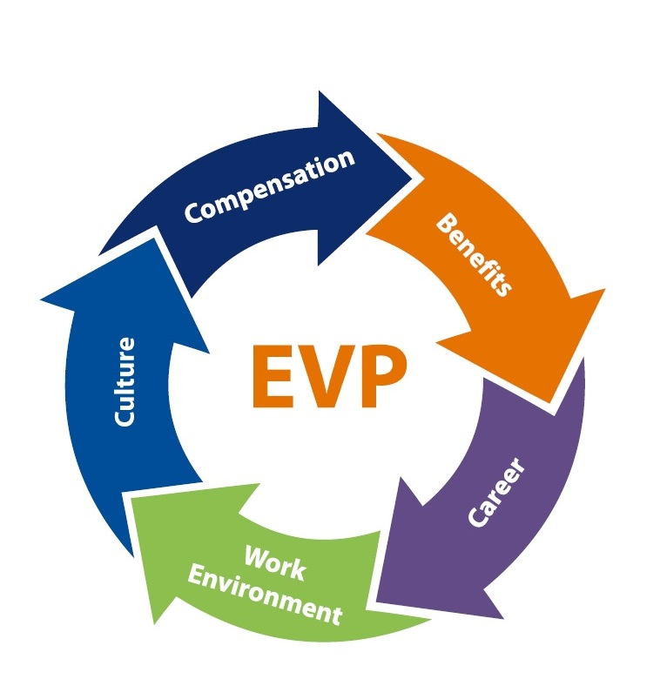
Figure 1: Employee Value Proposition
Source: (Thiensiri, 2021)

Compensation
Employees are provided timely salaries as well as incentives for achieving the targets to encourage them for more efficiency and better performance. In addition to this, the business is also indulged in providing medical insurance for their employee’s safety and security. Rewards and recognition are highly promoted in the company to balance employee satisfaction and motivation towards work (Daum and Stoll, 2020).
Benefits
If Possible, all companies have to provide several benefits to their employees such as flexible and self-determined working hours, 25/7 support by management, ease of joining, insurance, lesser requirements of skills, earnings, alerts and planning, etc. Thus, these benefits may attract higher employees towards the company. In addition to this, the senior employees of the company also get more incentives and rewards for their retention in the company.
Career
People must be able to develop their careers. However, some companies do not provide many options for the development of a professional career but a good amount of salary with the flexibility of working hours (Pawar and Charak, 2017). So, talent is essential for a company growth and every company must spot talents in their organization and help them progress in their career ensuring an efficient career development (Vilčiauskaitė, B. et al. 2020).
Work environment
The management must allow employees to work flexibly and make decisions by themselves enabling the attraction and retention of employees in the organisation. The roles and duties must be clearly described to the employees and provided to them, with means to effectively perform their remote working. Also, people have different expectation from the workplace and the employer must personalize his offer according to the types of employees needed to be managed (Lowe, G. S. & Grant Schellenberg, G. 2002).

Culture
The company’s culture must be very positive and supportive as the organisation focuses on the employee’s satisfaction. The company’s management recognises the efforts of their employees and thus offers them several growth opportunities. The shared beliefs and team leadership need to be efficient in the company’s culture in order to make it positive and healthy (Mascarenhas, 2019).

Conclusion
The report concludes the effectiveness of employee engagement in leading the organisation towards growth and development. It has been identified from the report that employee engagement helps the company in attaining the ambitions and aims of the business with efficient working. The attraction and retention of employees must be performed effectively to maintain the sustainability of the company. This also provides a competitive advantage to the organisation as employees satisfaction leads towards the success of the company and achievement of future goals. However, the company can adopt the tools for employee engagement in the organisation for increasing the productivity and profitability of the company. In the report, an employee value proposition has been described, that would be helpful for the company in increasing the retention and engagement of the employees. Therefore, the report concludes the necessity of organisations to focus on employee engagement strategies as it supports the achievement of organisational goals and objectives.

References
Akhmetshin, E. M., Ilyina, I. A., Kulibanova, V. V., and Teor, T. R. (2019). “Employee Engagement” Management Facilitates the Recovery from Crisis Situations. In 2019 Communication Strategies in Digital Society Workshop (ComSDS) (pp. 50-55). IEEE.
Antony, M. R. (2018). A paradigm shift in employee engagement–A critical analysis on the drivers of employee engagement. International Journal of Information, Business and Management, 10(2), 32-46.
Burnett, J. R., and Lisk, T. C. (2019). The future of employee engagement: Real-time monitoring and digital tools for engaging a workforce. International Studies of Management and Organization, 49(1), 108-119.
Daum, D. L., and Stoll, J. A. (2020). Employee Preferences. Employee Surveys and Sensing: Challenges and Opportunities, 153.
Lowe, G. S. & Grant Schellenberg, G. (2002) Employees’ basic value proposition: Strong HR strategies must address work values. Canadian HR Reporter. 15 (13).
Mascarenhas, B. G. (2019). Employer branding, employee value proposition, and employee experience: New approaches for people management in organizations. In Strategic Employee Communication (pp. 97-103). Palgrave Macmillan, Cham.
Motyka, B. (2018). Employee engagement and performance: a systematic literature review. International Journal of Management and Economics, 54(3), 227-244.
Osborne, S., and Hammoud, M. S. (2017). Effective employee engagement in the workplace. International Journal of Applied Management and Technology, 16(1), 4.
Pawar, A., and Charak, K. S. (2017). Study on Evolving Extents of Employer Branding Using Employment Value Proposition in India. International Journal of Research in Business Studies and Management, 4(12), 1-8.
Shaik, F. F., and Makhecha, U. P. (2019). Drivers of employee engagement in global virtual teams. Australasian Journal of Information Systems, 23.
Sun, L., and Bunchapattanasakda, C. (2019). Employee engagement: A literature review. International Journal of Human Resource Studies, 9(1), 63-80.
Thiensiri, P. (2021). Vital role of leader as employee value proposition for employee engagement in Thai perspective. Kasetsart Journal of Social Sciences, 42(3), 489-494.
Vilčiauskaitė, B. et al. (2020) MANAGING OLDER TALENTS IN THE CONTEXT OF AGING SOCIETY. Economics & sociology. [Online] 13 (4), 213–226.
Young, H. R., Glerum, D. R., Wang, W., and Joseph, D. L. (2018). Who are the most engaged at work? A meta‐analysis of personality and employee engagement. Journal of Organizational Behavior, 39(10), 1330-1346.

