STRATEGIC MANAGEMENT AND SUSTAINABILITY
LCBB6004

ASSESSMENT 1

Strategic Review of Burberry Plc

Dr Hossein Shokri

Lilija Tconeva
2029799

December 2023
TABLE OF CONTENTS

- Introduction 4

- Burberry’s business and corporate strategy 4

- Resources and capabilities 7

- Resources and capabilities allocation 8

- Value Chain and Value System Analyses 9

- VRIO 10

- Strategy in action 11

- The Group works towards being a responsible business 12

- Conclusion 13

- Recommendations 13

References

References (Figures)

Table of Figures

FIGURE NO | DESCRIPTION | PAGE NO
1 | Generic strategies | 5
2 | Ansoff Matrix | 6
3 | Revenue drivers | 8
4 | Revenue | 12
5 | Market Growth | 12

- Introduction
Three elements provide a practical template for evaluating a strategy: strategic position of an organisation, assessment of future strategic choices and turning strategy into action. This framework is a comprehensive tool for analysing organisations’ positions although choices often need to be made before the strategic position is fully understood and oftentimes it can be only built from experience by trying out a strategy. For example, a new product feedback can sometimes uncover the true strategic position better than remote analysis. Furthermore, a strategic position involves the organisation’s external environment, resources, capabilities, goals and culture. The strategic choices define the methods a strategy will be pursued and implemented (Whittington et al. 2020, p. 12-16).
This report provides a critical analysis and evaluation of Burberry’s PLC strategic choice and strategy action.

Burberry Plc was founded by the 21 year-old Thomas Burberry in 1856, who invented the gabardine- the first waterproof, breathable, revolutionary light fabric for rainwear, foundation for the iconic Burberry Trench coat. The equestrian knight logo was inspired by the 13 and 14 century armour on display at the Wallace collection. As the company grew, it built manufacturing presence in the UK, became recognised by the royals, established own charity and became the first luxury brand to join the Ethical Trading Initiative (Burberry, 2023).
Burberry’s product portfolio consists of apparel and accessories for men, women and children. It distributes its products through a network of retail, wholesale and licencing channels globally. It merchandises its products through e-commerce platform, and is headquartered in London, UK (MarketLine, 2020, p.24).

- Burberry’s business and corporate strategy
Businesses are faced with two fundamental strategic choices: what business model and what business strategy to adopt in their market. Business or corporate strategies define how to compete in the marketplace and depend on the specific needs of the served market. A business model describes the value creation for customers and other participants, activities that add value, and associated revenue and costs (Whittington et al. 2020, p. 203, 221).
To achieve competitive advantage, organisations must create greater value than the competitors. In defining competitive advantage Michael Porter defines four generic strategies (Figure 1), depending on how companies position themselves in the market: cost- leadership (cheaper prices than the rivals), differentiation (differentiated products and services from competitors that are valued and charged more), focus (products and services tailored to a specific segment) and hybrid (combination of different generic strategies under specific circumstances) (Whittington et al. 2020, p. 204- 212).

Figure 1: Generic strategies
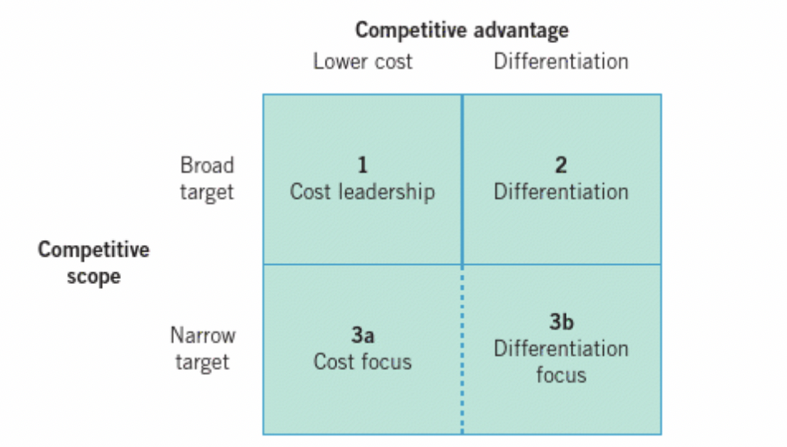
Source: (Whittington et al. 2020, p. 205)

According to Porter’s model, Burberry follows business differentiation. It involves unique product, valued by customers that allow for price premium. For example, in retail, companies may differentiate by fashion, store size, location. Over the last five years, Burberry have improved their product offer and brand positioning to reflect the company’s unique qualities and heritage. The current stage of the strategy is focused on revenue growth and gain (Burberry, 2023).

There are three differentiation drivers when considering differentiation strategy:
- Product and service attributes that provide better or unique features than comparable ones. Burberry aims to broaden the appeal through modern luxury aesthetic and refocus on Britishness, interpreting the British history with a modern vision. It uses the finest materials available for their products, seek to deliver highest standard customer service. Store refurbishment and new e-commerce opportunities to differentiate. (Burberry, 2023)

- Customer relationships relate to how the products are perceived by customers.
Burberry has distinctive and quality products. It tries to reduce their environmental impact and collaborates with other companies for more sustainable luxury fashion. It plays a positive role in contributing to local economies and supporting employees and communities with relevant organisations’ partnerships. Burberry builds a sense of community through memorable experience (Burberry, 2023).

- Complements build on linkages to other products – Burberry shifts the mix more towards accessories, growing leather and shoe businesses (Burberry, 2023).

Ansoff’s Matrix (Figure 2) defines four directions for business growth that can be used for brainstorming strategic options: market penetration, product and services diversification, market development and unrelated diversification. Therefore, companies have two diversification strategies available- to move to new product and services development for existing market or moving existing products into new markets. Alternatively, businesses can follow unrelated diversification strategy with new markets and new product services (Whittington et al. 2020, p. 238-239).

Figure 2: Ansoff’s Matrix
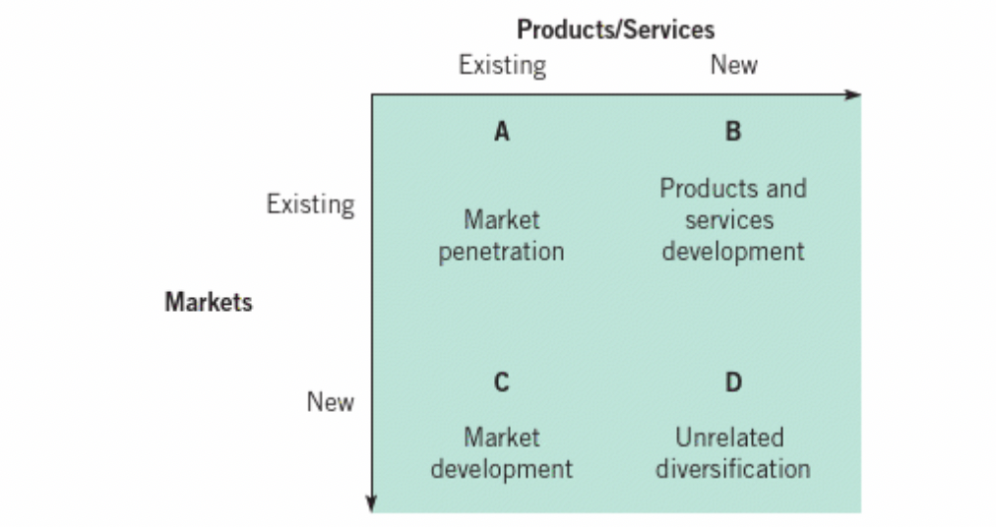
Source: (Whittington et al. 2020, p, 239)
Burberry follows market development strategy. For this route businesses focus on attracting new customers for their existing products which involves new customer segments, new geographical areas and new uses of products (Lynch, 2018, p.280).
Burberry has a long-term ambition to develop the brand into £5bn revenue company through these objectives:

- Strengthen distribution
- Harness the power of the brand
- Bring products to full potential
- Strengthening relationship with customers
- Accelerating store refurbishment across Europe, the Americas, Middle East, India and Africa
- India and Southeast Asia market growth
- Focus on Mainland China
- Grow stronger presence
(Burberry, 2023)

- Resources and capabilities
Resources are assets that deliver value added in the business. Capabilities are those management skills, leadership and routines that deploy, share and generate value from the resources (Lynch, 2018, p. 115)

Burberry
Resources | Capabilities
413 stores | Online and Digital capabilities,
From which 138 concessions, 56 outlets | Omnichannel capabilities,
35 franchises, 2 manufacturing sites in UK and Italy (MarketLine, 2023) | Metaverse projects, NFT Launches  Marketing, innovative design,
Balance sheet, cash flow, 9,201 employees,  partners, suppliers, brand name, quality  products and materials, app, superior | exceptional customer service and brand experience, positive social and environmental impact,
craftmanship, website (Burberry, 2023) | first luxury brand to livestream a fashion show (Burberry, 2023)
- Resources and capabilities allocation

- Two phased strategy- 2018-2020 to build foundation/ 2020- onwards to accelerate growth.
- Figure 3 shows 4 revenue drivers to achieve it- product, distribution, communication, digital innovation.
(Burberry, 2018/19)

Figure 3: Revenue drivers
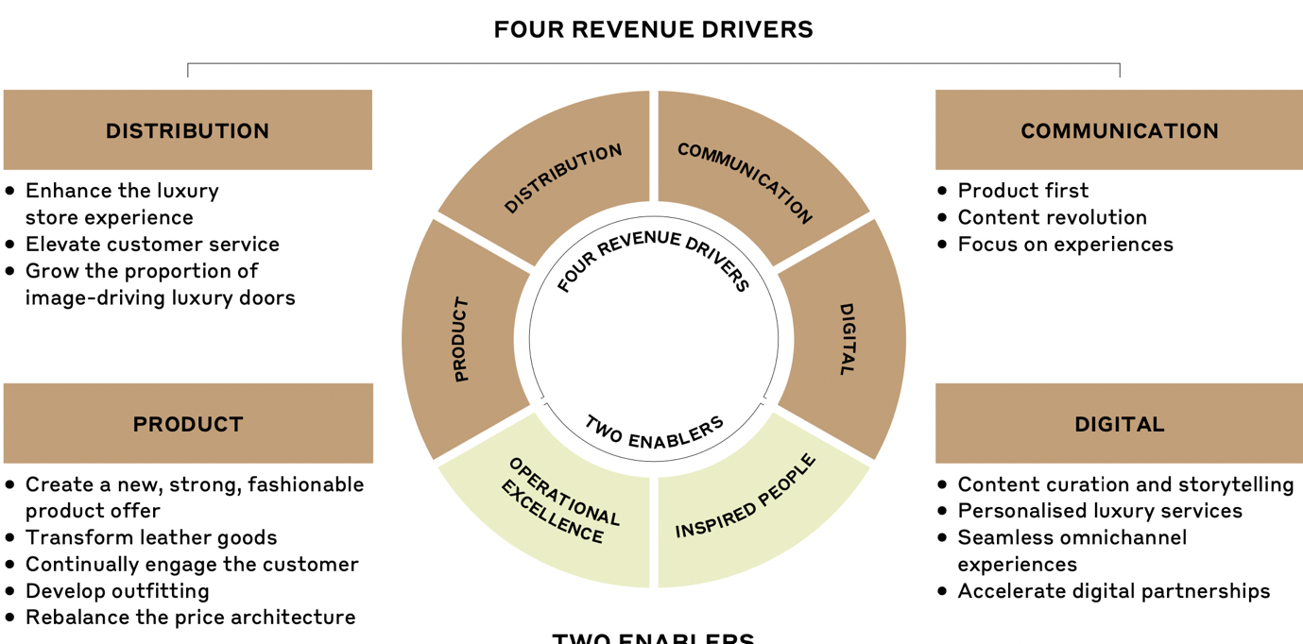
Source: (Burberry, 2018/19, p. 22)

Burberry focused on visibly changing its products, leather goods development and fur free commitment to attract luxury consumers and retain existing ones. Over 100 expert craftsmen working on luxury handbags and accessories gave better control over cost, quality, delivery and sustainability. Distribution network is evolving to reflect the company’s new luxury positioning. Store layout, creative window displays and pop ups were tailored according to location and non- luxury wholesale and retail stores rationalised, closing 18 stores in a year (Burberry, 2018/19).
Tailored campaigns, social media presence, influencers, key opinion leaders, wrapping flagship stores wholly in Burberry monogram and displaying large Burberry bears, helped Burberry to reach more than 60m consumers. (Burberry, 2018/19)
It focused on front and back of house capabilities improvement such as enhanced sale digital tools, staff training, regional leadership conferences to align skills globally and exemplary customer service. Progress in expanding third party relationships such as Farfetch, development of Burberry.com, enabling flexibility in payment such as Apple Pay and personalisation enhancement. Supply chain teams and external partners collaboration simplified decision making while speeding up processes. Quality management was introduced and IT transformation to enhance cybersecurity capabilities and customer engagement (Burberry, 2018/19, p.29- 38).

- Value Chain and Value system analyses
Value chain consists of all activities that create a product or service. It’s used to understand the strategic position of an organisation. Businesses could be also part of a wider value system- inter- organisational links and relationships necessary to create products or services (Whittington et al. 2019, p. 105).

Primary activities involve producing and selling the products.
- Burberry outsources most of its inbound activities. Operations show productivity and efficiency which ensures economic growth, generating profits. Burberry adds value by constant innovation and creativity and sustainability. It hired world class designers to freshen the fashion line of the company. Target marketing, adverts with supermodels to appeal to younger consumers.

Tight distribution control, discontinuing products that don’t align with the Burberry brand and expanding of stores are part of its outbound logistics. Analysing it would cut costs and time which would increase customer satisfaction. Effective marketing, sales and services increase the brand equity and distinguish it from competitors. However, growth is not a reliable objective as businesses tend to pursue market share at the expense of profitability.

- Efficient support activities enhance the brand reputation.
Burberry has structured operating model. Changes to the Board were announced employing some strong performing figures such as Alan Stewart who was behind the financial transformation of Tesco Plc. The strategic investment of acquiring a business from Pattern for $22.76m, their long-standing supplier would provide greater control over quality, delivery and sustainability of products (MarketLine, 2023).

- Burberry is part of a value system consisting of suppliers and distribution channels. Moreover, own and third party distribution network enables the company to penetrate the markets (MarketLine, 2023).

- VRIO
VIRO analysis determines if a company has enough capabilities and resources to achieve and sustain competitive advantage (Whittington et al. 2019, p. 104).

Burberry
Resources | Valuable | Rare | Costly to imitate | Exploited  by organisation | Competitive implications
Brand equity | yes | yes | yes | yes | Sustainable Competitive adv.
Product quality | yes | yes | yes | yes | Sustainable Competitive adv.
Marketing | yes | yes | yes | yes | Sustainable competitive adv.
Employees | yes | yes | no | yes | Temporary Competitive adv.
Supply chain | yes | no | no | yes | Competitive parity
Financial resources | yes | no | no | yes | Competitive parity

Burberry brand is valuable, rare and costly to imitate which generates sustainable competitive advantage. So does the product quality and marketing. The company was the first to make gabardine fabric and has an unique, patented pattern. The resources are costly to imitate although there are fake products in the market. Employees are valuable, rare but not costly to imitate which bring temporary competitive advantage that competitors can acquire over time at no cost disadvantage compared to the first moving firm. Supply chain and financial resources are valuable, not rare and easily copied which gives the company competitive parity. Therefore, Burberry is on equal position with competitors with the last two resources.

- Strategy in action
SAF can be used to evaluate strategy options in terms of contribution to the organisation (Lynch, 2018, p. 333).

- Suitability (key opportunities and threats)
Burberry has a positive outlook through e-commerce and stands to benefit from the growth of apparel retail market in Europe. It is set to increase at a CAGR of 8.5% to $783.9bn, 2020-2025 with UK accounting for the largest market value of 23. 2%. As Burberry offers a wide range of make-up products it is set to benefit from the growth of the global make up market accounting for 38.4% (MarketLine, 2023).
Burberry’s structured operating model provides competitive advantage as it allows the company to serve a wide range of customers. It has delivered more clarity and exposure of the brand. The changed interiors and facades of stores, new collection, multimedia campaign and fashion show in 2023 drove strong acceleration in sales.
The company, however, faces threats from tax law and trends changes, stiff competition from global and local brands such as Dior, Next, Hermes. Low entry barriers make it easy for competitors to enter which could put pressure on prices and lead to market share loss (MarketLine, 2023).

- Acceptability (shareholders expectations)
Burberry strategy is acceptable because it focusses on capital efficiency, revenue and operating profit growth to provide ROI and create long term value for the shareholders. The company concentrated on productivity and sales increased by 7%, average operating assets increased by 5%. In April 2023, shareholders approved a final dividend of £44.5p per ordinary share, an increase from £35.4p from 2022 (Burberry, 2023).

- Feasibility (if strategy works in practice)
The feasibility of the strategy is proven by its results. Figures 4 and 5 show yearly revenue increase and market growth by region respectively. In 2023, the revenue reached £3.1bn, record sales and earnings per share (Burberry, 2023). Burberry, however, has a debt of 1.200m, an increase of 4.6% in 2023. As a result, higher interest charges are likely to incur, affecting profitability (MarketLine, 2023). Nevertheless, the revenue increase and the positive global market outlook would make it possible for the company to finance the strategy. Clear organisational structure channel, region and product division supported by core corporate functions further supports the strategy feasibility.

Figure 4: Revenue Figure 5: Market growth
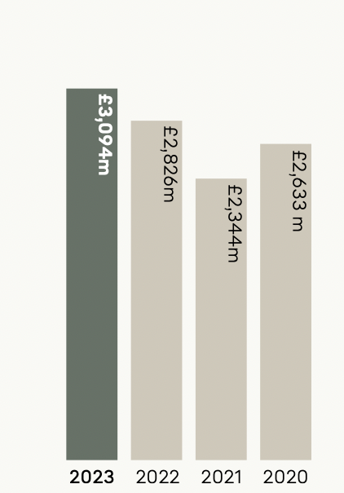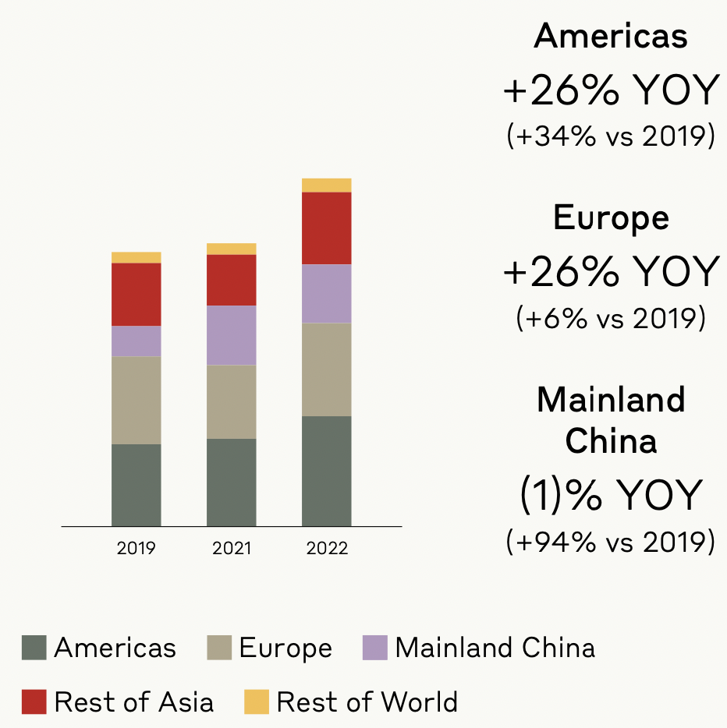
Source: (Burberry, 2023, p.11) Source: (Burberry, 2023, p.16)

61.0p
- The Group works toward being a responsible business

- Product
Certified raw materials, reducing plastic, innovating manufacturing processes, ethical trading.
- People
Focus on equity, diversity and inclusion, creating rewarding colleague experience where people can express their creativity.
- Planet
Becoming Climate positive by 2040 with eliminating emissions across the value chain 90%. Waste and recycling programmes.
- Communities
Strategy involves empowering youths by charitable initiatives, fostering creativity with programmes supporting underrepresented groups and LGBTQ+ Communities and various humanitarian projects (The Burberry Foundation).
(Burberry, 2023)

- Conclusion
The strategic fit between strategy and structure of Burberry Plc ensured strong financial performance against the global uncertainty and post- pandemic recovery. The new strategy to elevate the brand by improving product range and renewing store portfolio marked continuous increase in sales performance. As a result, some target markets such as Asia, where restrictions still exist, show resilience. As well as delivering for shareholders, Burberry’s inclusive culture influences the success of the company. The value chain and value systems analyses show that Burberry optimises resources, uses its leadership and structure to enforce strict ethical trading standards and quality, emphasising on corporate social responsibilities, laying ambitious climate sustainability targets and preserving the nature as a base for growth. The company understands the consumer trend shifts towards ethics therefore, it invests in ethical marketing as well as digital innovations to attract consumers and especially younger ones.

- Recommendations
Burberry should focus on brand awareness as a responsible business in new market segments and differentiate new consumer segments in existing markets for their products. This would influence purchase decisions and drive sales and growth in new markets. VRIO analysis shows that the unique brand, quality and ethical marketing provide sustainable competitive advantage enabling premium prices. Sales growth is a misleading goal as it leads to reducing prices dramatically. Therefore, Burberry shouldn’t compete on pricing as nor them neither their rivals would gain competitive advantage but try to operate at lower costs. They can consider cutting discounting and reducing stores in less upmarket locations to create more value of the brand. In summary, there are still a lot of challenges with the ever changing customers’ expectations and evolving of innovations but being a collective mission, the new Burberry’s strategy sets a strong foundation for continuous future success.

REFERENCES

Burberry (2018/19) Annual Report 2018/19. Available at: https://www.burberryplc.com/content/dam/burberry/corporate/oar/documents/Burberry_201819-Annual-Report.pdf (Accessed: 15 December 2023)

Burberry (2023) Annual report 2022/2023. Available at: https://www.burberryplc.com/content/dam/burberryplc/corporate/documents/annual-report-2022-23/Annual-report-2022-23.pdf (Accessed: 04 December 2023)

Burberry (2023) Business model. Available at: https://www.burberryplc.com/company/business-model (Accessed: 21 November 2023)

Burberry (2023) Dividends. Available at: https://www.burberryplc.com/investors/shareholder-centre/dividends (Accessed: 05 December 2023)

Burberry (2023) Going beyond for better. Available at: https://uk.burberry.com/going-beyond-for-better/ (Accessed: 28 November 2023)

Burberry (2023) Our History. Available at: https://us.burberry.com/c/our-history/ (Accessed: 19 November 2023)

Burberry (2023) Strategic report. Available at: https://www.burberryplc.com/content/dam/burberryplc/corporate/oar-2022-23/our-strategy-2022-23.pdf (Accessed: 28 November 2023)

Burberry (2023) Strategy. Available at: https://www.burberryplc.com/company/strategy (Accessed: 20 November 2023)

Lynch, R. (2018) Strategic Management. 8th Ed. Harlow: Pearson
MarketLine (2020) Apparel and non-apparel manufacturing in UK. Available at: https://advantage-marketline-com.ezproxy.uwtsd.ac.uk/Analysis/ViewasPDF/united-kingdom-apparel-non-apparel-manufacturing-103607 (Accessed: 28 November 2023)

MarketLine (2023) Burberry acquired business from Pattern for $22.76m. Available at: https://advantage-marketline-com.ezproxy.uwtsd.ac.uk/Deals/Facts/burberry-to-acquire-technical-outerwear-factory-from-pattern_4275283 (Accessed: 04 December 2023)

MarketLine (2023) Burberry Group Plc. Available at: https://advantage-marketline-com.ezproxy.uwtsd.ac.uk/Company/Profile/burberry-group-plc?swot (Accessed: 04 December 2023)

Whittington, R. et al. (2020) Exploring strategy. 12th Ed. Harlow: Pearson

REFERENCES (Figures)

Whittington, R. et al. (2020) Generic strategies [Figure 1] Available at: https://ebookcentral.proquest.com/lib/trinity/reader.action?docID=5987036 (Accessed: 15 December 2023)

Whittington, R. et al. (2020) Ansoff Matrix [Figure 2] Available at: https://ebookcentral.proquest.com/lib/trinity/reader.action?docID=5987036 (Accessed: 15 December 2023)

Burberry (2018/19) Revenue drivers [Figure 3] Available at: https://www.burberryplc.com/content/dam/burberry/corporate/oar/documents/Burberry_201819-Annual-Report.pdf (Accessed: 16 December 2023)

Burberry (2023) Revenue [Figure 4] Available at: https://www.burberryplc.com/content/dam/burberryplc/corporate/documents/annual-report-2022-23/Annual-report-2022-23.pdf (Accessed: 16 December 2023)

Burberry (2023) Market growth [Figure 5] Available at: https://www.burberryplc.com/content/dam/burberryplc/corporate/documents/annual-report-2022-23/Annual-report-2022-23.pdf (Accessed: 16 December 2023)

