The Three Living and the Three Dead
Intimations of Mortality: Animations of Morality

Slide 1 The Story of the Three Living Men and the Three Dead Men, from 'Recueil de Poesies Francaises', c.1280-90 (French Poetry)
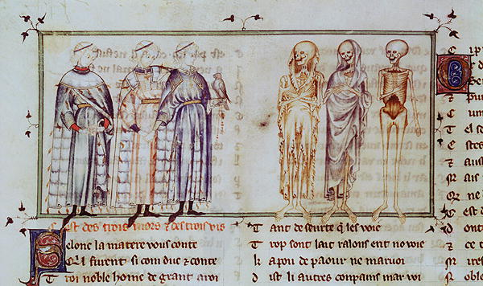
A standard early depiction: three wealthy young men confronted by three skeletons. One of the young men carries a hawk and holds his neighbour’s hand, perhaps for support. The nearest skeleton in dressed in the remains of a high-status gown. There is a gap between the two groups but no tree or cross to separate them. There is no background or landscape. This is the earliest representation I could find.

Slide 2 The de Lisle Psalter with enlargement of text. 1308-1340, poem in English and French, East Anglia, held at the British Library.
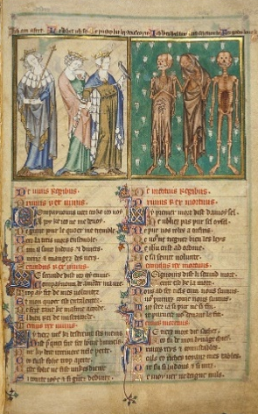
'Le dit des trios morts et trios vifs' The poem is written in French, although the line above the picture is Middle English: Living 1: ‘I am afraid’ (Ich am afert), Dead 1: ‘I was well fair’ (Ich wes wel fair); Living 2: ‘Lo, what I see!’ (Lo whet ich se), Dead 2: ‘Such shall you be’ (Such schel tou be); Living 3: ‘Methinks these be devils three’ (Me þinkes hit bey develes þre), Dead 3: ‘For God’s love, beware by me’ (For godes love bewer by me). From this text we see that the Dead are not evil, but only trying to warn the Living of what is to come. The wealthy and powerful must leave their luxurious lives and turn to God. The dead in this case have no indicators of status, although the Living are well dressed. As in slide 1, a hawk and division between groups. This time there is some background: daisies for the Dead. This flower usually means purity, simplicity, patience – perhaps that last is the clue. Interestingly the right hand skeleton looks out at the reader, including them in the meaning of the picture.
Slide 3 Petites Heures du Duc de Berry, 1375-1390, f. 282v. France, held at the Bibliotheque nationale de France
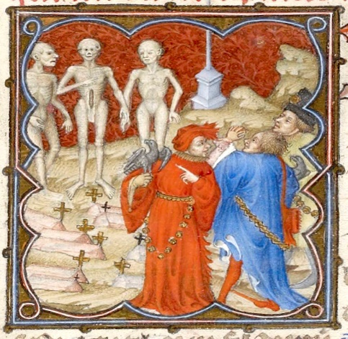
The Dead here are unclothed, but with ‘real’ faces. The Living are richly dressed and, again, hunting (seen as a pastime of the nobility). They meet in a graveyard and the Living show emotion. This it typical of the works commissioned by Jean, Duc de Berry: beautifully executed.
Slide 4 Sacro Speco, Scala Santa, Subiaco, Italy. 14th century wall painting
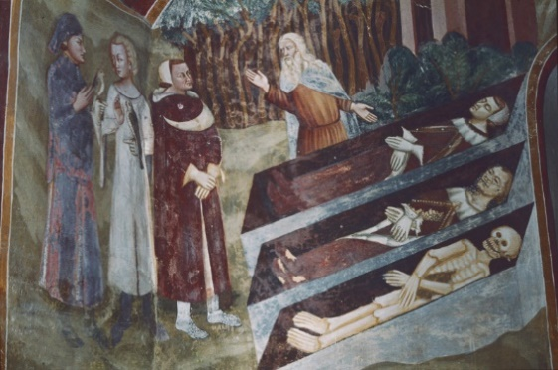
A ‘real’ landscape. This time the Dead really are dead: not animated skeletons, but men in coffins. A Hermit has appeared: he seems to be explaining to the Living. He is a mediator, not only between the two groups in the painting, but between the viewer and the painting. The Dead are in varying stages of decomposition but the two still clothed wear high status clothes and carry hawks. A variation on the original theme, the meaning remains the same. This painting, although on a wall, is in a monastery and therefore less public than that shown from Wickhampton, which perhaps account for the higher quality of the work.

Slide 5 St Andrew’s church, Wickhampton, Norfolk. 14th century
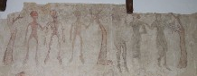
Three Living and Three Dead uncovered in the 19th Century. As with many wall paintings, poorly preserved: the paint is very delicate and, with exposure to light and air, prone to decay. Books do not suffer in this was as light and air are excluded. The standard of execution is primitive, but these images are on display for all to see and must have had as much impact on congregations as those in books had on their readers. It is interesting to note that the Living are always nobles, even in this case. Here thought there is a tree separating the two groups.

Slide 6 France c. 1480-90 Harley MS 2917 f. 119. Held at the British Library
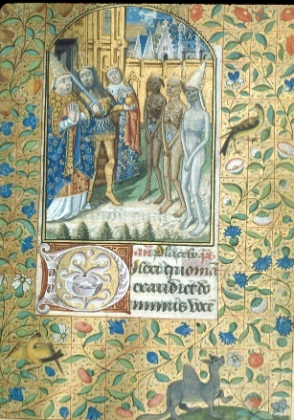
A king, an emperor and a pope face their dead counterparts. The characters are not to be identified with ‘real’ people but act as ciphers for the powerful of all kinds. The Living lean back in horror. The landscape is possibly the exterior of a church. These paintings frequently preface the Office of the dead in Books of Hours but are also found in other books and appear only from the thirteenth century onwards, their heyday being the fourteenth and fifteenth centuries.

Slide 7 Held at the Staatliche Museen, Berlin. Woodcut, 15th century.
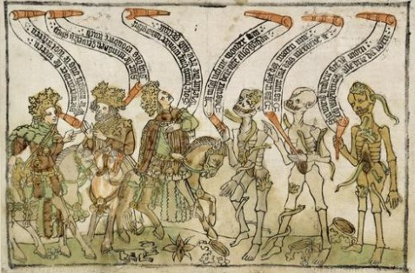
A woodcut from Germany. The artistic quality is less polished than the paintings in the manuscripts, but still bears the original meaning. The young men are still well dressed, still worried by the skeletons. The great benefit of the printed book is its comparative cheapness. This could bring moral texts into many more homes.

Slide 8 The Hours of Joanna I of Castile (the Mad), 1500, S Netherlands, held at the British Library
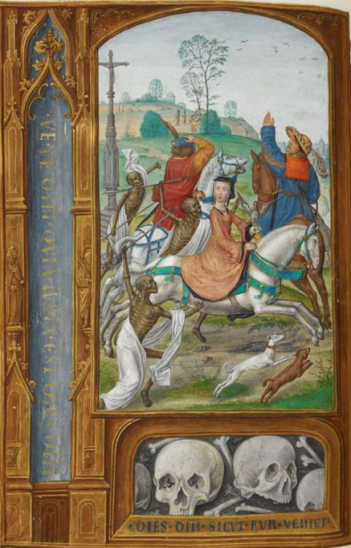
A woman is centre stage here, as befits the owner of the manuscript. For the first time we see the Living on horseback, increasing their status. They ride fast to escape the menacing, aggressive Dead. A full landscape with a cross, perhaps indicating a graveyard again.

Slide 9 Norre Alslev church, Denmark c. 1480.
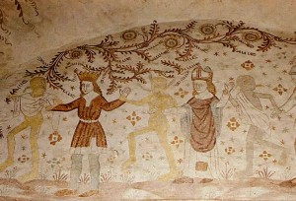
This is an image that came out of the taste for macabre art: not the Three Living, but this time the Dance of Death. Less exclusively high-status, each of the Living represents a trade or calling: king, pope, bishop, knight, physician, logician, young man, old man and the fool. The idea here is that Death is inescapable: all must follow him in his dance. If you are inspired to look further into the macabre art of the middle ages, there is a world of information available.

Slide 10
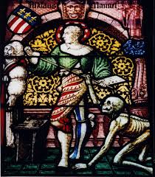
Plate 1 Munster of Bern, Switzerland, 15th century
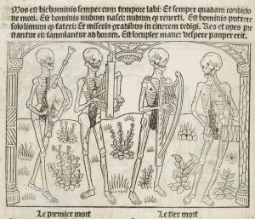
Plate 2 from Le Miroer Salutaire, France, 1486
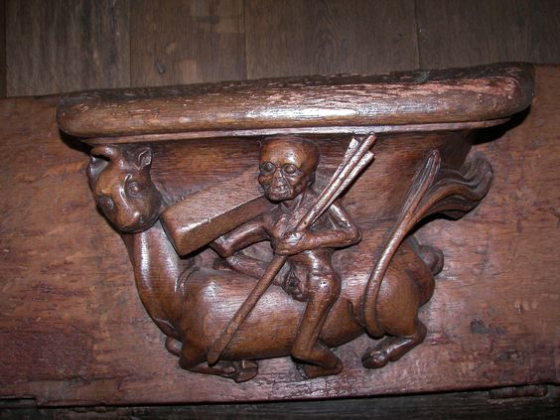
Plate 3 Eglise St Adrien
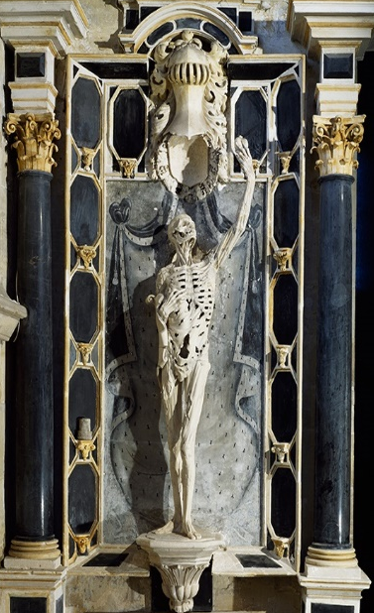
Plate 4 Tomb of Rene de Chalon, Bar le Duc, 1545-1547
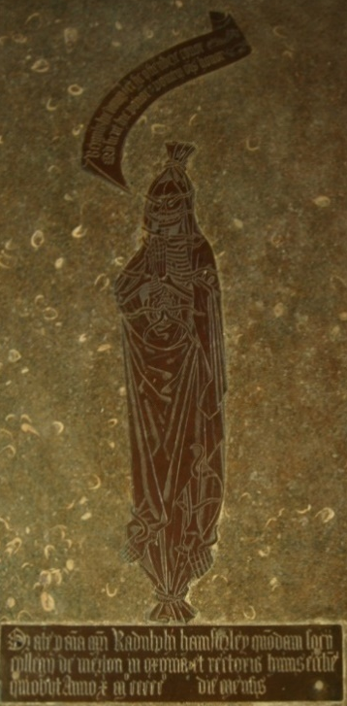
Plate 5 St Andrew, Oddington, Oxfordshire 1515
In this final slide we see many other ways in which death was depicted: stained glass, a transi tomb, funerary brass, a misericord and even stained glass. They all come from the medieval period, and all over Europe. I could have included hundreds of depictions of the Three Living and the Three Dead, of the Dance of Death and of many other representations of skeletons and skulls. The fear of death, especially following the Black Death and its recurrences and at a time when there was always war somewhere, showed itself everywhere: in church, in books, on house walls… If the Dead here are in Purgatory, then the Living can help with intercessory prayers. If they are in Hell then there is no hope: they are damned, and all they can do is to warn the Living to beware of falling into sin. The hope was that, by taking the lessons offered by these pieces, the viewer would find salvation.
Bibliography
Backhouse, Janet, Illumination from Books of Hours (London: The British Library Board, 2004)
Binsky, P, Medieval Death: Ritual and Representation (London: British Museum Press, 1996)
Camille, Michael, Gothic Art (London: Weidenfield & Nicholson, 1996)
Courthion, Pierre, Flemish Painting (London: Thames & Hudson, 1958)
Jones, Malcolm, The Secret Middle Ages (Stroud: Sutton Publishing Ltd. 2002)
Kinch, Ashley, Imago Mortis: Mediating Images of Death in Late Medieval Culture (Leiden & Boston: BRILL, 2013)
Smith, Kathryn A., The Taymouth Hours (London: The British Library, 2012)

Websites
The British Library blog:
http://blogs.bl.uk/digitisedmanuscripts/2014/01/the-three-living-and-the-three-dead.html
Christina Welch’s blog about cadaver carvings in Britain:
http://www.britishcarvedcadavers.co.uk/anatomy.php
Lubeck’s Dance of Death:
http://www.dodedans.com/Emargin01.htm
The British Library
www.bl.uk
Vitrearum’s Medieval Church Art (Alan Barton’s site):
http://www.medievalchurchart.com/2008/09/taste-for-macabre-late-medieval-cadaver.html
The University of Glasgow’s Special Collections:
http://special.lib.gla.ac.uk/exhibns/death/origins.html
La Mort dans l’Art:
http://www.lamortdanslart.com/main.htm

https://www.art.com/products/p12266666-sa-i1636105/the-story-of-the-three-living-men-and-the-three-dead-men-from-receuil-de-poesies-francaises.htm
https://www.bl.uk/catalogues/illuminatedmanuscripts/ILLUMIN.ASP?Size=mid&IllID=472
http://gallica.bnf.fr/ark:/12148/btv1b8449684q/f573.image.r=Horae+ad+usum+Parisiensem+ou+Petites+heures+de+Jean+de+Berry.langEN
http://etc.usf.edu/clippix/picture/subiaco-sacro-speco-scala-santa-the-three-living-and-the-three-dead.html
http://www.edp24.co.uk/news/weird-norfolk-norfolk-s-memento-mori-1-5225613
http://www.bl.uk/catalogues/illuminatedmanuscripts/ILLUMIN.ASP?Size=mid&IllID=13168
http://studiomatters.com/in-morte-sumus
https://www.pinterest.co.uk/pin/280700989247097662/
http://www.medievalwall.com/painting/dance-of-death/attachment/dance-of-death-n%C3%B8rre-alslev-church-o-falster-denmark-around-1480/
https://www.pinterest.com/pin/513340057498033894/
http://studiomatters.com/in-morte-sumus/3living-3-dead-500x371
https://commons.wikimedia.org/wiki/File:Poc%C3%A9-sur-Cisse_(37)_%C3%A9glise_saint-Adrien_6.jpg
http://morbidanatomy.blogspot.co.uk/2008/09/transi-de-ren-de-chalon-ligier-richier.html
https://commons.wikimedia.org/wiki/File:Oddington_StAndrew_BrassHamsterley.JPG

