Academic and Employability skills
(02 January 2020)

By: M.W. Samsudeen
Student Number: 1908197
To: Mr. Timothy Hopkins
Course Code: (BMSW4001_LON)

Executive Summary
The purpose of this report was to analyse my own academic and employability skills. The key objectives were to analysis and evaluate the skills and relate them into real life situations. I have used published literature, notebook, in-class exercises and internet. Academic and employability skills both can which I have learned and implemented in both of my studies and employability. This report is to show the methodologies that I have learned and developed in my academic and employability skills in-class exercises. I will provide the important information which I have gathered to briefly discuss my own academic and employability skills. And I will discuss the lessons learned and what I recommend the reader to do.

Acknowledgements
I have received suggestions and feedback from Timothy Hopkins to improve on the report.

Table of Contents
Executive summary…………………………………………i
Acknowledgements…………………………………………iv
- Instructions…………………………………………………..5
- Methodology…………………………………………………6
  - How I gathered the information…………………………….6
  - Describe the methods I used to collect data……………...6
  - What measurements I made………………………………..6
- Results………………………………………………………...7
  - Time management: Eisenhower Method……………….....7
  - Personal Swot Analysis……………………………………..8
  - Personal development plan………………………………...9
  - Harvard Referencing…………………………………..……10
  - Paraphrasing…………………………………………………11
  - Summarising………………………………………………...12
- Discussions………………………………………………....13
4.1 Time management: The Eisenhower’s method…13
4.2 Personal Swot Analysis…………………………….14
4.3 Clear View on my current situation………………14
4.4 Personal Development Plan…………………………..14
4.5 Setting specific goals…………………………………14
4.6 Harvard Referencing……………………………………15
4.7 The purpose of referencing…………………………….15
4.8 Paraphrasing…………………………………………….15
4.9 Paraphrasing Techniques………………………………15
4.10 Summarising……………………………………………16
- Conclusion…………………………………………………..16
- Recommendations…………………………………………17
- Reference……………………………………………………18

Introduction

Academic and employability skills include several skills which can be applied to both areas.
The purpose of this report was to analyse my own academic and employability skills. The key objectives were to analysis the academic and employability skills on the published literature, notebook, internet and in-class exercises. Reflecting on what I have learned and identifying the models of reflection which is the theory and practice. We have looked at different types of academic and employability skills during our in-class exercises. I will only be talking about the most important academic and employability skills. For example, Eisenhower’s method, Swot Analysis, personal Development Plan, Harvard Referencing, Paraphrasing and Summarising. I have used four different methods to collect the information. for example, published literature, internet, in-class exercises and notebook. And I will also explain how implementing these skills will make me achieve and improve my current status at work and studies. This report summarises how I have explored these ideas and how they will be useful to my future directions.

Methodology

  - How I gathered the information – Most importantly I have carefully read through the assignment brief and acknowledged the aim of the report and understood how I should collect data. For example, I have looked through my notebook, internet, published literature and in-class exercises. To gather all the relevant information that is refereeing to academic and employability skills which I must include in the report.

  - Describe the methods I used to collect data - I have used four different types of methods to collect the data to complete this report. For example, my notebook, in-class exercises, internet and published literature to get the specific important information. And I also used the university website which is the Moodle contains all the accurate information and useful tips and techniques for the academic and employability skills subject.

  - What measurements I made – I have read through the assignment brief and I only included the relevant information needed to complete this report. For example, I have only included different types of academic and employability skills that we covered in-class exercises such as, Eisenhower method, Swot Analysis, personal development plan, Harvard referencing, paraphrasing and summarising.

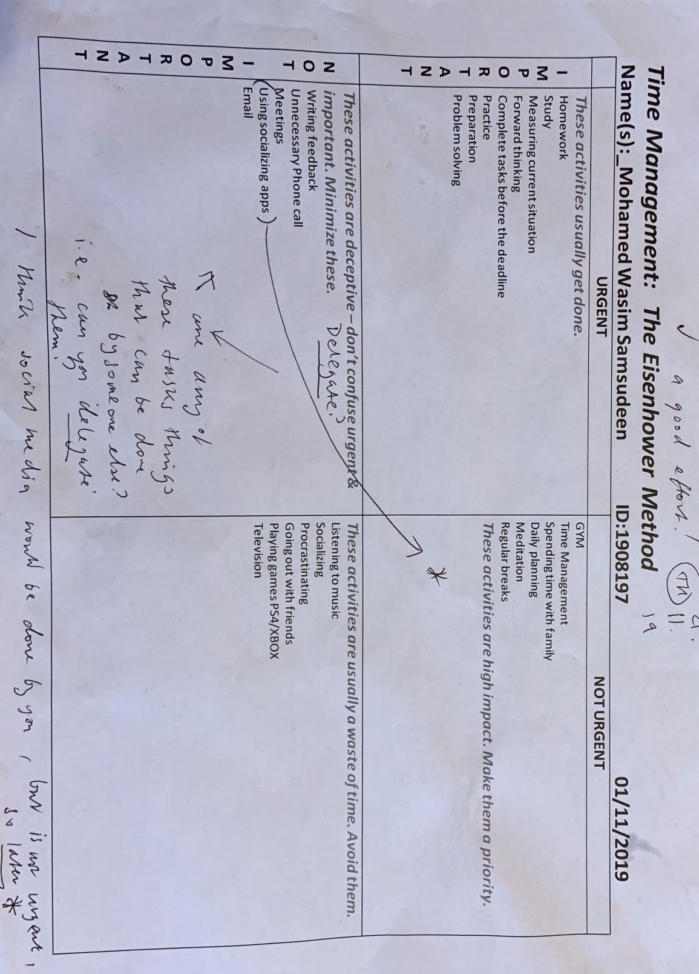
Findings

  - Time Management: The Eisenhower Method

3.2 Personal Swot Analysis
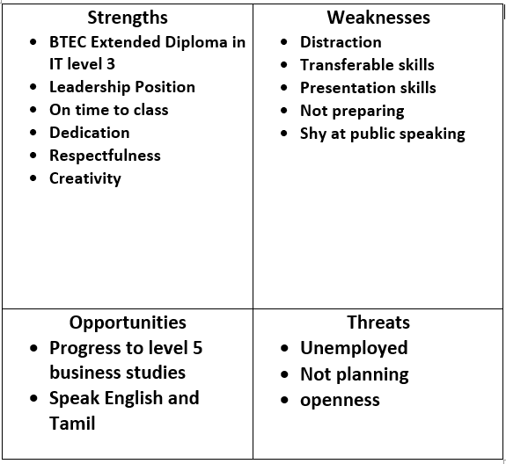

3.3 Personal Development Plan

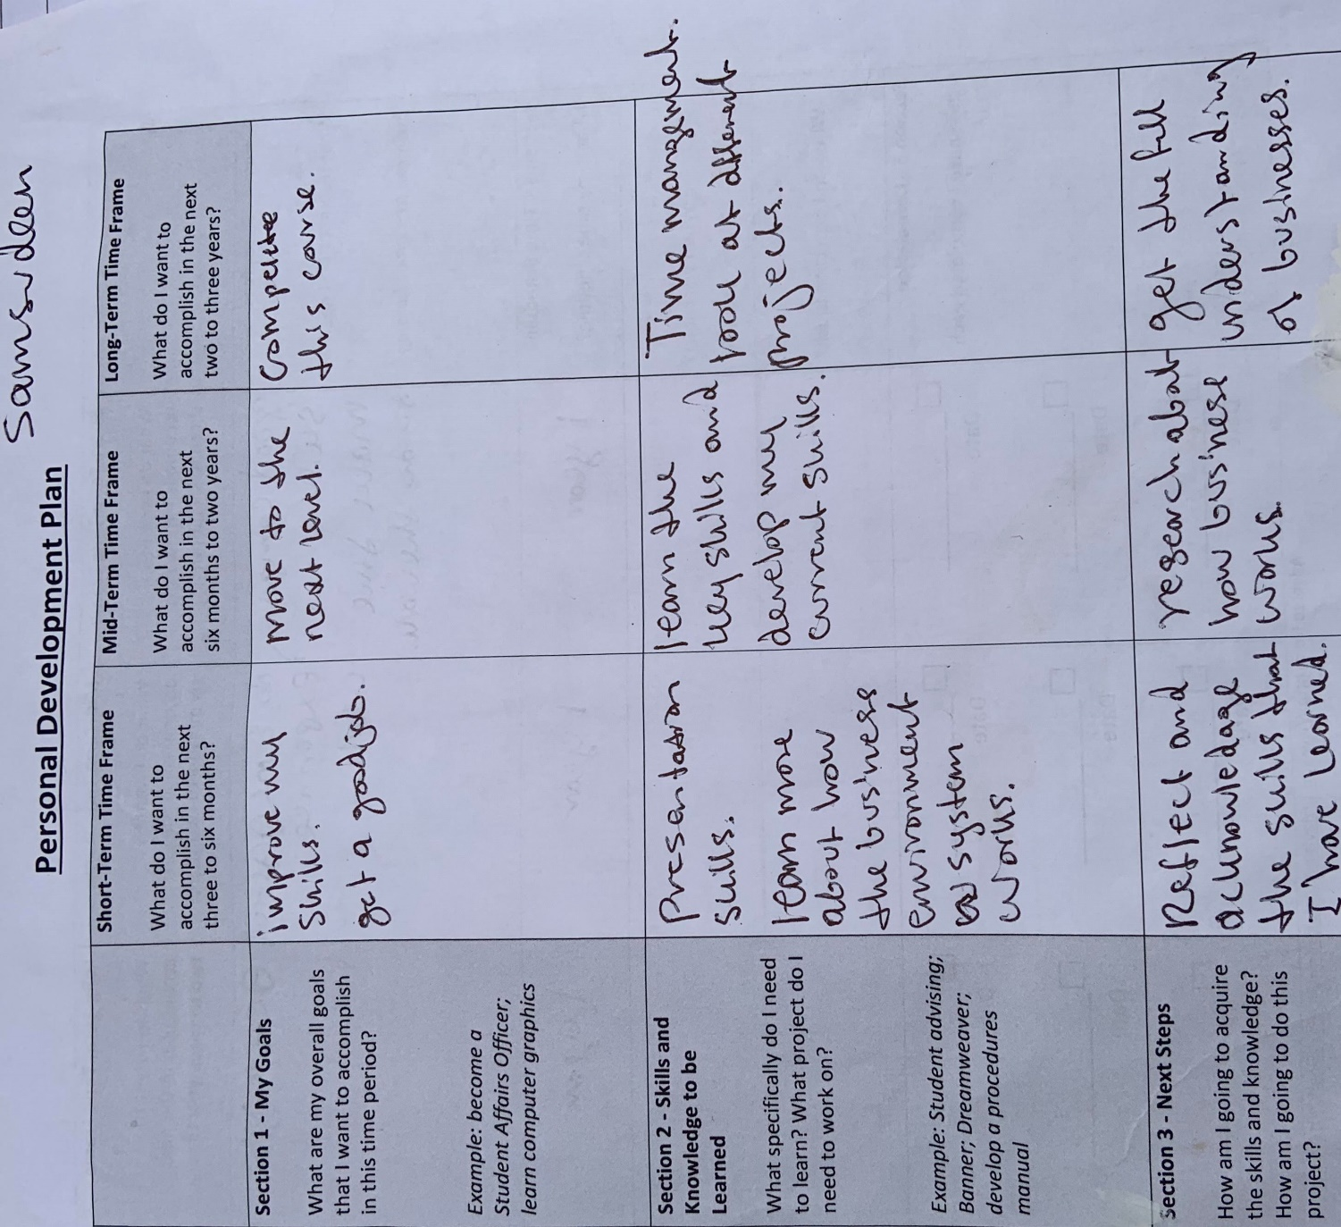

3.4 Harvard Referencing
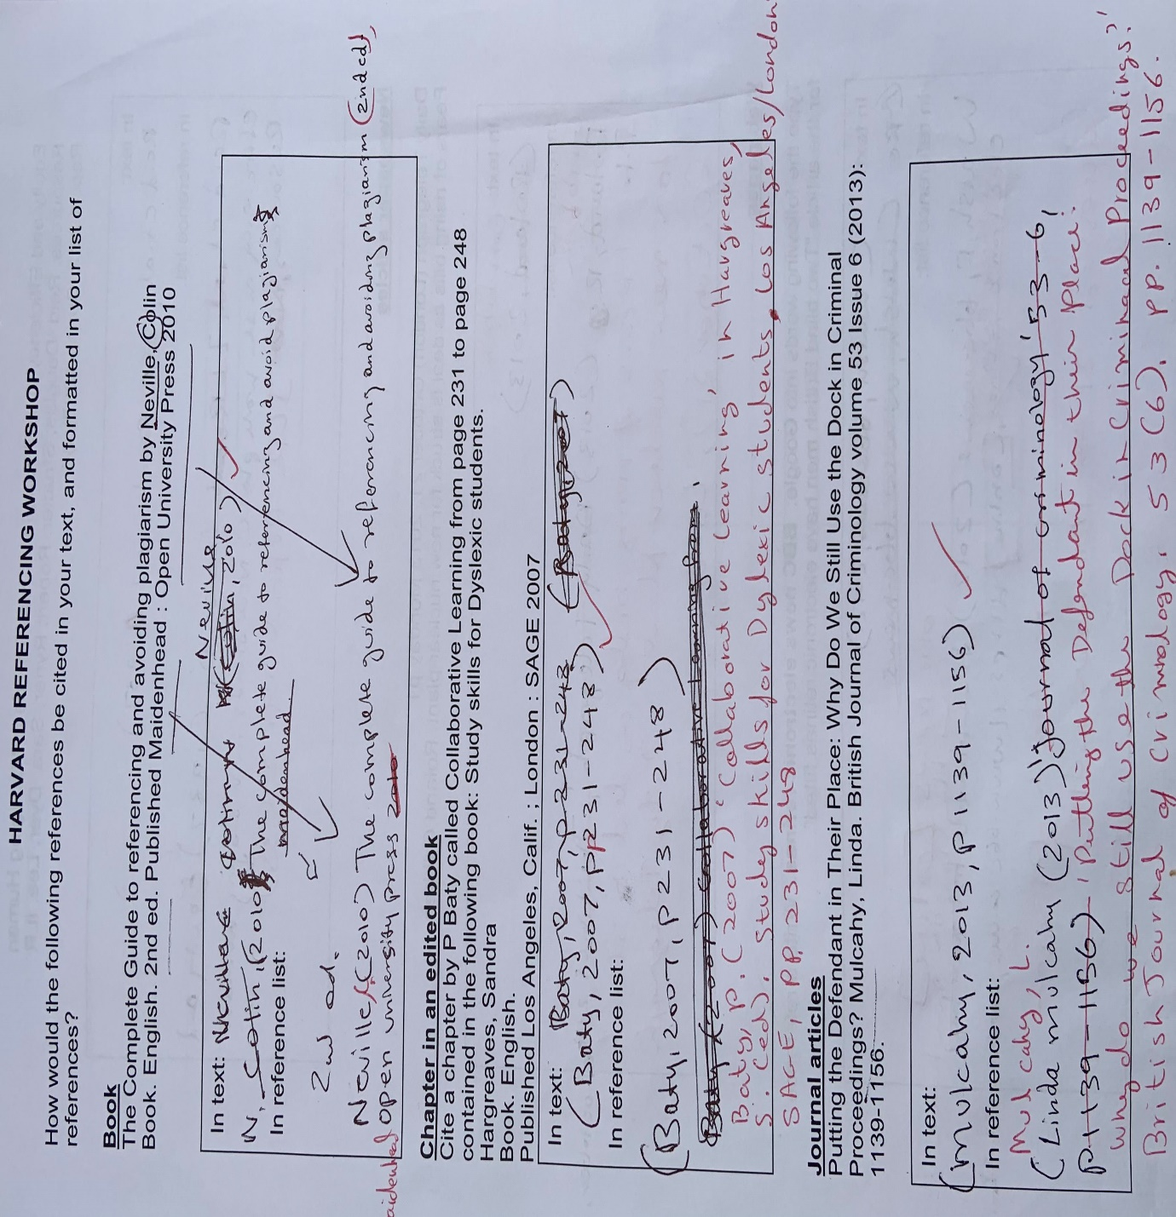

3.5 Paraphrasing
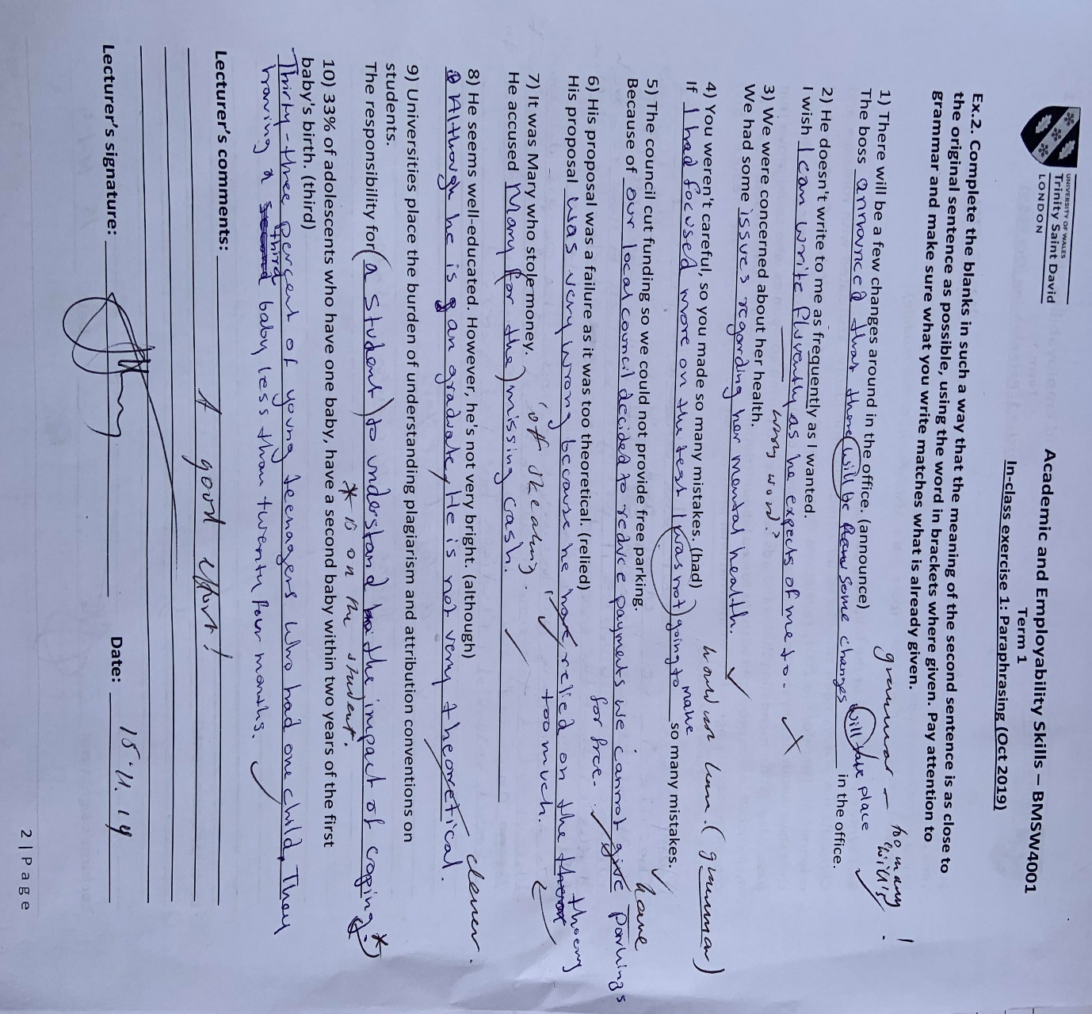

3.6 Summarising
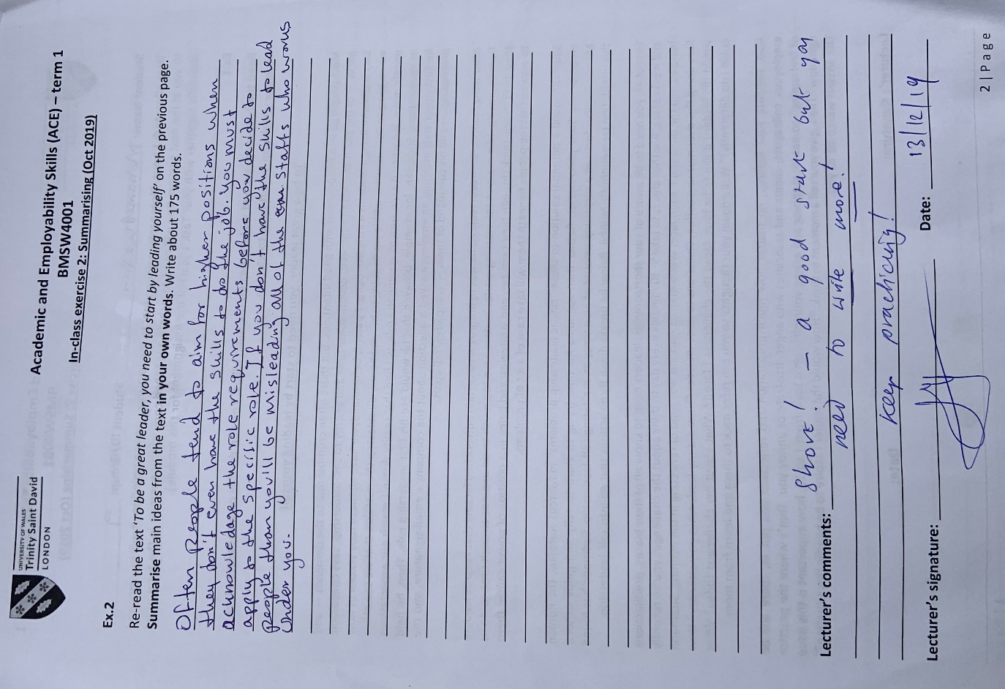

Discussion

The academic and employability skills that I suggested in my finds they are critical for my professional implication and aims. I will be evaluating and discussing the key findings and their significance.
There are various academic and employability skills that we have learned in our in-class exercises and we have clearly discussed each of the skills which I have mentioned in my findings and we also, did a test on each of these skills and received a feedback from our tutor explaining how well we did on our test and where we all need to make improvements.
Transferable skills are one of the main key skills which can be implemented to both academic and employability skills. It is one of the main skills which the employer is looking for in a candidate beside the employee should have a bit of technical intellect and key subject knowledge. Even if you have no previous working experience and you apply for a newer position if you know what transferable skill is than there are higher chances that you’ll get the job.
I have specifically picked out certain skills which will benefit me in my workplace and studies.
4.1 Time management: The Eisenhower’s method
The Eisenhower’s Method is made up of four different components such as, important and urgent, important but not so urgent, not so important but urgent and not important and not urgent. It used to organize and prioritise the tasks to figure out what needs most attention and what can be postponed.
By Learning the Eisenhower’s method, it has enabled me to use the time wisely. I use the Eisenhower’s method to plan my everyday routine. Time management is one of the basic skills it comes before any other skills because if you don’t use the time wisely, you’ll get withdrawn from the university and at work you’ll be asked to leave. For example, I always leave early to get the train and arrive at university on time without being late for the lessons. Also, for work time management is vital. For example, if I don’t arrive on time to my own workplace than I will put others in risk to complete they’re on task which will lead to cause even more occurring problems as the company is still running. Everyone needs to take their work seriously and arrive on time as they are scheduled on the timetable. If I decide to progress to the next level in my current workplace than I need to show them that I will be the good candidate for that role. If I’m bad at time management than I’ll not get the role to lead the team in the future.

4.2 Personal Swot Analysis
Personal Swot Analysis can be used to analysis and identify an individual, product or a company. strengths, weaknesses, threats and opportunities. For example, I have used the Swot analysis method which enabled me to know my own strengths, weaknesses, threats and opportunities in my university. By leaning this method,
4.3 Clear View on my current situation
I have used the Personal Swot Analysis to assess myself. I have clearly stated my strengths, weaknesses, opportunities and threats. And what I must develop and improve to move forward in my professional implication and aims. It gave me a clarity of what skills and opportunities are available for me in my academic and employability.
4.4 Personal Development Plan
The personal development Plan is used in every aspect in academic and employability. It is used to improve on yourself and plan clearly where you are headed in your career. Listing the key aims and goal that I want to accomplish.
4.5 Setting specific goals
Setting specific short-term, mid-term and long-term goals in your professional career and academic studies will help me to know what I need to complete and achieve in the time period. Carefully, organising my ideas and being proactive to accomplish each objective has enabled myself to know what I must do to achieve the goals. The steps I should make to achieve these objectives. For example, making measurements and setting a time frame and checking whether I have accomplished the goal or not.

4.6 Harvard Referencing
It is one of the most important skill which I have learned. There are lots of different ways to reference a source of information which I have paraphrased in my own words using somebody else’s work. I must reference where I got the information from to avoid plagiarism. I can use writers’ ideas and make up my own ideas, but I must reference where I got the information from. And I must write the correct Harvard referencing format to specific source of information which I have gathered the data from. There are different sources available for you to use and attain data from. For example, you can get collect data from, newspaper, articles, internet, journals, conference and reports.
4.7 The purpose of referencing
The aim of referencing is to show and find the resources that you have applied to your work and to avoid plagiarism.

4.8 Paraphrasing
Paraphrasing is you’re rewording a specific information to get more simple and clear understanding. Paraphrasing shows that you have fully understood the information and your able to translate it in your own words and you know the accurate information. You’ll be able to answer any questions about the specific topic and develop your ideas according to the information to your own understanding.
4.9 Paraphrasing Techniques
Paraphrasing involves lots of techniques, for example, changing synonyms, changing word class, Changing the order of the sentence, giving your opinion and the authors opinion, Changing the structure of the sentence, nouns to verb, adjectives to nouns and action word. However, the paraphrasing should not change the original context of the sentence. I must cite where I got the resource from to avoid plagiarism.

4.10 Summarising
Summarising technique is very useful it enabled me to pick out the key points in a larger text and it enabled me to leave out the unnecessary information in the text. It helped me to organise and write a text in its purposeful and much shorter way. Summarising method can be used in various subjects it enables you to understand the text easily.

Conclusion

Firstly, I have talk about different skills relating to academic and employability skills, such as, Eisenhower’s method, Swot Analysis, personal Development Plan, Harvard Referencing, Paraphrasing and Summarising. And how they can be used to improve on your academic and employability skills.
Secondly, learning these skills and methods will enhance your understanding and improve how you plan and organise your daily tasks and activities which you do daily.
Thirdly, this report is based on academic and employability. The skills that I have discussed and discovered in my findings are vital for both academic and employability skills. I have also discussed how important they are to your career.

Recommendations

In the future, these skills will worth more value and by fully understanding each of the skills and knowing their purpose and what they are used for will provide you with a clear understanding of your own career path. It will also help you to assess yourself to know where you are at the current situation. And what you need to do to improve on the negative skills that are holding you back from achieving what you want to accomplish. I recommend, academic and employability skills are very important, and they should be implemented in every aspect of your career.

I recommend, the readers to learn the different types of academic and employability skills because it will enable them to plan properly to achieve their full potential and personal goals quicker. By learning the academic and employability skills there are greater chances that you can be employed in the choice of your career field.

Reference

The importance of Time Management
(Morgan, P. (2017) The Business student’s guide to study and Employability. SAGE, London, P.52)

https://www.scribbr.co.uk/thesis-dissertation/methodology/, Date accessed on 11/12/2019
https://uwtsd.ac.uk/media/uwtsd-website/content-assets/documents/library-and-learning-resources/infoskills/Harvard-eng_v.1.2.pdf, (accessed on 11/12/2019)
Transferable Skills (n.d) what are transferable skills? [online]
Available at: https://www.wikijob.co.uk/content/interview-advice/competencies/transferable-skills (Accessed: 23/12/2019)

Personal Swot Analysis (n.d) Personal SWOT Analysis to Assess and Improve Yourself [online]
Available at: https://creately.com/blog/diagrams/personal-swot-analysis/ (Accessed: 23/12/2019)

