Management and
Organisational Behaviour
M5X01924
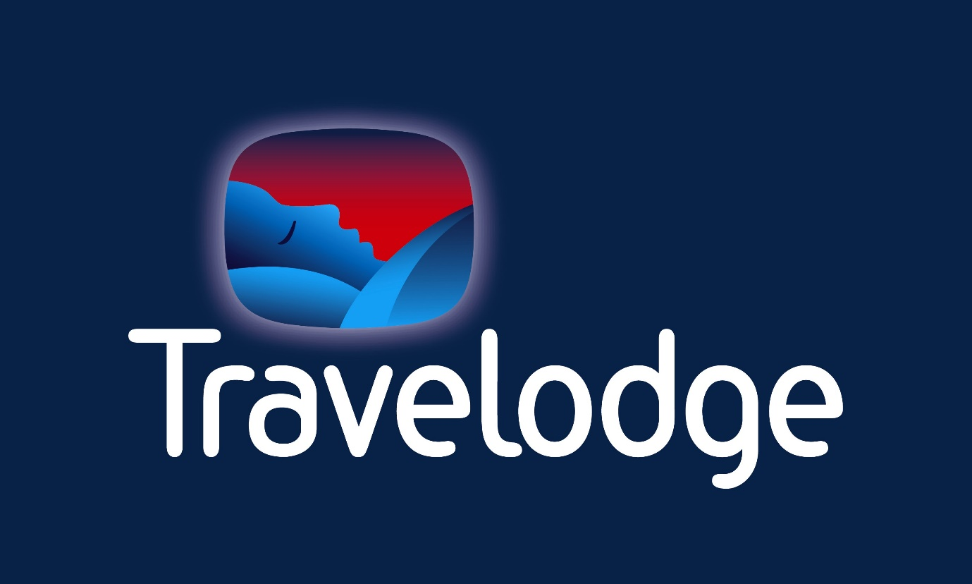

Student name: Costica Munteanu
Student number: 1815196
Lecturer: Dr. Olu Adegbite

Contents

Introduction 2
Organisational Structure of Travelodge 2
Recent change initiatives, their impact and how well they were managed 3
Strategic direction and Business performance 4
Conclusion 5
References 6

Introduction

The scope of this report is to analyse based on theories the organisational structure, culture, and goals of Travelodge. Also, it is important to see what challenges they had and how they managed them and their plans of future. Travelodge is the second large chain Hotels in UK. There are 575 hotels placed in different countries such as: 74 in London, 493 in other regions, 12 in Ireland and 5 in Spain. All of them are placed in the centres of town with astonishing views and high standards of products and services. More than 11,000 people are working in this organisation full time and part time every day. Based on the Grifiin definition, Organisational structure is: “A set of construction elements which may be used in shaping an organization. The result of their use in the concrete arrangement of the elements of an organization and their inter relationship.”

Organisational Structure of Travelodge

CTO
Digital marketing Director
Legal & Secretary
COO
CFO
CEO
Chairman of the board
Brand Marketing

Commercial pricing analytics

International & Development
Customer experience
Revenue Trading

The duties of organisational structure are to be efficiency to take decisions, to communicate that starts from the top of the organisation till down. Another duty is to be used as span of control. Harnessing experience that refers to arrange the organisation by experiences that they have, functions; the main idea of this is to use the experience of groups to achieve tasks and projects. In Travelodge hotels, the decisions are taken together by voting. Also, they have annual meetings when they decide that is happening in their business. And if it is necessary, they make changes in company. In a big company as Travelodge has more hierarchical layers with more rigid roles. At Travelodge the manager of the hotel will never lead the things that the porter is doing as taking care of the guests’ bags and show them where is their rooms. The life cycle of an organisation is another important factor that influence the organisational structure in this hotel. This hotel is expanding, meaning that the hotel must hire more people, create more rooms, all of these for satisfying the guests needs. The organisational culture in this hotel is a powerful one and is focused on the persons at the top of the ranked structure. Their goals for 2020, based on the unbeatable value in hotels strategy, is to become the favourite hotel for value serving supreme value in vacations and business tourism. They created a plan of £100m modernisation for investing in more than 300,000 rooms. This thing will have a huge impact because the guests will like more and will come often. They are applying bother theories: E and O, that based on the definition that Kippenberger gave it in 2000, the Theory E “is the creation of economic value/high returns to shareholders” and Theory O “sees organisations as having many stakeholders, developing employees and their loyalty. For Travelodge, to grow, they are using both of them because their main goals are to firm management from the top and to involve persons under, to hold the absurdity between economic and organisational competence.

Recent change initiatives, their impact and how well they were managed
As every business, they had challenges also. Starting with competition that made them to invest much more and to work much more for becoming one of the best hotels. Also, the Covid-19 had a huge impact on Travelodge hotel. On 24th March this year they officially announced that they will start to close, temporary, because they received guidance for government. Some of the hotels, were transformed in places for people who do not have places to stay. Also, they let opened some hotels for emergency workers and homeless. They lost money because tourists did not booked rooms anymore. Another challenge that they had in 2019 was because of the increase in the National Living Wage that started in April 2019 and had important cost pressure in their hotel. The strategy that they adopted was to invest more in operational technology by buying tablets to help manage the important procedures and innovated automated preparation for their preservation team. Last year, Brexit, challenged them also. Because they wanted to be “Brexit ready”, they took 3000 students, offered summer contract that helped them to work and study. Their plan was a strategic one, to help the students and to help them also. Why? Because they offered jobs, helped the students, trained them, and in this way, the Company has the staff vey well prepared for their 100 future hotels that they want to open in the next five years. The CEO, Peter Gowers, the Travelodge chief executive, declared in an interview, for THE Guardian, in 2019: “Today’s students have to study harder than ever and meet the rising costs of education. Our new student programme gives flexibility during your studies and the potential to build a longer-term career after graduation – a better way to earn while you learn.” These changes helped them to increase the profit. They made recently changes and improvements for guests, by investing more in quality and to promote them more on different channels and publicity.

Strategic direction and Business performance

The type of strategic direction that they implement is mission. Mission refers to the scope of the business. In Travelodge, the managers want to offer highest quality of products and services, and in this way, they have long term strategic direction that help them to accomplish other goals such as profit. Also, culture, that refers to behaviour, what guests expect from them. It is not easy to change but is good to do this because acts as a strong form of strategic direction. Respecting the guests and offering them all the necessary things, respecting their culture, thoughts, for Travelodge is very important. The employees are trained and know that each guest is different and must be treated as one. They are doing their best, focusing on their customers. The fact that in their meetings, are trying to analyse all the aspects of the company, even to see that bad reviews and change, is a good strategy for development and improvement. Is not easy, during the fact that each of them has different opinions, by voting they resolve this problem. In terms of performance, the Revenue of Travelodge is growing every year. In 2017, the total revenue was 637,1 million pounds, in 2018, the revenue was 693,3 million pounds and in 2019, they declared 728 million pounds. Is clearly to understand they are doing an amazing job. Each year the revenue is increasing. Why? Because each year they are opening new hotels, modernise the hotels, adapts to new trends, improves the services and the employees are doing their job. Are dedicated and motivate to be the best.

Conclusion

Based on the evaluation that was made on these hotels, they had challenges as any other hotel. Considering that it is one of the best hotel companies, the pressure is huge. They've got a bottom of it and with the help of the partners, who've invested, they've reached the top. What's good about this company is the management, who knows what it's doing. Having the necessary knowledge, the necessary skills, being determined to be the best and taking care to make decisions together, to listen to each other, made Travelodge a noted and important hotel. They think ahead, as was the case with Brexit, when they knew in advance what to do and how to help people, but also them. They always try to be prepared for anything and the strategies they apply are very good. Their plans are great and optimistic about the development of hotels and the opening of new ones. As revenues increase year on year, it is easy to understand that they have the resources to develop. Now that the pandemic has dropped, they can implement different projects to ensure the safety of customers who want to stay in their hotels. Also, the routes must be arranged in such a way that there is social distance and employees must comply with the hygiene rules. In terms of the services they offer, in order to motivate people to stay in their hotels, they should give more facilities, discounts, and offer more flexibility with parking payments. In this way, they will become the top 1 hotel.

References

- Brown, A., 2007. Organisational Culture. Harlow [u.a.]: Prentice Hall [u.a.].
- Beer, M. and N. Nohria. 2000. Cracking the code of change. Harvard Business Review (May-June): 133-141
- Diefenbach, T., 2013. Hierarchy In Organization. Hoboken: Taylor and Francis.
- Griffin, G., 1998. Management Theory And Practice. South Yara: Macmillan Education Australia.
- Kippenberger, T. (2000), "Two contrasting theories of change: Theory E and Theory O", The Antidote, Vol. 5 No. 7, pp. 17-21.
- Travelodge Hotels, 2020. Annual Report Travelodge 2019. Thame and London Limited, TVL Finance plc and Travelodge Hotels Limited (collectively, “the “Company”).
- Butler, S., 2020. Travelodge Seeks 3,000 Students As It Faces Brexit Staff Shortage. [online] the Guardian. Available at: <https://www.theguardian.com/business/2019/may/07/travelodge-seeks-3000-students-as-it-faces-brexit-staff-shortage> [Accessed 21 July 2020].
- Statista. 2020. Topic: Hotel Industry In The United Kingdom (UK). [online] Available at: <https://www.statista.com/topics/3146/hotel-industry-in-the-united-kingdom-uk/> [Accessed 21 July 2020].

