Awarding Body: University of Wales Trinity Saint David

Programme Name: BA Business Management

Module Name: Strategic Management and Sustainability (LCBB6004)

Assignment Title: Assessment 1

Student Name and Number: Anita Varga/ 2012895

Tutor Name: Hossein Shokri

Word Count: 2500

Table of Contents
Introduction 3
Strategic Management and Sustainability................................................................................3
VW Group................................................................................................................................3
Main Body 4
Recommendations.................................................................................................................14
Conclusion 15
Reference List 16
Appendix 20

Introduction
This essay will analyse VW Group and its competitive environment. It will identify its resources and capabilities and also the key business strategies of the company in the past five years. This essay will evaluate how the organization has tried to become more competitive whilst considering sustainability and environmental issues. In the end, there will be some recommendations on how the company could gain competitive advantage in the future considering sustainability.
Strategic management and sustainability
Strategic management is the process of continuous planning, monitoring, analysing and assessing all necessities a company needs to meet its goals (Fuertes et al., 2020). Sustainability can be defined as the ability to meet the needs of the present without depleting it keeping in mind the needs of the future generations.
VW Group
The selected company for the report is Volkswagen (Volkswagen, 2023). The brand is a German motor vehicle manufacturer headquartered in Wolfsburg, Germany. This international company was founded in 1937 and has got 675805 full-time employees. There are world famous brand names belong to VW such as Lamborghini, Audi, Bentley, Porsche (Yahoo Finance, 2023).

Main Body
Identify with evidence the key business strategies of VW over the past five years.
There has been a rising demand for sustainable practices in firm operations which has led to organisations transforming their business models to ensure reduced degradation of the environment. VW adopted a similar strategy in its manufacturing process to cater to the sustainability targets set by the UK government. In order to reduce the impact of harmful carbon emissions, the car manufacturer installed ‘defeat devices’ which would help the firm to establish itself as a sustainable brand in the international market (BBC, 2020). Defeat devices are highly advanced software installed in cars which are capable of disabling emission control devices during pollution tests. This allowed the company to demonstrate lower levels of greenhouse gases emission as per the standards of the government. VW utilised a technology which would help reduce carbon oxide emissions diesel cars by entrapping the gases, thereby, saving fuel. However, to make this efficient, defeat devices were installed in the vehicles and while they were capable of cheating during the tests, in reality, the emission levels were excessively higher (Wolfe and Tempus, 2020). The software shut down the emission control equipment to increase the vehicle’s torque and speed which polluted the environment more than was legally permitted.
This enabled VW to portray a sustainable business to consumers worldwide and the firm seemed to be concerned about the negative impact on the environment, society and the economy. There have been several concerns regarding the deterioration of human life due to harmful business operations which have led to the awareness of incorporating sustainability in daily life. Consumers are prone to purchase from business organisations which promote sustainability in their operations and offer green products (Deloitte, 2023).In the UK, a similar trend has been observed with consumers growing concerned about the environmental impact due to unsustainable business practices. This could lead to higher sales for brands which would be implementing such strategies in their business models and offer greener commodities to consumers (Zurich, 2021). VW realised the importance of the incorporation of a sustainable business model which could enhance brand image and drive sales.
The enterprise adopted the three pillars of sustainability concerned with society, economy and the environment which would enable VW to be a green brand (Purvis, Mao and Robinson, 2019). According to this theory, businesses need to conduct operations in an organic manner which would be beneficial in protecting the environment, attaining social equity and being viable for the economy. The German car manufacturer was able to distinguish itself from the competitors by green-washing consumers and governments alike by claiming effective CSR practices in the business (Teck et al., 2020). Due to this, VW sold around 11 million vehicles globally out of which 1.2 million were purchased by UK consumers. Since VW is a luxury brand, it can be concluded that the company was earning large profits by selling self-claimed ‘green vehicles’ embedded with cheating devices.
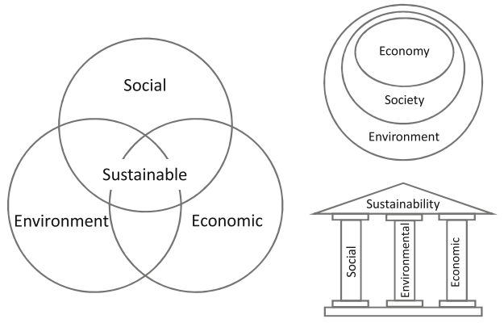
Figure 1: Three Pillars of Sustainability
(Source: Purvis, Mao and Robinson, 2019)
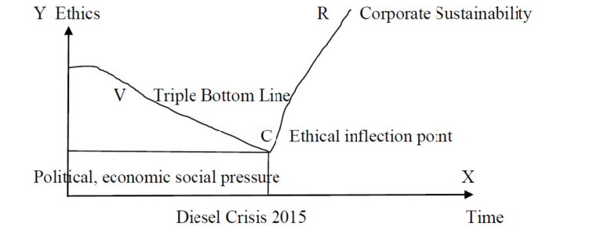
Figure 2: Volkswagen Scandal and CSR
(Source: Teck et al., 2020)
This strategy, however, backfired on the enterprise in 2015 when tests conducted by professionals from West Virginia University revealed that VW-manufactured diesel cars were not conforming to US standards (Dura, 2019). The testing exposed the Volkswagen Passat vehicle which was producing 20 times higher emissions while the Jetta model was generating 38 times more than the legal permit. As a result, the company lost its reputation in the international market after the emission scandal which lowered the consumer’s trust in VW. Over 90,000 vehicle owners in Wales and the UK were affected by this and the enterprise had to compensate them for £193m (BBC, 2022). The legal settlement inflicted heavy expenses for VW along with damaging the company’s reputation and the subsidiaries Audi, Skoda and Seat.
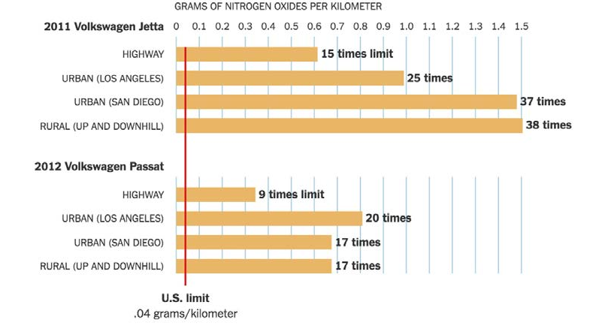
Figure 3: Average nitrogen oxide emission during real-time tests
(Source: Dura, 2019)
As a result of the scandal, Volkswagen has suffered major losses in terms of compensatory payments and reduced customer loyalty. This enabled the company to ensure sustainable practices in the business which could regain the trust of the consumers VW and recover the brand popularity among people. VW has transformed its business strategies which have helped facilitate the production of electric cars which would reduce the negative impact on the environment by zero emissions and responsible recycling (Volkswagen, 2023). Additionally, the enterprise has used innovative capabilities to develop smart vehicles which would be capable of storing energy in the wheels.

Identify with evidence the resources and capabilities of the case study company over the past five years and analyse to what extent the company has aligned its resources and capabilities to its current business strategies.
The resources of an organisation indicate the materials which are utilised by the firms to create valued products and services for the consumers (Prieto‐Sandovalet al., 2019). These can be either tangible or intangible which include equipment, factories, funds, employee capabilities and the brand reputation of the organisation. Resources could be divided into physical, financial, human, technological and intellectual. On the other hand, capabilities refer to the ability of the firm to transform the resources effectively which would help it accomplish a particular goal or target. Organisations would be able to optimally utilise the resources if they have efficient capabilities through the development of employee skills.
Effective leadership skills, agility in business operations, customer service and innovation are some of the capabilities which organisations could possess and use in exploiting the available resources. The resources and capabilities of Volkswagen could be analysed with the help of a VRIO framework. The VRIO analysis could be used to assess the firm’s resources and capabilities which could help the firm gain a significant position in the market (Miethlichand Oldenburg, 2019). These are analysed based on their valuable nature, rarity, inimitability and utilisation by the firms. The framework would be beneficial for understanding the internal environment of Volkswagen and determining the competitive advantage of the company.
Resource/Capability | Valuable | Rare | Inimitable | Organisation | Competitive Advantage Impact
Innovative Capability | Yes | Yes | Yes | Yes | Long-term competitive advantage
Diverse and talented employees | Yes | No | No | Yes | Competitive equality
Technological Advancement | Yes | Yes | Yes | Yes | Long-term competitive advantage
High Revenue | Yes | No | No | Yes | Competitive equality
Effective Leadership Skills | Yes | No | No | Yes | Long-term competitive advantage
Optimum customer service | Yes | Yes | Yes | Yes | Long-term competitive advantage
Table 1: VRIO Framework for Volkswagen
(Source: Created by the learner)
Assessment of the different resources and capabilities of Volkswagen
Volkswagen has established its brand as innovative and creative in its manufacturing process due to high opportunities in the UK as seen in Appendix B. The company utilises this capability to ensure a reduced impact on the ecosystem, security of consumers and protection of natural resources (Volkswagen Group, 2023). Innovation has been a valuable capability for VW which enabled the firm to install defeat devices in vehicles. Since these are prohibited by the UK government, their availability is rare and hard to duplicate. With extensive use of the software in the cars, VW was able to gain a long-term competitive advantage. Similarly, technological advancement in the company is prominent for VW since the enterprise has been able to utilise high-tech software in the vehicles. This helped the firm to be competitive in the international market and gain larger market shares as compared to different competitors such as General Motors, Nissan and Honda (Comparably, 2023).Due to the use of defeat devices in the vehicles, VW was able to establish itself as a sustainable brand and acquire a competitive advantage over rival car manufacturers as can be observed in Appendix A. This has enabled a long-term competitive advantage due to the rarity and value of technology in the firm.
Due to the presence of diversity in the enterprise, the company has been able to enjoy competitive equality for a long time (Oak, 2021). The diverse pool of workers has enabled VW to have a wide range of skills and capabilities which might have been utilised in the installation of defeat devices. Talented employees would be able to offer innovative ideas for enhancing business operations and incorporating sustainability. With the installation of cheating devices in the vehicles, VW was able to earn high revenues post-2010 with over €210 billion recorded in 2015 (Statista, 2023). Due to the high revenue-generating capability of the company, it has been possible to implement expensive technologies. Additionally, effective leadership enabled VW to implement the business strategy and boost the company’s sales. The management at the enterprise is a valuable asset for VW which helped commit the crime. However, due to exceptional customer service, VW was able to convince consumers of its sustainable practices and ensure higher sales.
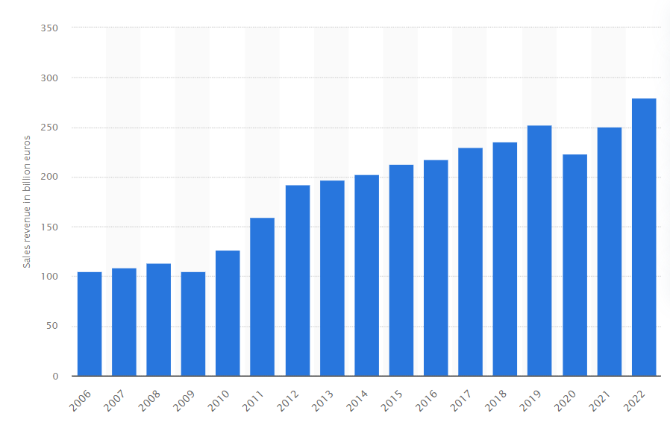
Figure 4: Volkswagen Sales
(Source: Statista, 2023)
Evaluate with evidence how VW has tried to become more competitive while taking into consideration sustainability and the environment.
For the organisation Volkswagen, sustainability can be defined as ecological objectives, pursuing economic and social with equal energy. The company believes to create lasting values, offering good working conditions and conserving resources and the environment. With the concept of sustainability concept, the company wants to make sure that opportunities and risks associated with our environmental, social and governance activities get identified first. Keeping up with the aim of the company's CSR, the company faced a positive and lasting impact with value and reputation. The company is known for its luxury cars and being sophisticated till 2014. VW was in the second position of the automobile industry after Toyota Motor Corporation as referred to in Appendix C.
After that, the company faced a huge backlash due to the 'defeat device’ found in the cars by the Environmental Protection Agency (EPA). The use of the device meant that the cars were certified according to EU pollution standards however in reality they were emitting 40 times the permitted amount of nitrogen oxide. The report made by the company reveals that 11 million cars were sold in 2015 worldwide including eight million in Europe after introducing the device (Jung and Sharon, 2019). On popularising the brand with the device VW is said to have an increase in productivity. According to the company, they met sustainable profits and were leading in the market before the defeat device was recognised (BBC, 2022).
The defeat device made people doubt whether to trust the company in future as they were misled about the sustainability ratings which affected the values of their vehicles. The cheating device gave a bad reputation affecting customer loyalty which made customers switch over to their competitors making a distinct drop in sales. The company promised to pay £193m to their customers in England and Wales after the case was settled for the installation of cheating devices. The company had to go through fines, compensation, civil settlements and buyback schemes to gain the trust of people in the future. The unethical practice by the company made a dramatic loss in the share value by dropping it to one–third as the scandal was revealed. The stock prices of the company were dropping at a fast pace wiping billions of dollars from the company. The defeat device scandal not only affected the company and its customers, but the dealers also could not get out of this. They were suffering from thin profits and sluggish sales because the diesel cars were stopped which were above 20 per cent of total sales. The dealers to have a relaxing period the brand offered a package of specific programs to help them cope with the scandal. The program provides a specific amount value in the form of bonuses and incentives. An extra discretionary fund was provided for them to use accordingly.
After the scandal was settled VW has taken steps to restore its reputation. According to the courts, the estimation to penalise VW was a giant amount. Therefore, it was decided not to impose the brand imposing additional burden rather a green way was chosen to penalise it. The organisation recommended that a huge amount should be invested in advancing traditional technologies. EPA played a crucial role in enforcing VW to be fast in the roll-out of its zero-emission cars which will emit zero-pollutant into the environment. The company recalled the entire defeat device and offered a goodwill package to its customers. It started restoring its reputation for sustainability by investing in electric vehicles. The brand started using this as a core strength to be in the lead position in energy-efficient vehicles. It launched the “Electric For All” campaign and wants to release 70 EVs over the next decade at affordable rates. The company's investment in EVs to decrease the release of harmful greenhouse gases shows a renewed form of commitment toward sustainability. Despite the scandal, the company enjoyed record-breaking sales in 2018 and 2019 (Odugu et al., 2022).
Recommendations
Recommendations on how further sustainability practices can help the organisation to develop competitive advantages in the future.
Some recommendations are presented for VW to get advantages soon in terms of sustainability. It may include the employment of appropriate technologies that enable greater control of GHG emissions which can help decrease the damage to the environment in times of economic and industrial growth.
- VW can make use of food waste materials in making car parts instead of plastics. The materials can include coffee, eggs, walnuts, rice and lentils. Eggshells mixed with resin produces a smooth opaque material which can be made glossy or matte which meets temperature specification and thus can be used as window switches (Designweek, 2023).
- Volkswagen could incorporate green technology in its car manufacturing process which would help the company be more sustainable. Utilising advanced petrol engines in the production of cars, the impact on the environment would be considerably less which would enable the company to gain a competitive advantage over others (Green Car Guide, 2023). Additionally, by developing cars which produce zero emissions, VW would be recognized as a sustainable brand in the international market. Customers would be willing to purchase VW cars if they are convinced of the sustainability practices followed by the company.
- It is crucial that Volkswagen maintains transparent business operations to ensure that customers are aware of the sustainability practices adopted by the organisation (Indeed, 2022). Moreover, if consumers are informed of the processes implemented in production and the supply chain, they would have more trust in the brand. The organisation would be able to account for its actions and ensure that sustainability is incorporated into the firm which would lead to higher sales.

Conclusion
The task is completed based on the case study of Volkswagen. The report is to make people understand the business strategies used by the company over the last five years. The capabilities and resources of the organization and how much the organization has aligned them with current business strategies are discussed. The report consists of the evaluation of how the organization has become competitive in terms of sustainability and the environment. Some recommendations are advised to help the organization develop competitive advantages in the coming days.

Reference List
Fuertes, G., Alfaro, M., Vargas, M., Gutierrez, S., Ternero, R. and Sabattin, J. (2020) Conceptual framework for the strategic management: a literature review—descriptive. Journal of Engineering, 2020, pp.1-21.
Volkswagen (2023) The Volkswagen Group Available at: https://www.volkswagenag.com/en/group/portrait-and-production-plants.html (Accessed: 12 April 2023).
Yahoo Finance (2023) Available at: https://uk.finance.yahoo.com/quote/VOW.DE/profile?p=VOW.DE (Accessed: 12 April 2023).

BBC (2020) UK drivers win first round in VW 'dieselgate' case Available at: https://www.bbc.com/news/business-52184229(Accessed: 14 April 2023).
BBC (2022) Volkswagen to pay out £193m in 'dieselgate' settlementAvailable at: https://www.bbc.com/news/business-61581251(Accessed: 14 April 2023).
BBC (2023) What is the UK inflation rate and why is the cost of livingrising? Available at: https://www.bbc.com/news/business-12196322 (Accessed: 14 April 2023).
Comparably (2023) Volkswagen Competitors Available at: https://www.comparably.com/companies/volkswagen/competitors (Accessed: 14 April 2023).
Craft (2023) Volkswagen competitors and similar companies Available at: https://craft.co/volkswagen/competitors (Accessed: 14 April 2023).
Deloitte (2023) How consumers are embracing sustainability Available at: https://www2.deloitte.com/uk/en/pages/consumer-business/articles/sustainable-consumer.html (Accessed: 14 April 2023).
Designweek, 2023 Food for thought: could cars of the future be made from eggshells? Available at: https://www.designweek.co.uk/issues/13-17-february-2023/cars-made-from-eggshells-callum-designs/(Accessed: 13 April 2023).
Dura, C. (2019) The Volkswagen Emissions Scandal–Facts, Figures and Effects. Annals of the University of Petroşani, 21, pp.35-48.
Field (2023) List Of Environmental Laws Available at: http://www.field.org.uk/list-of-environmental-laws/ (Accessed: 15 April 2023).
GOV.UK (2023) Equality Act 2010: guidance Available at: https://www.gov.uk/guidance/equality-act-2010-guidance#:~:text=Print%20this%20page-,Overview,strengthening%20protection%20in%20some%20situations. (Accessed: 15 April 2023).
Green Car Guide (2023) Green Car Technologies Explained Available at: https://www.greencarguide.co.uk/features/green-car-technologies-explained/ (Accessed: 15 April 2023).
Indeed (2022) What is business transparency and how can you promote it? Available at: https://uk.indeed.com/career-advice/career-development/business-transparency (Accessed: 14 April 2023).
Jung, J.C. and Sharon, E. (2019) The Volkswagen emissions scandal and its aftermath. Global business and organizational excellence, 38(4), pp.6-15.
Miethlich, B. and Oldenburg, A.G. (2019) The employment of persons with disabilities as a strategic asset: A resource-based-view using the value-rarity-imitability-organization (VRIO) framework. Journal of Eastern Europe Research in Business and Economics, 1, pp.1-13.
Oak, S. (2021) The importance of Volkswagen Group UK’s internal diversity groups and how having them could attract diverse women to the sector. Available at: https://www.automotive30club.co.uk/inspiring-automotive-women/the-importance-of-volkswagen-group-uks-internal-diversity-groups-and-how-having-them-could-attract-diverse-women-to-the-sector (Accessed: 18 April 2023).
Odugu, R.D., Duttagupta, A., Verma, S. and Kumar, T. (2022). How Volkswagen Used Marketing to Regain Its Brand Image After the Cheating Emission Scandal: A Case Study. ECS Transactions, 107(1), p.12985.
Prieto‐Sandoval, V., Jaca, C., Santos, J., Baumgartner, R.J. and Ormazabal, M. (2019) Key strategies, resources, and capabilities for implementing circular economy in industrial small and medium enterprises. Corporate Social Responsibility and Environmental Management, 26(6), pp.1473-1484.
Purvis, B., Mao, Y. and Robinson, D. (2019) Three pillars of sustainability: in search of conceptual origins. Sustainability science, 14, pp.681-695.
Rowsell, J. (2022)Supply chain challenges now 'the rule' for Volkswagen Available at: https://www.cips.org/supply-management/news/2022/october/supply-chain-challenges-now-the-rule-for-volkswagen/ (Accessed: 18 April 2023).
smmt (2020) UK new car market posts seventh straight month of growth Available at: https://www.smmt.co.uk/2023/03/uk-new-car-market-posts-seventh-straight-month-of-growth/#:~:text=Britain’s%20new%20car%20market%20rises,almost%20a%20quarter%20market%20share. (Accessed: 13 April 2023).
Statista (2023) Best-selling passenger car worldwide in 2022 Available at: https://www.statista.com/statistics/239229/most-sold-car-models-worldwide/#:~:text=Car%20shoppers%20purchased%20more%20than,within%20the%20global%20automotive%20sector.(Accessed: 13 April 2023).
Statista (2023) Volkswagen AG's sales revenue 2006-2022 Available at: https://www.statista.com/statistics/264349/sales-revenue-of-volkswagen-ag-since-2006/ (Accessed: 18 April 2023).
Teck, T.S., Ayadurai, S., Chua, W., Liang, T.P. and Sorooshian, S. (2020) Sensemaking Corporate Social Responsibility, Reflexive Organisational Change and Moral Transpose, the Case of Volkswagen'Diesel Dupe'Crisis. J. Mgmt. & Sustainability, 10, p.66.
The Global Economy (2023) United Kingdom: Innovation index Available at: https://www.theglobaleconomy.com/United-Kingdom/GII_Index/ (Accessed: 16 April 2023).
Trading Economics (2023) United Kingdom Corruption Index Available at: https://tradingeconomics.com/united-kingdom/corruption-index (Accessed: 16 April 2023).
UNA-UK (2023) International Literacy Day Available at: https://una.org.uk/international-literacy-day-factsheet (Accessed: 18 April 2023).
Volkswagen (2023) Sustainability. Available at: https://www.volkswagen.co.uk/en/electric-and-hybrid/sustainability.html(Accessed: 16 April 2023).
Volkswagen Group (2023) Group. Available at: https://www.volkswagenag.com/en/group.html (Accessed: 14 April 2023).
Volkswagen Group (2023) Volkswagen Group Innovation. Available at: https://www.volkswagenag.com/en/group/group-innovation.html(Accessed: 14 April 2023).
Wolfe, E. and Tempus, A. (2020) Illegal devices that bypass vehicle emissions controls spread across US Available at: https://www.theguardian.com/us-news/2020/sep/09/auto-car-emissions-defeat-devices-delete-kits (Accessed: 14 April 2023).
Zurich (2021)Shoppers want brands to help them be greener Available at: https://www.zurich.co.uk/news-and-insight/shoppers-want-brands-to-help-them-be-greener (Accessed: 14 April 2023).

Appendix
Appendix A
Strengths | Weaknesses
- Luxury vehicle manufacturing enterprise  - 10 premium brands in with 120 operational facilities (Volkswagen Group, 2023) | - Emission scandal caused by defeat devices  - Supply chain disruptions (Rowsell, 2022)
Opportunities | Threats
- Sustainable business operations  - Optimising the supply network | - High inflation in the UK  - Excessive competition from companies such as Toyota and Ford (Craft, 2023)
Table 2: SWOT Analysis
(Source: Created by the learner)
Appendix B
Political | The UK corruption index was observed to be 73 in 2022 denotingtransparency in business operations (Trading Economics, 2023).
Economic | The UK has a high inflation rate of 10.4% as found in February 2023 indicating lower consumer purchasing power (BBC, 2023).
Social | Britain has observed a constant literacy rate of 99% for several years implying availability of highly skilled employees (UNA-UK,  2023).
Technological | The innovation indexin the UK was 59.7 in 2022 helpingorganisations to be innovative (The Global Economy,2023).
Environmental | Environment Act in the UK requires businesses to protect water, air and land (Field, 2023).
Legal | Based on the Equality Act of 2010, businesswould be restrictedfrom discriminating their workers (GOV.UK, 2023).
Table 3: PESTEL Analysis
(Source: Created by the learner)
Appendix C
Porters Five Forces
Competition-the degree of competition is high. The important competitor of the brand is Toyota Motor Corporation(Statista, 2023).
Threat of new entrant- the degree of new entrants is low. The company is known to be one of the best in the industry. A car producer entering the market and gaining success alongside with VW will be impossible.
Bargaining power of suppliers- the bargaining power of suppliers is high. VW is known to be a luxurious car. The suppliers producing such parts are less than usual car parts.
Bargaining power of customer- the degree of bargaining power of customers is high. The existence of the company depends on its customers. The company is liable to maintain a transparent relationship with its customers (smmt, 2020).
Threat of substitutes -. The degree of substitutes is high. People can move over to public transport or pool cars if there is an increase in fuel prices.

