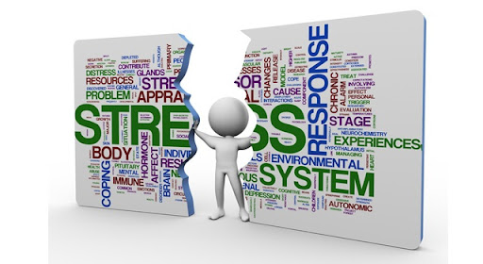
Module Code : BMSW4004
Student Name : Ghegea Mariana Florentina
Module lecture : Sujeewa Herath Student ID: 2019388
Task 2

Problem Solving and decision making

Table of content

Introduction ………………………………………………………….. Page 02

Discussion …………………………………………………………….. Page 03

Pestel Analysis ……………………………………………………….. Page 05

Fishbond ……………………………………………………………… Page 09

PMI Strategy …………………………………………………………. Page 09

Conclusion ……………………………………………………………. Page 10

References ……………………………………………………………. Page 11

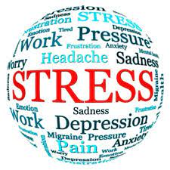
Introduction
Today's modern cultures are finding that work-related stress is a major contributor to mental health problems. Work-related strain has led to depression, anxiety, and other negative mental health impacts for certain people as a direct consequence of the excessive pressures and/or expectations imposed on them at work. Others may contribute to the development of clinical depression in some populations, but data shows that work-related strain is more likely to cause unpleasant effects in certain individuals.. In fact, studies have shown a link between work-related stress symptoms and mental health issues. Teachers have been shown to have some of the greatest levels of stress of any occupation, according to studies (citation). There is no issue with the response itself when it comes to the stress pandemic's actuality. Instead, how we respond to stress affects its impact on our minds and bodies. The link between work-related stress and mental health has been clearly shown in several studies. Even though stress is a part of every profession, it's especially concerning when it comes to those who work in human services. As a result of their high level of involvement in the lives of others, these people are more likely to have mental health problems associated with work-related pressures.( Bhagat, Segovis and Nelson 2016. )

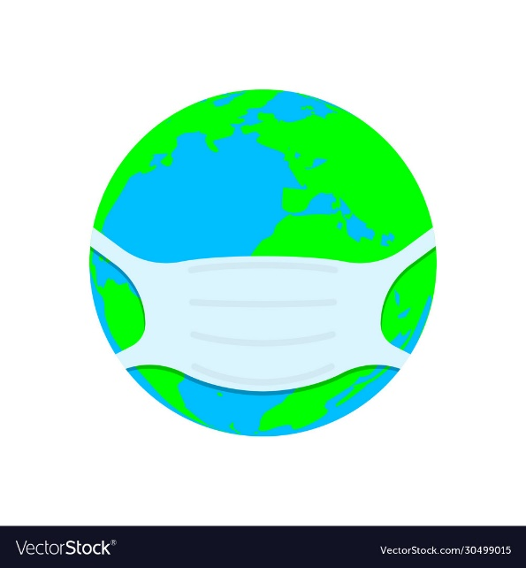
Discussion
According to a recent WHO assessment, the COVID-19 epidemic has interrupted or stopped key mental health care in 93% of nations globally. Covid-19 has a detrimental effect on the availability of mental health care and emphasizes the critical need for more financing, according to a study of 130 nations conducted by the World Health Organization (WHO). As a result of the epidemic, the need for mental health care is growing. Bereavement, loneliness, financial hardship, and fear all set off or exacerbate mental health problems. Insomnia and anxiety are becoming more common problems for many individuals. COVID-19, on the other hand, has been linked to neurological and mental side effects including insanity, agitation, and even stroke. SARS-CoV-2 infection puts those with pre-existing mental, neurological, or drug use problems at greater risk for catastrophic results, including death.( Dsouza 2020).
It looked like Covid-19 was a far-off issue in a far-off place when the Scottish government released my report on the social and equality impacts of Brexit at the end of January 2020. In the last two months, Europe has emerged as the epicenter of the epidemic, shifting the attention of the United Kingdom and its devolved governments. A major issue for equalities organizations is how Brexit will affect them. However, Covid-19 poses a greater threat to vulnerable people in the UK and throughout the globe. While the spread of coronavirus does have medical repercussions, the government's reaction to this epidemic, which has larger social and economic consequences, also has an influence. A detailed equalities impact assessment of Brexit's legal and socioeconomic implications for diverse groups of people has yet to be prepared by government, despite the fact that Brexit is guaranteed to have long-term systemic repercussions for the UK economy, politics, society and more. In the absence of further information, it's extremely possible that vulnerable groups will be harmed and that unforeseen effects will result. The effects of a weaker UK economy after Brexit will be felt most acutely by those in low-income groups who rely on public services and benefits and have less discretionary income and spending power. These groups include women, ethnic minorities, people with disabilities, refugees and asylum seekers, people who are or were in care, and precarious workers.( Gluschkoff 2016).
Mental health issues like anxiety, sadness, and OCD may worsen as a result of the stress, uncertainty, and social isolation that the pandemic would induce. The elderly in particular may have difficulties if they are forced to live in isolation. Stress and worry may follow for people who have their income slashed or lose their employment, and it will be significantly more difficult for those who are already struggling. Workers in the gig economy who are in a precarious position are particularly susceptible, since they may not be able to claim ill pay or earn if they have to isolate themselves, and they are more likely to be fired if employers have to tighten their belts. People who are homeless are more vulnerable, since they are more likely to suffer from underlying health problems and lack the resources to separate themselves and meet their most basic requirements, such as food, shelter, and sanitary facilities. With a lack of financial or social resiliency, those who are most affected by Brexit or the coronavirus will be the most susceptible. Not only should we defend our most disadvantaged populations' health, but also their quality of life in general, encompassing their financial stability, mental health, and availability of resources and social connections. But only time will tell whether or not his emergency measures are effective in meeting basic human necessities during this pandemic.( Irawanto, Novianti and Roz 2021).
PESTLE ANALYSIS
Political aspect- In a significant way, the COVID-19's expansion is transforming world politics every day. This year's COVID-19 will have a significant impact on world politics. There are measures formerly thought unthinkable being adopted as the death toll climbs and the economic impact extends. Many governments throughout the world have been chastised for their haphazard and inadequate reaction to the COVID-19 outbreak, and this criticism is only growing. The consequences of COVID-19 might lead to widespread political unrest, especially in countries with more authoritarian administrations. In addition, as COVID-19 continues to devastate the globe, some countries will see how dependent their supply networks are on others. In this setting, personal protective equipment (PPE) supply chains such as face masks, ventilators, and other medical equipment are the most severely affected. COVID-19 has sparked fear on a worldwide scale, as it would with any illness epidemic. For lengthy periods of time, people are compelled not to leave their houses. (Kivimäki and Kawachi 2015).
Economical aspect-Lockdowns imposed by multinational communities hit the global economy hard, among other things. One of PESTLE's most important macro-environmental elements is the economy. It has an effect on all firms, no matter how little. As an example, even the most lucrative enterprises may be harmed by factors such as rising unemployment, inflation, sluggish economic growth, and taxation Some small businesses struggle to make it even with government help. Some companies will make it through this epidemic unscathed and even thrive after quarantine, but no one knows what will happen next.( Mo 2020). The poor market performance caused by the COVID-19 has had a significant monetary impact. China and the United States, two of the world's largest financial markets, have already seen this. Investors are pulling their money out of traditional commercial tools to protect themselves from the current market volatility, raising fears of a long-term decline. COVID-19 is predicted to cause a short-term lack of resources as more individuals get the virus. As long as governments insist on people staying at home, companies and governments will have a hard time finding qualified workers to fill open positions. Thus, diminished economic production is projected, since businesses may close as a result of the situation.( Kuo, 2020).
Social aspect- COVID-19 has had a devastating effect on people's life, traumatised healthcare processes, and most importantly, altered workplace ethics owing to both "work from home" and "no work." COVID-19 has had a significant societal influence for a variety of reasons. Around 1.6 billion students would be impacted by worldwide school closures by the middle of April 2020. Possibly one of the most startling societal outcomes of the COVID-19 has been the occurrence of extreme incidences of racism, including physical attacks. (Mo 2021).COVID-19 has already discouraged a significant number of individuals from travelling, notably by air. Obligations of social distance, working from home, and online education have placed an undue load on individuals, resulting in mental health issues. As the incidence of COVID-19 rises, so will the negative effects on mental health. Patients who catch COVID-19 (particularly those who are hospitalised and in intensive care) and families of those who die are likely to have greater incidences of post-traumatic stress disorder (PTSD). People who are at greater risk of contracting the disease may also be more prone to worry, PTSD, and anxiety.( Labrague and Santos 2021).
Technological aspect-Knowing the present and future technical demands may help firms. As a result of the COVID-19 epidemic, many people are worried . Working from home and doing business online has made communication and video conferencing technologies more popular. Companies that have digitally transitioned outlive those that have not. Touch-tracing programmes alert those who have had intimate contact with COVID sufferers. When the virus entered China, it hit hard, infecting many individuals and forcing others into forced seclusion. This led to partial and total factory and workshop closures. Several well-known technology firms outsourced services from these plants. As a consequence, companies had supply issues. Apple's iPhone supply was unavailable owing to Foxconn ceasing much of its Chinese production. Cybersecurity dangers are projected to rise as more people work from home. Off-site employment, online education, and social isolation will drive demand for technology goods and services. COVID-19 has had a favourable influence on virology. COVID-19 will undoubtedly lead to new advances in virology.( Siegrist, Wahrendorf and Siegrist 2016).
Environmental aspect-Environmental planning is common practise in business. The goal of such a strategy is to promote resource reusability, such as solar panels and wind turbines, and reduce the use of environmentally harmful resources. While travel restrictions and stay-at-home rules reduced foreign manufacturing, expenditures, and employment levels, they also reduced air pollution and greenhouse gas emissions. Parks and land and marine preservation zones are unmanaged due to environmental security employees being locked out. Illegal animal hunting and deforestation have increased. Food sellers are using polythene bags again owing to health concerns raised by reusing paper bags. Also, takeout food delivery using single-use containers has grown.
Legal aspect- COVID-19 changed the global legal environment. The situation remains chaotic and so unpredictable. Following the COVID-19 epidemic, regulations are now the legal means of imposing important social constraints with significant economic consequences. Decreased freight transportation services and import/export restrictions have led to a rise in non-shippable agricultural and fisheries items. As demand for agricultural and fishing commodities has declined, so has manufacturing, leading to significant job losses in both industries. Employees working from home due to pandemic are subject to national and local tax requirements. Working from home may cause a delay in accessing crucial information. The government stimulus announced for jobless individuals burdens the state. Fines and penalties for breaking social distance regulations cause emotional pain.( Restauri and Sheridan 2020).

FISHBONE DIAGRAM

Short deadline
Less Staff
Long Hours
Insecurity
Work pressure
Lack of equipment
Strict rules
Lack of teamwork
Over-changes job
Work-Related stress
Lack of understanding
Lack of skills
Busy Period
Lack of skills
Over Management
Lack of training
Lack of organization
Lack of commitment
Lack of communication
Imperfect organization
Support

PMI Strategy
Plus | Minus | Interesting
-low risk to get the virus (+10) | -less motivation (-10) | -Save transport money (+6)
-flexibility (+10) | -over working (-8) | - No traffic (+4)
-comfortability (+9) | -loneliness (-8) | - No one to watch over me(-7)
+27 | -26 | +3

Results
Score of the table: (Plus) +27; (Minus) -26 ; (Interesting) +3
The total is: +4
Is better to work from home to reduce the stress caused by the pandemic and also it can be more relax and flexible but to improve more the following should be take in consideration:
- Promoting health and well-being
- Promoting interaction with others.
- Setting aside time for reflection.
- Recognizing and rewarding employees.

Conclusion
Therefore it can be concluded that people get stressed out when they can't deal with work-related demands and problems. Demands should be matched with the knowledge and abilities of the workforce. Stress may arise when workers believe they lack the skills or time to achieve deadlines. Planning, training, and support may alleviate stress and relieve strain. Today's modern cultures are finding that work-related stress is a major contributor to mental health problems. Excessive expectations and/or pressures at work have led to some people experiencing depression, anxiety, and other mental health issues as a consequence of job-related stress.

References
Bhagat, R.S., Segovis, J. and Nelson, T., 2016. Work stress and coping in the era of globalization. Routledge.
Dsouza, D.D., Quadros, S., Hyderabadwala, Z.J. and Mamun, M.A., 2020. Aggregated COVID-19 suicide incidences in India: Fear of COVID-19 infection is the prominent causative factor. Psychiatry research, 290, p.113145.
Gluschkoff, K., Elovainio, M., Kinnunen, U., Mullola, S., Hintsanen, M., Keltikangas-Järvinen, L. and Hintsa, T., 2016. Work stress, poor recovery and burnout in teachers. Occupational medicine, 66(7), pp.564-570.
Irawanto, D.W., Novianti, K.R. and Roz, K., 2021. Work from home: Measuring satisfaction between work–life balance and work stress during the covid-19 pandemic in indonesia. Economies, 9(3), p.96.
Kivimäki, M. and Kawachi, I., 2015. Work stress as a risk factor for cardiovascular disease. Current cardiology reports, 17(9), pp.1-9.
Kuo, F.L., Yang, P.H., Hsu, H.T., Su, C.Y., Chen, C.H., Yeh, I.J., Wu, Y.H. and Chen, L.C., 2020. Survey on perceived work stress and its influencing factors among hospital staff during the COVID‐19 pandemic in Taiwan. The Kaohsiung Journal of Medical Sciences, 36(11), pp.944-952.
Kwok, K.O., Li, K.K., Wei, W.I., Tang, A., Wong, S.Y.S. and Lee, S.S., 2021. Influenza vaccine uptake, COVID-19 vaccination intention and vaccine hesitancy among nurses: A survey. International journal of nursing studies, 114, p.103854.
Labrague, L.J. and de Los Santos, J.A.A., 2021. Fear of Covid‐19, psychological distress, work satisfaction and turnover intention among frontline nurses. Journal of nursing management, 29(3), pp.395-403.
Mo, Y., Deng, L., Zhang, L., Lang, Q., Liao, C., Wang, N., Qin, M. and Huang, H., 2020. Work stress among Chinese nurses to support Wuhan in fighting against COVID‐19 epidemic. Journal of nursing management, 28(5), pp.1002-1009.
Mo, Y., Deng, L., Zhang, L., Lang, Q., Pang, H., Liao, C., Wang, N., Tao, P. and Huang, H., 2021. Anxiety of Nurses to support Wuhan in fighting against COVID‐19 Epidemic and its Correlation With Work Stress and Self‐efficacy. Journal of clinical nursing, 30(3-4), pp.397-405.
Restauri, N. and Sheridan, A.D., 2020. Burnout and posttraumatic stress disorder in the coronavirus disease 2019 (COVID-19) pandemic: intersection, impact, and interventions. Journal of the American College of Radiology, 17(7), pp.921-926.
Siegrist, J., Wahrendorf, M. and Siegrist, 2016. Work stress and health in a globalized economy. Springer Berlin Heidelberg.

