
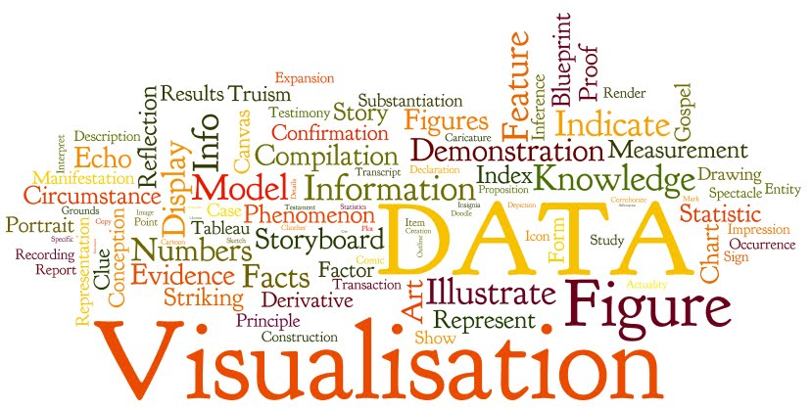

MODULE: Data Analysis & Visualisation
Module code: ACCB4002

Analysis and Visualisation of Data

Student name: Desislava Ruseva Petrova
Student ID: 2023694
DATE OF ASSIGNMENT 05/08/2021

Table of Contents

What is the message that the poster gives us? 2
Text – Are there many fonts or styles of text? Whether the text is too large or too small? Can everything be read? 3
Graphs – Are they suitable for the data we need to display? Are the graphs easy to read? 3
Graphics – Are there graphs from the project that do not present the information? If so, are they actively prevent you from seeing information that is being presented? Is the overall design good or bad? Does it raise any ethical issues? 3
Colour – Is it visible everything? Are the colours suitable for the project? 3
Cognition – Does it use any unnecessary needs on the viewer for the point of memory load, perception, or mental modelling? 4
Improvements – What would you do to make better infographic? Be sure to explain how this would solve all the problems identified earlier. You may include a rough sketch of all reworked areas of the chart if you wish. 4
References 5

What is the message that the poster gives us?

The poster is aiming at informing the reader on the impact COVID-19 has had on the different businesses and their respective sectors. It is also giving the reader an opportunity to look on the opportunities and possibilities businesses will have after COVID-19 and the recovery routes and time businesses will need to bounce back from the negative impact the virus has had on them.

Text – Are there many fonts or styles of text? Whether the text is too large or too small? Can everything be read?

All headings are clear and easy to read thanks to the bold font used by the designer.
Some small fonts might be a bit harder to read, due to the colour of the font in combination with the size of the text.
The weight of the heading fonts is good, though for the different graph headers, the text might be a little too small to read for some viewers, which could cause a confusion as it is the single feature that gives sense to the poster, as without it, the viewer will not be able to understand what the graphs and percentages mean.
The font for the legends of the charts and graphs can also seem a bit too hard to read at times due the unconventionality and the thickness of it. Some more conventional fonts vastly improve the readability [2].

Graphs – Are they suitable for the data we need to display? Are the graphs easy to read?

The graphs are clear and easy to read and they seem to indicate every percentage clearly. In some of the graphs’ legends, it is difficult to read the description or the name for each respective colour. The colours used across every graph seem to match quite well, which allows the reader to easily distinguish, and it properly attracts the focus.
The graphs could be smaller as it would allow for more space to be used for the legends of the graphs, which is an essential part for the understanding of each graph.

Graphics – Are there graphs from the project that do not present the information? If so, are they actively prevent you from seeing information that is being presented? Is the overall design good or bad? Does it raise any ethical issues?

Most graphics do offer enough information, though in some cases, it might be difficult to deduce what the discussed topic is, solely on the heading of each graph and the legends attached to it.
Perhaps some subheadings might help the reader get introduced to the evaluated topic.
Some graphs do not back up the displayed data and might leave the reader uncertain on where the information is coming from, for example, ‘Most are cautious about business recovery time’
This heading might raise the question ‘Who are most?’ as there is no source where this information is coming from, nor it is addressing a particular source’s statistics.

Colour – Is it visible everything? Are the colours suitable for the project?

The colour scheme seems quite appealing to the eye though in some occasions, smaller text cannot be read as easily.
The green colour seems to fit the subject as it is easy on the eyes, and the light and dark green can be easily related to the subject being shown to the reader. Many hospitals tend to prefer using the light green colour as objects are easier to spot if found on the floor.
The colour of the graphs is consistent across the poster, though in some occasions, decline/decrease is coloured in blue, and in others it is coloured in green, which might cause confusion for the reader.

Cognition – Does it use any unnecessary needs on the viewer for the point of memory load, perception, or mental modelling?

Many different graphics are used to represent data of a similar structure and purpose, for example, in the upper left corner (Impact of COVID-19 on business) and the lower left corner (Most are cautious about business recovery time) they have used to different types of graphs.
A pie chart and a donut chart, where they could have simply used the same for both, as it would not put unnecessary stress on the reader on trying to read and understand the same type of graph.

Improvements – What would you do to make better infographic? Be sure to explain how this would solve all the problems identified earlier. You may include a rough sketch of all reworked areas of the chart if you wish.

I would use bolder colours for the more important number figures, as it will make it easier to attract the reader’s attention. The colour-scheme used in the poster, though being visually attractive, might cause the viewer to keep searching for what the information they might be interested in. It seems as if the primary colour of the poster is green and the secondary blue, though it might have been a better option to reverse the orders, as the blue sticks out more than the green does, especially on the used background.
Some of the graphs are different, though they are using the same types of data structures and are conveying the same types of information by using a percentage chart. It is unnecessary to use two different types of charts to display the same information as it puts more stress on the reader and takes more time to identify what the presented information is. As mentioned, [1], it is important for the poster to have a clear and consistent design all across.

References
[1] "Research Guides: How to Create a Research Poster: Poster Basics", Guides.nyu.edu, 2021. [Online]. Available: https://guides.nyu.edu/posters. [Accessed: 14- Jul- 2021].

[2] Banerjee, D. Majumdar, M. Sudan Pal and D. Majumdar, "Readability, Subjective Preference and Mental Workload Studies on Young Indian Adults for Selection of Optimum Font Type and Size during Onscreen Reading", Al Ameen J Med Sci, vol. 4, no. 2, p. 137, 2011. [Accessed 1 July 2021].

