Assignment Title: Assignment 2: Event Strategic Planning and Delivery Considerations for an International Meeting / Event
Module Title: International Meetings Management for the Hotel Industry BMIH6007
Lecturers: Kathryn Flynn

Student Name: Flavia Nanu
Student Number: 2239004

Table of Contents

1. Introduction 2
2. The Event Cycle 2
3. Concept of the Event 3
4. Aim and Objectives of the Event 5
5. Event Management 7
Operational skills 7
Marketing activities 8
6. Budget of the Event 9
7. Trends in the Event Industry 10
Sustainability trends in the MICE industry of the UK 10
UK events industry growth 11
8. Situational and Cultural Factors 12
PESTEL analysis of the UK 12
SWOT analysis for the event 13
9. Conclusion 14
10. Reference List 15

1. Introduction
The 2025 “Year of Croeso” commemorates Wales’ special culture, language, and interesting sights. It points out that Wales is an attractive place for tourists, offering a chance to discover Welsh traditions. The “Croeso to Welsh Heritage” event will be held at Caernarfon Castle, a worldwide famous medieval site in Wales (Cadw, 2025). In this report, factors like ideas for the event, its budget, event management, trends in the industry, and the cultural effect will be looked at. The challenge of dealing with the environment outside and the available budget will affect the results of the project. Besides, the event’s calendar and SMART objectives will be essential for its setup and completion.

2. The Event Cycle
Event management is a fast-expanding discipline that is focused on the diverse strategies implemented in events (Fox et al., 2014). The event cycle is based on different stages through which the events go, and it is a systematic method used to improve the events along with the experiences of participants.
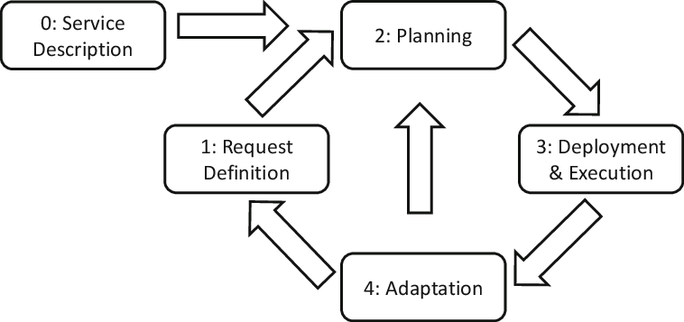
Figure 1: Stages of Event Cycle
(Source: Curry, Gao and Curry, 2020)
The significant stages that are a part of the event cycle include planning, organising, measuring and analysing.
Plan - The first stage will be based on setting the aims and objectives of the event that can be fulfilled after its proper completion. Meredith (2022), highlighted that planning is a crucial part of a project or event that demands significant focus from the management to ensure the alignment between operations and the predefined outcomes of the event/project. As discussed by Aquilino, Harris and Wise (2021), the development of a collection connection with local communities is significant for understanding the traditions of the local Welsh community. The event managers will develop appropriate partnerships with the cultural institutes, artists and schools in the locality.
Organise - The organising stage will include the development of the event schedule and the development of the required logistics for conducting the event. Recruiting the required managers, support staff and stewards. As discussed by Urdea and Constantin (2021), experiential marketing campaigns are effective in the current environment to fulfil customer expectations. Social media will be used for promoting the event by employing the local influencers having a vast follower base.
Measure – The event success will be measured according to the data of visitors, guests and dignitaries collected during the event. Sales of online tickets and evaluation of social media pages is significant to measure the event profits. Mair and Smith (2022) have stated that sustainable resource usage is important for events to reduce their adverse impact on the environment. Maintaining sustainability is important due to the global climate issues.
Analyse – Evaluating the event success in detail is important to understand whether visitors have gained proper cultural experiences. Irawan and Hartoyo (2022) have opined that, tourists provide more attention towards environmental services in the events. Details related to visitor numbers, problems faced by them and collected revenues are examined in this stage. the sustainability of the event and the

3. Concept of the Event
The event schedule of the event is developed to ensure that the required experiences are offered to the attending visitors or guests.
- Theme of the event: Year of Croeso, 2025.
- Event Date: 12th July, 2025 (Saturday).
- Venue: Caernarfon Castle.
- Attending guests: International visitors eager to learn about Welsh culture, resident dignitaries, students and personalities from media.
9 am – 10 am – Guests arrival and welcoming activities – Entry of guests will start in the castle courtyard. CADW and “Visit Wales” representative will provide a welcome speech in multiple languages. Guests will receive welcome goodie bags including event catalogue and badges.
10 am – 11 am - Event opening programme - The culture minister will start the event, and a group of school students will perform the national anthem, followed by a cultural parade.
11 am – 1 pm - A heritage experience tour - The volunteers will provide a heritage experience tour to visitors. The tour will include different parts like learning about Welsh culture, demonstrations provided by local artists, and audio-visual elements providing details about the heritage and history of Wales.
1 pm – 3 pm - A local food experience - The guests can get the experience of a local Welsh lunch in the inner hall of the Castle. Caernarfon is considered to be the castle of dreams that brings the legends to life (Visit Wales, 2025). The lunch spread will be based on providing a local experience to the guests within the imperial Roman architecture.
3 pm – 4 pm - Performances - Guests can enjoy the performances of several local artists on the lawn of the castle.
4 pm – 5 pm - Heritage walks in and around the castle - The guests can explore the entire castle area by themselves, or they can also book guides who can provide detailed knowledge about the castle's history.
5 pm - 5:30 pm - Finale ceremony - A speech will be provided by the organisers and the CADW representatives, and feedback will be collected from guests.

4. Aim and Objectives of the Event
Aim - This event aims to enhance knowledge about Welsh culture among visitors and provide them with a unique cultural experience.
SMART objective one - Enhancing cultural awareness.
S - Specific | To develop a heritage walk providing information to the guests about the cultural aspects and Welsh history.
M - Measurable | To ensure that cultural awareness among around 80 per cent of the guests has increased after the event.
A - Achievable | Providing culturally sound guides or volunteers to the guests to ensure an immersive and knowledgeable experience.
R - Relevant | It is relevant to the theme “Year of Croeso 2025” that aims at the promotion of Welsh culture.
T - Timely | Gaining guest feedback through the social media platforms within two days of the event's completion.
Table 1: SMART Objective One
(Source: Self-developed)
SMART objective two - Ensuring proper waste management and sustainability.
S - Specific | To implement a policy that bans the usage of single-use plastic materials and develop proper waste disposal areas.
M - Measurable | To ensure that more than 80 per cent of the waste related to the event can be recycled.
A - Achievable | Developing partnerships with the local suppliers of eco-friendly packaging materials, caterers and cleaning staff.
R - Relevant | It is relevant to the United Nations Sustainable Development Goals (UNSDGs) that influence the values of the event.
T - Timely | The event venue is to be cleared, and waste is to be recycled within 7 days.
Table 2: SMART Objective Two
(Source: Self-developed)
SMART objective three - Ensuring satisfaction of visitors and enhancing their experiences.
S - Specific | To provide immersive heritage experiences to the visitors.
M - Measurable | To ensure that more than 85 per cent of the guests provide "Highly satisfied" ratings on the surveys to be conducted.
A - Achievable | Including interactive video materials, detailed information is provided about Welsh culture and ensuring that the best food experiences are provided to the guests.
R - Relevant | It is relevant to the theme of the event, which aims to welcome the guests and provide an unforgettable experience related to Welsh culture.
T - Timely | Gaining feedback from the visitors while they are exiting the venue and completing the analysis process within 2 days.
Table 3: SMART Objective Three
(Source: Self-developed)

5. Event Management

Operational skills
The operations skills are significant for individuals being recruited for events and are important to ensure the event's success. As discussed by Anufrieva et al. (2021) and O’Toole (2011), socio-cultural events have become highly significant in the current environment. Event management is a significant activity performed by organisations that demands effective planning along with significant skills of the socio-cultural workers in terms of effectively dealing with the competition in the market (Getz and Page, 2019). As highlighted by Hysa and Mansi (2020), the framework of Maslow’s Hierarchy of Needs represents the basic, psychological and self-fulfilment needs of an individual that allows an organisation to ensure the well-being of the workforce by addressing them. In the context of the present event, the basic needs involve safety and security that requires effective crowd control and health protocols, while, the psychological needs in belongingness and esteem demands effective recognition of staff efforts, team collaboration and engaging experience. Moreover, the self-fulfilment needs can be supported by delivering inspirational and meaningful events. Hence, the operational skills that are significant to ensure the success of this event include coordination skills, staff management skills, technical skills, safety and health risk management skills and communication skills. All these skills are very essential for this event to address all these hierarchical needs that will ultimately foster a successful event experience.
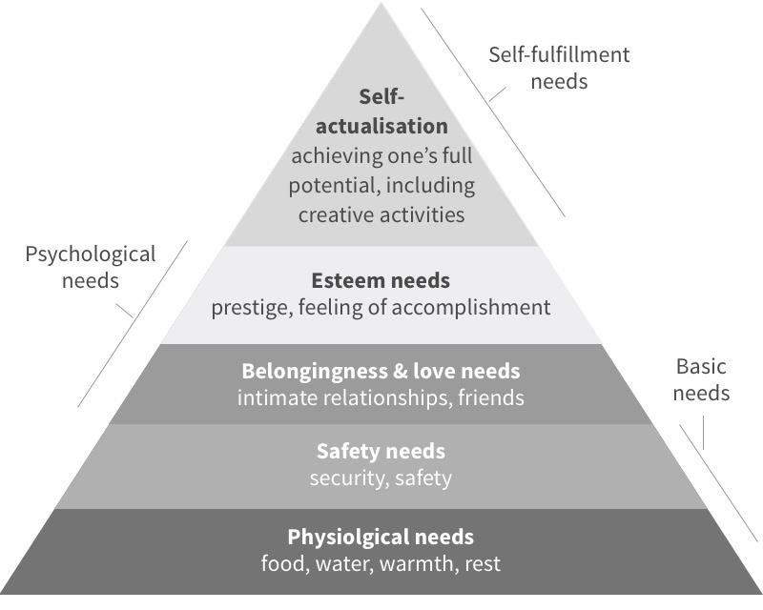
Figure 2: Maslow’s Hierarchy of Needs
(Source: Hysa and Mansi, 2020)

Marketing activities
The brands or organisations operating in the current environment use effective marketing strategies based on social media platforms to increase awareness among customers. As discussed by Ekaputri et al. (2021), the creativity in content and attractive packaging has become highly significant for companies to enhance the potential of brands to enhance brand awareness. The social media marketing strategy has been considered by the event to increase its awareness among the target customers. The target customers of the event belong to the age group between 30 to 55 years. According to EMBOK (2025), activities in an event require key stages like their initiation, planning, implementation and closure to ensure the efficiency of the activities. In the context of marketing, the event managers follow these steps to ensure the use of modern technologies for improving the awareness of the event among potential guests with effective planning and their implementation. The local social media influencers are the most significant resources, who can increase the reach of the community.
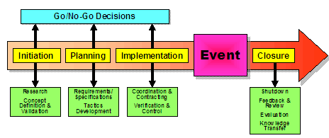
Figure 3: EMBOK model
(Source: EMBOK, 2025)

6. Budget of the Event
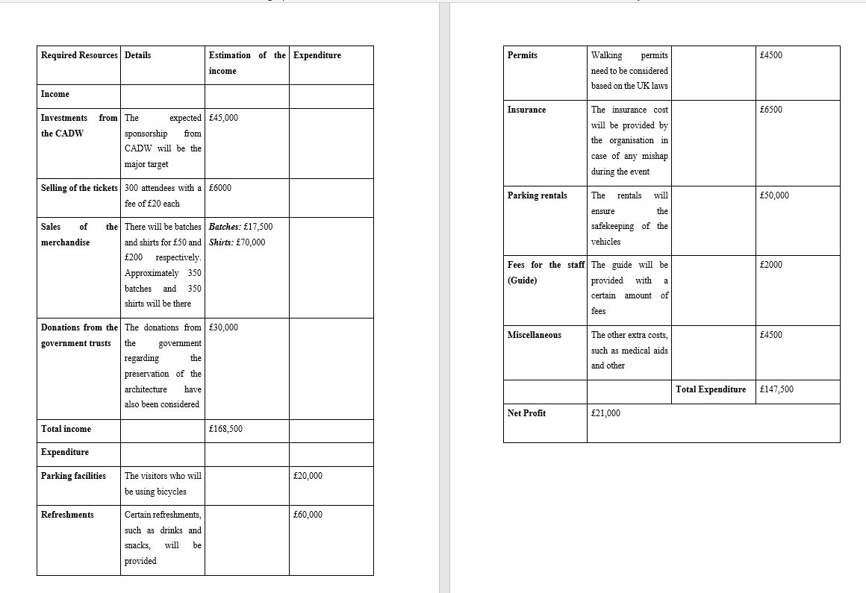
Table 4: Budget for the event
(Source: Self-developed)
It is very important to look at both income and expenses for the “Croeso to Welsh Heritage” event to ensure it goes well. Using a situational analysis tool like the one outlined by O'Toole in 2011 can check the possibility of a project. The activities that raise money include contributions from Cadw, sales of tickets and tour items, and help from the government. As explained by Rogers and Wynn-Moylan (2022), the global event industry mainly relies on conventions and conferences. Some of the main expenses are parking, offering snacks, payment for permits, insurance expenses, fees for workers, and other related costs. Public policy is now swayed by big cultural events, one example being the Olympics (Smith, 2012). The event can only be successful when insurance and permits are dealt with properly. Sales can be increased by focusing on social media and selling cultural items.

7. Trends in the Event Industry

Sustainability trends in the MICE industry of the UK
The sector for managing events has moved strongly toward a sustainable approach due to people caring more about environmental concerns (O’Brien, 2023). Being eco-friendly is now important to suppliers and venues, following a bigger trend in the industry. In 2023, the UK MICE market is estimated to grow to £49 billion and by 2035, it is supposed to increase to £114 billion (Market Research Future, 2025a), supported by international conferences and business events. Most UK consumers choose events and businesses that follow eco-friendly practices. Sustainability trends will affect how successful the “Croeso to Welsh Heritage” event is. The event organizers should use the “Meet Green” guidelines for a more sustainable event.
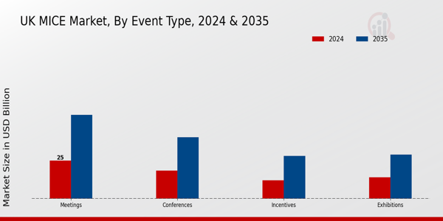
Figure 4: UK MICE market
(Source: Market Research Future, 2025a)

UK events industry growth
The events and business visits sector of the UK is quite diverse, as it covers entertainment events, trade fairs, outdoor events, conferences, congresses and business tourism. The current value of the UK events industry was around 61.65 million British pounds within the UK economy (Visit Britain, 2024). The Events Industry Council has stated that the performance of the sector depicted sustained levels of growth. The United Kingdom has received around 1.5 million inbound visitors to business events in 2023, who spent around 1.7 billion British pounds. The large proportion of Business visitors in the UK is a part of the MICE (Meetings, Incentives, Conferences and Exhibitions) sector. According to Market Research Future (2025b), the events industry of the UK is projected to grow from around 60 billion pounds in 2024 to approximately 232 billion pounds in 2035. The CAGR of the industry is expected to be around 13 per cent within the period of 2025 to 2035.
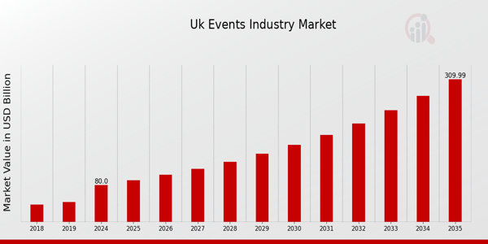
Figure 5: Growth of the UK events industry
(Source: Market Research Future, 2025b)

8. Situational and Cultural Factors

PESTEL analysis of the UK
Political factors -
- The complexities and costs related to visas required for attending events in the United Kingdom in 2025 is a significant factor that affects the success of the event.
- The UK Government aims to attract more than 50 million visitors from international locations by 2030, which will support the “Croeso to Welsh Heritage” event.
- The UK events sector has become a world leader in developing different events in the world (GOV, 2025).
Economic factors -
- Rise in the global conferences and corporate events has a positive influence on the economic growth of the UK (Market Research Future, 2025a).
- The investments in venues and infrastructure have increased hugely in the UK, which can support the organising of the “Croeso to Welsh Heritage” event.
Social factors -
- The rising festival culture in the UK events sector has increased its growth levels (Hasija, 2023).
- The opportunities provided by festivals in the UK to directly engage with the receptive and relaxed environment can be enjoyed by guests attending the “Croeso to Welsh Heritage” event.
Technological factors -
- Advanced technologies are integrated in the event management sector that has transformed the UK MICE sector (Market Research Future, 2025a).
- A technological shift in the UK MICE industry will lead to increased participation of guests and visitors in the “Croeso to Welsh Heritage” event.
Environmental factors -
- Environmental sustainability has gained major importance in the MICE industry of the UK (Market Research Future, 2025a).
- Sustainable materials and green technology implementation can support the future success of the event.
Legal factors -
- The legal aspects, like contracts, permits and insurance, have to be considered by the UK organisations operating in different sectors (Drew, 2024).
- The organisers of “Croeso to Welsh Heritage” have to consider these legal factors to ensure its success. According to Allied Market Research (2025), compliance requirements and the regulatory environment are highly complicated for UK event planners.

SWOT analysis for the event
From the SWOT analysis (Refer to appendix 1), it has been found that the key strengths of the event involve its iconic venue, support from government, diverse programming and effective community involvement. However, it may have several weaknesses like its weather dependency, complex logistics and language/cultural barriers. From the above PESTLE analysis, it has found that within the UK, there are a lot of opportunities for this event from the external factors that promote cultural tourism and heritage. There are also several threats for the event such as risk of security and crown management, socio-political uncertainties and health and safety concerns.

9. Conclusion
In conclusion, the "Croeso to Welsh Heritage" event offers a unique opportunity to showcase Wales' rich cultural heritage and traditions. By aligning the event with sustainability trends, utilizing a strategic budget, and adhering to industry best practices, the event can achieve success. A focus on community involvement, eco-friendly practices, and leveraging modern marketing strategies will enhance the guest experience and ensure that the event contributes positively to the promotion of Welsh culture and heritage on a global scale.

10. Reference List
Allied Market Research (2025) UK events industry share , size , Statistics Growth Analysis 2032, Allied Market Research. Available at: https://www.alliedmarketresearch.com/uk-events-industry-market-A169718 (Accessed: 06 May 2025).
Anufrieva, N.I., Tsarev, D.V., Gribkova, G.I., Medved, E.I. and Kiseleva, O.I. (2021) ‘Increasing university students' organizational skills during practical application of event management technologies in organizing events’, Revista Tempos e Espaços em Educação, 14(33), pp.1-12.
Aquilino, L., Harris, J. and Wise, N. (2021) ‘A sense of rurality: Events, placemaking and community participation in a small Welsh town’, Journal of Rural Studies, 83, pp.138-145.
Cadw (2025) Castell Caernarfon, Cadw. Available at: https://cadw.gov.wales/visit/places-to-visit/castell-caernarfon (Accessed: 06 May 2025).
Curry, E., Gao, F. and Curry, E., (2020) Quality of service-aware complex event service composition in real-time linked dataspaces. Real-time linked dataspaces: enabling data ecosystems for intelligent systems, pp.169-190.
Drew, J. (2024) Key legal considerations for an event planning startup , LegalVision UK. Available at: https://legalvision.co.uk/startups/event-planning-start-up/ (Accessed: 06 May 2025).
Ekaputri, H.E., Nurfadilah, F.A., Rafsanzani, F. and Santy, R.D. (2021) ‘The Effect of Creative Content to Increase Brand Awareness: Information Technology-Based Marketing Strategies’, International Journal of Research and Applied Technology (INJURATECH), 1(2), pp.410-423.
EMBOK (2025) Phases. Available at: https://www.embok.org/index.php/embok-model/phases (Accessed: 06 June 2025).
Fox, D., Gouthro, M.B., Morakabati, Y. and Brackstone, J. (2014) Doing events research: From theory to practice. Routledge.
Getz, D. and Page, S. (2019) Event studies: theory, research and policy for planned events. 3rd Edition. Routledge: Oxford
GOV (2025) Business visits and events strategy. Available at: https://assets.publishing.service.gov.uk/media/5a7f4dcd40f0b6230268eaf9/150326_BVE_Strategy_PDF_FINAL.pdf (Accessed: 06 May 2025).
Hasija, D. (2023) How UK event industry has transformed & influenced globally, Events WOW. Available at: https://www.eventswow.com/a-journey-through-time-how-the-uk-event-industry-has-transformed-thrived-and-influenced-globally/ (Accessed: 06 May 2025).
Hysa, E. and Mansi, E., (2020) Happiness and Economic Growth: Western Balkans and European Union. In Happiness and Contemporary Society: Conference Proceedings Volume pp.105-113.
Irawan, N.C. and Hartoyo, E. (2022), November. ‘Environmental management and stakeholder roles in sustainable tourism development: a feasibility study’, In IOP Conference Series: Earth and Environmental Science (Vol. 1108, No. 1, p. 012068). IOP Publishing.
Mair, J. and Smith, A. (2022) ‘Events and sustainability: why making events more sustainable is not enough’, In Events and sustainability (pp. 1-17). Routledge.
Market Research Future (2025a) UK mice market size, trends, and global analysis to 2035, UK MICE Market Size, Trends, and Global Analysis to 2035. Available at: https://www.marketresearchfuture.com/reports/uk-mice-market-46692 (Accessed: 06 May 2025).
Market Research Future (2025b) UK events industry market size, growth, share, 2035, UK Events Industry Market Size, Growth, Share, 2035. Available at: https://www.marketresearchfuture.com/reports/uk-events-industry-market-44351 (Accessed: 06 May 2025).
Meredith, J. (2022) Project management: a managerial approach.
O’Brien, S. (2023) Venue sustainability: A transformative trend in UK event management, Event Organisers Summit. Available at: https://eventorganiserssummit.co.uk/venue-sustainability-a-transformative-trend-in-uk-event-management/ (Accessed: 06 May 2025).
O’Toole, W. (2011) Events feasibility and development: from strategy to operations. Elsevier: Oxford
Rogers, T. and Wynn-Moylan, P. (2022) Conferences and conventions: a global industry. 4th Edition. Routledge: Oxford
Smith, A. (2012) Events and urban regeneration: the strategic use of events to revitalise cities. Routledge: Oxford
Urdea, A.M. and Constantin, C.P. (2021) ‘Experts’ perspective on the development of experiential marketing strategy: implementation steps, benefits, and challenges’, Journal of Risk and financial management, 14(10), p.502.
Visit Britain (2024) Business Events Research, VisitBritain.org. Available at: https://www.visitbritain.org/research-insights/business-events-research (Accessed: 06 May 2025).
Visit Wales (2025) Home, VisitWales. Available at: https://www.visitwales.com/attraction/castle/caernarfon-castle-cadw-822841 (Accessed: 06 May 2025).

I confirm that I have not presented any AI generated text as my own work. I confirm I have copies of my drafts, notes, and other resources I used before, and after the use of AI tools which I may be asked to provide in evidence.

