Individual Report

Development of innovative product OR unique service proposition

Module Name: Developing Innovation and Creativity for Business Advantage
Module Id: BMSW6102
Lecturer Name: Rexon Nting
Student Name: Arteom Poleacov
Student Id: 1917562

Executive Summary
Given the different marketing challenges of the traditional brick-and-mortar business model, the current report aims to propose and develop an online retail store with a commercial website that will be using a version of the "personalisation by personality" technique (in the form of an Ai-inspired chatbot). This has been chosen primarily because such techniques would help a given business increase its sales revenue, online visibility and marketing reputation cost-effectively. Hence, for this purpose, the given business venture/company has decided to build a highly innovative website. The overall budget for the website construction and development has been kept at $ 65,000. In this context, different software and programming languages like PHP, CSS, HTML, JavaScript and other minor graphic and content-designing software have been used. Additionally, in terms of marketing and promotional strategies, a 4P marketing mix has been used. Also, several digital marketing/promotional strategies like social media marketing, paid search engines, pay-per-click advertising, email marketing etc have been used to increase customer influx, the website traffic and online visibility. Several tools regarding AI chatbots also help the agencies of law enforcement to identify doubtful patterns that are not at all detected by human beings. Henceforth, this chatbot can also successfully be used or applied for predicting unlawful activities with the assistance of 'artificial neural networks.'

Table of Contents
Introduction 5
A) The Innovative Product Proposition 5
A.1 Description of the Innovative Product Proposition 5
A.2 Targeted Customers 6
A.3 Medium by which this service will be provided 6
A.4 Methods of Sustaining the proposed product innovation 7
A.5: Existing Market Competition 10
B) eCommerce 10
B.1: Using SaaS 11
B.2: Using a marketplace, 12
B.3: Creating content, including copy and photograph 12
B.4: Payment Method/Setting 12
C) Marketing 13
C.1: Marketing and Promotional Strategy 13
C.2: Target Customers and how to reach them 14
C.3: The Application of Social Media 15
C.4: The Application of Paid Search Engines 16
C.5: Role of Customer Journey 16
C.6: The Application of Email Marketing 17
D) Privacy and Data Protection 18
D.1: The Application of the data protection act of 2018 18
D.2: The Application of the Privacy and Electronic Communication Regulations (PECR) 18
D.3: The need for consent 19
D.4: Provision to the facility regarding ‘opt out’ for the marketing communications 20
D.5: Requirement for supporting the rights like 'the right to erasure.' 20
D.6: Significance of secured access to the Cloud Provider 21
D.7: Significance of sensitivity regarding the frequent changes and the default access 21
D.8: Significance of Encrypting Data 21
Conclusion 22
References 23

Introduction
According to different sources, one of the most modern requirements of business development is "innovation" and "change". In this regard, it has been noticed that ever since the covid-19 pandemic, the market and business worlds have completely revolutionised. Over the last few years, eCommerce and online marketing have indeed become an integral part of the retail and business world. And unlike other times, nowadays, most businesses prefer to sell and buy products and different types of services online, thanks to the modern trend of digitalisation. According to Pasquali, (2023), the overall value of different types of retail eCommerce sales, worldwide is more than 6 trillion USD and studies have shown that given the growing popularity of online shopping and its differential benefits, this number and value might increase in the next few years.
Additionally, given the current volatile economic situation worldwide, it has been noticed that traditional "brick and mortar" or "offline businesses" are facing quite a challenge in terms of smooth operational management, primarily because of the increased cost of different products, services, equipment, etc. Also, ever since the pandemic and due to social distancing protocols, many traditional businesses have mentioned that they have faced a drastic loss of customers, primarily because people now are no longer interested in offline shopping.
Hence, from this perspective, and given the different modern challenges faced by the “brick & mortar business model” as well as the different advantages of eCommerce in a business, the current report intends to propose a suitable innovative online retail service. According to Jibril et al (2020), such developments and proposals are important to benefit both the customers and the business, primarily because they help fulfil customer demands & expectations as well as business needs simultaneously.

The Innovative Product Proposition

A.1 Description of the Innovative Product Proposition
Given the different modern trends of trends and personalisation, it has been noticed that ever since the covid-19, most people like to shop online, primarily because online shopping is private, judgement-free and personalised. Most online shopping apps nowadays tend to have different types of personalised options as per the degree of optimisation and several other AI- features. In light of this, the current report proposed a venture that will use an AI-powered chatbot to suggest different daily essentials (food, groceries items, beauty & personal products, healthcare products etc) based on the user’s physical features, personality & lifestyle habits. The name of the venture will be “Samo Za Men”.(SZM) Most of the features of this venture will be based on one of the most recent retail innovations “Personalisation by Personality” (ChannelSight, 2023).
In other words, Samo Za Men is a type of online retail store that will recommend different daily essential products like food, groceries items, different healthcare & medicinal products and personal items, based on the initial data & preferences entered by the user. Psychologically speaking, since these data & preferences technically represent a person's interests, lifestyle habits, personality & physical features, therefore this will help the chatbox suggest more tailored recommendations that are not only budget-friendly but also would benefit the user in multiple ways. According to the business owner, this has been considered beneficial for business, primarily because
- It will enormously increase customer satisfaction and engagement index
- According to Aisha (2020), such types of personalisation increases customer retention and turnout rate.
- They help general large amounts of revenue in a cost-efficient manner.

A.2 Targeted Customers
This venture will be targeting
- People who have specific dietary requirements as per their lifestyle and personality (like vegan or gluten-free, etc)
- Environmentally-conscious people
- Health-conscious people
- Young adults between the age group of 18- 30 years (primarily because such people tend to be over-fastidious, as a side effect of the different online lifestyle, clothing, and dietary trends)
- People who have different types of physical ailments like food allergies etc.

A.3 Medium by which this service will be provided
It has been decided that such a type of service will be provided as one of the different features of the SZM app and website. In this context, the website will have an AI-powered chatbot that would constantly assess the user's buying preferences to determine their needs & would subsequently suggest suitable items. Moreover, the chatbot will be using Natural Language Processing (NLP) and Machine Learning (ML)-based algorithms to understand and respond to the differentiated needs of the user.
Thus, from this, one can state that the medium by which this service will be provided is via “an AI-based chatbot”. In simpler terms, the current innovation (i.e. personalisation by personality) will be used in this venture in the form of a computer program, which will be an in-built feature of SZM.

A.4 Methods of Sustaining the proposed product innovation
To sustain and implement the proposed product innovation, the venture will be following two types of strategies, as per the different stages
Stage 1-Planning Stage
During this stage, the planning, marketing & software development team has been known to follow the first 5 steps of the "New Product Development Strategy" [Already Done]
- Step 1- Idea Generation: During this step, the committees gathered different types of innovative business ideas from both the internal and external stakeholders and different other personnel. Also, the committees evaluated the possibility of the implementation of such innovative ideas, as per their advantages, disadvantages & implementation structure. And lastly, market research about the different technological developments, ongoing trends, the needs & expectations of the customers & the industry etc was also done.
- Step 2- Idea Screening: In this step, the committees screened the different proposed ideas, in light of the collected market research. The overall purpose of the company at that time was to shortlist potential ideas that would benefit both the organisation as well as the customers in a budget-friendly and profitable manner.
- Step 3- Concept Development & Testing: Finally, during this step, the company decided to use and implement the "personalisation by personality" innovation. And this led to the development and construction of a website that would contain an AI-inspired chatbot. The chatbot would use NPL and ML-based algorithms to assist users by personalising their shopping experience, as per their needs, physical features, personality and lifestyle habits. In terms of testing, it was done in combination with the Simulated Test Market (STM) strategy.
- Step 4- Marketing Strategy Development: In this context, the above-mentioned committees developed a suitable marketing strategy (which is mentioned in the subsequent parts of the report), such that both cost minimisation and resource allocation could be equally prioritised. Also, the target market, STP (Segmentation, Targeting and Positioning) strategy, Product price, distribution, marketing budget, marketing mix, etc were finalised.
- Step 5- Business Analysis: During this step, the sales, cost and project projections related to the selected proposal were evaluated and finalised by the planning, marketing & the software development team
Stage 2: Implementation Stage
In this context, the venture has decided to follow the rest of the steps of the "New Product Development Strategy" as well as the "Simulated Test Market (STM) strategy."
- Implementation of the "New Product Development Strategy"
- Step 6- Product: In this step, the proposed retail website (with the chatbot function) was finally tested among company employees and it was observed that the prototype was functionally efficient in understanding customer buying preferences and in suggesting suitable products, subsequently.
- Step 7- Test Marketing: It has been decided that this step will be carried out in connection with the STM strategy. And, in theory, the software development team has suggested that in an ideal situation, with no major market changes, the proposed retail website (with the chatbot function) might be able to function effectively. Hypothetically, this represents the different benefits the venture might receive, once the service/ website will be officially launched
- Step 8- Commercialisation: In terms of commercialisation, it has been decided that in the future, the company will launch the website first and then the application. Additionally, this will be coordinated with the different proposed marketing and promotional strategies.
- Implementation of the “STM Strategy”
According to Wolf et al (2018), a "Simulated Test Marketing" (STM) strategy is a type of qualitative market research technique or tool that mimics the real-life market situation temporarily to assess the performance of the proposed/developed product or service. And for this purpose, three types of markets will be created to test the performance of the proposed retail website (with the chatbot function)
- A general market
- A restricted market
- A high-demand market.
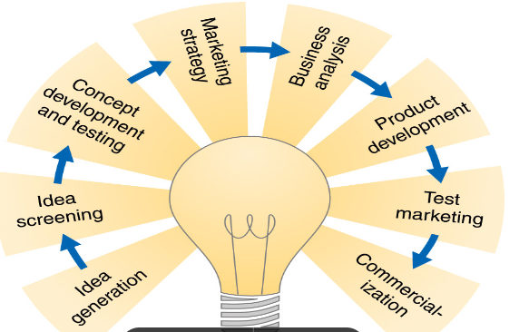
Figure 1: Overview of the New Product Development Strategy
(Source: Lecture Notes)

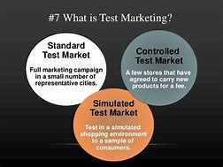
Figure 2: Explanation of the Simulated Test Marketing(STM) Strategy
(Source: Anonymous)

A.5: Existing Market Competition
Given that nowadays online shopping and eCommerce are an integral part of almost all businesses and retail companies, studies have mentioned that the market competition in this field is extremely high or strictly competitive. This is primarily because nowadays enhanced customer satisfaction, along with increased customer retention is considered a good key performance indicator (KPI) (Hohenberg and Taylor, 2021)
Additionally, according to different existing literature, the most well-known competitors, in this case, are Alexa (by Amazon), EBI.AI (by EBI.AI ), ProProfs Chats (used by BestBuy) etc (Geyser, 2023). These companies tend to use the "personalisation" feature and innovation by suggesting the best possible options, as per existing data. But under those conditions, the socio-economic background, cultural background and personal information or needs of the customers are not considered. And this is where SZM tends to have a significant competitive edge.

eCommerce
The proposed eCommerce retail website for the "Samo Za Men"(SZM) venture will be built using different front-end development languages like HTML, CSS and JavaScript, as well as different back-end development languages like PHP. In this context, studies have shown that HTML is used to build the skeleton of the website, CSS is used to style a given website (as per the different needed features and visualisation needs) and JavaScript which is a programming language is used to determine and develop the extent of functionality in a given website (GMI Blogger, 2023). Additionally, PHP which is a back-end development tool/language is technically used to develop the dynamics of the proposed website and to sync it with cloud programming (for storage purposes).
Moreover, currently, in this case, apart from the above-mentioned uses, the software development team has also decided to use the PHP language primarily because
- It will support different types of third-party extensions like .NET, MySQL, and Apache.
- PHP has been selected due to its Content Management System (CMS) feature, which will allow software developers to create digital content without the need for any type of specialised knowledge (Singla, 2021).

Components Required | Initial | Eventual
Software development | $15,000 | 0
Use of AI  (for the chatbot) | $10,000 | $12,000
Use of ML  (for the chatbot) | $10,000 | $12,000
Use of NPL  (for the chatbot) | $10,000 | $12,000
Overheads | $4,000 | $8,000
Graphic Designing | $6,000 | 0
Content Development | $4,000 | 0
Maintenance | $5,000 | $8,000
TOTAL | $65,000 | $ 52,000
Table 1: Initial and Eventual Budget for Website and Chatbot Development
(Source: Created by Author)

B.1: Using SaaS
As mentioned above, SaaS, which is a cloud-based service, would be linked to the proposed website primarily because it would allow the users to connect to the internet as well as use the developed service online. Apart from this, SaaS and its related features would also be used to store the different personal information, preferences/choices, expectations and needs of the customers (on a needed basis).

B.2: Using a marketplace,
One of the key benefits of attaching an online marketplace to the website will be that it would increase traffic, online visibility and pay-per-click value of the website. Based on this, the software development team of SZM has decided that while developing the software, different marketplaces like Amazon, eBay, Etsy and Walmart would be linked, both directly and indirectly.
Moreover, this decision was also made to increase product sales and application of the proposed Chatbot functions (Beklemysheva, 2022). Also, in the future, it is believed that data from such a marketplace would help analyse the efficiency of both the developed website and chatbot, about the different corporate goals set by SZM.

B.3: Creating content, including copy and photograph
As mentioned earlier, for the current website, PHP would be used for developing the dynamics of the website. And as illustrated by Handley (2023), the following tools and software will be used for content creation and editing
- Canva- for graphic designing
- Semrush Content Marketing Platform: As an SEO copywriting tool to create web content
- Descript: As a Video creation and editing tool
- Grammarly- for spelling and grammar check, etc

B.4: Payment Method/Setting
In terms of different online payment methods, the software development team has decided to link different types of online payment methods like Go Cardless, PayPal, Worldpay, Opayo (aka Sage Pay), etc. This decision has been taken primarily based on the fact that these payment methods are efficient and they save time and effort.
Moreover, the software development team has also decided to allow card payment (debit and credit card), as long as the user's financial activities and information comply with the PCI-DSS (Payment Card Industry Data Security Standard) security standard

Marketing

C.1: Marketing and Promotional Strategy
In this context, one can state that to maximise profit, the website would be marketed via the use of the 4P marketing strategy.
- Product- As mentioned before, the product here is an innovatively designed online retail store with a commercial website and a special AI-inspired Chatbot that would provide different types of personalisation opinions, about different daily essentials (food, groceries items, healthcare products etc) based on the user's physical features, personality & lifestyle habit. The company has decided to use such a type of retail innovation, primarily because it would increase customer satisfaction, engagement, retention and turnover index, as well as market visibility of the website.
- Price- In this context, the overall cost price of developing this website is about $65,000. And as the different prices of the products (food, groceries items, healthcare products etc) are concerned, it has been decided that in that case, a mixture of competitive price strategy and the market price would be applied, so that customers can easily afford them (Faith, 2018).
- Place- In terms of location, this service/product will be available online. Here, one can mention that first, the website would be commercially and publicly launched by the company online and then after an initial performance review, the associated, the developed mobile application will be launched.
- Promotion- To promote this newly developed website, different types of marketing and promotional strategies like social media marketing, email marketing, pay-per-click advertising, etc would be used. According to Puthussery (2020), these marketing techniques have been chosen because, not only do they increase website traffic and customer influx, but they also enhance the online visibility of the product/service, which by default increases the market reputation of the company.
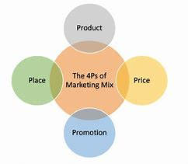
Figure 3: Overview of 4P Marketing Mix
(Source: Inspired by Faith, 2018)

C.2: Target Customers and how to reach them
As mentioned earlier this venture and by extension, the developed website and chatbot would be targeting the following specific type of people, although in general, the website and chatbot are open for types of customers (i.e. the general population of the UK).
- People who have specific dietary requirements as per their lifestyle and personality (like vegan or gluten-free, etc)
- Environmentally-conscious people
- Health-conscious people
- Young adults between the age group of 18- 30 years (primarily because of various internet lifestyle, fashion, and food trends, people of this age group usually tend to be overly picky)
- People who have different types of physical ailments like food allergies etc.
And to successfully reach them, primarily social media marketing techniques and promotions across different social platforms would be done (since such people are usually online) (Durgam, 2018).

C.3: The Application of Social Media
A simple analysis of the different marketing and promotional strategies used by the "Samo Za Men" venture shows that currently, in this case, social media platforms are used to increase the online visibility and brand awareness of the newly developed website (with an AI-inspired chatbot that uses the "personalisation by personality feature). Moreover, currently, in this project, such measures are also used
- To reach a wide variety of customers worldwide, which by default increases the customer influx. (Hohenberg and Taylor, 2021)
- To attract potential customers (Puthussery, 2020)
- To monitor different types of online conversations so that one can effectively determine changing customer and market needs, demands and expectations. This will enhance market research from multiple angles (Durgam, 2018)
- To advertise and eventually sell different products and services, so that the company's sales and revenue targets can be met.
This is because the overall purpose here is to increase the application and functionality of the developed chatbot feature.
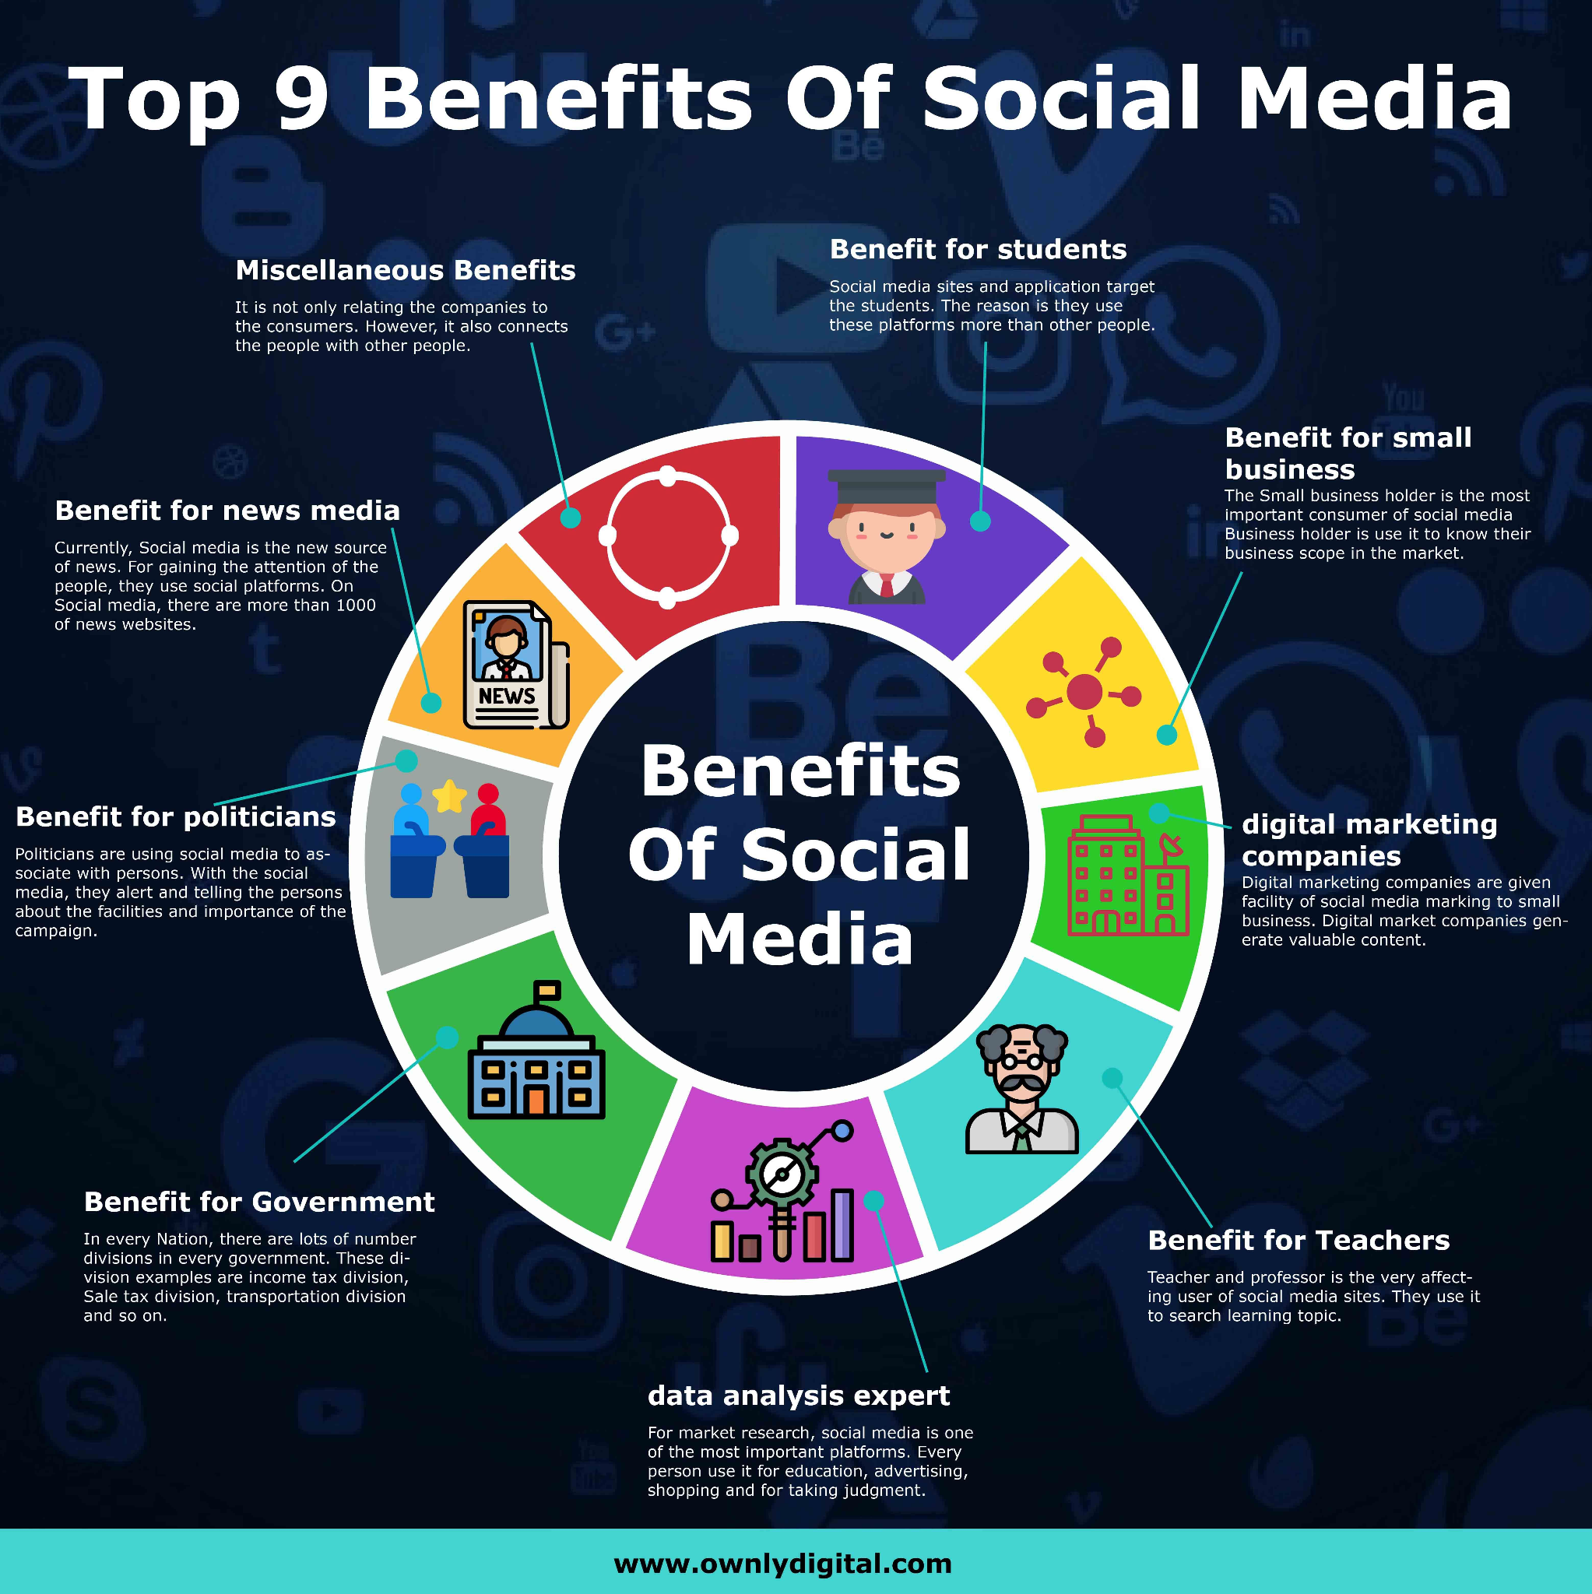
Figure 4: Benefits of Social Media Marketing
(Source: Inspired by Durgam, 2018)

C.4: The Application of Paid Search Engines
According to different studies, companies often tend to use paid search engines as an integral part of their marketing methods because paid search advertising them to have the following advantages
- Search engines like Google Ads are known to be extremely targeted and cost-effective. Additionally, they also help target potential customers by location, device, language, time of day, and even previous web visits. And this is why, SZM has decided to use Google ads as a promotional and marketing technique
- Secondly, compared to techniques like SEO optimisation, paid search engines are easy to execute, primarily because they are often associated with the differential benefits of keyword search
- Techniques like pay-per-click (PPC) advertisements have been known to increase website traffic, as well as performance. Also, PPC is an easy way to accomplish different business goals (Morris,2021). And this is why, SZM has decided to use PPC as a marketing technique
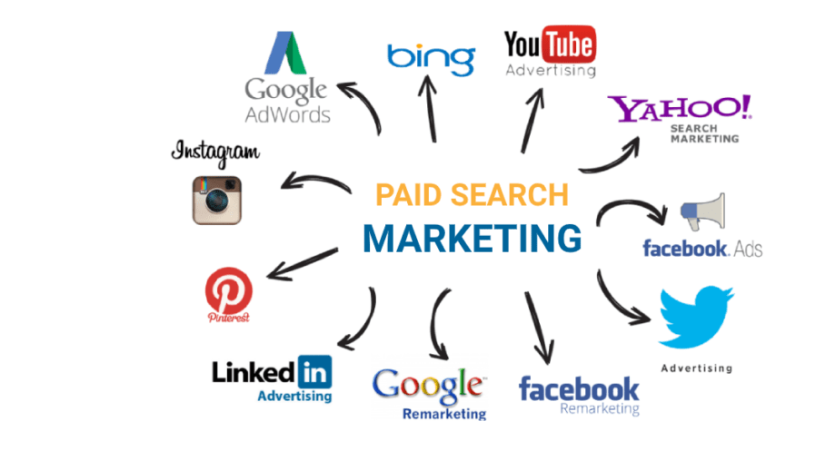
Figure 5: Examples of Paid Search Engine-based marketing
(Source: Anonymous)

C.5: Role of Customer Journey
As mentioned before, given that SZM is launching a relatively new featured website, one can state that under such conditions, highlighting a given customer’s journey, publicly on the website, will increase trust and understanding between potential customers and SZM (as a website). Also, in the long run, such signs could increase customer satisfaction, engagement, retention and turnover rate, which by extension will help SZM grow and develop further.

C.6: The Application of Email Marketing
Currently, as per the given project, one can state that email marketing has been used as a marketing technique because of three major reasons
- They help in expanding the range of personalisation, by helping create more personalised content (as per customers)
- They have lower costs, compared to other marketing techniques and they help improve sales
- They can be used as a method to collect feedbacks, surveys etc, all of which indicate the varied opinions of the customers
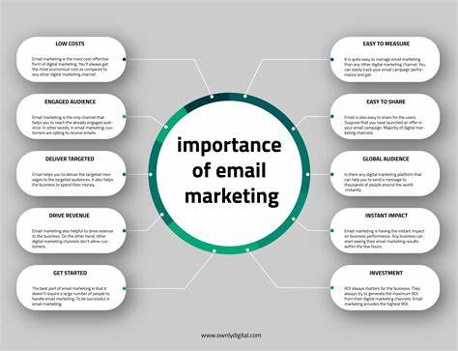
Figure 6: Importance of Email Marketing
(Source: Inspired by Puthussery, 2020)

Privacy and Data Protection

D.1: The Application of the data protection act of 2018
The 'data protection act 2018' itself is the overall implementation of the 'general data protection regulation' in the UK. Every person must be responsible enough while using personal data as they have to follow and maintain the strict rules known as 'principles of data protection.' The online customers are also majorly ensured with the provided information by the organisation, "Samo Za Men."(SZM) must be used or applied lawfully, fairly, and transparently.
As 'An AI-powered chatbot' is made and developed for suggesting the daily-based essentials, including several physical features, lifestyle habits, and personalities of the customers, it must be protected with the above-mentioned act. As the company, as stated above, has developed a website for attracting customers towards the different kinds of products like food and grocery items and healthcare products, it must incorporate an 'AI chatbot' following the guidelines for fulfilling the demands and needs of the customers (Li et al. 2019). They should be ensured that the primary data that would be collected, processed, and stored must maintain compliance with the protection of the relevant data with the help of laws and regulations. Additionally, the thorough implementation of the 'proper security measures' must protect personal data from major unauthorised disclosure, misuse, and access too. The 'end-to-end encryption' also stops anyone, not the sender and the receiver, from seeing any part of the message, but it is widely being adopted by the designers of the 'AI chatbot' without creating a doubt regarding the combustion of the methods for ensuring to maintain the overall security to the chatbot. Through AI chatbots, customer engagement can be increased, lead generation can be improved, the cost of the customer device can be improved, and monitoring consumer data can be beneficial for gaining insights.

D.2: The Application of the Privacy and Electronic Communication Regulations (PECR)
The full form of PECR is already being mentioned above, and it came into force in 2003, and it was also derived from the 'European law' whereas the implementation of the PECR of the 'European directive' has also been known as the directive based on 'e-privacy.' The regulations based on the PECR in the UK made it unlawful while transmit the 'automated recorded message' for making purposes directly through telephone services without making the active consent of the subscribers. The AI-powered chatbots tend to make responses to the inquiries of the users in an intelligent way by leveraging advanced technologies with the assistance of ML, NLP, and advanced analysis. Thus, the AI-powered chatbot may also break down the user-provided voice for inputting the thoroughly identified words, parts of speech, and sentences in terms of formulating smart responses and following up on the actions. The chatbot is a 'computer-based program' that uses artificial intelligence (AI) along with 'natural processing' (NLP) for understating the questions and automating the responses by stimulating human conversations (Houlden et al. 2023). The 'AI chatbot' is a 'conversational application' for helping in customer services, providing support, and making thorough engagement through replacing and augmenting the against of human support. Support must be provided with artificial intelligence for developing automation technologies that may communicate with end users through chatting.

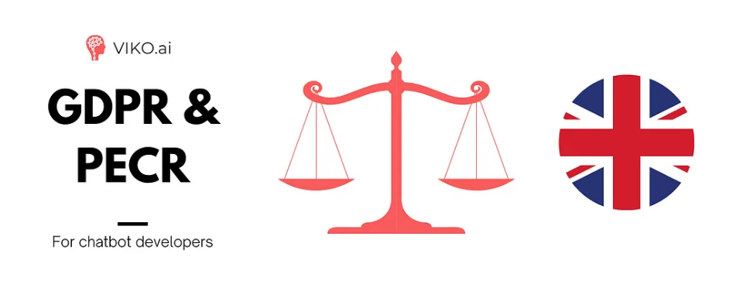
Figure 7: Ways of protecting information by GDPR and PECR
(Source: Houlden et al. 2023)

D.3: The need for consent
Honesty, respect, and communication tend to make the relationship better, and asking and gaining consent demonstrates that respect should be provided to the people or the customers using this online website, SZM, for buying different retail products. It also eliminates the overall entitlement of the feeling in one user, which is ready to be delivered to another partner of theirs. This consent also is vital in the whole research process as it is ready to ensure the informed choice to the customers regarding making active participation in the whole research study. Thus, the requirements for gaining informed consent that has been derived from the research participants are thoroughly stipulated by various policies and regulations. The consent must be maintained effectively by the users of AI-powered chatbots as they provide their details while purchasing the products, and those questions are set up by this website. Hence, the consent itself is an agreement among the participants to engage them with this website to allow them to access their preferred retail goods. Their consent should freely and be communicated with one another, where the affirmative and the verbal expression of consent can help understand and respect the boundaries of one another.

D.4: Provision to the facility regarding ‘opt out’ for the marketing communications
The difference between opt-in and opt-out is to mention a particularly positive step by demonstrating that the users want marketing the option with 'opt out' means the person should make a positive step for refusing and unsubscribing the area from marketing. Alongside this, opt-out refers to taking the relative action for withdrawing the consent in case the user does not want to receive any further communication for taking the boxes actively regarding mentioning their gender, physical condition, kind of food preferences, and so on. The different customers can be categorised from the above-stated zones by which they might be differentiated and suggested various products as per tier body requirements (Chahal et al., 2023). It also relates to various procedures by which the customers may avoid receiving the required product information as the associated options with this website may be associated with the campaigns relating to direct marketing like 'email marketing.'

D.5: Requirement for supporting the rights like 'the right to erasure.'
The 'underlying principle' of the given right to the customers demonstrates 'no compelling reason' for the processed data where the data-based subject can request the data controller to remove the personal details of the customers from the public domain. The further distribution of the personal data of the customers should potentially be stopped from processing and accessing their overall personal data respectively. The UK GDPR act also states the rights for reasoning the persona; data of the users that is also regarded as the 'right to be forgotten.' Thus, this right can only be applied to the overall data at the time of receiving the requests from a large number of customers. Additionally, the adequate right is also imperative for the developed organisation to process the personal data for preparing that the data subject is eventually involved in this right (Saxena and Beg, 2021). Individuals may have the right to erase personal data for restructuring the processing of the personal data without making any delay as the infringement of the protection of the data principles can meet the safeguarding for archiving and processing the sensitive personal data.

D.6: Significance of secured access to the Cloud Provider
Protecting the apps and data to the cloud is required for looking out for secure access to the cloud zone in terms of protecting the stored data within the cloud-based applications. With the help of online security, deep control and visibility must be accessed over the users, and the applications for keeping the workers flexible, productive, and secure for enhancing the protection and the visibility and control of the application of the cloud (Mehraj and Banday, 2020). Thus, the organisation, SZM, also offers the integrated suite largely in terms of delivering the solutions to the cloud-based security for securing the enterprises to the cloud-based data and applications along with the users.

D.7: Significance of sensitivity regarding the frequent changes and the default access
The label policy of the 'default sensitivity' is available for the users to start the labelling of the documents focusing on the 'sensitivity levels.' Additionally, it contains the following configuration through publishing the default labels to all the users in the content. Henceforth, the 'cloud firewall' delivers a 'layer of protection' to the assets by stopping 'malicious web traffic from making entries.

D.8: Significance of Encrypting Data
The 'advanced encryption standard' (AES) is used for encrypting the data at rest, whereas encryption in transit tends to protect the data at the time of intercepting the communication and moving the data between the site and the cloud provider between the two services. Additionally, the data is vulnerable majorly as it is ready to be transmitted for intercepting the data that are ready to be compromised by travelling across the web network that is out of the direct control of the users (Camera, 2022). The ‘encryption data’ may become unreadable for falling into the hands of the major unauthorised users.

Conclusion
Hence, in conclusion, it can be stated that the proposed online retail store (with a commercial website, and an AI-inspired chatbot, that is built using the "personalisation by personality" technique) is a better way of conducting business as compared to the traditional "brick-and-mortar business model" primarily because such measures are generally cost-effective, time-saving, generates more profits and helps increase the brand reputation and online visibility of the company in multiple ways. This not only allows the brand to grow (both nationally and internationally) but also allows them to easily infiltrate and tap foreign markets that have a similar type of potential customers. And according to different studies, in the long run, such measures are beneficial for both the customers and the company. Hence, from this perspective, one can state that the proposed online retail store is a better way of doing business in the modern digital world.

References
Aisha, 2020. What is Personalization? Importance, Benefits, and Examples. Available at What is Personalization? Definition, Benefits & Examples (notifyvisitors.com) [Accessed on 10th April 2023].
Beklemysheva, A., 2022. Key Benefits to Starting an Online Marketplace. Available at: 37 Best Content Creation Tools & Software in 2023 (semrush.com) [Accessed on 10th April 2023]
Camera, F.F., 2022. The Encryption Paradox: Fostering Security by Threatening Security. Trento Student Law Review, 4(2), pp.43-71. https://teseo.unitn.it/tslr/article/view/2392
Chahal, F., Fouchal, H. and Gaiti, D., 2023, February. Consensus algorithms for Opt-in/Opt-out and proximity marketing context. In 2023 International Conference on Computing, Networking and Communications (ICNC) (pp. 207-213). https://ieeexplore.ieee.org/abstract/document/10074503/
ChannelSight, 2023. Top 12 Retail Innovations Shaping eCommerce in 2023. Available at Top 12 Retail Innovations Shaping eCommerce in 2023 - ChannelSight [Accessed on 10th April 2023].
Durgam, V., 2018. Social media and its role in marketing. International journal of advanced research in management, 9(2), pp.1-10.https://www.academia.edu/download/60410512/10.34218_2Fijarm.9.2.2018.pdf
Faith, D.O., 2018. A review of the effect of pricing strategies on the purchase of consumer goods. International Journal of Research in Management, Science & Technology (E-ISSN: 2321-3264) Vol, 2.https://papers.ssrn.com/sol3/papers.cfm?abstract_id=3122351
Geyser, W., 2023. Best AI Chatbot Platforms for 2023. Available at Best AI Chatbot Platforms for 2023 (influencermarketinghub.com) [Accessed on 10th April 2023].
GMI Blogger, 2023. 15 BEST PROGRAMMING LANGUAGES FOR WEB DEVELOPMENT IN 2023. Available at: 15 Best Programming Languages for Web Development in 2023 (globalmediainsight.com) [Accessed on 10th April 2023].
Handley, R., 2023. 37 Best Content Creation Tools & Software in 2023. Available at: 37 Best Content Creation Tools & Software in 2023 (semrush.com) [Accessed on 10th April 2023].
Hohenberg, S. and Taylor, W., 2021. Measuring customer satisfaction and customer loyalty. In Handbook of market research (pp. 909-938). Cham: Springer International Publishing.https://link.springer.com/content/pdf/10.1007/978-3-319-57413-4_30.pdf
Houlden, N., Jackson, V., and Youssef, M.H., 2023. Is cyber security being taught correctly? ITNOW, 65(1), pp.46-47. https://ieeexplore.ieee.org/abstract/document/10056906/
Jibril, A.B., Kwarteng, M.A., Pilik, M., Botha, E. and Osakwe, C.N., 2020. Towards understanding the initial adoption of online retail stores in a low internet penetration context: An exploratory work in Ghana. Sustainability, 12(3), p.854.https://repository.arizona.edu/bitstream/handle/10150/641495/Main_manuscript_revision_2_final.pdf?sequence=1
Li, H., Yu, L. and He, W., 2019. The impact of GDPR on global technology development. Journal of Global Information Technology Management, 22(1), pp.1-6. https://www.tandfonline.com/doi/abs/10.1080/1097198X.2019.1569186
Mehraj, S. and Banday, M.T., 2020, January. Establishing a zero-trust strategy in the cloud computing environment. In 2020 International Conference on Computer Communication and Informatics (ICCCI) (pp. 1-6). IEEE. https://ieeexplore.ieee.org/abstract/document/9104214/
Morris, C., 2021. 7 Powerful Benefits of Using PPC Advertising. Available at 7 Powerful Benefits of Using PPC Advertising (search engine journal.com)[Accessed on 10th April 2023].
Pasquali, M., 2023. E-Commerce worldwide: Statistics & Facts. Available at E-commerce worldwide - statistics & facts | Statista [Accessed on 10th April 2023].
Puthussery, A., 2020. Digital marketing: an overview.https://books.google.co.in/books?hl=en&lr=&id=wFjTDwAAQBAJ&oi=fnd&pg=PT3&dq=modern+digital+marketing+techniques&ots=qQ-nz_-3JR&sig=qYV9njzRTqLSBglmPDTPkc2oQbA
Saxena, A. and Beg, M.I., 2021. Intrusion to an individual’s privacy gives one the Right to Erasure in the digitalized world. PalArch's Journal of Archaeology of Egypt/Egyptology, 18(4), pp.5838-5846. https://archives.palarch.nl/index.php/jae/article/view/7188
Singla, L. 2021. What is PHP for web development and why should you use it? Insights - Web and Mobile Development Services and Solutions. Available at: What Is PHP For Web Development & Why Should You Use It? (netsolutions.com) [Accessed on 10th April 2023].
Wolf, M.M., Cochran, K. and Hamilton, L., 2018. Using Simulated Test Marketing to Evaluate Consumer Purchase Interest in Environmentally Labeled Lettuce. In Integrated View of Fruit & Vegetable Quality (pp. 177-188). CRC Press.https://www.taylorfrancis.com/chapters/edit/10.1201/9781351073769-24/using-simulated-test-marketing-evaluate-consumer-purchase-interest-environmentally-labeled-lettuce-wolf-cochran-hamilton

