

BA (Hons) Hospitality & Hotel Management
Module: Marketing Essentials
Module code: BMIH4009D
Lecturer: Natalie Brailsford
Student name: Nicoleta Andreea Rosca
Student id:2009573

Task 1- Marketing plan

Introduction
This paper outlines a marketing strategy for the sale of wedding packages in the customer centric, historical, and artsy venue, the Vivian Hall at the Dylan Thomas Centre in Swansea. It includes a SMART marketing plan, market segments, a market audit, SWOT analysis, the unique selling point, the 4Ps of marketing, the marketing activities, and the monitoring tools.

Marketing Objectives
- Increase Bookings: Achieve a minimum of 20 wedding bookings to the packages at Vivian Hall by the end of the next fiscal year and an overall increase of event’s revenue of 30%.
- Enhance Brand Awareness: Create buzz about the Vivian Hall as a choice of wedding venue in Swansea and increase social media followers by 25% and website traffic in 6 months.
- Student Engagement: Per quarter, there is an extent to admit 15 students from the UWTSD’s Hospitality and Tourism discipline and involve them in the actual wedding event coordination and management, to achieve educational objectives.
- Customer Satisfaction: Couples are satisfied with the event since 90% of them will fill the post-event feedback forms positively to help generate positive word-of-mouth.

Market research

The United Kingdom wedding industry is intensively competitive. Combined with the historical aspect of the building and the reference to returning to books to further a relationship from a well-known romantic classic, Vivian Hall has an aura that may not appeal to every couple, but certainly has a unique selling point. Indeed, a new trend in Swansea is that the event organisers demand the locations for the events to have a touch of class together with the Welsh culture and since the DT Centre has all these architectural features, it is the perfect venue for the show. Various competitors offer its clients with their packages and unique locations making it especially important for this venue to be unique (Conferences-UK, 2024). Also, people are looking for convenience and extra important services like DJ package or Catering options. Tendencies of 2020 are in small and more intimate weddings, which are more appropriate for Vivian Hall. Target audiences is looking for diverse, disability-friendly venues with appropriate cultural appeal, better prices, and easy organisation.

Target market and customer profile

The target market towards which the Vivian Hall wedding packages will be looking for engagements of 25-45 years and from Swansea and the surrounding South Wales regions. They look for a place that offers them a honeymoon destination that is as cultural and as close to the local feel as possible. They are middle-to-upper income employed people or artists, who are interested in renting historic sites for professional or personal romantic occasions.

Customer Segments:
Intimate Wedding Couples: Intimate weddings (up to 50 persons); formal, tranquil atmosphere which corresponds to the Fern Hill offer.
Mid-Sized Celebrations: Couples that would be hosting 50-100 guests, who prefer something classy and that my aim at bringing ease to their big day, this also fits best under A Dream of a Night (Dylanthomas, 2024).
Large Weddings: Looking for a grand experience with 150-200 of the guest population with major services on par with the Sea and the Sky and Rhapsody of Love packages.
These regional segments enable targeting of specific marketing services and improvement of customer satisfaction.

SWOT analysis
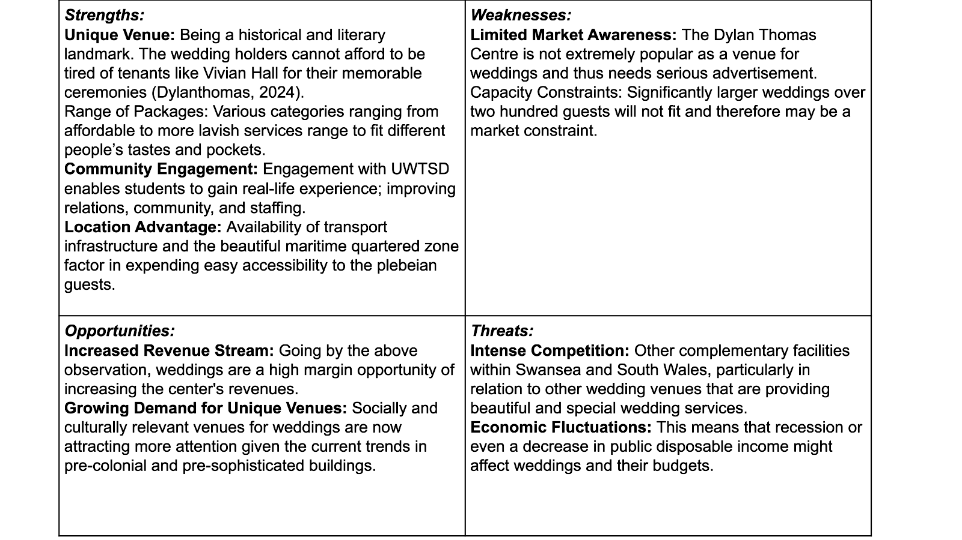

Unique value proposition
To have a unique wedding is provided an outstanding hall that will become the preferred wedding of tourists in Dylan Thomas Centre. Different from conventional catering, the packages are based on the poetry of Dylan Thomas to make the venues romantic and literary. From an intimate affair to a larger Wedding reception, there are flexible choices for a couple where they can rent a magnificent Grade II listed hall, gourmet food, and professional disco for dancing. For the University of Wales Trinity Saint David, our partnership guarantees efficient event supply and memorable events to the university, as well as addressing local education and community engagement needs.

Marketing Mix

Product:
There are targets that encompass different sections of VH: Fern Hall – simple and more private wedding (Fern Hill), whereas more luxurious and indulgent is Rhapsody of Love. All these packages entail freedom to choose a venue including Saturday, food, entertainment, among other things such as floral centrepieces. The advanced packages have other additional services like enhanced acoustics, longer sets and staying over options. All packages are themed based on Dylan Thomas work which brings a unique poetic touch appreciated by couples who want to organise an exquisite, culturally based wedding (Vivian Hall, 2024).

Price:
The pricing plans are different to fit a price range and allow for any guest count. That is, there is Fern Hill package of £3000 for small weddings and the Rhapsody of Love package for large weddings £15000. This range enables the couple to pick according to their pockets as well as what they like. Pricing is competitive with value benefits from the historical façade and unique services providing an even more attractive product in contrast to other competing facilities in the region (Kotler et al., 2018).

Place:
The Dylan Thomas Centre is situated in the marine area of a same named city and can be easily located in public transport, there is car parking available in the premises. For local and particularly out of town guests, the fact that it is situated in central and within walking distance to the bus and train station is convenient. The availability of the venue is also good for the couples who rate uniqueness, beautiful backgrounds, and easy accessibility to the city places (Gower holidays, 2018).

Promotion:
Marketing will rely on online and offline media thus launching social media marketing campaigns, printing media such as bridal magazines, and cooperating with wedding planners. Promotional actions will focus on stressing the literary concern of the venue, the opportunities within packages, and additional services. Unique offers during winter and affiliation with hotels and photographers in the area will be suggested to target potential customers (Institute of hospitality, 2024). Visibility is promoted by sensitising those within the region who organise promotional events such as wedding fairs at the centre (Tuten, 2023).

Marketing Activities
For Vivian Hall to advertise its wedding packages, social media advertising uses sites such as Instagram, Facebook, Pinterest with the theme of literary setting of the venue. Local influencers and wedding planners are reaching more people in creating awareness. We will place adverts in local bride magazines and get involved in regional wedding fairs, providing special read more deals. High-quality visuals, including a high-resolution picture of the venue and information regarding the packages, will be added to an SEO-friendly webpage (Blythe, 2019) including a company reel. Furthermore, email promotions will be used to reach and sell the services of the venue to the engaged couples in Swansea while inviting them for an inspection of the venue (Das, 2021).

Promotion methods
A combination of advertisements will be used to popularise Vivian Hall’s wedding packages. Facebook and Instagram will create a display about the venue’s historic appeal in engaging local target customers. (De Veirman et al., 2019). Newspaper supplements or free local bridal magazines and the wedding fairs would give exposure to the target consumers only. Partnership with other planners and popular wedding-related Instagram accounts will increase its popularity among wedding planners and brides-to-be, the website with a dedicated page and high-quality SEO written content will drive new business through couples looking for venues online (Das, 2021).

Gantt chart
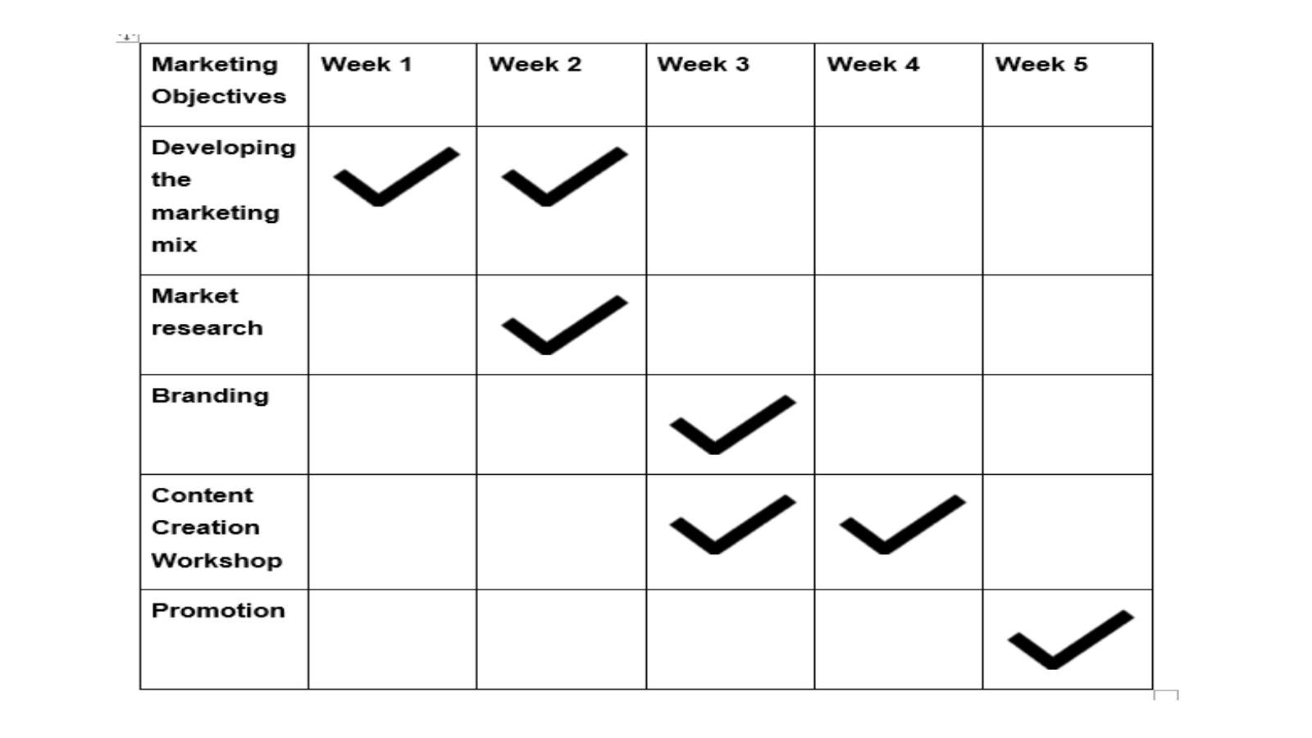

Monitoring
The promotional channel used in the marketing of Vivian Hall will be monitored through marketing quantified tools such as Google Analytics and social media analytics to determine a variety of aspects including engagement, reach and conversions. Information gathered from customers and leads generated from the wedding fairs, as well as the booking rates will be evaluated frequently and measures taken to maximise the functions for each promotional tool while keeping costs as low as possible (Kotler et al., 2019).

Conclusion
The following paper presents a marketing plan to promote the Vivian Hall’s wedding packages and its distinctive literary theme and flexibility. The specific objectives of the marketing communications strategy and selling plan, which targets engaged couples through proper market segmentation and a clear marketing mix, promotions, and monitoring processes, include increased visibility and bookings and providing distinctive, special, and unique wedding experiences.

References
Blythe, J (2019). Essentials of Marketing, 7th ed., Pearson Education
Conferences-UK, (2024). The Dylan Thomas Centre: United Kingdom - Conference venue| Conferences. Available at: https://www.conferences-uk.org.uk/venue/the-dylan-thomas-centre (Accessed: 27 November 2024).
Das, S., (2021). Search engine optimization and marketing: A recipe for success in digital marketing. Chapman and Hall/CRC.https://www.taylorfrancis.com/books/mono/10.1201/9780429298509/search-engine-optimization-marketing-subhankar-das, (Accessed: 27 November 2024)
De Veirman, M., Hudders, L. and Nelson, M.R., (2019). What is influencer marketing and how does it target children? A review and direction for future research. Frontiers in psychology, 10, p.498106.https://www.frontiersin.org/journals/psychology/articles/10.3389/fpsyg.2019.02685/full?trk=public_post_comment-text, (Accessed: 26 November 2024)
Dylanthomas, (2024). History of the Dylan Thomas Centre DylanThomas.com. Available at: https://www.dylanthomas.com/dylan-thomas-centre/history-dylan-thomas-centre/, (Accessed: 25 November 2024).
Gower holidays, (2018). Dylan Thomas Centre, Swansea| Gower Holidays. Available at: https://www.gowerholidays.com/things-to-do-see/attractions/dylan-thomas-centre-somerset-place/, (Accessed: 27 November 2024).
Institute of hospitality, (2024). The Institute of Hospitality is the global professional body for hospitality| Institute of Hospitality. Available at: http://www.instituteofhospitality.org/,m (Accessed: 27 November 2024).
Juanna, A., Monoarfa, M.A.S., Podungge, R. and Tantawi, R., (2024). Identification of Trends in Business Promotion and Marketing Using Video-Based Content on Social Media. Jambura Science of Management, 6(2), pp.88-103.https://ejurnal.ung.ac.id/index.php/jsm/article/view/23966, (Accessed: 27 November 2024)
Kotler P, Armstrong G, Harris, LC, Piercy N (2019), Principles of Marketing, 8th ed., Pearson, London
Kotler, P., Armstrong, G. & Opresnik, M.O., (2018) Principles of Marketing Seventeenth, global., Pearson, London.
Thorgren, E., Mohammadinodooshan, A. and Carlsson, N., (2024), May. Temporal Dynamics of User Engagement on Instagram: A Comparative Analysis of Album, Photo, and Video Interactions. In Proceedings of the 16th ACM Web Science Conference (pp. 224-234).https://dl.acm.org/Doi/abs/10.1145/3614419.3644029, (Accessed: 28 November 2024)
Tuten, T.L., (2023). Social media marketing. Sage publications limited.https://books.google.co.in/books?hl=en&lr=&id=1D_JEAAAQBAJ&oi=fnd&pg=PT13&dq=social+media+promotion+&ots=z3-rNFf55W&sig=rgjnivH42EjBMIkz9B3a5W6-UkU&redir_esc=y#v=onepage&q=social%20media%20promotion&f=false, (Accessed: 28 November 2024)
Vivian Hall, (2024). The Vivian Hall: At the heart of black pill village| The Vivian Hall | At the heart of Black pill village. Available at: https://www.vivianhall.org/ (Accessed: 07 November 2024).
Yost, E., Zhang, T. and Qi, R., (2021). The power of engagement: Understanding active social media engagement and the impact on sales in the hospitality industry. Journal of Hospitality and Tourism Management, 46, pp.83-95.https://www.sciencedirect.com/science/article/abs/pii/S1447677020302242, (Accessed: 29 November 2024)

