

LEVEL 7

SEMESTER 2

MODULE CODE: SHSS7007
Research Methods

aSSESSMENT TYPE: research paper
assessment component: 2

COMPONENT WEIGHTING: 80 %

WORD COUNT: 6000 WORDS

MODULE TUTOR: N. Wainwright

Assessment
Critically reflect on the methodological process and outcomes of your outdoor / physical education research project including implications for your practice, the learning programme and an evaluation of the method(s) used.
Your paper should include the following:
  - A brief, critical reflection on the research question, aim and objectives of your project (1500 words).
  - A critical evaluation of your choice of methodology and research design (1500 words).
  - A critical evaluation of the faithful implementation of the methods as used and ethical issues encountered (1500 words).
  - A critical reflection on the implications of the research for your practice and / or learning programme (1500 words).

SUBMISSION DETAILS: 18th May 2020 (New deadline: 28th May 2020)

ASSESSMENT CRITERIA | Learning  Outcomes | GRADE
ASSESSMENT CRITERIA | Learning  Outcomes | Poor  - 20% | Unsatisfactory  40 – 49% | Satisfactory  50 – 59% | Good  60 – 69% | Excellent  70% + | %
Critical reflection on the research question, aim and objectives of the project. | 1  1,2 |  |  |  |  |  | 40%
Critical evaluation of the methodology and research design. | 1,2 |  |  |  |  |  | 20%
Critical evaluation of the faithful implementation of the methods and ethical issues encountered. | 3333333,431 |  |  |  |  |  | 20%
Critical reflection on the implications of the research for your practice and / or learning programme. | 3,5 |  |  |  |  |  | 20%
It is expected that students will present work that is proofread and follows the School Reference Guide and Assessment Checklist. Therefore, a range of 0 – 10 marks will be deducted for poor referencing, spelling, grammar, punctuation, and presentation.

Tutor comments

Strengths:
First Tutor’s Comments:

Areas for Further Improvement/Consideration:
First Tutor’s Comments:

Second Tutor’s Comments:

Tutor 1: | 1st Mark:
Tutor 2: | 2nd Mark:
Date of Submission:  Assessment 1: | Agreed Mark:

A critical reflection of the methodological process and outcomes of my outdoor education research project including implications for my practice, the learning programme and an evaluation of the method(s) used. (6464 words)

As a student-researcher my previous experience sits heavily within Scientific Laboratory research. Therefore, this module allowed me to explore my abilities and capabilities in a different field of research (Social Science) and using different methods (workshop ⁽⁵⁾⁽⁶⁾). This was a considerable change from what I am used to, which is reflected by the challenges and issues that have affected this research project.

Collaboration

Due to a recent change in employment, from Primary School teacher to Project Manager with the RSPB, I utilised this experience as a chance to combine my Masters research with my new job role. This was a positive step, as it allowed me to build important connections within the organisation, but also added extra complications, which I will discuss throughout my reflections/evaluations.

Research into collaboration has shown that it has lots of challenges and issues, but when carefully managed and considered can lead to very positive outcomes (Goddard et al, 2006; Loan-Clarke and Preston, 2002; Mitchell et al, 2008; Payne et al, 2011). Collaborative research is defined as creating communities of practice (Mitchell et al, 2008) and in ideal cases the partnership produces a smooth dovetailing of skills and expertise (Stead and Harrington, 2000; Goddard et al, 2006). It is important to consider the different types of collaboration, as each will operate differently. This was an example of vertical collaboration, as I was working with academics who have previous experience in this area rather than my peers (Morrison et al, 2003; Goddard et al, 2006). I therefore needed to be aware of the relationship between myself and the other academics, ensuring that I gave them the respect they deserved, so that they continued to support and develop this research alongside myself, whilst sharing the knowledge they already have. For this stage of the project, these relationships worked well: I learnt from research recently conducted which was in the process of being published; I was able to have working discussions with my collaborators which aided my understanding during the literature review stage and they were able to warn me of possible issues relating to the workshop design chosen.

It is also important to be aware of challenges so that they can be controlled. If they are not controlled properly, it can lead to fragmented research (Goddard et al, 2006). See table 1 for a description of challenges and issues that can occur during collaborative research and the relevance to this project.

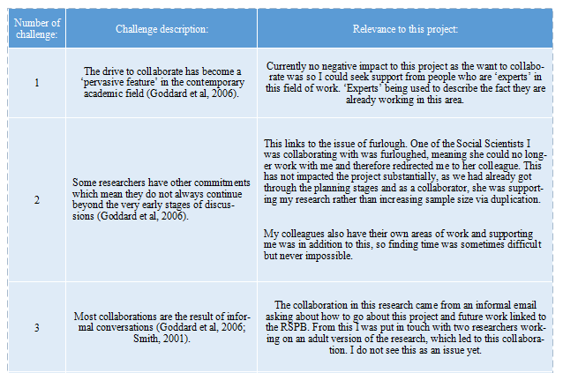
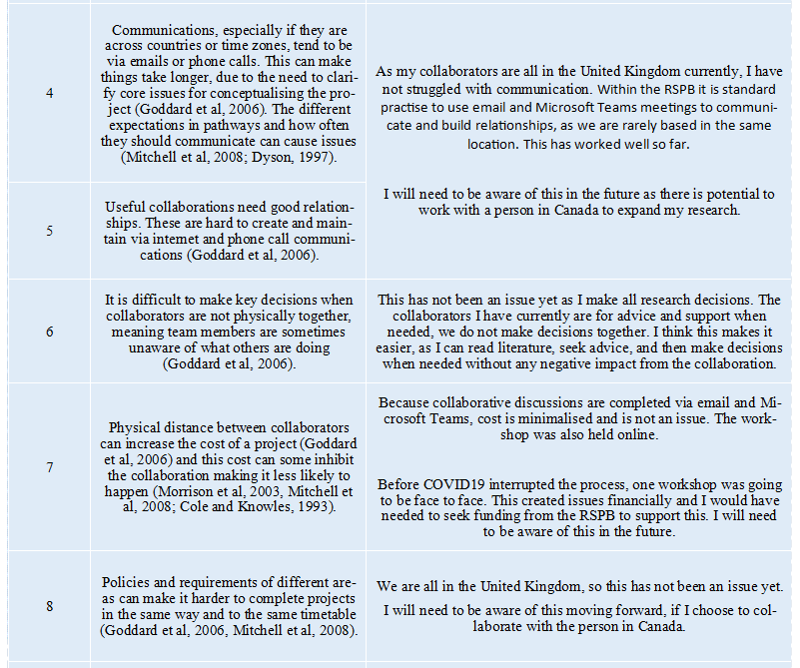
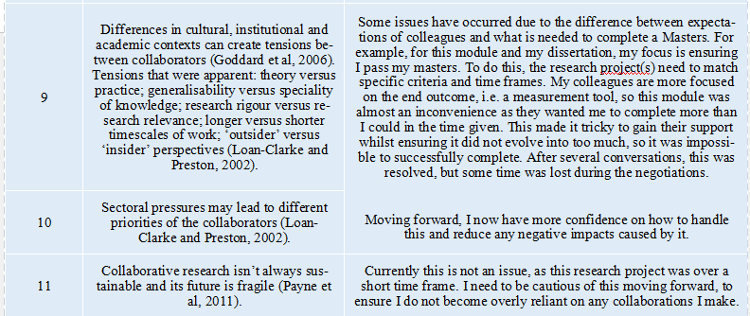

If these challenges are managed then many researchers gain from collaborative research (Loan-Clarke and Preston, 2002), see image 1 for potential benefits:
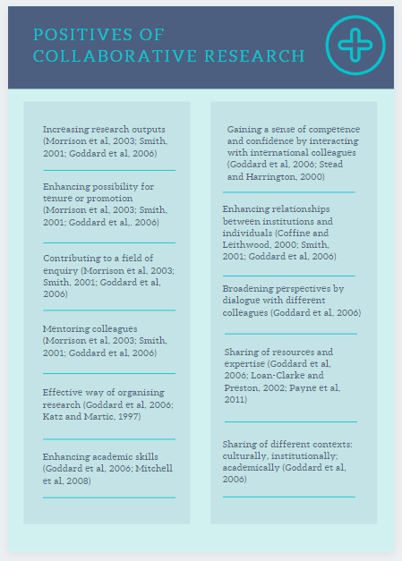

For this project, the positives were: an enhanced relationship between me and the RSPB a, sharing of expertise and a possibility of a relationship in the future. This means once my Masters is completed, I may continue to research and develop my research skills with support.

Research Question, Aims and Objectives

I utilised this module to explore a potential focus area for my dissertation, this allowed me to study the current research into connections to nature (CtN) in children and tools available, as shown in my project proposal⁽¹⁾. Throughout this process, I have learnt a lot which will ensure my dissertation is well planned and therefore should run more smoothly. Fundamentally, I have learnt that everything needs to focus back on the research question. That should be the golden thread throughout.

Through the critiquing of several papers, and discussions with RSPB Social Scientists Joelene Hughes and Victoria Carr, I was able to create a project proposal⁽¹⁾, which included the research question: ‘What should and do children gain from the different sessions the RSPB offers to children (with a larger focus on schools on reserves and schools outreach), and what methods are the most effective to gather this information from children partaking in the sessions?’. Following submission of the project proposal ⁽¹⁾ and discussion with a University Tutor, we decided that this was too ambitious for this module. Therefore, the research question became ‘What should and do children gain from the different activities the RSPB offers to children?’ It was chosen due to the future focus on creating a tool to measure differences in CtN over small periods of time. Therefore, this research project would be the starting point for future research.

As part of my reflection, I found the definition of a research question as: an uncertainty about a problem that can be challenged, examined and analysed to provide useful information (Aslam and Emmanuel, 2010) or a broad question which is set at the start of a study (Parahoo, 1997; Draper, 2004). The question should arise from a perceived knowledge deficit (Farrugia et al, 21009) and should guide the research design methods and analytic strategies (Thabane, 2006). After reading these definitions and further information, I am concerned that my question was not designed properly. It does not have a problem to challenge, examine or analyse. It also does not really come from a knowledge deficit. I believe this mistake has arisen due to the focus too far in the future, towards the development of a tool. I should have considered this as a separate piece of research and given it as much thought as I have future research, therefore a better question may have been: ‘How do conservation organisations such as the RSPB deliver connection to nature activities to ensure children develop a deeper connection, and how do children show that the experience has worked?’. This would have been answered from the workshop and provided a more detailed answer for the research project overall. The original question only allowed the ‘skimming of the surface’; it was too vague.

Cormack and Benton (1996) distinguish between two types of research question: interrogative and declarative. Interrogative is expressed as a question and alludes to a gap in knowledge. Declarative is a statement that clearly defines the purpose of a study (Draper, 2004). Mine is clearly a question and therefore is interrogative. It suggests we are unaware of what children should and do gain from RSPB activities. I believe this is true in some ways, but not in others. For example, we all have an idea of what we believe children should be getting from the activities, but have these views ever been collated and compared? I am not aware they have. An issue with my question is linked to the sample - the question does not explain who is going to answer the question, therefore I should have included a wider range of people in my sample, rather than only RSPB staff. To correct this, the question could have been: ‘What is the perspective of Education staff within the RSPB on how conservation organisations, such as the RSPB, deliver connection to nature activities to ensure children develop a deeper connection, and how do children show that the experience has worked?’ This would have been much clearer.

Draper (2004) discusses two different types of knowledge that are generated: descriptive versus exploratory. Descriptive describes an experience, whereas exploratory looks for relationships between various components of knowledge that is already available. I believe my research question allowed the production of descriptive knowledge, but as I was unaware of this focus, I may have not utilised the data enough to draw on a fully descriptive answer to the question. This has left my research open to negative critiquing. In the future, I will ensure that I am aware of which knowledge I want to generate and therefore ensure the data collection and analysis will allow this to the best possible effect.

As a successful research project depends upon how well a researcher formulates the research question (Aslam and Emmanuel, 2010), and needs to be built ensuring it does many things (see image 2), I believe this research project would not be sufficiently successful and therefore would not be worthy of publication. Looking at image 2, this research question did not achieve many of these objectives, as prior to this evaluation I was unaware of most of these, especially the FINER and PICOT criteria. Therefore, moving forward, I will ensure I consider all of these steps to create successful research questions for future research.

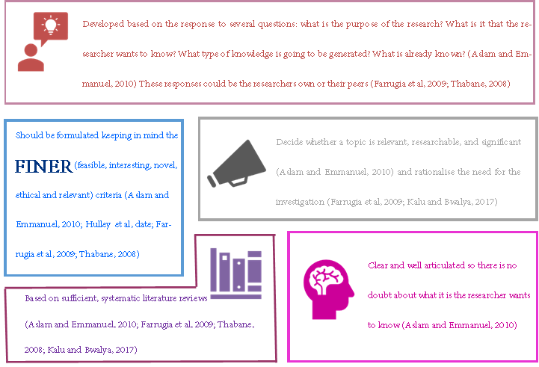
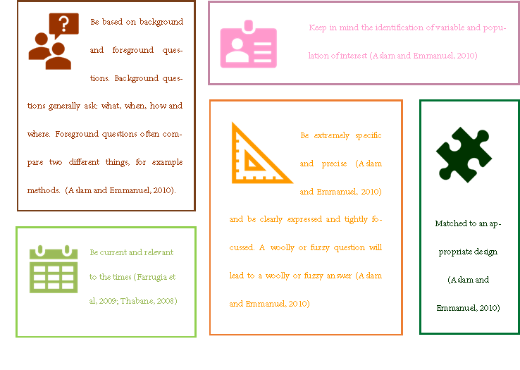
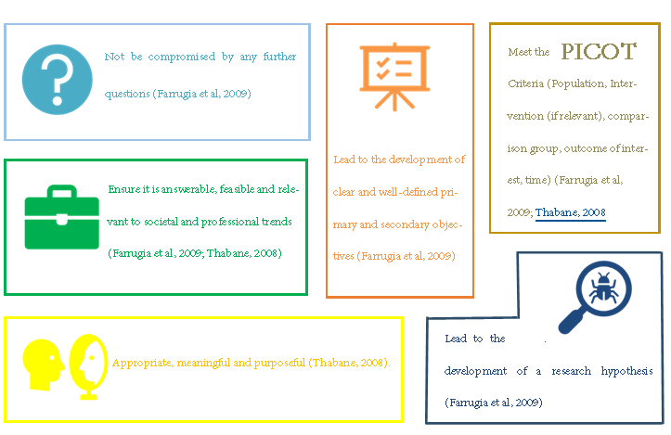

In order to answer the original research question, I created four aims, which were further broken down into objectives. See table 2:

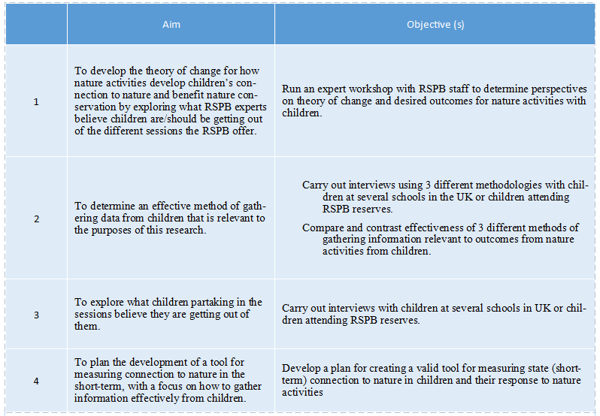

Due to the adaptation of the research question, only the aim and objective listed in row 1 were continued within the investigation. As the question was focusing on ‘What should and do children gain from RSPB sessions’, the aim should have reflected this completely. The latter part of the aim ‘exploring what RSPB experts believe children are/should be getting out of the different RSPB sessions’ does reflect and answer this question, but the first part does not. The first part focuses solely on the theory of change, which is not mentioned in the research question at all, so why has it suddenly appeared in the aim? The theory of change (Weiss, 1995; Cornell and Kubisch, 1998) is important in understanding what children get out of the sessions, as it describes the effect that the sessions have on the children and the change that happens. The workshop with the RSPB experts was a first step to creating the theory of change. This was not made clear enough in the research question or aim. Therefore, considering my new research question produced is this reflection, the aims should have been:
- To describe how conservation organisations deliver connection to nature experiences from the perspective of RSPB staff.
- To describe how RSPB staff believe conservation organisations know whether an experience has worked.
- To describe how RSPB staff believe children show a successful/deepening connection to nature.
- To begin to create a theory of change using all descriptions.
These changes would have allowed the research question to be fully answered.

Again, the objective was only partially met, as the aim to create a theory of change was not introduced in the workshop. Partly this was by choice, as it would have needed to be taught/shared with the participants before asking questions relating to it, but also because it was overlooked when designing the questions. This means that the research question can be answered by the research, but the aim and objectives were not fully met.

The questions to be explored were:
1a) How do children develop connection to nature and how can the RSPB influence this?
1b) What connection to nature outcomes do we want to achieve through RSPB activities?
1c) Which RSPB activities may help develop connection to nature in children?
1d) What aspects of ‘Schools on Reserves’ and ‘Schools Outreach’ help to increase connections to nature?
These questions allowed the partial collection of information needed to answer the refined research question, but, as with the aims and objectives, they were not completely linked to the actual research question. Image 3 shows these questions adapted and improved.

On reflection, the proposal stage was too ambitious and not enough time was spent rethinking these steps after I adapted the research question. In the future the research question, aim, objectives and questions will be reconsidered following any changes that are made to ensure they are still effective. See image 3 for a summary of improvements that could have been made.

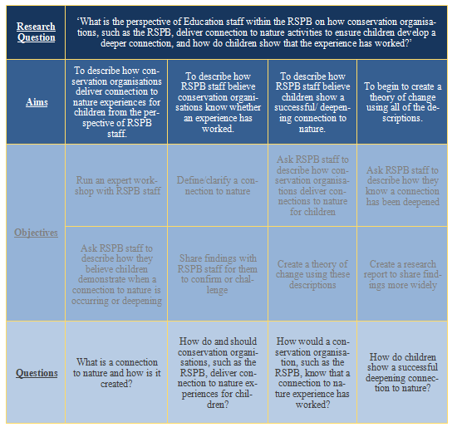

Methodology and Research Design

Research design is the overall plan of how the researcher intends to implement the project in practice (Draper, 2004). Parahoo (1997) and defines the research design as a plan that describes how, when and where data will be collected and analysed (Draper, 2004). The design and methodology used should be appropriate to fully answer the research question and should therefore arise from the question itself and the study’s overall aim (Kalu and Bwalya, 2017). I never completely considered the design properly; part of it was represented in initial discussions at university, other parts were shown in the project proposal⁽¹⁾, but this is the first time I have considered it as a separate entity. This concerns me slightly, as there are probably plenty of things that I should have considered and planned for before the research began.

The design should include details for enhancing the internal and external validity of the study (Polit and Hungler, 1991; Draper, 2004). It should include: how the sample is identified and recruited, ethical considerations, confidentiality, anonymity, access to research site, how data is to be collected and analysed and the plans the research has for disseminating the finding of the study (Draper, 2004). In my project proposal and ethics form I considered all the above except the last two: analysis and plans for disseminating the findings. Plans for disseminating the findings is irrelevant in this project, as the results were never going to be shared as a separate project. I will reflect on each of the remaining areas mentioned as we move through this section of my evaluation.

Research methodology and research methods are two terms which are frequently used interchangeably. Methodology is the overall research approach, such as: experimental, survey, ethnography, phenomenology, grounded theory, action research, or participatory research. Different methodologies are influenced by different perspectives or paradigms. Method refers to the practical way the data will be collected and analysed, such as: structured questionnaires, rating scales, structured observation, semi-structure and un-structured interviews, participant observation, narrative analysis and content analysis (Draper, 2004; Farrugia et al, 2009; Kalu and Bwalya, 2017). In this research project, the methodology was survey and the method was a semi-structured workshop ⁽⁵⁾⁽⁶⁾ collecting qualitative data.

Qualitative research is used in various disciplines, including behaviour and social sciences, to enhance understanding of individuals’ experiences, situations, cultures, beliefs, values and to develop theories to describe these experiences (Kalu and Bwalya, 2017; Creswell & Plano Clark, 2011; Munhall, 2012; Wuest, 2012; Holloway & Galvin, 2016; Turk and Kalarchian, 2014). It originated due to the thoughts that human behaviour, experience, and relationships cannot fully be captured through quantitative study (Turk and Kalarchian, 2014). A qualitative research design was chosen for this research, due to no current tool existing which measures connection to nature differences over a short amount of time in children. Upon further reflection of the last statement, this was not a real reason to choose a qualitive design for this research. I did not need to measure children’s connection to nature, or its change over a short time period to answer this research question. To make my decision I was focused too far ahead rather than on this specific, small section of the wider focus. Although this reflection suggests qualitative was chosen for the wrong reasons, it was partially still an appropriate selection for this research. The qualitative research allowed the exploration of the participant’s views into the topic and provided freedom to describe these findings in a qualitative, descriptive way. It might have been useful to have used a mixed methods design, as using a follow up questionnaire collecting quantitative data may have allowed the researcher to be clear about how many of the participants agreed or disagreed with the overall answers that were created during the workshop. A workshop was not an effective way of measuring how many participants truly believed and agreed with each statement.

As well as this, the trustworthiness of qualitative research is often questioned by some researchers and readers because the traditional concepts of validity and reliability are addressed differently to that of quantitative research (Kalu and Bwalya, 2017; Shenton, 2004; Ritchie, 2013). Due to this lack of trustworthiness, the research needs transparency, accountability, and reflexivity to be shown through the whole process, this can be done by exhibiting clarity and responsibility (Kalu and Bwalya, 2017). The Consolidated Criteria for Reporting Qualitative Research (COREQ) exists to enhance the quality of qualitative methodology. It also enables transparency (Turk and Kalarchian, 2014). This research project has limited transparency as the write-up did not happen, but I am now aware of what is needed to ensure qualitative research is reliable and valid.

The use of theory in qualitative research is very important, it aids the structuring of the whole process (Creswell, 2003; Klenke, 2008; Kalu and Bwalya, 2017), therefore my research focused in on the theory of change. Theory of change is defined as ‘how and why an initiative works’ (Weiss, 1995; Cornell and Kubisch, 1998) or a ‘change which occurs when one becomes what he is and not when he tries to become what he is not’ (Beisser, 1970). It can either be part of a longitudinal study, where it allows the researcher to consider the variables during the planning stage (Ployhart and Vanderberg, 2010), or it can be a systematic and cumulative study of the links between activities, outcomes and contexts of an initiative (Cornell and Kubisch, 1998). In this research project, the theory of change sits as the main focus on its own: it is looking at the links between RSPB activities, the outcomes that RSPB staff want and the contexts in which the activities are held, therefore this links very closely to what Cornell and Kubisch (1998) explained. Fundamentally it will help us to explore how and why RSPB activities allow an increase in a child’s connection to nature, and allows us to build the first stepping stone to creating a tool to measure the impact of different activities on the theory of change. A good theory of change should be plausible, doable, and testable (Cornell and Kubisch, 1998). This research has created the first step in designing a theory of change. By answering the research question, the researcher should find out what changes should happen over the course of an activity. This workshop allows the first step: ensure the change is plausible. Through discussion with experts, it allows the creation of a theory of change which is plausible and expected. As it is being created from activities that are already happening, and reflections on what changes those activities are creating, it is therefore already doable. The last step of ‘testable’ is the tricky step and therefore should be the focus of future research.

It is important to consider the theory of change because it: allows a thorough understanding of the variables impacting the research, can sharpen the planning and implementation of an initiative (in this case a tool to measure the impact of activities), enables the creation of an evaluation process, allows the identification and specification of interim and long term outcomes and identifies the contextual conditions which may affect outcomes (Ployhart and Vanderberg, 2010; Cornell and Kubisch, 1998). Therefore, this reading led to the development of the research question being answered via a workshop of RSPB experts selected using a purposive sampling method.

Sampling in qualitative research plays a vital role; it helps the researcher to identify the focus population of the study (Kalua and Bwalya, 2017; Patton, 1990; Marshall and Rossman, 2014). To ensure transparency, the reader needs to know: why a sample was chosen, its appropriateness for the research and what sampling technique was employed (normally supported by robust references from literature) (Kalu and Bwalya, 2017; Lincoln and Guba, 1985; Patton, 2002; Cleary et al, 2014). For example, if a purposive sampling strategy was adopted for the research, the reader will look for an in-depth rationalisation for choosing the sample and its appropriateness (Kalu and Bwalya, 2014). See table 3 for the transparency of this studies sample selection.

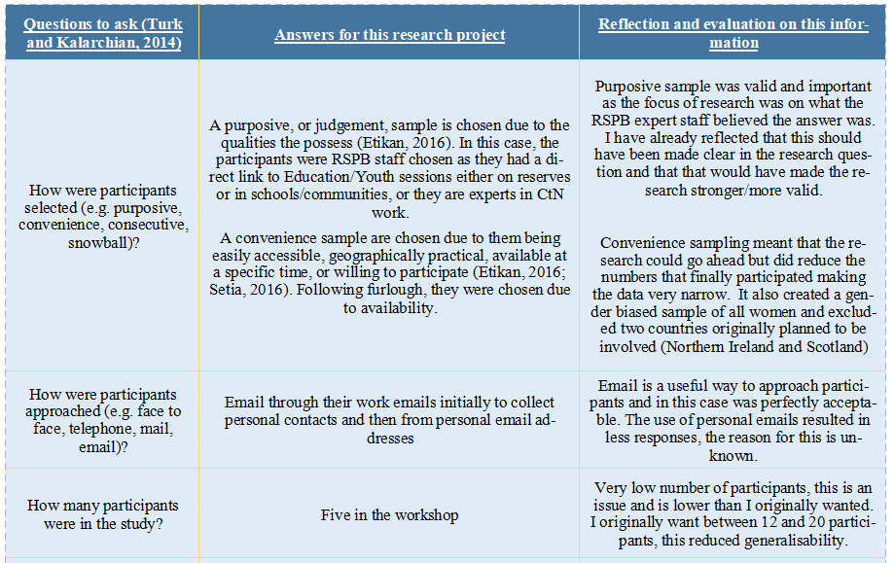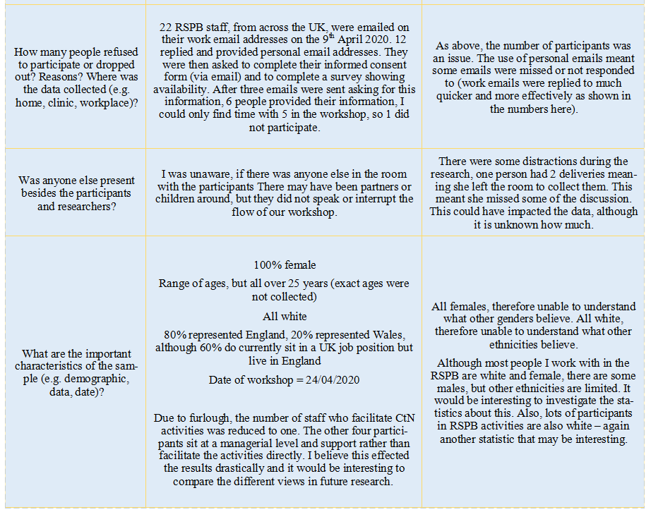

As mentioned in table 3, the sample was chosen using a non-probability or non-random sampling technique. This type of sampling technique has a lot of limitations, for example: rarely represents the whole population, likely to be biased, outliers can be more devastating to data, can lead to poor quality of data, and can lead to gender, ethnic or age bias (Etikan et al, 2016; Setia, 2016). Even though there are these flaws, it is extremely useful for researchers who have: limited resources, limited time, a small workforce, limited funding or resources, are new to research and don’t aim to generate results which are generalisable to a wide population (Etikan et al, 2016). The last reason is the main reason this sample was originally a purposive sample, more specifically an example of homogeneous sampling, due to all participants having similar jobs (Etikan et al, 2016).

Although qualitative data allows the freedom to involve a range of collection methods which can reduce bias and enhance data credibility (Kalu and Bwalya, 2017; Mills and Huberman, 1994; Yin, 2003; Marshall and Rossman, 2014; Eisenhardt, 1989), this research project was limited by time allowing the use of only one method. Therefore the only method used was a semi-structured workshop (Drever, 1995), which allowed the researcher to have prompts ready in case they needed to direct the discussion back to the main focus/question, therefore allowing a more open-ended technique (Turk and Kalarchian, 2014). See image 4:

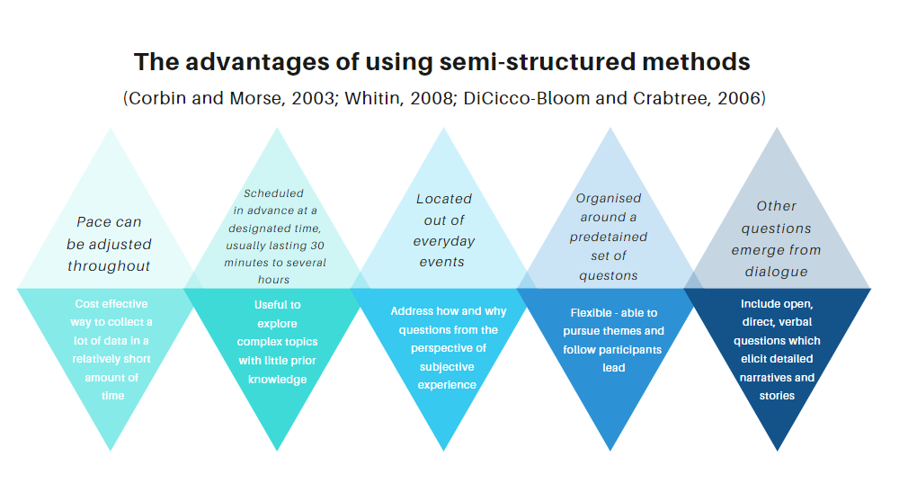

Semi-structured methods usually take the format of an opening statement to introduce yourself and build rapport with the participants, a few general questions to elicit conversation, some additional questions designed to probe for information if it does not come up (Rabionet, 2011). See image 5 and 6 for a more detailed checklist for the explanation and probes. This structure allows the research to maintain control over the process, asking questions but contributing little else (Sorrel and Redmond, 1995; Whitin, 2008).

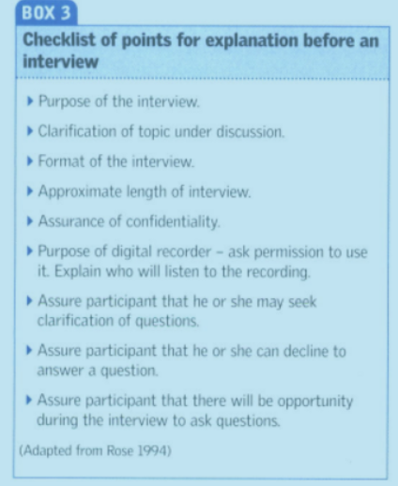 | 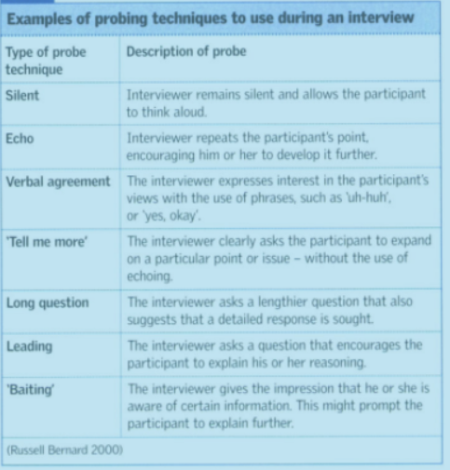
The explanation used in this project⁽⁶⁾ covered the: purpose, format, assurance of confidentiality, recording permissions and reason for its use, assurance of a chance to ask questions. Some things were not covered in the explanation but were covered in the permission document ⁽⁴⁾ and emails ⁽³⁾ They were: clarification of topic under discussion, approximate length of workshop, opportunities to decline and withdraw. I never directly explained that the participants may seek clarification of a question, and in this situation this was acceptable because they already knew me so were relaxed enough to do so, but I need to ensure I include this step in the future. I also think I needed to clarify the topic better, for example I made the assumption that all of us believed a connection to nature was the same thing, in one question I explained how I had defined the RSPB’s view and there were some differences in opinion arising from that. It would have been useful to have discussed this appropriately at the start or prior to the workshop.

As it was a workshop, the researcher did not use many of the probing techniques discussed in image 6. The participants used some of them meaning I did not need to; they were echo and verbal agreement. I sometimes allowed silence to happen, although it was rare and I made use of long questions, but these were all planned already (although some differences in what was said).

In this research project, the workshop was held online using Microsoft Teams and recorded using their software. Originally, two workshops were planned: one online and one face to face. This would have allowed the evaluation and reflection of the two styles and my delivery of each. Unfortunately, due to COVID19 I was only able to complete one online workshop. See table 4 for an explanation of the positives and challenges of using online methods.

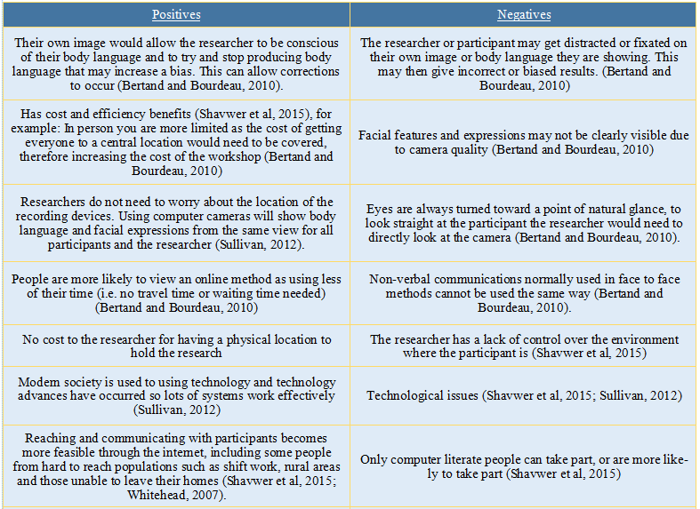
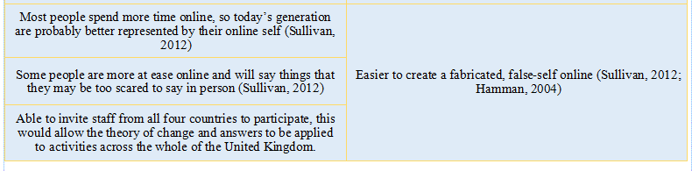

Once collected, data is often transcribed, coded, and analysed, sometimes using specialised software that aids in organising the information (Turk and Kalarchian, 2014). In this project, the data was recorded using Microsoft Teams, before being transcribed by hand and using Word Dictate, then analysed using NVIVO and its coding abilities before a final analysis by myself. It is important that researchers continue to be transparent and provide ample information about the analytic journey from data to conclusions, this enables the reader to make their own conclusions about how fair and true the research is (Kalu and Bwalya, 2017; Silverman, 1993; Silverman, 2016). In this research project, this step did not happen as the research was not written up in a final format for this to take place, although this step would be very important as there was subjective data and answers that were created/found.

This was my first experience of transcribing and I felt like I did not understand what I should be doing or what needed to be included. I used Word Dictate to write the bulk of it for me, which made it much easier when I listened a section at a time and transcribed it, as I had a starting point. It would have been easier to write the participant code and time, then Word Dictate that one section, instead of allowing it to dictate the whole c.90-minute workshop. This took a very long time to do and it was difficult to get the motivation to sit down and listen to it. It felt like a very frustrating step and therefore I kept putting it off. Next time, I would chunk the transcription and analysis into smaller sections by transcribing question one, analysing question one, and so on. This would have kept me interested and wanting to find more. The downside of this is the analysis nodes did not come from only that one question section, participants answered the different questions at different points. For example, question 4 quite heavily repeated the answers from question 1, therefore by transcribing and analysing at different times this may have been missed.

As a person with a specific learning difficulty, which links directly to auditory memory, I found transcribing what was being said very difficult. If I had been doing it completely by myself, I would have been listening to four words and then writing it out. Word Dictate helped with this a lot, and it was fairly accurate. The sections where it, and I, struggled were where the participants spoke over each other. These sections were not transcribed completely, which may mean some data was lost.

NVIVO was very helpful for pulling out the themes into nodes, although sometimes I coded huge chunks of text meaning a second stage of analysis was needed. This second stage increased the chance for subjective concerns and therefore unethical findings. Once coded, the use of NVIVO word frequency query allowed me to become aware of the words which were discussed the most. This was a good starting point for then answering the questions but was not a final step. An issue with this is that people nodded or said ‘yeah’/’yes’ when they agreed, if they made their agreement clear at all. This would not show up using this method of analysis. Following this I could also use NVIVO’s text search query to pull out sections linking to identified, high-frequency words. This again was only useful to a certain level – it did not link the answers to the four questions asked.

I then hit a point where I was no longer sure how to use NVIVO to analyse my research, so I picked a node and went through it ‘by hand’, summarising it into an answer to that question. This was interesting, as some of the nodes I had created, for example ‘inhibitions of CtN’, did not directly link with a question that I had planned. This was proof that I had not stuck to the semi-structured plan Therefore, I matched the themes to their most suited section to create a conversation to answer the question indirectly. For example, I put the inhibitions into the section regarding how children get connected and how the RSPB can influence this. I chose to put it there because I believe that if organisations focus on how to reduce these inhibitions, then they can support children to increase their connections. This is my thought, created by the research, but is not directly linked to the focus of this research project.

After I had answered each of the four main questions, I created a two-paragraph summary to answer the main research question. This was interesting as some of the main questions were not as linked to the research question as I first thought. For example, the research question was: ‘What should and do children gain from the different activities the RSPB offer to children?’ Two of the four questions were: Which RSPB activities may help develop connection to nature in children? And What aspects of Schools on Reserves and Schools Outreach help to increase connections to nature? Both questions link more to CtN than RSPB activities directly, therefore this did not help fully answer the research question. A few other analytical steps should have been planned for and implemented. For example: analyse the ethical implications and researcher bias throughout and to code data against the known five pathways to CtN. This would have enhanced the data created. Following these steps, I should have shared my findings⁽⁷⁾ with participants for correction and comment (Turk and Kalarchian, 2014).

Faithful implementation

Throughout the whole project, the qualitative design was faithfully implemented. The research never strayed away from this, even though at times the use of quantitative may have enhanced the data.

The participants were planned to be a purposive sample, but due to the furlough scheme, I adapted my list of potential participants, reducing the number of people who work on the ground with the children. Therefore, I invited those who had links to the theme of the purposive sample, but it became more of a convenience sample as it was those who were available and replied to take part. I believe the sample affected the results greatly, and therefore I would change how I gained a sample next time. I am not sure how I could have changed the outcome for this project though, due to the implications of timing and furlough.

The workshop was implemented in a semi-structured style as planned, but the prompts and questions planned were not used as efficiently as they should have been. The workshop was designed to be semi-structured to ensure it was ethically sound but allowed some freedom to ask unplanned questions. Due to it being my first online workshop and myself being nervous, I did not stick to the planned prompts as much as I should. Instead of asking the questions exactly as pre-planned, I attempted to fill the silence I by expanding on or explaining what I meant by the question rather than trusting they understood. In this case, I don’t think this was an issue ethically or to the results I found as the explanations I gave were still open to any possible answer, but in the future I will be more careful.

Following the workshop, I found transcribing hard to do faithfully. It is difficult not to summarise what is being said or to decide what you think is being said, especially when trying to turn spoken English into written. Spoken English includes extra conjunctions and pauses filled with ‘like’, ‘erm’, and ‘you know’. Although this was an internal battle, I managed to leave it in my head and transcribe only what was said. This included putting ‘Could not hear due to talking over each other’ in some sections of the transcription. This allowed it to be done accurately, quickly and faithfully. Due to this, some key data may have been lost, but it ensured I did not decipher what I wanted to hear and left the transcription open and honest.

Due to it being a workshop, I could see 4/5 participants nodding or shaking their heads at a time, but that meant one person was always off the screen. There was also no clear way of recording who agreed or disagreed with each point that was made. Sometimes it was clear because the participant would talk next and tell you or said ‘yeah’ or nodded. But sometimes I had no idea at all what other participants were thinking. This makes it hard for data to be completely faithful to what the participants felt, although this is a flaw of the method rather than the researcher.

NVIVO allows you to read and code sources without being able to interpret or change quotes. This is helpful when faithfully implementing research. For example, I read the transcription of the research, and then code something into one or more questions/themes. I will have an analytic thought in my head, but at this point I do not write it down, I am simply sifting and sorting. I then come back to it in my next stage of analysing. This is where it can become subjective, where I read between the lines or analyse what that say against someone else. This part of analysing makes it harder to be faithfully accurate to what the participants are saying, for example: “in the classroom or elsewhere there is so much else going on, and I don’t think they have the chance to just stop and look at nature” became “Due to so much going on all of the time, this may prevent them appreciating nature deeply, its often more of a fleeting thing”. This shows what I took from the participants comment and shows a slight difference in understanding and meaning. Issues arise if this changes several times during write ups and corrections/editing.

To show that the research is faithful, the researcher is expected to show transparency through all stages of research (Kalu and Bwalya, 2017). As this research project is not written up as a report, it is hard to show transparency, but I would ensure this happened in any future write up to represent how faithful I was, as well as any potential bias that I may have produced. As with transparency, accountability is expected to be shown by: openly stating that informed consent was collected, demonstrating how anonymity was kept, informing reader whether participation was voluntary or not and whether they were able to withdraw if they wanted, and also whether participants were briefed about the researcher’s findings (Kalu and Bwalya, 2017). Again, these things have not been completed in the form of a report, although all things have happened in the research. The one that would need to happen is the sharing of results with the participants as currently this has not happened.

Ethics

As research can present risks to participants, the researcher has an obligation to ensure their wellbeing (Kalu and Bwalya, 2017; Polit and Beck, 2010; Neuman, 2011; Munhall, 2012). Therefore, the University’s ethics form ⁽²⁾ was completed and adapted based on the changes in research from the original proposal to the final research project. I was also going to complete the ethical stages for the RSPB but due to furlough this did not happen. The lack of this does not change whether the research was or was not ethical, it simply just reduces one extra step.

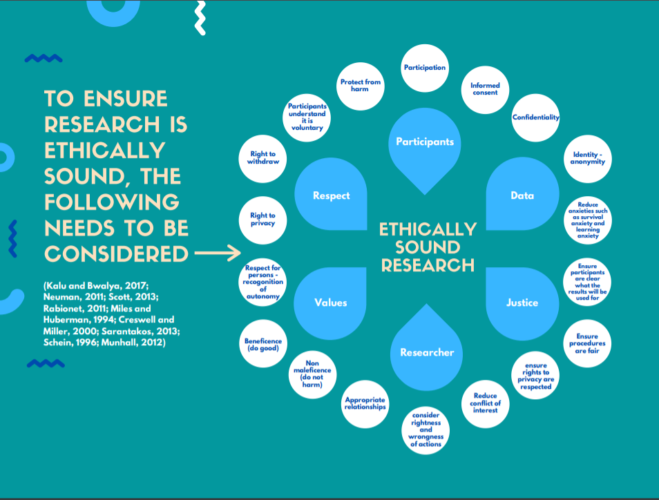

This research was ethically sound, because:
- Informed, written consent was obtained via email ⁽³⁾⁽⁴⁾. Details of the research were explained in a previous email, and the option of not partaking in research and removal of their contribution at any time was reminded at several times prior to and after research happened.
- The research was GDPR compliant. I have up to date training and ensured any documents were kept in passworded or locked locations. Raw data was not shared with anybody and data that is shared in this write-up is anonymised, ensuring confidentiality. When emailing I used BCC to prevent any sharing of private or work emails between potential participants.
- Participants understood that it was voluntary

There is a potential issue with the use of Microsoft Teams to record the workshop, as this video sits on Microsoft’s platform. As I still need the video, I have refrained from deleting it. Once this module has been assessed, I will delete the video. Only the participants and I have access. Another issue was that COVID19 was never assessed as part of the ethics form. It would have been useful to have considered this in some way during the research, and as I complete future research I will keep an ethics log which will allow considerations to be managed throughout the research.

Implications

I have learnt a lot from completing this research project, some of which I have reflected on through this reflection/evaluation, see image 8 for a summary of what I have realised:
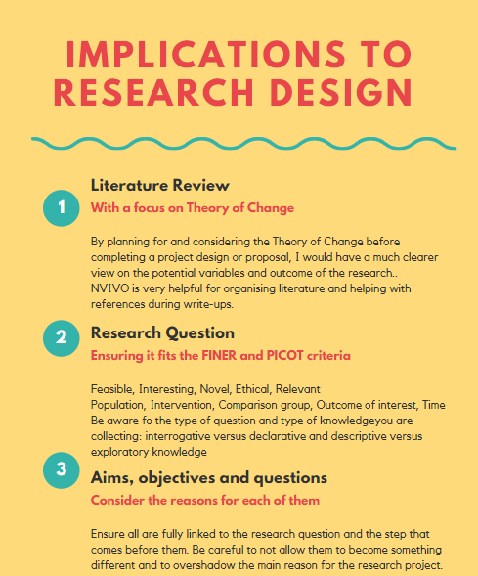
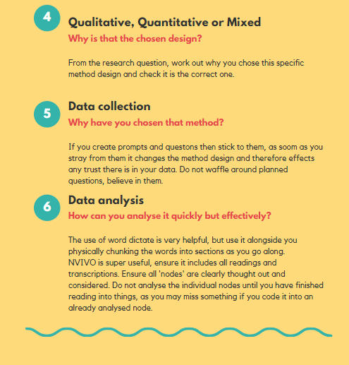

Through reading for this assignment, I have found a lot of things that I should have considered when designing my project. Therefore, the biggest implication is the use of these in future research. Figure y is a tool for use in designing any future research, which will help me ensure research is feasible for the time frame and preventing me from being too ambitious.

Another important learning point is the effect that change can have on a project. For example, by changing the original proposal so it was suitable for the time frame, I left a lot of gaps in the design that went ahead. It had not been considered in enough detail on its own, and therefore was not suitably planned. In the future, I will ensure everything is thought out in more detail, especially if change occurs. Another change was due to the furlough scheme and COVID 19. This changed the sample and made it biased. I should have stepped back, reconsidered whether it was the best sample for what I wanted and then re-designed certain aspects to ensure it would still be suitable.

As previously reflected on, I believe this would have been better suited as a mixed methods design: a qualitative workshop followed by a quantitative survey based on statements I had created from the qualitative data. This would have allowed the knowledge of whether participants agreed or disagreed with the data, rather than it being assumed they all agree or assumed that some would disagree. This issue leaves the data to be scrutinised and discounted by most readers. In the future I will more carefully considerate how the data is going to be used after it is collected and analysed and then use this knowledge to check the design is correct.

Another thing I have learnt, which may be very important moving forwards, is about collaboration. I have the potential to collaborate with a person in Canada. As this would be my first collaboration with anyone outside of the United Kingdom, I need to be very aware of the issues associated with collaboration and ensure that I plan for and combat them where possible. By being aware, I can work to ensure the collaboration is effective and sustainable.

A final reflection relates to my dissertation. In my research I found RSPB experts believed we should be focusing on the CtN of parents and grandparents, as they see this as a major contributor to the children’s CtN, e.g. the better their CtN, the more they are likely to facilitate children’s access to repeated CtN experiences rather than the one off experiences we aim to provide. This would be an interesting comparative survey to see if parents/grandparents with a greater CtN have children with greater CtN.

References (need approximately 60 references)

- Alderman, L. (2014). Purposeful Program Theory: Effective Use of Theories of Change and Logic Models. Evaluation Journal of Australasia; 14(1), pages 44-47
- Aslam, S. and Emmanuel, P. (2010). Formulating a researchable question: Acritical step for facilitating good clinical research. Indian J Sexual Transmitting Diseases AID; 31(1), pages 47-50.
- Beisser A., (1970). The Paradoxical theory of change. Available at: https://static1.squarespace.com/static/572d003b40261d2ef97e5b0b/t/59d64989bce1767a9d98ebbb/1507215754788/G+Paradoxical+Theory+of+Change.pdf [Accessed: 15th May 2020]
- Bernard, H. (2000). Data Management and Analysis Methods. In: Densin, N. and Lincoln, Y. Ed Handbook of Qualitative Research, 2nd Edition. Thousand Oaks, CA: Sage, pages 769-802
- Bertand, C. and Bourdeau, L. (2010). Research Interviews by Skype: A new Data Collection Method. Proceedings of the European Conference on Research Methods; pages 70-73
- Cleary, M. et al, (2014). Data collection and sampling in qualitative research: does size matter? Journal of Advanced Nursing; 70(3), pages 473-475.
- Coffin, G. and Leithwood, K. (2000) District contributions to principals situated learning. In: Leithwood, K. Ed Understanding schools as intelligent systems, Stamford, CT: JAI press, pages 19-38.
- Corbin, J and Morse, J. M. (2003). The unstructured interactive interview: Issues of reciprocity and risks when dealing with sensitive topics. Qualitative Enquiry; 9(3), pages 335-3554
- Cormack, D. F. S. and Benton, D. C. (1996). The research Process in Nursing, 3rd Edition. Oxford: Blackwell Science.
- Cornell J., and Kubisch A., (1998). Applying a theory of change approach to the evaluation of comprehensive community initiatives: progress, prospects, and problems.
- Creswell J. W. and Plano Clark, V. L. (2011). Designing and Conducting Mixed Methods Research (2nd Edition). Los Angeles: Sage Publications.
- Creswell, J. W. (2003). A Framework for Design. [online]. Available at: http://sandbox.informatics.iupui.edu/~kmacdorm/courses/ResearchDesign/Presentations/Creswell1Framework.pdf [Accessed: 20th May 2020]
- Creswell, J. W. and Miller, D. L. (2000). Determining validity in qualitative inquiry. Theory into practice; 39(3), pages 124-130.
- DiCicco-Bloom, B. and Crabtree, B. F. (2006). The qualitative research interview. Medical Education; 40(4), pages 314-321
- Draper, J. (2004). The relationship between research question and research design. In: Crookes, Patrick A., and Davies S. Edition: Research in Practice: Essential skills for reading and applying research in Nursing and Health Care, 2nd Edition. Edinburgh: Bailliere Tindall, pages 69-84.
- Drever, E. (1995). Using semi-structured interviews in small-scale research. A teacher’s guide.
- Dyson, L. (1997). Toward successful researcher-teacher collaboration: process and benefits involved in developing a special education project. Alberta Journal of Educational Research; 43, pages 207-221.
- Etikan, I. et al (2016). Comparison of Convenience Sampling and Purposive Sampling. American Journal of Theoretical and Applied Statistics [online]; 5(1), pages 1-4. [Viewed: 20th May 2020]. Available from: http://www.sciencepublishinggroup.com/j/ajtas DOI: 10.11648/j.ajtas.20160501.11
- Farrugia, P. et al, (2009). Practical tips for surgical research: Research questions, hypotheses, and objectives. J can chir; 53(4), pages 278-281
- Goddard T., Cranston N., and Bilot J., (2006). Making it work: Identifying the challenges of collaborative international research. The International Electronic Journal of Leadership in Learning; 10(11).
- Hamman, R. (2004). The application of ethnographic methodology in the study of cybersex. Cybersociology 1, pages 295-297.
- Holloway, I. and Galvin, K. (2016). Qualitative research in nursing and healthcare. John Wiley & Sons.
- Kalu, F. and Bwalya, J. (2017). What Makes Qualitative Research Good Research? An Exploratory Analysis of Critical Elements. International Journal of Social Science Research; 5(2), pages 43-56.
- Katz J. S. and Martin, B. R. (1997). What is research collaboration? Research Policy; 26(1), pages 1-18.
- Klenke, K. (2008). Qualitative Research in the Study of leadership (1st edition). Emerald Group Publishing LTD.
- Lincoln Y. S. and Guba, E. G. (1985). Naturalistic Inquiry. Newbury Park, California: Sage Publications.
- Loan-Clarke, J. and Preston, D. (2002). Tensions and Benefits in Collaborative Research Involving a University and Another Organization. Studies in Higher Education; 27(2), pages 169-185.
- Marshall, C. and Rossman, G. B. (2014). Designing qualitative research. Sage Publications.
- Miles, M. B. and Huberman, A. M. (1994). Qualitative Data Analysis. Thousand Oaks, CA: Sage.
- Mitchell S., Reilly R., and Logue M. (2008). Benefits of collaborative action research for the beginning teacher. Teaching and teacher education; 25, pages 344 – 349
- Munhall, P. L. (2012). Nursing Research: A qualitative perspective (5th Edition) Ontario: Jones and Bartlett Publications. Pages 491-502.
- Neuman, 2011
- Parahoo, K. (1997). Nursing Research: Principles, process, and issues. Basingstoke: Macmillan, 1997.
- Patton, Q. M. (1990). Qualitative Evaluation and Research Methods, 2nd edition. Newbury Park, CA: Sage Publication, Inc.
- Patton, Q. M. (2002). Qualitative Evaluation and Research Methods, 3rd edition. Newbury Park, CA: Sage Publications Inc.
- Payne et al (2011). Benefits and challenges of collaborative research: lessons from supportive and palliative care. BMJ Supportive & Palliative Care; 1, pages 5 – 11.
- Ployhart, R. and Vanderberg R., (2010). Longitudinal research: The theory, design, an analysis of change. Journal of management; 36(94), pages 94 – 120.
- Polit, D. F. and Hungler, B. P. (1991). Nursing Principles and Methods, 4th Edition. Philadelphia, J. B. Lippincott Company.
- Polit, D. F. and Beck, C. T. (2010). Essentials of Nursing Research: Appraising Evidence for Nursing Practice, 7th edition. Philadelphia: Lippincott Williams and Wilkins Company.
- Rabionet, S. E. (2011). How I learned to design and conduct semi-structured interviews: An ongoing and continuous journey. The qualitative report; 16(2), pages 563-566.
- Ritchie, J. et al (2013). Qualitative Research PRactive: A Guide for Social Science Students and Researchers. Sage Publications, Inc.
- Rogers P., (2008). Using programme theory to evaluate complicated and complex aspects of interventions. SAGE Publications; 14(1), pages 29 - 48.
- Rose, K. (1994). Unstructured and semi-structured interviewing. Nurse researcher; 1(3), pages 23-32.
- Sarantakos, S. (2013). Social Research, 4th edition. Palgrave Macmillan Publications, London.
- Schein E., (1996). Kurt Lewin’s change theory in the field and in the classroom: notes toward a model of managed learning. Systems PRactive; 9(1), pages 27 – 47.
- Schein, E. H. (1996). Kurt Lewin’s Change Theory in the Field and in the Classroom: Notes Toward a Model of Managed Learning.
- Scott, P. A. (2013). Ethical Principles in Health Care Research. In Curtis E. A. and Drennan J. eds, Quantitative Health Research: Issues and Methods,1st edition. Berkshire, England: Open University Press, McGraw – Hill Education. pages 77-90.
- Setia, M. (2016). Methodology Series Module 5: Sampling Strategies. Indian J Dermatol; 61(5), pages 505-509.
- Shavwer, Z. et al (2015). An examination of the WHOQOL-BREF using four popular data collection methods. Computers in Human Behaviour; 55, pages 446-454.
- Shenton, A. K. (2004). Strategies for ensuring trustworthiness in qualitative research projects. Education for Information, 22, pages 63-75.
- Silverman, D. (2016). The ethnographic interview. Waveland Press.
- Smith, D. (2001). Collaborative research: Policy and management of knowledge creation in UK universities. Higher Education Quarterly; 55(2), pages 131-157.
- Stead, G. and Harrington, T. (2000). A process perspective of international research collaboration. The career Development quarterly; 48, pages 323-331.
- Sullivan, J. (2012). Skype: An Appropriate Method of Data Collection for Qualitative Interviews? The Hilltop Review; 6(1), pages 53-60.
- Thabane, L et al. (2006). Posing the research question: not so simple. Canadian Anaesthesiologists Society; 56, pages 71-79.
- Turk, M. and Kalarchian, M. (2014). What Makes a Good Qualitative Research Article? Bariatric Surgical Practice and Patient Care; 9(1), pages 26-28.
- Weiss, C. H. (1995) Nothing as Practical as Good Theory: Exploring Theory-based Evaluation for Comprehensive Community Initiatives for Children and Families. In New Approaches to Evaluating Community Initiatives: Concepts, Methods and Contexts. Edition, James Cornell et al. Washington DC: Aspen Institute.
- Whitehead, L. C. (2007). Methodological and ethical issues in internet-mediated research in the field of health and integrated review of the literature. Social Science and Medicine; 65, pages 782-791
- Whitin, L. S. (2008). Semi-Structure interviews: guidance for novice researchers. Nursing Standard 22(23), pages 35-40.
- Wuest, J. (2012). Grounded theory: The method. In: Nursing Research: A qualitative perspective, 5th Edition. Ontario: Jones and Bartlett Publications. Pages 491-502

Appendix
- Project Proposal
https://1drv.ms/w/s!Ag3h5a2epKhRlmqyIRvEZEZPHPws?e=wD3s5Z
- Updated Ethics form
https://1drv.ms/w/s!Ag3h5a2epKhRlmyuXxXm8ojSdjtS?e=hKQdnG
- Emails sent to participants
https://1drv.ms/w/s!Ag3h5a2epKhRlnAtsAn9-O5pnrZ6?e=CxiqJd
- Informed Consent Form
https://1drv.ms/w/s!Ag3h5a2epKhRlnKeVKCaU_Qs6YAd?e=TUc5j8
- Information for participants
https://1drv.ms/w/s!Ag3h5a2epKhRlnZMD_BAOEkYHS7H?e=ZyjyyR
- Information for Workshop Facilitator
https://1drv.ms/w/s!Ag3h5a2epKhRlnQMgryBN4Ylhx4E?e=3bZZ45
- Key findings of the research (to support reflection on Q/A/O)
https://1drv.ms/w/s!Ag3h5a2epKhRlm4adQLsz803vbZP?e=oUw8dW

