International Financial Management
Name of the Student:Petyo Marinov
Student ID:1917136
Lector:Ms Zainab Atta

Table of Contents

Introduction 2
Significance of IFM to BP Plc 2
Obstacles in the International Financial Market 4
Dividend Distribution Policy 5
Efficient Market Hypotheses 8
Methods of Appraising Projects 8
Conclusion 9
References 11

Introduction
Renowned multinational oil company BP plc, with its headquarters in the UK, has significant operations around the entire world. BP is an important participant in the discovery, fabrication, and transportation of natural gas and oil resources, with operations throughout many different nations (Estronca 2023). Considering BP plc's broad global reach, this paper offers a critical evaluation of the importance of IFM for the company. Evaluating the theory of market efficiency about the business's activities, looking at the methodologies used for project assessment, and reviewing the dividend distribution policy are among the major goals. This investigation will clarify how IFM tactics affect a multinational corporation's budgetary decisions in a constantly changing international marketplace.

Significance of IFM to BP Plc
Due to the business's enormous worldwide activities, International Financial Management (IFM) is of utmost significance to BP plc. IFM is crucial for BP for several causes, including:
Currency Risk Mitigation: Since BP performs operations in several nations that use several currencies, it is subject to changes in exchange rates. The corporation may use IFM to put offsetting plans in place to reduce currency risk. For example, due to the volatility of the Brazilian Real, BP encountered significant currency risk while investing in deepwater projects in Brazil (Dupont 2020). To successfully reduce this risk, the corporation used financial tools including currency swaps.
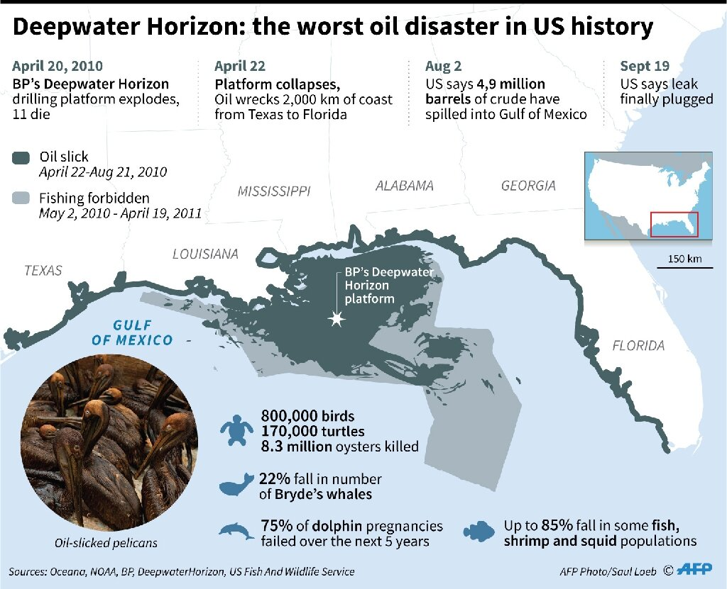
Fig-1: Deepwater Horizon
(Source: Dupont 2020)
Global Funding and Capital Allocation: In order to fund its capital-intensive initiatives, BP turns to the world's marketplaces for financing. Competent IFM practices are a need for accessibility to international capital markets. BP raised money about $1 billion from across the world to pay for the Deepwater Horizon cleaning and rehabilitation activities during the investment in the Gulf of Mexico (NOAA 2017).
Risk Diversification: By participating in several foreign marketplaces, BP can spread out its hazards among different geographical areas. The diversified approach assists the business in lowering its exposure to regional economic crises or geopolitical unrest in certain nations.
Legal Compliance: Tax laws, reporting requirements, and banking laws vary between nations. IFM makes certain that BP abides by these rules in every country, preventing legal difficulties and financial fines. For instance, BP has encountered challenging regulatory landscapes in both Russia and the US, demanding a robust IFM architecture (Ioannou et al. 2023).
Scale Economies: Effective IFM enables BP to optimise its finance processes on a worldwide level. This optimisation leads to cost reductions, better liquidity management, and higher profits, all of which benefit the financial well-being of the business.

Obstacles in the International Financial Market
As a global company operating in a variety of areas, BP plc faces several difficulties in several international financial markets. Due to its extensive global footprint, BP is subject to considerable currency rate changes. For example, BP's sales in foreign currencies decreased because of the British Pound (GBP) depreciation after the Brexit vote in 2016 (Xiong 2022). BP announced a $6.7 billion loss in 2020, mostly because of exchange rate effects (Meredith 2020). Operational disruptions might result from political unrest in the host nations. An illustration of this is BP's encounter with Venezuela, where shifting political circumstances resulted in the nationalisation of assets, causing the corporation to suffer large losses (Fernandes et al. 2019). Conformity problems arise from different legal structures throughout different nations. Following the Deepwater Horizon oil disaster in 2010, BP was subject to severe regulatory actions and fines in the United States (McGuire et al. 2022). BP's management and staff interactions may be impacted by cultural variations. BP's joint ventures with Rosneft and corporate discussions were impacted by cultural quirks and regulations in Russia (Ozawa 2023). BP must make significant investments in renewable energy and mitigation initiatives because of the strict ecological standards in some markets, like the European Union (Sadiq et al. 2023). The need for BP's energy goods may be impacted by economic crises in the host nations. For example, the COVID-19 pandemic lowered the world's energy consumption, which had an impact on BP's profitability (Gneiting et al. 2021). Competing in nations subject to global embargoes, such as Iran, which restrict access to the world's capital markets and hamper commerce, presents difficulties for BP.

Dividend Distribution Policy
One important component of BP plc's financial strategy is its dividend distribution policy, which is affected by several elements. Investors who are interested in income through dividends appreciate BP's previous adherence to a consistent payout policy. Even during times of market turbulence in the energy sector, the corporation intends to continue paying dividends to shareholders. For instance, despite the COVID-19 pandemic and declining oil prices in 2020, BP lowered but did not completely withdraw its dividend, demonstrating its dedication to stability (Ambrose 2021). Continuous dividend expansion is a goal for BP, even if sustainability is equally important. As its financial situation gets better, the corporation intends to raise dividends. BP's (BP Plc) second-quarter earnings plummeted 70% from a year earlier to $2.6 billion, failing estimates due to declining refinery margins and oil trading revenue, but the energy giant was nevertheless able to increase its dividend by 10% (Bousso and Nasralla 2023). BP keeps its payout ratio at a level that is feasible and permits investing in its business and expansion. This protects the corporation from overcommitting to dividends at the cost of crucial investments. The influence of BP's global activities on its dividend policy is substantial. The business must take the consistency of cash flows from a variety of resources across many nations into account. The ability of the entire corporation to pay dividends, for instance, might be impacted by political or economic unrest in one location. The dividend strategy of BP focuses on finding a balance between the demand for financial stability in different sectors (Tillotson et al. 2023). To ensure regular dividend payments, it considers elements including currency volatility and regulations in the worldwide markets.
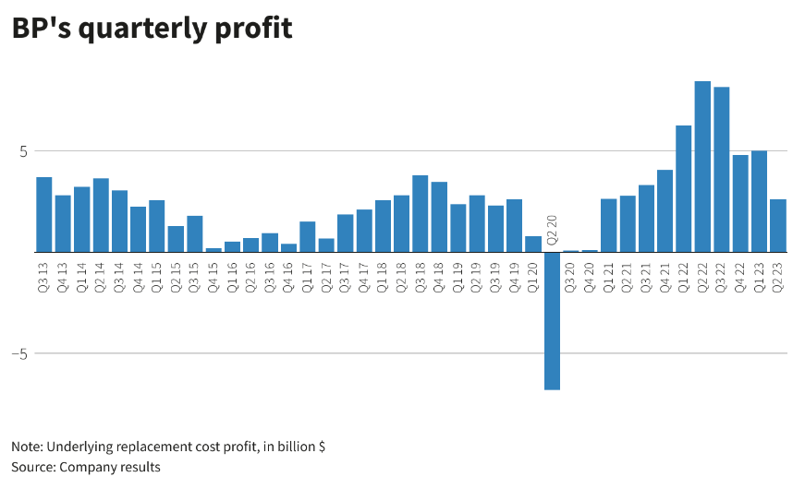
Fig-2: BP Plc’s Quarterly Profit
(Source: Bousso and Nasralla 2023)
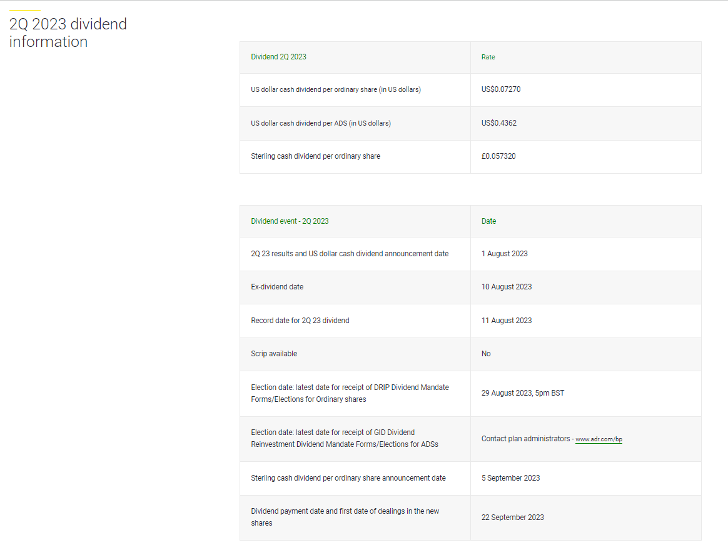
Fig-3: BP Plc Dividend Information
(Source: BP Plc 2023)

Efficient Market Hypotheses
The Efficient Market Hypothesis (EMH) states that because financial markets effectively consider every possible detail, it is difficult for investors to continually produce higher returns through research or trading (Khairajani 2023). According to EMH, BP Plc's stock prices on open markets must represent all information that is currently accessible on its business activities, financial situation, and outside variables notably oil costs. The financial activities of BP are affected by this since the corporation is required to base its decision-making on price trends that, in theory, fully incorporate every available detail. Financial markets frequently display different levels of effectiveness (Acheampong. With varying degrees of data availability and market effectiveness, BP does business internationally. Prominent stock exchanges notably the London Stock Exchange as well as the New York Stock Exchange are usually believed to be more effective, but certain developing nations could have greater data asymmetries and inconsistencies (Business Mondays 2023). BP's financial choices are influenced by market efficiency (or inefficiency). The corporation may be able to take advantage of mispricing unproductive marketplaces by purchasing discounted assets. In contrast, BP may focus more heavily on internal financial research and risk management in extremely effective markets in order to make wise judgements. As investors took to determine the scope of possible obligations during the Gulf of Mexico oil leak catastrophe in 2010, BP's stock price was very volatile (NOAA 2017). This situation revealed the difficulties of market effectiveness in the face of unusual circumstances.

Methods of Appraising Projects
In order to evaluate foreign projects, BP plc uses a variety of techniques, such as NPV, IRR, as well as risk assessment. BP determines the current value of anticipated cash flows from foreign projects after subtracting upfront costs. A project is feasible if the NPV is significant. For instance, BP assesses profitability by discounting future cash flows to their current value when assessing offshore drilling operations in the North Sea (Jha 2023). IRR estimates the project's anticipated rate of return. In order to evaluate project returns to necessary rates of return or cost of capital, BP employs the IRR as a benchmark. Projects with higher IRRs tend to be more appealing. When evaluating expenditures in green power, where returns are based on energy costs and government subsidies, BP may use IRR (Christophers 2022). BP undertakes thorough risk analyses, considering variables including geopolitical unrest, market turbulence, and legislative modifications. The organisation may implement risk mitigation methods due to this procedure's assistance in quantifying possible hazards and unpredictability in project results (Khalilzadeh et al. 2022). These evaluation techniques work well in global environments, assisting BP in prioritising projects with the greatest chance of value generation while taking risk concerns into account. For example, in order to maintain profitability and minimise geopolitical concerns, BP considered NPV and risk evaluations before investing in the Shah Deniz natural gas project in Azerbaijan (Salameh 2019). Depending on the specifics of an international project, several assessment techniques may be used. For long-lasting, steady projects with consistent cash flows, NPV may be given priority by BP, but IRR might be more pertinent for initiatives with shorter time horizons and higher returns. For projects, however, in politically volatile sectors, risk evaluations are essential.

Conclusion
The business activities of BP plc, a major global petroleum company, heavily rely on International Financial Management (IFM). Key factors influencing IFM's significance involve handling currency risk, leveraging global capital markets, diversification risks, maintaining legal compliance, and improving financial services. BP has difficulties in the global financial system, such as exchange rate volatility, political concerns, different regulatory standards, and cultural considerations, which call for efficient IFM solutions. Additionally, BP's dividend distribution strategy, which places a focus on profitability, expansion, and conservative payment ratios, is consistent with IFM's ideas. BP's financial decisions are influenced by the Efficient Market Hypothesis, although different worldwide markets have different levels of market effectiveness, which influences the company's risk management as well as capital allocation methods.

References
Acheampong, A.O., Amponsah, M. and Boateng, E., 2020. Does financial development mitigate carbon emissions? Evidence from heterogeneous financial economies. Energy Economics, 88, p.104768.
Ambrose, J. (2021) BP reports $5.7bn loss as covid-19 pandemic hits oil demand, The Guardian. Available at: https://www.theguardian.com/business/2021/feb/02/bp-loss-covid-19-oil-demand (Accessed: 10 October 2023).
Bahrudin, N.Z., Saddam, S.Z., Mustaffa, A.H., Abdullah, H. and Sahudin, Z., 2021. Factors Affecting Dividend Policy: Evidence from Consumer Product and Trading Services Sector. Global Business & Management Research, 13(4).
Bousso, R. and Nasralla, S. (2023) BP boosts dividend even as profit slumps 70% to $2.6 billion, Reuters. Available at: https://www.reuters.com/business/energy/bp-boosts-dividend-even-profit-slumps-70-26-bln-2023-08-01/ (Accessed: 10 October 2023).
BP Plc (2023) Dividends: Investors: Home, bp global. Available at: https://www.bp.com/en/global/corporate/investors/shareholder-and-dividend-information/dividends.html (Accessed: 10 October 2023).
Business Mondays (2023) How does the London Stock Exchange match against the New York Stock Exchange in 2023?, Business Mondays. Available at: https://businessmondays.co.uk/how-does-the-london-stock-exchange-match-against-the-new-york-stock-exchange-in-2023/ (Accessed: 10 October 2023).
Christophers, B., 2022. Fossilised capital: Price and profit in the energy transition. New political economy, 27(1), pp.146-159.
Dupont, V. (2020) A decade after Deepwater, bp faces new existential challenges, Phys.org. Available at: https://phys.org/news/2020-04-decade-deepwater-bp-existential.html (Accessed: 10 October 2023).
Estronca, C.R.M.R., 2023. BP: responsible leadership at the core of an oil company (Doctoral dissertation).
Fernandes, A.J., Jimenez, A., Kraak, J.M. and Tsagdis, D., 2019. Managing political risk in the oil and gas industry in a developing economy: the case of BP in Angola. European Journal of International Management, 13(5), pp.733-755.
Gneiting, U., Lusiani, N. and Tamir, I., 2021. Power, profits and the pandemic: from corporate extraction for the few to an economy that works for all. Available at SSRN 3956244.
Ioannou, D., Pérez, J.J., Geeroms, H., Vansteenkiste, I., Weber, P.F., Almeida, A.M., Balteanu, I., Kataryniuk, I., Attinasi, M.G., Buysse, K. and Campos, R., 2023. The EU's Open Strategic Autonomy from a Central Banking Perspective. Challenges to the Monetary Policy Landscape from a Changing Geopolitical Environment.
Jha, A., 2023. Optimal capacity density of offshore wind farms: An analysis for the prospective wind energy projects in the North Sea (Master's thesis, University of Agder).
Khairajani, D., 2023. Efficient Market Hypothesis: A Conceptual Framework. In Emerging Trends and Innovations in Industries of the Developing World (pp. 140-145). CRC Press.
Khalilzadeh, M., Shakeri, H. and Zohrehvandi, S., 2021. Risk identification and assessment with the fuzzy DEMATEL-ANP method in oil and gas projects under uncertainty. Procedia computer science, 181, pp.277-284.
McGuire, W., Holtmaat, E.A. and Prakash, A., 2022. Penalties for industrial accidents: The impact of the Deepwater Horizon accident on BP’s reputation and stock market returns. PLoS one, 17(6), p.e0268743.
Meredith, S. (2020) BP reports second-quarter loss after Major Write Downs, halves dividend, CNBC. Available at: https://www.cnbc.com/2020/08/04/bp-reports-6point7-billion-second-quarter-loss-after-major-write-downs-cuts-dividend.html (Accessed: 10 October 2023).
NOAA (2017) Deepwater Horizon Oil Spill Settlements: Where the money went. Available at: https://www.noaa.gov/explainers/deepwater-horizon-oil-spill-settlements-where-money-went (Accessed: 10 October 2023).
Ozawa, M., 2023. Trust and European-Russian Energy Relations: Ensuring Energy Security. Springer Nature.
Sadiq, M., Hassan, S.T., Khan, I. and Rahman, M.M., 2023. Policy uncertainty, renewable energy, corruption and CO2 emissions nexus in BRICS-1 countries: a panel CS-ARDL approach. Environment, Development and Sustainability, pp.1-27.
Salameh, R.M., 2019. Pipelines, pipe plans, and pipe dreams: an economic and geopolitical perspective on building natural gas export infrastructure from Lebanon and the East Mediterranean (Doctoral dissertation).
Tillotson, P., Slade, R., Staffell, I. and Halttunen, K., 2023. Deactivating climate activism? The seven strategies oil and gas majors use to counter rising shareholder action. Energy Research & Social Science, 103, p.103190.
Xiong, W., 2022, April. Impact of Brexit on UK-China International Trade. In 2022 7th International Conference on Social Sciences and Economic Development (ICSSED 2022) (pp. 909-920). Atlantis Press.

