

Student: Gabriela Grudeva Grudeva
Student ID: 2218257
Module: LCBB4004 Marketing Fundamentals
Module Lecturer: Piyumika Gamage

Contents
Cover page……………………………………………………………………………………………1
Introduction 2
Methodology 2
Discussion 3
Apple strategies 4
Apple marketing mixed strategies, the 4Ps extended to 7Ps. 6
Elements in Apple Marketing Mix (Apple 7Ps of Marketing) 7
Conclusion 8
References 8

Introduction
This report will cover the various marketing segments that businesses use to grow and flourish on a global scale, as well as the various strategies and factors that contribute to Apple.com success. The study will explain what marketing is, the different types of marketing segmentation, and how the business employs them. The numerous threats, rivals, and obstacles the business has encountered throughout its life will also be covered.

Methodology
“Marketing is engaging customers and managing profitable customer relationships. The two-fold goal of marketing is to attract new customers by delivering value and satisfaction”. (Kotler, et.al.,2020, p5). One of the most well-known and prosperous businesses in the world is Apple.com.The business has implemented three different product lines, the 1st line is computer hardware and software products, 2nd is product line is mobile devices, and the 3rd product line is iTunes Store. The iTunes Store was implemented to support the iPоd, but after its huge success, Apple expanded its activities and offers music, apps, videos, and books. This innovation pushed Apple to an even higher position and brought enormous success to the company.
Using life-cycle segmentation some businesses use a different approach to create life-cycle groups like offering different products for different generations and genders.
Market segmentation:
This is a way for organizations to divide the market into groups of buyers, and according to their needs, and characteristics to develop products for different groups of people.
There are different types of segmentations, like Geographical segmentation –
this segmentation covers locations, regions, countries, and cities.
Many businesses today locate their companies to a certain location, country, or city,
where products/services will be produced so they can meet certain criteria.
Demographic segmentation – this divides the market into sections based on
life-cycle, education, age, income, occupation, gender, religion.
Psychographic segmentation – this method divides people into different segments based on their way of living or personal characteristics.
And lastly, Behaviour segmentation – divides buyers between their knowledge, attitude, and most businesses believe this is the perfect start for a business.

Discussion
Big companies have some common strategies to attract clients – Customer driven market strategy. They have moved towards target marketing, identifying the right segmentation, selecting a few of them, and developing the product to meet the requirements.
Apple Inc. is a global company with headquarters in the US that was well-known for producing personal computers, consumer devices, and software. Their GAM campaign targeted not only digitally knowledgeable customers but also those who lacked the technical expertise needed to transfer platforms, and those who owned a PC, but was unaware of other PC alternatives. The targeting stage entails finding the groups that are most suitable for the business. In other words, targeting refers to selecting groups that were found because of segmentation to buy goods.
Apple's target market is therefore made up of affluent people who are willing to spend more on technology products and services with cutting-edge design, functions, and capabilities. The "Get a Mac" (GAM) promotion was well-known in the foreign market. This promotion was tailored by Apple in numerous nations. For instance, the "Get a Mac" advertisements were adapted for the UK and Japan, with local performers and settings that reflected the subtleties of each country's society. The outcome was a 42% increase in market dominance. Apple experienced unprecedented sales, and the campaign had a significant societal impact. The ads ran at a time when the Mac platform was experiencing explosive development and were a huge hit.
College and university students are the primary markets for MacBooks because they use them for keeping notes and submitting homework.
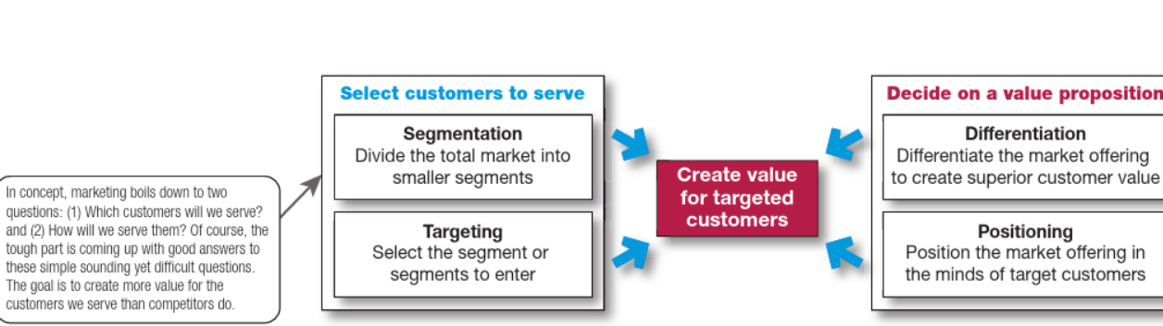(Kotler, 2019 et al., p.199)

One of the strategies that Apple uses is Ecosystem. Usually, when a business can provide a variety of products/services they can use that system to offer an amazing experience for the customers, users now can connect their iPhone, Mac, and apple watch. As customers' expectations rise, the business never stops researching and coming up with innovative methods to enhance its offerings and satisfy its clients. Just last year, Apple and Mercedes-Benz AG partnered to develop a better audio system so that customers could now listen to iTunes music. Apple Music is anticipated to be available on all Mercedes-Benz vehicles, and the business has also agreed to support Dolby Atmos.
Apple is in partnership with TV, music, App developers, manufactories, and the movie industry. The App engineers have invented the platform for iOS users, so they can download everything they need from the App store. Performance, status/brand, comfort/usability, and design are some of their main value propositions. Convenience is the first benefit that Apple offers its clients. All of Apple's new products, such as the iPhone, iPod, and iMac, are user-friendly.
“Apple has expanded globally to become the most profitable business, in which they are serving more than millions of customers and retail outlets located around different parts of the world. In human capital and physical resources wise, the company has employed 137,000 full-time employees and retained an amount of 510 retail stores in more than 20 countries this year” (Farfan, 2019).

Apple strategies
A strategy-formulation matrix called the Internal Factor Evaluation Matrix (IFE) assesses and enumerates the weaknesses and strengths of Apple's business functional area. Apple has shaped a good reputation and brand thanks to extensive marketing efforts. Additionally, it also establishes and creates its user software, operating system, and electronics. This has enabled Apple to provide distinctive, distinct, and easy-to-use goods that may assist consumers with problems in their daily lives.
This EFE strategy called the External Factor Evaluation Matrix (EFE), enables the company to assess and summarize the threats and possibilities facing the organization. To support the company's growth in the global market, Apple should keep creating fresh, cutting-edge product lines, like their well-liked Airpod portable Bluetooth earbuds.
“On the other hand, some threats would cause an effect on Apple such as competition with Spotify. Apple does have its iTunes; however, users need to purchase song by song with an amount of money. In other words, the situation is different with Spotify, for users to listen and download music for free, Spotify’s users only need to pay RM14.90 every month to be a premium member and enjoy free music” (Apple.com, 2019).
SWOT matrix is another tool, used by businesses to create 4 main kinds of strategies. With its many benefits, Apple is able to grow rapidly in the market and establish itself as one of the top IT companies. These benefits aid Apple in expanding into new areas as well as retaining its position as the market leader. Apple has an edge in that it can provide outdated smartphone models at a reduced cost to less developed countries. This might make it possible for Apple to reach out to more middle-class customers and reduce its stock.
Analyzing strategic positions and actions (SPACE) Matrix - Businesses frequently use a space matrix, which is also a management tool, to determine the kind of strategy they should adopt to compete with competitors and stay competitive in the market. The Y-axis shows FS - Financial strength and ES - Environmental security, while the X-axis shows CA - Competitive edge and IS - Industry strength. This will show the company how it is positioned in the market—conservative, bold, competing, or protective. Apple's products are more expensive than those of its competitors. Customers with a high knowledge of price may decide to buy from Apple's competitors instead because they charge less. Additionally, one of Apple's internal strategic stances is its competitive position. Customer loyalty is the first element that can affect the competitive position, Apple consumers are very devoted, and product quality is the second element that affects the competitive situation. Apple consistently produces high-quality goods, which contributes to the company's profitability, and brings along happy and satisfied customers.
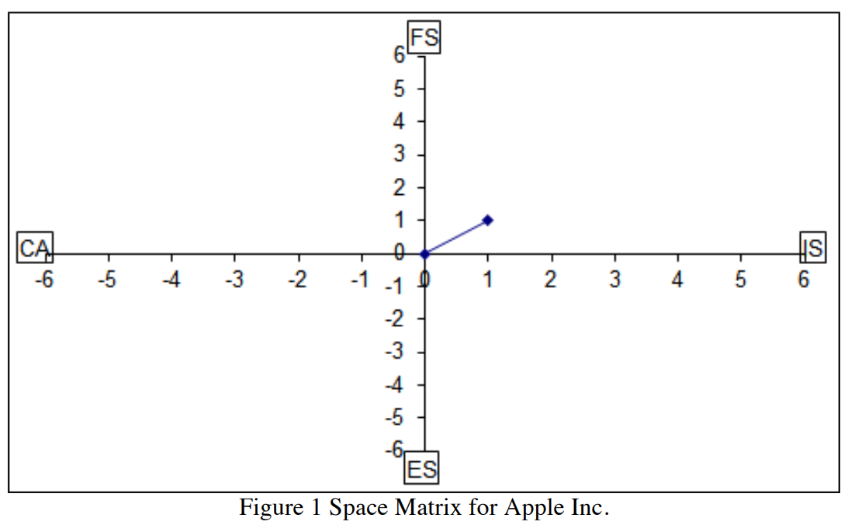
(Journal of International Business and Management, 2021, p.7)
This table shows that Apple is in a very good, strong, and competitive position in the market and has a directional vector coordinate of (+1.00, +1.00).

Apple marketing mixed strategies, the 4Ps extended to 7Ps.
The Marketing mixed strategy is a tool that is commonly used by companies that are selling products or services. This tool originated in the late 60s and it helps companies to identify the "Ps," which increase the attractiveness of a deal. The marketing blend only contained the four Ps of product, pricing, place, and promotion. Since then, three more factors have been added: Physical evidence, People, and Process. These three variables are particularly important in in-service marketing.
Direct sales force - In some markets, the technology firm promotes and sells specific goods using a direct sales force. “For example, in 2016 Apple relied on direct sales support for its iAd advertising business. In 2018, the company’s net sales through direct and indirect distribution channels accounted for 34% and 66% of total net sales, respectively.” (Dudovskiy,2021).
Wholesalers – Apple is in a partnership with many wholesalers to sell a significant portion of its goods and services.
Retailers - Numerous local Authorized Retailers exist, including Mobile Guru and T-Mobile in New York, Carphone Warehouse, and Argos in London, among others.

Elements in Apple Marketing Mix (Apple 7Ps of Marketing)
Price - Apple employs a premium pricing approach, charging the most for its goods and services. “For example, the company offers iPhone 12 Pro Max for as much as USD 1,099.00. The world’s largest IT company by revenue has a long-held belief that “consumers will pay more for products that are so well designed they can’t fathom living without them.” (Dudovskiy,2021).
Apple frequently employs the price-skimming approach. In contrast to penetration pricing, price skimming involves businesses setting extremely high prices for new products before later lowering those prices after rival companies release comparable products.
Place - Apple stores - the world’s largest IT company by revenue owns more than 500 retail stores in 25 countries and regions. Stores are usually located in busy areas where they would be easily accessible to more people.
Online stores – All customers can buy Apple items from their official web page https://www.apple.com/.
Product - The Apple goods that are presently on the market demonstrate the company's diversity in this component of the marketing mix in terms of product variation to meet customers' requirements in various areas of their lives. There are numerous sales outlets available, including Apple's own retail stores, the Apple website, e-commerce sites, and business resellers.
Promotion - This mix has a variety of components that company managers can use. The most regular ones are advertising, human trading, direct marketing, public relations, funding, and social media. Apple runs some fabulous and beautiful advertising campaigns. It makes significant financial investments in a promotion. For instance, it invests about 100 million dollars a year on Twitter ads only.
Process - Apple has created a process plan to guarantee a smooth and efficient client experience. It has put money into automated procedures like purchase handling, delivery, and returns. This has made it possible for it to offer clients a quick and effective service.
People in the Marketing Mix - To assure that consumers have a satisfying and unforgettable experience, Apple has made important investments in people strategy. It has a group of highly skilled and perspective professionals who deliver outstanding customer service. The AppleCare Protection Plan provides one-stop service and assistance from Apple specialists while extending customers' service coverage.
The physical environment in the marketing - Apple has also made substantial investments in its real environment plan. It has developed a physical setting that is intended to be welcoming and appealing to consumers. This includes its website, stores, merchandise designs, logo, and other elements that are contemporary and visually appealing.

Conclusion
In conclusion, what's most delightful about Apple is how it refined into a highly creative business. Apple will, however, benefit from updating some of its procedures to successfully handle issues that may arise in the future. Hence why Apple can adjust to the challenging climate, and its success is guaranteed. As the term implies, multi-segment positioning seeks to concurrently target different customer groups with different product or service bundles. Apple had developed a distinct image in the consumer goods sector thanks to its thorough aesthetic design and distinctive advertising campaigns.

References

Apple.com (2023) Available at: Apple (United Kingdom) (Accessed: 12th March 2023).
Bush, T. (2016) What is the Marketing Mix. Available at: https://pestleanalysis.com/what-is-the-marketing-mix/ (Accessed: 26th March 2023).
Digital Marketing (2018) Apple 7Ps of Marketing Mix. Available at: Apple 7Ps of Marketing Mix – Digital Marketing (wordpress.com) (Accessed: 28th March 2023).
Dudovskiy, J. (2021) Apple Marketing Mix (Apple 7Ps of Marketing). Available at: Apple Marketing Mix (Apple 7Ps of Marketing) - Research-Methodology (Accessed: 30th March).
Dudovskiy, J. (2021) Apple Segmentation, Targeting and Positioning. Available at: Apple Segmentation, Targeting and Positioning - Research-Methodology (Accessed: 14th March 2023).
Ekekwe, N. (2012) ‘Disruptive Technologies, Innovation and Global Redesign’. Emerging Implications. pp.1-1204. DOI:10.4018/978-1-4666-0134-5.
Kothler, T.P. et al. (2019) Principles of Marketing. London: Pearson Education Limited.
Panagiotelis, A. et al. (2014) ‘Journal of Business & Economic Statistics’ From Amazon to Apple: Modeling Online retail Sales, Purchase Incidence and Visit Behavior. 32 (1), pp.1-29. https://www.jstor.org/stable/43701627

Pratap, A. (2023) Apple Marketing Mix 4Ps. Available at: https://blog.notesmatic.com/apple-marketing-mix-4ps/ (Accessed: 18th March 2023).
Rahman, M. (2023) Marketing Mix of Apple 7Ps of Apple. Available at: Marketing mix of Apple (7Ps of Apple) - www.howandwhat.net (Accessed: 28th March 2023).
Sahoo, D. (2012) ‘The Indian Journal of Management’ Strategic Change of a Campaign at Apple Inc. 5(2), pp.40-60. Vol 5 Issue 2 Jul-Dec 2012.pdf (vidwat.in)
Tien, N. (2019) ‘International Journal of Research in Marketing Management and Sales’ International distribution policy comparative analysis between Samsung and apple. 1(2), pp.24-27. International-distribution-policy-comparative-analysis-between-samsung-and-apple.pdf (researchgate.net)
Yie, E. C. et al. (2021) ‘A Critical Analysis of Internal and External Environment’. Case Study of Apple Inc. 4(10), pp.1-14. DOI: https://doi.org/10.37227/JIBM-2021-08-149.

