LCBB4004
Marketing Fundamentals

Assessment 2

The Effect of Globalisation on an Organisations’ Marketing Strategy

Module Lecturer: Efua Adams

Table of Contents
Introduction 3
Definition of marketing 4
The various marketing directions to create customer value 4
The impact of globalisation on the business, examine its markets and its competitors 6
PESTLE factors with "ASOS" and an evaluation of the markets and its competitors 8
How the organisation positions itself in the global business environment and the effect of its stakeholders on the organisation 10
SWOT analysis of "ASOS" 12
Segmentation, targeting, & positioning of "ASOS" 14
Marketing mix elements of "ASOS" 15
Conclusion & Recommendations 16
References 17

Introduction
A thorough internal and external examination of the firm, "ASOS" a player in the UK's apparel market, has been done for the report, which is centred on it. The study begins with defining marketing and then goes on to outline the key steps involved in the development. Furthermore, it links PESTLE elements to "ASOS" and specifies whether they are advantageous or disadvantageous for the company. Later, it compares "ASOS" to Porter's Five Forces Model and discusses if each force is high, medium, or low. To identify "ASOS"'s strengths, weaknesses, opportunities, and threats, a SWOT analysis has also been done. The marketing mix parts of "ASOS" have then been developed, followed by some suggestions, after segmentation, targeting, and positioning of "ASOS" have been completed. Since its founding in 2000, "ASOS" has been a public limited business with its headquarters in London, UK.
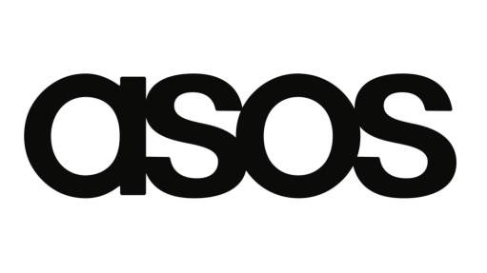
Figure: “ASOS” (Princes, 2019).

Definition of marketing
Marketing is the sum of all the operations firms carry out to increase demand for certain goods or services among a target market and to advertise particular features of those goods or services to draw in that market and maintain its patronage. As a result, consumers are now much more tech-savvy, and there are several channels available to help businesses draw in customers online (Marques, 2015).
To reach an underserved market and increase sales, "ASOS" may now use online marketing. It may be stated that "ASOS" profited from this component as a consequence (Visconti et al, 2020). For instance, the marketing division of "ASOS" investigates various choices and data to get insights about public demand for pertinent items, produces the products, offers them at a reasonable price in its shops, and promotes them while keeping them compatible with its brand (Marques, 2015).

The various marketing directions to create customer value
Improve the buying process
Due to their frequent interactions with "ASOS" consumers, employees of the firm work as brand ambassadors. Customer service at "ASOS" is superior to that at other businesses in that "ASOS" employees go above and beyond for their clients. Thanks to this marketing mix, "ASOS" has excellent customer satisfaction and high levels of customer loyalty (Park, 2020).
Focus on brand perception
Customers cannot physically touch or see the clothing they are purchasing at "ASOS" which makes the purchasing procedure unique compared to other retailers. However, their website gives off a feeling of virtual reality, allowing clients to retain their purchases in a basket before making a payment with a credit card or another kind of payment. The target clients of "ASOS" appreciate the whole procedure since it is virtual and easy (Kotler et al, 2016).

Get customer feedback
The receipt that consumers at "ASOS" get after placing an order for items serves as the company's physical evidence. The "ASOS" website, which is incredibly easy to use and utilise to purchase things, is the primary issue here. Customers may check the status of their purchases, and the website is highly dependable, which makes "ASOS” company development simpler (Park, 2020).
Make a unique produce
As an example, "ASOS" makes sure it has a strong marketing strategy with a high chance of success before trying to attain marketing objectives. All marketing methods saw considerable changes as people's preferences changed over time during the COVID-19 outbreak, seriously harming corporate organisations. Additionally, its online presence has allowed it to expand its reach, allowing it to reach a larger audience. In order to navigate these challenges, ASOS has developed a recovery plan that includes a focus on expanding its online presence and increasing its digital marketing efforts.
Provide a positive experience
Building a strong brand that accurately represents the premium goods that "ASOS" sells is the company's mission. It offers a broad variety of goods, such as apparel, footwear, accessories, cosmetics, and more. With more than 4000 workers, "ASOS" will generate revenues of around 3.26 billion pounds in 2020. (Princes, 2019) ASOS has a wide variety of products and price points, which makes it accessible to customers from all backgrounds. The company also works with local communities and suppliers to help them become more sustainable, which has helped to further raise the company’s profile.

The impact of globalisation on the business, examine its markets and its competitors
The impact of globalisation on the business
Increased competition
As the product, price, location, promotion, people, process, and physical proof of the firm can all be investigated, the marketing mix components of any commercial organisation may provide fantastic insights into the corporation. It has been active in the clothes and online retail industries for 21 years.
Rising Economies
Situational analysis is the first step in the marketing process, when marketers examine the internal and external environments of the company organisation to determine its strengths, market demand, client perception, etc. For instance, "ASOS" undertakes situational study before developing any new products or services since it enables them to be furnished with fresh perspectives (Deepak et al, 2019).
Commercial Demand:
The next step in the marketing development is setting goals, where the dealers describe the aims of the company from a marketing perspective and provide guidance for the subsequent steps. To ensure that the strategies and execution follow through with the original goals, "ASOS" for instance, establishes its objectives before moving on to the next phases of the marketing process (Park, 2020).
Cultural differences might also exist amongst populations living in the same nation. Language variations across regions might cause some misunderstanding at work. Confusion might also result from the ways that each age talks differently. This is shown in vivid detail in the movie The Princess Diaries, when the little girl exclaims incredulously, "Shut up!" She has just been cruelly instructed to remain quiet, so her grandma is astonished.

Infrastructure Improvement
Businesses develop a broad strategy for achieving marketing goals at this stage of the marketing process. They also make specific strategies for how to contact the beleaguered leads and potential clients and how to convert them into devoted patrons of their companies. For instance "Before attempting to accomplish its marketing objectives, ASOS makes sure it has a clear approach that has a strong possibility of succeeding (Kotabe et al, 2020).
Increased competition
Marketers put into practice the previously decided-upon marketing tactics at this point in the process. At this point, several adjustments might yet take place since implementation differs from planning and offers additional information as they go along. As an example, "ASOS" has been adaptable in how it implements its marketing techniques, and it revisits those plans to make adjustments as needed (Kotler et al, 2021).
The marketing process has many phases, which have been listed below. These stages include situational analysis, strategy, goals, implementation, and control. At this point in the marketing development, marketers watch the results of their efforts and try to influence the results' instructions. For instance, "ASOS" closely monitors if its marketing strategy is yielding the desired results from the beginning, and when it falls short of its expectations, they make adjustments to manage the outcomes (Kotler et al, 2016).

PESTLE factors with "ASOS" and an evaluation of the markets and its competitors
Political, social, technical, economic, environmental, and legal variables are only a few of the external environmental aspects that have a big impact on "ASOS," some of which are good for it and some of which are bad. Below, it has been addressed how those aspects relate to "ASOS" and if they are good or bad for the show (Chernev, 2018).
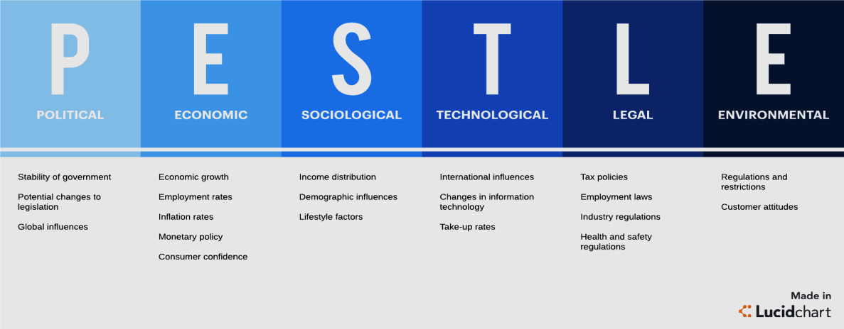
Figure: PESTLE (Chernev, 2018).
Political
The UK is where "ASOS" is based, and the government there has particularly kind policies for retail establishments. In terms of politics, there is also a lot of stability and little corruption. Trade restrictions are minimal, therefore "ASOS” commercial "'s activities run easily. Political reasons are thus favourable for "ASOS" it might be said (Hutt et al, 2021). For instance, English is the language of both England and the United States. Communication between these two cultures is still rife with disparities, however. Along with standard communication etiquette, language use varies. Take the effort to comprehend some fundamental cultural differences if communication at work spans cultural boundaries to avoid communication blunders.
Economical
Because so many businesses had to shut down when the pandemic struck, the coronavirus harmed the UK economy. The economy shrank by over 10% in 2020, which suggests decreased disposable income, a greater unemployment rate, and slower economic development. As a consequence, customers showed a greater interest in purchasing just necessities, which hurt the retail clothes sector. Although brighter days are on the horizon, they won't be as satisfying for a while. The economy is projected to rise at a 6.5% rate in 2021. Therefore, it may be said that "ASOS" is negatively impacted by the economy (Hutt et al, 2021)
Social
The COVID-19 epidemic had a negative social and economic impact on the UK market since it was successful in altering behaviour, attitudes, culture, etc. People's sense of style and purchasing habits altered as a result of the pandemic's need that they spend a lot of time at home. Consumers are less inclined to purchase fashion items today than they were before the epidemic. Given that "ASOS" is a retail apparel company and that people's behaviours, viewpoints, and lifestyles have changed unfavourably toward its merchandise, it may be argued that social elements are not in "ASOS" (Adams et al, 2019).
Technological
Since the epidemic, regulars are costs a lot more time than they used to on screens. As significance, consumers' understanding of know-how has greatly increased, and there are several stages offered to support corporations in appealing trades online. As of right now, "ASOS" may leverage internet marketing to reach an underserved market and boost their prospective sales. We may thus say that "ASOS" has benefited from this element (Lacobucci, 2021).
Environmental
The success of "ASOS" hasn't been significantly impacted by the fact that the UK's environment and weather haven't changed since the outbreak. Therefore, it may be said that neither side of the coin favours "ASOS" (Princes, 2019). Throughout the COVID-19 epidemic, commercial organisations suffered greatly, and all marketing approaches underwent momentous modifications as people's requirements evolved (Visconti et al, 2020).
Legal
There were several limitations in the retail sector during the epidemic. As a result, "ASOS" was forced to curtail certain of its activities, which had a detrimental impact on its income. There is still time to enact additional laws and regulations, but doing so is unlikely to be beneficial. As a result, "ASOS" has suffered from this element (Visconti et al, 2020).

How the organisation positions itself in the global business environment and the effect of its stakeholders on the organisation
Porter's 5 Forces Model for "ASOS"
The danger of new competitors, suppliers' and buyers' negotiating power, the threat of replacement goods, and competition among current players are the five forces that determine a company's future profitability and sustainability. "ASOS" is no exception to this rule (Princes, 2019).
The threat of new entrants
The retail sector, and particularly the clothes retail sector, is constantly threatened by new entries. Nevertheless, it takes a lot of money to be a force in the marketplace, and it receipts a lot of work, time, and genius to create a brand in contradiction of the ones that are already there. New players might so join, but the danger isn't great, making the force average for "ASOS" (Princes, 2019).
Bargaining power of suppliers
When there are few suppliers accessible, the goods of the suppliers are distinctive, or they may enter the market, and their negotiating power increases. The items from the vendors aren't all that distinctive, but "ASOS" has the pleasure of choosing from a wide range of them. Consequently, "ASOS" suppliers have weak negotiating positions (Anastasiu et al, 2020). Working with people from different linguistic and cultural backgrounds may be quite difficult. Communication within the same language might have comparable issues as talks between persons who speak different languages.
Bargaining power of buyers
The general public may purchase clothing and related items from "ASOS" in addition to a wide range of other possibilities. This makes it simple for them to switch to other brands if they don't like the pricing or quality of "ASOS". Additionally, consumers can quickly compare companies and make purchases now that a wealth of information is readily accessible to them. Because of this, "ASOS" customers have strong negotiating leverage (Cho et al, 2019).
The threat of substitute products
Although clothing, accessories, shoes, and cosmetic goods have been available for a while, there haven't been any effective competitors to "ASOS offerings. Because of this, "ASOS" faces a negligible danger from competing goods (Xin, 2020). For example, customers can now shop online, which has decreased the cost of physical store operations and enabled ASOS to increase efficiency. Additionally, digitisation has enabled ASOS to streamline its business processes, such as inventory management and customer service. (Kalia, 2022)
Rivalry among existing players
Several businesses are working in the garment sector, and there is fierce competition among them. With their subtly distinctive marketing strategies, The Hut Group, Farfetch, Matches Fashion, and other firms compete with one another. The UK's weather and climate were stable both before and throughout the pandemic; therefore this factor had little effect on "ASOS." commercial performance. As a consequence, it may be concluded that this aspect is neutral for "ASOS" meaning neither positive nor bad. All of these companies are, however, fiercely vying for the clients of one another. Because of this, "ASOS" has fierce competition among its current players (Deepak et al, 2019).

SWOT analysis of "ASOS"
A SWOT analysis has been done for "ASOS" to classify the company's weaknesses, opportunities, strengths, and threats. SWOT is a powerful method for assessing an organization's internal environment (Park, 2020). Take the effort to comprehend when parties from various cultures are having a hard time communicating. Understanding how communication differs between cultures might help avoid conflict caused by miscommunication.
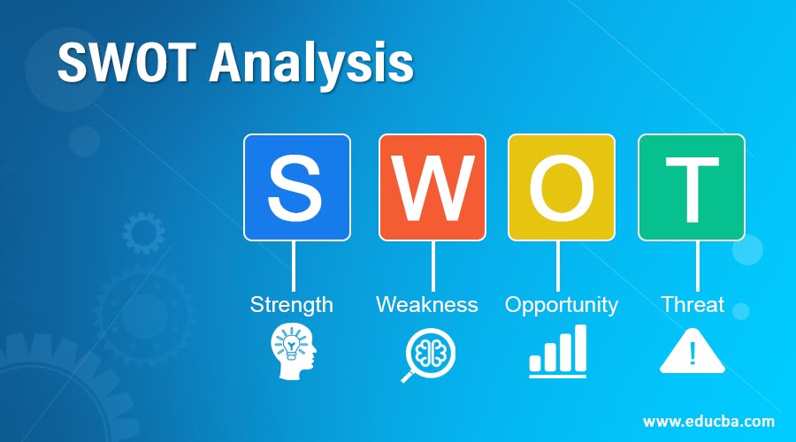
Figure: SWOT analysis (Park, 2020).
Strengths
The brand image of "ASOS" is one of its important assets since it has been successful in maintaining its reputation for high-quality goods and outstanding corporate social responsibility. Additionally, "ASOS" designs are very important in boosting the company's revenue since they put it ahead of its rivals in terms of fashion design. Additionally, they effectively source from 500 manufacturers in 28 nations via their supply chain operation, which is a source of their power. Finally, influencer marketing programmes of "Because it drew millennials to the company, ASOS has served as a source of strength (Kotabe et al, 2020).

Weaknesses
Because it is behind the UK industry average in research and development, "ASOS" has this as one of its major shortcomings. Furthermore, "ASOS" has a problem when it comes to free delivery issues. Last but not least, "ASOS" hasn't always been the most inventive corporation on the market, and this plays to "ASOS" weakness (Kotabe et al, 2020).
Opportunities
"ASOS" has a lot of amazing chances because of its many qualities and the state of the market. The design staff at "ASOS" is excellent, and they can introduce new ideas that might become popular, boosting the company's revenue. Additionally, "ASOS" may outperform its rivals by making use of its excellent supply network. Last but not least, "ASOS" has the benefit of having a strong brand identity and effective marketing activities, so it may decide to extend its market (Kotler et al, 2021)
Threats
"ASOS" is susceptible to several dangers in the future since it has numerous flaws. As a consequence of its underinvestment in research and development, "ASOS" may lag behind its rivals, and these rivals may implement changes to practise that the market demands sooner than "ASOS" Consequently, "ASOS" may lose some of its market shares. Additionally, failing to be sufficiently inventive might harm "ASOS" as a brand in the future (Kotabe et al, 2020).

Segmentation, targeting, & positioning of "ASOS"
For every brand to be successful, segmentation, targeting, and positioning must be done properly. The segmentation, targeting, and positioning of "ASOS" have been discussed here
Segmentation
To communicate its messages more efficiently, "ASOS" has segmented its marketing depending on a few traits. Instead of using a one-size-fits-all strategy, "ASOS" has divided the market into demographic segments based on factors such as age, gender, sexual orientation, marital status, level of education, etc. They have also divided the market into geographical (from city to city) and psychographics (based on character, values, lifestyle, arrogance, etc.) segments. The market has also been divided into segments based on behavioural factors like loyalty (Chernev, 2018).
Targeting
"ASOS" has targeted certain market segments after market segmentation. They emphasise diversity while targeting young people of all genders and sexual orientations in terms of demographics. Geographically, "ASOS" has concentrated on metropolitan customers. In terms of psychograph, "ASOS" has chosen to market to those who respect variety & distinctively made goods. The target audience for "ASOS" consists of politically correct individuals who like fashion and are open-minded to trying new things (Hutt et al, 2021).
Positioning
"ASOS" has sited itself as a company that upkeeps about variety and goes above and beyond to guarantee high-quality product design. It has also established a reputation as a brand for distinctive people who are concerned about issues like political correctness, climate change, and the environment. Additionally, it has a cool and adaptable atmosphere surrounding it, and open-mindedness is one of the brand's core tenets (Adams et al, 2019).

Marketing mix elements of "ASOS"
As well as how "ASOS" has been using the 4Ps, the marketing mix components are explained below (Iacobucci, 2021).
Product
Men's and women's clothing, footwear, jackets, shirts, jeans, and other fashion accessories are all sold by "ASOS" Additionally, "ASOS" offers things for sale online, and its assortment includes goods from several other prominent companies, such as Calvin Klein, Nike, etc. The success of "ASOS" is attributed to its high-quality goods and practical pricing and delivery (Princes, 2019).
Price
As part of its dynamic pricing strategy, "ASOS" sells some of its items at exorbitant prices while selling the majority of them at fair prices. Many of their items are ostentatious yet are offered at fair prices. As it draws in its target clients, its price plan aids in the expansion of its firm (Visconti et al, 2020).
Place
Since "ASOS" is an internet retailer, its presence may be found there. Customers may examine the company's goods and services by logging in to its highly appealing website. When an order is placed, "ASOS" delivers the items in return for a delivery fee from its warehouses where it keeps its inventory. The "ASOS" distribution channel is crucial to the brand's success (Princes, 2019).
Promotion
To market its goods, "ASOS" routinely runs several sales campaigns, such as price cuts. To keep its registered clients informed about new items and sales promotions, "ASOS" sends promotional messages to them constantly and shrewdly. Additionally, "ASOS" promotes its goods in periodicals and via various internet platforms, including Facebook, Instagram, Twitter, YouTube, Pinterest, Reddit, etc. These campaigns aid "ASOS" in growing their companies (Deepak et al, 2019).

Conclusion & Recommendations
To accomplish their marketing objectives at this stage of the marketing development, firms create a complete game plan as well as specific methods for contacting their target leads and potential customers and turning them into loyal customers. Digitisation has enabled ASOS to remain competitive and adaptive to changing market conditions. Additionally, it has enabled the company to respond quickly to customer needs, reducing costs and increasing profits. All in all, digitisation has been crucial to ASOS’s success. Situational analysis, the first step in the marketing process, involves examining the inner and outer environments of the firm to identify its strengths, market demands, customer perceptions, and other factors. Situational analysis is one step that "ASOS," for instance, does before creating any new merchandise or facility since it helps them come up with original ideas (Kotler et al, 2021).

References
Adams, P., Freitas, I.M.B. and Fontana, R., 2019. Strategic orientation, innovation performance and the moderating influence of marketing management. Journal of Business Research, 97, pp.129-140.
Anastasiu, L., Gavriş, O. and Maier, D., 2020. Is human capital ready for change? A strategic approach adapting Porter’s five forces to human resources. Sustainability, 12(6), p.2300.
Chernev, A., 2018. Strategic marketing management. Cerebellum Press.Not
Cho, W., Ke, J.Y.F. and Han, C., 2019. An empirical examination of the use of bargaining power and its impacts on supply chain financial performance. Journal of Purchasing and Supply Management, 25(4), p.100550.
Deepak, R.K.A. and Jeyakumar, S., 2019. Marketing management. Educreation Publishing.
Hutt, M.D. and Speh, T.W., 2021. Business marketing management: B2B. South-Western, Cengage Learning.
Iacobucci, D., 2021. Marketing management. Cengage Learning. MU
Kotabe, M.M. and Helsen, K., 2020. Global marketing management. John Wiley & Sons.
Kotler, P. and Keller, K.L., 2016. A framework for marketing management (p. 352). Boston, MA: Pearson.
Kotler, P., Keller, K.L., Ang, S.H., Tan, C.T. and Leong, S.M., 2021. Marketing management: an Asian perspective.
Marques, M.B., 2015. Equity valuation Asos PLC (Doctoral dissertation).
Park, S., 2020. Marketing management (Vol. 3). Seohee Academy.
Princes, E., 2019. Boosting impulse buying behavior in marketing management: customer satisfaction perspective. Polish Journal of Management Studies, 20.
Visconti, L.M., Peñaloza, L. and Toulouse, N. eds., 2020. Marketing management: A cultural perspective. Routledge.
Xin, B. ed., 2020. Do buyers have bargaining power? Evidence from informal groundwater contracts. PloS one, 15(9), p.e0236696.

