

An investigation of a secondary school’s approach to developing the social interaction skills of pupils who are perceived to have social, emotional and behavioural problems.

This dissertation is being submitted in partial fulfilment for the award of the degree of MA Education.

Jonathan Christopher Ling
PUPIL ID NUMBER: 0451460
1st September 2024

Word Count: 17146

Declaration

This work has not previously been accepted in substance for any degree and is not being concurrently submitted in candidature for any degree.

Signed JC Ling (candidate)
Date: 11.09.24

STATEMENT 1
This dissertation is being submitted in partial fulfilment of the requirements for the degree of MA Education.

Signed JC Ling (candidate)
Date: 11.09.24

STATEMENT 2
This dissertation is the result of my own independent work/investigation, except where otherwise stated. Other sources are acknowledged by footnotes giving explicit references. A bibliography is appended.

Signed JC Ling (candidate)
Date: 11.09.24

STATEMENT 3
I hereby give consent for my dissertation, if accepted, to be made available for photocopying and for inter-library loan, and for the title and summary to be made available to outside organisations.

Signed JC Ling (candidate)
Date: 11.09.24

Abstract

This research was designed to explore how the school in which I currently work develops the social interaction skills of pupils who are perceived to have some form of social, emotional and behavioural problems. It was interested in the approaches taken by the school to enable these pupils to successfully engage with other members of the school community through a programme of formal and informal school-based activities. The research considered whether or not the school could claim to have played a part in behavioural changes and if so, how.
The research involved 20 pupils who study in an English-medium secondary school in South Wales. The school has 1530 pupils and an eligible for free school meals (e-FSM) percentage of 6.3%, which is below the Welsh national average of 21.2% (Welsh Government, 2024). It forms part of a rural community and has up to 20 feeder schools. As the lead researcher in this study, I have a personal interest having worked at the school for 22 years as a Curriculum Leader, Assistant Headteacher and now as sole Deputy Headteacher.
The research employed a mixed methods approach to data collection, and a research design based on participatory action research. A pragmatic, cohort-based study involving a group of 20 pupils, its principal aim was to deepen understanding of the school’s practice, with a view to driving positive changes in school procedures.
Research methods included surveys as well as using the Boxall Profile, which assesses learners’ social, emotional and behavioural development. This involved a baseline assessment at the start of the project, followed by a term of twice-weekly, Lego-based Therapy sessions and a final Boxall Profile test at the end of the research study to measure change in the Developmental and Diagnostic skills of pupils. At a specific point, pupils also participated in a supplementary Google survey that asked a series of questions on their thoughts concerning the research study itself that measured enjoyment, success and purpose.
From the data collected, it is evident that there have been demonstrative improvements in a wide variety of areas. In particular, the use of Lego-based Therapy has been instrumental in improving pupils’ self-esteem, social interaction and self-confidence, which adds to the weight of evidence documented in this paper that regular participation in such therapy aids considerably pupils’ wellbeing.

Key Words: Social interaction skills, societal change, Lego-based Therapy, Boxall Profile.

Table of Contents

Abstract Page 3
Table of Contents Page 5
List of Figures Page 6
List of Tables Page 7
Acknowledgements Page 8
Chapter 1: Introduction Page 9
  - Research Overview Page 13
Chapter 2: Literature review Page 17
2.1 Welsh context Page 18
2.2 Classroom Change Page 19
2.3 Rewiring the Classroom Page 24
2.4 Attendance and Persistent Absentees Page 26
2.5 Spike in neurodevelopmental conditions Page 31
2.6 Lego Therapy and school-based interventions Page 33
Chapter 3: Methodology Page 36
3.1 Cohort participants Page 36
3.2 Research Design Page 38
3.3 Research Paradigm Page 40
3.4 Research Methods Page 42
3.4.1 Quantitative Data Page 42
3.4.2 Qualitative Data Page 47
3.5 Limitations Page 49
3.6 Ethical considerations Page 51
3.7 Approach to Data Analysis Page 53
Chapter 4: Presentation and analysis of data Page 57
4.1 Quantitative Findings – The Boxall Profile Page 57
4.1.1 Key Findings of Boxall Profile data Page 63
4.2 Qualitative Findings – Surveys Page 68
Chapter 5: Conclusion and Recommendations Page 80
5.1 Recommendations for Future Research Page 84
Chapter 6: References and Bibliography Page 86
Chapter 7: Appendices Page 95
Appendix 1: Ethics Form Page 95
Appendix 2: School’s Aspiration statement Page 115
Appendix 3: Google Survey questions Page 115
Appendix 4: Research study letter to parents Page 117
Appendix 5: School Improvement Plan – Oracy Page 118

List of Figures

Figure | Title | Page
1 | Lego Roles and Responsibilities (school produced graphic). | 34
2 | Outline of approach Identifying Key Cohort and Sampling data. | 37
3 | Plan-do-review model from research design (adapted from Evans et al., 2022). | 39
4 | Photographs of models created and roles assigned to pupils. | 43
5 | Outlining The Boxall Profile Flow. | 44
6 | Examples of the observations are outlined in Developmental - organisation of experience and internalisation of control strands. | 46
7 | Research Process of Group. | 49
8 | Steps in an iterative descriptive analysis process. | 54
9 | Pupils’ opinions on whether they have enjoyed taking part in the Lego Sessions, where 1=not at all and 10=very much. | 69
10 | Pupils express which skills they feel that they have learned or improved as part of the Lego activities. | 70
11 | Pupils’ confidence levels after participating in the research study when talking to friends. | 72
12 | Pupil confidence levels before the sessions, where 1=not at all and 5=extremely confident. | 73
13 | Pupil confidence levels after the sessions, where 1=not at all and 5=extremely confident. | 73
14 | Pupils who would recommend taking part in this research study to their friends. | 74
15 | Do pupils feel more confident in communicating to their friends after taking part in the research study? | 77
16 | Do pupils feel that they have developed stronger relationships with their friends? | 78

List of Tables

Table | Title | Page
1 | Attendance of pupils in maintained schools in Wales, aged 5-15, by sex and free school meal eligibility from 2014 to 2023 in percentage figures. | 30
2 | Results from the Developmental and Diagnostic assessments from the Boxall Profile baseline Assessment One. | 58
3 | Results from the Developmental and Diagnostic assessments from the Boxall Profile baseline Assessment Two. | 60
4 | Boxall Profile Assessments One and Two comparison of the data and improvements shown in Developmental behaviour. | 61
5 | Boxall Profile assessments One and Two comparison of the data and improvements shown in Diagnostic behaviour. | 62
6 | Key strands needing development post Assessment One. | 64
7 | Pupils express which skills they have learned during the research study. | 71
8 | Pupils express what they would like to see in the second part of the sessions? E.g., more complex Lego builds, board games, interactive games, team building activities etc. | 75

Acknowledgements

This dissertation would not have been possible without the help of the following key people. I owe my gratitude and thanks to my wife Kathryn who has supported and assisted me for the past few years in achieving this personal and academic goal. I would like to also thank my two children Sam and Maddie who have offered me help with the thoughts and ideas underpinning this work. I owe particular thanks to my academic tutor Gareth Evans at the University of Wales Trinity Saint David who has helped to piece together this work after a period of uncertainty in this Master’s degree; I appreciate his candour and humour. Finally, I owe a debt of gratitude to the staff and students at my school, without whom none of this would have been possible.

Chapter 1: Introduction

A pupil’s wellbeing in school is hugely impacted by their ability to make friends, interact with their peers and participate actively in the school’s teaching and learning offer. Failure to participate in these basic activities can have a considerable impact on a pupil’s ability to not only thrive emotionally but academically too (Evangelou, 2008). As such, this study is interested in how pupils’ social interaction skills can be developed so that they can engage more successfully with other members of a school community.

The school at the focus of this research project (School X) is a high performing secondary school (soon to be an all age school) which is situated in an area of wealth in South Wales. It is ranked among the highest performing state schools in Wales at GCSE and A level (The Times, 2024). The Welsh inspection body Estyn (2019, p.2) said in its report of the school in 2019 that the school demonstrates exceptionally high levels of pupil attainment and wellbeing. These levels of attainment are evidenced by the fact that the school has consistently placed in the top five state schools in Wales at GCSE and A level performance (Welsh Government, 2023). According to Estyn, the school has an excellent reputation for academic success whilst maintaining an inclusive and supportive environment (Estyn, 2019, p.2).

This is an achievement to be celebrated but does consequently lead to pressure to maintain this success for both staff and pupils. Ball (2003) alludes to the principle of ‘performativity’ where schools (and consequently pupils and teachers) are subject to increasing performance measures and accountability at all levels, which in turn impacts how they behave and what they do. This performativity can therefore have a destabilising effect on the wellbeing of all school stakeholders and the maintenance of positive attitudes to learning and pupil wellbeing remain consistent school priorities as a result.

The pupils identified as forming the sample group for this study are therefore surrounded by a culture of success and achievement (born out of a culture of performativity, to some extent) that for some is a natural progression, but for others is more troublesome due to socio-economic, family and additional learning needs. The school and this particular group of individuals were chosen because of the increasing number of pupils experiencing social, emotional and communication difficulties. Indeed, in their book on rebuilding school culture, Lemov et al. (2023) lament many of the issues that schools across the globe are facing on the back of a global health pandemic, mental health crisis and lack of faith in social institutions exacerbated by the overuse of mobile technology. These issues are felt as sharply in my school as in many others across the sector and have led to a decline in social and communication skills, which can be observed across the institution. The particular pupils selected (and more importantly why) will be outlined in the cohort and sampling design outlined later (see Chapter 3).

My own personal motivations are simple and twofold. As a father myself, I always feel a personal responsibility to nurture and improve the life chances of others. Secondly, having worked in education for 27 years, including 12 years in senior leadership, I feel a moral obligation to support and develop pupils’ educational opportunities, of which a key component is the ability to communicate effectively. As a committed professional, I am always looking to develop my own practice to help drive school improvement at both a micro and a macro level. My role in school over the 22 years I have been there has been intrinsically linked to the pastoral wellbeing of pupils and has formed the bedrock of my moral purpose that is to ensure that no child is left behind. This has never wavered and mirrors the newly implemented Additional Learning Needs (ALN) Act in Wales (Welsh Government, 2018).

As part of the Act, the Welsh Government understands that the fundamental positive or negative impact that a child’s experience of education can have on outcomes in their later life is well recognised and that pupils need to experience a happy and successful school life in order to progress into adulthood. However, the pressures of contemporary issues relating to the cost of living, health pandemic, financial depression and global conflict is sorely testing pupils’ ability to focus on the day to day of school (Welsh Government, 2010; United Nations, 2020; Haidt, 2024). In his book ‘Building School Culture, Reconnect for Meaning, Purpose and Belonging’, Lemov (2023) outlines three unprecedented problems that young people are facing which are exacerbating the social and emotional problems, which I investigate in this dissertation. These include too much screen time, a lack of trust in public institutions and the challenge that pupils face when working together.

With this background, there is a duty in all schools to improve the life chances of all children in their care particularly those who make the transition from primary to secondary and furthermore for those who find this bridge a challenge (Evangelou, 2008). The move from primary to secondary school comes at a time of great change for children and young people. As well as adapting to their new school environment and developing new relationships, they are dealing with the physical and psychological changes that the start of adolescence brings. All children and young people are different and the move to a new school, or even moving to a new part of a school, may affect each of them in distinct and sometimes unexpected ways (Anna Freud, 2024). It is for these reasons that I chose in this study to focus my attention on Year 7 pupils.

Evangelou (2008, p.9) states that there are five aspects of a successful transition and that any good transition for children involves in the first instance ‘developing new friendships and improving their self-esteem and confidence’. Therefore, I wanted to test my hypothesis that a structured and coherent approach to wellbeing and intervention can help children and young people become more emotionally resilient and better placed to engage with life and learning. I worked with a group of 20 pupils who have social, emotional and mental health (SEMH) and Additional Learning Needs (ALN) diagnoses and those who may not have any formal diagnosis but have feelings of low self-esteem and lack of confidence, as identified by themselves or by teaching staff.

This research project fits into the existing literature by supporting the view that a pupil’s SEMH is key to academic wellbeing and success (Craig, 2009; O’Shaughnesy, 2015; Heller-Sahlgren, 2018). It investigates how a structured, coherent programme can assist a pupil in their social interaction through learning how to develop positive relationships, self-regulation, what constitutes appropriate questions and answers and how to integrate successfully in to a group dynamic. I believe that the research presented here contributes to our collective knowledge and understanding by adding to the weight of literature (Scottish Government, 2018; Estyn, 2019) that suggests a school’s culture and ethos is fundamental in fostering happy, confident and successful pupils.

  - Research Overview

My research question was as follows:

- Does the support provided by the school’s pastoral care and Achievement Team allow a pupil to improve their social interaction skills with others and if so, how?

In other words, the research was interested in understanding whether the everyday pastoral work of supporting pupils in both the taught, hidden and extra-curricular activities that a school engages with every day help a pupil progress their wellbeing and social interactivity with their friends, families, teachers and other staff – and if so, how it does this.

My research aims were:

- To investigate the impact that a school’s teachers have on a pupil’s social and emotional wellbeing.
- To investigate the impact of Lego-based Therapy on a pupil’s social interaction skills and feelings about attending school.

My research objectives included:

- Identifying and collecting data that explores whether improvements are indeed made in pupils’ social interaction skills and levels of confidence, which are the result of the school’s interventions and support.
- Evaluating and exploring what children and young people are trying to communicate through their behaviour.
- Better understanding whether improvements can be made with the support of adults and older pupils in the school who are prepared to dedicate time, energy and effort in improving pupils’ outcomes, attendance and wellbeing.

The objectives of my research activity are therefore centred on my belief that a structured programme of interactive activities, games and confidence building sessions within a defined framework and with strict entry and exit criteria can allow for demonstrable improvements in confidence and interaction as measured by the Boxall Profile (see Chapter 3). These may not form part of the school’s core ‘taught curriculum’ but form an integral part of the wider responsibility that every school has as part of its ‘null’ or ‘hidden’ curriculums (concepts that will be explored in Chapter 2). This ties in therefore with my research question that is interested in the bespoke projects schools employ to help develop the social interaction skills of pupils who are perceived to have social, emotional and behavioural problems and need support and help with the transition to secondary school.

Having trialled this project last year (2022) with a smaller cohort of individuals, I found that taking part in a variety of different interventions and activities to promote and develop successful social interaction skills can support learners to transition from solely taking part in teacher-led activities to them running sessions independently with teacher facilitation.

The sessions facilitated during the pilot project aimed to help with:
- Developing positive social relationships through collaborative activities including Lego,
- Individuals asking relevant and appropriate questions,
- Developing self-regulation in pupils,
- Improving oracy skills,
- Taking turns and making eye contact,
- Answering questions appropriately,
- Confidence initiating/engaging in conversation(s).

Based on the findings of this pilot study, I am of the view that the pastoral support provided by School X is itself the main driver behind a pupil’s improved wellbeing and social interaction. This research sought to explore further this hypothesis that improvements are possible due to pastoral intervention via Lego-based interventions (as originally found in the trial project), drawing on a fuller range of evidence and greater empirical rigour.

The work presented here includes the use of both qualitative and quantitative data based on measuring human interaction, qualities and responses harvested from the Boxall Profile and Google surveys. Pupils completed two Boxall Profile assessments with the aim of exploring whether the structured programme of interactions organised over a six-month period would lead to demonstrable improvements in the highlighted areas, most notably in their confidence and social interactions with peers and adults.

The study’s second research method involved the conducting of a survey with the pupils once they had completed the first Boxall assessment and had spent eight weeks engaging in confidence-building exercises to see if they perceived any improvement or change in their social interaction skills. Both methods will be considered in greater detail in Chapter 3.

Chapter 2: Review of literature

Chapter 1 placed my research in context and identified a number of key research objectives for this dissertation. Chapter 2 consists of a literature review that focuses on the key research in this area that is linked to promoting self-esteem in children and developing pupil confidence in the classroom. It is designed to identify factors leading to increasing issues with anxiety and self-confidence and evaluate critically why this is taking place and how schools can work to overcome these issues at a time of great social upheaval.

In this initial introduction to the literature, it is important to make clear the impact of recent seismic events and their effect on schools. These past five years have globally witnessed a world health pandemic leading to the death of an estimated three million people (WHO, 2022). Furthermore, the impact of the COVID-19 pandemic on education is both unprecedented and widespread in education history, affecting nearly every pupil in the world (UNICEF 2020; United Nations 2020). These events have affected the education, health and wealth of pupils and will likely have changed their perception of not only how they learn, but also how they feel about themselves and others in the school community. Given these transformational events, it is not surprising that many pupils have witnessed once in a lifetime changes leading to increasing social, emotional and behavioural problems. Lemov (2023) comments that despite often-heroic efforts at remote instruction, the result has been a massive setback in teaching and learning progress and that pupils have had to endure extensive social isolation and loss.

The unexpected arrival of the pandemic and subsequent school closures saw a major effort to adapt and innovate by educators and education systems around the world (Stanistreet, Elfert and Atchoarena, 2020; Lauret and Bayram-Jacobs, 2021). In my experience, this was largely successful and many schools were able to innovate and change at very short notice, with remote learning becoming the de facto method of education provision for varying periods. Educators proactively responded and showed great support for the shifts in lesson delivery (Yong, 2021). However, schools are now coming to terms with the aftermath of such an event and finding the reality of ‘life after COVID-19’ to be turbulent and expensive. Pupil behaviour has changed considerably and it is important that teachers find remedies to manage this (Bennett, 2020; World Economic Forum, 2022; Jayman, 2022; Milanovic and Blainey, 2023).

2.1 Welsh context

Since the establishment of the Welsh Parliament in 1999 and the devolution of education in Wales, the country has sought to plough its own furrow and create a national identity in classrooms across the nation. This is traced back to the publication of The Learning Country (Welsh Government, 2001) which espoused a new, long-term vision for education and lifelong learning in Wales (Evans, 2022). The ethos that accompanied this change was based upon a policy of child-centred education that developed into the foundation of the Curriculum for Wales (Welsh Government, 2022). This was developed following a difficult period for education in Wales and criticism by organisations such as the Organisation for Economic Co-operation and Development (OECD, 2014), which raised concerns about educational standards. Subsequently, Wales chose to move away from a performance-driven, accountability-based system to one more centred around the learner and their journey through school. This culminated in the creation of the new Curriculum for Wales, based on Donaldson’s Successful Futures (2015) report, which highlighted health, wellbeing and inclusivity as key tenets of the new direction.

The new curriculum stressed that inclusion in education is firstly about equity for all learners whatever their identity, additional learning need and background (Welsh Government, 2022a). In fully inclusive schools, all learners are engaged and achieving through being present, participating and learning (Unicef, 2023). Inclusion forms the backbone of the Welsh Government’s Equity in Education Plan (Welsh Government, 2022b). This forms one of the key drivers of my research activity; that a school can only be truly equitable if it allows for an individualised and differentiated curriculum. Equity is achieved when individuals receive what they need to be on equal footing with others in the same environment (Hudson, 2021). In the school/classroom, that might mean extra time, different support, and unique resources for some pupils to achieve their learning goals.

2.2 Classroom change

In their annual survey of nearly 7,000 teachers in the UK, the National Association of Schoolmasters Union of Women Teachers (NASUWT, 2023) has recently produced their ‘Big Question’ summary, which reinforces many of the issues introduced in this chapter. It highlights that whilst violent and abusive pupil behaviour towards staff and to each other is not a new problem, it is on the increase, particularly since the pandemic. The report states that poor socialisation skills following COVID-19 restrictions is the most commonly cited driving factor in poor behaviour, identified by almost three-quarters (73%) of teacher respondents. Other commonly identified concerns include the loss of experienced teachers because of the retention crisis across the profession and pupils being distracted by mobile phones and social media, therefore copying unacceptable behaviour seen online. The report concludes that an overwhelming majority of teachers and leaders surveyed feel the number of pupils exhibiting violent and abusive behaviours has increased in the last 12 months. The same is true for the number of pupils verbally abusing staff members. Not least is the fact that eight in ten teachers say their morale and enthusiasm for their job is affected by the verbal or physical abuse they have experienced. Stress and anxiety are other common after-effects of being subjected to verbal or physical abuse.

In addition, the above report highlights that the number of people entering the teaching profession has reached a worryingly low number. Data derived from the Pupil Level Annual School Census (PLASC) (Stats Wales, 2023) returns supplied by schools every January, shows that the number of teachers entering secondary schools has dropped from 10,500 in 2012 to only 6,250 in 2022. I believe that this trend suggests a direct correlation between the perception of those working in certain sectors of education and how potential applicants believe this may affect their health and wellbeing over a period of time (Kurtz, Lloyd and Solis, 2024). This can be evidenced from the data from the Gatsby charitable organisation (2023) on teacher recruitment and retention in England where secondary job advertisements are up by 12%; only 59% of teachers are expected to be teaching in three years’ time, a drop from 72% in 2019; and around half of secondary leaders say their school could not interview any candidate for a position due to a weak field. This lack of high-quality applicants means that pupils could face disruption in their learning due to teachers having to teach outside of their subject specialism and an over reliance on substitute teachers. This exacerbates the growing divide between those in the least and most challenging schools who find teacher recruitment the most challenging (Evans, 2023). Overall, the combination of a limited new teacher supply and high demand for secondary teachers necessitates careful planning to address the imminent shortages in the next few years (Allen, Ford and Hannay, 2023). Even as recently as March 2024, a survey of 9,000 teachers in England and Wales observed that nearly one in five teachers had been hit by a pupil during the course of the day and that a greater proportion of primary and secondary teachers reported pupils fighting, pushing and shoving compared with two years ago (Teacher Tapp, 2024).

A further complicating factor that has had wide-scale implications for the education sector has been the recent global economic crisis. This crisis was primarily caused by the COVID-19 pandemic leading to restrictions of movement, business closures, supply chain disruption and rising inflation (International Monetary Fund, 2024). This was further exacerbated by an energy crisis due to the Russia-Ukraine war and subsequent financial volatility. Both the National Foundation for Educational Research (NFER) (Lucas and Julius, 2024) and The Sutton Trust (2022) have published articles that have outlined the extent of the crises that schools in England and Wales are facing. They reference reduced funding for schools, salary pressures, and increased numbers of low income families seeking free school meals (a recognised measure of deprivation) as the most pressing issues. The Sutton Trust (2022) states that schools are seeing growing numbers of hungry, cold and tired pupils, with those in the most deprived schools seeing the most hardship. It adds that:

In state schools, 74% of teachers have seen an increase in pupils unable to concentrate or tired in class, 67% have more pupils with behaviour issues, and 54% have seen an increase in those coming into school without adequate winter clothing like a coat. 38% of teachers reported an increase in children coming into school hungry.
(The Sutton Trust, 2022, p.1)

Consequently, it is not surprising that given the fact that many pupils are living in financial hardship, it is affecting their ability to focus and achieve well in school (OECD, 2023). It can therefore be argued, according to the literature available, that these levels of deprivation may well impact on a pupil’s confidence and self-esteem in school (Anders and Montacute, 2023; Holt-White and Cullinane, 2023).

The introduction of the new Curriculum for Wales (Welsh Government, 2022) can also be considered a complicating factor in the local context as schools and pupils struggle to cope with the related changes in assessment and accountability models. The curriculum is intended to focus more on developing pupils’ skills instead of focusing primarily on content and knowledge. Indeed literacy, numeracy and digital competence are mandatory cross-curricular skills within the Curriculum for Wales and it will be the responsibility of all practitioners, across all curriculum areas, to develop and ensure progression in these skills (Welsh Government, 2022). It does need however to be concerned with pupils’ social and emotional wellbeing as well, and with a rise in the number of pupils suffering health and wellbeing issues, poor attendance and a rising divide in achievement between more disadvantaged and more prosperous families, a number of serious challenges persist (Evans, 2023). Indeed in relation to GCSE performance, the achievement gap between children from poorer and more prosperous backgrounds in Wales is equivalent to around 22–23 months of educational progress (Evans, 2023).

Evidence seems to suggest that so far, schools have seen a change in pupils’ attitudes to, and in, school which do help to showcase many of the skills espoused by Welsh Government (Estyn, 2023), but there are serious concerns that this is to the detriment of basic skills in reading, writing and numeracy. This viewpoint is supported by schools inspectorate Estyn (2023) in their annual report, which highlights shortcomings in these key skills. This has also been identified in the Institute for Fiscal Study’s latest report on Wales (IFS, 2024), which outlines eight recommendations for Welsh Government. It notes that whilst having ‘noble objectives to broaden the curriculum, improve well-being and focus on skills’ (IFS, 2024, p.14), these general skills-based curricula might not be effective in developing those skills. It concludes by saying that policymakers and educators in Wales should pause and in some cases rethink the reforms.

Henceforth this leads me to return to my research question about how my school addresses these issues and the structures and processes necessary to facilitate effective change. The next subsection will address a number of other identifiable trends that have resulted in a rise of pupils who need additional support in the case school, via the school’s Achievement (pastoral) Team.

2.3 Rewiring the classroom

Despite schools having returned to some form of normality over the past 18 months, they are still not recovered from the isolation, uncertainty and fear of the pandemic years. The impact of these factors persists. Lost learning, isolation and centre determined grades (the allocation of GCSE grades during COVID-19 based upon a school’s best judgement of a pupil’s ability in a subject) all continue to cast a shadow over pupils and their engagement in school life (Education Policy Institute, 2021; Nuffield Foundation, 2024). Some commentators, such as Tomkunas (2023), have noted that the pandemic facilitated a variety of adaptations in schools that led to outcomes that were primarily negative (in relation to pupil social development and teacher stress), mixed (e.g. pupil well-being and academic achievement), or positive (e.g. pupil resilience and flexibility). Despite some optimism that the pandemic may have offered some alternatives for future learning in the shape of blended learning and opportunities for individualised learning, most accept that school closures and then the disruption that ensued have been very harmful for pupils (Sofiandis et al., 2021; Chatzipanagiotou and Katsarou, 2023). A study by Milanovic and Blainey (2023) on the impact of COVID-19 on primary school pupils in England shows a loss of two months’ worth of learning in grammar, punctuation and spelling, alongside a similar loss in reading scores between 2019 and 2022.

Twenge (2017) traces the historic decline in the psychological well-being of pupils to the rise of the smart phone and more specifically to the moment when the proportion of social media users was high enough that any teenagers wishing to have a normal social life no longer had an alternative but to become users themselves, thus rendering its users dependant. The relevance of her statement to this dissertation is predicated on the fact that these events were taking place at around the same time as the pandemic took hold and only served to increase the reliance that pupils had on their phones and the virtual world that it provided. To an extent, it provided some form of community and peer-to-peer relationships but certainly not to the extent that a normal classroom environment would provide (Twenge, 2021). This can be seen in the number and types of social interactions that many pupils engage with now in online situations, that are not age appropriate and do not come equipped with boundaries that schools naturally offer (Sherer and Levounis, 2024).

Benard (2004) notes that the environment, not just the individual, plays a key role in coping with stress and anxiety. In my experience, her assertion that schools are to a large extent ‘protective’ learning places, where teacher relationships and control help to convey compassion and respect, and help to develop peer to peer relationships, is persuasive. As these places are full of ‘firm guidance’, structure and challenge, they allow opportunities for meaningful participation and contribution. This leads to a feeling of confidence and self-esteem. Without these safe harbours, many pupils with low self-esteem and confidence suffer and those with the loudest voices prevail; an environment which festered during lockdowns. Therefore, the need for schools that provide these ‘protective’ places is essential and I would argue that the initiatives and activities, which my school provides, is a major factor in helping pupils strengthen their confidence and find their voice amongst the noise of a cacophony of other competing forces.

The counter argument to this viewpoint is found with authors such as Rutter (1985), whose work on resilience demonstrates that some individuals can thrive even in adverse environments, suggesting that individual factors can outweigh environmental influences. This is supported by Duckworth and Gross (2014), who champion the importance of individual traits such as resilience and self-control and the need to foster a growth mindset when struggling in the pit of difficult times at school (Dweck, 2006). This shows that the interplay between these factors (e.g. environmental and individual) is complex, with both having the potential to impact on educational outcomes. Bronfenbrenner’s ecological systems theory (1979) recognises this through the importance of multiple environmental layers, including schools, in shaping individual development. While it does not diminish the role of personal agency, it stresses the interdependence of the individual and the environment.

In my presentation and interpretation of the data (Chapter 4), I will go into detail about how the use of games, Lego-based Therapy and talking opportunities are useful in building pupils’ trust and imbuing them with the confidence they need to interact appropriately with others.

2.4 Attendance and persistent absentees

The correlation between achievement in school, a feeling of wellbeing and good attendance is well documented (Roque et al., 2017; Reid, 2010). Regular attendance allows pupils to consistently engage with educational material and participate in classroom activities, contributing to overall success in school (Finning et al., 2020). The perspective that attendance, achievement and good behaviour are central to successful schools is frequently cited in academic literature (Gottfried, 2010; Bradshaw et al., 2010); this can be evidenced for example in the link between absence and attainment for pupils aged 7-11 and 14-16 in English schools in 2019 and 2020. Pupils with higher attainment in these ages had lower levels of absence over the key stages cited, compared to those with lower attainment (DfE, 2022; Estyn, 2014).

Lemov (2015, p.384) notes that high behavioural expectations lead pupils to aspire to environments of ‘undisturbed inquiry’ and high expectations. Not only does good attendance allow interaction with teachers for curriculum content but more importantly in the context of this dissertation, it enables active participation in classroom discussions with peers in what Benard (2004) labelled a ‘protective’ environment. These disparate strands combine to support the link that good attendance in school is key to good achievement and a subsequent feeling of self-esteem (Gottfried, 2010).

Previous researchers such as Kearney (2014), Balfontz and Byrnes (2012) and McNeal (1999) have commonly divided risk factors for attendance problems into those related to the individual, their family, school, and peers. These broader themes can then be broken down into narrower themes which can provide more granular data linked to areas including social isolation (Havik et al., 2015), a lack of peer support (Hendron and Kearney, 2016), peer conflict, bullying and a pressure to skip school (Malcolm et al., 2003). Much of the literature (Ali, 2020; DfE, 2024) points to the fact that achieving good attendance in school (and subsequently achieving well and feeling good about oneself), is a combination of effective parenting in alliance with effective schooling (Welsh Government, 2023). Implications include a need for increased awareness of the role of school factors in attendance problems, focus on promoting positive peer and pupil-teacher relationships, and collaborative working between young people, families and schools (Finning et al., 2020). This literature is fundamental in underpinning my dissertation that has selected pupils who all identify as contributing to this complex blend as part of the sample group (see Chapter 3).

Regular participation in school helps pupils build effective learning habits and build solid relationships which is less likely whilst absent from school (Galliher, 2006). In its policy paper ‘Belonging, Engaging and Participating’, the Welsh Government (2023) recognises that good attendance has a positive effect on emotional and physical wellbeing and that establishing good attendance patterns from an early age is vital for social development. The long-term effects of absenteeism can be significant and the pupils represented in my sample group often fall into this category, hindering their own progress in relationship building (Gottfried 2011; Stempel, 2017). If the link between regular attendance and a positive school experience is key then the events of the COVID-19 pandemic have only served to exacerbate the already grave situation. The Children’s Commissioner for England recently published her annual report where she stated that:

Our findings confirm the strong link between absence and attainment. Schools can offer a broad range of benefits to children including the opportunities to learn and gain vital qualifications. However, the benefits of school go beyond academic results. They can also be places of social and emotional development. If we want to offer every child the best chance in life, it must start with ensuring that they can regularly attend school.
(De Souza, 2023, p.6)

Whilst there still remains a paucity of literature regarding qualitative and quantitative data linked to the long-term effects of COVID-19 on pupils’ wellbeing, behaviour and achievement, commentators are starting to publish work showing the impact of absenteeism on pupils (Nathwani, 2021; Totsika, 2023). This research is clear that the impact of long-term absenteeism is detrimental to the mental health of pupils in an education context. McDonald et al. (2023) write that for children with pre-existing ALN, the negative impact of the pandemic on school attendance may have been particularly marked. Prior to the pandemic, children with ALN were already more than twice as likely to be persistently absent from school than a child without these needs (McDonald et al., 2023).

In its own inquiry into the impact of COVID-19 on schools in June 2022, Estyn (p.2, 2022) points out that ‘the pandemic has disproportionately affected the attendance (and, due to known correlations, the well-being, learning and attainment) of specific groups of learners’ and that furthermore ‘almost twice as many learners are in elective home education now than prior to the pandemic’. The attendance figures below (see Figure 1) clearly show that the fall in attendance rates has been catastrophic for many learning establishments in Wales, with an average drop of 4%-5% across the sector.

Measure | 2014/15 | 2015/16 | 2016/17 | 2017/18 | 2018/19 | 2020/21 | 2021/22 | 2022/23
All pupils | 94.5 | 94.6 | 94.6 | 94.3 | 94.3 | 90.6 | 89.8 | 89.5
Female | 94.5 | 94.6 | 94.6 | 94.3 | 94.4 | 90.7 | 89.7 | 88.4
Male | 94.5 | 94.6 | 94.6 | 94.2 | 94.2 | 90.5 | 89.9 | 88.7
e-FSM | 91.8 | 91.8 | 91.7 | 91.3 | 91.2 | 84.7 | 84.5 | 81.2
Non e-FSM | 95.2 | 95.3 | 95.2 | 95.0 | 95.1 | 92.5 | 91.6 | 90.4

Table 1: Attendance of pupils in maintained schools in Wales, aged 5-15, by sex and free school meal eligibility from 2014 to 2023 in percentage figures (Welsh Government, 2023)

In the 2018/19 school year in Wales, overall absenteeism figures stood at 5.7%. Provisional data for the 2022/23 school year to date shows this has risen to 10.5%. Persistent absence amongst pupils eligible for free school meals (e-FSM) has more than doubled from 8.8% of pupils in 2018/19 to 18.8% of pupils in 2022/23 (Welsh Government, 2023).

The stated aim of the Welsh Government is to improve the educational and health outcomes of children and young people living in poverty (Welsh Government, 2023). However, nearly one in five pupils who are e-FSM regularly do not attend school and are therefore classed as a frequent absentee; these may well include pupils, for example, that struggled to get back into the routine of school after the pandemic and pupils with high levels of anxiety. Barriers such as an inability to buy resources or pay for transport to school, lacking a supportive home environment or simply caring for other members of the family will prove additional complicating factors (De Souza, 2023). Recognition that there is a rising tide of school absenteeism has led to English and Welsh governments publishing blueprints for tackling this issue (Welsh Government, 2024; UK DfE 2024).

2.5 Spike in neurodevelopmental conditions

The need for interventions and support for children with certain conditions has never been greater. Children with mental health disorders and social learning problems such as anxiety disorders, social adjustment difficulties and social isolation are on the rise across the United Kingdom (Magson et al., 2021; Von Soest et al., 2022).

Recent decades have seen a dramatic increase in neurodevelopmental disorders and the attention paid to them. Cainelli and Bisiacchi (2023) note that virtually everyone has heard about disorders such as dyslexia, autism, or attention-deficit/hyperactivity disorder (ADHD), thanks to the considerable media coverage they have gained in recent years. As a result of the new categorisation of these disorders in ‘The Diagnostic and Statistical Manual of Mental Disorders’ (DSM-5), which is the handbook used by health care professionals around the world as the authoritative guide to the diagnosis of mental disorders (American Psychiatric Association, 2013), it is now estimated that as many as 2.1% of 16-25 year olds in Wales will have a condition which fits in to this new category (Langley et al., 2023). This now represents a growing percentage of the population of Wales who may have a slight or severe version of one of these conditions. This increase in awareness is certainly noticeable in my context and parents are certainly more cognisant of what they are entitled to as parents/carers thanks to the Welsh Government’s new ALN Act (2022). As part of the Act, every local authority in Wales must have arrangements for providing children and their families and young people with impartial information, advice, and support. This is key to my research as schools need to be proactive (rather than reactive) in their support arrangements, with initiatives such as those promoted in this study.

The pressures facing schools in delivering the new ALN Act have been highlighted in the Senedd’s (Welsh Parliament) scrutiny, including in the Children, Young People and Education Committee’s (CYPE) ongoing inquiry into implementation of education reforms (Dauncey, 2023). Changes to the implementation timeframe have been made so that schools can adapt to the structural and financial pressures that have been placed upon them as a result; they now have one more year to ensure compliance with the new legislation by August 2025. This recognises the difficulties that schools are having in dealing with the new bill or, as they point out, the difficult task of implementation (Senedd Cymru, 2023).

Evidence is also clear that from an educational perspective the amount of resourcing that is either required to manage pupils who have such a condition individually or as a co-morbidity is costly. Total expenditure on ALN provision in schools in Wales in 2022-23 by local authorities was budgeted to be £494m, an increase of £36.6m or 8.0% compared with the previous year (Welsh Government, 2022). In addition, the management of pupils with a neurodevelopmental disorder and/or neurological disorder is complex and involves multiple professionals from health and education fields. Many pupils who have a severe need will benefit from an Individual Development Plan (IDP) and extensive support from ALN departments, whilst those who do not meet the criteria will need to be supported by schools in other ways. It is in circumstances like the latter that the development of social competence building activities will be helpful in assisting some pupils who do not carry the funding to provide one-to-one support on a regular basis.

The need therefore for coping with the requirements of the ALN Act and for promoting positive self-esteem in children is a significant task, particularly in light of a number of the signposted issues. Brittle (2020) acknowledges that teaching in a school has consistently been identified as a highly stressful occupation in itself and unsurprisingly a vast amount of literature has been dedicated to this topic. Furthermore, Special Educational Needs (SEN) teachers have been recognised as most prone to high stress and burnout, adding another layer of complexity and need (Chang, 2009).

2.6 Lego Therapy and school-based interventions

Lego-based Therapy is a social development programme that aims to provide an effective social development intervention for children who fall into the DSM-5 category or have other conditions affecting social competence (LeGoff et al., 2014). The strategies used in Lego-based Therapy reflect observation, research, pupils and engaging teachers to run the sessions. Detailed, objective and actual records of successful implementation are then needed to make the therapy empirically viable. LeGoff et al. based the initial idea of Lego-based Therapy on Attwood’s (1998, p.96) concept of ‘constructive application’, that is using a child’s own interests to motivate learning and change. Fundamentally, the success of the initiative is based around the idea that through play, pupils get to model peer interactions and practise social competence with peers away from social direction from adults. So as to ensure a certain structure and robustness to the interactions, roles are divided up so that there is a joint ownership of the construction (see Figure 1 below). The ‘Director’ needs to make sure that the group works collaboratively together whilst The ‘Engineer’ is required to give verbal descriptions of the pieces needed and directions on how to assemble them. The ‘Supplier’ listens to the ‘Engineer’ and finds the pieces described to allow the build to proceed. Finally, the ‘Builder’ follows the directions and puts the pieces together. A successful group dynamic will allow pupils to promote and develop successful social interaction skills. Pupils are expected to change roles during a session to ensure that they use a range of skills over a series of different builds.

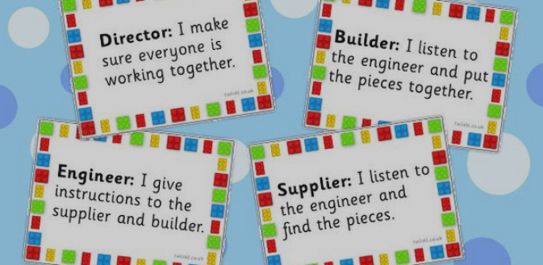
Figure 1: Lego-based Therapy Roles and Responsibilities (School produced graphic)

Following the publication of early outcome studies between 2004 and 2006 (LeGoff and Sherman, 2006), results showed improvements in social competence in intervention groups compared with children who received no interventions, alongside the other important factor of providing an approach that was enjoyable, stress free and motivating. There is a growing accumulation of evidence, both empirical and anecdotal, that gains are more or less immediate and grow over longer periods of time (LeGoff and Sherman, 2006; Barr et al., 2022).

My research has mirrored the approach of using the Lego-based Therapy model (LeGoff et al., 2014) and uses the Boxall Profile as the quantitative tool to measure its success. This has allowed for an assessment of each learner’s social, emotional and behavioural development (SEBD), and in turn provided a ‘score’ for each pupil at different points in their social development journeys. In this case, self-esteem is based on one’s belief in their own self-worth and is a subjective assessment of themselves that may change over time. The importance of my research is based on the fact that it aims to develop our pupils’ self-esteem and how they perceive themselves (Walker, 2020). Importantly, and in the context of this work, self-esteem is considered the result of pupils’ interactions with other people (in this case peers) and how they shape and mould their personalities after a series of difficult years.

This review of literature has stressed the need for an infrastructure to support academic staff in supporting pupils who are facing difficulties that have arisen either because of the COVID-19 pandemic, social disadvantage or through an ALN. The next stage of this dissertation will detail the research methods used to capture the data needed to respond to my research question, and includes details on the research strategy, data analysis techniques and management of the data harvested.

Chapter 3: Methodology

In this chapter, I outline the methods that I implemented to undertake my research, and more importantly, the reasons behind my choices. I consider in more detail my chosen sample, and explain my use of action research as a preferred research design. In addition, limitations of the work and potential hurdles are explored.

3.1 Cohort participants

I have chosen to work with a handpicked group of 20 pupils who have been identified as having either an SEBD issue or an ALN, as identified by transition data highlighted by the school’s transition process. The pupils were aged 11 and 12 (in Year 7), and consisted of 11 girls and 9 boys. A number of these pupils may not have any formal diagnosis but have feelings of low self-esteem and lack of confidence as identified by themselves (through self-referral to our Achievement Team) or by teaching staff in both primary and secondary sectors. Furthermore, the selection of cohort participants also made use of SELFIE (Social and Emotional Learning for Improvements Elsewhere) data, which has been developed to enable schools’ and councils’ learning improvement teams to establish the links for all pupils, between their wellbeing and their attendance and learning. This data is currently used by School X’s Year 7 Achievement Team and by primary schools across the local authority as a way of measuring pupils’ positive and negative social experiences in education (See Figure 2 below for an overview of the study’s approach to sampling).

Figure 2: Outline of approach identifying Key Cohort and Sampling data leading to the selection of the cohort sample.

SELFIE is a web-based system, developed through collaboration between the University of Sussex and School X’s local council. The survey looks at two areas: ‘my feelings’ and ‘my class’, and helps to gain an insight into the social and emotional climate of the school from the perspective of all members of the school community. From the results, schools can identify those pupils who need additional support and target interventions. This has helped identify children with lower levels of well-being and helped target action plans to improve their well-being. In addition, six of the pupils involved have an IDP for their ALN.

This study is not aimed at examining the experiences of all pupils across the school as to do so would be very time consuming and costly. Such a study, in order to produce meaningful results, would require a large team of researchers and is not within the scope of this dissertation. This however means that there are potential issues linked to the generalisability and validity of the data group as they are based only upon the experiences of around 10% of the total chosen year group in School X. However, as this sample cohort is not being compared to the larger group but rather against their own improvement data, then the choice of sample group is in my view still worthwhile. It is fundamentally a snapshot of the school’s Year 7 pupils.

3.2 Research Design

The study was designed using an action research methodology and a mixed methods approach to data collection. A mixed methods approach best met the needs of this research because, in general, quantitative research answers the ‘how’ questions whereas the ‘why’ questions are left to qualitative research (Biggam, 2021). The research undertaken is both quantitative and qualitative in nature, which allows for a broader range of data and, in my view, richer analysis of the research question. The figure below (Figure 3) follows the work first outlined by John Dewey’s (1916) theory of experiential education and later exemplified by Kolb (1984) in his work on experiential learning. My work broadly follows the principles outlined by Evans et al. (2022), who developed a collaborative working model as a vehicle for effective action research in education:

Figure 3: Plan-do-review model from research design (adapted from Evans et al., 2022)

In Step 1 of my action research model, I identified a problem that I wanted to explore, namely that an increasing number of pupils in School X were entering Year 7 with confidence and wellbeing issues. In Step 2, I engaged in collecting the baseline data (Boxall data) which allowed me to gauge future impact and use it to plan subsequent interventions. Step 3 involved the intervention strategies that took the form of the Lego-based interventions, which are the bedrock of this work. Step 4 involved the second collection of data, subsequent evaluation and triangulation of findings. The final stage, Step 5, represents the end of the process and an opportunity to present what I have learned and consider future implications arising from the research (Evans et al., 2022).

Planning and undertaking an action research project means asking questions about what we are doing, why, and how we can evaluate our practice in terms of the values we hold (McNiff et al., 1996). My action research process was inspired by the research design espoused by McNiff et al. (1996) in that I have identified an aspect that the school wants to improve – communication and confidence skills of socially anxious pupils – and I have imagined a way forward that involves the use of Lego-based Therapy as a vehicle for interaction (what McNiff et al. describe as the ‘action’). I have run the research study over a specified period of six months and subsequently taken stock of what happened through data analysis. My next steps (beyond the life of this particular study) will be to modify the research design in light of the findings presented and continue with the action until we (the school) are satisfied (McNiff et al., 1996). Research design is governed by the notion of ‘fitness for purpose’; hence there is no one single process that will fulfil everyone’s needs (Cohen et al., 2007, p.78).

3.3 Research paradigm
Cresswell (2005) states that:

There are three recognised methods for conducting research: quantitative, qualitative and mixed methods. Mixed method research is research in which the researcher uses the qualitative research paradigm for one phase of a research study and the quantitative research paradigm for another in order to understand a research problem more completely.
(p.17)
Based on this definition, I believe a mixed methods approach enables a better understanding of a research problem by combining both qualitative and quantitative data and developing an understanding that when used in combination, quantitative and qualitative methods complement each other and allow for a more complete analysis. Johnson et al. (2007) describe mixed methods research as being ‘qualitatively driven’, ‘quantitatively driven’, and ‘equal-status’. I believe that the data harvested from my research is of equal status as both strands provide important data streams of key information in relation to pupil’s behaviours, actions and opinions.

Pragmatism has often been identified in the mixed methods research literature as an appropriate paradigm for conducting mixed methods research (Brierley, 2017). Pragmatism is often chosen by mixed methods researchers because it focuses on practical outcomes, flexibility in methodology, and a problem-centred approach; it emphasises finding solutions to real-world problems rather than adhering strictly to a specific methodological approach. It is outcome-oriented, making it suitable for research that aims to address practical issues (Morgan, 2014), which is of particular interest to this study.

I have chosen pragmatism as my research paradigm as it places an emphasis on action and change; it focuses on actionable knowledge and understanding how theories can be applied in real-life contexts to improve practices and policies (Patton, 2015; Lincoln et al. 2018). This aligns well with my research aims and objectives. Furthermore due to its flexibility and adaptability, pragmatism makes it particularly useful in addressing contemporary, multifaceted social issues where complex and dynamic factors interact, such as in educational research (Biesta, 2010). This paradigm therefore lies at the heart of my research having both an axiological, value-laden basis for selection and a methodological mixed methods justification for its choice.

3.4 Research Methods

In the following subsections, I will outline the qualitative and quantitative methods used and the justification for selecting these approaches.

3.4.1 Quantitative Data

Quantitative data is critically important across various fields because it allows researchers and decision-makers to understand patterns, measure outcomes, and make informed decisions with precision and confidence (Dawson, 2002). Quantitative data allows for direct comparison between different groups, conditions, or time periods. For instance, educational researchers might compare test scores between different teaching methods to determine which is more effective (Cohen et al., 2018). Furthermore, quantitative data can reveal trends and patterns that may not be evident through qualitative data alone (Field, 2018). In my context, the use of quantitative data allowed me to analyse the efficacy of the Lego-based research study as a means of measuring social confidence in the cohort selected.

In this study, a quantitative data collection tool called the Boxall Profile was completed for each participating pupil, based on teacher observation of their behaviour in a Lego-based Therapy session held two mornings a week over a 6-month period. The Boxall Profile was completed at the start of the research study (Step 2 of Figure 3) and then subsequently at the end of the process after completion of a period of Lego-based Therapy (Step 4 of Figure 3). Figure 4 below shows examples of the information given to pupils and models produced by them as part of the Lego-based Therapy.
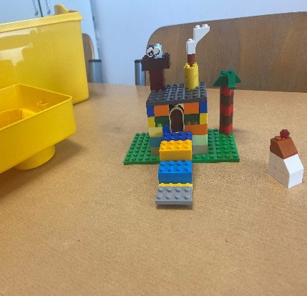
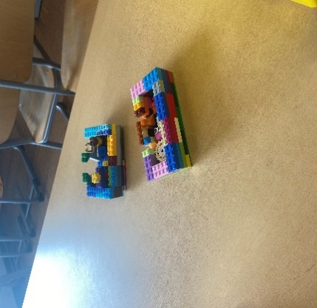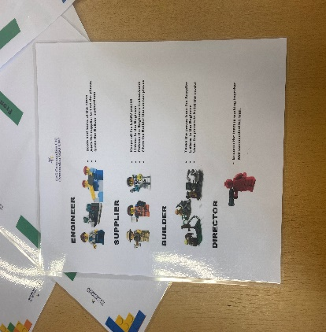

Figure 4: Photographs of models created and roles assigned to pupils (Engineer, Supplier, Builder and Director) as part of Lego-based Therapy process.

The Boxall Profile is a robust assessment tool created to identify early signs of SEBD. Through its 34 strands analysis; it provides a precise picture of a pupil’s strengths, as well as any difficulties that could affect their learning. Based on these results, the Boxall Profile identifies what type of support each pupil needs and practical strategies and techniques for support in the future. The graphic in Figure 5 highlights the two strands assessed during the Boxall Profile and a brief overview of how to both assess, and interpret, a pupil’s results.
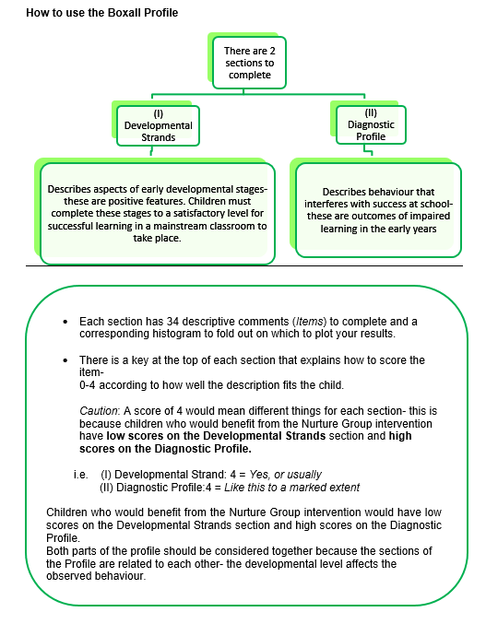

Figure 5: Outlining The Boxall Profile flow (see: www.boxallprofile.org).

The Boxall Profile consists of two sections: the ‘Developmental Strands’, and the ‘Diagnostic Profile’, each consisting of 34 items. The observing teacher rates the pupil’s behaviour against a set of norms that apply to children with ‘no problems evident’ (Allyson and Craig, 2014). Children in need of support have low scores on the Developmental strands describing a child who is emotionally secure, makes constructive, adaptive relationships and is able to cooperate with others. Children in need of support have high scores on the Diagnostic strands portraying children who have marked negativism towards others, are anti-social, and angry (Allyson and Craig, 2014). A child ‘with no problems evident’ would therefore have a low score on Developmental strands such as purposeful attention and positive engagement and high scores on Diagnostic scores like avoiding attention, negativism and disengagement. The profile for the individual pupil is created from the teacher rating scores. For the purposes of this research project, if a pupil’s scores have improved because of the interventions in the Lego-based Therapy sessions then the interventions are deemed as successful in their original design.

Figure 6 below shows an exemplar graphic of the Boxall Profile data produced by the observer’s findings on two separate dates in April and July. In this Developmental section, it is divided into two sections (organisation of experience and internalisation of controls) that outline how pupils behave during the Boxall Lego-based Therapy observations.

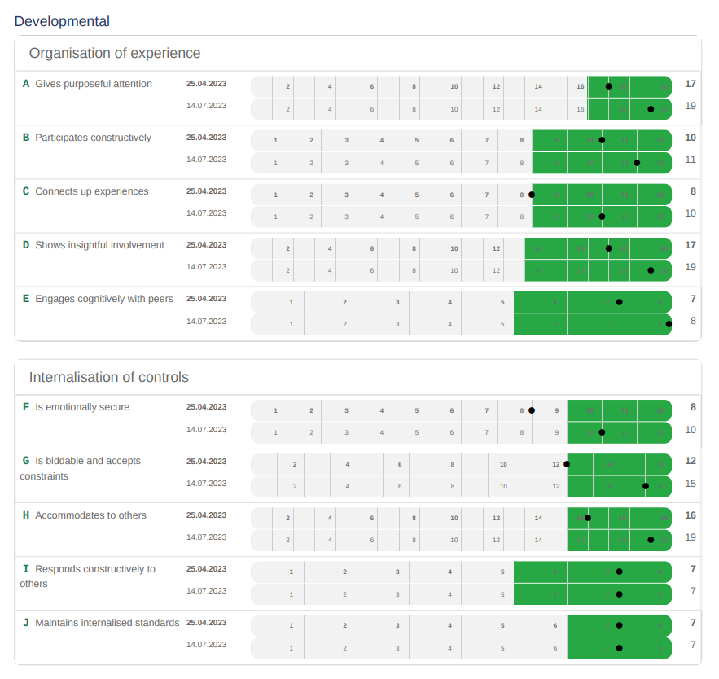
Figure 6: Examples of the observations are outlined in Developmental - organisation of experience and internalisation of control strands. (www.boxallprofile.org).

The first section in Figure 6 (Organisation of Experience) outlines how a pupil behaves by giving purposeful attention, participating and engaging cognitively with their peers (see red circle above in Figure 6 highlighting participation). In this case, the pupil measured falls within the data that apply to children with ‘no problems evident’ (green sections). The second section (Internalisation of Controls) demonstrates how a pupil deals with working with others in a calm and measured manner’. For the purposes of this work, this shows how a pupil responds constructively to others, is biddable and emotionally secure. Interpretations of this data are explored in further detail in the next chapter, but fundamentally my research data and findings are drawn from a comparison of the baseline data in Step 2 (pre-intervention) of my action research model, and the data collected in Step 4, post-intervention. This allowed for a statistical analysis between the data sets and conclusions to be reached from the success (or otherwise) of the Lego-based Therapy process.

3.4.2 Qualitative Data

Qualitative data provides deep insights into complex phenomena that cannot be captured by numerical data alone. It helps in exploring the ‘how’ and ‘why’ behind behaviours, attitudes, and experiences and offers perspectives that quantitative measures might miss (Green and Thorogood, 2018). Qualitative data often complements quantitative data by providing context. While quantitative data may show trends, qualitative data can explain the underlying reasons. For example, in educational research, scores such as those provided by the Boxall Profile (quantitative data) might show a disparity between individuals, but surveys (qualitative data) can reveal the social or cultural factors contributing to these differences (Creswell and Poth, 2017).

Thomas (2017, p.217) underlines the importance of surveys as a ‘versatile tool…. used in a number of different kinds of research’ that affords the opportunity to ask closed questions or open questions that may allow a longer, more detailed answer. For my research, the qualitative data collection (Step 4 of Figure 3) involves a qualitative survey where pupils were asked a series of questions based upon their experiences of the research study and their perceptions of the progress that they were making. Surveys have the advantage of consistency, as each question asked is the same (Thomas, 2017) and enable the collection of primary data, which is crucial for answering research questions that secondary data cannot address. They allow researchers to gather information on attitudes, behaviours, experiences, or opinions directly from respondents (Creswell, 2014) and when designed correctly, surveys can capture data from a representative sample, allowing findings to be generalized to a broader population (Fowler, 2013).

Compared to other methods like interviews or observations, surveys can collect large amounts of data relatively quickly and at a lower cost. Online survey tools have further enhanced this efficiency, making it easier to reach respondents which forms the rationale behind my decision to use Google (Saunders et al., 2019). All registered pupils have access to the Google suite of documents as part of their email registration and work frequently in Google drive to complete schoolwork and homework. This suite of documents includes word processing, presentational tools and data packages but more importantly in this context, a software element called ‘Forms’ which allows the user to create and complete surveys. Pupils are familiar with this tool as it forms part of their learning and feel comfortable in using it.

The questions listed in the Google Form and asked of participating pupils were grouped within themes related to feelings, communication and confidence in school. The quantitative data collected via the Boxall Profile in association with the qualitative data collected from the surveys form the basis of all data collected and subsequently analysed in the next chapter. Essentially, there is a two-pronged approach: Boxall Profile findings are presented and the data interpreted; secondly, pupils’ survey results are presented and data interpreted, thus giving equal status to both qualitative and quantitative results in the analysis (as per Figure 7, which shows the journey taken from cohort selection to data analysis).

Figure 7: Research Process of group (Survey preview – Appendix 3)

3.5 Limitations

This type of research design is not without its challenges. Firstly, such an approach requires careful consideration of timing both in terms of deciding on the sequence of data collection, but also in terms of time management, as collecting and interpreting different data sets can be difficult. Furthermore, this approach requires a researcher to be skilled in both quantitative and qualitative data collection and more importantly how it is interpreted and subsequently evaluated equally. Drawing on nearly 30 years’ experience of handling data as a teacher and senior leader responsible for assessment, recording and reporting across the school (in relation to the use of numbers linked to attainment, attendance etc.) and language (when reporting to parents and interacting with pupils’ use of surveys), I believe I have the skills and experience to complete this task competently.

Cresswell (2006) identifies another challenge in interpreting mixed methods research that is linked to ‘design mixing’. This can be summarised as the skill needed by the researcher to decide on how the quantitative and qualitative elements will be mixed together. In this dissertation, this refers to the moment when the two sets of data are brought together at the point of analysis. To mitigate against this limitation, my use of a sequential design (one set of data collected after another and not at the same time) (Cresswell and Plano Clark, 2017) allowed me to firstly collect quantitative data followed by qualitative data to explain the quantitative results. This I believe provided a clear, transparent alignment of data in line with the research aims.

Finally, the sample size of 20 pupils, whilst representative of approximately 10% of the year group does raise the potential for a selection bias due to the nature of the pupils selected to form the group (Thomas, 2017, p.141). Therefore, the small size of the group and time constraints are minor limitations in generalisability to the reliability of the data set, but I believe that the sample group selected is statistically representative of the year group in terms of age, gender and geography (Bryman, 2006). Furthermore, the primary aim of my action research is to better understand the learners in my own setting and that any data collected will enhance my knowledge of the school environment.

Finally, the study only included mainstream schools therefore further research would be necessary to explore the effectiveness in special educational needs schools.

3.6 Ethical Considerations

I believe I have outlined in my Ethics Form (Appendix A) a teleological justification for conducting this research which upholds my obligation to conduct the study in a socially just, respectful and peaceful manner (Mill,1969 as cited in in Kivunja and Kuyini, 2017) and which complies with the British Educational Research Association’s ethical guidelines (BERA, 2018). In terms of procedural ethics, I have followed what I believe to be a gold standard approach as laid out by Cohen et al. (2007, p.51) in ‘Research Methods in Education’, namely a thorough exploration of ethical considerations such as informed consent, privacy, anonymity and confidentiality.

The principle of informed consent was adhered to, as full written consent was requested and granted from all participants in the research study. This was arranged via correspondence from the school explaining the research study and the intended objectives of the activities. Parents were explained that they have the right to refuse their child’s participation and may withdraw their child at any time from the sessions if they wish. Pupils were explained their right to refuse participation, the ability to withdraw and the principal of no adverse consequences. Pupils were explained the ethics of the research study and that their parents would be required to give consent to participate also. Fairness was demonstrated in the principle that no harm would come to any persons involved in this study. Fairness was ensured in the sample group through the principle of non-discrimination; that the selection of participants was inclusive and did not fairly exclude or over-represent any group (Resnik, 2018). Pupils were explained their right to refuse, the ability to withdraw and the principal of no adverse consequences. No harm was to come to any persons involved in this study.

Privacy was provided through the guarantee of data minimisation, that only data that was absolutely necessary for the research was collected and that data encryption was guaranteed through secure storage methods and was password protected (Caldwell, 2014). Anonymity and confidentiality were ensured through the removal of personally identifiable information to prevent the identification of participating pupils (Beskow et al., 2012). All participants’ parents were asked for informed consent (a voluntary agreement for their child to participate in research) and were given full knowledge of the destination of any data, the reason for the research and the potential risks. The participation letter and subsequent conversations made clear what the parents were consenting to and their right to withdraw.

Throughout the research project, I adhered to the normal school safeguarding policy in all aspects in order not to put my personal safety or professional name at risk. Throughout the research project, I adhered to the All Wales Safeguarding policy (2008) and the school’s Governing body policy (2020). As one of the school’s safeguarding team, I am aware of appropriate safeguarding arrangements and regularly give safeguarding professional development to staff and pupils (when necessary).

3. 7 Approach to Data Analysis

I undertook a process of descriptive analysis to help interpret meaning from the data collected. In her work on descriptive analysis, Loeb (2017) outlines the need to identify causal relationships in research in order to validate it. In my research, I aimed to identify whether a specific academic intervention, in this case, a Lego-based intervention, caused an effect on the participants involved (specifically, whether it impacted on their wellbeing and confidence). Descriptive analysis as described by Loeb (2017) can help identify socially important phenomena that may not have been previously recognised. McAteer (2013) reinforces this belief when stating that descriptive analysis can allow the audience to fully understand, where, with whom and why something happened, while at the same time providing a structure for the development of ongoing reflection and sense-making.

Cresswell (2018) supports this approach in identifying its value as a powerful means of discovering trends and gaining understanding. He writes that descriptive analysis research focuses on analysing a particular phenomenon or situation and is important because it focuses on identifying causal relationships between variables. In my context, this applies to a number of previously identified phenomena such as those listed in my literature review (e.g. the COVID-19 pandemic, virtual learning environments, the role of smartphones and economic global recession) and what impact, and why, they have had on pupils in school today.

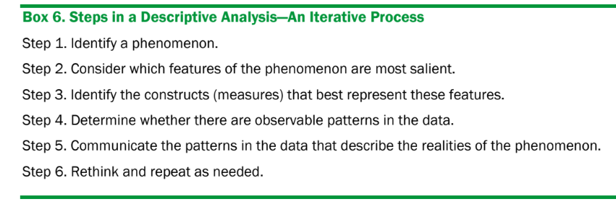
Figure 8: Steps in an iterative descriptive analysis process (Loeb, 2017)

The iterative process of descriptive analysis outlined in Figure 8 provided the framework for my interpretation of both qualitative and quantitative data, aligned with the mixed methods approach outlined earlier, and provided a means through which causal research could be more fully explored (Loeb, 2017, p4). In particular, I was interested in understanding not just what happened, but why it happened. I believe that this is at the core of my dissertation, which seeks to not only investigate how we, as a school, can develop pupils’ social emotional skills but why such problems have arisen in the first place (i.e. the causal nature referenced above).

The iterative process of descriptive analysis as presented by Loeb (2017) is undertaken in six steps. In Step 1, the phenomenon identified by this research study is that a growing number of pupils transitioning into secondary schools have increased social and emotional issues, which manifest themselves into feelings of negative wellbeing, stress and reduced confidence levels whilst in school (see Chapter 1). Therefore, to initiate the process in Step 1 I selected 20 pupils who fitted these criteria as my sample group to participate in an intervention that would allow me to investigate how and why we could improve these measures. In Step 2, I considered which features of the phenomenon were most salient, which in this case related to the way in which social and emotional issues manifested themselves in pupils in school (e.g. pupils’ enjoyment of school, confidence in communicating to others and strengthening relationships amongst peers). Having previously worked on Lego-based Therapy in preceding years I decided that in Step 2 I would undertake an action research Lego-based Therapy process to test whether participation in this group could support pupils with the issues identified. Through a process of descriptive analysis, I was able to explore the causal relationship between these phenomena and why they occur.

Step 3 outlines how, after carefully considering the phenomenon, I implemented a mixed methods research study using both qualitative and quantitative data. This approach made use of both the Boxall Profile process and Google survey tool to collect data. In Step 3, I met the group regularly to take part in Lego-based Therapy and carry out the Boxall Profile assessment. To complement this quantitative data, pupils also completed a post-intervention Google survey, which sought answers to questions of both a qualitative and quantitative nature. In Step 4, I searched for patterns in the data sets and set them out as part of my key thematic findings (see Chapter 4.1.1). My identification of patterns is not solely linked to a pre-existing hypothesis but does explore the usefulness of Lego-based Therapy as a tool for improving a pupil’s social-emotional wellbeing, which was itself born out of the identified phenomena in Step 1 (the recent global crises of a health pandemic, global recession and overuse of personal mobile devices). These statistics are simple, not overly complex, and reduce the data sets to make them suitable and useful for a wide audience in education.

In Step 5, the research study follows best practice and presents the data visually and in a format that is useful to the audience (Loeb, 2017). Step 6 is considered in my concluding chapter, which considers how this work might be ‘rethought’ and taken forward, for ease of reading. The next chapter of this dissertation explains the most important patterns in the data when answering the research question and works on the premise of the three key features of data visualisation, namely: function, familiarity and simplicity (Loeb, 2017) or as Thomas (2017) puts it – making the data meaningful to the reader.

Chapter 4: Presentation and analysis of data

In this chapter, I will analyse data and discuss findings from both the Boxall Profile and Google surveys. First, I present data gathered from the Boxall Profile observations that are quantitative in nature and allow for an evaluation of a pupil’s social and emotional wellbeing. Further exploration is then carried out between assessments observed in the spring and summer terms, and the key findings are evaluated and presented. Analysis of the data gathered by the Google surveys is then presented and evaluated in the final section of this chapter, before the dissertation concludes in Chapter 5.

4.1 Quantitative Findings – The Boxall Profile

I will begin this section by presenting two key data sets, labelled Table 2 and Table 3. These figures outline the pupils who participated in the Lego-based Therapy, their anonymised form classes and how they performed in the Boxall Profile assessments pre and post-intervention.

The data outlined below in Table 2 is a summary of the assessments carried out as per the methodology described in the previous chapter. Two assessments were carried out capturing the Developmental strands (cognitive strengths) and Diagnostic profile (barriers to learning) of the 20 pupils included in the final data. The data was collected approximately eight weeks apart and formed part of a six-month programme of Lego-based Therapy social competence.

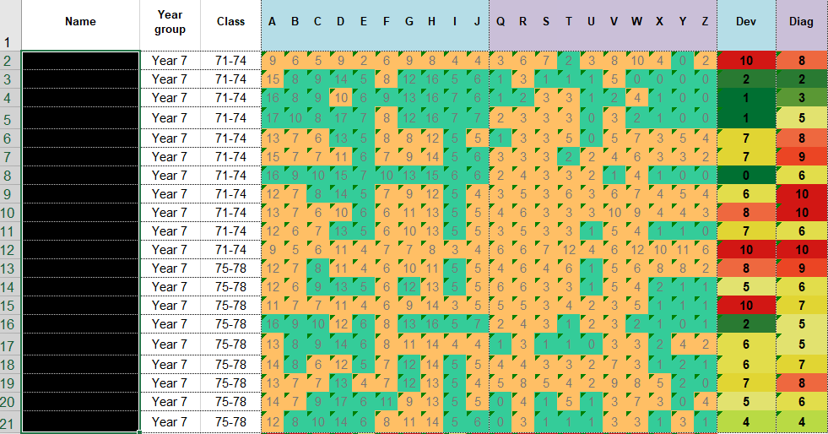
Table 2: Results from the Developmental and Diagnostic assessments from the Boxall Profile baseline Assessment One.

All names have been redacted to protect the anonymity of the pupils in the ‘Name’ column whilst the pupils’ form class is shown as either 71-74 or 75-78. This has no bearing on the research study but simply reflects which group they registered in every morning. Each column in the table represents a strand of the profile (A-J labelled dev for Developmental and Q-Z labelled diag for Diagnostic) representing an area of the profile such as organisation of experience, undeveloped behaviour and unsupported development.

The Boxall class overview (Table 2) provides a clear picture of the social, emotional and wellbeing needs of a whole class or group. One row represents one child; one column represents one area of the Boxall Profile (social and emotional skills from A to J; challenging behaviours from Q to Z). Looking at the last two columns, staff can identify pupils with high levels of needs (children scoring 8+ on either measure, highlighted in red). Scores highlighted in green indicate a positive score whilst those in amber represent a good performance but with some areas for development. Looking at the last row of the overview, staff can identify difficulties common across the whole class; for example, 15 out of 20 children have difficulties in Strand H ‘accommodating to others’. Another area of need can be identified in Strand W, which represents an insecure sense of self and a negative internal model (these are explored further in Table 6, in Chapter 4.1.1). Teaching staff can then put in place strategies to help pupils develop the missing social, emotional skills.

To arrive at the data in Assessment One (Table 2 - both Developmental and Diagnostic) the teacher assesses pupils’ behaviour against a set of norms that apply to children with ‘no problems evident’. Through its analysis, it provides a precise picture of a pupil’s strengths, as well as any difficulties that could affect their learning. Based on these results, the Boxall Profile identifies an identification of what type of support each pupil needs and practical strategies and techniques for support in the future.

Developmental questions measure a pupil’s cognitive, social and emotional strengths whilst Diagnostic identifies a pupil’s challenges and barriers to learning such as craving attachment, self-negation or disengagement from the learning process. Where a pupil scores a green score there are no apparent difficulties, amber indicates low levels of difficulties whilst a red score highlights an elevated level of difficulty in this area. For example, for the pupil in row two their elevated scores across the strands mean that they are awarded a ten score for Developmental needs and eight for Diagnostic needs. If we were to compare this with the pupil in row three whose scores are considerably lower, with a score of two for Developmental and two for Diagnostic, we can extrapolate that the pupil in row two has greater needs and will need more substantial interventions.

In Table 3 below the data are presented showing the pupils’ results from the Boxall Profile assessment conducted eight weeks later by the same teacher after having undergone Lego-based Therapy sessions and social interaction activities with the assistance of sixth form prefects. A quick inspection of the data shows a clear improvement in scores across the cohort, as demonstrated by a reduced number of red and amber scores and a greater number of light and dark green scores. These results are explored in further detail in the Key Findings section (4.1.1).

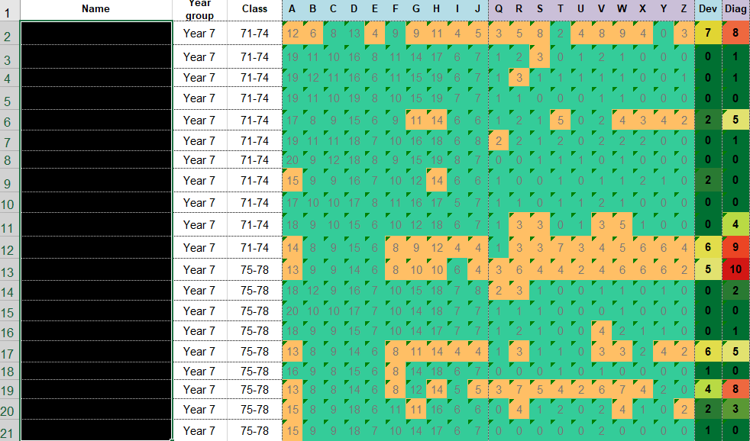
Table 3: Results from the Developmental and Diagnostic assessments from the Boxall Profile baseline Assessment Two.

The table below (Table 4) shows the results from Assessment One with a comparison of the results from Assessment Two to indicate any progress observed by the teacher. When interpreting the Developmental strands an increased score represents positive progress whilst the opposite applies to the Diagnostic strands where a reduction in the score signifies a removal of barriers to learning thus enabling progress to be made.

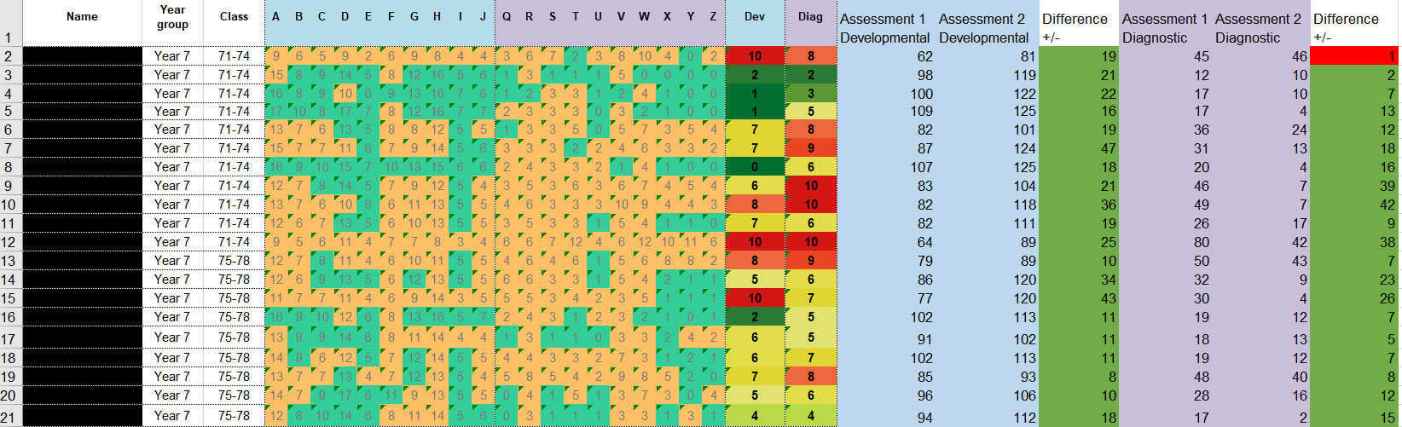
Table 4: Boxall Profile assessments One and Two comparison of the data, and clear improvements shown by the pupils in Developmental behaviour in Assessment Two.

The differences indicated in the Table 4 (above) demonstrate the improvement shown by pupils in their ability to learn and function in the classroom (cognitive strands). For example, the pupil in row two made an improvement from 62 to 81, according to the Boxall Profile scoring matrix indicating an improvement of 19 points. The lowest level of improvement is eight (row 19), whilst the largest improvement is a pupil in row seven with an improved score of 47. No pupils’ scores indicate a regression in their levels of cognitive functioning according to the Boxall Profile marking scheme. The mean improvement score is calculated at 20.95 for the developmental strands across the cohort of pupils reducing the number of pupils with an elevated (red) score from three to zero. See section 4.1.1. for further analysis.

The differences indicated in Table 5 (below) demonstrate the improvement shown by pupils in overcoming their challenging behaviour that prevent successful social and academic performance. In this data, an improvement is indicated by a reduction in the score indicated in the ‘Assessment 2 Diagnostic’ column. Of the 20 pupils assessed, 19 showed improved scores indicating an improvement in their ability to manage their challenging behaviour in a social environment. One pupil (row two) indicated a very minor regression in their Diagnostic strand whilst the average improvement score is noted at 15.25 points on the Boxall Profile scale.

Table 5: Boxall Profile assessments One and Two comparison of the data and improvements shown in Diagnostic behaviour
4.1.1 Boxall Profile: Key findings

There are a number of key findings that can be synthesised from the analysis of the data from Assessment One, Assessment Two and a comparison between them. This has been formulated through the comparison of the data evidenced in the two assessments carried out by the observing teacher and an uncovering of the key findings outlined below. My principal deductions here posit on the assumption that the process of interacting with other pupils has improved the pupils’ self-confidence, ability to work with others and reduced their challenging behaviour due to the need for social competence when interacting with others in engaging with play. These have been recurring themes in this research. This supports my reading in Chapter 2 when exploring the benefits of the Lego-based Therapy for young people (LeGoff and Sherman, 2006; Barr et al., 2022). Simply put, Lego-based interventions are beneficial for those participating.

Firstly, nearly all of the 20 pupils who participated in the research study had only low or no apparent difficulties when completing the first assessment. This is seen when looking at the Assessment one data that indicates either green or amber (as defined by the Boxall Profile in Table 2). Nevertheless, despite these low scores there remain six pupils who are highlighted as red in either the Developmental or the Diagnostic strands that indicates the potential for conflict when discussing social interaction (Table 5).

When examining Tables 2 and 3 a number of strands stand out as being problematic in both the Developmental and Diagnostic areas. These can be identified, as they are the strands where the highest numbers of pupils have scored an amber score in Assessment One. These strands are a barrier to effective teamwork and building confidence in young people. These are outlined below (Table 6). Each strand is categorised alphabetically from A-Z.

Developmental strand | Diagnostic strand
Strand F refers to the internalisation of controls and highlights a pupil who is emotionally insecure. | Strand R highlights that a pupil can form positive attachments with others. A low score here indicates that a pupil is self-negating and lacks self-esteem.
Strand A refers to a pupil’s organisation of experience and indicates that a young person can adapt flexibly and interact purposefully and constructively with others. An inability in this strand suggests that a pupil is unable to give purposeful attention to an activity. | Strand V refers to an unsupported development and a need to establish trust before an attachment is made. A low score here indicates an individual who is distrustful of others in social situations.
Strand H represents an ability to function in a group and accommodate to others. A low score here would signify a difficulty in interacting with others. | Strand W represents an insecure sense of self and a negative internal model.

Table 6: Key strands needing development post Assessment One

Assessment One (see Table 2) highlights that more than three quarters of the pupils tested in The Boxall Profile baseline Assessment One had a number of areas of concern when considering others in social situations. These insecurities would certainly imply a reluctance to interact socially with unknown individuals in both formal and informal activities and justify their inclusion in this research study. Consequently, in the Lego-based Therapy sessions that followed Assessment One the teacher and Sixth Form prefect helpers sought to support those highlighted as scoring a red indicator, namely pupils in rows 2, 7, 9, 20, 12 and 15 in particular. This involved giving extra praise when completing a successful build (strands F and W) and providing consistent encouragement to a pupil to remain ‘on task’ (strands A and R). Strands A and V were supported through constant reminders of a pupil’s role in the research study whether it be ‘Engineer’ or ‘Architect’ and how their involvement assisted in the organisation, and success, of the group’s build.

If we subsequently compare the results of Assessment One with those of Assessment Two, having taken part in their social immersion research study over an extended period, a number of important quantitative results stand out. I have listed these by theme, based on Boxall data collected:

- Social Confidence – Assessment One demonstrated that most of the pupils showed a number of weaknesses in their social confidence which is evident from the amber data, highlighting difficulties in forming trusting relationships and a tendency to lack self-worth. The results from Assessment Two show a marked improvement in the data with significantly larger numbers of green scores. This would indicate a noticeable improvement in the confidence levels of those involved in the cohort because of the research study.

- Social and Emotional indicators – The average (mean) Developmental cohort score in Assessment One was 88.2 (n=20) whilst in this had improved to 109.7 showing a clear improvement of 21.5 marks per pupil, as per the Boxall grading system. Similar results can be found when analysing the Diagnostic scores. The average score in Assessment One was 32.7 whilst the average in Assessment two stands as 16.9 showing another clear improvement in scores of 15.9. Test results here suggest a significant improvement in all but one of the Developmental strands of the profile following intervention and represent a clear correlation in the data.

- Outliers benefitting – The number of pupils indicated as scoring red in Assessment One has reduced from six in total to one only in Assessment Two. This also forms a significant reduction in those who show high levels of difficulties. The results indicate here that those pupils who presented with the highest levels of need have benefitted significantly from the research study. The six pupils who originally received a score of 8+ in the totals columns of either of the strands subsequently improved the most. The mean scores of those identified originally as red improved by 31.8 (n=6) in comparison to 14.78 in the Developmental strand (n=14). Furthermore this also applies to the Diagnostic strand where a similar pattern is identified with scores of 27.3 (n=6) and 11.07 (n=14). These suggest a strong improvement for pupils with significant needs and that gains are immediate as established in Chapter 2.

- Exceptions to the rule – Out of a cohort of 20 pupils, only 1 is seen to have shown any form of regression. Even this is very marginal and represents a 1-point deterioration in Diagnostic scores. The range of scores in the second Developmental observations ranged from 81 to 125 with a mean of 109 (n=20). The ranges of scores in the Diagnostic observations were not quite as pronounced but still shows a statistically large rise in scores when compared with Assessment One. Here the range is 2 to 46 with a mean score of 16.9. Fifteen of the 20 pupils scored observations of under 20 whilst a few outliers had large discrepancies of scores of 45 and 46. This is true of the only pupil in the sample group who showed a very minor regression in her Diagnostic score as a result of the teacher observations.

- Reduction in challenging behaviours observed – The scores illustrated in the Diagnostic profiles (Diagnostic identifies a pupil’s challenges and barriers to learning such as craving attachment, self-negation or disengagement from the learning process) have significantly improved. This suggests that the research study facilitated a successful reduction in the barriers which were previously holding them back in their confidence and engagement in activities which is evidence based by the scores. In Assessment One all pupils showed a minimum of two scores demonstrating low level of difficulties with a number of pupils showing as many as nine or ten scores indicating problems (n=20). The average score is 6.7. By the time pupils are tested in Assessment Two the data shows that just over half (11) pupils have no or only one score indicating a level of difficulty. The mode number in this data set is zero. Four of the 20 pupils still show elevated scores of eight, nine or ten but eighty percent have substantially improved scores with the mean score now standing at only 2.9 highlighting a demonstrable difference.

4.2 Qualitative Findings – Surveys

Qualitative data for this section was obtained solely through the vehicle of surveys. The sample group (n=20), who all completed Assessment One and two of the Boxall Profile, also completed a survey at the end of the process about their thoughts and feelings of how they felt after the research study had finished. A full list of the fifteen questions can be found in Appendix 3.

This form of self-reporting survey is quick, easy and safe to administer and pupils are proficient in their use. All pupils were offered support in interpreting how to answer the questions but no support was given to pupils when answering the questions, which they completed independently. The responses from the questions show a good range of empirical data that identifies that improvements were indeed made in pupils’ social interaction skills and levels of confidence, at least in part as a result of the school’s interventions and support.

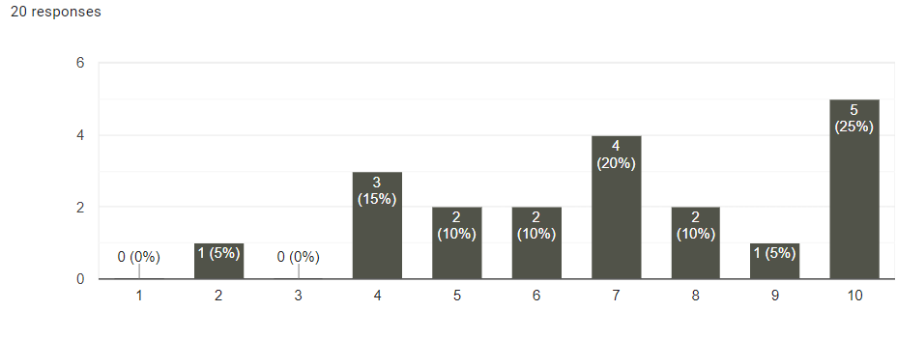
Figure 9: Pupils’ opinions on whether they have enjoyed taking part in the Lego Sessions where, 1=not at all and 10 = very much

In this question (Figure 9), the x-axis represents the number of responses given to the question whilst the y-axis presents a score of 1-10. One represents a score expressing that they did not enjoy participating in the research study whilst a score of 10 means that they enjoyed participating very much. In question one when asked if they had enjoyed the Lego sessions; 60% (n=20) of the pupils gave a score of more than seven out of 10 and 25% gave the research study full marks (10/10). This shows that most pupils took enjoyment from participating in the research study by giving a mean score of 6.95 and a mode score of 10. I believe that this demonstrates the useful nature of this collaborative research study as a way of boosting a pupil’s wellbeing.

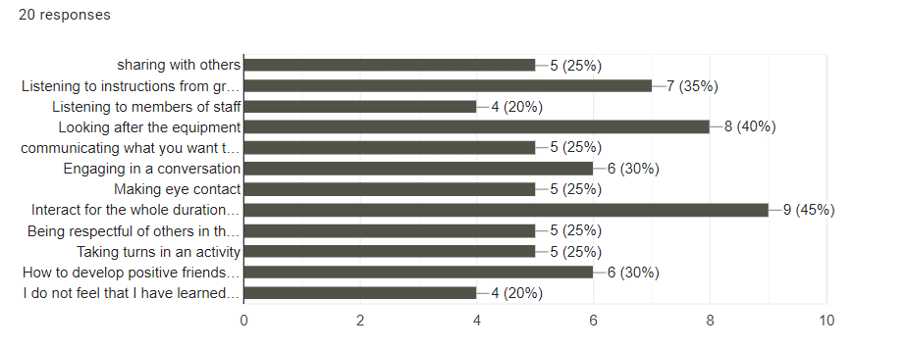

Figure 10: Pupils express which skills they feel that they have learned or improved as part of the Lego activities.

In Figure 10, pupils were asked to select the skills they felt they had learned over the duration of the research study. They were entitled to select as many as they felt necessary in their own opinion. The skill that pupils feel that they have learned the most is the ability to interact for the whole duration of the activity (45%) which links back to Developmental strand A of the Boxall Profile where pupils had previously lost concentration quickly and failed to apply themselves at length. Pupils also expressed that they feel better equipped to look after the equipment distributed. This shows an improved awareness of the local environment and others. This is linked to the third highest response which I believe in the context of this research question is the most important.

As outlined in Figure 10, 35% of the pupils stated that listening to instructions from other members of the group had been an acquired skill as a result of group participation. I believe that this response is validated by both this question in the Google survey and in the Boxall reports that conclude a similar improvement journey for many participants. A total of three pupils highlighted that they did not feel that they had acquired any new skills.

Table 7 (below) asked pupils to list any other skill that they felt that they had learned thanks to Lego-based Therapy. Responses here were limited (n=9) but three pupils indicated that “talking to people”, “taking turns” and “talking positive language” had been important take aways from this activity. A number of the questions in this survey sought more qualitative responses from the sample. When asked what other skills they had learned from the interventions, the following were suggested:

Participating pupils | Comment
Pupil A | to listen to help
Pupil B | taking in turns
Pupil C | no
Pupil D | hand eye coordination
Pupil E | I have learnt to always communicate not just be quiet we have a voice for a reason might as well share it to communicate with others in activities
Pupil F | Having fun with the group
Pupil G | ?
Pupil H | speaking in positive language
Pupil I | Talking to people.

Table 7: Pupils express which skills they have learned during the research study.

A small number stated that they had learned to communicate better but this view was not shared by many in the group, some of whom responded by saying that they simply did not know. This may well be an indication of written competence and cognitive ability than the intended objectives of boosting confidence amongst the pupils themselves.

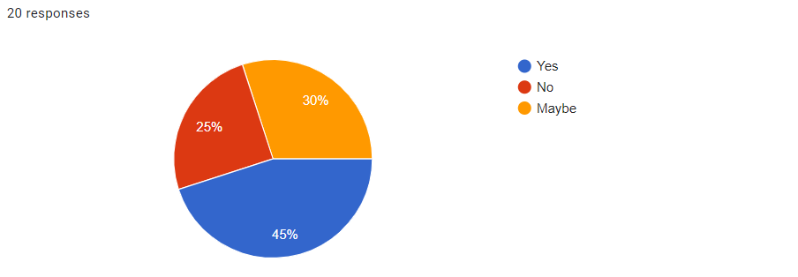
Figure 11: Pupils’ confidence levels after participating in the research study when talking to friends.

Figure 11 addresses the question of whether or not pupils felt more confident in communicating with friends after taking part in the Lego-based Therapy. A quarter of those involved stated that they did not feel more confident, whilst 75% believed that they were either definitely more confident or maybe more confident in communicating with their friends. I believe that this reflects well on the interventions as three quarters of those taking part gave positive reflections on their involvement. This is perhaps as a result of the skills that they feel they honed in Figure 10; namely listening to instructions from others in the group (35%), looking after the equipment (40%) and interacting for the whole duration of the activity (40%). These are essential every day skills that a pupil would benefit from in every classroom scenario and hence boost confidence skills.

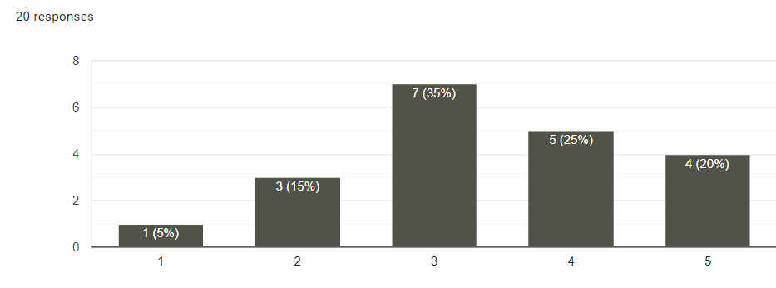
Figure 12: Pupil confidence levels before the sessions,1= not at all, 5 = extremely confident.

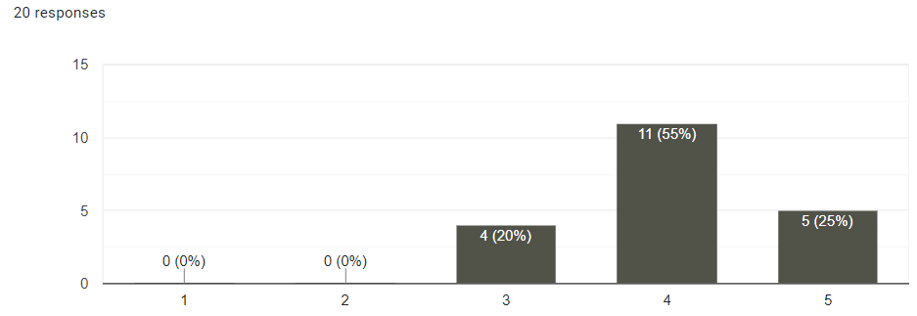
Figure 13: Pupil confidence level after the sessions, 1= not at all, 5 = extremely confident.

Figures 12 and 13 offer clear empirical evidence that a number of pupils benefitted positively from the interventions offered by the research study. In this question, the x-axis represents the number of responses given to the question whilst the y-axis presents a score of 1-5. Pupils were asked if they could rate their scores before and after the Lego sessions with a score of one if they did not feel confident at all and five if they felt extremely confident.

If we were to take a mean score of the 20 pupils involved in the research project and calculate an average score then confidence levels as self-assessed by pupils (n=20) rise from a mean of 3.38 before the research study to a mean of 4 after the research study has been completed. Whilst this does not represent a significantly large increase, it does show that many pupils felt that the interventions had validated their participation and supported their wellbeing through an improved sense of confidence. In addition, not one pupil measured themselves as a one or two on the 5-point scale that would have indicated a failure to benefit from the research question. Further validation of the research study is evident in Figure 14, where pupils were asked if they would recommend participation to their friends. More than half of the participants gave a yes response (55%) whilst 85% stated either yes or maybe. A minority of pupils (15%) stated they would not recommend it to their peers.
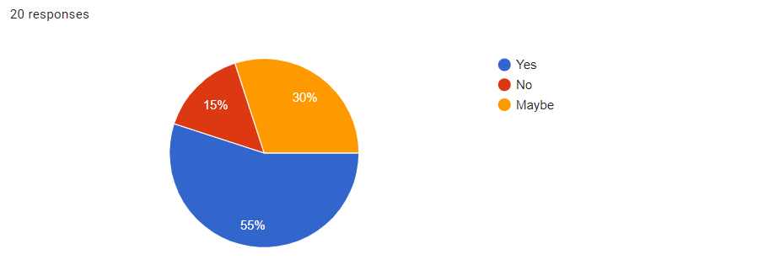
Figure 14: Pupils who would recommend taking part in this research study to their friends.

Figure 14 gives a positive reflection on pupils’ participation in the research study where only three out of the 20 pupils involved did not feel that this research study was worth recommending to their friends. The fact that 17 out of the 20 would recommend taking part in this research study is testament to the organisation and collaborative nature that these sessions engendered. This would offer very positive reinforcement of the viability and validity of the intervention for future year groups.

Many pupils, when asked, did offer a selection of good ideas as to what activities they would like to see themselves, or for others in future cohorts. These included the following activities in Table 8 (below):

Participating Pupils | Comment
Pupil A | board game
Pupil B | team building games
Pupil C | More complex Lego
Pupil D | I would like to see more Lego and board games
Pupil E | complex Lego
Pupil F | Board games, team games
Pupil G | Maybe something like making your own board game/Any game in groups then presenting it then everyone gets a turn to have a turn playing with each game
Pupil H | less boring things
Pupil I | Online building / Creating new things online
Pupil J | class Lego build
Pupil K | I don't really find interests in playing games like board games and others
Pupil L | football
Pupil M | more complex Lego builds
Pupil N | playing computer games
Pupil O | more complex Lego
Pupil P | playing jenga with no words
Pupil Q | board games

Table 8: Pupils express what they would like to see in the second part of the sessions? E.g., more complex Lego builds board games, interactive games, team building activities etc...

These suggestions will certainly form part of the next steps of the school’s improvement journey as the school aims to build upon the success of this cohort of pupils in managing wellbeing, stress and anxiety in vulnerable pupils post pandemic. I would infer from these comments (Table 8) that during the course of a pupil’s busy academic day, all pupils are in need of activities that will allow them to liberate the stresses and anxieties that build during the course of the day, particularly if there are cognitive barriers to learning. These extracurricular, goal-setting and reflection activities will be increasingly in need if we are to stem the huge increase in the number of children being referred to National Health Service mental health services (in England) for anxiety, which has just hit its highest level ever recorded (Gregory, 2024). In 2023-24, there were 204,526 referrals of children made to mental health services with a primary cause of anxiety. In 2016-17, there were just 3,879 referrals. This, as the article suggests in The Guardian newspaper, is a ‘jaw-dropping number of children’ (Gregory, 2024) and indicates our need for vigilance moving forward. Wales is seeing similar increases in the number of referrals being made according to the data available (Welsh Government, 2022). Implementing a combination of interventions can create a holistic approach that looks to address factors contributing to a pupil’s confidence and anxiety reduction.

These activities may take the form of a sporting or team building activity depending on a pupil’s needs. I believe that the data from this research project suggests that all pupils benefit from some form of activity during their free time whether that be before, during or after school. This is particularly important for pupils such as those who form the cohort sample group who lack confidence at times and benefit from a structure and organisation such as that provided by the Lego-based Therapy. The data provided by Table 8 underlines the need for collaborative learning tasks, which can foster both cognitive and social-emotional development complemented by pupils who enjoy the tasks.
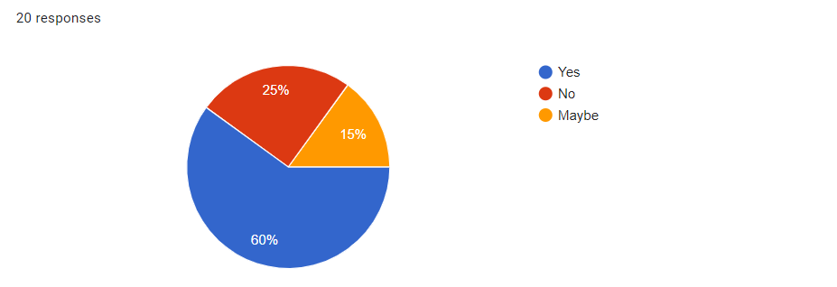
Figure 15: Do pupils feel more confident in communicating to their friends after taking part in the research study?

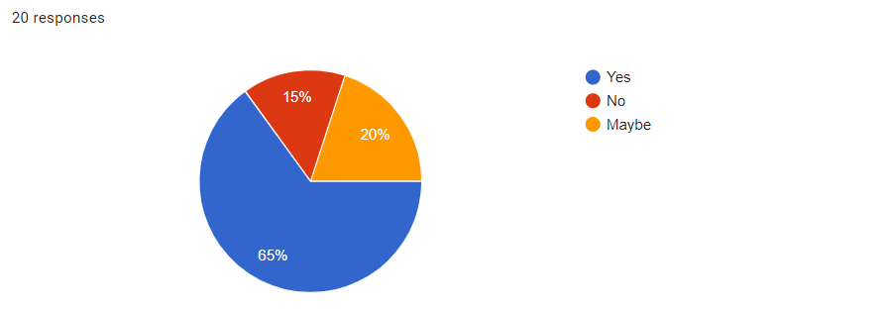
Figure 16: Do pupils feel that they have developed stronger relationships with their friends?

Figures 15 and 16 offer a more optimistic picture of how many perceived their involvement in the group. When asked whether they felt more confident in communicating with their friends (Figure 15), 60% responded yes, whilst only 25% replied no. This supports the idea that the intervention project was a successful intervention as it enabled pupils who had previously had issues in communicating with their peers with the skills necessary to provide them with a stronger relationship with their friends.

In support of this line of enquiry, the majority of the group (65%) felt that they had developed stronger relationships with their friends in answering yes to the question of improved relationships, a cornerstone of the research study’s stated aim (Figure 16). This I believe represents a direct causal relationship between the intervention study and an improvement in the participants’ wellbeing. Whilst this research study is not able to identify if the pupils’ confidence levels were initially low due to the overuse of mobile phones and virtual learning during COVID-19, these histograms demonstrate a clear empirical analysis that Lego-based intervention activities have helped to improve their communication skills and confidence levels when seeking friendships.

Chapter 5: Conclusion and Recommendations

In this research study, I have investigated how a pupil’s social interaction and confidence is impacted by their cognitive, social and emotional strengths in addition to the Diagnostic challenges and barriers that they face in their lives. I believe that many of the issues facing pupils today are complex and multifactorial. Global events and developments in modern technology are intrinsically linked to behavioural patterns, falling attendance rates and the rise in student dissatisfaction in school, culminating in poorer achievement and self-esteem (UNSECO, 2020). The combination of these factors is leading to what some consider to be system-changing pressures in schools (ASCL, 2022).

Given the increasing emphasis on the role of schools in seeking to improve social outcomes for children and young people, this study shows that Lego-based Therapy, as part of a wider programme of socially interactive activities, could be a pragmatic and immediate option for schools. This is particularly prescient given the challenging state that many schools find themselves in today in terms of decreasing finances, falling attendance and development of a new curriculum. In my research, I set out to advance understanding of these things, using three specific objectives as a guide. These were as follows:

- Identifying and collecting data that explores whether improvements are indeed made in pupils’ social interaction skills and levels of confidence, which are the result of the school’s interventions and support.
- Evaluating and exploring what children and young people are trying to communicate through their behaviour.
- Better understanding whether improvements can be made with the support of adults and older pupils in the school who are prepared to dedicate time, energy and effort in improving pupils’ outcomes, attendance and wellbeing.

This concluding chapter will summarise the main findings of the research project by revisiting these objectives and offer specific conclusions for each. Recommendations for future exploration are illustrated before a final selection reflecting on the research process that has been undertaken.

Objective 1 - Identifying and collecting data that explores whether improvements are indeed made in pupils’ social interaction skills and levels of confidence, which are the result of the school’s interventions and support.

The literature review revealed that Lego-based Therapy is a social development programme that aims to provide an effective social development intervention for children who suffer from neurodevelopmental issues or have other conditions affecting social competence (LeGoff et al., 2014).

The findings of the research study reveal that immediate gains are achievable from a Lego-based intervention. Twenty pupils were involved in the Lego cohort and only one pupil showed a very minor regression in some of the data. The remaining 19 pupils demonstrated an improvement in both Diagnostic and Developmental strands of the Boxall profile. Furthermore, pupils reported an improvement in both their ability to communicate with others and an overall improvement in their confidence levels. The findings support the idea that a coherent pastoral plan of intervention and support can demonstrate clear, empirical improvements in wellbeing and self-esteem (Elway, 2021; Walker, 2020; O’Neill, 2018). The possibility does exist that some improvements in the pupils’ wellbeing and confidence is due to other factors such as getting older, changes in friendship groups and better home contexts. Nevertheless, this study supports the findings of earlier work by LeGoff (2004) who suggests that social functioning and communication are improved as a result of involvement in this research study (LeGoff, 2004; Sherman, 2006). LeGoff (2004) also found that children participating in Lego therapy displayed increased self-esteem and a greater willingness to engage in social interactions over time.

It can therefore be concluded that Lego-based interventions support my initial hypothesis that the school’s pastoral care and Achievement Team allow some pupils to improve their social interaction skills with others. I feel confident that the Lego-based intervention is the primary catalyst for improvement but do acknowledge that other school based interventions such as peer mentoring, buddy interventions, extracurricular activities, personalised learning plans and parental involvement and communication with the school may also be contributory factors.

Objective 2 - Evaluating and exploring what children and young people are trying to communicate through their behaviour.

The literature review identified that understanding what children and young people are trying to communicate through their behaviour involves looking beyond the surface actions and identifying the underlying needs, emotions, or challenges they might be facing (Shapiro, 2020). This dissertation supports the belief that pastoral based interventions can allow children to communicate more effectively if they are provided with a vehicle which allows them to structure their words and actions, such as that provided by Lego-based Therapy (the specific intervention used in this study).

From this empirical study, it was apparent that communication could be improved even if some of the traumatic and stress-inducing experiences suffered were not explored sufficiently by this work as they fell outside of the remit of the research objectives.

Objective 3 - Better understanding whether improvements can be made with the support of adults and older pupils in the school who are prepared to dedicate time, energy and effort in improving pupils’ outcomes, attendance and wellbeing.

The literature review highlighted that schools can play a pivotal role in meeting a child's unmet needs through various strategies and support systems. Schools can help with academic support through Pastoral Support Plans (PSPs) and IDPs that can tailor education to each child's unique requirements. Emotional and social support can be improved through counselling services and mentoring schemes, whilst family and community engagement can improve a pupil’s academic outcomes, attendance and wellbeing with greater parental involvement and wider community partnerships.

The findings of this dissertation demonstrate that through participation in extracurricular activities large improvements are made in improving confidence in communicating with peers and how pupils feel about their friendship groups. Participation in extracurricular activities such as those outlined in this work can promote both teamwork and social skills thus promoting an inclusive culture where all pupils feel valued and respected.

The study as a result has raised a number of issues and as such highlights the need for further research.

5.1 Recommendations for Future Research

In my view, further work needs to address the concerns highlighted in my dissertation particularly in relation to the role COVID-19 has played in adolescent behaviour. In addition to this pandemic, global economic struggles have only served to exacerbate changes in classroom culture as outlined in the Literature Review. As such, I propose the following recommendations for future research:

- Continue a programme of interventions for a selected sample of pupils identified as part of the school’s transition programme from Year 6 to Year 7. This cohort should include pupils who have demonstrated challenging behaviour, poor attendance (below 85%) and/or a lack of social cohesion in their relationships with others.

- Continue to research the use of the Boxall Profile’s assessment tool across a wider range of schools to identify, track and support those in need of extra support. Ensure that individualised, achievable targets are drawn up that address behaviour and skills and explore their impact over time.

- Oracy skills are fundamentally linked to confidence in their use. Many pupils are reluctant to express themselves orally in front of their peers due to a lack of self-esteem. This represents another improvement plan priority for School X (Appendix 5). As highlighted in pupils’ survey responses, an area requiring further development would be to see how boys and girls differ in their attitude to the use of oracy within the classroom and evaluate how schools could improve the use of such key skills to assist with the teaching and learning process.

References

Ali, N., Asad, U., Mussawar, S., Ahmad A., Sajjad A., Abdul S., Amreena B., Shakeel A. (2020) School role in improving parenting skills and academic performance of secondary schools pupils in Pakistan, Heliyon, Volume 6, Issue 11, 2020.

Allemang, B., Sitter, K., Dimitropoulos, G. (2022) Pragmatism as a paradigm for patient-oriented research. Health Expect. 2022 Feb; 25(1):38-47. doi: 10.1111/hex.13384. Epub 2021 Nov 8. PMID: 34748689; PMCID: PMC8849373.

Allen, R., Ford, I., and Hannay, T. (2022) Teacher recruitment, job attachment and career intentions after the COVID-19 pandemic, The Gatsby Foundation, June 2022.

Allison, J. (2014) Keeping our difficult kids in school: The impact of the use of the ‘Boxall Profile’ on the transition and integration of behaviourally - disordered pupils in primary schools. Kairaranga – Volume 15, Issue 2: 2014.

Anna Freud (2024) Supporting children and young people’s transition to secondary school Guidance for parents and carers, Available at: https://brandplatform.annafreud.org/share/Gf6ycma1EGer3hHgyGjF.

Anders, J. and Montacute, E. (2023) Attainment and assessment. Wave 1 initial findings, Briefing No. 7. COSMO: COVID Social Mobility and Opportunities Study.

Balfanz, R., and Byrnes, V. (2012) Chronic absenteeism: Summarizing what we know from nationally available data. Baltimore, MD: John Hopkins University Center for Social Organization of Schools.

Ball, S.J. (2003) The teacher's soul and the terrors of performativity, Journal of Education Policy, 18:2, 215-228, DOI: 10.1080/0268093022000043065.

Barr, A., Coates, E., Kingsley, E., delaCuesta, G.,Biggs, K., LeCouteur, A.,and Wright, B. (2022). A mixed methods evaluation of the acceptability of therapy using LEGO® bricks (LEGO® based therapy) in mainstream primary and secondary education. Autism Research, 15(7), 1237–1248.

Bayliss, P., Emery C. and Watson, D. (2012) Children's social and emotional wellbeing in schools, a critical perspective, Policy Press.

Bell, J. (2005) Doing Your Research Project. A guide for first time researchers in education, health and science, 4th Edition, Open University Press, 2005.

Benard, B. (2004) Resiliency: What we have learned, WestEd, 2004. ISBN: 978-0-914409-18-2.

Bennett, T. (2020) Rebooting behaviour after lockdown- advice to schools re-opening in the age of COVID-19. https://tombennetttraining.co.uk/wp-content/uploads/2020/11/Lockdown-Behaviour-1.pdf (Accessed 18th January 2024).

Bennathan, M., Boxall, M. and Colley, D. (2010) The Boxall Profile for young people: assessment and intervention at secondary Stage. Nurture Group Network. ISBN: 978-0-9553190-1-3.

Beskow, L. M., Dame, L. A., & Costello, K. (2012) Research participants’ understanding of and perspectives on confidentiality protections. AJOB Empirical Bioethics, 3(3), 1-9.

Biesta, G. (2010). Why 'what works' still won't work: from evidence-based education to value-based education. Studies in Philosophy and Education, 29(5), 491-503.

Bradshaw, C. P., Mitchell, M. M., & Leaf, P. J. (2010). Examining the effects of school-wide positive behavioral interventions and supports on student outcomes: Results from a randomized controlled effectiveness trial in elementary schools. Journal of Positive Behavior Interventions, 12(3), 133-148.

Brittle, Bonnie. (2020). Coping strategies and burnout in staff working with students with special educational needs and disabilities. Teaching and Teacher Education. 87. 102937. 10.1016/j.tate.2019.102937.

Bronfenbrenner, U. (1979) The ecology of human development: Experiments by nature and design. Harvard University Press google schola, 2, pp.139-163.

Brown, C. and Donnelly, M. (2022) Theorising social and emotional wellbeing in schools: a framework for analysing educational policy, Journal of Education Policy, vol. 37, no. 4, pp. 613-633. https://doi.org/10.1080/02680939.2020.1860258.

Burton, S. and Shotton, G. (2018): Emotional wellbeing : An introductory handbook for schools,
Second edition; 2018; Routledge.

Bryman, A. (2016). Social research methods (5th edition.). Oxford University Press.

Cainelli E, Bisiacchi P. (2022) Neurodevelopmental disorders: past, present, and future. Children (Basel). 2022 Dec 24;10(1):31. doi: 10.3390/children10010031.

Caldwell, K. (2014). Ethical principles in qualitative research. Sage Publications.

Critical Appraisal Skills programme (Casp-UK). (2017) Critical Appraisal Skills Programme: Making sense of evidence. http://www.casp-uk.net/casp-tools-checklists (Accessed 15th March 2024).

Efron, and Ravid, R. (2019). Writing the literature review: a practical guide. Guilford Press.

Chang , M.L., (2009) An appraisal perspective of teacher burnout: Examining the emotional work of teachers, Educational Psychology Review (2009).

Chatzipanagiotou, Paraskevi & Katsarou, Eirene. (2023). Crisis management, school leadership in disruptive times and the recovery of schools in the post COVID-19 Era: a systematic literature review. Education Sciences. 13. 118. 10.3390/educsci13020118.

Cohen, L., Manion, L., & Morrison, K. (2007). Research Methods in Education (6th ed.). Routledge, London. https://doi.org/10.4324/9780203029053

Cohen, L., Manion, L., and Morrison, K. (2018). Research methods in education (8th ed.). Routledge, London.

Colley, D., Rae, T., Roden, W., and Stollery, H. (2018) Beyond the Boxall Profile for young people, strategies and resources. London: The Nurture Group Network Ltd.

Craig, Carol. (2009) Well-being in schools: The curious case of the tail wagging the dog? Available at: https://www.researchgate.net/publication/253795825.

Creswell J.W. (2005) Educational research: planning, conducting, and evaluating quantitative and qualitative research (2nd edition.). Upper Saddle River, NJ: Pearson Education.

Creswell, J.W., and Plano Clark, V. (2011) Designing and conducting mixed methods research, 2nd edition. Thousand Oaks: Sage.

Creswell, J.W. (2014) Research Design: qualitative, quantitative, and mixed methods approaches 4th edition. SAGE Publications.

Creswell, J. W., and Poth, C. N. (2017) Qualitative inquiry and research design: choosing among five approaches (4th edition.). SAGE Publications.

Creswell, J.W. and Creswell, J.D. (2018) Research Design: qualitative, quantitative, and mixed methods approaches. Sage, Los Angeles.

Dawson, C. (2002) Practical Research Methods: A user-friendly guide to mastering research techniques and projects, How To Books, Oxford.

Department for Education (2024), Working together to improve School Attendance. Available at:https://assets.publishing.service.gov.uk/media/66bf300da44f1c4c23e5bd1b/Working_together_to_improve_school_attendance_-_August_2024.pdf.

Dewey, J. (1916) Democracy and Education, (2007 edition) Teddington: Echo Library.

Duckworth, A.L., & Gross, J.J. (2014) Self-control and grit: related but separable determinants of success. Current Directions in Psychological Science, 23(5), 319-325.

Dweck, C. S. (2016) Mindset: The new psychology of success. Penguin Random House, New York.

Evangelou, M., Taggart, B., Sylva, K., Melhuish, E., Sammons, P., (2008) What makes a successful transition from primary to secondary school? Institute of Education, University of London, 2008 ISBN 978 1 84775 085 3.

Evans, G. (2022) Back to the future? Reflections on three phases of education policy reform in Wales and their implications for teachers. J Educ Change 23, 371–396 (2022). Available at: https://doi.org/10.1007/s10833-021-09422-6.

Evans, G., Llewellyn, S., and Lewabe, J. (2022) Towards a research-engaged teaching profession: insider reflections on a collaborative approach to developing teachers in Wales as professional enquirers. PRACTICE, 4(3),171–190. Available at: https://doi.org/10.1080/25783858.2022.2109987.

Evans, G. (2023) A new dawn or false hope? Exploring the early implementation of curriculum for wales. Education Inquiry, 1–15. Available at: https://doi.org/10.1080/20004508.2023.2297506.

Estyn (2023) Estyn annual report, Available at :https://annual-report.estyn.gov.wales/summary_messages/sector-report-all-age-2022-2023/#questions.

Estyn (2019) Healthy and happy, school impact on pupils’ health and wellbeing. Crown copyright 2019.

Field, A. (2018) Discovering statistics using IBM SPSS statistics, 5th edition, SAGE Publications.

Fetters, M.D., Curry, L.A. and Creswell, J.W., 2013. Achieving integration in mixed methods designs—principles and practices. Health services research, 48(6pt2), pp.2134-2156.

Finning, K., Waite, P., Harvey, K., Moore, D., Davis, B., and Ford, T. (2020) Secondary school practitioners’ beliefs about risk factors for school attendance problems: a qualitative study, Emotional and Behavioural Difficulties, 25:1, 15-28.

Fowler, F. J. (2013) Survey Research Methods, 5th edition. SAGE Publications.

Gottfried M. A. (2011) The detrimental effects of missing school: Evidence from urban siblings. American Journal of Education, 117(2), 147–182.

Gottfried M. A., Kirksey J. J. (2017) When pupils miss school: The role of timing of absenteeism on pupils’ test performance. Educational Researcher, 46(3), 119–130.

Gottfried, M. A. (2010) Evaluating the relationship between student attendance and achievement in urban elementary and middle schools: An instrumental variables approach. American Educational Research Journal, 47(2), 434-465.

Grantham, R., Primrose, F. (2017) Investigating the fidelity and effectiveness of nurture groups in the secondary school context, Emotional and Behavioural Difficulties, 22:3, 219-236, DOI: 10.1080/13632752.2017.1331986.

Green, J. and Thorogood, N. (2018) Qualitative methods for health research, 4th edition, SAGE Publications.

Gregory, A. (2024) ‘Jaw-dropping’ number of children in england with anxiety shocks even professionals, The Guardian, 27th August 2024, https://www.theguardian.com/society/article/2024/aug/27/jaw-dropping-number-of-children-in-england-with-anxiety-shocks-even-professionals.

Haidt, J. (2024) The Anxious generation: How the great rewiring of childhood is causing an epidemic of mental illness, Penguin Press.

Heller-Sahlgren, G. (2018) Smart but unhappy: independent-school competition and the wellbeing-efficiency trade-off in education. Economics of Education Review 62: 66–81.

Holt-White, E. and Cullinane, C. (2023) Social mobility : the next generation lost potential at age 16, The Sutton Trust. Available at: https://www.suttontrust.com/wp-content/uploads/2023/06/Social-Mobility-The-Next-Generation-Lost-Potential-Age-16.pdf.

Hothersall, S. J. (2018) Epistemology and social work: enhancing the integration of theory, practice and research through philosophical pragmatism, European Journal of Social Work, 22(5), pp. 860–870. doi: 10.1080/13691457.2018.1499613.

Hudson, H. (2021) What is equity in education and why does it matter? https://xello.world/en/blog/student-engagement/equity-in-education/.

International Monetary Fund (2024) World economic outlook update, July 2024: The global economy in a sticky spot (July 16, 2024).

Ivankova, N.V., Creswell, J.W., and Stick, S.L. (2006) Using mixed-methods sequential explanatory design: from theory to practice. Field Methods, 18(1), 3-20.

Kivunja, C. and Kuyini, A.B., (2017) Understanding and applying research paradigms in educational contexts. International Journal of higher education, 6(5), pp.26-41.

Kolb, D. (1984) Experiential learning, experience as the source of learning and development, Englewood Cliffs, NJ: Prentice Hall.

Kurtz, H., Lloyd, S.C and Solis, V. (2024) Introducing the teacher morale index (Education Week, 6th March 2024). Available at: https://www.edweek.org/teaching-learning/introducing-the-teacher-morale-index/2024/03.

Langley, K., Del Pozo-Banos, M., Daalsgard, S., Paranjothy, S., Riglin, L., John, A., Thapar, A., (2023) Can a nation-wide e-cohort of ADHD and ASD in childhood be established using welsh routinely available datasets? BMJ Open. 2023 Aug 21;13(8):e071851. doi: 10.1136/bmjopen-2023-071851. PMID: 37604636; PMCID: PMC10445352.

Lauret, D., Bayram-Jacobs, D. (2021) COVID-19 lockdown education: the importance of structure in a suddenly changed learning environment. Educ. Sci. 2021, 11, 221. https://doi.org/10.3390/educsci11050221.

LeGoff, D.B., Gomez de la Cuesta G., Krauss G.W., Baron-Cohen S. (2014) Lego-based Therapy, Jessica Kingsley Publishers.

Lemov, D. (2023) Building school culture: reconnect for meaning, purpose and belonging, Jossey Bass, San Francisco.

Lemov, D. (2015) Teach like a champion. Jossey Bass, San Francisco.
Lincoln, Y.S., Lynham, S.A., Guba, E.G. (2018) Paradigmatic controversies, contradictions and emerging confluences, revisited. In: Denzin NK, Lincoln YS, eds. The Sage Handbook of Qualitative Research. 5th ed. Sage; 2018:108‐150.

Loeb, S., Dynarski, S., McFarland, D., Morris, P., Reardon, S. and Reber, S. (2017) Descriptive analysis in education: A guide for researchers. (NCEE 2017–4023). Washington, DC: U.S. Department of Education, Institute of Education Sciences, National Center for Education Evaluation and Regional Assistance.

Lucas, M. and Julius, J. (2024) The ongoing impact of the cost-of-living crisis on schools, National Foundation for Educational Research (NFER). Available at: https://www.nfer.ac.uk/publications/the-ongoing-impact-of-the-cost-of-living-crisis-on-schools/.

Machi, L and McEvoy, B. (2016) The Literature review: six steps to success, Corwin publications.

Magson, N.R., Freeman, J.Y.A., Rapee, R.M. (2021) Risk and protective factors for prospective changes in adolescent mental health during the COVID-19 pandemic. J Youth Adolescence 50, 44–57 (2021). https://doi.org/10.1007/s10964-020-01332-9.

Maslow, A. H. (1943) A theory of human motivation. Psychological Review, 50(4), 370–396.

McAteer, M. (2013) Action research in education. (Research Methods in Education). SAGE/BERA.

Maxcy, S.J. (2003) Pragmatic threads in mixed methods research in the social sciences: The search for multiple modes of inquiry and the end of the philosophy of formalism. In Handbook of Mixed Methods in Social and Behavioral Research. Edited by Abbas Tashakkori and Charles Teddlie. Thousand Oaks: Sage, pp. 51–89.

McNeal, R. B. (1999) Parental involvement as social capital: differential effectiveness on science achievement, truancy, and dropping out. Social Forces, 78(1), 117–144. ERIC Number: EJ593784.

McNiff, J., Lomax, P. and Whitehead, J., (1996) You and your action research project, 1st Edition, Routledge.

McNiff, J. (2014) Writing and doing action research. Sage publications.

McAteer, M. (2013) Action research in education. Action Research in Education, pp.1-192. Sage publications.

McDonald, B., Lester, K. J. and Michelson, D. (2023) She didn't know how to go back: school attendance problems in the context of the COVID-19 pandemic—A multiple stakeholder qualitative study with parents and professionals. British Journal of Educational Psychology, 93, 386–401.

Migiro, S.O. and Magangi, B.A. (2011) Mixed methods: A review of literature and the future of the new research paradigm. African journal of business management, 5 (10), pp.3757-3764.

Milanovic, K. and Blainey, K. (2023) The longer-term impact of COVID-19 on pupil attainment and wellbeing. Hodder Education.

Miles, M.B., Huberman, A.M. and Saldana, J. (2014) Qualitative data analysis: A Methods Sourcebook. Sage, London.

Montacute, R. (2022) The cost of living crisis and its impact on education, Sutton Trust publication. Available at: https://www.suttontrust.com/news-opinion/all-news-opinion/the-cost-of-living-crisis-and-its-impact-on-education/, 2nd December 2022.

Morgan, D. L. (2014). Pragmatism as a paradigm for social research. Qualitative Inquiry, 20(8), 1045-1053.

Moseholm, E. and Fetters, M. D. (2017) Conceptual models to guide integration during analysis in convergent mixed methods studies. Methodological Innovations, 10(2). https://doi.org/10.1177/2059799117703118.

Nathwani, G., Shoaib, A., Shafi, A., Furukawa, T.A. and Huy, N.T. (2021) Impact of COVID-2019 on school attendance problems. J Glob Health. 2021 Jul 31;11:03084. doi: 10.7189/jogh.11.03084. PMID: 34386209; PMCID: PMC8325878.

Pont, B., Hargreaves, A., Timperley, H. and Kools, M. (2014) Improving schools in wales: an oecd perspective. Organisation for Economic Co-operation and Development (2014). Available at:https://www.oecd-ilibrary.org/docserver/9789264307193-en.pdf?expires=1724784118&id=id&accname=guest&checksum=4CD71D1AD3D9A0F26068B59B860D34F7.

National Institute of Mental Health (2021), Autism Spectrum Disorder. Available at: https://www.nimh.nih.gov/sites/default/files/documents/health/publications/autism-spectrum-disorder/22-MH-8084-Autism-Spectrum-Disorder.pdf.

Nederhof, A.J. (1985) Methods of coping with social desirability bias: A review. Eur. J. Soc. Psychol., 15: 263-280. https://doi.org/10.1002/ejsp.2420150303.

Norwich, B., Moore, D., Stentiford, L. and Hall, D. (2022) A critical consideration of ‘mental health and wellbeing’ in education: Thinking about school aims in terms of wellbeing. British Educational Research Journal. 48. 10.1002/berj.3795.

Elliot Major, L., Eyles, A., Lillywhite, E. and Machin, S. (2022) A generation at risk-rebalancing education in the post-pandemic era. The Nuffield Foundation, Available at: https://www.nuffieldfoundation.org/wp-content/uploads/2022/02/A-generation-at-risk-rebalancing-education-in-the-post-pandemic-era-1.pdf.

Owens, G., Granader, Y., Humphrey, A. and Baron-Cohen, S., (2008) LEGO® therapy and the social use of language programme: An evaluation of two social skills interventions for children with high functioning autism and asperger syndrome. Journal of autism and developmental disorders, 38, pp.1944-1957.

O’Shaughnesy, J. (2015) Knowledge and character. In: Knowledge and the Curriculum, pp. 30–35. Policy Exchange.

Patton, M. Q. (2015). Qualitative research & evaluation methods: integrating theory and practice. (4th ed.). Sage Publications, New York.

Perry, B. D. (2001). The neuroarcheology of childhood maltreatment: The neurodevelopmental costs of adverse childhood events. In: B. Geffner (Ed.), The cost of child maltreatment: Who pays? We all do. San Diego: Family Violence and Sexual Assault Institute.

Psychological Review (2021), National Institute of Mental Health Attention-deficit/hyperactivity disorder (ADHD). 50(4), 370-396. Available at: https://www.nimh.nih.gov/health/topics/attention-deficit-hyperactivity-disorder-adhd](https://www.nimh.nih.gov/health/topics/attention-deficit-hyperactivity-disorder-adhd).

Reid, K. (2010) Improving attendance and behaviour in Wales: the action plan, Educational Studies, 36:3, 233-247.

Resnik, D. (2018). The ethics of research with human subjects. 74. 10.1007/978-3-319-68756-8.

Rocque, M., Jennings, W.G., Piquero, A.R., Ozkan, T. and Farrington, D.P. (2017) The importance of school attendance: findings from the cambridge study in delinquent development on the life-course effects of truancy. Crime & Delinquency, 63(5), 592-612.

Rorty, R. (1980) Pragmatism, relativism and irrationalism. Proceedings and Addresses of the American Philosophical Association 53: 719–38.

Rutter, M. (1985) Resilience in the face of adversity: protective factors and resistance to psychiatric disorder. The British Journal of Psychiatry, 147(6), 598-611.

Saunders, M., Lewis, P. and Thornhill, A. (2019) Research methods for business students, 8th edition. Pearson.

Scottish Government, (2018) Developing a positive whole-school ethos and culture – relationships, learning and behaviour. Available at : https://www.gov.scot/publications/developing-positive-whole-school-ethos-culture-relationships-learning-behaviour/pages/1/.
Sherer, J. and Levounis, P. (2024) Special report: is social media misuse a bad habit or harmful addiction? Psychiatric News. Available at: https://psychiatryonline.org/doi/full/10.1176/appi.pn.2024.04.4.5. 2024/03/21, American Psychiatric Publishing (PN), 59(0).
Sibieta, L. (2024) Major challenges for education in wales, IFS Report R303, Institute for Fiscal Studies.

Sofianidis, A., Meletiou-Mavrotheris, M., Konstantinou, P., Stylianidou, N. and Katzis, K. (2021) Let pupils talk about emergency remote teaching experience: secondary pupils’ perceptions on their experience during the COVID-19 Pandemic. Educ. Sci. (2021).

Stanistreet, P., Elfert, M. and Atchoarena, D. (2020) Education in the age of COVID-19: Understanding the consequences. Int Rev Educ 66, 627–633 (2020).

Stempel, H., Cox-Martin, M., Bronsert, M., Miriam Dickinson, L., Allison, M.A. (2017) Chronic school absenteeism and the role of adverse childhood experiences, Academic Pediatrics, Volume 17, Issue 8, 2017, Pages 837-843, ISSN 1876-2859, (https://www.sciencedirect.com/science/article/pii/S187628591730493X).

Thomas, G. (2017) How to do your research project : A guide for students - London : SAGE Publications, 2017.

Tomkunas, A. J., Welliver, M., Wink, M. N., and LaRusso, M. D. (2023) Should schools “return to normal”? Mixed outcomes resulting from COVID-19 in schools. Psychology in the Schools, 60, 4618–4636.

Totsika, V., Kouroupa, A., Timmerman, A. (2023) School attendance problems among children with neurodevelopmental conditions - One year following the start of the COVID-19 pandemic.
J Autism Dev Disord (2023).

Twenge, J. (2017) iGen: Why today's super-connected kids are growing up less rebellious, more tolerant, less happy and completely unprepared for adulthood. New York, NY: Atria. ISBN: 978-1-5011-5201-6 paperback. 342 pp.. Fam Consum Sci Res J, 48: 290-293.

Twenge, J.M., Haidt, J., Blake, A.B., McAllister, C., Lemon, H., Le Roy, A., (2021) Worldwide increases in adolescent loneliness, Journal of Adolescence, Volume 93, 2021, Pages 257-269,
ISSN 0140-1971, https://doi.org/10.1016/j.adolescence.2021.06.006. Available at:
https://www.sciencedirect.com/science/article/pii/S0140197121000853.

UNESCO (2020) Adverse consequences of school closures, Available at: https://www.unesco.org/en/covid-19/education-response/initiatives?hub=800.

Von Soest, T., Kozák, M., Rodríguez-Cano, R. (2022) Adolescents’ psychosocial well-being one year after the outbreak of the COVID-19 pandemic in Norway. Nat Hum Behav 6, 217–228 (2022). https://doi.org/10.1038/s41562-021-01255-w.

Welsh Government. (2010) Thinking positively - emotional health and wellbeing in schools and early years settings, Available at: https://gov.wales/sites/default/files/publications/2018-12/thinking-positively-emotional-health-and-well-being-in-schools-and-early-years-settings.pdf.

Welsh Government. (June 2023) Child poverty strategy in wales, Available at: https://www.gov.wales/draft-child-poverty-strategy-wales-2023-integrated-impact-assessment.

Yang, X. (2021). Increased screen time and negative mental health outcomes among adolescents during COVID-19. Journal of Adolescent Health.

Yost, B. (2005) Children, youth and environments, vol. 15, no. 1, 2005, pp. 432–38. JSTOR, Available at: http://www.jstor.org/stable/10.7721/chilyoutenvi.15.1.0432.

Zhao, Y., Watterston, J. (2021) The changes we need: education post COVID-19. J Educ Change 22, 3–12 (2021). https://doi.org/10.1007/s10833-021-09417-3.

Appendix 1
APPLICATION FOR ETHICAL APPROVAL

In order for research to result in benefit and minimise risk of harm, it must be conducted ethically. A researcher may not be covered by the University’s insurance if ethical approval has not been obtained prior to commencement.

The University follows the OECD Frascati manual definition of research activity: “creative work undertaken on a systematic basis in order to increase the stock of knowledge, including knowledge of man, culture and society, and the use of this stock of knowledge to devise new applications”. As such this covers activities undertaken by members of staff, postgraduate research pupils, and both taught postgraduate and undergraduate pupils working on dissertations/projects.

The individual undertaking the research activity is known as the “principal researcher”.

Ethical approval is not required for routine audits, performance reviews, quality assurance studies, testing within normal educational requirements, and literary or artistic criticism.

Please read the notes for guidance before completing ALL sections of the form.

This form must be completed and approved prior to undertaking any research activity. Please see Checklist for details of process for different categories of application.

SECTION A: About You (Principal Researcher)
1 | Full Name: |  | Jonathan Christopher Ling
2 | Tick all boxes that apply: |  | Member of staff: | ☐ | Honorary research fellow: | ☐
 | Undergraduate Pupil | ☐ | Taught Postgraduate Pupil | ☒ | Postgraduate Research Pupil | ☒

3 | Institute/Academic Discipline/Centre: | UWTSD, Yr Athrofa
4 | Campus: | SA1 Campus, Swansea
5 | E-mail address: | 0451460@pupil.uwtsd.ac.uk
6 | Contact Telephone Number: | 07813326975
 | For pupils:
7 | Pupil Number: | 0451460
8 | Programme of Study: | MA (Ed)
9 | Director of Studies/Supervisor: | Junnine Thomas Walters

SECTION B: Approval for Research Activity
1 | Has the research activity received approval in principle?  (please check the Guidance Notes as to the appropriate approval process for different levels of research by different categories of individual) |  | YES | ☒ | NO | ☒
 |  |  |  |  | Date
2 | If Yes, please indicate source of approval (and date where known): Approval in principle must be obtained from the relevant source prior to seeking ethical approval | Research Degrees Committee |  | ☐
2 |  | Institute Research Committee |  | ☐
2 |  | Other (write in) |  | ☒ | Junnine Thomas Walters

SECTION C: Internal and External Ethical Guidance Materials
 | Please list the core ethical guidance documents that have been referred to during the completion of this form (including any discipline-specific codes of research ethics, location-specific codes of research ethics, and also any specific ethical guidance relating to the proposed methodology). Please tick to confirm that your research proposal adheres to these codes and guidelines. You may add rows to this table if needed.
1 | UWTSD Research Ethics & Integrity Code of Practice | ☒
2 | UWTSD Research Data Management Policy | ☐
3 | British Educational Research Association (BERA) (2018) Ethical guidelines for educational research. | ☒

SECTION D: External Collaborative Research Activity
If there are external collaborators then you should gain consent from the contact persons to share their personal data with the university. If there are no external collaborators then leave this section blank and continue to section E.
1 | Institution | N/A
2 | Contact person name | N/A
3 | Contact person e-mail address | N/A
4 | Is your research externally funded? |  | YES | ☐ | NO |  | ☒
5 | Are you in receipt of a KESS scholarship? |  | YES | ☐ | NO |  | ☒
6 | Are you specifically employed to undertake this research in either a paid or voluntary capacity? | Voluntary | YES | ☐ | NO | ☒
7 |  | Employed | YES | ☐ | NO | ☒
8 | Is the research being undertaken within an existing UWTSD Athrofa Professional Learning Partnership (APLP)? | If YES then the permission question below does not need to be answered. | YES | ☐ | NO |  | ☒
9 | Has permission to undertake the research has been provided by the partner organisation? | (If YES attach copy)  If NO the application cannot continue | YES | ☐ | NO |  | ☒

Where research activity is carried out in collaboration with an external organisation
10 | Does this organisation have its own ethics approval system? | YES | ☐ | NO | ☐
 | If Yes, please attach a copy of any final approval (or interim approval) from the organisation (this may be a copy of an email if appropriate).

SECTION E: Details of Research Activity
1 | Indicative title: | An investigation in to how my school’s pastoral care and Achievement Team support allow a pupil to improve their social interaction skills with others and why.
2 | Proposed start date: | April 2023 | Proposed end date: | September 2023
Introduction to the Research (maximum 300 words per section)
Ensure that you write for a Non-Specialist Audience when outlining your response to the points below:
- Purpose of Research Activity
- Proposed Research Question
- Objectives of Research Activity
- Objectives of Research Activity
Demonstrate, briefly, how Existing Research has informed the proposed activity and explain
- What the research activity will add to the body of knowledge
- How it addresses an area of importance.
3 | Purpose of Research Activity  A pupil’s wellbeing in school is hugely impacted by their ability to make friends, interact with their peers and participate actively in the school’s teaching and learning offer. Failure to participate in these basic activities can have a considerable impact on a pupil’s ability to not only thrive emotionally but academically too.  Welsh Government recognises that the fundamental positive or negative impact that a child’s experience of education can have on outcomes in their later life is well recognised and that pupils need to experience a happy and successful school life in order to progress in to adulthood. The pressures of contemporary issues relating to the cost of living, health pandemic, financial depression and global conflict is sorely testing pupils’ ability to focus on the day to day of school whilst these issues weigh heavily upon them.  (WG,2010 https://gov.wales/sites/default/files/publications/2018-12/thinking-positively-emotional-health-and-well-being-in-schools-and-early-years-settings.pdf).  With this background it is our moral obligation in school to improve the life chances of all children in our care particularly those who make the transition from primary to secondary and furthermore for those who find this bridge a challenge. Therefore, I intend to test my hypothesis that a structured and coherent approach to wellbeing and intervention can help children and young people become more emotionally resilient and better placed to engage with life and learning. I aim to work with a group of 20-30 pupils consisting of pupils who have SEMH and ALN issues and those who may not have any formal diagnosis but have feelings of low self-esteem and lack of confidence as identified by themselves or by teaching staff. I may also make use of SELFIE data (Social and Emotional Learning for Improvements Elsewhere) which has been developed to enable schools and councils' learning improvement teams to establish the links for all pupils, between their wellbeing and their attendance and learning. This data is currently used by the Year 7 Achievement Team.  This programme will fit in to the existing literature by supporting the view that a pupil’s social, emotional mental health is key to academic wellbeing and success. I aim to show that a coherent programme will assist a pupil in their social interaction through learning how to develop positive relationships, self-regulation, what constitutes appropriate questions and answers and how to integrate successfully in to a group dynamic. In the long term I would hope to prove that improvements in social interaction leads to academic added value.  I believe that it will help add to our knowledge and understanding by adding to the weight of literature that suggests that a school’s culture and ethos is fundamental in fostering happy, confident and successful pupils. I aim to prove that this reinforces the school’s motto of Education, inspiration and opportunities for life. Furthermore I aim to support the view that wellbeing in school is increasingly under threat as a result of societal change and technological developments.  (this box should expand as you type)
4 | Research Question  How successful is school X in developing the social interaction skills of pupils in our care who are perceived to have social, emotional and behavioural problems and how adept are we in enabling them to successfully engage with other pupils through formal and informal activities? Subsequently, can the school claim to have played a part in the improvement and if so how?  (this box should expand as you type)
5 | Objectives of Research Activity  Inclusion in education is firstly about equity for all learners whatever their identity, additional learning need and background. It ensures particular attention to the provision made for, and the achievement of individuals and different groups of learners within the school. Inclusive education is about the meaningful participation and achievement of all learners. In fully inclusive schools, all learners are engaged and achieving through being present, participating and learning. Inclusion forms the backbone of Welsh Government’s Equity in Education Plan. This forms one of the key drivers of my research activity; that a school can only be truly equitable if it allows for an individualised and differentiated curriculum. Equity is achieved when each individual receives what they need to be on equal footing with others in the same environment. In the school/classroom, that might mean extra time, different support, and unique resources for some pupils to achieve their learning goals. I believe that this project supports this aim in making these pupils more ambitious, capable learners  and more healthy, confident individuals.  The objectives of my research activity are therefore centred on the belief that a structured programme of interactive activities, games and confidence building sessions with a defined framework and with strict entry and exit criteria can allow for demonstrable improvements in confidence and interaction as measured by the Boxall assessment profile.  Having trialled this project last year with a smaller cohort of individuals, the project found that having taken part in a variety of different games and activities to promote and develop successful social interaction skills that the group had developed from learners solely taking part in teacher-led activities to them having subsequently run some sessions independently with teacher facilitation.  I propose that the school’s pastoral support itself is the main driver behind a pupil’s improved wellbeing and social interaction. It may however be hypothesised that each individual pupil in the study may need bespoke care, support and guidance to demonstrate improvement whether it be from adults or peers.  (this box should expand as you type)
6
Objectives of Research Activity

Understand what children and young people are trying to communicate through their behaviour - so we can promote their positive mental health, improve their ability to learn ad communicate with others.
Understand that large improvements can be made with the support of adults and older pupils in the school who are prepared to dedicate time, energy and effort in improving pupils’ outcomes, attendance and wellbeing
- Developing positive social relationships  - Developing self-regulation in pupils  - Improving oracy skills  - Overall confidence | - Individuals asking relevant and appropriate questions  - Taking turns & making eye contact  - Answering questions appropriately  - Confidence initiating/engaging in conversation(s)

(this box should expand as you type)
Proposed methods (maximum 600 words)
Provide a brief summary of all the methods that may be used in the research activity, making it clear what specific techniques may be used. If methods other than those listed in this section are deemed appropriate later, additional ethical approval for those methods will be needed. You do not need to justify the methods here, but should instead describe how you intend to collect the data necessary for you to complete your project.
7 | Use literature to provide empirical evidence as to the value and worth of carrying out the following proposed methods of research.  This work objectives to include the of use qualitative data based on measuring human interaction, qualities and responses harvested from the Boxall Profile assessment and survey. This will involve the parsimonious use of data gathering and highlighting both positivist and anti-positivist interpretations in carrying out this research.  Gary Thomas underlines the importance of data gathering as a “versatile tool….used in a number of different kinds of research” (Thomas, 2017) thereby increasing the number and range of pupils available for research.  The intention is to send a letter of consent requesting the permission of parents and pupils who are invited to participate in the project as identified by the author and colleagues involved in supporting the programme.  Pupils will complete 2 Boxall Profile assessments with the aim of proving that the structured programme of interactions organised over a 6-month period will lead to demonstrable improvements in the highlighted areas, most notable in their confidence and social interactions with peers and adults. The Boxall test is a form of observation and represents a recognised research tool which will act as a framework for gathering data. The assessment provides teachers and professionals working with children and young people with an insight into their world, allowing them to think about what might lie behind challenging behaviour, a perceived lack of confidence or wellbeing need. Once needs have been identified, the Boxall Profile can be used to plan and review the support offered to pupils.  There are two Boxall Profile® Tests - one for children (nursery/primary school pupils), and the other for young people (secondary school pupils), which the Online Boxall Profile® automatically sets according to the date of birth inputted by the member of staff. On completion, the scores of each individual child are compared to the standardised emotional literacy scores of "competently functioning" children of a similar age group.  Individualised, achievable targets for social and emotional aptitudes are then set for the child which are reviewed and re-assessed periodically. Both profiles have two sections, each consisting of a list of 34 descriptive items.  I intend to use 2 research methods. Firstly, I will make use of the Boxall Profile observations to measure different aspects of the pupils’ cognitive, social and emotional development that influence how well they are able to learn and function in the classroom. I aim to measure and interpret the progress made over the course of the 2 assessments and show that a structured programme of interactive activities, games and confidence building sessions with a defined framework and with strict entry and exit criteria can allow for demonstrable improvements in confidence and interaction as measured by the Boxall assessment profile. Boxall Profile observations will be completed by myself.  Secondly, I intend to conduct survey with the pupils once they have completed the first Boxall assessment and have spent eight weeks engaging in confidence building exercises to see if they perceive whether they have improved as a result and developed more successful social interaction skills. This will be done using a Google Questionnaire/survey using the pupils’ email addresses as a secure method of acquiring the results. I also intend to survey members of the Achievement Team staff so as to record any judgements that they have regarding the progress of the pupils in this cohort. This will involve staff indicating whether they have noticed an improvement in their social emotional functioning and wellbeing. This may be proved by the following indicators;  - a reduction in the number of behaviour points issued,  - improved attainment levels,  - improved attendance levels,  - fewer visits to the Achievement Team bases,  - improved attitude to learning.  Potential ethical issues involve the concerns of some parents that the data will be used to identify their child and hence request withdrawal from the programme.  (this box should expand as you type)
Location of research activity
Identify all locations where research activity will take place.
8 | The research activity will take place in a semi-rural secondary school with approximately 1600 pupils which is situated in South Wales.  (this box should expand as you type)
Research activity outside of the UK
If research activity will take place overseas, you are responsible for ensuring that local ethical considerations are complied with and that the relevant permissions are sought. Specify any local guidelines (e.g. from local professional associations/learned societies/universities) that exist and whether these involve any ethical stipulations beyond those usual in the UK (provide details of any licenses or permissions required). Also specify whether there are any specific ethical issues raised by the local context in which the research activity is taking place, for example, particular cultural and/or legal sensitivities or vulnerabilities of participants. If you live in the country where you will do the research then please state this.
9 | N/A  (this box should expand as you type)

10 | Use of documentation not in the public domain: Are any documents NOT publicly available? | NO | ☒
10 |  | YES | ☐
11 | If Yes, please provide details here of how you will gain access to specific documentation that is not in the public domain and that this is in accordance with the current data protection law of the country in question and that of England and Wales.  (this box should expand as you type)

 | Does your research relate to one or more of the seven objectives of the Well-being of Future Generations (Wales) Act 2015? | YES | NO
12 | A prosperous Wales | ☒ | ☐
13 | A resilient Wales | ☒ | ☐
14 | A healthier Wales | ☒ | ☐
15 | A more equal Wales | ☐ | ☒
16 | A Wales of cohesive communities | ☒ | ☐
17 | A Wales of vibrant culture and thriving Welsh language | ☐ | ☒
18 | A globally responsible Wales | ☐ | ☒
19 | If YES to any of the above, please give details:
The Wellbeing and Future Generations Act is about improving the social, economic, environmental and cultural well-being of Wales (WG, 2015). The aim is to create a Wales that we all want to live in.
As the representative of a public body in wales our aim is to uphold this principle by offering up the opportunity to improve the life chances of our pupils.
In particular it is always the stated intention of improving the wellbeing of our pupils which can be achieved through this initiative. The aim in essence to create a society in which pupils’ physical and mental well-being is maximised through the opportunity to gain confidence by working with professionals in school who understand and see the need for future health benefits.

(this box should expand as you type)

SECTION F: Scope of Research Activity
 | Will the research activity include: | YES | NO
1 | Use of a questionnaire or similar research instrument? | ☒ | ☐
2 | Use of interviews? | ☒ | ☐
3 | Use of sample groups? | ☒ | ☐
4 | Use of participant diaries? | ☐ | ☒
5 | Use of video or audio recording? | ☐ | ☒
6 | Use of computer-generated log files? | ☐ | ☒
7 | Participant observation with their knowledge? | ☒ | ☐
8 | Participant observation without their knowledge? | ☐ | ☒
9 | Access to personal or confidential information without the participants’ specific consent? | ☐ | ☒
10 | Administration of any questions, test stimuli, presentation that may be experienced as physically, mentally or emotionally harmful / offensive? | ☐ | ☒
11 | Performance of any acts which may cause embarrassment or affect self-esteem? | ☐ | ☒
12 | Investigation of participants involved in illegal activities? | ☐ | ☒
13 | Use of procedures that involve deception? | ☐ | ☒
14 | Administration of any substance, agent or placebo? | ☐ | ☒
15 | Working with live vertebrate animals? | ☐ | ☒
16 | Procedures that may have a negative impact on the environment? | ☐ | ☒
17 | Other primary data collection methods. Please indicate the type of data collection method(s) below. | ☒ | ☐
 | Details of any other primary data collection method:  The research will make use of data that has been generated by Boxall testing and may also use data generated by SELFIE testing. These are both well established ways of generating useful quantitative data to inform schools of pupils who may need some form of social and emotional support in school.  (this box should expand as you type) | ☒ | ☐
If NO to every question, then the research activity is (ethically) low risk and may be exempt from some of the following sections (please refer to Guidance Notes).

If YES to any question, then no research activity should be undertaken until full ethical approval has been obtained.

SECTION G: Intended Participants
If there are no participants then do not complete this section, but go directly to section H.

 | Who are the intended participants: | YES | NO
1 | Pupils or staff at the University? | ☐ | ☒
2 | Adults (over the age of 18 and competent to give consent)? | ☐ | ☒
3 | Vulnerable adults? | ☐ | ☒
4 | Children and Young People under the age of 18? (Consent from Parent, Carer or Guardian will be required) | ☒ | ☐
5 | Prisoners? | ☐ | ☒
6 | Young offenders? | ☐ | ☒
7 | Those who could be considered to have a particularly dependent relationship with the investigator or a gatekeeper? | ☐ | ☒
8 | People engaged in illegal activities? | ☐ | ☒
9 | Others. Please indicate the participants below, and specifically any group who may be unable to give consent. | ☐ | ☒
 | Details of any other participant groups:  (this box should expand as you type) | ☐ | ☒

Participant numbers and source
Provide an estimate of the expected number of participants. How will you identify participants and how will they be recruited?
10 | How many participants are expected? | I aim to work with a group of 20-30 pupils in Year 7 which will provide a good number of pupils to base the working hypothesis on.  (this box should expand as you type)
11 | Who will the participants be? | Participants consisting of pupils who have SEMH and ALN issues and those who may not have any formal diagnosis but have feelings of low self-esteem and lack of confidence as identified by themselves or by teaching staff. I may also make use of SELFIE data (Social and Emotional Learning for Improvements Elsewhere) which has been developed to enable schools and councils' learning improvement teams to establish the links for all pupils, between their wellbeing and their attendance and learning. This data is currently used by the Year 7 Achievement Team.  (this box should expand as you type)
12 | How will you identify the participants? | Pupils will be identified through an entry criterion which will highlight issues pertaining to interaction with peers. This process will involve the interrogation of wellbeing data, testimony from primary school, the ALN register and concerns raised by the school’s Achievement Team highlighted in the Autumn term of Year 7.  Pupils will be selected and a baseline Boxall profile assessment will allow the school to measure a pupil’s social, emotional and behavioural score at the outset of the programme.  Two more Boxall profile assessments will take place in the spring term and summer term where pupils will be measured against exit criteria which has been previously drawn up. The empirical data created by the programme will allow the school to measure improvement quantitatively and ascertain whether qualitative testimony can reinforce the findings.  (this box should expand as you type)

 | Information for participants: | YES | NO | N/A
13 | Will you describe the main research procedures to participants in advance, so that they are informed about what to expect? | ☒ | ☐ | ☐
14 | Will you tell participants that their participation is voluntary? | ☒ | ☐ | ☐
15 | Will you obtain written consent for participation? | ☒ | ☐ | ☐
16 | Will you explain to participants that refusal to participate in the research will not affect their treatment or education (if relevant)? | ☒ | ☐ | ☐
17 | If the research is observational, will you ask participants for their consent to being observed? | ☒ | ☐ | ☐
18 | Will you tell participants that they may withdraw from the research at any time and for any reason? | ☒ | ☐ | ☐
19 | With questionnaires, will you give participants the option of omitting questions they do not want to answer? | ☒ | ☐ | ☐
20 | Will you tell participants that their data will be treated with full confidentiality and that, if published, it will not be identifiable as theirs? | ☒ | ☐ | ☐
21 | Will you debrief participants at the end of their participation, in a way appropriate to the type of research undertaken? | ☒ | ☐ | ☐
22 | If NO to any of above questions, please give an explanation
 | (this box should expand as you type)

 | Information for participants: | YES | NO | N/A
24 | Will participants be paid? | ☐ | ☒ | ☐
25 | Is specialist electrical or other equipment to be used with participants? | ☐ | ☒ | ☐
26 | Are there any financial or other interests to the investigator or University arising from this study? | ☐ | ☒ | ☐
27 | Will the research activity involve deliberately misleading participants in any way, or the partial or full concealment of the specific study objectives? | ☐ | ☒ | ☐
28 | If YES to any question, please provide full details
 | (this box should expand as you type)

SECTION H: Anticipated Risks

Outline any anticipated risks that may adversely affect any of the participants, the researchers and/or the University, and the steps that will be taken to address them.

If you have completed a full risk assessment (for example as required by a laboratory, or external research collaborator) you may append that to this form.
1 | Full risk assessment completed and appended? |  | Yes | ☐
1 |  |  | No | ☒
2 | Risks to participants  For example: sector-specific health & safety, emotional distress, financial disclosure, physical harm, transfer of personal data, sensitive organisational information
 | Risk to participants:  I have read the University guidelines on ethical research; UWTSD Research, Ethics and Integrity code of professional conduct and practice (2017) and BERA Ethical guideline for educational research (2011). In light of both sets of guidelines I will take the following steps to ensure there is no risk to participants.  I will ensure that no child or member of staff will be treated differently if they want to withdraw or not participate in this research and I will obtain assent from the children.  NO incentives will be offered to pupils to participate in this study.  I will comply with the legal requirements of storage and the use of data. All data will be stored in a password protected account and will be made confidential with all names removed.  I have chosen research methods that are fit for purpose to achieve both quantitative and qualitative data. These methods are regularly carried out as normal practice in our school as part of quality assurance, pupil voice, work scrutiny etc. The anonymity and confidentiality of the data gathering will help to reduce the impact of intrusion and distress on the participants.  (this box should expand as you type) | How you will mitigate the risk to participants:  All participants will be clearly informed that they can withdraw from involvement at any time with no detriment. This will be put in writing.  I will ensure that data is securely stored on a password protected device, that no names are collected and pseudonyms used if appropriate to protect identities.  Any research methods proposed form part of our current procedures for collecting and interpreting qualitative data via a familiar operating system. All staff and pupils understand its use and security.  The pupils that have been identified are already receiving extra pastoral support from the wellbeing team and ALN department due to their specific needs. If any pupil shows signs of distress or anxiety as a result of participating they will be removed from the project.  (this box should expand as you type)
3 | If research activity may include sensitive, embarrassing or upsetting topics (e.g. sexual activity, drug use) or issues likely to disclose information requiring further action (e.g. criminal activity), give details of the procedures to deal with these issues, including any support/advice (e.g. helpline numbers) to be offered to participants. Note that where applicable, consent procedures should make it clear that if something potentially or actually illegal is discovered in the course of a project, it may need to be disclosed to the proper authorities
The project does not intentionally set out to uncover any illegal activity but this will of course be disclosed if necessary. Similarly, if any safeguarding matters arise, the appropriate action will be taken to safeguard and protect those involved via the appropriate channels.

In my position as a senior leader and a safeguarding officer, I believe that I am in a position to deal with any sensitive or unsettling topics with experience and expertise. The nature of this project however is not linked in any way to these types of disclosures which would be dealt with immediately if any such issue arises.
Parents have been informed that if any issues are disclosed as part of the project that any relevant authorities will be contacted.

(this box should expand as you type)
4 | Risks to the investigator  For example: personal health & safety, physical harm, emotional distress, risk of accusation of harm/impropriety, conflict of interest
 | Risk to the investigator:  Throughout the research project, I will adhere to the normal school safe guarding policy in all aspects in order to not put my personal safety or professional name at risk.  Throughout the research project, I will adhere to the All Wales Safeguarding policy (2008) and the school’s Governing body policy (2020) in all aspects in order to not put my personal safety or professional name at risk.  (this box should expand as you type) | How you will mitigate the risk to the investigator:  As one of the school’s safeguarding team I am aware of appropriate safeguarding arrangements and regularly give safeguarding CPD to staff and pupils (where necessary).  Any interviews will be conducted in an open, well light environment with unlocked doors and a CCTV camera. All interviews will be conducted in a COVID 19secure environment (if still necessary).  (this box should expand as you type)
5 | University/institutional risks  For example: adverse publicity, financial loss, data protection
 | Risk to the University:  Reputational damage  Data Protection  Adverse publicity  (this box should expand as you type) | How you will mitigate the risk to the University:  I am aware, as a pupil of the University, that I need to uphold the good name of the establishment by conducting myself and my research in a professional, ethical and appropriate manner. I am aware of the standards set by the Education Welfare Council.  My school also has a partnership with the university as a centre of Initial Teacher Education training and, therefore, I am aware of the need to behave in the same ethical and professional manner in order to not damage that partnership. Consequently I will not fabricate or falsify any results or manipulate the research. I will not plagiarise other people’s work, I will submit my work punctually and in the appropriate format. I will ensure that any possible data breaches are minimised by storing the data in an appropriate manner.  (this box should expand as you type)
6 | Environmental risks  For example: accidental spillage of pollutants, damage to local ecosystems
 | Risk to the environment:  I do not believe that this school based project is any way dangerous to the local environment.  (this box should expand as you type) | How you will mitigate the risk to environment:  (this box should expand as you type)

 | Disclosure and Barring Service
 | If the research activity involves children or vulnerable adults, a Disclosure and Barring Service (DBS) certificate must be obtained before any contact with such participants. | YES | NO | N/A
7 | Does your research require you to hold a current DBS Certificate? | ☒ | ☐ | ☐
8 | If YES, please give the certificate number. If the certificate number is not available please write “Pending”; in this case any ethical approval will be subject to providing the appropriate certificate number. | 001326380406

SECTION I: Feedback, Consent and Confidentiality

1 | Feedback  What de-briefing and feedback will be provided to participants, how will this be done and when?
Oral Feedback will be provided to those pupils involved in the study whilst a full version of the project will be provided to the project teacher leading the participation in the study along with the Headteacher.
Pupils will be aware that there are entry and exit criteria for participating in this project and hence pupils will be made aware of their involvement in the project and when we feel that they are ready to exit.

(this box should expand as you type)
2 | Informed consent  Describe the arrangements to inform potential participants, before providing consent, of what is involved in participating. Describe the arrangements for participants to provide full consent before data collection begins. If gaining consent in this way is inappropriate, explain how consent will be obtained and recorded in accordance with prevailing data protection legislation.
Full parental consent will be requested from all participants in the research project. This will be arranged via correspondence from the school explaining the project and the intended objectives of the activities. Parents will be explained that they have the right to refuse their child’s participation and may withdraw their child at any time from the sessions if they wish. A pupil will also have the right to remove themselves from any activity or with draw if they wish to do so.

Pupils will be explained their right to refuse, the ability to withdraw and the principal of no adverse consequences. Pupils will be explained the ethics of the project and their parents will be required to give legal written consent to participate. No harm will come to any persons involved in this study. Pupils will be asked to give verbal assent to participate in the project. Pupils will be asked to give their assent during discussion in class when explaining the project’s objectives. They may withdraw at any point.

All participants’ parents will be asked for informed consent (a voluntary agreement for their child to participate in research). They will be given full knowledge of the destination of any data, the reason for the research and the potential risks. The participation letter and subsequent conversations will make clear what the parents are consenting to and their right to withdraw. Pupils will be explained this verbally at the outset of the project when they are asked for their assent.

(this box should expand as you type)
‘ parent3 | Confidentiality / Anonymity  Set out how anonymity of participants and confidentiality will be ensured in any outputs. If anonymity is not being offered, explain why this is the case.
Anonymity and confidentiality should be considered the norm for the conduct of research (BERA 2018). The project will not name people and will give the utmost endeavour to hide the identity of participants. In this instance confidentiality means not disclosing the identity from a participant in any way that might identify an individual.
The research project will provide anonymity meaning that neither the researcher or another person cannot identify the participant from the information provided. This means extra care being taken with names (direct identifiers) and indirect identifiers such as age, gender and job role for those teachers partaking.
All data collected will be anonymised at source and a pseudonym used if appropriate in transcripts and write ups.
Access to all data and Boxall Test results will be password protected and only accessible by myself

(this box should expand as you type)

SECTION J: Data Protection and Storage

 | Does the research activity involve personal data (as defined by the General Data Protection Regulation 2016 “GDPR” and the Data Protection Act 2018 “DPA”)? | YES | NO
1 | “Personal data” means any information relating to an identified or identifiable natural person (‘data subject’). An identifiable natural person is one who can be identified, directly or indirectly, in particular by reference to an identifier such as a name, an identification number, location data, an online identifier or to one or more factors specific to the physical, physiological, genetic, mental, economic, cultural or social identity of that natural person. Any video or audio recordings of participants is considered to be personal data. | x☐ | ☐
 | If YES, provide a description of the data and explain why this data needs to be collected:
2 | Pupils will complete 3 Boxall Profile assessments with the aim of proving that the structured programme of interactions organised over a 6 month period will lead to demonstrable improvements in the highlighted areas, most notable in their confidence and social interactions with peers and adults.  There are two Boxall Profile® Tests - one for children (nursery/primary school pupils), and the other for young people (secondary school pupils), which the Online Boxall Profile® automatically sets according to the date of birth inputted by the member of staff. On completion, the scores of each individual child are compared to the standardised emotional literacy scores of "competently functioning" children of a similar age group.  Individualised, achievable targets for social and emotional aptitudes are then set for the child which are reviewed and re-assessed periodically. Both profiles have two sections, each consisting of a list of 34 descriptive items. The data needs collecting to highlight that the pupil is eligible and suitable for the project and subsequent data needs collecting so as to allow participants to either remain or exit the research project.  (this box should expand as you type)
 | Does it involve special category data (as defined by the GDPR)? | YES | NO
3 | “Special category data” means sensitive personal data consisting of information as to the data subjects’ –  (a) racial or ethnic origin,  (b) political opinions,  (c ) religious beliefs or other beliefs of a similar nature,  (d) membership of a trade union (within the meaning of the Trade Union and Labour Relations (Consolidation) Act 1992),  (e) physical or mental health or condition,  (f) sexual life,  (g) genetics,  (h) biometric data (as used for ID purposes), | ☐ | x☐
 | If YES, provide a description of the special category data and explain why this data needs to be collected:
4 | (this box should expand as you type)

 | Will data from the research activity (collected data, drafts of the thesis, or materials for publication) be stored in any of the following ways? | YES | NO
5 | Manual files (i.e. in paper form)? | ☐ | ☒
6 | University computers? | ☐ | ☒
7 | Private company computers? | ☐ | ☒
8 | Home or other personal computers? | ☐ | ☒
9 | Laptop computers/ CDs/ Portable disk-drives/ memory sticks? | ☒ | ☐
10 | “Cloud” storage or websites? | ☒ | ☐
11 | Other – specify: | ☐ | ☐
12 | For all stored data, explain the measures in place to ensure the security of the data collected, data confidentiality, including details of backup procedures, password protection, encryption, anonymisation and pseudonymisation:
All data stored will be anonymised and password protected and a pseudonym used if appropriate when analysing the results of interviews with staff members. The laptop is securely stored in a locked office. Access to Google Drive and Google forms which will provide cloud access to the survey is password protected on the secure laptop. No use of memory sticks will be made.

(this box should expand as you type)

 | Data Protection
 | Will the research activity involve any of the following activities: | YES | NO
13 | Electronic transfer of data in any form? | ☒ | ☐
14 | Sharing of data with others at the University outside of the immediate research team? | ☐ | ☒
15 | Sharing of data with other organisations? | ☐ | ☒
16 | Export of data outside the UK or importing of data from outside the UK? | ☐ | ☒
17 | Use of personal addresses, postcodes, faxes, emails or telephone numbers? | ☐ | ☒
18 | Publication of data that might allow identification of individuals? | ☐ | ☒
19 | Use of data management system? | ☐ | ☒
20 | Data archiving? | ☐ | ☒
21 | If YES to any question, please provide full details, explaining how this will be conducted in accordance with the GDPR and Data Protection Act (2018) (and any international equivalents, where appropriate):
The following information below is from Nurtureuk Data and Privacy website
(Boxall Profile owner company) and outlines how the data I use will be conducted in accordance with the GDPR and Data Protection (2018).

Every pupil assessed using the website has their own unique reference or Electronic Boxall Profile® (“EBP”), a unique identifier of the pupil automatically generated by the platform or chosen when a user creates a new pupil’s record (e.g. the pupil’s Unique Pupil Number). Users shall ensure they know the EBP number of each pupil assessed. Users shall also ensure that the same EBP is used when assessing a pupil more than once.
You may choose to provide another identifier for pupil data (such as their unique pupil number or another identifier used by your systems) in addition to the randomly generated EBP to make it easier to use the website and to monitor pupil data. We strongly advise that you do not use an identifier that makes any pupil directly identifiable (such as the pupil's name). Instead, we suggest maintaining an offline list (in a secure location) of all the pupils under your care, with the corresponding EBPs and/or identifiable details for your own reference.

Personal pupil data will never be used by nurtureuk for marketing, communications or research purposes, or shared with any third party without the express consent obtained from the owner of the relevant EBP.
Any organisational or personal data entered by a user and stored on the website remains the property of the administrating organisation the user belongs to, or the owner of the individual account that purchased tokens to allow the user to complete the assessments.
An EBP and all the associated pupil data and Boxall Profile® assessments entered by a user on the website are owned by the administrating organisation, i.e. the organisation that purchased access to the website via a subscription or tokens.
You have the right to delete or edit any data you have inputted or stored on the website,

Secure Socket Layer (SSL) encryption is used on the website to encrypt the information you provide us. This ensures that the data is collected and stored securely.
Only our nurtureuk approved support staff and/or the technical collaborators can access your data under the following circumstances:
- Where necessary to provide customer support or investigate a complaint
- During product development, testing and/or for site maintenance purposes
- In order to provide or suggest some of our services to you
- When analysing data for research purposes by our researchers
Nurtureuk will not rent or sell your personal information to other organisations for use by them in their own direct marketing activities.

We use the website to collect and analyse data for research purposes. Nurtureuk uses the data to better understand the SEMH difficulties experienced by children and young people in the UK and beyond, in order to raise awareness of pupils’ needs in education and at the government-level. All data used for research purposes is anonymised and only used once all personally-identifiable information has been removed and data has been aggregated, so that no findings released by nurtureuk can be attributable to a specific pupil, a specific user or a specific organisation.
We will not disclose any identifiable information about individual EBPs or group of EBPs with other parties without consent. We use aggregated and anonymised data related to EBPs for research purposes, create awareness of social, emotional and mental health difficulties among the public at large and relevant authorities. For any other purposes, you will be asked for consent.

Your password is encrypted and stored securely on our servers. We do not keep a record of your password. Please refrain from sharing your password details with nurtureuk staff when sending queries or calling regarding your account.
Where we have given you (or where you have chosen) a password which enables you to access certain parts of our website, you are responsible for keeping the password confidential. You agree not to share that password with anyone else.

(this box should expand as you type)
22 | List all who will have access to the data generated by the research activity:
Myself, Daniel Williams (project lead and Teacher of English) and my supervisor Junnine Thomas -Walters

(this box should expand as you type)
23 | List who will have control of, and act as custodian(s) for, data generated by the research activity:
Myself (Jonathan Ling) and Daniel Williams

(this box should expand as you type)
24 | Give details of data storage arrangements, including security measures in place to protect the data, where data will be stored, how long for, and in what form. Will data be archived – if so how and if not why not.
Data will be stored in password protected devices on a computer which will be locked in a secure room. No data will be archived.

(this box should expand as you type)
25 | Please indicate if your data will be stored in the UWTSD Research Data Repository (see https://researchdata.uwtsd.ac.uk/ ). If so please explain. (Most relevant to academic staff)
No

(this box should expand as you type)
26 | Confirm that you have read the UWTSD guidance on data management (see https://www.uwtsd.ac.uk/library/research-data-management/) | YES | ☒
27 | Confirm that you are aware that you need to keep all data until after your research has completed or the end of your funding | YES | ☒

SECTION K: Declaration
The information which I have provided is correct and complete to the best of my knowledge. I have attempted to identify any risks and issues related to the research activity and acknowledge my obligations and the rights of the participants.

In submitting this application I hereby confirm that I undertake to ensure that the above named research activity will meet the University’s Research Ethics and Integrity Code of Practice which is published on the website: https://www.uwtsd.ac.uk/research/research-ethics/
1 | Signature of applicant: | J C Ling | Date:  07/02/2023

For PUPIL Submissions:
2 | Director of Studies/Supervisor: | Junnine Thomas Walters | Date:15/02/23
3 | Signature: | J Walters | Date:15/02/23

For STAFF Submissions:
4 | Academic Director/ Assistant Dean: |  | Date:
5 | Signature: |  | Date:

Checklist: Please complete the checklist below to ensure that you have completed the form according to the guidelines and attached any required documentation:
☒ | I have read the guidance notes supplied before completing the form.
☒ | I have completed ALL RELEVANT sections of the form in full.
☒ | I confirm that the research activity has received approval in principle
☐ | I have attached a copy of final/interim approval from external organisation (where appropriate)
☐ | I have attached a full risk assessment (where appropriate) ONLY TICK IF YOU HAVE ATTACHED A FULL RISK ASSESSMENT
☒ | I understand that it is my responsibility to ensure that the above named research activity will meet the University’s Research Ethics and Integrity Code of Practice.
☒ | I understand that before commencing data collection all documents aimed at respondents (including information sheets, consent forms, questionnaires, interview schedules etc.) must be confirmed by the DoS/Supervisor, module tutor or Academic Director.

RESEARCH PUPILS AND STAFF ONLY
All communications relating to this application during its processing must be in writing and emailed to pgresearch@uwtsd.ac.uk , with the title ‘Ethical Approval’ followed by your name.
You will be informed of the outcome of your claim by email; therefore it is important that you check your University and personal email accounts regularly.
PUPILS ON UNDERGRADUATE OR TAUGHT MASTERS PROGRAMMES should submit this form (and receive the outcome) via systems explained to you by the supervisor/module leader.

This form is available electronically from the Academic Office web pages: https://www.uwtsd.ac.uk/academic-office/appendices-and-forms/

Appendix 2
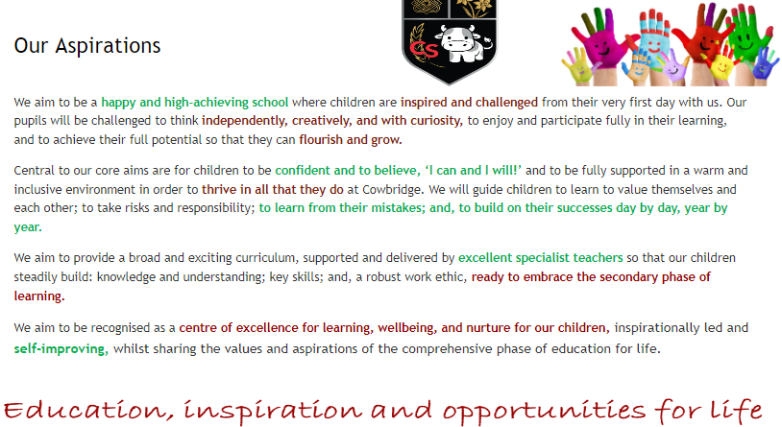

Appendix 3
Social Interaction Group
You have now had the chance to spend a term playing with and building some well-made constructions with Lego. You have worked in small groups listening to and communicating with other pupils in the group as a way of building the shapes requested. You may have been an engineer, a builder, a supplier or even the director, at some point? We hope that you have valued the sessions so far?
The purpose of the group is not only to allow you to take part in building, but also to allow us to help support you in building your social communication skills with other pupils in school and with other people in the wider community.
In order to see if the project is working, please be kind enough to answer the following questions which will help us see if it helpful to you (and us) in making you into ambitious, capable, creative and confident pupils both in and out of the classroom?
You do not have to answer the questions if you do not wish to do so and if you do help with your answers then you will remain anonymous (in other words I will not know who has said what in the answers).

- Have you enjoyed taking part in the Lego sessions?
- Which, if any, of the following skills do you feel you have learned or improved so far (please choose as many as you like)?
- After taking part in the sessions, do you now feel more confident in communicating to your friends?
- If you answered yes to the above question, why do you feel more confident?
- Could you rate your confidence level before the sessions, 1= not at all, 5 = extremely confident?
- Could you rate your confidence level after the sessions, 1= not at all, 5 = extremely confident?
- Would you recommend taking part in this project to your friends?
- What other activities would you like to see in the second part of the sessions? e.g more complex Lego builds, board games, interactive games, team building activities etc?
- What else do you think the school can do to improve your wellbeing?
- Do you feel that taking part in the programme has improved your opinion about school? 1-10
This section is about self-development, more particularly about developing positive social relationships, developing self-regulation, improving oracy skills, positive social relationships and improving confidence.
- After taking part in the sessions, do you now feel more confident in communicating to your friends?
- After taking part in the sessions, do you now feel that you have developed stronger relationships with your friends?
- After taking part in the sessions, do you now feel more able to better express yourself orally?
- Self-regulation - After taking part in the sessions do you feel that you have improved your ability at working with others in a group situation? Are you better able to abide by the rules of an organised group activity and interact and co-operate with more success?
Is there anything you wanted to add that would help us support you and your peers in school and make them better

Appendix 4
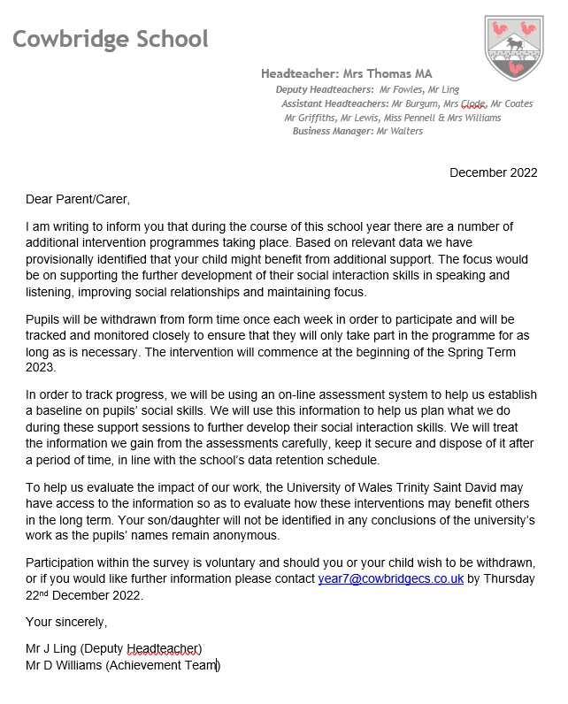

Appendix 5



