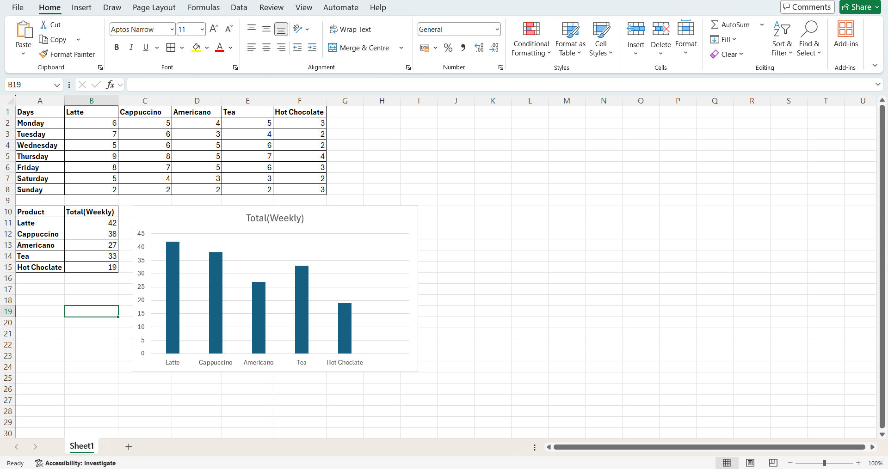
Evaluation log:
For this task, I created an Excel spreadsheet to show the weekly sales for Valley Coffee Co. I decided to use Excel because it is good for organising numbers and making charts. It is so much easier to see the information clearly in a table than just reading it from an email. Excel also lets me add up the totals and create a chart, which helps show the results clearer. I also read a guide from Microsoft Support that also vouches for how easy and quick Excel is to use.

The information I used came from the email that Mr.Habib sent. It includes the sales for five different products from Monday through Sunday. The products were Latte, Cappuccino, Americano, Tea and Hot Chocolate. I copied all the sales figures into a table in Excel, making sure each product and each day was in the correct place. I checked the numbers carefully because if I entered a number incorrectly, the totals would not be right.
After I entered the data, I worked out the total sales for each product by adding together the sales from every day of the week. This helped me answer the two questions from the scenario, which were to find out which product sold the most and which sold the least. I found that the Latte sold most with 42 sales, while Hot Chocolate sold the least with 19 sales.
Once I had the totals, I created a bar chart to display them. At first, I was only going to use the table, but I realised that a chart would make the information much easier to understand. Instead of reading lots of numbers, Mr.Habib can look at the chart and quickly compare the products. I also gave the chart a title so it was clear what showed.
While I was working, I made a few changes to improve my report. I first entered all the daily sales into one table, but then I added another small table showing the weekly totals. I thought this would make it easier for the owner to see the results without having to add the numbers himself. I also adjusted the chart, so it only showed the total sales for each product instead of all the daily sales, because that answered the questions more clearly.

I also spent some time making the spreadsheet look tidy. I made the headings stand out and organised everything, so it was easy to read. I kept the layout simple because I wanted the report to be clear rather than crowd with too much information. I think this makes it more useful for someone who just wants a quick overview of the week’s sales.
I think my final report meets the client’s needs because it clearly answers the questions that were asked. It shows which product sold the most and which sold the least, and the chart helps explain the results easy. The information is organised in a way that is easy to follow, and the totals are clearly displayed.
If I had more time, I would improve the report by adding more formatting, such as using colours to highlight the highest and lowest- selling products. I could also use formulas so the totals would update automatically if new sales were entered. Another improvement would be to add a second chart showing sales for each day of the week so the owner could see which days were busiest.
Overall, I am happy with my work because it is accurate, easy to understand and answers everything that Mr.Habib asked for. I think using Excel was the right choice because it allowed me to organise the data, calculate the totals and present the information in a clear and simple way.

