Module Name: Integrating Project
Student Name: Adrian Dulgheru
Student ID: 2231314
Abstract
This project has aimed to focus on the importance of the integrity of a project. The aims as well as the objectives of this project have been outlined in this project. The overview of the project has been shown in this project. A literature review on this project has been showcased in this project. The literature review has aimed to focus on the objectives of this project. A methodology such as the approach of research, strategies as well as method(s) has been shown in this project. The methodology has been done to justify the collected data for this project.

Table of Contents
Introduction 4
Overview 5
Aims 5
Objectives 5
Literature Review 6
Methodology 8
Conclusion 12
References 13

Introduction
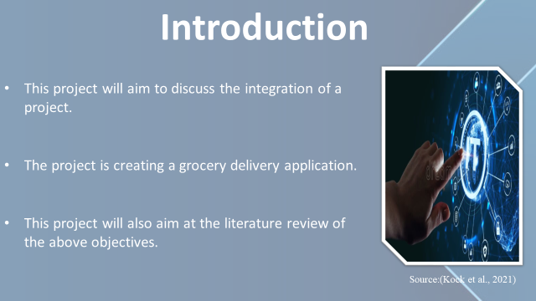
This project will aim to discuss the integration of a project. The project is creating a grocery delivery application. The objectives of the project will be outlined in this project. The first objective such as the identification of the impact of online shopping will be described in this project. The project will aim to emphasise the second objective such as the evaluation of the importance of time management through online shopping. The understanding of the importance of digital media in everyday life as the third objective will be described in this project.
This project will also aim at the literature review of the above objectives. The objectives will be discussed in this literature review portion of this project. A literature gap will also be emphasised in this project. A methodology will also be used to justify the data collected. This project will aim to tell us that the research is essential for development of a good grocery delivery application.

Overview
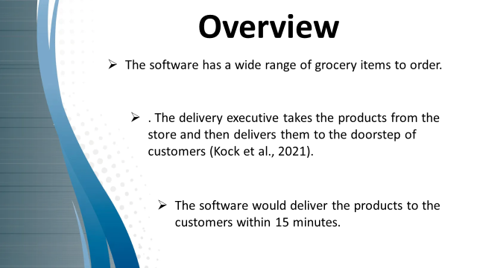
Android-based grocery shopping is a type of application that helps common people buy grocery products from their homes through that application. The interface of the software is a very user-friendly and attractive graphical interface. This helps customers to understand the software properly and order their grocery items. The software has a wide range of grocery items to order. It helps the customers to choose their products from the same application and order them easily. The software would deliver the products to the customers within 15 minutes. The application first notes the demands of the customers and confirms the order after checking the availability. After that, the application sends the order to the nearest stores situated nearest to the customer, 's address. The application then sends a notification to the nearest delivery partner available. The delivery executive takes the products from the store and then delivers them to the doorstep of customers (Kock et al., 2021).

Aims
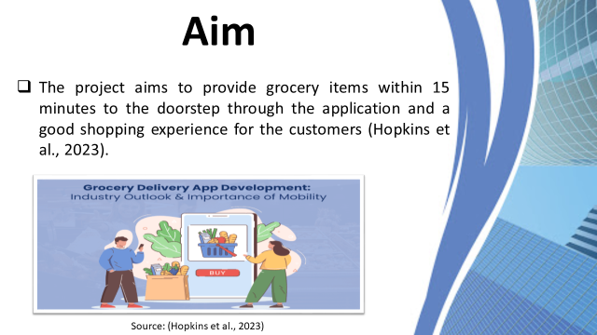
The project aims to provide grocery items within 15 minutes to the doorstep through the application and a good shopping experience for the customers (Hopkins et al., 2023).

Objectives
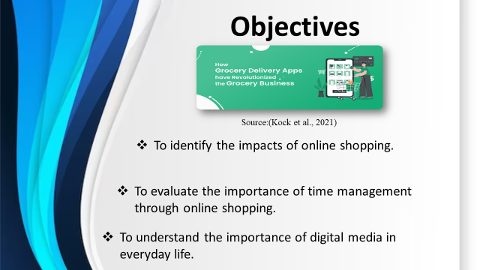
- To identify the impacts of online shopping.
- To evaluate the importance of time management through online shopping.
- To understand the importance of digital media in everyday life.

Literature Review
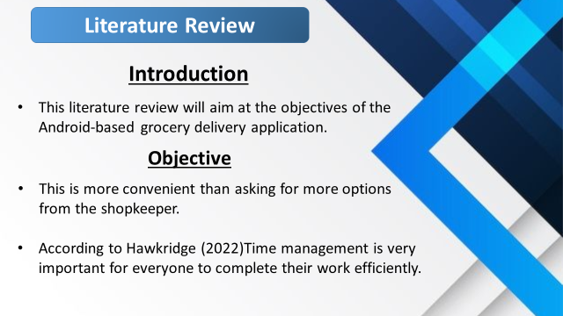
Introduction
This literature review will aim at the objectives of the Android-based grocery delivery application. The objective of the application is to deliver grocery items to the doorstep of customers within 15 minutes will be discussed in this literature review. The evaluation of the importance of time management will be discussed in this literature review. The impotence of understanding the importance of digital media in everyday life will be discussed in this literature review. A literature gap will be discussed in this literature review. This literature review will aim to discuss the importance of the application in the everyday life of people.
Objective
According to Hawkridge (2022), the objective of this grocery delivery application is to identify the impacts of online shopping. Online shopping is very common in recent days. Online shopping has a huge impact on the shopping experience of customers. Online shopping is more convenient than the regular shopping style. Customers can see all the other options of a product and compare them to order the right product. This is more convenient than asking for more options from the shopkeeper. Online shopping also impacts the price comparison of products. Customers can easily compare the prices as they can see the prices of the products in one application. It helps customers to get the best price for products. Online shopping also helps customers to privatise their shopping. Online shopping gives the option to customers to choose their demanded product without knowing the others. It helps customers to order their product easily as well as without tension.
Objective
The second objective of this project is to evaluate the importance of time management through online shopping. According to Hawkridge (2022), online shopping helps customers save time as they can order grocery items from home and get the ordered products within 15 minutes to the doorstep. This can help customers to save time as well as manage their time for other important works of everyday life. Time management is very important for everyone to complete their work efficiently. Online shopping provides time to the customers and it helps customers to utilise this time to good effect. Online shopping assists in managing time with customers as regular shopping style needs customers to shop. It can take time to go to shop and buy products whereas online shopping saves time for customers. Time is very important for everybody as time cannot be held and time is very important to finish everyday work properly.
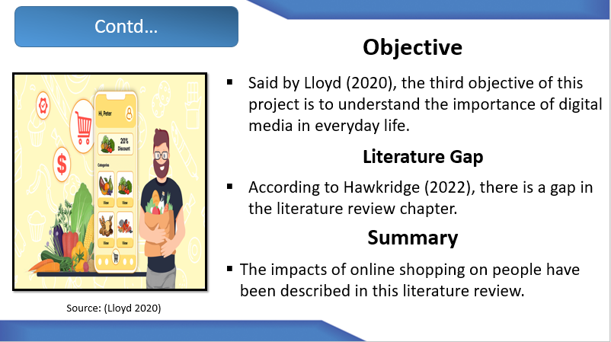
Objective
Said by Lloyd (2020), the third objective of this project is to understand the importance of digital media in everyday life. Digital media is very important for personal life in recent days. Digital media helps professionals to provide communicative information to the people using the internet. It also helps people in making orders as well as entertainment. Digital media is very important for people to maintain their everyday lives in recent days.
Literature Gap
According to Hawkridge (2022), there is a gap in the literature review chapter. In this chapter, there is a gap in discussing the impacts of online shopping. It is discussed that online shopping has positive impacts on people or customers. Whereas, online shopping also has some negative impacts. Said by Lloyd (2020), there is a risk of fraud in online shopping as the customers cannot see the products with their eyes. One of the disadvantages of online shopping is that local retailers do not get any support as customers do not go to local retailers. This can affect the economic condition of local retailers as well as create a chance for the enhancement of crime.
Summary
The literature review has aimed to discuss the objectives of creating an online grocery shopping application. The impacts of online shopping on people have been described in this literature review. The importance such as comparison of prices, convenience of customers and many more have been discussed. This literature review has emphasised the evaluation of the importance of time management through online shopping. The understanding of the importance of digital media in everyday life has been discussed in this literature review. This literature review has also outlined the literature gap such as the negative impact of online shopping in our society.

Methodology
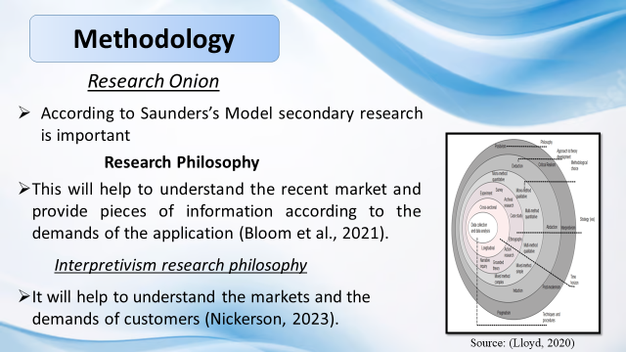
Research Onion
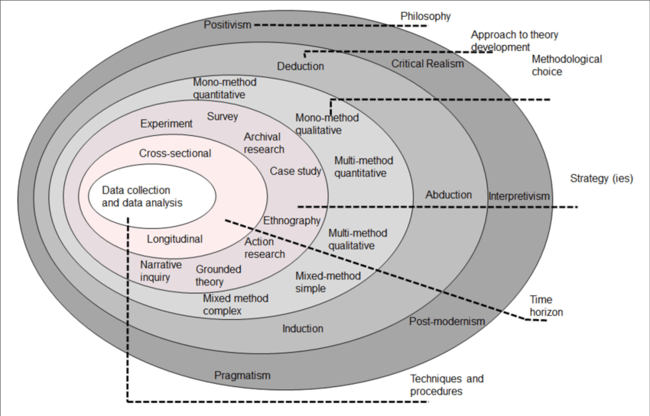
Source: (Lloyd, 2020)
According to Saunders’s Model secondary research is important. In Secondary research, the peeling of layers of the project will be done. The pilling method will start with a psychological stance and work towards the participles of data collection. In this project, the research will start from the findings of grocery retailers and after that work on the collection of data. The recent data will be collected from 2019 to 2024 to analyse the target market (Bloom et al., 2021).
Research Philosophy
The belief in the method of collection of data about a phenomenon is called research psychology. The idea of a collection of data will be done through interpretivism research philosophy. The data will be collected on recent times and the analysis of data of the target market. This will help to understand the recent market and provide pieces of information according to the demands of the application (Bloom et al., 2021).
Interpretivism research philosophy
The assumption that the reality is personal, multiple as well as socially constructed is called interpretivism. This research physiology is related to secondary research as secondary research as secondary research is conducted based on the studies conducted by others. It is also related to the project as the collection of recent data will happen on the studies of others. It will help to understand the markets and the demands of customers (Nickerson, 2023).
Research approach
The plan as well as the procedures for research is called the research approach. It starts from the span of the steps from broad assumptions to the method of collecting data, interpretation as well as analysis. An inductive approach will be used for research. This approach will begin with collecting the relevant data for the research study. This approach is relatable to the secondary research method. It is also relatable to the project as a collection of the relatable data will help to modify the application. The collection of data is very important for creating an application that is user-friendly. The project also needs relatable data to analyse them and give a service that is useful for people. The inductive approach will also help in collecting data of the local retailers as local retailers are essential for delivering grocery items in 15 minutes. The collection of data regarding delivery executives is also important for delivering the items to the doorstep of customers (Bloom et al., 2021).
Research Strategy
The plan of research activities and achievement of goals is called the research strategy. It will help in clarifying the questions of research, identification of sources, communication as well as organisation of data. The strategy for the collection of data will be a secondary quantitative strategy. It relates to secondary research as secondary research belongs to the collection of data from other works. It will also relate to this project. This strategy will help to collect data and analyse those data for the fulfilment of the project. The analysis of secondary data will help to form the grocery delivery application. It will help to know the market rates and create applications according to the rate (Maclnnes, 2020).
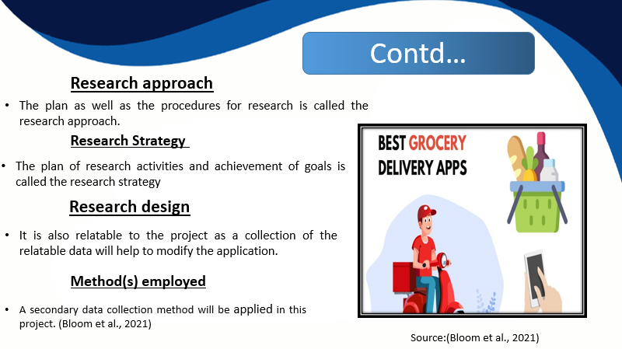
Research design
The strategy of answering the questions of research with the help of observed data is called research design. Creation of design of research aimed at the solution. Exploratory research design will be applicable as research design. It is related to secondary research as secondary research is also done by the information of others. This design is also related to the project. This design helps to analyse the data that are not been previously analysed in depth. This will help to develop the grocery delivery application. It will also help to analyse those data not analysed critically by other builders of the same kind of application. It will help to develop that is more comfortable for customers. It will help in attracting customers and develop the brand value of the application (Voxco, 2021).
Method(s) employed
The method employed is the implication of methods that are accepted according to a method. It includes the implication of a specific technique or process for achieving the desired outcome. A secondary data collection method will be applied in this project. It relates to the secondary method of research as this type of research is done on the data collected by somebody else. It is also relatable to this project as this project also needs data from somebody else. It will help to know the demands of customers and develop applications according to data. It will also help to know the demands of grocery retailers as it is very important for the development of the project as well as connecting with the local grocery retailers (Walsh and Bokhove, 2021).

Conclusion
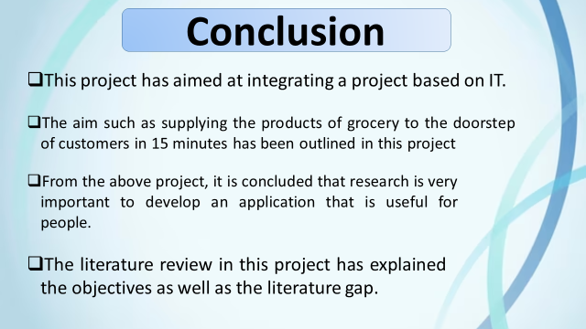
This project has aimed at integrating a project based on IT. The aims and objectives of this project have been discussed in this project. The aim such as supplying the products of grocery to the doorstep of customers in 15 minutes has been outlined in this project. The first objective such as the identification of impacts of online shopping has been emphasised in this project. The second objective such as the evaluation of the importance of time management through online shopping has been described in this report. Further, this project has aimed at the discussion of the third objective such as understanding the importance of digital media in everyday life.
This project has aimed at the literature review on the above-mentioned objectives of this project. The literature review in this project has explained the objectives as well as the literature gap. The literature gap such as the negative impacts of online shopping has been explained in this project. A methodology has been used in this project to justify the collected data for future development of the grocery delivery application. From the above project, it is concluded that research is very important to develop an application that is useful for people

References
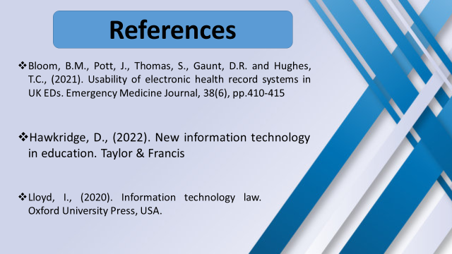
Bloom, B.M., Pott, J., Thomas, S., Gaunt, D.R. and Hughes, T.C., (2021). Usability of electronic health record systems in UK EDs. Emergency Medicine Journal, 38(6), pp.410-415.
Hawkridge, D., (2022). New information technology in education. Taylor & Francis.
Hopkins, A., Hohman, F., Zappella, L., Cuadros, X.S. and Moritz, D., (2023). Designing data: Proactive data collection and iteration for machine learning. arXiv preprint arXiv:2301.10319.
Iacovidou, E., Purnell, P., Tsavdaridis, K.D. and Poologanathan, K., (2021). Digitally enabled modular construction for promoting modular components reuse: A UK view. Journal of Building Engineering, 42, p.102820.
Kock, F., Berbekova, A. and Assaf, A.G., (2021). Understanding and managing the threat of common method bias: Detection, prevention and control. Tourism Management, 86, p.104330.
Linnenluecke, M.K., Marrone, M. and Singh, A.K., (2020). Conducting systematic literature reviews and bibliometric analyses. Australian Journal of Management, 45(2), pp.175-194.
Lloyd, I., (2020). Information technology law. Oxford University Press, USA.
Maclnnes, J., (2020). Sage Research Methods. [Online] Available at: https://methods-sagepub-com-christuniversity.knimbus.com/foundations/secondary-analysis-of-quantitative-data[Accessed 10 01 2024].
Nickerson, C., (2023). Interpretivism Paradigm & Research Philosophy. [Online] Available at: https://simplysociology.com/interpretivism-paradigm.html [Accessed 10 01 2024].
Voxco, (2021). What is Exploratory Research?. [Online] Available at: https://www.voxco.com/blog/what-is-exploratory-research/ [Accessed 10 01 2024].
Walsh, C. and Bokhove, C., (2021). Targeting data collection in games based assessment. Computers and Education Open, 2, p.100054.
Watermeyer, R., Crick, T., Knight, C. and Goodall, J., (2021). COVID-19 and digital disruption in UK universities: Afflictions and affordances of emergency online migration. Higher education, 81, pp.623-641.

