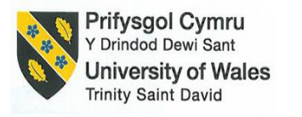

School of Hospitality & Tourism Management
BA International Hotel Management
Module Handbook Winter Term 2023
BMIH5007
Financial Management for the Hotel Industry
LEVEL 5
Word Count: 2197

Student Id: 2128001
Student Name: Laura Lupoae
Module: BMIH5007 Financial Management
Lecturer: Tristan Hawkins

Submission Date: 1st March 2024

Executive Summary
This research examines the financial management strategies and practices of two major companies in the hospitality industry—Mandarin Oriental Hotel Group and Premier Inn—and draws comparisons between the two. Revenue, market share, growth potential, and CSR spending are only a few of the important metrics included in this analysis.
According to the total revenue comparison between hotels and their financial report analysis, MOHG has a greater average revenue per hotel, more revenue streams, and greater worldwide exposure than Premier Inn. According to the data, MOHG has a more competitive and wider business model than Premier Inn, which relies primarily on the UK market. This paper examines the market positions of two hotel chains, Mandarin Oriental and Premier Inn, in the global hotel industry. It demonstrates that Mandarin Oriental is a luxury hotel brand that caters to high-end consumers, whereas Premier Inn is a budget hotel brand that serves a diverse variety of customers. It also demonstrates that Mandarin Oriental has a stronger foothold in Asia, whilst Premier Inn has a dominant position in the UK.
This paper looks at the obstacles and potential for two hotel chains, Premier Inn and Mandarin Oriental Hotel Group, in a global market. It demonstrates that both hotels face economic, political, and social constraints, but they also have room to grow by adjusting to client needs and increasing their reach. It shows that the two hotel chains, Mandarin Oriental and Premier Inn, are pursuing CSR activities to become more responsible and engaged in society. It says that Premier Inn can improve its CSR image by implementing a thorough strategy and forming a connection with local communities.
It also offers suggestions for two hotel brands, Mandarin Oriental and Premier Inn, to upgrade their financial management in a variety of ways. It demonstrates that Mandarin Oriental may boost income by providing more appealing services to its consumers, but Premier Inn can reduce costs by embracing more efficient processes. Furthermore, it demonstrates how both hotels may develop better financial planning and analysis by leveraging data analytics and business intelligence solutions.

Table of Contents
Executive Summary i
Introduction 1
Comparison of the Hotels in Key Area Consideration 2
Total Revenue 2
Market Position 3
Growth Potential 5
Financial Commitment to CSR 6
Conclusion & Recommendation. 8
Recommendations 8
Conclusion 9
Reference 10
Appendix 15
Appendix-A: Consolidated Statement of Profit and Loss for 2021 of MOLH 15
Appendix-B: Consolidated Balance Sheet for 2021 of MOLH 16
Appendix-C: Five-Year Summary of Consolidated Income Statement MOLH 17
Appendix-D: Five-Year Summary of Consolidated Balance Sheet of MOLH 17
Appendix-E: Consolidated Income Statement of Premier Inn in 2021 18
Appendix-F: Consolidated Balance Sheet of Premier Inn for 2021 19

Introduction
This study examines the financial management strategies and practices of two major hotel chains—the Mandarin Oriental Hotel Group and Premier Inn—to better understand the hospitality sector as a whole. This research hopes to provide useful information on the current and future financial stability of these well-known hospitality behemoths by reasoning important indicators, including total revenue, market position, growth potential, and CSR pledges. We can better comprehend the differences between Mandarin Oriental and Premier Inn, by their emphasis on luxurious grandeur and Premier Inn's focus on pricing. In addition, we will provide suggestions tailored to each hotel, indicating avenues for future growth.

Comparison of the Hotels in Key Area Consideration

Total Revenue
MOLH generated revenue from management and branding activities amounted to $46.4 million, or 9.0%, of its total revenue in 2020 (Mandarin Oriental, 2022). According to their 2020 annual report, which is shown in the Appendix, MOLH generates money from three main sources: rooms, food and beverage, and other hotel operations. The report includes that their revenue originates from several locations, with Asia being the largest contributor, followed by Europe, the Middle East, Africa (EMEA), and the Americas.
MOLH's revenue has fluctuated in recent years, owing to the impact of the COVID-19 epidemic and the recovery of the travel market. The appendix illustrates MOLH's total revenue from 2017 to 2021, comprising affiliates and alliances. MOLH reported a significant underlying loss of US$118.7 million in 2020. As travel restrictions were lifted in some areas, MOLH's revenue recovered strongly in 2021 and 2022 (Frost, 2021). The Group generated an underlying profit of $15.4 million in 2021 and $68.9 million in 2022, demonstrating the stability and power of its brand and portfolio (Mandarin Oriental, 2023).
The revenue from Premier Inn's management and branding activities, whose fees totalled £46.0 million. However, according to their 2020/21 annual report, Premier Inn's revenue is divided into two categories: lodging and food and beverage. Room sales are Premier Inn's primary source of profits, making up 86.5% of total revenue in 2022 (Kollewe, 2023). The remaining revenue came from food and beverage (9.8%), other lodging services (2.4%), and other revenues (1.3%). Despite the hurdles of the COVID-19 epidemic and a competitive market, revenue has gradually increased in recent years. Premier Inn's income returned sharply in 2021 and 2022, with occupancy rates rising to 65.7% and 75.4%, respectively (Sweney, 2023).
The total revenue comparison from the financial Statement of 2021 indicates that MOHG's average revenue per hotel was $41.3 million, whereas Premier Inn's average revenue was $2.55 million. This implies that MOHG has more options to cross-sell and upsell its products and services to clients than Premier Inn, and it is less reliant on a single category for revenue. MOHG earns a bigger percentage of its revenue from overseas markets than Premier Inn. Based on the number of hotels, it is appropriate to believe that MOHG has a more diversified and broad global revenue distribution compared with Premier Inn, which remains primarily a UK-based brand.

Market Position
Mandarin Oriental's market positioning is built around its distinct brand identity, which mixes Asian heritage, contemporary design, and great service. It uses its dedicated customer base, excellent reputation, and smart alliances to increase brand value and awareness (Dhuri, 2023). According to Bowman's Strategy Clock, which helps in analysing competitive edge and potential approaches based on two dimensions: price and perceived value (Bhasin, 2019), Mandarin Oriental's hotels fall into the following categories:
- Focused differentiation: Mandarin Oriental's hotels are distinguished by their prime location, distinctive design, unique amenities and services, and ability to respond to special customer demands (StrategyPuke, 2023). These segments are developing an effective brand identity, a dedicated client base, and a distinct value proposition.
- Differentiation: Mandarin Oriental hotels have a competitive advantage in quality, innovation, and consumer endorsement.
- Hybrid: Mandarin Oriental's hotels aim to provide medium-value and medium-price products and services to many customers. The hotels in emerging markets are efficient and cater to general customer needs by balancing efficiency and differentiation (Roll, 2020).
Mandarin Oriental accounts for 0.2% of the worldwide upscale hotel market, which is predicted to be worth $700 billion. Although it has a limited market share compared to its competitors, it is well-represented in Asia, accounting for more than half of its portfolio (LSEG, 2023). Their target consumers are affluent on a specific segment of clients who are Business travellers, leisure travellers, Loyal fans, and VIPs who are drawn to the brand because they value consistency, familiarity, recognition, convenience, efficiency, and appreciation of high-quality services and cherish unique and personalised trips (Marketline, 2023). It is well-known for its Fan Campaign, in which major celebrities endorse the company. MOLH also has a solid reputation and strategic agreements with other top brands, including American Express, Forbes Travel Guide, and Lufthansa.
Premier Inn's market positioning is centred on its value promise of providing consistent, high-quality, and reasonably priced service to its guests. It also uses its great brand awareness, reputation, and loyalty to increase brand value and recognition (Innes, 2023). Using Bowman's Strategy Clock, Premier Inn hotels are only classified as Hybrid. This means that Premier Inn hotels provide medium-value and medium-priced products and services to their niche market, striking a balance between cost efficiency and distinctiveness (Gilliland, 2017).
Premier Inn accounts for 0.3% of the international hotel industry and 12% of the hotel market share in the UK (Price, 2021). Premier Inn is the UK's largest hotel brand, having a presence in other countries, including Ireland, Germany, and the UAE. Premier Inn's target consumers include both business and leisure travellers who value convenience, comfort, and dependability (Stephenson, 2023). According to customer segmentation research conducted by Big Difference Marketing, Premier Inn customers can be classified into four groups depending on their value and behaviour. These are high-value business travellers, high-value, low-value business, and low-value leisure travellers. These demographic segments value simplicity, cost efficiency, relaxation, and flexibility (Rahman, 2023). Premier Inn has a strong brand identity that is built around its value proposition of providing consistent, high-quality, and inexpensive service to its clients. It is widely regarded as one of the UK's most popular and reputable hotel brands for its quality, innovation, and customer happiness. Premier Inn also has a solid reputation and strategic agreements with other major companies, like Whitbread, Costa Coffee, and Tesco Clubcard (Strudley, 2022).
Based on the analysis, it is clear that Mandarin Oriental and Premier Inn hold different market positions in the global hotel business. Mandarin Oriental is a premium hotel brand that caters to affluent and sophisticated guests by offering extravagant amenities. Premier Inn is a value hotel brand that provides medium-value and medium-priced amenities to a broad spectrum of both business and leisure travellers. Mandarin Oriental competes on distinction, whilst Premier Inn focuses on cost-efficiency. Mandarin Oriental has a smaller market share than Premier Inn but a better presence in Asia. Premier Inn has a larger market share than Mandarin Oriental but is superior in the United Kingdom.

Growth Potential
The expansion of Mandarin Oriental Hotel Group's operations in strategic international markets, including the United States at the heart of the company's long-term development plan (Rahman et. al. 2021). The company's established track record of exceptional hospitality and innovative amenities will be invaluable to the success of this venture (Wibisono et al., 2023).
Premier Inn's success in the UK may be attributed to the company's dedication to providing high-quality, reasonably priced, and technologically advanced services. They are well-established at home but may benefit from branching out into other markets that provide something comparable to lessen their reliance on any one sector (Sigala, 2020).
One way they might expand is by improving their online profile. The significance of online booking, mobile applications, and consistent digital experiences is growing as customers' tastes shift (Mimaki et al., 2022). Implementing stringent cleaning and sanitation practices and providing accommodating cancellation rules are two examples of post-COVID practices (Winter, 2021).
Both hotels have tremendous market opportunities in different geographical positions like Africa, the Middle East and Latin America as luxury and value-for-money travel demands are increasing (Jennings, 2018). Both brands could use technology to provide more personalized and tailored experiences for each guest on each visit and biometrics to understand guest preferences alongside customized recommendations, offers, and services (Luxury Hotels, 2022). Offering subscription and membership options allows guests to access their hotels and services for a set charge or at a reduced rate, resulting in a loyal client base and recurring revenue. Also, it offers hybrid and multipurpose areas and services that serve many demands and purposes (Yoong, 2023).
Both hotels will face some growth barriers regarding economic, political, and social circumstances like fluctuation and recessions in the money market, causing a slowdown of the business; trade wars, tariffs, sanctions, and travel bans may create political crises, and Environmental sustainability and social norms might affect expansion (Duetto, 2016). In sum, both Premier Inn and Mandarin Oriental Hotel Group have tremendous development prospects in distinct market niches (MOF, 2021). Premier Inn can maintain its momentum by exploring growing areas, strengthening its digital presence, and being sensitive to shifting customer tastes, while Mandarin Oriental can thrive by expanding into major global markets and adopting sustainable practices.

Financial Commitment to CSR
Mandarin Oriental Hotel Group exemplifies a deep dedication to CSR through Sustainable initiatives. They have invested in energy efficiency, renewable energy, and carbon offset initiatives to reduce greenhouse gas emissions and reach carbon neutrality by 2050 (MandarinOriental, 2022). It has also donated to several charities, causes, and organisations that promote health, education, the environment, and culture, including UNICEF, the Red Cross, the World Wildlife Fund, and UNESCO. They help local SMEs by sourcing, hiring, and participating in community service and outreach programs (SustainCase, 2018). They provide opportunities for training and development to their employees while also supporting diversity and inclusion, health and safety, and human rights in the workplace. However, reporting on these CSR efforts may be more open and transparent. Better reporting can inform stakeholders of the impact of their involvement and the results they've helped produce (Davies et al., 2023).
Premier Inn embraces the values of its employees, communities and world as it wants to portray itself as a responsible company. It has invested in renewable energy efficiency, biofuel and carbon offsetting projects to lower its carbon impact. Premier Inn has pledged to reach net zero carbon emissions by 2040, ten years ahead of the UK government's aim (PremierInn, 2019). It has donated excess food to local organisations and communities, as well as being a support to the work of Great Ormond Street Hospital.
It may expand its sustainability reporting and disclosure to promote transparency, accountability, and stakeholder engagement on ESG performance and impact to meet global standards and frameworks such as GRI, TCFD, and SDGs. Premier Inn may reuse, repair, refurbish, or recycle its furniture, linen, toiletries, and other materials, as well as collaborate with suppliers and partners to develop products and services that minimise pollution and harmful emissions (Neuenburg, 2022). It may work with electric vehicle suppliers, rent bikes, provide organic or fair-trade products, allow guests to offset their carbon impact, and reward those who choose to reuse towels or skip housekeeping.
In conclusion, both the Mandarin Oriental Hotel Group and Premier Inn are making efforts in CSR, displaying a more comprehensive commitment to sustainability and community participation (Sithole, 2021). Premier Inn can strengthen its CSR reputation by implementing a holistic plan and actively interacting with local communities.

Conclusion & Recommendation.

Recommendations
To maintain their competitive advantage and assure future development, we suggest that both organizations diversify their income sources, speed up their sustainability initiatives, and increase their market presence. In addition, a greater dedication to CSR, with an emphasis on transparency and community participation, may improve a company's reputation and ring true with ecologically and socially sensitive customers (Huang et al., 2022). Some possible specific ideas for Mandarin Oriental Luxury Hotels and Premier Inn to improve their financial management include:
- Expanding its sources of income by providing offers that correspond to its target consumers' requirements and interests, such as wellness programs, local cuisine, and VIP access may help Mandarin Oriental. This would significantly enhance customer loyalty, satisfaction, and retention while also increasing average revenue per guest.
- Premier Inn may save costs by using efficient operations including energy efficiency, garbage management, and online booking. This would increase its profits, cash flow, and return on investment.
- Both brands can improve their financial planning and analysis by implementing data analytics and business intelligence technologies that provide more accurate and timely insights into their financial performance and impact, such as revenue, expenses, cash flow, profitability, and ESG measures.

Conclusion
To sum up, hotels like the Mandarin Oriental and budget chains like Premier Inn show that the hospitality business is vast and varied. Premier Inn aims at budget-conscious customers, with a focus on price and dependability, whereas Mandarin Oriental targets discriminating luxury tourists with an emphasis on sustainability and individualized care. Both businesses are quite financially stable, yet they serve different niches (Casado-Aranda, et al. 2021). To thrive in the ever-changing hospitality business, companies like Mandarin Oriental Hotel Group and Premier Inn will need to be flexible and creative to fulfil the changing demands of their customers.

Reference
Casado-Aranda, L.A., Sánchez-Fernández, J., & Bastidas-Manzano, A.B. (2021). Tourism research after the COVID-19 outbreak: Insights for more sustainable, local and smart cities. Sustainable Cities and Society, 73, 103126.
Davies, K., Gouthro, M.B., Matthews, N., & Richards, V. (2023). Festival Participation, Inclusion and Poverty: An Exploratory Study. Tourism and Hospitality, 4(1), 51-74.
Huang, W., Saydaliev, H.B., Iqbal, W., & Irfan, M. (2022). Measuring the impact of economic policies on Co2 emissions: ways to achieve green economic recovery in the post-COVID-19 era. Climate Change Economics, 13(03), 2240010.
Mimaki, C.A., Darma, G.S., Widhiasthini, N.W., & Basmantra, I.N. (2022). Predicting post-COVID-19 tourist's loyalty: will they come back and recommend? International Journal of Tourism Policy, 12(1), 1-23.
Rahman, M.K., Gazi, M.A.I., Bhuiyan, M.A., & Rahaman, M.A. (2021). Effect of Covid-19 pandemic on tourist travel risk and management perceptions. Plos one, 16(9), e0256486.
Sigala, M. (2020). Tourism and COVID-19: Impacts and implications for advancing and resetting industry and research. Journal of Business Research, 117, 312-321.
Sithole, N., Giampiccoli, A., & Jugmohan, S. (2021). Towards a spontaneous community participation model in community-based tourism. African Journal of Hospitality, Tourism and Leisure, 10(1), 222-237.
Wibisono, N., Rafdinal, W., Setiawati, L., & Senalasari, W. (2023). Predicting the Adoption of Virtual Reality Tourism in the Post-COVID-19 Pandemic Era. African J. Hosp. Tour. Leis, 12, 239-256.
Winter, T., & Kim, S. (2021). Exploring the relationship between tourism and poverty using the capability approach. Journal of sustainable tourism, 29(10), 1655-1673.
Frost, R. (2021) Covid-19 Hotel Development Analysis: Mandarin Oriental Hotel Group [infographic], THP News. Available at: https://tophotel.news/covid19-hotel-development-analysis-mandarin-oriental-hotel-group-infographic/ (Accessed: 20 February 2024).
Kollewe, J. (2023) Premier inn room rates soar as Budget Hotel Era 'evaporates', The Guardian. Available at: https://www.theguardian.com/business/2023/jun/22/premier-inn-profits-buoyed-by-king-charles-coronation (Accessed: 20 February 2024).
Mandarin Oriental (2022) Mandarin Oriental International : 2021 annual results presentation, MarketScreener. Available at: https://www.marketscreener.com/quote/stock/MANDARIN-ORIENTAL-INTERNA-6491070/news/Mandarin-Oriental-International-2021-Annual-Results-Presentation-39649141/ (Accessed: 20 February 2024).
Mandarin Oriental (2023) Mandarin Oriental International : 2022 annual results presentation, MarketScreener. Available at: https://www.marketscreener.com/quote/stock/MANDARIN-ORIENTAL-INTERNA-6491070/news/Mandarin-Oriental-International-2022-Annual-Results-Presentation-43134572/ (Accessed: 20 February 2024).
Sweney, M. (2023) Premier Inn owner surpasses pre-covid profits as travellers seek deals, The Guardian. Available at: https://www.theguardian.com/business/2023/apr/25/premier-inn-whitbread-pre-covid-profits-deals (Accessed: 20 February 2024).
Bhasin, H. (2019) What is Bowman's strategy clock? Marketing91. Available at: https://www.marketing91.com/what-is-bowmans-strategy-clock/ (Accessed: 20 February 2024).
Dhuri, P. (2023) The Mandarin Hotel Brand Story, Luxury Abode. Available at: https://www.luxuryabode.com/blog/the-mandarin-hotel-brand-story/artid2450 (Accessed: 20 February 2024).
LSEG (2023) Mandarin Oriental International Ltd, FT.com. Available at: https://markets.ft.com/data/equities/tearsheet/profile?s=M04%3ASES (Accessed: 20 February 2024).
Marketline (2023) Marketresearch.com, Market Research. Available at: https://www.marketresearch.com/MarketLine-v3883/Mandarin-Oriental-International-Strategy-SWOT-34553751/ Accessed: 20 February 2024).
Roll, M. (2020) Mandarin oriental - an iconic Asian luxury hotel brand, Martin Roll. Available at: https://martinroll.com/resources/articles/asia/mandarin-oriental-a-leading-asian-hospitality-brand/ (Accessed: 20 February 2024).
StrategyPunk (2023) Maximizing Competitive Advantage: An overview of Bowman's strategy clock (plus PPT), StrategyPunk. Available at: https://www.strategypunk.com/bowmans-strategy-clock-powerpoint-template/ (Accessed: 20 February 2024).
Gilliland, N. (2017) What makes Premier Inn the World's strongest hotel chain? Econsultancy. Available at: https://econsultancy.com/what-makes-premier-inn-the-world-s-strongest-hotel-chain/ (Accessed: 20 February 2024).
Innes, M. (2023) Premier Inn credits brand investment for helping it become 'one of the UK's favourite brands', Marketing Week. Available at: https://www.marketingweek.com/premier-inn-credits-brand-investment-for-helping-it-become-one-of-the-uks-favourite-brands/ (Accessed: 20 February 2024).
Price, K. (2021) Whitbread reports market share gains despite..., The Caterer. Available at: https://www.thecaterer.com/news/whitbread-market-share-gains-q3-2020 (Accessed: 20 February 2024).
Rahman, M. (2023) Marketing mix of Premier Inn (7ps of Premier Inn), www.howandwhat.net. Available at: https://www.howandwhat.net/marketing-mix-premier-inn/ (Accessed: 20 February 2024).
Stephenson, J. (2023) Premier Inn owner hails brand marketing a 'powerful tool', Marketing Week. Available at: https://www.marketingweek.com/premier-inn-marketing-powerful-tool/ (Accessed: 20 February 2024).
Strudley, C. (2022) Premier Inn: True love is knowing what you're getting, Savanta. Available at: https://savanta.com/knowledge-centre/view/premier-inn-true-love-is-knowing-what-youre-getting/ (Accessed: 20 February 2024).
Claar, S.K. (2021) Sustainability in the hospitality industry: Challenges and opportunities, Cornell SC Johnson. Available at: https://business.cornell.edu/hub/2021/10/06/sustainability-in-the-hospitality-industry-challenges-and-opportunities/ (Accessed: 20 February 2024).
Duetto (2016) 4 threats to Hotel Industry Growth, Duetto. Available at: https://www.duettocloud.com/library/4-threats-hotel-industry-growth (Accessed: 20 February 2024).
Jennings, S., Murali, R. and Schoenwaelder, T. (2018) The hotel of the future: New experiences, new opportunities: Deloitte Us, Deloitte United States. Available at: https://www2.deloitte.com/us/en/pages/consumer-business/articles/hotel-of-the-future.html (Accessed: 20 February 2024).
LuxuryHotel (2022) Luxury Hotel Industry Statistics: Luxury Hotel Market Share + more, LuxuryHotel. Available at: https://luxuryhotel.com/guides/luxury-hotel-statistics/ (Accessed: 20 February 2024).
MOF (2021) News & Views: Luxury Brand & Digital Agency: Matter of form, News & Views | Luxury Brand & Digital Agency | Matter Of Form. Available at: https://www.matterofform.com/news/articles/the-diversification-of-the-hospitality-industry (Accessed: 20 February 2024).
Yoong, K. (2023) Virtualization and diversification: Looking beyond the hotel bed, Hospitality News & Business Insights by EHL. Available at: https://hospitalityinsights.ehl.edu/virtualization-and-diversification-in-hotels (Accessed: 20 February 2024).
MandarinOriental (2022) Sustainability, Luxury 5 Star Hotels & Resorts Worldwide. Available at: https://www.mandarinoriental.com/en/our-company/sustainability (Accessed: 20 February 2024).
Neuenburg, J.-P. and Kowalewski, D. (2022) Sustainable growth in Hospitality, Accenture. Available at: https://www.accenture.com/us-en/insights/travel/sustainability-hospitality (Accessed: 20 February 2024).
PremierInn (2019) Net zero carbon emissions, Net zero carbon emissions | News | 2021 | Premier Inn. Available at: https://www.premierinn.com/gb/en/news/2021/net-zero-carbon-emissions.html (Accessed: 20 February 2024).
SustainCase (2018) Case study: How the Mandarin Oriental Hotel Group promotes ethical business conduct - sustain case - Sustainability Magazine, SustainCase. Available at: https://sustaincase.com/case-study-how-the-mandarin-oriental-hotel-group-ensures-ethical-business-conduct/ (Accessed: 20 February 2024).

Appendix

Appendix-A: Consolidated Statement of Profit and Loss for 2021 of MOLH
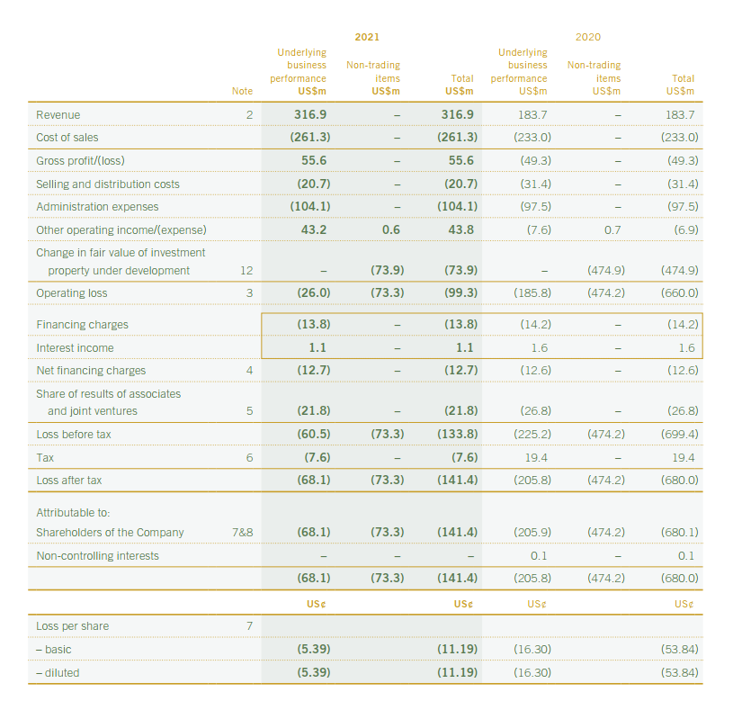

Appendix-B: Consolidated Balance Sheet for 2021 of MOLH
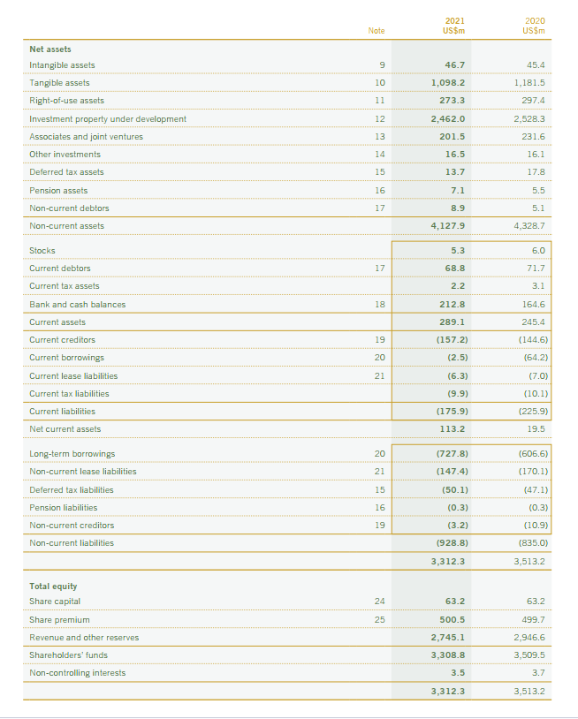

Appendix-C: Five-Year Summary of Consolidated Income Statement MOLH
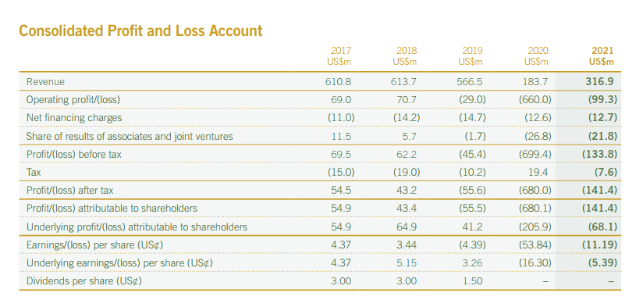

Appendix-D: Five-Year Summary of Consolidated Balance Sheet of MOLH
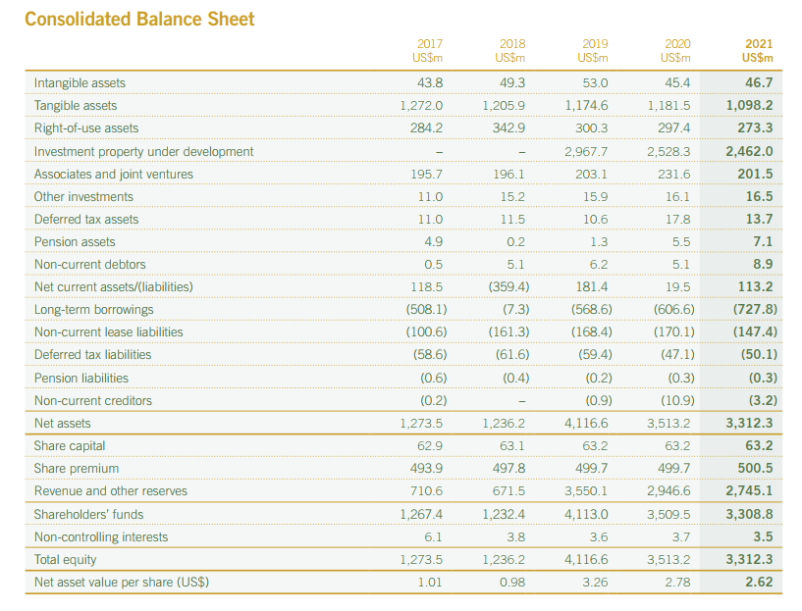

Appendix-E: Consolidated Income Statement of Premier Inn in 2021
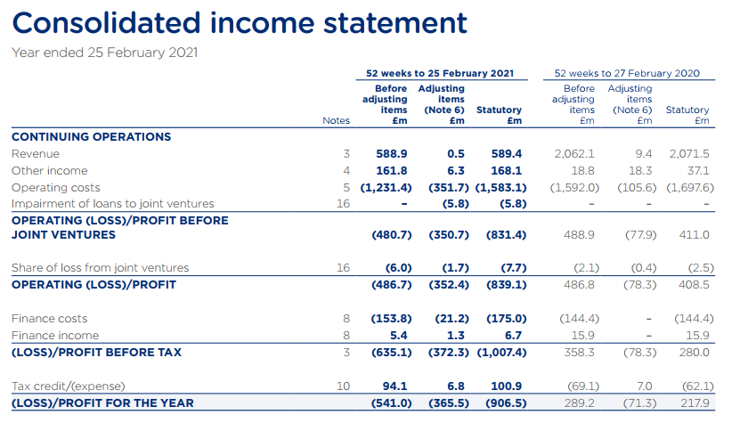

Appendix-F: Consolidated Balance Sheet of Premier Inn for 2021


