Synthesize a Solution to a Potential Real-Life Scenario: Internet of Things and Smart City Security Issues
Jordan Phillips
BSc (Hons) Computer Networks and Cybersecurity (Year 3)
University of Wales, Trinity Saint David
jphillips.147607@student.uwtsd.ac.uk

Abstract – Internet of Things (IoT) is continually advancing as various devices such as sensors and actuators, as well as internet protocols, i.e. IPv6, improve. Everyday more devices are incorporated into IoT with the introduction of Smart Homes, Campuses and Cities, and the University of Wales, Trinity Saint David (UWTSD) has recently built a new smart campus. This presents both new opportunities and problems and this report details a design to incorporate smart devices into the new campus infrastructure. For added physical security, devices such as motion sensors for light control, cameras and RFID locks were incorporated. Bring your own Device (BYOD) plays a role in the new campus, and therefore security policies will be implemented to ensure network security. Examples include encryption of data stored on personal devices and ACLs to limit user access to data depending on levels of access. Following the design phase, research found various security threats to smart cities such as Man-in-the-Middle, Spoofing, Flooding, Selective Forwarding and Denial of Service. These attacks require different security measures to mitigate risk and analysis showed methods such as cryptography, where data is encrypted and requires a key to be read, and authentication and hop-count filtering to ensure device legitimacy, were appropriate cybersecurity measures.
Key words – Internet of Things, Smart Campus, Smart City, Security
I Introduction
The University of Wales Trinity Saint David (UWTSD) Mount Pleasant Campus will be relocating to a newly built Smart Campus. Internet of Things (IoT) will play a vital role within the new campus regarding resources and services. The university will include a smart class room, car parks, lightening and outdoor smart gardens. From this scenario, a design of the new campus will be created to display various security steps which can be taken to protect the new campus and its vital hardware, i.e. servers (DHCP, Web, IoT etc) and databases. Security methods such as encryption [1], firewalls [2] and access control lists (ACL) [3] will be discussed in detail within this report.
IoT is continuously growing with an estimation that billions of devices will be connected around the world [2]. These devices, known as “Things”, utilise sensors, actuators, communications interfaces, operation systems and software’s that allow them to monitor and record changes to their surrounding environment [2]. Therefore, these devices can operate in a machine-to-machine (M2M) communication, eliminating the need for human interaction and throughput for network operations [2] [4]. IoT advancement has been enabled by advances in RFID, sensors, communication networks and Internet protocol, namely IPv6 [5]. However, most IoT capable devices in the market lack basic security measures [2], including:
- Poor Physical Security [2].
- Insufficient authentication and authorisation of entities [2].
- Lack of transport layer encryption [2].
- Insecure Network services, software and firmware [2]
These vulnerabilities can lead to malicious attacks from unknown or unauthorised intruders.
The rest of this report will include and discuss a network design for the UWTSD campus move scenario. This design will detail several security options to protect various areas from unauthorised individuals or groups. Following this, a detailed look into various security challenges that IoT devices face, as well as discussing certain countermeasures which can be used to mitigate the risk of, or damage caused by, various attacks.
II Design
A scenario was presented in which UWTSD’s mount pleasant campus will be relocated to a new smart campus. To this end, a Packet Tracer design was created to display how this smart campus could operate in terms of functionality with IoT devices, as well as certain measures which could be used to mitigate risks from attacks.
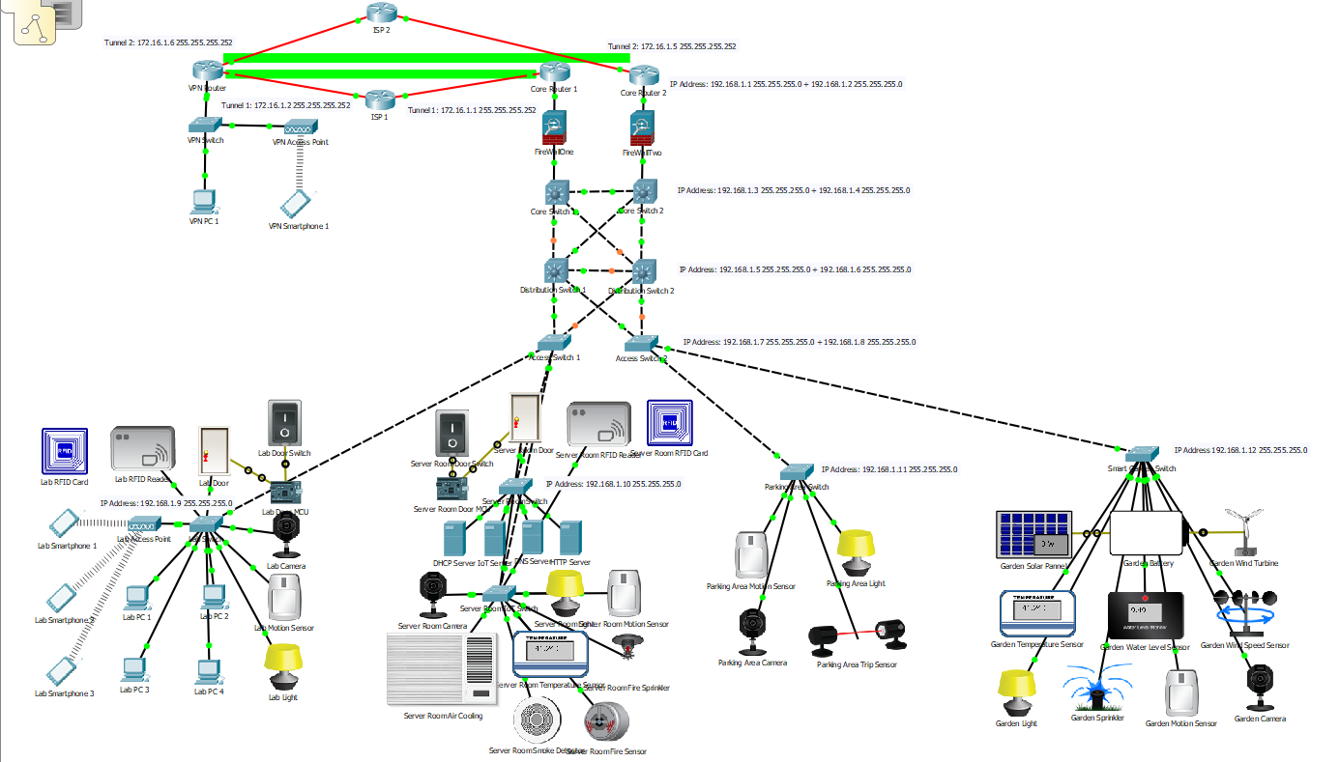
Figure 1: Smart Campus Design
Figure 1 shows a possible design of a smart campus which includes a lab area, server room, smart car park, smart garden and a VPN. The network makes use of IoT enabled devices, standard work stations, wireless access points within labs for BYOD functions, multiple layers to split network traffic and network redundancy.
All IoT capable devices are programmed to relay information to the IoT server, which gathers this information. From this point, the server is programmed with a variety of instructions for other smart devices within the network. The scenario specified that smart light control is a desired addition to the campus, therefore, each room, or area, is outfitted with motion sensor devices. Once these motion sensors detect movement, this information is relayed to the IoT server, which sends a signal to activate the lighting within the appropriate area. Camera devices are also installed which are also activated during periods of movement. This improves the physical security of the campus section, as it records and monitors individuals or groups who are active within the area.
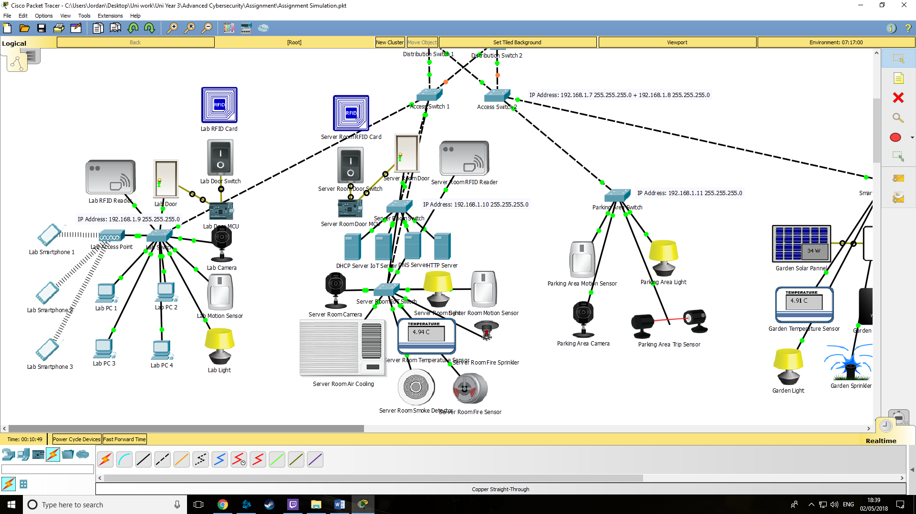
Figure 2: Server Room View
Server rooms, Figure 2, located within the campus possess several different services, including DHCP, DNS, HTTP and IoT. The IoT server, as discussed, interacts with the IoT enabled devices, operating as a central point where these sensor devices relay their data to. The DHCP allows the automatic allocation of IP addresses to devices. This improves quality of life (QoL) within the network, as IP addresses are given out without a network administrators involvement. This also allows for BYOD policies to be enforced, as BYOD devices can acquire IP addresses while present within the campus. DNS and HTTP servers act as IP address translation for the university’s site and source of the university site, respectively.
The server room possesses multiple security and safety features, including Radio-Frequency Identification (RFID) [6] [7] enabled door lock, temperature control and motion cameras. The RFID prevents any unauthorised personnel from accessing the server room, as only those with the proper RFID tag can gain access. RFID technology uses electromagnetic waves to achieve communication between a tag, which stores information required for authentication, and the reader device which requests or writes information into the tags [6] [7]. Reader devices are capable of relaying identification information through the internet via IoT technology [7]. This makes them ideal systems which can provide momentary notice of access with RFID cards, or inventory management [7].
Security cameras are also setup which activate once the motion sensor detects movement in the vicinity. These cameras, in conjunction with the RFID locks, add a layer of physical security to the server room. This ensures no unauthorised personnel may enter without warning. Air cooling and fire sprinklers are set up to ensure the area is sufficiently cool for server storage and protected from any combustion scenarios.
Figure 3: Lab View
Labs, Figure 3, also utilise RFID readers for door control and motion sensors in conjunction with light devices and cameras for lighting and recording of movement. The concept is like the server room in which the camera activates in the presence of movement, which will monitor the area to ensure no unauthorised personnel are present. Each lab possesses several directly connected computer devices as well as a wireless access point for wireless devices. This allows for multiple wireless devices to connect to the University network, enabling policies such as Bring Your Own Device (BYOD) [8] [9].
BYOD has gained popularity as the number of smart devices are becoming more and more common in everyday life [10]. This leads to more companies wishing to implement a BYOD policy to allow employees to use their own devices in place of company supplied devices [10]. BYOD adds a layer of flexibility by allowing employees or students to access company, or university, resources with their own device [9] [10]. Despite added benefits brought by BYOD, it does possess certain security issues which must be addressed [9]. Smart devices have advanced hardware and software capabilities, and if given access to company facilities, can be used to steal data, or infect the systems with malicious malware [10]. This malware, applied either intentionally by an attacker or unwittingly by an employee, can then be used to carry out different cyber attacks against the company network [10] [11].
Therefore, policies [11] must be enforced to ensure the university’s data would not be compromised. These policies would define what devices can access, as well as certain requirements for devices. A key aspect of security policies is that they must be easy to understand and allow employees to give feedback on [11]. Such policies include:
- Securing devices with passwords and authentication whenever possible [11].
- Passwords must consist of a combination of characters, numbers and symbols with more than 16 characters in total [11].
- Employees should be trained in application usage and download / installation practises [11].
- Employees must report stolen or lost devices for action to be taken to minimise risks [11].
- Prevent employees from allowing third party users from accessing their company device, i.e. children, relatives or friends [11].
- Limitations in what a user can access, i.e. students can access certain information where staff could access and / or edit information.
- Users must ensure data confidentiality and integrity while using their device [11]. Therefore, devices must be secure and encrypted to prevent leaking of information [11].
Despite the security steps required to incorporate BYOD into the university campus, it can lead to improvement in student learning and greater flexibility in device usage [8].
Figure 4: Smart Car Park View
The creation of a smart parking area, Figure 4, involved fewer IoT devices than other areas. This design uses motion sensors to activate lighting and security cameras in a similar manner to the server room and lab. For parking monitoring, trip sensors are implemented which can be used to determine if parking zones are occupied or not. If an object, such as a vehicle, occupies the area between the sensors, it will transmit to the IoT server that the sensors are active, therefore, an object is occupying the area.
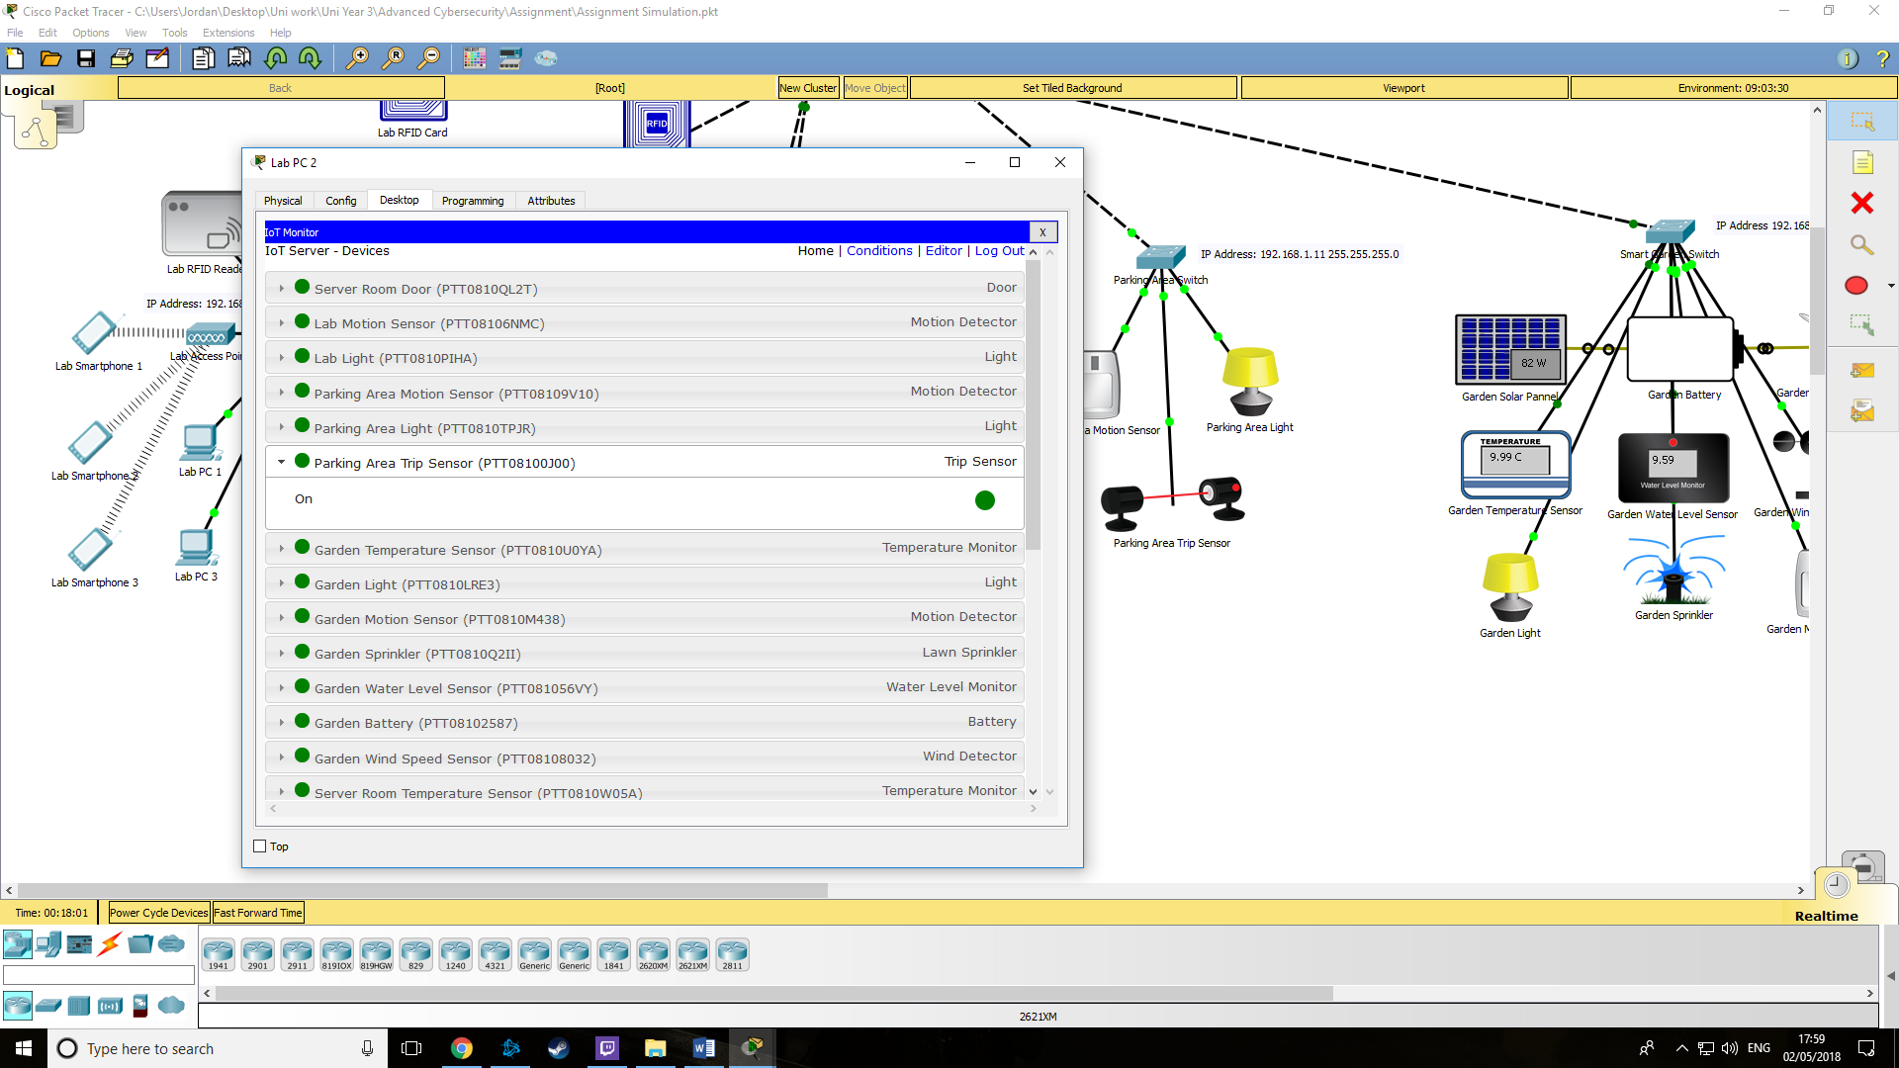
Figure 5: Trip Sensor
Figure 5 displays the trip sensor, on the right, in an active state, which can be monitored from devices connected to the IoT server. While the design shows one of these sensors, the concept is that multiple would be connected to the network to indicate different car parking spots.
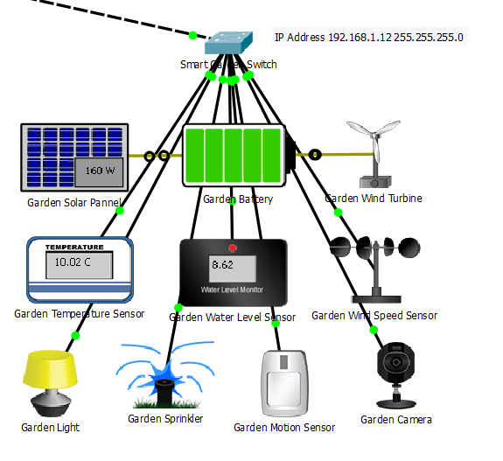
Figure 6: Smart Garden View
Finally, UWTSDs new campus utilises a smart garden, seen in Figure 6. This garden will utilise several smart devices and sensors to accomplish different tasks. These include using temperature and water level sensors to control sprinkler systems. Should temperature rise too high and if detected water levels drop too low, the sprinklers will be activated. A number of clean energy systems can also be implemented, such as solar panels and wind turbines, which are directly connected to the university to supply independent power. Finally, similar to other sections of the new campus, the garden will utilise motion sensors for lighting control and security camera activation.
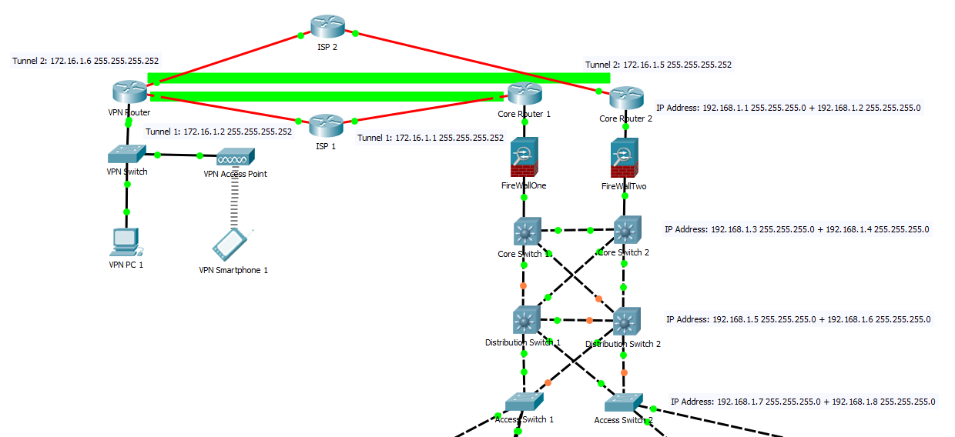
Figure 7: Network Topology
UWTSD’s new campus requires a network to connect the smart lab, server room, car park and garden too. This design, shown in Figure 7, shows the network topology used within the simulation. The network utilises the redundancy concept where there are multiple paths through the network to reach a destination [12]. This ensures that there’s always a route to the destination, even if one device along the path is disconnected [12]. Implementing redundancy techniques, however, does increase the total cost of the network [12]. Therefore, it is vital to determine areas in which redundancy could be implemented for maximum benefit [12]. Examples include:
- Multiple Internet Service Providers (ISP), which allows for internet connection if one ISP goes down.
- Multiple core, distribution and access layer switches, which allows for traffic to continue through the network should a switch device fail.
These two aspects were chosen primarily as they ensure that devices can connect to the internet and to ensure the network does not fail in the even a device stops functioning.
The network utilises two VLAN addresses:
- VLAN 10 is used as the main VLAN, which contains all switchports connected to authorised network devices.
- VLAN 100 is used as a blackhole VLAN, which contains all switchports not utilised.
VLAN 10 acts as the primary VLAN which network traffic utilises. Each switch possesses a unique VLAN address allowing them to switch packets throughout the network. This allows for devices to communicate to other devices, including the DHCP server in which they obtain their IP address.
While VLAN 10 contains authorised devices, VLAN 100 contains switchports not in use. All non-used switchports are set to administratively down mode and connected to VLAN 100, the blackhole VLAN. Administratively shutting down unused ports is a security measure which prevents unauthorised devices from being connected to an empty switchport and accessing the network. To further secure unused ports, they are added to the blackhole VLAN, which is not utilised anywhere within the network. This ensures that in the event an attacker connects a device to the network and can open the port, they cannot navigate through the network, as the blackhole VLAN is not supported within the network infrastructure. Additional VLANs could be configured to further separate traffic within the network, i.e. IoT, device, staff and administrative traffic, but were not in the final design.
Firewalls and Access Control Lists (ACL) are further security measures added to the network. Firewalls are implemented at the edge of the campus’ network, which connects to the internet. The firewalls can then be configured to prevent unauthorised access into the network by preventing certain packets from entering, or exiting, the network infrastructure. However, due to limitations in ability to configure these devices, they were not included in the final version, but are still shown where they would be located within the network topology.
ACLs are a security measure implemented on the gateway port, which monitors traffic flow between the source and destination [13] [14]. Implementing security measures, such as virus scan, in each sensor or IoT device is too difficult [13]. Therefore, ACLs are used as a cost-efficient alternative for packet monitoring [13]. ACLs can ensure the legitimate and effective use of network resources by providing control over which resources a user can access [14]. This method is widely used with ISPs to carry out security access policy settings for each network user [14]. ACLs were setup on the gateway routers connecting the ISPs within the design. These are used to allow certain traffic, such as OSPF, from passing the network edge to the ISP. This ensures control over which devices can communicate outside of the network, and which cannot. The flip side is also true as ACLs allow OSPF traffic from the VPN to enter the network via Generic Routing Encapsulation (GRE) Tunnel connections. Figure 8 below shows the ACLs setup within the network design, as well as showing ping success to VPN Network and ping failure from non-supported networks to PC devices.
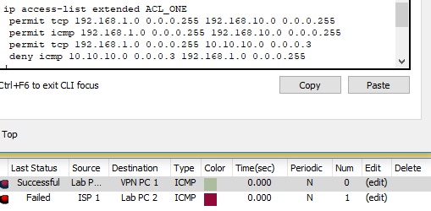
Figure 8: ACL and Ping Test
However, due to limitations in ability to configure advanced ACLs which can segregate traffic to different levels of access, they were not included in the final version.
GRE Tunnels were setup between the edge routers of the network and the VPN. These are used by the internal network and VPN site to communicate securely between locations. This connection is also added to the OSPF database, which allows the entire network to access it. The main network is located within area 0, while the remote site and tunnels are located within area 1. The GRE Tunnels allow for direct, point-to-point, communication between nodes which has certain advantages, such as safe passage through the tunnel without interaction with the physical routers. As GRE Tunnels are virtual, routers that GRE packets pass through do not interact with the contents of the package, and instead the packets are simply passed along until they reach the tunnels endpoint. This adds levels of confidentiality and integrity to packets sent between destinations using GRE Tunnels.
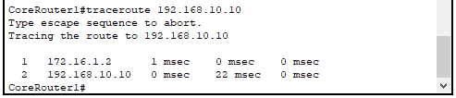
Figure 9: GRE Tunnel Traceroute
Figure 9 shows a traceroute command from core route 1, on the edge of the network, to the IP address 192.168.10.10, which is the PC shown within the remote VPN network. The packet used the network 172.16.1.0, in the design is the Tunnel network, to reach the remote network of 192.168.10.0.
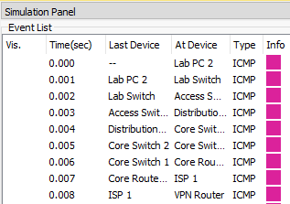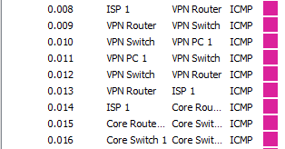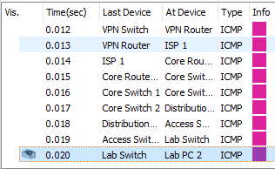
Figure 10: ICMP Simulation
Figure 10 shows the path taken by the ICMP packet originating from lab PC 2, towards the VPN PC. The ping was successful in navigating through the network, through the tunnel between the main network and the VPN, through the VPN router to the PC then finally returning. This shows the security measures allow for traffic between the two networks without any issues along the path.
Passwords are utilised by all devices involved within the network topology. These are used to ensure authorised personnel only can access device configuration, by either directly connecting to the device or by attempting to telnet or SSH to it. However, passwords alone will not be enough, therefore the network is also configured to encrypt all passwords so that they cannot be read. This ensures that passwords cannot be obtained by unauthorised parties by accessing the device, or intercepting remote access signals.
The final configuration implemented within the network is the use of Secure Shell (SSH). Each device can be accessed with SSH for remote monitoring. SSH was chosen over Telnet as the connection established via SSH is encrypted, while Telnet is plain text. This adds additional security to the established connection.
III Security Issues
As mentioned, IoT is constantly developing and advancing [2]. Smart Homes and Smart Cities utilise Wireless Sensor Networks (WSN) as the core infrastructure that collects data from the city to utilise smart services [15] [16]. Smart Cities consist of both physical and cyber components [15]. Physical devices, such as the sensor devices, are physically located within an area, while the cyber systems are used to monitor the physical devices [15] [16]. However, despite numerous advancements in IoT and WSN technology, there are several threats to these networks and, as a result, Smart Cities [16]. Groups, or an individual, can capture a physical device to gain access to information within, such as cryptographic material [17]. The attacker can also use this device to manipulate the node to disrupt the network from within [17].
While physical tampering is an issue, several attacks can also cause issues within a network. These attacks can range from simple attacks to more sophisticated attacks. Several simple attacks include:
- Spoofing, where a malicious group impersonates a device located on the network to attack other hosts, steal data, spread malware or circumvent access controls [17] [18].
- Eavesdropping where an unauthorised individual, or group, intercept communications taking place in real time between clients and servers [17] [19]. This can cause loss of data integrity and confidentiality, as the attacker can gain access to login credentials and other data transmitted across the network [19].
- Man-in-the-Middle attack, which is regarded as one of the most successful attacks, where a malicious individual, or group, gains access of a user’s transferred data [17] [20]. The attacker intercepts communication between the end user and the destination to acquire this data, hence the name Man-in-the-Middle. However, this attack can also be known as Session Hijacking [20].
- Replay attack, which is where an attacker detects data being transmitted and repeats or delays it [17]. This can lead to the attacker gaining access to the network, information or duplicating a transaction [21].
While the simple attacks can cause havoc, even gain access to network resources and information, certain sophisticated attacks can cause more harm to the network or data. These attacks can often be more difficult to detect or prevent. These attacks include:
- Selective Forwarding is an attack where a malicious node selectively forwards certain packets while dropping other packets [17] [22]. Nodes transmit packets to neighbouring nodes and assumes they will forward that packet to its destination [22]. However, due to this attack, that node can instead drop the packet entirely, disrupting the data flow of the network [22]. This attack becomes exponentially more dangerous if the malicious node, or nodes, are located within the main data flow path [22].
- Black Hole attack, which is like selective forwarding where an attacker places a malicious node within the network [22]. However, unlike selective forwarding attacks, a black hole attack causes the malicious node to drop all packets received [22].
- Hello Flood attack, where an attacker takes advantage of Hello Packets utilised within networks [22]. The attacker, using a laptop-class device, broadcasts hello messages with a large enough transmission to convince other nodes that the attacker is a neighbour [22] [23]. This results in a loss of data availability as users are unable to access the channel [22] [23].
- Denial of Service (DOS), where an attacker attempts to prevent genuine users from accessing data or services [22]. The destination system is overwhelmed with false requests that it is unable to acknowledge genuine traffic [22]. This leads to network performance being greatly hindered [22].
Certain methods can be used to reduce the threats these attacks pose. Hop-Count filtering can be used to detect spoofing attacks [24]. This method uses the Time-to-Live (TTL) value of the source packet, which is compared to the value from the IP2HC mapping table [24]. Packets with matching values are permitted, while others are discarded [24].
Cryptography is a highly recommended security method which uses secret keys to encrypt and decrypt data [20]. This improves the integrity and confidentiality of the data sent across a network [20]. Cryptography serves as one of the main methods of preventing data loss from attacks such as Man-in-the-Middle and Hello Flooding [20] [23]. Even if attackers manage to acquire data, if it has been encrypted the attacker will have no means of reading the stolen information without the decryption key [20].
Authentication is another method of preventing certain attacks, such as flooding [25]. Legitimate nodes possess valid authentication keys and sign their messages so that other nodes can authenticate the source [25]. That way only authorised messages are transmitted and stored within the network, while unauthorised information will be discarded instantly [25].
IV Conclusion
IoT is constantly progressing through advancement in sensors, actuators and Internet Protocols, specifically IPv6. More and more businesses are moving towards smart buildings and UWTSD has developed a new campus. This report detailed the creation of a network which supported IoT capable devices for the new UWTSD smart campus. All active ports are incorporated into VLAN 10 for network connectivity, allowing for smart devices to access the IoT server. Steps were taken to secure the network against various threats, such as implementing BYOD policies to protect network resources and data while allowing for wireless devices to be connected to the network.
Other implementations include ACLs, used to limit certain connectivity within the network, i.e. allowing pings between the main network and offsite, but denying unauthorised pings from outside the network. Firewalls were implemented to monitor packets traveling in and out of the network. However, limitations in the ability to configure firewalls in Packet Tracer required their removal from the network, but these devices would be implemented in the physical version.
Several attacks were analysed, such as spoofing, man-in-the-middle, selective forwarding and flooding, detailing how these attacks function and how they can disrupt the network. E.g. selective forwarding causes a malicious device to only forward certain packets, disrupting data flow within the network. Countermeasures such as cryptography, hop-count filtering and authentication were discussed to prevent several attacks. Encryption methods via cryptography were also implemented into the network design, preventing unauthorised parties from acquiring passwords.
References
[1] S. Muzaffar, O. T. Waheed, Z. Aung and I. A. M. Elfadel, "Single-clock-cycle, multilayer encryption algorithm for single-channel IoT communications," 2017 IEEE Conference on Dependable and Secure Computing, Taipei, 2017, pp. 153-158.
[2] N. Maheshwari and H. Dagale, "Secure communication and firewall architecture for IoT applications," 2018 10th International Conference on Communication Systems & Networks (COMSNETS), Bengaluru, 2018, pp. 328-335.
[3] R. Trandafir, M. Carabas, R. Rughinis and N. Tapus, "FirewallPK: Security tool for centralized Access Control List management," 2014 RoEduNet Conference 13th Edition: Networking in Education and Research Joint Event RENAM 8th Conference, Chisinau, 2014, pp. 1-6.
[4] C. Kumar and H. F. Mahdi, "A real time algorithm for the machine to machine communication-smart warrior system," 2017 IEEE 13th Malaysia International Conference on Communications (MICC), Johor Bahru, 2017, pp. 213-217.
[5] S. Bhattarai and Y. Wang, "End-to-End Trust and Security for Internet of Things Applications," in Computer, vol. 51, no. 4, pp. 20-27, April 2018.
[6] S. Vattem and T. Anjali, "Complete RFID security solution for inventory management systems," 2017 International Conference on Advances in Computing, Communications and Informatics (ICACCI), Udupi, 2017, pp. 179-183.
[7] S. S. Park, "An IoT application service using mobile RFID technology," 2018 International Conference on Electronics, Information, and Communication (ICEIC), Honolulu, HI, 2018, pp. 1-4.
[8] P. Saa, O. Moscoso-Zea and S. Lujan-Mora, "Bring your own device (BYOD): Students perception — Privacy issues: A new trend in education?", 2017 16th International Conference on Information Technology Based Higher Education and Training (ITHET), Ohrid, 2017, pp. 1-5.
[9] V. Gkamas, M. Paraskevas and E. Varvarigos, "Design of a Secure BYOD Policy for the Greek School Network: A Case Study," 2016 IEEE Intl Conference on Computational Science and Engineering (CSE) and IEEE Intl Conference on Embedded and Ubiquitous Computing (EUC) and 15th Intl Symposium on Distributed Computing and Applications for Business Engineering (DCABES), Paris, 2016, pp. 557-560.
[10] A. Armando, G. Costa, A. Merlo, L. Verderame and K. Wrona, "Developing a NATO BYOD security policy," 2016 International Conference on Military Communications and Information Systems (ICMCIS), Brussels, 2016, pp. 1-6.
[11] A. V. Herrera, M. Ron and C. Rabadão, "National cyber-security policies oriented to BYOD (bring your own device): Systematic review," 2017 12th Iberian Conference on Information Systems and Technologies (CISTI), Lisbon, 2017, pp. 1-4.
[12] A. S. Dulesov, N. V. Dulesova and K. D. Jurevich, "Optimal redundancy of radial distribution networks by criteria of reliability and information uncertainty," 2017 International Conference on Industrial Engineering, Applications and Manufacturing (ICIEAM), St. Petersburg, 2017, pp. 1-4.
[13] K. Inoue and Y. Yano, "A large scale access-control list for IoT security comprising embedded IP-core and DDR DRAM," 2016 International SoC Design Conference (ISOCC), Jeju, 2016, pp. 197-198.
[14] C. Xue, X. Wu, T. Qin, H. Bi and Z. Wang, "Improvement of ACL assembly algorithm," 2017 2nd International Conference on System Reliability and Safety (ICSRS), Milan, 2017, pp. 380-385.
[15] C. Wickramaarachchi, C. Chelmis, R. Kannan and V. K. Prasanna, "Protecting critical buses in power-grid against data attacks: Adaptive protection schemes for smart cities," 2016 Future Technologies Conference (FTC), San Francisco, CA, 2016, pp. 1047-1056.
[16] J. Wu, K. Ota, M. Dong and C. Li, "A Hierarchical Security Framework for Defending Against Sophisticated Attacks on Wireless Sensor Networks in Smart Cities," in IEEE Access, vol. 4, pp. 416-424, 2016.
[17] D. He, S. Chan and M. Guizani, "Cyber Security Analysis and Protection of Wireless Sensor Networks for Smart Grid Monitoring," in IEEE Wireless Communications, vol. 24, no. 6, pp. 98-103, Dec. 2017.
[18] J. Xu, L. Duan and R. Zhang, "Transmit Optimization for Symbol-Level Spoofing," in IEEE Transactions on Wireless Communications, vol. 17, no. 1, pp. 41-55, Jan. 2018.
[19] M. Sun, Y. Zou, M. Qian, J. Zhu and Q. Wang, "Exploiting multi-radio cooperation in heterogeneous wireless networks for absolute security against eavesdropping," 2017 ITU Kaleidoscope: Challenges for a Data-Driven Society (ITU K), Nanjing, China, 2017, pp. 1-6.
[20] M. Conti, N. Dragoni and V. Lesyk, "A Survey of Man in The Middle Attacks," in IEEE Communications Surveys & Tutorials, vol. 18, no. 3, pp. 2027-2051, thirdquarter 2016.
[21] K. Murakami, H. Suemitsu and T. Matsuo, "Classification of repeated replay-attacks and its detection monitor," 2017 IEEE 6th Global Conference on Consumer Electronics (GCCE), NAGOYA, Japan, 2017, pp. 1-2.
[22] K. N. SunilKumar and Shivashankar, "A review on security and privacy issues in wireless sensor networks," 2017 2nd IEEE International Conference on Recent Trends in Electronics, Information & Communication Technology (RTEICT), Bangalore, 2017, pp. 1979-1984.
[23] K. Saghar, D. Kendall and A. Bouridane, "RAEED: A solution for hello flood attack," 2015 12th International Bhurban Conference on Applied Sciences and Technology (IBCAST), Islamabad, 2015, pp. 248-253.
[24] O. A. Osanaiye, "Short Paper: IP spoofing detection for preventing DDoS attack in Cloud Computing," 2015 18th International Conference on Intelligence in Next Generation Networks, Paris, 2015, pp. 139-141.
[25] T. N. D. Pham, C. K. Yeo, N. Yanai and T. Fujiwara, "Detecting Flooding Attack and Accommodating Burst Traffic in Delay-Tolerant Networks," in IEEE Transactions on Vehicular Technology, vol. 67, no. 1, pp. 795-808, Jan. 2018.

marking criteria and Student FEEDBACK

This section details the assessment criteria. The extent to which these are demonstrated by you determines your mark. The marks available for each criterion are shown. Lecturers will use the space provided to comment on the achievement of the task(s), including those areas in which you have performed well and areas that would benefit from development/improvement.

Common Assessment Criteria Applied (Assignment 1) | Marks available | Marks  awarded
1. Research-informed Literature
Extent of research and/or own reading, selection of credible sources, application of appropriate referencing conventions.
Outstanding knowledge of research informed literature. High level of referencing skills consistently applied. (Grade mark: 100.00%) | 15 | 15
2. Knowledge and Understanding of Subject
Extent of knowledge and understanding of concepts and underlying principles associated with the discipline.
High detailed knowledge & understanding of the main theories and concept (Grade mark: 100.00%) | 15 | 15
3. Analysis
Analysis, evaluation and synthesis; logic, argument and judgement; analytical reflection; organisation of ideas and evidence
Very high quality analysis developed. Use paragraphs to summarise key aspect from the report and include some future recommendations. (Grade mark: 96.67%) | 30 | 29
4. Practical Application and Deployment
Deployment of methods, materials, tools and techniques; application of concepts; formulation of innovative and creative solutions to solve problems.
A solid implementation that has ticked the basic requirements for security required. The use of further cryptography would have increased the mark as would the inclusion of ACLs however that said all devices secured by both physical devices and shut down unused ports. (Grade mark: 80.00%) | 30 | 24
5. Skills for Professional Practice
Attributes in professional practice: individual and collaborative working; deployment of appropriate media; presentation and organisation.
Can communicate with an exceptionally high level of professionalism.  (Grade mark: 100.00%) | 10 | 10

Assignment Mark (Assessment marks are subject to ratification at the Exam Board. These comments and marks are to give feedback on module work and are for guidance only until they are confirmed. ) | Late Submission Penalties (tick if appropriate) |  | 93%
 | Up to four weeks late |  | 93%
 | First Attempt? |  | 93%

