

University of Wales Trinity Saint David
School of Engineering

Implementation of Advance Steel in
Totec Design ltd.
Group Project - ACMA5009

Simeon Scoberg-Evans
1252150
22/05/2024
Table of Contents
1 Introduction 1
1.1 Background 1
1.2 Aims 2
1.3 Objectives 2
2 The Implementation Process 3
2.1 The Implementation of Advance Steel 3
2.2 Analysis of the Implementation of Advance Steel 4
2.2.1 McKinsey 7S Model 4
2.3 Reflection of the Implementation of Advance Steel 6
3 Proposed Implementation Process 8
3.1 Analytical Tools Applied to Process 8
3.1.1 Kotter’s 8-Step Change Model 8
3.1.2 Herzberg’s Two-Factor Theory 10
3.2 Plan 11
3.2.1 Training 11
3.2.2 Gantt Chart 13
13
4 Conclusion 14
5 References 16

Introduction

Background
In the contemporary business landscape, organisational change and innovation are inevitable components for sustainable growth and competitiveness (Teece, et al., 1999). All organisations have been involved in various instances of change and innovation throughout their lifetime, as businesses need to adapt to survive (Rajagopal, 2012). The experience which stands out the most was the introduction of a specialist 3D computer aided design (CAD) steelwork fabrication software, called Advance Steel, into a workplace – a mechanical and piping design consultancy called Totec Design ltd. - with no experience with not only this software, but any specialist steelwork fabrication software.
For background, the staff of Totec Design have used a 2D CAD package, called AutoCAD, since the early 1990’s, when CAD was first introduced to the market. Traditionally, steelwork fabrication drawings are manually produced from 2D drawings on AutoCAD. A design engineer will lay out all the existing piping, steelwork, concrete, and any relevant pieces of equipment in the vicinity of the project’s scope, then lay out all the new piping, steelwork, and pipe supports in what is called a ‘General Arrangement’ (GA) drawing. From there, each steel member used is then redrawn on a separate drawing and dimensioned for fabrication, hence ‘Fabrication Drawing’. That drawing is then sent back to our client who then fabricates the steelwork per our fabrication drawing, then welds and/or bolts the assembled components to be sent to site for assembly or installation. Advance Steel allows the design engineer to model the steelwork in a 3D model and then automatically produces fabrication drawings and the design engineer is required to only dimension and arrange them into an aesthetically pleasing layout (to make it as easy as possible for the fabricators to read), and those drawings are updated automatically when changes are made to the 3D model. Previously, when the drawing is revised, the designer would have to remember to update the alterations to each individual part on its corresponding fabrication drawing, as well as on the GA drawing. Thus, the new software was being implemented to reduce the time it takes to produce fabrication drawings, and to reduce the number of mistakes during each drawing revision.
What makes Advance Steel so appealing is that 3D CAD is largely used as visual communication to facilitate dialogue between decision makers, particularly those that cannot read engineering drawings, and designers/engineers (Tiede & Blaschke, 2005), whereas Advance Steel offers a time and error reduction process with its fabrication drawing production facilities as well as a scale 3D representation. It also contains other features within the 3D modelling technology that reduces time and errors for designers, not just when producing fabrication drawings, and it also outputs computer-aided manufacturing (CAM) files, called NC1 files, that are used by CAM fabrication machines to cut, and in some cases weld, the steel members to the exact dimensions of the CAD model and at a higher cutting and welding tolerances that can be achieved with manual fabrication methods (N.W. Metal Fabricators inc., 2023).

Aims
The aim of this report is to analyse how the implementation of the new steelwork 3D modelling and fabrication software was managed, assess the effectiveness of the implementation, and to then provide recommendations as to how the implementation could have been managed more successfully, by using the analysis gained from the actual software implementation and then applying management tools and techniques that have been proven to aid the effectiveness and the overall efficiency of operational changes and innovations.

Objectives
The first step is to document the implementation process, then critically analysing – using the McKinsey 7S model - and reflecting on how the process was implemented from the perspective of both management and employees.
The next step is to then propose a more effective implementation process, using management tools to analyse and then improve upon the process. Kotter’s 8-step change model will be applied to offer better structure to the change management process, then Herzberg’s two-factor theory will be used to show how the proposed process will impact employee motivation, and a detailed plan will be produced with an accompanying Gantt chart will be produced to give a timeline for the proposed implementation process.

The Implementation Process

The Implementation of Advance Steel
Three seats (a ‘seat’ is AutoCAD’s term for one bundle that contains numerous design software packages) containing Autodesk’s Advance Steel package were purchased for two of the employees that had the most experience with 3D modelling CAD software, and for another employee that is inexperienced in 3D modelling but will be learning how to do so. The increased cost of the package meant that it was not worthwhile for every member of staff to be given a seat as most would not need to use it (there are nine design engineers in the company, two of which have a basic steelwork software integrated into the 3D CAD piping software that they use and is sufficient for their needs).
Graitec, the original creator of the software, who were bought-out by Autodesk, offered online training sessions on specific aspects of the software and one-to-one half hour Teams meetings and webinars with sales representatives and experts, but no other training was offered to employees. The four- and five-day training courses (see 3.2.1 Training for details) vary in difficulty from beginner to advanced, but the director deemed them to be a “waste of money”. They decided, like with all new software introduced to the company, that employees would have to learn how to use the software without any professional training. The design engineers were expected to learn how to use the software through practical experience, with management expecting them to solve any issues they came across by working it out themselves, searching online forums, or by contacting an expert at Graitec. Initially, the designers began using Advance Steel on projects that had very little and/or simple steel pipe supports, trestles, or frames. The steelwork would be laid out on 3D before being “flatshot” (a 2D line capture of the 3D model) for manual 2D fabrication drawings, as the fabrication output on Advance Steel was still not understood by the workforce. Employees were not given any time to practice and learn the new software, the self-training had to take place during running projects, during stints where they were waiting to hear back from a client or while a design was under external review.
When the employees became knowledgeable on, and understanding of, the fabrication drawing output on Advance Steel, months after the introduction of the software, that became the primary method of producing fabrication drawings on certain projects. One employee, who oversees IT in the office, that used the software most regularly and gained the best understanding of the software became the office ‘expert’ in the software and set up templates, standards, settings, toolkits, and other user variable functions, within the software for all other users. That individual works almost exclusively on projects for one client, whose projects we began to use the software to its full potential. The director does not understand nor trust the software, so for most of our other clients the 2D manual fabrication method, see Introduction, is still in use.

Analysis of the Implementation of Advance Steel

McKinsey 7S Model
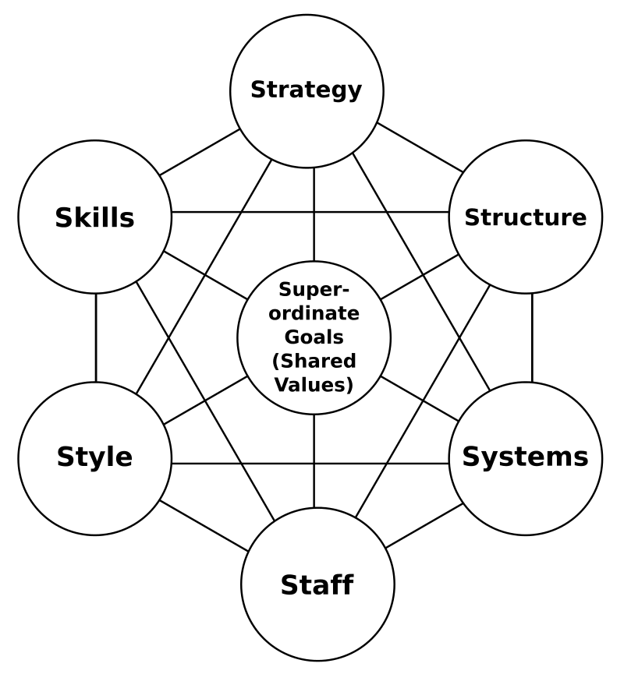
In 1982, two consultants, Tom Peters and Robert H. Waterman Jr., on the “margins” of management consultant firm McKinsey & Company (Peters, 2001) published a book called In Search of Excellence. This book studied what made America’s most successful companies so successful as well as American management techniques, at a time when most books in the industry were studying Japanese management techniques and trying to discern what made them so successful (Maccoby, 1984). The book was hugely successful and laid the foundation for what is now known as the McKinsey 7S Model, or McKinsey 7S Framework, which is an organisational analysis tool that is primarily used to assess and monitor changes within an organisation, from the organisational structure to new processes, new systems, and so on. The model defines how effectiveness can be achieved through the interactions of seven key elements (Corporate Finance Institute, n.d.):
Figure 1 visual representation of the McKinsey 7S model (Hayes, 2014)
The seven key elements are split into two groups that are equally as important to driving successful change initiatives. Hard elements are easily defined, tangible and can be directly impacted by management, and soft elements are more abstract and are driven primarily by the culture of the organisation (Cascade, 2024).

Hard Elements
- Structure: the organisational hierarchy, the chain of command, or in effect, it details the management configuration and responsibilities of employees (Kenton, et al., 2022). In the case of Totec, there is an authoritarian leadership style where the director has control over every aspect of the company. This made it easier to introduce the new software, as only they needed to be convinced of the usefulness of Advance Steel and they made the decision to implement it without any further bureaucracy or debate.
- Strategy: the plan devised by management to assure the success of the objectives. A sound strategy consists of a clearly articulated, long-term plan that is reinforced by a strong vision, values, and mission (Jurevicius, 2023). At Totec, the only plan was to purchase the software and to utilise it on projects that required a lot of steelwork. There was no training planned nor was there any time given to the staff to learn how to use the software, they were expected to expand their skills and knowledge through using it on active projects.
- Systems: the processes, procedures, and routines of staff that characterises how the work is progressed within the organisation (Lucidchart, n.d.). With the implementation of Advance Steel at Totec, management introduced the software to projects right away and that created a new routine with its own procedures and processes. As positive a step as that was, the negative side to implementation was that the new software was to be used with specific clients on specific projects, which meant that employees are forced to switch between the old 2D CAD system and the new 3D CAD system that both have their own processes, procedures, and routines.

Soft Elements
- Skill: this concerns both the skills of the individual employees and the organisation, particularly regarding how their capabilities and competencies affect the business’ overall performance. Skills play a key role during organisational changes, especially when considering where they reinforce the new strategy or structure (The Association of British Dispensing Opticians, n.d.). The director of Totec must have respected their employee’s CAD skills and knowledge enough to implement Advance Steel with no training. This negatively affected the business in the short-term because it caused slowed the project down and led to errors, and in the long-term because the employees will have picked up bad habits and will have a worse workflow, compared to someone that has been trained in how to get the most out of the software in the most efficient way.
- Style: the organisational style of the company as a whole and the way in which the key managers behave in achieving the organisation’s goals (Story, 2020). The style of Totec can be characterised as an autocratic leadership, where the director has total decision-making power and retains as much authority as possible, but where authoritarian leadership structures usually mean that employees adhere strictly to directives and have little freedom or participation (Hanna & Sales, 2023), employees at Totec are trusted to develop their own design concepts how they see fit. The director still micromanages each project and regularly interferes/redesigns elements, although, reviewing concepts is a very important step in the design process to gain an alternate perspective on the concept, in case an element has been missed or could be designed more efficiently (Kyte, 2013).
- Staff: what type of employee and how many employees does the organisation need to achieve their goals, and how will those employees be recruited, trained, motivated, and rewarded (Ravanfar, 2015). In this respect, the director of Totec made the right choice of employees to implement the new software; teaming up a highly skilled design engineer with no experience in 3D modelling with two of their most experienced colleagues, one with 3D modelling expertise and the other with vast engineering design knowledge, who all work on projects together regularly, and are all keenly interested in utilising Advance Steel. What management failed to do was to offer those employees any training and offering no reward for implementing and using the software.
- Shared Values: or superordinate goals, focusses on what the organisation is trying to achieve and how that is achieved; social missions and reputation are key factors (Bryan, 2008). Totec’s goal is to produce the best possible design at the most affordable price and as easy to manufacture and install as possible for our clients. Advance Steel makes that process more efficient which leads to achieving those external goals. But the pressure put on the employees having to learn how to use the new software on projects with tight deadlines, demoralises them and means that the internal culture suffers.

Reflection of the Implementation of Advance Steel
The new software had a very positive reception among the employees at Totec Design ltd., but there were several issues with how management implemented the new software into the workplace. Firstly, the lack of training and time to practice with/get comfortable using the software caused a rift between management and the employees, with the employees feeling as though they had been abandoned by a manager who expected too much from them. Knowing that two-thirds of IT employees find that receiving training helped to relieve workplace stress (Acton & Golden, 2003), not providing training not only led to a slower and longer implementation and utilisation period, but also increased job related stress for the employees as they adapted to using Advance Steel.
Another negative aspect to the process was the interference from management when they decided not to utilise the software on projects with all clients, only using it to produce fabrication drawings and/or NC1 files for two clients, albeit two of Totec’s main clients. This micromanagement caused the employees to feel undermined and mistrusted, as they saw the lack of trust in the software as a lack of trust in their understanding of and ability with the software. Although micromanaging is not always a negative (Ndidi, et al., 2022), excessive control of employees is often detrimental to the employees’ morale, which in turn decreases their productivity (Aguilar & Kosheleva, 2021), as it did in this circumstance.
Not all management decisions caused conflict with employees, as the clear communication and their involvement in the decision-making process had a positive impact on the relationship. There is much debate about the effectiveness of employee participation, with Marshall Sashkin’s assertion that participation is not only effective but that it is an ethical imperative (Shaskin, 1984) running contrary to evidence provided, by Edwin Locke and others, that participation can sometimes lead to lower employee satisfaction and productivity (Locke, et al., 1986). On this occasion, though, it certainly improved employee satisfaction and productivity both, as employees were more interested in the new software as they had researched its features and uses during the decision-making process.
The software had a very positive effect on the employees charged with its use. Skill development has long been considered in important factor in employee performance and well-being (Farid & Thaer, 2021), and it did indeed boost morale and motivate the staff at Totec. Not only were they reinvigorated by learning a new piece of software, but that software also streamlined a very monotonous task and hastened their workflow, all of which has helped relieve stress as reducing and managing workload levels has been proven to be part of a proactive approach to stress management (MacDonald, 2003). The business itself has become more efficient because the clients that request Advance Steel fabrication drawings and/or NC1 files are getting their drawings and files back quicker, which helps them hit their manufacturing and installation deadlines, which increases the likelihood of them using Totec’s services again on later projects. It also means that those employees can move onto other projects quicker and reduce the deadlines on them as well.

Proposed Implementation Process

Analytical Tools Applied to Process

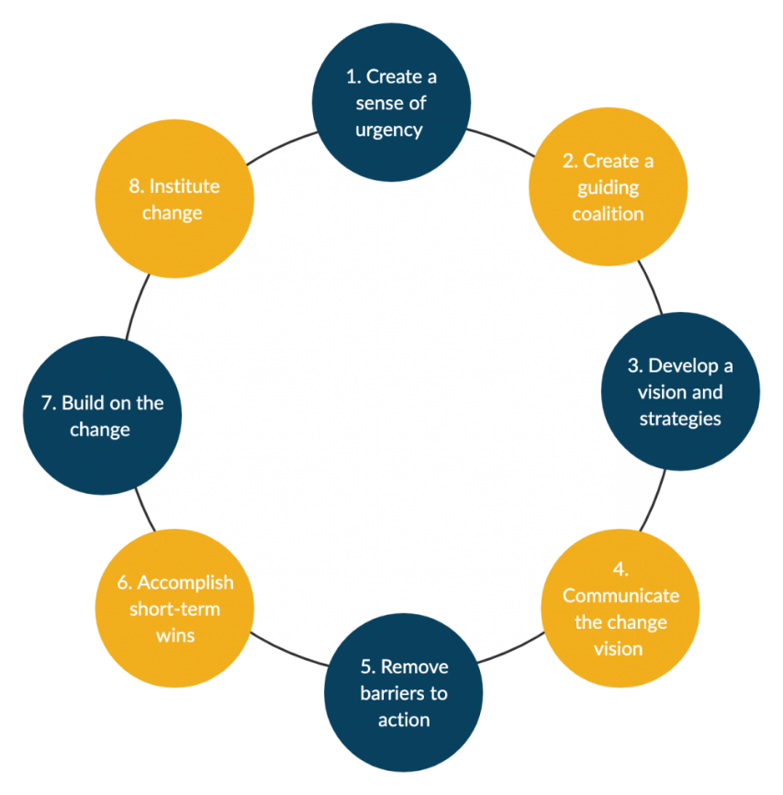
Kotter’s 8-Step Change Model
Figure 2 diagram of Kotter's 8-Step Change Model (Athuraliya, 2023)

Kotter’s 8-Step Change Model is a change management model that empowers organisations that are undertaking an organisational change or innovation by encouraging the employees to rapidly adopt and implement any new processes, technologies, or other organisational changes (Jain, 2019).
Applying Kotter’s 8 Step Change Model can provide a structured approach when addressing the shortcomings of the mismanaged implementation of Advance Steel into the workplace:
- The first step of the process is to provide a sense of urgency (Kotter, 1996), at Totec this was achieved by the director deciding to implement new software (Advance Steel). Management needs to highlight the lost hours and potential errors that occur during the manual 2D fabrication drawing methods to communicate the sense of urgency. This will motivate the employees to embrace the change because a slow, monotonous task is being streamlined (Wihler, et al., 2022).
- The next step is to build a guiding coalition of volunteers to coordinate and communicate (Kotter, 1996) the implementation of Advance Steel, that will understand the urgency of the situation and avoid this becoming one of the 70 percent of substantial changes that failed because of a lack of change effort or an insufficient launch (Kotter, 2008). All employees that are going to be using the software and management need to have a coalescing opinion on the need for the new software. They need to champion the benefits of the new software and make sure that any concerns raised by employees over its implementation are addressed, otherwise they will become demotivated and dissatisfied with their job (Itzchakov, et al., 2023).
- Stage three of the process is to develop a strategic vision to clarify how the future will be different to the past (Kotter International Inc., 2024). Advance Steel needs to be the primary software for steelwork design and fabrication drawings, across all projects at Totec. This will give clients consistent drawings in the same style and layout, making it easier for their fabricators. The strategy should include comprehensive training programs, a timeline for implementation and resources to support the staff though the transitory period, as employees, particularly high stressed individuals, often demonstrate decreased commitment and reluctance to change interventions when under the stress of an organisational change (Vakola & Nikolaou, 2005).
- The next step is communicating the change vision (Kotter, 1996), which needs to be a two-way conversation between management and staff. Management needs to listen to the concerns of the employees and then demonstrate how those concerns can be addressed in a respectful manner. The implementation process needs to be transparent, ‘warts and all’, to build trust with the employees, and feedback on issues needs to be delivered in a prompt fashion, and doing so will increase staff cohesion (Birhanu & Gugssa, 2024).
- The fifth step is to enable action by removing barriers (Kotter, 1996), which can be achieved by implementing Advance Steel across all projects for the employees using it. Employees will feel empowered by their input in stages 1-4 of this model, and in the fact that they are learning how to use a new piece of software and increasing their skillset and knowledge in both 2D and 3D CAD, and the resultant career growth (White, 2020). Seeing that their contribution to the success of the implementation of software will also help boost morale in the workforce (Anitha, 2014).
- The next step is to generate small wins (Kotter, 1996), which can be incredibly significant to raising morale and motivating a workforce. It has been reported that 28% of incidents that had a minor impact on a project had a major impact on how employee’s felt about the project on reflection (Amabile & Kramer, 2011). Small wins for this software implementation could be to complete training, the creation of a standard drawing border, first batch of fabrications issued to client, successful output of NC1 files, etc.
- Step seven is to sustain acceleration by initiating change after change until the vision becomes a reality (Kotter International Inc., 2024). By building on the initial success of implementing Advance Steel into the workplace, gains can be consolidated by making it the workplace standard for steelwork fabrication drawings. By making Advance Steel the only process for fabrication drawings, more training can be offered to increase understanding and better/more efficient utilisation of the software. Also, addressing any remaining concerns or resistance to the software will help to consolidate the gains made from the implementation as a more unified workplace can have a strong positive effect on efficiency (Sidorenkov & Boroshovski, 2023).
- The final step of Kotter’s model is to institute change (Kotter, 1996) by embedding the change within the organisation’s culture and process (Ahmadi, 2023). Making this institutional change will make the employees involved feel valued and empowered, as well as more supportive of future changes within the company. It will also streamline the design process increasing overall efficiency and reducing time wastage, positively impacting Totec’s future profits (Orr & Orr, 2014). Totec needs to anchor it into the design process across all projects, not only when dealing with certain clients that expect and request Advance Steel fabrication drawings, or due to requiring the output of NC1 files.

Herzberg’s Two-Factor Theory
Herzberg's two-factor theory, also known as Herzberg’s motivation-hygiene (Herzberg, et al., 1959), theory can be used to analyse the significance of the impact that the implementation of Advance Steel had on employee motivation. Inspired by Maslow’s hierarchy of needs (Jones & Snodgrass, 2012), Herzberg distinguished between motivators (factors that more directly lead to job satisfaction and personal motivation) and hygiene factors (factors which decrease job dissatisfaction but do not necessarily motivate) in regard to an employee’s job satisfaction (Misener & Cox, 2001), i.e. job satisfaction is ensured by motivators and a lack of hygiene factors spawned job dissatisfaction (Nickerson, 2023). The two-factor theory applied to the implementation of Advance Steel:
- Motivators: for management it can be as simple as rewarding and acknowledging employees for their involvement and effort in embracing the change that can increase their motivation and engagement in this and future changes. Offering opportunities to develop skills and allowing them to be heard during decision-making are also motivators, feeling as though you are being listened to makes people feel valued and reduce work related stress (Jackson, 1992).
- Hygiene factors: sufficient training in the new software is one of the main hygiene factors as a lack of training causes undue stress to employees and causes stress related errors (Heponiemi, et al., 2021). Support mechanisms, such as the Graitec one-to-one discussions or one of their training courses (for more details, see 3.2.1 Training) and clear communication with management are also essential hygiene factors.
By ensuring that the motivators and hygiene factors are met, management can expect employees to be motivated and engaged throughout the implementation of Advance Steel, and they will become determined to expand their knowledge of, and develop their skills with, the software to get as much out of it as possible as they are more job satisfied has been enhanced.

Plan

Training
Graitec offer several training packages for Advance Steel, starting at the four-day ‘Advance Steel Essentials’ course that can then be complimented with more advanced, specific, five-day training course. For example, one advanced training course was for stair and railing design and fabrication - two of the most difficult aspects of steelwork design and detailing. They also offer bespoke training sessions, where the customer tells Graitec what specific aspect of Advance Steel they need training on, and they then create a bespoke training plan and offer a course at a flat rate of £1200 per day.
In Totec there are three members of staff that will be utilising the software, with varying experience using 3D CAD software. Two employees have considerable experience and are very comfortable using 3D design software, whereas one member of staff has no experience with 3D CAD. All three should go on the ‘Essentials’ training, which cost £1200 per person and is a four-day course split across two sessions. In the first week of their training, the employees should work on their current projects from Monday to Wednesday, and then do their training on Thursday and Friday, and then repeat that routine the following week. The employees will then see how beneficial the new software will be to their projects, which leads to a positive transfer of training (Jaidev & Chirayath, 201). This gives them plenty of time to get work on their other projects, so they do not fall behind on them. When new technology is introduced, the inconvenience of having to learn a new system and having their workflow slowed down as they cope with the transition can cause them undue stress and emotional exhaustion, which can lead to burnout (Knani, et al., 2018), if not managed effectively.
Once that training course is complete, the three employees would then start to use the software on their design projects right away because people learn better through practical experiences than from retaining written knowledge (Khan, et al., 2011). From Monday to Thursday, the three employees will use Advance Steel on their projects and should start to become acquainted with the software and then on the Friday, the two members of staff that are experienced in 3D CAD will start the first of five days of advanced training, while the less experienced member of staff continues with their project work and does not participate in the advanced training. This is necessary because there are elements of the software that are complex and difficult to learn with no help but can cut down on wasted time in the design process. These advanced courses will be too difficult for the inexperienced member to understand while they are familiarising themselves with 3D CAD as well as a new software system. Over-training causes increased levels of stress to employees and also lead to decreased levels of engagement (Creighton, 2018), which would be catastrophic to the implementation process if a member of staff decides that they are too frustrated with the new software and reverts back to the previous 2D CAD system. As mentioned in 3.1.1 Kotter’s 8-Step Change Model, the employees must be united in the implementation process for it to be as effective as possible.
The following week, there should be two days of advanced training on the Thursday and Friday, and then repeated for the third week when the course will be completed. The two members of staff that have undertaken the advanced training can now aid their inexperienced colleague with any aspects of the software that they are struggling with. This aids all employees as it has been proven that supervising and training reinforces the performance of the supervisor’s trained skill (Reid, et al., 2011).
Later, say 3 months into the implementation process, there will be a meeting between management and the employees implementing the software to review and discuss the implementation process. Whether any further training is required will be a major part of the discussion, as by this point the employees will be well familiarised with the software and they will be aware of any aspects of the software that they do not understand well enough or struggle to use will be apparent. Ideally, any member of staff requesting training should receive the training that they desire because by making their design process more efficient, they can get more work done and increase revenue for the company in the long-term (Walden, 2007).
Table 1 Graitec training costings
Training | Training Length (days) | Number of Staff | Cost (per person) | Total Cost (£)
Advance Steel Essential | 4 | 3 | 1200 | 3600
Advanced Training – Stairs & Railings | 5 | 2 | 1500 | 3000
Total | 22 |  |  | 6600

Gantt Chart
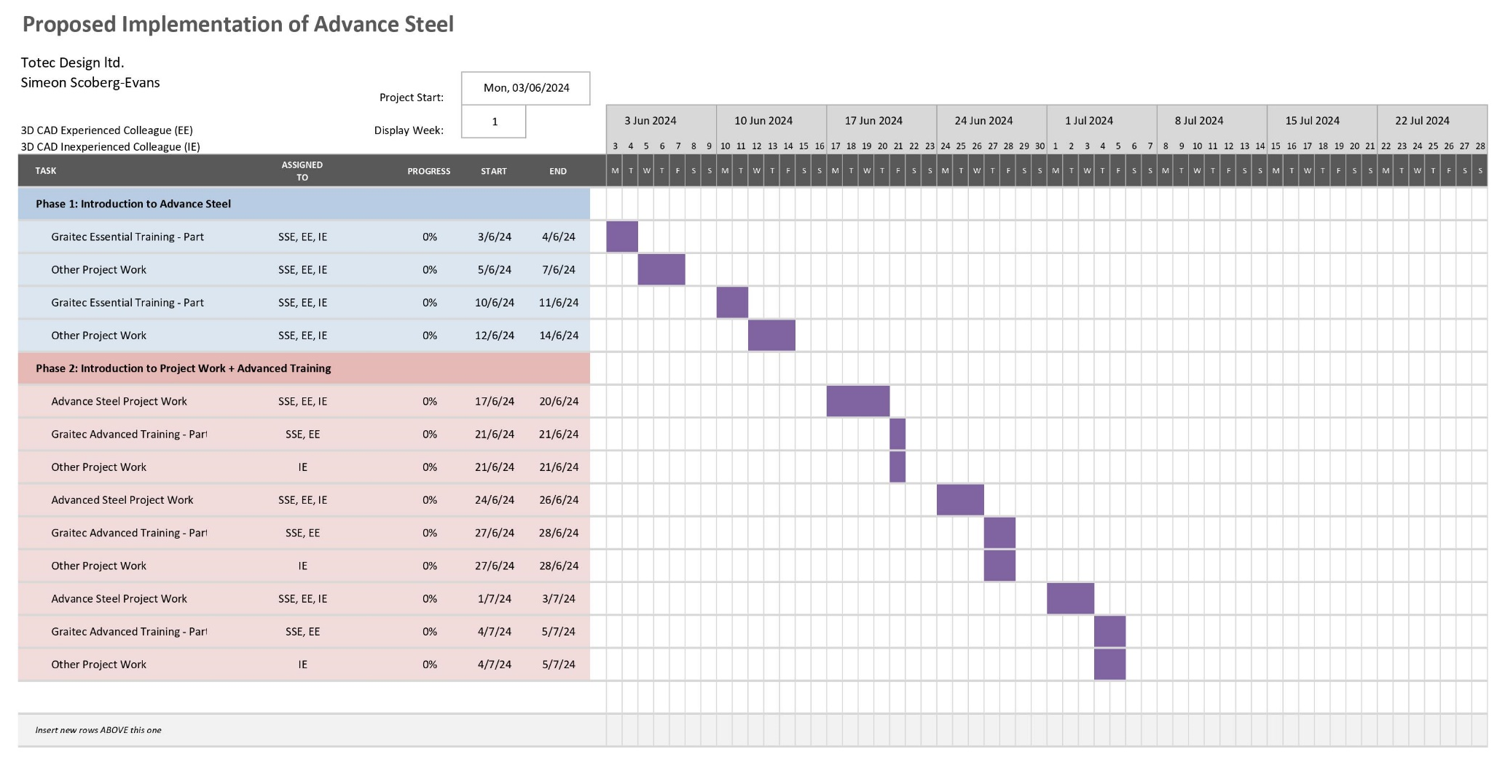
Figure 3 Gantt chart of proposed implementation of Advance Steel

Conclusion
The implementation of Advance Steel into the workplace of Totec Design ltd. was successful and had a strong positive reaction from the employees tasked with utilising it. It has made their job easier, removed a very monotonous and time-consuming task (redrawing and repeatedly editing 2D drawings manually), developed their 3D modelling skill set, and their participation in the decision-making process, that management allowed them, gave them more of a sense of agency. They felt as though they were being listened to and their opinions respected by their employer. All these factors led to a boost in morale and motivation among those employees.
Though successful, it was fraught process that could have been managed in a far better and professional manner. The lack of training caused conflict between management and employees, leaving the employees stressed as they felt as though they had been ‘thrown in the deep end’. Family run SMEs are known for a laxer approach to employee training (Kotey & Folker, 2007) but it is patently a negative to staff morale and to efficiency; you can do the job better and faster when you are not trying to understand how something works at the basic level, let alone on a more complex task or situation. One can sympathise with the director not wanting to spend the £3600 on essential training, on top of the cost of the seats from Autodesk and the 12 days (across the three employees) of lost time on other projects, but the short-term cost is outweighed by the long-term gain in productivity because training and development increases productivity in not only the individual, but also of the organisation (Nda & Fard, 2013). The more efficient the employees are with the software the quicker they can complete projects, thus Totec can complete more projects for clients annually.
The micromanagement of projects only increased stress and demotivated the employees at a time when the lack of training was already causing significant issues. Micromanagement can lead to a variety of negative reactions such as anxiety, demotivation, disengagement, and reduced productivity (Ryan & Cross, 2024), so instead of telling the employees what projects they should and should not use Advance Steel on, the director should trust the judgement his staff as well as their skills and expertise, and let them use the software on all of their projects. The director may not be aware that this micromanagement is detrimental, but by simply delegating this decision to the members of staff, who are in a better position to make the decision, will have a positive effect on their job satisfaction (Jokisaari & Vuori, 2018).
By offering training to the staff and allowing them to use the software across all of their projects, management would have found their employees working more efficiently, more motivated, and taking more satisfaction from their job (Olaniyan & Ojo, 2008). Even if employee job satisfaction is not a great concern for management - which it ought to be because negative job satisfaction directly correlates to higher rates of absenteeism, a lack of engagement in company objectives, and lower productivity, morale, and contribution (Varma, 2017) - the fact that efficiency and productivity greatly increase from improving the employee’s knowledge and capability on the software, means that it is imperative for management to make sure that training is offered the next time a new piece of software, or organisational change, is introduced.

References
Acton, T. & Golden, W., 2003. Training the knowledge worker: a descriptive study of training practices in Irish software companies. Journal of European Industrial Training, 27(2/3/4), pp. 137-146.
Aguilar, S. & Kosheleva, O., 2021. What is wrong with micromanagement: economic view. Asian Journal of Economics and Banking, 5(3), pp. 284-288.
Ahmadi, H., 2023. Facilitating Change Management with Kotter’s 8-step Model. [Online]
Available at: https://itsm.tools/kotter-change-management/
[Accessed 2 April 2024].
Amabile, T. & Kramer, S., 2011. The Power of Small Wins. Harvard Busines Review, 5 May, pp. 70-80.
Anitha, J., 2014. Determinants of employee engagement and their impact on employee performance. International Journal of Productivity and Performance Management, 63(3), pp. 308-323.
Athuraliya, A., 2023. The Easy Guide to Kotter’s 8 Step Change Model. [Online]
Available at: https://creately.com/blog/strategy-and-planning/kotters-8-step-change-model/
[Accessed 9 April 2024].
Birhanu, E. & Gugssa, M., 2024. Employee cohesion and its influence on workplace learning: The lived experiences of public university lecturers in Ethiopia.. Journal of Workplace Learning, 36(1), pp. 113-128.
Bryan, L., 2008. Enduring Ideas: The 7-S Framework. [Online]
Available at: https://www.mckinsey.com/capabilities/strategy-and-corporate-finance/our-insights/enduring-ideas-the-7-s-framework#
[Accessed 16 May 2024].
Cascade, 2024. McKinsey 7S Model: Importance & How To Use It. [Online]
Available at: https://www.cascade.app/blog/mckinsey-7s-model
[Accessed 15 May 2024].
Corporate Finance Institute, n.d. McKinsey 7S model. [Online]
Available at: https://corporatefinanceinstitute.com/resources/management/mckinsey-7s-model/
[Accessed 11 May 2024].
Creighton, K., 2018. HR Daily Advsior. [Online]
Available at: https://hrdailyadvisor.blr.com/2018/08/10/training-workplace-avoid/
[Accessed 19 May 2024].
Farid, K. & Thaer, J., 2021. The impact of skills development on employee performance. International Journal of Computer Science & Network Security, 21(11), pp. 278-286.
Hanna, K. T. & Sales, F., 2023. Definition: Authoritarian Leadership. [Online]
Available at: https://www.techtarget.com/searchcio/definition/authoritarian-leadership
[Accessed 16 May 2024].
Hayes, J., 2014. The Theory and Practice of Change Management. 4th ed. London: Palgrave Macmillan.
Heponiemi, T. et al., 2021. Electronic Health Record Implementations and Insufficient Training Endanger Nurses’ Well-being: Cross-sectional Survey Study. Journal of Medical Internet Research, 23(12).
Herzberg, F., Mausner, B. & Snyderman, B. B., 1959. The Motivation to Work. 2nd ed. New York City: John Wiley.
Itzchakov, G., Weinstein, N. & Cheshin, A., 2023. Learning to listen: Downstream effects of listening training on employees' relatedness, burnout, and turnover intentions. Human Resource Management, 62(4), pp. 565-580.
Jackson, S., 1992. The listening healer in the history of psychological healing. American Journal of Psychiatry, 149(1), pp. 1623-1632.
Jaidev, U. & Chirayath, S., 201. Pre-Training, During-Training and Post-Training Activities as Predictors of Transfer of Training. IUP Journal of Management Research, 11(4), pp. 54-70.
Jain, M., 2019. Kotter’s 8-Step Change Model: Advantages & Disadvantages. [Online]
Available at: https://whatfix.com/blog/kotters-8-step-change-model/
[Accessed 15 May 2024].
Jokisaari, M. & Vuori, J., 2018. Leaders’ resources and newcomer socialization: the importance of delegation. Journal of Managerial Psychology, 33(2), pp. 161-175.
Jones, T. & Snodgrass, J., 2012. Effects of motivating and hygiene factors on job satisfaction among school health nurses. San Francisco, APHA.
Jurevicius, O., 2023. McKinsey 7S Model. [Online]
Available at: https://strategicmanagementinsight.com/tools/mckinsey-7s-model-framework/
[Accessed 12 May 2024].
Kenton, W., Khartit, K. & Velasquez, V., 2022. How to Use the McKinsey 7-S Model for Strategic Planning. [Online]
Available at: https://www.investopedia.com/terms/m/mckinsey-7s-model.asp
[Accessed 15 May 2024].
Khan, R., Khan, F. & Khan, M., 2011. Impact of Training and Development on Organizational Performance. Global journal of management and business research, 11(7), pp. 63-68.
Knani, M., Fournier, P.-S. & Biron, C., 2018. Psychosocial risks, burnout and intention to quit following the introduction of new software at work. Work, 60(1), pp. 95-104.
Kotey, B. & Folker, C., 2007. Employee training in SMEs: Effect of size and firm type—Family and nonfamily. Journal of Small Business Management, 45(2), pp. 214-238.
Kotter International Inc., 2024. Our Foundation; The 8 Steps for Leading Change. [Online]
Available at: https://www.kotterinc.com/methodology/8-steps/
[Accessed 2 April 2024].
Kotter, J. P., 1996. Leading Change. Boston: Harvard Business School Press.
Kotter, J. P., 2008. A Sense of Urgency. Boston: Harvard Business Press.
Kyte, A., 2013. A ‘fresh eyes’ look at improving the effectiveness of engineering group design projects. Engineering Education, 8(1), pp. 81-97.
Locke, E., Schweiger, D. & Latham, G., 1986. Participation in decision making: When should it be used?. Organizational Dynamics, 14(3), pp. 65-79.
Lucidchart, n.d. What Is the McKinsey 7S model?. [Online]
Available at: https://www.lucidchart.com/blog/mckinsey-7s-model
[Accessed 16 May 2024].
Maccoby, M., 1984. MANAGEMENT: Doing Business By the Book. Washington Post, 15 September, p. n/a.
MacDonald, W., 2003. The impact of job demands and workload on stress and fatigue. Australian Psychologist, 38(2), pp. 102-117.
Misener, T. & Cox, D., 2001. Development of the Misener Nurse Practitioner Job Satisfaction Scale. Journal of Nursing Measurements, 9(1), pp. 91-108.
N.W. Metal Fabricators inc., 2023. The Role of CAD/CAM Software in Modern Metal Fabrication Machining. [Online]
Available at: https://nwmetalfab.com/2023/10/the-role-of-cad-cam-software-in-modern-metal-fabrication-machining/
[Accessed 6 May 2024].
Nda, M. & Fard, R., 2013. The impact of employee training and development on employee productivity. Global journal of commerce and management perspective, 2(6), pp. 91-93.
Ndidi, A., Amah, E. & Okocha, B., 2022. Micromanaging Behaviour and Employee. International Journal of Research and Innovation in Social Science, 6(4), pp. 745-755.
Nickerson, C., 2023. SimplyPsychology. [Online]
Available at: https://www.simplypsychology.org/herzbergs-two-factor-theory.html
[Accessed 14 April 2024].
Olaniyan, D. A. & Ojo, L. B., 2008. Staff training and development: A vital tool for organizational effectiveness.. European journal of scientific Research, 24(3), pp. 326-331.
Orr, L. & Orr, D., 2014. Eliminating Waste in Business: Run Lean, Boost Profitability. New York City: Apress.
Peters, T., 2001. Tom Peters's [sic] True Confessions. [Online]
Available at: https://www.fastcompany.com/44077/tom-peterss-true-confessions
[Accessed 8 May 2024].
Rajagopal, 2012. Darwinism in Business. In: Darwinian Fitness in the Global Marketplace. 1st ed. London: Palgrave Macmillan.
Ravanfar, M. M., 2015. Analyzing Organizational Structure based on 7s model of McKinsey. Global Journal of Management and Business Research, 15(A10), pp. 7-12.
Reid, D., O’Kane, N. & Macurik, K., 2011. Staff training and management. In: W. W. Fisher, C. C. Piazza & H. S. Roane, eds. Handbook of applied behavior analysis. New York/London: The Guildford Press, pp. 281-294.
Ryan, S. & Cross, C., 2024. Micromanagement and its impact on millennial followership styles. Leadership & Organization Development Journal, 45(1), pp. 140-152.
Shaskin, M., 1984. Participative management is an ethical imperative. Organizational Dynamics, 12(4), pp. 5-22.
Sidorenkov, A. & Boroshovski, E., 2023. The Role of Cohesion and Productivity Norms in Performance and Social Effectiveness of Work Groups and Informal Subgroups. Behavioral Sciences, 13(5), p. 361.
Story, J., 2020. How to use the McKinsey 7S model in marketing. [Online]
Available at: https://www.smartinsights.com/marketing-planning/marketing-models/mckinsey-7s-model/
[Accessed 16 May 2024].
Teece, D., Pisano, G. & Shuen, A., 1999. Chapter 6 - Dynamic Capabilities and Strategic Management. In: M. H. Zack, ed. Knowledge and Strategy. London: Rouledge, pp. 77-115.
The Association of British Dispensing Opticians, n.d. Useful management Tools: McKinsey 7S Framework. [Online]
Available at: https://www.abdo.org.uk/wp-content/uploads/2019/07/ABDO-BSH-Management-Tools-McKinseys-Framework.pdf
[Accessed 12 May 2024].
Tiede, D. & Blaschke, T., 2005. A Two-Way Workflow for Integrating CAD, 3D Visualization and Spatial Analysis in a GIS Environment. Heidelberg, Wichmann Verlag, pp. 26-28.
Vakola, M. & Nikolaou, I., 2005. Attitudes towards organizational change: what is the role of employees’ stress and commitment?. Employee Relations, 27(2), pp. 160-174.
Varma, C., 2017. Importance of Employee Motivation & Job Satisfaction For Organizational Performance. International Journal of Social Science & Interdisciplinary Research, 6(2), p. 11.
Walden, G., 2007. Short-term and long-term benefits as determinants of the training behaviour of companies. Journal for Labour Market Research, 40(2/3), pp. 169-191.
White, T., 2020. The Effects of Employee Engagement and Morale on Workforce Retention, Providence: Johnson & Wales University.
Wihler, A., Hülsheger, U., Reb, J. & Menges, J., 2022. It’s so boring–or is it? Examining the role of mindfulness for work performance and attitudes in monotonous jobs. Journal of Occupational and Organizational Psychology, 95(1), pp. 131-154.

