

University of Wales Trinity Saint David, Birmingham
Assignment Title: Assessment-2: Report and demonstration
Module: Network Programmability
Module code: ACCA5029_BIRM
Student Name: Cristian-Constantin Paraschiv
Student ID: 2026077

Contents
Part 1. Introduction 3
Part 2. Infrastructure-as-Code 4
Part 3. Ansible 5
3.1. How Ansible function. 5
3.2 Advantages and Disadvantages of Ansible 6
Part 4. Virtual Machines 7
4.1. Hypervisors 7
Part 5. Implementation (Practical) 8
5.1. Preparation as well as deployment system 8
5.2. Ways to configure essential features and remote privilege (SSH). 18
5.3. Establishing credentials (keys) as well as copying credentials from the host to the users. 20
5.4. Ansible installation, setup, and deploy. 23
5.5. Installing and configuring Apache2, PHP, MySQL, and PhpMyAdmin using Ansible 25
Conclusion 29
References 30

Assessment-2: Report and demonstration

Abstract - The number of computers as well as client platforms that must be controlled, regardless of whether an organisation, has significantly increased because of the widespread use of virtualisation, as well as the rising power of sector hosts and the accessibility of cloud computing. Server farm orchestrating and configuration management solutions are now used, as they frequently are. Parties of similar machines or output terminals (physically hosting or virtualization software) that execute similar facilities and strategies are managed by system administrators. These are installed on hypervisors used by the company, in addition to being utilised as housed or cloud implementations in storage systems. Inside the framework of "as a Service" programs, this report will discuss and illustrate a comprehension of virtual machines (Oracle - Ubuntu in our case) for both the installation of applications, in addition to analyse a cloud computing architecture along with Python-written function programme for IT automated processes - Ansible.

Part 1. Introduction
Despite the fact that it is unclear what it is the IoT - Internet of Things technology, furthermore, perhaps different kinds among the connectivity through prospective connected and portable frameworks might very well ultimately are becoming [1], [2], each is crystal clear: inside the existing Information & Communication Technology (ICT) industry [3], [4], the requirement for manoeuvrable and dependable implementing of narrowing the implementation methodology, in addition to non - linear and non-software methods is essential. Hypervisor and cloud based have been made possible by SDNs - Software-Defined-Networks as well as NFV - Network-Function-Virtualization, which authorise features to be executed as software applications (virtual instruments, plugins) underneath the supervision of one orchestrating/coordination element or various elements in the instance of various levelled implementation [6], [7]. The statement pattern mentioned previously, within which application is applied to preparing that minimises the distance, duration, and dedication among application creation and implementation in practical settings, in addition to the specialised and organisational discrepancy among the sorts of study workgroups, has been dubbed DevOps [5], [8]. This same DevOps methodology seeks to enhance interaction, coordination, and synchronisation and application engineers (Dev) among IT management specialists (Ops). To handle which, one is today referred to as Infrastructure-as-Code (IaC), some DevOps tasks assume forward conventional instruments within the application engineering field, such as programming edition platform or situational programming review maintenance [9], [10], or [11]. The IaC's objective is to give platform operators the potential to control the skills and expertise of many different modules via a single location rather than the conventional technique, which requires that one of every module requires a specialised operator. Therefore, in work, we present a framework for effectively administering the architecture with little involvement from programmers or district officials. In this instance, software utility Ansible, which would have been created to streamline difficult orchestration\instrumentation additionally “configuration management” duties, was already chosen. Thus, infrastructure (structure) as a whole was created using the necessary coding style of Python that enables individuals to create instructions using the YAML Ain’t Markup Language (YAML). We expand Ansible with an additional component that enables management and installation of many applications, including notably Apache Server, My SQL, and PHP across VirtualBox by installing Ubuntu inside Oracle VM, to fully realise the ability of the Ansible framework.

Part 2. Infrastructure-as-Code
Implementing the identical serialisation even as DevOps does for programming language, Infrastructure-as-Code describes the governance of internet environment (such as multiple virtual, capacity buffers, as well as connections architecture) in a comprehensive format [13].Nevertheless, IaC stands for a major DevOps strategy that is frequently utilised in connection using agile development, similar to the notion wherein exactly identical programming language creates the equivalent binaries, Illustration 1. Thus, each IaC concept produces the identical environments any moment it is implemented.
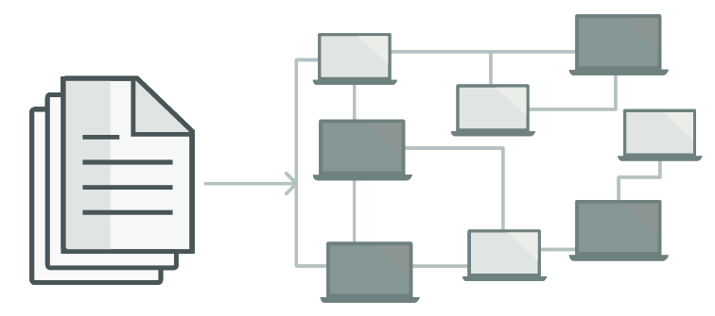
Illustration 1: Data dissemination using Infrastructure-as-code (https://learn.microsoft.com/en-us/devops/deliver/what-is-infrastructure-as-code).

Therefore, Infrastructure-as-code developed intended address that issue for launch pipeline ambient divergence. Under IaC, study or infrastructure personnel are required to keep track on all parameters for each module or deploying scenario. Any setting eventually turns into a snowflake, or a singular arrangement that could be mechanically duplicated. Difficulties throughout deliveries are caused by inconsistent surroundings. Therefore, Snowflakes requires methods for infrastructural management including upkeep, thus, makes mistakes more likely. This same fact whereby a deploying statement consistently transforms any goal atmosphere exactly the identical setup, despite of the system's beginning condition, is known as idempotency, which is also a tenet of Infrastructure-as-Code. Perhaps autonomously setting a given objective or deleting the old objective and generating a new habitat are ways to accomplish impotency. These "configuration management" technologies Chef\ Puppet\Ansible\SaltStack have all been created to deploy and administer applications on current hosts and final devices. Therefore, fact that CloudFormation but also Terraform are "orchestration\instrumentation applications" indicates that are created to provide hosts on their own, enabling additional instruments to handle host configuration. Illustration 2 summarises the results for the major widely used IaC instruments [24]. Furthermore, the following stage is to explain Ansible as well as virtualized environments.

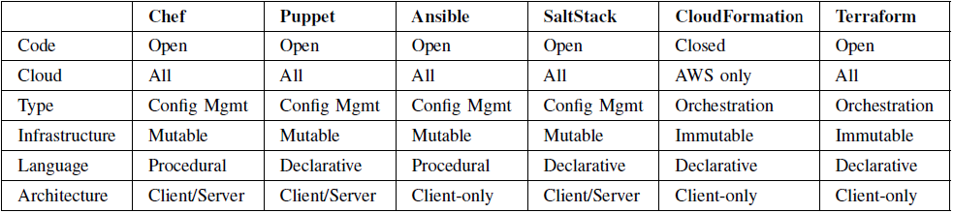
Illustration 2: Major Infrastructure-as-Code platform comparisons [12].

Part 3. Ansible
Ansible is a Python-based, free software(open-source) command-line programme for IT administration. Thus, ability to deliver applications, setup machines, and coordinate/orchestrate complex operations to enable the provision of applications, platform upgrades, and extra [14], [15], or [24]. Nevertheless, can setup either Unix-like platforms and Microsoft Windows, and it operates on numerous Unix-like platforms. It has a clear(descriptive) syntax(language) of its design that it uses to define machine setup. To financially fund and promote Ansible, Michael DeHaan, Timothy Gerla, and Said Ziouani formed the corporation known as Ansible [17]. Ansible was purchased by Red Hat in October 2015 [18], [19]. Ansible provides agentless and executes PowerShell directly when connected online momentarily over SSH or Windows Deployment Administration [16], [22], [23], or [24]. Additionally, outline the operation of Ansible.

3.1. How Ansible function.
Such host-user oriented technology is comparable towards the Ansible programme. Usually, should exist a minimum of two networks(nodes) for Ansible to function. First is the administrator, sometimes referred to simply the Ansible "control node". Thus, second nodes are the managed hosts, or the hosts that the Ansible node will manage, whereas this node is where the Ansible software will be deployed. Furthermore, describe the following Illustration 3 of the Ansible structure in more detail to help clarify the process [20], [22], or [23]:

- Control node: Ansible installation device.
- Ansible Playbooks: The key to Ansible's power resides entirely within the playbooks. A playbook serves provides Ansible's blueprint or collection of directions for how this must have to be done once it connects with a computer system. Playbooks are authored using YAML, that also is just another name for XML.
- Ansible Tasks: Method that Ansible must carry out.
- Ansible inventory: Internet addresses plus appellation credentials for the machines that need to be handled
- Ansible Play: Runs are often a collection of actions taken on certain servers to carry out specific duties.
- Ansible Roles: Depending upon a recognised folder architecture, this enables the automated loading of associated vars documents, operations, and Ansible artefacts. In organising duties, responsibilities are organisational elements that may be allocated to a group of servers.
- Module: Effectively on distant servers, using specified instructions
- Handlers: Exactly once an occasion calls the handler could it get put into action.
- Templates: Include documents with the “. j2” extensions that utilise the Jinja2 script language in Python.

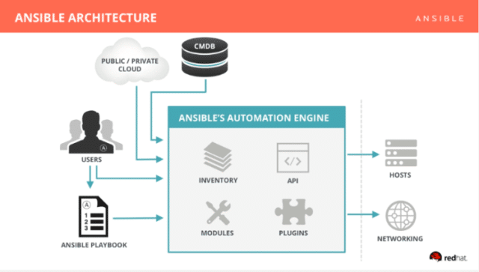
Illustration 3: Illustration of the Ansible Structure/Architecture (https://www.rogerperkin.co.uk/network-automation/ansible/what-is-ansible/).

3.2 Advantages and Disadvantages of Ansible
Additionally, the benefits and drawbacks of Ansible [21], [15], [22], or [23] shown in Table 1.

Table 1
Advantages | Disadvantages
- Ansible is a cost-free accessible toolset. | - Ansible uses a pushing technique instead of a pulling approach, in contrast to Chef. Users must think about utilising Ansible Tower.
- Really straightforward to build together and utilise: Utilization Ansible's playbooks doesn't require any specialised programming knowledge. | - For newcomers checking use Ansible for the initial instance, the complimentary courses and instruction do not offer the same level of detail and simplicity.
- Ansible is extremely effective at modelling even the most complicated IT procedures. | - Provisional Microsoft Functionality: Ansible is currently in the developing stages of attempting to expand assistance for Microsoft; however, next editions of Ansible are promised to provide greater Windows compatibility.
- Adaptable: Regardless of location the software is installed, coordinate the complete infrastructure. So, adjust it to suit requirements. | - A fee is required to use Ansible Tower.
- Agentless: Neither additional application nor security gates have to be installed on the user computers for automation. There is absolutely no requirement to establish a distinct managerial organisation. | - The Interface of Ansible Tower is not particularly client friendly. There are various alarms and noises, which might occasionally be too much to handle.
- Cost effective: None additional programs must be installed, and the host has greater space for defined scope.

Part 4. Virtual Machines
Simulations that imitate a real computer in technology are called virtual machines (VMs). Composites typically consist of several documents, including those storing the virtual machine's settings, memory for the digital storage device, plus a few pictures that capture the status of the virtual environment at specific times [25].

4.1. Hypervisors
The computer framework that manages VMs is called a hypervisor. It acts as a bridge seen across virtual machine and the underpinning real devices, making sure either gets accessibility to the components it requires to run. Additionally, it makes certain all the instances do not really conflict with one another by using up each participant 's ram or processing power. Two categories of virtualization exist [25]:
- This same conventional OS platform is completely replaced by type 1 - "bare-metal" virtualization software, which interface therewith the fundamental material assets. Therefore, frequently show up in situations involving virtual hosts.
- Type 2 virtualization function upon an established OS as a software. These are primarily frequently used on interface machines to execute different OSs, but since VMs rely on the guest OS to control and acquire the actual physical technology, they have a price cost.

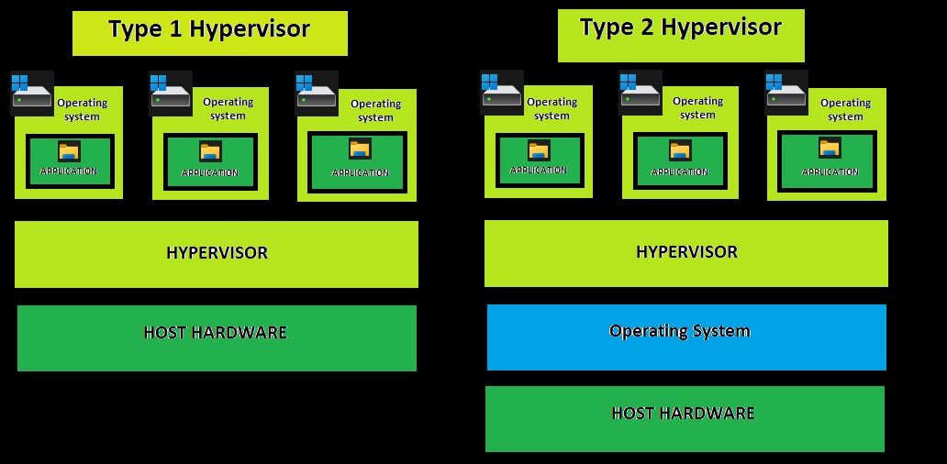
Illustration 4: Type I and Type II of Virtualization.

Part 5. Implementation (Practical)
VirtualBox (OracleVM - https://www.virtualbox.org/), and Debian (Ubuntu - https://ubuntu.com/download/) must be downloaded in order to begin planning the deployment. Furthermore, starting with the initial phase, demonstrating ways can run and setup Ubuntu inside VirtualBox, these report covers ways to deploy, produce a simulated environment, effectively setup Ubuntu via the host to users utilizing Ansible.

5.1. Preparation as well as deployment system
The new tab via VirtualBox is chosen in addition to establish a fresh route for the simulated environment. Some names, operating category, and edition should therefore all be supplied in order to construct a simulated computer (Illustration 5).

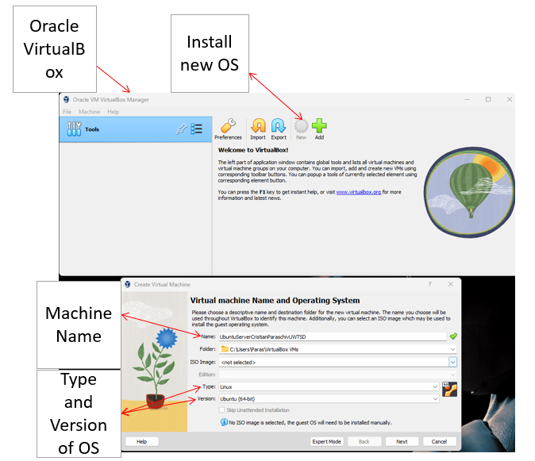
Illustration 5: Construct a simulated computer via VirtualBox.

Consequently, ram allocation and the number of processors each system (Illustration 6).

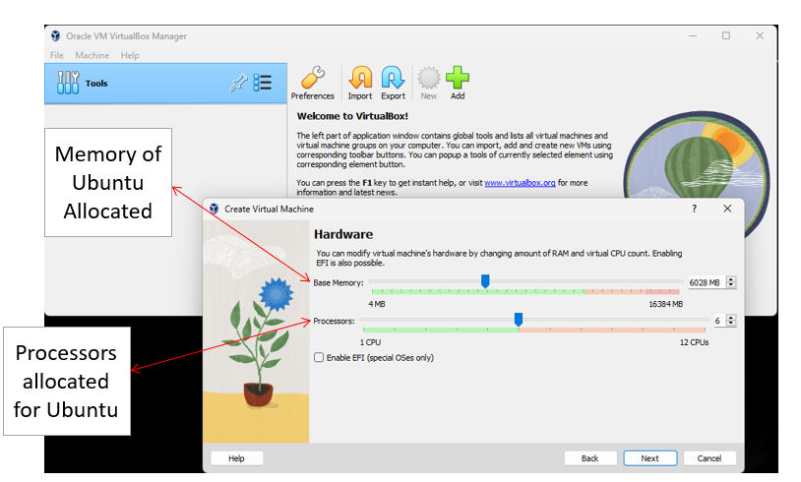
Illustration 6: Memory distribution and every platform's CPU count.

The storage option is provided within following stage (Illustration 7).
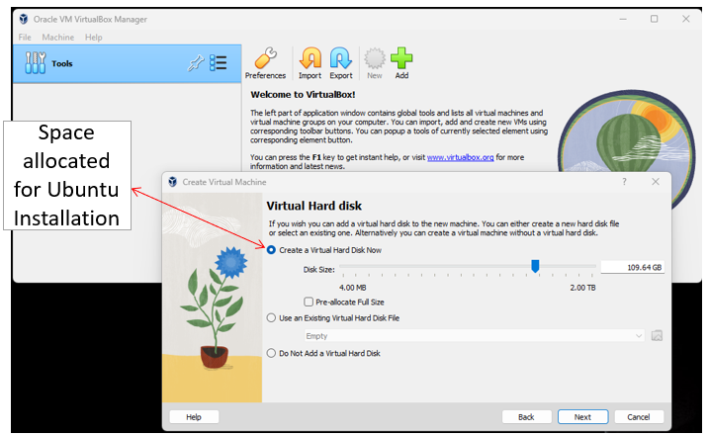
Illustration 7: Storage option

Moreover, at this step, the modelled environment was constructed, but considerable configuration was also required (Illustration 8).

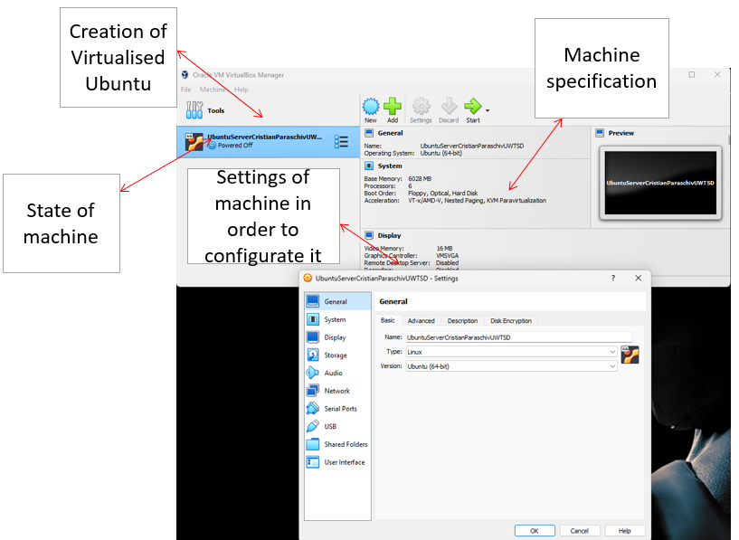
Illustration 8: Specification settled.

There is a choice of wherein to pick any Iso image in the following phase to configure the disk in addition to get the setup ready for the machine (Illustration 9, and 10).

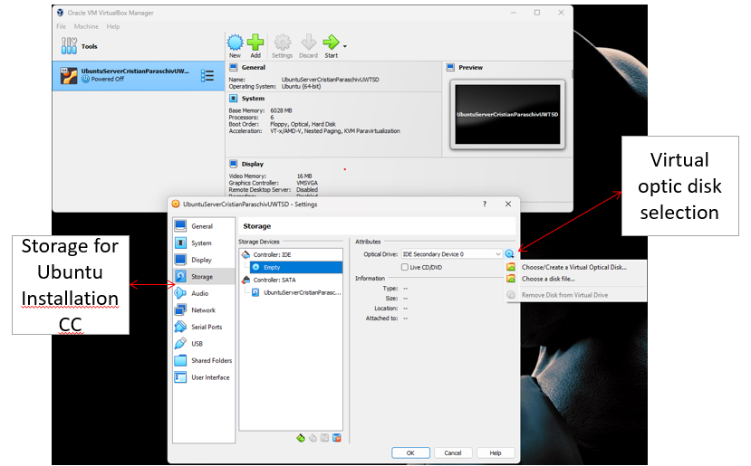
Illustration 9: Disk Configuration.

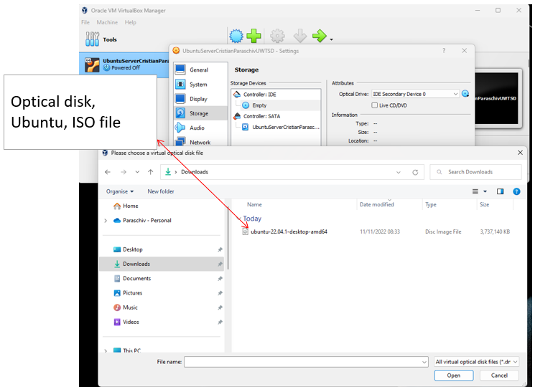
Illustration 10: Iso image path.

Since all devices are installed to the identical internet at this point, connection settings should switch from NAT to a bridge adapter (Illustration 11).

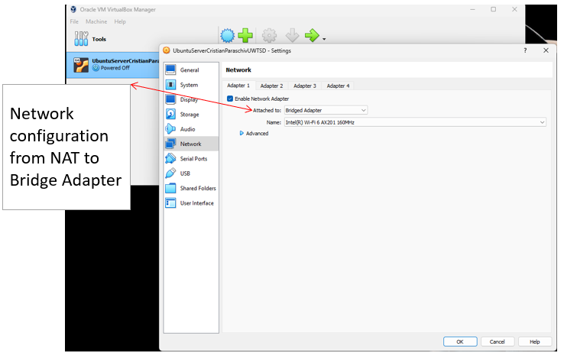
Illustration 11: Internet configuration.
The platform now readily available once all the setup issues have been resolved.
Additionally, deployment is rather simple (Illustration 12). Simply configure Ubuntu while specifying the preferred region, dialect, and system maintenance settings (Illustration 13,14,15,16, and 17). It requires a login information prior deployment (Illustration 18).

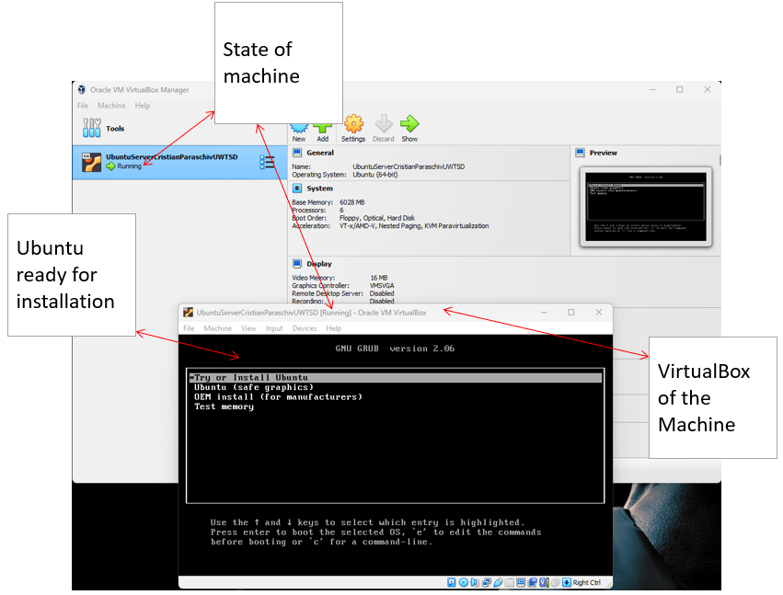
Illustration 12: System prepared for setup.

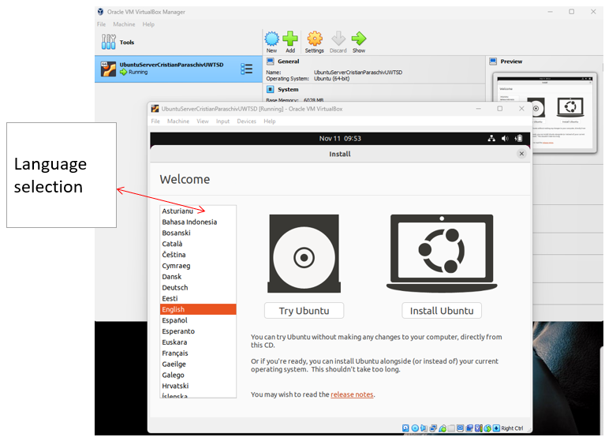
Illustration 13: Dialect selection.

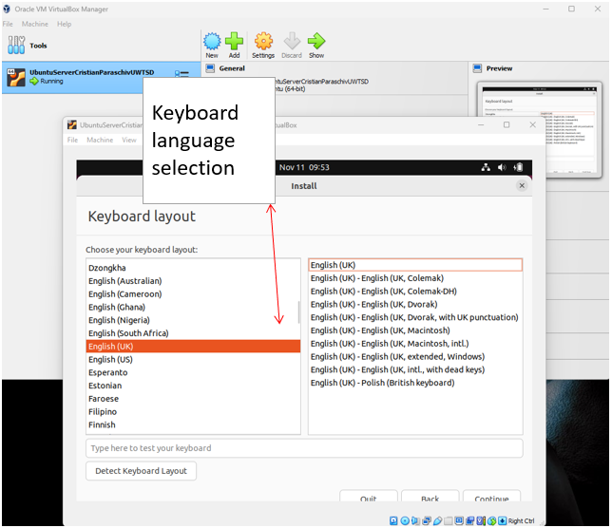
Illustration 14: Layout of Keyboard selection.
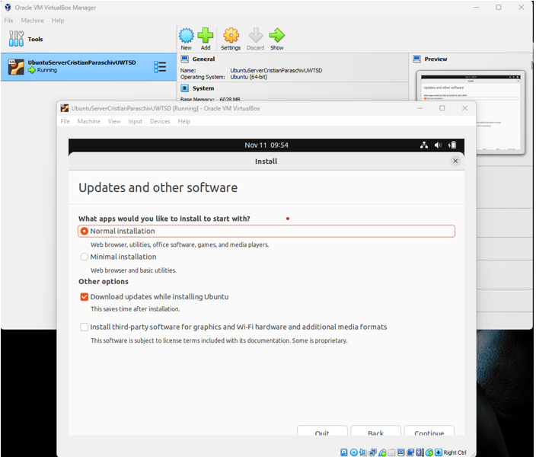
Illustration 15: System and Software maintenance.

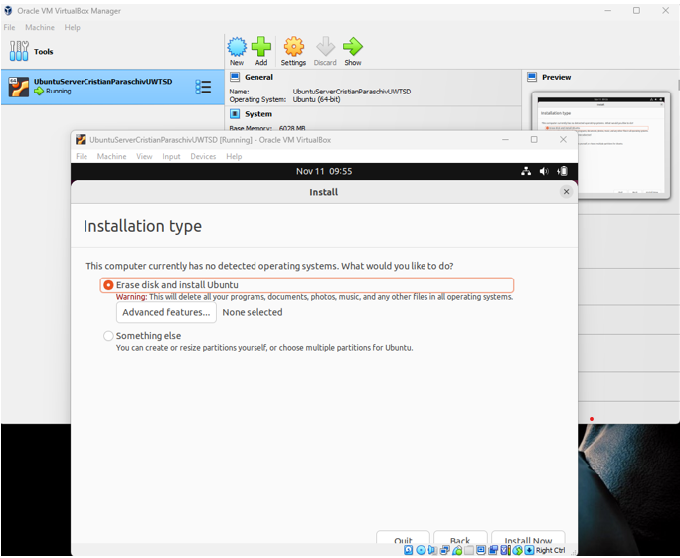
Illustration 16: Setup category.

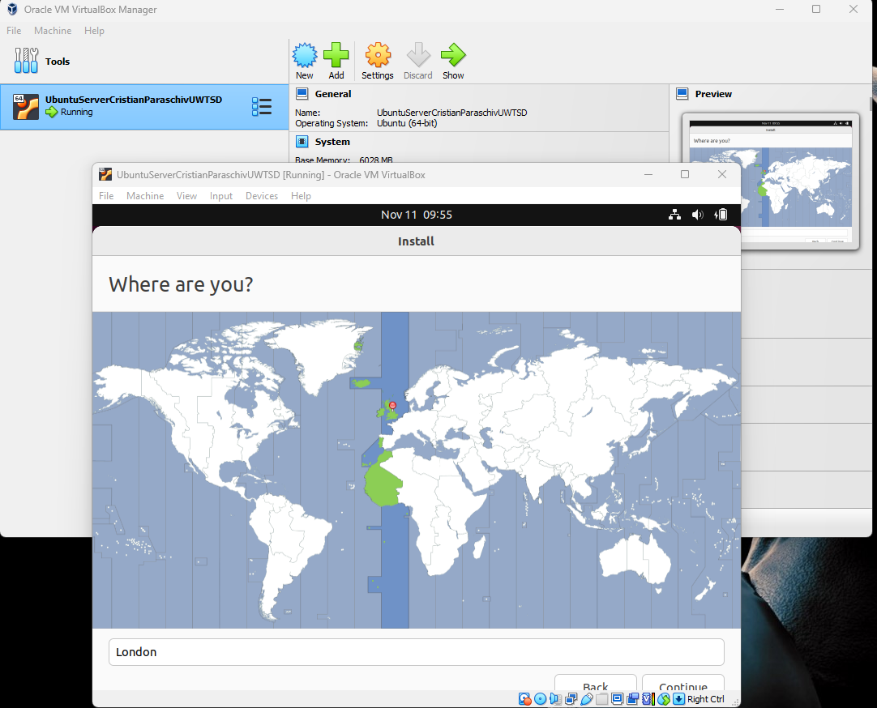
Illustration 17: Geographic location - selection.

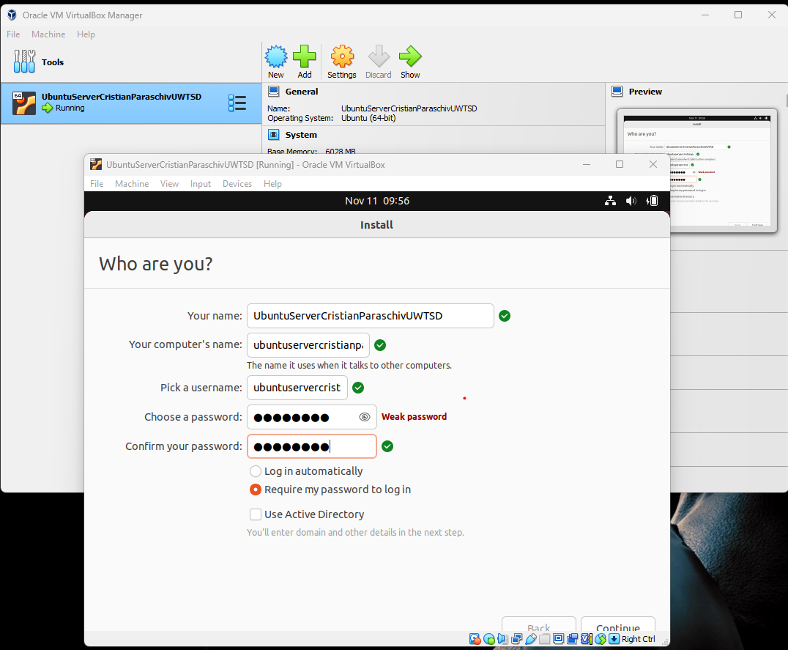
Illustration 18: Login parameters before starting deployment.

The system begins installing the contents in the final stage, and deployment time is brief (Illustration 19, and 20).

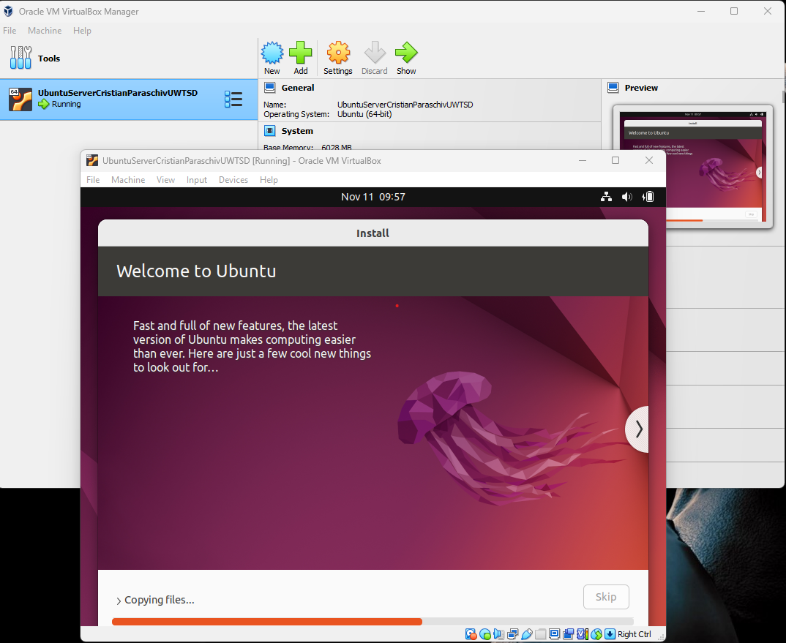
Illustration 19: System deployment files.

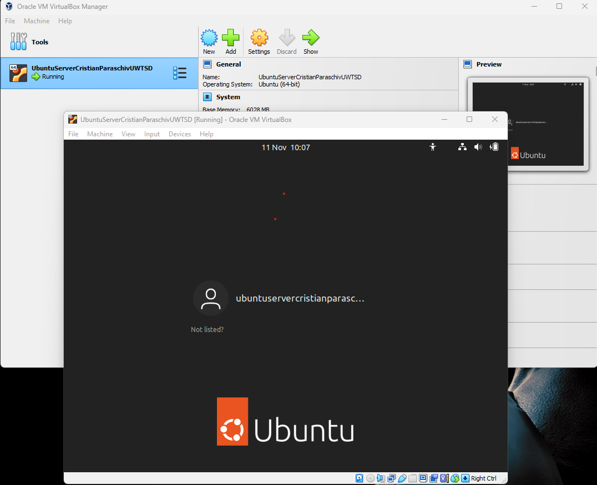
Illustration 20: System ready to be accessed.
Three computers get deployed and arranged in the way described; one is a host and the other two users (Illustration 21).

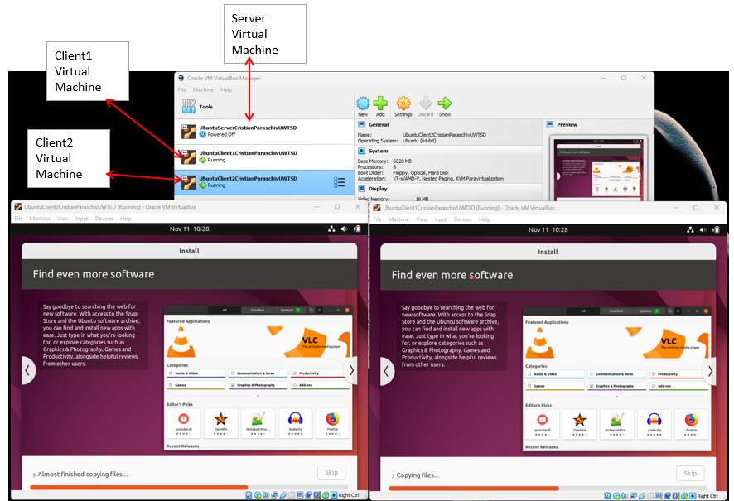
Illustration 21: Configuration of a host and users.

5.2. Ways to configure essential features and remote privilege (SSH).
This item covers the communication among the server with users utilizing a straightforward instruction as well as key preparation and user key copying. Additionally, provided and used. There is absolutely no requirement to acquire a remote interface since Debian (Ubuntu) currently has already preinstalled. A host and two users are shown in the pursuit.
The computers' internet protocol may be discovered in the first stage by using the syntax “ip a”, as shown in Illustration 22.

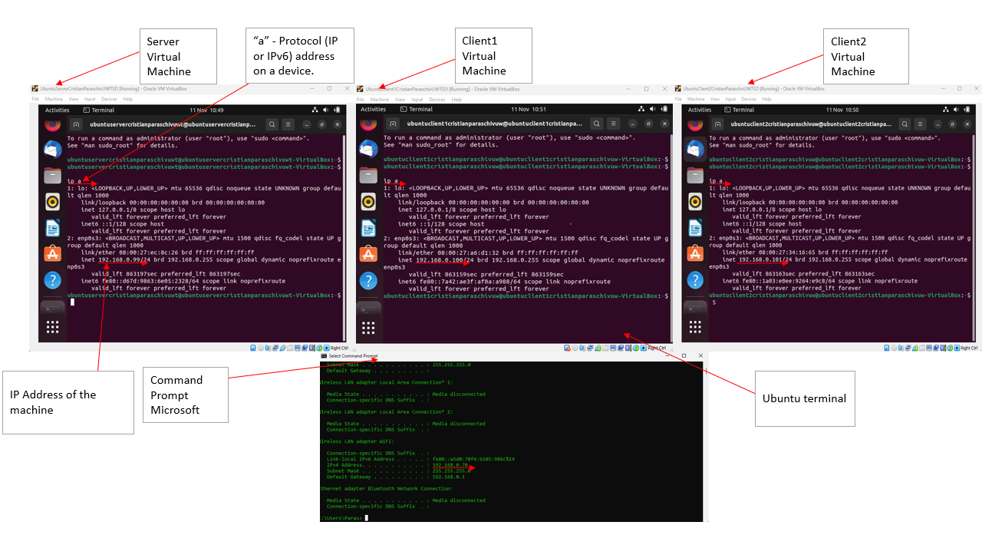
Illustration 22: Where to locate device internet protocols, within interface.

During this phase, consider Illustration 23 for determine whether the computers are accessible and to transmit and receive signals (ping – module).

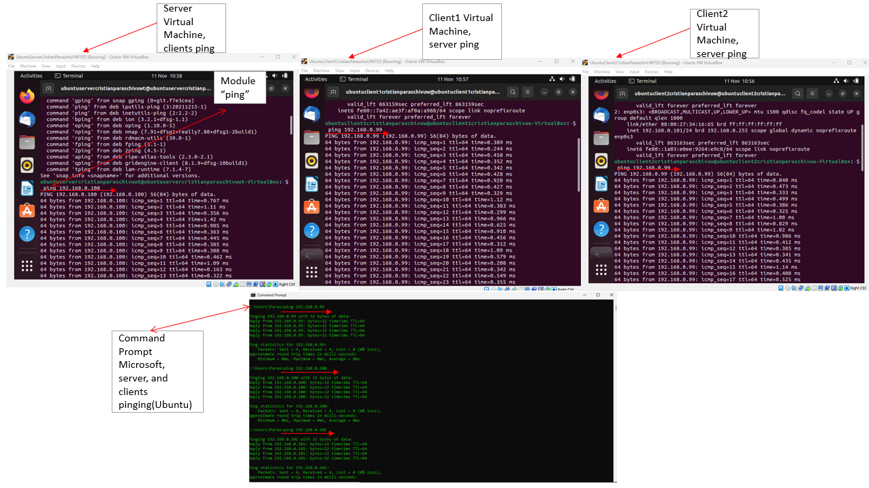
Illustration 23: Test to verify if the machines can send or collect messages and thus are reachable.

Illustration 24 shows the Internet protocol or domain name which are attempting to login to as well as is usually simplest basic version of the statement. Through employing the language in Illustration 24, this operation relies on the assumption whether someone username on the distant computer matches identifier on local grid. A user application communicates with a remote computer for SSH to operate. This same remotely controlled host ought should launch on its own in almost any Linux system. Users might require reaching host momentarily via a screen interface or direct device resource while it is not functioning for whatever purpose.

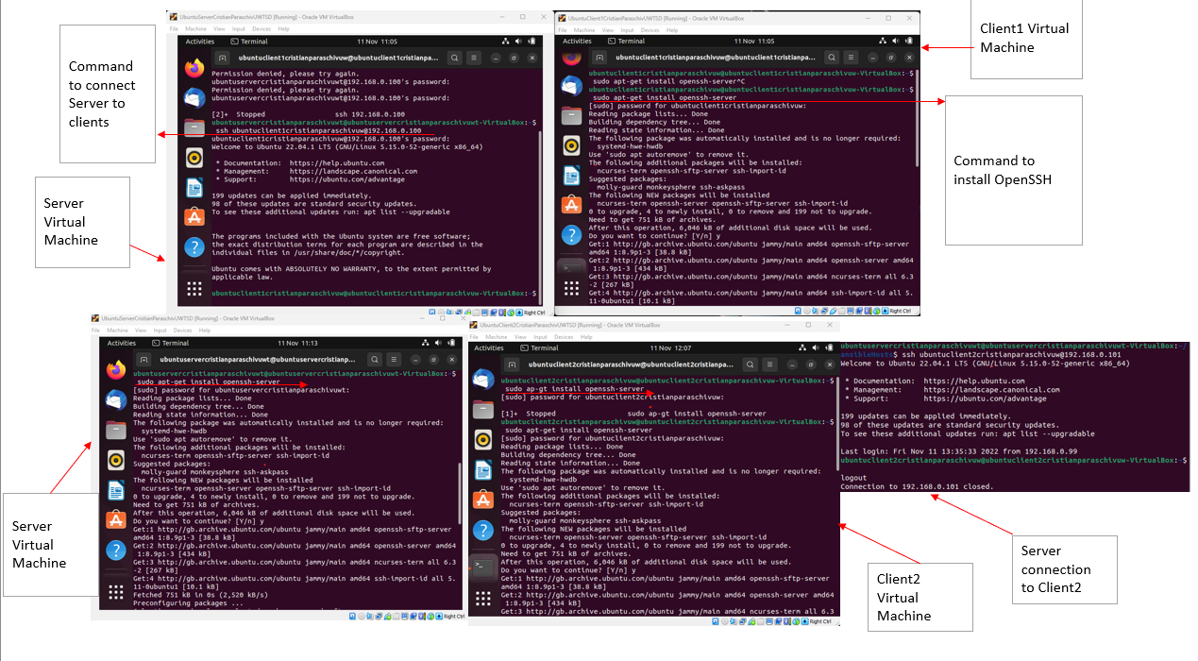
Illustration 24: Server and customer connections over distance.

As seen in Illustration 25, attempting to push the button or using the phrase exit will allow to detach form the remotely controller.

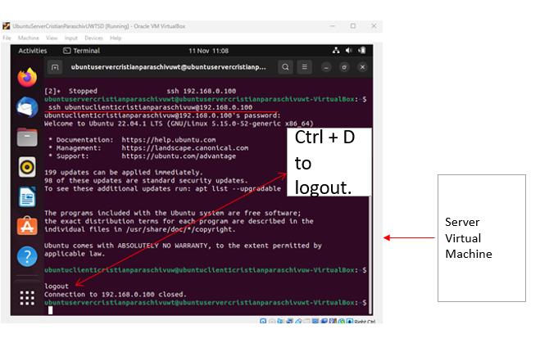
Illustration 24: How to break the link.

5.3. Establishing credentials (keys) as well as copying credentials from the host to the users.
Establish credentials via a secured relationship in this stage. SSH credentials (keys), which offer a safe means to access host, are advised for all individuals. Inside the pursuit shown in Illustration 25, specify such credential, position, or password in addition to mentioning how to produce the credentials. It is strongly advised to provide a strong password if you choose to do so. To further increase protection and stop unauthorised people from accessing through, employ a passphrase. Both public key and a private key are now available for authentication.

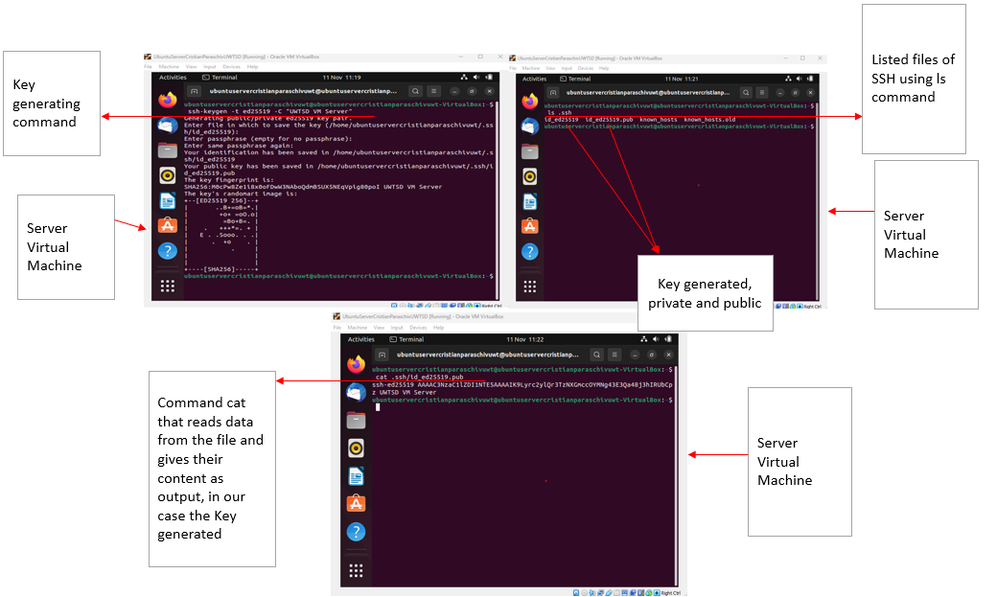
Illustration 25: Regarding safety purposes, generating ID’s.

This section deals with the syntactically required transmission of public keys between domain controller to users. Therefore, should currently possess passcode administration to host for the above approach to operate. Consequently, must indicate both client profile to which enable passcode administration as well as the destination server to establish a connection. Public SSH keys shall automatically transferred to clients, as shown in Illustration 26.

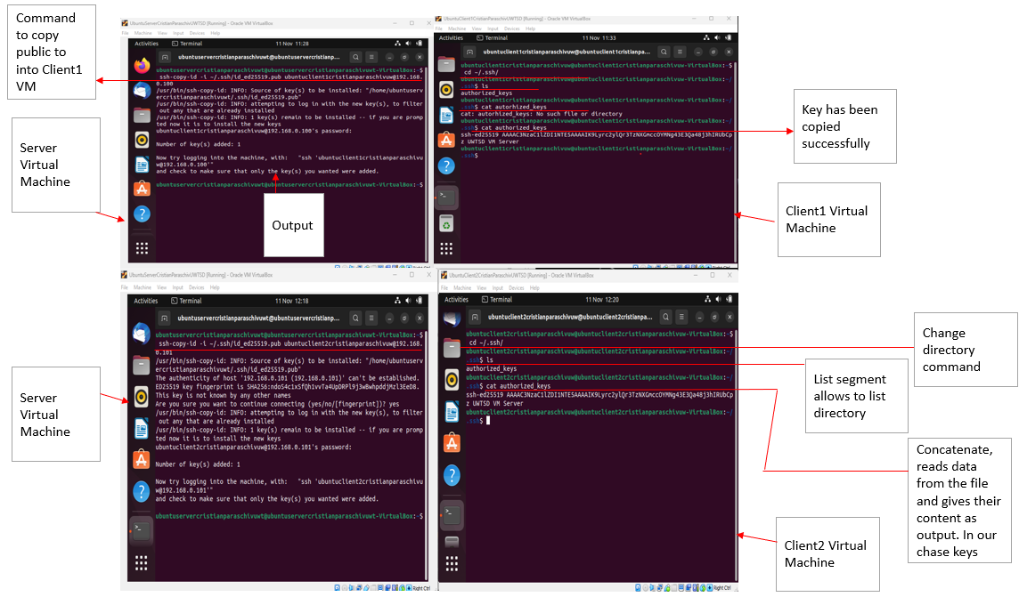
Illustration 26: How to move public/private credentials between hosts and users.

Additionally, a connection may be made remotely even while utilising the keys in Illustration 27, or 28.
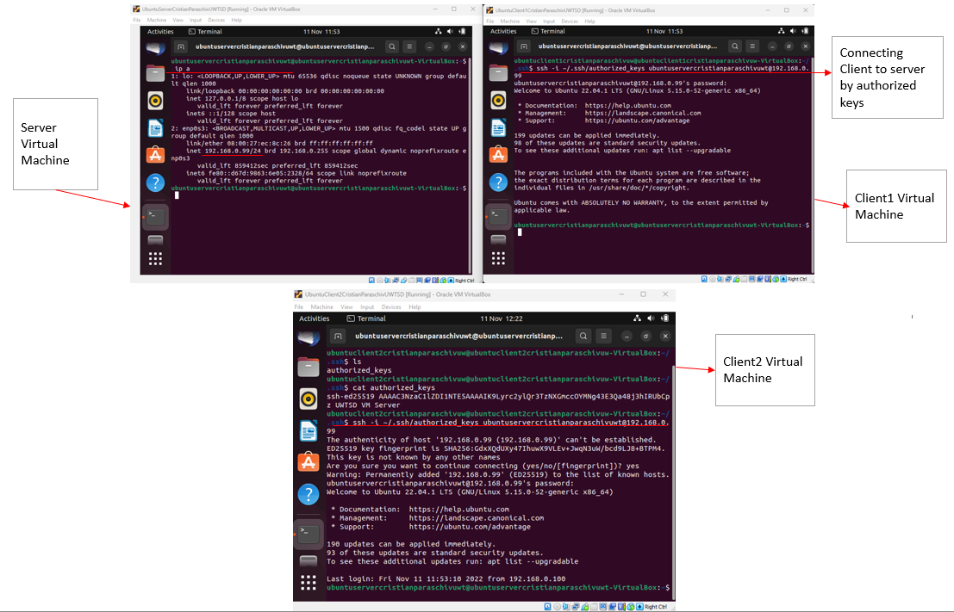
Illustration 27: Public/private credentials are used to remotely govern users from the host.

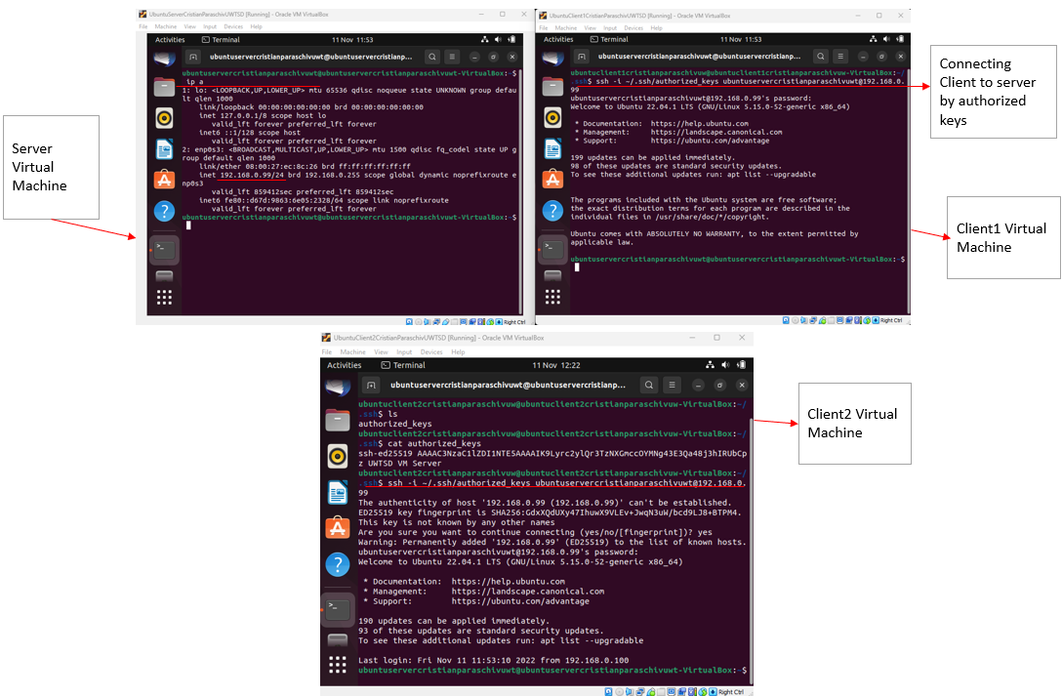
Illustration 28: Using authorised credentials to communicate.

5.4. Ansible installation, setup, and deploy.
This phase describes methods to setup Ansible inside that operational platform's interface and its functionality during the setting of VMware and the installation of the Debian (Ubuntu) systems, in addition to setting. At this stage, an updating is carried out as shown in Illustration 29. Additionally, establishing a repository hosting the Ansible environment and editing the host script. Employing a set or collection of catalogues called as inventories, Ansible operates simultaneously across various controlled nodes and architecture. Whenever the inventories are established, utilize criteria to pick relevant servers or organizations and execute Ansible across them.

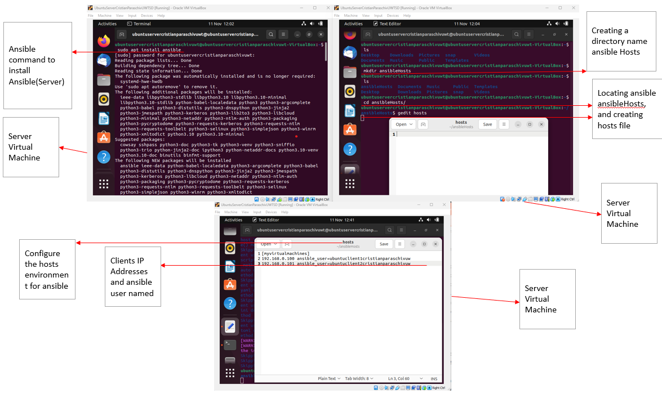
Illustration 29: Ansible environment generating hosts documents, bundle details from each specified supplier.

Additionally, language is shown in Illustration 30 for listing all hosted documents employing query pathway "-i" on inventories address. As a result, a language was likewise used to extract information off the host table.

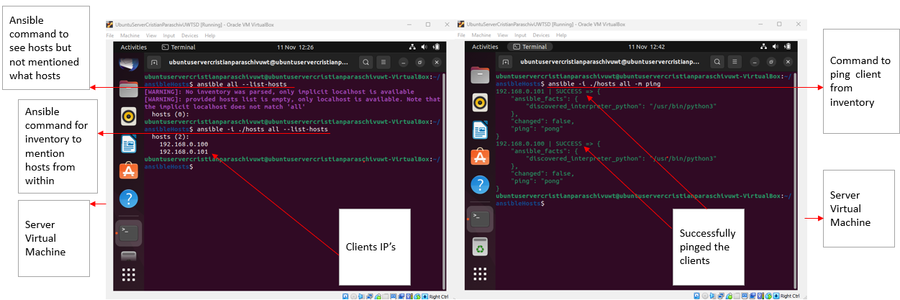
Illustration 30: Domains included in the hostname directory, along with their responses, and machines respond.

Additional function is available to collect information regarding the devices contained in the host directory made by specifying the inventories, Illustration 31.
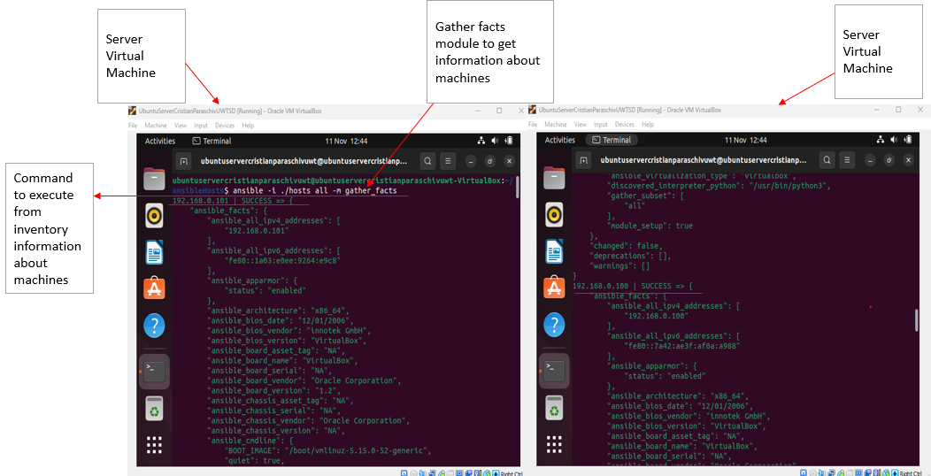
Illustration 31: Another way in addition of machines information.

Furthermore, ansible.cfg, a control document, is currently used to modify setup parameters. The setup applies to every server that was originally mentioned. Ansible will subsequently recognize precisely wherein to pull data in addition to load the necessary modules because it is stated inside the script wherein to collect inventories materials off the server and how to retrieve the secret privileges, Illustration 32.

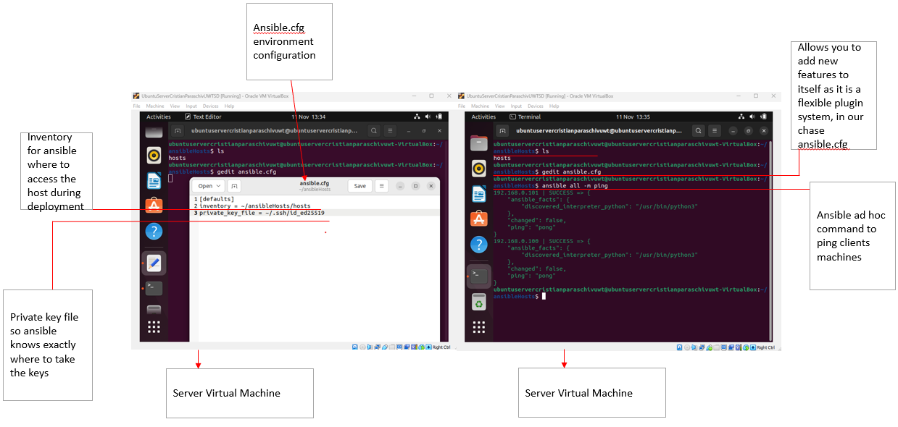
Illustration 32: Environment for pathways to be executed in.

By retrieving packages via the repository, apt maintains an interpreta catalog of packages in addition to apt upgrade, which previously stated. As a result, updating chases instructs the Ansible apt component to refresh the caching before making the required updates, Illustration 33.
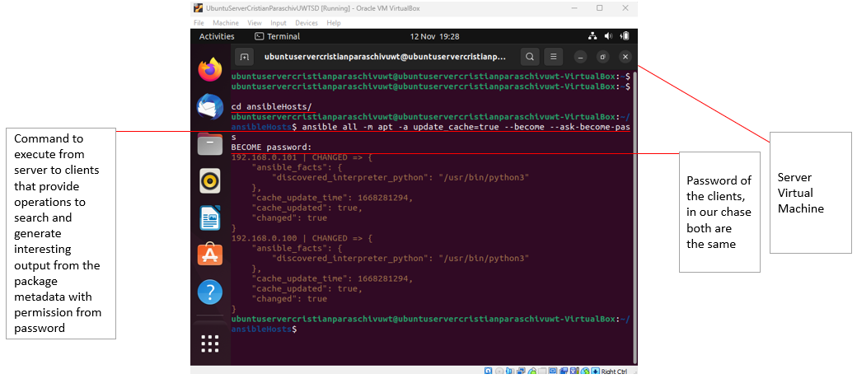
Illustration 33: Reload the caching.

5.5. Installing and configuring Apache2, PHP, MySQL, and PhpMyAdmin using Ansible
In this part, we will firstly demonstrate way Ansible gets used to deploy and setup Apache. In addition, you may deploy Apache via a host to the users by writing YAML documents and running instructions. As a result, by instructing Ansible to run scripts from established playbooks and requesting authorization from users. Including a demonstration of the installation and deployment and extra running tests, as illustrated in Illustration 34, 35 and 36.

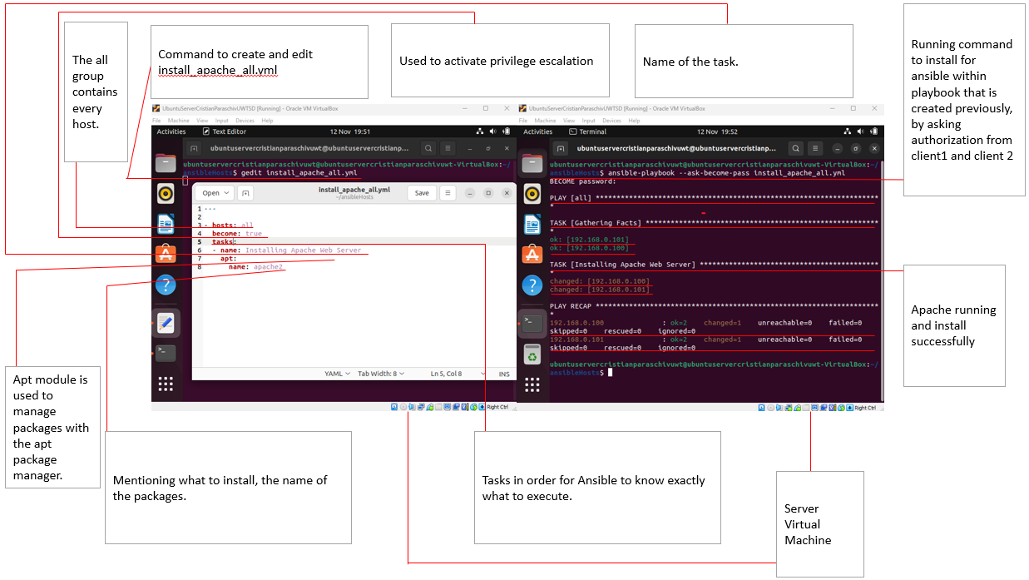
Illustration 34: Configuring the YAML language in conjunction with playbook-based distribution.
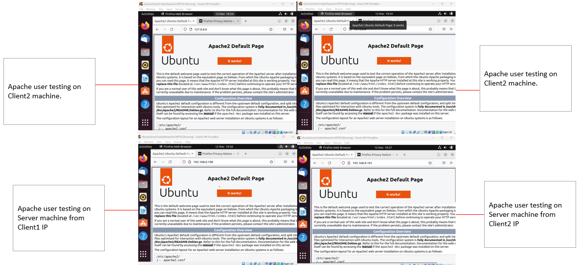
Illustration 35: Internet protocol - webpage accessibility is being tested by users.

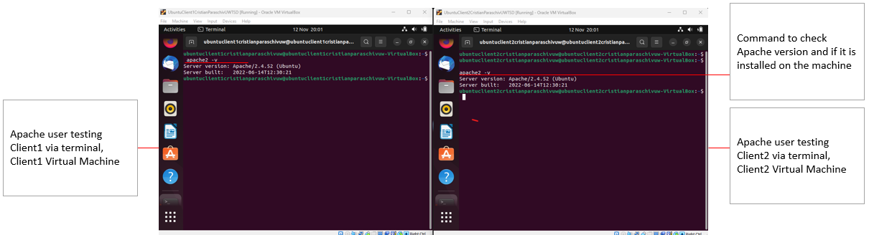
Illustration 36: Through the UI, edition verification.

Following each user error, the following language shall be employed to acquire bundle data via both specified providers, following each program's termination, as shown in Illustration 37.

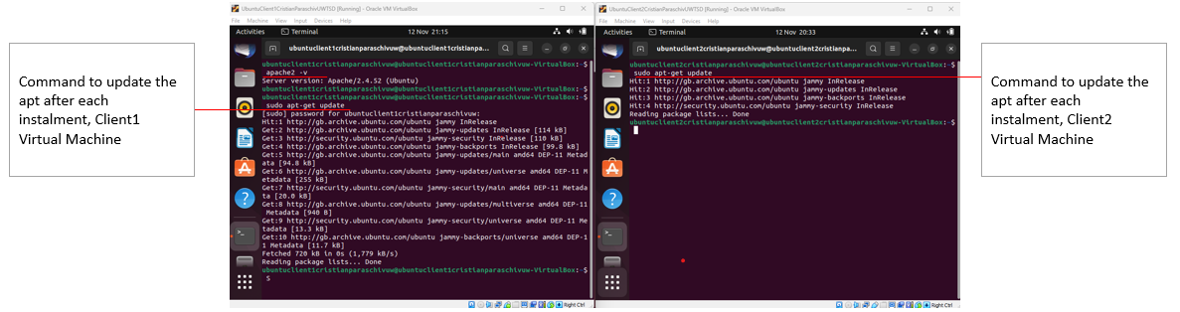
Illustration 37: Obtain bundle details from each specified provider.

Only the packages included within the YAML files change from the phase provided and PHP implementation, we already detailed how the setup is deployed within Apache. The strongest associations include every language utilized, client acceptance validation, and upgrade, presented in Illustration 38, 39 and 40.

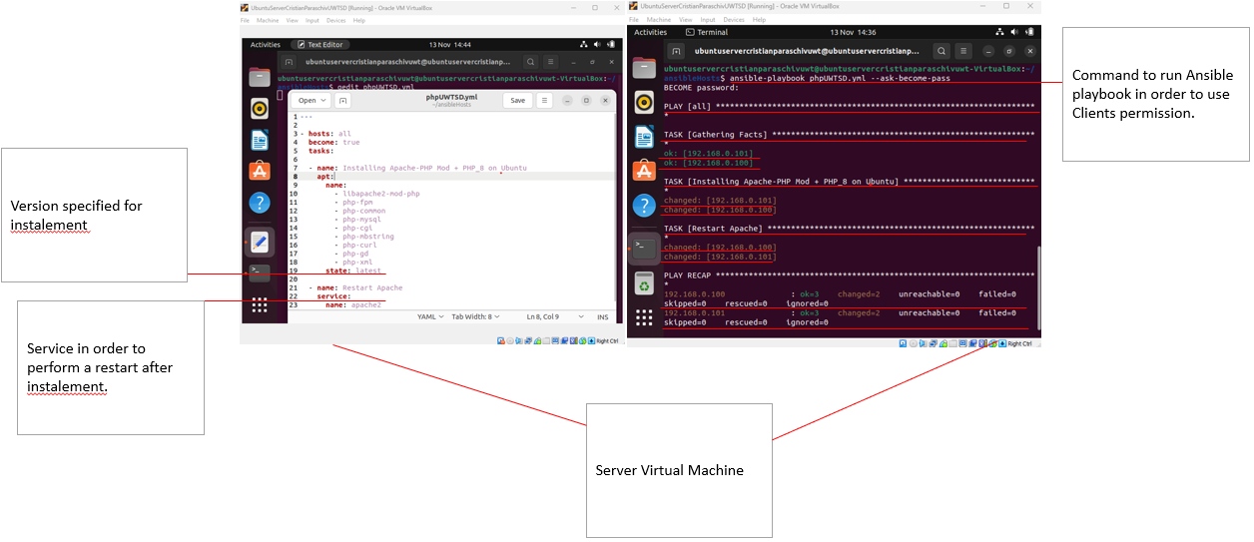
Illustration 38: Distribution, installation, and setup of PHP.

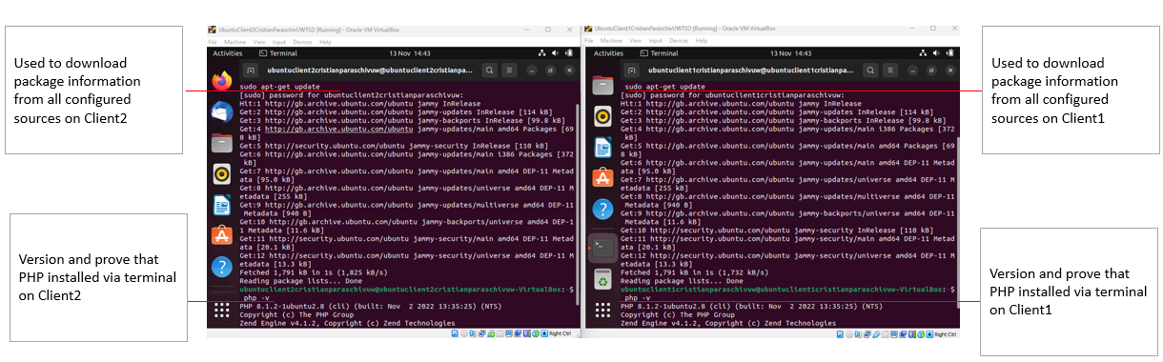
Illustration 39: The version and parcel upgrade are displayed via the console.

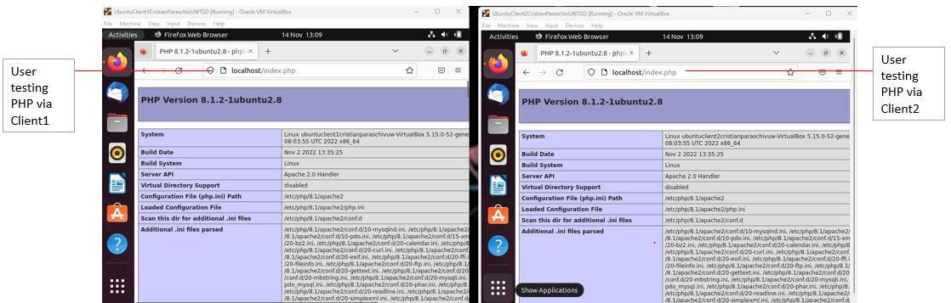
Illustration 40: Audience testing – PHP.

The installation, administration, and validation of MySQL with PhpMyAdmin are covered in the last phase. Moreover, the setup process for these two is identical to the ones discussed regarding installations using the identical scripts with distinct vocabulary. MySQL must be set up following installation in process the dataset, grant cleaning rights, and create an account with administrator access. Client validation is also represented by Illustrations 41, 42, and 43.
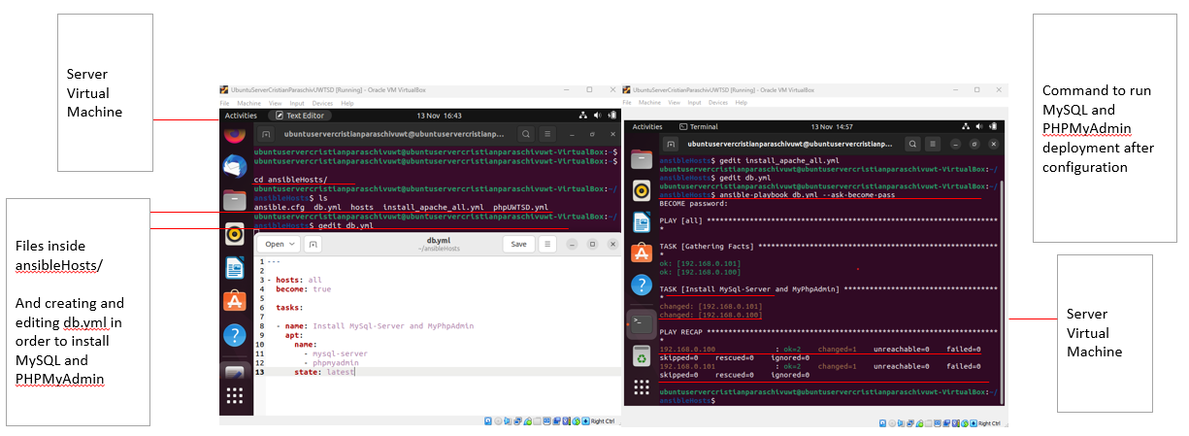
Illustration 41: Environment setup, MySQL and PhpMyAdmin deployment.

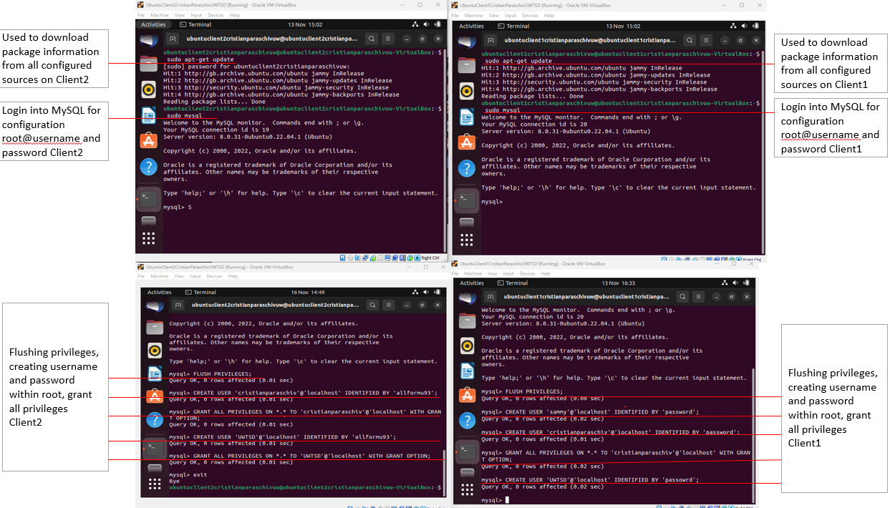
Illustration 42: Set the administrator login, passcode, and privileges.

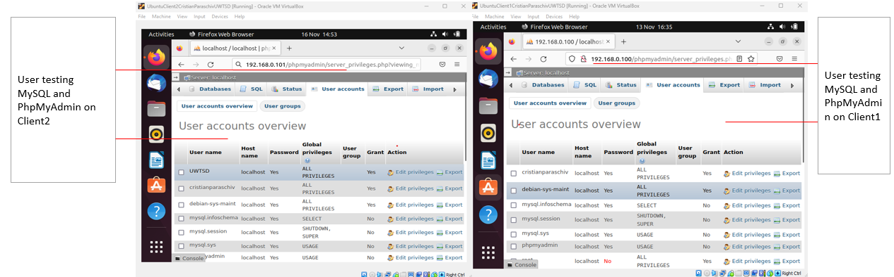
Illustration 43: Using the web to assess users

Conclusion
Ansible do not require a broader paradigm to verify the fundamental elements of architecture are accurate. This is true since Ansible is indeed dynamic command mechanism that prevents continued setup on a server by failing instantly on unintended faults for specific server. As a result, mistakes are forced to towards the head of the list and appear in a report at the conclusion of every Ansible execution. The fact that Ansible is an inter coordination platform, though, allows it quite simple to include checks at the conclusion of a module execution employing both flexible jobs and responsibilities. Validation procedures may determine rather or not to re-insert a computer onto a massive amount pooling if utilised with wheel upgrades. And last, since Ansible works inside a simple force approach by configuration and therefore Ansible problems cascade right this same upwards from to the Ansible system's response script.

References
[1] J. Hosek et al., ‘A SyMPHOnY of Integrated IoT Businesses: Closing the Gap between Availability and Adoption’, IEEE Commun. Mag., vol. 55, no. 12, pp. 156–164, Dec. 2017, doi: 10.1109/MCOM.2017.1700028. Available at: https://ieeexplore.ieee.org/abstract/document/8198821
[2] European Wireless 2015; 21th European Wireless Conference; Proceedings of: date 20-22 May 2015. Berlin: VDE Verlag GmbH, 2015. Available at: https://ieeexplore.ieee.org/abstract/document/7147697
[3] E. Olshannikova, A. Ometov, Y. Koucheryavy, and T. Olsson, “Visualizing Big Data with augmented and virtual reality: challenges and research agenda,” Journal of big data, vol. 2, no. 1, pp. 1–27, 2015, doi: 10.1186/s40537-015-0031-2. Available at: https://www-proquest-com.ezproxy.uwtsd.ac.uk/docview/1987954712?pq-origsite=primo&accountid=130472
[5] L. Bass, I. M. Weber, and L. Zhu, DevOps: a software architect’s perspective. New York: Addison-Wesley Professional, 2015. Available at: https://books.google.co.uk/books?hl=en&lr=&id=fcwkCQAAQBAJ&oi=fnd&pg=PT13&dq=L.+Bass,+I.+Weber,+and+L.+Zhu,+DevOps:+A+Software+Architect%E2%80%99s+Perspective.+Addison-Wesley+Professional,+2015.&ots=KSzvs9LTTc&sig=fg_FS84ytE3NJrtB46WMl69rzPI#v=onepage&q=L.%20Bass%2C%20I.%20Weber%2C%20and%20L.%20Zhu%2C%20DevOps%3A%20A%20Software%20Architect%E2%80%99s%20Perspective.%20Addison-Wesley%20Professional%2C%202015.&f=false
[6] 2017 IEEE Conference on Network Function Virtualization and Software Defined Networks (NFV-SDN). IEEE, 2017. Available at: https://ieeexplore-ieee-org.ezproxy.uwtsd.ac.uk/xpl/conhome/7893447/proceeding
[7] A. Basta, A. Blenk, K. Hoffmann, H. J. Morper, M. Hoffmann, and W. Kellerer, “Towards a Cost Optimal Design for a 5G Mobile Core Network Based on SDN and NFV,” IEEE eTransactions on network and service management, vol. 14, no. 4, pp. 1061–1075, 2017, doi: 10.1109/TNSM.2017.2732505. Available at: https://ieeexplore.ieee.org/document/7994617
[8] G. Xilouris et al., “Service orchestration leveraging software networks and DevOps in 5G,” in 2017 8th International Conference on the Network of the Future (NOF), 2017, pp. 150–152. doi: 10.1109/NOF.2017.8251240. Availabe at: https://ieeexplore.ieee.org/document/8251240
[9] K. Morris, Infrastructure as code: managing servers in the cloud, First edition. Beijing: O’Reilly, 2016. Available at
[10] M. Artac, T. Borovssak, E. Di Nitto, M. Guerriero, and D. A. Tamburri, “DevOps: introducing infrastructure-as-code,” in Software Engineering Companion (ICSE-C), 2017 IEEE/ACM 39th International Conference on, pp. 497–498, IEEE, 2017. Availabe at: https://www.researchgate.net/profile/Damian-Tamburri/publication/318124847_DevOps_Introducing_Infrastructure-as-Code/links/5b17c6bbaca272021ce9147e/DevOps-Introducing-Infrastructure-as-Code.pdf
[11] D. Palma and T. Spatzier, “Topology and orchestration specification for cloud applications (TOSCA),” Organization for the Advancement of Structured Information Standards (OASIS), Tech. Rep, 2013. https://res.infoq.com/articles/book-infrastructure-as-code/en/resources/excerpt-for-infoq.pdf
[12] [1] 10th Annual IEEE International Systems Conference: proceedings : April 18-21, 2016 Hyatt Regency Grand Cypress, Orlando, Florida, USA. Piscataway, NJ: IEEE, 2016. Available: https://ieeexplore.ieee.org/stamp/stamp.jsp?arnumber=7490666
[13] R. Robbes, C. Bird, and M. Kim, MSR 2016 : proceedings, 13th Working Conference on Mining Software Repositories : 14-15 May 2016, Austin, Texas, USA. New York: ACM, 2016. Available at: https://ieeexplore-ieee-org.ezproxy.uwtsd.ac.uk/xpl/conhome/7830495/proceeding
[14] How Ansible works, Learn the fundamentals of Ansible, powerful IT automation software that emphasizes simplicity and ease of use. Available at: https://www.ansible.com/overview/how-ansible-works
[15] Ansible Documentation. Available at: https://docs.ansible.com/ansible/latest/index.html
[16] Installing Ansible. Available at: https://docs.ansible.com/ansible/latest/installation_guide/intro_installation.html#control-node-requirements
[17] The Ansible Team. Available at: https://web.archive.org/web/20150905195548/http://www.ansible.com/about-team
[18] Source: Red Hat is buying Ansible for more than $100M. Available at: https://venturebeat.com/dev/source-red-hat-is-buying-ansible-for-more-than-100m/
[19] Red Hat to Acquire IT Automation and DevOps Leader Ansible. Available at: https://www.redhat.com/en/about/press-releases/red-hat-acquire-it-automation-and-devops-leader-ansible
[20] Basic Concepts of Ansible. Available at: https://docs.ansible.com/ansible/latest/network/getting_started/basic_concepts.html
[21] Red Hat Ansible Automation Platform features and benefits. Available at: https://www.redhat.com/en/technologies/management/ansible/features
[22] F. A. Locati, Learning ansible 2, 2nd revised edition. Place of publication not identified: Packt Publishing Limited, 2016. Available at: https://books.google.co.uk/books?hl=en&lr=&id=EZ3cDgAAQBAJ&oi=fnd&pg=PP1&dq=disadvantages+ansible&ots=LkWZjQAm3a&sig=G9COfneWJBL5PRuhyNNgQi_iAH0#v=onepage&q=disadvantages%20ansible&f=false
[23] L. Hochstein and R. Moser, Ansible: up and running: automating configuration management and deployment the easy way, Second edition. Sebastopol, California: O’Reilly Media, 2017. Available at: https://books.google.co.uk/books?hl=en&lr=&id=h5YtDwAAQBAJ&oi=fnd&pg=PP1&dq=drowback+ansible&ots=MKrg5kUW_P&sig=Miax7mJCyBYulT_aENmaAvp6wdo#v=onepage&q=drowback%20ansible&f=false
[24] M. Krief, Learning DevOps, 1st edition. Packt Publishing, 2019. Available at https://ebookcentral.proquest.com/lib/trinity/detail.action?docID=5969307&pq-origsite=primo
[25] Virtualization. Available at: https://www.ibm.com/cloud/learn/virtualization-a-complete-guide#toc-hypervisor-UrK7TB8Y

