Stephen Thomas – 1703181
Music Technology
Research practices – ADAD5001
Lecturer – Rob Jones

Introduction

Throughout this essay I will aim to create the question for my final dissertation. To do this I will explore three key phrases and known practitioners in my chosen area of study, and in more specialised areas of the chosen field which will in turn provide the framework for what will eventually lead to my dissertation question whilst exploring and developing an understanding of different areas of study within the essay.

Key words / phrases.

Psychotherapy

What is psychotherapy? Psychotherapy, or therapy for short, is a term that involves a variety of treatment techniques. Whilst undergoing psychotherapy, a person generally talks to a therapist over a number of sessions to try and understand and work through the triggers of their illness as opposed to undergoing medicinal treatment. There are five different types of therapy, psychoanalysis and psychodynamic therapy, behaviour therapy, cognitive therapy, humanistic therapy and integrative and holistic therapy.

Psychoanalytical therapy was founded by Sigmund Freud (1856 – 1939) with the belief that people could be cured by making their unconscious thoughts conscious, gaining somewhat of an insight into their mental illness. The basic aim of psychoanalytical therapy is therefore to release repressed and unconscious emotions in order to cure the patient. “Psychoanalysis provides a particular kind of relationship, one that meets the needs of those individuals who have reached the stage of symbolic or "representational" thinking, but who are held back from further development by pathogenic influences from the past.” (Anne Hurry, Psychoanalysis and developmental therapy, page 42).

Behavioural therapy centres on how someone’s thoughts and beliefs can be a direct influence on their mood and how they act. Focusing on behavioural patterns in the patient and how their current problems can be overcome. With the long-term goal of redirecting the patients’ beliefs and behavioural patterns to have a better impact on their mental health.

Cognitive therapy is a practice that’s main goal is to promote self-awareness and emotional intelligence in the patient so that they can help to distinguish within themselves what are healthy or unhealthy feelings so to redirect the patients thoughts to another area and essentially train the patients’ brain to be able to “read” when an unhealthy thought will arise and remove themselves from that situation. Helping them to understand how the unhealthy thoughts and distorted perceptions of how they see certain aspects of their lives can lead to painful feelings. 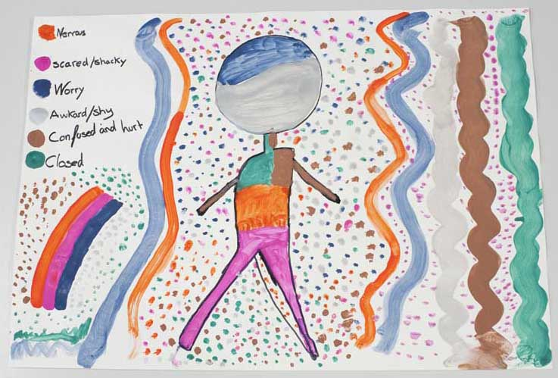

A painting from an art therapy session, highlighting the patients feelings and emotions.

The aim of humanistic therapy is to help to promote a greater feeling of “self” within the patient. As helping the patient to think in healthier ways about themselves, promoting self-value and a better understanding of their feelings can help them to gain a sense of meaning in life. “Humanistic psychology poses two overarching challenges to the study of the conscious and nonconscious process: 1. What does it mean to be fully and experientially human and (2) how does that understanding illuminate the fulfilled or vital life?” (Kirk J. Schneider, J. Fraser Pierson, James F. T. Bugental, The handbook of humanistic psychology: Theory, Research and Practice, page 17.)

Integrative therapy is the practice that approaches what is causing your problems in life and then finds ways, through creating a programme in which to live your life in more open and accepting manner while focusing on your physical and mental wellbeing. Essentially attempting to help the patient to become the best version of themselves.



Increasing in popularity over the last decade has been the use of the arts in therapy as a way of expressing emotion. Whether through art, music, poetry, creative writing, dance, photography or bibliography, many therapists now use the arts as a way to allow the patient to express their emotions through more non-conventional ways where the patient may feel more comfortable as opposed to the more conventional one on one private sessions. “The special role of art therapy in facilitating the processes involved in these stages is discussed and illustrated via case examples of Vietnam veterans treated for posttraumatic stress syndrome with the aid of visual, literary, and dramatic arts.” (Johnson, D. R. (1987). The role of the creative arts therapies in the diagnosis and treatment of psychological trauma. The Arts in Psychotherapy)

The effects of music genres on their consumers.

People listen to music for a plethora of different reasons. Whether it be for motivation while exercising, to take their minds off completing a mundane task such as an essay, to help wake them up in the morning or they’ve been through a particularly bad break-up, there’s a type of music for almost everything and almost everyone.

Recent research shows that being a musician, even an amateur at any instrument can have a major effect on your brain and can majorly increase productivity and cognitive ability compared to people that do not play any instruments. “structural differences are found in those brain regions that are closely linked to skills learned during instrumental music training (such as independent fine motor movements in both hands and auditory discrimination) (Gottfried Schlaug, Effects of Music Training on the Child’s Brain and Cognitive Development). Therefore, could it be the case that different genres of music could have different effects on the consumers who listen to that genre? While many people may claim to listen to a broad selection of music, most generally have their own genres as “go-to’s” dependent on their mood. Sad songs for when they’re feeling down, upbeat songs for when they’re feeling positive.
There are many different factors that could determine why certain songs could make you feel a certain way. Firstly, there are the different modes of music. The major scale is a scale associated with happiness when it is played, though it can portray the feeling of majesty and sentimentality when played slowly. The mixolydian mode generally has an exotic sound. The lydian mode can portray and ethereal and dreamy feeling when it is being listened to. The phrygian dominant mode can also have an exotic or middle-eastern feel. The harmonic major scale has a majestic but mysterious feel (imagine music from lord of the rings). Then you have scales such as the natural minor scale which has a darker, more tragic feel, and the Locrian mode which has a very dark and unstable characteristic. Though the reasons we make these connections could simply be because of the environment around us with certain of these scales being naturalized in society to be associated with a certain feeling (if you were to sing sad lyrics over a major scale it would feel horrendously wrong) could there be a deeper reason behind the effect music has on us as individuals?
To further understand how music affects us, we must further understand how the brain works when we listen to music. The cerebellum and auditory cortex of our brain splits the music into pitch and volume. The cerebellum then sends the basic parts of the music to the amygdala (the part of the brain responsible for emotion) which causes a rush of dopamine leading to an emotional response which is the controlled by the caudate. Research (Abrams, D., Ryali, S., Chen, T., Chordia, P., Khouzam, A., Levitin, D., & Menon, V. 2013) has shown that though we each have our own favourite genres of music, and we may not particularly enjoy certain types of music, all genres have synchronized effects on our brain. Contrary to popular belief, heavy metal music has a calming effect on the brain, especially if the listener is in an agitated or angry state when listening. This is due to the loud growls and screams as well as the tempo and drumbeat of the genre causing your brain to overload with messages, releasing stress hormones. Pop, rap, country and reggae music all have remarkably similar effects on your brain as these genres generally contain repetitive and catchy songs, making it easier for the listener to replay the song in their head over and over. Making the listener want to sing along and dance due to the feeling of comfort that comes with recognising the song. This leads to the brain becoming less calm. In 1993, a study known as the “Mozart effect” revealed that listening to classical music could in-fact make children smarter. Due to the genre causing calmness and pleasure to the listener, the brain would receive a dopamine rush and release stress hormones. Causing a lot of pregnant women to play Mozart to their children while in the womb in the hopes that the child would develop at a quicker rate and be more intelligent and successful.

Therefore, due to a mixture of the musical modes, social conditioning and the response the brain has to different genres of music, the different genres of music do have different effects on their consumers, regardless of a personal preference towards the type of music.

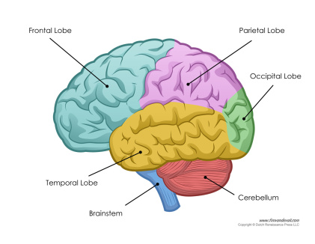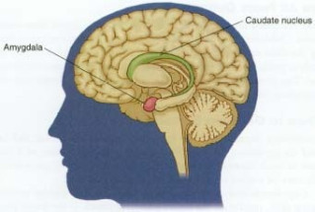

The different parts of the brain that control our response to music.

Social Normalisation
In a modern society where in some parts of the world people can be free to make almost any choice they want, to places where being homosexual is considered a punishable offence, what is considered the norm? This may come down to current day events and people jumping on bandwagons so to speak but is anything considered unnatural and not normal in today’s society? Take Donald Trump for example, how can a man who no previous political experience be elected president of one of the worlds most powerful countries? How then, can that same man want to build a wall between two countries and stop every person from one religion from entering his country be considered a normality? This is due to social normalisation. In a world where as long as there is enough publicity, people will willingly follow any cause so that they are deemed to be “normal”. Hilary Clinton stated in her run for presidency that her campaign would not let Donald Trump normalize himself over fears over his comments over women causing widespread misogyny, due to the public then seeing his actions as normal. Another area in which social normalisation thrives is mental health. 
Donald Trump, the 45th and current president of the United States.
According to the mental health charity MIND, one in four people in the United Kingdom will suffer with mental health problems each year. But one in six people will report feeling like they have experienced a common mental health problem, such as anxiety or depression. While this may be the case, many more people claim to have a mental health issue just to appear relatable and trendy to their peers as a direct result of social normalisation. As so many people are experiencing real mental health problems, such as anxiety, bipolar disorder, clinical and situational depression etc. it has become popular on social media platforms for people to either make jokes about these illnesses in an attempt to normalise them or to make a false claim to having one of these illnesses to appear more normal. The normalisation of these illnesses means that people who are vaguely stressed about something in their life can claim to have an anxiety disorder and not be questioned. The normalisation of these illnesses is not fair to those who are clinically diagnosed. It is used a façade for those who read articles online claiming, “it’s okay not to be okay” and therefore feel it is normal to claim to have a mental illness.
Social normalisation can however be used as a positive tool. Such as advertising campaigns that show that recycling can be beneficial for the planet. Such as the recent campaigns to remove plastic straws from fast food restaurants and other such establishments which led to these restaurants almost immediately replacing them with recyclable paper straws. Or the “This Girl Can” advertising campaign by sport England which aimed to normalise exercise and sport to women after a survey revealed a sizable gender gap in who participated in sports. This led to 1.6 million more women taking up sports in the next 12 months who credited that ad campaign to giving them the confidence to go and try something new.
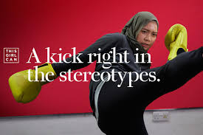
An image from the “this girl can” campaign.
So while there are cases of social normalisation being used as a powerful tool for both positive and negative reasons as stated above, it seems that it is part of modern day culture in society and so long as people can get a platform to prevent an argument, social normalisation will be at the centre of many disagreements.

Conclusion
While researching the different aspects of this essay, I found that not only did I have a passion for psychotherapy as someone who has been through the system before and has close relationships with others in the same position. But also, a passion for how the arts, particularly music can be used as a major tool in the aiding of a person’s recovery from mental illness. This coupled with a general disdain for the social normalisation of mental illnesses led me to a number of different conclusions as to my final proposal, but eventually it was my overall passion for music and helping others that led me to:
“Music in psychotherapy: can listening to and creating different types of music provide a beneficial aid to recovery?”
As this was area where I truly felt that my passion for music and mental health would be beneficial towards my studies and provide me with the best platform to succeed with my future studies in this area.

Bibliography

- Anne Hurry, Psychoanalysis and developmental therapy, 1998, London, Routledge.
- Daniel A. Abrams, Srikanth Ryali, Tianwen Chen, Parag Chordia, Amirah Khouzam, Daniel J. Levitin, Vinod Menon, Inter‐subject synchronization of brain responses during natural music listening, 2013, European journal of neuroscience.
- Gottfried Schlaug, Andrea Norton, Katie Overy, Ellen Winner, Effects of Music Training on the Child’s Brain and Cognitive Development, 2005, Harvard Medical school, Boston College.
- Johnson, D. R. The role of the creative arts therapies in the diagnosis and treatment of psychological trauma. The Arts in Psychotherapy, 1987, Pergamon journals ltd.
- Kirk J. Schneider, J. Fraser Pierson, James F. T. Bugental, The handbook of humanistic psychology: theory research and practice, 2014, second edition, sage publishing.
- Mary Butterton, Listening to music in psychotherapy, 2000, CRC Press.
- Shaun Mcniff, The arts and psychotherapy, 1981, Charles C. Thomas.

