

Why have the Governments in England and Wales not adopted a BSL Act?

Student Name: Luke Collins-Hayes
Student Number: P147091
Tutor Name: Tania Davies
Module: Research Project (BMHP6011)

Research Project submitted as part of the requirements for the award BSc (Hons) Health and Care of Children and Young People

DECLARATION

This work has not previously been accepted in substance for any degree and is not being concurrently submitted in candidature for any degree

Signed……………………………………………

Date………………………………………………

STATEMENT 1
This research project is being submitted in partial fulfilment of the requirements for the degree of BA.

Signed…………………………………………….

Date………………………………………………

STATEMENT 2
This research project is the result of my own independent work/investigation, except where otherwise stated.

Other sources are acknowledged by footnotes giving explicit references. A bibliography is appended.

Signed……………………………………………

Date………………………………………………

STATEMENT 3
I hereby give consent for my research project, if accepted, to be available for photocopying and for interlibrary loan, and for the title and summary to be made available to outside organisations.

Signed………………………………………………

Date…………………………………………………

STATEMENT 4

I hereby give consent for my research project, if accepted, to be available on the university’s IT system to those who have consent to use the system.

Signed………………………………………………

Date…………………………………………………

ACKNOWLEDGEMENTS

It is a pleasure for me to thank those people who have contributed for this and make it possible. I would like to express my sincere gratitude to my university who have supported me with writing this research project.

Firstly, I would like to thank the members of my family who have helped and motivated me through my work at several stages of the writing process. I would also like to thank for all the support they have given to me throughout my time at the University.

Secondly, I would like to thank my employees of the Action On Hearing Loss who given me much time to work throughout this research project.

Thirdly, I would like to thank Catrin Macaulay for supported and helped me with writing and guiding me through this research project.

Abstract
The British Sign Language (BSL) Act 2015 came into law on 17 September 2015 in Scotland and is the first of its kind in the United Kingdom (UK). This legislation aims to raise awareness of British Sign Language (BSL) and improve access to services for those using the language. Sign language should be recognised as the first language of a Deaf child as it is the only language that a Deaf child can acquire without someone specifically teaching it, because they cannot hear. The Governments in England and Wales have not followed Scotland’s lead and have not started the process of making a proposal to create a BSL Act and making it law. This project reviews research on what factors contribute to the Governments in England and Wales not adopting a British Sign Language (BSL) Act for deaf communities.

Contents Page
Section Page

Title 1
Declaration 2
Acknowledgements 3
Abstract 4
Contents 5

Chapter 1 6
Introduction 6
Background 6
Justification of study 7
Limitations of study 7
Aim and objectives 7

Chapter 2 8
Methodology 8
Literature review 9
Summary 17

Chapter 3 18
Findings and discussion 18
Ethical considerations 18

Chapter 4 19
Conclusions 19
Recommendations 20

References 21
Appendix 25

Chapter 1
Introduction
The aim of this research project is to examine why Governments in England and Wales not adopting a British Sign Language (BSL) Act for deaf communities following the adoption of the BSL Act which was passed as law by The Scottish Parliament in 2015. It will comprise of four chapters; Chapter 1 will discuss the introduction, background, justification of study, limitations of study, aim and objectives. Chapter 2 is the methodology and literature review which comprise of four themes namely; Language Legislation and Policy Planning, Deaf children and young people’s Education, Ideologies and Attitudes toward Sign Languages and Social model versus Medical model then summary. Chapter 3 will review of findings and discussions and ethical considerations and finally, Chapter 4 will conclude by drawing together the main points that have emerged from the research and outlining recommendations for improvement.

Background
Sign language is a visual way of communicating using hand gestures, facial expressions and body language (Sutton-Spence and Woll, 1999). It has its own grammar that is not based upon spoken English and has regional dialects or variations on signs depending upon where the person lives, which is similar to recognising an accent for those who are not deaf. There are about 70 million Deaf people who use sign language as their first language in the world (World Federation of the Deaf, WFD 2016). Sign language is not a universal language and it evolves wherever there are Deaf people. Different sign languages are used in different countries or regions. For example, British Deaf people use British Sign Language (BSL) while American Sign Language (ASL) is used by American Deaf people. Although the spoken language in America and the United Kingdom (UK) is similar, the signed languages are vastly different as they have completely different linguistic features. In the UK, there are more than 11 million people with hearing loss; around 900,000 people are severely or profoundly Deaf and more than 45,000 of these are Deaf children as highlighted by Action on Hearing Loss (AOHL, 2018). BSL is the preferred language of over 87,000 Deaf people in the UK for whom English may be a second or third language (British Deaf Association, BDA 2018).

Justification of study
Deaf children and young people typically experience delays with their communication skills, development and educational achievements in the United Kingdom (UK). Indeed, there is growing evidence that lack of language access has negative implications (Parker, 2018) which include cognitive delays, mental health difficulties, lower quality of life, higher trauma and limited health literacy (Hall, 2017). It is claimed that the adoption of the BSL Act which was passed as law by The Scottish Parliament in 2015 will create a cultural shift in attitudes about Deaf people and influence systems such as the education system so that BSL is accepted and valued (De Meulder, 2016).

Limitations of study
The scope of this research project was limited by the 5,000 words count and by the inability to undertake primary research, such as interviews and observations. It is therefore restricted to a review of secondary sources of data.

Aim and Objectives
This research project examines what factors contribute to the Governments in England and Wales not pressing forward with a British Sign Language (BSL) Act for deaf communities in contradistinction to the adoption of the BSL Act which was passed as law by the Scottish Parliament in 2015 with the ambition of setting out Scotland as being the number one place in the world for users of BSL to both live and work, and to visit. In order to achieve this aim, the research will attempt to meet the following four objectives by:
- Giving a background of sign language in the UK
- Identifying journal article research linked to sign language and deaf communities
- Evaluating some of the advantages and limitations of using sign language in the UK
- Drawing a conclusion as regards what constitutes the most effective provision and making recommendations for improvement

Chapter 2
Methodology
In order to address the aim and objectives of this research project, relevant secondary research literature was identified from a variety of sources searched. The literature searched included peer reviewed journal articles such as: The Journal of Deaf Studies and Deaf Education, American Annals of the Deaf, Sign Language Studies, Journal of Communication Disorders, National Deaf Children’s Society (NDCS) reports, Consortium for Research in Deaf Education (CRIDE), newspapers, magazines articles and appropriate websites.

The Critical Appraisal Skills Programme (CASP) was used in this research. Using this tool enables the researcher to assess the relevance, credibility and results of published literature. This tool enables a literature review to inform original projects in order to help make sense of research methodologies and ensuring reliability (Taylor et al, 2001). CASP offers a system ‘check list’ to find information quickly from credible sources such as the use of books, journals articles and websites which are key for gathering information. The CASP framework enables the researcher to find information from different resources. The ‘check list’ contains 10 questions that have been developed to help researchers use the best sources for their work. These questions provoke thought about the quality of data collected, the fairness of data application and how the findings help others (Smith et al, 2007).

A variety of terms relation to sign language and deaf children and young people was searched. Keywords and terms included British Sign Language (BSL), deaf, hard of hearing, oralism, spoken language. Given this study’s limitations, it was impossible to examine numerous themes thus this research focussed on the following four themes which are; Language Legislation and Policy Planning, Deaf children and young people’s Education, Ideologies and Attitudes toward Sign Languages and Social Model versus Medical Model, the following theme will begin by examining Language Legislation and Policy Planning.

Literature Review
Language Legislation and Policy Planning
The UK has no constitutional document or any other piece of legislation that defines any particular language as the UK’s official language but English is the official language, according to Meulder (2015). Unlike English, Scottish Gaelic, Welsh and Irish Gaelic are the main spoken, autochthonous, minority languages in the UK but BSL has no legal status there or in any other part of the UK and it was also not protected under the European Charter for Regional or Minority Languages (Reagan, 2010) until the Scottish Parliament passed BSL Act as law in 2015. Dunbar (2002) argued that the UK has a relatively weak within rights culture and a certain reluctance to create a legislation based on rights which can be used to hold governments accountable.

The Scottish Government (2007) pointed out that the four main language groups such as English, Scottish Gaelic, BSL and other minority languages are often considered for the purpose of public policy so as to better understand the needs of these languages which have been brought to the UK. In the last 20 years, the UK has remained monolingual with linguistic diversity still being viewed as a problem that must be overcome rather than a resource that must be fostered (Turner, 2003). Language planning and legislation must be reactive, geographically specific and based on political experiences, but the UK Government’s language policy has been described as cross-cutting and disorganised which makes the voices of BSL users extremely hard to discern, specifically for BSL, according to Turner (2009). Fisherman (1991) points out that BSL users themselves are being as shaped by disability discourse as by inadequate engagement.

The British Deaf Association (BDA) was founded in 1890 and represented BSL signers in the UK. It has been Deaf-led since 1994 following a century of hearing leadership and is the only charity organisation in the UK that can claim to be BSL signers’ official representative (BDA, 2018). The BDA is not recognised by the Government or authorities. Ladd (2003) described that BSL users have also been represented by charities for deaf people but these are led mostly by hearing people linked to the charity system of the UK where the Government has transferred major social responsibilities, power, and influence to these organisations but not a value free transfer.

Other traditional disability charities have held signification power in policy and decision making concerning the lives of people with disabilities which have dominated negotiations with Governments (Shakespeare, 2006). For example, another deaf organisation called Action on Hearing Loss (AOHL) was founded in 1924 as the medicalised deafness movement which was led by medical-oralist people and wealthy individuals (AOHL, 2018a). It has been claimed that there are nine million people with a hearing loss in the UK which makes the Government recognise AOHL as the representative organisation for BSL signers (Ladd and Gulliver, 2007). Oliver (1990) argued that Government funding to recognised organisations that are for rather than of people with disabilities. For example, AOHL’s annual turnover is worth around £100 million and they are supporting a wide range of biomedical research project which cures for hearing loss, stem cell technologies and the identification of genes that cause deafness from birth (AOHL, 2018b).

BSL was officially recognised in the UK in March 2003 following years of lobbying and several political marches. However, BSL signers are still the only group whose first language is not English who must rely on disability discrimination legislation known as the Equality Act 2010 to secure access to information and services in their own language (Krausneker, 2009). This shows that the UK Government is still neglecting deaf people and their rights to access education, health and other services. Thus, developing language legislation in England and Wales is of paramount importance and necessary so that deaf people can claim their language rights.

Deaf children and young people’s education provision
The first educational institutions for deaf individuals were opened in the 18th century and before that, deaf pupils were taught only on a one-to-one basis with the aim of enabling them to use language so as to receive and administer their inheritances, according to Moores (2010a). In this period, fingerspelling and signing were considered the basic tools for teaching deaf students. Many deaf people. These educators were in agreement that the aim of education was to incorporate deaf individuals into humanity by means of language and to allow them to obtain salvation since most deaf teachers in those times were priests (McLoughlin, 1987).

Residential schools for deaf children were created in the early 19th century and some countries decided to put all deaf, blind and mute pupils included in the same schools. However, the curriculum for the deaf students began to differ from that of the other pupils with the teaching of majority languages, oralism and above all, written text. The curriculum included teaching specific areas for deaf pupils among which were drawing, mime, lip-reading, pronunciation and professional training for specific trades as described by Fernandez-Viader and Fuentes (2004).

Following the 1880 of the Second International Congress on Education of the Deaf which met in Milan, Italy, the agreement was to abolish any kind of sign language in almost all countries in the world and instead to teach through the oral method (Moores, 2010b). Oral language became the sole method for teaching and transmission. Sign language was forbidden, and deaf teachers were removed from schools resulting in deaf pupils’ education becoming a medical matter (Brill, 1984). Oral language therapy was emphasised, physicians and speech therapists were brought into schools for deaf children and most deaf children were placed in hearing children’s schools where teachers lacked the necessary skills required to teach them.

According to Parker (2018), the outcome of the education system in the UK for Deaf children currently has raised a number of concerns in that deaf children are being denied access to a language that may meet their needs. This in turn is affecting their development and causing them to fall behind in their learning. This study involves research about Deaf children leaving with poor attainment results as highlighted by the Consortium for Research in Deaf Education (CRIDE, 2017), the figures for which were received from 132 services in England, covering 150 out of 152 authority areas. The remaining two authorities were not contacted because they did not have any deaf children in their areas.

The figures showed that 71% of deaf children did not achieve good grades compared to their hearing peers, a gap that had increased by 25% from the previous year’s figure of 46%. Furthermore, in the past seven years, there has been a 14% cut in the number of specialist teachers with 15% of councils now having only one specialist teacher to support more than 100 deaf children. Of further note is that 66% of severely or profoundly Deaf children communicate using spoken English only in school or other education settings; only 29% of those children use sign language in some form either on its own or alongside spoken English.

There are around 90% of deaf children born to hearing parents in the UK. According to Swinbourne (2012), hearing parents of those children are often required to pay for the sign language course which can cost up to £600. Murray (2015a) argued that a delay in access to language and communication can cause severe and long-lasting effects for a child’s cognitive, social-emotional and academic skills. Many deaf children arrive at schools with the task of learning a first language rather than learning through an already developed language and around 56% of councils do not provide any services or support for parents of deaf children to learn sign language (Swinbourne, 2012). Batterbury (2012) points out that if the England and Wales governments gave full legislation for BSL then it would encourage families of deaf babies and toddlers to learn BSL and to be provided with the opportunity to access BSL classes free of charge. This would enable deaf children’s level of understanding and communication to reach the same level in their language development as hearing children.

Ideologies and Attitudes toward Sign Languages
The most fundamental ideologies for attitudes towards sign languages concern questions about sign languages, for examples, are sign languages real languages? Why deaf people gestures? Why are sign languages important for deaf people? As regards these questions, there still remains widespread misunderstandings, misconceptions and misinterpretations of sign languages (Wilcox et al, 2012). These questions place sign languages low in an imagined hierarchy of languages as they have no morphology; they suggest that sign languages have no value for deaf children and young people (Wilcox et al, 2012).

According to Cooper and Fisherman (1974), attitudes towards a language or a feature of a language, toward language use or language as a group marker, are all examples of language attitudes. Attitudes are made up of three components which are: an affective component, a cognitive component and a conative component. The affective component refers to the feelings one has towards an object or a topic, the cognitive component concerns one’s thoughts and beliefs and the conative component contains the plan or behavioural intention for acting on the attitude of language (Baker, 1992). Language attitudes, according to Baker (1992), are wide ranging and include several relevant areas in which reside a variety of specific attitudes such as language variation, dialect and speech style, learning a new language, a specific minority language, language groups, communities and minorities, language lessons, the uses of a specific language, parental attitudes to language learning and language preference.

Preston (2002) explained that everyday communication with the users of sign languages is met with great uncertainty as people often label others who are able to communicates with sign language users as working with the disabled. The political negotiation of how to approach and deal with sign languages is hugely relevant with sign language users which reflects on attitudes toward sign languages. Krausneker (2015) argued that sign languages are more often publicly visible when demonstrated by interpreters or overly confident sign language students whereas native signers are much less often seen live so the attitudes towards sign languages are possibly based on experiences with hearing signers. This is not an ideal because interpreters or hearing signers might never produce an eloquent, unaccented and native variant of a sign language. Furthermore, language attitudes can be directly or indirectly transmitted by social treatment such as that found in the public domain, language policy, media texts, advertisements and conversations (Garrett, 2010).

According to De Meulder (2015), a relatively simple legislation framework that can offer solutions to complex problems related to the full acceptance of deaf people as linguistic minorities and their participation in the larger society. As if the BSL Act is adopting in England and Wales then deaf people can achieve equality when national sign languages are given full support by governments and society which seen the reality can be proven to be different for everyone (Murray, 2007). Valentine and Skelton (2007) explained that deaf community’s sign language based rights as a form of language planning activity that promote legislation related to sign languages is a form of language planning. This planning can involve policies that are designed to increase the number of users of a language which seen a key area of educational policy and teaching of a language to a new generation of users (Wheatley and Pabsch, 2010).

BSL Act will be seen as attitude planning involves change the attitudes of society to seen that invidiuals and group attitudes about a language or ways of using language such as sign languages (Haualand and Allen, 2009). For example, governments take measures to promote the use of sign languages and allow deaf people to access information in sign language includes education, public services and health which is secure that the fundamental right to freedom of expression and opinion is granted to deaf children, young people and adults (Kauppinen and Jokinen, 2014). There are four basic factors for human rights of deaf people which are recognition and use of sign language including recognition of and respect for deaf culture and history. Bilingual education in sign language, accessibility to all areas of society and life including legislation to secure equal for all and prevent discrimination and sign language interpretation (World Federation of the Deaf, WFD 2014).

Social model versus Medical model
The medical model of disability identifies systemic barriers, negative attitudes and exclusion by society purposely or inadvertently and the medical model is a term in psychology which indication that should be treated medically (Brisenden, 1986). Shakespeare and Watson (2001) described that the social model of disability is caused by the way society is organised rather than by a person’s impairment or difference. It looks at ways of removing barriers that restrict life choices for disabled people and when the barriers are removed so disabled people can be independent and equal in society. Deaf children and young people frequently face competing discourses surrounding signed and spoken languages and what it means to be Deaf following hearing screening and early intervention services which identified the predominance of a medical model (Lane, 2005).

A social model of disability locates that within social oppression, inequality and exclusion which has failed to recognise the linguistic and cultural identity of the deaf community as argued by Thomas (2004). The social model has overlooked how the deaf community’s cultural identity which can lead to a focus on collective rather than individual rights and experiences (Valente, 2011). There are around 12,000 new born babies have a hearing screening test every week in the UK (The National Archives, 2014) and a hearing screening test is normally done with babies aged up to the first four to five weeks old but sometimes it can be up to three months of age (NHS, 2015). A small soft tipped earpiece is placed in the baby’s ear then gentle clicking sounds are played in their ears which if receives sounds then the cochlea will respond. However, the hearing screening test, early intervention services and audiologists are the examples of medical model of disability which overlook to cures deaf children to able to hear, provides by the hearing equipment such as hearing aids or cochlear implants.

Cochlear implant (CI) surgery has been available to deaf children and adults for around 40 years and it is reported that around 324,200 CI devices had been implanted worldwide by the end of 2012 but expected to increase more in every year (National Institute on Deafness and Other Communication Disorders, 2016). In the UK, 74% of deaf children were received a CI in between 2006 and 2011, according to Raine (2013). A cochlear implant is an electronic medical device that replaces the function of the damaged inner ear which do the work of damaged parts of the inner ear (cochlea) to provide sound signals to the brain (Cochlear, 2018). This leads to audition and spoken language development in regards to the successful outcomes of cochlear implantation for deaf children at a young age which have been widely reported (Niparko and Marlowe, 2010).
Punch and Hyde (2011) argued that deaf children and young people with CIs still experienced the difficulties of communication and social participation. These authors explained that most of deaf children with CIs saw themselves as deaf in an audiological rather than cultural sense as they often wanted to explore Deaf culture, Deaf identity and sign language when they reached young adulthood.

However, the deaf community and deaf people themselves using a cultural frame of reference rather than a frame of hearing impairment that is the word term by medical model (Snoddon and Underwood, 2014), the reality of deafness that come from the inside. It is little relation to the experience of physical and intellectual of illness. The culture of deaf people and their identity are the dominant and a majority of deaf children are denied access to sign language so they are become the risk of language deprivation and their cognitive, social and psychological effects as argued by Padden and Humphries (2005). There are remain barriers to inclusion such as lack of access to sign language in education and society and an absence of deaf community. The power of medical professionals which oversight to meet hearing parents of deaf children firstly rather than meet deaf community and they can able to given the perspective why deaf children should have hearing equipment such as hearing aids and cochlear implants then enable them to learn spoken language rather than sign language in order to fit in the hearing world (Walker, 2005).

Summary
This chapter begin by setting out the methods used in conducting this research project. This was followed by an examination of Language Legislation and Policy Planning, where it was explained that the UK has English, Scottish Gaelic, Welsh and Irish Gaelic are the main spoken, autochthonous, minority languages in the UK but BSL has no legal status there or in any other part of the UK until the Scottish Parliament passed BSL Act as law in 2015. Subsequently, it was explained that the outcome of the education system in the UK for Deaf children currently has raised a number of concerns where they have been denied access to a language that may meet their needs, affected their development and caused them to fall behind in their learnings. Everyday communication with the users of sign languages find great uncertainty as people often thoughts that others who are able to communicates with sign language users are labelled as work with the disabled and lastly, it is seen as medical model are powerful and control to disabled people rather than being as social model of disability. The next chapter will discuss the findings of the literature review and will consider the ethical implications of this project.

Chapter 3
Findings and Discussion
This project set out to examine what factors contribute to the Governments in England and Wales that have not process with a British Sign Language (BSL) Act for deaf communities. Although many searches of the literature resulted in this area which are quantitative and qualitative. The project has revealed that BSL was officially recognised in the UK in March 2003 which was the result of years of lobbying and several political marches but BSL signers are still the only group whose first language is not English must rely on disability discrimination legislation known as Equality Act 2010 to secure access to information and services in their own language. Develop language language legislation in England and Wales so deaf people can claim their rights to access in education, services, information and health. There is a very lack of Britain research of factors contribute to the Governments in England and Wales that have not process with a BSL Act.

Ethical considerations
All research involved many different journal articles come along by different countries because there is lack of journals or researches by British people. However, there is no clear statement about ethical committee approval and nothing of clear description about gaining consent, maintaining anonymity or confidentiality for all research. Given that this project involved no primary research, the approval of ethics committees was not necessary in order to conduct the search.

Chapter 4
Conclusion
As explained in Chapter One, deaf children and young people are struggles with their communication skills, developmental and educational in the United Kingdom (UK) which there is growing evidence that lack of language access has negative implications (Parker, 2018). Following the adoption of the BSL Act which was passed as law by The Scottish Parliament (2015) and it is seen that the BSL Act will create a cultural shift in attitudes about Deaf people which hopes to influence the systems such as education so that BSL is accepted and valued. The aim of this project was therefore to what factors contribute to the Governments in England and Wales that have not process with a British Sign Language (BSL) Act for deaf communities. In order to achieve this aim, the research project had the following the four objectives;
- Give a background of sign language in the UK
- Identifying journal article research linked to sign language and deaf communities
- Evaluating pros, cons, conclusion of sign language in the UK
- Deciding most effective provision and give recommendations for improvement

In conclusion, each of this project’s objectives were met. A background of sign language in the UK, identifying journal article research linked to sign language and deaf communities, evaluation pros, cons, conclusion of sign language in the UK and deciding most effective provision and give recommendations for improvement. Chapter Two identified and examined a variety of research and methodologies section then set out the following four themes; Language Legislation and Policy Planning, Deaf children and young people’s Education, Ideologies and Attitudes toward Sign Languages and Social model versus Medical model. Chapter Three considered the identified literature across each of the four themes and discussed the findings and then the ethical considerations. The following section therefore sets out a number of recommendations that have resulted from this project.

Recommendations
This research project explored what factors contribute to what factors contribute to the Governments in England and Wales that have not process with a British Sign Language (BSL) Act for deaf communities. Given that the answers to this research question appears to remain inconclusive, a number of recommendations can be made with regard to future practice, research and education.

As regards practice, firstly:
- This is a need for England and Welsh Governments to adopting a proposal BSL Act which they can have a look at Scotland’s BSL Act to improve the designed lives of deaf communities and in order to improve their access education, services, information and health.

As regards research, secondly:
- This is a need for more British research as there is lack of evidences for British deaf communities’ language rights and to access their education, services, information and health so as to carry out research into how to support deaf communities need in the UK.

As regards education, finally:
- This is a need to consider the education and deliver sign language classes for deaf children, young people and their families to avoid a delay in access to language and communication which causes severe and long lasting effects for cognitive, social-emotional and academic skills of deaf children and young people.

References
Action On Hearing Loss (2018a) About us (Online) Available from: https://www.actiononhearingloss.org.uk/about-us/ Accessed: 5th April 2018
Action On Hearing Loss (2018b) Finding cures (Online) Available from: https://www.actiononhearingloss.org.uk/finding-cures/ Accessed: 5th April 2018
Aveyard, H. (2014) Doing a literature review in health and social care: a practical guide 3rd Edition. Maidenhead: Open University Press
Batterbury, S. (2012) Language Justice for Sign Language Peoples: The UN Convention on the Rights of Persons with Disabilities Language Policy. Vol. 11 (3), pp. 253-272
Baker, C. (1992) Attitudes and Languages Clevedon: Multilingual Matters
British Deaf Association (2018) What we stand for (Online) Available from: https://bda.org.uk/history/what-we-stand-for/ Accessed: 12th April 2018
Brill, R. G. (1984) International Congress on Education of the Deaf: An analytical history, 1878-1980 Washington, DC: Gallaudet College Press
Brisenden, S. (1986) Independent Living and the Medical Model of Disability Disability and Society. Vol. 1 (2), pp. 173-178
Cochlear (2018) Cochlear implants (Online) Available from: https://www.cochlear.com/uk/home/understand/hearing-and-hl/hl-treatments/cochlear-implant Accessed: 19th April 2018
Consortium for Research in Deaf Education (2017) CRIDE 2017 England report (Online) Available from: http://www.ndcs.org.uk/professional_support/national_data/cride.html Accessed: 3rd April 2018
Cooper, R. L. and Fishman, J. A. (1974) The Study of Language Attitudes International Journal of the Sociology of Language Vol. 3, pp. 5-19
De Meulder, M. (2016) The influence of deaf people’s dual category status on sign language planning: the British Sign Language (Scotland) Act (2015) Current Issues in Language Planning. Vol. 18 (2), pp. 215-232
De Meulder, M. (2015) The Legal Recognition of Sign Languages Sign Language Studies. Vol. 15 (4)
Dunbar, R. (2002) Language Legislation and Language Rights in the United Kingdom European Yearbook of Minority Issues. European Centre for Minority Issues. Leiden: Martinus Nijhoff Publishers
Fernandez-Viader, M. D.P and Fuentes, M. (2004) Education of Deaf Students in Spain: Legal and Educational Politics Developments Journal of Deaf Studies and Deaf Education. Vol. 9 (3), pp. 327-332
Fisherman, J. (1991) Reversing Language Shift Clevedon: Multilingual Matters
Garrett, P. (2010) Attitudes to Language Cambridge: Cambridge University Press
Haualand, H., and Allen, C. (2009) World Federation of the Deaf Global Survey Report World Federation of the Deaf
Kauppinen, L. and Jokinen, M. (2014) Including Deaf Culture and Linguistic Rights Philadelphia: University of Pennsylvania Press
Krausneker, V. (2015) Ideologies and Attitudes toward Sign Languages: An Approximation Sign Language Studies. Vol. 15 (4), pp. 411-431
Krausneker, V. (2009) On the Legal Status of Sign Languages: A Commented Compilation of Resources Current Issues in Language Planning. Vol. 10 (3), pp. 351-354
Ladd, P. and Gulliver, M. (2007) Sign Language Peoples as Indigenous Minorities: Implications for Research and Policy Environment and Planning. Vol. 39, pp. 2899-2915
Ladd, P. (2003) Understanding Deaf Culture: In Search of Deafhood Clevedon: Multilingual Matters
Lane, H. (2005) Ethnicity, Ethics and the Deaf-World Journal of Deaf Studies and Deaf Education. Vol. 10 (3), pp. 291-310
McLoughlin, M.G. (1987) A history of the education of the deaf in England Liverpool: G.M. McLoughlin
Meulder, M.D (2015) A Barking Dog That Never Bites? The British Sign Language (Scotland) Bill Sign Language Studies. Vol. 15 (4), pp. 446-472
Moores, D. F (2010a) Partners in Education: The 21st International Congress on Education of the Deaf Vancouver British Columbia American Annals of the Deaf. Vol. 155 (1), pp. 3-4
Moores, D. F. (2010b) Partners in Progress: The 21st International Congress on Education of the Deaf and the Repudiation of the 1880 Congress of Milan American Annals of the Deaf. Vol. 155 (3), pp. 309-310
Murray, J. J. (2015a) Linguistic Human Rights Discourse in Deaf Community Activism Sign Language Studies. Vol. 15 (4), pp. 379-410
Murray, J. J. (2007) One Touch of Nature Makes the Whole World Kin: The Transnational Lives of Deaf Americans University of Iowa
National Institute on Deafness and Other Communication Disorders (2016) Cochlear implants (Online) Available from: https://www.nidcd.nih.gov/health/cochlear-implants Accessed: 5th March 2018
National Health Service (2015) Newborn hearing screening (Online) Available from: http://www.nhs.uk/Conditions/pregnancy-and-baby/Pages/newborn-hearing-test.aspx Accessed: 20th April 2018
Niparko, J.K. and Marlowe, A. (2010) Oxford handbook of auditory science: the ear Oxford: Oxford University Press
Oliver, P. (2012) Succeeding with your literature review: a handbook for students Berkshire: McGraw-Hill: Open University Press
Oliver, M. (1990) The Politics of Disablement Basingstoke: Macmillan
Parker, K. (2018) Attainment gap between deaf pupils and their peers widens (Online) Available from: https://www.tes.com/news/school-news/breaking-news/attainment-gap-between-deaf-pupils-and-their-peers-widens Accessed: 20th March 2018
Preston, D. R. (2002) Language with an Attitude Malden: Blackwell
Punch, R. and Hyde, M. (2011) Social participation of children and adolescents with cochlear implants: A qualitative analysis of parent, teacher and child interviews Journal of Deaf Studies and Deaf Education. Vol. 16 (4), pp. 474-493
Raine, C. (2013) Cochlear implants in the United Kingdom: Awareness and utilization Cochlear implants international. Vol. 14 (1), pp. 32-37
Reagan, T. (2010) Language Policy and Planning for Sign Languages Washington: Gallaudet University Press
Scottish Government (2007) A Strategy for Scotland’s Languages: Draft Version for Consultation (Online) Available from: http://scotland.gov.uk/Publications/2007/01/24130746/0 Accessed: 2nd April 2018
Shakespeare, T. (2006) Disability Rights and Wrongs London: Routledge
Shakespeare, T. and Watson, N. (2001) The social model of disability: An outdated ideology? Research in Social Science and Disability. Vol. 2, pp. 9-28
Snoddon, K. and Underwood, K. (2014) Toward a social relational model of Deaf childhood Disability & Society. Vol. 29 (4), pp. 530-543
Smith, C. A., Cohen-Callow, A., Hall, D. M., and Hayward, R. A. (2007) Impact of a Foundation-Level MSW Research Course on Students’ Critical Appraisal Skills Journal of Social Work Education. Vol. 43 (3), pp. 481-496
Sutton-Spence, R. and Woll, B.B (1999) The linguistics of British sign language Cambridge: Cambridge University Press
Swinbourne, C. (2012) Enabling communications is vital in families of deaf children (Online) Available from: https://www.theguardian.com/commentisfree/2012/jan/15/deaf-children-families-signing-access Accessed: 13th April 2018
Taylor, R., Reeves, B., Ewings, P., Binns, S., Keast, J. and Mears, R. (2001) A systematic review of the effectiveness of critical appraisal skills training for clinicians Medical Education. Vol. 34 (2), pp. 120-125
The National Archives (2014) Facts about the NHS Newborn Hearing Screening Programme (NHSP) (Online) Available from: http://webarchive.nationalarchives.gov.uk/20150408175905/http:/hearing.screening.nhs.uk/statistics Accessed: 20th April 2018
Thomas, C. (2004) How is Disability Understood? An Examination of Sociological Approaches Disability and Society. Vol. 19 (6), pp. 569-583
Turner, G. H. (2009) Sign Language Planning: Pragmatism, Pessimism and Principles Current Issues in Language Planning. Vol. 10 (3), pp. 243-254
Turner, G. H. (2003) Government Recognition and £1 Million Boost for British Sign Language Deaf Worlds. Vol. 19 (1), pp. 74-78
Valente, J. M. (2011) Cyborgization: Deaf Education for Young Children in the Cochlear Implantation Era Qualitative Inquiry. Vol. 17 (7), pp. 639-652
Valentine, G., and Skelton, T. (2007) The Right to Be Heard: Citizenship and Language Political Geography. Vol. 26, pp. 121-140
Walker, M. (2005) Amartya Sen’s Capability Approach and Education Educational Action Research. Vol. 13 (1), pp. 103-110
Wilcox, S. E., Krausneker, V., and Armstrong, D. E. (2012) Language Policies and the Deaf Community Cambridge: Cambridge University Press
Wheatley, M., and Pabsch, A. (2010) Sign Language Legislation in the European Union Brussels: EUD
World Federation of the Deaf (2016) Sign Language (Online) Available from: https://wfdeaf.org/human-rights/crpd/sign-language/ Accessed: 4th March 2018
World Federation of the Deaf (2014) Submission Related to the Draft General Comment no. 1 on Article 12. General Comment on Article 12 of the CRPD Committee on the Rights of Persons with Disabilities
Appendix 1
CASP 10 Questions Checklist

 | 1 Did the review address a clearly focused question? | 2 Did the authors look for the right type of papers? | 3 Do I think all the important, relevant studies were included? | 4 Did the review’s authors do enough to assess the quality of the studies? | 5 The results of the review have been combined, was it reasonable to do so? | 6 The overall results of the review? | 7 How precise are the results? | 8 Can the results be applied to the local population? | 9 All important outcomes considered? | 10 Are the benefits worth the harms and costs?
1 Sign Language Planning: Pragmatism, Pessimism and Principles Current Issues in Language Planning (Turner, 2009) | Yes | Yes | Yes | Yes | Yes | Yes | Can’t tell | No | No | Can’t tell
2 Education of Deaf Students in Spain: Legal and Educational Politics Developments Journal of Deaf Studies and Deaf Education (Fernandez-Viader and Fuentes, 2004) | Yes | Yes | Yes | No | No | Can’t tell | Can’t tell | Yes | Yes | Can’t tell
3 The influence of deaf people’s dual category status on sign language planning: the British Sign Language (Scotland) Act (2015) Current Issues in Language Planning (De Meulder, 2016) | Yes | Yes | Yes | Yes | No | Can’t tell | Can’t tell | Yes | Yes | Yes
4 Ideologies and Attitudes toward Sign Languages: An Approximation Sign Language Studies (Krausneker, 2015) | Yes | Yes | Yes | Yes | Yes | Yes | Yes | No | Yes | Yes
5 A Barking Dog That Never Bites? The British Sign Language (Scotland) Bill Sign Language Studies (De Meulder, 2015) | Yes | Yes | Yes | Yes | Yes | Yes | Yes | Yes | Yes | Yes
6 Toward a social related model of Deaf childhood Disability & Society (Snoddon and Underwood, 2014) | Yes | Yes | Yes | Can’t tell | Can’t tell | Can’t tell | No | No | Yes | Yes

Appendix 2
Evidence of Themes
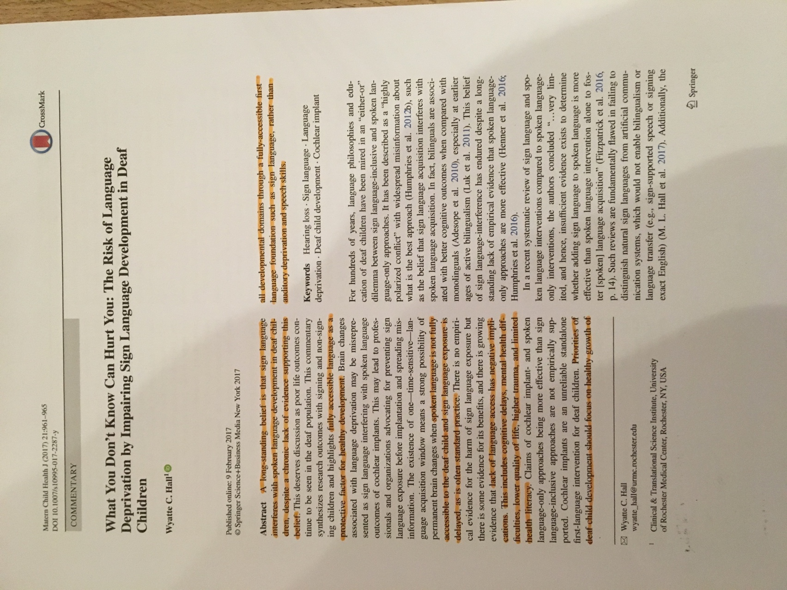

This journal article is about deaf children and young people’s sign language development are under risk of being language deprivation after spoken language interferes and it is argued that it does affect to their education. They argued that bring a legislation of sign language will support deaf children and young people to learn sign language at first language and to access their education with the right support, communication levels and equality. This is the theme for deaf children and young people’s education provision.

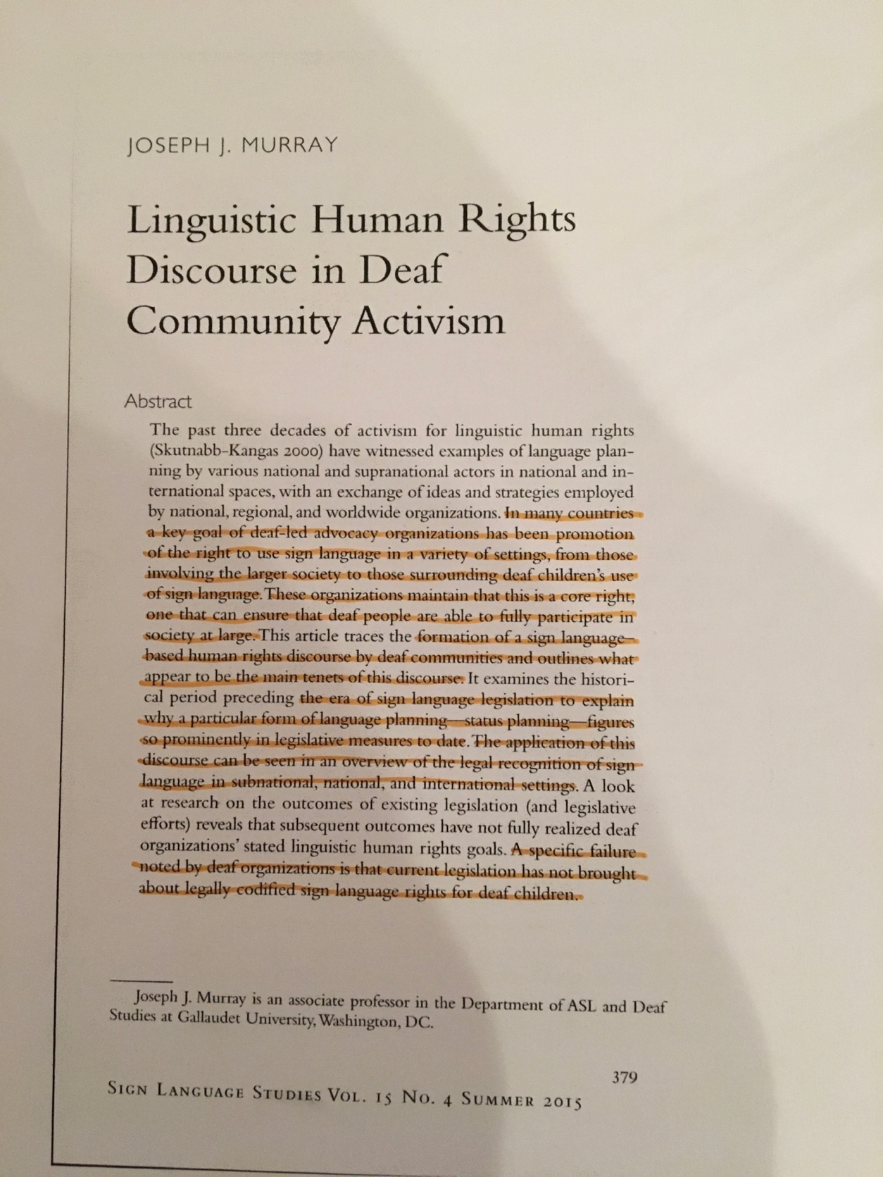

This journal article explains that sign language planning and become legislation must be reactive, geographically specific and based on political experiences, but the UK Government’s language policy has been described as cross-cutting and disorganised which makes the voices of BSL users extremely hard to discern, specifically for BSL. BSL users themselves are being as shaped by disability discourse as by inadequate engagement. This is the theme for language legislation and policy planning.

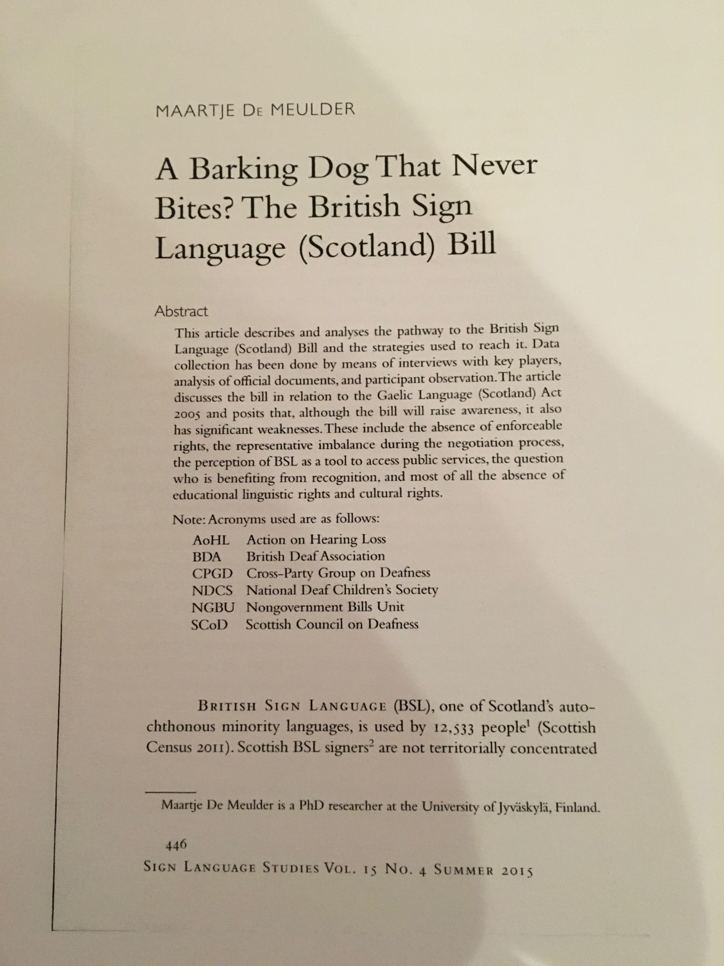

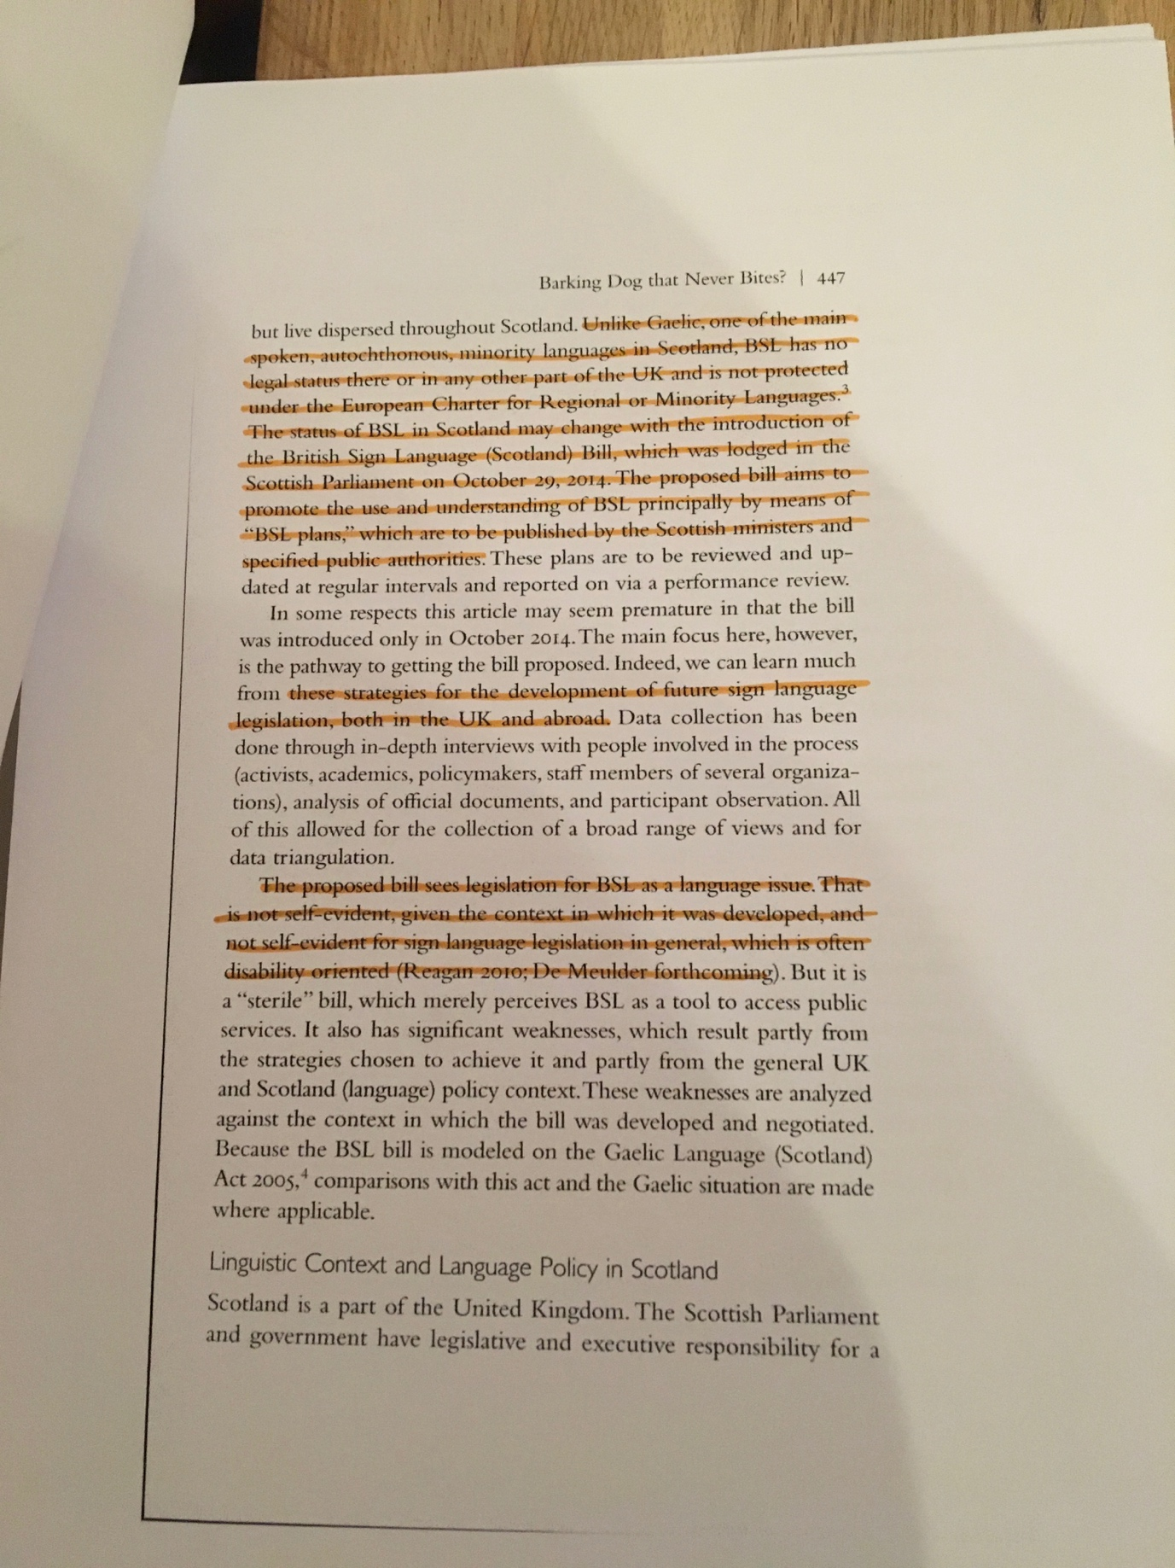

This journal article is about analyses the pathway to the BSL Scotland Act and how it began include the strategies used to reach it. It is supported to themes.

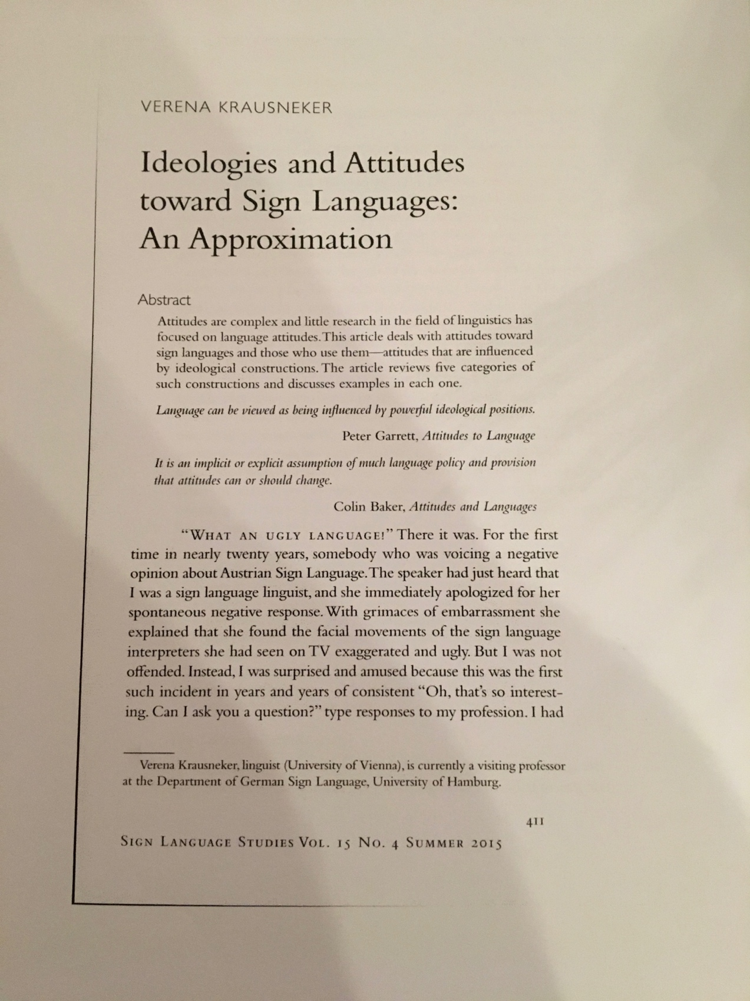

This journal article is about ideologies and attitudes toward sign language which is also theme for this research project. This article had discussed about issues of hearing people’s attitudes and ideologies about sign language and deaf communities which possibly make difficult to create legislation for sign language as they thought it is not important because deaf people were overseen as the disabilities rather than language users.

This journal article is focus on social model of deaf but also talks about how medical model are affect them and influence Governments’ beliefs and values which makes difficult for deaf communities given their voices to ask for sign language legislation.

